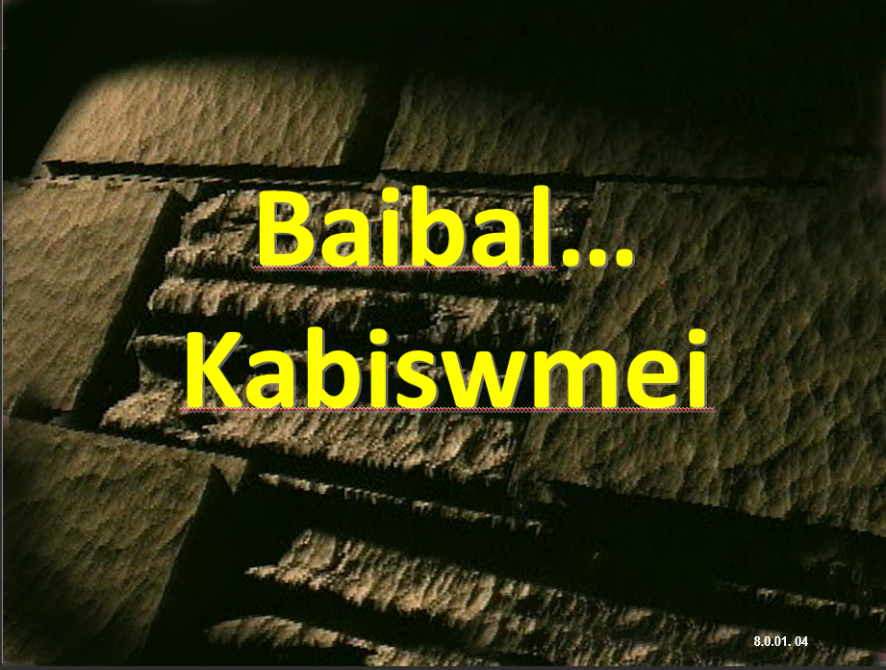

TBB NCHAM DWAN CHAKIU TA DINH KHOU SIN KHANG LAT-RAAH LWAN

JOHN E. FRYMAN, PH.D.

KAGWAN 9.7

THE BIBLE…BASICALLY MINISTRIES INTL INC.
FORT WORTH, TEXAS
2008
Copyright 2005
The Bible…Basically Ministries Intl. Inc.
And John E. Fryman, Ph.D.

KALANGV TITHAYMEI

Ncham Dwan tuang Kaliph kalangv swna lianvloumei

#1 Nuh-nahmei hykeyloumei
Kalam Dinhmei khatni D 7 K J 1

#2 Kabamv Kapuihmei: Reynungc Neihpat Daeng dic hiakmei 33

#3a DAMHMEI Khukh 58

#3b ABRAHAM lev JOSEP Khukh 70

#3c MOUSI lev JOSHUA Khukh 98

#3d MEICKANG kathumh Khukh 122

#3e KARIMMEI Khukh 155
#3f JISU Khukh 174
#4mv TQC Khapmei khou (Maengh kazauhmei) 213
[PC 9.6 gwan khou ntau-tau maek e]

#4sl TQC Khapmei khou (kaliph) 230
#5a Baibal Kw, Kalangv 1 245
#5b Baibal Kw, Kalangv 2 273
#6 Laanclou bammei Baibal 310
#7 Kabuk Duancthaumei: Latdyng Guangc 328
#8 Kabuk Duancthaumei: Latdyng Thanh 366

#9 Ncham Dwan Luailoumei 426

KATGUTLOUMEI

Reyliangmei khou, nguay, Poubauhmei khou Katuang daihmei Buk khang katlou e, khatni kabam kathuicna khou mituang latdip nunc khatni zauc nuh khang lianvlou bammei guay hei rui Ringhpouc daeng zayguang anaalou bammei meinunc khang ni katgutlou e.

Kaneimei khou, khatni nthukliangna, tingkwm riakngu mbu nzian dianghmei pam swmei khatni ata nkhavmei Sarav khang lungh syng khou rui katlou e. katuang katiu thauloumei khatni nkhavloumei kazauhmakna mi taanv hei luai ngam nituang hamh e. Kamei hei apanty khou zianliangmei akaipui e, Guloumeipu tuang taanv khatni Gaychamv khou lwmlou, ngangvloumei tuang sakhi pangc khou daicliangmei akhat e.

J.E.F.

Mi tuang dip hei thu kadip sing hygay khang nsa karaengna kasiamhlou tu e.

