Alliance Church Second Circle, Amman, Jordan Dr. Rick Griffith
26 Aug 2022 Wedding Message
NLT 15 Minutes
Selflessness in Marriage
Philippians 2:1-4

Topic: Marriage
Subject: How can you be united in marriage?
Complement: Show a selfless humility.
Purpose: The listeners will show selflessness to make a united marriage.

Introduction

Interest: “You never know true happiness until you are married—and then, it’s too late!” so said one person who probably didn’t have a very good marriage.

Need: Marriages are in trouble and dividing worldwide, whether resulting in divorce or just a lifetime battle in the house.

So how can you have a successful marriage?

How can you start out right united on day 1 of your marriage? What can you do today on your wedding day to be unified?

Background:

The Bible has much to say in the marriage passages like Genesis 2 and Ephesians 5 and 1 Peter 3 and others. These teach great truths, but most of us have heard wedding sermons from these texts.

In Philippians, Paul shared asked the church to give him joy by being united (Phil 2:1-2). He was concerned about church unity—but today I will apply congregational unity to the smallest of congregations—the marriage bond.

Subject: How can you be united in marriage? What is the way to have a harmonious life together for many years?

Preview: Today we will see one thing not to do and two things to do.

Text: Philippians 2:3-4 gives us these three keys to unity.

(What’s the first key to a united marriage? It is a key thing NOT to do…)

I. Don’t be selfish (2:3a).
[Don’t be self-centered—or self-seeking—or self-interested.]

“Do nothing from selfishness or empty conceit.” Not “don’t do something from selfishness” but “don’t even do one thing from selfishness”! That’s a tall order!

Don’t be selfish: You have learned for over three decades how to meet your needs—you clean yourself, feed yourself, clothe yourself, educate yourself, etc. But from this time on…

Don’t be selfish: Meeting your needs doesn't bring unity with others.

Don’t spend the money the way you want.

Agree on priorities together so you give money and spend money in a way you both have decided in advance.

Use the same bank account or envelope or wherever you put your money.

Don’t have “his money” and “her money.” I have seen married couples argue, “I paid the rent last month so this month it is your turn!”

Don’t use your time the way you want to—ask your spouse what he or she wants to do.

Don’t talk about the subjects that you want to talk about.

The best example of selflessness is Jesus. He didn’t leave heaven to die on a cross because he liked pain and suffering. He paid our penalty as the most selfless act ever committed.

(So the first key to a united marriage is not to be selfish. But what should you do instead? How can you avoid selfishness? Simply put…)

II. Be humble (2:3b).
[Be meek.]

Paul gives a great way to prevent selfishness: “with humility of mind regard one another as more important than yourselves” (2:3b).

Be humble in your mind first—it starts with what you think about yourself!

Be humble: Conquer pride. This is worst sin and probably the root of all sin.

Satan invented pride in heaven!

Then Adam and Eve reproduced it on earth—they wanted to be like God.

Be humble: Realize your way is not always the best way.

I had to learn in the first weeks of my marriage that there is more than one way to wash dishes or load a dishwasher.

I had to learn in our first month of marriage that marriage is not for competition.

I wanted to encourage industry instead of laziness as newlyweds, so I said, “Let’s make a deal. Whoever gets out of bed last makes it.”

Pretty soon I learned that making the bed myself is much more difficult—and I don’t think Susan ever made it herself! I had married a morning person.

Then an idea hit me; “Hey, why not get up together and make the bed together?” We did and then moved to the big chair to pray together each morning. I began liking that word together!

Be humble: Give way. Be the kind of person you would love to be married to!

The best example of humility is Jesus. He didn’t leave heaven to die on a cross because he liked pain and suffering. He paid our penalty as the humblest act ever committed.

(So the key to a united marriage is not to be selfish but instead to be humble. But what does humility look like? Someone could claim to be humble but actually be proud! How can you really be humble?)

III. Put your spouse first (2:3c-4).
[Consider the interests of the other before your own.]

Paul’s advice is quite practical: “Do not merely look out for your own personal interests, but also for the interests of others” (2:4).

Every day of your married life you will make many decisions as to whether you will do things your way or your spouse’s way.

Put your spouse first: Choose what he or she likes.

Put your spouse first. What does that look like?

I never wear anything that my wife Susan dislikes.

When Susan is ready to go to bed, so am I. Yes, we go to bed together and get up together with only very rare exceptions.

Maximize each of your strengths. My wife typically drives herself in every country where we have lived—USA, Singapore for 30 years, etc. but not yet in Jordan. So putting her first means that I don’t push her to drive—not until she is ready.

The best example of putting others first is Jesus. He didn’t leave heaven to die on a cross because he liked pain and suffering. He paid our penalty to put us first more than anyone else ever did.

(I know that you want unity in marriage. Who wants disunity? But how can you attain unity in marriage?)

Conclusion

Show a selfless humility (Main Idea). Demonstrate in practical ways that you consider your spouse more important than you.

Main Points

Don’t be selfish (2:3a).

Be humble (2:3b).

Put your spouse first (2:3c-4).

Application

I said earlier not to have a competition with your spouse. But actually, there is one competition that is good…

Try to out-give your spouse! If you are going to have any arguments, argue over who’s going to serve most! “Oh, let me wash the dishes! You’ve had a hard day!” “No, honey, I’ll do it—you have a lot to do tonight!”

God will be honored in that kind of argument.

Prayer

Alliance Church Second Circle, Amman, Jordan Dr. Rick Griffith
26 Aug 2022 Wedding Message
NLT 15 Minutes

Selflessness in Marriage
Philippians 2:1-4

Topic: Marriage
Subject: How can you be united in marriage?
Complement: Show a selfless humility.
Purpose: The listeners will show selflessness to make a united marriage.

Introduction

Interest: “You never know true happiness until you are married—and then, it’s too late!” so said one person who probably didn’t have a very good marriage.

Need: Marriages are in trouble and dividing worldwide, whether resulting in divorce or just a lifetime battle in the house.

So how can you have a successful marriage?

How can you start out right united on day 1 of your marriage? What can you do today on your wedding day to be unified?

Background:

The Bible has much to say in the marriage passages like Genesis 2 and Ephesians 5 and 1 Peter 3 and others. These teach great truths, but most of us have heard wedding sermons from these texts.

In Philippians, Paul shared asked the church to give him joy by being united (Phil 2:1-2). He was concerned about church unity—but today I will apply congregational unity to the smallest of congregations—the marriage bond.

Subject: How can you be united in marriage? What is the way to have a harmonious life together for many years?

Preview: Today we will see one thing not to do and two things to do.

Text: Philippians 2:3-4 gives us these three keys to unity.

(What’s the first key to a united marriage? It is a key thing NOT to do…)

I. Don’t be selfish (2:3a).
[Don’t be self-centered—or self-seeking—or self-interested.]

“Do nothing from selfishness or empty conceit.” Not “don’t do something from selfishness” but “don’t even do one thing from selfishness”! That’s a tall order!

Don’t be selfish: You have learned for over three decades how to meet your needs—you clean yourself, feed yourself, clothe yourself, educate yourself, etc. But from this time on…

Don’t be selfish: Meeting your needs doesn't bring unity with others.

Don’t spend the money the way you want.

Agree on priorities together so you give money and spend money in a way you both have decided in advance.

Use the same bank account or envelope or wherever you put your money.

Don’t have “his money” and “her money.” I have seen married couples argue, “I paid the rent last month so this month it is your turn!”

Don’t use your time the way you want to—ask your spouse what he or she wants to do.

Don’t talk about the subjects that you want to talk about.

The best example of selflessness is Jesus. He didn’t leave heaven to die on a cross because he liked pain and suffering. He paid our penalty as the most selfless act ever committed.

(So the first key to a united marriage is not to be selfish. But what should you do instead? How can you avoid selfishness? Simply put…)

II. Be humble (2:3b).
[Be meek.]

Paul gives a great way to prevent selfishness: “with humility of mind regard one another as more important than yourselves” (2:3b).

Be humble in your mind first—it starts with what you think about yourself!

Be humble: Conquer pride. This is worst sin and probably the root of all sin.

Satan invented pride in heaven!

Then Adam and Eve reproduced it on earth—they wanted to be like God.

Be humble: Realize your way is not always the best way.

I had to learn in the first weeks of my marriage that there is more than one way to wash dishes or load a dishwasher.

I had to learn in our first month of marriage that marriage is not for competition.

I wanted to encourage industry instead of laziness as newlyweds, so I said, “Let’s make a deal. Whoever gets out of bed last makes it.”

Pretty soon I learned that making the bed myself is much more difficult—and I don’t think Susan ever made it herself! I had married a morning person.

Then an idea hit me; “Hey, why not get up together and make the bed together?” We did and then moved to the big chair to pray together each morning. I began liking that word together!

Be humble: Give way. Be the kind of person you would love to be married to!

The best example of humility is Jesus. He didn’t leave heaven to die on a cross because he liked pain and suffering. He paid our penalty as the humblest act ever committed.

(So the key to a united marriage is not to be selfish but instead to be humble. But what does humility look like? Someone could claim to be humble but actually be proud! How can you really be humble?)

III. Put your spouse first (2:3c-4).
[Consider the interests of the other before your own.]

Paul’s advice is quite practical: “Do not merely look out for your own personal interests, but also for the interests of others” (2:4).

Every day of your married life you will make many decisions as to whether you will do things your way or your spouse’s way.

Put your spouse first: Choose what he or she likes.

Put your spouse first. What does that look like?

I never wear anything that my wife Susan dislikes.

When Susan is ready to go to bed, so am I. Yes, we go to bed together and get up together with only very rare exceptions.

Maximize each of your strengths. My wife typically drives herself in every country where we have lived—USA, Singapore for 30 years, etc. but not yet in Jordan. So putting her first means that I don’t push her to drive—not until she is ready.

The best example of putting others first is Jesus. He didn’t leave heaven to die on a cross because he liked pain and suffering. He paid our penalty to put us first more than anyone else ever did.

(I know that you want unity in marriage. Who wants disunity? But how can you attain unity in marriage?)

Conclusion

Show a selfless humility (Main Idea). Demonstrate in practical ways that you consider your spouse more important than you.

Main Points

Don’t be selfish (2:3a).

Be humble (2:3b).

Put your spouse first (2:3c-4).

Application

I said earlier not to have a competition with your spouse. But actually, there is one competition that is good…

Try to out-give your spouse! If you are going to have any arguments, argue over who’s going to serve most! “Oh, let me wash the dishes! You’ve had a hard day!” “No, honey, I’ll do it—you have a lot to do tonight!”

God will be honored in that kind of argument.

Prayer

Preliminary Questions

Verses Questions

Context: What did the author record just prior to this passage?

Purpose: Why is this passage in the Bible?

Background: What historical context helps us understand this passage?

Questions

Tentative Subject/Complement Statements

Text

Possible Illustrations

Text

Possible Applications

Text
Selflessness in Marriage
Philippians 2:1-4

Exegetical Outline (Steps 2-3)

Exegetical Idea: The way to unity among believers is

I. The way to make Paul joyful was for the church to be united (2:1-2).

The conditions (“if”) were four for Paul’s joy (2:1).

The command was to give Paul joy (2:2a)

The way to give Paul joy was unity (2:2b).

II. The way to unity among believers is selflessness (2:3-4).

The way to unity is selflessness (2:3a).

The way to selflessness is humility (2:3b).

The way to humility is to regard others more than self (2:3c-4).

Purpose or Desired Listener Response (Step 4)
The listeners will show selflessness to make a united marriage.

Homiletical Outline (Cyclical inductive form)

Introduction

Interest: “You never know true happiness until you are married—and then, it’s too late!”

Need: Marriages are in trouble and dividing worldwide, whether resulting in divorce or just a lifetime battle in the house.

Background: Paul shared that the church would give him joy by being united (Phil 2:1-2). He was concerned about church unity—but today I will apply congregational unity to the smallest of congregations—the marriage bond.

Subject: How can you be united in marriage?

Preview: We will see one thing not to do and two things to do.

Text: Philippians 2:3-4 gives us these three keys to unity.

(What’s the first key to a united marriage?)

I. Don’t be selfish (2:3a).

“Do nothing from selfishness or empty conceit.” Not “do something from selfishness” but “don’t even do one thing from selfishness”! That’s a tall order!

Don’t be selfish: You have learned for over three decades how to meet your needs—you clean yourself, feed yourself, clothe yourself, educate yourself, etc.

Don’t be selfish: Meeting your needs doesn't bring unity with others.

Don’t spend the money the way you want.

Don’t use your time the way you want to—ask your spouse what he or she wants to do.

Don’t talk about the subjects that you want to talk about.

The best example of selflessness is Jesus.

(So the first key to a united marriage is not to be selfish. But what should you do instead? How can you avoid selfishness? Simply put…)

II. Be humble (2:3b).

Be humble in your mind first—it starts with what you think about yourself!

Be humble: Conquer pride. This is worst sin and probably the root of all sin.

Be humble: Realize your way is not always the best way.

Be humble: Give way. Be the kind of person you would love to be married to!

The best example of humility is Jesus.

(So the key to a united marriage is not to be selfish but to be humble instead. But what does humility look like? Someone could claim to be humble but actually be proud! How can you really be humble?)

III. Put your spouse first (2:3c-4).

Every day of your married life you will make many decisions as to whether you will do things your way or your spouse’s way.

Put your spouse first: Choose what he or she likes.

Put your spouse first. What does that look like?

The best example of putting others first is Jesus.

(I know that you want unity in marriage. Who wants disunity? But how can you attain unity in marriage?)

Conclusion

Show a selfless humility (Main Idea).

Main Points

Application

I said earlier not to have a competition with your spouse. But actually, there is one competition that is good…

Try to out-give your spouse! If you are going to have any arguments, argue over who’s going to serve most! “Oh, let me wash the dishes! You’ve had a hard day!” “No, honey, I’ll do it—you have a lot to do tonight!”

Prayer

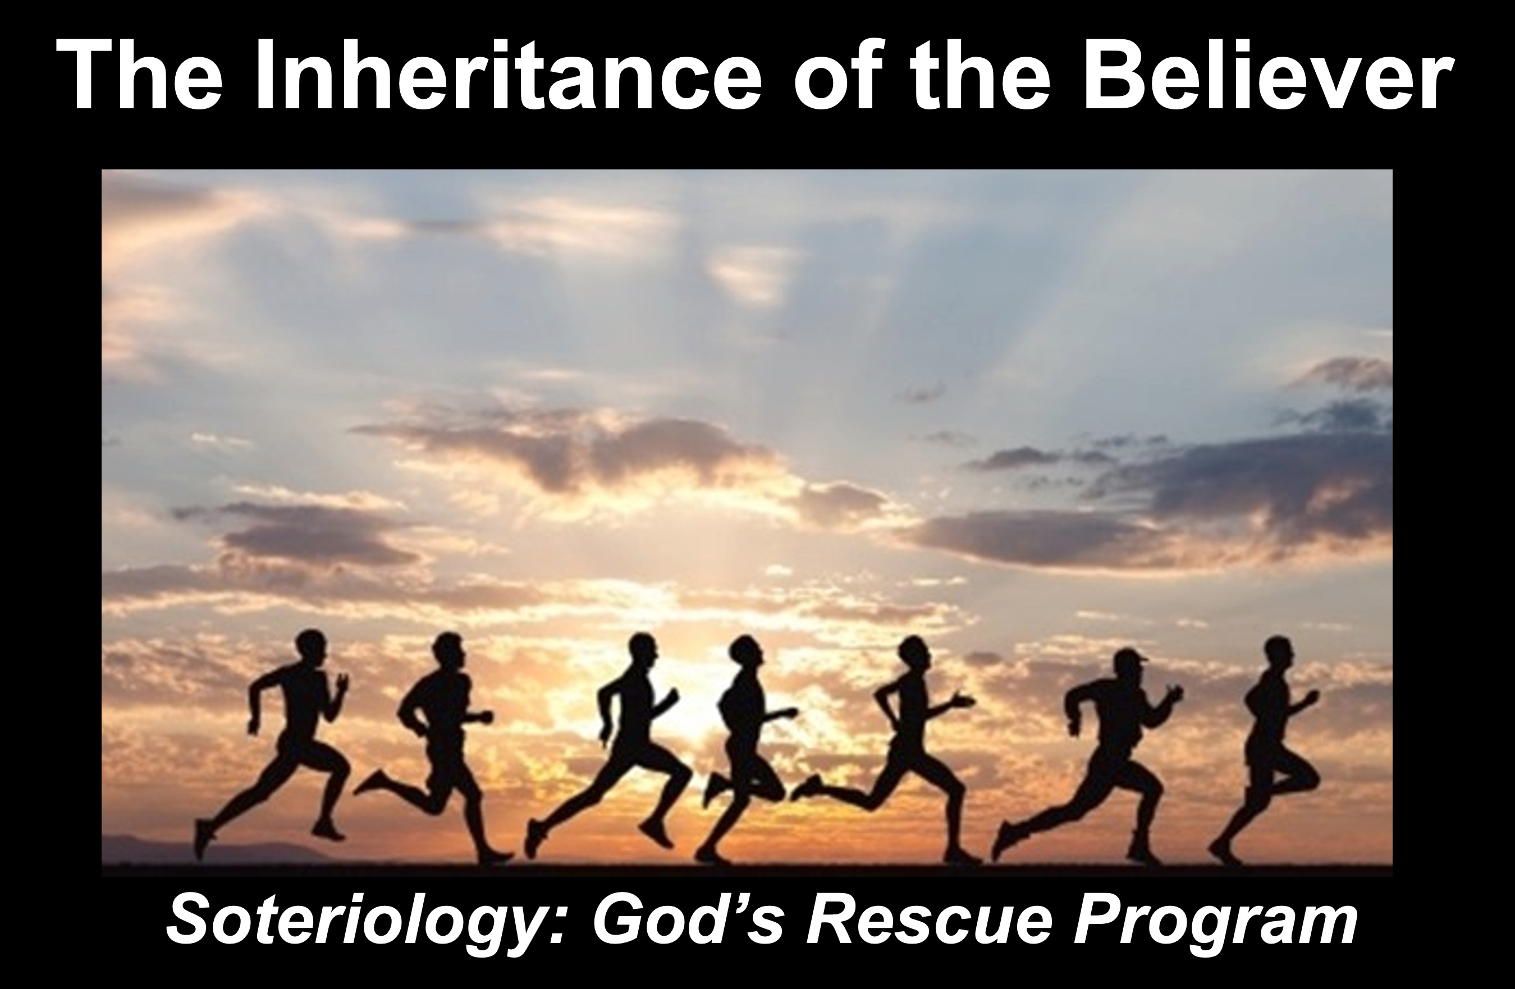
Rick Griffith
2021
Message of 4

Selflessness in Marriage
Philippians 2:1-4

Introduction

Subject with a blank for the key word _______________

I. MP has a blank for the key word ________________ (verses).

SP has a blank for the key word ________________ (verses).

SP has a blank for the key word ________________ (verses).

SP has a blank for the key word ________________ (verses).

II. MP has a blank for the key word ________________ (verses).

SP has a blank for the key word ________________ (verses).

SP has a blank for the key word ________________ (verses).

SP has a blank for the key word ________________ (verses).

Conclusion

Main Idea has a blank for the key word ________________ (verses).

Application question

Thought Questions

- Read the passage aloud. Contrast:

Issue | Contrast

- Text-based question

- Application to your own Christian experience

Download this sermon PPT and notes for free at BibleStudyDownloads.org/resource/new-testament-preaching/

