Jordan Evangelical Theological Seminary Chapel (18 Nov 2021) Dr. Rick Griffith
Amman International Church (4 Nov 2023) Message 4 of 4
NLT 30 Minutes
Title
The Inheritance of the Believer: Part 4
Blessings in Hebrews

Topic: Ruling
Subject: Why press on with Christ?
Complement: Press on to rule and rest with Christ.
Purpose: The listeners will press on in their faith during trials with both a fear of failing Jesus and a hope for the future.
Attribute: Rewarder
Meditation: Hebrews 4:8-11
Reading: Hebrews 4:1-11
Benediction: Hebrews 3:14
Songs: Soften My Heart (conclusion)

Introduction

Interest: [Many people who trust Jesus do not finish well.]

Have you ever met someone with too high a view of Jesus? Neither have I.

But I sure have met many with too low a view of the Lord—and this kept them from finishing well.

It seems that many people who trust Jesus do not finish well.

Need: Will you be faithful to Christ until you die?
Why Press On?

Subject: Why press on with Christ? What reasons can you give to remain faithful to Jesus?

Background: Hebrews warns Christians from abandoning the Christian race. They needed reasons to stay in the race.

We already addressed last week their need to press on to avoid God’s discipline.
Running
(5 slides)

The Five Warning Passages have at least five different ways to view the salvation race (5 white slides).
NO
Jesus

But what is the result for the believer who later rejects Christ?
Views
(6 slides)

Seeing these readers as carnal believers has the best evidence (6 red slides).
4:12-13

Only God knows our state as nothing is hidden from him (Heb 4:12-13).
Why Press On”

Preview: So we have seen the need to press on to avoid God’s discipline. But today we will see two more reasons to press on with Christ.

Text: Our primary focus today is Hebrews 3–4.

(What is the first reason to press on with Christ?)
• RULE

I. Press on to enter your millennial rule (Heb 3:7-19).
[Perseverance in the Christian race leads to reigning with Jesus for 1000 years.]
Crown

These Hebrew readers were in danger of losing their kingdom rule.

Hebrews 3:7-19 compares these Hebrew Christians with their ancestors in the wilderness who never entered Canaan rest.
3:7-14
(3 slides)
• Rest
• Rule
Why?
Two Prohibits
Apostates
Rev 5:10

Hebrews 3:14 is the key verse for the Partaker view. The “we will share” (NLT) or “have become partakers of Christ” (NAU) has the big word IF. The sharing in the rule with Jesus is conditioned on faithfulness to the end of our lives.
3:15-19
(2 slides)

Revelation 5:10 also reaffirms God’s desire for us here: “And they will reign on the earth.”

But apostates will not rule with Christ.

This is because rejecting Jesus disqualifies believers from ruling with him.

(So the first reason to press on with Christ is to press on to enter your millennial rule. What is the second reason to press on with Christ?)

II. Press on to enter your millennial rest (Heb 4:1-13).
[Perseverance in the Christian race leads to a “restful rule” for 1000 years.]

Israel's unbelief should warn these Hebrew Christians against rejecting Christ, as disobedience would forfeit their Canaan rest (Hebrews 4:1-13).
NO
ENTRY

The OT Jewish believers who stopped believing failed to enter Canaan rest as an example of the same judgment happening to unfaithful Christians today (4:1-3a).
4:1-3a

But the readers could be guilty of also not continuing to trust Christ and thus miss the millennial Sabbath rest (4:8-11).
4:8-11
7 Views

At least seven views exist on the “Sabbath-rest for the people of God.”
1

Present Sabbath Rest & Future Heavenly Rest
2

Present Sunday & Grace Rests & Future Heavenly Rest
3

Present Spiritual Rest
4

Present Spiritual & Future Heavenly Rest
5
6
7

Future Heavenly Rest

Millennial Rest with Present-Day Application

Future Millennial Rest

At least five arguments support the future millennial rest in Hebrews.
Millennial Support

The context
1 Context

Christ is superior in his person (1:1–4:13).
Superior
(3 slides)

Believers are called "companions" (metochoi) with Christ in His anointing by God as messianic King (1:9 quoting Ps. 45:6-7).
1:8-9

Christ's victory over His enemies before the Millennium (1:13) is linked with the promise that believers will share in that victory (cf. 3:14).
1:13
1:14

In contrast, angels are but servants who care for us (1:14).

Angels will not control the future world, but Christ will share this rule with man in "the world to come," or millennium (2:5).
3 Other Scripture
4:8-11
Joshua Rest
4:3-5
2 Promise
3:5-6
3:1-2
2:15

We are partners with Jesus (3:1)—but only IF “we keep our courage and remain confident in our hope in Christ” (3:6).

The land promise

Hebrews 3 quotes Psalm 95 five times (3:7-11, 15; 4:3, 5, 7) to emphasize millennial rest in Canaan. Surely the "rest" of Psalm 95 is not eternal rest in heaven or the spiritual rest of salvation, but the repose Israel sought in having her own land. As Psalm 95 is an enthronement psalm that depicts the time of the Messiah's rule, it is appropriate that the author use this particular psalm to refer to the millennial rest.

The "rest" in this passage must be something that Joshua could have offered his people had they believed. Certainly, he could not have offered them salvation (spiritual peace) or eternal life (heaven). But what he did offer was access to the land so that wherever the people would tread, that land would be theirs (Josh. 1:3).

The millennial view best explains the "work" in 4:10: "for anyone who enters God's rest also rests from his own work, just as God did from his." Most commentators see the work here as a figurative "abstention from servile work" or sinful deeds at all times. However, ceasing work in a literal sense makes better sense since the text compares man's rest with God's rest from His literal work of creation; certainly, God does not rest from sinful deeds.

Other Scripture

Psalm 132:14 depicts God as resting in the millennial age.
Ps 132:14

Isaiah 14:2-3 says that as God rests there, so will Israel, for He will give the nation rest from pain and turmoil and harsh service in which it has been enslaved.
Isa 14:2-3

He also promises, "My people will live in peaceful dwelling places, in secure homes, in undisturbed places of rest" (Isa. 32:18; cf. Ezek. 34:15).
Isa 32:18

Ezekiel 47–48 shows that, in the millennium, the 12 tribal allotments under Joshua will all lie on the west side of the Jordan River.
Tribal
Redistribute

The significant differences between the two depictions of the leadership territory is due to two views on the measuring rod used.
End Time Geography

In either case, the center of Canaan will comprise land for the priests, Levites, and Prince.
Close Up

Believers will reign with Christ for 1000 years! It makes sense that this period is between Christ’s return in Rev 19 and the eternal state in Rev 21–22.
Rev 19-22

Extra-biblical references
4 Extra Bible

The rabbis around the time of Christ were the first to teach the millennial Sabbath. Many taught that the "Present Age" would last 6000 years, followed by a Sabbath in the "Age to Come" of a literal 1000 years.
Rabbinic Ages

The early church for the first 300 years taught the same as the Jewish rabbis—a literal millennium to follow Christ’s return.
Early Christian

Hebrews 4:8 time period
5 Time Period

Hebrews 4:8 refers to the Sabbath rest as an era: "For if Joshua had given them rest, God would not have spoken later about another day." Obviously "day" refers to another era, not another state of being. This does not definitively argue for the millennial view since the heavenly rest view relates to a future era; however, it is consistent with the kingdom view and inconsistent with the "present spiritual rest" orientation.
4:8-11

Since some of the readers might fail to experience the rest, they had not yet experienced it. This is because it is in the future.
4:1-2

Hebrews 4:3 refers to the Sabbath rest (katápausis) as ”rest” (NIV, NAU) or “place of rest” (NLT). Where else would this place be but where Israel entered—Canaan?
4:3-5
Heart

But is that rest today? Certainly what we do today determines if we will enter Canaan rest in the millennium. But note also what the author says in verse 11…
4:6-7

Verse 11 shows that the readers had not yet entered rest since they are commanded to be faithful to enter in the future.
4:8-11
Why?
(Why press on with Christ? The blessing and benefit is more amazing than we can imagine!)

Conclusion

So what have been our key answers to the “Why press on with Christ” question?

Press on to enter your millennial rule (Heb 3:7-19).
• Rule

Press on to enter your millennial rest (Heb 4:1-13).
• Rest

We can sum it up simply this way: Press on to rule and rest with Christ (Main Idea).
MI

Instead of God’s discipline, choose his blessing of reigning with him in the future Sabbath rest in the kingdom (millennial) age (MI restated).

Turning away from Christ forfeits your future rule.
Forfeits Rule

But believers with soft hearts and faithful lives will experience a wonderful rule and rest (4:9-11).
4:9-11
Lake

Are you committed to helping reach people “from every tribe, nation, language, and people” (Rev 5:9)?
Rev 5:9

Let’s be “faithful to the end, trusting God just as firmly as when we first believed [so] we will share in all that belongs to Christ” (Heb 3:14).
3:12-14

What concerns you about the fact that "Nothing in all creation is hidden from God. Everything is naked and exposed before his eyes, and he is the one to whom we are accountable" (4:13)? Confess this to God.
4:12

Exhortation: The Hebrews were beginning to harden their hearts against the amazing new covenant in Christ and all it offers. But is your heart hardening?

Three times the author told them not to let their hearts harden (3:7, 15; 4:7). Is God also telling you? Let's bow for prayer.

Are you softer or harder towards Jesus than 5 years ago? Why? Tell him that you want to be softened.
Prayer

Prayer

Preliminary Questions

Verses Questions

Context: What did the author record just prior to this passage?

The readers were warned not to have too low a view of Jesus.

Purpose: Why is this passage in the Bible?

We need both warnings and promises to have a balanced view of life and ministry.

The warnings help us not be stupid and deny the faith.

The promises help us press on to maturity and reward.

Background: What historical context helps us understand this passage?

The readers were living in Israel but God knew that soon the Jews would be kicked out of their own land by the Romans.

The original audience lived in a believing community that was suffering for Christ and thus tempted to return to Judaism.

Questions

Why don’t we teach on the millennium anymore?

The tendency is to avoid anything controversial in our churches because our goal has become to fill seats more than to make disciples.

Bible prophecy has thus fallen on hard times.

The recent revival of amillennialism has been followed by the politics of arguing for the Palestinian cause and a reduction of commitment to Israel.

How can the kingdom age be a time of both service for Christ as well as rest?

Eden itself had restful work. God placed Adam there long before God instituted the Sabbath for people in Exodus 17.

In many ways, the millennium will be a restoration of Edenic ideals.

Tentative Subject/Complement Statements

We will rule and rest in the future millennial kingdom of Christ.

Possible Illustrations

I have served the Lord 41 years in full-time ministry but now have entered a period of “work-filled rest” here in Jordan with reduced roles but still much useful ministry.

Possible Applications

Compare your heart for God now with 5 years ago.

Do you ever even think about what your reign with Christ will be like (cf. 1 Cor 6:1-2)?

The Inheritance of the Believer: Part 4
Blessings in Hebrews

Purpose or Desired Listener Response (Step 4)
The listeners will press on in their faith during trials with both a fear of failing Jesus and a hope for the future.

Homiletical Outline (Cyclical inductive form)

Introduction

Interest: Many people who trust Jesus do not finish well.

Need: Will you be faithful to Christ until you die?

Subject: Why press on with Christ?

Background: Hebrews warns Christians from abandoning the Christian race. They needed reasons to stay in the race.

Preview: So we have seen the need to press on to avoid God’s discipline. But today we will see two more reasons to press on with Christ.

Text: Our primary focus today is Hebrews 3–4.

(What is the first reason to press on with Christ?)

I. Press on to enter your millennial rule (Heb 3:7-19).

The Hebrew readers were in danger of losing their kingdom rule.

Hebrews 3:7-19 compares these Hebrew Christians with their ancestors in the wilderness who never entered Canaan rest.

Hebrews 3:14 is the key verse for the Partaker view. The “we will share” (NLT) or “have become partakers of Christ” (NAU) has the big word IF. The sharing in the rule with Jesus is conditioned on faithfulness to the end of our lives.

Revelation 5:10 also reaffirms God’s desire for us here: “And they will reign on the earth.”

But apostates will not rule with Christ.

This is because rejecting Jesus disqualifies believers from ruling with him.

(So the first reason to press on with Christ is to press on to enter your millennial rule. What is the second reason to press on with Christ?)

II. Press on to enter your millennial rest (Heb 4:1-13).

Israel's unbelief should warn these Hebrew Christians against rejecting Christ, as disobedience would forfeit their Canaan rest (Hebrews 4:1-13).

At least seven views exist on the “Sabbath-rest for the people of God.”

At least five arguments support the future millennial rest in Hebrews.
(Why press on with Christ? The blessing and benefit is more amazing than we can imagine!)

Conclusion

So what have been our key answers to the “Why press on with Christ” question?

Press on to enter your millennial rule (Heb 3:7-19).

Press on to enter your millennial rest (Heb 4:1-13).

We can sum it up simply this way: Press on to rule and rest with Christ (Main Idea).

Instead of God’s discipline, choose his blessing of reigning with him in the future Sabbath rest in the kingdom (millennial) age (MI restated).

Exhortation: The Hebrews were beginning to harden their hearts against the amazing new covenant in Christ and all it offers. But is your heart hardening?

Prayer

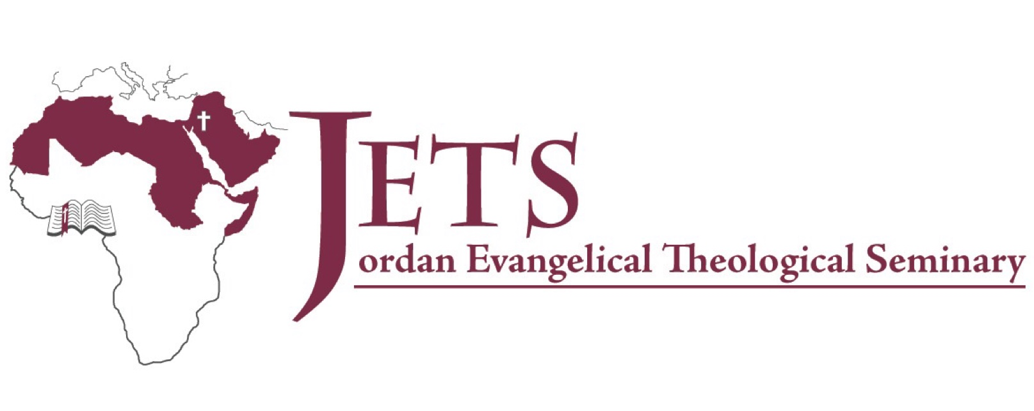
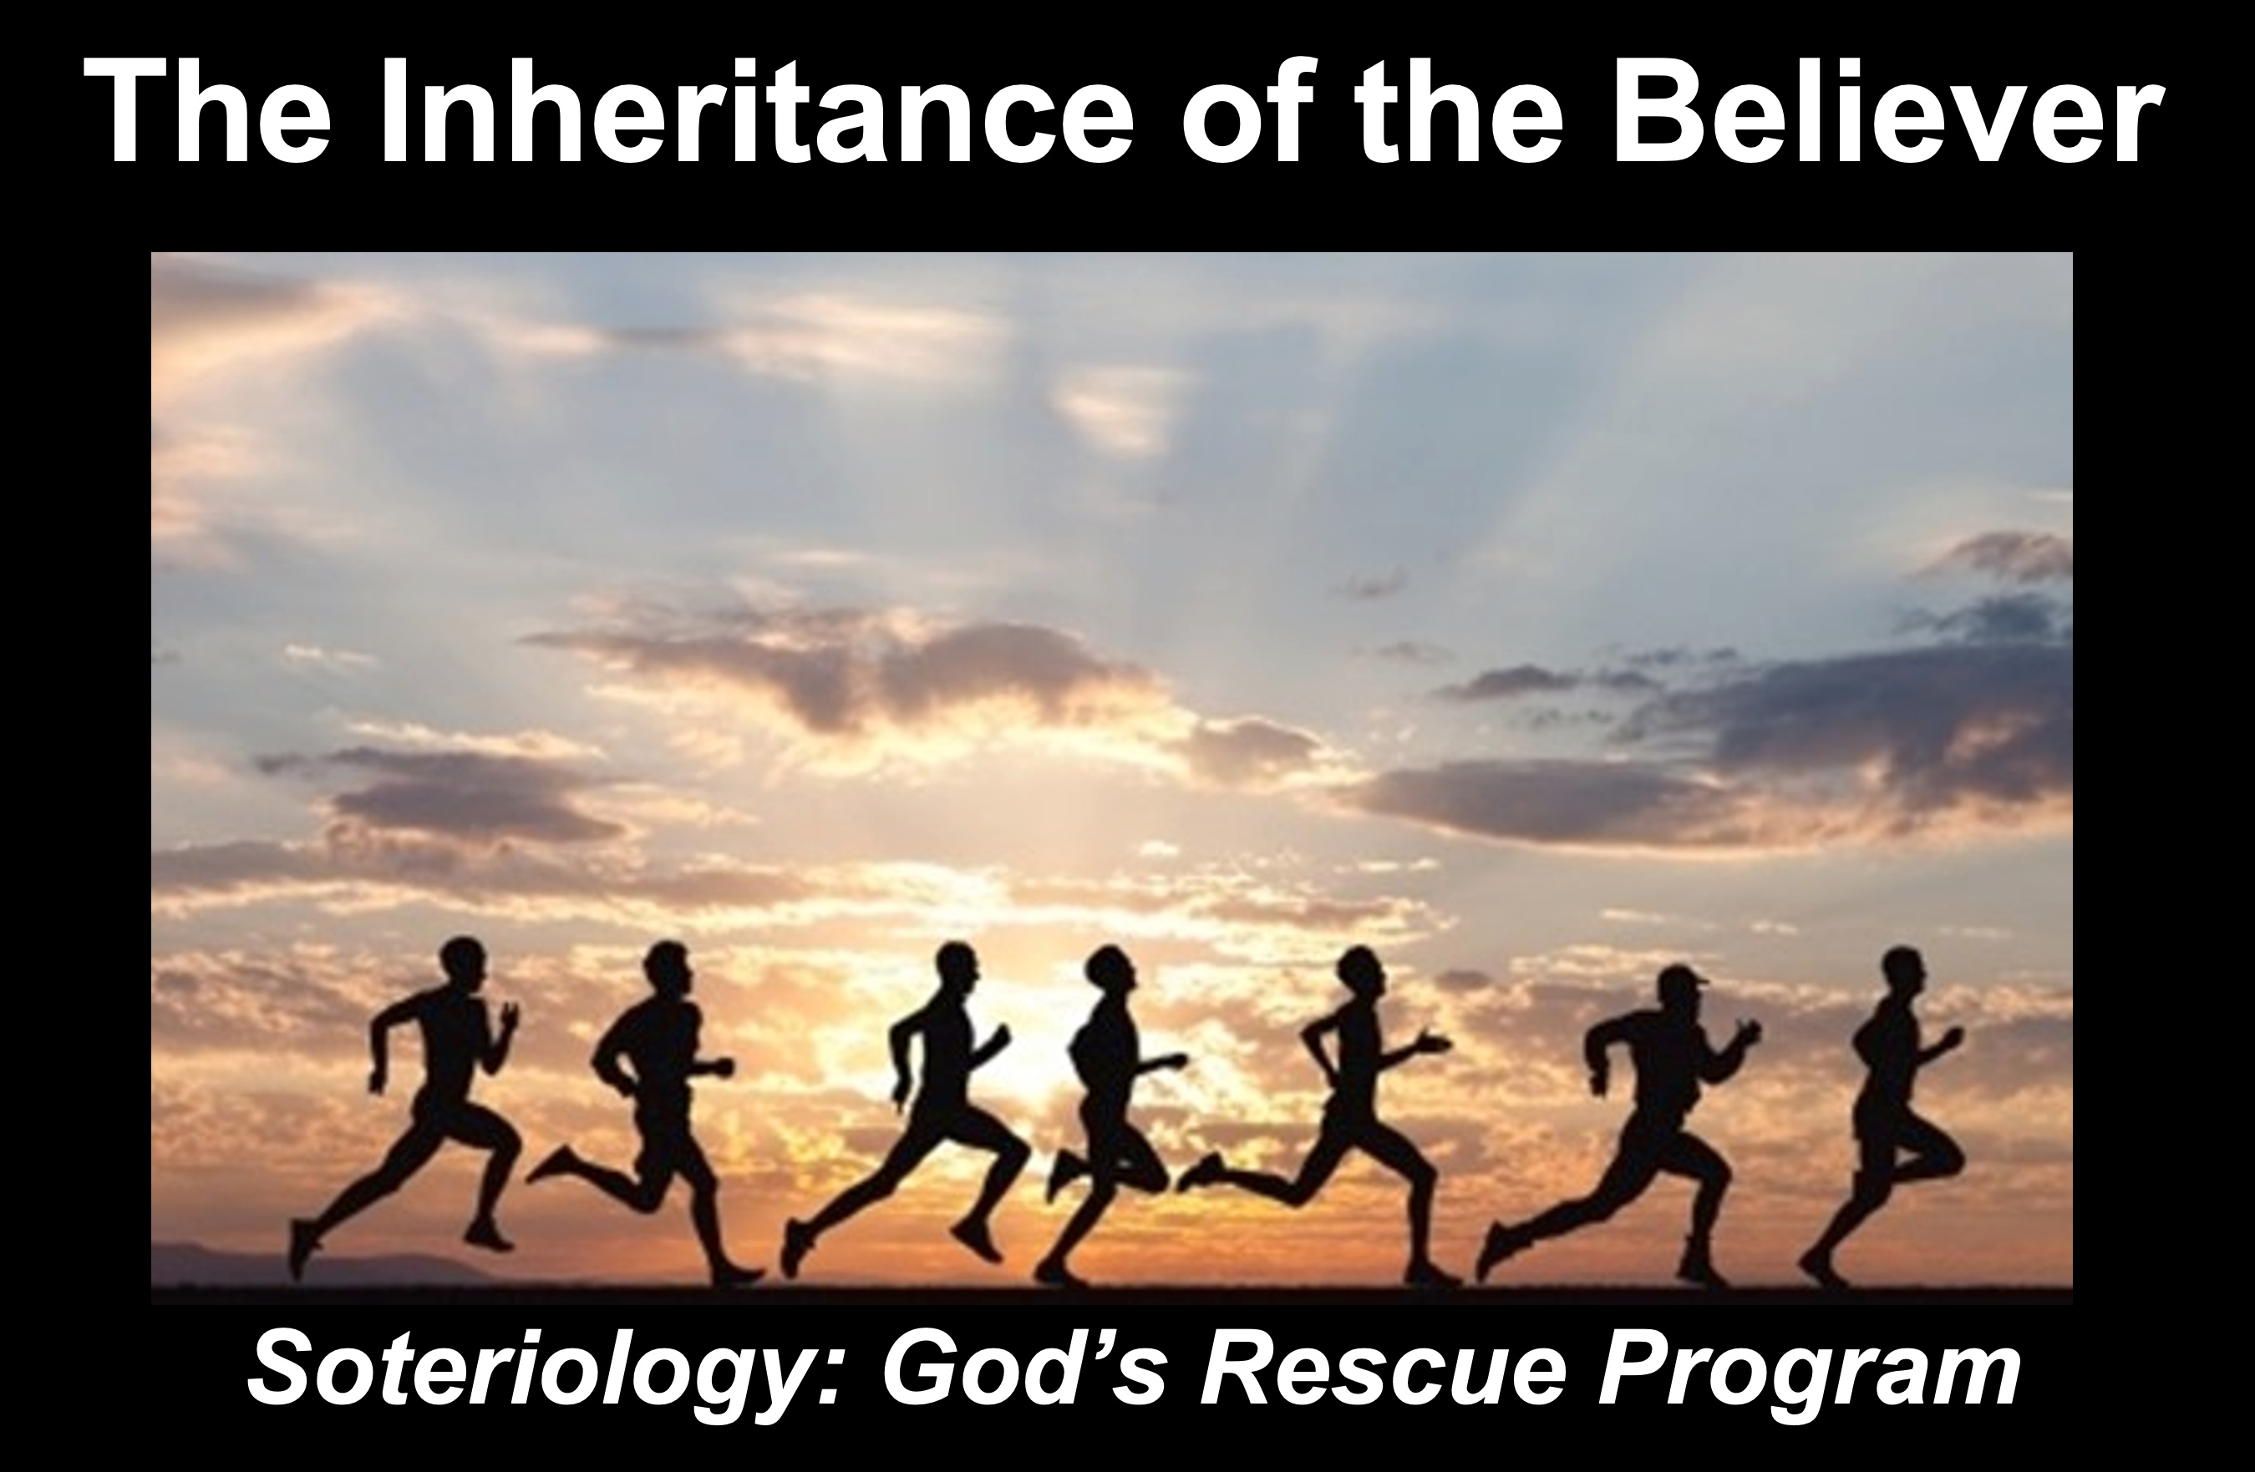

Rick Griffith
15 Nov 2021
Message 4 of 4

The Inheritance of the Believer: Part 4
Blessings in Hebrews

Introduction

Many people who trust Jesus do not finish well.

Will you be faithful to Christ until you die?

Why press on with Christ?

Hebrews warns Christians not to abandoning the Christian race. They needed reasons to stay in the race.

I. Press on to enter your millennial rule (Heb 3:7-19).

The Hebrew readers were in danger of losing their kingdom rule.

Hebrews 3:7-19 compares these Hebrew Christians with their ancestors in the wilderness who never entered Canaan rest.

Hebrews 3:14 is the key verse for the Partaker view. The “we will share” (NLT) or “have become partakers of Christ” (NAU) has the big word IF. The sharing in the rule with Jesus is conditioned on faithfulness to the end of our lives.

Revelation 5:10 also reaffirms God’s desire for us here: “And they will reign on the earth.”

But apostates will not rule with Christ.

This is because rejecting Jesus disqualifies believers from ruling with him.

II. Press on to enter your millennial rest (Heb 4:1-13).

Israel's unbelief should warn these Hebrew Christians against rejecting Christ, as disobedience would forfeit their Canaan rest (Hebrews 4:1-13).

At least seven views exist on the “Sabbath-rest for the people of God.”

At least five arguments support the future millennial rest in Hebrews.

Conclusion

Press on to rule and rest with Christ (Main Idea).

The Hebrews were beginning to harden their hearts against the amazing new covenant in Christ and all it offers. Is your heart also hardening?

Download this sermon PPT and notes for free at BibleStudyDownloads.org/resource/new-testament-preaching/

