Jordan Evangelical Theological Seminary Chapel (11 Nov 2021) Dr. Rick Griffith
Title
Amman International Church (28 Oct 2023) Message 3 of 4
NLT 30 Minutes
The Inheritance of the Believer: Part 3
Warnings in Hebrews
Hebrews 6 & 10

Topic: Apostasy
Subject: Two key warnings from Hebrews about apostasy
Complement: Don't convince God to bring you to heaven early.
Purpose: The listeners will not abandon their faith in Christ.
Attribute: Judgment of God
• Don’t

Introduction

Interest: [Apostates are believers who reject Christ and destroy the Church from within.]
Nametag

I guess that you have never seen a nametag like this.

That’s because apostates don’t wear nametags.
Apostate

Believers have failed to fight apostasy for the past 200+ years.
• Destroy Within

Apostates are believers who turn away from Christ and yet live among the saints and destroy the church within. This has happened significantly in what used to be called the "Christian West."
Who?
Men
• Names
Book

Kevin Swanson chronicles the history of Western apostasy in his book called Apostate.
Swanson Family

This includes many well-known men of the past—and even moderns like Ernest Hemingway and Lady Gaga. One thing they all have in common is that they all grew up in Christian homes but later turned away from the faith. The word “apostate” means to turn away so they originally trusted in Christ but then turned away.

Swanson writes, "This is the story of the decline and fall of Western civilization. It is the story of uncommonly powerful men, unfathomably evil men. . . apostates."
• Darwin
• Marx
God is Dead
• Nietzsche is dead
Bell & Winfrey

What did the apostates teach?
Teach?

John Dewey founded the public education system in the USA to eliminate home schools.
• Dewey

Darwin convinced the academic world of evolution instead of creation..

Marx was an atheist.

Nietzsche popularized the saying, “God is dead” in 1883. But God responded 17 years later, “Nietzsche is dead.”

Modern apostates who also grew up in Christian homes include Rob Bell (author of Love Wins, a universalist book), and Oprah Winfrey—the most popular apostate in the world as the most influential woman who teaches the same belief that all are saved.

Background: This is message 3 of my 4-part series on the Inheritance of the Believer. In the first message, we saw this key truth.
Rewards by works

Salvation is by faith, but rewards are by works (MI1). Then, the second message concluded that…

Our salvation is secure, but defectors lose rewards (MI2).
Defectors no reward

Need: Today we will see that the book of Hebrews warns Jewish believers from apostasy—do you know what they are warned about?
Hebrews Letter

How do we know that the readers were Jews? The whole book assumes they know the OT law and sacrifices.
Jews?
Go Back?
13 Times
Christ Superior
• Red Banner
Hell?
Danger?
• Loses

We also know the readers were Christians. These are clearly believers—why else would he repeatedly call them "brothers and sisters"? These Jews were second-generation (2:1-4) believers (3:1; 4:14b-15a; 10:19, 32; cf. 12:7; 13:1, 20-22) who should have matured beyond their present immature state in Christ (5:11-14).
Jewish Christians

These believing Jews were undergoing so much difficulty that they were considering a return to Judaism—a temptation to turn away or turn back to their Jewish roots.

So the writer sought to convince them that Jesus is better than anything they ever experienced in Judaism.
Better

Hebrews uses the word "better" 13 times…

The first movement of the book notes that Christ is superior in his person to anyone in the OT.

Subject: Today we will see two key warnings from Hebrews about apostasy.
5 Warnings

There are 5 warnings in total.

But we do not have time for all 5 today—so we will see two key warnings from Hebrews about apostasy.

Preview: We will look only at Warning 3 and Warning 4.

Text: These are the two most controversial texts in Hebrews—and probably the whole NT.
Warnings
(5 slides)
(Warnings 1-2 are worthy of consideration but we will focus first on the Warning 3. We will also address Warning 4 later and Warning 5 notes that refusing God has consequences. So let’s first see Warning 3.)

1. Warning 3: Rejecting Christ can lead to physical death (5:11–6:20).
Warning
3
[Christians who later reject Jesus can die before their time.]
Red Crown

It is impossible to repent from apostasy because you’re dead (Heb 6:4-6).

Too often we read this as if it says, “For it is impossible to bring back to SALVATION…” But it doesn’t say “SALVATION.” It says “REPENTANCE” and no one can be brought BACK to repentance unless he has already FIRST repented, right? This text refers to Christians!
Impossible Heb 6”4-6

Will some Christians go to hell?

What is the danger in 6:4-8?

A Christian who loses his salvation

A hypothetical, impossible situation that could never happen
• Hypo

A profession that really wasn't genuine and leads to hell
• Profess

A believer who is disqualified for Christian service and will never again return to spiritual commitment due to death has the best evidence
• Death

[Hebrews 6:4-6 warns against a believer who is disqualified for Christian service and will never again return to spiritual commitment due to death.

The situation they faced was the Jewish War against Rome (AD 66-73).]
Map
Arrows
From East
Antonia Fortress

North Wall
Leveled
Temple Assault

I think the readers lived in Israel.

Maybe they were even from a secluded community like Qumran.
Qumran

They fled to Jerusalem along with all of Israel.

During the Jewish Revolt of AD 66-73, all the Jews—believers and unbelievers alike—found refuge in Jerusalem against the Roman armies.

The temple had stood for almost 600 years. In fact, this Second Temple had just been completed in AD 64 but Jesus said that not one of its stones would remain on another (Matt 24:2).
Sanctuary

The temple was a massive complex that ended up being the last part of the city for the Jews to defend. Was this temple worth defending?

Of particular importance was this fortress with four towers overlooking the temple complex.

The Romans strategically focused their attack on the northern side to capture Antonia Fortress.

Finally it was leveled except for one tower that Titus used to command his troops.

The assault was an absolute bloodbath—especially against commoners and priests inexperienced in war to face the professional Roman soldiers, who killed them by the thousands.

[But Christians left for Pella in response to a prophetic revelation.]

But before this time, Jerusalem also had many Christians. This letter addressed believing Jews during these years of the Jewish-Roman War (AD 66-73).
Jerusalem Christians

The question for Christian Jews was simply this: Should they also join with their unbelieving Jewish brothers to fight against Rome? Should they risk their lives to preserve the obsolete temple system instead of persevering in their belief in a risen Savior?
Stay & Fight?

The believers left Jerusalem before Rome destroyed it in AD 70.
Map
Left

No Christian was left in the city—but would these readers go with them?

A revelation told them to find protection in Pella.
Pella
W2
W3
(So, rejecting Christ can lead to physical death. But why does that judgment of physical death come?)

2. Warning 4: Willful sin can lead to physical death (10:26-31).
10:26-27
8:13
• No, Jer Fire!

• Hell fire?
10:26-27
The Fire
• Righteous
• Persevere
• Confident
• Suffered
• Sanctified
• Author
• Received
• Build
• Profess
[Christians who deliberately turn away from Jesus can die before their time.]
[Believers who purposely reject Christ can enter heaven earlier than God intended.]

[The context in Hebrews 10 shows the readers are Christians.]
• Christians

Are these people Christians?
Why believers?

There are many verses in Hebrews 10 that show them to be believers in Christ.

The letter repeatedly refers to the readers as believers.

They had already professed this hope in Christ (10:23).

They should build one another up in the faith (10:24-25).

They had "received the knowledge of the truth" (10:26).

The author also could sin like this (10:26).

They had been "sanctified" (10:29).

They had faithfully suffered for Christ (10:32-34).

They had confidence in the Lord (10:35).

They needed only to persevere in that faith (10:36).

They were deemed among "the righteous" (10:38).

[These believers were not in danger of hell but of the Jerusalem fire to come.]

God’s judgment on these readers if they turned away would be “the raging fire that will consume his enemies.”

Most commentaries claim that this means the readers would go to hell.

But is this hellfire? If so, that would mean these Christians would then go to hell! This is against all that the NT teaches about believers having eternal life.

No, it refers to the Jerusalem fire! Their salvation was secure—but their apostasy would bring death with the unbelieving Jews who stayed in Jerusalem to protect the temple!

Hebrews 8:13 appropriately warns that the old covenant would soon disappear in the temple destruction.

The arrival of the new covenant in Jesus meant that God no longer wanted us to follow the old covenant under Moses. It became obsolete at the death of Christ in AD 33.
• AD 33

Hebrews was written about 35 years later when the sacrificial system still operated. I guess someone sewed the veil of the temple back together!
• AD 67-68

The writer then amazingly wrote that this obsolete old covenant would soon disappear—in AD 70 with the destruction of the temple and the sacrificial system. Since then a Jew has not been able to offer sacrifices even if he wanted to do so.
• AD 70

(So how should we respond to such a dire warning?)

Conclusion

Don't convince God to bring you to heaven early (MI)!
MI
W3
W4
Happened
• Examples
Labels
• Animate
Final Destiny
Leave
• Jesus 13:12
• Hebrews
13:13
Commit to Him
Prayer

Turning away from Jesus—apostasy—can result in the Lord not only taking away our rewards but also taking away our lives!

Main Points

Warning 3: Rejecting Christ can lead to physical death (5:11–6:20).

Warning 4: Willful sin can lead to physical death (10:26-31).

It’s happened.

We already saw in message 2 how God disciplined believers with death for the serious sin of apostasy.

The problem with labels is they make us think we must be one or the other.

The Partaker View sees death for apostasy while maintaining eternal security.

Applications

The application for Jesus was to leave Jerusalem (13:12).

The application for the Hebrews was to leave Jerusalem (13:13).

The application for you is to commit yourself to him (leave sin).

Prayer

Preliminary Questions

Verses Questions

Context: What did the author record just prior to this passage?

This is a topical message so there is no previous passage.

No one knows the author of Hebrews anyway.

Purpose: Why is this passage in the Bible?

We need warnings as we tend to drift in our faith.

The subject of God taking us to heaven earlier than he had planned is a serious issue that many face.

Background: What historical context helps us understand this passage?

We must understand the background of the Jewish War Against Rome (AD 66-73).

Jewish Christians were caught in a difficult spot of nationalistic pride but also not protecting the obsolete temple system in Jerusalem.

Questions

Why are Hebrews 6:4-6 and Hebrews 10:26-32 such contentious passages?

Why do most Christians feel that they must fall into either the Reformed or Arminian views of these texts?

Tentative Subject/Complement Statements

Willfully rejecting Christ can lead to your physical death.

Possible Illustrations

One of my older female Chinese students in Singapore shared with our class once that God had disciplined her husband’s adultery with death.

The Jerusalem siege

The various events of AD 66-70 led to Titus sieging the capital.

The Romans built a siege wall to protect their troops from marauding Jewish fanatical defenders who left the city at night to attack the Roman troops.

Possible Applications

How can you safeguard yourself from apostasy?
The Inheritance of the Believer: Part 3
Warnings in Hebrews
Hebrews 6 & 10

Purpose or Desired Listener Response (Step 4)
The listeners will not abandon their faith in Christ.

Homiletical Outline (Cyclical inductive form)

Introduction

Interest: Apostates are believers who reject Christ and destroy the Church from within.

Background: We have seen in the first two messages that apostates exist.

Salvation is by faith but rewards are by works (MI1).

Our salvation is secure but defectors lose rewards (MI2).

Need: Hebrews warns Jewish believers from apostasy—do you know what they are warned about?

Subject: Today we will see two key warnings from Hebrews about apostasy.

There are 5 warnings in total.

But we do not have time for all 5 today.

Preview: We will look only at Warning 3 and Warning 4.

Text: These are the two most controversial texts in Hebrews—and probably the whole NT.

(Warnings 1-2 are worthy of consideration but we will focus first on the Warning 3…)

1. Warning 3: Rejecting Christ can lead to physical death (5:11–6:20).

It is impossible to repent from apostasy because you’re dead (Heb 6:4-6).

Hebrews 6:4-6 warns against a believer who is disqualified for Christian service and will never again return to spiritual commitment due to death.

(Why does that judgment of physical death come?)

2. Warning 4: Willful sin can lead to physical death (10:26-31).

The context in Hebrews 10 shows the readers are Christians.

These believers were not in danger of hell but of the Jerusalem fire to come.

Hebrews 8:13 appropriately warns that the old covenant would soon disappear in the temple destruction.

(So how should we respond to such a dire warning?)

Conclusion

Don't convince God to bring you to heaven early (MI)!

Main Points

It’s happened.

Application: Commit yourself to him.

Prayer

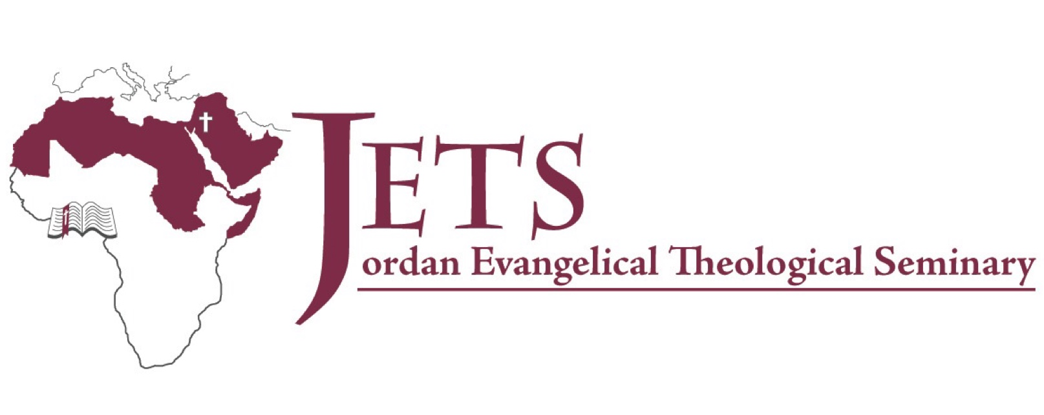
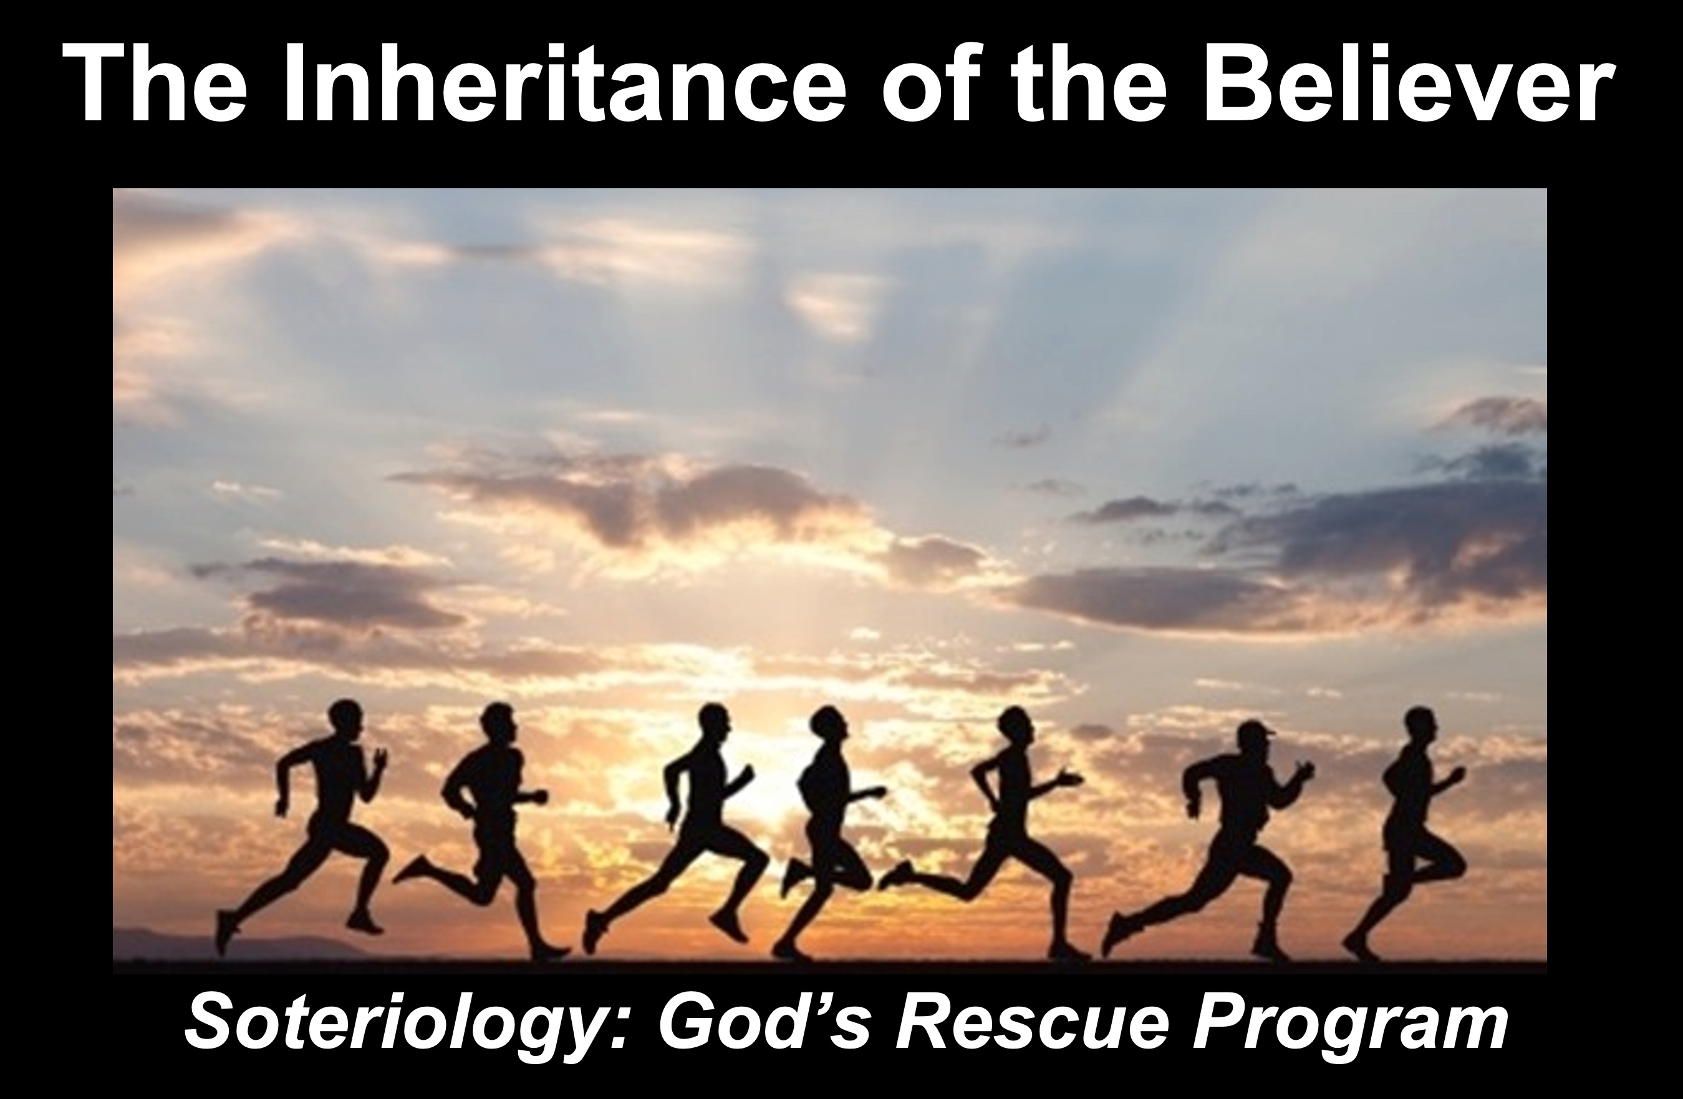

Rick Griffith
11 November 2021
Message 3 of 4

The Inheritance of the Believer: Part 3
Warnings in Hebrews 6 & 10

Introduction

Apostates are believers who reject Christ and destroy the Church from within.

We have seen in the first two messages that apostates exist.

Salvation is by faith but rewards are by works (MI1).

Our salvation is secure but defectors lose rewards (MI2).

Hebrews warns Jewish believers from apostasy—do you know what they are warned about?

Today we will see two key warnings from Hebrews about apostasy.

We will look only at Warning 3 and Warning 4.

1. Warning 3: Rejecting Christ can lead to physical death (5:11–6:20).

It is impossible to repent from apostasy because you’re dead (Heb 6:4-6).

Hebrews 6:4-6 warns against a believer who is disqualified for Christian service and will never again return to spiritual commitment due to death.

2. Warning 4: Willful sin can lead to physical death (10:26-31).

The context in Hebrews 10 shows the readers are Christians.

These believers were not in danger of hell but of the Jerusalem fire to come.

Hebrews 8:13 appropriately warns that the old covenant would soon disappear in the temple destruction.

(So how should we respond to such a dire warning?)

Conclusion

Don't convince God to bring you to heaven early (MI)!

Main Points

It’s happened.

Application: Commit yourself to him.

Download this sermon PPT and notes for free at BibleStudyDownloads.org/resource/new-testament-preaching/

