Jordan Evangelical Theological Seminary Chapel (21 Oct 2021) Dr. Rick Griffith
Amman International Church (12 Aug 2023) Message 1 of 4
NLT 20 Minutes
The Inheritance of the Believer: Part 1
Title
1 Corinthians 10:1-5

Topic: Salvation
Subject: How can we balance the Bible’s teaching on salvation and rewards?
Complement: Salvation is by faith but rewards are by works.
Purpose: The listeners will press on in obedience to obtain their full reward.
Attribute: God as Rewarder
Reading: 1 Corinthians 10:1-5

Introduction
Israel Saved?

Interest: Were the Israelites of the Exodus saved from sin as well as saved from Egypt? Turn to the person next to you and give your answer (YES or NO) and why.

Some say these Israelites were mostly unbelievers as we see them as idolaters in the wilderness—so they were not saved from sin.

Others say that they were saved from sin since they rejected the gods of Egypt—but they were not rewarded.

Subject: How can we balance the Bible’s teaching on salvation and rewards?
Subject: Balance

Were these Israelites saved? Our answer to this question will impact how we look at many OT and NT texts.

Was Canaan for them representative of entering heaven? There are huge theological implications for this question, so we will take four weeks to explore such issues.

Preview: Let’s balance the Bible’s teaching on salvation and rewards today with three observations.

(Here is our first truth about salvation and rewards…)
MI

I. God saved Israel from Egypt and from sin by simple faith.
[The Exodus generation was saved by faith shown in killing a Passover lamb.]

Background: Israel’s situation in Egypt looked dire.
Oppression

Egyptians ruthlessly oppressed Israel to motivate them to leave Egypt.
Ultimate Power

But Pharaoh claimed to have ultimate power.
Who Greater?

The question was whether Pharaoh or Yahweh was more powerful.
The Point

Exodus 1–11 teaches God’s faithful care and sovereignty.

(But how did God defeat the superpower of the day?)
John 1:29
Map
Heb 11:28
Ex 12:13

Israelites were saved from sin also by doing what seemed silly.

God commanded blood on the doorposts (Exodus 12:13).

They did this seemingly silly act by faith (Heb 11:28).

The lamb depicted the real Passover Lamb (John 1:29).

(So what is the typology here?)

II. Jesus is our New Exodus who delivers us from sin as our Passover Lamb.
MI
[Christ saves from sin’s slavery like the Passover lamb saved Israel from Egypt’s slavery.]

Jesus takes away our sins like Israel placed their faith in a lamb.
John 1:29

John told his disciples that Jesus would atone for sin as the Passover lamb atoned for Israel’s sin (John 1:29).
1 Cor 5:7

Jesus is our Passover Lamb like the bloody cross on the door (1 Cor 5:7).
Angel of Death
Faith in a Lamb
Jesus Paid for Sin
This is My Body

Israel’s faith in their lamb ultimately pointed to their faith in the Lamb.

“This is my body” meant that Jesus’s death paid for our sins.

The Passover Angel of Death depicts God seeing us through the blood of Christ.

The common thread to the Exodus and the Cross is deliverance.
MI
OT Inherit
Sal/Conf
(3 slides)
Centrality of Cross
Most Accurate?
Deliverance
(2 slides)
1 Cor 10
(6 slides)

The Exodus pictures redemption in that all in the Exodus were saved.

All delivered from Egypt were believers but most were judged (1 Cor 10:1-5).

Salvation in all ages is the death of Jesus.

Salvation has always been by faith alone.

The cross is central to history in that forgiveness is only found there.

But believers—then and now—still need confession.

(But if the Israelites of the Exodus were saved, why didn’t they enter Canaan?)

III. Inheritance in the OT included both salvation and reward.
[The OT teaches two inheritances—one by faith and one by works.]

The Partakers View explains inheritance in the OT.
Final Destiny

Inheritance in the OT was of two types:

All Israelites who believed in the LORD would have God as their inheritance—or be saved.

But only those Israelites that obeyed the LORD wholeheartedly would inherit Canaan—or be rewarded.

Dillow sums up the OT inheritance in six truths (Joseph Dillow, Final Destiny, 56):

A difference exists between inheriting the land of Canaan and living there. The former refers to ownership and the latter to mere residence.
1-2

While Israel was promised the inheritance as a nation, the condition for maintaining their inheritance right to the land of Canaan was faith, obedience, and completion of one's task. The promise, while national, was applied only to the believing and obedient remnant.

The inheritance is not to be equated with heaven but with something in addition to heaven, promised to those believers who faithfully obey the Lord.
3-4

Just as Old Testament believers forfeited their earthly inheritance through disobedience, we can also forfeit our future reward (inheritance) by a similar failure. Loss of inheritance, however, does not mean loss of salvation.

Two kinds of inheritance were enjoyed in the Old Testament. All Israelites who had believed and were therefore regenerate had God as their inheritance but not all inherited the land. This paves the way for the concept that the New Testament may also teach two inheritances. We are all heirs of God, but we are not all joint heirs with Christ unless we persevere to the end of life. The former refers to our salvation and the latter to our reward.
5

A child of Israel was both an heir of God and an heir of Canaan by virtue of faith in God resulting in regeneration. Yet only those believers in Israel who were faithful would maintain their status as firstborn sons who would actually receive what had been promised to them as an inheritance.
6

(How should we balance the Bible’s teaching on salvation and rewards?)

Conclusion
MI

Salvation is by faith but rewards are by works (Main Idea).

We come into a right relationship with God by placing our trust in Christ—but that is just the beginning as we need to obey him to be fully blessed (MI restated).

Main Points
MP1

God saved Israel from Egypt and from sin by simple faith.
MP2

Jesus is our New Exodus who delivers us from sin as our Passover Lamb.
MP3

Inheritance in the OT included both salvation and reward.

Exhortation: Are you also “in the wilderness”? How can you better press on in your own journey of faith?
Press On!

If you feel like your fellowship with God is hindered now, do you need to “clean the pipe”? What must you confess?

Do things seem dark now? Do not fail to trust God in the darkness for what he has revealed in the light.

Prayer
Prayer

Preliminary Questions

Verses Questions

Context: What did the author record just prior to this passage?

The Corinthian church were clearly believers.

But they were not living up to Christian standards.

The closest example of this prior to chapter 10 was that they insisted on their right to eat meat even if it offended other believers (1 Cor 8–9).

Purpose: Why is this passage in the Bible?

This text in 1 Cor 10:1-4 warns that true believers can reject God in idolatry so he takes their physical lives.

Paul was warning the Corinthians—and us—that we can have eternal life but without rewards beyond that—so we must be faithful.

Background: What historical context helps us understand this passage?

Corinth was a wicked city of idolatry.

The believers there had not fully left their idolatrous lifestyle.

Questions

Do all Christians have eternal life?

Can believers commit apostasy (turn away from the faith)?

Can believers have assurance of salvation now before seeing whether they will persevere until death?

If a person has eternal life but then loses his salvation through apostasy, did he ever have eternal life in the first place?

Tentative Subject/Complement Statements

Text

Possible Illustrations

The JETS Statement of Faith on Salvation underscores assurance of salvation.

Possible Applications

Text
The Inheritance of the Believer: Part 1
1 Corinthians 10:1-4

Exegetical Outline (Steps 2-3)

Exegetical Idea:

I. The way God saved Israel from Egypt was by faith.

God commanded blood on the doorposts (Exodus 12:13).

They did this seemingly silly act by faith (Heb 11:28).

The lamb depicted the real Passover Lamb (John 1:29).

II. The way Christ saves us is that Jesus is our New Exodus who delivers us from sin as our Passover Lamb.

Jesus is our Passover Lamb like the bloody cross on the door (1 Cor 5:7).

All delivered from Egypt were believers but most were judged (1 Cor 10:1-5).

III. The nature of inheritance in the OT was a twofold blessing that included both salvation and reward.

All Israelites who believed in the LORD would have God as their inheritance—or be saved.

But only those Israelites that obeyed the LORD wholeheartedly would inherit Canaan—or be rewarded.

Purpose or Desired Listener Response (Step 4)
The listeners will press on in obedience to obtain their full reward.

Homiletical Outline (Cyclical inductive form)

Introduction

Interest: Were the Israelites of the Exodus saved from sin as well as saved from Egypt? Turn to the person next to you and give your answer (YES or NO) and why.

Some say these Israelites were mostly unbelievers as we see them as idolaters in the wilderness—so they were not saved from sin.

Others say that they were saved from sin since they rejected the gods of Egypt—but they were not rewarded.

Subject: How can we balance the Bible’s teaching on salvation and rewards?

Were these Israelites saved? Our answer to this question will impact how we look at many OT and NT texts.

Was Canaan for them representative of entering heaven? There are huge theological implications of this question, so we will take four weeks to explore such issues.

Preview: Let’s balance the Bible’s teaching on salvation and rewards today with three observations.

(Here is our first truth about salvation and rewards…)

I. God saved Israel from Egypt and from sin by simple faith.
[The Exodus generation was saved by faith shown in killing a Passover lamb.]

Background: Israel’s situation in Egypt looked dire.

Egyptians ruthlessly oppressed Israel to motivate them to leave Egypt.

But Pharaoh claimed to have ultimate power.

The question was whether Pharaoh or Yahweh was more powerful.

Exodus 1–11 teaches God’s faithful care and sovereignty.
(But how did God defeat the superpower of the day and bring Israel out of Egypt?)

Israelites were saved from sin also by doing what seemed silly.

God commanded blood on the doorposts (Exodus 12:13).

They did this seemingly silly act by faith (Heb 11:28).

The lamb depicted the real Passover Lamb (John 1:29).
(So what is the typology here?)

II. Jesus is our New Exodus who delivers us from sin as our Passover Lamb.
[Christ saves from sin’s slavery like the Passover lamb saved Israel from Egypt’s slavery.]

Jesus takes away our sin like Israel placed their faith in a lamb.

Jesus is our Passover Lamb like the bloody cross on the door (1 Cor 5:7).

Israel’s faith in their lamb ultimately pointed to their faith in the Lamb.

“This is my body” meant that Jesus’s death paid for our sin.

The Passover Angel of Death depicts God seeing us through the blood of Christ.

The common thread to the Exodus and the Cross is deliverance.

The Exodus pictures redemption in that all in the Exodus were saved.

All delivered from Egypt were believers but most were judged (1 Cor 10:1-5).

Salvation in all ages is the death of Jesus.

Salvation has always been by faith alone.

The cross is central to history in that forgiveness is only found there.

But believers—then and now—still need confession.

(So if the Israelites of the Exodus were saved, why didn’t they enter Canaan?)

III. Inheritance in the OT included both salvation and reward.
[The OT teaches two inheritances—one by faith and one by works.]

The Partakers View explains inheritance in the OT.

Inheritance in the OT was of two types:

All Israelites who believed in the LORD would have God as their inheritance—or be saved.

But only those Israelites that obeyed the LORD wholeheartedly would inherit Canaan—or be rewarded.

Dillow sums up the OT inheritance in six truths.

(How should we balance the Bible’s teaching on salvation and rewards?)

Conclusion

Salvation is by faith but rewards are by works (Main Idea).

Main Points

God saved Israel from Egypt and from sin by simple faith.

Jesus is our New Exodus who delivers us from sin as our Passover Lamb.

Inheritance in the OT included both salvation and reward.

Exhortation: Are you also “in the wilderness”? How can you better press on in your own journey of faith?

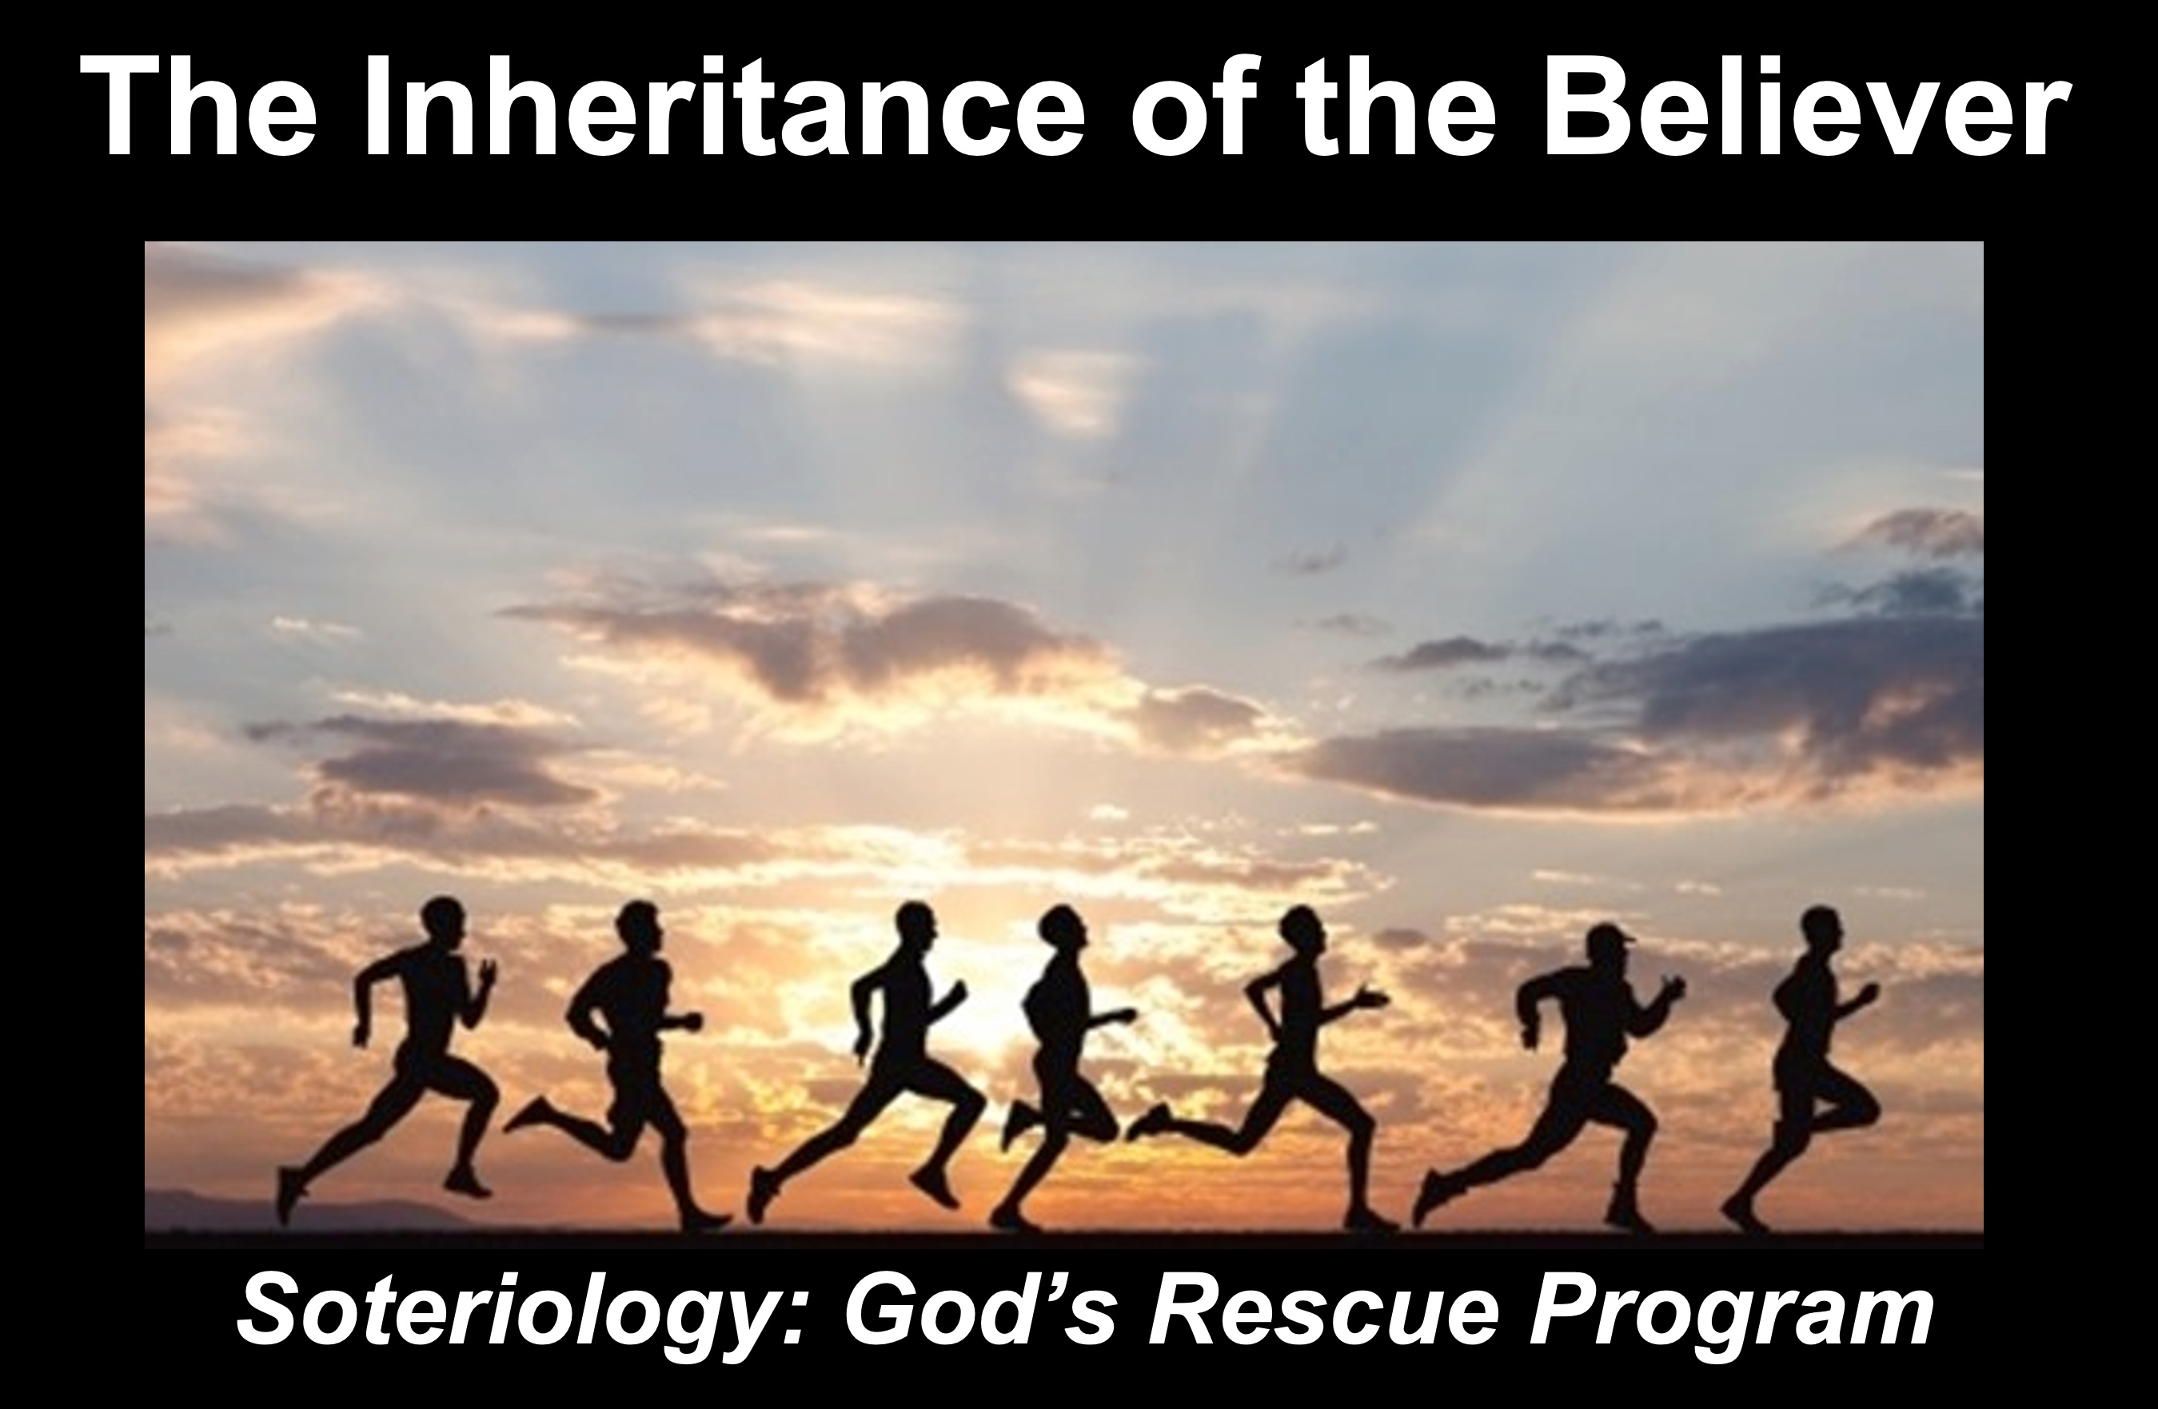
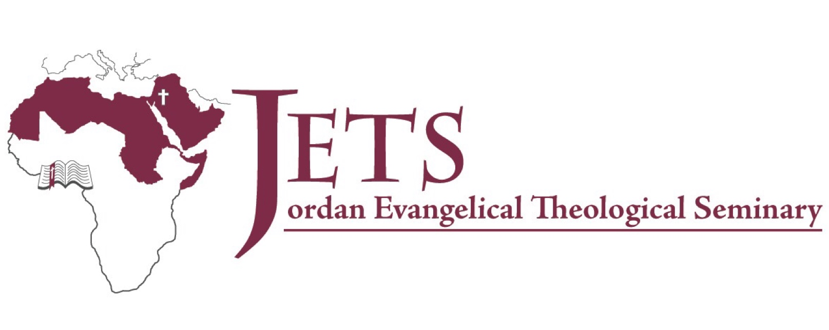
Dr Rick Griffith
21 Oct 2021
Message 1 of 4

The Inheritance of the Believer: Part 1
1 Corinthians 10:1-4

Introduction

Subject with a blank for the key word _______________

I. MP has a blank for the key word ________________ (verses).

SP has a blank for the key word ________________ (verses).

SP has a blank for the key word ________________ (verses).

SP has a blank for the key word ________________ (verses).

II. MP has a blank for the key word ________________ (verses).

SP has a blank for the key word ________________ (verses).

SP has a blank for the key word ________________ (verses).

SP has a blank for the key word ________________ (verses).

Conclusion

Main Idea has a blank for the key word ________________ (verses).

Application question

Thought Questions

- Read the passage aloud. Contrast:

Issue | Contrast

- Text-based question

- Application to your own Christian experience

Download this sermon PPT and notes for free at BibleStudyDownloads.org/resource/new-testament-preaching/

