International Church Honolulu Dr. Rick Griffith
21 June 2026 Single Message
NLT 30 Minutes
Title
Experiencing the God of Peace
Five Texts on Jehovah Shalom (The Lord is Peace)

Topic: Peace
Subject: How can you experience the God of peace?
Complement: Live in faithful obedience.
Purpose: The listeners will show faithful obedience during tumultuous times.
Attribute: God of Peace
Meditation: Is. 26:3 The steadfast of mind You will keep in perfect peace, because he trusts in You.
Reading: Judges 6:1-24 (God’s Call of Gideon)
Benediction: Heb. 13:20-21
Songs: He is Our Peace (Maranatha)

Introduction
Painting

Interest: A painting contest was once conducted to depict peace. If you were in such a competition, what would you paint? Tell the person next to you.

Many beautiful paintings were submitted, featuring serene landscapes and still waters, with several at sunset under beautiful skies and sunshine. Contestants submitted paintings of peaceful nature scenes of orchards…
Two Paintings
• Lakes & forests
Orchards

or seascapes

or lakes and forests.

But one entry was quite the contrast! It showed a raging storm with waves crashing into the rocks of a seashore. The dark sky menaced over the entire scene—all of it except the center. Amidst the chaos, a mother bird sat in the cleft of the rocks, perched on her nest, protecting her tiny chicks, unfazed by the storm above. Not surprisingly, this painting received the prize. It won the contest, reminding us that peace doesn’t come because our surroundings don’t have challenges. It comes from resting in Christ amidst those trials.
Mother
Bird
Storm

Need: When the waves of life crash around you, do you have peace?
50%

Or do the waves scare you into sinking like they did Peter walking on the water?

Do you struggle with anxiety? About 50% of our nation admits to regular anxious thoughts, and many take meds to calm them down and hopefully give them peace.

Are your relationships with others harmonious?

Background: What is peace?
Two Definitions

The painting competition shows us that there are two distinct definitions of peace.

The false assumption is that peace is the absence of storms—a life completely free from conflict, pressure, or difficulty.

But the biblical reality is calm within the storm—a mother bird unfazed on her nest while chaos rages above. True peace is shelter during the crashing waves.

The Hebrew word for peace is shalom. “Jehovah Shalom” (יְהוָה שָׁלוֹם, YHWH Shalom) means “The LORD is Peace” or “The LORD of Peace.”
Shalom
Judges 6

We typically speak of Jehovah (Yahweh) Shalom, which is obviously an OT title and thus Hebrew. As I began to prepare this message, I thought, “How cool! I get to preach the OT again, and this time about the God of Peace, who is talked about all over the OT!

But the title appears in the Old Testament only once— in the story of Gideon’s fear in the Book of Judges 6:24.

After the Angel of the LORD appeared to Gideon, Gideon feared he would die because he had seen the Angel face-to-face. But the LORD said:

“Peace be to you. Do not fear; you shall not die” (Judg. 6:23).

In response, “Gideon built an altar there to the LORD and called it ‘The LORD is Peace’” (Judg. 6:24).

The Hebrew word shalom means far more than the absence of war. It includes:
Shalom Meanings

* wholeness

* well-being

* harmony

* safety

* prosperity

* covenant blessing

* spiritual completeness

So Gideon experienced God’s peace when God required him to do something incredibly difficult. But what about you?

Subject: How can you experience the God of peace? How can Yahweh Shalom give you peace in your life’s circumstances?
Subject

Titles: I wanted to speak about all the times Yahweh Shalom appears in the Bible, but when I did a Hebrew search for “Yahweh Shalom,” I found only the Gideon story. And the title never appears in the NT. So I tried a word search for the title “God of Peace”:
Filtering
the NT

It appears only FIVE times in the Bible—and never in the OT!

Every time it appears, it is in Greek rather than Hebrew.

Every time it appears, it is in the epistles.

Every time it appears in the epistles, it is in a time of distress.

Every time it appears in the epistles, it is near the end of the letter that Paul or the author of Hebrews wrote.

Every time it appears in the epistles, it is in a blessing.

Every time it appears in a blessing, it tells us how God works.
Subject

So let’s look at these five texts and learn five ways God works in our lives.

Preview: Five passages depict the God of peace in tumultuous times. We will see a command resulting in peace for each of these five verses.

Texts: Each of these is from the epistles.

(What is the first way to experience the God of peace?)

I. Partner with missionaries.
MP
[God grants peace when we follow his heart for the lost.]

Rom. 15:33 NIV The God of peace be with you all. Amen.
Prayer & Protection

Here, Paul concludes chapter 15 of his letter by requesting the church in Rome’s help for his upcoming missionary trip to Spain.

In this context, he wishes that the God of peace be with you all.

Note that, along with this blessing, he asks the Romans to pray for his work to advance the gospel.

Paul shared his plan to extend his ministry to Spain for their help (Rom 15:23-24).
23-24

Why was Paul going to Spain? He had finished pioneering in the Eastern Empire. Like in the time of Jonah, Spain (or Tarshish) was the very end of the known world.
Spain Map

Was there really “no more place for me to work in these regions” (NIV, 14:23)? No. He means that church-planting movements in the East would reach these people.

Financial help from the Romans would further his work, since he would be halfway to Spain by the time he reached Rome.
25-27

But first, he had to bring the Gentile offering to Jerusalem to show unity with their Jewish mother church (Rom 15:25-27).
Jerusalem

How did this Gentile support for Jerusalem relate to Paul’s calling to Gentiles?
28-29

He says here that he intended it to repay something of what the Jerusalem church had done for the Gentiles, which is interesting, since it was the Antioch church—not the Jerusalem church—that sent him out to reach the Gentiles.
• Rome
• Spain

Paul also hoped to bless the Roman believers (28-29) and head to Spain.

Pray for protection and advancement of God’s ministry ambassadors.
Expansion

Paul moved west to Spain, and, in like manner, God moved us west to MENA. So, in 2021, we shifted from Singapore to Jordan. Thanks for your monthly support, which pays much of our rent in Jordan! My students are now from 11 different nations based at JETS, so please pray for us.
JETS-5

Please pray for our protection. Last year, we had missiles from Iran flying over our apartment in Amman. Through your prayers, nearly all 300 of them were shot down, and no one was hurt!
3 Requests

Please pray that God would advance what Susan and I are trying to accomplish in the Middle East.

I need wisdom to lead our JETS faculty.

I need God to prosper my teaching the Bible, including requiring my students to teach in their churches.

I need the Lord to prosper the downloading of my 2006 teaching resources in the Arab world—and the 1100 Chinese files as well.

(How else can you experience the God of peace? We see in the very next chapter of Romans another way that God grants peace. This is to…)

II. Fight heresy with truth.
MP
[God grants peace when we oppose error.]

Rom. 16:20 The God of peace will soon crush Satan under your feet. May the grace of our Lord Jesus be with you.
17-20

Let’s read Romans 16:17-20—And now I make one more appeal, my dear brothers and sisters. Watch out for people who cause divisions and upset people’s faith by teaching things contrary to what you have been taught. Stay away from them. 18 Such people are not serving Christ our Lord; they are serving their own personal interests. By smooth talk and glowing words, they deceive innocent people. 19 But everyone knows that you are obedient to the Lord. This makes me very happy. I want you to be wise in doing right and to stay innocent of any wrong. 20 The God of peace will soon crush Satan under your feet. May the grace of our Lord Jesus be with you.

Paul knows that false teachers were upsetting the Roman church. So how could the believers have peace? By fighting!

Fight false teachers who cause division.
Defense Tactics

Our church in Amman had a man last year who was filled with zeal—but his zealousness repeatedly caused confusion and division—so the leadership had to ask him to leave.

We also need to be careful of what we watch on YouTube. Amidst the many good things to watch, there are also teachers who can undermine your faith.

(How else can you experience the God of peace?)

III. Focus your thoughts on worthy things.
MP
[God grants peace when he gets a hold of your thought life.]

Phil. 4:9 Keep putting into practice all you learned and received from me—everything you heard from me and saw me doing. Then the God of peace will be with you.
Phil 4:6-9
(3 slides)

These things that Paul commands them to practice are summed up in the preceding verse—" And now, dear brothers and sisters, one final thing. Fix your thoughts on what is true, and honorable, and right, and pure, and lovely, and admirable. Think about things that are excellent and worthy of praise.”

Here is a great checklist for our thought life.
TV

Fixate your thinking and actions on admirable priorities.
Cartoon
• Hey!

Do not live in a vegetative state (read cartoon).
Mother

Refuse to look at anything vile and vulgar (Ps 101:2b-3a).
7 Traits

Memorize verses 8-9 or at least the 7 traits. It will help you think rightly.

Right thinking leads to right living, and right living leads to peace.
Diagram

(How else can you experience the God of peace?)

IV. Live a holy life.
MP
[God grants peace when you live the “set apart” life.]

1 Thess 5:23 Now may the God of peace make you holy in every way, and may your whole spirit and soul and body be kept blameless until our Lord Jesus Christ comes again.
Circles

The word “sanctify” (NIV, NAU, ESV) here is to set apart for holy use. The NLT asks that the God of peace “make you holy” in every way.

How long? Until Jesus returns!

In what areas of our lives?

Be blameless in all three parts of you—spirit, soul, and body.

Your spirit is the immaterial core that communes with God. Make it holy for peace.

Your soul is the immaterial seat of personality or conscious self. Make it holy for peace.

Your body must be holy also to experience God’s peace. Too often, we abuse our bodies with junk food or meds we don’t need, and then we wonder why we lack God’s peace!

(How else can you experience the God of peace? Here is the final way, which is to…)
MP

V. Accept God’s equipping for ministry.
[God grants peace when you recognize that you are complete in Christ.]
20-21

Heb. 13:20-21 Now may the God of peace —
who brought up from the dead our Lord Jesus,
the great Shepherd of the sheep,
and ratified an eternal covenant with his blood—
may he equip you with all you need
for doing his will.
May he produce in you,
through the power of Jesus Christ,
every good thing that is pleasing to him.
All glory to him forever and ever! Amen.

Use God’s gifting to do his will.
4-Step Cycle

Divine Provision: Do you know how God has uniquely equipped you? He gives you all you need to obey him! Do you ever feel that God hasn’t given you what you need to experience his peace? You have it all now.

Your Action: Use those unique gifts to do His will.

Divine Pleasure: Through Christ, your actions please the Lord.

Peace as a Result: Peace is the effect, not the cause.
Subject

(How can you experience the God of peace in one summary command?)

Conclusion
MI

Live in faithful obedience (Main Idea).

Which is your weakest area in knowing God’s peace?
MPs
Pillars

Partner with missionaries.

Fight heresy with truth.

Focus your thoughts on doing worthy things.

Live a holy life.

Accept God’s equipping for ministry.

Exhortation:
MP
Chart

Which of these five ways to peace is lacking in your life? (Explain chart.)
Bird

Commit that area of weakness to experience the God of peace.
Prayer

Prayer

Scripture

NASB

Rom. 15:33 Now the God of peace be with you all. Amen.

Rom. 16:20 The God of peace will soon crush Satan under your feet. The grace of our Lord Jesus be with you.

Phil. 4:9 The things you have learned and received and heard and seen in me, practice these things, and the God of peace will be with you.

1 Thess 5:23 Now may the God of peace Himself sanctify you entirely; and may your spirit and soul and body be preserved complete, without blame at the coming of our Lord Jesus Christ.

Heb. 13:20-21 Now the God of peace, who brought up from the dead the great Shepherd of the sheep through the blood of the eternal covenant, even Jesus our Lord, equip you in every good thing to do His will, working in us that which is pleasing in His sight, through Jesus Christ, to whom be the glory forever and ever. Amen.

NLT

Rom. 15:33 And now may God, who gives us his peace, be with you all. Amen.

Rom. 16:20 The God of peace will soon crush Satan under your feet. May the grace of our Lord Jesus be with you.

Phil. 4:9 Keep putting into practice all you learned and received from me—everything you heard from me and saw me doing. Then the God of peace will be with you.

1 Thess 5:23 Now may the God of peace make you holy in every way, and may your whole spirit and soul and body be kept blameless until our Lord Jesus Christ comes again.

Heb. 13:20-21 Now may the God of peace—
who brought up from the dead our Lord Jesus,
the great Shepherd of the sheep,
and ratified an eternal covenant with his blood—
may he equip you with all you need
for doing his will.
May he produce in you,
through the power of Jesus Christ,
every good thing that is pleasing to him.
All glory to him forever and ever! Amen.

NIV
Rom. 15:33 The God of peace be with you all. Amen.

Rom. 16:20 The God of peace will soon crush Satan under your feet.
The grace of our Lord Jesus be with you.

Phil. 4:9 Whatever you have learned or received or heard from me, or seen in me—put it into practice. And the God of peace will be with you.

1Th. 5:23 May God himself, the God of peace, sanctify you through and through. May your whole spirit, soul and body be kept blameless at the coming of our Lord Jesus Christ.

Heb. 13:20-21 May the God of peace, who through the blood of the eternal covenant brought back from the dead our Lord Jesus, that great Shepherd of the sheep, equip you with everything good for doing his will, and may he work in us what is pleasing to him, through Jesus Christ, to whom be glory for ever and ever. Amen.

ChatGPT Prompt: What is the Old Testament teaching concerning the Lord of Peace (Jehovah Shalom)?

Answer:

“Jehovah Shalom” (יְהוָה שָׁלוֹם, YHWH Shalom) means “The LORD is Peace” or “The LORD of Peace.” The title appears in the Old Testament in the story of Gideon in the Book of Judges 6:24.

The Original Context: Gideon and Fear

After the Angel of the LORD appeared to Gideon, Gideon feared he would die because he had seen the Angel face-to-face. But the LORD said:

“Peace be to you. Do not fear; you shall not die” (Judg. 6:23).

In response:

“Then Gideon built an altar there to the LORD and called it ‘The LORD is Peace’” (Judg. 6:24).

So “Jehovah Shalom” first emphasizes that:

* God Himself is the source of peace.
* Peace comes from God’s presence and favor.
* Divine peace removes fear and brings assurance.

Meaning of “Shalom”

The Hebrew word shalom means far more than the absence of war. It includes:

* wholeness
* well-being
* harmony
* safety
* prosperity
* covenant blessing
* spiritual completeness

Thus, “Jehovah Shalom” teaches that the LORD brings total well-being to His people.

Major Old Testament Themes Concerning the Lord of Peace

1. God Gives Peace Through His Covenant

Peace is connected with a covenant relationship and obedience.

In Book of Leviticus 26:6, God promises Israel:

“I shall also grant peace in the land.”

Likewise, Book of Numbers 6:24–26 ends with the priestly blessing:

“The LORD lift up His countenance on you and give you peace.”

Peace is, therefore, a covenant blessing flowing from fellowship with God.

2. Peace Comes From God’s Presence

The Old Testament repeatedly links peace with God being near His people.

In Book of Psalms 29:11:

“The LORD will bless His people with peace.”

And in Psalm 4:8:

“In peace I will both lie down and sleep,
For You alone, O LORD, make me dwell in safety.”

Peace is not primarily circumstantial; it comes from trusting God’s rule and care.

3. Peace Is Connected With Righteousness

The prophets taught that true peace cannot exist apart from righteousness.

Book of Isaiah 32:17 says:

“The work of righteousness will be peace.”

False prophets often proclaimed “peace” when there was actually rebellion against God (Jer. 6:14).

Thus, Old Testament theology rejects superficial peace. Real peace comes through restored relationship with God.

4. The Messiah Would Bring Ultimate Peace

The Old Testament anticipates a coming King who would establish lasting peace.

In the Book of Isaiah 9:6, the Messiah is called:

“Prince of Peace.”

Isaiah foresaw a future kingdom where nations would no longer learn war (Isa. 2:4).

Similarly, the Book of Ezekiel 37:26 speaks of a “covenant of peace.”

The Old Testament, therefore, points forward to a final, comprehensive peace brought by God’s anointed ruler.

Theological Summary

The Old Testament teaching concerning “Jehovah Shalom” is that:

* The LORD Himself is the source of true peace.
* Peace is rooted in God’s covenant relationship with His people.
* Divine peace includes spiritual, emotional, social, and national wholeness.
* Peace flows from righteousness and trust in God.
* The coming Messiah would ultimately establish universal and lasting peace.

In the Old Testament, peace is never merely inner calm; it is the restoration of life under God’s righteous rule.

Preliminary Questions

Verses Questions

Context: What did the author record just prior to this passage?

We typically speak of Jehovah (Yahweh) Shalom, which is obviously an OT title and thus Hebrew. As I began to prepare this message, I thought, “How cool! I get to preach the OT again, and this time about the God of Peace, who is talked about all over the OT!

But Yahweh Shalom appears as a title only one time in the OT: “Then Gideon built an altar there to the LORD and called it ‘The LORD is Peace’” (Judg. 6:24).
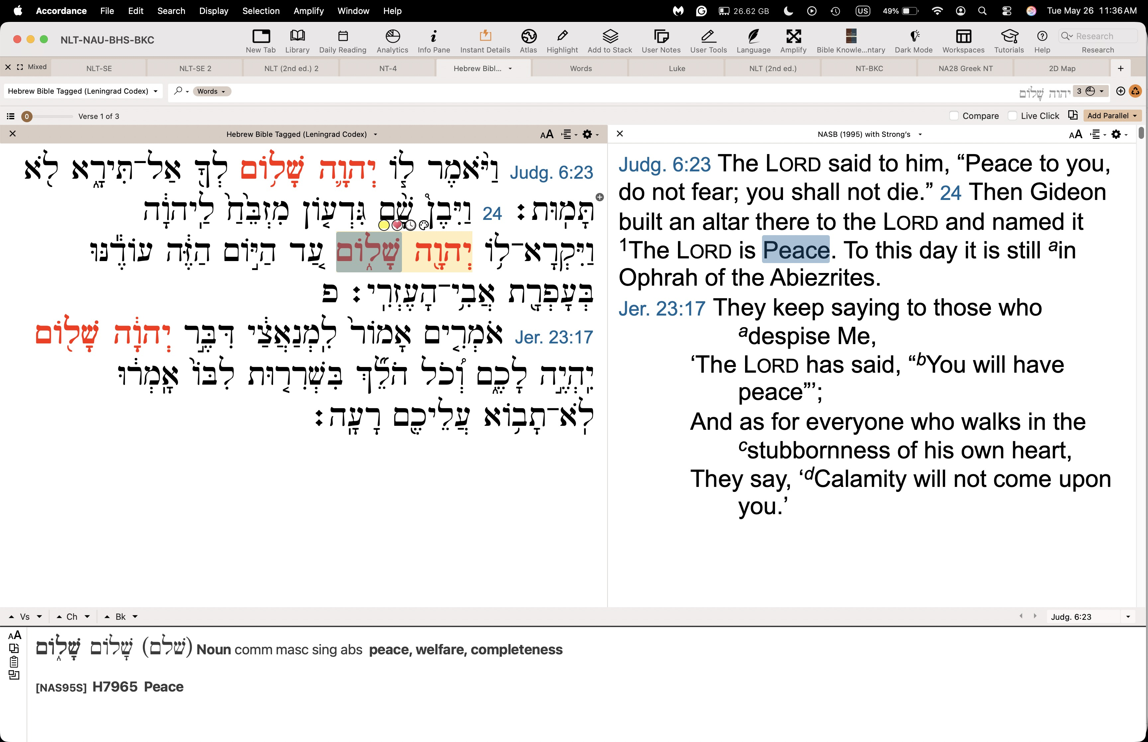

So, instead of a Hebrew search for “LORD,” I tried a word search for the title “God of Peace”:

It appears only FIVE times in the Bible.

Every time it appears, it is in Greek rather than Hebrew.

Every time it appears, it is in the epistles.

Every time it appears in the epistles, it is in a time of distress.

Every time it appears in the epistles, it is near the end.

Every time it appears in the epistles, it is in a blessing.

Every time it appears in a blessing, it tells us how God works.

So let’s look at these five texts and learn five ways God works in our lives.

Purpose: Why is this passage in the Bible?

God wants us to see his work in the context of the peace he gives.

When we work in partnership with him, we experience his peace.

Peace is not the cause; peace is the effect.

Background: What historical context helps us understand this passage?

Peace does not come during times of blessing, prosperity, and abundance. Normally, apathy results from such times.

Peace comes during periods like the early church experienced: either persecution or awaiting the next round of difficulty and suffering. All five mentions of the God of Peace are in the AD 50s and 60s when believers were under a cloud of suspicion, imprisonment, or even death.

Questions

What is peace? And what, then, is a peace deal?

We generally think of peace as the absence of conflict.

But is that true? Ask anyone in an unhappy marriage and you will find that many of them lack conflict, but they also lack peace. Instead, they experience distance or apathy even though they do not have overt arguments. If you told them that they had peace, they would say, “No, we don’t have knock ‘em drag out arguments. We just stopped trying long ago, but that’s not peace.”

How does God as the God of Peace relate to his other attributes?

All of God’s traits are in perfect harmony, so that indicates peace, or wholeness.

Can you imagine the Father, Son, and Spirit without peace, each vying for their own will? Impossible!

If peace is the result, then what is the way to get this result?

Each of the five texts on the God of Peace share one way to experience peace.

Let’s think through one command for each verse that results in peace.

Tentative Subject/Complement Statements

Text

Possible Illustrations

Bird sheltering chicks in the storm (Phil 4 message)

Times when I lacked peace

Parent’s divorce

Pinewood derby

Times when I had peace

Night before missions

ICS resignations

Missiles overhead

Where to retire

Possible Applications

Text
Experiencing the God of Peace
Five Passages

Exegetical Outline (Steps 2-3)

Exegetical Idea: The way to experience the God of peace is through faithful obedience.

I. The way to experience the God of peace is to partner with missionaries.

Rom. 15:33 And now may God, who gives us his peace, be with you all. Amen.

Pray for protection and advancement of God’s ministry ambassadors.

II. The way to experience the God of peace is to fight heresy with truth.

Rom. 16:20 The God of peace will soon crush Satan under your feet. May the grace of our Lord Jesus be with you.

Fight false teachers who cause division.

III. The way to experience the God of peace is to fix your thoughts on doing worthy things.

Phil. 4:9 Keep putting into practice all you learned and received from me—everything you heard from me and saw me doing. Then the God of peace will be with you.

Focus your thinking and actions on admirable priorities.

IV. The way to experience the God of peace is to live a holy life.

1 Thess 5:23 Now may the God of peace make you holy in every way, and may your whole spirit and soul and body be kept blameless until our Lord Jesus Christ comes again.

Be blameless in all three parts of you—spirit, soul, and body.

V. The way to experience the God of peace is to accept God’s equipping for ministry.

Heb. 13:20-21 Now may the God of peace—
who brought up from the dead our Lord Jesus,
the great Shepherd of the sheep,
and ratified an eternal covenant with his blood—
may he equip you with all you need
for doing his will.
May he produce in you,
through the power of Jesus Christ,
every good thing that is pleasing to him.
All glory to him forever and ever! Amen.

Use God’s gifting to do his will.

Purpose or Desired Listener Response (Step 4)
The listeners will

Homiletical Outline (Cyclical inductive form)

Introduction

Interest: A photography contest depicted peace.

Need: When the waves of life crash around you, do you have peace?

Or do the waves scare you like they did Peter walking on the water?

Do you struggle with anxiety?

Are your relationships with others harmonious?

Background: What is peace?

Subject: How can you experience the God of peace?

Preview: Five passages depict the God of peace in tumultuous times. We will see a command resulting in peace for each of these five verses.

Texts: Each of these is from the epistles.

(What is the first way to experience the God of peace?)

I. Partner with missionaries.

Rom. 15:33 And now may God, who gives us his peace, be with you all. Amen.

Pray for protection and advancement of God’s ministry ambassadors.

(How else can you experience the God of peace?)

II. Fight heresy with truth.

Rom. 16:20 The God of peace will soon crush Satan under your feet. May the grace of our Lord Jesus be with you.

Fight false teachers who cause division.

(How else can you experience the God of peace?)

III. Focus your thoughts on worthy things.

Phil. 4:9 Keep putting into practice all you learned and received from me—everything you heard from me and saw me doing. Then the God of peace will be with you.

Fixate your thinking and actions on admirable priorities.

(How else can you experience the God of peace?)

IV. Live a holy life.

1 Thess 5:23 Now may the God of peace make you holy in every way, and may your whole spirit and soul and body be kept blameless until our Lord Jesus Christ comes again.

Be blameless in all three parts of you—spirit, soul, and body.

(How else can you experience the God of peace?)

V. Accept God’s equipping for ministry.

Heb. 13:20-21 Now may the God of peace—
who brought up from the dead our Lord Jesus,
the great Shepherd of the sheep,
and ratified an eternal covenant with his blood—
may he equip you with all you need
for doing his will.
May he produce in you,
through the power of Jesus Christ,
every good thing that is pleasing to him.
All glory to him forever and ever! Amen.

Use God’s gifting to do his will.
(How can you experience the God of peace in one summary command?)

Conclusion

Live in faithful obedience (Main Idea).

Which is your weakest area in knowing God’s peace?

Partner with missionaries.

Fight heresy with truth.

Focus your thoughts on worthy things.

Live a holy life.

Accept God’s equipping for ministry.

Exhortation: Commit that area of weakness to experience the God of peace.

Prayer

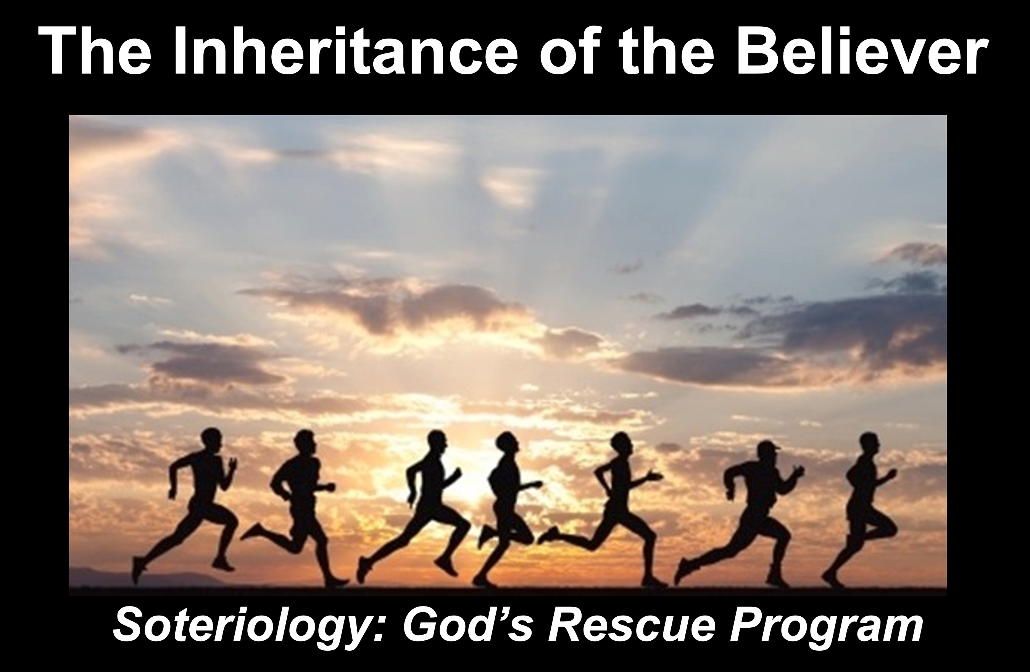
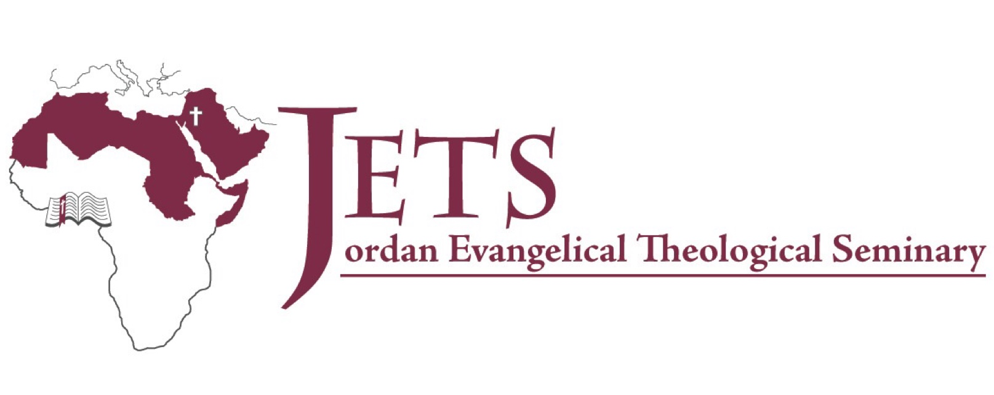

Rick Griffith
2025
Message of 4

Title
Passage

Introduction

Subject with a blank for the key word _______________

I. MP has a blank for the key word ________________ (verses).

SP has a blank for the key word ________________ (verses).

SP has a blank for the key word ________________ (verses).

SP has a blank for the key word ________________ (verses).

II. MP has a blank for the key word ________________ (verses).

SP has a blank for the key word ________________ (verses).

SP has a blank for the key word ________________ (verses).

SP has a blank for the key word ________________ (verses).

Conclusion

Main Idea has a blank for the key word ________________ (verses).

Application question

Thought Questions

- Read the passage aloud. Contrast:

Issue | Contrast

- Text-based question

- Application to your own Christian experience

Download this sermon PPT and notes for free at BibleStudyDownloads.org/resources/new-testament-preaching/

