Soteriology: God’s Rescue Program
Singapore Bible College
Rick Griffith, ThM, PhD

Download these notes and all accompanying PowerPoint slides for this course freely at BibleStudyDownloads.org at the “Salvation” link

Fourth Edition
© June 2020

1st printing (29 copies; May 2016)
2nd printing (digital upload; 2nd ed., June 2016)
3rd printing (digital upload; 3rd ed., June 2020)
4th printing (digital upload; 4th ed., June 2020)

Table of Contents

I. Syllabus 4
A. Professor 4
B. Scope 4
C. Purpose 4
D. Objectives 4
E. Procedures 5
F. Grading 5
G. Supplemental Bibliography 6
H. Schedule (Reading Report for 10-20 May 2016) 7
I. My Biographical Sketch 8
II. The Bible’s Teaching on Salvation 10
A. Some Introductory Considerations 10
1. The Tenses of Salvation 10
2. Why Would God Want to Save Sinners? 10

B. The Need for Salvation 10
1. The Creation 10
2. The Fall of Man 15

C. The Biblical Terminology for Salvation 21
1. The Whole Bible on Salvation 21
2. Salvation in the Old Testament 22
3. Salvation Terms in the New Testament 23

D. The Death of Christ 24
1. What’s So Good About Good Friday? (John 18–20) 24
2. The Meaning of the Death of Christ 27

E. Some Results of Salvation 30
1. Justification 30
2. Our Position in Christ 32
3. The Christian and the Mosaic Law 35
4. Will All Believers Remain Faithful to Christ Until Death? 39

F. Theories of the Atonement 50
1. Satan: Views Relating Christ’s Death to Satan 50
2. Exemplary: Views Seeing Christ’s Death an Example to Influence 50
3. Punishment: Views Owing to God’s Justice and Substitution 51

G. The Doctrine of Election 52
1. Romans 8:28-30 52
2. What About the Unreached (Rom. 1:18-20)? 53
3. Salvation by Works 55
4. Theological Words in Romans 56
5. The Roman Road 57

H. The Extent of the Atonement 58
1. The Question 58
2. The Views 58
3. Some Important Affirmations 58
4. Exegetical Considerations 58
5. Theological Considerations 59

I. The Application of Salvation 60
1. Conviction 60
2. Calling 60
3. Regeneration 61
4. Faith 61

J. The Security of the Believer 62
1. Theological Support for Eternal Security 62
2. Biblical Support for Eternal Security 64
3. Sources for Further Study on Eternal Security 64
4. Discussion Questions: 65
5. Eternal Security in Corinth 66
6. The Sealing of the Spirit 67
7. Security and Assurance 68

K. The Nature of the Gospel 69
1. The Gospel in John’s Evangelistic Gospel 69
2. Paul’s Definition of the Gospel (1 Corinthians 15:3-5) 69
3. Views on Lordship Salvation 70

L. Conclusion 73
1. What is the Gospel? 73
2. What will you do with what you have learned in this course? 75

M. Supplements 76
1. Views on “All Israel Will Be Saved” (Rom. 11:26) 76
2. Illustrations to Use in Sharing the Gospel 78

SOTERIOLOGY WORD OF LIFE Bible Institute, NE Asia (Jeju, Korea)
Quarter 4, May-June 2020 Professor: Dr. Rick Griffith

Syllabus

Professor

Dr. Rick Griffith is Doctor of Ministry (DMin) Director at Singapore Bible College, where he has taught Bible, theology and preaching since 1991. He also helped start a K-12 international school (ics.edu.sg) and church (cicfamily.com). Rick trains pastors in Mongolia, Sri Lanka, Nepal, Myanmar and restricted nations. His Advanced Studies in the NT and OT courses are at internetseminary.org, and 8000 pages of his notes and 165,000 PowerPoint slides can be downloaded in 49 languages at BibleStudyDownloads.org. His ThM and PhD are from Dallas Seminary. Dr. Rick and his wife Susan are missionaries with WorldVenture. Their sons Kurt (33) & his wife Cara, Stephen (30) & his wife Katie & 1-year-old son Jesse, and John (27) live in the USA. Susan has a vibrant ministry of training student wives from China, India, Indonesia, and other restricted countries.

Scope

God’s rescue plan for humanity is immense! Therefore, in our short 8-hour course, we will only hit the tip of the iceberg. This will start with God’s original order before salvation was even needed, moving to man’s fall, and the various stages of God’s program to redeem humanity. Also included will be a survey of the key interpretive views of Calvinism (Reformed), Arminianism (Wesleyan), and the modified Calvinist or Partakers View.

Purpose

Two areas of theology vital to our ability to understand and serve the Lord are Hamartiology (study of sin) and Soteriology (study of salvation). The first proves the need for the second, or, as my evangelist friend says wise, “You gotta get them lost before you get them saved!” The course is immensely important in the Word of Life curriculum as it shows the need for and the nature of the gospel that we are to preach to the nations.

Objectives

By the end of the course you should be able to …

Understand the original nature of man in his sinless state co-ruling with God.

Explain the impact that the Fall of Man had on humanity.

See the progressive plan of God to rescue us from our dilemma.

Critique the three major interpretive approaches to salvation: Calvinism (Reformed), Arminianism (Wesleyan), and the modified Calvinist or Partakers View.

Feel awed at the glory of heaven and the privilege of heaven as our future home!

Make any needed changes in your life to appear before Him unashamedly.

Each of the above objectives except the last two is measurable and thus will be assessed on the quizzes and the final exam.

Procedures

Reading from the class notes, Bible (translation of the student’s choice), and text will be required each class day. The main book is the Salvation section (65 pages) of Charles Ryrie, Basic Theology, 2nd ed. (Wheaton, IL: Victor Books of SP Publications, 1999).

Quizzes over the reading assignments will be given at the beginning of two mornings. These will be short (15 minutes) with 5-10 objective questions, such as multiple-choice, true-false, matching, and fill-in-the-blank questions. Note that the questions come only from the readings, though several issues will also be discussed in class as well. Therefore, be familiar with both the biblical text and also Ryrie’s comments on it.

The Final Exam will assess your comprehension of the course notes and class discussions only (not the readings). This exam will be a combination multiple-choice, short answer, fill-in the blanks, and matching exam. You will not be asked about Ryrie’s viewpoint, as this will already have been covered in the quizzes. However, I encourage you to still study the quizzes as these show the most important issues related to the study of salvation.

Grading
1. Reading Ryrie/notes Read 1 time for full credit = 20 points
2. Quizzes 20 points each x 2 quizzes = 40 points
3. Final Exam 40 questions after the course = 40 points
Total 100 points

The reading total of 20 points is figured as follows:

Ryrie’s Book & Class Notes:
100% _____ (20 Points)
only 75% _____ (12 Points)
only 50% _____ (8 Points)
only 25% _____ (4 Points)

Supplemental Bibliography

The required reading of Ryrie is an excellent starting place for studying salvation. However, I hope this is only the beginning of your study in this fascinating subject, so I have added some other books here, some of which are in the WOLBI library (though the presence of a book in the WOLBI library does not necessarily indicate WOLBI's agreement with the contents). The following books are the best that I know about to study salvation, even though I do not agree with their conclusions. I have listed them in order of preference, also happens to be their alphabetical order.

Dillow, Joseph C. Final Destiny: The Future Reign of the Servant Kings. 2nd ed. Monument, CO: Paniym Group, 2012. 1093 pp. US$50 pb.
A massive volume of 66 chapters articulating a mediating position between the Reformed and Arminian views on the NT that Jody Dillow calls the “Partakers” view, based on Hebrews 3:14. Argues for eternal security (Reformed) but against perseverance of the saints (Arminian).

Hodges, Zane C. Absolutely Free! A Biblical Reply to Lordship Salvation. Grand Rapids, MI: Academie Books of Zondervan, 1989.
Responds to John MacArthur’s book below with the “free grace” view that claims that visible fruit need not be present in a believer’s life after salvation.

Ryrie, Charles C. So Great a Salvation: What It Means to Believe in Jesus Christ. Wheaton, IL: Victor Books of SP Publications, 1989.
Responds to John MacArthur’s book below with the “moderate” view that claims that visible fruit should be present in a believer’s life after salvation.

MacArthur, John F., Jr. The Gospel According to Jesus: What Does Jesus Mean When He Says, “Follow Me?” Grand Rapids, MI: Academie Books of Zondervan, 1988.
Presents what has often been called the “Lordship Salvation” view that claims that visible fruit must be present in a believer’s life after salvation.

Stanley, Charles. Eternal Security: Can You Be Sure? Nashville, TN: Nelson, 1990.
Pastor Stanley replies to the question with an emphatic Yes! This is a very readable, non-technical treatment of this important subject.

Schedule (Reading Report for 10-18 June 2020)

Name # Reading Grade Course Grade

Please tick the last column if completed in full on time and then summarize this at the bottom. Note that the order of the course follows Ryrie’s Basic Theology, 319-92.

Session | Day | Subject | Assignment | 
1 | W 6/10  10am | 01-Soteriology Syllabus  • The Tenses of Salvation  • Why Would God Want to Save Sinners?  02-Creation & Fall: The Need for Salvation | None
2 | W 6/10  11am | 03-The Biblical Terminology  • The Whole Bible on Salvation  • Salvation in the OT  • Salvation Terms in the NT | Ryrie, 319-20
3 | Th 6/11  10am | 06-Justification | Ryrie, 321-54
4 | Th 6/11  11am | 07-Our Position in Christ | Class Notes, 37-41
5 | T 6/16  12pm | 09-Perseverance  Quiz 1 on Sessions 1-5 | Class Notes, 42-48
6 | W 6/17  1130am | 08-The Christian and the Mosaic Law | Ryrie, 355-78
7 | Th 6/18  10am | 14-The Eternal Security of the Believer | Ryrie, 379-86  Class Notes, 61-67
8 | Th 6/18  11am | 15-The Inheritance of the Believer  Quiz 2 on Sessions 6-8 | Class Notes, 42-48  Submit this sheet
 |  | Final Exam | Study for Final Exam
 |  | Omitted but Covered in 12-Session Course:
 |  | The Death of Christ  • What’s So Good About Good Friday?  • The Meaning of the Death of Christ | Ryrie, 321-28  Ryrie, 329-42
 |  | Theories of the Atonement  The Doctrine of Election | Ryrie, 355-57  Ryrie, 358-66
 |  | The Extent of the Atonement  The Application of Salvation | Ryrie, 367-73  Ryrie, 374-78
 |  | The Nature of the Gospel  • John’s Gospel  • 1 Corinthians 15:3-5 | Ryrie, 387-92
 |  | • Views on Lordship Salvation  • What is the Gospel? | Submit this sheet

The reading total of 20 points is figured as follows:

Ryrie’s Book & Class Notes:
100% _____ (20 Points)
only 75% _____ (12 Points)
only 50% _____ (8 Points)
only 25% _____ (4 Points)

Note that the dark horizontal lines separate the course by days but the sessions that are quizzed are different sessions. For example, Quiz 1 will cover sessions 1-4, but session 5 will be assessed on Quiz 2 rather than Quiz 1, even though session 5 may have preceded the Quiz 1.

Please submit this page or a photocopy of it once you have completed your reading, or at the latest on Friday next week.

My Biographical Sketch

The Griffith Family

John (27), Kurt & Cara (33), Stephen & Katie (30) & Jesse (8 months), Susan & Dr Rick

Background

“Never say ‘never.’” Rick and Susan Griffith both learned this age-old tip the hard way.

Rick recalls sitting in his elementary school classes thinking, “If there’s one thing I’ll never become it’s a teacher. Imagine saying the same stuff over and over, year after year!”

Yet after trusting Christ in junior high and beginning to teach the Word of God, Rick’s attitude began to change. After his business degree at California State University, Hayward, and Master of Theology degree (Pastoral Ministries) and the Doctor of Philosophy degree (Bible Exposition) from Dallas Theological Seminary in Texas, Dr. Griffith soon found himself on the other end of the classroom—and loving it!

Susan, from Yucaipa, California, also learned not to say “never.” As she earned her Bachelor of Arts degree in piano at Biola University, several friends married and worked to put their husbands through three more years of seminary training. “I’ll never do that!” she exclaimed. Soon afterwards she invested three years (1981-1983) singing together with her future husband in the Crossroads, Campus Crusade's traveling music team in Asia. This nine member Philippines-based group shared Christ in the Philippines, China, Hong Kong, Korea, Japan, Macau, Thailand, Malaysia, Indonesia, and Singapore.

In December 1983 Susan’s “never” became a reality. She and Rick were married and like Jacob and Rachel of old, Susan also worked for her mate. During these seven seminary years Rick served as a pastor, corporate chaplain, and International Students church consultant. Susan taught women's Bible studies and often ministered by singing. Their primary church in Texas is Christ Chapel Bible Church in Fort Worth.

They have three sons: Kurt (33 yrs.) works with business analysis wife Cara in Seattle at their consulting company called Tandem Motion, Stephen is a pilot (30 yrs.) with his counselor wife Katie (also Seattle) with grandson Jesse (born 14 May 2019), and John is a graphic designer in California (27 yrs.).

Ministry

However, since 1991 the Griffiths’ home has been Singapore where Rick serves as Doctor of Ministry Director with 26 other full-time faculty at Singapore Bible College. SBC has 495 students from 26 countries and 25 denominations, as well as many professionals in its Certificate of Church Ministry studies. He began by teaching Old and New Testament Survey, Old and New Testament Backgrounds, Eschatology (the study of future things), Evangelism, Pastoral Epistles, Psalms, Homiletics (preaching), Hebrew Exegesis, and four Old Testament exposition courses. Then for years he also taught Pentateuch, Gospels, Eschatology (theology of the future), Ecclesiology (theology of the church), and Pneumatology (theology of the Holy Spirit). Now he teaches mostly Bible Exposition classes, including Homiletics, OT Foundations, and OT & NT Survey. He has also written three Advanced Studies in the Old and New Testament courses at Internet Biblical Seminary (www.internetseminary.org).

Dr. Griffith loves the variety and strategic nature of his teaching. He invests his life into Anglicans from Sri Lanka, Lutherans from Singapore, Presbyterians from Korea, Conservative Baptists from the Philippines, and missionaries from Campus Crusade, OMF, and Operation Mobilisation—sometimes all in one class! One class had 17 of the 20 students training for ministry outside of Singapore. Nearly all SBC graduates enter pastoral or missionary ministries due to Asia’s shortage of trained leaders.

Ministry opportunities abound. Rick and Susan have conducted premarital counseling for students and their home has an open door to students and guests traveling through Singapore. They have sung in evangelistic thrusts and in 1992 also participated in founding International Community School, an expatriate Christian primary and secondary school in Singapore now with 480 students. The Griffiths are missionaries with WorldVenture and Rick serves as the Singapore field leader.

Dr. Griffith also enjoys several other partnerships. He also serves as Asia Translation Coordinator for "The Bible... Basically International" seminars; web author & editor, Internet Biblical Seminary; and itinerate professor for 62 trips throughout Asia in places such as Lanka Bible College (Sri Lanka), Myanmar Evangelical Graduate School of Theology, Union Bible Training Center (Mongolia), Jordan Evangelical Theological Seminary, and Biblical Education by Extension training in three restricted access countries.

In 2006 Dr. Rick began Crossroads International Church, Singapore. Here “Pastor Rick” serves as pastor-teacher. The church worships at the Metropolitan YMCA at 60 Stevens Road. See cicfamily.com.

In 2009 Dr. Rick began BibleStudyDownloads.org to offer his courses for free download. It has 17,000 pages of course notes in Word and pdf, and especially over 67,000 PowerPoint slides in English, and translations comprising 104,000 PowerPoint slides by his students into 49 languages, such as Ao, Arabic, Bangla, Bisaya, Burmese, Chin, Chiru, Chinese, Dutch, English, French, German, Gujarati, Hindi, Ilonggo, Indonesian, Japanese, Kachin, Karen, Khmer, Kiswahili, Korean, Lotha, Malay, Malayalam, Mao, Mizo, Mongolian, Moyon, Nepali, Nias, Paite, Portuguese, Rongmei, Russian, Sinhala, Spanish, Sumi, Tagalog, Tamil, Tangkhul, Tenyidie, Thai, Vaiphei, and Vietnamese.

Field

SBC is strategically located in Singapore at the “ministry hub” of Southeast Asia. The population of this multi-cultural society is 75 percent Chinese, 15 percent Malay and 8 percent Indian. Other groups include Filipinos, Thais, Japanese, Americans, and Europeans. The Singaporean cross-cultural missionary force is increasingly contributing to God’s work in overseas ministries.

Passion

Rick’s passion is for God’s leaders to preach and live the Word of God as God’s servants:
- Teaching obedience to Christ’s teaching is key to our commission to make disciples (Matt. 28:20)
- Paul’s legacy to Timothy focused on exposition: “Preach the Word” (2 Tim. 4:2-3; cf. Acts 6:1-16)

However, recent trends include the following:
- Church people are biblically illiterate in a “famine for hearing the words of the Lord” (Amos 8:11)
- Attempting to be “relevant,” pastors preach what people want to hear—not what they need

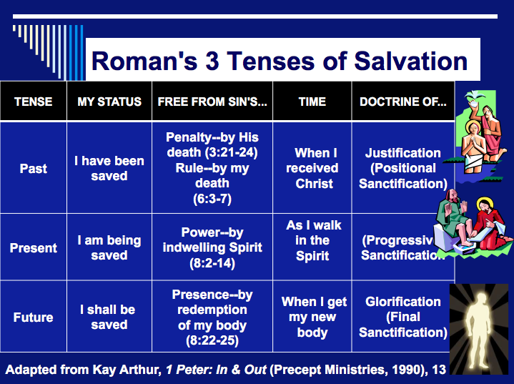
The Bible’s Teaching on Salvation

Some Introductory Considerations

The Tenses of Salvation

Why Would God Want to Save Sinners?
(Ryrie, Basic Theology, 319)

Why Study Salvation?
(Ryrie, Basic Theology, 320)

The Need for Salvation

The Creation

The origin of man determines the nature of man. If man evolved, then he is continually getting better and better and can save himself.

However, if man was made perfect and fell from that exalted position, then he must return to that high place ruling with God through a process of salvation.

The next four pages explain in greater detail the various options for origins and where each position leads.

Creation vs. Evolution

 | Creation | Evolution
Source for belief | God’s Word | Man’s speculations
Basis for belief | Reasonable faith (no eyewitnesses or repeatable events, but order stemming from order) | Leap of faith (no eyewitnesses or repeatable events, but order stemming from disorder)
Assumption about God | God exists | God does not exist
Cause for ordered universe | Primary (intelligent) causes | Secondary (natural) causes
Foundation of the cause | Design | Chance (accidents)
Origin of matter | God’s spoken word | No explanation
Origin of universe | God’s spoken word made the right balance of air molecules, enough water (found only on earth), the right distance from the sun, a protective ozone layer to allow visible light to pass through but keeps out harmful ultraviolet light, a perfect 23.5 degree tilt to produce seasons, the correct orbits for the planets, etc. | Big Bang: all the energy and matter exploded, creating hydrogen gas molecules that collected themselves into stars (but this contradicts scientific fact that gas pressure pushing out is 100 times stronger than gravity pulling in–also, no one has ever seen an explosion create order!)
Age of universe | 6,000-10,000 years | 5 billion years
Use of term “prehistoric” | Inappropriate | Appropriate
Origin of intelligence | Outside intelligent source (God) | Evolved from non-intelligent matter
Origin of the first life forms | God’s spoken word (Gen. 1:1) | A simple life form–life created itself. (Actually, there exists no such thing as the least complicated single cell—the bacterium is vastly complex.)
Origin of man | God’s spoken word (Gen. 1:26-27) | Descended from bacteria, onions, cockroaches, snakes, and apes as a result of millions of DNA accidents

 | Creation | Evolution
Origin of man’s soul | Given by God (Gen. 2:7) | Does not exist or was added later
Origin of human ethnic groups | Intermarriage within the same language groups produced concentrations of genes (Gen. 11) | No explanation has been offered
Origin of species | Life always gives rise to life (the first immutable law of biology) | Life arose from dead, inorganic matter
Propagation of species  based on… | Science (observed facts: all species reproduce after their own kinds; cf. Gen. 1:21, 24-25). In other words, like always gives rise to like (the second immutable law of biology). | Theory (unproved, unobserved ideas: e.g., while beings change or mutate to higher forms only once in 10,000 times, this miracle occurred millions of times to produce humans)
Transitional life forms | None required, none ever discovered | Millions required, none ever discovered
View of historical events | Catastrophism: the world has changed weather (climate), topography, etc. due to a worldwide Flood (and possibly an Ice Age) | Uniformitarianism: the world has continued with the same weather, erosion, etc. since time began (except an Ice Age?) as scoffers predict in 2 Pet. 3:4-5
Relationship to 2nd law of thermodynamics (“all things move from order to disorder”) | Consistent with this law | Contradicts this law
Man and dinosaurs | Coexisted | Dinosaurs predated man by millions of years
Depends on creativity from… | the Creator | the created (man)
Popularity among laymen | Majority view | Rare
Popularity among scientists | Rare | Majority view
Accountability to a Creator | Great (man will be judged) | None (no judgment will occur)

Theistic Evolution

Despite the huge differences between creation and evolution (see previous chart), some believe in both creation and evolution. These theistic evolutionists (from Greek theos for “God”) teach that God created the world by evolution. What can be said to theistic evolution claims?

1. Inefficient: “Evolution is the most wasteful, inefficient, cruel method that could be devised to create living things. Even evolutionists admit that almost all mutations are bad—causing cripples, sickness, disfigurements, and deaths.... God is all-powerful and wise. Why would He use such a wasteful, inefficient, cruel method to create man, taking three billion years to do it, when He is able to create instantaneously?”

2. Unscientific: “There is not one fact of science which proves that God used evolution to create anything.” If God guided evolution, He has not allowed a single intermediate form of life to survive as evidence. Surely He would not allow all scientific facts to counter His creative process. All fossils represent fully formed creatures, just as one would expect from the Genesis account. But what of all the ape-like creatures that have been portrayed as transitional links between apes and man? “When all of the evidence is carefully and thoroughly studied by the best scientific methods, however, it turns out that these fossils were either from monkeys, apes, or people, and not from something that was part ape and part human.”

a. Piltdown Man, found in Piltdown England (1912), came from jaw and skull fragments. About 500 books and pamphlets were written about him until 1950, when someone discovered that it actually was the chemically treated skull of a modern human to make it look old and ape teeth filed down to look human! This fraud fooled the world’s “experts” for almost 40 years.

b. Nebraska Man (1922) was based solely on a single tooth found in Nebraska. Additional bones of the creature later revealed it to be a pig!

c. Neanderthal Man (1860), found in the Neanderthal Valley in Germany, later had more fossils, such as a hunched-over full skeleton in France (1908). They used tools and had similar brain sizes to modern humans, but their skulls were flatter than ours and appeared primitive in some ways. However, Dr. Rudolph Virchow later revealed the hunched-over skeleton as a Frenchman who had arthritis! Other skeletons have been found which are fully erect, and x-rays of the fossil bones and teeth now confirm that all of the Neanderthals were actually humans with rickets (caused by lack of vitamin D).

d. Other “ape-men” are also discredited. Ramapithecus was an orangutan and Orce Man was actually a six-month-old donkey. Australopithecus (1924) was believed even by many evolutionists to have been an ape, and included a female version, Australopithecus afarensis (1973, nicknamed “Lucy”). However, when a knee joint was needed to prove that Lucy walked upright, they used one found more than 60 meters lower in the strata and more than three kilometers away! Also, Java Man’s discoverer (Dr. Eugene Dubois) later identified him as a giant gibbon, Peking Man is an ape, and Cro-Magnon Man a modern European. Now some evolutionists even say that apes evolved from man!
3. Theological Problems: Theistic evolution is incompatible with scriptural theology in many ways:

a. The Creation Account: The Bible gives no hint of evolution. The most natural reading of the Genesis account of creation is that God created in six literal days. The “day-age” theory where each “day” is a long period of time (even millions of years) has marshaled many advocates. However, Genesis 1 clearly says there was “evening and morning” each day. This excludes any evolutionary processes.

b. The Fall and the Origin of Moral Evil: Theistic evolutionists deny that Genesis 1–11 records real history, but call these chapters “great myths,” even denying that man ever fell into sin in the Garden. Yet the historicity of Adam is the basis upon which the NT compares Christ as the last Adam (Rom. 5:12-14; 1 Cor. 15:22, 45-49). Paul even related the historicity of Adam to the historicity of Christ’s resurrection (1 Cor. 15:12-23). The origin of evil cannot be credited simply to “the heart of mankind” because it originally stemmed from Satan, an external force (Gen. 3:1-5; Eph. 6:12).

c. The Origin of Man: Human life came when Adam was created from dust directly from God at a point in time (Gen. 2:7; cf. Matt. 19:4). Yet theistic evolutionists claim man received God’s image at an unknown point in time along the evolutionary chain; therefore, God’s image came after reproductive processes over millions of years of Adam and Eve’s “Neolithic progenitors.” Genesis 1:26-27 says that God created man in the image of God—not in the image of apes. Others also claim that the Bible is concerned only with man’s relationship with God, not ordinary human life. Such a dichotomy contradicts Genesis, which deals with far more than spiritual life. Berry denies that Adam and Eve were ancestors to all mankind, yet Eve is said to be “the mother of all the living” (Gen. 3:20; cf. Acts 17:26) and all mankind sinned through one man (Rom. 5:12). Theistic evolution downplays or denies the extent to which sin marred God’s image. This image became so perverted that God chose to destroy all humans except for one righteous man and his family (Gen. 6:5-7).

d. Natural Selection, Death, and Suffering: Theistic evolution makes God the author of suffering and death. This gives even atheists opportunity to criticize Christians for belief in such a cruel God. Berry insists that death existed before Adam so that his sin in the Garden only brought spiritual, not physical death. However, no sin or death existed before the Fall (Gen. 2:17; Rom. 5:12-15) so that all suffering resulted from man’s sin, not God’s (Gen. 3:15-19; Rom. 8:19-22). God made everything “very good.”

e. Distinction Between Man and Animals: Berry says man’s ability to obey is the only difference between man and animals. But what about man’s ability to discern truth, communicate in speech, and his creative abilities? Theistic evolution is an error that vigorously opposes creation science and the Bible. The bottom line as all this relates to soteriology concerns the nature of man. If man is simply another type of animal that evolved from primordial slime, there is no morality, no sin, no destiny and no need for a Savior. There is then no need for this course as well.

The Fall of Man

Various religions and philosophies define our basic need in different ways.

Scripture points to resolving man’s rebellion against God as our primary need.

Results of the Fall (Genesis 3)

God’s “Giving Over” of Man to Sin (Romans 1)

Was Jesus Wrong? Peter Enns Says, “Yes”
by Tim Chaffey and Roger Patterson, AiG–US (January 30, 2012)
Answers in Genesis, along with its founder and president, Ken Ham, has been the target of many recent attacks from within the church and without. We have received a great deal of criticism because Ken has spoken and written against the teachings of Dr. Peter Enns, who recently worked as Senior Fellow of Biblical Studies with BioLogos.
We have frequently warned about the dangers of forcing man’s fallible ideas into the text of Scripture because it unlocks a door of compromise that will inevitably be pushed open further by the next generation. This can be traced throughout church history in many areas. When it comes to the age-of-the-earth controversy, the various harmonistic views developed from a quasi-literal interpretation of much of Genesis 1 (the gap theory) to modern views which have completely reclassified the text (the framework hypothesis) so that people can believe whatever they want about origins while claiming they are being “faithful” to the Bible.
While liberal theologians have long bought into theistic evolution, many conservative Christians have flirted with the idea of long ages (and some have bought into it), but they have almost universally rejected any notion that the first man was not a special creation of God. In the past few years, however, a handful of books from ostensibly conservative Christians has challenged the traditional interpretation that God created man from the dust of the ground. Instead, these authors have argued for some eclectic blend of creation and evolution when it comes to mankind’s origin.
We have consistently challenged the church to reject any attempt to reinterpret Genesis because of the dangerous hermeneutical precedent this sets. That is, if we desire to reinterpret (i.e., reject) certain parts of God’s Word because of man’s fallible opinions about the past that are based on anti-supernatural presuppositions, then at what point do we stop reinterpreting the Bible? If Genesis should be reinterpreted to accommodate the billions of years and evolution proposed by the majority of scientists, should we not also reinterpret other sections of Scripture that are at odds with the majority of scientists, such as the Virgin Birth, Resurrection, and Ascension of Christ?
“Oh, come on, that will never happen,” some Christians might protest. We’ve been told this time and time again by Christians who think AiG has made a proverbial mountain out of a molehill or committed the slippery slope fallacy. Well, that door of compromise has now been opened to such an extent that the gospel itself is under attack. In his recent book, intended to provide a rationale for rethinking Christianity in light of the claims of current evolutionary theories,1 Dr. Peter Enns promotes the idea that Adam and Eve were not real, historical people. To bolster this claim, Enns relies on the discredited documentary hypothesis to say that the Pentateuch (first five books of the Bible) was not written until after the Babylonian exile. Moses didn’t write them, but instead it was some scribe or group of scribes that compiled oral and written traditions and stuck them together. Despite a wealth of biblical and historical evidence to the contrary, Enns portrays this idea as a given, accepted by any scholar worth his or her salt. In a footnote in his new book, Dr. Enns addressed one of the objections to this view—Jesus said that Moses wrote about Him.
Although treating this issue fully would take us far afield, I should mention at least a common line of defense for Mosaic authorship: Jesus seems to attribute authorship of the Pentateuch to Moses (e.g., John 5:46–47). I do not think, however, that this presents a clear counterpoint, mainly because even the most ardent defenders of Mosaic authorship today acknowledge that some of the Pentateuch reflects updating, but taken at face value this is not a position that Jesus seems to leave room for. But more important, I do not think that Jesus’s status as the incarnate Son of God requires that statements such as John 5:46–47 be understood as binding historical judgments of authorship. Rather, Jesus here reflects the tradition that he himself inherited as a first-century Jew and that his hearers assumed to be the case.2
Before looking at the disastrous conclusions that follow from such a belief, let’s read the passage in question.
“Do not think that I shall accuse you to the Father; there is one who accuses you—Moses, in whom you trust. For if you believed Moses, you would believe Me; for he wrote about Me. But if you do not believe his writings, how will you believe My words?” (John 5:46–47)
Jesus didn’t just seem to attribute authorship of the Pentateuch to Moses, He clearly affirmed in this passage that Moses wrote at least some of it. Earlier in the confrontation, Jesus told the Jews that they searched the Scriptures because in them they thought they had eternal life, but Jesus said that the Scriptures testify of Him, and that the people needed to come to Him for eternal life. Then He narrowed it down to a particular section of the Old Testament. The Jews divided their Scriptures into two (sometimes three) sections: the Law and the Prophets (see Luke 24:27; sometimes the Prophets were divided into the Prophets and the Writings). So by referring to Moses, it appears that Jesus was attributing Mosaic authorship to the first five books of the Bible.
Since Jesus said Moses wrote about Him, that settles the issue. “Not so fast,” says Enns, who offered two arguments in response to this claim. First, Enns stated that “even the most ardent defenders of Mosaic authorship today acknowledge that some of the Pentateuch reflects updating, but taken at face value this is not a position that Jesus seems to leave room for.” It is true that some portions of the Pentateuch reflect updating. For example, Deuteronomy 34 was almost certainly not written by Moses, since it is the account of his death. It may very well have been recorded by Joshua.3 Enns apparently appeals to a straw man argument here in claiming that all who disagree with his view are hyper-literalists, when he states that Jesus did not leave room for any updating. Enns implies that when Jesus called Moses the author, it must be understood that every letter was penned by Moses himself or else Moses could not truly be called the author. Candidly, this is simply an absurd contention. Authors today have editors who contribute to and revise their work, but this does not cause anyone to deny authorship to the person who wrote the majority of the text. The Apostle Paul had others write for him, but this does not mean Paul wasn’t the author.
Enns acknowledges that this is not his strongest argument. His more important claim is that Jesus wasn’t really making an authoritative historical statement about Mosaic authorship.4 “Rather, Jesus here reflects the tradition that he himself inherited as a first-century Jew and that his hearers assumed to be the case.” Please read that statement again and try to understand the seriousness of this charge. According to Dr. Peter Enns, Jesus wrongly attributed the writing of the Pentateuch to Moses because He accepted an erroneous tradition of His day.
The idea advanced by Dr. Enns here is known as the accommodation theory and was first advanced in the eighteenth century by Johann Semler, the father of German rationalism. The accommodation theory is very popular among liberal theologians and basically asserts that Jesus accommodated (accepted and taught) the various ideas of His day, even if they were wrong.5 Allegedly, since Jesus was primarily concerned with spiritual matters, He didn’t bother to correct some of their false historical or scientific beliefs because doing so might have distracted from His real message.
There are many problems with this type of thinking. First, Jesus routinely rebuked people who held beliefs contrary to Scripture and corrected those who were in error. He specifically told the Sadducees, “You are mistaken, not knowing the Scriptures nor the power of God” (Matthew 22:29). This is hardly accommodating someone’s errors. Furthermore, Jesus often reacted strongly to accepted practices that were contrary to the Word of God. He drove the moneychangers out of the temple (John 2:15–16) and excoriated the scribes and Pharisees (Matthew 23:16–33). If Jesus simply accommodated the errors of His time, He would never had done these things.
Those who promote the accommodation theory emphasize that Jesus said not even He knew the timing of His return: “But of that day and hour no one knows, not even the angels of heaven, but My Father only” (Matthew 24:36). However, one scholar correctly pointed out, “Limits on understanding are different from misunderstanding. The fact that He did not know some things does not mean He was wrong in what He did know.”6 We can be certain that when Jesus affirmed something to be true, He knew it was true, and He spoke with absolute authority. Jesus never accommodated the erroneous thinking of His day. He always spoke the truth, the full truth, and nothing but the truth.
So what’s the big deal if Jesus accommodated the errors of His day? Well, if Jesus taught error, then He would have lied to His listeners, in which case He would have been a sinner. If He unwittingly taught error, then He would have misled His followers, making Him a false teacher. Either option leaves us with a Jesus who is sinful and less than God. If Jesus had sinned, then He could not have been the spotless Lamb who appeased God’s wrath by His sacrificial death on the Cross, because He would have needed to die for His own sins. If Jesus did not die for our sins, then we are still in our sins and are headed for an eternity in the lake of fire.
Did Jesus really say Moses wrote about Him? Consider His words in the following verses:
He said to them, “Moses, because of the hardness of your hearts, permitted you to divorce your wives, but from the beginning it was not so.” (Matthew 19:8; cf. Deuteronomy 24:1–4)
“But go and show yourself to the priest, and make an offering for your cleansing, as a testimony to them, just as Moses commanded.” (Luke 5:14; cf. Leviticus 14:2–32)
“Abraham said to him, ‘They have Moses and the prophets; let them hear them.’” (Luke 16:29)
“But even Moses showed in the burning bush passage that the dead are raised, when he called the Lord ‘the God of Abraham, the God of Isaac, and the God of Jacob.’” (Luke 20:37; cf. Exodus 3:1–6)
Then He said to them, “These are the words which I spoke to you while I was still with you, that all things must be fulfilled which were written in the Law of Moses and the Prophets and the Psalms concerning Me.” (Luke 24:44)
“Did not Moses give you the law, yet none of you keeps the law? Why do you seek to kill Me? ... I did one work, and you all marvel. Moses therefore gave you circumcision (not that it is from Moses, but from the fathers), and you circumcise a man on the Sabbath. If a man receives circumcision on the Sabbath, so that the law of Moses should not be broken, are you angry with Me because I made a man completely well on the Sabbath?” (John 7:19, 21–23; cf. Exodus 24:3; Genesis 17:9–14)
And just in case you aren’t convinced yet that the absolute truthfulness of Jesus is essential, think carefully about these words Jesus spoke to the Jews.
“When you lift up the Son of Man, then you will know that I am He, and that I do nothing of Myself; but as My Father taught Me, I speak these things. And He who sent Me is with Me. The Father has not left Me alone, for I always do those things that please Him” (John 8:28–29).
Since Jesus only spoke the words the Father taught Him, then to say that Jesus accommodated the errors of His day is to also claim that God the Father made these same mistakes. It may sound unkind to say it, but the accommodation view promoted by Dr. Enns is heresy. It charges our precious Savior with error and accuses the Father of instructing the Son to teach error.
We have previously claimed that Dr. Enns has a low view of Scripture. Well, that low view of Scripture logically leads to a low view of the Savior. In both Hebrews 6:18 and Titus 1:2 we are given a clear statement—God cannot lie! To assert that Jesus knowingly told His hearers falsehoods or affirmed something that He knew was false can only be called a lie. To rightly understand the nature of the Scriptures and their inerrancy and infallibility, we must clearly connect these ideas with the character of God. Since God cannot lie, neither can His Scriptures. As the incarnate Son of God, Jesus would not mislead anyone, even though He was a first-century Jew. To suggest that Jesus would lie, even if you try to call it an “accommodation,” is to deny the deity of Christ.
This is not a side issue. This is not a “can’t we all just get along” dispute. This is a false teaching that strikes right at the heart of the gospel, and it should never be accepted by those who claim to love Jesus Christ. This problem has been addressed by many writers since its introduction in the eighteenth century. The basic problems with the accommodation view have been described in detail and we will summarize them here.7 To accept accommodationism means that God is not able to use language in a way that perfectly communicates the meaning without embracing falsehoods. Wayne Grudem states succinctly that to embrace accommodation “essentially denies God’s effective lordship over human language.”8 Secondly, as noted above, to say that God has communicated using a falsehood denies His moral character as described in Numbers 23:19, Titus 1:2, and Hebrews 6:18. Further, since we are to be imitators of God and His moral character (cf., Leviticus 11:44; Ephesians 5:1; 1 Corinthians 11:1, etc.), then if God misled people, shouldn’t we also use intentionally misleading or false ideas to communicate? All of these ideas are contrary to the clear teaching of Scripture and deny the holiness of God.
We pray that Dr. Enns and others who hold this view will recognize the seriousness of this error and repent, and we ask you to pray to that end as well. Even his single footnote has exposed how the church desperately needs to stop thinking they can innocuously incorporate secular philosophies with God’s Word (and even, wittingly or unwittingly, undermine the deity of Christ along the way). Christians need to take an absolute and uncompromising stand on the Word of God as our ultimate source for doctrine.
Help keep these daily articles coming. Support AiG.

Endnotes
- It is important to note that the evolutionary ideas endorsed by Dr. Enns and others extend beyond the common notion of biological evolution. Biological evolution is dependent on the time and processes involved in the geological evolution of the earth. The formation of the earth is based in the nebular hypothesis as an extension of the big bang cosmology that demands the universe is 14 billion years old. These three areas, cosmological, geological, and biological, are impossible to divorce if one embraces the mainstream scientific consensus. The result is that the current scientific understanding becomes the authority when considering the origin of the universe, the earth, and the life on it—including humans made in the image of God. Back
- Peter Enns, The Evolution of Adam: What the Bible Does and Doesn’t Say about Human Origins (Grand Rapids, MI: Brazos Press, 2012), p. 153. Back
- Of course, it is possible that God enabled Moses to prophetically write about his own death, but the easiest and most likely solution to this alleged dilemma is to propose that Joshua or another person wrote the chapter after Moses died. Another example of this “updating” is found in the phrase “to this day.” Several times these words appear with a place name or a custom (Genesis 22:14, 26:13, 32:32, 35:20, 47:26), indicating that the place name or custom was still in effect in the time the book was written or compiled. This does not in any way provide a strong argument against Mosaic authorship of the Pentateuch. First, one of the popular explanations for the authorship of Genesis is that it originally consisted of several eyewitness records from some of the key figures in the book (Adam, Noah, Abraham, Isaac, etc.), but was eventually compiled and edited by Moses. If this is accurate, then the words “to this day” simply reflect the words of Moses who told his readers that a place name or custom established in Genesis was still in use in his day. The fact that the words “to this day” are not used in the same manner in the other books of the Pentateuch supports this idea. Second, if God revealed the content of Genesis to Moses, it does not negate the possibility of Moses inserting these updates. Third, even if these updates were added long after Moses, it would not negate Mosaic authorship of the Pentateuch as a whole. Back
- This is not a new claim for Enns. He raised similar notions in a 2002 article: Peter Enns, “William Henry Green and the Authorship of the Pentateuch: Some Historical Considerations,” Journal of the Evangelical Theological Society, Volume 45 (September 2002). Back
- A related heresy is known as the limitation theory. This view focuses on apparent limitations Jesus had because of His humanity. Since He became hungry, thirsty, and tired, then why couldn’t He be limited in His understanding and be wrong about many things as long as they weren’t directly related to His work of redemption? This view neglects the truth that Jesus was (and is) also God, and God cannot make a mistake. It also fails to account for the many instances where Jesus was able to know the thoughts of those He was addressing (e.g., Matthew 9:4, 12:25; John 2:24–25), which is a strong argument for His divinity. Back
- Norman L. Geisler, Systematic Theology, Volume One (Minneapolis, Minnesota: Bethany House, 2002), p. 276. Back
- The following is a brief list of articles and books that address the accommodation theory: Norman L. Geisler, Systematic Theology, Volume One, (Minneapolis, Minnesota: Bethany House, 2002), pp. 274–280; Wayne Grudem, Systematic Theology (Leicester, England: InterVarsity Press, 1994), pp. 97–100; “Chicago Statement of Biblical Inerrancy,” Article XV, see Grudem, p. 1206; Charles Hodge, Systematic Theology, Volume I, (Grand Rapids, Michigan: Eerdmans, 1997), pp. 153–188; John W. Wenham, “Christ’s View of Scripture” in Norman L. Geisler, editor, Inerrancy (Grand Rapids, Michigan: Zondervan, 1979), p. 14; G.K. Beale critiqued Enns’s particular understanding of the accommodation view in a review of an earlier work by Peter Enns entitled Inspiration and Incarnation: Evangelicals and the Problem of the Old Testament (Grand Rapids, Michigan: Baker, 2005). This review appeared in the Journal of the Evangelical Theological Society (June 2006) and was followed by a response from Enns. Beale included his review, a summary of the response by Enns, and a critique of that response in his book, The Erosion of Inerrancy in Evangelicalism: Responding to New Challenges to Biblical Authority (Wheaton, Illinois: Crossway, 2008). Back
- Grudem, Systematic Theology, p. 97. Back

The Biblical Terminology for Salvation

The Whole Bible on Salvation

Here’s an Issue for your small group…

Which is the most accurate depiction of salvation in the OT and NT?

Salvation by…

Faith Alone

Faith Alone

Faith + Works

Faith Alone
Works

Faith
Faith + Works

Faith + Works

OT

NT

Which verses in the Bible support your answer?

Distinguishing Salvation and Sanctification

 | Man’s  Role | God’s Response | Life of  Faith | Restored Fellowship
OT

NT

Salvation in the Old Testament

How were people saved during Old Testament times? Were only Jews saved? How? Was it through the tabernacle and temple sacrifices? Did killing these animals actually forgive sin? These questions will naturally arise in a thinking person’s mind when encountering the OT.

First, salvation has always been by faith and not by works of the Law. This is Paul’s key point in Galatians and Romans and it applies to all times. Paul gives Genesis 15:6 as support: “Abraham believed God, and it was credited to him as righteousness” (Rom. 4:3; cf. vv. 11, 16-24; Heb. 11). Salvation in all ages is based in God’s grace, not our works (Eph. 2:8-9). The ways He has shown His grace has changed over the ages, but His method of salvation by grace through faith is constant.

OT believers expressed their faith in many ways: worshipping God, offering sacrifices, or doing good deeds, but it was their faith that saved–not their sacrifices or worship or deeds. Their faith was placed in God’s provision of a coming Saviour (1 Pet. 1:10-12), though they did not realize that this Redeemer specifically was Jesus Christ. Further, there is no hint that their salvation could be lost.

One may ask, “But doesn’t the OT say sacrifices forgave people?” Leviticus promises Israelites that they “will be forgiven” by sin offerings and guilt offerings (4:20, 26, 31, 35; 5:10, 13, 16, 18; 6:7; 19:22; cf. Heb. 9:13). However, these refer to any specific sin rather than forgiveness from all sin for salvation; also, ritual without repentant faith was useless (Ps. 40:6-8; Isa. 1:11-20; Jer. 7:21-26).

This parallels our experience some. We are saved from the penalty of sin by faith, just like Jews (and Gentiles identifying with Israel) in the OT–but we show faith by trusting Christ as our past sacrifice rather look forward to a future sacrifice. We still sin, but 1 John 1:9 promises, “If we confess our sins, he is faithful and just and will forgive us our sins and purify us from all unrighteousness.” We have positional forgiveness for all sins (past, present, and future) and a secure relationship with God. However, confession helps us experience practical forgiveness and restoration of our fellowship with Him. In like manner, Job sacrificed for cleansing and restored fellowship while saved (Job 42:7-9).

But why can’t the “blood of bulls and goats…take away sins” (Heb. 10:4)? Sacrifices forgave and cleansed only from external ceremonial impurity (Heb. 9:13), but Christ removed all sin and cleansed internally. A clear treatment of OT sacrifices is John S. Feinberg, “Salvation in the Old Testament,” Tradition and Testament, eds. John S. and Paul D. Feinberg (Chicago: Moody, 1981), 39-77 (adapted below into chart form). Issues 1-3 are the same for OT and NT but 4-5 are different:

 | OT Times  (Moses to Christ’s Death) | NT Times  (Christ’s Death to Today)
Basis  of Salvation | God’s gracious provision of the death of Christ since “it is the blood that makes atonement for one’s life” (Lev. 17:11b) | God’s gracious provision of the death of Christ (“without the shedding of blood there is no forgiveness” Heb. 9:22)
Requirement  of Salvation | Faith in the provision that God has revealed–as a gift (Ps. 51:16-17) | Faith in the provision that God has revealed–as a gift (Gal. 2:16)
Ultimate Content  of Salvation | Object of faith is God Himself–prophets exhorted repentance, not sacrifices (Jer. 3:12; Joel 2:12) | Object of faith is God Himself–heroes of faith are cited to exhort faith in God (Heb. 11)
Specific  Revealed Content  of Salvation | Cumulative content of faith involved sacrifices & promises: animals (Gen. 3:21); Abel’s sacrifice (Gen. 4:4); Abrahamic covenant (Gen. 15), etc. | New content of faith is the shed blood of Jesus Christ (1 Pet. 1:18-21) which removes sin while OT sacrifices merely covered sin
Believer’s Expression  of Salvation | Obey moral law, offer animal sacrifices, obey Mosaic law (civil and ceremonial aspects) | Obey moral law, observe Lord’s Supper and baptism, etc. through the Spirit’s enabling (Rom. 8:9)

Salvation Terms in the New Testament
(Adapted from Charles C. Ryrie, Basic Theology [Wheaton: SP Pub., 1986], 320)

The term for “salvation”

Uses of “salvation” in the NT

The Death of Christ

What’s So Good About Good Friday? (John 18–20)

Exegetical Outline

Exegetical Idea: The purpose Jesus was arrested, tried, killed and resurrected was so that all might believe in His sovereign yet innocent payment for man’s sin.

(18:1-11) The manner in which Jesus was arrested shows His sovereign control of this betrayal.

(18:1-3) Jesus put His life in danger by going to His normal meeting place for Judas to easily find Him.

(18:4-7) Jesus showed that He knew this began the events that would kill Him by causing the crowd to fall back when He said, “I am He.”

(18:8-9) Jesus protected His disciples so that none of them would be killed.

(18:10-11) Jesus rebuked Peter and healed Malchus to show His willingness to die according to God’s will.

(18:12–19:16a) The manner in which Jesus had illegal trials shows His innocence of personal sin.

(Note: Jesus had six trials in all, four of which are recorded by John.)

(18:12-27) Jesus’ first set of trials before Jewish leaders falsely accused him of blasphemy while Peter denied Him.

(18:12-23) Annas tried Jesus at night without any witnesses while Peter denied Him once.

(18:24-27) Caiaphas tried Jesus at night [for blasphemy based on conflicting witnesses] while Peter denied Him two more times.

(Synoptics alone) The Sanhedrin convicted Jesus of blasphemy but illegally sent Him to Pilate without waiting the required two days.

(The trials to this point had been illegal but also unsuccessful in killing Jesus since the Sanhedrin had no authority for capital punishment. For this it had to send Jesus to the Romans and also to change the charge since Romans would not execute for religious reasons.)

(18:28–19:16a) Jesus’ second set of trials before Roman leaders falsely accused him of treason.

(18:28-38) Pilate questioned Jesus but found him innocent.

(Luke 23:6-12 alone) Antipas sought to have Jesus entertain him but made no charge against Him.

(18:39–19:16a) Pilate unlawfully had Jesus scourged and finally delivered Him to be crucified though he felt He was innocent (19:12).

(19:16b-42) The manner in which Jesus died by crucifixion shows His death was payment for man’s sin.

(19:16b-37) While on the cross Christ paid for others’ sin rather than showing concern for Himself.

(19:16b-22) Jesus was acknowledged king of the Jews by Pilate even though He bore His own cross and was crucified.

(19:23-24) Jesus fulfilled Scripture by allowing His clothes to be divided and bargained for.

(19:25-27) Jesus delegated care for His mother to His disciple John.

(19:28-30) Jesus claimed that man’s sin had been paid in full.

(19:31-37) Jesus died of a broken heart rather than by suffocation.

(19:38-42) Christ’s substitutionary death was validated by his tomb burial rather than Potter’s field consumption by animals.

(Ch. 20) The purpose Jesus proved His deity and ability to impart eternal life through His resurrection was so that all people may believe in Him for this life.

(20:1-10) On Sunday morning the empty tomb was witnessed by Mary Magdalene, Peter, and John.

(20:11-29) Three appearances of Christ prove His power as God to conquer death.

(20:11-18) That morning Mary saw Jesus alive again.

(20:19-23) That evening ten disciples saw Jesus alive again.

(20:24-29) The next Sunday Thomas saw Jesus alive again.

(20:30-31) John concludes that the reason he wrote about Jesus’ miracles was so that readers could have eternal life through believing in Him.

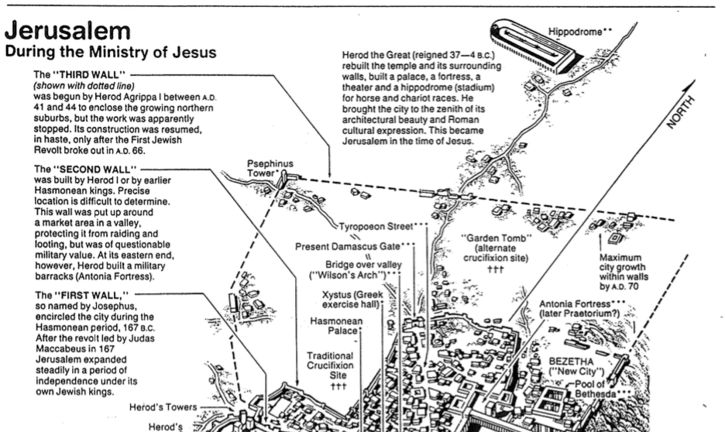

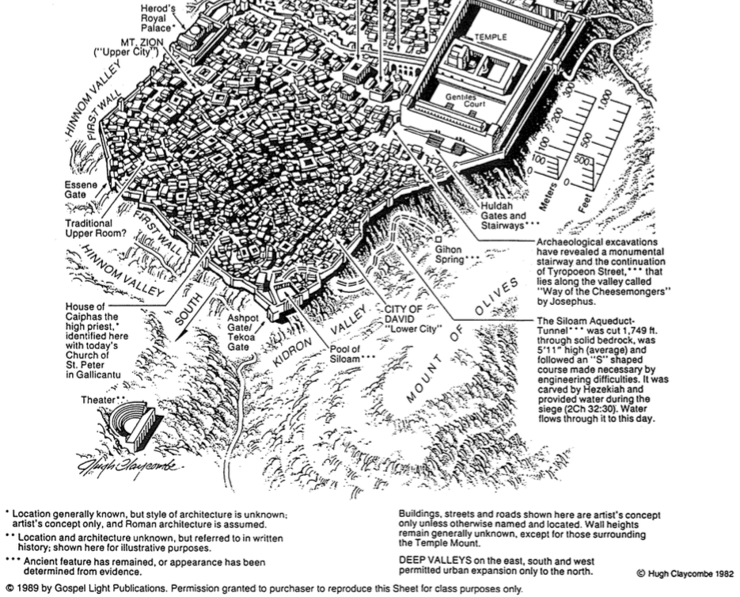

The Meaning of the Death of Christ
(Adapted from Charles C. Ryrie, Basic Theology [Wheaton: SP Pub., 1986], 329-42)

A Substitution for Sinners

The Concept of Substitutionary Atonement

The Evidence for Substitutionary Atonement

The Denial of Substitutionary Atonement

A Redemption in Relation to Sin

The OT Doctrine

The NT Words

The Doctrine Summarized

People are redeemed from the marketplace or slavery to sin.

People are redeemed by the payment of a price, the blood of Christ.

People are redeemed to the state of freedom.

A Reconciliation in Relation to the World

The Need for Reconciliation—Why?

The Cause for Reconciliation—How?

The Object of Reconciliation—Who?

The Provision and Application of Reconciliation

A Propitiation in Relation to God

The Need for Propitiation: The Wrath of God

The Provision of Propitiation: The Sacrifice of Christ

The Negation of Propitiation: The Teaching of C. H. Dodd

The Distinction Between Propitiation and Expiation

Propitiation Expiation

Placating God’s wrath Removing wrath, sin or guilt

Wrath personal Wrath impersonal

Appeasing an offended person Reparation for a wrong

Brings wrath into the picture Can leave wrath out

Christ propitiated the wrath of God by becoming an expiation for our sins.

An Important Practical Point

“If because of the death of Christ God is satisfied, then what can the sinner can nothing to satisfy God? The answer is nothing. Everything is done by God himself. The sinner can and need only receive the gift of righteousness God offers” (Ryrie, 342).

Some Results of Salvation
(Adapted from Charles C. Ryrie, Basic Theology [Wheaton: SP Pub., 1986], 343-54)

Justification

The Meaning of “Justification”

Uses of the Term

The Catholic View of Justification

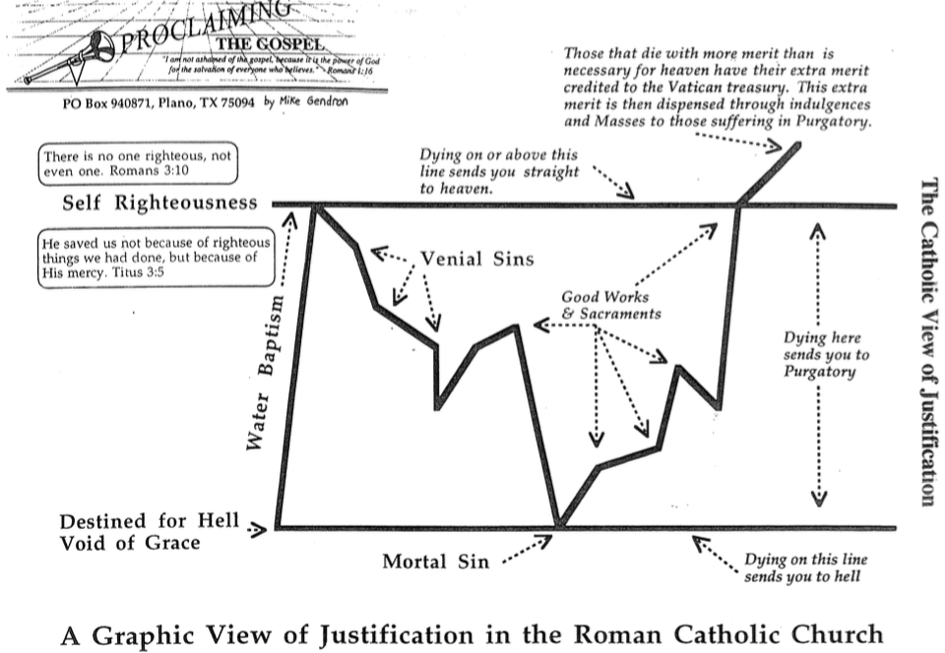

The Scriptural View of Justification
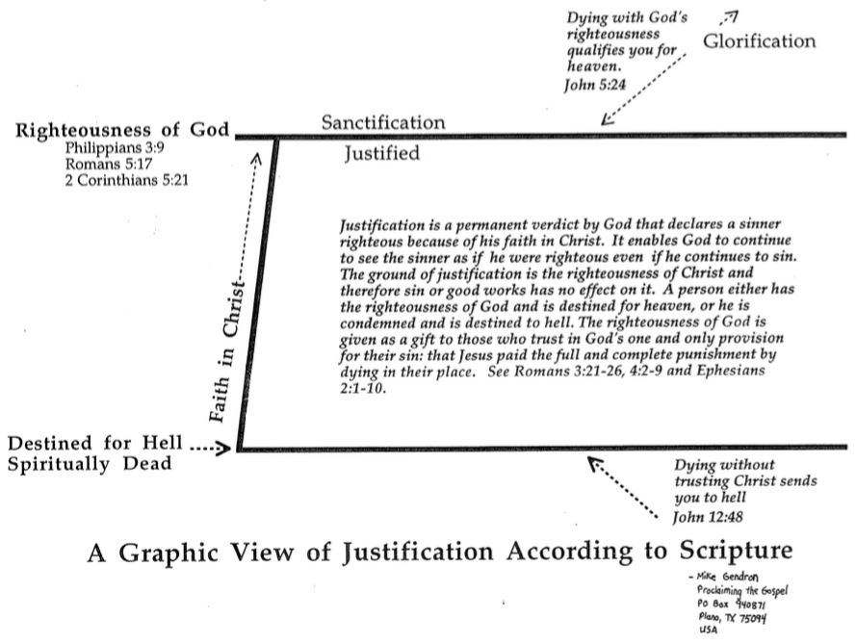

Our Position in Christ

The current rage in psychological circles focuses on individual self-esteem—how good a person feels about himself or herself. This is not a scriptural emphasis at all. Rather than encouraging us to exalt self, the Bible tells us to deny self (Matt. 16:24), not think too highly of self (Rom. 12:3), and that the heart is desperately wicked (Jer. 17:9)!

We have no reason for good self-esteem. However, we have every reason to walk in confidence due to what God thinks of us. While this is taught in many NT books, the book of Ephesians probably emphasizes our position in Christ better than any NT book. Notice how several of the texts below come from Ephesians.

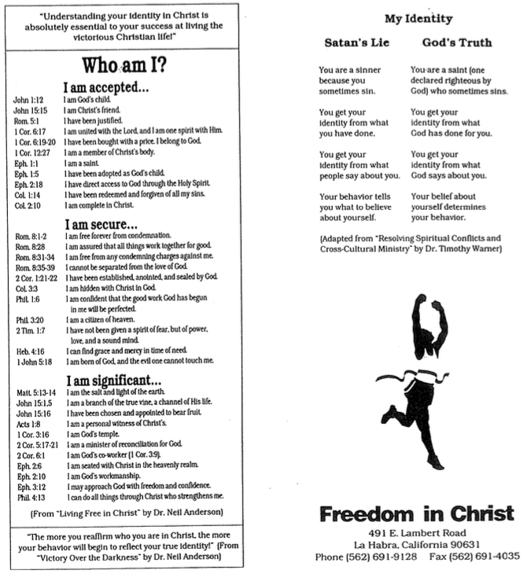

Whose Children are We (Romans 5)?

Adam’s Children | God’s Children
Ruin 5:9 | Rescue 5:8
Sin 5:12, 15, 21 | Righteousness 5:18
Separation from God 5:18 | Relationship with God 5:11, 19
Disobedience 5:12, 19 | Obedience 5:10
Judgment 5:18 | Deliverance 5:10, 11
Law 5:20 | Grace 5:20

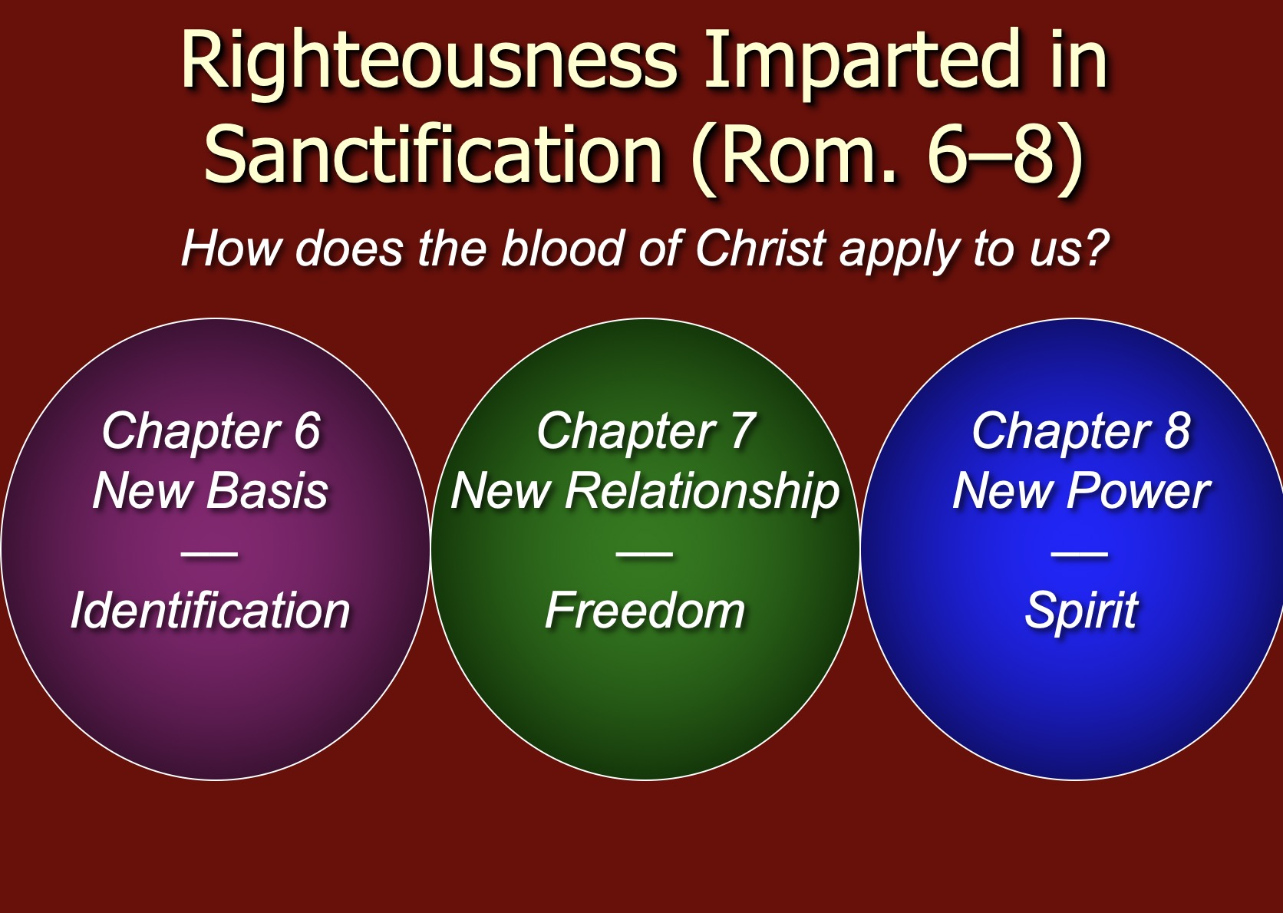

Justification, Sanctification, and Death to Sin (Rom. 6)

Contrasts Between Justification and Sanctification

Justification | Sanctification
“Not guilty” | “Set apart”
Legal standing | Internal condition
Once for all time | Continuous throughout life
Entirely God’s work | We cooperate
Perfect in this life | Not perfect in this life
The same in all Christians | Greater in some than in others

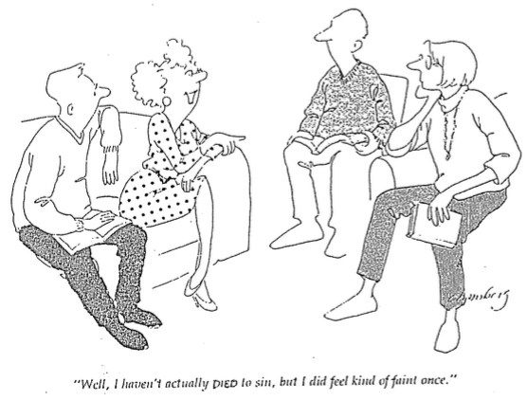

The Christian and the Mosaic Law

Introduction to the Law

A. A quick quiz to get you thinking…

1. T or F Christians should keep parts of the OT law that are not repeated in the NT.
2. T or F There are actually two laws: the moral (Ten Commandments) and ceremonial/civil.
3. T or F The Sabbath should still be obeyed by Christians.
4. T or F Believers today are obligated to keep all of the Ten Commandments.
5. T or F Tithing should be practiced by all followers of Christ.
6. T or F Christians today are prohibited from eating blood (e.g., yong tau foo, blood pudding, pig or duck blood at Chinese New Year).
7. T or F Believers must not charge other Christians interest based upon the Law (Deut. 23:19; Exod. 22:25; Lev. 25:36-37; Ezek. 18:8, 13, 17; 22:12; Prov. 15:5; 28:8).

B. Defining the Meaning of Law (adapted from Fee/Stuart, 135-36)

1. Sometimes “Law” refers to the Pentateuch as a single book (e.g., Josh. 1:8).

2. Sometimes Christians refer to the “Law” as the five books of the Pentateuch, even though Genesis has no legal codes.

3. NT usage of the term “Law” sometimes refers to the Pentateuch and sometimes the entire OT (e.g., Luke 16:17).

4. Oftentimes “Law” refers to only the legal formation from Exodus 20–Deuteronomy 33. (It always refers to at least this portion of Scripture.)

C. The Christian’s Relationship to the Law (adapted from Fee/Stuart, 136-39; these issues are addressed in detail in my ThD dissertation in the SBC library under Richard James Griffith, “The Eschatological Significance of the Sabbath,” Dallas Seminary, 1990, esp. pp. 144-56).

1. The OT law is a covenant between Israel and God–not between the church and God. The church and Israel must be kept distinct.

2. Our loyalty to God is shown in different ways than was Israel’s. In other words, God expected Israel to be loyal and He expects the same of us, but Israel’s loyalty was shown through observing the sacrificial system whereas our loyalty is shown by our obeying NT commands. (However, faith is what pleased God then and now–Heb. 11:6.)

3. Most OT stipulations are not repeated in the NT–especially the civil (penalties for crimes) and ritual (worship, especially sacrificial regulations) laws. Therefore, most of the OT does not directly apply to believers.

4. Some OT stipulations are repeated in the NT–including nine of the Ten Commandments, the exception being the Sabbath.

5. All of the OT law is still the Word of God for us even though it is not still the command of God for us. As such it is still useful for teaching and preaching, though applications must be made based upon the principles under girding the laws.

6. Only that which the NT explicitly renews from the OT law can be considered part of the NT “law of Christ” (Gal. 6:2). [Note: Fee/Stuart put all of the Ten Commandments in this category, which makes modern believers guilty of Sabbath breaking. I disagree that the Sabbath is binding in the present age. I worship corporately on Sunday, not Saturday!]
D. The Purposes of the Law (adapted from J. Dwight Pentecost, BibSac 128 [July 1971]: 227-33)

Paul’s letter to the Galatians teaches sanctification not by the Law but by faith in Christ alone. This finds support in that Abraham was justified by faith centuries before the Law even came (Gal. 3:17). After that, the Law and the Promise (Gen. 12:1-3) co-existed for years, so there is no basic conflict between the Law and the Promise. This led Paul to ask, “What, then, was the purpose of the law?” (Gal. 3:19). Actually, there were at least ten purposes for the Law:

1. It revealed or exposed the sinfulness of man (Gal. 3:19).

2. It revealed the holiness of God (1 Pet. 1:15).

3. It revealed the standard of holiness for people in fellowship with God (Ps. 24:3-5).

4. It supervised the physical, mental, and spiritual development of the redeemed Israelite until he could come to maturity in Christ (Gal. 3:24).

5. It unified the people to establish the nation in voluntary submission to God’s decrees (Exod. 19:5-8; Deut. 5:27-28).

6. It separated Israel among the nations as a kingdom of priests to mediate God’s truth to these nations (Exod. 31:13).

7. It provided forgiveness of sins for individual Israelites to restore their fellowship with God, even though they already functioned as a redeemed people (Lev. 1–7).

8. It made provision for Israel to worship God as a redeemed people (Lev. 23).

9. It tested if one was in the kingdom or the theocracy over which God ruled (Deut. 28). Faith led to obedience and blessing; lack of faith lead to disobedience and judgment.

10. It revealed Jesus Christ (typology in the sacrificial system; Luke 24:27).

Pentecost says that the revelatory aspect of the Law is permanent as it still reveals the holiness of God today (1 Tim. 1:8), but the regulatory aspect is temporary as it regulated the life and worship of the Israelite (Gal. 4:8-10; Col. 2:16-17). However, this view does not seem correct, as the entire Law has been abolished. I feel that a better approach is the one below…

E. A Suggested Strategy for Expounding Old Testament Law

1. Interpretation: Study the intent behind the legal command, asking the question, “Why was this command given in Israel?” It is especially helpful to answer this question by showing how the law reveals the character of God. For example:

“God told Israel in Leviticus 19:9-10 not to harvest the corners of the fields because He had compassion on the poor who could glean there for their food.”

2. Principlizing: State the intent of the law in the form of a general principle.

“God wants His people to give the underprivileged the chance to earn a living.”

3. Application: Show how this principle relates to a contemporary parallel situation.

“As an employer you should provide opportunities for the poor to support themselves.”

You probably can tell by now that I think the answer to each question on the previous page’s quiz is false.

Does the Law of Moses Apply to Me?

 | Theonomic  Greg Bahnsen | Reformed  Willem VanGemeren | Weightier Issues  Walter C. Kaiser | Modified Lutheran  Douglas J. Moo | Dispensational  Wayne G. Strickland
What is the Law? | Same definition as the views 3-5 | God's oral or written instructions since creation | The whole Mosaic law given in the Pentateuch (Genesis to Deuteronomy) but also amplified in the rest of the Old Testament
Who is the Law for? | The Elect  (Israel = Church) | All mankind  (Israel = Church) | Believers  (Israel and Church) | Believers  (Israel and Church) | Israel only  (Israel ≠ Church)
Which parts of the Law apply today?  • "Moral law"?  (i.e., Decalogue or 10 Commandments) | All moral laws apply to people of God only in every age; therefore, all elect persons since creation should observe either the Jewish Sabbath (Saturday, before Christ) or "Christian Sabbath," (Sunday, after Christ) | All moral laws apply to believers and unbelievers of every age (e.g., all persons—including unbelieving Gentiles since creation—should observe the Sabbath or "Christian Sabbath," being Sunday) | All moral laws that stem from God's character:  • 10 Commandments  • Leviticus 18–19 (sex)  (i.e., Sabbath is required since Israel's nationhood and prohibited sexual practices still apply) | As with dispensationalists, the Mosaic law is abolished in its entirety; however, its moral content provides good guidelines for Christian living, though Christ holds the final say through the ministry of the Holy Spirit in believers today; Sabbath obedience is not consistently applied (?) | God's "moral law" before Moses is now called the "law of Christ" (Gal. 6:2) and governs believers through the Spirit's new covenant indwelling; The Law does not easily divide into "parts" and is done away with in its entirety (Rom. 7:1-6; 1 Cor. 9:19-21; Heb. 8:13), including the Sabbath (Col. 2:16-17)
• Civil laws?  (i.e., judicial law) | All apply  (e.g., laws today should require death for adultery) | Some apply  (e.g., still tithe and don't charge believers interest) | Judicial principles (not laws) apply since moral laws underlie all judicial and ceremonial laws | Only principles apply now as the Mosaic law was given only to Israel | None apply as these regulated Israel alone (but principles such as love and compassion still apply)
• Ceremonial laws? | All five views agree that ceremonial aspects such as the sacrificial system and Jewish priesthood are now fulfilled in Jesus Christ
What is the relationship of the Abrahamic Covenant to Mosaic Covenant? | Both are God's "covenant of grace." They consist of the same substance of God's saving relationship which makes the MC still apply today | MC was added to the AC; both still apply though they are similar in substance but different in form and purpose | MC was given specifically to Israel but its moral principles are still relevant to all believers under the AC | Like dispensationalists, MC was conditional but AC was not; MC as a temporary framework prescribed terms of obedience for Israel in Law period | MC regulated Israel's life so she could experience the blessings of the AC, but MC is no longer operative as it is fulfilled in Christ
Spectrum on Degree of Applicability*
Weightier
Issues
Modified
Lutheran
Law as fully abolished in every sense
Theonomic
Reformed
Dispensational

Law as fully applicable in
every sense

Law as fully abolished in
every sense

––––––––––––––––––––––––––––––––––––––––––––––––––––––––––

Does the Law of Moses Apply to Me? (2 of 2)
* Adapted from Lee Hwee Chin, "The Applicability of the Law Today," unpublished research paper for the course "Old Testament Survey,"
Singapore: Singapore Bible College, 2001), 1.

 | Theonomic  Greg Bahnsen | Reformed  Willem VanGemeren | Weightier Issues  Walter C. Kaiser | Modified Lutheran  Douglas J. Moo | Dispensational  Wayne G. Strickland
Strengths | • Continuity between the OT and NT upheld  • Desires ethics to relate to all of life  • Sees positive aspects of the law | • Continuity between the OT and NT upheld  • Notes Mosaic law's foreshadowing of Christ  • Sees a convicting role of the law today for unbelievers | • Biblical support for some law aspects (i.e., moral) being weightier than others (Matt. 23:23)  • Holiness Code of Leviticus 18–19 stem from nature of God | • Accounts for new covenant emphases under the Law of Christ (Gal. 6:2)  • Says OT laws repeated in the NT are applicable  • Applies law principles today | • Biblical in that Mosaic law began at Sinai and ended with Christ's death as a temporary custodian or tutor  (Gal. 3:19, 24-25)  • Clearly distinguishes between Israel and church  • Advocates continued guidance in law of Christ
Weaknesses | • Dividing law as moral, civil & ceremonial not biblically supported  • Misguided to apply godly commands to unregenerate man  • All "law" need not be Mosaic (natural law and law of Christ also exist)  • The NT never applies the OT to civil matters  • Law condemned man  (2 Cor. 3:9) | • Dividing law as moral, civil & ceremonial not biblically supported  • Use of "law" in differing ways inconsistent & confusing  • Requiring Sabbath for today contradicts NT (Col. 2:16-17)  • Unclear if moral law became law of Christ  • Merges Israel and church | • Dividing law as moral, civil & ceremonial not biblically supported  • Arbitrary to pick and choose which parts of the law are required  • Choice of Decalogue and Lev. 18–19 too narrow for moral law | • Seeks to teach the indivisibility of the law while upholding its moral content  • Too extreme to claim that the law has absolutely no purpose today  • Fails to see the gospel in the OT by demarcating Law and Gospel into distinct, discontinuous eras | • Distinguishing law's revelatory aspects (eternal, revealing God's nature) from regulatory (temporary, ruled Israel) makes distinctions within an inseparable code—if the OT law is essentially a unity, then why divide it into two parts?  • The law is not nullified but actually upheld by faith (Rom. 3:31)

Kingdom & Covenants Timeline

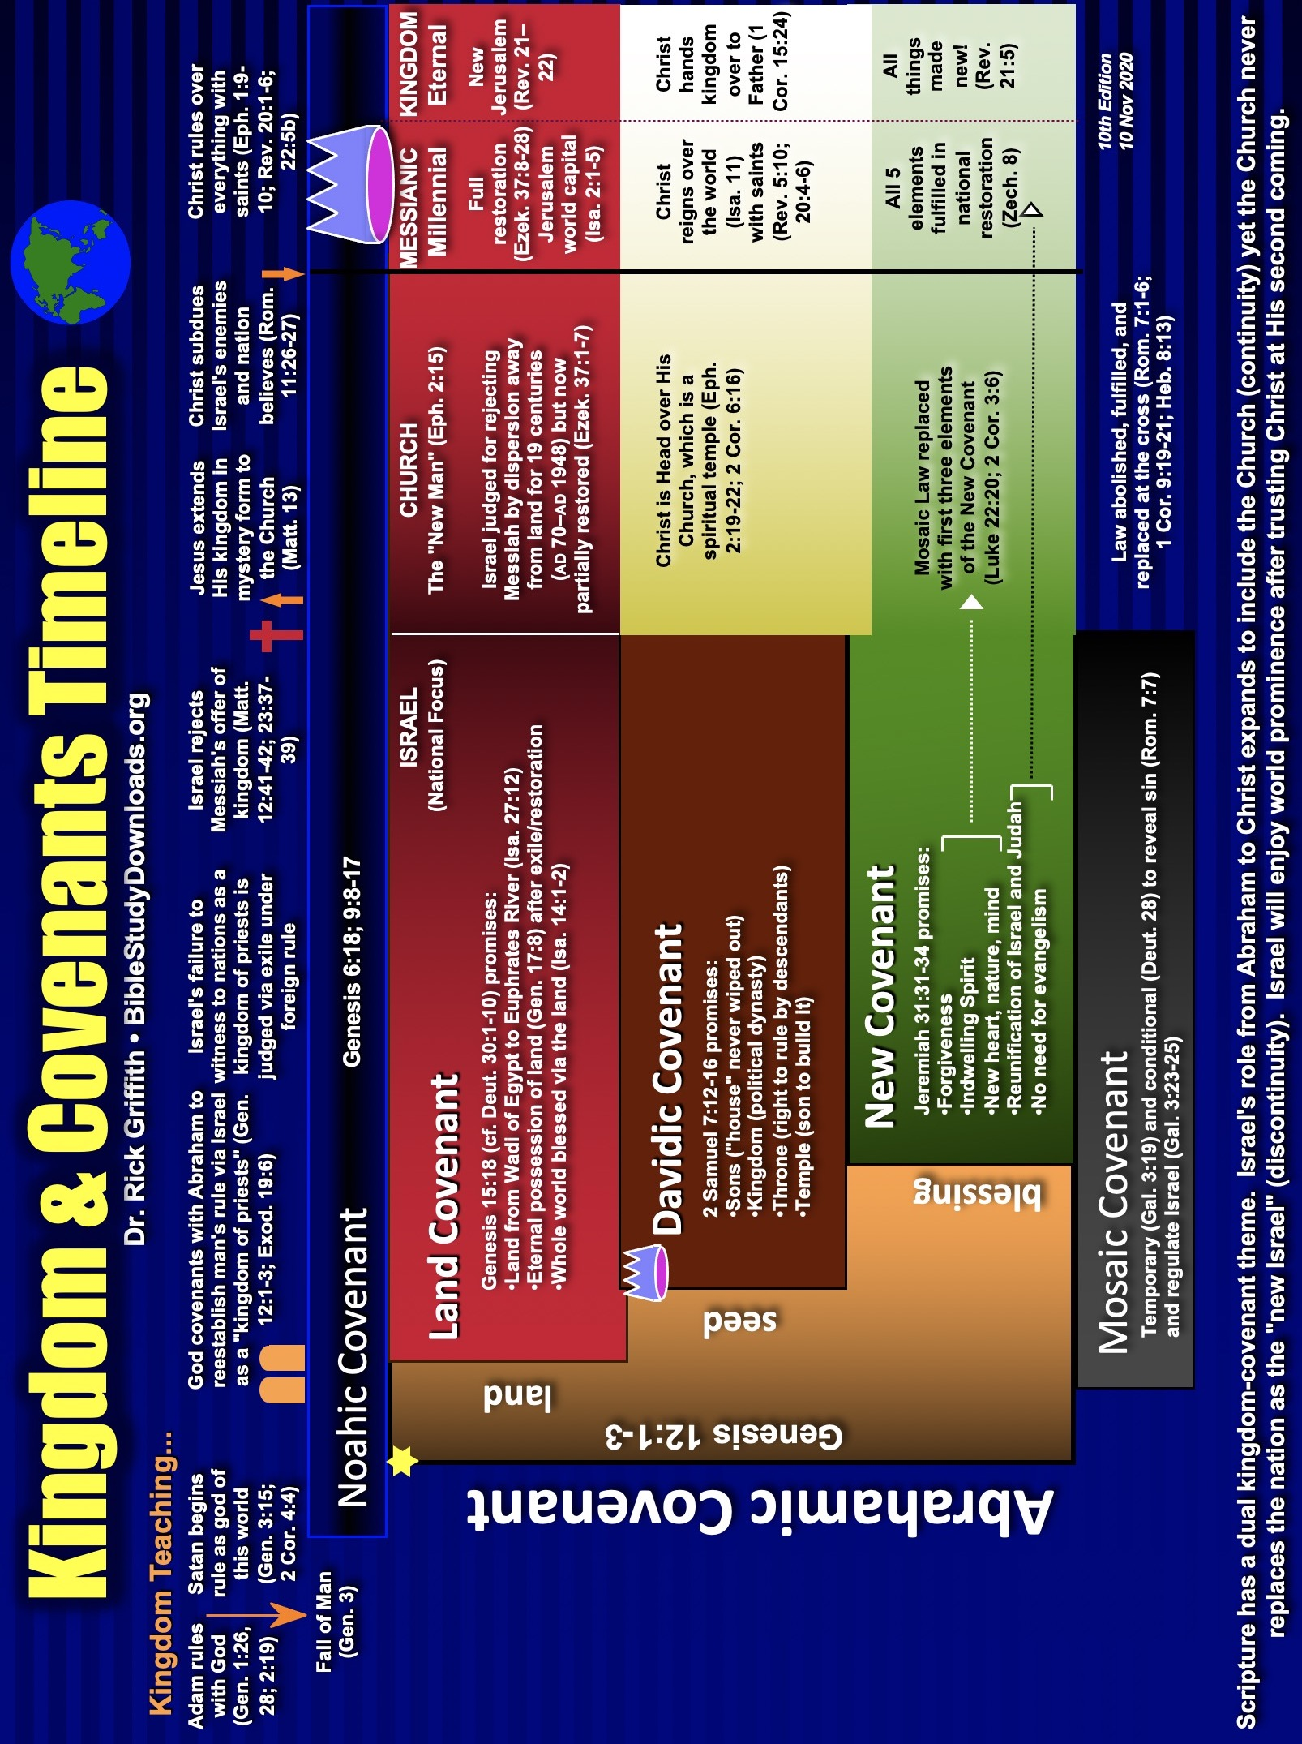

Will All Believers Remain Faithful to Christ Until Death?

Parallels Between Hebrews 6:4-12 and 10:26-36
William L. Lane, Hebrews 9–13, vol. 47, Word Biblical Commentary (Dallas: Word, 1991), 2:296-97
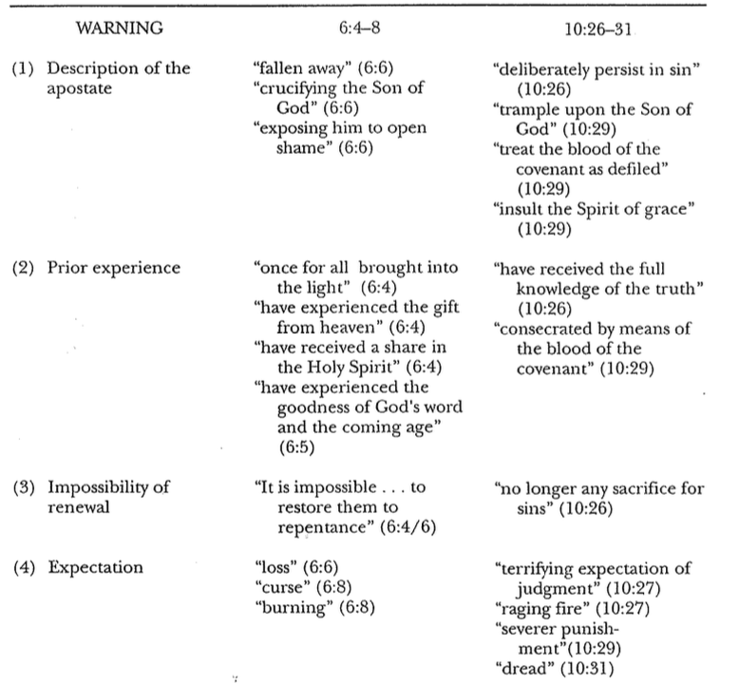

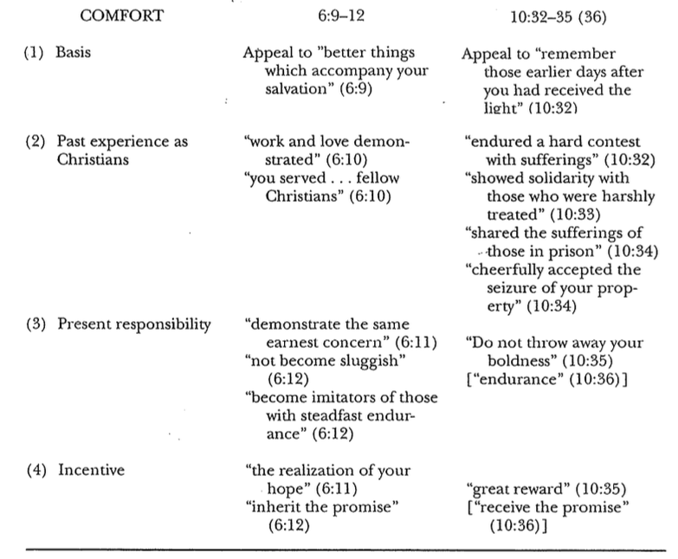

Views on the Warning Passages

Hebrews warns those who “fall away” five times (2:1-4; 3:7–4:13; 5:11–6:8; 10:19-39; 12:18-29). Each warning cautions readers not to reject Christianity for Judaism. These passages are perhaps the most controversial in the NT. But what penalty do these verses actually warn against–and to whom are they addressed? The basic issues can be contrasted in the following chart:

Issues | False Believer | Former Believer | Carnal Believer
What group of Jews  is being addressed? | Unbelievers:  Professing “Christians” in the assembly who are not really believers after all | Believers:  Christians who sin because they do not see the superiority of Christ | Believers:  Christians who sin because they do not see the superiority of Christ
What is their punishment? | Never had salvation | Loss of salvation | Loss of reward
What is the result? | Hell | Hell | Divine discipline  (even by death)
Which theological perspective holds to this view? | Reformed  (Presbyterian, B-P, etc.)  Some Arminians too | Arminian  (Methodist, AOG, Nazarene, etc.) | Partakers  (Baptist, Bible  church, etc.)
Strengths | It takes the seriousness of the warnings as signifying hell | It takes the seriousness of the warnings as signifying hell | Loss of rewards as a judgment for true believers is more biblically consistent than loss of salvation
Weaknesses | Hebrews consistently speaks of the readers as genuine Christians  (3:1; 4:14; 10:23, 39) | “Temporal security” goes against the NT doctrine of justification by grace (John 3:16; Rom. 8:28-39) | Texts refer to judging persons, not deeds (“fire that will consume the enemies of God,” 10:27; cf. 6:8) though these may denote the AD 70 Jerusalem fire
Adherents | Hughes, Hebrews, 420;  McKnight (below), 34; Toussaint, GTJ (1982): 67, 78-79 | Attridge, Hebrews, 293-96;  Lane, Hebrews 9–13, 295-96 | Dillow, Reign of Servant Kings, 458-65; Pentecost, in Integrity of Heart…,140; Oberholtzer, BibSac (1988): 412-25; Gleason, BibSac (2000)

For two other views not noted above see Scot McKnight, “The Warning Passages of Hebrews: A Formal Analysis and Theological Conclusions,” Trinity Journal 13 (Spring 1992): 23-25. He says that scholars also hold to the hypothetical view (that does not see apostasy as possible) and the community view (that applies the text only to groups rather than individuals). However, neither of these views has received much of a following and thus is not treated above.

Views on Eternal Security and Perseverance

Can a Christian lose his salvation? This question is often answered from either a Calvinistic or Arminian view. However, a third, meditating view draws from both of these views. Joseph C. Dillow has championed this Partakers view, or Inheritance view in Final Destiny: The Future Reign of the Servant Kings. 2nd ed. (Monument, CO: Paniym Group, 2012). This monumental work of 1093 pages is quite scholarly and yet very readable, comforting and convincing to me. Note the distinctions between these three views:

Issues | Reformed | Arminian | Partakers
How does each system define election and perseverance? | God sovereignly elects to salvation and helps believers persevere in faith until death | God elects those whose free will accepts Christ and preserves them unless they lose faith | God elects to salvation; some do not persevere, but the faithful will partake of rewards
What specific elements of salvation make up this system of belief? | Total depravity  Unconditional election  Limited atonement  Irresistible grace  Perseverance | Natural inability  Conditional election  Unlimited atonement  Resistible grace*  Conditional perseverance | Total depravity  Unconditional election  Unlimited atonement  Irresistible grace  Conditional perseverance
How does this view see carnal Christians  (e.g., 1 Cor. 3:1-5)? | They aren’t Christians or are at a low level of spiritual commitment in a particular area | They spurn Christ to the point of almost losing their salvation | These believers lack blessings now and later (but are still saved)
Do all believers persevere until death? | Yes  1 Cor. 15:2; Phil. 1:6 | No  Rom. 8:13; Gal. 5:21; 6:8 | No  1 Cor. 3:15; Rev. 3:26
Can a true Christian lose his salvation? | No,  it is eternally secure | Yes,  it is not eternally secure | No,  it is eternally secure
Is 100% assurance of salvation possible? | No, since no one knows if he has genuine faith that will persevere | No, since no one knows if  he will persevere | Yes, if one knows  Christ as Saviour
How does this system counsel believers in habitual sin? | “You better re-examine whether you genuinely trusted Christ” | “You either lost your salvation or never were really saved” | “You must turn from your sin to be fully rewarded (Heb. 3:14)”
How do those struggling with sin gain spiritual motivation? | From fear that they may not actually be saved after all | From fear that they may not have sufficiently maintained their salvation | From fear that they will miss key rewards (their inheritance can be lost but not their salvation)
What actually results in the listeners from this teaching? | They may become carnal Christians by doubting their salvation | They believe God must always be appeased  (low view of grace) | They will more likely appreciate God’s faithfulness to them
Who holds this view? | John Calvin (d. 1564),  Reformed churches,  Presbyterians,  Charles Hodge,  Arthur Pink | Jacob Arminius (d. 1609),  John Wesley, Methodists,  Wesleyans, Nazarenes, Holiness churches,  Pentecostals/Charismatics | Baptists, Bible churches,  Joseph Dillow,  Zane Hodges,  Earl Radmacher,  Charles Ryrie
* Formerly known as “prevenient” grace—it means God’s grace comes to all to enable them to believe, but it is not always successful and can be resisted.

Perseverance versus Free Grace

Will all who are saved continue to persevere in their faith? In other words, could someone genuinely profess faith in Christ but die in a spiritually pathetic state? People have dealt with this issue for ages, but especially in our day when many claim the name of Christ but show little fruit. Note some NT verses used to advocate perseverance as opposed to a free grace position.

Perseverance | Free Grace
Matthew 7:15-22  "Beware of false prophets, who come to you in sheep's clothing but inwardly are ravenous wolves. ¹⁶ You will recognize them by their fruits. Are grapes gathered from thorn bushes, or figs from thistles? ¹⁷ So, every healthy tree bears good fruit, but the diseased tree bears bad fruit. ¹⁸ A healthy tree cannot bear bad fruit, nor can a diseased tree bear good fruit. ¹⁹ Every tree that does not bear good fruit is cut down and thrown into the fire. ²⁰ Thus you will recognize them by their fruits. ²¹ "Not everyone who says to me, 'Lord, Lord,' will enter the kingdom of heaven, but the one who does the will of my Father who is in heaven. ²² On that day many will say to me, 'Lord, Lord, did we not prophesy in your name, and cast out demons in your name, and do many mighty works in your name?'” | This text does not relate to people in general but to how to recognize false prophets.  A false prophet’s lifestyle reveals his true, unsaved condition. Such a person is not willing to suffer for the sake of righteousness. Rather, his only “suffering” is the difficulty entailed to convince his followers to open their wallets. Such people can be spotted not because they give open profession to Jesus or even due to their ability to perform miracles. We must discern their godless character by their unwillingness to do God’s will.  It goes beyond this text to say that these are believers who persevere in their faith. To establish such a claim, one must first prove such heretics are believers.
John 8:31-32 To the Jews who had believed him, Jesus said, “If you hold to my teaching, you are really my disciples. 32Then you will know the truth, and the truth will set you free.” | In this text Christ exhorts believers to be true disciples. He does not say that if they disobey that they will no longer be Christians (or never were). Rather, they will not truly be free.
John 15:6 If anyone does not remain in me, he is like a branch that is thrown away and withers; such branches are picked up, thrown into the fire and burned. | “Remain” denotes obedience. This text simply indicates that Jesus disciplines disobedient believers. It goes too far to claim that the fire here denotes hell.
Rom. 8:12 Therefore, brothers, we have an obligation—but it is not to the sinful nature, to live according to it. | Paul knew that believers can choose wrongly, so he exhorted the Roman Christians to live according to their new nature.
Rom. 11:22 Consider therefore the kindness and sternness of God: sternness to those who fell, but kindness to you, provided that you continue in his kindness. Otherwise, you also will be cut off. | “‘Kindness and sternness’ (v. 22) are aspects of the divine nature, the latter experienced by Israel in her present condition, the former being the portion of Gentile believers. But the positions can be reversed, and if this occurs, it will not be due to any fickleness in God, but to the nature of the human response. Once Israel’s unbelief is put away, God is prepared to graft her branches in again (v. 23)” (NIV Bible Commentary).

Perseverance |  | Free Grace
1 Cor. 15:2 By this gospel you are saved, if you hold firmly to the word I preached to you. Otherwise, you have believed in vain. |  | Belief “in vain” does not denote false faith or not “truly” believing. It means the object of their faith would be unreliable if Christ was not resurrected (v. 14; cf. Dillow, 364-65).
2 Cor. 13:5 Examine yourselves to see whether you are in the faith; test yourselves. Do you not realize that Christ Jesus is in you—unless, of course, you fail the test? |  | We cannot assume that being “in the faith” means being regenerate, as elsewhere it means living according to what we believe (2 Cor. 1:24; cf. 1 Cor. 16:13; Dillow, 448-49). The verse means some Christians fail to live according to their profession.
Phil. 1:6 being confident of this, that he who began a good work in you will carry it on to completion until the day of Christ Jesus.  This verse places the responsibility of the believer’s security upon God rather than any human being. |  | This verse can be handled in at least two ways:  - It teaches eternal security, not perseverance.  - The "good work" refers to God's work of bringing people into his family through the Philippians. God assured that their participation in the gospel would continue to bear fruit until Christ’s return.  What it does not say is that each individual church member would remain faithful until Christ returns. Obviously, each one of them died prior to the return of Christ.
Col. 1:15 If you hold fast… |  | A believer may not be presented before Christ relatively blameless (Dillow, 536).
Titus 1:16 [False teachers] claim to know God, but by their actions they deny him. |  | These persons have never been believers since they reject the truth (1:14).
Heb. 3:6 But Christ is faithful as a son over God’s house. And we are his house, if we hold on to our courage and the hope of which we boast. |  | Only faithful believers are part of Christ’s priestly “house” so they rule with him (cf. 2 Tim. 2:12). It is not true for every Christian (Dillow, 384).
Heb. 3:14 We have come to share in Christ if we hold firmly till the end the confidence we had at first. |  | There exists a distinction between "knowing Christ" (salvation) and "sharing in Christ" (being rewarded in Him).
Hebrews 10:35-39 ³⁵So do not throw away your confidence; it will be richly rewarded. ³⁶You need to persevere so that when you have done the will of God, you will receive what he has promised. ³⁷For in just a very little while, "He who is coming will come and will not delay. ³⁸But my righteous one will live by faith. And if he shrinks back, I will not be pleased with him." ³⁹But we are not of those who shrink back and are destroyed, but of those who believe and are saved. |  | The fact that the author notes their need to persevere indicates the possibility that they may not do so. In fact, the entire letter appeals for the readers not to shrink back to Judaism, which he viewed as a distinct possibility. That such backsliders would not please God does not indicate that they were never believers in the first place. It indicates that such persons would be “destroyed” (killed) in the Jerusalem fires of AD 70 that consumed the unbelieving Jews with whom the readers were tempted to follow.  “Apostasy here is not theoretical; it is a real possibility. This is the apostasy of… the regenerate child of God who has received the imputed righteousness of Christ” (Dillow, 527).
Perseverance |  | Free Grace
James 2:20-26 You foolish man, do you want evidence that faith without deeds is useless? 21Was not our ancestor Abraham considered righteous for what he did when he offered his son Isaac on the altar? 22You see that his faith and his actions were working together, and his faith was made complete by what he did. 23And the Scripture was fulfilled that says, “Abraham believed God, and it was credited to him as righteousness,” and he was called God’s friend. 24You see that a person is justified by what he does and not by faith alone. 25In the same way, was not even Rahab the prostitute considered righteous for what she did when she gave lodging to the spies and sent them off in a different direction? 26As the body without the spirit is dead, so faith without deeds is dead. |  | Does James distinguish false faith from true faith that saves from damnation? No. How does James use “faith” and “salvation”? James contrasts a regenerate person who claims he has a walk of faith with one who actually does have this lifestyle (Dillow, 392). Faith in James refers not to the initial act of faith that saves from hell. It denotes the ongoing walk of faith that can save one from the pathway to “death,” or the downward progression “unto death resulting in a negative assessment of one’s life at the Judgment Seat of Christ” (ibid.). The NT often refers to faith as a walk instead of as an initial event (Rom. 14:23; Gal. 3:11; 5:25; Col. 2:6; 2 Cor. 5:7), especially in James (1:2-4, 6; 2:1, 5; 5:15).  Further, James uses “salvation” in a temporal—not eternal—sense. In fact, the NT refers to salvation as entering heaven only 43% of the time and not even once in the OT (Dillow, 394). “Normally salvation refers to deliverance from a temporal difficulty, death, disease, or a meaningless life” (Dillow, 395). James uses “save” five times, never referring to salvation from eternal damnation. It denotes salvation from consequences of sin (1:21), loss at the Judgment Seat of Christ (2:14), sin’s penalties (4:12), disease (5:15), and physical death (5:20; cf. Dillow, 394-404).
2 Pet. 1:10-11 Therefore, my brothers, be all the more eager to make your calling and election sure. 11For if you do these things, you will never fall, and you will receive a rich welcome into the eternal kingdom of our Lord and Savior Jesus Christ. |  | The context notes, “For if you possess these qualities in increasing measure, they will keep you from being ineffective and unproductive in your knowledge of our Lord Jesus Christ. But if anyone does not have them, he is nearsighted and blind, and has forgotten that he has been cleansed from his past sins’ (1:8-9). The “falling” refers not to loss of salvation but to a stumbling in one’s growth as a Christian.
1 John 2:19 They went out from us, but they were not of us; for if they had been of us, they would have continued with us; but they went out that they might be made manifest, that none of them were of us. | The key issue here is, “Who are ‘they’?” Are these believers who had not persevered? The context contrasts the “they” in verse 19 with the “you” in verse 20, meaning antichrists (“they”) had arisen from the apostolic circle itself. Other passages in the epistle show the same we/you contrasts (1:1-3; 4:4-6). John is speaking of heretics whose defection showed that they were never saved in the first place (Hodges, The Gospel Under Siege, 58-59).
Perseverance |  | Free Grace
The Reformed view typically says that these men had never believed in the first place. | Apostasy of Hymenaeus and Alexander  1 Timothy 1:18-20 ¹⁸Timothy, my son, I give you this instruction in keeping with the prophecies once made about you, so that by following them you may fight the good fight, ¹⁹holding on to faith and a good conscience. Some have rejected these and so have shipwrecked their faith. ²⁰Among them are Hymenaeus and Alexander, whom I have handed over to Satan to be taught not to blaspheme.  These men: (1) had believed (“faith”), (2) had given evidence of their faith in a good conscience, and (3) needed to be taught not to blaspheme, “taught” being a word used of divine discipline of the regenerate (1 Cor. 11:32; Tit. 2:12-13; Heb. 12:5-6; Dillow, 525).
Apostasy in Galatians

Galatians 6:12 ¹² Those who want to make a good impression outwardly are trying to compel you to be circumcised. The only reason they do this is to avoid being persecuted for the cross. . .

“Submission to circumcision indicated cessation of faith in Christ (Gal. 2:17-21). In fact, it meant that a believer viewed Christ’s death as vain, had severed himself from Christ (Gal. 5:2), had fallen from grace (Gal. 5:43), and was liable to judgment (Gal. 5:10). To be severed from Christ and to fall from grace logically required a former standing in grace and connection with Christ from which to fall and be severed! Those who are regenerate may possibly deny the faith and forfeit their share in the coming kingdom. There is no need to assume that they lose salvation, as the Arminian maintains” (Dillow, 527).

Apostasy in Hebrews

Hebrews 10:38-39 ³⁸But my righteous one will live by faith. And if he shrinks back, I will not be pleased with him." ³⁹But we are not of those who shrink back and are destroyed, but of those who believe and are saved.

Perseverance |  | Free Grace
2 Peter 1:5-11 ⁵ For this very reason, make every effort to supplement your faith with virtue, and virtue with knowledge, ⁶ and knowledge with self-control, and self-control with steadfastness, and steadfastness with godliness, ⁷ and godliness with brotherly affection, and brotherly affection with love. ⁸For if these qualities are yours and are increasing, they keep you from being ineffective or unfruitful in the knowledge of our Lord Jesus Christ. ⁹ For whoever lacks these qualities is so nearsighted that he is blind, having forgotten that he was cleansed from his former sins. ¹⁰ Therefore, brothers, be all the more diligent to make your calling and election sure, for if you practice these qualities you will never fall. ¹¹ For in this way there will be richly provided for you an entrance into the eternal kingdom of our Lord and Savior Jesus Christ.

Verses 8-9 note that some who are forgiven are ineffective, unfruitful, nearsighted, and blind. They should return to Christ so they won’t fall away and so they will be richly rewarded upon entrance into eternal life (vv. 10-11).
Apostasy in the Last Days

^{NIV} 1 Timothy 4:1 The Spirit clearly says that in later times some will abandon the faith and follow deceiving spirits and things taught by demons.

The verb for “fall away” (apostesontai avposth,sontai, from avfi,stamai) is used only here in the NT in the intransitive sense as “leave, go away; desert, commit apostasy; keep away; trans. incite to revolt” and appears in Acts 5.37 (Friberg NT). One cannot abandon a faith that he never had accepted.

Denial of the Faith

^{NIV} 1 Timothy 5:8 If anyone does not provide for his relatives, and especially for his immediate family, he has denied the faith and is worse than an unbeliever.

This text says that some Christians act worse than unbelievers. This is a lifestyle of apostasy that is equally as serious as spoken blasphemy.

Perseverance |  | Free Grace
Apostasy of Widows

1 Timothy 5:14-15 ¹⁴ So I counsel younger widows to marry, to have children, to manage their homes and to give the enemy no opportunity for slander. ¹⁵ Some have in fact already turned away to follow Satan.

Apostasy for Materialism

1 Timothy 6:10 For the love of money is a root of all kinds of evil. Some people, eager for money, have wandered from the faith and pierced themselves with many griefs.

Apostasy Due to Gnostic Deception

1 Timothy 6:20-21 Timothy, guard what has been entrusted to your care. Turn away from godless chatter and the opposing ideas of what is falsely called knowledge, ²¹which some have professed and in so doing have wandered from the faith

Timothy himself is being warned here, which makes it clear that the possibility of apostasy relates to genuine believers.

Apostasy of Demas and Others

- Demas (2 Tim. 4:10)
- Phygelus & Hermogenes (2 Tim. 1:15)
- Many others (2 Tim. 4:16)

In the NT, “fall away” does not “refer to falling away from eternal salvation. It refers, rather, to a falling away from the path of growth, or forfeiture of eternal reward” (Dillow, 535, n. 1743).

Supporting Perseverance (i.e., Advocates Conditional Security)

Davis, John Jefferson. “The Perseverance of The Saints: A History of the Doctrine,” JETS 34, no. 2 (June 1991): 213-28.

Opposing Perseverance (i.e., Advocates Eternal Security)

Dillow, Joseph C. Final Destiny: The Future Reign of the Servant Kings. 4th ed. Monument, CO: Paniym Group, 16 Dec 2019. 1124 pp. pb.
Will each genuine Christian persevere in faithfulness at death?

Yes No

Reformed Partakers⁵ Arminian

Apostasy Apostasy Leads to Apostasy Leads to
Cannot Happen Loss of Rewards Loss of Salvation

Eternal Security Eternal Security No Eternal Security
but No Assurance and Assurance and No Assurance

Theories of the Atonement
(Adapted from Charles C. Ryrie, Basic Theology [Wheaton: SP Pub., 1986], 355-66)

Satan: Views Relating Christ’s Death to Satan

Ransom to Satan (Origen, 185-254)

Dramatic (Aulen, 1879-1978)

Exemplary: Views Seeing Christ’s Death an Example to Influence

Moral Influence (Abelard, 1079-1142)

Example (Socinus, 1539-1604)

Governmental (Grotius, 1583-1645)

Barthian (Barth, 1886-1968)

Punishment: Views Owing to God’s Justice and Substitution

Recapitulation (Irenaeus, 130-202)

Satisfaction (Anselm, 1033-1109)

Penal Substitution (Calvin, 1509-1564)

The Doctrine of Election

Romans 8:28-30
John D. Grassmick, Romans 206, Dallas Seminary, 1985

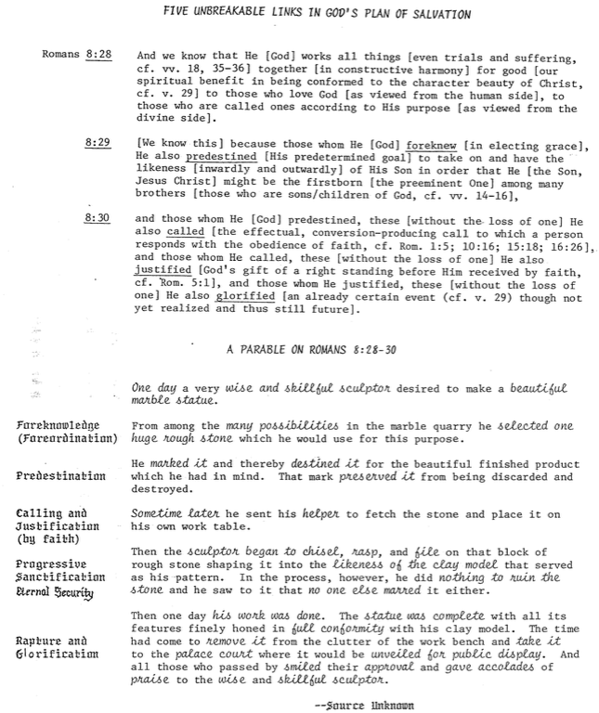

What About the Unreached (Rom. 1:18-20)?

One friend I know leads several people to Christ each week. Once I asked him how he did it. “Rick,” David noted, “you gotta get ‘em lost before you can get ‘em saved.” Seeing my puzzled look, he commented insightfully, “Most presentations of the gospel tell people that Christ is the answer before they even know what the question is. We try to give the solution before they even know they have a sin problem, so I spend most of my presentation showing them how helpless they are without Christ.”

This strategy is not unique to my friend David. Paul begins his great epistle in Romans 1:1–3:20 by expressing in clear terms how lost all people are without Christ. Most evangelicals believe that those who hear the message about Christ and reject it will go to hell (John 3:36; cf. Luke 16:27-31), but many also ask, “Are all people really lost? What about those who have never even heard of Christ?” Let’s address some common questions on this subject:

1. What about those who never hear the message about Christ in the first place?

a. Some (e.g., universalists) say all religions are basically the same and each provides a route to God; however, this denies the uniqueness of Christianity.

b. Some (e.g., Catholics) say there’s a second chance after death, but Hebrews 9:27 excludes any kind of purgatory.

c. Others point to the sincerity of the unevangelised, claiming that they will be judged only if they fail to live up to the light that they already have. However, this claims a form of salvation by works and Romans 1:20 says that all people are without excuse—not they may be without excuse.

d. One view attracting some evangelicals says if the unevangelised respond in faith to the light received, God saves them on the basis of Christ’s saving work—even though they do not know about this Giver of salvation (John Sanders, No Other Name: An Investigation into the Destiny of the Unevangelized [Grand Rapids: Eerdmans, 1992], 215, 282-83 and Clark H. Pinnock, A Wideness in God’s Mercy: The Finality of Jesus Christ in a World of Religions [Grand Rapids: Zondervan, 1992], 149-50; idem, “Toward an Evangelical Theology of Religions,” Journal of the Evangelical Theological Society 33 (1990): 359-68). For a rebuttal, see Robert A. Peterson, Hell on Trial (Presbyterian & Reformed, 1995), 228-34.

e. The only proper response to the state of the unevangelised is that they indeed are lost without Christ. This is supported in several ways:

1) Scriptural Arguments:

a) God’s wrath is on people rejecting the clear light of conscience and creation evidence so that all are “without excuse” (Rom. 1:18-20; 2:12-16). Thus, God’s judgment “is based not on their response to unrevealed truth but to revelation they have received” (J. Ronald Blue, “Untold Billions: Are They Really Lost?” Bibliotheca Sacra 138 [Oct.-Dec. 1981]: 344; cf. Millard J. Erickson, “The Destiny of the Unevangelized,” Bibliotheca Sacra 152 [January-December 1995 in 4 parts]; The Evangelical Mind and Heart [Grand Rapids: Baker, 1993], 130-31; Ronald H. Nash, Is Jesus the Only Savior? [Grand Rapids: Zondervan, 1994]).

b] God does not send people to hell—He only lets those who reject what is plain to them go on the self-designated course to hell (ibid, 347). These are “given over” to heterosexual lusts (Rom. 1:24-25), homosexuality (vv. 26-27), and a depraved mind (vv. 28-32).

c] No one is righteous (Rom. 3:10-11) and all are condemned (5:18). This is why all people must call upon the name of the Lord to be saved (Rom. 10:13; cf. John 14:6; Acts 4:12), which cannot happen unless someone is sent to tell them about Christ (vv. 14-15). This means that there exists no one who genuinely obeys even conscience and the so-called “moral law” which many claim is taught by the Ten Commandments.

2) Great Commission: Christ’s mandate to bring the gospel to every person assumes a lost world (Matt. 28:19; Mark 16:15; Luke 24:47; John 20:21; Acts 1:8). The fact that he gave this commission presumes that he knew the first century believers could do it. In fact, they largely did it in the Roman Empire even to India, though it took much longer to reach China.

3) Apostolic Example: Paul’s passion was to reach people for Christ in new areas which never heard the gospel (Rom. 15:17-24). How could this have been his passion if persons in these unreached areas were not lost? Each apostle was persecuted while seeking to reach the lost, and all but John died a martyr’s death doing so.

4) Logical Argument: If the unreached are not headed for hell, then the worst thing a Christian could do is to tell them about Christ! Why? Because if they hear the message, there’s a possibility of rejecting it and going to hell; however, if they don’t hear the message in the first place, hell isn’t even a possibility. Therefore, the best decision is to call back all our missionaries.

2. What happens to babies who die? I believe that they go to heaven based on two texts:

a. David showed confidence in seeing his infant son who died (2 Sam. 12:23). While someone may question whether David’s opinion is correct (or whether we can read a NT understanding of the afterlife into his words), neither of these counterarguments is convincing to me. See Robert P. Lightner, Heaven for Those who Can’t Believe (Schaumburg, IL: Regular Baptist Press, 1977) for support for these babies. I believe the same applies to insane people whole cannot even discern general revelation noted in Romans 1:18-20.

b. Jesus noted that the kingdom of God belonged to little children (Mark 10:14-15). Some believe this means we need childlike faith to enter heaven (Sanders, No Other Name, 290), but the passage appears to teach both doctrines.

3. How can I communicate hell to non-Christians? A few suggestions:

a. Don’t be afraid to talk about hell. Jesus wasn’t! Christ talked about hell even more than He did about heaven.

b. Talk about sin in your evangelistic presentations. Talk about how God is holy and just and therefore must judge sin.

c. Remind unbelievers that hell was “prepared for the devil and his angels” (Matt. 25:41). Man through his disobedience has entered into this arrangement.

d. Avoid speaking of hell and sin as “spiritual separation from God.” Unbelievers are used to being separated from God and because of their sin many have convinced themselves that separation is good—so this hardly seems like a punishment!

e. Teach about hell in balance with even more fundamental doctrines, such as the deity of Christ, Trinity, substitutionary death of Christ, virgin birth, etc. While one need not be well-versed in these to become a Christian, he certainly cannot oppose them and be considered a true believer. Of course, all of us believe in some false beliefs, but those who oppose these basic ones must be taught clearly before they can be deemed truly evangelized.

Salvation by Works

Can a person really be saved without any works at all? Wouldn’t it seem odd for someone to live his entire life for evil but then trust Christ just before he died, and then live in heaven eternally? However, would one who did good works throughout his life yet never trusted Christ be eternally lost in hell? Two passages below seem to teach salvation by works, so how do we explain them?

Works Verses | Explanation
Rom. 2:6 God “will give to each person according to what he has done.”  Rom. 2:7 To those who by persistence in doing good seek glory, honor and immortality, he will give eternal life.  Rom. 2:8 But for those who are self-seeking and who reject the truth and follow evil, there will be wrath and anger. | These verses seem to teach salvation by works while others teach salvation by faith (e.g., Rom. 3:20). Paul appears to teach salvation by works elsewhere (cf. 1 Cor. 6:9-11; 2 Cor. 5:10; Gal. 5:21) but he did not see these as contradictory. It is better to see Romans 2:7 as hypothetical. Paul simply says that eternal life would be possible if one could keep the law entirely, but since no one can do this then all alike are under sin. This fits his argument that all persons are under judgment in Romans 1–3 and it also harmonizes well with 3:19-20.
Matt. 19:16 Now a man came up to Jesus and asked, “Teacher, what good thing must I do to get eternal life?”  Matt. 19:17 “Why do you ask me about what is good?” Jesus replied. “There is only One who is good. If you want to enter life, obey the commandments.”  Matt. 19:18 “Which ones?” the man inquired. Jesus replied, “ ‘Do not murder, do not commit adultery, do not steal, do not give false testimony,  Matt. 19:19 honor your father and mother,’ and ‘love your neighbor as yourself.’ ”  Matt. 19:20 “All these I have kept,” the young man said. “What do I still lack?”  Matt. 19:21 Jesus answered, “If you want to be perfect, go, sell your possessions and give to the poor, and you will have treasure in heaven. Then come, follow me.”  Matt. 19:22 When the young man heard this, he went away sad, because he had great wealth. | Was Jesus really telling this man that salvation was by works? If so, Jesus would contradict the numerous times he taught that salvation came through simple faith in Him (John 3:15, 16, 18, 36; 5:24; 6:35; 7:38; 11:25; 20:31; cf. 1 John 5:11-13).  Rather, it seems more reasonable that Jesus was calling this rich man’s bluff. The man had claimed to perfectly keep the law and thus be worthy of salvation (v. 16), so Jesus was asking him to prove it.  But if the man had truly sold everything, he still wouldn’t be saved. Notice that Jesus said he must also follow him. This means that he must be one who believed in Jesus.  The preceding context emphasizes having the humble faith of a child to enter heaven. The rich man provides the contrast, for his trust in his works was far from humble. He thought of eternal life as something he could earn (vv. 16, 20). When he had to choose between money and Jesus, money won.

Theological Words in Romans

Predestination (8:29, 30a)  Election (9:10-13) | The gracious act of God before creation when he chose some people for salvation and conformity to the likeness of Christ because of his sovereign good pleasure
Foreknowledge (8:29, 30) | God’s personal, relational look into the future to save certain individuals not based upon their faith but upon His desire to bring them into relationship with Him
Calling (8:28, 30b) | God’s effective “summons” through the preaching of the gospel of persons from the kingdom of darkness that guarantees their response and entrance into His kingdom
Righteousness (3:21) | Holiness or perfection which is inherent for God yet imputed (applied) to persons who trust in the perfection of Christ on their behalf
Faith (3:22, 25) | Trust or reliance of a person upon the atoning work of Christ on the cross as the sinless substitute to pay the sinner’s penalty due to God
Grace (3:24) | God’s giving undeserved blessings through His own good pleasure and no merit on man’s part—giving us what we do not deserve
Mercy (11:30, 31, 32; 12:1) | God’s withholding punishment through His compassion and no merit on man’s part—not giving us what we do deserve
Justice (3:25-26) | The fairness of God whereby He must punish sin in an individual or in a Sinless Substitute for that person, who for the believer is Jesus Christ
Justification  (3:24; 4:25; 5:18; 8:30c) | The instantaneous legal act of God when he declares a sinner “not guilty” due to Christ’s righteousness being applied to this person, which makes him/her righteous in God’s sight
Redemption (3:24; 8:23) | The return of a sinner to God (“buying back” from the slave market) by Jesus Christ’s payment of the price of death with his own blood on the unbeliever’s behalf
Propitiation (3:25) | The removal of God’s punishment for sin through the perfect sacrifice of Jesus Christ so that God’s righteous anger is satisfied
Imputation (5:13) | Taking into account or reckoning (an accounting term for counting or charging to one’s account) either the sin of Adam to an unbeliever or the perfection of Christ to a believer
Salvation (1:16; 5-9-10; 8:24; 9:27; 10:1, 9-10, 13; 11:11, 26) | The act of God which delivers fallen man from the penalty of sin (eternal death) through his faith in Jesus Christ
Sanctification (5:2; 15:16) | God’s progressive work though the Holy Spirit to make a Christian increasingly free from sin’s power and increasingly like Jesus Christ
Glorification (8:18, 19, 30d) | The believer’s final state of being in complete conformance to the character of Jesus Christ in a resurrected body that will last forever

The Roman Road

Many years ago someone discovered a way to share the gospel simply by using verses only within the book of Romans. Since this became a “road” to salvation for many, it became known as the “Roman Road.” Try it with a pre-believer!

1. | Romans 3:23 | All have sinned
2. | Romans 6:23 | The penalty for our sin is death
3. | Romans 5:8 | Jesus Christ died for sin
4. | Romans 10:9-10 | To be forgiven for our sin, we must believe  and confess Jesus as Lord

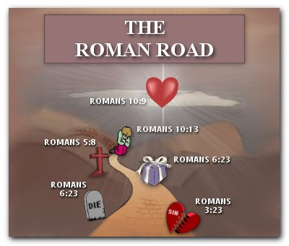

The Extent of the Atonement
(Adapted from Charles C. Ryrie, Basic Theology [Wheaton: SP Pub., 1986], 367-73)

The Question

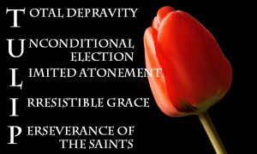
The Views

Some Important Affirmations

Exegetical Considerations

2 Peter 2:1

1 John 2:2

1 Timothy 2:4-6; 4:10

Hebrews 2:9

John 3:16

Acts 17:30

Theological Considerations

Universal Gospel Preaching

The Value of Christ's Death

Do the Nonelect Have Their Sins Paid for Twice?

The Application of Salvation
(Adapted from Charles C. Ryrie, Basic Theology [Wheaton: SP Pub., 1986], 374-78)

Conviction

What is Conviction?

Who are Convicted?

Of What are They Convicted?

How is Conviction Accomplished?

Calling

The General Call

The Effective Call

Regeneration

The Meaning of Regeneration

The Means of Regeneration

The Relation of Regeneration and Faith

The Fruit of Regeneration

Faith

The Meaning of Faith

The Necessity of Faith

The Kinds of Faith

The Facets of Faith

The Security of the Believer

Eternal Security
Will Every True Christian Really Go to Heaven—For Sure?

One of the most important questions a Christian can ask is whether his salvation is permanent. Can one who genuinely trusts Christ—and therefore inherits eternal life and a place in heaven—can that person lose this salvation? Please note that we are talking about a real believer here, not simply one who thinks he is a Christian. While Paul and other NT writers address this question, none address it as completely as John (though others are dealt with below as well).

Another introductory clarification concerns the difference between eternal security and assurance of salvation. Security refers to one’s position before God forever, whereas assurance generally indicates whether the believer has knowledge of this security. Believers can be secure without knowing it (i.e., without having assurance). My wife as a little girl once saw the water in her bathtub flow down the drain. She reasoned that since the water occupied more space than she did, if the water can all pass through the drain, then she could too. In reality, she was secure from this tragedy ever occurring, but for some time she lacked assurance of salvation from the drain. Security and assurance are different matters.

Conversely, a person can think he or she is eternally secure (i.e., feel assurance of salvation) but actually be an unbeliever with no security at all. Although assurance is a wonderful study worthy of our time, this study concerns itself with eternal security.

There are many reasons that every Christian is eternally secure:

Theological Support for Eternal Security

The Work of the Triune God

The Work of God the Father

The Father is the One who elects persons for salvation. One who says that God’s choice is ever wrong or inadequate to save is on a shaky foundation.

But if God chooses one for salvation, is this permanent? Christ answered this important question in John 6:37, “All that the Father gives me will come to me…” (emphasis mine).

The Work of the Christ the Son

Jesus protects the salvation of true believers. He declared, “My sheep listen to my voice; I know them, and they follow me. I give them eternal life, and they shall never perish; no one can snatch them out of my hand. My Father, who has given them to me, is greater than all; no one can snatch them out of my Father’s hand” (John 10:27-29).

Christ claimed that salvation is permanent. Christ promised, “Whoever comes to me I will never drive away” (John 6:37, emphasis mine).

The Sealing Work of the Spirit

The seal of salvation is God’s Spirit—not our works or continued faith or anything else. This seal shows our ownership and guaranteed protection by God.

Eph. 1:13-14 “And you also were included in Christ when you heard the word of truth, the gospel of your salvation. Having believed, you were marked in him with a seal, the promised Holy Spirit, who is a deposit guaranteeing our inheritance until the redemption of those who are God’s possession—to the praise of his glory.” Paul’s point is that if God gives us His Spirit, then He will surely give us our full inheritance in heaven!

The only way this seal could be broken is through the fault of the Spirit!

This assurance of salvation in the sealing is the reason we should never grieve the Spirit. Eph. 4:30 “And do not grieve the Holy Spirit of God, with whom you were sealed for the day of redemption.”

The Nature of Salvation

Salvation is God’s free gift and is not earned by good deeds (Eph. 2:8-9). So if it is received by grace without works then it cannot be undone by lack of works. Since security depends upon what God has done for you, this work of God would have to be undone for your security to be lost!

All believers are promised eternal life (1 John 5:11-12; Tit. 3:5-6). The term “eternal life” indicates that this life cannot be lost. If believers had the potential of possessing only “temporal life” spiritually, it would be a lie to say this life is eternal.

The Believer’s Standing before God

God sees each believer as eternally perfect before Him. Hebrews 10:14 says “by one sacrifice he has made perfect forever those who are being made holy.”

No Christian can experience God’s condemnation by going to hell. “Therefore, there is now no condemnation for those who are in Christ Jesus” (Rom. 8:1).

A believer cannot be separated from God’s love. Rom. 8:35-39 affirms this: “Who shall separate us from the love of Christ? Shall trouble or hardship or persecution or famine or nakedness or danger or sword? As it is written: ‘For your sake we face death all day long; we are considered as sheep to be slaughtered.’ No, in all these things we are more than conquerors through him who loved us. For I am convinced that neither death nor life, neither angels nor demons, neither the present nor the future, nor any powers, neither height nor depth, nor anything else in all creation, will be able to separate us from the love of God that is in Christ Jesus our Lord.”

Someone may ask, “God may not reject me, but can I disqualify myself?” The “nor anything else in all creation” noted above includes our own lack of good works or our committing of a sin which would “undo” God’s gift on our behalf. If we needed to add anything to the work of Christ on the cross, His work would be incomplete.

Biblical Support for Eternal Security

Many explicit statements in the New Testament say that our salvation is simply through belief and results in eternal life (all verses from the English Standard Version of 2002):

John 3:15-16 Whoever believes in him may have eternal life. For God so loved the world, that he gave his only Son, that whoever believes in him should not perish but have eternal life.

John 5:24 Truly, truly, I say to you, whoever hears my word and believes him who sent me has eternal life. He does not come into judgment, but has passed from death to life.

John 6:40 For this is the will of my Father, that everyone who looks on the Son and believes in him should have eternal life, and I will raise him up on the last day.

John 6:47 Truly, truly, I say to you, whoever believes has eternal life.

John 10:28 I give them eternal life, and they will never perish, and no one will snatch them out of my hand.

John 17:3 And this is eternal life, that they know you the only true God, and Jesus Christ whom you have sent.

Romans 6:23 For the wages of sin is death, but the free gift of God is eternal life in Christ Jesus our Lord.

1 Timothy 1:16 But I received mercy for this reason, that in me, as the foremost, Jesus Christ might display his perfect patience as an example to those who were to believe in him for eternal life.

Titus 3:7 so that being justified by his grace we might become heirs according to the hope of eternal life.

1 John 2:25 And this is the promise that he made to us—eternal life.

1 John 5:11-13 ¹¹And this is the testimony, that God gave us eternal life, and this life is in his Son. ¹²Whoever has the Son has life; whoever does not have the Son of God does not have life. ¹³I write these things to you who believe in the name of the Son of God that you may know that you have eternal life.

Sources for Further Study on Eternal Security

Chafer, Lewis Sperry. Grace. Grand Rapids: Zondervan, 1922. 373 pp.

Dillow, Joseph C. The Reign of the Servant Kings. Miami Springs, FL 33266: Schoettle Pub. Co. (P.O. Box 594), 1992. 649 pp.

Hodges, Zane C. Absolutely Free!! A Biblical Reply to Lordship Salvation. Grand Rapids: Zondervan, 1989. 238 pp.

Swindoll, Charles R. The Grace Awakening. Dallas, Word, 1990, 1996. 315 pp.

Stanley, Charles. Eternal Security. Nashville: Nelson, 1990. 194 pp.

Griffith, Rick. See these studies in my New Testament Survey, vol. 2 (17th edition, April 2006):
- “The Three Tenses of Salvation” (155a)
- “Theological Words in Romans” (155h)
- “Justification, Sanctification and Death to Sin” (155k)
- “The Sealing of the Spirit” (155o)
- “Eternal Security in Corinth” (161dd)
- “The Scriptural View of Justification” (174c)
- “Our Position in Christ” (180e)
- “Eternal Security in Ephesians” (180h)
- “Eternal Security in Hebrews” (266a)
- “Views on the Warning Passages” (266c)
- “Views on Eternal Security and Perseverance” (266d)
- “Romans vs. James on Justification” (272)
- “Views on Lordship Salvation” (274b-c)
- “What is the Gospel?” (317a-b)
- “Does Major Sin Prove a Person is Unsaved (Rev. 21:8)?” (350-51)

Discussion Questions

Why do you think most people have difficulty accepting the doctrine of the eternal security of the believer?

“If Christ came to seek and to save that which was lost, and yet we can somehow become unsaved—and therefore undo what Christ came to do—would it not be wise for God to take us on to heaven the moment we are saved in order to insure we make it? Isn’t it unnecessarily risky to force us to stay here?” (Stanley, 10) Do you agree?

“If our salvation hinges on the consistency of our faith, by what standard are we to judge our consistency? Can we have any doubts at all? How long can we doubt? To what degree can we doubt? Is there a divine quota we dare not exceed?” (Stanley, 95) Agreed?

Do you think believing in the “once saved, always saved” view causes Christians to neglect their salvation? Why or why not?

Eternal Security in Corinth

One issue Christians disagree about is “once saved, always saved.” Are believers genuinely saved for eternity now, or must we wait until death to find out if we have persevered enough to achieve eternal life? In other words, can a Christian find assurance of salvation?

Answers to this question typically fall into two camps. Arminian churches (Methodists, Wesleyans, Pentecostals, General Baptists, Salvation Army, etc.) emphasize free will in salvation so they teach against eternal security. However, Calvinistic churches (Presbyterians, Reformed, Particular Baptists, Brethren, Anglican, etc.) usually support eternal security. Their logic is often that those who are genuinely saved will persevere to the end of their lives and prove they had salvation all along.

A problem comes with people who claim the name of Christ but do not persevere in faith and practice. Are these people saved? At this point the church at Corinth can serve as a key test case. Corinthian believers were by far the most carnal Christians in the NT. If there ever was a church that Paul would have taught against the concept of eternal security, Corinth would have been that church—they had divisions, incest, prostitution, lawsuits, spiritual gift abuses, disbelief in the resurrection, etc.

Surprisingly, Paul affirmed the Corinthians repeatedly that they have eternal security:

Their salvation will be maintained until the Lord’s return.

“He will keep you strong to the end, so that you will be blameless on the day of our Lord Jesus Christ. God, who has called you into fellowship with his Son Jesus Christ our Lord, is faithful” (1 Cor. 1:8-9)

Even carnal believers will still enter heaven because of their saving faith but without rewards.

“If any man builds on this foundation using gold, silver, costly stones, wood, hay or straw, his work will be shown for what it is, because the Day will bring it to light. It will be revealed with fire, and the fire will test the quality of each man’s work. If what he has built survives, he will receive his reward. If it is burned up, he will suffer loss; he himself will be saved, but only as one escaping through the flames” (1 Cor. 3:12-15; cf. 2 Cor. 5:10)

They should expel the incestuous man so Satan could even kill him, but he’d still be saved.

“When you are assembled in the name of our Lord Jesus and I am with you in spirit… hand this man over to Satan, so that the sinful nature may be destroyed and his spirit saved on the day of the Lord” (1 Cor. 5:4-5)

Paul exhorts them to serve God wholeheartedly since their service would be fully rewarded.

“Therefore, my dear brothers, stand firm. Let nothing move you. Always give yourselves fully to the work of the Lord, because you know that your labor in the Lord is not in vain” (1 Cor. 15:58)

God alone secured their redemption, for He sealed them with the Spirit to assure their salvation.

“Now it is God who makes both us and you stand firm in Christ. He anointed us, set his seal of ownership on us, and put his Spirit in our hearts as a deposit, guaranteeing what is to come” (2 Cor. 1:21-22)

For further study, read Joseph C. Dillow, Final Destiny: The Future Reign of the Servant Kings, 2nd ed. (Monument, CO: Paniym Group, 2012); Charles Stanley, Eternal Security: Can You Be Sure? (Nashville: Nelson, 1990); Charles R. Swindoll, The Grace Awakening (Dallas: Word, 1990, 1996).

The Sealing of the Spirit
(cf. Eldon Woodcock, “The Seal of the Holy Spirit” Bibliotheca Sacra 155 [April-June 1998]: 139-63)

A. Agent: God is the agent of the sealing (i.e., He is the one who seals the believer), according to 2 Corinthians 1:22 (cf. John 6:27).

B. Sphere: “The Holy Spirit is the seal. The believer is sealed with or in the Spirit. In Ephesians 1:13 there is no preposition expressed” (Ryrie, 80). In other words, technically we are not sealed “by” the Spirit but “with” the Spirit.

C. Extent: All believers are sealed:

1. All the Corinthian believers (carnal and spiritual alike) were sealed (2 Cor. 1:22).

2. Christians are nowhere exhorted to seek a sealing.

3. A believer’s sealing is the basis for the command not to grieve the Spirit (Eph. 4:30).

D. Time: Since all Christians are sealed, this must happen at salvation.

E. Intent: There exist three purposes of the sealing of Christians:

1. Security: It assures that since God gave us His Spirit, He will give us our entire inheritance in heaven as well (2 Cor. 1:22b; Eph. 4:30), including redeeming our bodies (Eph. 1:13-14).

2. Ownership: It shows that God owns us (2 Cor. 1:22b, “seal of ownership”)

3. Authority: It recognizes that God has ultimate say in our lives.

Security and Assurance

Christians often use the terms “security” and “assurance” interchangeably. However, there are several important distinctions between the two.

 | Eternal Security | Assurance of Salvation
Basic Meaning | Being saved from the penalty of sin forever (once saved, always saved) | Knowing that we are saved from the penalty of sin forever
Definition | “The work of God which guarantees that the gift of salvation, once received, is forever and cannot be lost” (Ryrie, Basic Theology, 328) | “The realization of the truth of eternal security or perseverance” (Ryrie, Basic Theology, 328)
Spirit’s Ministry | Sealing (Eph. 1:13-14) | Assuring (Rom. 8:15-17)
Believer’s… | Position as child of God (Rom. 8:16b) | Practice of confidence (Rom. 8:16a)
Recipients | All Christians possess | Some Christians doubt
Permanence | Can’t be lost (John 6:39-40; 10:27-29; Rom. 8:30, 38-39; Heb. 7:25) | Can be lost (for this reason John wrote 1 John 5:11-13)
Songs | “I Know Whom I Have Believed,”  “In Christ Alone,” “The Solid Rock” | “Blessed Assurance” (#367)

Clarification: Preservation is essentially the same as eternal security, but perseverance focuses more on the believer who perseveres (though through the decree and power of God). In contrast, security focuses on God—it is God who secures our salvation (Ryrie, Basic Theology, 328).

Conclusion

A. We’re secure with the Spirit’s presence—thank Him that he’ll never leave us (Heb. 13:5)!

B. Live in holiness, recognizing God’s forgiveness.

C. You have security even if you don’t have assurance.

D. Accept and help weak believers who do not know these wonderful truths.

E. The Holy Spirit guarantees us that once we have Him, it is only a matter of time before we will have our entire heavenly inheritance.

The Nature of the Gospel

The Gospel in John’s Evangelistic Gospel

Paul’s Definition of the Gospel (1 Corinthians 15:3-5)

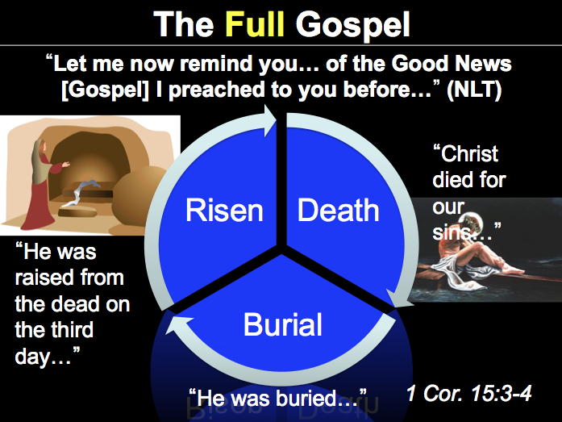

Views on Lordship Salvation

Must Christ be Lord to be Savior? Does salvation require a person to submit to Christ as master along with being the substitute for sin? Those who teach "Lordship salvation" answer "yes" but carefully note that they do not teach salvation by works or even faith plus works. Others disagree.¹

 | Lordship | Mediating | Free Grace
Key Advocate | John MacArthur | Charles Ryrie | Zane Hodges
Accept Christ as… | Savior and Lord | Savior then Lord | Savior alone
Nature of saving faith: What kind of response is required to the truth of the gospel? | Intellectual (understanding of truth), emotional (conviction & affirmation of truth), and volitional (determination of the will to obey truth)² | Intellectual and volitional (“an act of the will to trust in the truth which one has come to know” about Christ’s forgiveness and vicarious death)³ | A conviction that Jesus is the Christ who guarantees eternal life (John 11:25-27; cf. 20:30-31)⁴
Simplicity of faith | Authentic and insufficient faith are distinguished (e.g., counterfeit, temporary)⁵ | Faith is simple without various “types” as in the Lordship view | Faith is so simple it appropriates eternal life (1 John 5: 9-13)⁶
Repentance | Turning to God from sin (“change of heart and purpose”) to be saved⁷ | A “change of mind” about Christ⁸ | It “may precede salvation [but…] it need not do so”⁹; faith alone saves.
How saving faith and discipleship relate | The two should not be distinguished¹⁰ | Discipleship must begin after salvation | Discipleship may begin after salvation¹¹ but lacking it affects rewards
Post-salvation works | Demonstrate salvation¹² | Demonstrate faith | Demonstrate discipleship
Meaning of “Lord” | Sovereign master¹³ | God (deity)¹⁴ | Messianic title
One who “used to be a Christian” but no longer believes | He never was a Christian in the first place¹⁵ | A believer in Jesus Christ may stop believing¹⁶ | A believer in Jesus Christ may stop believing¹⁷
Counsel to a genuine believer with doubts | “Examine yourself to see whether you are in the faith…” (2 Cor. 13:5a) | Examine the promises of God that you are a believer (1 John 5:13) | Examine the promises of God that you are a believer (1 John 5:13)
Assurance | Conditional¹⁸ | Divinely promised¹⁹ | Unconditional²⁰
Perseverance²¹ | True believers will persevere in the end²² | Believers can fail to persevere in the end | Believers can fail to persevere in the end ²³
Carnal Christians | Possible for a time²⁴ | Possible for lifetime²⁵ | Possible for a lifetime
Key objection to the other two views | “You can accept Christ as Savior now but Lord later” produces only professing “Christians” with false assurance²⁶ | Lordship theology adds confusing and unbiblical terms to the simple gospel message | Salvation is absolutely free and as a gift it has no other condition than faith, so lordship theology distorts the simple gospel
Problems | - Blurs faith for salvation and works as disciple²⁷  - Leaves no option of an immature Christian²⁸  - Lordship has degrees²⁹  - Carnal Christians exist  - Assurance is illusive  - Experience refutes³⁰  - Denies sin unto death³¹ | Lordship advocates say true repentance is:  - a decision to change behavior³²  - part of the gospel³³  - often linked with faith³⁴  - noted alone for salvation³⁵ | Lordship advocates say:  - It overlooks the danger of false professions  - This is “cheap grace” or “easy believism”  - It has the same problems with repentance as the Moderate view
Endnotes

This study summarizes Randall C. Gleason, "The Lordship Salvation Debate," in Principles of Leadership: What We Can Learn from the Life and Ministry of Bill Bright, eds. Ted Martin and Michael Cozzens (Orlando: New Life, 2001): 377-97. The sources for the chart are John F. MacArthur, The Gospel According to Jesus (Grand Rapids: Zondervan, 1988); Charles C. Ryrie, So Great a Salvation: What it Means to Believe in Jesus Christ (Wheaton: Victor, 1989); Zane C. Hodges, Absolutely Free! A Biblical Reply to Lordship Salvation (Grand Rapids: Zondervan, 1989). The sources in the following footnotes are all cited in Gleason’s article.
2 Kenneth L. Gentry, Jr., Lord of the Saved: Getting to the Heart of the Lordship Debate (Phillipsburg, NJ: Presbyterian & Reformed, 1992), 20.
3 Ryrie, 121.
4 Hodges, 37-39. He also notes, “It is an unproductive waste of time to employ the popular categories—intellect, emotion, or will—as a way of analyzing the mechanics of faith… But is [faith] mere intellectual assent? Of course not! . . .What faith is, in biblical language, is receiving the testimony of God. It is the inward conviction that what God says to us in the gospel is true. That—and that alone—is saving faith” (Hodges, 31 italics his).
5 Earl D. Radmacher, in MacArthur, Faith Works: The Gospel According to the Apostles (Dallas: Word, 1993), 38-39.
6 Hodges, 40.
7 MacArthur, Faith Works, 88; idem., The Gospel According to Jesus, 164; cf. Gentry, Lord of the Saved, 46-47.
8 Ryrie, 99; cf. Thomas L. Constable, “The Gospel Message,” Walvoord: A Tribute, ed. Donald Campbell (Chicago: Moody, 1982), 207-8; Livingston Blauvelt, Jr., “Does the Bible Teach Lordship Salvation?” Bibliotheca Sacra 143 (Jan.-Mar. 1986), 41-42; Robert P. Lightner, Sin, the Savior, and Salvation (Nashville: Nelson, 1991), 212.
9 Hodges, 146 (italics his). On this page he notes that while repentance is not a condition for salvation, it is a condition for fellowship with God. He also notes that, while John’s gospel explicitly claims to do evangelism (20:30-31), it never once mentions repentance (Hodges, 147-48)!
10 The Lordship view claims that saving faith should not be contrasted with discipleship, including “repentance, surrender, and the supernatural eagerness to obey” (MacArthur, 30-31). Since believers in Acts were called disciples and the church’s commission is to make disciples (Matt. 28:19-20), he sees little if any distinction between the two.
11 Non-Lordship advocates often note that faith is a gift but discipleship is costly (e.g., Hodges, 67-76).
12 “Faith encompasses obedience” and “obedience is… an integral part of saving faith” (MacArthur, The Gospel According to Jesus, 173, 174).
13 MacArthur, The Gospel According to Jesus 206-10; Gentry, Lord of the Saved, 59-65.
14 Texts relating to salvation often employ the meaning of deity when the word “Lord” is used (e.g., Rom. 10:9; 1 Cor. 12:3; Ryrie, 70, 73; ibid., Balancing the Christian Life [Chicago: Moody, 1969], 173-76). While this certainly includes the concept of sovereign ruler, the difficulty with the Lordship view is that people accept his personal lordship to varying degrees, so how much submission is enough for salvation?
15 MacArthur, The Gospel According to Jesus, 17.
16 Ryrie, 141.
17 Hodges, 107-11.
18 All three positions above teach “once saved, always saved” (i.e., eternal security). While noting that assurance is available based upon scriptural promises, MacArthur also claims that it is conditioned upon the pursuit of holiness and the fruit of the Spirit (Faith Works, 202-12).
19 Some see assurance as primarily based on the promises of God’s Word but secondarily based on the evidence of a transformed life (Ryrie, 143-44; cf. Lightner, 244-47).
20 Hodges, 93-99; idem., The Gospel Under Siege (Dallas: Redecion Viva, 1981), 10. This is not to say that believers should not grow in their assurance by seeing their own spiritual growth (Heb. 6:11; 2 Pet. 1:5-11). However, assurance and security must be distinguished. Eternal security is the absolute certainty of a person’s salvation from God’s perspective. Assurance is the believer’s awareness of his eternal security.
21 Perseverance means that “those who have true faith can lose that faith neither totally nor finally,” as defined by Anthony A. Hoekema, Saved by Grace (Grand Rapids: Eerdmans, 1989): 234. Agreeing with this definition is John F. MacArthur, “Perseverance of the Saints,” Master’s Journal 4 (Spring 1993): 8.
22 MacArthur teaches perseverance by saying that true saving faith endures since “believe” in the present tense shows continuous action and the abiding quality of faith as a gift given by God (The Gospel According to Jesus, 172-73).
23 Perseverance is rejected but eternal security is accepted.
24 “The concept of the ‘carnal Christian’ as a separate category of believers is not only misleading but harmful” (Hoekema, Saved by Grace, 21). This “theory” is “one of the most perverse teachings of our generation” (Ernest C. Reisinger, Lord and Christ: The Implications of Lordship for Faith and Life [Phillipsburg, PA: Presbyterian & Reformed, 1992], 79).
25 This believer is not the same as a non-Christian since he is included in the “we all… are being transformed into the same image from glory to glory” (2 Cor. 3:18). Nevertheless, Paul says the carnal Christian does exist (1 Cor. 2:14-3:3), but since he is a “new creature” (2 Cor. 5:7) he will bear some fruit (Ryrie, 32-32).
26 MacArthur, The Gospel According to Jesus, 17.
27 Gleason, 380.
28 MacArthur raises the standard for “saving faith” too high: “It clings to no cherished sins, no treasured possessions, no secret indulgences. It is an unconditional surrender, a willingness to do anything the Lord demands… It is a total abandonment of self-will, like the grain of wheat that falls to the ground and dies so that it can bear much fruit (cf. John 12:24). It is an exchange of all that we are for all that Christ is. And it denotes obedience, full surrender to the lordship of Christ. Nothing less can qualify as saving faith” (MacArthur, The Gospel According to Jesus 140). He summarizes, “Faith obeys. Unbelief rebels… There is no middle ground” (ibid., 178). One wonders if anyone has the faith MacArthur describes. Besides, Scripture has many examples of Christians who have immature faith. The believer’s faith must grow and mature (James 1:2-4). Moses was a man of great faith but he was disciplined for his rebellion (Num. 14:9; Deut. 9:23-24). Christ even called the disciples men “of little faith” (Matt. 8:26). Since believers often rebel, God disciplines (Heb. 12:4-13) and uses trials (1 Pet. 1:6-7) to mature their faith.
29 As Christ is not the Lord of anyone in the complete sense, it is almost arbitrary to say whether someone has sufficiently accepted Him as Lord.
30 Both Scripture and the experiences of believers show many persons who were genuinely saved and yet failed to follow Christ throughout life. These will suffer loss of reward at the judgment seat of Christ and “be saved… as through fire” (1 Cor. 3:15). A classic example is Lot, who compromised his faith in God (Gen. 19) but still was deemed righteous in God’s sight in 2 Peter 2:7-8 (see Ryrie, Balancing the Christian Life, 173).
31 The sin unto death (1 John 5:16, KJV) is a sin in the life of a believer so severe that God disciplines him by taking him to heaven by loss of physical life. Such was the case with the Exodus generation (Deut. 2:14), a sexually immoral man who would potentially die so that his “spirit may be saved” (1 Cor. 5:5), and believers abusing the Lord’s Table (1 Cor. 11:30). MacArthur does not address this issue but insists that the sign of a true disciple is “when he does sin he inevitably returns to the Lord to receive forgiveness and cleansing” (The Gospel According to Jesus, 104, emphasis mine). If MacArthur is correct, then why does God take the lives of some believers hopelessly caught in sin?
32 Acts 26:20; 2 Cor. 12:21; Rev. 2:21-22.
33 Christ commanded his disciples to preach repentance (Luke 24:47). Peter and Paul preached repentance throughout their ministries (Acts 2:38; 3:19; 5:31; 8:22; 11:18; 17:30; 20:21; 26:20).
34 Mark 1:15; Acts 11:17-18; 19:4; 20:21; Heb. 6:1.
35 As only faith is sometimes noted as necessary for salvation (John 3:16; 6:28-29; Acts 13:39; 16:31; Rom. 10:9), so repentance alone is required in other verses (Acts 2:38-47; 3:19; 11:17-18). This shows that the two are opposite sides of the same coin. Such a view is supported in the Dallas Theological Seminary doctrinal statement.

Conclusion

What is the Gospel?

A student wrote to ask why it took Christ’s blood to pay for sin. With so many heresies today, his question recalls Jude’s exhortation for Christians “to contend for the faith” (v. 3). Yet how can we contend for something we don’t even understand? Below is my reply to his sincere and vital question.

What a great question you asked. I agree that too few of us stop long enough to evaluate why Christ had to die for us. We must accept it as a fact to be saved, but I think it shows maturity on your part to ask the “why” question. I'll try to answer your question in as simple words as possible.

Part of the answer relates to the balance in God between His love on one side and His perfection and fairness on the other.

Here's the problem...

God is perfect. This means He cannot stand sin. And the result for us is we cannot enter His presence with our sin. And because He is fair He must judge sin (require a penalty) so we all owe a debt to Him for our sin.

What is the penalty God requires? Our sin doesn't just separate us from a perfect God a little, so the penalty God requires for our sin is death (Rom. 6:23). This is what the Bible means when it says that His fairness can only be satisfied with the shedding of blood (death is what we all deserve).

Capital crimes deserve capital punishment. Most of the time people don't think of themselves as having committed a capital crime like murder, but we all have. We look at ourselves in comparison to one another—and we generally compare ourselves to the worst people! This way we don't look so bad.

That works fine on a human plane when we are only trying to legislate society to the degree that everyone doesn't kill each other. But when we're talking about an issue of going to heaven and being with a holy God forever we must compare ourselves to this holy God! And He says that every one of us doesn’t measure up (Rom. 3:23).

When we see things this way we finally realize that we are in an awful predicament. We really are in bad shape–even the best of us!

Here's the solution...

There's good news though! God also loves us, so how can He show His love and yet not compromise His fairness? He in His love provides a way for His fair demands to be met with a substitute for us. God allows a substitute to take the penalty we deserve (Rom. 5:8).

Can a substitute really take our place? If I killed someone, would the government allow someone else to die by hanging instead of me? I can't answer this for Singapore law. Perhaps no one has ever volunteered before! But in some societies the demands of the law do not require that the one who takes the penalty be the one who committed the crime. In such cases a substitute is allowed.

So “without the shedding of blood there is no forgiveness” (Heb. 9:22). This has always been true. In OT times the blood spilled was the blood of a lamb. The worshipper placed his hand on the head of the animal and he killed it himself. Read Leviticus 1 and you'll see that it wasn't the priest who did the actual killing. This was a graphic way to show the worshipper that sin has a price.

Of course, we now know that an OT lamb ultimately pointed to Jesus as the final sacrifice for sin. This is why Revelation 4 calls Jesus the “Lamb” with a capital “L.”
What is the Gospel? (2 of 2)

How was Jesus the ultimate sacrifice? For one, He was greater than man (lambs are lower in God's eyes than people, the crown of His creation). He was God and man simultaneously so He could bear the sin of man perfectly to satisfy the justice (fairness) of God.

Another difference is that lambs actually never sinned. There is something innocent about little, cute lambs–perhaps because they have not been tainted by sin. Only humans can sin since only humans have a conscience and an ability to choose between right and wrong. And every human has failed–all have sinned.

But Jesus was the only person that was fully human and yet without sin. He's the only one who ever passed the sin test–being tried and found innocent in every respect. Had Christ committed even one sin, He would have had to die for that sin. This would have disqualified Him from bearing our sin.

But praise God, Jesus never did commit His first sin. This allowed Him, if He died, to die for those that were under the penalty of sin. So He chose to die for us, satisfying our debt to God's fairness and simultaneously demonstrating God's love.

Isn't that the most wonderful news you have ever heard? It was to me! Now God says that for Christ's blood to apply to us we simply accept this by faith.

Why can't Christ's blood apply to everyone–even to those without faith? If He died for the whole world, why then isn't the whole world saved from the penalty of death? In OT times, the person had to express his faith to God. This was done through offering a lamb at the temple. In like manner, today faith must be expressed for forgiveness to come.

But how is faith expressed? The New Testament doesn't prescribe only one way to express faith. Typically people express faith in Christ through prayer, but the NT never actually gives us a specific prayer to use. Nevertheless, I think that prayer is probably the best way to show God that we want Christ's blood to apply to us.

What should that prayer include? Tell God you trust (believe) that Christ died for you and you want His forgiveness. This is called accepting Him as Saviour (substitute for your sin). Included in this is what the NT calls “repentance,” which literally means a “change of mind” concerning what you are trusting to save you from the penalty of sin. Don't trust your good works, church attendance, baptism, or anything else since none of these takes care of your basic problem: sin.

Sounds simple, right? Many think it's too simple–and they reject it for being too easy. In reality it is not hard at all, unless it is hard to humble yourself to the point of admitting that you can do absolutely nothing to save yourself! Notice that all these false ways people use to try to reach God (some listed above) are accomplished by us–and that can lead to pride. This is why Ephesians 2:8-9 says, “For by grace you have been saved through faith, and that is not of yourselves. It is the gift of God, not as a result of works, so that no one can boast.” There's no such thing as a proud person in heaven.

So, are you sure you have accepted the real gospel explained above? Have you expressed your trust in Christ in this manner before? If not, may I urge you to do it even today? Be sure to let me know about it.

Your friend in Christ,

Dr. Rick

PS: You may have noticed that most verses cited above are from the Book of Romans. Since this is the best full-length explanation of the gospel in the NT, I recommend you study it. However, the best short explanation of how the gospel is Christ’s death and resurrection for us is 1 Corinthians 15:1-11.

What will you do with what you have learned in this course?

Of all the things we have studied in this course, what has been the most meaningful to you personally?

What specifically do you believe that God wants you to do about this new realization you noted above?

Supplements

Views on “All Israel Will Be Saved” (Rom. 11:26)

Near the end of Paul’s three chapters on God’s election of Israel (Rom. 9–11), his argument includes this perplexing statement (11:25-27):

²⁵I do not want you to be ignorant of this mystery, brothers, so that you may not be conceited: Israel has experienced a hardening in part until the full number of the Gentiles has come in. ²⁶And so all Israel will be saved, as it is written:
‘The deliverer will come from Zion;
he will turn godlessness away from Jacob.
²⁷And this is my covenant with them when I take away their sin.’”

What does Paul mean? His declaration has been viewed in four major ways:

All Jews will be saved.

A. Support: Israel is the people of God—His elect nation (9:4, 11; 11:1, 28).

B. Response: Election of the nation does not mean the salvation of each individual in it, especially since most Jews throughout the centuries have rejected Christ. God does not have different method of salvation for Jews since they must trust Christ too (1:16-17).

All Christians will be saved.

A. Support: Paul upheld the security of the believer elsewhere (see Romans 8 studies).

B. Response: This is a theologically true statement but doubtful that Paul had it in mind here. The believer’s security is not in the context. But the main problem with this view is that nowhere does Paul ever call Christians or the church “Israel.”

All elect Jews will be saved.

A. Support: The total number of elect Jews in every generation, or the “fullness” of Israel (11:12), parallels the “fullness of the Gentiles” (11:25) in the context that refers to the total number of elect Gentiles.

B. Response: Paul’s use of the words “all Israel” ruins these parallels on “fullness.” Certainly he meant more than simply all the elect (Jew or Gentile) would be saved.

The great majority of Jews of the final generation will be saved.

A. Support: The nation of Israel will, in large part, trust in Christ at the second coming and be saved on the same basis as everyone else. This view has the best arguments for it:

1. The OT prophesies repeatedly that Israel will trust in Messiah (e.g., Isa. 2:5; 10:20-22; 25:8-9; 26:2; 29:23; 40:9; 45:17, 25; 52:3, 6-7, 9-11; 54:7-10; 62:12). Israel will be redeemed and righteous (Isa. 1:25-27; 2:3; 4:3-4; 33:24; 44:22-24; 45:25; 48:17; 63:16). Paul then is only repeating a truth known for generations.

2. This view best addresses the time element: the salvation of Israel will occur only after the “full number of Gentiles has come in.”

3. The deliverer in the quote from Isaiah 59:20 was clearly God coming from Zion. The Jewish Talmud saw Isaiah depicting the Messiah, so Paul used it in like manner to refer to Christ’s return “to those in Jacob who repent of their sins” (Isa. 59:20b).

4. The covenant “when I take away their sins” (11:27) is the new covenant initiated with Israel in the messianic kingdom when her sins are forgiven (Jer. 31:34) and the Spirit given to the nation (Isa. 59:21; Ezek. 36:27).

B. Response: How can Paul say “all” Jews will be saved if he really means “the great majority”? This use of “all” with some exceptions is common in Scripture. Besides, we cannot say for sure that literally all Jews will not repent at Christ’s return.

Illustrations to Use in Sharing the Gospel

Love

Paternal (God loves us because we are made in His image): Do you have a son or daughter? Do you love him/her? Why? (You love your child because he or she’s part of your family, made in your own image) Would you still love that child even if he/she did something wrong against your wishes? We, too, are originally part of God’s creation, made in his image. But even though we’ve turned away from Him, He continues to reach out in love to us.

Sin

Rock (All fall short of God’s standards): Let’s suppose you and I were both to pick up a rock and try to throw them to China (or some other location mentioned in the conversation). Neither of us would reach the target because it’s too far. Well, God is completely holy and perfect, so He’s target for us is perfection. None of us can claim to be without sin, so we all fall way short of His standard.

Three a day (All fall short of God’s standards): How bad are we in comparison to God’s standard of perfection? Let’s suppose you were really a relatively good person who sinned only three times a day. This includes every bad thought, word, and action. This would amount to over 1000 sins a year. Multiply this by your age and you’ll see that you have fallen much short of God’s perfect standard!

Central Business District (We have no excuse for our sin): I once drove down to a hotel on Orchard Road at 6:15 PM. As I approached the road I noticed that the big sign over the road said “Restricted Zone: In Progress.” However, it was too late to turn back and get a day pass. The police wrote down my car’s license number and three weeks later I received a ticket for $70. Even though I was sincere, even though I was ignorant of the sign until it was too late, even though I could offer other excuses, in the final analysis I had no excuse.

Archery (All fall short of God’s standards): One definition of sin is an archery term that means to “miss the mark.” There’s a bulls eye that is rarely hit. Morally speaking, God is perfect and always hits the “bulls eye.” But we always fall short of His standards.

Non-swimmers (Man cannot save himself): Suppose a ship sank but none of the passengers in the water could swim. When each turned to his friend for help, what would happen? Of course, all would die, for they would all be in the same predicament. What if each one tried to save himself by pulling himself out of the water? Death would also result. In like manner, man cannot save himself spiritually. In fact, spiritually speaking, we’re all in the water together and drowning.

Death

Capital Punishment (Certain sins result in death)
In Singapore the government has established various laws to punish those who sin. If one is caught with a certain amount of drugs in his possession at the airport, the law says that person must die. Why? To uphold standards for society. God’s standards are even higher than the government’s and He says that sin must result in death.

Wages (We have all earned death): Suppose you were to work for me for a day and I pay you $50. This would be your wages since it represents what you have earned. The Bible says that because of our sin we have all earned death as our wage (Rom. 6:23).

Substitution

Book (Christ bore the weight of our sin upon Himself): Your sin weighs upon you just like this book weighs down my hand. But my other hand represents Jesus, and God desires to take this weight off of you to place it on Jesus (turn book over and place on other hand).

Cancer (Christ exchanges His goodness for our sin): Suppose you had cancer and through some medical means I was able to take your cancer cells into my own body in exchange for my good cells into your body. What would happen to me? Right, I would die. What would happen to you? Yes, you would live.

Kai (Christ gave His blood for us)
During the Vietnam War there was an orphanage located near an American Marine Base. One day the Viet Cong fired mortar shells into the orphanage, killing dozens of children and wounding many more. A boy name Kai had a seriously wounded friend who needed a blood transfusion. Kai’s friend had a rare blood type and only Kai’s blood matched it. Little Kai had never heard of a blood transfusion before but when the American doctors explained it would save his friend’s life, little Kai volunteered. As Kai’s blood began to flow to his friend, Kai began to whimper. When the doctors asked if it hurt, he said no. A little later he whimpered again. Again he told the doctors it did not hurt. Finally the doctors asked, “What’s wrong, Kai?” With tears coursing down his light brown, dusty cheeks, Kai asked, “When am I to die, sir, when am I to die?” You see, little Kai did not know that he was to give only a portion of his blood. He thought he would give it all, and he was willing to die for his little friend.

Snake (Christ took the cause of our death upon Himself): A poisonous snake once bit a little girl in her backyard. Seeing that the girl would be dead in just a few minutes, the girl’s mother cut her daughter’s leg and sucked out the venom. The girl lived, but the poison killed the mother, who in effect had died as her daughter’s substitute.

Drawbridge (People take for granted Christ’s death for them): A man once had a job to lower a drawbridge twice a day at 8:00 AM and 4:00 PM for people to take a train over a river to and from work. He had a young boy whom he loved very much that was too young for school so he often accompanied his father up to the switching station. They would often wave to the train passengers as the train passed by. One day at about 3:45 while the bridge was up the man lost track of the whereabouts of his son, who had wandered off. He looked for him panicking for several minutes but had to give up the search as the train was coming at full steam towards the raised drawbridge. He made it back to the switching house in time enough to lower the bridge, but just as he reached for the lever he spotted his son, far down below him—in the midst of the gears! The father had to make a split second decision—either to leave the bridge up and cause the train to hit the raised drawbridge and crash into the river, or to allow the gears to crush his only son to save the train passengers. With pools of tears in his eyes and great anguish in his heart he lowered the drawbridge, crushing his small boy in the powerful gears. The people on the train safely passed by as usual, unaware of the great cost to save their lives. Those of us on earth are aware of an even greater cost to save us—the precious Son of the Father—who was crushed for our sins. Yet we often act like the passengers and glibly cast aside the tremendous sacrifice on our behalf.

Judge (God balances his fairness with mercy): A judge once had a boy come before him for sentencing only to discover that the lad was his own son. In order to be fair to the law, he set the fine at the appropriate amount, but then did something quite unusual. Laying down his legal robes, he came down from the bench and paid the fine himself to the officer, thus satisfying the legal requirement while at the same time being gracious to the one he loved. In like manner, Christ also saw our awful predicament in our disobedience, except in our case the penalty was much more severe—death itself. But Jesus laid aside his royal robes as God and came and paid that death penalty himself, thus satisfying the penalty and showing us his grace.

Twins (Satisfaction for sin has been paid by Christ): Suppose you killed someone and ran away, then the dead person’s family members came looking for you for revenge. However, your twin brother/sister loves you very much and delivers himself/herself over to these people, who vent their anger by killing him/her. This would satisfy the anger of the relatives and save your life.

Soldier (Christ died for ungrateful, ungodly people): A promising, young, American lieutenant graduated from West Point Military Academy and soon found himself leading a group of recruits to fight the Viet Cong in Vietnam. One night they confronted the enemy who wounded one of their men. The rest ran for cover in a trench where they stayed all night, listening to the groans of the dying, wounded soldier a few feet away. Finally, the lieutenant could not bear to hear the groans of his friend any longer and risked his life to save the man. He successfully pulled him back to the trench, but as he was about to hop in himself he was shot in the back and killed instantly. Sometime later, back in the US, the brave lieutenant’s parents heard that the young soldier whom their own son had saved was in town. The surviving soldier came to their home late, drunk, using profanity and insensitive to the great cost given for his own life. After shutting the door behind the young soldier the bereaved mother could only say, “I gave my own precious son to save that wretch of a man?” Likewise, the Father gave his precious Son, Jesus Christ, to save an ungrateful, profane, race like ours.

Gift

Birthday (Seeking to earn our salvation insults God): On your birthday people give you gifts, don’t they? Have you ever insisted upon paying for a gift? How do you think your friend or relative would feel if you did this? How do you think God feels when He offers us eternal life for free but we insist that we must pay for it (by our good works, baptism, church attendance, money, religious rituals, etc.)?

Pencil (The gift of salvation must be received to apply to us): I would like to give you this pencil for free (extend it to the person). If you pay me 10¢ or any price for it, it’s not a gift. If you work for me in any way it’s not a gift. It’s simply yours—you just need to receive it.

Faith

Jet (Christ is trustworthy): Let’s suppose I was employed by the ticket counter at an airport in a poor country to lead you to your jet to get you back home. So I lead you to a jet that hadn’t been painted for years, had oil leaking out of the back, had part of a wing broken off, and had a hole in three of the windows? How would you feel? When you hesitate, I simply reply, “Oh, don’t worry. Just have faith and this jet will get you to Singapore!” The important thing isn’t the amount of your faith, it’s the condition of the jet!

Ice (Christ is trustworthy): If you walked out on a lake frozen over with ice 1 millimeter thick, what do you think would happen? Of course, you’d fall in! What if you really sincerely believed that the ice would hold you up? Yes, you’d still fall in! How about if the ice was 1 meter thick, would it hold you up? Even if you had very little faith that it would? You see, the issue is not how much faith you have, it’s what or whom you place your faith in! Many people are sincerely trusting “thin ice” to sustain them in this life and the next, but it won’t work. On the other hand, even if you place the little faith that you have in Christ, you place this trust in the right source. He’ll sustain you.

Chair (We all exercise faith everyday): Have you ever personally met the designer of this chair? (pause for answer) When you sat down on this chair you exercised faith.

Doctor (Faith can be placed in Christ because of His credentials): Once my wife got very sick and I took her to the hospital. When the doctor gave her some pills to take, she simply took them without asking any questions at all! Can you imagine that? She had never seen the man before, we had never been to this hospital before, and we didn’t know who made the pills or even their chemical composition! Why would she do such an outrageous thing as take a pill which, for all she knew, could have been poison? (pause for answer) This was a simple act of faith in the credentials of one whom the hospital had deemed competent. As my wife found the doctor competent to meet her physical needs, I have found Jesus Christ competent to meet all of my spiritual needs.

Pilot (Faith can be placed in Christ because of His credentials): Have you ever taken a plane ride? Did you personally know the pilot of the jet? No, you exercised faith in this person to get you to your destination without ever knowing him.

Niagara (Biblical faith is a commitment—not simply intellectual assent): A famous tightrope walker once performed the greatest feat of his career by walking across Niagara Falls with only the aid of a balancing bar. The crowd was very enthusiastic! “Do you think I can do it without the balancing bar?” he asked in response. The crowd cheered him on, so he did it. “How many feel I can take a wheelbarrow across and back?” The crowd went wild again, “Yes! You can do it!” they yelled. So he went back and forth with a wheelbarrow. “Who believes I can do it again with a dog inside?” the tightrope walker shouted. “We do!” Responded the crowd, so a dog was brought over, placed in the wheelbarrow, and the two made another successful trip. “Now who believes that I can do it with an even heavier load within the wheelbarrow—with the weight of a person inside?” he asked. By this time the crowd was ecstatic and going wild. “Any volunteers?” came the request. (pause) No one volunteered! They believed intellectually that he was able to take them across, but they were not committed to this belief. In like manner, many people intellectually believe Christ can take them to God but they are unwilling to commit themselves to that belief. Such belief without personal commitment is not genuine belief.

Circles (Biblical faith is a commitment—not simply intellectual assent): Two circles can be used to represent two kinds of life. Trusting Christ means being willing to turn your life over to Him to let Him direct your life. (See Four Spiritual Laws)

Modern theistic evolutionists include Francis S. Collins, The Language of God: A Scientist Presents Evidence for Belief (Free Press: 2006); Vernon Blackmore and Andrew Page, Evolution: The Great Debate (Oxford: Lion, 1989); R. J. Berry, God and Evolution: Creation, Evolution and the Bible (London: Hodder & Stoughton, 1988; idem, Adam and the Ape: A Christian Approach to the Theory of Evolution (London: Falcon, 1975). John Morton, Redeeming Creation (Auckland: Zealandia, 1984), 11 even calls evolution the Christian’s “cornerstone”!
Duane T. Gish, The Amazing Story of Creation (El Cajon, CA: Institute for Creation Research, 1990), 44. This excellent, illustrated, 112 page full-colour book critiques evolution in simple language (SBC library # 213 GIS). See also his earlier books, Dinosaurs: Those Terrible Lizards and Evolution: The Challenge of the Fossil Record.
Gish, 44.
Gish, 78-79. The following examples are summarized from pages 78-83.
Dr. Solly Zuckerman (head of the Department of Anatomy, Univ. of Birmingham, England) and Dr. Charles Oxnard (Prof. of Anatomy and Director of Graduate Studies at the Univ. of Southern California Medical School) both confirm that Australopithecus did not walk upright like humans and were not man’s ancestors. Zuckerman’s conclusions are published in his book, Beyond the Ivory Tower (1970). See Gish, 84.
David H. Lane (a biologist in Wellington, New Zealand) has published a two-part series entitled “A Critique of Theistic Evolution.” Part one is “Special Creation or Evolution: No Middle Ground,” Bibliotheca Sacra 150 (January-March 1994): 12-16. Part two is “Theological Problems with Theistic Evolution,” Bibliotheca Sacra 150 (April-June 1994): 155-74, which forms the basis for the comments in points “b” to “e’ in this section.
Alan I. Richardson, Preface to Bible Study, rev. ed. (London: SCM, 1972), 75; cf. Blackmore and Page, 171; Martin Bott, “Down to Earth,” in Real Science, Real Faith, ed. R. J. Berry (Eastbourne: Monarch, 1991), 28-29.
Blackmore and Page, 171.
Michael R. Johnson, Genesis, Geology and Catastrophism: A Critique of Creationist Science and Biblical Literalism (Exeter: Paternoster, 1988), 87; E. K. V. Pearce, Who Was Adam? (Exeter: Paternoster, 1969). Those who lived before Adam died not as a penalty for sin since they were “sinless” in that they had no fully evolved morality.
Douglas C. Spanner, Biblical Creation and the Theology of Evolution (Exeter: Paternoster, 1987), 57-59.
Berry, God and Evolution, 70.
Lane, “Theological Problems with Theistic Evolution,” 171.
Ibid, 90.
Ibid, 70; idem, Adam and the Ape, 51.
Berry, 159.
The Reformed view allows for temporary lapses into a carnal (worldly) state, but it assumes that these will always be rectified before death so that no true believer can die in rebellion with God.
Apostasy refers to a true Christian denying the faith in word or deed. This cannot happen in the Reformed view because perseverance is upheld. Instead, what appears to be a denial of one’s personal faith is evidence that the person was never a Christian in the first place (only a “professing Christian” but in reality an unbeliever).
Eternal security means “once saved, always saved” so that salvation could never be lost, either through the fault of the believer or of God. Security is God’s work of preserving each person by His own grace and choice. This doctrine keeps a consistent meaning to “eternal life,” for to lose “eternal life” is nonsense if it never was eternal. One cannot possess temporary “eternal life” that can be lost!
4 Assurance of salvation means the believer can know with 100% confidence that he will go to heaven at death because the work of Christ on his behalf has forgiven any sin that could be committed. Since the Reformed view teaches that all believers will persevere and no one ever knows until death whether he will continue believing until death, this results in a continual state of lack of assurance of salvation, even though a true believer’s eternal security is guaranteed. Dillow calls the scholar advocating the Reformed view “the Experimental Predestinarian” due to that scholar’s insistence upon perseverance in good works. This term is used because, even though one might be predestined (elect, chosen) for salvation, no one can tell if a person has persevered until that person’s “experiment” of life is completed at death (Dillow, 12-17). ⁵ Dillow calls his view “partakers” or “partner” based on Hebrews 3:14, “For we have become partakers [lit. partners, Gr. metochoi] of Christ, if we hold fast the beginning of our assurance firm until the end.” “The Partner perseveres in good works to the end of life” (Dillow, 18). Paul uses the synonym in 1 Corinthians 9:23, “I do all things for the sake of the gospel, so that I may become a fellow partaker [Gr. synkoinonos] of it.” The Partaker receives his inheritance in the future millennial kingdom as Christ’s partner, reigning with Him.

