SOTERIOLOGY WORD OF LIFE Bible Institute, NE Asia (Jeju, Korea)
Quarter 4, May-June 2020 Professor: Dr. Rick Griffith

Professor

Dr. Rick Griffith is Doctor of Ministry (DMin) Director at Singapore Bible College, where he has taught Bible, theology and preaching since 1991. He also helped start a K-12 international school (ics.edu.sg) and church (cicfamily.com). Rick trains pastors in Mongolia, Sri Lanka, Nepal, Myanmar and restricted nations. His Advanced Studies in the NT and OT courses are at internetseminary.org, and 8000 pages of his notes and 165,000 PowerPoint slides can be downloaded in 49 languages at BibleStudyDownloads.org. His ThM and PhD are from Dallas Seminary. Dr. Rick and his wife Susan are missionaries with WorldVenture. Their sons Kurt (33) & his wife Cara, Stephen (30) & his wife Katie & 1-year-old son Jesse, and John (27) live in the USA. Susan has a vibrant ministry of training student wives from China, India, Indonesia, and other restricted countries.

Scope

God’s rescue plan for humanity is immense! Therefore, in our short 8-hour course, we will only hit the tip of the iceberg. This will start with God’s original order before salvation was even needed, moving to man’s fall, and the various stages of God’s program to redeem humanity. Also included will be a survey of the key interpretive views of Calvinism (Reformed), Arminianism (Wesleyan), and the modified Calvinist or Partakers View.

Purpose

Two areas of theology vital to our ability to understand and serve the Lord are Hamartiology (study of sin) and Soteriology (study of salvation). The first proves the need for the second, or, as my evangelist friend says wisely, “You gotta get them lost before you get them saved!” The course is immensely important in the Word of Life curriculum as it shows the need for and the nature of the gospel that we are to preach to the nations.

Objectives

By the end of the course you should be able to …

Understand the original nature of man in his sinless state co-ruling with God.

Explain the impact that the Fall of Man had on humanity.

See the progressive plan of God to rescue us from our dilemma.

Critique the three major interpretive approaches to salvation: Calvinism (Reformed), Arminianism (Wesleyan), and modified Calvinism (Partakers).

Feel awed at the glory of heaven and the privilege of heaven as our future home!

Make any needed changes in your life to appear before Him unashamedly.

Each of the above objectives except the last two is measurable and thus will be assessed on the quizzes and the final exam.

Procedures

Reading from the class notes, Bible (translation of the student’s choice), and course text will be required each class day. The main book to read is the Salvation section (65 pages) of Charles Ryrie, Basic Theology, 2nd ed. (Wheaton, IL: Victor Books of SP Publications, 1999).

Quizzes over the reading assignments will be given at the beginning of two mornings. These will be short (15 minutes) with 5-10 objective questions, such as multiple-choice, true-false, matching, and fill-in-the-blank questions. Note that the questions come only from the readings, though several issues will also be discussed in class as well. Therefore, be familiar with both the biblical texts and also Ryrie’s comments on them.

The Final Exam will assess your comprehension of the course notes and class discussions only (not the readings). This exam will be a combination multiple-choice, short answer, fill-in the blanks, and matching exam. You will not be asked about Ryrie’s viewpoint, as this will already have been covered in the quizzes. However, I encourage you to still study the quizzes as these show the most important issues related to the study of salvation.

Grading

1. Reading Ryrie/notes Read 1 time for full credit = 20 points
2. Quizzes 20 points each x 2 quizzes = 40 points
3. Final Exam 40 points after the course = 40 points
Total 100 points

The reading total of 20 points is figured as follows:

Ryrie’s Book & Class Notes:
100% _____ (20 Points)
only 75% _____ (12 Points)
only 50% _____ (8 Points)
only 25% _____ (4 Points)

Supplemental Bibliography
The required reading of Ryrie is an excellent starting place for studying salvation. However, I hope this is only the beginning of your study in this fascinating subject, so I have added some other books here, some of which are in the WOLBI library (though the presence of a book in the WOLBI library does not necessarily indicate WOLBI's agreement with the contents). The following books are the best that I know about to study salvation, even though I do not agree with their conclusions. I have listed them in order of preference, also happens to be their alphabetical order.

Dillow, Joseph C. Final Destiny: The Future Reign of the Servant Kings. 2nd ed. Monument, CO: Paniym Group, 2012. 1093 pp. US$50 pb.
A massive volume of 66 chapters articulating a mediating position between the Reformed and Arminian views on the NT that Jody Dillow calls the “Partakers” view, based on Hebrews 3:14. Argues for eternal security (Reformed) but against perseverance of the saints (Arminian).

Hodges, Zane C. Absolutely Free! A Biblical Reply to Lordship Salvation. Grand Rapids, MI: Academie Books of Zondervan, 1989.
Responds to John MacArthur’s book below with the “free grace” view that claims that visible fruit need not be present in a believer’s life after salvation.

Ryrie, Charles C. So Great a Salvation: What It Means to Believe in Jesus Christ. Wheaton, IL: Victor Books of SP Publications, 1989.
Responds to John MacArthur’s book below with the “moderate” view that claims that visible fruit should be present in a believer’s life after salvation.

MacArthur, John F., Jr. The Gospel According to Jesus: What Does Jesus Mean When He Says, “Follow Me”? Grand Rapids, MI: Academie Books of Zondervan, 1988.
Presents what has often been called the “Lordship Salvation” view that claims that visible fruit must be present in a believer’s life after salvation.

Stanley, Charles. Eternal Security: Can You Be Sure? Nashville, TN: Nelson, 1990.
Pastor Stanley replies to the question with an emphatic Yes! This is a very readable, non-technical treatment of this important subject.

Schedule (Reading Report for 10-18 June 2020)

Name # Reading Grade Course Grade

Please tick the last column if completed in full on time and then summarize this at the bottom. Note that the order of the course follows Ryrie’s Basic Theology, 319-92.

Session | Day | Subject | Assignment | 
1 | W 6/10  10am | 00-Dr Rick Kahoot in Class  01-Soteriology Syllabus  • The Tenses of Salvation  • Why Would God Want to Save Sinners?  02-Creation & Fall: The Need for Salvation | None
2 | W 6/10  11am | 03-The Biblical Terminology  • The Whole Bible on Salvation  • Salvation in the OT  • Salvation Terms in the NT | Ryrie, 319-20
 |  | 06-Justification & TULIP Kahoot
3 | Th 6/11  10am | 06-Justification | Ryrie, 321-54
4 | Th 6/11  11am | 07-Our Position in Christ | Class Notes, 37-41
 |  | 07-Soteriology Basics Kahoot
5 | T 6/16  12pm | 09-Perseverance  Quiz 1 on Sessions 1-5 | Class Notes, 42-48
 |  | 08-Mosaic Law Kahoot
6 | W 6/17  1130am | 08-The Christian and the Mosaic Law | Ryrie, 355-78 Atonement & Election
 |  | 10-13 Atonement, Election, Application, Assurance Kahoot
7 | Th 6/18  10am | 14-The Eternal Security of the Believer | Ryrie, 379-86  Class Notes, 61-67
8 | Th 6/18  11am | 15-The Inheritance of the Believer  Quiz 2 on Sessions 6-8 | Class Notes, 42-48  Submit this sheet
 |  | 14-15 Security & Inheritance Kahoot
 |  | Final Exam | Study for Final Exam
 |  | Omitted but Covered in 12-Session Course:
 |  | 04-The Death of Christ (Good Friday is Good)  05-The Meaning of the Death of Christ | Ryrie, 321-28  Ryrie, 329-42
 |  | 10-Theories of the Atonement  11-The Doctrine of Election | Ryrie, 355-57  Ryrie, 358-66
 |  | 12-The Extent of the Atonement  13-The Application of Salvation | Ryrie, 367-73  Ryrie, 374-78
 |  | 16-The Nature of the Gospel  • John’s Gospel  • 1 Corinthians 15:3-5 | Ryrie, 387-92
• Views on Lordship Salvation
• What is the Gospel?

The reading total of 20 points is figured as follows:

Ryrie’s Book & Class Notes:
100% _____ (20 Points)
only 75% _____ (12 Points)
only 50% _____ (8 Points)
only 25% _____ (4 Points)

Note that the dark horizontal lines separate the course by days but the sessions that are quizzed are different sessions. For example, Quiz 1 will cover sessions 1-4, but session 5 will be assessed on Quiz 2 rather than Quiz 1, even though session 5 may have preceded the Quiz 1.

Please submit this page or a photocopy of it once you have completed your reading, or at the latest on Friday next week.

My Biographical Sketch

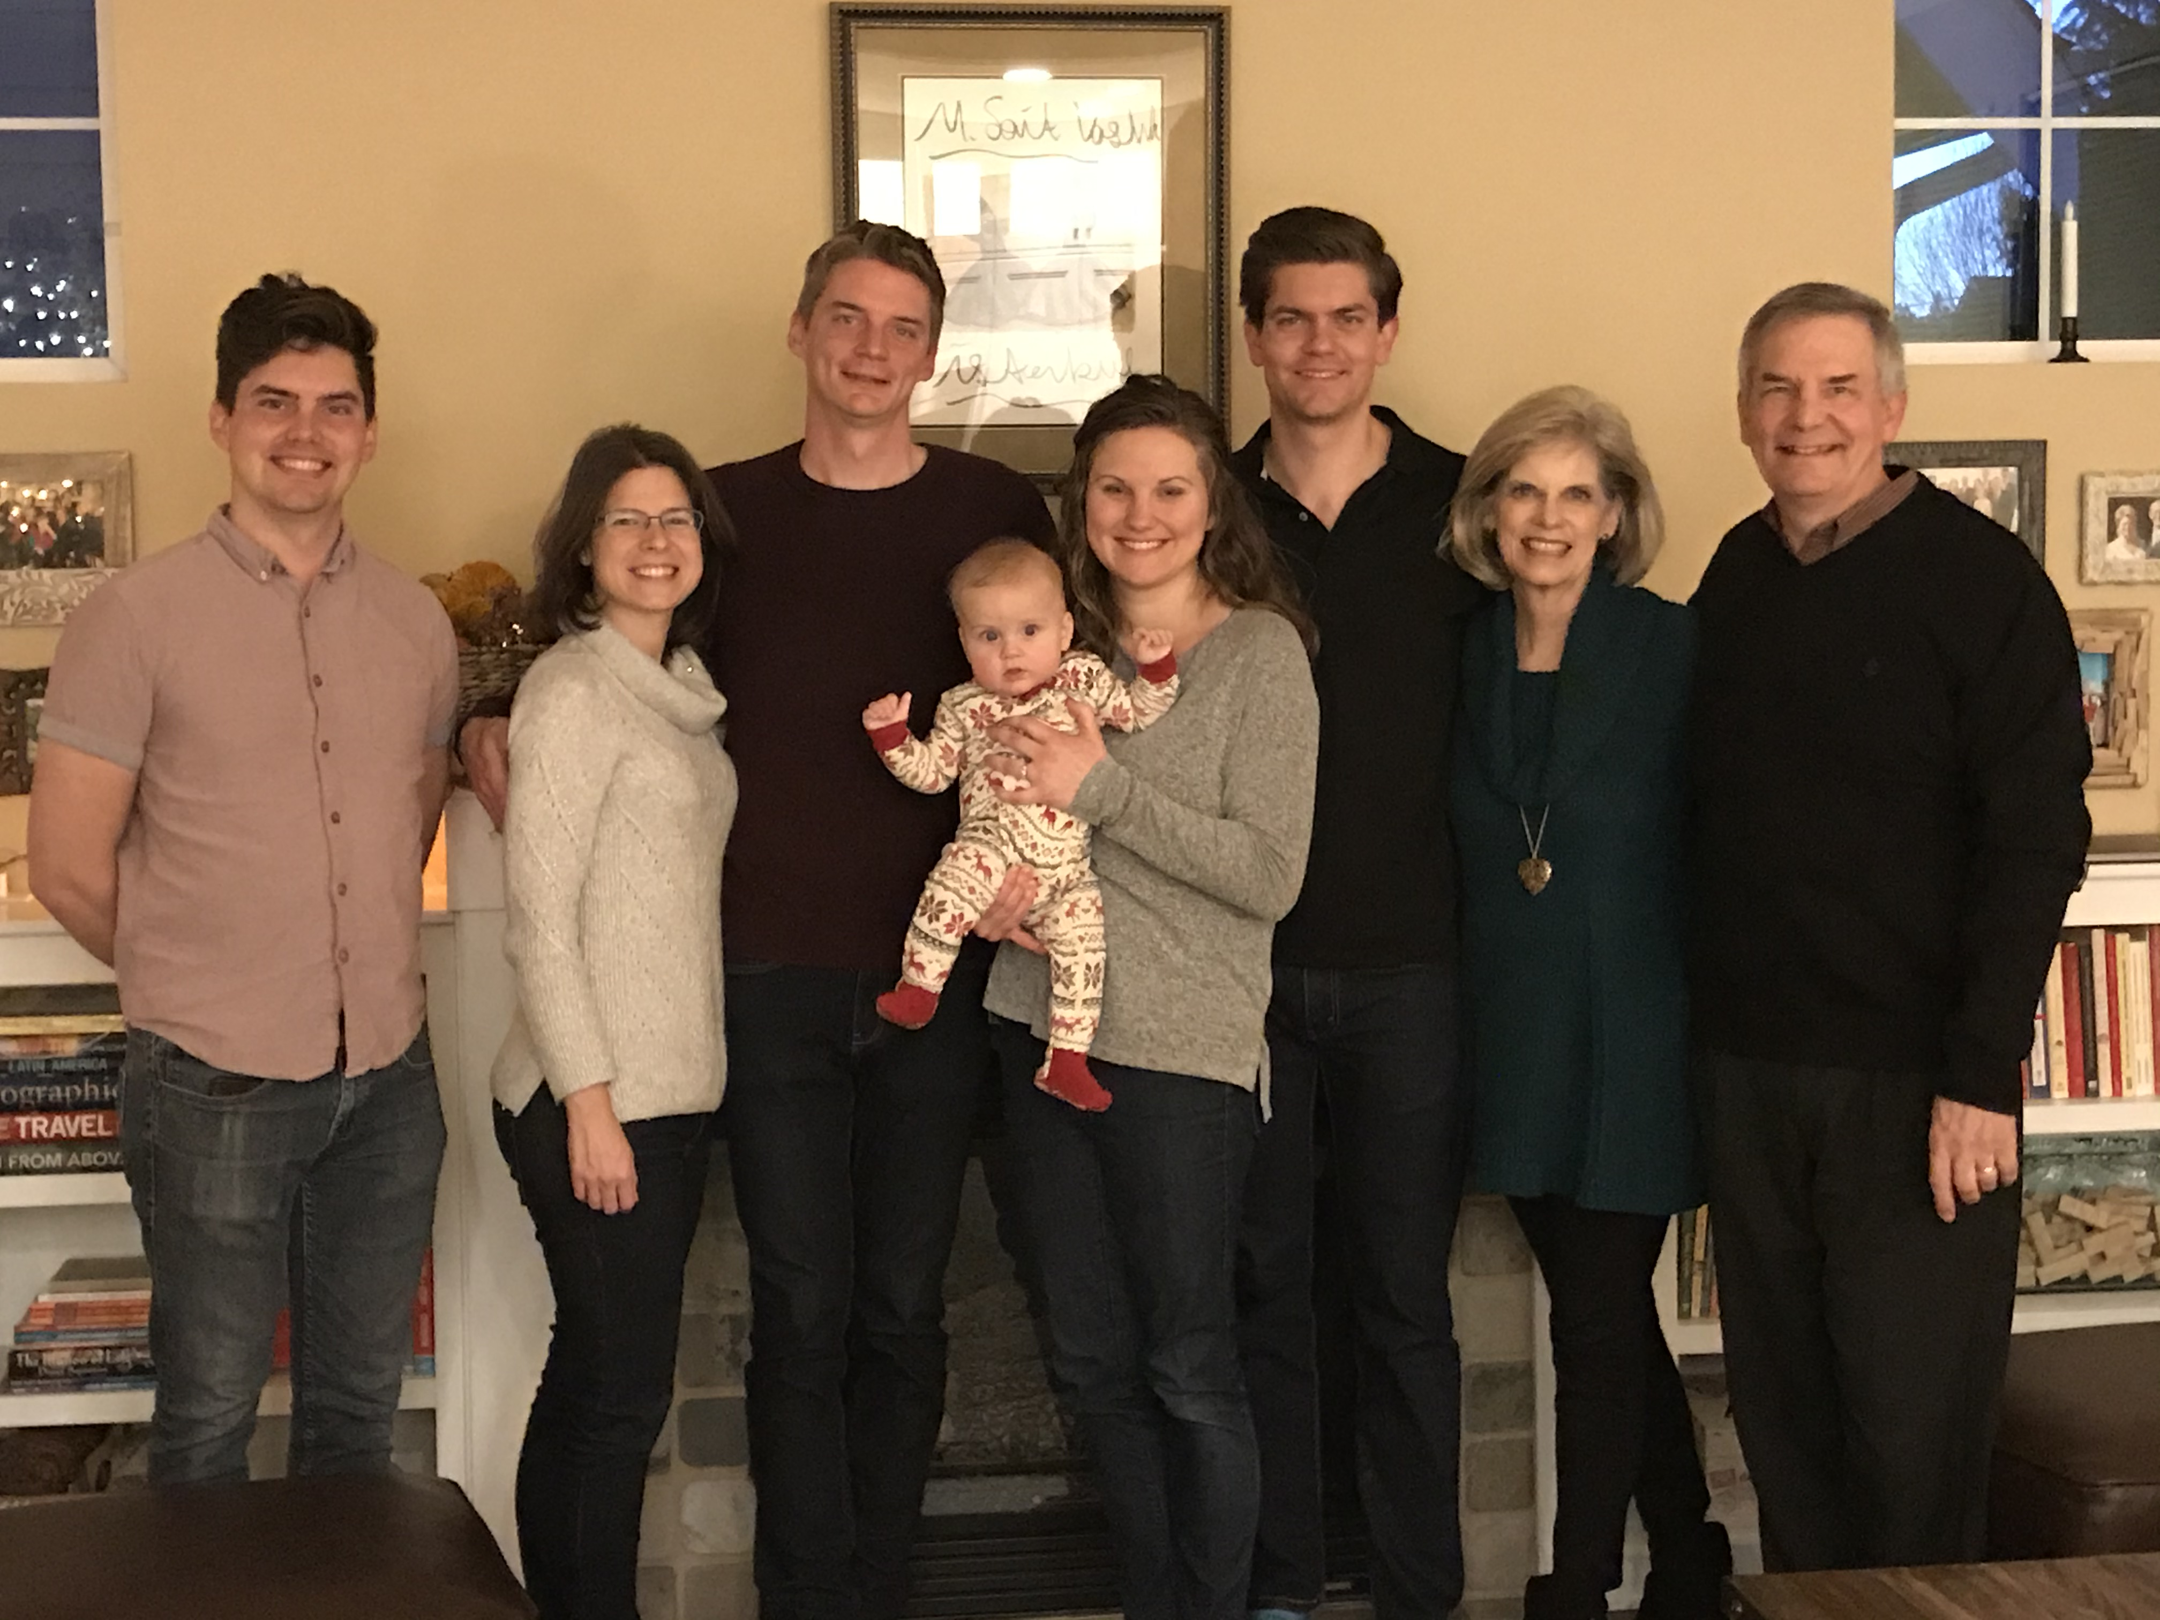

The Griffith Family

John (27), Kurt & Cara (33), Stephen & Katie (30) & Jesse (8 months), Susan & Dr Rick

Background

“Never say ‘never.’” Rick and Susan Griffith both learned this age-old tip the hard way.

Rick recalls sitting in his elementary school classes thinking, “If there’s one thing I’ll never become it’s a teacher. Imagine saying the same stuff over and over, year after year!”

Yet after trusting Christ in junior high and beginning to teach the Word of God, Rick’s attitude began to change. After his business degree at California State University, Hayward, and Master of Theology degree (Pastoral Ministries) and the Doctor of Philosophy degree (Bible Exposition) from Dallas Theological Seminary in Texas, Dr. Griffith soon found himself on the other end of the classroom—and loving it!

Susan, from Yucaipa, California, also learned not to say “never.” As she earned her Bachelor of Arts degree in piano at Biola University, several friends married and worked to put their husbands through three more years of seminary training. “I’ll never do that!” she exclaimed. Soon afterwards she invested three years (1981-1983) singing together with her future husband in the Crossroads, Campus Crusade's traveling music team in Asia. This nine member Philippines-based group shared Christ in the Philippines, China, Hong Kong, Korea, Japan, Macau, Thailand, Malaysia, Indonesia, and Singapore.

In December 1983 Susan’s “never” became a reality. She and Rick were married and like Jacob and Rachel of old, Susan also worked for her mate. During these seven seminary years Rick served as a pastor, corporate chaplain, and International Students church consultant. Susan taught women's Bible studies and often ministered by singing. Their primary church in Texas is Christ Chapel Bible Church in Fort Worth.

They have three sons: Kurt (33 yrs.) works with business analysis wife Cara in Seattle at their consulting company called Tandem Motion, Stephen is a pilot (30 yrs.) with his counselor wife Katie (also Seattle) with grandson Jesse (born 14 May 2019), and John is a graphic designer in California (27 yrs.).

Ministry

However, since 1991 the Griffiths’ home has been Singapore where Rick serves as Doctor of Ministry Director with 26 other full-time faculty at Singapore Bible College. SBC has 495 students from 26 countries and 25 denominations, as well as many professionals in its Certificate of Church Ministry studies. He began by teaching Old and New Testament Survey, Old and New Testament Backgrounds, Eschatology (the study of future things), Evangelism, Pastoral Epistles, Psalms, Homiletics (preaching), Hebrew Exegesis, and four Old Testament exposition courses. Then for years he also taught Pentateuch, Gospels, Eschatology (theology of the future), Ecclesiology (theology of the church), and Pneumatology (theology of the Holy Spirit). Now he teaches mostly Bible Exposition classes, including Homiletics, OT Foundations, and OT & NT Survey. He has also written three Advanced Studies in the Old and New Testament courses at Internet Biblical Seminary (www.internetseminary.org).

Dr. Griffith loves the variety and strategic nature of his teaching. He invests his life into Anglicans from Sri Lanka, Lutherans from Singapore, Presbyterians from Korea, Conservative Baptists from the Philippines, and missionaries from Campus Crusade, OMF, and Operation Mobilisation—sometimes all in one class! One class had 17 of the 20 students training for ministry outside of Singapore. Nearly all SBC graduates enter pastoral or missionary ministries due to Asia’s shortage of trained leaders.

Ministry opportunities abound. Rick and Susan have conducted premarital counseling for students and their home has an open door to students and guests traveling through Singapore. They have sung in evangelistic thrusts and in 1992 also participated in founding International Community School, an expatriate Christian primary and secondary school in Singapore now with 480 students. The Griffiths are missionaries with WorldVenture and Rick serves as the Singapore field leader.

Dr. Griffith also enjoys several other partnerships. He also serves as Asia Translation Coordinator for "The Bible... Basically International" seminars; web author & editor, Internet Biblical Seminary; and itinerate professor for 62 trips throughout Asia in places such as Lanka Bible College (Sri Lanka), Myanmar Evangelical Graduate School of Theology, Union Bible Training Center (Mongolia), Jordan Evangelical Theological Seminary, and Biblical Education by Extension training in three restricted access countries.

In 2006 Dr. Rick began Crossroads International Church, Singapore. Here “Pastor Rick” serves as pastor-teacher. The church worships at the Metropolitan YMCA at 60 Stevens Road. See cicfamily.com.

In 2009 Dr. Rick began BibleStudyDownloads.org to offer his courses for free download. It has 17,000 pages of course notes in Word and pdf, and especially over 67,000 PowerPoint slides in English, and translations comprising 104,000 PowerPoint slides by his students into 49 languages, such as Ao, Arabic, Bangla, Bisaya, Burmese, Chin, Chiru, Chinese, Dutch, English, French, German, Gujarati, Hindi, Ilonggo, Indonesian, Japanese, Kachin, Karen, Khmer, Kiswahili, Korean, Lotha, Malay, Malayalam, Mao, Mizo, Mongolian, Moyon, Nepali, Nias, Paite, Portuguese, Rongmei, Russian, Sinhala, Spanish, Sumi, Tagalog, Tamil, Tangkhul, Tenyidie, Thai, Vaiphei, and Vietnamese.

Field

SBC is strategically located in Singapore at the “ministry hub” of Southeast Asia. The population of this multi-cultural society is 75 percent Chinese, 15 percent Malay and 8 percent Indian. Other groups include Filipinos, Thais, Japanese, Americans, and Europeans. The Singaporean cross-cultural missionary force is increasingly contributing to God’s work in overseas ministries.

Passion

Rick’s passion is for God’s leaders to preach and live the Word of God as God’s servants:
- Teaching obedience to Christ’s teaching is key to our commission to make disciples (Matt. 28:20)
- Paul’s legacy to Timothy focused on exposition: “Preach the Word” (2 Tim. 4:2-3; cf. Acts 6:1-16)

However, recent trends include the following:
- Church people are biblically illiterate in a “famine for hearing the words of the Lord” (Amos 8:11)
- Attempting to be “relevant,” pastors preach what people want to hear—not what they need

