The Theme of the Old Testament

I. The Problem

A. It’s helpful to know various facts about the Old Testament such as when the people lived, what they did, lessons we can learn from them, etc.

B. However, often we can “get lost looking at the trees without ever seeing the forest.” So before we discuss this issue as a class let’s first get your opinion.

C. In the next 5 minutes write out what you consider to be the theme of the Old Testament in the space below. In other words, what is the OT all about? What is it trying to prove? By all means use your Bible to look up key passages. Try to avoid reading the New Testament into your definition so that it sounds like a NT theme. Make this an OT theme, O.K.?

1. My View

2. Other Views in the Class

II. Solutions (cf. also Gerhard Hasel, Old Testament Theology, 3d ed. [Grand Rapids: Eerdmans, 1982], 117-43)

A. Redemption of Man (Salvation History or Soteriological Purpose)

1. Proponents: J. Barton Payne, The Theology of the Older Testament (Grand Rapids: Zondervan, 1962), 3; Graeme Goldsworthy, According to Plan (Leicester, England: IVP, and Homebush West, Australia: Lancer, 1991), 8; Hasel, 141 (but see him under the “God” and “No Center” views below). This is popular at SBC as well.

2. Statement: The Bible has at its focus the salvation of mankind (as many as will believe) through Jesus Christ. Similar to this theme is viewing the centre of biblical revelation as missiological (e.g., “I do all things for the sake of the gospel”1 Cor. 9:23; cf. John 4:34).

3. Critique: Redemption is prominent in the NT but is an external structure imposed on the OT from systematic theology and focuses too much on man rather than God. Also, while Christ is the central person of the Bible, the OT emphasizes him as King more than as Saviour (there is very little emphasis in the OT on the salvation of individuals). This view also does not include God’s program for angels, the unredeemed, and creation as a whole, so it is too restrictive. Finally, it neglects the physical (land) aspects prominent in the OT and is not clearly traced in the wisdom books (not supported in Eccles., Prov., etc.).

B. Glory of God (Doxological Purpose)

1. Proponents: Calvinistic (predestination) scholars (cf. Westminster Confession); The holiness of God is a similar theme advocated by E. Sellin, Theologie des Alte Testamente (2d ed., Zeipzig, 1936), 19 and J. Hänel, Die Religion der Heiligkeit (Glütersloh, 1931), iii; Paul Lee Tan, A Pictorial Guide to Bible Prophecy, 56 (Eschatology notes, 30).

2. Statement: The Bible has at its focus the glory and worship of God (by as many as God has foreordained). The Westminster Shorter Catechism (1647) states, “Man’s chief end is to glorify God and to enjoy him forever” (cf. Rev. 1:6; 4:11; 5:12-13).

3. Critique: This view is certainly true in that it states the end to which all things point but it is incomplete in that it does not state how God seeks to glorify Himself.
C. Sovereignty of God

1. Proponents: Ludwig Köhler, OT Theology, trans. A. S. Todd (Philadelphia, 1957), 30

2. Statement: God is the controller of all events and persons throughout history.

3. Critique: While God does control all things, this view fails to show the end to which God is working in the world.

D. God

1. Proponents: The later von Rad, ThLZ 88 (1963), 406; Hasel, 140 (but see him under the “Redemption” view above and “No Center” view below).

2. Statement: “The OT is in its essence theocentric just as the NT is christocentric. In short, God is the dynamic center of the OT” (Hasel, 140).

3. Critique: This view is correct in identifying God as the key subject of the Scripture, but it fails in identifying what God seeks to do in the world. Thus it is too general a theme.

E. Creation Faith

1. Proponents: H. H. Schmidt, 1973 (cited by Hasel, 139)

2. Statement: God is working in the world to create faith in his creatures (?).

3. Critique: More study needs to be done here to determine what Schmidt really means, but at first glance the idea of creation seems too narrow to encompass the whole OT.

F. Deuteronomistic Theology of History

1. Proponents: S. Hermann (cited by Hasel, 135)

2. Statement: The OT is history written not simply to record facts but to present the theology of the school of scholars who wrote the book of Deuteronomy.

3. Critique: While it is true that OT history is theological in nature, this perspective denies that Moses wrote Deuteronomy and it fails to show how this book alone is broad enough to encompass the whole OT.

G. Worship

1. Proponents: Let the Nations Be Glad (John Piper)

2. Statement: God’s purpose is to provide worshippers from every nation (Rev. 5:9; 7:9). This view combines the glory of God and the redemption perspectives.

3. Critique: Revelation 5:9; 7:9 teaches that God will save people from every nation to worship him. However, while this takes place in heaven, these texts are in a Tribulation context. More accurate is Revelation 22:5 because it takes place in the eternal state.

H. Promise Theme (Blessing or Covenant)

1. Proponents: Walter C. Kaiser, Toward an Old Testament Theology (Grand Rapids: Zondervan, 1978), 33 and Toward an Exegetical Theology: Biblical Exegesis for Preaching and Teaching (Grand Rapids: Baker, 1981), 139; Walther Eichrodt, Theology of the Old Testament, 2 vols., trans. J. A. Baker (Philadelphia: Westminster, 1961); Paul N. Benware, Survey of the OT (rev. ed., Chicago: Moody, 1993), 14, 18, 35).

2. Statement: “Such a textually derived center, what the NT eventually was to call the “promise” (epangelia), was known in the OT under a constellation of terms. The earliest such expression was ‘blessing.’ It was God’s first gift to the fish, fowl (Gen. 1:22), and then to mankind (v. 28). For men, it involved more than the divine gift of proliferation and ‘dominion-having.’ The same word also marked the immediacy whereby all the nations of the earth could prosper spiritually through the mediatorship of Abraham and his seed… But there were other terms. McCurley counted over thirty examples where the verb dibber (usually translated ‘to speak’) meant ‘to promise’” (Kaiser, 33).

3. Key Texts: Gen. 12:1-3 (Abraham); 2 Sam. 7:11-16 (David). Cf. Gen. 3:15; 9:25-27

4. Critique: This is good but it does not take into account Genesis 1–11. For support, Kaiser cites Genesis 1:22, 28 but these verses give commands rather than a promise. Yet the promise theme is clear throughout the OT in the progressive establishment of various unconditional covenants by God (see these notes, p. 21).

I. No Overall Theme or Center

1. Proponents: The earlier Gerhard von Rad, Old Testament Theology (German ed.), 2:376; Gerhard Wright, Interpreter’s One Volume Commentary on the Bible, 983; Hasel, 123 (but see “Redemption” and “God” views above).

2. Statement: There are many themes in Scripture but no single theme can be said to be the dominant one. “One needs to be on guard that one does not yield to the temptation to make a single concept or a certain formula into an abstract divining-rod with which all OT expressions and testimonies are combined into a unified system” (Hasel, 123). Von Rad notes, “On the basis of the Old Testament itself, it is truly difficult to answer the question of the unity of that Testament, for it has no focal point as is found in the New Testament” (Die Mitte des AT, 49).

3. Critique: This theory assumes that because we don’t see an overall purpose in the OT, it must not be there. It faults the text rather than our inability to understand. Instead, we should assume that God knows what he is saying but we need to dig deeper to discern it.

J. Kingdom Theme (Rule of God)

1. Proponents: Kenneth L. Barker, “The Scope and Center of Old and New Testament Theology and Hope,” in Dispensationalism, Israel and the Church, eds. Craig A. Blaising and Darrell L. Bock, 305; Eugene H. Merrill, Kingdom of Priests: A History of Old Testament Israel (Grand Rapids: Baker, 1987); J. Dwight Pentecost, Thy Kingdom Come (Wheaton: SP Pub., 1990), 9; Roy B. Zuck, ed., A Biblical Theology of the Old Testament (Chicago: Moody, 1991), ix; Klein, EvTh 30 (1970): 642-70; H. Schultz, OT Theology (Edinburgh, 1892), 1:56.

Others advocate a modified kingdom theme. Seebass (1965) says the theme is the rule of God; Georg Fohrer, ThZ 24 (1965), 161 advocates “the rule of God and the communion between God and man”; and R. Schnackenburg, NT Theology Today (New York, 1965) says the key biblical theme is a dual kingdom-covenant idea. I agree with Schnackenburg in this dual kingdom-covenant theme as the central focus of the OT (notes, 22, 24, 33).

2. Statement: “I am in essential agreement with the authors’ stated center of biblical theology–basically the kingdom principle of Genesis 1:26-28. Most statements of a theological center are too limited (e.g., promise or covenant), too broad (God), or too man-centered (e.g., redemption or salvation-history). It seems clear that, although there are several great theological themes in Scripture, the central focus of biblical theology is the rule of God, the kingdom of God, or the interlocking concepts of kingdom and covenant (but not covenant alone). This theocratic kingdom is realized and consummated primarily through the mediatorial work of God’s (and David’s) messianic Son. Significantly, Ephesians 1:9-10 appears to indicate that God’s ultimate purpose in creation was to establish his Son–the ‘Christ’–as the supreme Ruler of the universe” (Kenneth L. Barker in Zuck, ed., ix).

This is similar to the sovereignty view (“C” above), yet more complete in that it shows how God delegates limited rule to man in various ages until he gives ultimate rule to his Son (Ps. 2).

3. Key Texts: Gen. 1:26-28; 12:1-3; Exod. 19:5-6; Eph. 1:9-10

 | Genesis 1:26-28 | Genesis 12:1-3 | Exodus 19:5-6 | Ephesians 1:9-10
Event | Creation Mandate | Abrahamic Covenant | Mosaic Covenant | Messianic Kingdom Rule
Mediator or Co-Ruler with God | Man (Adam) | Abraham | Israel | Jesus Christ
Subordinates  (what is ruled over) | All creation except people (animals & nature) | All peoples | All peoples | All creation (people, animals & all nature)
Passage | “Then God said, ‘Let us make man in our image, in our likeness, and let them rule over the fish … birds … livestock … all the earth, and over all the creatures that move along the ground…’ God blessed them and said to them, ‘Be fruitful and increase in number; fill the earth and subdue it. Rule over the fish of the sea and the birds of the air and over every living creature that moves on the ground.’” | “…I will make you into a great nation and I will bless you; I will make your name great, and you will be a blessing. I will bless those who bless you, and whoever curses you I will curse; and all peoples on earth will be blessed through you.” | “Now if you obey me fully and keep my covenant, then out of all nations you will be my treasured possession. Although the whole earth is mine, you will be for me a kingdom of priests and a holy nation.” | “And he made known to us the mystery according to his good pleasure, which he purposed in Christ, to be put into effect when the times will have reached their fulfillment –to bring all things in heaven and on earth together under one head, even Christ.”  Note that “all things” includes both animals (Isa. 11:6-9) and nature (Matt. 17:27; Mark 4:36-41; 6:45-51; 11:2)

K. Kingdom & Covenants

1. This is the best option as it combines “H” and “J” above into one theme.
2. It also finds support in that man will rule for eternity (Rev 22:5).

My View of the OT’s Theme

The Old Testament narrates
God’s restoring man to participate in his kingdom rule for his own glory
mandated in Eden but lost in the Fall
and accomplished by redeeming man
through Israel’s role as a kingdom of priests
and ultimately through the Messiah,
who will reign as Saviour and King
in fulfillment of the Abrahamic Covenant

Kingdom, Covenants & Dispensations Diagram

J. Dwight Pentecost, Thy Kingdom Come (Wheaton: SP Pub., 1990), 323
See my own chart on the next page as well

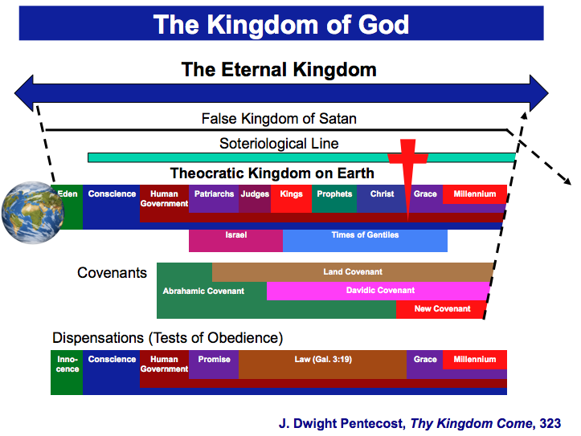

Kingdom & Covenants Timeline

