# Table of Nations

*The Bible Visual Resource Book*, 15

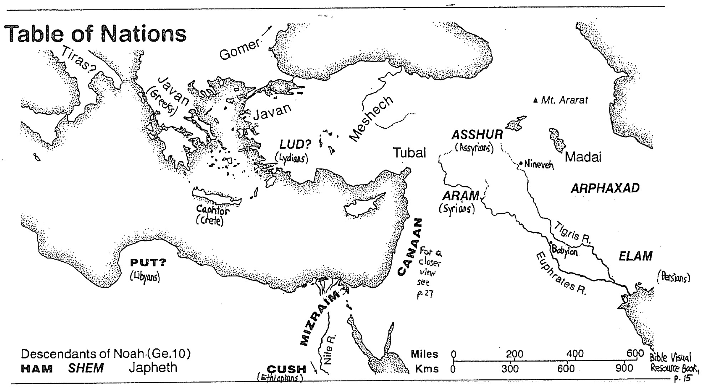

All people on earth trace their lineage from Noah, so there is really only one race—the *human* race!

After a southward descent from Mt. Ararat, people tried to build a tower at Babel and were dispersed.

**NOAH**

Urban: Non-Eber

(Mesopotamians)

Far-East & Americas

(Mongoloids)

Ishmael

Isaac

Esau

Jacob

Edomites

Jews

Amalekites

N. Africa

(Blacks)

Egyptians

Ethiopians

Libyans

Others

Christ

Barbarians

Romans

Spaniards

Greeks

*** Amorites began in Syria and migrated SW (to Canaan) and SE (into Mesopotamia); cf. H. A. Hoeffner, “Amorites,” *ZPEB,* 1:141.

** Babylon and Nineveh (Assyria) were both built by the Hamite Nimrod (Gen. 10:8-12), but after the dispersion of languages (Gen. 11), his people migrated to Cush (modern Ethiopia), and Semites occupied these cities.

* Philistines originated from Egypt (Gen. 10:14). Most migrated to Caphtor (Crete) in the Aegean Sea while a few migrated to Canaan in patriarchal times (Gen. 21:32, 34; 26:1, 8, 14-15, 18; Ezek. 25:15-16; Jer. 47:4; Amos 9:7). The larger group invaded Egypt in the 12th century BC. After being repulsed, they settled in Gaza, perhaps with the earlier Philistines.

Mid-East

(Canaanites)

Hittites

Sinites

Sidonians

Hivites

Idumaeans

Third Edition  
26 Jan 2026

**Japheth**

(Japhethites)

**Shem**

(Semites)

**Ham**

(Hamites)

Europeans

(Caucasians)

Rural: Eber

(Hebrews)

Assyrians**

Ethiopians

Chinese

Hittites

Romans

Libyans

Sinites

Joktan

(13 tribes)

Akkadians

Mongolians

Peleg

Others

Sidonians

Koreans

Greeks

Babylonians****

Elamites

Egyptians

Spaniards

Japanese

Native Americans

Terah

Hivites

Sumerians

Hivites

**Sources**: Gen. 5; 10; 25:1-4; 36; 1 Chron. 1:19-23; Paul Benware, *Survey of the OT,* 264-74; Barry Beitzel, *Moody Atlas,* 76-79; Louis Hamada, *Understanding the Arab World,* 42, 51, 56; R. Laird Harris, “Genealogy,” *ZPEB,* 2:673; Eugene Merrill, *Kingdom of Priests*, 25-32; Henry Morris, “The Genesis Record” (http://www.csinfo.org); *NIV Study Bible,* 21; John Whitcomb, *Chronological & Background Charts of the OT,* 2d ed., 71, 73 (OTS, 143-44); John Whitcomb & Henry Morris, *The Genesis Flood*, 45-54.

Nabataeans

Lot

Haran

Abraham

Chaldeans

Syrians

East Indians (migrated)

Others

Phoenicians

Amorites***

Russians

Persians

Moabites

Ammonites

Philistines*

Scythians

Gibeonites

Gibeonites

Arabs

(via Hamite Hagar

& intermarriage)

Midianites

(via Hamite Keturah)