Nehemiah

Restoring the Walls and People

Walls |  |  |  |  | People
Chapters 1–7 |  |  |  |  | Chapters 8–13
Construction |  |  |  |  | Instruction
Political |  |  |  |  | Spiritual
Return  1–2 |  | Rebuilding  3–7 |  |  | Renewal  8–10 |  |  | Reforms  11–13
Persia Prayer  1 | Jerusalem Inspection  2 | Dele- gation  3 | Opposed/ Finished  4–6 | Organ-ized  7 | Convic- tion  8 | Confes- sion  9 | Cove- nant  10 | Resettle- ment & Dedication  11–12 | Sabbath & Intermarriage Reforms  13
-----52 days (6:15)----  445-433 BC  13:6a |  |  |  |  |  |  |  |  |  | 425 BC?  420 BC?  13:6b

Key Word: Walls

Key Verse: “So the wall was completed on the twenty-fifth of Elul, in fifty-two days. When all our enemies heard about this and all the surrounding nations saw it, our enemies lost their self-confidence, because they realized that this work had been done with the help of our God” (Nehemiah 6:15-16)

Summary Statement:
The way the remnant responded to God’s faithful restorations of the walls and people under Nehemiah was diligent service and worship.

Application:

Our completing God’s projects should lead us to further obedience.

Nehemiah

Introduction

I. Title Ezra and Nehemiah originally formed a single book according to Josephus (Against Apion 1.8), Jerome (Preface to the Commentary on Galatians), and the Talmud (Baba Bathra 15a). The Hebrew Bible also has the two books together under the title Ezra Nehemiah (hy:m]j,n“ ar;z“[, ezra' nehemeyah). However, the repetition of Ezra 2 in Nehemiah 7 may indicate that the two were originally separate works. Ezra means "help, succour, assistance" (BDB 740d 1) and Nehemiah means "Yahweh comforts" (BDB 637c 3). Once again the names are significant in that Ezra's ministry enabled the Jews to return to the land and consecrate themselves while Nehemiah gave God's comfort through building Jerusalem's protective wall.

II. Authorship

A. External Evidence: The Book of Nehemiah has long been considered as being named after its author and chief character, Nehemiah himself.

B. Internal Evidence: The inspired title of the book reads, "The Words of Nehemiah, Son of Hacaliah" (1:1) and much of the content appears in the first person (1:1–7:5; 12:27-43; 13:2b-31), making it clear that Nehemiah recorded this book. Some believe the third person sections (7:6–12:26; 12:44–13:2a) were written by Ezra since Nehemiah was absent for these events as he was in Babylon during this time (13:6). Nehemiah 7:5-73 is nearly identical to Ezra 2:1-70, but both lists probably were derived from another record of the same period (TTTB, 124).

Nothing is known of Nehemiah's childhood, youth, or family background since the account opens with him as an adult serving King Artaxerxes of Persia. The text does reveal that his father's name was Hacaliah (1:1) and he had a brother named Hanani (1:2), but this is of little help as these men and Nehemiah are not mentioned elsewhere in Scripture. The "Nehemiah" of Ezra 2:2; Nehemiah 7:7 (in 538 BC) must have been another man of the same name as he came to Judah 90 years before the Nehemiah of the book that bears his name (who arrived in 445 BC). What is known of this Nehemiah is his prayerfulness, diligence, intellectual capabilities, emotional maturity, spiritual status, and wisdom shown in the high position of cupbearer granted to him by the king of Persia.

III. Circumstances

A. Date: Nehemiah left Persia in the twentieth year of Artaxerxes (2:1; 445 BC) and returned to the king in his thirty-second year (13:6a; 433 BC). "Some time later" he came again to Jerusalem (13:6b), but the specific time is not given. Perhaps it was about 425 BC (TTTB, 125) or even 420 BC (Whitcomb, "Chart of Old Testament Kings and Prophets" on p. Error! Bookmark not defined.). This chronology places the writing after 425 BC, perhaps even as late as 400 BC (LaSor, 647). Arguments for later dates based upon stylistic affinities to later Aramaic are unconvincing since the Aramaic of Ezra (of Ezra-Nehemiah) is clearly earlier than that of second century Qumran (LaSor, 648). This dating of approximately 425 BC makes Nehemiah a contemporary of Malachi, which finds support in their common descriptions of post-exilic Judaism.

B. Recipients: The first readers of Nehemiah comprised Jews who had returned from Persia with Ezra three or four decades before, as well as grandchildren and great-grandchildren of the returnees with Zerubbabel about 125 years earlier.

C. Occasion: This story continues from Ezra about 11 years after Ezra's spiritual reforms among the remnant in Jerusalem. However, whereas Ezra helped the spiritual establishment of the new community, Nehemiah gave it physical, geographical, and political stability (LaSor, 655). Before Nehemiah came on the scene (445 BC) the restored remnant had been back in Judea over 90 years (since 538 BC), the temple had been rebuilt (516 BC), and Ezra's reforms had been instituted (458 BC). However, Nehemiah found the walls and gates still in ruins and took it upon himself to see to it that the city was not left unprotected. Nehemiah's faith in God saw him accomplish in 52 days what had not been done in the 93 years since the return under Zerubbabel. Afterwards he wrote this account of how the LORD used him to rebuild the walls in order to encourage the people with God's obvious hand in reestablishing his people in their homeland. This account undoubtedly helped his original readers to see that diligence based on obedient faith can accomplish God's will despite what appears impossible.

IV. Characteristics

A. Although Esther follows Nehemiah in our English Bibles, Nehemiah actually is later chronologically. Thus it concludes the account of the historical books of the English Bible Old Testament. In the Hebrew canon, the final book is Chronicles, preceded by Nehemiah.

B. Perhaps no other book of Scripture provides a better depiction of the balance between dependence and diligence, as well as prayer and planning. His prayers are generally short but fervent (cf. 1:5-11; 2:1-4, 19-20; 4:1-6, 7-10, 11-14; 6:9, 14).

C. One difficulty in reconciling Nehemiah with Ezra concerns the walls themselves. At the beginning of the account, Nehemiah seems surprised that the walls were broken down. Why would this be news to him in 445 BC since the Babylonians had destroyed them much earlier in 586 BC (2 Kings 25:10)? One clue is perhaps that the walls had begun to be rebuilt under Ezra during the reign of Artaxerxes, but the project had been stopped (Ezra 4:12, 21-23). Probably Nehemiah had thought the project was completed (Getz, “Nehemiah,” BKC, 1:674).

D. Nehemiah is the only biblical book written mostly in the first person (see Authorship above).

Argument

The Book of Nehemiah continues the account of Ezra and, as they originally formed a single work, has the same theme: the record of the restoration of God's people in the land which serves to encourage the remnant towards covenant obedience, especially in true temple worship. Ezra indicates how the returns of Zerubbabel and Ezra contributed to the establishment of the new covenant community. Nehemiah completes the restoration with the third and final return under Nehemiah to rebuild the walls (Neh 1–7), followed by the restoration of the people (Neh 8–13). The book also includes some very insightful teaching on leadership principles (Neh 1–7), spiritual principles (Neh 8–10), and moral and social principles (Neh 11–13; cf. TTTB, 126).

Synthesis

Restoring the walls and people

1–7 Walls
1–2 Return
1 Persia prayer
2 Jerusalem inspection
3–7 Rebuilding
3 Delegation
4:1–6:14 Opposition
6:15-19 Completion
7 Organization

8–13 People
8–10 Covenant renewed
8 Conviction
9 Confession
10 Covenant
11–13 Covenant obeyed
11:1–12:26 Resettlement
12:27-47 Dedication
13 Final reforms

Outline

Summary Statement for the Book
The way the remnant responded to God’s faithful restorations of the walls and people under Nehemiah was diligent service and worship.

The rebuilding of Jerusalem’s walls in the third return under Nehemiah's leadership despite opposition teaches covenant obedience rooted in temple worship (Neh 1–7).

God enabled Nehemiah to prepare to rebuild the wall to reestablish Jerusalem as the center of worship at the temple (Neh 1–2).

In Persia, Nehemiah learned of Jerusalem’s broken wall and interceded with God and Artaxerxes to rebuild the wall (1:1–2:8; fulfilled Daniel 9:25 in 444 BC).

In Jerusalem, Nehemiah prepared to reconstruct the wall by inspecting the project, encouraging the people, and rebuffing his critics (2:9-20).

Nehemiah rebuilt the wall in only 52 days by delegation, frustrating his opposition, and protecting the city so the Jews would feel safe to repopulate it (Neh 3–7).

Nehemiah wisely delegated the rebuilding project to workers who constructed the wall near their homes as incentive to do quality work (Neh 3).

Nehemiah effectively handled opposition to the project by prayer and standing guard against the enemies (4:1–6:14).

External opposition came from Sanballat and Tobiah who sought to stop the work by ridicule, threat of attack, and discouragement (Neh 4).

Internal opposition came from greedy Jews who abused their countrymen in contrast to Nehemiah's selfless service as governor (Neh 5).

Since the people had only been working on the wall for a few weeks, “the hundredth part of the money, grain, new wine and oil” (5:11) likely refers to usury (interest) on a monthly basis, actually yielding an interest rate of 12% annually. Charging any interest to fellow Israelites clearly violated the Law (Exod. 22:25; Lev. 25:35-37; Deut. 23:20-21), even though it was rarely observed. For further study, see E. Neufeld, “The Rate of Interest and the Text of Nehemiah 5.11,” Jewish Quarterly Review 44 (1953/54): 194-204; R. P. Maloney, “Usury and Restrictions on Interest-Taking in the Ancient Near East,” Catholic Biblical Quarterly 36 (1974): 1-20. Perhaps the actual interest exceeded 12% since commodities were included as well.

External opposition came from Sanballat, Tobiah, and Geshem who tried compromise, blackmail, treachery, and intimidation by false prophets (6:1-14).

Despite internal opposition from Tobiah’s relatives, the wall took only 52 days, discouraging the enemies as they saw God clearly at work (6:15-19).

Nehemiah organized Jerusalem by posting guards and using the returnee list from century earlier to encourage the Jews to repopulate the city (Neh 7).

The restoration of the people through Nehemiah's leadership exhorts covenant renewal and commitment to the temple (Neh 8–13).

The covenant renewal after two days of reading and expositing the Word of God encouraged the remnant to record their covenant obedience (Neh 8–10).

Conviction: Ezra's reading of the Pentateuch and Levite exposition urged all to celebrate the Feast of Tabernacles and begin a revival based on God’s Word (Neh 8).

Confession: Everyone gathered again 24 days later to fast, listen to the Law of Moses, worship, confess sin, and obey a written covenant (Neh 9).

Covenant: Nehemiah publicized those who agreed to follow the covenant as a written record of the people's commitment to obey (Neh 10).

A list of the priests, Levites, and leaders of the people who signed the covenant reminded them of their agreement to obey the Law (10:1-27).

Nehemiah recorded the covenant stipulations of submission to the Word, no intermarriage, Sabbath observance, and financial support (10:28-39).

The covenant was obeyed in resettling Jerusalem, dedicating the walls, and other reforms to commit to the temple and covenant stipulations (Neh 11–13).

The people obeyed the plan for 10% of the nation to resettle Jerusalem to protect the city and temple from attack to show their commitment to the temple (11:1–12:26).

The wall dedication by Levites, two choirs, and contributions for the temple service once again show their commitment to God’s house (12:27-47).

Nehemiah forbade foreigners from the temple, supported temple workers, corrected Sabbath abuses, and prohibited intermarriage to force covenant faithfulness (Neh 13).

Focusing Your Narrative Idea on Authorial Intent
An Example from Nehemiah 1–2

A Different Approach

Nearly all evangelical commentaries expound the Book of Nehemiah as if it’s a manual on effective leadership (see Edwin M. Yamauchi, “Ezra-Nehemiah,” EBC, 4:591; Donald K. Campbell, Nehemiah: Man in Charge, 23; Charles R. Swindoll, Hand Me Another Brick: A Study in Nehemiah; Gene A. Getz, “Nehemiah,” BKC, 1:673-74). I think this emphasis has problems:

1. It is highly questionable that the authorial intent of the Book of Nehemiah is to train readers as better leaders. I feel that it is unlikely that the first readers saw the primary purpose of the book as holding up the man Nehemiah as a model to follow.

2. This perspective places undue attention to the human instrument, Nehemiah himself, rather than on the God who sovereignly led him to the accomplish the task (1:5, 9-11; 2:4b, 8b, 12, 18, 20).

3. It puts the stress on how the walls of Jerusalem were raised which is but a minor focus. The real emphasis should be why the walls needed to be rebuilt (2:17).

4. Ezra and Nehemiah in the Hebrew Bible constitute one book and therefore should share a common theme. Since Ezra is not a manual on leadership then this should not be expected of Nehemiah as well.

5. This view also limits proper application only to those in leadership positions.

6. The leadership view hardly takes into account the historical background and chronology. A careful evaluation of the historical situation and how the book fits into the total plan of God brings the Lord to center-stage as the sovereign, covenant-keeping God (see below).

Exegetical Outline

Prologue

Historical background: About 1500 years earlier God had promised Abraham that he would make his descendants into a great nation possessing the entire land from the River of Egypt to the Euphrates (Gen. 12:1-3; 15:18f.). Hundreds of years later God further spoke through Isaiah and many other prophets that a Davidic king called the Messiah would rule Israel in this geographical domain. However, the nation rebelled against the Lord and went into exile as the Law had warned (Deut. 28). The key question looming in the minds of the exiled Jews was whether God would still fulfill his promise of a new nation in Palestine under the Messiah as ruler. Was he still sovereign even though his people were in such distress?

Historical foreground: No doubt people wondered how a Messiah could be offered to the nation if Israel was still in exile. For example, one of the messianic prophecies stated that he would be born in Bethlehem (cf. Micah 5:2, written nearly 200 years earlier). Surely the nation would have to sometime return to its homeland for the Messiah to offer the kingdom–an offer which indeed did occur under Christ (Matt. 10:7) but was rejected. Furthermore, Daniel had recorded only a few years earlier that Artaxerxes’ command to rebuild Jerusalem under Nehemiah (444 BC) would begin “seventy sevens” (490 years) of prophetic years in the nation’s history (Dan. 9:25). The 69th prophetic year (483rd year) would culminate in the death of Messiah in AD 33 (Dan. 9:26).

The postexilic era testifies to the gracious hand of a sovereign God who had not forgotten his promises, for under Zerubbabel and Ezra a small remnant had returned from Babylon, rebuilt the temple and begun reforms. The building under Nehemiah completes this record with a direct fulfillment of Daniel 9:25. Thus, the account of Ezra-Nehemiah shows that God is indeed the God over all gods (Ezra 1:2), a covenant-keeping God. Likewise, his people need to keep the covenant as well (Yamauchi, EBC, 4:590).

Exegetical Idea: The way God sovereignly fulfills his promise to preserve Israel in a restored Jerusalem was through preparing Nehemiah to rebuild the city wall.

I. The way the sovereign God prepared to restore the covenant city of Jerusalem was through placing upon Nehemiah both the burden and position to be used of God (Neh 1).

A. God informed Nehemiah that the covenantal people and city were in shame (1:1-3).

B. God moved Nehemiah to see Israel’s sin and his promises and ability to restore (1:4-11a).

C. God had placed Nehemiah in a prominent position to restore Jerusalem to the stature befitting Jerusalem as the city inhabited by the sovereign LORD (1:11b).

II. The way the sovereign God prepared to restore Jerusalem was through granting Nehemiah’s requests before King Artaxerxes (2:1-8).

III. The way the sovereign God prepared to restore Jerusalem was by granting Nehemiah honor over the people after his wall inspection despite opposition from the enemies (2:9-20).

A. God granted Nehemiah honor before the Persian officials over the opposition (2:9-10).

B. God granted Nehemiah honor before the people by being informed of the task (2:11-16).

C. God granted Nehemiah honor before the people by reminding them that God was surely in their work despite opposition (2:17-20).

Homiletical Exposition (cyclical inductive form) Title: “Where God guides, God Provides”

Introduction:
1. Sometimes it seems like things happen without any divine purpose to it all (examples).
2. How we can know that God wills for us to accomplish a certain task (subject)?
3. When Israel was exiled things looked hopeless. Could the nation once again be completely restored? The Book of Ezra records a partial restoration, but the city walls were still destroyed. Was God still with them and still the sovereign Lord? And how can we be reminded that God is really sovereign (subject restated)?

I. God sovereignly provides both the vision and ability to do certain ministries.

A. God gave Nehemiah both the burden and position to be used in rebuilding the wall (Neh 1).

B. God gives us vision and strategic positions to serve him when we are obedient.

II. God sovereignly prepares other key people as resources to help his people do his tasks.

A. God granted Nehemiah’s requests before King Artaxerxes (2:1-8).

B. God prepares the hearts of others to enable us to do his will too.

III. God sovereignly helps his people gain the respect needed to accomplish his tasks.

A. God gave Nehemiah honor with the Jews after he inspected the walls (2:9-20).

B. God gives us the credibility needed to do his will.

Main Idea: God sovereignly gives us the needed vision, resources, and credibility to do his tasks.
Restatements: Where God guides, God provides! He always equips us to accomplish his will.
Application: What vision, place of influence, resources, and credibility has he given you?

Jerusalem of the Returning Exiles
The Bible Visual Resource Book, 99; Gene Getz, “Nehemiah,” in Bible Knowledge Commentary, 1:679

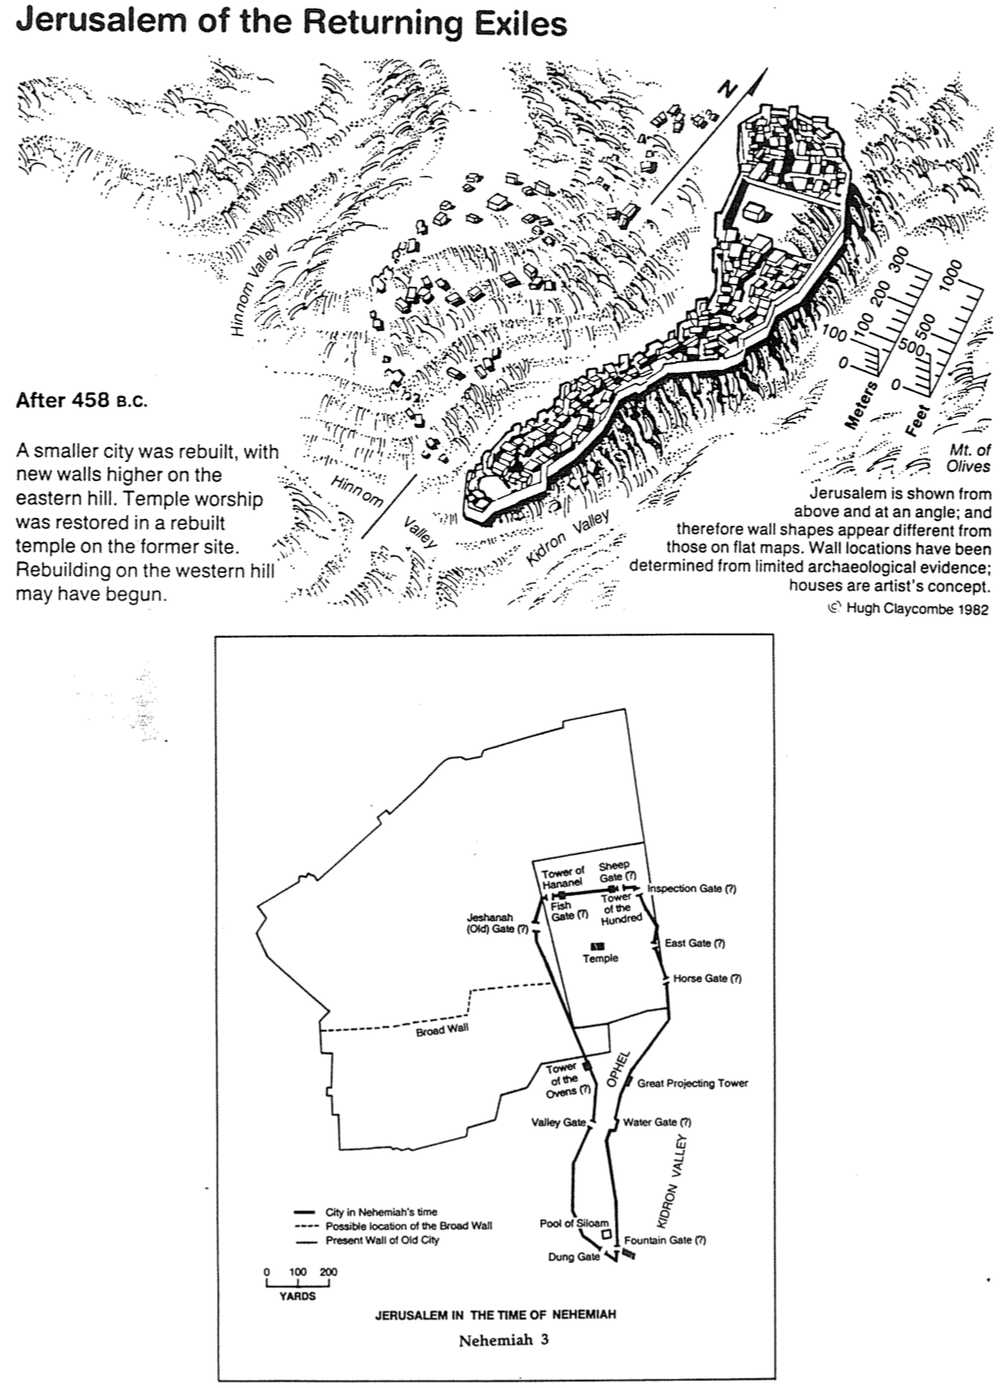

Nehemiah’s Responses to Problems

Gene Getz, “Nehemiah,” in Bible Knowledge Commentary, 1:681

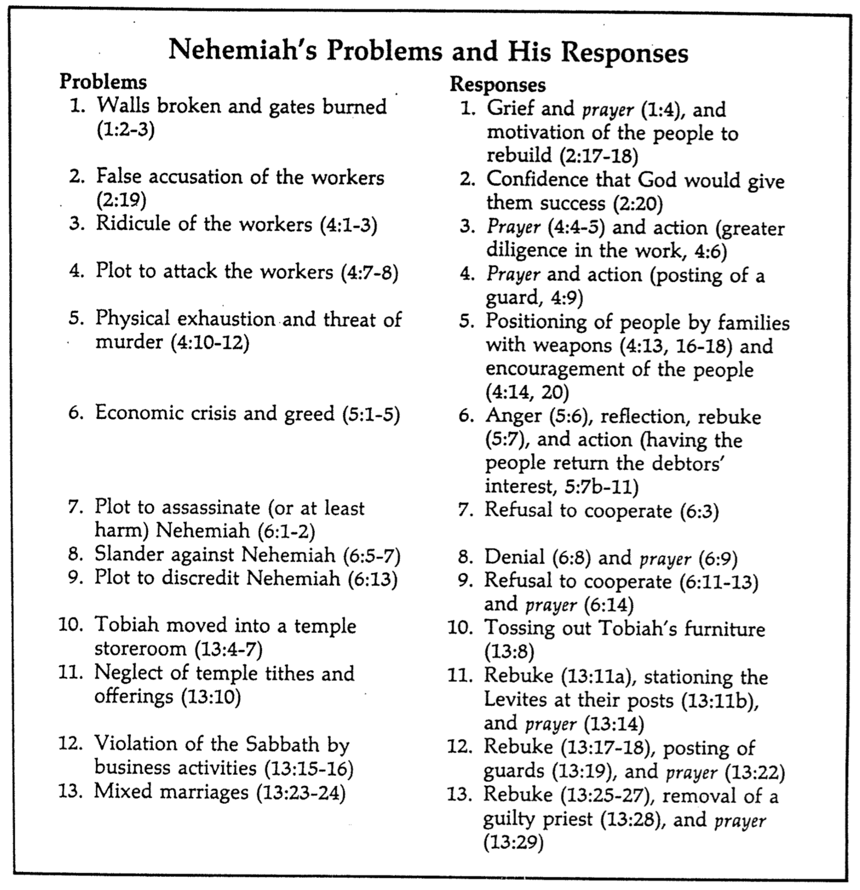

Nehemiah’s Leadership

Donald K. Campbell, Nehemiah: Man in Charge, 23

While leadership is not the main purpose of the book, nevertheless, the man Nehemiah exemplifies many principles for good leadership. Some these include the following:

1. He established a reasonable and attainable goal.
2. He had a sense of mission.
3. He was willing to get involved.
4. He rearranged his priorities in order to accomplish his goal.
5. He patiently waited for God’s timing.
6. He showed respect to his superior.
7. He prayed at crucial times.
8. He made his request with tact and graciousness.
9. He was well prepared and thought of his needs in advance.
10. He went through proper channels.
11. He took time (three days) to rest, pray, and plan.
12. He investigated the situation firsthand.
13. He informed others only after he knew the size of the problem.
14. He identified himself as one with the people.
15. He set before them a reasonable and attainable goal.
16. He assured them God was in the project.
17. He displayed self-confidence in facing obstacles.
18. He displayed God’s confidence in facing obstacles.
19. He did not argue with opponents.
20. He was not discouraged by opposition.
21. He courageously used the authority of his position.

Chronicles Clip #4
C. Zanziper (Reubeni Foundation, Jerusalem)

