**Lamentations**

|  |  |  |  |  |  |  |
| --- | --- | --- | --- | --- | --- | --- |
| **Emotions of and Reasons for the Fall** | | | | | | |
| **Fall**  **Described** | | **Judgment**  **Acknowledged** | | **Jeremiah’s**  **Feelings** | **Trusting**  **Leaders** | **Prayer** |
| **Chapter 1** | | **Chapter 2** | | **Chapter 3** | **Chapter 4** | **Chapter 5** |
| **The**  **Suffering** | | **The**  **Cause** | | **The**  **Hope** | **The**  **Reason** | **The**  **Lament** |
| **3 Line**  **Acrostic** | | **3 Line**  **Acrostic** | | **1 Line**  **Acrostic** | **2 Line**  **Acrostic** | **1 Line**  **Not Acrostic** |
| **People** | | **God** | | **Prophet** | **God** | **People** |
| Third Person  Singular  (“she”)  1:1-11 | First Person  Singular  (“I”)  1:12-22 | Third Person  Singular  (“He”)  2:1-10 | First  Person  Singular  (“I”)  2:11–4:22 | | | First  Person  Plural  (“us/our”)  5:1-22 |
| **Jerusalem** | | | | | | |
| **586 BC** | | | | | | |

**Key Word: Confession/Lamentations**

**Key Verse: “Because of the LORD’s great love we are not consumed, for his compassions never fail. They are new every morning; great is your faithfulness” (Lamentations 3:22-23).**

**Summary Statement:**

**The way Jeremiah modeled repentance after Jerusalem’s destruction was by confessing that God alone could restore Judah from their sin.**

**Application:**

**When God punishes us, our only hope lies in turning to our ‘Enemy’**

**(Adapted from Huang Sabin)**

**Lamentations**

**Introduction**

**I. Title** The Hebrew title for the book (hk;yae *'ekah*) is the exclamation "How!" (BDB 32d 2) or "Oh!" taken from the first word of chapters 1, 2, and 4 (1:1; 2:1; 4:1, 2; cf. Isa. 1:21; Jer. 48:17). The Greek title *Threnoi* means "Dirges" or "Laments," and the Latin title *Threni* ("Tears" or "Lamentations") was derived from this word. The subtitle in Jerome's Vulgate became the basis for the English title "The Lamentations of Jeremiah" (*TTTB*, 207). Lamentations is the only prophetical book not named after its author. Rather, the title conveys the deep personal and national loss that the author feels after the fall of Jerusalem.

**II. Authorship**

A. External Evidence: The Masoretic (Hebrew) text does not claim a particular author, but Jewish tradition attributes the authorship to Jeremiah (Targum at Jer. 1:1; Talmud *B. Bat.* 15a; LXX and Vulgate headings: cf. LaSor, 617, n. 2). The LXX introduction reads, "And it came to pass after Israel was taken captive and Jerusalem laid waste that Jeremiah sat weeping and raised this lament over Jerusalem…" Jeremiah's authorship was universally accepted until 1712 when Herman von der Hardt challenged it (Dyer, *BKC*, 1:1207). All objections of von der Hardt and others have been thoroughly refuted (LaSor, 618; Gleason L. Archer, Jr., *A Survey of Old Testament Introduction*, 365-7; Walter C. Kaiser, *A Biblical Approach to Personal Suffering*, 24-30).

B. Internal Evidence: The book is anonymous yet its contents reveal an author who was an eyewitness, profound theologian, skillful poet, and true patriot (LaSor, 618). Nothing in it raises doubt to the tradition that the author is Jeremiah. Similarities between the Books of Jeremiah and Lamentations are striking: 1:2 (Jer. 30:14); 1:15 (Jer. 8:21); 1:16; 2:11 (Jer. 9:1, 18); 2:20; 4:10 (Jer. 19:9); 2:22 (Jer. 6:25); 4:21 (Jer. 49:12). Both books express the same compassion, sympathy, and grief over Judah's downfall (*TTTB*, 207). It is no wonder that Jeremiah has been called "the weeping prophet."

**III. Circumstances**

A. Date: Nearly all scholars agree that the book refers to the fall of Jerusalem to Nebuchadnezzar of Babylon in 586 BC. Nothing indicates that it was written during the exile. The vividness and deep emotions in the account indicate that an eyewitness composed it shortly after the events took place.

B. Recipients: Jeremiah was never exiled to Babylon (cf. Jer. 40–44), so Lamentations shows to the remnant left in the land the devastating effects of God's judgment on His people.

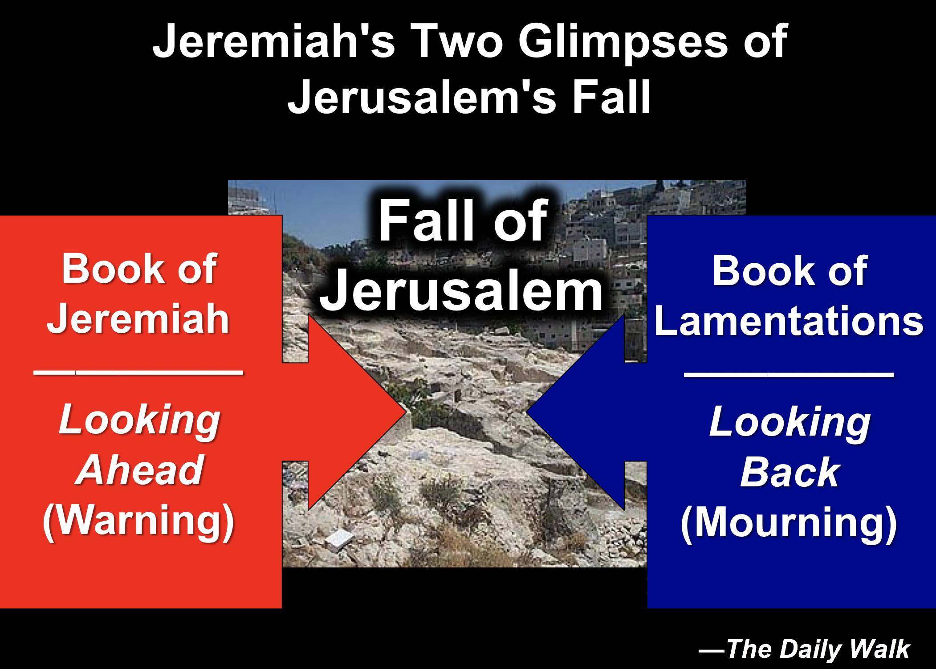C. Occasion: In 586 BC Nebuchadnezzar destroyed Jerusalem with its temple and the nation of Judah went into exile, following years of prophetic warning by Jeremiah, Zephaniah, Habakkuk, and others—warnings which stretched back even as far as the Law (cf. Deut. 28:41, 49-57, 64f.). On the heels of such a catastrophic defeat Jeremiah mourned the loss in the five poems that comprise Lamentations. These poems express the anguish of the remnant and the reasons for God's judgment as a stimulus to national repentance. The worst disaster ever to befall the Jewish nation was certainly this destruction of Jerusalem and the temple (including the departure of the Spirit of God from the Holy of Holies). The two scriptural books written by Jeremiah focus on this tragic event:

Jeremiah’s Two Glimpses of Jerusalem’s Fall



**IV. Characteristics**

A. As previously noted, Lamentations is the only prophetical book not named after its author. This makes sense since Jeremiah already has a prophecy bearing his name. The title conveys the deep personal and national loss which he felt after the fall of Jerusalem.

B. This is the saddest of all books in Scripture. In 2 Kings 25 and Jeremiah 52 we find the *facts* of the destruction of Jerusalem and the temple, but only Lamentations captures the *emotions* (LaSor, 617).

C. Lamentations is also the only Bible book whose basic structure forms an acrostic. All chapters (except chapter 3) have 22 verses, each beginning with successive letters of the Hebrew alphabet (except chapter 5). Chapter 3 has 66 verses with each letter repeated three times. The pattern may be for easy memorization or to emphasize the complete nature of suffering for sin (Dyer, *BKC*, 1:1211).

**Verse Chapter 1 Chapter 2 Chapter 3 Chapter 4 Chapter 5**

1 a (=A) a a a not

2 b (=B) b a b acrostically

3 g (=“C”) g a g arranged

4 d (=D) d b d

5 h (etc.) h b h

6 w (etc.) w b w

etc. etc. etc. etc. etc.

# of Verses 22 22 66 22 22

# of Lines 66 66 66 44 22

Lines/stanza 3 3 1 2 1

Chapter 5 is not an acrostic, but it does have a "mini-acrostic." Verses 19-20 are composed of four lines starting with the letters A, K, L, and “Z,” respectively (i.e., a, k, l, and t). The effect is to express the highest praise for Yahweh followed by the last two verses of the book that contain a tentative, hopeful cry for help (Homer Heater, Jr., “Structure and Meaning in Lamentations,” *Bibliotheca Sacra* 149 [July-September 1992]: 304-15).

D. Not only does the book use multiple acrostics but it has a chiastic structure as well. In other words, certain elements reappear in a deliberate order later in the book. Chapters 1 and 5 both depict Jerusalem’s destruction from the viewpoint of the inhabitants, chapters 2 and 4 both describe God’s view, and the center of the book (chap. 3) shows Jeremiah’s response:

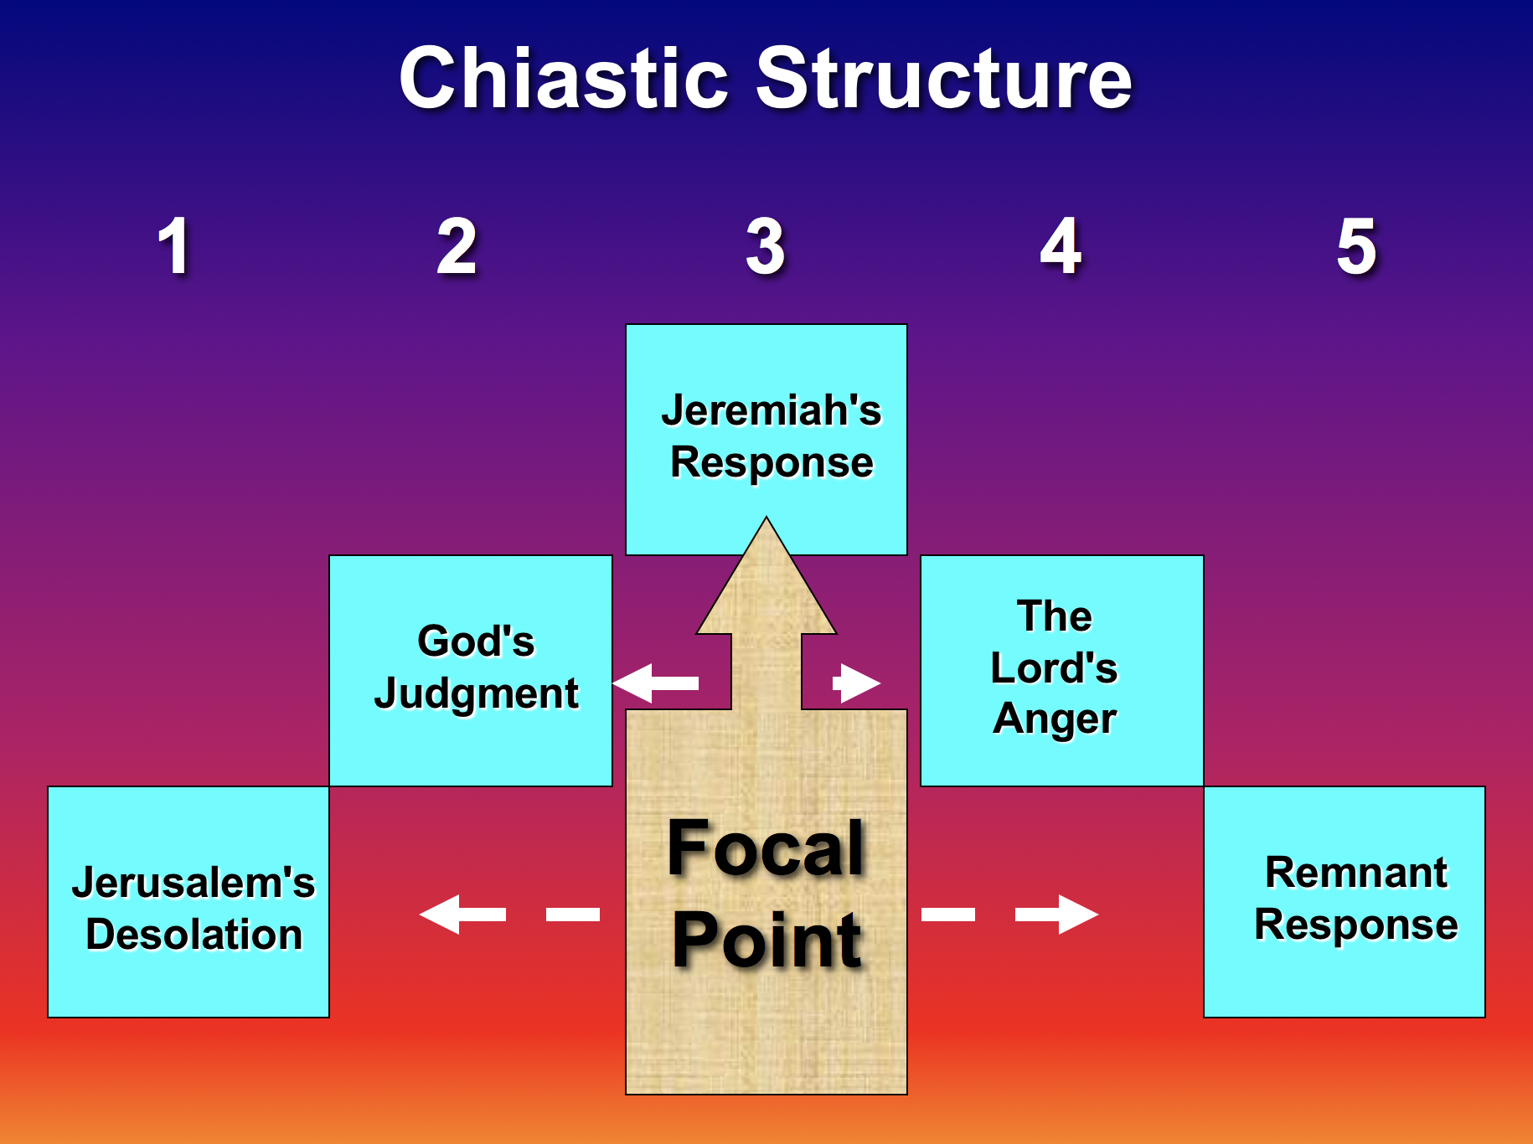

The Chiasm Structure of Lamentations



E. Deuteronomy 28 prophesied the terrible judgments resulting from sin nearly 800 years before Lamentations was written. The parallels between these writings are striking (Charles Dyer, *Bible Knowledge Commentary*, 1:1209):

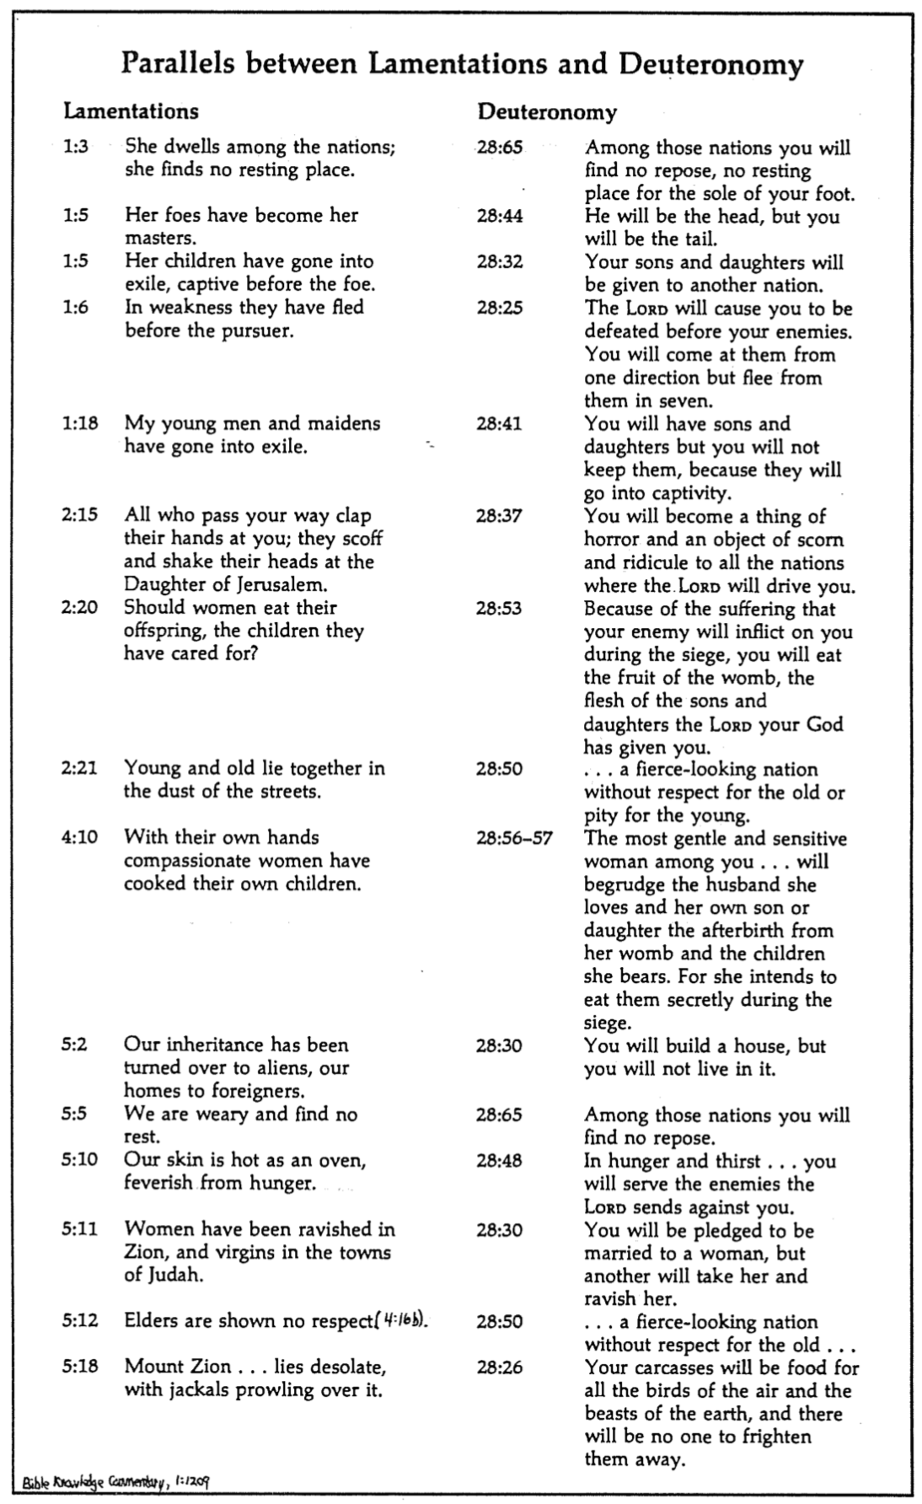

Parallels between Lamentations and Deuteronomy

(BKC)

**Argument**

Jeremiah's Lamentations consists of five poems that express in deeply emotional terms the siege conditions and reasons God caused the fall of Jerusalem. The purpose of documenting such an unpleasant situation is to serve as a model of national confession that the remnant would repent and trust God for His merciful restoration. It begins with two acrostic poems of equal length which describe the siege (ch. 1) as a result of God's withdrawal of His hand (ch. 2), then expresses in an extended poem his own feelings of affliction, hope, and repentant confidence in God as a model for the suffering people to follow (ch. 3). The fourth acrostic poem indicates that the city fell for trusting in its leaders rather than God (ch. 4), and the final poem (not an acrostic) laments, acknowledges national sin, and requests restoration (ch. 5). The chiastic structure makes chapter 3 the focal point in which Jeremiah models the repentant attitude needed in Judah (see previous paragraph “D” above).

**Synthesis**

**Emotions of and reasons for the fall**

**1 Fall described**

1:1-11 Heights to depths (3ps)

1:12-22 Deserved desolation (1ps)

**2 Judgment acknowledged**

2:1-10 God caused it

2:11-22 Lament/exhortation

**3 Jeremiah's feelings**

3:1-18 Affliction

3:19-39 Hope

3:40-66 Repentant confidence

**4 Reason: trusting leaders**

4:1-11 Glory vs. siege

4:12-20 Trusted leaders—not God

4:21-22 Edom to be punished

**5 Prayer**

5:1-15 Lamentation

5:16-18 Confession

5:19-22 Restoration

**Outline**

**Summary Statement for the Book**

**The way Jeremiah modeled repentance after Jerusalem’s destruction was by confessing that God alone could restore Judah from their sin.**

# Jerusalem's horrible fall recalls the awful effects of rebellion against God to stir Judah to repent and obey (Lam 1).

## The fall of Jerusalem from prominence to a lowliness reminds the nation of the heights the city enjoyed by grace before God's judgment (1:1-11).

## Jerusalem confesses her deserved desolation with the agony the people feel over the awful effects of rebellion against God (1:12-22).

# God caused Jerusalem's destruction so that all would admit this as his judgment and seek his mercy (Lam 2).

## God caused the destruction of the city and its covenantal institutions to help his people see this as his judgment (2:1-10).

## Jeremiah laments the city's condition so that all would admit this as God’s judgment and seek his mercy (2:11-22).

### The people listening to their false prophets caused their suffering by their enemies as God prophesied (2:11-17; cf. Deut. 28).

### The people should cry out to God in prayer to prevent their deaths from starvation (2:18-19).

### Jeremiah prays for God to deliver them from their cannibalism, murders, and terrors on every side (2:20-22).

# Jeremiah voices his affliction, hope, and repentant confidence in God so the suffering people will follow (Lam 3).

## Jeremiah describes his afflictions in general, poetic terms to identify with the suffering people (3:1-18).

## Jeremiah puts his hope in God to model how to pray for mercy (3:19-39).

## Jeremiah repents and acknowledges God's deliverance to model national repentance and confident faith in God (3:40-66).

### The remnant must pray so that those still living after the holocaust will repent (3:40-42).

### The sad state of the people should show the awful consequences of disobedience (3:43-54).

### God will defend the repentant Israelites and pay back the Babylonians to stir national repentance and faith in God’s justice (3:55-66).

# God judged Jerusalem in the siege for trusting in their leaders instead of him and will judge Edom to move them to trust him (Lam 4).

## Jerusalem’s pre-siege glory contrasts with the contemptible siege conditions to recall God's wrath for breaking their covenant (4:1-11).

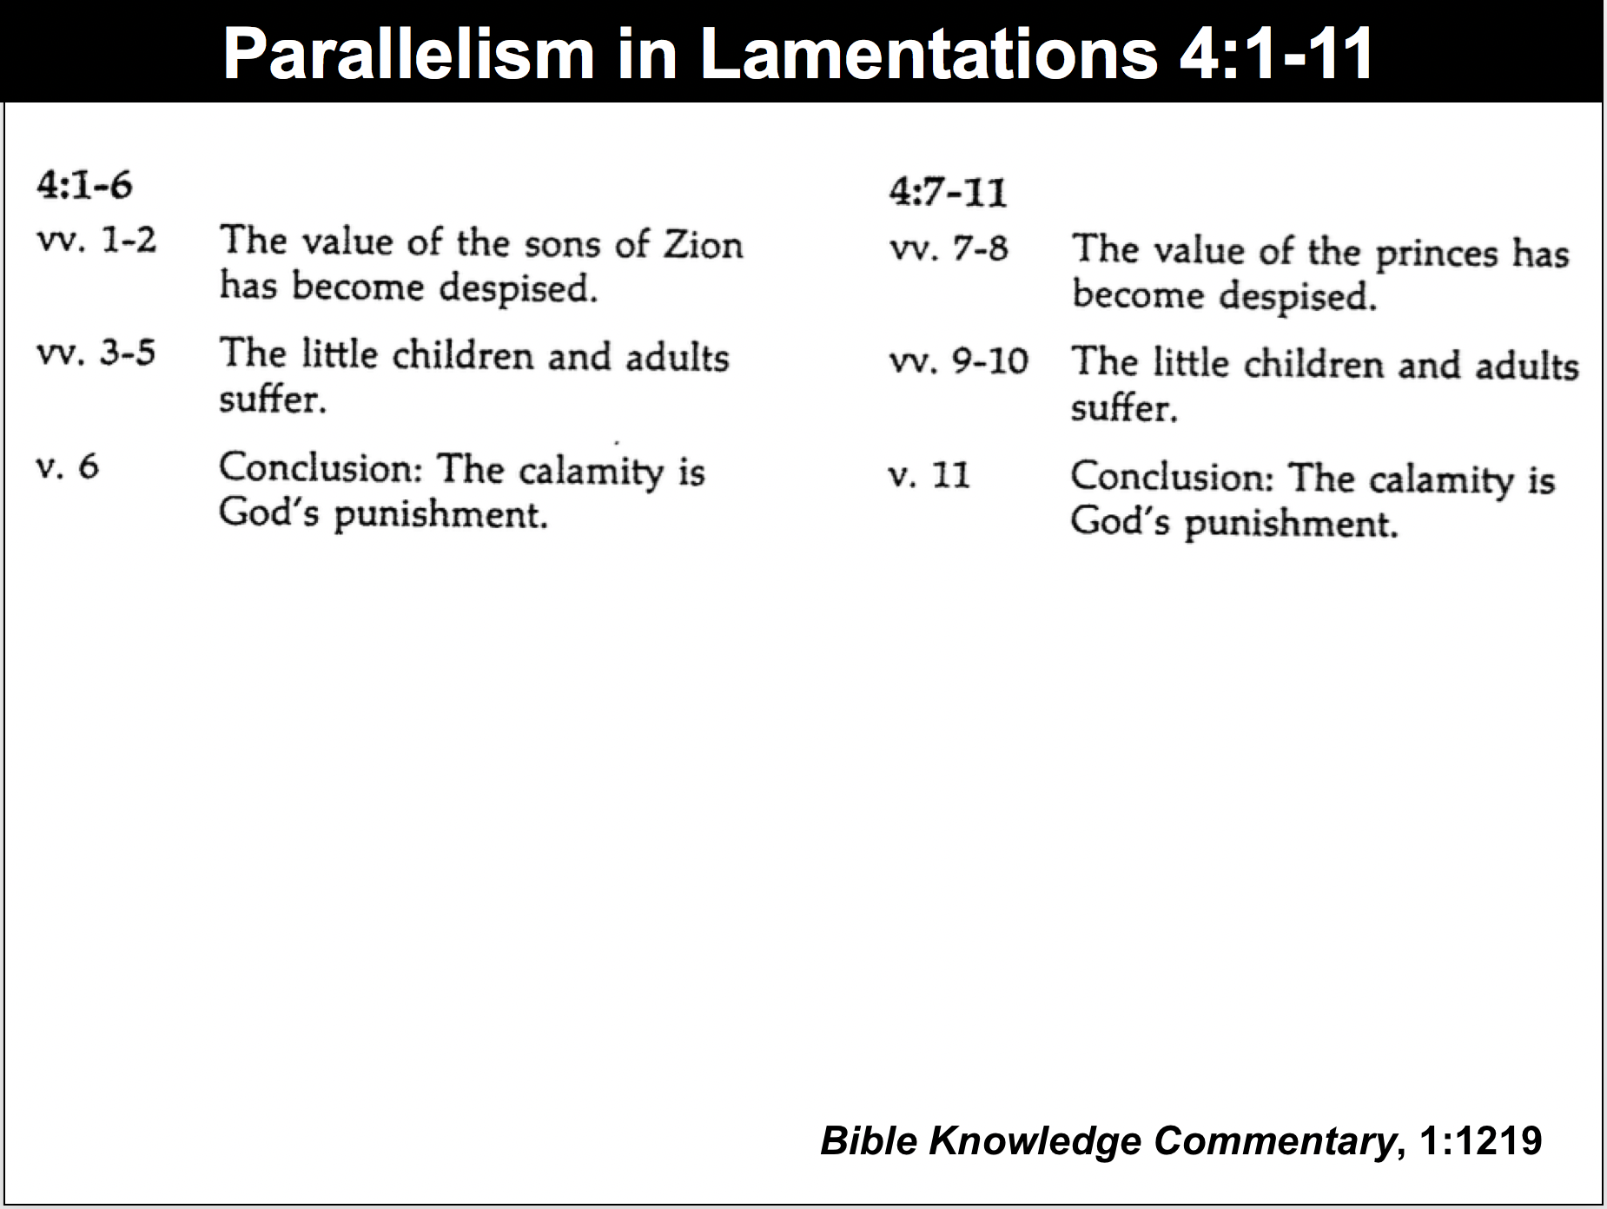

Parallelism in Lamentations 4:1-11

## The city fell because the people trusted their prophets, priests, elders, alliances, and king rather than God but they can trust him now (4:12-20).

## Jeremiah sarcastically calls on Edom to rejoice over Jerusalem's doom but warns of their coming judgment as God is fair to all (4:21-22).

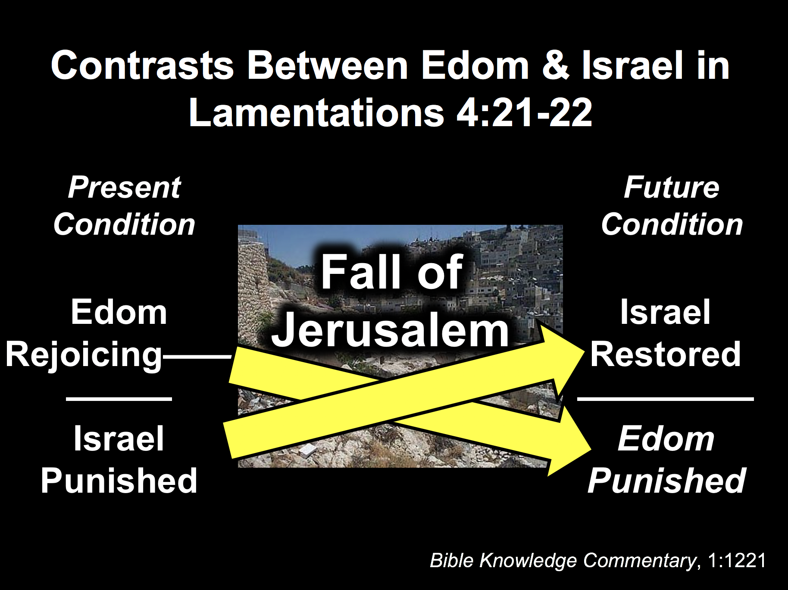

Contrasts between Edom & Israel



# Jerusalem’s lament, confession, and appeal for restoration should move the remnant to repent and hope for renewal (Lam 5).

## The city (“us/our”) laments to God so the remnant will feel their suffering (5:1-15).

## The city (“us/our”) confesses sin to exhort the remnant to repent (5:16-18).

## The city (“us/our”) prays for restoration to encourage the remnant to hope for renewal (5:19-22).