Ecclesiastes

Work & Wisdom Don’t Last

Theme (of 1:12–6:9):  Fleeting | Work | Wisdom | Youthful  Joy/Godliness
1:1-11 | 1:12–6:9 | 6:10–11:6 | 11:7–12:14
Man’s Humanity | Man’s Hands | Man’s Head | Man’s Heart
Cycles | Work | Ignorance | Aging
Place: Earth (“under the sun”)

c. 935 BC

Key Word: Fleeting

Key Verses: Enjoy Life: “A man can do nothing better than to eat and drink and find satisfaction in his work. This too, I see, is from the hand of God, for without him, who can eat or find enjoyment?” (2:24-25)

Fear God: “Now all has been heard; here is the conclusion of the matter: Fear God and keep his commandments, for this is the whole duty of man. For God will bring every deed into judgment, including every hidden thing, whether it is good or evil” (12:13-14)

Summary Statement:
The reason we should enjoy life and fear God is because work and wisdom don’t last.

Application:

Let life’s fleeting lead you to fear God so that you can experience freedom.

––––––Which will it be for you? Freedom or Frustration?–––––

If life’s fleeting nature leads you to forsake God then you will experience frustration.
Ecclesiastes

Introduction

- Title Ecclesiastes in Hebrew is Qohelet (tl,h,qo), meaning "collector (of sentences)" or "preacher" (BDB 875b). Notable translations render the word "the Preacher" (NASB, KJV) or "the Teacher" (NIV, NLT). Other views include "speaker in assembly" (König, Driver) or "debater" (Plumptre; cited in BDB 875b). The Septuagint (Greek translation of the Old Testament) translates this book title as Ekklesiastes ("one who calls an assembly") from which we get our English title "Ecclesiastes."

- Authorship

A. External Evidence: The uniform tradition in Judaism (Megilla 7a and Shabbath 30) and in the Church until recent centuries affirmed Solomonic authorship.

B. Internal Evidence: Critical scholars doubt Solomonic authorship because of linguistic differences in vocabulary and style which are thought to reflect the language of a period several hundred years after Solomon. However, an unbiased look at the book itself supports authorship by Solomon himself (Gleason Archer, A Survey of OT Introduction, 486-99):

1. The author is one of David's sons who became king (1:1). Solomon was the only son of David ever to become king (although "son" can mean "descendant"). His identification of himself as "the Preacher" cannot disprove Solomonic authorship.

2. Recent discoveries reveal that some of the Aramaic and Persian linguistic features were known in Canaanite-Phoenician literature even before Solomon's time! The language actually “fits into no known period in the history of the Hebrew language” (ibid, 489).

3. The description of the author aptly fits King Solomon as being a man of wisdom (1:16), involved in extensive building projects (2:4-6), owning slaves (2:7), who was very wealthy (2:8a), possessing a harem (2:8b), and quoting proverbs (12:90.

III. Circumstances

A. Date: Assuming Solomon’s authorship, the time of writing would have to be during his forty year reign as king (971-931 BC) since it ended in death. Some advocate that Solomon wrote Song of Songs in his early years, Proverbs in his mid-life, and Ecclesiastes near the end of his life. While this may be true (see occasion below), no one knows for sure.

B. Recipients: Solomon does not specify his target audience, but in its original setting his readers would have been those who experienced the wealth of his kingdom. These Jews living in the "golden age" of Israel's history would especially need to hear his message that achievements and wisdom are not the sum total of meaning in life. They probably had more opportunity for materialistic pursuits than at any other time of Jewish history. Certainly they had also experienced their share of injustice in life despite the high standard of living. For example, Solomon’s reign also had its increased labors and taxation (1 Kings 12:4), so the concept of injustice appears often in Ecclesiastes.

C. Occasion: Probably Solomon's greatness and extensive pursuits could not have been accomplished until later in his life. Therefore, the setting is that of an old sage musing on his profitless pursuits and comparing them with his knowledge and experience of God. Solomon wrote the Book of Ecclesiastes to admonish others not to pursue the same empty pursuits and mysterious questions that occupied so much of his time rather than fearing God.

IV. Characteristics

A. Canonicity: Ecclesiastes was one of the last of the books of Scripture to be agreed upon as worthy to have a place with the rest of the inspired Scriptures.

B. “Pessimism”: The debate on canonicity centered primarily on Ecclesiastes' supposed skepticism about life. Among many “despairing” phrases, Solomon repeats the refrain “everything is meaningless” (1:2; 2:11, 17; 3:19; 12:8). Scholars note that the author “is a rationalist, a skeptic, a pessimist, and a fatalist” (R. B. Y. Scott, Proverbs, Ecclesiastes, 192) and one who believes “life is profitless; totally absurd” (James L. Crenshaw, Ecclesiastes, 23). Certain elements of “false theology” are also mentioned: there’s no afterlife (3:19-21), stillborns are not human (6:3-5), there’s no heaven vs. hell (6:6b), we can be too righteous (7:16), men are more godly than women (7:28), and God approves of sin (9:7).

However, since the book was read annually at the Jewish Feast of Tabernacles (the most joyous feast), ancients certainly did not view it as negative! Furthermore, it tells us repeatedly that life is a gift from God to be enjoyed (2:24-25; 3:12-13, 22, etc.), we should fear God (3:14; 5:7; 7:18, etc.), injustices will be corrected (3:17; 8:12-13; 11:9; 12:14), etc.

How can we reconcile these negative and positive statements? Roy Zuck disagrees that these are actually contradictory after all (A Biblical Theology of the Old Testament, 245-46):

1. Solomon was demonstrating that life without God has no meaning.

2. Solomon was affirming that since much in life cannot be fully understood, we must live by faith, not by sight.

3. Ecclesiastes and its realistic view of life counterbalance the unqualified optimism of traditional wisdom (e.g., in comparison to Proverbs, which rarely notes exceptions to general rules but only presents norms in black and white fashion).

4. It also affirms that the only answer to the meaning of life is to fear God and enjoy one’s lot in life.

C. Meaning of terms: Two terms have long perplexed scholars in this book:

Word/Phrase | Traditional Understanding | Other Options Offered
hebel  lb,h, | lit. “vapour, breath” (BDB 210d 1); "what is evanescent, unsubstantial, worthless, vanity” (BDB 210d 2); “meaningless" (NIV); “vanity” (KJV), “futile” (NET) | "enigmatic, mysterious" (Graham S. Ogden); “absurd” (Michael V. Fox);  “irony” (Edwin Good);  “fleeting” (Earl Radmacher)
"under the sun" | manner of observing life  from a human perspective (Leupold) | sphere of man's earthly activity, i.e.,  “down here on earth” (Ardel B. Caneday)

If we follow the other options, these two words would not show the book looking at worthless things and pursuits from a human perspective. Instead the book notes that many things in life are difficult to figure out during man’s sojourn on earth or else life is transitory (“fleeting”); therefore, he may as well not worry about his ignorance or short life so that he can enjoy life and fear God.

Yet problems with these four options exist: (1) the first three lack lexical support, and (2) these three other options neglect the positive statements in the book. However, “fleeting” deserves a closer look, as it is consistent with the literal qualities of “vapour” or “breath” in that neither lasts long. Further, “meaningless” is not true of all things, while “fleeting” does indeed describe all things as temporary.

Argument

The thesis of the book is clearly stated up front (1:2) and reiterated at the end of the book (12:8): "Vanity of vanities," in the sense that all of man's achievements will not last. Solomon had "experienced it all" and thus wrote to warn others of the potential pitfalls in life, work, wisdom and righteousness so that they can learn from his mistakes. The major divisions of the book concern the transience of human achievement (1:12–6:9) and the transience of human wisdom (6:10–11:6). Throughout the writing are exhortations not to be concerned with things too great for understanding (enigmas) but to enjoy life and fear God instead.

Synthesis

Transience of human achievement and wisdom Enjoy life Fear God

1:1-11 Theme of 1:12–6:9

1:12–6:9 Transience of human achievement
1:12-18 Human achievement/wisdom not fulfilling
2:1-11 Pleasure
2:12-17 Wisdom
2:18–6:9 Work
2:18-26 Can be squandered so fear God 2:24a 2:24b-26
3:1–4:3 God's timing/purposes so fear God 3:12, 22 3:13-14
4:4-16 Improper motives
5:1–6:9 Reverence > materialism 5:18 5:19-20

6:10–11:6 Transience of human wisdom
6:10-12 Immutability of events
7:1–9:10 Man's ignorance
7:1-14 of prosperity/adversity
7:15-18 of imbalance
7:19-22 of pride
7:23-29 of insight
8:1–9:10 of God's judgment/future 8:15a 8:15b
9:11–10:11 Success not guaranteed 9:7-9 9:7b, 9b
10:12-20 Fools
11:1-6 Uncertain future

11:7–12:14 Youthful joy/godliness
11:7–12:7 Contrasted with old age 11:7-10 12:1
12:8-14 Conclusion: reverence/obedience 12:13-14

Outline

Summary Statement for the Book
The reason we should enjoy life and fear God is because work and wisdom don’t last.

Solomon proves every human endeavor as transitory by the ceaseless cycles of life (1:1-11).

Title: Solomon declares himself the Preacher, the son of David, king in Jerusalem (1:1).

Theme (for 1:12–6:9): The transience of human endeavors is proven in man's transience, nature, and history (1:2-11).

Stating the Theme: Every endeavor is transient (1:2).

Proving the Theme: The transience of human labor is shown in man's short life, nature, and History (1:3-11).

Theme: No profit exists in human labor (1:3).

Proof: Proof: Life’s many fleeting repetitions bring no real change (1:4-11).

Ceaseless cycles are evident in man's generations (1:4).

Ceaseless cycles are evident in nature (1:5-8).

The sun continually rises and sets (1:5).

The wind blows in circles (1:6).

The rivers and seas cycle water endlessly (1:7).

All things people see, hear and experience don’t ultimately satisfy us (1:8).

Ceaseless cycles are evident in history (1:9-11).

History merely repeats itself (1:9a).

We think things are new only because we forget them appearing in the past (1:9b-11).

The reason we should enjoy life and fear God is because all work is fleeting (1:12–6:9).

No human pursuit satisfies (1:12-15).

As king, Solomon had the ideal position to investigate the value of human achievement (1:12).

Solomon came to three conclusions concerning all human achievement (1:13-15).

Every pursuit brings grief (1:13).

Every pursuit expends effort with no lasting results (1:14).

Every pursuit doesn’t really improve things (1:15).

Solomon lists several of his pursuits that did not satisfy (1:16–2:11).

Prudence doesn’t satisfy (1:16-18).

Solomon's wisdom was unsurpassed by anyone of his time and perhaps by anyone in history (1:16; cf. 1 Kings 4:29-34).

His pursuit of wisdom (human intellect), madness (foolish ideas) and folly (pleasures) resulted in frustration (1:17).

Even when he achieved wisdom it was accompanied with mental grief and emotional pain (1:18).

Pleasure doesn’t satisfy (2:1-3).

Solomon tried pleasure in humor (2:2).

Solomon tried pleasure in wine (2:3a).

Solomon tried pleasure in foolishness (2:3b).

Projects do not satisfy (2:4-6).

Solomon built homes for himself (2:4a; cf. 1 Kings 7:1-12).

Solomon planted vineyards for himself (2:4b; cf. Song 8:10, 11).

Solomon made gardens and parks for himself (2:5a).

Solomon had food production for himself (2:5b).

Solomon built irrigation ponds for himself (2:6; cf. Neh. 2:14; 3:15,16).

Possessions do not satisfy (2:7-8).

Solomon had numerous servants/slaves (2:7a).

Many of these slaves operated his fleet of ships (1 Kings 9:26-28).

The amount of daily food required to feed all of these servants was enormous (1 Kings 4:22-23; 10:4-7).

Solomon possessed more flocks and herds than anyone in Israel's history (2:7b).

He had 40,000 stalls of horses and 12,000 horsemen (1 Kings 4:26)!

This was in direct disobedience to the Law (Deut. 17:16).

Solomon had incalculable money for any material desire (2:8a; 1 Kings 10:14, 15, 27).

Many even added to his wealth (1 Kings 10:10, 23-25)!

This was in direct disobedience to the Law (Deut. 17:17b).

Solomon had musicians for his aesthetic desires (2:8b).

Solomon had a harem for his sexual desires (2:8c; cf. 1 Kings 11:1-8).

Power doesn’t satisfy (2:9).

Solomon's conclusion is that all the preceding pursuits brought no ultimate satisfaction or lasting value (2:10-11).

Wisdom doesn’t satisfy since the wise man and the fool both die (2:12-17).

Solomon sought preeminence in wisdom because he viewed his pursuits as unsurpassable (2:12).

Wisdom has advantages over foolishness but has no ultimate advantage in this life since death occurs to all (2:13-16).

Wisdom is better than stupidity since it helps us avoid failure (2:13).

Even though wise people avoid pitfalls while fools stumble in their stupidity, death occurs to them both (2:14).

Placing confidence in wisdom is stupidity since both the wise and foolish die (2:15).

People forget about wise and foolish people alike (2:16).

Since work is fleeting, trust God's timing, enjoy life, and enjoy God (2:17–6:9).

Since one's productive work may be squandered, those who fear God have true satisfaction (2:17-26).

Productive work does not ultimately provide satisfaction because the fruit of one's labor may be squandered (2:17-23).

If it makes no difference how a person lives and no work is truly worthwhile then all of life's accomplishments are futile (2:17).

No can assure how his labor will be used after he dies (2:18-20).

Someone who doesn't deserve the fruits of our labor often enjoys them (2:21).

The pains of work may prevent one from getting a good night's sleep (2:22-23).

Only by those who fear God will enjoy true satisfaction (2:24-26).

Enjoying work itself and the fruits of one's work is commendable (2:24a).

Enjoying the fruits of one's toil is possible only when God allows it to happen (2:24b-26).

Enjoyment of work and the benefits of labor is from God's hand (2:24b).

No one can experience true enjoyment apart from God (2:25).

God grants the righteous wisdom, knowledge and joy (2:26a).

God grants the sinner the opportunity to work ultimately for the righteous to enjoy (2:26b)!

Even though one knows neither God's timing nor His purposes in injustice, this shouldn't prevent him from enjoying life now (3:1–4:3).

Every activity on earth has its appropriate time to occur (3:1-8).

Thesis: Every event/activity has its appointed time (3:1).

The thesis is illustrated through several proper and improper times to do certain activities (3:2-8).

Man's work is meaningless but God's work is inscrutable (3:9-11).

Man's work is meaningless but it is from God (3:9-10).

Man's work has no value in and of itself (3:9).

God gives man work to occupy his time (3:10).

God's work (and timing) is perfect yet inscrutable (3:11).

God makes all things beautiful ("appropriate," "proper"; cf. 5:18) in their time (3:11a).

God has placed a longing in man to know how he and his activities relate to eternity (3:11b).

God reserves the right to withhold His sovereign, eternal plan from man's knowledge (3:11c).

Since God's actions are eternal and immutable man should rejoice in his labor now and fear Him (3:12-15).

One should enjoy life as the gift of God (3:12-13).

One should fear God since He will judge injustice (3:14-15).

God's work is eternal so man should fear Him (3:14).

God's work is unalterable (3:15).

1] Man can't change God's work in the past (3:15a).

2] Man can't change God's work in the future (3:15b).

3] God's control is seen in His repeating events of the past (3:15c).

God will judge injustice with only a temporary reign (3:16-17).

Injustice and wickedness exists where it shouldn't (3:16).

Injustice exists where one would expect justice (3:16a).

Wickedness exists where one would expect righteousness (3:16b).

God will judge both the righteous and the wicked (3:17).

The wicked and the righteous both will give an account to God (3:17a).

1] The wicked will all account to God at the Great White Throne Judgment (cf. Rev. 20:11-15).

2] The righteous will all account to God at the Judgment Seat of Christ (cf. 2 Cor. 5:10; Eph. 6:8).

A time of judgment will come for everyone alive (3:17b).

Injustice shows people that they are mortal like animals (3:18-21).

Man is like the animals (3:18-20).

Man and animals both experience the same fate of death (3:18-19).

Man and animals both return to the dust (3:20).

Man's advantage over animals cannot be demonstrated or observed as they die (3:21).

Realizing that we all will die should cause us to enjoy life now (3:22).

Realization of the inevitability of death should cause us to enjoy life now (3:22a).

People are ignorant of what the future holds, including the afterlife (3:22b).

Injustice can cause us to think it's best to have never existed at all (4:1-3).

The people with power oppress others while no-one comforts them (4:1).

Death itself may be better than life under oppression by others (4:2).

"People" who were never conceived are better off than the dead or the oppressed (4:3).

Improper motives for doing one's job include envy, greed, and prestige (4:4-16).

Envy is a meaningless motive for work (4:4-6).

The compulsive competitor only achieves futility in life (4:4).

The lazy sluggard destroys himself (4:5).

The balanced worker is better than the compulsive competitor (4:6).

Greed is a meaningless motive for work, but friendships provide mutual benefit (4:7-12).

Materialism motivates a man to work only for himself in lonely futility (4:7-8).

He "works his tail off" even though he only needs to support himself (4:8a).

He never has "enough" money (cf. Luke 12:13-21) (4:8b).

He never asks himself whether his workaholism is worth not enjoying life (4:8c).

Strong friendships are mutually beneficial (4:9-12).

Friendships provide mutual specialization yielding greater productivity (4:9).

Friendships provide mutual assistance when helpless (4:10).

Friendships provide mutual comfort when vulnerable (4:11).

Friendships provide mutual protection when attacked (4:12).

Prestige is a meaningless motive for work (4:13-16).

It's better to be poor and wise (thus having little influence) than powerful and foolish (thus having great influence due to wealth) since the latter can't learn (4:13).

Although one from humble roots can become a popular king, even his prestige, power and influence are transitory (4:14-16a).

Prestige (which is attained and soon lost) is a vain and wasted pursuit (4:16b).

Reverence for God protects the fruits of one's labor but pursuing wealth has many negative consequences (5:1–6:9).

True reverence for God demonstrated in proper worship and the fulfillment of one's vows protects the fruits of one's labor (5:1-7).

Reverence for God is demonstrated in proper worship (5:1-3).

Proper worship can only occur when one prepares himself to worship God (5:1a).

Proper worship can only occur when one listens to God (5:1b-3).

Fools unknowingly sin by offering up meaningless and impulsive words (5:1b).

One should weigh his words and thoughts carefully because of who God is (5:2).

The Command: Realize how awesome and majestic God is (5:2a, cf. Isa. 40).

The Reason: Realize how puny man is before God in comparison (5:2b, cf. Ps. 8:4).

Proper worship can only occur when one sets aside his cares (5:3, cf. Ps. 46:10a).

Daydreaming occurs when one can't put aside his many concerns (5:3a).

The fool is the one who can't stop talking (5:3b).

Reverence for God shown in paying vows protects the fruits of one's labor (5:4-6).

All vows must be paid (5:4, cf. Deut. 23:21-22).

No vow at all is better than an unfulfilled vow (5:5).

Don't sin though an impulsive vow then later confess it was a mistake (5:6a).

God's anger at one's rash vows may wipe out his accomplishments and possessions, thus losing the fruits of his labor (5:6b).

Solomon's Conclusion: Reverence for God means to stop dreaming in worship and making rash vows (5:7).

Dreaming in flippant worship is meaningless (5:7a).

Rash vows made through excessive talking are meaningless (5:7b).

Rather than daydreaming and verbosity one should give God the honor He is due (5:7c).

Materialism has many negative results but godly people can enjoy wealth (5:8–6:9).

Don't be surprised that some corrupt officials hoard wealth (5:8-9).

Oppression and denial of justice and righteousness shouldn't be surprising (5:8a).

Extortion and greed occur at all levels of government, including the top (5:8b-9).

Materialism has many disillusioning results (5:10-17).

Dissatisfaction results from materialism (5:10).

Higher expenses result from materialism (5:11).

Sleeplessness results from materialism (5:12).

Self-inflicted pains result from materialism (5:13).

Lack of an inheritance for one's dependents results from materialism (5:14).

Nothing to take to the next life results from materialism (5:15-16).

Loneliness and emotional ills result from materialism (5:17).

God gives money either for the laborer or for others to enjoy (5:18–6:9).

We should enjoy the money we earn (5:18).

God allows some to enjoy their wealth as God’s gift (5:19-20).

God prevents many from enjoying their riches and honor (6:1-2).

Many people don’t enjoy their wealth (6:1).

God prevents some people from enjoying their wealth and honor (6:2a).

God gives their wealth to others instead, which is very perplexing and painful (6:2b).

If you don’t enjoy your possessions, then you will never enjoy life (6:3-9).

It is better to be stillborn than to be wealthy and miserable (6:3-6).

It's better to be stillborn than to be an old, unhappy man with many children (6:3).

The reason a miscarriage is better than an unfulfilled rich man is because the miscarriage never knows that things could have been better (6:4-6).

Miscarriages don't benefit from being born (6:4).

Miscarriages don't have any joys so they don't miss them (6:5).

Miscarriages and rich, unfulfilled men both eventually die anyway (6:6).

Life is futile for those never satisfied with their money (6:7-9).

We work to eat but food doesn't ultimately satisfy (6:7).

Wisdom and poverty don’t conquer materialism (6:8).

Materialists are never satisfied (6:9a).

Materialism is a worthless pursuit (6:9b).

The reason we should enjoy life and fear God is because all wisdom is fleeting (6:10–11:6).

Introduction: God has planned all events and will not change them (6:10-12).

God will not change His plan despite man's many futile arguments (6:10-11).

Man is transitory and ignorant of the future (6:12).

Man is ignorant so he must rely upon the immutable and wise plan of God (7:1–9:10).

Man is ignorant of the significance of prosperity and adversity (7:1-14).

The wise gain wisdom from adversity (7:1-10).

Character and integrity are better than outward characteristics (7:1a).

The wise reflect upon the brevity of their lives (7:1b-4).

One's death day is better than one's birthday (7:1b).

Attending a funeral is better than gorging at a feast because this reminder of one's own end prompts him to soberness and wisdom (7:2; cf. Ps 90:12).

Sorrow is better than laughter since inner joy results from seriously looking at life (7:3).

The wise deal with death but fools ignore death and think only of pleasure (7:4).

The wise listen to rebuke (7:5-6).

Listening to a wise man's rebuke is better than listening to a fool's song (7:5).

One should heed wise rebuke because a fool's laughter is empty (7:6).

The wise submit to both prosperous and adverse circumstances (7:7-10).

An oppressive situation can tempt one to anger and greed (7:7).

A finished product is better than just a dream about it (7:8a).

A patient disposition is better than a proud disposition (7:8b).

A quick temper reveals a man to be a fool (7:9).

An adverse situation will not tempt us to complain that "the 'good-ole days' were better than today" if one is really wise (7:10).

Wisdom enables one to benefit from prosperity (7:11-12).

Wisdom plus prosperity is good (7:11).

Wisdom and prosperity both provide protection (7:12a).

Wisdom is superior to prosperity since generally a wise man lives longer than does a [rich] fool (7:12b; cf. 7:17; Prov. 13:14).

Wisdom enables one to rest in God's plan concerning prosperity and adversity (7:13-14).

Although people find fault with God's ways they can't change them (7:13).

Rejoice in prosperity (7:14a).

Recognize God's sovereignty in adversity (7:14b).

The purpose God made prosperity and adversity is so that man's ignorance of the future will cause him to trust God (7:14c).

True wisdom is balanced: One should avoid the extremes of self-righteousness and wickedness (7:15-18).

The Paradox: Sometimes the wicked live longer than the righteous (7:15).

Some righteous people live a short life (which is contrary to the general rule that they normally live longer than the wicked; 7:15a; cf. Ex. 20:12; Deut. 4:40; Ps. 91:16).

Some wicked people live a long life (which is contrary to the general rule that they normally die sooner than the righteous; 7:15b; cf. Pss. 55:23; 58:3-9; 73:18).

The Solution: One should not allow this paradox to motivate self-effort or sinfulness (7:16-18).

One should not depend upon his own righteousness or wisdom since this will confound or disappoint him (7:16).

One should not live wickedly since this may prompt God to take his very life (7:17).

One who fears God will avoid both extremes: depending upon his own righteousness and living a loose life of sin (7:18).

True wisdom is strong: One should avoid the pride that results from blindness to his own faults (7:19-22).

The Proposition: Wisdom provides more strength than civil authority (7:19).

The Proof: Wisdom provides strength to avoid perfectionism and to handle criticism (7:20-22).

Wisdom provides strength to avoid perfectionism (7:20).

Wisdom provides strength to handle criticism without judging (7:21-22).

True wisdom is insightful: One should avoid thinking he has all the answers but should still show insight (7:23-29).

Wisdom viewed negatively: Wisdom has its limitations in things it cannot find (7:23-24).

Wisdom cannot understand the perplexities of God's distribution of prosperity and adversity (vv. 1-18; 7:23).

Wisdom cannot understand the past (7:24).

Wisdom viewed positively: Wisdom has insight into things it can find (7:25-29).

Wisdom comprehends facts about wisdom, folly, and madness (7:25).

Wisdom knows to stay away from extramarital and premarital sex (7:26).

Wisdom realizes that nobody has real wisdom (7:27-29).

Solomon experienced unsuccessful attempts to adequately explain the perplexities of life (7:27-28a).

One person in a thousand is truly wise (7:28b).

No one in a thousand has true wisdom (7:28c).

Wisdom understands that man's sinfulness is his own fault, not God's (7:29).

Man is ignorant of the perplexities of God's judgment and the future so a wise man obeys authority, realizes his limited understanding, enjoys life and works hard while he can (8:1–9:10).

A wise man can avoid punishment from authorities by submission to them (8:1-9).

A wise man possesses a clear mind and a cheerful countenance (8:1).

A wise man discerns reasons why we should submit to human authorities (8:2-9).

Submit to authorities because of our oath before God to obey them (8:2).

Submit to authorities because we have no choice against supreme authorities (8:3-4).

Submit to authorities because of the consequences of disobedience (8:5-9).

1] One who obeys won't be troubled by the authorities (8:5).

2] Eventually opposition against authority returns upon us (8:6-7).

3] We cannot escape the consequences of disobedience (8:8).

4] Those with authority can hurt us (8:9).

Even a wise man can't understand man's and God's apparent failures to punish wickedness but he still enjoys life (8:10-17).

Man's and God's apparent failures to punish wickedness puzzle us (8:10-14; cf. 3:16; 4:1).

Man's failure to punish wickedness puzzles us (8:10-13).

1] People quickly forget the evil deeds of wicked hypocrites after they die (8:10).

2] The failure of swift punishment often leads others to sin (8:11).

3] Although some people don't get punished for their sin it's still best to fear God since the wicked will eventually be judged (8:12-13).

God's apparent failure to punish wickedness puzzles us (8:14).

We should enjoy life because the reasons God allows unpunished wickedness are beyond our comprehension (8:15-17).

We should enjoy the life God gives because this brings joy in the midst of perplexity (8:15).

We should enjoy life because, although we diligently try, it's impossible to understand God's judgments (8:16-17).

1] Even if we devoted 24 hours each day studying the enigmas of life we could never fully figure them out (8:16-17a; cf. Isaiah 55:9; Romans 11:33).

2] Even those who claim to understand God's judgments don't really know (8:17b).

Even a wise man and a righteous man don't know whether God will allow love or hate towards him in the future (9:1).

The only conclusion we can draw from our ignorance of the mysterious (and seemingly contradictory) plan of God (chaps. 7-8) is that wise and righteous people are in the hand of God (9:1a).

Each of us is totally unaware of whether we will be the objects of love or hatred (9:1b).

No one will escape death, the common fate for all (9:2-3).

No matter what kind of life we live we'll still die (9:2).

The unfortunate part of this common destiny is that it causes people to sin terribly in their madness (9:3).

Life is still preferable to death (9:4-6).

The living have hope for future enjoyment on earth (9:4-5a).

The dead have no hope for future enjoyment on earth (9:5b-6).

Enjoy life as God enables (9:7-9).

* Has God already approved of all our works, even sin (9:7)? What does this verse mean?

We should eat and drink in happiness, realizing that the ability to enjoy God's good gifts is evidence that God approves of our works (9:7; cf. 5:18-6:2).

We should dress nicely (9:8a).

We should use pleasant lotion (9:8b) s.

We should enjoy our spouse as a reward in life (9:9).

We should work hard while we can (9:10).

We should expend all our energies in doing our best at whatever we do (9:10a).

The reason we should be hard workers is because at death all opportunities for work and service for God cease (9:10b).

Wisdom can’t guarantee success due to life's inequities and uncertainties (9:11–10:11).

Introduction: Even wisdom is subject to an uncertain future (9:11-12).

Success does not depend upon human ability because of unexpected misfortune (9:11).

The fastest people don't always win the race (9:11a).

The strong people don't always win the fights (9:11b).

The wise people aren't always the best fed (9:11c).

The brilliant people aren't always the richest (9:11d).

The learned people don't always get the breaks (9:11e).

* What is "his time" (Heb: "his hour") referring to in verse 12?

Anyone at anytime can be a victim of misfortune or death (9:12).

Wisdom's value may be unrewarded by the negligence of others (9:13-16).

Solomon was impressed with a poor wise man who saved his city from death but went unrewarded (monetarily or socially) because everyone forgot his wise strategy (9:13-15).

Wisdom is superior to military might even though it's not appreciated as much (9:16).

Wisdom's value may be ruined by just a little foolishness (9:17-10:1).

Fools prefer a shouting authority figure over a wise but quiet counselor (9:17).

Wisdom is superior to weapons but even one foolish sinner can destroy the good results of wisdom (9:18b).

A little folly will destroy the great value of wisdom just as little flies in perfume make it smell bad (10:1).

Wisdom's value may be unappreciated by foolish leaders (10:2-7).

Wisdom is valuable in that it helps keep us from danger (10:2-4).

Wisdom directs us in the places of protection (10:2a; cf. Ps 16:8).

Foolishness leads to behavior which demonstrates folly to all (10:2b-3).

Wisdom helps keep our job through composure before an angry boss (10:4).

A leader may overlook one's wisdom if he doesn't determine job position by merit (10:5-7).

Some leaders put fools in high positions while those smart enough to get rich are put in lowly positions (10:5-6).

Some leaders exalt unqualified slaves and humble qualified princes (10:7).

Wisdom's value may be nullified by carelessness or improper timing (10:8-11).

Dangers to oneself by carelessness in common tasks can be averted by wisdom (10:8-10).

One can fall into a pit which he himself had dug (10:8a).

One can receive a snake bite after he tears down a wall (10:8b).

One can be hurt by chips of stone flying from a rock he's quarrying (10:9a).

One can be endangered by the logs which he is splitting (10:9b).

Wisdom brings success but it must be employed at the proper time (10:10-11).

It takes more work to use a dull ax than a sharp ax (10:10a).

Wisdom applied to all situations brings greater likelihood of success (10:10b).

Wisdom has no profit if it's not employed at the proper time (10:11).

A fool is self-destructive; so don’t criticize a fool in authority (10:12-20).

The speech of a fool is self-destructive (10:12-14a).

The speech of the wise man wins him favor (10:12a).

The speech of the fool is self-destructive (10:12b-14a).

A fool's words consume him (10:12b).

A fool's conversation is foolish from start to finish (10:13).

A fool's words start with stupidity, not sensibility (10:13a).

A fool's words end with evil insanity, not good sense (10:13b).

A fool's words are excessive (10:14a).

The future of a fool is unknown but he doesn't listen to advice (10:14b-c).

Everyone is ignorant of the future, including the fool (10:14b).

The fool ignores warnings of possible results of his folly, especially what may become of him after he dies (10:14c).

The labor of a fool is self-destructive (10:15-19).

A fool's work so exhausts him that he's unable to perform easy tasks (10:15).

A fool's leadership is destructive (10:16-17).

A nation with incompetent and undisciplined leadership will suffer (10:16).

A nation with competent and disciplined leadership will be blessed (10:17).

A fool's leadership ruins a people and depletes their resources (10:18-19).

A fool's laziness in work results in ruin and loss of protection (10:18).

A fool's time is wasted in partying (10:19a).

A fool believes that having enough money will solve all his problems (10:19b).

Warning: Don't even privately criticize foolish authorities because they may find out (10:20).

Do not curse a man in authority even in the privacy of your bedroom (10:20a).

The reason we shouldn't curse authorities is because an unknown source may reveal our criticisms (10:20b).

Give generously, invest wisely, and work hard since you do not know the future (11:1-6).

Give generously and invest wisely in light of your uncertain future (11:1-3).

Give generously, for your gifts will return to you later (11:1; cf. Living Bible).

Give freely [though not indiscriminately] (11:1a).

Unselfish giving will result in blessing in return in time (11:1b).

Don't hoard, but give and invest since you are ignorant of the future (11:2).

Be involved in diversified investments and giving (11:2a).

It's wise to avoid "putting all your eggs in one basket" since you don't know which ventures will fail (11:2b).

Everything is subject to God's providence over which man has no control (11:3).

Man can't stop the clouds from pouring down rain (11:3a).

Man can't control where trees will fall (11:3b).

Work hard in light of your uncertain future (11:4-6).

Idleness and/or procrastination [waiting for just the right timing] never accomplishes anything (11:4).

(1) The one who waits for the wind to die down (so the seed won't be scattered) will never plant any seed (11:4a).

(2) The one who watches the clouds (to make sure it won't rain) will never harvest his crop (11:4b).

We are ignorant of God's working (11:5).

(1) We don't know which direction the wind will take.

(2) We don't know how the bones of a fetus are formed in a pregnant woman (11:5b).

(3) We can't understand God's activity in making and controlling everything any more than we can know the wind or prenatal development (11:5c).

Expend energy into several tasks since you don't know which ones will succeed (11:6).

(1) We should work diligently all day long in different tasks (11:6a).

(2) The reason we should work diligently in different tasks is because of our ignorance concerning which tasks will succeed, or whether they all will succeed (11:6b).

The reason youth should enjoy life and fear God is because every human endeavor is fleeting (11:7–12:14).

Youth—enjoy life and honor God now before you grow old and die (11:7–12:7).

Enjoy life throughout your lifetime because death is coming (11:7-8).

Living is pleasant and good (11:7).

Enjoy life throughout your years (11:8a).

Live responsibly in light of eternity after death (11:8b).

The future after death is obscure (11:8c).

Enjoy life in your youth because youth does not last long (11:9-10).

Rejoice and let your heart give you joy in your youth (11:9a).

Do what you feel like doing and pursue what your eyes see (11:9b).

Realize that God will require an accounting of your pursuits in life (11:9c).

Throw off psychological anxiety and the things that cause physical pain (11:10a).

The reason you should banish anxiety and pain is because youth passes quickly (11:10b).

Live responsibly in your youth due to the limits of old age and the certainty of death (12:1-7).

Honor God the Creator by living responsibly while you're young before life’s pleasures are lost in your elderly years (12:1).

Honor God the Creator by living responsibly while you're young before the gloom and physical decay of old age set in (12:2-5).

Old age is accompanied by loss of perspective (12:2).

The enjoyable things of life are clouded out (12:2a).

The perspective is obscured by gloominess and depression (12:2b).

Old age is accompanied by bodily functions that slow down and cease (12:3-4).

The limbs tremble with age (12:3a).

The spine curves making one walk bent over (12:3b).

The teeth fall out leaving too few to chew properly (12:3c).

The eyes become dim and possibly even blind (12:3d).

The lips are pursed during eating while the teeth don't do their work (12:4a).

The ability to sleep soundly is disturbed by even the slightest noise (12:4b).

The voice (or hearing) is weak (12:4c).

Old age is accompanied by loss of courage and ability (12:5a-e).

The sense of balance/adventure fears high places and falling (12:5a).

The fearlessness of venturing out is replaced by a desire to stay home (12:5b).

The hair turns white or gray (12:5c).

The legs are feeble causing the whole body to move more slowly (12:5d).

The desires to do things are diminished (cf. NIV "desire no longer is stirred") (12:5e).
or possibly…

The sexual desire/ability to procreate ceases (cf. NASB "the caperberry is ineffective"; 12:5e).

Remember God the Creator by living responsibly while you're young before death comes (12:5f-7).

At death all people enter their eternal state while others mourn their loss (12:5f).

Death is compared to both light and water (cf. Ps 36:8-9) (12:6).

The light (of life) is extinguished by the snapping of the cord holding up the bowl in which the light burns, which shatters the bowl (12:6a).

The water (of life) is unavailable from a broken pitcher or a well with a broken wheel for a pulley (12:6b).

After death the body and breath of life go opposite ways to their respective origins (12:7; cf. Gen. 2:7).

The body returns to the dust from where it originated (12:7a).

The breath of life returns to God from whom it originated (12:7b).

Because life is fleeting, be intentional to fear and obey God (12:8-14).

The Theme: All work and wisdom is fleeting (12:8).

The Authority: Ecclesiastes (and other wisdom books) gives God-inspired wisdom that we should heed (12:9-12).

Solomon put his wisdom to work by teaching (12:9-10).

Solomon was a wise man who taught others knowledge (12:9a).

Solomon taught with proverbs (12:9b-d).

Some proverbs he thought up himself (12:9b).

Some proverbs he got from others (12:9c).

Some proverbs he arranged together [in the book of Proverbs?] (12:9d).

Solomon taught using the best words (12:10).

He used words that were aesthetically pleasing (12:10a).

He wrote with precision to guard the truth (12:10b).

Scripture gives wisdom but non-inspired books have no ultimate answers and only wear us out (12:11-12).

God’s words through wise men teach us to live wisely (12:11).

God’s Word motivates and guides in wise living (12:11a).

God’s Word provides a strong basis for wise living (12:11b).

God’s Word is divinely inspired (12:11c).

Non-inspired books provide no ultimate answers and wear man out (12:12).

Solomon warned against relying upon books other than those of the wise (12:12a).

Writing many books still never answers man's important questions (12:12b).

Excessive studying of non-divine writings wears man out physically (12:12c).

The Conclusion: Respect and obey God because of applicability and judgment (12:13-14).

The conclusion to living life to its fullest is twofold: respect and obey God (12:13a-b).

The most fulfilling way to live life is by respecting God's character (12:13a).

The most fulfilling way to live life is by obeying God's standards (12:13b).

The reason we should respect and obey God is twofold: applicability and judgment (12:13c-14).

We should respect and obey God because this is everyone's responsibility (12:13c).

We should respect and obey God because He will require an accounting of every good or bad act (12:14).

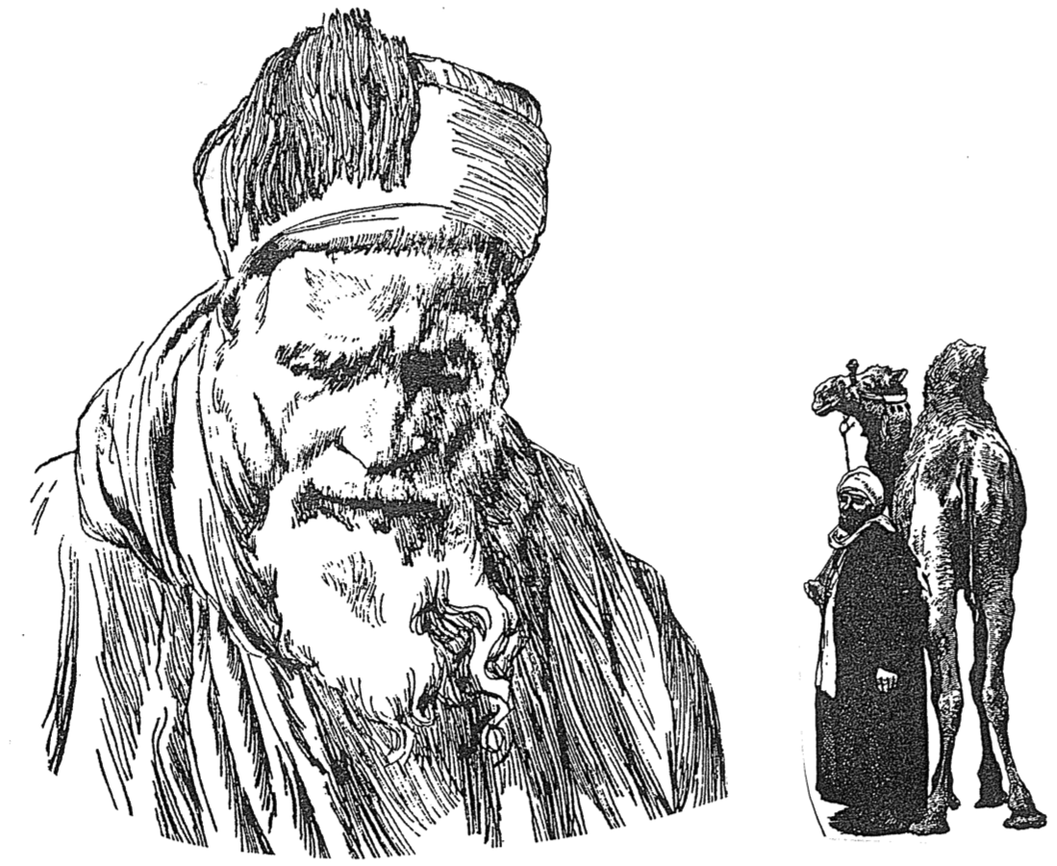
Life Under the Sun or Son
Bruce Wilkinson and Kenneth Boa, Talk Thru the Bible, 172

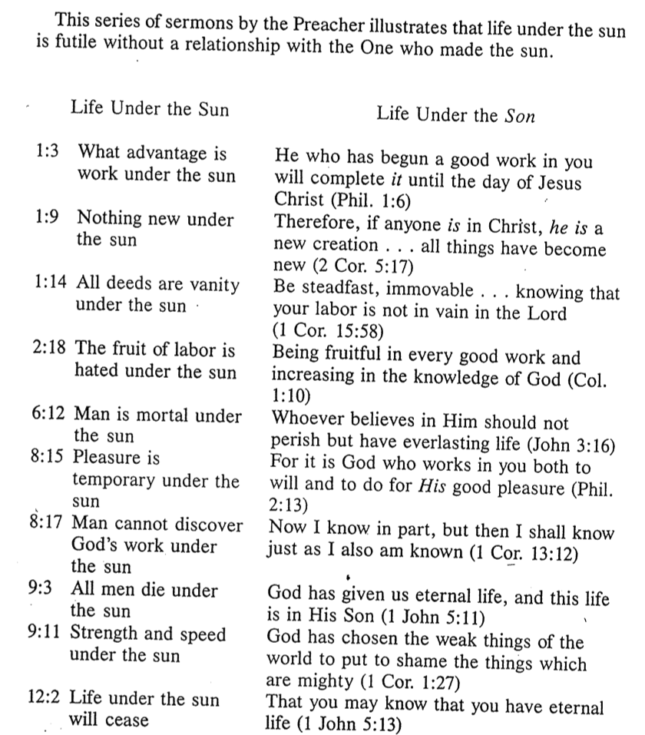

Striking a Balance
Huang Sabin, SBC

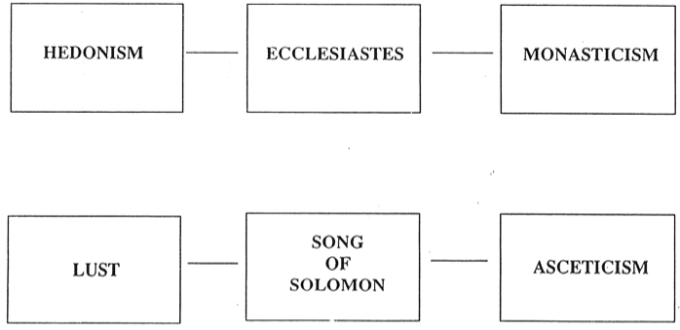

Avoiding Foolish Extremes
Huang Sabin, SBC

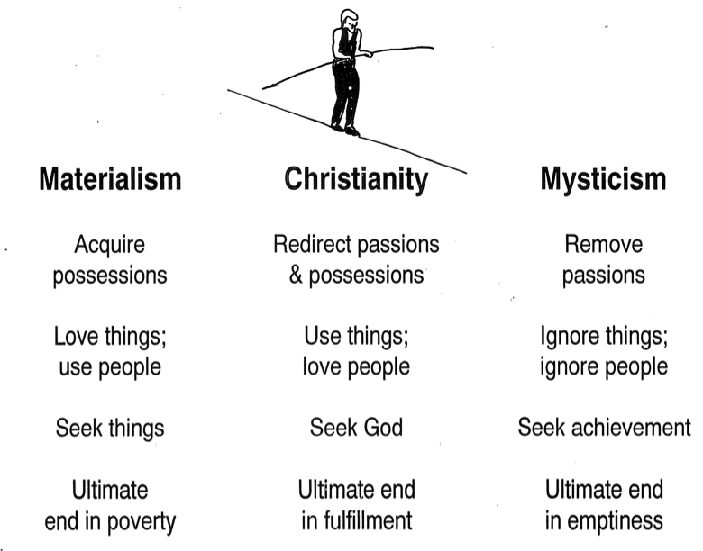

Prayer of the Unknown Soldier
Huang Sabin, SBC

