**Zechariah**

|  |  |  |  |  |  |
| --- | --- | --- | --- | --- | --- |
| **Rebuild Temple for Messiah** | | | | | |
| **God’s Covenant Faithfulness** | | | **Future Messianic Rule** | | |
| **Chapters 1–6** | | | **Chapters 7–14** | | |
| “The word of the LORD came to Zechariah…” (1:1) | | | “The word of the LORD came to Zechariah…” (7:1) | | |
| **Visions of the Covenant** | | | **Visions of the Messiah** | | |
|  |  |  |  | **Two Burdens** | |
| **Command to**  **Repent**  **1:1-6** | **Eight Covenantal Visions**  **1:7–6:8** | **Joshua’s Symbolic Coronation**  **6:9-15** | **Four Restoration Messages**  **7–8** | **Rejected at First**  **Advent**  **9–11** | **Received at**  **Second**  **Advent**  **12–14** |
| “The word of the LORD came to Zechariah” | “Then I looked up–and there before me” | “The word of  the LORD came  to me” | “The word of the LORD came to me” | “The burden of the word of the LORD” (NASB) | “The burden of the word of the LORD” (NASB) |
| **Pictures** | | | **Problems** | **Predictions** | |
| **Israel’s**  **Fortune** | | | **Israel’s**  **Fasting** | **Israel’s**  **Future** | |
| **While Building the Temple**  **520-518 BC (1:1; 7:1)** | | | | **After Building the Temple**  **480-470 BC (9:13?)** | |
| **Jerusalem** | | | | | |

**Key Word: Messiah**

**Key Verse: “This is what the LORD says, ‘I will return to Zion and dwell in Jerusalem. Then Jerusalem will be called The City of Truth, and the mountain of the LORD Almighty will be called The Holy Mountain’” (Zechariah 8:3).**

**Summary Statement:**

**The way Israel could be encouraged to rule with the Messiah was by rebuilding the temple.**

**Application:**

**How does your future reign with Christ affect the way you make decisions today?**

**Zechariah**

**Introduction**

**I. Title**: The name Zechariah (*זְכַרְיַהוּ zekaryahu*) in Hebrew means "Yahweh remembers" (BDB 272b 1f). The title is fitting as this book records how God remembers the covenant He made with the people of Israel and will complete it through the Messiah's rule.

**II. Authorship**

A. External Evidence: The universal testimony of Jewish and Christian tradition affirms Zechariah as the author of the entire book (*TTTB*, 289). For exceptions, see "Date" below.

B. Internal Evidence: The name Zechariah is shared by about thirty men in the Old Testament, but this book specifically designates Zechariah, son of Berekiah, the son of Iddo as author (1:1). The same verse calls him a prophet, and his grandfather served as head of the priestly families that returned from the exile (Neh. 12:4, 16). This makes Zechariah both prophet and priest, which accounts for his emphasis on the temple. Zechariah was born in Babylon and called to prophesy at a young age (2:4). He died at the hands of a murderer "between the temple and the altar" (Matt. 23:35) in the same way that another Zechariah was murdered years earlier (cf. 2 Chron. 24:20-21).

**III. Circumstances**

A. Date: The date of his writing is pinpointed to October-November 520 BC during the reign of Darius I Hystaspes, King of Persia (1:1). The beginning of Zechariah’s ministry occurred just two months after Haggai began his ministry. Chapters 1–8 include dated prophecies (1:7; 7:1) that stretch only two years later, while the remainder of the book is undated. The reference to Greek influence (9:13; ca. 490-470 BC) may indicate that Zechariah prophesied the later chapters (Zech 9–14) about forty years later, which would explain some of the differences in style, content, and vocabulary (cf. Gleason Archer, *A Survey of Old Testament Introduction*, 415f.).

The dates in Zechariah and Haggai can be summarized (*NIV Study Bible*, 1405, adapted):

|  |  |  |
| --- | --- | --- |
| 1. | Haggai’s first message (Hag. 1:1-11; Ezra 5:1) | Aug. 29, 520 BC |
| 2. | Rebuilding of the temple resumes (Hag. 1:12-15; Ezra 5:2) | Sept. 21, 520 |
|  | –Rebuilding was hindered (?) from 536 to c. 530 (Ezra 4:1-5) and the work ceased altogether from c. 530 to 520 (Ezra 4:2). |  |
| 3. | Haggai’s second message (Hag. 2:1-9) | Oct. 17, 520 |
| 4. | Beginning of Zechariah’s preaching (1:1-6) | Oct./Nov. 520 |
| 5. | Haggai’s third message (Hag. 2:10-19) | Dec. 18, 520 |
| 6. | Haggai’s fourth message (Hag. 2:20-23) | Dec. 18, 520 |
| 7. | Tattenai’s letter to King Darius seeking to stop the temple building (Ezra 5:3–6:14) | 519-518 |
| 8. | Zechariah’s eight night visions (1:7–6:8) | Feb. 15, 519 |
| 9. | Joshua crowned as high priest (Zech. 6:9-15) | Feb. 15 (?), 519 |
| 10. | Repentance urged and blessings promised (Zech. 7–8) | Dec. 7, 518 |
| 11. | Dedication of the temple (Ezra 6:15-18) | March 12, 516 |
| 12. | Zechariah’s final prophecy (Zech. 9–14) | After 480 (?) |

However, recent attacks from critical scholars advocate that chapters 9–14 come from either pre-exilic (before 586 BC) or late Maccabean authorship (ca. 100 BC). This is rejected since these dates assume that predictive prophecy cannot occur, overemphasize differences in the two sections, and neglect to account for differences in style and purpose due to a change in topic or time. There is no reason to believe that the book of Zechariah was not recorded during the time in which the prophet himself preached.

B. Recipients: The post-exilic Jews who had returned to their homeland 18 years previously were the original recipients of this prophecy.

C. Occasion: In 538 BC, near the end of the seventy-year captivity, Cyrus of Persia decreed that the Jews living in Babylon could return to their homeland (Ezra 1:1-4). However, after living away from Jerusalem for fifty years or more (from 605 or 597 or 586 to 538 BC), most considered Babylon their home and were not thrilled about "returning to their homeland," which they had never even known. Following Jeremiah's advice, the exiles had built houses, planted gardens, married, and raised families (Jer. 29:4-7). Many Jews had done well in business and undoubtedly had children and grandchildren of their own. Why move to a "foreign" land devastated years earlier that didn't even have a city wall?

As a result, the first return comprised only 50,000 who returned with Zerubbabel (September 538 BC; cf. Ezra 2:64-65). They quickly began work on the temple foundation, rebuilt the altar, and resumed the sacrifices (537 BC; cf. Ezra 3). However, opposition from Samaritans caused the project to cease (536 BC; cf. Ezra 4).

The story picks up in the Books of Zechariah and Haggai, which show how the returnees adopt a similar lifestyle of comfort to that of their brethren who remained in Babylon. They had become lax in their zeal to rebuild the temple, so Zechariah encouraged them that the temple needed to be rebuilt as it played a significant part in God's plan for the nation.

**IV. Characteristics**

A. Zechariah is the "major Minor Prophet"–the longest of the Minor Prophets (*TTTB*, 290).

It is even 9 chapters longer than Lamentations, which is one of the "Major Prophets"!

B. Zechariah is second only to Isaiah in number of messianic passages.

C. The style contains considerable variety with its visions, messages, and apocalyptic oracles.

D. While Zechariah and Daniel tell the most about the Gentile domination, Daniel emphasizes the role of Gentiles whereas Zechariah provides the greater insight into Israel during this period.

E. Zechariah is the most positive OT book with little about judgment and much about blessings.

**Argument**

Zechariah's prophecy aims to prepare the people of God for the coming Messiah. The first half (Zech 1–6) reminds Judah of God's faithfulness to His covenant in both the past and the present, motivating the people to complete the temple construction due to their unique position before God. The second half (Zech 7–14) looks to the future messianic rule. Chapters 7–8 remind the people that while God punished sin through the exile, restoration will come after the nation's obedience. Finally, chapters 9–14 encourage obedience because, although the Messiah will be rejected at His first advent (Zech 9–11), redemption of the nation will result at His second advent (Zech 12–14). Therefore, since the Messiah is indeed coming, the nation should respond in obedience now, especially by rebuilding the temple, since the Messiah's glory will inhabit it.

**Synthesis**

**Rebuild temple for Messiah**

**1–6 God's covenant faithfulness**

1:1-6 Command to repent

1:7–6:8 Eight covenantal visions Meaning = God's…

1:7-17 Man among myrtles Anger at nations/restoring Israel

1:18-21 Horns and craftsmen Judging nations afflicting Judah

2 Man with measuring line Future blessing on restored Israel

3 New garments for Joshua Cleansing Israel as a priestly nation

4 Lampstand and olive trees Spirit enabling as light to the nations

5:1-4 Flying scroll Judgment upon individual Israelites

5:5-11 Woman in a basket Removal of Israel's sin of rebellion

6:1-8 Four chariots Judgment upon Gentile nations

6:9-15 Joshua's symbolic coronation

**7–14 Future Messianic rule**

7–8 Restoration for obedience

7:1-3 Fasting questioned

7:4–8:23 Unnecessary when restored

9–14 Messiah's coming provides reasons to obey

9–11 Rejection at first advent

9:1-8 Alexander the Great to judge Israel's enemies

9:9–10:12 Messiah's offers

9:9-10 Peace

9:11-17 Deliverance

10:1-5 Destruction of false shepherds

10:6-12 Regathering

11 Messiah's rejection, Israel's scattering

12–14 Reception at Second Advent

12–13 Israel's redemption

12:1-9 Physical

12:10–13:9 Spiritual

12:10a Outpouring of Spirit

12:10b-14 Mourning of the nation

13:1-6 Cleansing of the nation

13:7-9 Excursus: Rejection of Shepherd at First Advent

14 Judgment/blessings summarized

14:1-5 Jerusalem delivered via Christ on Mt. of Olives

14:6-11 Kingdom established

14:12-15 Enemies destroyed

14:16-19 Messiah worshiped

14:20-21 "Holy to the LORD"

**Outline**

**Summary Statement for the Book**

**The way Israel could be encouraged to rule with the Messiah was by rebuilding the temple.**

# The way God encouraged Israel to rebuild the temple was by showing its privileged position in the Abrahamic covenant (Zech 1–6).

## Repent *before* judgment—not *afterwards* like their ancestors (1:1-6).

## Eight visions of God's commitment to the Abrahamic covenant help Israel understand its privileged position, enabling them to complete the temple (1:7–6:8).

### The vision of a man among the myrtle trees reveals God's anger at the nations, yet His favor toward Israel, to stir His people to complete the temple (1:7-17).

### The vision of four horns and four craftsmen shows God's jealous care for Israel by judging the nations in the four corners of the earth that afflicted Israel (1:18-21).

### The vision of a man with the measuring stick depicts God protecting Israel by rebuilding and repopulating Jerusalem, while nations that destroyed Israel would fall (Zech 2).

### The vision of new garments for Joshua the high priest shows God's gracious cleansing of Israel's sin through the future Messiah, who will restore Israel as a priestly nation (Zech 3).

### The vision of the gold lampstand and two olive trees depicts God’s Spirit strengthening Israel, Joshua, and Zerubbabel to be a light to the nations (Zech 4).

### The vision of a flying scroll warns individual Israelites that God would punish their sin (5:1-4).

### The vision of a woman in a basket shows that God had removed the nation's sins of wickedness and idolatry to Babylon (5:5-11).

### The vision of four chariots shows that God will judge Gentile nations opposing him and Israel (6:1-8).

## Joshua's symbolic crowning signifies the Messiah who will rebuild the future temple and serve as both Priest and King (6:9-15).

**Zechariah’s Eight Night Visions**

Adapted from *The Bible Knowledge Commentary*, 1:1549

|  |  |  |
| --- | --- | --- |
| **Vision** | **Reference** | **Meaning** |
| The Red-horse Rider  among the Myrtles | 1:7-17 | God’s anger against the nations and blessing on restored Israel |
| The Four Horns and  the Four Craftsmen | 1:18-21 | God’s judgment on the nations that afflict Israel |
| The Surveyor with a Measuring Line | Zech 2 | God’s future blessing on restored Israel |
| The Cleansing and Crowning of Joshua the High Priest | Zech 3 | Israel’s future cleansing from sin and reinstatement as a priestly nation |
| The Golden Lampstand and the Two Olive Trees | Zech 4 | Israel as the light to the nations under Messiah, the King-Priest |
| The Flying Scroll | 5:1-4 | The severity and totality of divine judgment on individual Israelites |
| The Woman in the Ephah | 5:5-11 | The removal of national Israel’s sin of rebellion against God |
| The Four Chariots | 6:1-8 | Divine judgment on Gentile nations |

# The way Israel could be encouraged was to know they will reject the Messiah and be scattered at His first coming, but then repent for salvation and rule at His second coming (Zech 7–14).

## Israel can repent of its sinfulness and obey for future blessings (Zech 7–8).

### A delegation from Bethel asks whether to stop their self-imposed religious fast, recalling Jerusalem's destruction (7:1-3).

### God rebukes Israel's hypocritical fasting but promises restoration in Jerusalem at the LORD’s return (7:4–8:23).

#### The people were hypocrites to fast and feast while still disobeying the prophets (7:4-7).

#### God requires justice and mercy (not fasting) so his judgment in the exile came only because the people disobeyed what they knew (7:8-14).

#### Restoration will come after the nation obeys God (8:1-17).

#### The LORD will return to Israel gathered in Jerusalem when the people show joyful obedience (not fasting) as a testimony to the Gentile nations (8:18-23).

## Israel will reject the Messiah at His first coming and be scattered, but God will judge the nations and bring in a peaceful rule (Zech 9–11).

### God will judge Israel’s neighbors through Alexander the Great before Israel experiences the blessings of the Messiah (9:1-8).

### Israel will rejoice that the Messiah will regather, deliver, and lead them in peace (9:9–10:12).

#### Israel can rejoice at the appearance of the Messiah as a peaceful deliverer (9:9-10).

#### Messiah's kingdom will deliver Israel (9:11-17).

#### Messiah's kingdom will destroy false shepherds (10:1-5).

#### Messiah's kingdom will regather Israel (10:6-12).

### Israel will reject the Messiah at his first advent, resulting in the scattering of Israel (Zech 11).

#### The coming wrath after the Messiah’s rejection will devastate the entire land of Israel [fulfilled by Vespasian and Titus in AD 66-70] (11:1-3).

#### Contrasts between the Messiah as the True Shepherd and the Antichrist as the False Shepherd warn against following the wrong shepherd (11:4-17).

1) Israel’s True Shepherd will lead Israel that was destined for slaughter by the Romans, but the nation will lose its favor and national unity in dispersion due to unbelief by attaching the price of a slave to the Messiah (11:4-14; cf. Exod. 21:32).

2) Israel’s false and wicked shepherd, the Antichrist, will be condemned for his selfish leading of the nation (11:15-17).

## Christ’s Second Advent will destroy Gentile oppressors and redeem Jerusalem when Israel worships and enthrones the Messiah (Zech 12–14).

### Messiah will redeem Israel spiritually after the nation's physical deliverance from Gentile powers at the Second Advent (Zech 12–13).

#### Israel will have *physical* redemption from the LORD when the nations try to lay siege to Jerusalem (12:1-9).

#### Israel will have *spiritual* redemption from the LORD when Jews realize they have rejected the Messiah and turn to him for cleansing at the Second Advent (12:10–13:9).

##### An outpouring of the Holy Spirit will follow the ruin of Gentile nations (12:10a).

##### Israel will mourn clan by clan for murdering and rejecting Jesus over the ages (12:10b-14).

##### Israel will experience cleansing from sin (13:1-6).

##### Excursus: Israel rejecting Christ as the True Shepherd, leading to judgment by the Romans at his first Advent, shows that God will discipline them for cleansing at His Second Advent (13:7-9).

### After God destroys Gentile oppressors, Israel will worship the Messiah and enthrone him as King in the holy messianic kingdom (Zech 14).

#### The LORD will deliver Jerusalem from Gentile oppressors at the Second Advent, and his coming will split the Mount of Olives (14:1-5).

#### The Messiah will establish His kingdom in Jerusalem through a fantastic series of events (14:6-11).

#### Israel's enemies will be destroyed (14:12-15).

#### Messiah will be worshiped annually at the Feast of Tabernacles (14:16-19).

#### Jerusalem and Judah will be holy in the messianic kingdom (14:20-21).

**Luke 19:37 and Zechariah 14:4**

Luke 19:37 notes that Jesus fulfilled Zechariah 9:9 at the Triumphal Entry, when pilgrims to Jerusalem hailed Him as the Messiah at the summit of the Mount of Olives. More than that, Zechariah 14:4 prophesies that the *next* time He will be acknowledged as Messiah will be *at this very point* where He was *last* acknowledged as Messiah!

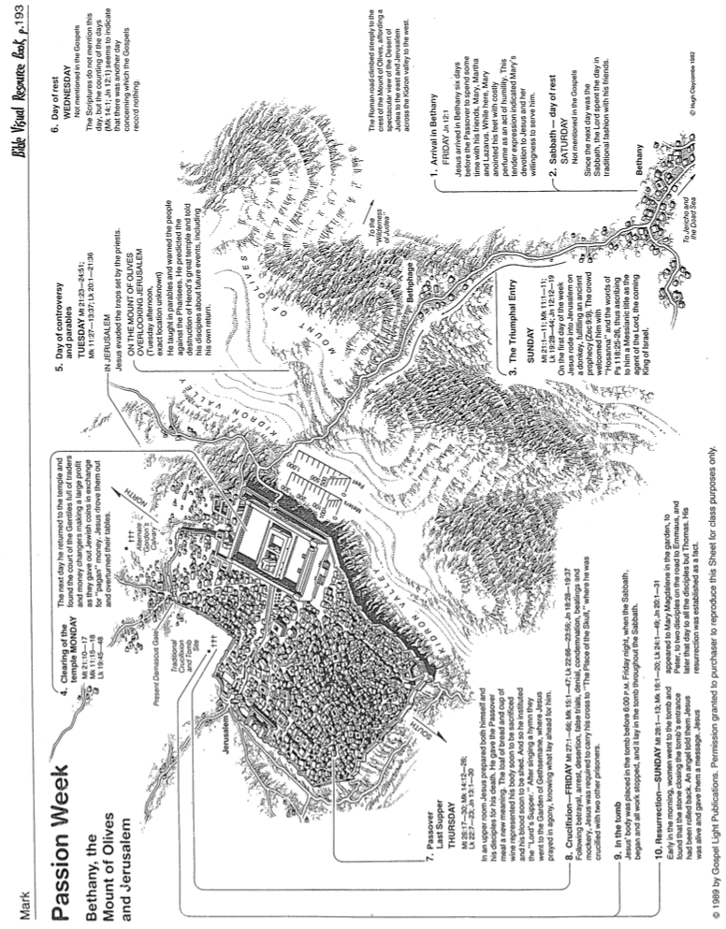

**Fasts in Zechariah**

Adapted from a Dallas Theological Seminary Class Handout, 1985

|  |  |  |  |
| --- | --- | --- | --- |
| **Zechariah** | **Time** | **Fast Commemorates:** | **Scripture** |
| **8:19d** | **10th Month**  **10th Day** | **Nebuchadnezzar Began Jerusalem Siege**  **(15 January 588)** | **Jer. 39:1; 52:4;**  **2 Kings 25:1** |
| **8:19a** | **4th Month**  **9th Day** | **Jerusalem Destroyed**  **(18 July 586)** | **Jer. 39:2; 52:6;**  **2 Kings 25:3** |
| **7:3, 5**  **8:19b** | **5th Month**  **10th Day** | **Jerusalem & Temple Burned**  **(15-18 August 586)** | **Jer. 52:12-13;**  **2 Kings 25:8** |
| **7:5**  **8:19c** | **7th Month**  **3rd Day** | **Gedaliah Slain**  **(9 October 586)** | **Jer. 41:1-3**  **2 Kings 25:25-26** |

**Visionary Literature**

Adapted from Leland Ryken, *How to Read the Bible as Literature,* and Mark L. Bailey, Dallas Theological Seminary, 1986

|  |  |
| --- | --- |
| **Characteristics of Visionary Literature** | **Therefore Interpret with These Guidelines** |
| 1. ***Structure***: many separate and equal passages contribute to a whole (“pictures a kaleidoscope structure of self-contained units”) | Interpret each self-contained unit of visionary material in relationship to both its own unit as well as within the context of the section or book where it is found |
| 1. ***Symbolism***: communicates history through ideological signs, not literal objects | Interpret symbols consistent with symbols in other texts |
| 1. ***Supernatural***: portrays a transcendental world through God, demons, and angels | Interpret as anticipating divine intervention for the salvation or judgment of both men and nations |
| 1. ***Scope***: transforms the state of reality at the time of writing to what can be imagined in the future | Interpret present images as depicting future unknowns, especially relating to the Day of the LORD and end times events |
| 1. ***Subjects***: places both familiar people and places with unfamiliar ones | Know the whole of visionary literature in Scripture in order to separate near from far fulfillments and to protect against spiritualizing the text |
| 1. ***Scenic***: reveals a cosmic scene rather than localized scenes | Recognize national and cosmic entities in the text instead of individual destinies |
| 1. ***Strangeness***: people, settings and events described in extraordinary realities | Do not interpret every detail of extraordinary descriptions |

**Threats to the Messianic Seed & God’s Deliverance**

Author Unknown

| **Scripture** | **Threat to the Seed** | **God’s Deliverance** |
| --- | --- | --- |
| Gen 4:8 | Cain committed murder | Seth was born to replace Cain |
| Gen 6:1-5 | Sons of God took daughters of man, wickedness of man was great | Destroyed world through flood but saved Noah and family |
| Gen 12:10-20 | Severe famine | Went to Egypt, prevented Pharaoh from taking Sarai |
| Gen 20:1-18 | Went to Gerar, Abimelech wanted to take Sarai | God prevented Abimelech by warning him in a dream |
| Gen 37:19-30 | Joseph was to deliver Israel from the future famine but the brothers wanted to kill him, indirectly exterminating themselves | Joseph was sold as a slave instead and brought to Egypt according to God’s plan |
| Gen 38 | The Seed had move through the child of Tamar who was still a widow | Judah gave Tamar a son, Perez to carry the Seed |
| Gen 43:1 | Very severe famine | Sent Joseph years ahead and they were kept safe from other nations and were left alone in Goshen of Egypt. |
| Exod 1:8-22 | Pharaoh tried to exterminate the Hebrew race | Protected and increased their numbers and raised up Moses. |
| Exod 14:5-9 | Pharaoh and his army pursued the Israelites to destroy them | Opened the Red Sea for the people to cross over. |
| Exod 15:22-25 | Water at Marah was poisoned, all people will die of thirst or poisoning | God made the water safe to drink |
| Exod 16:3,4 | No food in desert | God provided manna and quail |
| Exod 17:1-7 | No water | Water came from a rock |
| Exod 17:8-15 | Amalekites attacked | Amalekites defeated |
| Num 20:2-11 | No water again | Water came from a rock again |
| Num 21:1-3 | King of Arad attacked | Arad defeated and destroyed |
| Num 21:21-35 | Sihon and Og attacked | Sihon and Og defeated |
| Num 25:1-5 | Moab seduces Israel with idolatry and sexual immorality on Balaam’s advice | God sent a plague to kill the offenders |
| Judges 1-20 | Forsook God, idolatry, did what was right in their own eyes | Raised up judges to deliver them, preserved the Seed through Ruth and Boaz |
| 1 Sam 1-31 | Saul tries to kill David | God protected David |
| 2 Sam 15-18 | David’s son Absalom tries to kill David and his sons including Solomon | God protected David and Absalom died. |
| 2 Sam 21:1 | Famine because of Saul’s sin | God revealed the cause and David corrected the problem |
| 2 Kings 11  2 Chron 22–23 | Athaliah destroyed the whole royal family (except one) | Jehosheba hid Joash from Athaliah |
| Esther | Exiles were threatened with extinction by Haman | God prepared Esther beforehand to deliver the people |