**Haggai**

|  |  |  |  |
| --- | --- | --- | --- |
| **Drought for Neglected Temple Rebuilding** | | | |
| **Temple** | | **Blessings** | |
| **Wrong**  **Priorities** | **Greater**  **Glory** | **Drought**  **Judgment** | **Zerubbabel’s  Authority** |
| **1** | **2:1-9** | **2:10-19** | **2:20-23** |
| **Rebuke #1** | **Promise #1** | **Rebuke #2** | **Promise #2** |
| “Is it a time for you yourselves to be living in your paneled houses, while this house remains in ruins? …Go…and build the house” (1:4, 8a) | “I will fill this house with glory…The glory of this present house will be greater than the glory of the former house”  (2:7b, 9a) | “Whatever [my people] do and whatever they offer is defiled… [yet] from this day on I will bless you”  (2:14b, 19b) | “I will shake the heavens and the earth. I will overturn royal thrones and shatter the power of the foreign kingdoms”  (2:21-22) |
| **Present** | **Kingdom** | **Present** | **Kingdom** |
| **Drought** | **Sadness** | **Food Shortage** | **Leadership** |
| **August 29,**  **520 BC** | **October 17,**  **520 BC** | **December 18,**  **520 BC** | **December 18,**  **520 BC** |
| **Jerusalem** | | | | |

**Key Word: Priorities**

**Key Verse: (God to Judah) “‘You expected much, but see, it turned out to be little. What you brought home, I blew away. Why?’ declares the LORD Almighty. ‘Because of my house, which remains a ruin, while each of you is busy with his own house’”   
(Haggai 1:9).**

**Summary Statement:**

**Postexilic Jews should realign to God’s priorities by rebuilding the temple since he would bless their crops and the temple, and Zerubbabel would have authority in the millennium.**

**Application:**

**Don’t pursue personal prosperity more than you pursue God’s work.**

**(i.e., prioritize God’s work over wealth)**

**Honestly, which is more important to you—God or money?**

**Haggai**

**Introduction**

**I. Title**: The name Haggai (חַגַּי *haggay*) derives from an uncertain origin (BDB 291b), but may be from *hag* (חַגּ), which means "festival-gathering, feast, pilgrim-feast" (BDB 290d). Thus, his name may mean "festal" or "feast," possibly because he was born on the day of a major feast, perhaps Tabernacles (LaSor, 482). Haggai's second message takes place on that feast (2:1; *TTTB*, 283).

**II. Authorship**

A. External Evidence: Haggai is known only from this book and two references to him by Ezra (5:1; 6:14).

B. Internal Evidence: Some have supposed that the book was composed from several sources, especially since it is written in the third person. However, authors often used the third person in ancient writings (e.g., Moses, Jonah, etc.). Since Haggai's name appears nine times (1:1, 3, 12-13; 2:1, 10, 13-14, 20), few challenge his authorship of the book.

**III. Circumstances**

A. Date: Haggai is the most precisely dated book of the entire Bible, so it is virtually uncontested. The prophecy divides itself into four sections, with three different dates ranging from August 29, 520 BC, to December 18 of the same year. The reign of King Darius I Hystaspes establishes the basis for such an accurate accounting (1:1).

B. Recipients: The original readers of Haggai constituted the returning Jewish exiles who had begun to settle in Jerusalem.

C. Occasion: In 538 BC, near the end of the seventy-year captivity, Cyrus of Persia decreed that the Jews living in Babylon could return to their homeland (Ezra 1:1-4). However, after living away from Jerusalem for nearly fifty years or more (605 or 597 or 586 to 538 BC), most considered *Babylon* their home and were not excited about "returning to their homeland," which they had never even visited. Following Jeremiah's advice, the exiles in Babylon had built houses, planted gardens, married, and raised families (cf. Jer. 29:4-7). Some had done well in business, and Jews born in exile fifty years earlier had children and grandchildren. Why move to a "foreign" land devastated years earlier that didn't even have a city wall?

As a result, the initial return a few months later comprised a mere 50,000 who came back with Zerubbabel (September 538 BC; cf. Ezra 2:64-65). Contrast this with the 603,5501 soldiers under Joshua nearly 2000 years earlier (Num 2:32). These returnees quickly began work on the temple foundation, rebuilt the altar, and resumed the sacrifices (537 BC; cf. Ezra 3). However, opposition from Samaritans caused the project to cease (536 BC; cf. Ezra 4).

The story picks up in the Book of Haggai, which shows how the returnees adopted a similar lifestyle of comfort to that of their brethren remaining in Babylon. They lived in paneled houses while God's own house lay in ruins (1:4). Therefore, God raised up Haggai and Zechariah, who prophesied so that the temple work resumed on September 21, 520 at their encouragement (1:15). Not only did Haggai write to encourage the rebuilding of the temple, but he also explained why the returnees experienced crop failure from a drought sent by God to cause them to return to correct their priorities (1:11).

**IV. Characteristics**

A. Haggai is the most precisely dated book in the Scripture.

B. Haggai is the only scriptural writing organized by the dates of prophetic revelations.

C. Haggai is the first of the three post-exilic prophets (the others are Zechariah and Malachi).

**Argument**

Haggai's purpose in writing to the returned exiles is to explain that the drought they experienced was due to their neglect of the LORD's temple. He aimed to encourage them to resume rebuilding the temple so they could once again experience God's blessing. Haggai accomplishes this by **rebuking** them for concern for their own homes more than for God's house (ch. 1), **promising** God's presence with glory even greater in the new temple than in Solomon's (2:1-9), **rebuking** their temple neglect that resulted in judgment by drought, although the resumption of the task would bring God's blessing in renewed crops (2:10-19), and finally **promising** Zerubbabel divinely bestowed authority in foreshadowing the authority of Messiah in the future messianic kingdom (2:20-23).

**Synthesis**

**Drought for neglecting temple rebuilding**

**1 Wrong priorities Rebuke**

1:1 Setting

1:2-6 Homes–not temple

1:7-11 Drought for motivation

1:12-15 Work resumes

**2:1-9 Greater glory Promise**

2:1-2 Setting

2:3-5 God's presence despite inferior reconstruction

2:6-9 Greater glory

**2:10-19 Drought judgment Rebuke**

2:10-11 Setting

2:12-14 Defiled worship

2:15-19 Crops with rebuilding

**2:20-23 Zerubbabel's authority Promise**

2:20-21a Setting

2:21b-22 Judgment of the nations

2:23 Foreshadowed authority

**Outline**

**Summary Statement for the Book**

**Postexilic Jews should realign to God’s priorities by rebuilding the temple since he would bless their crops and the temple, and Zerubbabel would have authority in the millennium.**

# On 29 August 520 BC, the LORD rebuked Judah’s wrong priorities so they would finish rebuilding the temple (Haggai 1).

## On 29 August 520 BC, Haggai prophesied to Zerubbabel, the governor, and Joshua, the high priest, his first message from the LORD (1:1).

## The remnant’s wrong priorities, as evidenced by paneling their own houses instead of rebuilding the temple, resulted in a dire economy (1:2-6).

## The people’s financial poverty was revealed to be a result of postponing the temple rebuilding, so that they would resume the task to please God and end the drought (1:7-11).

## Resuming the temple rebuilding three weeks later earned God's promise of His presence (1:12-15).

# On 17 October 520 BC, the LORD promised the remnant God's presence and a glory greater in the new temple than that of Solomon's to encourage them in the rebuilding (2:1-9).

## Two months after the first message, on 17 October 520 BC, Zerubbabel, Joshua, and the remnant received Haggai’s second message from the LORD (2:1-2).

## God encouraged continued temple reconstruction with his presence, even though the new temple looked inferior to Solomon's (2:3-5).

## God promised that the millennial temple will be more glorious even than Solomon's because it will include the wealth of the nations and bring His peace (2:6-9).

Note: Some understand the glory in 2:7, 9 to be Christ’s presence in Zerubbabel’s temple during His *first* advent (cf. Matt. 12:6; Luke 2:32; John 2:13-22). However, the treasures in the millennial temple in verse 6 show that Christ’s *second* advent is more likely (cf. 2:21-22; Isa. 2:12-21; 13:13; Ezek. 38:20; Amos 8:8; Joel 3:16; Matt. 24:29-30).

# On 18 December 520 BC, the LORD rebuked temple neglect resulting in drought, but resuming the task will reward the remnant with renewed crops (2:10-19).

## Two months after the second message, on 18 December 520 BC, Haggai prophesied to the priests his third message from the LORD (2:10-11).

## God showed the priests that consecration couldn’t be transferred while defilement could to illustrate the nation's defiled service and worship (2:12-14).

## Drought from temple neglect would change into God's blessing in renewed crops, as the people had built for three months (cf. 1:14-15) to complete the foundation that very day (2:15-19).

# Later that day, on 18 December 520 BC, the LORD promised Zerubbabel authority that foreshadowed the Messiah’s authority in the future millennial kingdom (2:20-23).

## Later on the same day, on 18 December 520 BC, Haggai prophesied to Zerubbabel alone his fourth message from the LORD (2:20-21a).

## God promised to show His power by overthrowing the nations [at the coming of the millennial kingdom] (2:21b-22).

## God promised Zerubbabel divine authority that foreshadowed the Messiah’s authority in the future messianic kingdom (2:23).

**Temples in Scripture**

The Jerusalem temples all relate to the same spot where God’s Spirit dwelt in the Holy of Holies on Temple Mount. However, some notable differences exist between these various structures.

|  |  |  |  |  |
| --- | --- | --- | --- | --- |
|  | **Solomon** | **Zerubbabel/**  **Herod** | **Tribulation** | **Millennial** |
| *Temple Period* | First | Second | Third | Fourth |
| *Description* | 1 Kings 6–7 | Ezra 3–6 | Rev. 11:1-2 | Ezek. 40–43 |
| *Haggai Texts* | Haggai 2:3a, 9b | Haggai 1:4, 8-9; 2:3b | – | Haggai 2:7, 9a |
| *Construction* | 966-959 BC | 536-516 BC | Materials being gathered now | Still future |
| *Desecrated by* | Israelites and pagan kings such as Nebuchadnezzar  (2 Kings 25:9) | Antiochus, money changers (John 2:16), Pompey, Titus (Dan. 9:25) | Antichrist (Dan. 9:27) | No one  (Zech. 14:20-21) |
| *Destruction* | 586 BC | AD 70 | End of Great Tribulation? | Before new heavens and new earth (Rev. 21:22) |
| *Longevity* | 380 years | 606 years | Under 7 years? | 1000 years |
| *Sacrifices* | Before Christ | Before (approved) and after Christ (unapproved) | After Christ (unapproved) | After Christ (approved) |
| *God’s Glory* | Filled it  (1 Kings 8:10-11) | Didn’t fill it | Won’t fill it | Will fill it  (Ezek. 43:1-5) |
| *Sanctuary* | 90’ x 30’ =  2,700 sq. ft. | ? | ? | 87.5’ x 175’ = 15,312 sq. ft. |
| *Inner Court* | 150’ x 400’ = 60,000 sq. ft. | ? | ? | 175’ x 427.5’ = 74,812.5 sq. ft. |
| *Outer Court* | 500 x 500 cubits (875’ x 875’) or else six times as large (see note 9 on OTS, 520) | ? | ? | 875’ x 875’ = 765,625 sq. ft. |

**The Temple Mount**

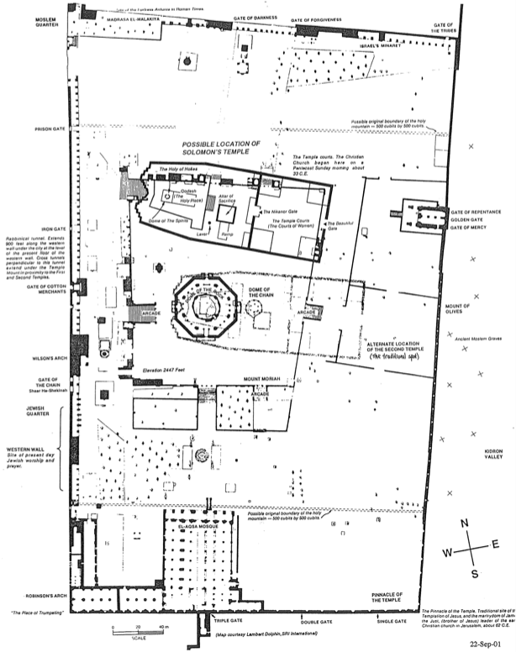

**Post World Trade Center Priorities**

The world was shocked at the 911 Tragedy on September 11, 2001, when terrorists flew passenger planes into the World Trade Center in New York and the Pentagon in Washington, D.C. As I watched the WTC buildings collapse on TV, I could identify with millions of other people that Osama bin Laden and others who did this must be brought to justice. Since this killing of thousands of innocent lives must be strongly opposed, the USA defeated the Taliban in Afghanistan to counter this threat.

As heinous as this tragedy is, where is the public outcry over another tragedy that has taken far more innocent lives? In 1973, the US Supreme Court's Roe v. Wade decision legalized abortion at any stage of the baby's life. Since then and until 2025, in the USA alone, over *65 million* Americans have been killed within the supposed sanctuary of their mothers' wombs! Is this not an equally appalling terrorist act? Is this not even *worse* in terms of the number of people murdered, especially since these are planned attacks by family members with government approval?

The problem has become so severe that in recent years, even *partial-birth* abortions have gained legal protection in the USA. The US Congress twice put legislation before President Clinton to abolish this practice of killing babies during birth, but both times, Clinton vetoed it.

The prophecy of Haggai commands us to align our priorities with God's. As God's holy people, we should fight terrorism on all fronts: public and private, illegal and legal.

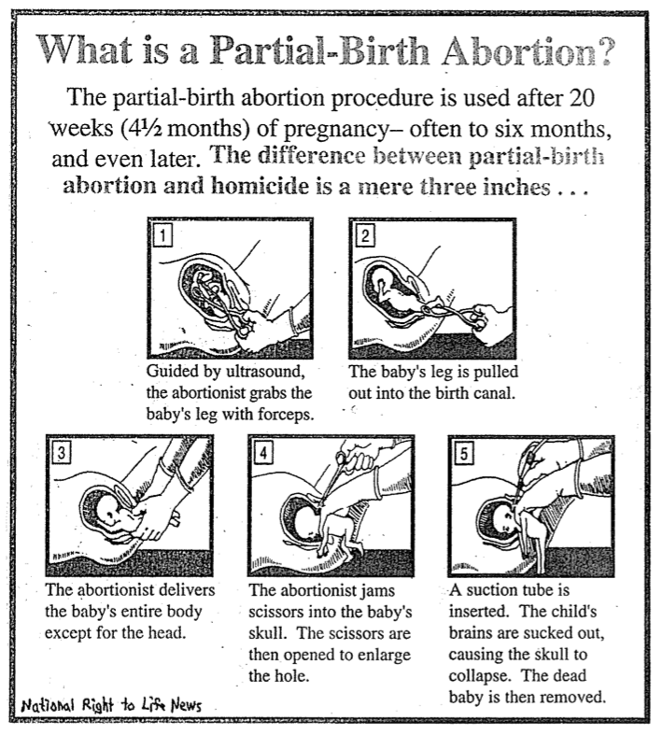

**Haggai and the Second Coming**

Clifton L. Fowler, 1934 (Book Unknown)

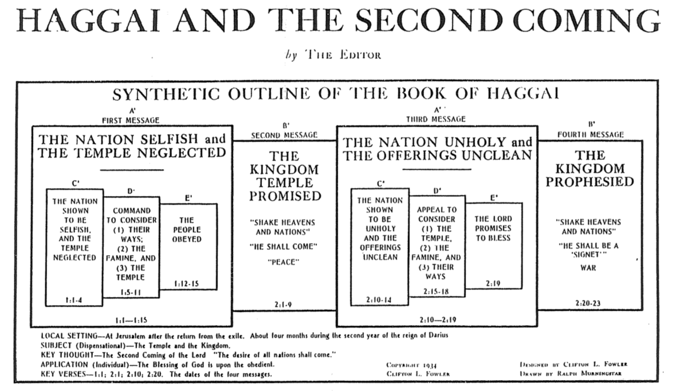

**Applications from Haggai**

*Adapted from Mark Bailey, Dallas Theological Seminary, 1985*

1. The work of the Lord should never be procrastinated (1:3).

2. Misplaced priorities hinder the work of God (1:4, 9).

3. The goal of God’s work is His glory and pleasure (1:8).

4. God sometimes uses natural disasters for spiritual discipline (1:6, 10, 11).

5. Obedience and reverence are prerequisites for spiritual blessing (1:12-14).

6. It is never too late to start obeying God (1:12-15).

7. Courage comes from knowing that God is present (2:1-4).

8. The remedy for a discouraged heart is to see the divine perspective (2:6-7).

9. Everything belongs to God and is under His control (2:7-8).

10. Holiness is not transferable (2:11-12).

11. Sin contaminates everything one does (2:13-14).

12. Disobedience brings discipline while obedience guarantees blessing (2:15-19).

13. God is sovereign over all the nations and kingdoms of the world (2:20-22).

14. The LORD guarantees that he will fulfill his covenants (2:23).

**Zerubbabel’s Authority**

*Talk Thru the Bible*, 285

Haggai portrayed the Messiah in the person of Zerubbabel when God said to Zerubbabel, “I will make you like my signet ring, for I have chosen you” (2:23). As a signet ring denoted authority, so Zerubbabel became the center of the Messianic line in which both Joseph and Mary’s lines merged:

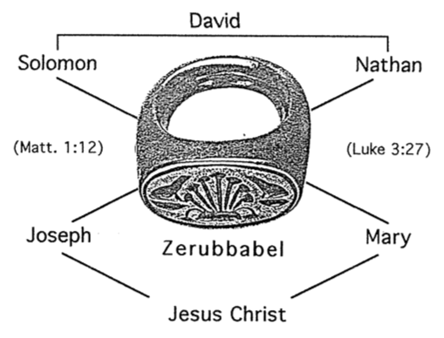

In both genealogies, the father of Zerubbabel is Shealtiel; however, each genealogy follows a different son of Zerubbabel until they both end with Joseph and Mary. This makes Zerubbabel and his father the common link in each lineage.

**Haggai and Zechariah Contrasted**

*Talk Thru the Bible*, 291, adapted

|  |  |
| --- | --- |
| **Haggai** | **Zechariah** |
| **Rebuke** | **Encouragement** |
| **Priorities** | **Messiah** |
| **More Concrete** | **More Abstract** |
| **Concise**  **(2 chapters)** | **Expanded**  **(14 chapters)** |
| **Present Concern** | **Future Concern** |
| **4 visions** | **Many visions** |
| **Take Part!** | **Take Heart!** |
| **Older Activist** | **Younger Visionary** |