**Jonah**

|  |  |  |  |  |  |  |  |
| --- | --- | --- | --- | --- | --- | --- | --- |
| **God’s Compassion on Gentiles** | | | | | | | |
| **Disobeys Missionary Mandate** | | | | **Obeys Missionary Mandate** | | | |
| **Chapters 1–2** | | | | **Chapters 3–4** | | | |
| **God’s Mercy on Jonah** | | | | **God’s Mercy on Nineveh** | | | |
| **The Great Sea** | | | | **The Great City** | | | |
| **Commissioning**  **1:1-2** | **Disobedience**  **1:3** | | **Consequences**  **1:4–2:10** | **Recommissioning**  **3:1-2** | **Obedience**  **3:3-4** | | **Consequences**  **3:5–4:10** |
| **“Go!”** | **“No!”** | | **“So Row!”**  **“Lo!”** | **“Go!”** | **“Yo!”** | | **“Whoa!”**  **“Oh No!”** |
| **Jonah’s \***  **Perversity**  **Chapter 1** | | **Jonah’s**  **Prayer**  **Chapter 2** | | **Jonah’s**  **Preaching**  **Chapter 3** | | **Jonah’s**  **Pouting**  **Chapter 4** | |
| **Jonah Wants to Die** | | **Jonah Wants to Live** | | **Jonah Wants to Live** | | **Jonah Wants to Die** | |
| **c. 760 BC** | | | | | | | |

**Key Word: Compassion**

**Key Verse: “[Jonah] prayed to the LORD, “O LORD, is this not what I said when I was still at home? That is why I was so quick to flee to Tarshish. I knew that you are a gracious and compassionate God, slow to anger and abounding in love, a God who relents from sending calamity” (4:2).**

**Summary Statement:**

**Jonah's disobedient indifference towards Nineveh symbolizes Israel’s same sin and depicts God's sovereignty and compassion over Gentiles to remind Israel of its missionary purpose.**

**Application:**

**Responding to God’s heart means catching His heart for the lost.**

**\* This row taken from Eugene Merrill, *A Historical Survey of the OT,* 271**

**Jonah**

**Introduction**

**I. Title** The name Jonah (יוֹנָה *yonah*) means "dove" (BDB 401d; 402a). This same dove metaphor symbolizes Israel in the Old Testament (cf. Hosea 7:11; 11:11; Psalm 74:19) since the experience of Jonah the prophet (dove) represents the entire nation of Israel (also a dove).

**II. Authorship**

A. External Evidence: The only verse outside the book of Jonah itself that mentions the prophet is 2 Kings 14:25. It states that Jonah had correctly prophesied that during the reign of Jeroboam II Israel's borders would once again expand from Hamath in the north to the Sea of Arabah (Dead Sea) in the south. It also reveals Gath Hepher, a small town three miles north of Nazareth, as Jonah's hometown.

B. Internal Evidence: The book nowhere states that Jonah is the author, and some have supposed that he could not have penned the writing since he is referred to in the third person (1:3, 5, 9, 12; 2:1; 3:4; 4:1, 5, 8-9). This argument ignores the fact that third person autobiographies were common in ancient times and practiced by Moses for entire books in which he is included (e.g., Exodus, Numbers, Deuteronomy) and by Daniel and Isaiah in portions of their prophecies (e.g., Isa. 37:21; 38:1; 39:3-5; Dan. 1:1–7:1). As the book contains little about the admirable qualities of the prophet, Jonah must be commended for recording such a faithful autobiographical work!

**III. Circumstances**

A. Date: Jonah prophesied during the reign of Jeroboam II of Israel (2 Kings 14:25; 782-753 BC), making him a contemporary of Amos. Critics claim that the work comes from the fifth to third centuries (see “Characteristics” section below, point D), but this assumes an anonymous author writing of a fictional Jonah. This is unacceptable as Christ Himself supported the historical accuracy of the book (cf. Matt. 12:39-41). He probably wrote during the end of Jeroboam’s reign (ca. 760 BC) when Jonah’s popularity was high from his fulfilled prophecy about Israel’s expansion (2 Kings 14:25).

B. Recipients: Jonah recorded his autobiographical account for the benefit of the self-sufficient northern kingdom, of which he was part. However, this message for Israel had strong implications for the southern kingdom and the present time as well.

C. Occasion: The time of Jeroboam II saw great expansion to reclaim former borders (see "External Evidence" above) since Assyria, the ruling power, was in temporary decline due to internal dissension. These factors resulted in a narrow, nationalistic focus in Israel, which enjoyed its prosperity. Unfortunately, Jewish nationalism contributed to its religious decline and blinded God's covenant people from seeing beyond their own borders to other peoples who needed to know the God of Israel. The least of those whom Israel cared about was the ruthless Assyrians, whose cruelty had become legendary. Through Jonah, the people of God learned that God remained the God of the nations as well as of Israel. Inclusion of the Gentiles in God's program was not a new concept to Israel at this time (cf. Gen. 9:27; 12:3; Lev. 19:33-34; 1 Sam. 2:10; Isa. 2:2; Joel 2:28-32), but the shortsightedness of the nation nevertheless needed a sharper focus on God’s compassion for all.

**IV. Characteristics**

A. All prophetic writings record what God said through the *words* of a prophet, but Jonah is unique in that it records what God intended to communicate through the *experiences* of a prophet. The story of what happens to Jonah is the message of the book itself (LaSor, 347), and this remains the only narrative prophetic writing. However, God has the first (1:1-2) and the last word (4:11), and Jonah is not the principal person in the book–God is.

B. Jonah is the only prophet in Scripture who attempted to run from God. In fact, the book is unique among writings in Scripture in that of all people and things in the book–the storm, the lots, the sailors, the fish, the Ninevites, the plant, the worm, and the east wind–only Jonah himself failed to obey God.

C. Jonah is the only entire biblical book emphasizing Israel's response to the Gentile nations.

D. The historicity of Jonah has been denied by many scholars who have difficulty: (1) swallowing a story about one actually living for three days in a great fish (1:17), (2) believing that Nineveh was so large it had 120,000 inhabitants (4:11), and (3) supposing that all of Nineveh really repented (3:5f.). Two such skeptics both posit a postexilic date of 400 to 200 BC rather than the ninth century BC as is argued above under “Date”:



“The story of the willful prophet is one of the best known and most misunderstood in the Old Testament: an occasion for jest to the mocker, a cause of bewilderment to the literalist believer but a reason for joy to the critic.... What an exaggerated idea of the greatness of Nineveh the author had!.... And what a wonderful result followed his preaching! The greatest prophets in Israel had not been able to accomplish anything like it.... We are in wonderland! Surely this is not the record of actual historical events, nor was it ever intended as such. It is a sin against the author to treat as literal prose what he intended as poetry” (Julius A. Bewer, *A Critical and Exegetical Commentary on Jonah*, ICC, 3-4).

“Its [the city of Nineveh] colossal size in 3:3 reflects the exaggerated tradition echoed by the fourth-century Ctesias rather than literal fact” (Leslie C. Allen, *The Books of Joel, Obadiah, Jonah, and Micah*, NICOT, 186).

What can be said in response to these doubts?

1. There have been several documented accounts of people who have been actually swallowed by large fish or whales and lived.

a. Sperm whales have swallowed 15-foot sharks (Frank T. Bullen, *Cruise of the* Chachalot *Round the World after Sperm Whales.* London, Smith, 1898).

b. “Others have written that whale sharks (the *Rhineodon Typicus*) have swallowed men who were later found alive in the sharks’ stomachs” (John D. Hannah, “Jonah,” in *The Bible Knowledge Commentary*, 1:1463).

c. Two accounts (one in 1758 and the other in 1771) have documented that a man was swallowed by a whale and vomited up shortly after with only minor injuries. See A. J. Wilson, “Sign of the Prophet Jonah and Its Modern Confirmations,” *Princeton Theological Review* 25 (October 1927): 630-42; George F. Howe, “Jonah and the Great Fish,” *Biblical Research Monthly* (January 1973): 6-8.

d. “One of the most striking instances comes from Francis Fox, *Sixty Three Years of Engineering* (pp. 298-300), who reports that this incident was carefully investigated by two scientists (one of whom was M. DeParville, the scientific editor of the *Journal Des Debats* in Paris). In February 1891, the whaling ship *Star of the East* was in the vicinity of the Falkland Islands, and the lookout sighted a large sperm whale three miles away. Two boats were lowered, and in a short time, one of the harpooners was enabled to spear the creature. The second boat also attacked the whale, but was then upset by the lash of its tail, so that its crew fell into the sea. One of them was drowned, but the other, James Bartley, simply disappeared without a trace. After the whale was killed, the crew set to work with axes and spades, removing the blubber. They worked all day and part of the night. The next day, they attached some tackle to the stomach, which was hoisted on deck. The sailors were startled by something in it which gave spasmodic signs of life, and inside was found the missing sailor, doubled up and unconscious. He was laid on the deck and treated to a bath of seawater, which soon revived him. At the end of the third week, he had entirely recovered from the shock and resumed his duties . . . His face, neck, and hands were bleached to a deadly whiteness and took on the appearance of parchment. Bartley affirms that he probably would have lived inside his house of flesh until he starved, for he lost his senses through fright and not through lack of air” (Gleason L. Archer, *A Survey of Old Testament Introduction*, 302).

Unfortunately, despite the wide circulation of this story, it is false as: (a) James Bartley never sailed on this ship, (b) the *Star of the East* was not a whaler (c) whaling near the Falkland Islands did not begin until 1909, and (d) the captain’s wife denied that a man was ever thrown overboard on her husband’s ship (Edward B. Davis, “A Whale of a Tale: Fundamentalist Fish Stories,” *Perspectives on Science and Christian Faith* 43 [December 1991]: 224-37).

2. That it took three days to walk around Nineveh (3:3) with such a large population is also questioned. Hannah, an evangelical (*BKC*, 1:1463), cites the critics’ argument: “True, the circumference of Nineveh’s inner wall, according to archeologists, was less than eight miles. So the diameter of the city, less than two miles, was hardly a three-day journey. (One day’s journey in the open territory was usually about 15-20 miles.)” However, this can also be explained in one of two ways:

a. “The great city of Nineveh” (1:2; 3:2; cf. 4:11) almost surely included three other towns in the vicinity as well. Four cities (Nineveh, Rehoboth Ir, Calah, and Resen) are mentioned in Genesis 10:11-12 as “the great city” and are called Kouyunjik, Khorsbad, Nimroud, and Karamles today. This can be observed on the following map by Austin Henry Layard, *Nineveh and Its Remains*, 2:40.

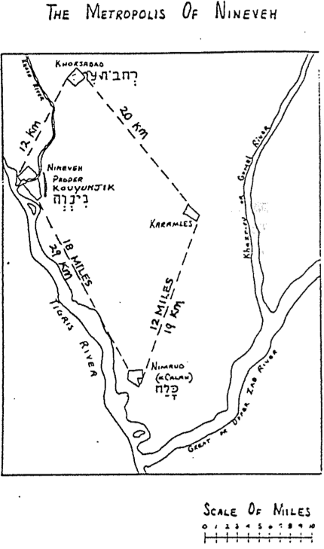

b. If one remains unconvinced about the four-city theory, then he can also realize that since Jonah stopped along the way as he preached through the city (3:3-4), it is not unreasonable that such a trip would take three days.

3. The historicity of Jonah’s experience is supported by other factors:

a. Jesus Himself confirmed the fact that Nineveh did indeed repent as the Book of Jonah records (Matt. 12:40-41). Those who deny that such was possible contend with the Lord, who affirmed the validity that Jonah was indeed a historical figure.

b. That Jonah served as a type of Christ also supports its historicity, as “if the antitype was historical, then the type must also have been historical” (Gleason L. Archer, *Encyclopedia of Bible Difficulties*, 302).

c. Known cities are mentioned in the book, including Nineveh (1:2; 3:2-4, 6-7; 4:11), Tarshish (1:3; 4:2), and Joppa (1:3).

d. Jonah is viewed as a historical figure from Gath Hepher (2 Kings 14:25) who lived during the reign of another historical figure, Jeroboam II.

e. Considering Jonah as nonliteral (a parable, allegory, or fiction) places its literary form out of character in comparison with the other prophetic books, which all record literal, historical prophets.

**Argument**

The actions of Jonah depicted the actions of the entire nation of Israel. As Jonah disobeyed God in his lack of concern for the nations (chs. 1–2), so had Israel. Further, as Jonah brought the message of God to Nineveh and learned that God's compassion extends towards Gentiles (chs. 3–4), so must Israel. Throughout the book, God demonstrates His sovereign means of accomplishing His purposes to remind Israel of its missionary purpose among the nations.

**Synthesis**

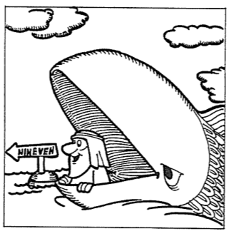God's compassion for Gentiles

1–2 Disobeys missionary mandate

1:1-2 Commissioning

1:3 Disobedience

1:4–2:10 Consequences

1:4-16 Storm–judgment

1:17–2:10 Fish–deliverance

3–4 Obeys missionary mandate

3:1-2 Recommissioning

3:3-4 Obedience

3:5–4:10 Consequences

3:5-10 Nineveh spared

4 Jonah angry

**Outline**

**Summary Statement for the Book**

**Jonah's disobedient indifference towards Nineveh symbolizes Israel’s same sin and depicts God's sovereignty and compassion over Gentiles to remind Israel of its missionary purpose.**

# Jonah's disobedience to God's commission to preach to Nineveh and deliverance by the fish depict Israel's neglect of its missionary mandate and God's compassion towards Israel even in its disobedient state (Chs. 1–2).

# Jonah's disobedience to God's call to preach to Nineveh and deliverance by a fish depict Israel neglecting its missionary call and God's compassion towards them (Chs. 1–2).

## God commissions Jonah to preach against Nineveh, illustrating His missionary mandate for Israel to share His compassionate love with the nations (1:1-2).

## Jonah disobeys God's commission as a picture of the failure of the nation to carry out its missionary mandate (1:3).

## The consequences of Jonah's disobedience reveal both the difficulties Israel faces for spurning God’s call and God's compassion towards His wayward people (1:4–2:10).

### The great storm is God's sovereign way to discipline Jonah for rejecting His call and pictures the difficulties Israel undergoes for spurning His call (1:4-16).

#### God sends Jonah a great storm as His sovereign discipline for rejecting His call to show Israel’s trials for rejecting its missionary call (1:4-5a).

#### Jonah complacently sleeps through the travail until awakened to illustrate Israel's apathy towards God’s call and its consequences (1:5b-6).

#### The sailors correctly blame Jonah for divine wrath to rebuke Israel, whose Gentile neighbors saw divine discipline on the apathetic nation (1:7-9).

#### God spares the sailors' lives when they throw Jonah overboard to picture His mercy on Gentiles despite the unfaithfulness of His people (1:10-16).

**Parallels Between Jonah 1 and Jonah 2**[1]

|  |  |
| --- | --- |
| **The Sailors** | |
| 1:4 | Crisis on the sea |
| 1:14 | Prayer to Yahweh |
| 1:15b | Deliverance from the storm |
| 1:16 | Sacrifice and vows offered to God |
| **The Prophet** | |
| 2:3–6a | Crisis in the sea |
| 2:2, 7 | Prayer to Yahweh |
| 2:6b | Deliverance from drowning |
| 2:9 | Sacrifice and vows offered to God |

### The fish shows God's sovereign and merciful deliverance of Jonah to show the thankful response that indifferent Israel should have for His mercy (1:17–2:10).

#### God provides a great fish as a mercy to deliver Jonah to picture His mercy on Israel, even in its indifference to its missionary mandate (1:17).

#### Jonah's psalm of thanksgiving for being delivered by the fish instructs Israel to thank God for His mercy in sparing the disobedient nation (2:1-9).

#### The fish vomits Jonah to show how God sovereignly uses even nature to motivate His people to fulfill their missionary mandate (2:10).

# Jonah's obedience to God's second commission and Nineveh's belief demonstrate God's compassion received by faith, prompting Israel to share His love (Chs. 3–4).

## God commissions Jonah again to preach against Nineveh as an illustration of His second opportunity for Israel to share His compassionate love with the nations (3:1-2).

## Jonah obeys God's commission as a picture of the need for the nation to carry out its missionary mandate (3:3-4).

## The results of Jonah's obedience reveal God's great compassion on all peoples who trust Him so that Israel would share the undeserved mercy of God to all (3:5–4:10).

### God spares Nineveh from destruction due to the repentance of the people and the king, demonstrating God's compassion on all who trust Him (3:5-10).

#### The *people’s repentance* in their belief, fasting, and sackcloth reminds Israel that Gentiles can turn to God if they will be His instrument (3:5).

#### The *king’s repentance* goes beyond the people by fasting from drink and including animals to show the extent feasible when Israel obeys its call (3:6-9).

#### The *repentance of God* in response to the obvious belief of Nineveh shows to Israel His great compassion upon all peoples who trust Him (3:10).

### Jonah is angry about God's compassion for Nineveh, but God shows His mercy so Israel will share His compassion with the nations (Ch. 4).

#### Jonah's anger over God delivering Nineveh symbolizes how Israel knows God's compassion and should extend it to Gentiles (4:1-5).

#### God's answer with a vine reaffirms His sovereign and undeserved actions to Jonah, showing Israel how all nations can receive it by faith (4:6-10).

**Events Leading to Nineveh’s Repentance in 758 BC**

Pagan peoples see bad omens in political and natural phenomena (e.g., plagues, eclipses). These calamities, along with recent worship of only one God, would have made the city of Nineveh very receptive to Jonah’s message of judgment!

**BC Event in Assyria**

787 Monotheistic worship of Nabu started

765 Plague throughout Assyria

763 Revolt in the city of Asshur

763 Eclipse of the sun

762 Revolt in the city of Asshur

761 Revolt in the city of Arrapha

760 Revolt in the city of Arrapha

759 Another plague

758 “Peace in the land” (repentance under Jonah?)

**Geography of Jonah’s Flight**

*The Bible Visual Resource Book*, 151

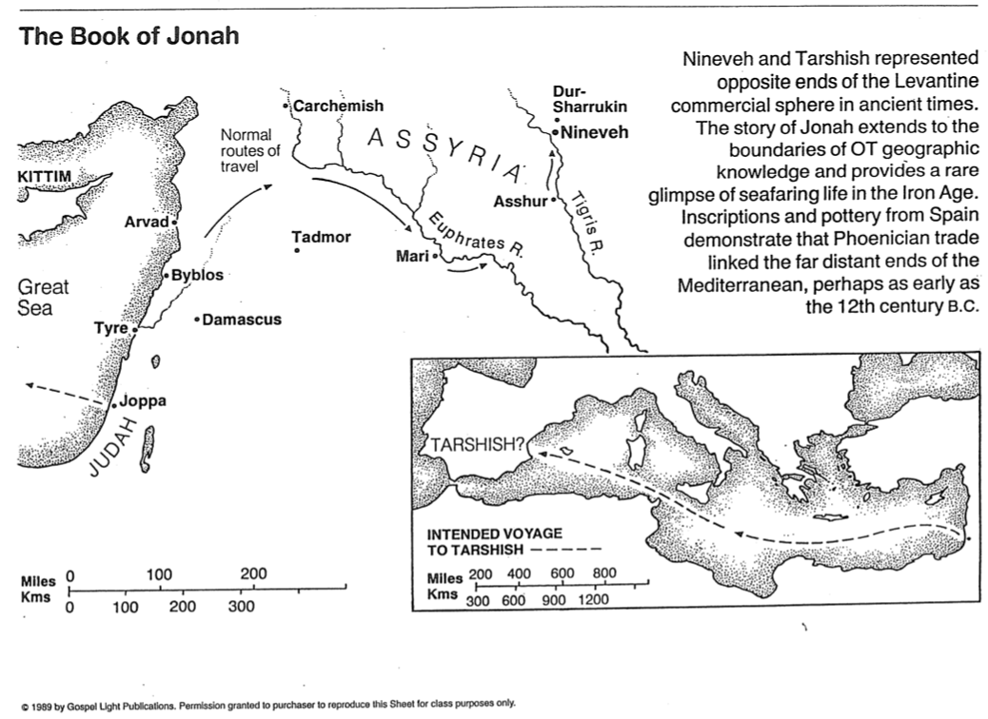

**Kings and Geography of Assyria**

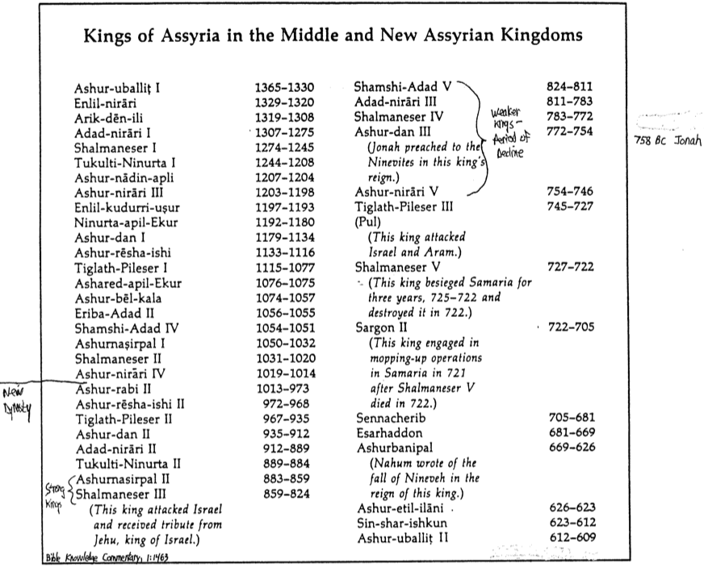

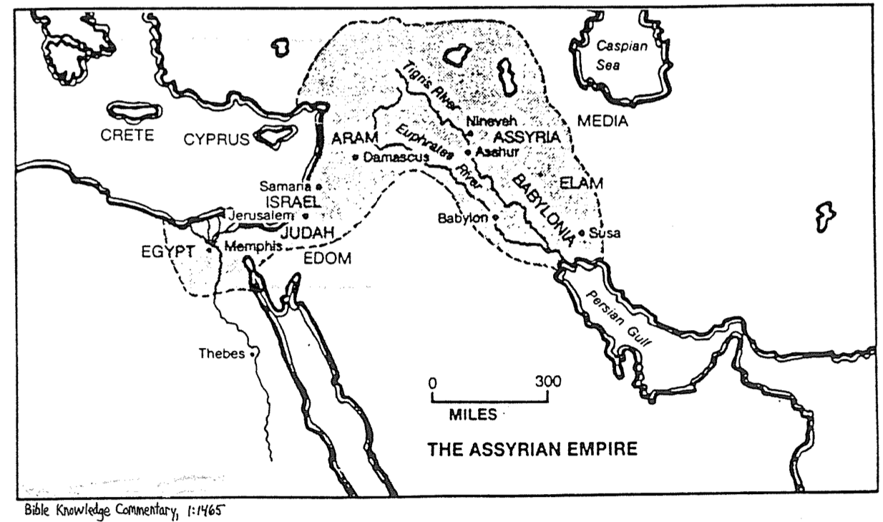

**Literary Parallels in the Book of Jonah**

Charles H. Talbert, *Literary Patterns, Theological Themes, and the Literary Genre of Luke-Acts*(Missoula, MT: Scholars Press, 1974), 71-72

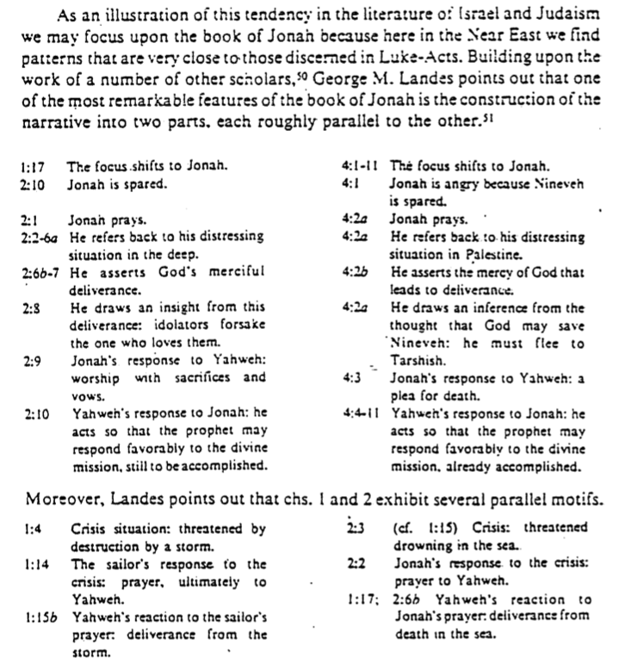

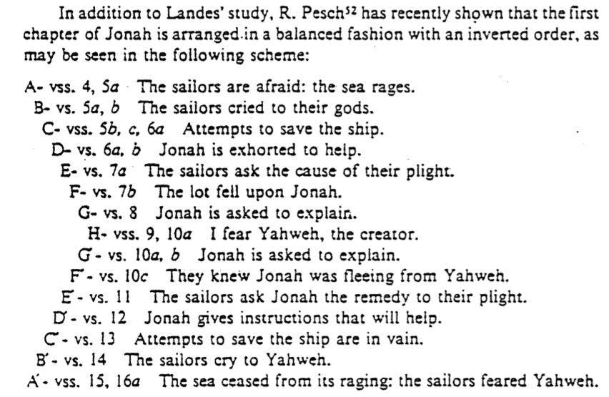

**Israel’s Privileges & Responsibilities**

Jonathan Lewis, ed., *World Mission: Part One* (Pasadena, CA: William Carey Library, 1987)

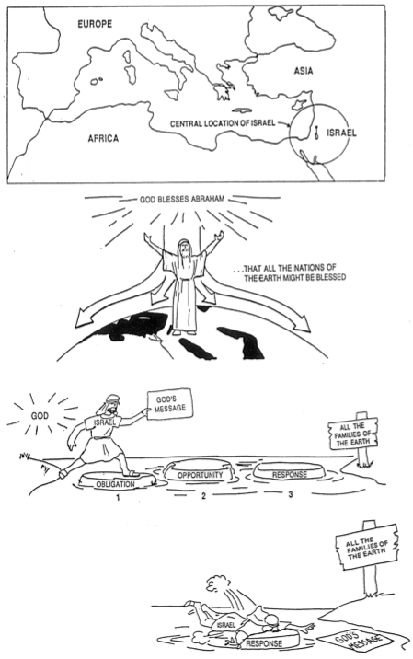

**Repetition of Key Words in Jonah** (1 of 4)

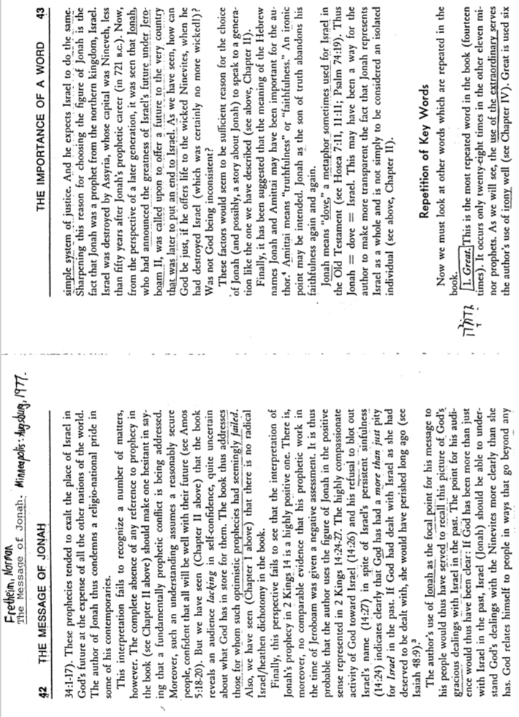

Repetition of Key Words in Jonah (2 of 4)

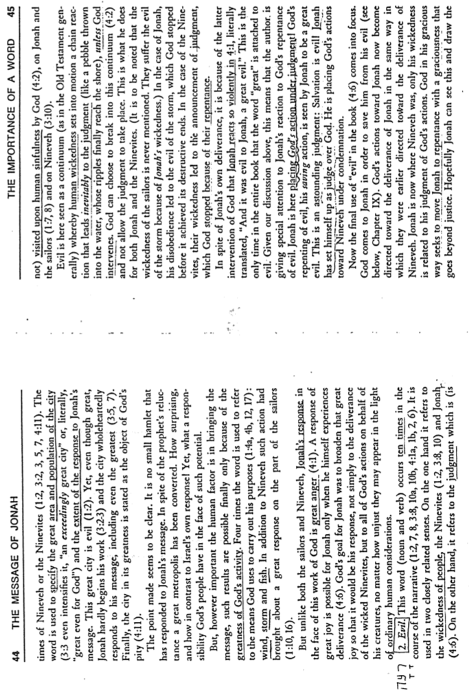

Repetition of Key Words in Jonah (3 of 4)

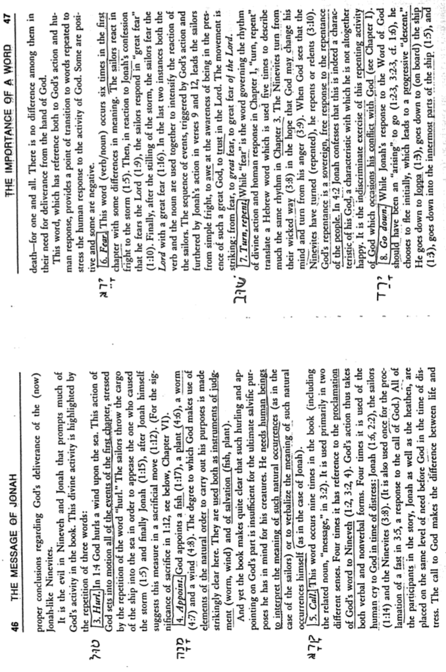

Repetition of Key Words in Jonah (4 of 4)

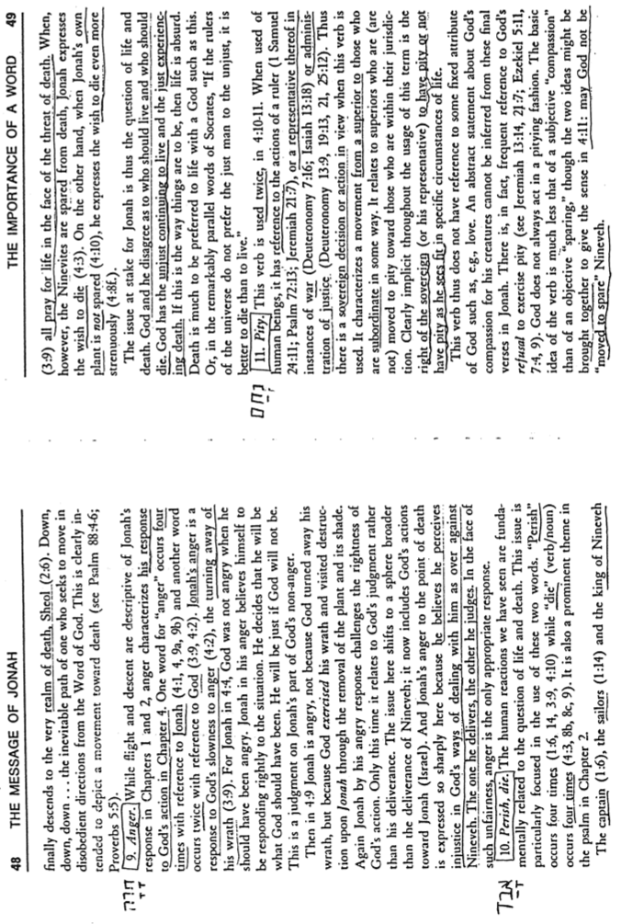

**Naughty Ninevites**

Elliott E. Johnson, “Nahum,” in *The Bible Knowledge Commentary*, 1:1493-1494

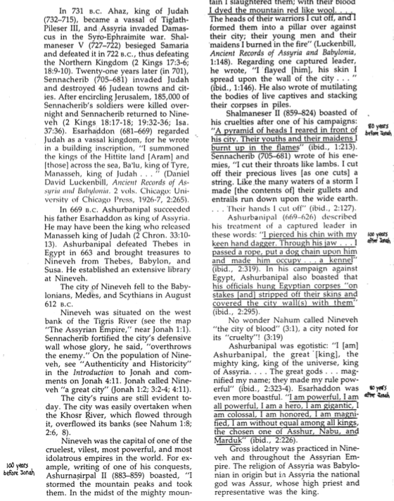

**The Lifesaving Station**

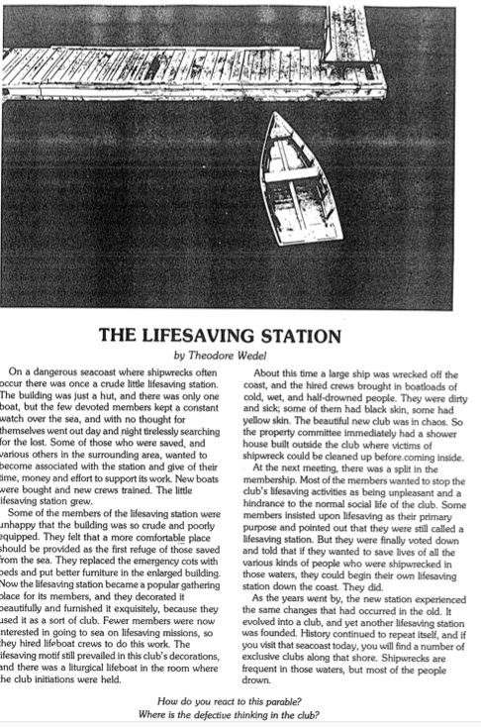

Lessons from Jonah

1. Don't run away from God's will for your life (1:3).
2. There's a personal cost to disobeying God (1:3-17).
3. God uses difficulties to help us see our stubbornness (1:3-17).
4. Other people also suffer from our rebellion (1:4-5).
5. Sometimes unbelievers have more insight and pray than do believers (1:6, 14, 16).
6. Even in His discipline, God provides deliverance (1:17).
7. God–not chance–controls all creation (1:4, 15; 4:6, 7).
8. Sometimes it's when the dark is darkest that we see the light (2:1).
9. Beware of the downward spiral of sin–see "down" progression (1:2a, 2b, 5; 2:6).
10. Near death experiences can be life changing (2:7).
11. Reciting God's Word we have memorized can help us get back on track (2:2-9).
12. God is the God of the second chance (3:1).
13. Don't let a previous failure set a negative pattern for you (3:3)
14. You never know if people will repent until you tell them God's Word (3:3-10).
15. Don't underestimate the spiritual potential of even the highest rulers (3:6-9).
16. God has always prepared people for his message more than we know (3:5).
17. Even the worst of people can genuinely repent and be forgiven (3:5, 10).
18. God always prefers our repentance instead of our judgment (3:10).
19. We sometimes prefer others' judgment instead of their repentance (4:1-2).
20. Watch out when you enjoy proclaiming God's wrath more than His love (4:2).
21. God often doesn't answer suicide requests and other stupid prayers (4:3, 9, 10).
22. God has compassion even on those rebelling against Him (4:6, 11).
23. God sends little tests to show us big lessons (4:7).
24. Sometimes God speaks most clearly through questions (4:4, 9, 11).
25. We too often care more about things than we do people (4:10).
26. God always cares more about people than he does things (4:11).

**Does God Change His Mind?** (1 of 2)

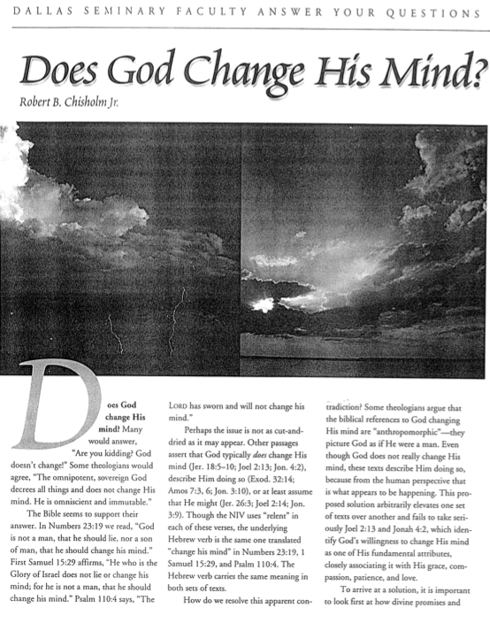

**Does God Change His Mind?** (2 of 2)

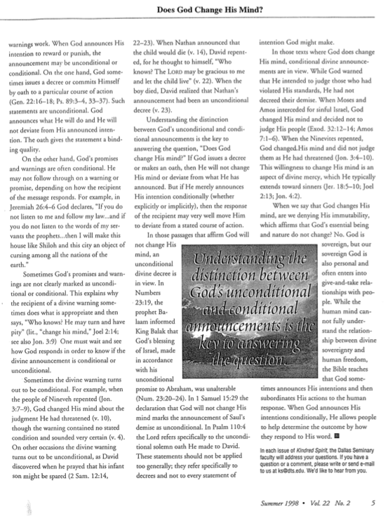

1. John D. Hannah, “Jonah,” in *The Bible Knowledge Commentary: An Exposition of the Scriptures*, ed. J. F. Walvoord and R. B. Zuck, vol. 1 (Wheaton, IL: Victor Books, 1985), 1467.