2 Samuel

Covenant Kindness Towards the Davidic Dynasty

Establishment |  | Sin |  | Consequences |  | Appendix
Triumphs |  | Transgressions |  | Troubles |  | Tribute
Obedience |  | Disobedience |  | Judgment |  | Summary
Chapters 1–10 |  | Chapter 11 |  | Chapters 12–20 |  | Chapters 21–24
Faith | Blessing | Adultery | Murder | Family | Politics | Humility | Pride
1–4 | 5–10 | 11:1-5 | 11:5-27 | 12–14 | 15–20 | 21–23 | 24
Over Judah | Over All Israel
From Hebron | From Jerusalem
7 1/2 Yrs.  (1011-1004 BC) | 33 Years  (1004-971 BC)

Key Word: Covenant

Key Verse: “When your [David’s] days are over and you rest with your fathers, I will raise up your offspring to succeed you, who will come from your own body, and I will establish his kingdom. He is the one who will build a house for my Name, and I will establish the throne of his kingdom forever” (2 Samuel 7:12-13).

Summary Statement:
God’s covenant kindness to David revealed his faithfulness to David’s dynasty and justice to punish his sin.

Application:

God blesses the obedient but judges the disobedient.

2 Samuel

Introduction

Note: The introduction in some part reiterates the introduction to 1 Samuel.

I. Title "Samuel" (laeWmv. semuel) means "name of El [God]" or "his name is El [God]" (BDB 1028d 1) from mve, "name," plus lae, "El," the singular form of ~yhil{a/, "Elohim." It sounds like the Hebrew for "ask, inquire" (from la;v' 1 Sam 1:20). The Books of Samuel originally formed a single scroll called "Samuel" after its first key character. The Septuagint first divided the book into two with the titles First and Second Kingdoms. First and Second Kings then followed with the titles Third and Fourth Kingdoms.

II. Authorship

A. External Evidence: The Jewish Talmudic tradition ascribed the authorship of First and Second Samuel to Samuel, but he could not have written beyond 1 Samuel 25:1 since this verse records his death. First Chronicles 29:29 refers to "the Book of Samuel the Seer," "the Book of Nathan the Prophet," and "the Book of Gad the Seer." This may refer to the threefold authorship of the Books of Samuel that may have been complied in their final form by a member of the prophetic school. Since they originally formed a single scroll entitled "Samuel," this may account for his name being attached to both books.

B. Internal Evidence: The book provides little, if any, evidence to identify the author(s).

III. Circumstances

A. Date: Although Samuel wrote 1 Samuel 1–24 at the end of his life (born ca. 1105 BC, died ca. 1015 BC), the rest of the Books of Samuel must have been composed over 85 years later after the division of the kingdom between Israel and Judah in 931 BC. This is seen in references to the divided monarchy (1 Sam 11:8; 17:52; 19:16; 2 Sam 5:5; 11:11; 12:8; 19:42-43; 24:1, 9) and the reference to Ziklag, a Philistine city that the writer says, "has belonged to the kings of Judah to this day" (1 Sam 27:6). In regard to the latest possible date of composition, the absence of reference to the fall of Samaria in 722 BC is notable. Therefore, the time of final composition most likely falls between 931 BC and 722 BC.

B. Recipients: As the Books of Samuel mention the divided monarchy (see above), those who read the books in their final form must have lived shortly after the reigns of David and Solomon. As inhabitants of a divided kingdom, this account of the nation unified under one king would have proved valuable from a historical context.

C. Occasion: Second Samuel picks up where the first left off. There is no real break between 1 Samuel 31:13 and 2 Samuel 1:1. God's approval of the Davidic dynasty is veiled in 1 Samuel 1–15, but it is clear in 1 Samuel 16 to 2 Samuel 24. Therefore, in 2 Samuel the purpose is to defend the Davidic dynasty (cf. 2 Sam. 7), especially when two reigns coexisted in the north and the south. Whereas nine dynasties eventually reigned in the northern kingdom, God, true to his promise (2 Sam 7:4-17), sustained the southern kingdom under one dynasty––David's.

IV. Characteristics

A. Second Samuel paints a very real picture of David––both strengths and weaknesses. While it lists his greatest achievements (2 Sam 1–10), it also does not hide his greatest failures (2 Sam 11). This chapter is the turning point of the book after which it’s mostly downhill.

B. David in 2 Samuel is one of the most important types of Jesus Christ in the Old Testament. In particular, David seeks to build a house for God, which the LORD refuses in order to build a “house” for David (7:4-17), called the Davidic Covenant. The Davidic Covenant also finds its source in the Abrahamic Covenant and further expands the original seed promise to Abraham (cf. notes, 61). God's promise of a seed to Abraham (Gen 12:1-3) from his own body (Gen 15:1-9) that will become a great nation is further explained in his promise to David (2 Sam. 7:10-16). The Davidic Covenant guarantees David that each king who will sit on the throne of Israel will be one of his direct descendants. Also, since this covenant is eternal (v. 16), it guarantees Israel that in the future a descendant of David will again occupy the throne in the kingdom––none other than our King Jesus (see. also p. 218b).

Argument

Second Samuel continues the argument of First Samuel––that God is working out his divine purposes through his covenant kindness to David and his seed. This is seen in David’s triumphs as ruler over a renewed kingdom (2 Sam 1–10) and God's faithfulness despite David's sin (2 Sam 11). God judges this sin (2 Sam 12–20), but never takes away the dynasty like he did with Saul. This is because the Davidic Covenant amplifies the unconditional Abrahamic Covenant and thus is also unconditional. A final section (2 Sam 21–24) is an appendix of David's final years with more accounts of his failures and successes to show God's continued blessing upon his line while still punishing sin. Throughout the account God delegates dominion or sovereignty first to David, which sets the stage for the same authority delegated to his descendants who later also sit on the throne in Jerusalem in the books of Kings and Chronicles.

In regard to spiritual truths in 2 Samuel, the most prominent one reiterates the cause and effect principle stated in every book since Genesis: obedience (2 Sam 1–7) always brings God's blessings (2 Sam 8–10), but disobedience (2 Sam 11) always brings his judgment (2 Sam 12–24; TTTB, 78).

Synthesis

Covenant kindness towards Davidic dynasty

1–10 Establishment
1–4 Over Judah at Hebron
1 Respect for Saul
2:1-11 Ish-Bosheth crowned
2:12–4:12 Rivals eliminated–refusal of force
5–10 Over all Israel at Jerusalem with new…
5 Capital (Jerusalem)
6 Worship center (Ark moved)
7 Dynasty (Davidic Covenant)
8 Boundary (Kingdom Expansion)
9 Son (Mephibosheth)
10 Vassals (Ammon and Syria)

11 Sin
11:1-5 Adultery
11:6-26 Murder
11:27 Illegitimate son

12–20 Consequences
12–14 Family troubles
12 Son dies (Solomon chosen)
13 Amnon (immorality)/Absalom (murder) (Rival eliminated)
14 Estrangement
15–20 Political troubles
15–18 Absalom's rival (Rival eliminated)
15:1–16:14 Absalom's self-coronation
16:15–17:29 Hushai's bad advice
18 Joab kills Absalom
19–20 David's restoration
19 Returned but divided
20 Joab kills Sheba

21–24 Appendix
21:1-15 Famine over Gibeonite oath
21:16-22 Victories
22:1–23:7 Song/Last words
23:8-39 Mighty men
24 Census

Outline

Summary Statement for the Book
God’s covenant kindness to David revealed his faithfulness to David’s dynasty and justice to punish his sin.

God established David as king over a renewed, perpetual kingdom to bless him and his dynasty (2 Sam 1–10).

David reigned over Judah at Hebron after Saul's death and trusted God to prepare the entire kingdom without force (2 Sam 1–4).

David received word of Saul and Jonathan’s deaths, killed the messenger, and lamented to respect God’s inaugurated kingship (2 Sam 1).

David became king of Judah at Hebron, but Saul's commander Abner crowned Saul's son Ish-Bosheth king over Judah against God's purpose (2:1-11).

David refused to take the kingdom by force but trusted God to judge rivals to his throne (2:12–4:12).

Abner initially fought David's commander Joab but then defected to David's side and Joab killed him to remove a potential rival to the throne (2:12–3:39).

David killed Ish-Bosheth’s murderers to punish seizing his kingdom for him by force (2 Sam 4).

David reigned over all Israel at Jerusalem and renewed the kingdom as evidence of God's blessing on him and his dynasty (2 Sam 5–10).

David reigned over all Israel and defeated the Jebusites and Philistines, establishing Jerusalem as the new capital (2 Sam 5).

Jerusalem became the new worship center when David brought the ark into the city (2 Sam 6).

Service | Man’s Way | God’s Way
Mode of Transporting the Ark | Dishonored God by use of cart (6:3) | Honored God by having priests carry it by hand (6:13)
David’s Role | King who forces priests to go against biblical commands | King who honors priests
Results | Uzzah dies trying to stabilize the cart (6:6); blessing goes to Obed-Edom instead of David (6:11) | Rest from enemies (7:1, 11)  Nation united under God

When David tried to build a temporal house for God, the LORD promised to build an eternal "house" for him as the father of a new dynasty in the Davidic Covenant (2 Sam 7).

David expanded the kingdom with a new boundary through military victories in the north and south as God's fulfillment of his promise to give Israel rest from its enemies (2 Sam 8).

David honored Jonathan's son Mephibosheth as a new son to show loyalty to Saul (2 Sam 9).

David’s victory over ungrateful Ammon and Syria acquired them as new vassals (2 Sam 10).

David’s adultery and murder showed his sinful, fallen nature, despite God choosing his dynasty (2 Sam 11).

David’s adultery with Bathsheba resulted in a problem pregnancy (11:1-5).

David’s murder of Uriah the Hittite—a loyal husband and soldier—shows that even God’s servants can sin greatly (11:6-26).

David’s marriage to Bathsheba bore him an illegitimate son (11:27).

David’s family and political penalties for his sin actually purged all rivals to his throne due to God’s kingdom promise to show both God’s justice and faithfulness (2 Sam 12–20).

David's sin led to family troubles in the deaths of two sons, incest, and estrangement to teach both the costs of disobedience and God’s means to remove Amnon as a rival to the throne (2 Sam 12–14).

David and Bathsheba’s son died to fulfill Nathan the prophet's words, but God gave them Solomon to fulfill the covenant promise to show both the severity and grace of God (2 Sam 12).

Amnon’s rape of Tamar repeated David's immorality with Bathsheba and Absalom’s murder of Amnon repeated David's murder of Uriah to show the costs of disobeying God (2 Sam 13).

David was estranged from Absalom two years even after his return to Jerusalem (2 Sam 14).

David's sin led to political troubles from Absalom and Sheba's rebellions, yet God restored his kingdom to protect David’s dynasty by purging Absalom as a rival to David’s throne (2 Sam 15–20).

Absalom rivaled his father's throne but David refused to protect his kingdom by force, resulting in Absalom's death and the protection of David’s dynasty (2 Sam 15–18).

Absalom won over many in Israel to become king, forcing David from Jerusalem into exile since he was unwilling to protect his kingdom by force (15:1–16:14).

Absalom followed Hushai's bad advice to wait to fight David instead of Ahithophel's good advice to attack David immediately as God's design to protect David (16:15–17:29).

David's army defeated Absalom's and Joab killed his cousin Absalom but David mourned his death, showing how God protected David’s dynasty since Absalom had no sons (2 Sam 18).

God restored David's kingdom in Jerusalem and subdued Sheba's rebellion in the north to show his faithfulness to protect David’s dynasty (2 Sam 19–20).

David returned to a restored kingdom in Jerusalem but the north-south division persisted (2 Sam 19).

The northern tribes followed Sheba the Benjamite’s rebellion and Joab regained his commander position by murdering Amasa and Sheba, thus restoring David's rule over all Israel (2 Sam 20).

An appendix of David's failures and successes in his final years gives more proof of God's continued blessing on his line while still punishing sin (2 Sam 21–24).

David ended a three-year famine in Israel due to Saul breaking the Gibeonite covenant by David’s killing seven of Saul's sons to show his commitment to fulfill oaths (21:1-14).

David's victories over the Philistines and the rest of Goliath's family in his later years shows the completeness of David's victories due to God's blessing on his life (21:15-22).

David's song of praise and last words supplement the story to display his faithful and humble trust in God's deliverance—not in his own power (22:1–23:7).

David's song of praise for deliverance from his enemies and Saul shows his faithful and humble trust in the LORD's deliverance rather than in his own power (2 Sam 22).

David's last words supplement the history to reveal his faithful and humble trust in the LORD's deliverance rather than in his own power (23:1-7).

A list of David's famous soldiers concludes the military summary of his reign (23:8-39).

David’s prideful census of his army to boast in his military might brought God's judgment in a plague that killed 70,000 Israelites up to where the temple would soon be built (2 Sam 24).

Note: Adonijah, the third and final rival to the Davidic throne, was also eliminated by Solomon to protect the Davidic dynasty in 1 Kings 1–2.

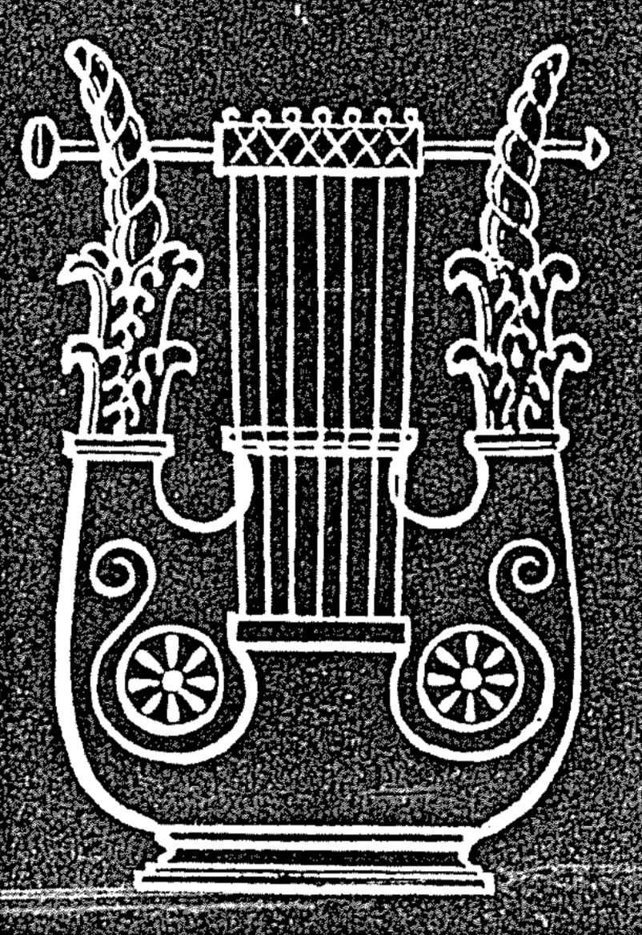

Geography of David’s Jerusalem

The Bible Visual Resource Book, 63; Biblical Archaeology Review (July/Aug ‘94): 24

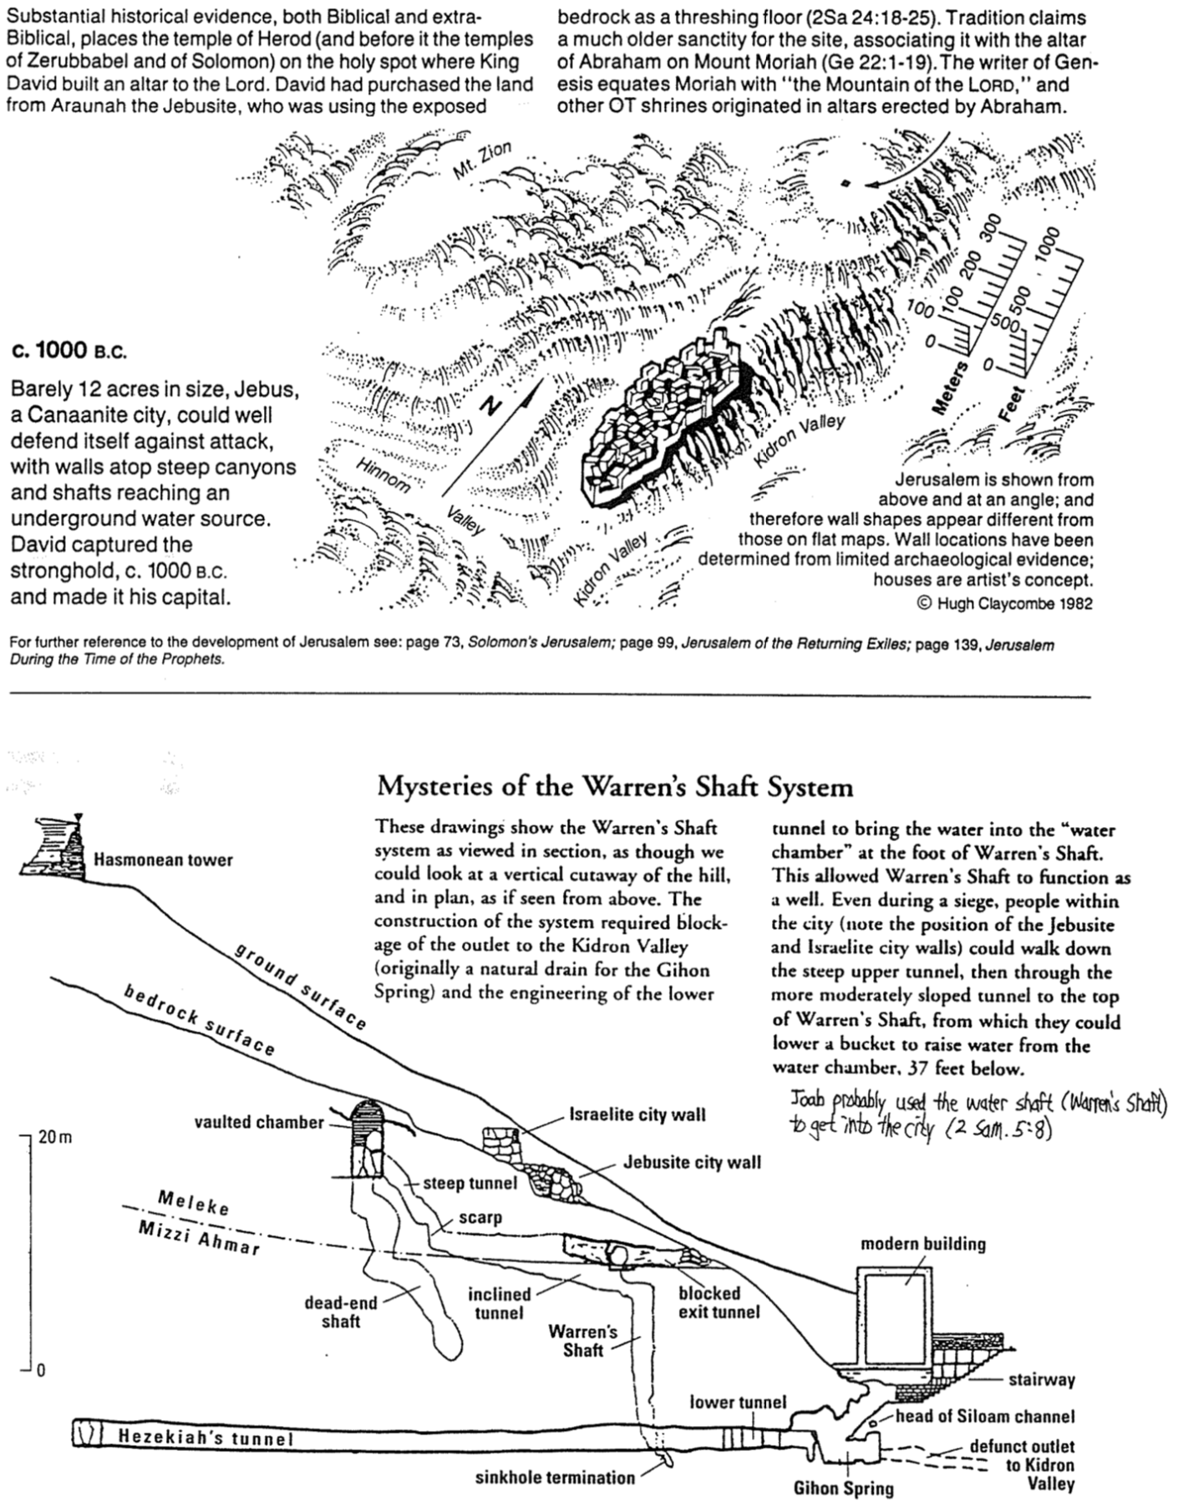

David’s Conquests

The Bible Visual Resource Book, 64
(Newspaper Sources and Dates Unknown)

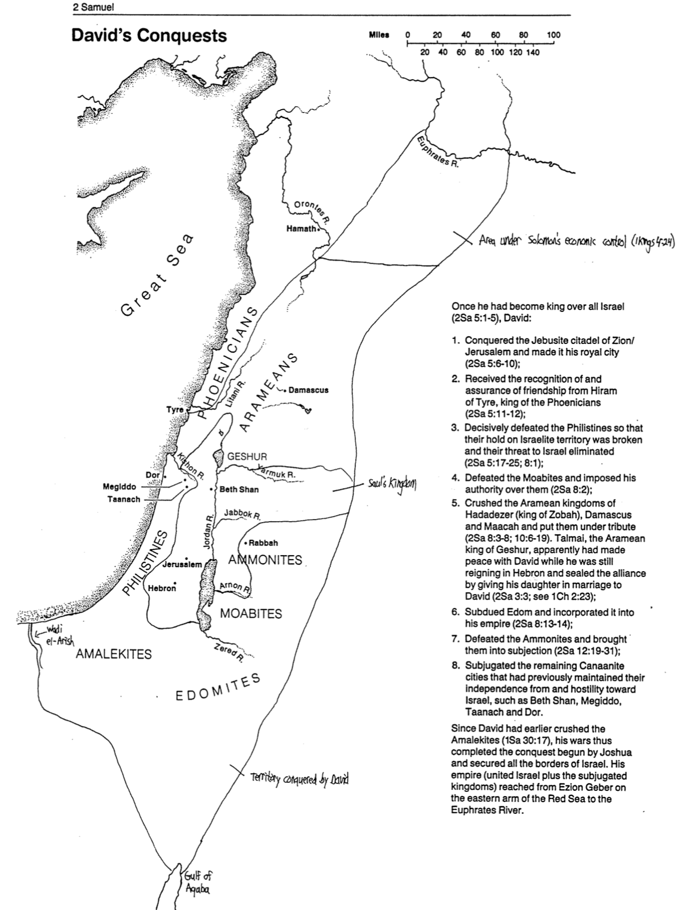

Did God Approve of David’s Polygamy?

Thomas S. Piper, Good News Broadcaster (Feb. 1977): 28
(See also page 246 of these notes)

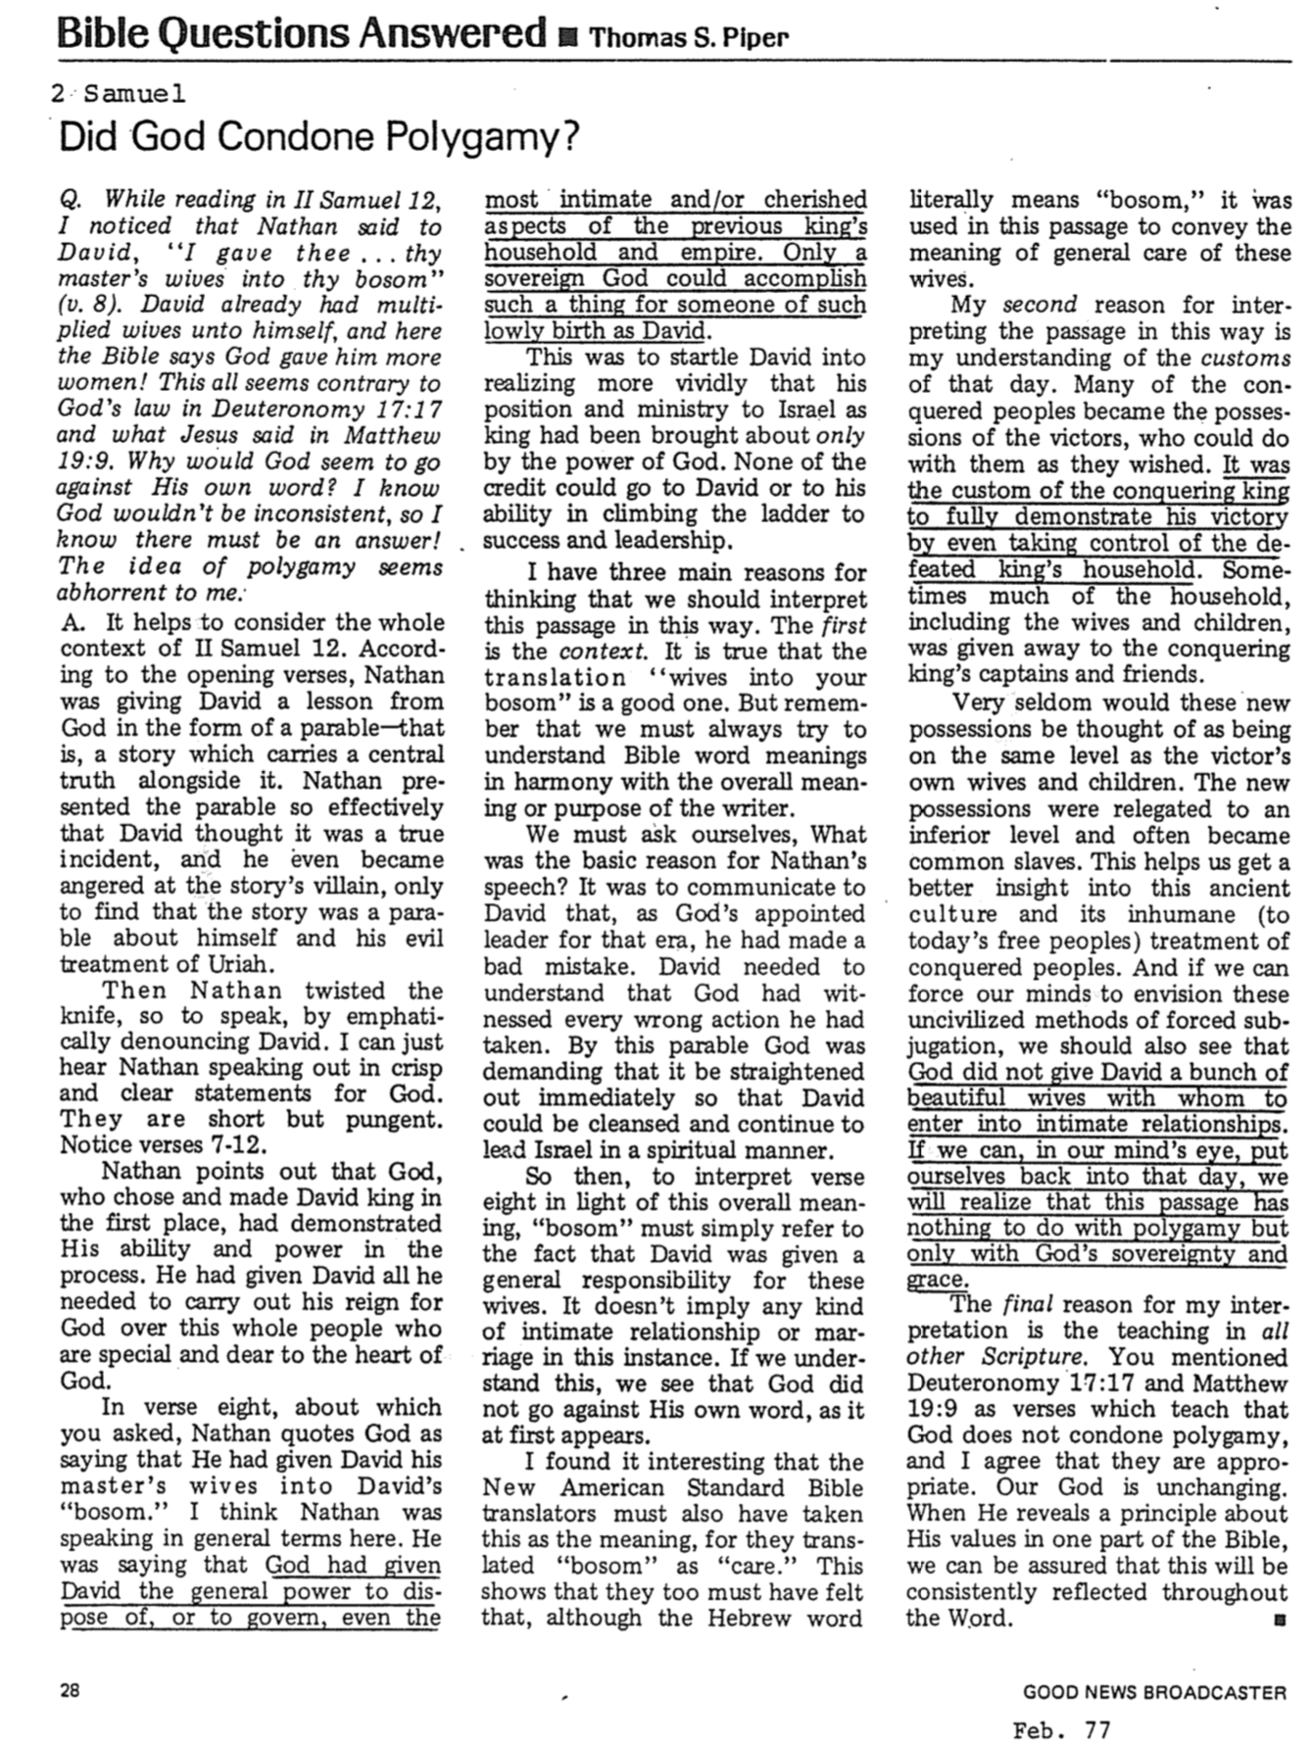

Saul-David-Solomon Contrasts

John H. Walton, Chronological and Background Charts of the OT, 2d ed., 29

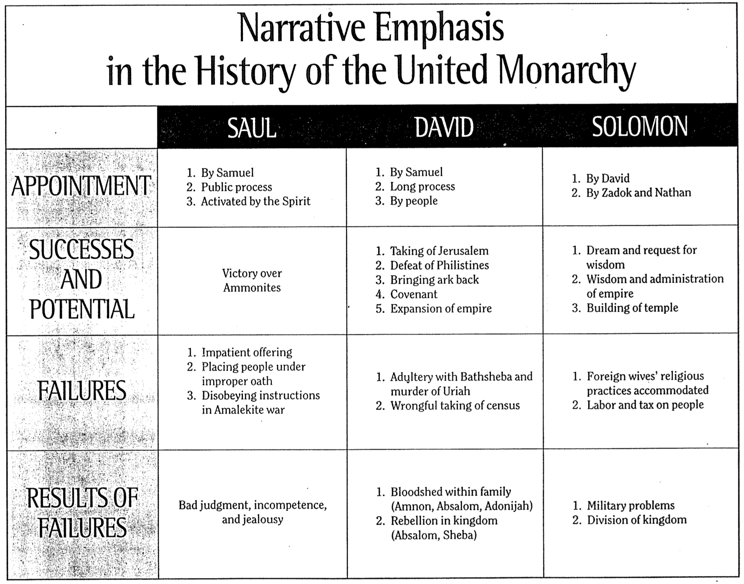

Timelines of 2 Samuel

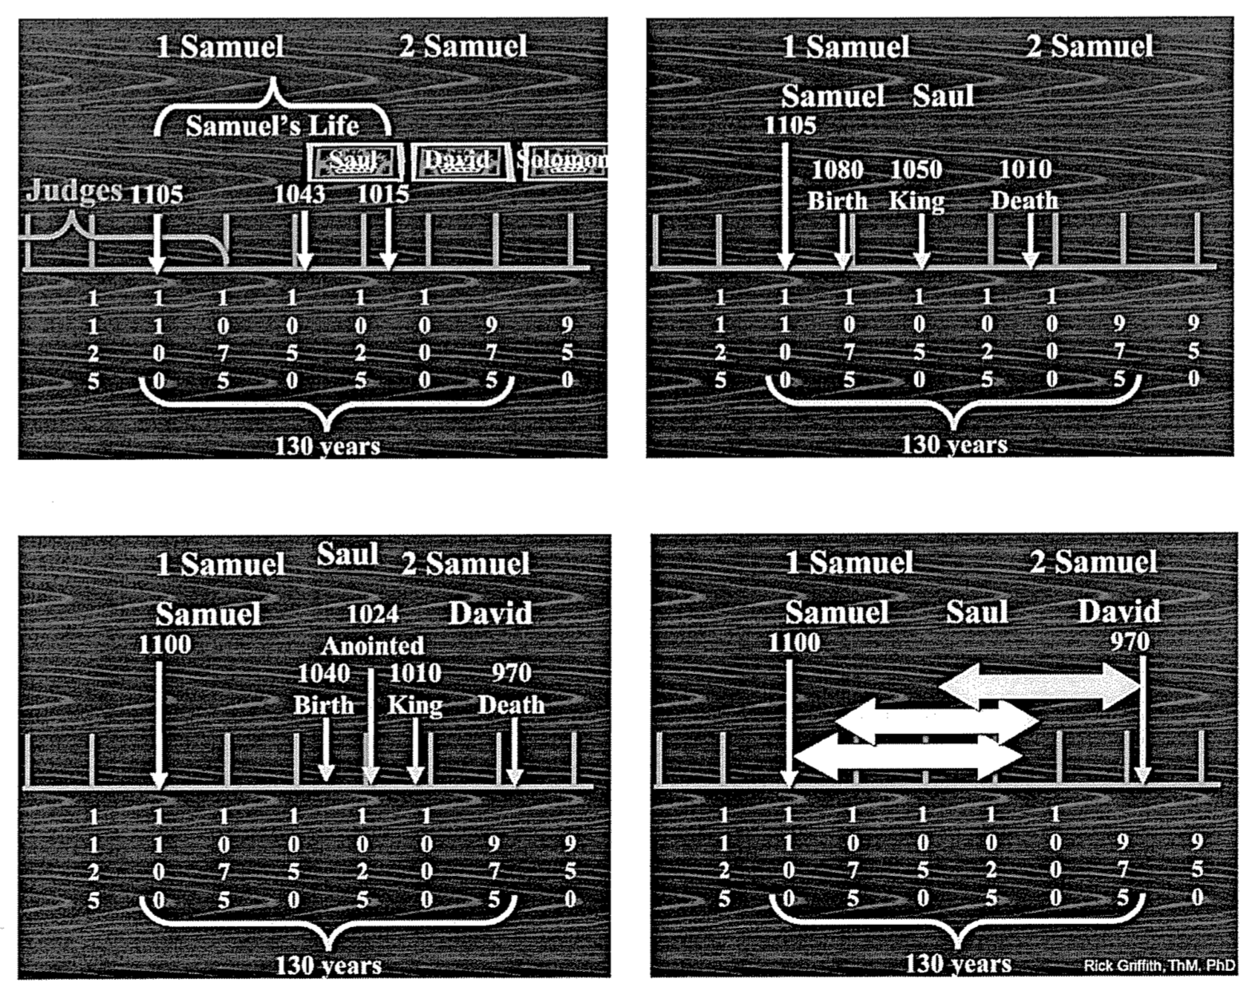

1375 Judges begin to rule
1100? Samuel born
1080 Saul born
1050 Saul becomes king
1040 David born (when Saul 40 years old)
1024 David anointed (Saul 56 years old approx.)
1010 Saul dies; David made king over Judah
1003 David becomes king over all Israel
997? David and Bathsheba sin
991 Solomon born (David age 49)
980? David’s census
970 David dies; Solomon made king
930 The kingdom is divided

The Genealogy of Jesus Christ
John Fryman, “The Bible…Basically” Seminar (Fort Worth, TX, 2003), Study Help 16

