2 Chronicles

David’s Line Preserved

Solomon |  |  | Davidic Dynasty
Chapters 1–9 |  |  | Chapters 10–36
Temple Constructed |  |  | Temple Destroyed
Royalty |  |  | Ruins
40 Years |  |  | 393 Years
971-931 BC |  |  | 931-538 BC
Wealth & Wisdom  1 | Temple Construction  2–7 | Successes  & Death  8–9 | Kingdom Divides via Rehoboam  10–12 | 7 Bad,  8 Good Kings  13–35 |  | 4 Bad Kings then Judah Falls  36
1 Kings 1–11 |  |  | 1 Kings 12–22 |  | 2 Kings 1–25

Key Word: Preservation

Key Verse: “As for you [Solomon], if you walk before me as David your father did, and do all that I command, and observe my decrees and laws, I will establish your royal throne, as I covenanted with David your father when I said, ‘You shall never fail to have a man to rule over Israel’” (2 Chronicles 7:17-18).

Summary Statement:
The spiritual perspective on the preservation of David’s line despite the fall and exile of Judah admonishes the remnant to proper temple worship—not the idolatry of the past.

Stealing from the temple and leaving it in disrepair (12:9; 16:2-3) is contrasted with replenishing (15:18) and repairing it (24:4-14).

Application:

Humble yourself when the LORD exalts you lest you yourself become your own idol:

“Success is never final;

Failure is never fatal;

It is courage [no, humility] that counts.”

–Winston Churchill, adapted

2 Chronicles

Note: The Introduction and Argument sections repeat the information in the 1 Chronicles notes.
However, the contrast chart (Characteristic C.) between 1 and 2 Chronicles is new.

Introduction

I. Title Like the Books of Samuel and Kings, so the Books of Chronicles originally comprised one scroll. The Hebrew name (~ymyh yrbd Dibere Hayyamim) translates "The Words (Accounts, Events) of the Days," which in modern idiom means "The Events of the Times." The book was divided in the 250 BC Septuagint with the name Paraleipomenon, "Of Things Omitted," referring to data lacking in Samuel and Kings. However, this title wrongly implies that Chronicles merely supplies omissions in Kings, which does not explain the parallel accounts and different emphases. The English title "Chronicles" is perhaps best. It stems from Jerome's Latin Vulgate (ca. AD 395) as he felt it chronicles the entire sacred history.

II. Authorship

A. External Evidence: The Talmud maintains that Ezra the priest authored the work, while some Talmudists believe that Nehemiah completed the genealogical tables (1 Chron. 1–9).

B. Internal Evidence: The content verifies Ezra’s authorship since it emphasizes the temple, the priesthood, and the kingly line of David in Judah. The style is very similar to the Book of Ezra, and both share a priestly perspective: genealogies, temple worship, priestly ministry, and obeying the Law (TTTB, 100). Ezra's authorship is especially supported by the fact that Ezra 1:1-3 repeats the closing verses of 2 Chronicles 36:22-23 almost identically.

III. Circumstances

A. Date: References to Judah’s deportation (1 Chron. 6:15; 9:1) show that the work was compiled after 586 BC, but another key passage shows the books were compiled after the return from Babylon. This passage (1 Chron. 3:17-24) reveals that the latest person recorded in Chronicles is Anani (v. 24) of the eighth generation from Jehoiachin (v. 17), who was taken captive to Babylon in 598 BC. Assuming 25 years for each of these eight generations places Anani's birth ca. 425 to 400 BC. However, Ezra authored the work and his ministry in Scripture does not stretch beyond ca. 445 (cf. Neh. 12:36). Therefore, the best estimate of the time of the compilation is between about 450-425 BC. The record of the Return (2 Chron. 36:22-23) also argues for a postexilic date.

B. Recipients: Using the above date of 450-425 BC for compilation, the original readers must have been Jews who had been back in the land for about a century and probably had recently experienced the reconstruction of the Jerusalem walls under Nehemiah.

C. Occasion: The Book of Kings (covering about the same period as Chronicles) had been written a century earlier (ca. 550 BC) and would certainly have been deposited in Jerusalem. They already had the book of Kings, so why did Ezra see a need to re-write the nation’s history in Chronicles? The answer lies in his focus on the temple, designed to prevent the people from ever returning to the high places. Thus Kings records the history from a political/ethical standpoint, but Chronicles provides the spiritual/priestly view. It reminded the people that David's royal line still remained to encourage the small remnant that had returned and built a meager temple compared to Solomon's (cf. Hag. 2:3). Thus Chronicles was recorded to bolster the hopes of those who saw only a vague reminiscence of the glory of former days.

IV. Characteristics

A. “All the books of the Bible, thus far, from Genesis to II Kings have pursued a chronological succession of events, right from Adam's creation to Judah's captivity; but now with the Chronicles we come to a writing which does not carry us forward . . . but goes back and reviews the whole story in order to derive and apply a vital lesson, namely, that the nation's response to God is the decisive factor in its history and destiny” (J. Sidlow Baxter, 2:179). Technically, 2 Chronicles 36:21-23 does carry the account forward, but these three verses cover only 48 more years to the return from exile under Cyrus.

B. Chronicles covers the same period of Jewish history begun in 2 Samuel (=1 Chron.) and stretches past 2 Kings (= 2 Chron.). This kingdom period charted appears as such:

 |  | 1 Chronicles |  | 2 Chronicles
Books | 1 Samuel | 2 Samuel |  | 1 Kings |  | 2 Kings
Kings | Saul | David |  | Solomon-Ahaziah |  | Ahaziah-Zedekiah
Dates | 1043 | 1011 |  | 971 852 | 852 722 586 560 |  |  |  |  | 538
Kingdom | ----------United------------ |  | ------Divided------- |  |  |  | -Surviving- |  | -Returned-

C. Some contrasts between the two books of Chronicles may prove helpful:

 |  | 1 Chronicles |  | 2 Chronicles
 | History Covered |  | Creation to Solomon enthroned |  | Solomon to Return from Exile
 | Dates Covered |  | 4143-971 BC |  | 971-538 BC
 | Length |  | 3172 years |  | 433 years
 | Kings |  | Saul-David (2 kings) |  | Solomon-Zedekiah (21 kings)
 | # of Chapters |  | 29 |  | 36
 | General Content |  | Success of Davidic kingdom |  | Success of Davidic kingdom (cont’d)
 | Judgments |  | No major ones |  | Judah (586 BC)
 | Temple |  | Preparations for Building |  | Built, then ruined 380 yrs. later
 | Beginning/end |  | Begins with genealogies and David’s obedience |  | Ends with judgment for Davidic kings’ disobedience

D. If one includes the genealogical section (1 Chron. 1–9; beginning 4143 BC, see p. 84) with the narrative (1 Chron. 10–2 Chron. 36; concluding 538 BC) the original single book of Chronicles covers more time than any book of Scripture (3606 years!).

E. Chronicles contains the largest genealogy in the Bible (1 Chron. 1–9).

F. The Book of Chronicles appears last in the Hebrew Bible (p. 51).

Argument

The central idea in Chronicles that unifies the entire account is the temple. The author emphasizes the temple to encourage the returned remnant with the spiritual/divine view that while the Davidic throne is not among them, the Davidic line and God Himself is (1 Chron. 1–9); consequently, the people should learn from the judgment of their ancestors' idolatry and worship him correctly with the temple as the center of the nation's worship. The chief matter in David's reign is his abundant preparations for building the temple (1 Chron. 10–29), the major part of the account of Solomon's reign is the construction and dedication of the temple (2 Chron. 1–9), and the remainder of the book includes only the kings of Judah as the northern kingdom is not related to the temple and the Davidic line (2 Chron. 10–36). Thus the emphasis on temple worship in Jerusalem alone is given to re-establish proper worship after many years of idolatry at various worship places.

Synthesis

David’s line preserved

1–9 Solomon
1 Wealth/Wisdom
2–7 Temple construction
2 Preparation
3:1–5:1 Building
5:2–7:22 Dedication
8–9 Successes
8:1-11 Political
8:12-16 Spiritual
8:17–9:28 Economic
9:29-31 Death

10–36 Davidic dynasty (good kings in bold print)
10–12 Rehoboam

13 Abijah (Abijam)
14–16 Asa
17–20 Jehoshaphat
21 Jehoram
22:1-9 Ahaziah
22:10–23:21 Athaliah
24 Joash
25 Amaziah
26 Uzziah (Azariah)
27 Jotham
28 Ahaz
29–32 Hezekiah
33:1-20 Manasseh
33:21-25 Amon
34–35 Josiah
36:1-3 Jehoahaz
36:4-8 Jehoiakim
36:9-10 Jehoiachin
36:11-14 Zedekiah
36:15-21 Fall of Jerusalem (586 BC)
36:22-23 Return under Cyrus (538 BC)

Outline

Summary Statement for 2 Chronicles
The spiritual view on the preservation of David’s line despite the fall and exile of Judah admonishes the remnant to proper temple worship—not the idolatry of the past.

God blessed Solomon’s reign due to his obedience in building the temple to show Israel proper worship (2 Chron 1–9).

God blessed Solomon's proper worship with wisdom and wealth to show his blessing on all who honor him (2 Chron 1).

God approved of Solomon's building and furnishing the temple by filling it with his Shekinah glory (2 Chron 2–7).

Solomon prepared to build the temple by hiring 153,600 workers and ordering timbers and artisans from Hiram of Tyre so the best possible temple might be built (2 Chron 2).

Solomon made the temple and filled it with new furnishings (plus excess gold and silver for the treasuries) in anticipation of the ark’s arrival (3:1–5:1).

After the placing of the ark and Shekinah glory, Solomon dedicated the temple with a message and prayer that met both God's and the people's approval (5:2–7:22).

Parallels Between David’s and Solomon’s Transfers of the Ark

 | David  (1 Chron.) | Solomon  (2 Chron.)
Ark location before transfer | Kiriath Jearim | City of David
Ark location after transfer | House of Obed near the City of David | Temple on Moriah (former threshing floor of Araunah)
Consultation with Israel’s leaders & national procession | 13:1-5 | 5:2-3
Transports the ark correctly | 15:1–16:3 | 5:2-10
Celebration of praise at arrival | 16:7-36 | 5:11-14
System of regular worship set up | 16:4-6, 37-42 | 8:12-16
Divine revelation given | 17:1-15 | 7:12-22
Prayer by the king | 17:16-27 | 6:12-42

Solomon's political, spiritual, and economic successes show God's blessing for his honoring the temple (2 Chron 8–9).

God gave Solomon political success his building of several cities, conscripting Canaanites as slaves, and marriage to Pharaoh's daughter (8:1-11).

God gave Solomon spiritual success in his keeping Israel's ordinances and feasts with the Levitical divisions that David appointed (8:12-16).

God gave Solomon economic success in ships, gold, the queen of Sheba’s visit, gold temple shields, ivory and gold throne, wisdom, horses, chariots, silver, etc. (8:17–9:28).

Solomon's death after a 40-year reign introduces the rest of the book to shows what happened to the temple (9:29-31).

God judged the Davidic kings in Judah for despising the temple by destroying it to teach post-exilic Israel proper worship in its new temple (2 Chron 10–36).

Rehoboam's division of the kingdom and invasion by Egypt for raiding the temple exhorts true worship in the new temple and the results of disobedience (2 Chron 10–12).

The kingdom divided due to Rehoboam's threat to overwork the people to show that God blesses righteous leadership but punishes evil (2 Chron 10).

Rehoboam's strong fortifications and large family reveal God's initial blessing on the kingdom of Judah by strengthening it (2 Chron 11).

God weakened Judah for Rehoboam's giving the fortified cities and temple treasures over to Egypt to show that he was a better Master, so Rehoboam repented (2 Chron 12).

Abijah's (Abijam) evil reign seen positively by defeating Jeroboam of Israel shows God's blessing upon David’s line and the true priests (2 Chron 13; cf. 1 Kings 15:1-8).

Asa removed idolatry from Judah but robbed the temple to pay Aram to defeat Baasha of Israel, so God gave him a foot disease so all would respect God's house (2 Chron 14–16).

Jehoshaphat reformed even more than his father by appointing godly judges and he had victory over a foreign alliance but sinned by allying himself with Israel (2 Chron 17–20).

Jehoram's evil marriage to Ahab’s daughter Athaliah saw victory over Edom but the loss of every relative except his son Ahaziah and a painful death (2 Chron 21).

Ahaziah's evil reign due to his wicked mother Athaliah saw Jehu kill him and Ahab's entire line but Ahaziah's line endured due to God’s promise to David (22:1-9).

Athaliah's evil reign destroyed the entire royal family except her one-year-old grandson Joash, but Athaliah was executed due to God’s promise to David (22:10–23:21).

Joash rebuilt the temple while Jehoiada the priest lived but was executed by Aram for replacing the temple with idolatry to promote temple worship (2 Chron 24).

Amaziah executed his father's murderers and refused troops from Israel, but followed Edom’s idolatry after defeating them and Jehoash of Israel defeated him (2 Chron 25).

Uzziah (Azariah) of Judah had 52 militarily strong years but was judged with leprosy and life in a separate house for disrespecting proper temple worship (2 Chron 26).

Jotham reigned based on the Law by not entering the temple and became powerful over Ammon as God's blessing for his respect for the temple (2 Chron 27).

Ahaz of Judah broke 105 years of good Judean kings by sacrificing his son, idolatry at the high places, and trusting Assyria instead of God (2 Chron 28).

Hezekiah reorganized the temple priests, so God defeating Sennacherib, but then God judged Hezekiah’s pride, he repented and died (2 Chron 29–32).

Manasseh's 55-year reign (the longest of any king) reinstituted the paganism destroyed by Hezekiah but after an Assyrian exile he restored true worship (33:1-20).

Amon's evil reign repeated Manasseh's mistakes but he never repented and was assassinated, leading to rule by his son Josiah (33:21-25).

Josiah's good reign ended paganism and recovered the Book of the Law, so he renewed the Law but died defending Babylon against Pharaoh Neco (2 Chron 34–35).

Jehoahaz's reign ended in exile and death in Egypt by Pharaoh Neco after only three months and led to rule by his son Eliakim, whom Pharaoh named Jehoiakim (36:1-3).

Jehoiakim's evil reign led to Nebuchadnezzar of Babylon deporting him with citizens such as Daniel (cf. Dan. 1:1-7) along with some temple articles (36:4-8; 605 BC).

Jehoiachin was deported to Babylon after three months in Nebuchadnezzar's second attack (597 BC), who took more temple treasures and made his uncle Zedekiah king (36:9-10).

Zedekiah's 11-year evil reign spurned Jeremiah's warnings and rebelled against Nebuchadnezzar, encouraging idolatry that defiles the temple (36:11-14).

Israel's refusal to repent led to Nebuchadnezzar's third and last siege (586 BC) that destroyed the temple and began a 70-year captivity for the land to enjoy its Sabbath rests (36:15-21).

Cyrus' decree (538 BC) to rebuild the temple fulfilled Jeremiah's prophecy (cf. Jer. 25:11-12; 29:10) and encouraged returnees that God had not forgotten his house (36:22-23).

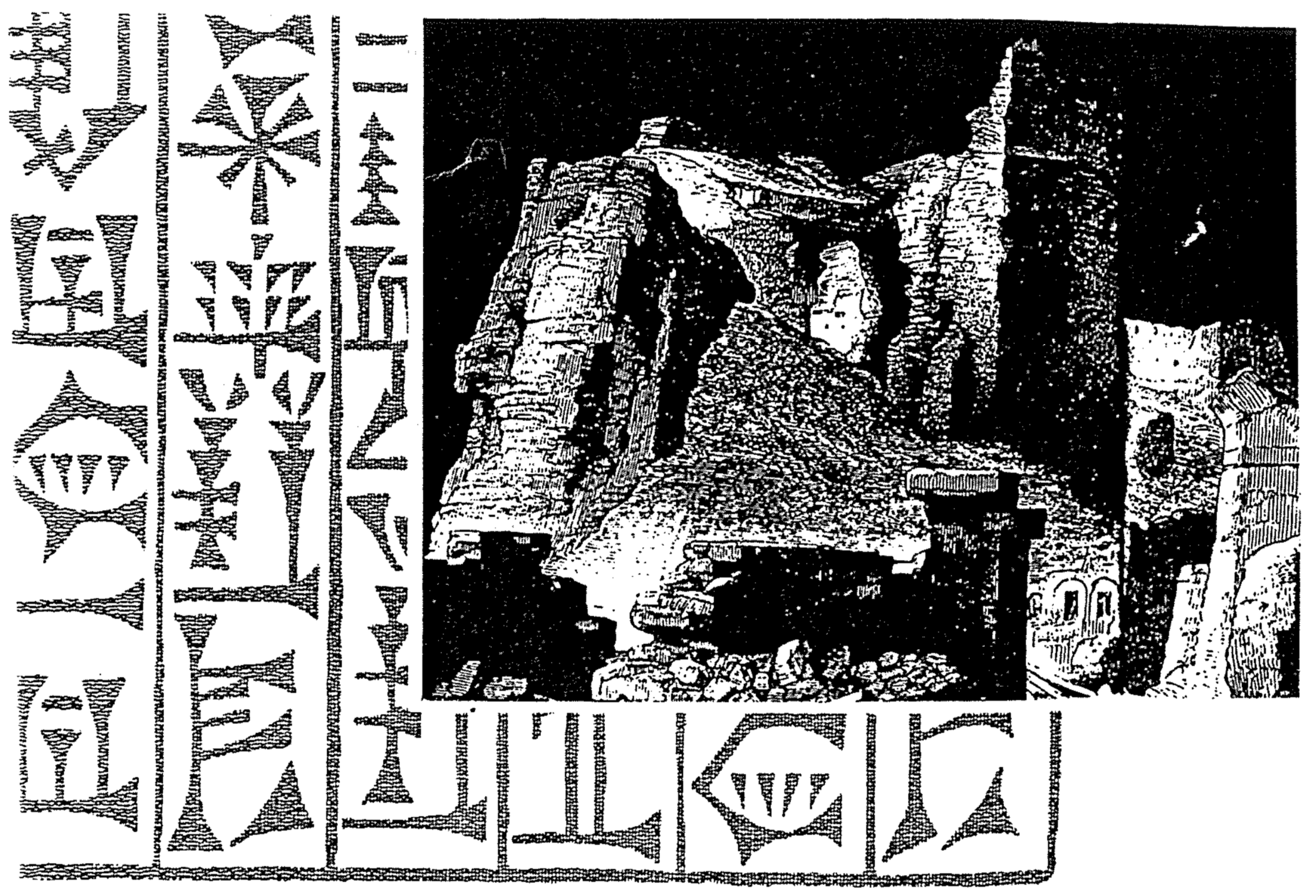

Decline of the Kingdoms

Huang Sabin, Singapore Bible College

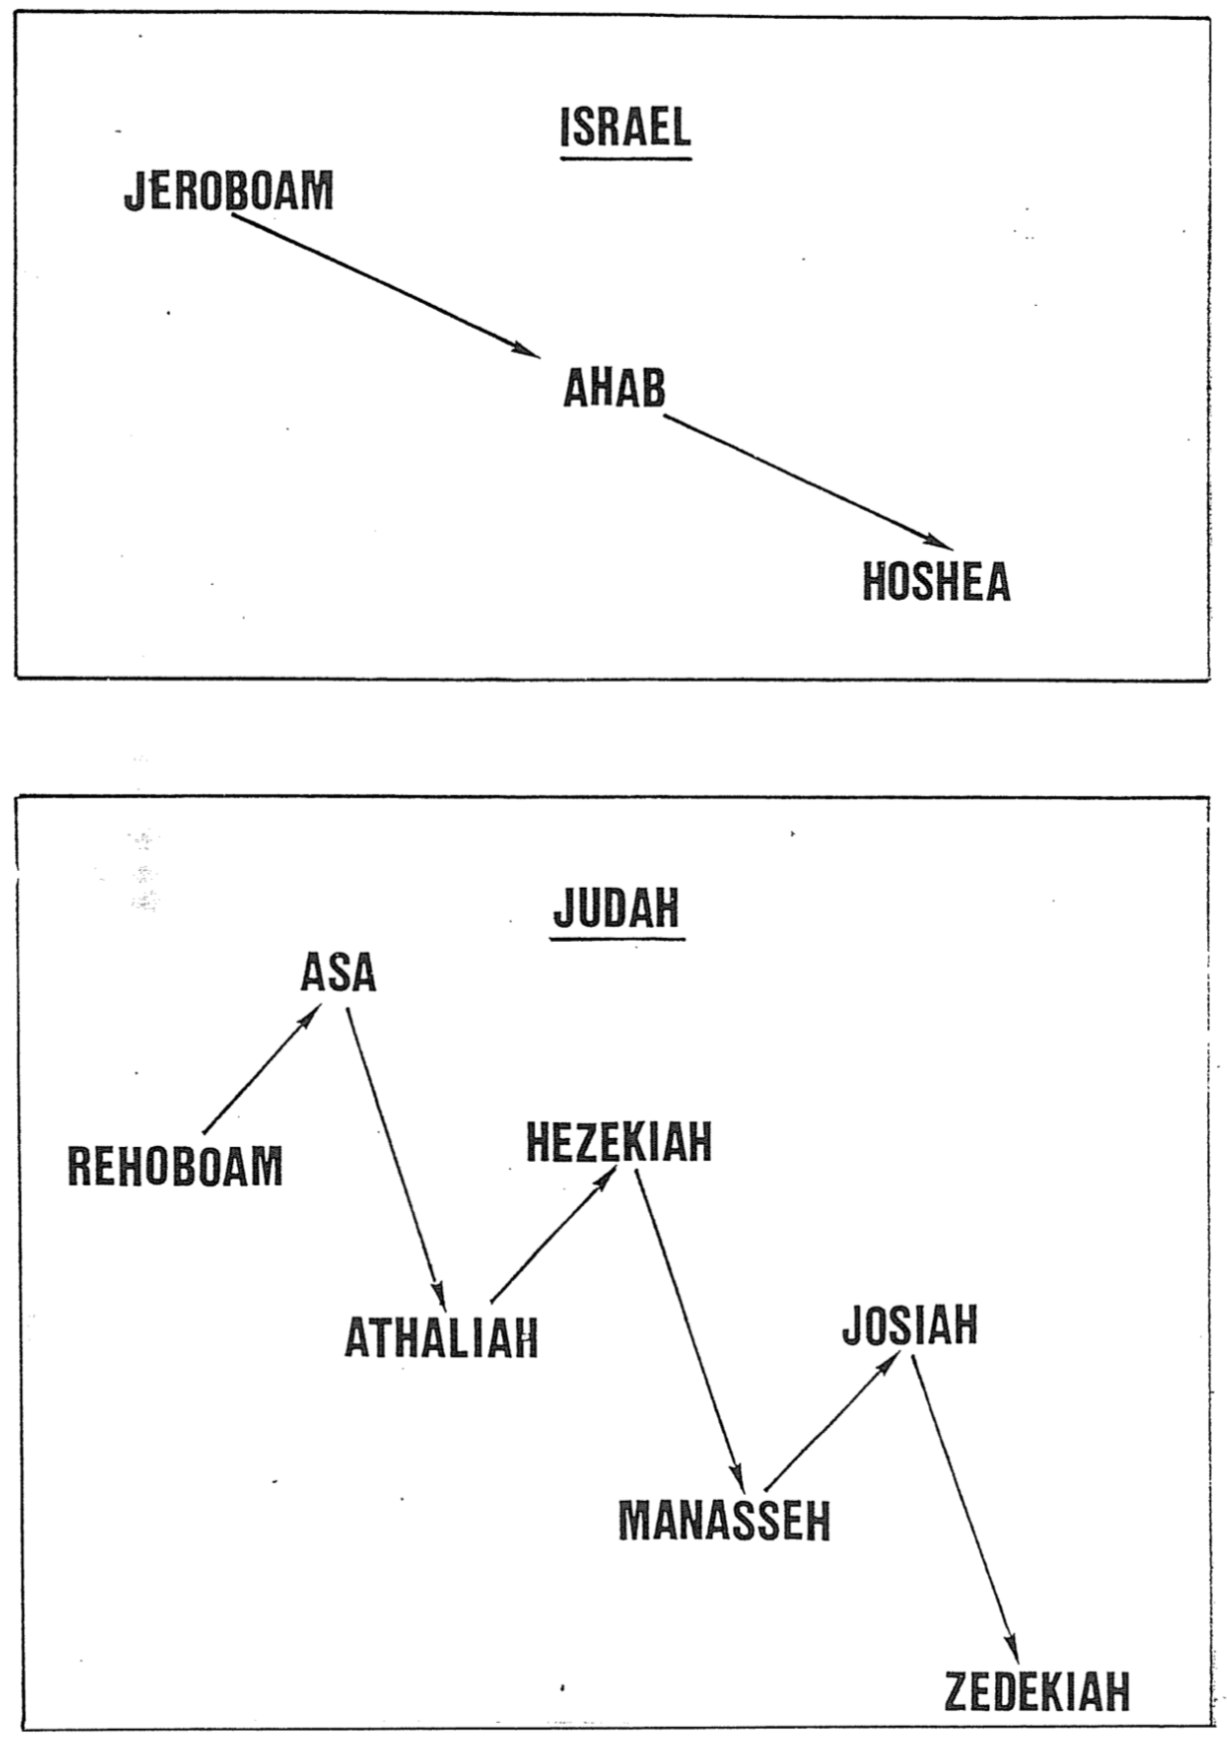

Patterns of Judean Kings’ Rule

The writers of both Kings and Chronicles deem every king in the northern nation of Israel as evil. However, with the southern nation of Judah it becomes more complicated. Although the writers give an “evil” or “righteous” summary for each reign, it is difficult to categorize every king as either totally “good” or “bad.” This is because some began well but ended poorly, or vice versa. Essentially these twenty-two kings (including David and Solomon) fall into four types. (Scripture references below refer to 2 Chronicles unless otherwise noted.)

Bad with a Good End (3)
Rehoboam (12:6-7, 12), Abijah** (=Abijam; 13:10; 1 Kings 15:3), Manasseh (33:12, 19)
Good with a Bad End (8)
Solomon* (1:1; cf. 1 Kings 11:6),
Asa (14:2), Jehoshaphat (17:3; 20:37), Joash (24:22), Amaziah (25:19, 27), Uzziah (26:16), Hezekiah (32:25), Josiah (34:1–36:1)

Revivals in 2 Chronicles
* Although Solomon was noted as rich and wise “for the LORD his God was with him and made him exceedingly great” (2 Chron. 1:1 NIV), the writers seem to avoid categorizing him as either “evil” or “good.”

** Abijah (= Abijam) is deemed evil in 1 Kings 15:3 but the Chronicler notes only his trust in the LORD (2 Chron. 13:10). His placement in the “bad with a good end” category above seeks to represent both views.
Bad to Worse (9)
Jehoram (21:6, 11-12), Ahaziah (20:35; 22:3), Athaliah (22:10), Ahaz (28:22), Amon (33:20-25), Jehoahaz (36:1; cf. 2 Kings 13:2), Jehoiakim (36:5), Jehoiachin (36:9), Zedekiah (36:12)
Good to Better (2)
David (1 Kings 3:6),
Jotham (27:6)

Revival # | 1 | 2 | 3 | 4 | 5 | 6
Chapters | 15 | 20 | 23–24 | 25 | 29–31 | 34–35
Kings | Asa | Jehoshaphat | Joash  (via Jehoiada) | Amaziah | Hezekiah | Josiah
Actions
Results

“If my people, who are called by my name, will humble themselves and pray and seek my face and turn from their wicked ways, then will I hear from heaven and will forgive their sin and will heal their land” (2 Chronicles 7:14).

Israel’s Later Eastern Neighbors

John H. Walton, Chronological and Background Charts of the OT, 2d ed., 72

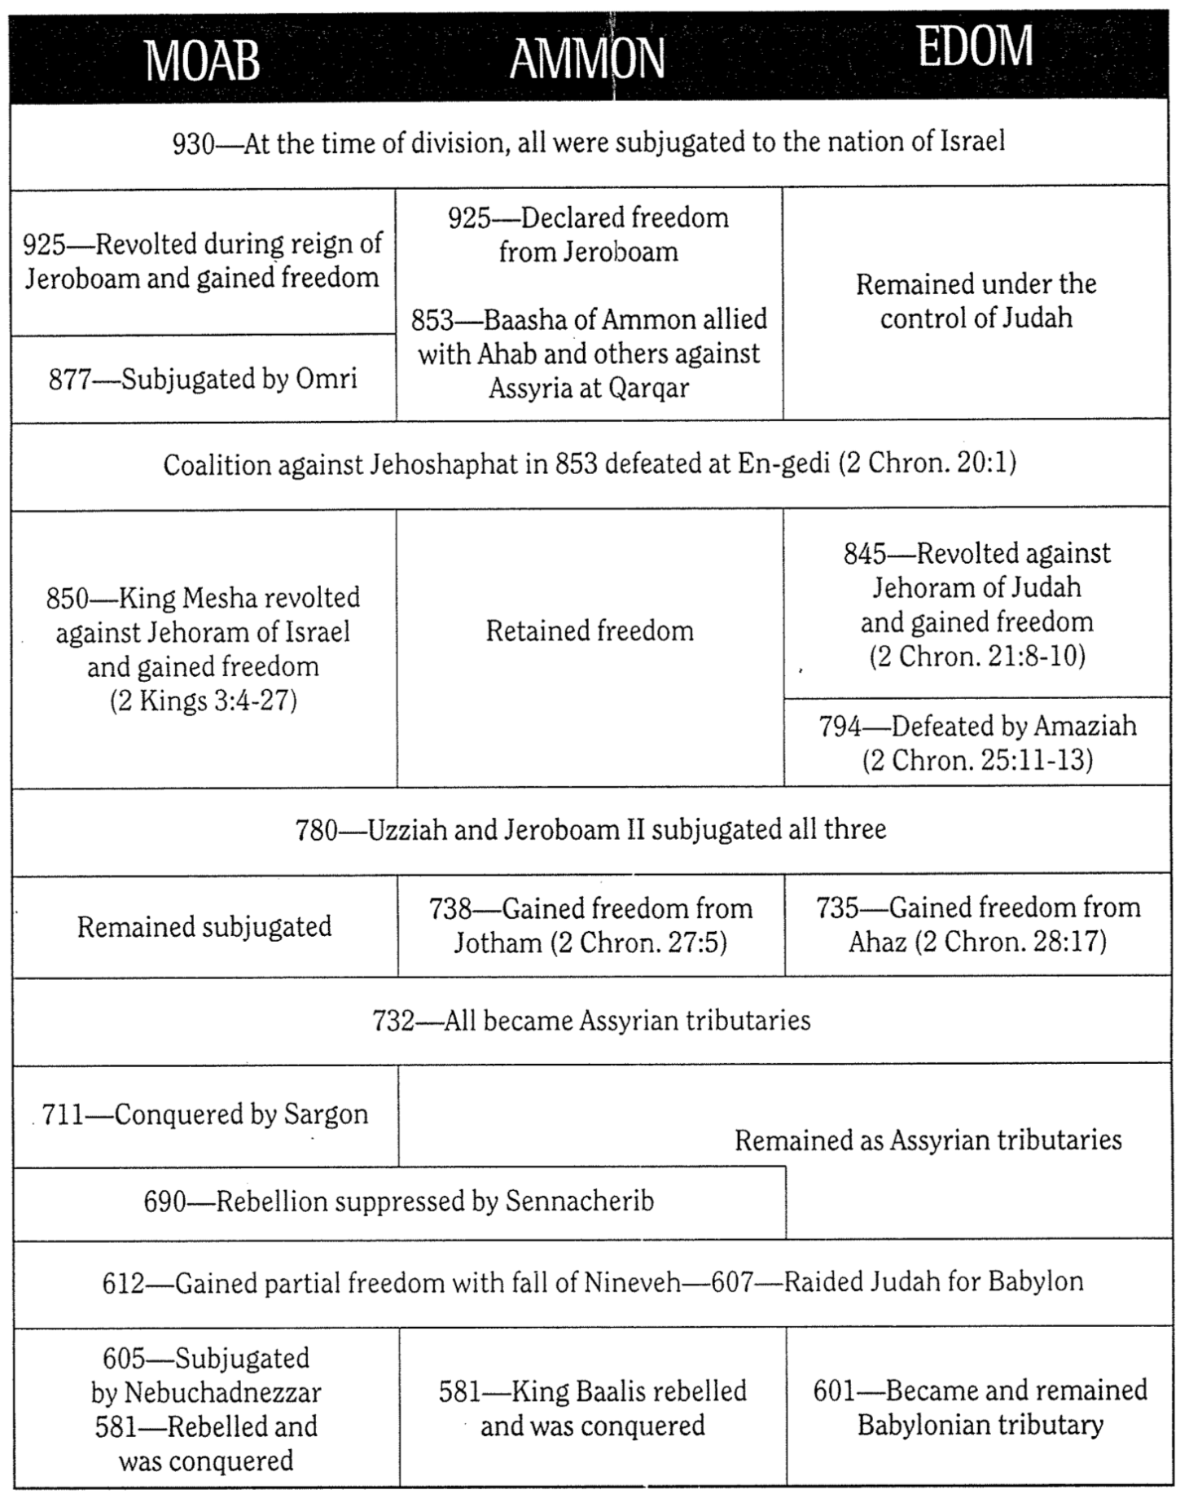
Nebuchadnezzar’s Six Deportations to Babylon

Sequence & Size | Date | King of Judah | Number Taken | Key Captives | Results/  Comments
1  Minor | 605 BC | Jehoiakim | Few  (Dan. 1:3) | Daniel, his 3 friends, & other nobility & royalty | Tribute imposed.  Egypt powerful.
2  Moderate | 598 BC | Jehoiakim | 3,023  (Jer. 52:28) | – | Minor deportation before the 597 BC deportation
3  Major | 597 BC | Jehoiachin | 10,000  (2 Kings 24:14) | Jehoiachin (2 Kings 24:12b), Ezekiel (Ezek. 1:2), Mordecai (Esther 2:6) | Large deportation.  Jehoiachin replaced with his uncle Zedekiah.
4  Minor | 587 BC | Zedekiah | 832  (Jer. 52:29) | – | Minor deportation before the 586 BC destruction
5  Major | 586 BC | Zedekiah | ca. 10,400*  (2 Kings 25:11) | Zedekiah | Jerusalem & temple destroyed after  30 month siege
6  Minor | 582 BC | – | 745  (Jer. 52:30) | – | Four years after Jerusalem’s destruction

* Jeremiah 52:30b says that 4600 people went into captivity during the minor deportations (598, 587, and 582 BC). However, assuming the total captives reached about 25,000 (Eugene H. Merrill, Kingdom of Priests, 471), since the 597 BC deportation took 10,000 captives (2 Kings 24:14) then the fall in 586 BC must have included about 10,400 exiles (25,000 - 10,000 - 4600 = 10,400).

Babylonian Captivity
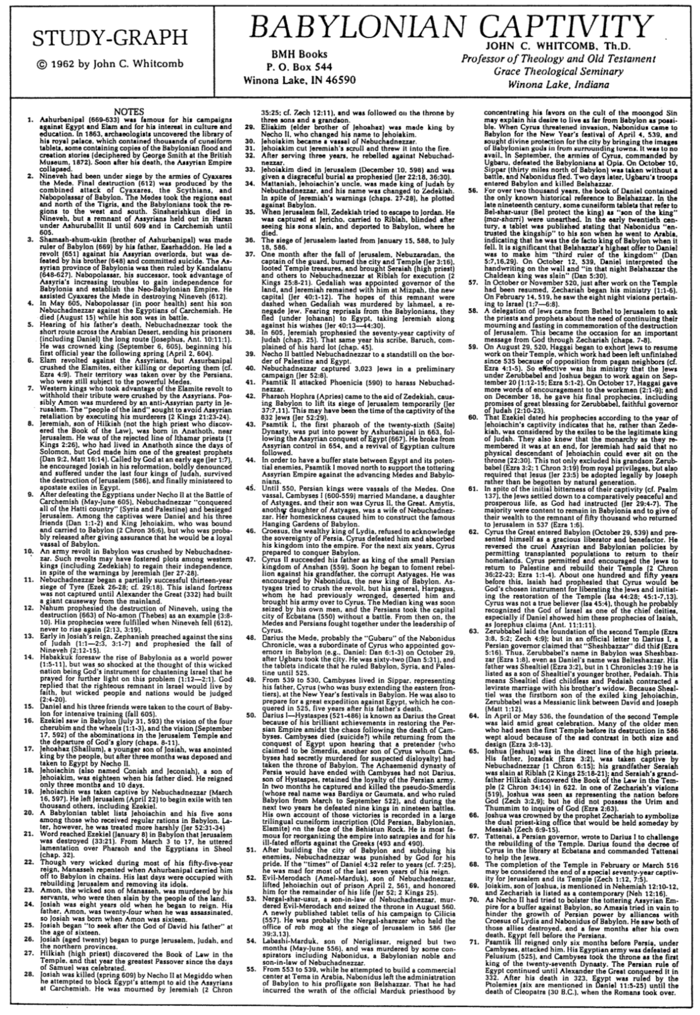

Babylonian Captivity
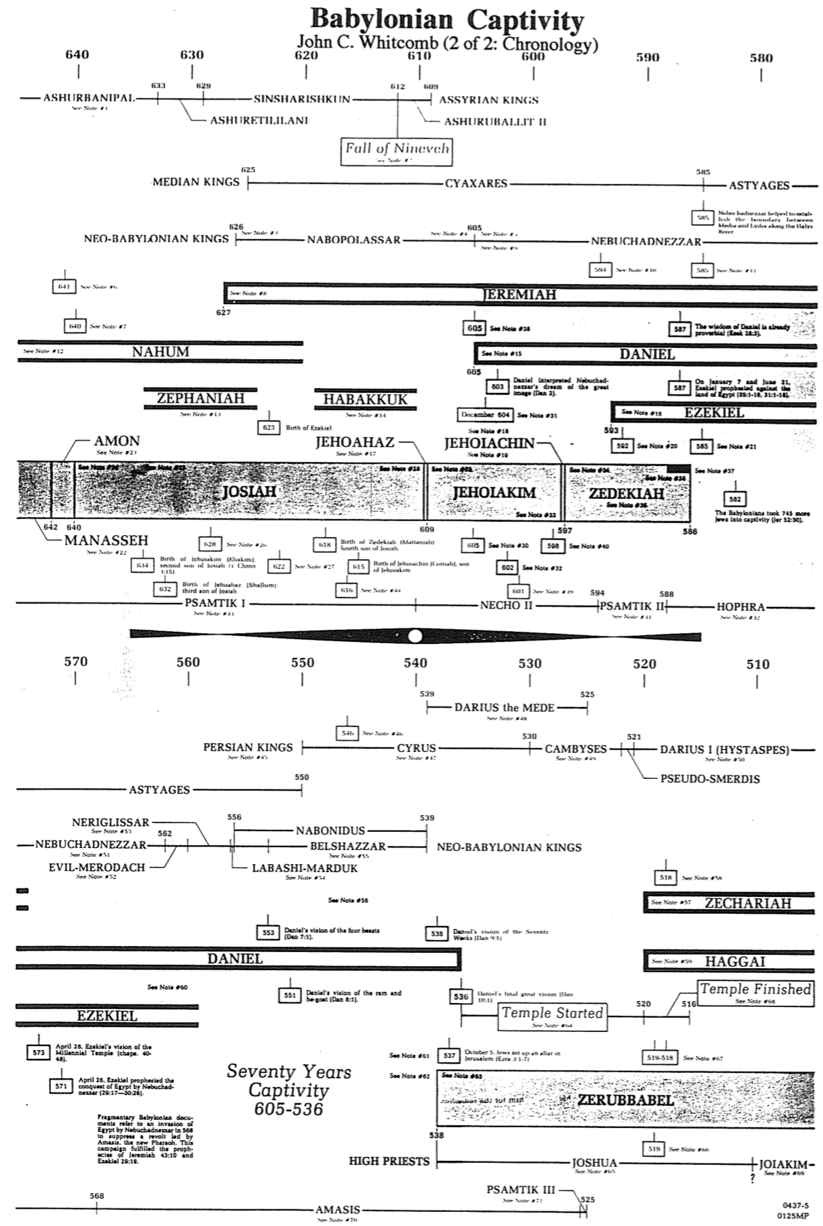
John C. Whitcomb (2 of 2: Chronology)

If I Forget Thee: Does Jerusalem Really Matter to Islam?
Daniel Pipes (1997)

The architects of the Oslo peace accords understood Jerusalem's power. Fearing that even discussing the holy city's future before less combustible issues are resolved would detonate the fragile truce between Israelis and Palestinians, they tried to delay this issue to the end. But they failed: riots met the opening a new entrance to an ancient tunnel last September and now the building of apartments on an empty plot in eastern Jerusalem has brought the negotiations to a halt. As it becomes clear that the struggle for Jerusalem will not wait, the outside world must confront the conflicting claims made by Jews and Muslims on the city that King David entered three millennia ago.

When they do, they will no doubt hear relativistic clichés to the effect that Jerusalem is "a city holy to both peoples," implying a parallel quality to the Jewish and Islamic claims to Jerusalem. But this is false. Jerusalem stands as the paramount religious city of Judaism, a place so holy that not just its soil but even its air is deemed sacred. Jews pray in its direction, mention its name constantly in prayers, close the Passover service with the wistful statement "Next year in Jerusalem," and recall the city in the blessing at the end of meals.

What about Jerusalem's role in Islam? Its significance pales next to Mecca and Medina, the twin cities where Muhammad lived and which hosted the great events of Islamic history. Jerusalem is not the place to which Muslims pray, it is not once mentioned by name in the Qur'an or in prayers, and it is directly connected to no events in Muhammad's life. The city never became a cultural center and it never served as capital of a sovereign Muslim state. Jerusalem has mattered to Muslims only intermittently over the past 13 centuries, and when it has mattered, as it does today, it has done so because of politics. Conversely, when the utility of Jerusalem expires, the passions abate and its status declines.

In AD 622, the Prophet Muhammad fled his hometown of Mecca for Medina, a city with a substantial Jewish population. On arrival, if not earlier, he adopted a number of practices friendly to Jews, such as a Yom Kippur-like fast, a synagogue-like house of prayer, and kosher-style dietary laws. Muhammad also adopted the Judaic practice of facing the Temple Mount in Jerusalem during prayer; "He chose the Holy House in Jerusalem in order that the People of the Book [i.e., Jews] would be conciliated," notes At-Tabari, an early Muslim commentator on the Qur'an, "and the Jews were glad." Modern historians agree: W. Montgomery Watt, a leading biographer of Muhammad, interprets the prophet's "far-reaching concessions to Jewish feeling" as part of his "desire for a reconciliation with the Jews."

But Jews criticized the new faith and rejected Muhammad's gestures, leading Muhammad to eventually break with them, probably in early 624. The most dramatic sign of this change came in a Qur'anic passage (2:142-52) ordering the faithful no longer to pray toward Syria but toward Mecca instead. (The Qur'an and other sources only mention the direction as "Syria"; other information makes it clear that "Syria" means Jerusalem.)

This episode initiated a pattern that would be repeated many times over the succeeding centuries: Muslims take religious interest in Jerusalem because it serves them politically and when the political climate changes, their interest flags.

In the century after Muhammad's death, politics prompted the Damascus-based Umayyad dynasty, which controlled Jerusalem, to make this city sacred in Islam. Embroiled in fierce competition with a dissident leader in Mecca, the Umayyad rulers sought to diminish Arabia at Jerusalem's expense. They sponsored a genre of literature praising the "virtues of Jerusalem" and circulated accounts of the prophet's sayings or doings (called hadiths) favorable to Jerusalem. In 688-91, they built Islam's first grand structure, the Dome of the Rock, on top of the remains of the Jewish Temple.

In a particularly subtle and complex step, they even reinterpreted the Qur'an to make room for Jerusalem. The Qur'an, describing Muhammad's Night Journey (isra'), reads: "[God] takes his servant [i.e., Muhammad] by night from the Sacred Mosque to the furthest mosque." When this Qur'anic passage was first revealed, in about 621, a place called the Sacred Mosque already existed in Mecca. In contrast, the "furthest mosque" was a turn of phrase, not a place. Some early Muslims understood it as metaphorical or as a place in heaven. And if the "furthest mosque" did exist on earth, Palestine would have seemed an unlikely location, for that region elsewhere in the Qur'an (30:1) was called "the closest land" (adna al-ard).

But in 715, the Umayyads built a mosque in Jerusalem, again right on the Temple Mount, and called it the Furthest Mosque (al-masjid al-aqsa, or Al-Aqsa Mosque). With this, the Umayyads not only post hoc inserted Jerusalem into the Qur'an but retroactively gave it a prominent role in Muhammad's life. For if the "furthest mosque" is in Jerusalem, then Muhammad's Night Journey and his subsequent ascension to heaven (mi`raj) also took place on the Temple Mount.

But, as ever, Jerusalem mattered theologically only when it mattered politically, and when the Umayyad dynasty collapsed in 750, Jerusalem fell into near-obscurity. For the next three and a half centuries, books praising the city lost favor and the construction of glorious buildings not only stopped, but existing ones fell apart (the Dome over the rock collapsed in 1016). "Learned men are few, and the Christians numerous," bemoaned a tenth-century Muslim native of Jerusalem. The rulers of the new dynasty bled Jerusalem and its region country through what F. E. Peters of New York University calls "their rapacity and their careless indifference."

By the early tenth century, notes Peters, Muslim rule over Jerusalem had an "almost casual" quality with "no particular political significance." In keeping with this near-indifference, the Crusader conquest of the city in 1099 initially aroused a mild Muslim response: "one does not detect either shock or a sense of religious loss and humiliation," notes Emmanuel Sivan of the Hebrew University, a scholar of this era.

Only as the effort to retake Jerusalem grew serious in about 1150 did Muslim leaders stress Jerusalem's importance to Islam. Once again, hadiths about Jerusalem's sanctity and books about the "virtues of Jerusalem" appeared. One hadith put words into the Prophet Muhammad's mouth saying that, after his own death, Jerusalem's falling to the infidels is the second greatest catastrophe facing Islam.

Once safely back in Muslim hands after Saladin's reconquest, however, interest in Jerusalem dropped, to the point where one of Saladin's grandsons temporarily ceded the city in 1229 to Emperor Friedrich II in return for the German's promise of military aid against his brother, a rival king. But learning that Jerusalem was back in Christian hands again provoked intense Muslim emotions; as a result, in 1244, the city was again under Muslim rule. The psychology at work here bears note: that Christian knights traveled from distant lands to make Jerusalem their capital made the city more valuable in Muslim eyes too. "It was a city strongly coveted by the enemies of the faith, and thus became, in a sort of mirror-image syndrome, dear to Muslim hearts," Sivan explains.

The city then lapsed back to its usual obscurity for nearly eight centuries. At one point, the city's entire population amounted to a miserable four thousand souls. The Temple Mount sanctuaries were abandoned and became dilapidated. Under Ottoman rule (1516-1917), Jerusalem suffered the indignity of being treated as a tax farm for non-resident, one-year (and so very rapacious) officials. The Turkish authorities raised funds by gouging European visitors, and so made little effort to promote Jerusalem's economy. The tax rolls show soap as the city's only export item. In 1611, George Sandys found that "Much lies waste; the old buildings (except a few) all ruined, the new contemptible." Gustav Flaubert of Madame Bovary fame visited in 1850 and found "Ruins everywhere." Mark Twain in 1867 wrote that Jerusalem "has lost all its ancient grandeur, and is become a pauper village."

In modern times, notes the Israeli scholar Hava Lazarus-Yafeh, Jerusalem "became the focus of religious and political Arab activity only at the beginning of the present century, and only because of the renewed Jewish activity in the city and Judaism's claims on the Western Wailing Wall." British rule over city, lasting from 1917 to 1948, further galvanized Muslim passion for Jerusalem. The Palestinian leader (and mufti of Jerusalem) Hajj Amin al-Husayni made the Temple Mount central to his anti-Zionist efforts, for example raising funds throughout the Arab world for the restoration of the Dome of the Rock. Arab politicians made Jerusalem a prominent destination; for example, Iraqi leaders frequently turned up, where they demonstrably prayed at Al-Aqsa and gave rousing speeches.

But when Muslims retook the Old City with its Islamic sanctuaries in 1948, they quickly lost interest in it. An initial excitement stirred when the Jordanian forces took the walled city in 1948 as evidenced by the Coptic bishop's crowning King `Abdallah as "King of Jerusalem" in November of that year but then the usual ennui [boredom] set in. The Hashemites had little affection for Jerusalem, where some of their most devoted enemies lived and where `Abdallah himself was shot dead in 1951. In fact, the Hashemites made a concerted effort to diminish the holy city's importance in favor of their capital, Amman. Jerusalem had served as the British administrative capital, but now all government offices there (save tourism) were shut down. The Jordanians also closed some local institutions (e.g., the Arab Higher Committee) and moved others to Amman (the treasury of the Palestinian waqf, or religious endowment).

Their effort succeeded. Once again, Arab Jerusalem became an isolated provincial town, now even less important than Nablus. The economy stagnated and many thousands left Arab Jerusalem. While the population of Amman increased five-fold in the period 1948-67, Jerusalem's grew just 50 percent. Amman was chosen as the site of the country's first university as well as of the royal family's many residences. Perhaps most insulting of all, Jordanian radio broadcast the Friday prayers not from Al-Aqsa Mosque but from a mosque in Amman.

Nor was Jordan alone in ignoring Jerusalem; the city virtually disappeared from the Arab diplomatic map. No foreign Arab leader came to Jerusalem between 1948 and 1967, and even King Husayn visited only rarely.

King Faysal of Saudi Arabia often spoke after 1967 of yearning to pray in Jerusalem, yet he appears never to have bothered to pray there when he had the chance. Perhaps most remarkable is that the PLO's founding document, the Palestinian National Covenant of 1964, does not even once mention Jerusalem.

All this abruptly changed after June 1967, when the Old City came under Israeli control. As in the British period, Palestinians again made Jerusalem the centerpiece of their political program. Pictures of the Dome of the Rock turned up everywhere, from Yasir Arafat's office to the corner grocery. The PLO's 1968 Constitution described Jerusalem as "the seat of the Palestine Liberation Organization."

Nor were Palestinians alone in their renewed interest. "As during the era of the Crusaders," Lazarus-Yafeh points out, many Muslim leaders "began again to emphasize the sanctity of Jerusalem in Islamic tradition," even dusting off old hadiths to back up their claims. Jerusalem became a mainstay of Arab League and United Nations resolutions. The formerly stingy Jordanian and Saudi governments now gave munificently to the Jerusalem waqf.

As it was under the British mandate, Jerusalem has since 1967 again become the primary vehicle for mobilizing international Muslim opinion. A fire at Al-Aqsa Mosque in 1969 gave Faysal the occasion to convene twenty-five Muslim heads of state and establish the Organization of the Islamic Conference, a United Nations for Muslims. Lebanon's leading Shi`i authority regularly relies on the theme of liberating Jerusalem to inspire his own people to liberate Lebanon. Since the Islamic Revolution, Iran's 1-rial coin and 1000-rial banknote have featured the Dome of the Rock. Iranian soldiers at war with Saddam Husayn's forces in the 1980s received primitive maps marking a path through Iraq and onto Jerusalem. Ayatollah Khomeini decreed the last Friday of Ramadan as Jerusalem Day, and the holiday has served as a major occasion for anti-Israel harangues.

Since Israeli occupation, some ideologues have sought to establish the historical basis of Islamic attachment to Jerusalem by raising three main arguments, all of them historically dubious. First, they assert a Muslim connection to Jerusalem that predates the Jewish one. Ghada Talhami, a scholar at Lake Forest College, typically asserts that, "There are other holy cities in Islam, but Jerusalem holds a special place in the hearts and minds of Muslims because its fate has always been intertwined with theirs."

Always? Jerusalem's founding antedated Islam by about two millennia, so how can that be? Ibrahim Hooper, national communications director for the Washington-based Council on American-Islamic Relations explains: "the Muslim attachment to Jerusalem does not begin with the prophet Muhammad, it begins with the prophets Abraham, David, Solomon and Jesus, who are also prophets in Islam." In other words, the central figures of Judaism and Christianity were really proto-Muslims.

Second, and equally anachronistic, is the claim that the Qur'an mentions Jerusalem. Hooper (and others) argue that "the Koran refers to Jerusalem by its Islamic centerpiece, al-Aqsa Mosque." But this makes no sense: a mosque built a century after the Qur'an was delivered cannot establish what a Qur'anic verse originally meant.

Third, some Muslims deny Jerusalem any importance to Jews. `Abd al- Malik Dahamshe, an Arab member of Israel's parliament, flatly stated last month that "the Western Wall is not associated with the remains of the Jewish Temple." A fundamentalist Israel Arab leader went further and announced that "It's prohibited for Jews to pray at the Western Wall." Or, in the succinct wording of a protest banner: "Jerusalem is Arab."

Despite these deafening claims that Jerusalem is essential to Islam, the religion does contain a recessive but persistent strain of anti-Jerusalem sentiment. Perhaps the most prominent adherent of this view was Ibn Taymiya (1263-1328), one of Islam's strictest and most influential religious thinkers. (The Wahhabis of Arabia are his modern-day successors.)

In an attempt to purify Islam of accretions and impieties, Ibn Taymiya dismissed the sacredness of Jerusalem as a notion deriving from Jews and Christians, and from the long-ago Umayyad rivalry with Mecca. More broadly, learned Muslims living in the years following the Crusades knew that the great publicity given to hadiths extolling Jerusalem's sanctity resulted from the Countercrusade—that is, from political exigency-and treated it warily.

Recalling that God once had Muslims direct their prayers toward Jerusalem and then turned them instead toward Mecca, some early hadiths suggested that Muslims specifically pray… away from Jerusalem, a rejection that still survives in vestigial form; he who prays in Al-Aqsa Mosque not coincidentally shows his back precisely to the Temple area toward which Jews pray.

In Jerusalem, theological and historical claims matter, serving as the functional equivalent of legal documents elsewhere. Whoever can establish a deeper and more lasting association with the city has a better chance of winning international support to rule it. In this context, the fact that politics has so long fueled the Muslim attachment to Jerusalem has two implications. First, it points to the relative weakness of the Islamic connection to the city, one that arises as much from transitory considerations of mundane need as from the immutable claims of faith.

Second, it suggests that the Muslim interest lies not so much in controlling Jerusalem as it does in denying control over the city to anyone else. Jerusalem will never be more than a secondary city for Muslims.

In contrast, Mecca is the eternal city of Islam, the place where Muslims believe Abraham nearly sacrificed Isaac's brother Ishmael and toward which Muslims turn to pray five times each day. Non-Muslims are strictly forbidden there, so it has a purely Muslim population. Mecca evokes in Muslims a feeling similar to that of Jerusalem among Jews: "Its very mention reverberates awe in Muslims' hearts," writes Abad Ahmad of the Islamic Society of Central Jersey. Very roughly speaking, what Jerusalem is to Jews, Mecca is to the Muslims. And just as Muslims rule an undivided Mecca, so Jews should rule an undivided Jerusalem.

_________________

The author (Daniel Pipes) is editor of the Middle East Quarterly and author of The Hidden Hand: Middle East Fears of Conspiracy (St. Martin's Press).

Originally appeared in slightly different form in The New Republic on April 28, 1997

This essay was received courtesy of Dr. Aaron Lerner of Independent Media Review and Analysis (IMRA), imra@netvision.net.il. Views expressed are not necessarily those of IRIS or its staff.

Though this essay is substantially longer that the typical IRIS mailing, we believe its content is well worth the exception.

Jason and Leiah Elbaum
IRIS
http://www.netaxs.com/people/iris

