Isaiah

Restoration of the Created Order

Judgment  (and Salvation) |  |  |  | Salvation  (and Judgment)
Chapters 1–39 |  |  |  | Chapters 40–66
Assyrian Invasion |  |  |  | Babylonian Captivity
Prophecy |  |  | History | Prophecy
Mostly Condemnation |  |  | Interlude | Mostly Consolation
Violations & Deliverance  1–12 | Judgment on the Nations  13–23 | Worldwide Judgment & Blessing  24–35 | Salvation, Sickness, & Sin  36–39 | Shepherd  of Israel  40–48 | Suffering  Servant  49–57 | God’s Initiative  58–59 | Restoration under Messiah  60–66
Judah

739-681 BC
(Before, During, and After Israel’s Fall to Assyria in 722 BC)

Key Word: Restoration

Key Verse: “Lift up your eyes to the heavens, look at the earth beneath; the heavens will vanish like smoke, the earth will wear out like a garment and its inhabitants die like flies. But my salvation will last forever, my righteousness will never fail” (Isaiah 51:6).

Summary Statement:
God will judge Judah for breaking his Law but also provide restoration of the created order in a godly remnant, return to the land, and salvation through Messiah who will bring universal blessing.

Application:

The future restoration of the earth should cause us to get our priorities right now.

Isaiah

Introduction

I. Title The name Isaiah (יְשַׁעְיַהוּ yesa‘yahû ) means "salvation of Yahweh" (BDB 447d), a fitting title for the deliverance which the book describes.

II. Authorship

A. External Evidence: Since Isaiah 1–39 differ in many ways from Isaiah 40–66, most scholars (e.g., S. R. Driver, Intro. to Lit. of OT, 204-8, 230-46; Robert H. Pfeiffer, Intro. to OT, 415-16, 452-81, etc.) since the rise of modern scholarship in the nineteenth century have challenged the book’s unity. They claim that a different author wrote each of these two parts, with the second part attributed to a "Deutero-Isaiah" after the Babylonian captivity (586 BC). Some even say it had three authors (Isaiah 1–39, 40–55, 56–66), with the last section being written by “Trito-Isaiah.” However, conservatives have repeatedly defended the book’s unity (e.g., Edward J. Young, Book of Isaiah, 3:538-49; R. K. Harrison, Intro. to the OT, 764-800; cf. Archer, Merrill, etc.):

1. Accusation: Chapters 1–39 have an Assyrian background, whereas Isaiah 40–66 has a Babylonian background.

Response: Babylon is mentioned more than twice as often in chapters 1–39 than in 40–66. The only shift is one of perspective from the present to the future. Besides, Isaiah may have prophesied chapters 1–39 before Assyria conquered Israel and then preached chapters 40–66 afterward concerning Babylon.

2. Accusation: The language, style, and theology of the two sections differ radically.

Response: The differences are exaggerated by critics and can be explained by different emphases (condemnation versus consolation). Critics often fail to acknowledge that content, the time of writing, and circumstances typically influence an author's style.

3. Accusation: Messiah is presented as King in chapters 1–39 but as Suffering Servant in chapters 40–66.

Response: These two concepts are not contradictory; both accurately depict each section.

4. Accusation: Isaiah could not have predicted the Babylonian captivity and return under Cyrus, who is explicitly mentioned by name (Isa 44–45) 150 years in advance.

Response: The accusation assumes that God cannot accurately predict, despite His claim to know the future (42:9). It also fails to address how many of Isaiah's prophecies were fulfilled hundreds of years later in Jesus Christ (e.g., Isa 53).

Furthermore, the New Testament upholds the unity of the book by attributing quotes from both sections to Isaiah. John 12:37-41 quotes Isaiah 6:9-10; 53:1, and Paul in Romans 9:27; 10:16-21 credits Isaiah with chapters 10, 53, and 65.

B. Internal Evidence: Isaiah, the son of Amoz, is author (1:1). He married a prophetess (8:3) and had two sons: Shear-Jashub (7:3) and Shalal-Hash-Baz (8:3). Isaiah probably lived in Jerusalem as he had access to the royal court (7:3; 36:1–38:8; cf. 2 Kings 18:3–20:19; 2 Chron. 26:22). Tradition says he was a cousin of King Uzziah (Talmud Meg. 10b), but no firm evidence supports this (Martin, BKC, 1:1029). The Assumption of Isaiah (cf. LaSor, 366) records that he was martyred in Manasseh's day by being sawn in two (cf. Heb. 11:37).

III. Circumstances

A. Date: Isaiah's long ministry stretched through the reigns of four kings of Judah (1:1), starting during the reign of King Uzziah (790-739 BC; 6:1), likely a few years before Uzziah's death (2 Chron. 26:22). His ministry then spanned the reigns of Jotham (739-731 BC), Ahaz (731-715 BC), and Hezekiah (715-686 BC) since Isaiah wrote Hezekiah's biography (cf. 2 Chron. 32:32). He also lived at least until Sennacherib's death in 681 BC (37:38), showing that his ministry lasted at least 58 years (739-681 BC) and perhaps 65 years (745-680 BC; cf. LaSor)! Therefore, Isaiah prophesied both before and after the fall of Israel in 722 BC, which may explain the differences between chapters 1–39 (pre-fall) and chapters 40–66 (post-fall).

B. Recipients: Isaiah’s audience comprised Jews in the southern kingdom of Judah who saw the destruction of the north and 46 of their own cities.

C. Occasion: Uzziah (Azariah) of Judah died just before Isaiah was called as a prophet (6:1), ending a 52-year reign as king. During his reign, Tiglath-Pileser, king of Assyria, made significant inroads into the west, conquering many lands and forcing the Israelites to pay tribute (cf. 2 Kings 15:29). Jotham, the next king, was a righteous man, but after him came the wicked Ahaz (2 Kings 16:1-3). At the same time, Rezin of Damascus and Pekah of Israel revolted against Judah. This military threat frightened Ahaz into making alliances with the Assyrian king Tiglath-Pileser, which Isaiah condemned as displeasing to God (Isa. 7:1-19).

During Ahaz’s reign, the northern kingdom fell to Assyria (722 BC), and Israel and Syria besieged Jerusalem (2 Kings 16:5-6; 2 Chron 28:5-15). During the reign of Hezekiah, the final king during Isaiah's ministry, Judah experienced some positive reforms (2 Chron. 29:1–31:21). However, Isaiah ministered during a predominantly turbulent time in Judah's history. His message was that Judah should trust in God rather than in Assyria (against Israel and Syria), or Egypt, or any of the other nations in the 12-nation anti-Assyrian coalition (Isaiah 13–23). After all, only God could protect the nation, and God alone had promised the glorious kingdom that Judah was seeking.

IV. Characteristics

A. Isaiah is probably the best-known of all the prophetic books in the Bible, as it contains many passages familiar to Bible students (e.g., 1:18; 7:14; 9:6-7; 26:8; 40:3, 31; 53).

B. It is the longest and most influential prophetic book, thus at the front of them in our Bibles.

C. Isaiah spoke more than any other prophet about the great kingdom Israel will enter at the Messiah's Second Coming (Martin, BKC, 1:1029). Although only the book of Revelation specifies the length of this kingdom as 1,000 years (Rev. 20:1-6), Isaiah describes the nature of this millennial kingdom more thoroughly than any other biblical book.

D. Isaiah shows the Bible in miniature: chapters 1–39 resemble God’s righteousness, holiness, and justice stressed in the 39 OT books, and the final 27 chapters (chapters 40–66) portray God's glory, compassion, and undeserved favor as seen in the 27 NT books (TTTB, 189).

E. Isaiah is one of the most quoted Old Testament books in the New Testament, with 100 quotes, surpassed only by Psalms, which has 119 or more quotes.

F. Many feel the prophecy of the king of Babylon’s fall (14:12-14) is Satan’s fall (cf. Ezek. 28).

G. Isaiah most clearly reveals the prophecies of Christ. He predicts the First Coming of Jesus in many ways: his virgin birth (7:14) and coming as a child (9:6) in humility (11:1; 42:1; 49:1; 52:17), as well as his atoning death (Isa. 53). He also repeatedly speaks of events associates with the Second Coming: cleansing of the nation (4:2), reign of Christ (9:6-7), victory over enemies (11:4), just and peaceful reign worldwide (11:5-11), etc.

H. Isaiah is also known for his “servant” prophecies. Note that “servant” refers both to Israel (41:8; 42:19; 43:10; 44:1-2, 21; 45:4; 48:20) and to the Messiah (42:1; 49:3, 5-7; 50:10; 52:13; 53:11).

Argument

Isaiah can be easily divided into two major sections. Chapters 1–39 concern the judgment that Israel and the surrounding nations faced, while chapters 40–66 comfort God's people with the salvation and restoration God promised His people. The first section was probably written before the Assyrian exile, and the second after the fall of the northern kingdom. Since Judah sought security from its neighbors, both sections encourage a return to God in repentance, especially since He will restore all creation in a glorious kingdom under the Messiah.

Synthesis

Restoration of the created order

Messianic Prophecies
1–39 Judgment and salvation
1–6 Judah's violations
1:1 Heading
1:2-31 Indictment
2–4 Future/present contrast 4:2 ff. Branch cleanses
5 Song of the vineyard
6 Isaiah Commissioned
7–12 Deliverance: near/far
7:1–9:7 Two sons 7:14 Virgin birth
9:8–10:4 Israel's exile 9:6-7 God, just, peace, right
10:5-34 Fall of Assyria
11–12 Messiah 11:1 Of Jesse: humble, just
13–23 Judgment on the nations (12-nation anti-Assyrian coalition)
13:1–14:27 Babylon
14:28-32 Philistia
15–16 Moab
17 Damascus/Israel
18 Ethiopia
19–20 Egypt
21:1-10 Babylon by the Sea
21:11-12 Edom
21:13-17 Arabia
22 Jerusalem
23 Tyre
24–27 Future judgment/restoration
24 Great Tribulation
25–27 Kingdom
25 Song of Praise (Isaiah)
26 Song of Praise (Redeemed)
27 Universal restoration
28–33 Woes (delight in God—not Egypt)
28 Israel
29 Judah
30–31 Egyptian alliance
32 Messiah 32:1 King of righteousness
33 Assyria
34–35 Vengeance/blessing
34 Judgment—nations
35 Blessing—Israel
36–39 Historical Parenthesis
36–37 Salvation from Assyria
38 Salvation from sickness
39 Sin leading to exile

40–66 Salvation/Restoration
40–48 Shepherd of Israel 40:3 Forerunner
40 Comfort/Sovereignty 40:10f. Power, shepherd
41 Cyrus/Israel = Servant
42 Servants contrasted 42:1-3 Spirit, meek, just
43:1–44:5 Restoration
44:6–45:25 God's uniqueness vs. idols
46–48 Babylon's destruction
49–57 Suffering Servant
49–50 Rejection = Gentile salvation 49:1f. Rejection
51:1–52:12 Remnant should trust God
52:13–53:12 Vicarious death/exaltation 53:4-6 Vicarious, resurrected
54:1–56:8 Salvation for Jews/Gentiles
56:9–57:21 Condemnation on leaders
58–59 God's initiative
58 False profession
59 Sinful practices
60–66 Restoration under Messiah
60 Prosperity/peace
61:1–63:6 Servant 61:1f. Blessing, judgment
63:7–65:25 Remnant prayer
66 Restoration/eternal seed

Outline

Summary Statement for the Book
God will judge Judah for breaking His Law, but also provide restoration of the created order in a godly remnant, return to the land, and salvation through the Messiah, who will bring universal blessing.

God will judge Judah and the nations through the Babylonians, but also bless a godly remnant in the distant future through the Messiah (Isa 1–39).

Judah has violated the Mosaic Covenant, so God will justly judge the nation (Isa 1–6).

The book’s heading identifies the author, date, and nature of the prophecy (1:1).

The prophecy is called a vision as it previews Judah's present and future history (1:1a).

The author of the vision is Isaiah, son of Amoz, whose name means "Yahweh is salvation," which sums up the book’s message (1:1b).

The time in which the vision takes place spans the reigns of four kings of Judah which totals at least 58 years (1:1c).

The response to the LORD’s indicting Judah in a court case for substituting ritual for repentance should be repentance for restoration (1:2-31).

The Charge: God’s people do not know him (1:2-4)!

Heaven and earth should witness God’s charge (1:2a).

Judah’s people rebelled against God like they didn’t know him (1:2b-4).

God’s children rebelled against him (1:2b).

Even animals know their master cares for them (1:3a).

But Israel didn’t know God (1:3b-4).

The Evidence: Rituals involving injustices reveal God’s people as guilty (1:5-15).

Exhibit A: Discipline by Assyria hadn’t led to repentance (1:5-9).

Judah was like a guilty victim where further beating won’t do any good (1:5-6).

God’s punishment by Assyria ravaged Judah’s cities but still left a remnant (1:7-9).

Exhibit B: Rituals without justice only mocked God (1:10-15).

Judah’s leaders were no better than the immoral rulers of Sodom and Gomorrah (1:10).

God despised bloody hands giving sacrifices, offerings, monthly and annual festivals, and prayers (1:11-15).

The blessing of restoration after judgment exhorted Judah to aid the oppressed (1:16-31).

Actions toward the defenseless would result in either prosperity or judgment (1:16-20).

Giving justice would result in eating the best food (1:16-19).

Rebellion through injustice would lead to “being devoured” by death (1:20).

God will execute judgment against Jerusalem’s injustices and idolatry by restoring the city when the Messiah rules (1:21-31).

Injustice will be removed by God’s judgment (1:21-25).

Just judges will replace idolatrous rebels (1:26-31).

Isaiah contrasts the future restored nation with the present sinful nation to encourage the people to repent (Isa 2–4).

Judah’s prophesied restoration to the land in the future kingdom should encourage the people to turn from their sin now (2:1-5).

The impending Day of the LORD in the Babylonian invasion due to Judah’s pride and rebellion should lead to repentance (2:6–4:1).

God would judge Judah for their proud self-confidence—in the near (586 BC) and far (Tribulation) Day of the LORD (2:6-22).

Judah’s pride was in her Eastern superstitions, divination, pagan alliances, materialism, and idolatry (2:6-8).

God’s response to Judah’s trust in herself would be to humble the nation both in the near Babylonian invasion and the distant Tribulation judgments (2:9-22).

God promised to humble Judah by removing all they trusted so they’d trust in him (3:1–4:1).

Food and water would become scarce (3:1).

Proud men parading sin and oppressing others would bring disaster (3:2-15).

Proud women profiting from their husbands’ crimes would be shamed (3:16–4:1).

Holy survivors of Judah will be fruitful under Messiah’s rule as “the Branch of the LORD” (4:2-6).

The way God would respond to Judah spurning his blessings in Isaiah's song of the vineyard would be to destroy the nation for six specific sins (Isa 5).

The way God would respond to Judah spurning his blessings in Isaiah's song of the vineyard would be to destroy the nation (5:1-7).

Isaiah began to sing about God as one he loved (5:1a).

God did all he could for Judah to grow “good grapes” as his vineyard (5:1b-2a).

Despite all its blessings, Judah grew “bad grapes” for God (5:2b-4).

God would destroy Judah for its oppression and violence (5:5-7).

The reason God would judge Judah in captivity was because of six specific sins (5:8-30).

Six indictments (“woes”) warn of death and exile for Judah’s sins (5:8-25).

Materialism will result in empty houses and a lack of food (8:8-10).

Drunkenness will lead to exile followed by restoration (8:11-17).

Drinking all day kept them from God’s priorities (8:11-12).

God would exile and humble the proud until he exalts himself by restoring them (8:13-17).

Scoffers sin even by daring God to punish them (8:18-19).

Deception by redefining sin will be judged (8:20).

Pride thinks itself cleverer than God (8:21).

Injustice and rejecting God’s word would ruin Jerusalem (5:22-25).

God will call Egypt, Assyria, and Babylon to devastate Judah (5:26-30).

The way God enabled Isaiah to endure a long ministry was by calling him to a difficult one with the promise of sure success (Isaiah 6).

One way God enabled Isaiah to endure a long ministry was by calling him to service (6:1-8).

God’s Vision: God showed Isaiah his holiness (6:1-4).

Isaiah’s Response: He humbly volunteered to be sent (6:5-8).

One way God enabled Isaiah to endure a long ministry was by calling him to a challenging yet successful life (6:9-13).

God’s Clarification: Isaiah’s preaching would be rejected (6:9-10).

God’s Command: Isaiah must preach until no one was left to hear with the promise of sure success (6:11-13).

God will deliver Judah in both near and distant times so that, despite judgment, He will not forget His promise to bless them in Messiah's reign (Isa 7–12).

God's near and far deliverance of Judah will come through the births of two sons: Maher-Shalal-Hash-Baz and the Messiah (7:1–9:7).

The births of Maher-Shalal-Hash-Baz (near) and Messiah (far) signify to Ahaz God's deliverance of Judah from enemies and sin, respectively (Isaiah 7).

The first fulfillment of the Immanuel prophecy in the birth of Maher-Shalal-Hash-Baz depicted God's faithfulness to His word (Isaiah 8).

God’s distant deliverance of Judah in Messiah’s birth predicts his righteous reign (9:1-7).

*Note: “Everlasting father” refers to Christ in his:
• deity
• relationship to time, not to other members of the Trinity
• “fatherly rule”
• Davidic Covenant eternal kingdom

God's near deliverance of Judah in Israel’s exile to Assyria should teach his protection but also warn of judgment for the same sins (9:8–10:4).

God's near deliverance of Judah through Assyria’s fall will show his justice even upon his instruments of justice (10:5-34).

God's distant deliverance of Judah by the Messiah’s coming will show his faithfulness to his righteous remnant, resulting in praise to God (Isa 11–12).

Ahaz should not trust in the twelve-nation coalition, as Assyria will defeat it as God's agent of judgment (Isaiah 13–23).

God will judge Babylon to show Judah the futility of trusting this nation for protection from the doomed Assyria, rather than trusting in God (13:1–14:27).

Babylon will fall due to its pride, so Judah is foolish to trust this nation for protection from Assyria rather than trusting in God (13:1–14:23).

Assyria will also fall, so Judah should know that God would punish even the instrument of his discipline of the nation (14:24-27).

God will judge Philistia for rejoicing in Israel’s destruction to show Judah God's protection of his people (14:28-32).

God will judge Moab to show Judah not to seek protection from the doomed Assyria, but rather to trust in God (Isa 15–16).

God will judge Damascus and Israel to show Judah the futility of trusting these nations for protection from Assyria rather than trusting God (Isa 17).

God will judge Sudan to show Judah not to seek its protection from the doomed Assyria, but rather to trust in God, as even Sudan will seek Him in the millennial kingdom (Isa 18).

God will judge Egypt to show Judah not to seek its protection from Assyria, but rather to trust in God, as Isaiah’s prophecy depicted Assyria’s defeat while it attacked Philistia (Isa 19–20).

God will judge the 722 BC desert uprising against Babylon by the Persian Gulf to show Judah not to seek its protection instead of God’s (21:1-10).

God will judge Edom to show Judah not to seek its protection from the doomed Assyria, but rather to trust in God (21:11-12).

God will judge Arabia to show Judah not to seek protection from the doomed Assyria, but rather to trust in God (21:13-17).

God will judge Jerusalem to show Judah not to seek its protection from the doomed Assyria, but rather to trust in God (Isa 22).

God will judge Tyre to show Judah not to seek its protection from the doomed Assyria, but rather to trust in God (Isa 23).

The worldwide Tribulation will refine and restore Judah, as God has not forgotten His covenant (Isaiah 24–27).

The whole world will be judged in the Tribulation as a culmination of the individual judgments upon the nations in chapters 13–23 (Isa 24).

The promised blessing on Israel in the kingdom era should encourage Judah that God has not forgotten His covenant (Isa 25–27).

Isaiah praises God's protection in song and prophesies the Wedding Banquet of the Lamb after Israel defeats her enemies (Isa 25; cf. Rev. 19).

The redeemed will praise God in song for protection in their time of judgment (Isa 26).

Forgiveness and restoration in the kingdom age will follow the nation’s refining, as God has not forgotten His covenant (Isa 27).

Six woes upon Israel, Judah, and Assyria affirm that God alone will deliver them from Assyria and crown His Messianic King (Isaiah 28–33).

Israel’s drunkards and Jerusalem’s scoffers will be replaced with a restored Israel and Judah (Isa 28).

Judah’s seeking security in external religion and foreign alliances will be useless (Isa 29).

Jerusalem’s (Ariel–"the lion of God") external religion without heart conversion will result in a successful siege of the city (29:1-14).

Judah’s kings who seek security in foreign alliances rather than in the LORD will be replaced with awe of God’s holy name (29:15-24).

Judah’s stubbornness, seen in its alliances with Egypt rather than trusting in God, is pronounced since Egypt also will be destroyed (Isa 30–31).

Judah’s futile quest for security in Egypt will ultimately lead to the Messianic King in an age of true security and blessing (Isa 32).

Assyria (the destroyer) will fall for afflicting Judah, and its judgment will make Jerusalem a place of justice and righteousness (Isa 33).

God’s vengeance on all nations mistreating Israel will precede Israel's blessing through restoration to the land (Isa 34–35).

God’s vengeance will befall all nations for mistreating Israel (Isa 34).

God’s judgment of the nations will result in Israel being restored to the land in belief to enjoy kingdom blessings (Isa 35).

God delivered Judah from Assyria but would exile them to Babylon for trusting alliances more than him (Isa 36–39).

Hezekiah’s salvation from the Assyrian threat under Sennacherib shows God's sovereignty over the gods of the surrounding nations (Isa 36–37).

Sennacherib's 701 BC Assyrian commander called the Rabshakeh ridicules the LORD and threatens Jerusalem’s fall if the people do not surrender (Isa 36).

Hezekiah’s trust in God leads to the killing of the Rabshakeh and 185,000 Assyrian soldiers to show God is sovereign over all gods (Isa 37).

Hezekiah's miraculous healing and 15-year lease on life shows God as sovereign over death and the sun’s movement, let alone Assyria (Isa 38).

Hezekiah’s foolish trust in Babylonian envoys—not God—will lead to exile in Babylon, to bridge to chapters 40–66 on Babylon (Isa 39).

Judah should trust in God’s faithfulness to receive land and salvation in Messiah’s vicarious death and rule for universal and eternal blessing (Isa 40–66).

God will punish Babylon and restore Judah with his shepherd's heart and knowledge of the future so Judah should reject Babylon's idols (Isa 40–48).

The way Judah could personalize God’s care and power despite the coming discipline in exile was by trusting him for all the strength they needed (Isa 40).

Judah could find comfort even though disciplined in exile by focusing on God’s care and power (40:1-26).

God comforted Judah that he would replace his discipline with his glory and eternal, unchanging Word (40:1-11).

God comforted Judah that His discipline would end after the exile (40:1-2).

God cared for Judah by promising they would see His glory with His eternal word (40:3-8).

Isaiah’s voice prepared them to see God’s glory when the Messiah appeared (40:3-5).

God’s voice contrasted man’s temporary, changing nature with God’s eternal, unchanging Word (40:6-8).

God cared for Judah tenderly (40:9-11).

God comforted Judah that He rules the world with all power (40:12-26).

He is bigger than the largest items of creation—oceans, outer space, the earth, mountains, and hills (40:12).

He is wiser than anyone (40:13-14).

The nations, best forests, and earth itself are nothing compared to God (40:15-17).

No one or nothing can be compared to God (40:18-26).

Idols don’t compare to him (40:18-20).

Celebrities don’t compare to him (40:21-24).

Stars don’t compare to him (40:25-26).

The way Judah could personalize God’s care and power was by trusting Him for all the strength they needed (40:27-31).

Judah needed to see that the LORD cared despite all their troubles (40:27).

Judah needed to trust that God never grows tired and gives strength to the weary (40:28-31).

Israel the servant nation should not fear since God is sovereign over Babylon’s puny idols as he will appoint Cyrus (41:25) as the only one who knows the future (Isa 41).

Note that “Servant” in Isaiah refers both to Israel (41:8; 42:19; 43:10; 44:1-2, 21; 45:4; 48:20) and to the Messiah (42:1; 49:3, 5-7; 50:10; 52:13; 53:11).

Judah can trust the LORD who planned for Cyrus to destroy nations (41:1-20).

The threatened nations foolishly make dumb idols to tell them the future (41:21-24).

But Judah can trust the LORD who predicted that Cyrus would destroy nations (41:25-29).

God's contrasts Israel with Messiah as servants to show the first will be judged but the second will be victorious to rule the world (Isa 42).

The Messiah (Jesus) will be God’s servant to meekly bring salvation and justice to the nations (42:1-9).

Israel and all creation should sing of the LORD’s deliverance rather than be God’s blind and deaf servant to be plundered (42:10-25).

God's restoration of the unworthy nation to the land comforts his people so that they can trust him (43:1–44:5).

Israel should not fear since the LORD will be with them through difficulty and restore them to the land (43:1-13).

God will deliver unfaithful Israel from Babylon as he did from Egypt despite their neglect to give sacrifices (43:14-28).

The LORD elected his servant nation Israel not to fear since he would pour out his Spirit on her children (44:1-5).

God's uniqueness should urge Judah not trust idols but rather see that he appointed Cyrus to restore them to their land (44:6–45:25).

Since God predetermines history while idols can do nothing, Israel should return to him for forgiveness (44:6-23; cf. 43:25; 44:22).

Cyrus will be God’s shepherd and messiah to ruin nations but rebuild Jerusalem in 140 years (44:24–45:8).

Gentiles should abandon their idols and trust the LORD who will raise up Cyrus without even rewarding him (45:9-25).

God will deliver Israel by destroying Babylon so his people will know that he alone is sovereign and committed to his covenant (Isa 46–48).

God will destroy Babylon's useless idols through Cyrus (46:11) because he alone is God who can plan salvation for Israel (Isa 46).

Babylon's empire that appeared invincible as a queen trusting in astrology will be destroyed because God is greater (Isa 47).

Israel’s liberation from Babylon and return to its land will show God keeps his covenant (Isa 48).

God's rebuke of Israel’s stubbornness to see how he fulfilled past prophecies exhorts them to see his glory in future fulfillments (48:1-11).

God—not the idols—proclaims that they will leave Babylon once he redeems them (48:12-22).

Epilogue: “There is no peace for the wicked” (48:22; cf. 57:21).

God’s Suffering Servant will restore Judah and bless the Gentiles in his vicarious death so the remnant should trust him now (Isa 49–57).

The rejected Messiah (Suffering Servant) will save the Gentiles and restore Israel to her land to show that he has not forsaken Israel (Isa 49–50).

God’s Servant Jesus is called “Israel” as he will at first look unsuccessful but later will restore Israel in the millennium and save the Gentiles (Isa 49).

Israel will be judged for her sins but the Messiah will save some through his obedient suffering and judge others who reject him (Isa 50).

The righteous remnant should trust him since they will be exalted (51:1–52:12).

Even though the earth itself will wear out, God will answer the remnant’s call for eternal joy by replacing slavery with rule in a new earth (Isa 51).

Jerusalem's restoration in the millennium will replace judgment from God with worldwide rule (52:1-12).

Messiah’s rejection and death will save many but then he will be exalted to comfort to Israel as the ultimate sacrifice for sin (52:13–53:12).

Messiah will suffer a horrible but vicarious death for the nation and for the Gentiles but have a rich man’s burial (52:13–53:9).

The result of Messiah’s death and prayer for his tormentors will be righteousness imputed to many and his resurrected life forever as God’s victorious soldier (53:10-12).

The reason the Servant's salvation will extend to both Israel and the Gentiles will be to show his loving loyalty (54:1–56:8).

Israel’s future prosperity with many Jews in the land ruling over the world should comfort them with God’s loyalty (Isa 54).

God’s blessing of the Gentiles along with Israel's blessings should show Israel how far his loving loyalty really extends (55:1–56:8).

The reason for God’s condemnation of Israel’s vile leaders is because kingdom blessings will come only to the contrite in heart (56:9–57:21).

God called the Gentiles to destroy Israel’s leaders for caring only for themselves (56:9-12).

The godly humbly trust the LORD rather than commit sexual sin before idols (57:1-21).

Epilogue: “There is no peace for the wicked” (57:21; cf. 48:22).

Judah’s false claims and sinful practices reveal that restoration will come only from God's initiative, not their goodness (Isa 58–59).

Judah’s false profession of godliness in response to God's threat of exile should exhort them to true worship (Isa 58).

God lists Judah’s sinful practices causing his judgment, to prove that salvation and restoration result only from God's initiative (Isa 59).

Israel’s glorious restoration in the millennium reveals that God will fulfill every promise in the Abrahamic Covenant (Isa 60–66).

God promises Israel a glorious future of prosperity and peace in the kingdom (Isa 60).

God promises the coming of the Servant who will prepare Jerusalem for the coming of the Father to usher in the millennium (61:1–63:6).

Israel’s remnant prays for forgiveness and restoration, resulting in God’s answer with judgment and restoration (63:7–65:25).

Israel’s remnant prays for forgiveness from past rebellion and for future restoration by God's grace (63:7–64:12).

God gives his reasons for judging the people but also his promise to restore them in the millennium (Isa 65).

God promises Israel restoration to the land and descendants in the millennium to fulfill his promises in the Abrahamic Covenant (Isa 66).

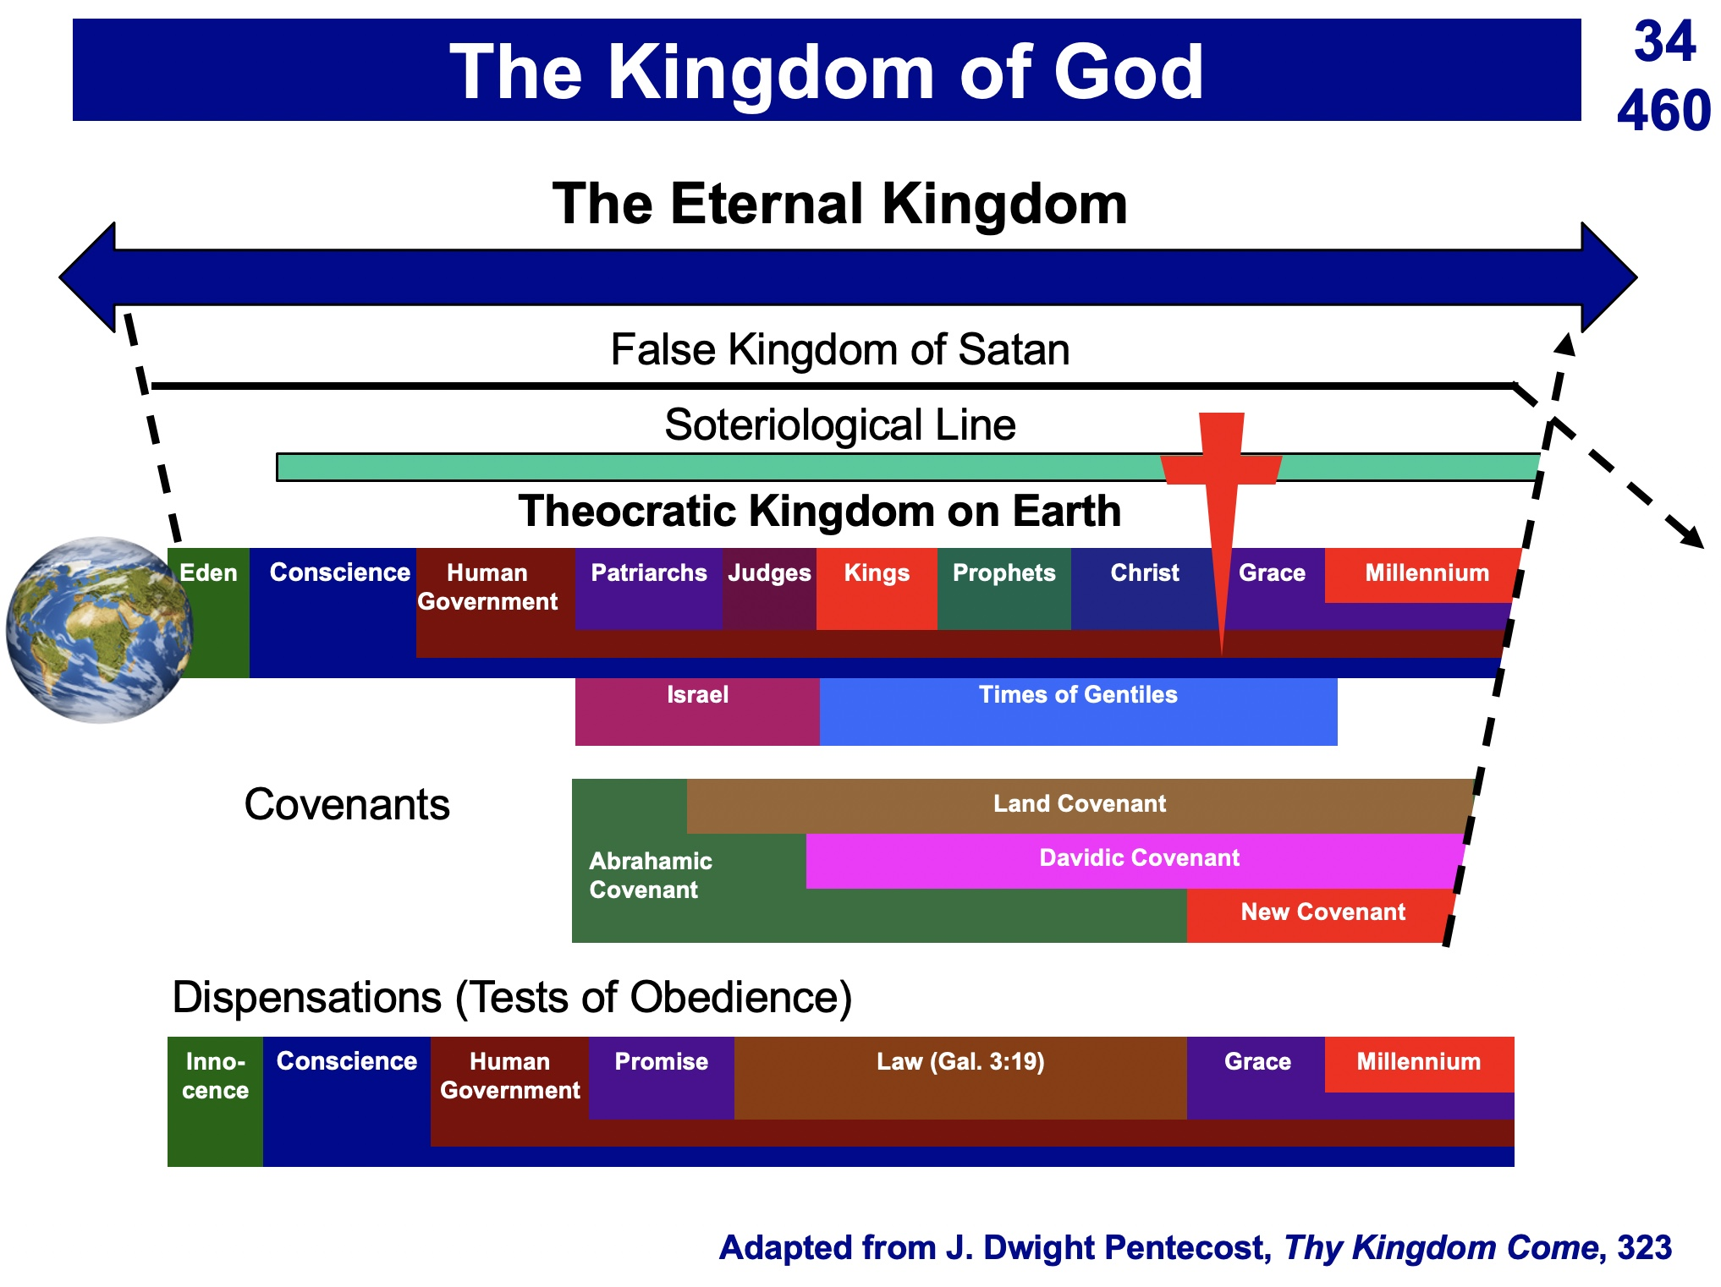

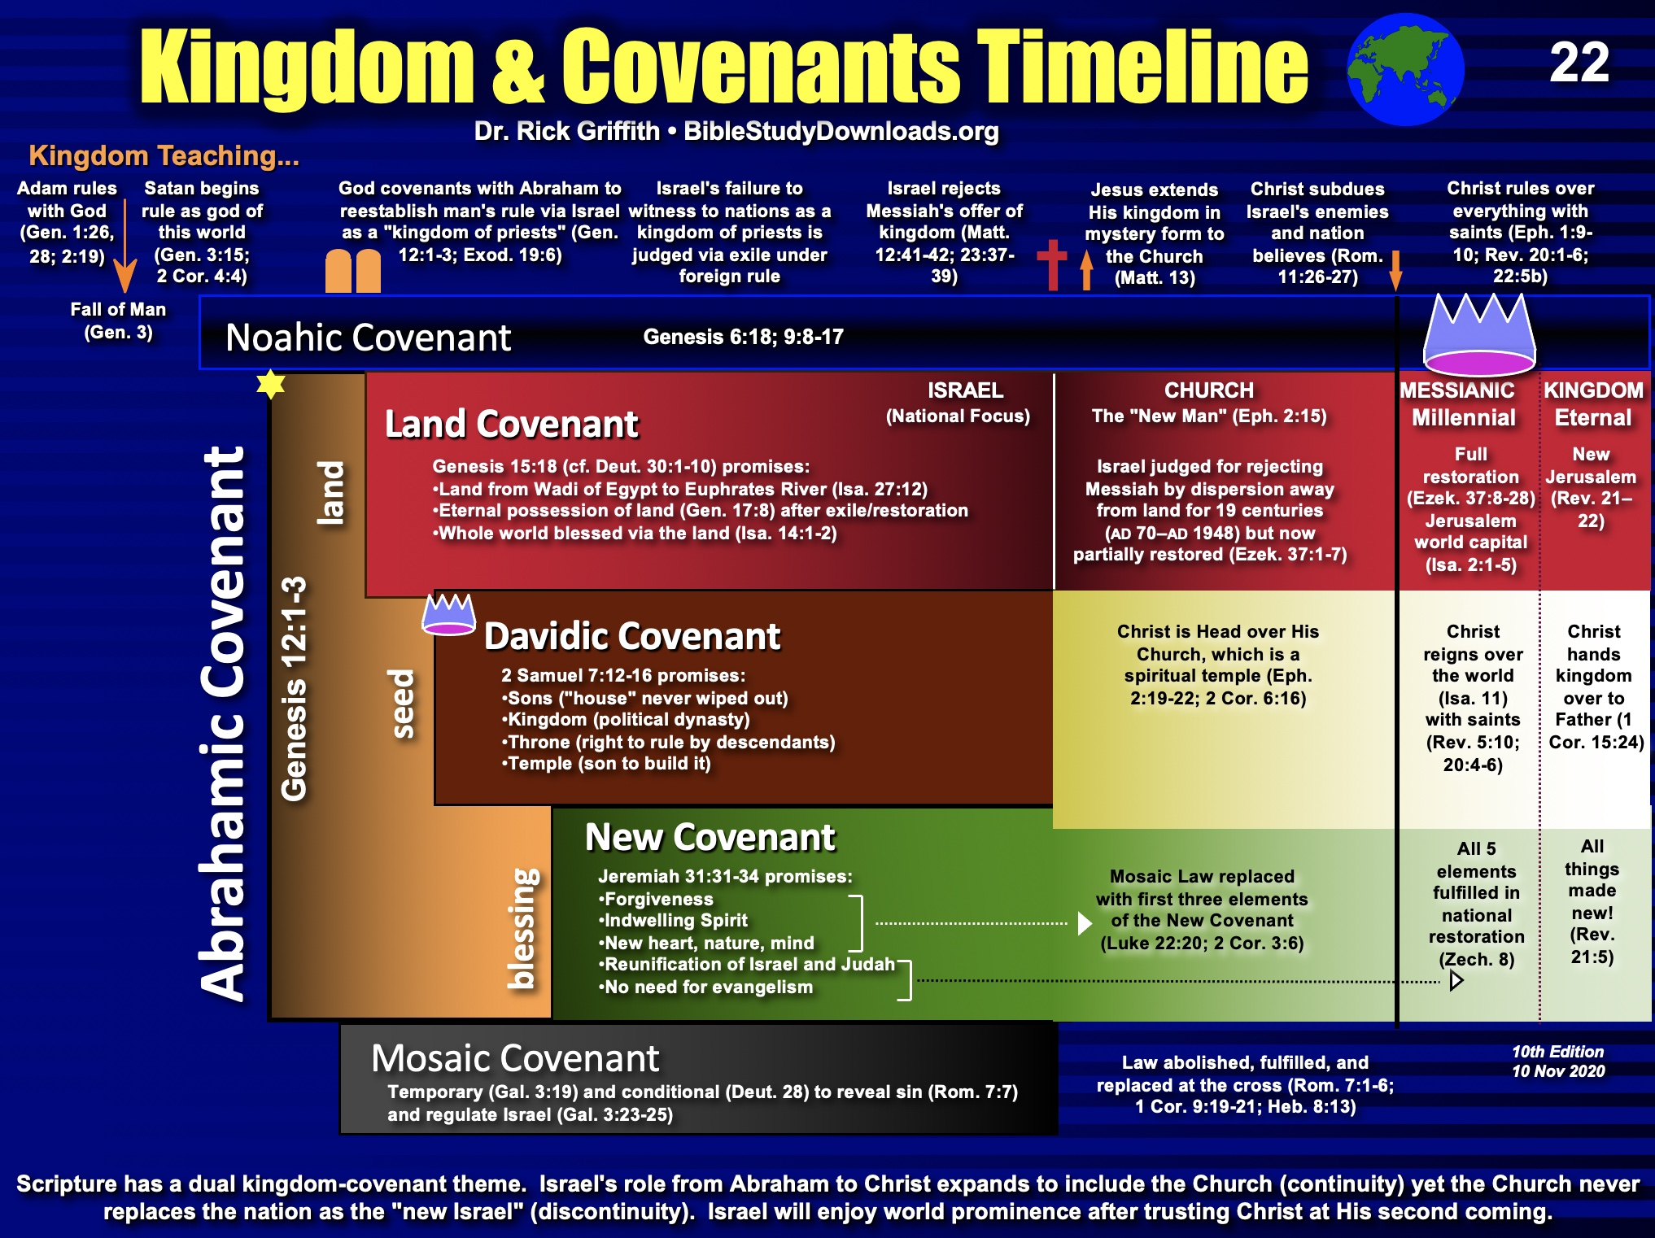

The Kingdom Diagrammed

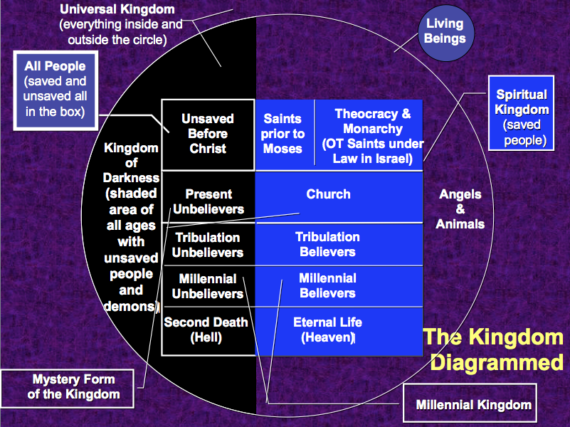

Aspect of the Kingdom | Description | Scripture
Universal Kingdom | All creation of every age | Ps. 145:13; 1 Chron. 29:12
Spiritual Kingdom | All saved of every age (white above) | Heb. 12:22-24; Col. 1:13b
Kingdom of Darkness | All unsaved of every age (dark above) | Col. 1:13a
Unsaved Before Christ | Unbelievers prior to Christ’s death | Gal. 3:21-22
Saints Before Moses | Those with faith in God (e.g., Noah) | Gen. 6:9; 15:6 (Abraham)
Theocratic Kingdom | God’s rule over Israel as mediators | Exod. 19:6
Mystery Form | Present saved & unsaved | Matt. 13:24-30, 47-50
Church | Saved between Pentecost & Rapture | Matt. 13:38
Present Unbelievers | Unbelievers in Church Age | 2 Cor. 2:15
Millennium | All people of the Millennium | Isa. 65:20
Tribulation Unbelievers | Unsaved of the Tribulation | Rev. 16:10
Tribulation Believers | Saved of the Tribulation | Rev. 20:4
Millennial Unbelievers | Unsaved of the Millennium | Rev. 20:7-10
Millennial Believers | Saved of the Millennium | Zech. 8:23
Second Death | Unbelievers in Hell | Rev. 20:14
Eternal Kingdom | Spiritual Kingdom in new creation | Dan. 2:44; Rev. 21–22

The Kingdom in Isaiah

Christians often talk about Jesus as king. It is especially discussed about Him being born king at Christmas. But this raises two important questions:

1. What kind of kingdom does Jesus bring as king? Many (esp. amillennialists) say that this is only a spiritual kingdom with no earthly or physical aspects, but others (esp. premillennialists) note many dimensions of the kingdom: spiritual, physical, political, etc.

2. What kind of kingdom did both John (Matt. 3:2) and Jesus (Matt. 4:17) mean when they preached, "Repent, for the kingdom of heaven is near"? Like the OT prophets, they said that Jews needed to turn from sin to enter the kingdom (Deut. 30:1-2). Had the nation repented, then this fulfillment would have occurred (Deut. 30:3-10). One should assume that this kingdom was the same kingdom that the OT prophets preached. Otherwise, Jesus and John would have misled the people.

Since Israel rejected this kingdom, Christ will not rule over it until the nation believes (see verses below in the “Spiritual” section). So after Israel finally believes in the future and Christ returns to establish his kingdom on earth (Rev. 19), what will this new period look like? Revelation 20:1-6 reveals the length of this era as 1000 years when saints will rule (cf. Rev. 5:10) and Satan will be bound from deceiving the nations (cf. Rev. 20:1-3). However, Isaiah gives the best total picture of what the kingdom will be like with more information than any other book in Scripture. This is the correct background one should know to understand Matthew’s concept of the kingdom.

I. Political

A. Jerusalem
1. Capital of the earth (2:2b)
2. A safe refuge for people (14:32; 25:4; 26:1-4; 32:18; 33:20-24; 35:9; 60:18; 62:8-9; 66:12)
3. City of glory without unbelievers (33:24b; 35:8-10; 52:1-3, 6)
4. Accessible (11:15-16; 33:21; 35:8; 60:15)

B. Israel’s Political Blessings
1. Enemies judged by Messiah (2:12-21; 24:21-23; 29:20-21; 45:14; 61:2; 66:24)
2. Exalted above the Gentiles (2:3; 14:1-2; 18:7; 49:22-23; 60:5, 14-17; 61:5-9; 62:1-4)
3. Serves as a nation of witnesses for God (44:8, 21)

C. Messiah’s Rule
1. His Second Advent precedes the kingdom (60:2; 61:11)
2. Extent of his rule
a. Rules on David’s throne as Davidic covenant fulfilled (4:2; 9:6-7; 16:5a)
b. Rules as King over the world (9:6-7; 11:3-5; 16:5; 24:21-23; 40:10)
c. Rules as King from Jerusalem (2:3; 24:23b; 33:17-22)
3. Nature of his rule
a. Rules gloriously (4:2; 24:23; 35:2; 40:5; 60:1, 2)
b. Rules wisely (11:2)
c. Rules meekly (42:3)
d. Rules righteously (32:1)
e. Rules nations with justice (9:7; 11:5; 16:5b; 32:1; 42:1, 4)
f. Rule unquestioned (11:4; 25:1-5; 29:17-21; 30:30-33; 42:13; 49:24-26; 66:14-19)
g. Rule in kingdom merges with eternal state (9:7; 33:20)

D. Other Rulers
1. Elders or rulers serve with Messiah in Jerusalem (24:23b; 32:1)
2. Judges serving as counselors (1:26)
3. Positions of responsibility given as rewards (40:10)

E. Worldwide peace rather than war (2:4; 9:4-7; 32:17-18; 55:12; 54:13; 60:18)

II. Physical

A. Earth and heavens renewed (65:17; 66:22)
1. Sun and moon
a. Light from both diminished in the Tribulation (13:10)
b. Sun still rises (41:25; 45:6; 59:19)
c. Moonshine equals the sun, which itself is seven times brighter (30:26)
d. Yet the sun and moon less intense and not harmful (24:23a; 49:10)
e. Both sun and moon finally eradicated in the eternal state (60:19-20)
2. Land of Israel
a. Borders enlarged (26:15; 33:17; 54:2-3; 61:7)
b. Land rebuilt after destruction (32:16-18; 49:8, 19; 61:4-5)
c. Much rainfall and water in the desert (30:23-25; 35:1-2, 6-7; 41:17-18; 49:10b)
d. Broad rivers flowing from the temple (33:20-21)
e. Animals blessed with much food (30:23)
f. Crops abundant (27:6; 35:1-2, 6-7) with the Genesis 3:17-19; Romans 8:19-22 curse on the earth removed (11:6-9; 35:9; 65:25)
g. Verdant trees replace thorn bushes and briers (55:13)
h. Mountain trees in previous desert wastelands (41:19)
i. Beautiful and prosperous from many nations‘ wealth (60:5; 61:6; 62:3; 66:10-12)
j. Glorified (60:1-9)
3. Jerusalem
a. Topographical changes with temple mount at city’s high point (2:2)
b. Cloud of smoke and pillar of fire protects Jerusalem (4:5-6)
c. Temple mount holy (11:9; 27:13; 56:7; 57:13; 65:25; 66:20)

B. Humans living in unique circumstances
1. Some Israelites living in glorified bodies after tribulation (26:19-20)
2. Babies still born to those in mortal bodies (44:3; 61:9; 65:20, 23)
3. Longevity of life where immaturity is rare but death is still existent (65:20)
4. Food for people plentiful (30:23; 62:8-9; 65:21-22)
5. Protection from harm with wild animals tamed (11:6-9; 35:9; 41:8-14; 65:25)
6. Work existent but always protective (62:8-9; 65:21-23)
7. Blind, deaf, lame, and mute all healed (29:17-19; 35:5-6)
8. Illness in Jerusalem eradicated (33:24; 65:23)
9. Death eventually destroyed in Jerusalem (25:7)

III. Emotional

A. Strength replaces fear (35:3-4; 41:10, 13-14)
B. Joy and gladness replace weeping, sorrow and sighing (9:1-4; 12:3, 6; 25:8-9; 30:29; 35:10; 42:10-11; 45:25; 52:8-9; 55:12; 60:15; 61:3, 7; 65:18-19; 66:10-11, 14)
C. Israel’s sentiment
1. The name “Israel” is replaced with the new names Hephzibah (Heb. “my delight is in her”) and Beulah (Heb. “married”; 62:2)
2. Israel no longer feels shame (25:8; 29:22)
3. Israel the praise of the earth (43:4; 62:7, 10) due to unique “marriage” to the LORD (54:1, 4-7; 62:5 NIV margin)
4. Israel singing (14:7; 30:29; 42:10-11; 52:9)

IV. Intellectual
A. Knowledge fills the earth based on the fear of the Lord (2:3; 11:9; 33:6)
B. Knowledge of God’s work seen in mountain trees flourishing in the desert (41:19)
C People taught by the Lord himself (49:10; 54:13)
D. Teachers succeed in providing direction (30:20-21)
E. People listen, understand, and articulate God’s values (32:3-4)

V. Spiritual

A. Satan bound (14:15)

B. Gentiles (Church)
1. Converted (16:5; 18:7; 49:6; 55:5; 60:3)
2. Disciplined for sin (19:19-22)

C. Jerusalem
1. Righteousness and holiness in the city (1:26-27; 4:3-4; 11:4-5; 35:8-9; 42:1-4; 52:1; 60:21; 61:3b) and desert (32:16)
2. Justice in the city (29:18-24; 65:21-23) and desert (32:16)

D. Israel’s spiritual restoration
1. Israel cleansed by God’s judgment before the kingdom (1:25; 4:2-4; 29:1-4; 30:26b; 31:6-7)
2. Israel reunited and regathered to the land (11:10-13, 15-16; 43:1, 5; 49:6; 61:4; 65:8-9)
3. Israel victorious over enemies (2:12-21; 11:14; 24:21-23; 41:11-14; 45:14; 61:2; 66:14b)
4. Israel free from oppression (14:3-6; 42:6-7; 49:8-9)
5. Israel believing in Messiah (10:20-22; 25:8-9; 26:1-2; 27:9, 12-13; 29:23; 40:9; 45:17, 25; 52:3, 6-7, 9-11; 54:7-10; 62:12)
6. Israel forgiven, redeemed and righteous (1:25-27; 2:3; 4:3-4; 33:24; 44:22-24; 45:25; 48:17; 63:16)
7. Israel blessed and rewarded by Christ (19:25; 40:10; 62:11; 61:8)
8. Israel comforted by Christ (12:1-2; 40:1-2, 11; 49:12; 51:3; 65:18-19; 66:11-13)
9. Israel filled/empowered by Holy Spirit as never before (32:15; 44:3; 59:21)
10. Israel’s covenants fulfilled (42:6; 49:8; 54:10; 61:8)
a. Abrahamic (19:25; 41:8-10)
b. Davidic (9:7; 11:1-2; 55:3)
c. Land (11:11-16; 65:9)
d. New (32:15; 44:3; 49:6; 59:21; 66:22)

E. Millennial worship
1. Israel worshipping the true God (12:1-6; 25:9–26:19; 56:7)
2. Jerusalem as the capital of nations’ (Gentile) worship (2:2-4; 11:12; 27:13; 30:29; 44:22-24)
3. The whole earth knows God–at least initially (11:9b)
4. Temple worship (56:5)
5. Priests and Levites serving the Lord (61:6; 66:21)
6. Animal sacrifices (56:7; 66:20-23)
7. Monthly New Moon celebrations (66:23)
8. Reinstitution of the Sabbath (56:4; 66:23)

F. Millennium absorbed into eternity
1. Kingdom age ends though salvation does not (51:6, 8)
2. Prosperity forever as a sign of God’s blessing (55:13)
3. Temple eunuchs blessed forever (56:5)
4. Both the sun and moon are finally eradicated in the eternal state (60:19-20)
5. Divine covenant continues on to be fulfilled in eternity (55:3; 61:8)

Concluding Applications

- Since we will rule the world, we better start showing discernment now (1 Cor. 6:1-3)
- Since this world must last 1000 more years (Rev. 20:1-6), we should take good care of it.
- Work for Christ now before the 1000-year Sabbath comes with its restful service (Heb. 4:9-11).

Contrasting Amil & Premil Views on the Prophets

The OT prophets wrote much on the kingdom. However, what they note is seen in very different ways from an amillennial versus a premillennial perspective (see also OTS, 442d-f, 461b-d, 473a).

 | Amillennial | Premillennial
Time of the Kingdom | Present church age  (after Christ’s first coming) | Future millennial age  (after Christ’s second coming)
Interpretive Approach | Symbolic rather than literal view of texts is allowed and even encouraged in prophetic genre | Normal, grammatical sense of language is used (figures of speech all have literal referents)
References to Israel | May mean Israel or the church, which is deemed the “new Israel” | “Israel” always means Israel (the ethnic seed of Jacob)
Location of Christ’s Reign | Either heaven or the new earth in eternal state (= Rev. 21:1) | A renewed earth (but not the new earth of Rev. 21:1)
Political Subjects of Christ’s Reign | The church in heaven and earth before the Second Coming, then on the new earth only after this | All people on earth from Jerusalem as the capital of the world (Isa. 2:3)
Spiritual Life | Some see Jews repenting in mass numbers | Israel & Gentiles repentant and cleansed (Ezek. 36)
Topographical Changes | Apocalyptic upheaval at the return of Christ seen in a symbolic sense (or not addressed at all) | Mt. Olives split (Zech. 14:4-5), temple at highest point (Isa. 2:2) with river flowing from it (Joel 3:18; Ezek. 47)
Geography | The church spreads the gospel throughout the earth | Tribes of Israel allotted new land boundaries with Gentiles among them in equal status (Ezek. 47–48)
Physical Life | The present age has life-spans generally under 100 years with death inevitable for all people | Most people live past 100 years (Isa. 65:20), babies still born (Isa. 44:3), death only for those in mortal bodies but many live in glorified bodies
Social Life  (Isa. 11:6-9) | Animals symbolize peace between believers and animals today or in the eternal state (OTS, 473a) | Peace between people and animals on a renewed earth (cf. Isa. 2:4)
Religious Life | A millennial temple and sacrifices viewed as contradicting Hebrews 9 and deemed obsolete | Millennial temple (Ezek. 40–43) with sacrifices memorial of Christ (Ezek. 44–46)
Intellectual Life | Knowledge of God heightened worldwide as the gospel advances | Worldwide knowledge of God where all people are believers at the start of the millennium (Jer. 31:34)
Emotional Life | Christ gives joy now to all believers | Jerusalem a city of joy (Isa. 9:1-4)

Millennial vs. Eternal State Covenant Fulfillment

In recent years premillennialists have moved closer to the amillennial camp by admitting greater continuity between the two testaments. In like manner, amillennial interpreters have shifted towards the premillennial position by agreeing to a more normal, grammatical hermeneutic. One example is their belief in a more literal fulfillment of the land promises to Abraham, including the dimensions from the southern boundary of the Wadi of Egypt to the northern boundary of the Euphrates River (cf. Gen. 15:18).

Both Isaiah and Ezekiel looked to the day when this land promise will be fulfilled:

- Isa. 27:12 “In that day the LORD will thresh from the flowing Euphrates to the Wadi of Egypt, and you, O Israelites, will be gathered up one by one.”

- Ezek. 47:19 “On the south side it will run from Tamar as far as the waters of Meribah Kadesh, then along the Wadi of Egypt to the Great Sea. This will be the south boundary.”

- Ezek. 48:28 “The southern boundary of Gad will run south from Tamar to the waters of Meribah Kadesh, then along the Wadi of Egypt to the Great Sea.”

The key question here, though, is when will this reach its literal fulfillment? Amillennialists do not believe in a future 1000-year rule of Christ on this earth prior to the eternal state, so they typically argue for fulfillment in the new heaven and new earth in the eternal state (cf. Rev. 21).

Premillennialists, however, have long held that this land promise (and also all of the promises of the Abrahamic Covenant) will occur in the millennial rule of Christ on the present earth. In my opinion, this view is more plausible for the following reasons:

1. Ezekiel’s temple of this period (Ezek. 40–43) receives a great deal of attention in the context in which Ezekiel’s two prophecies above occur (Ezek. 40–48). Since there will be no temple in the eternal state (Rev. 21:22), it is impossible for Ezekiel’s fulfillment to occur in the eternal state.

2. Time will still exist at this time since following the return of Christ the nations will go up to Jerusalem year after year (Zech 14:3-4, 16). In contrast, the eternal state knows no time as the sun and the moon will no longer exist (Rev. 21:23).

- Death will still exist in the time of which Isaiah speaks since he notes that people will live longer yet still die (Isa. 65:20); however, there will be no more death in eternity (Rev. 21:4).

- Israel will be prominent among the nations during Isaiah’s prophetic age (Isa. 2:1-3) whereas in the eternal age, all the nations are noted as bringing their wealth into the New Jerusalem, which makes no mention of Israel (Rev. 21–22).

Isaiah’s Center
John A. Martin, Dallas Theological Seminary (1 of 3)

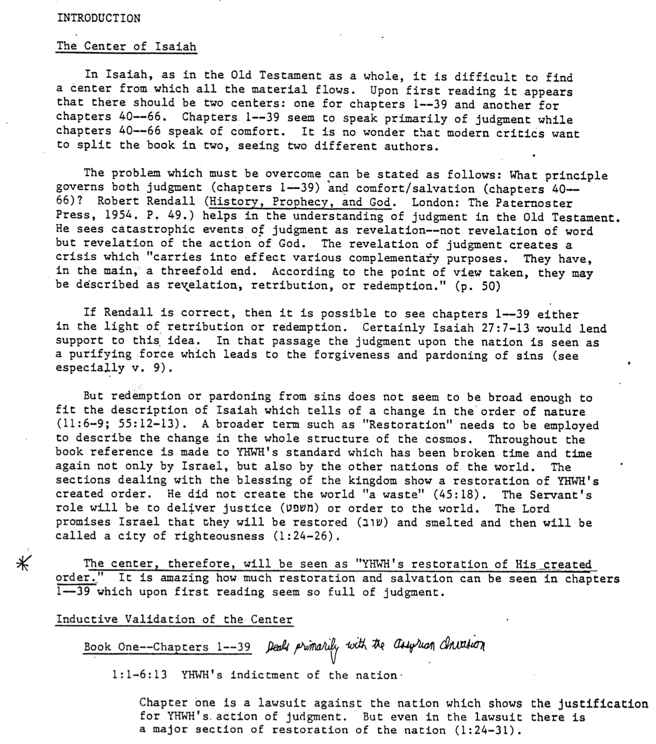

Isaiah’s Center
John A. Martin, Dallas Theological Seminary (2 of 3)

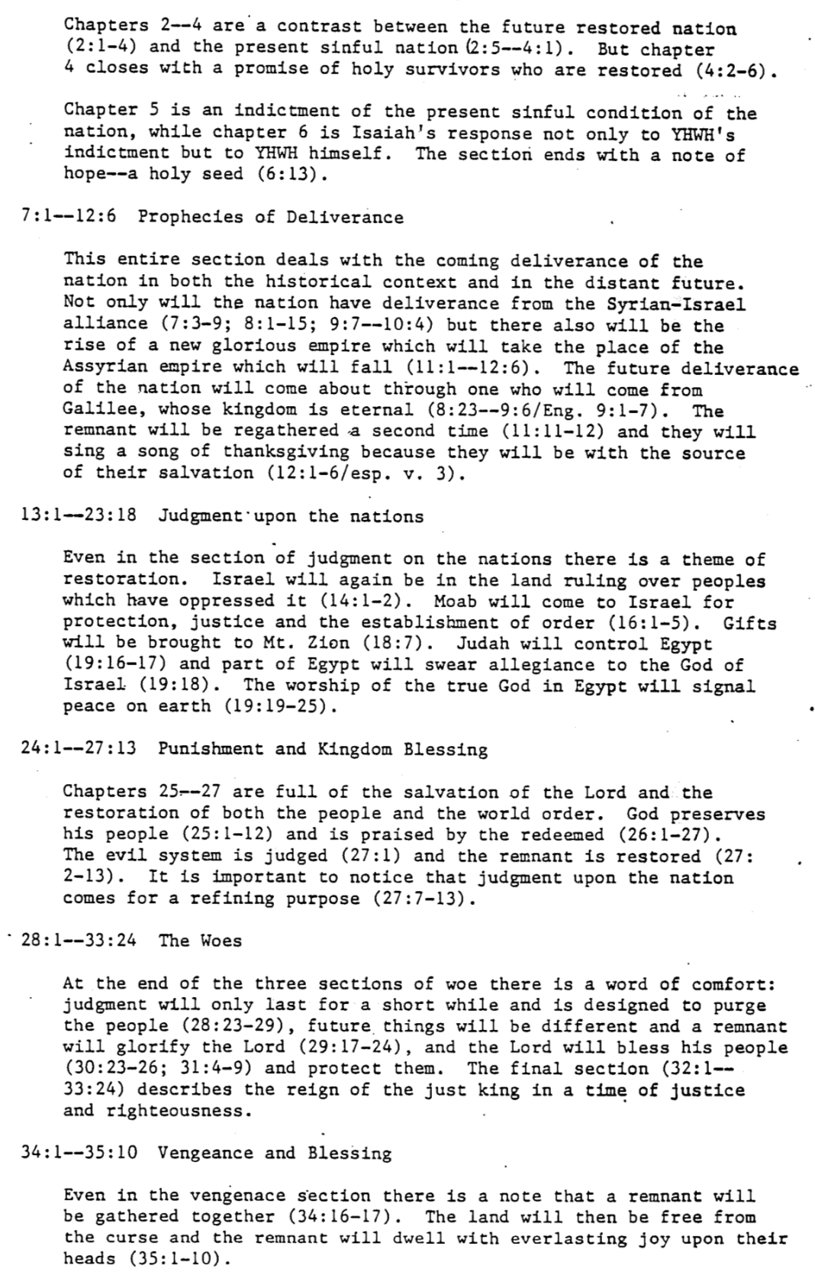

Isaiah’s Center
John A. Martin, Dallas Theological Seminary (3 of 3)

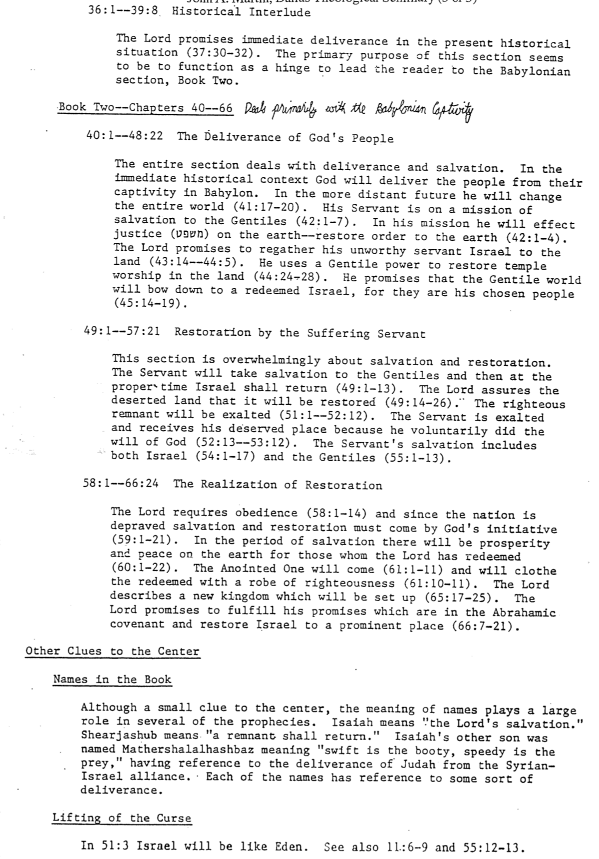

Messianic Prophecies in Isaiah

John A. Martin, “Isaiah,” in The Bible Knowledge Commentary: An Exposition of the Scriptures,
ed. John F. Walvoord and Roy B. Zuck (Wheaton, IL: Victor Books, 1985), 1:1049.

He will be called before His birth to be God’s Servant (49:1). | 1.
He will be born of a virgin (7:14). | 2.
He will be a Descendant of Jesse and thus in the Davidic line (11:1, 10). | 3.
He will be empowered by the Holy Spirit (11:2; 42:1). | 4.
He will be gentle toward the weak (42:3). | 5.
He will be obedient to the Lord in His mission (50:4-9). | 6.
He will voluntarily submit to suffering (50:6; 53:7-8). | 7.
He will be rejected by Israel (49:7; 53:1, 3). | 8.
He will take on Himself the sins of the world (53:4-6, 10-12). | 9.
He will triumph over death (53:10). | 10.
He will be exalted (52:13; 53:12). | 11.
He will come to comfort Israel and to bring vengeance on the wicked (61:1-3). | 12.
He will manifest God’s glory (49:3). | 13.
He will restore Israel spiritually to God (49:5) and physically to the land (49:8). | 14.
He will reign on David’s throne (9:7). | 15.
He will bring joy to Israel (9:2). | 16.
He will make a New Covenant with Israel (42:6; 49:8-9). | 17.
He will be a light to the Gentiles (42:6; 49:6). | 18.
He will restore the nations (11:10). | 19.
He will be worshipped by Gentiles (49:7; 52:15). | 20.
He will govern the world (9:6). | 21.
He will judge in righteousness, justice, and faithfulness (11:3-5; 42:1, 4). | 22.

Chart of Isaiah

Irving L. Jensen, Jensen’s Survey of the Old Testament, 334

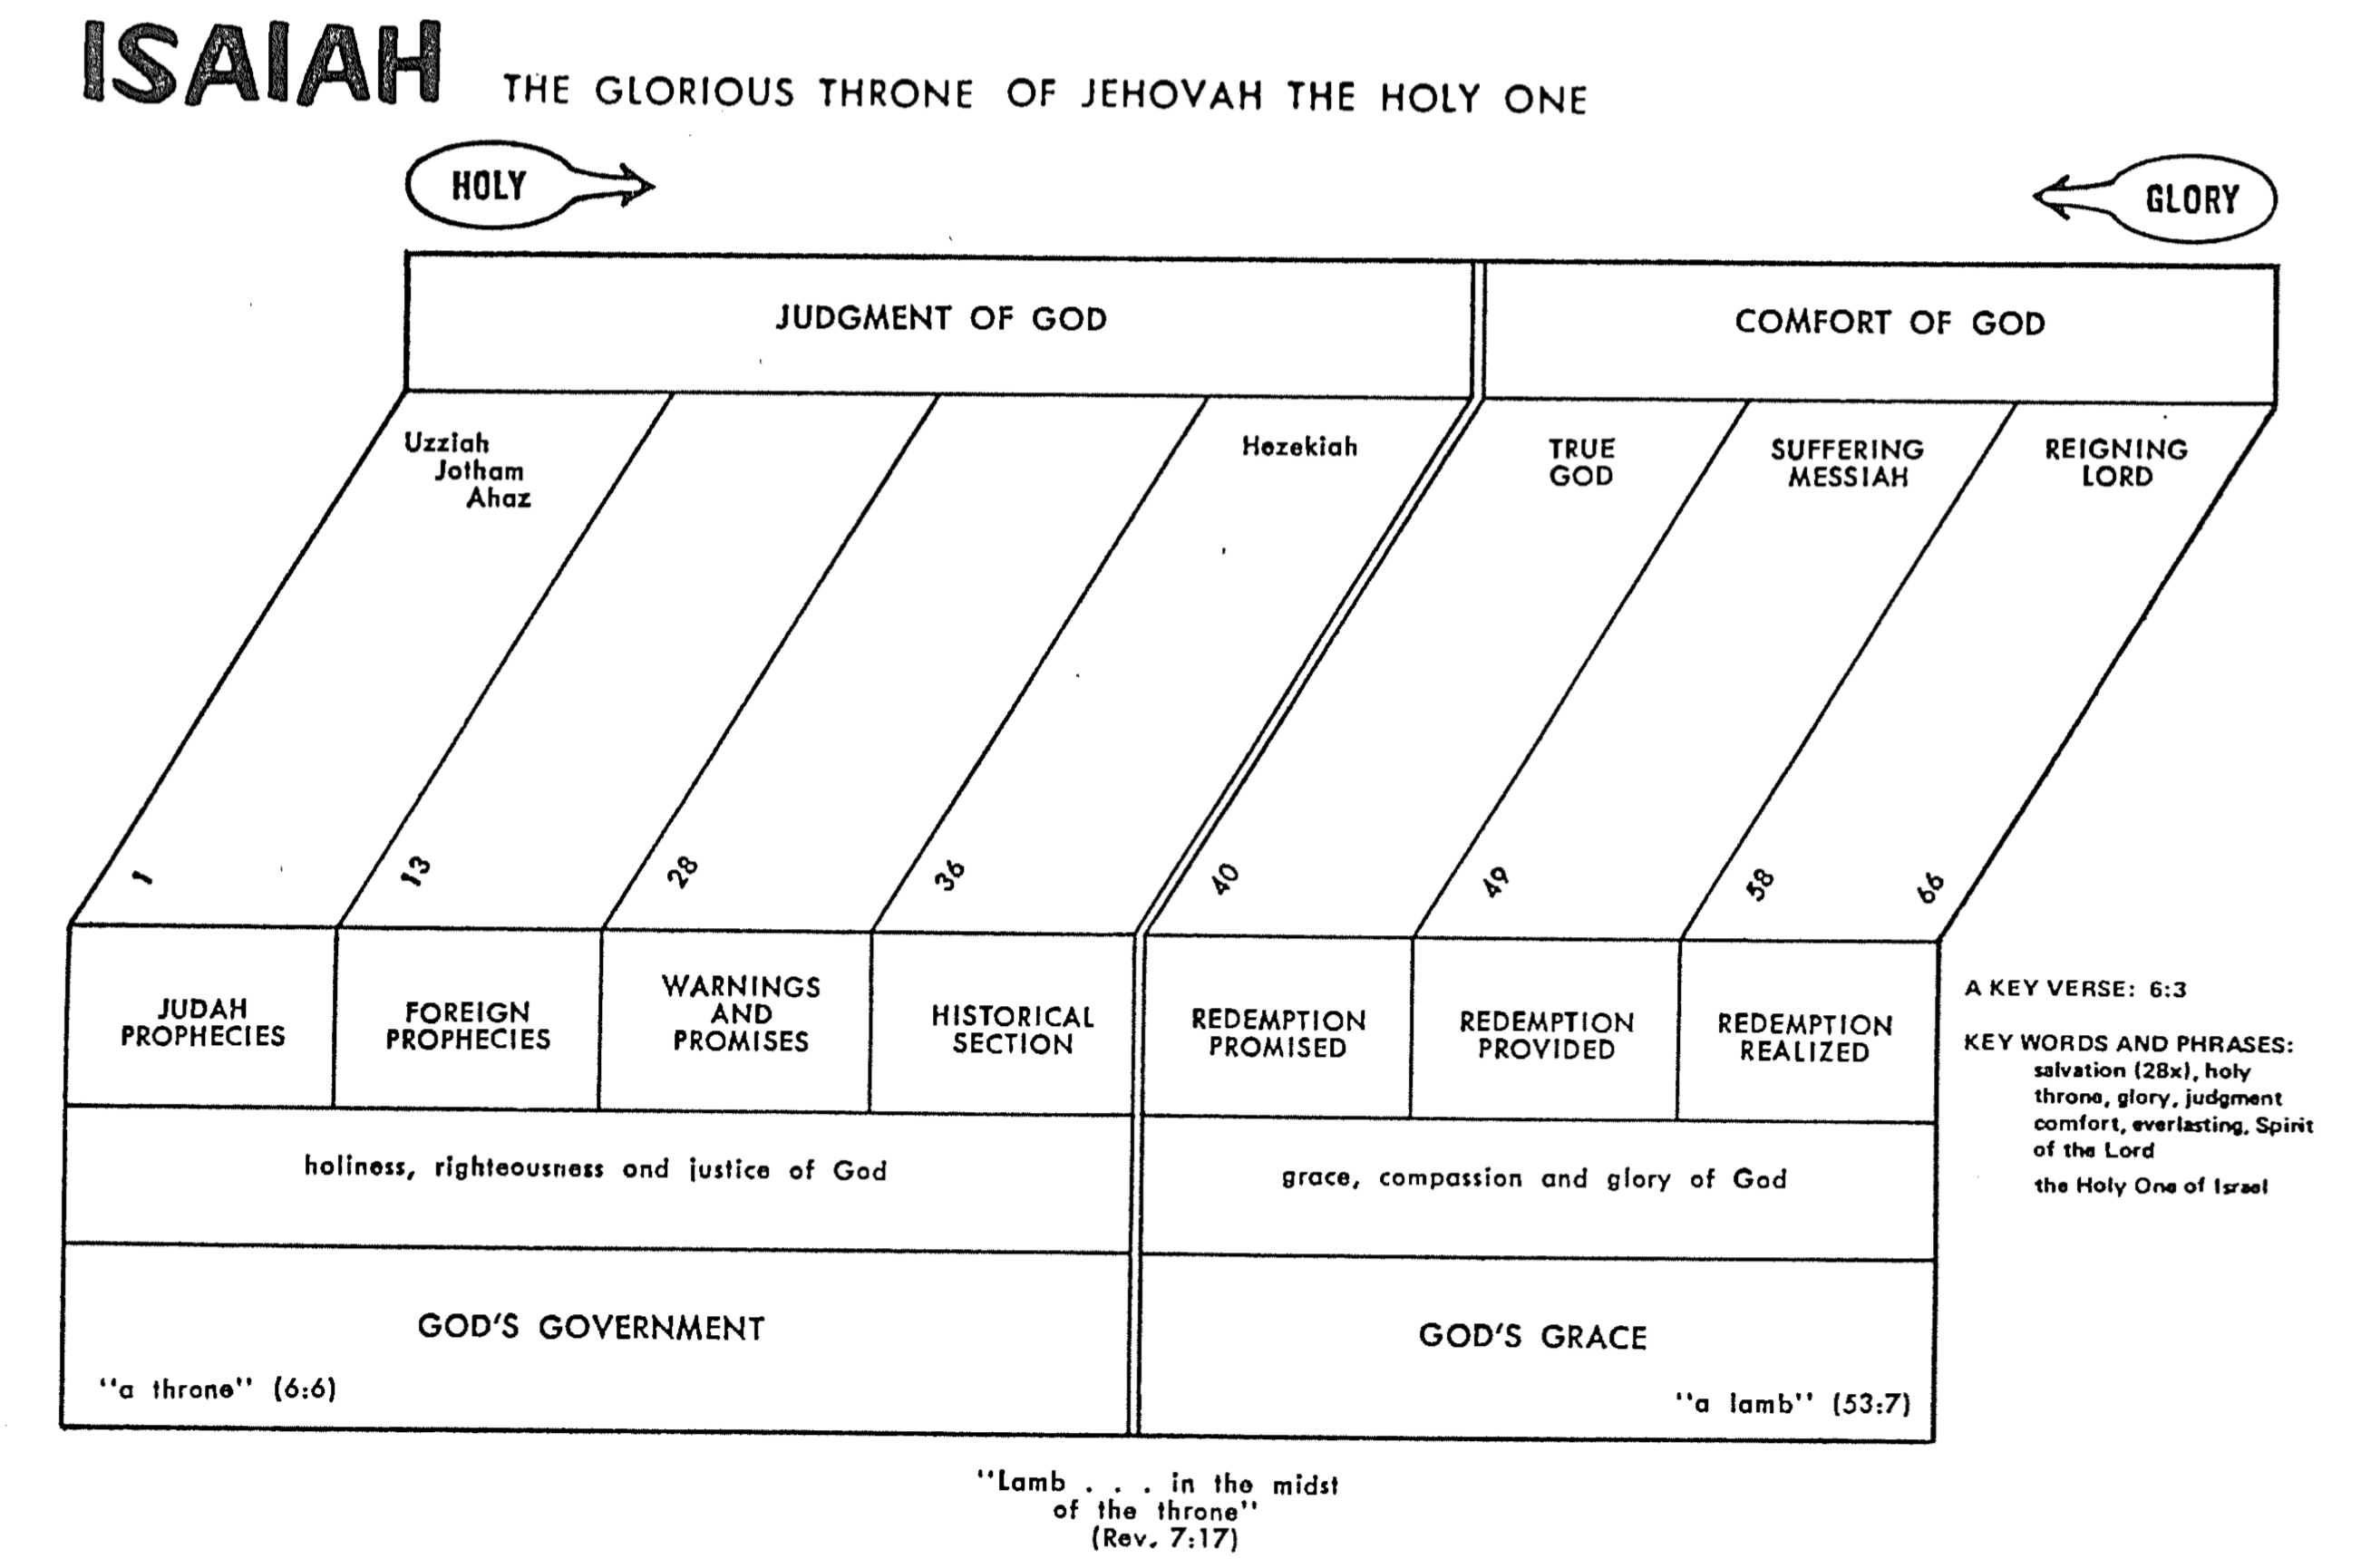

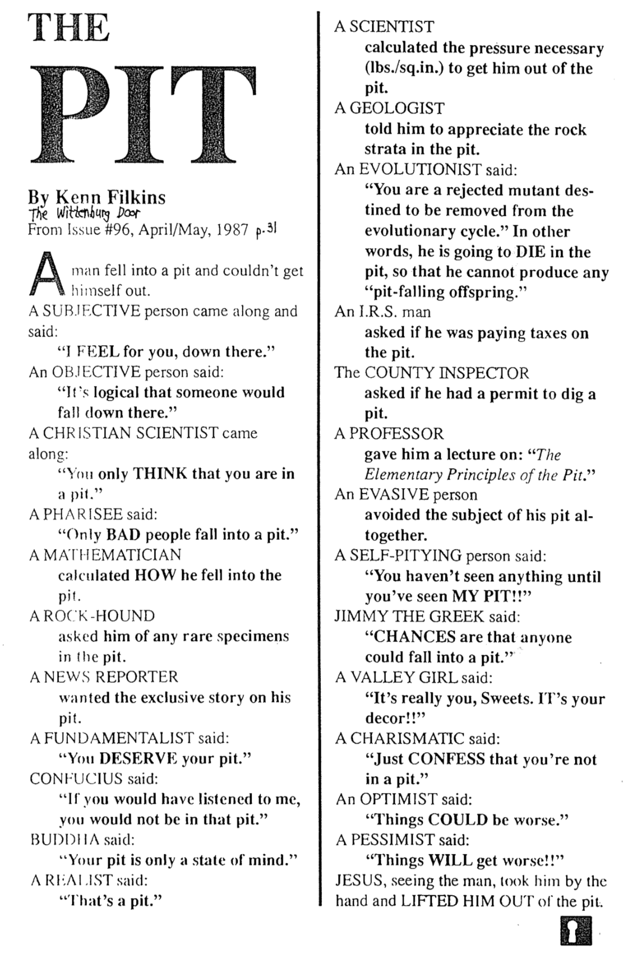
The Pit

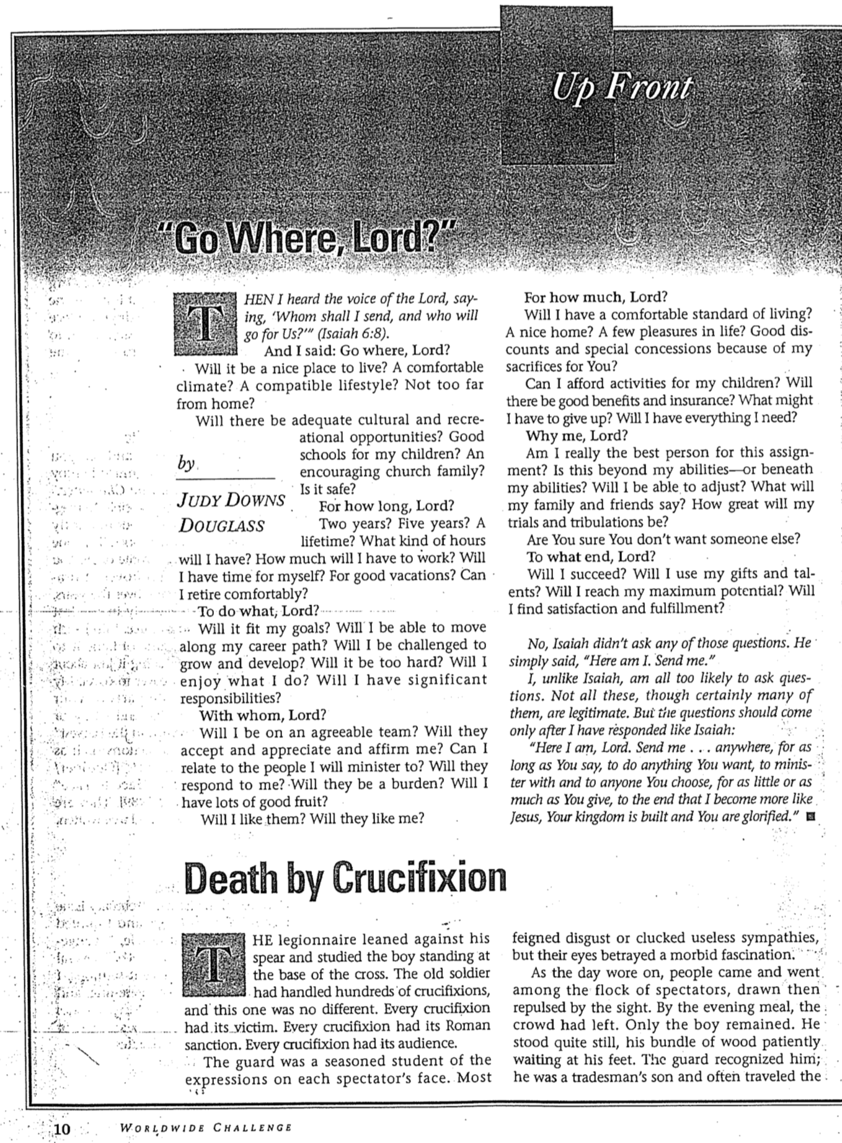
Go Where, Lord?

Idol Wordplays in Isaiah
Robert B. Chisholm, Jr., Dallas Theological Seminary

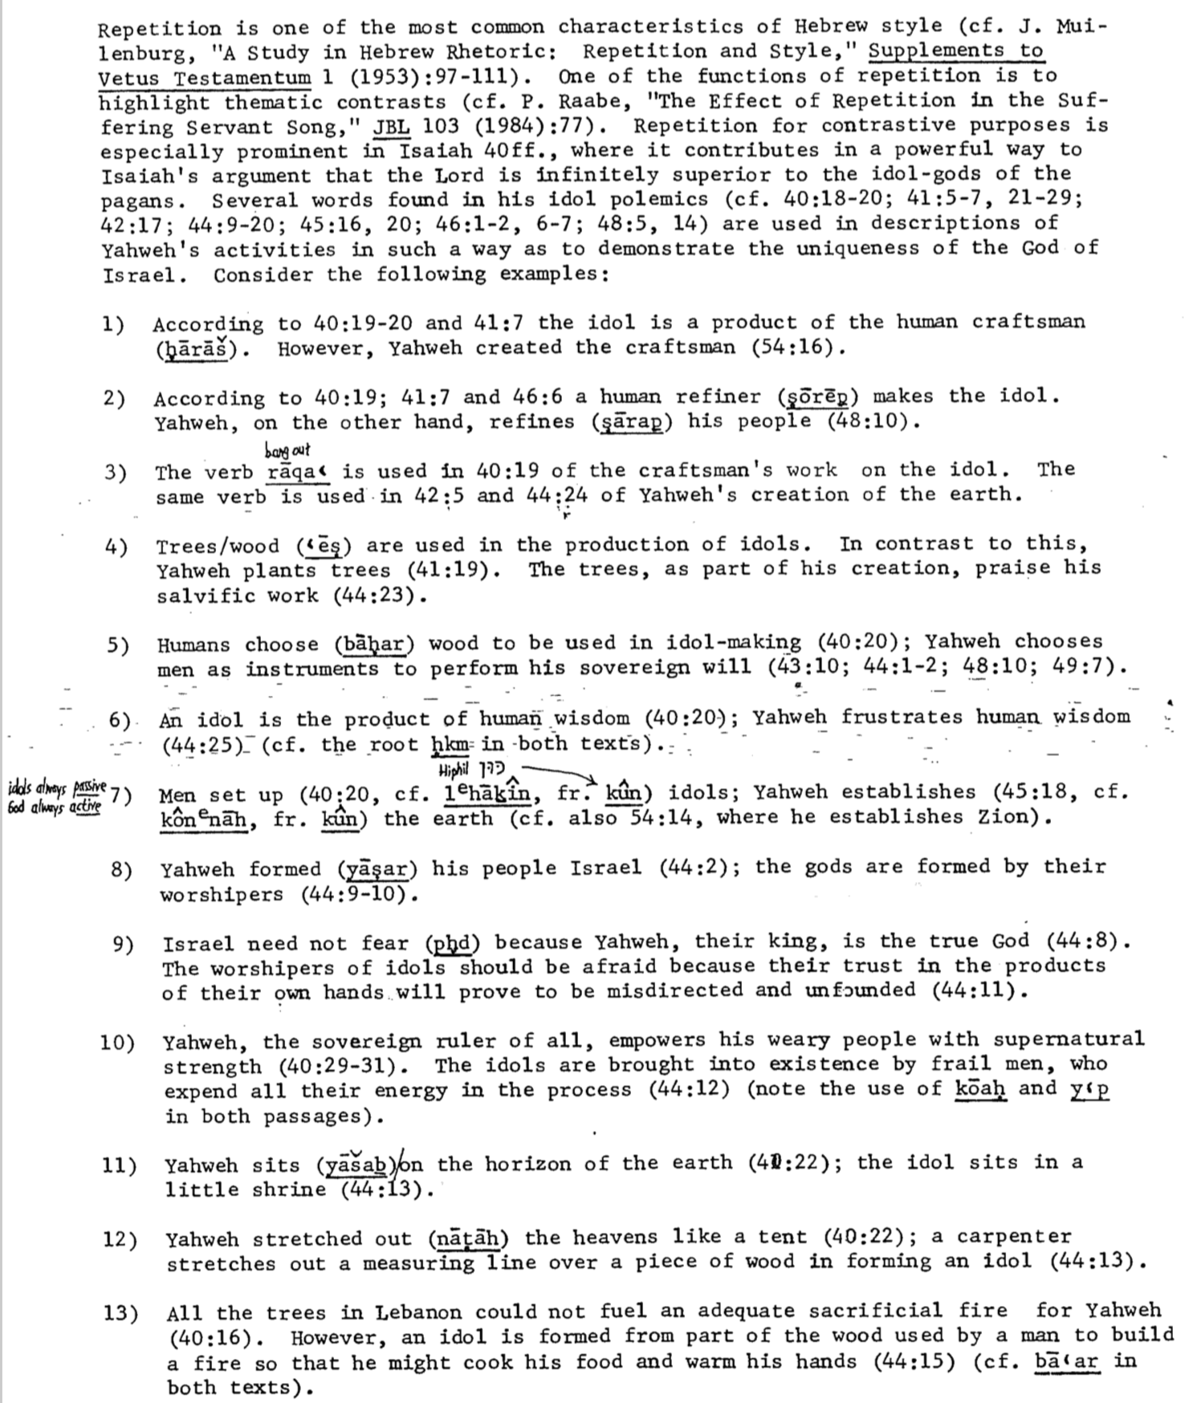

Recurring Strands in Isaiah 40–48

Homer Heater, Jr., Dallas Theological Seminary

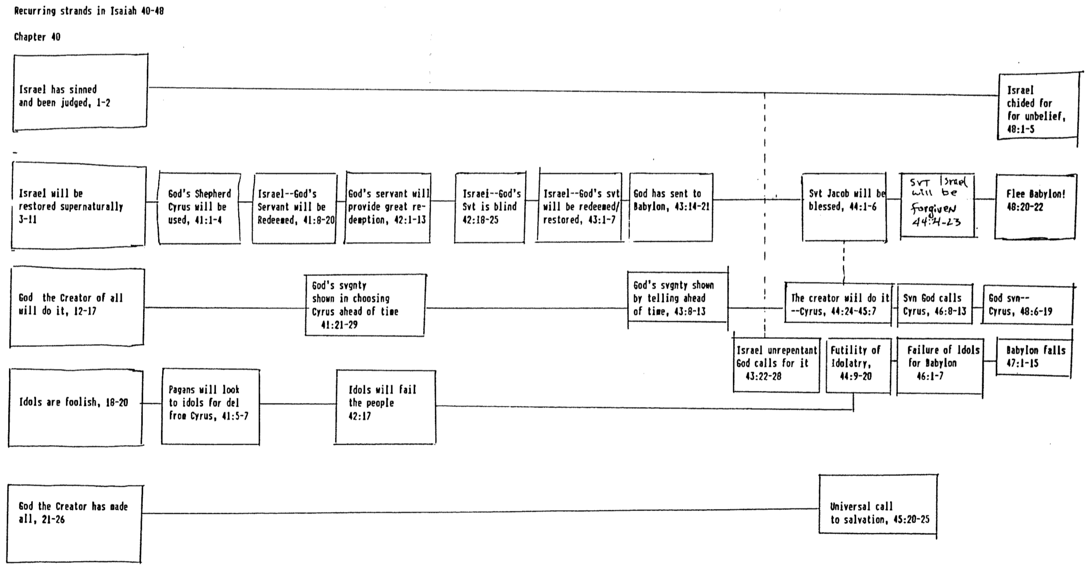
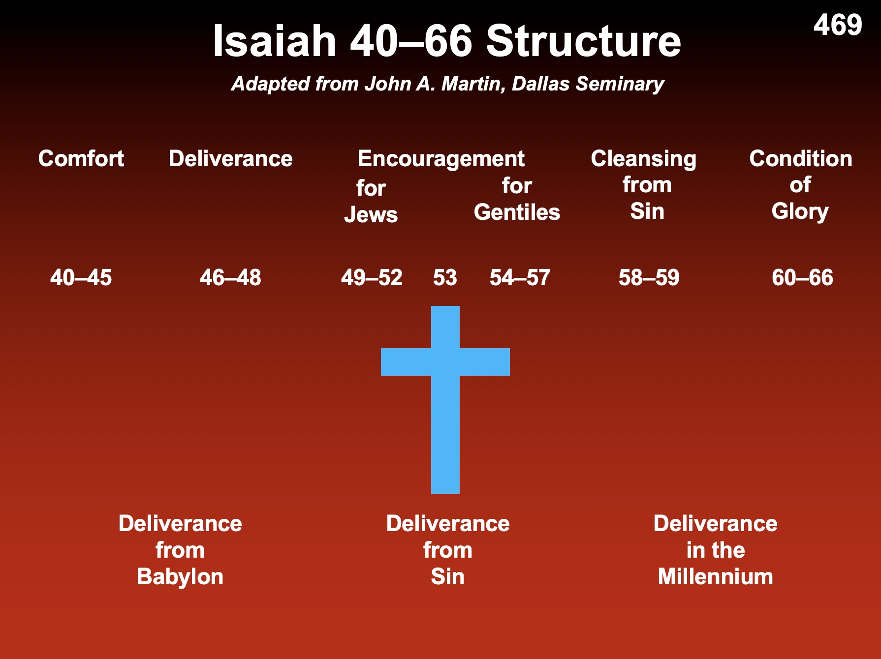
Isaiah 40–66 Structure

John A. Martin, Dallas Theological Seminary

Comfort Deliverance Encouragement Cleansing Condition
for for from of
Jews Gentiles Sin Glory

40–45 46–48 49–52 53 54–57 58–59 60–66

Deliverance Deliverance Deliverance
from from in the
Babylon Sin Millennium

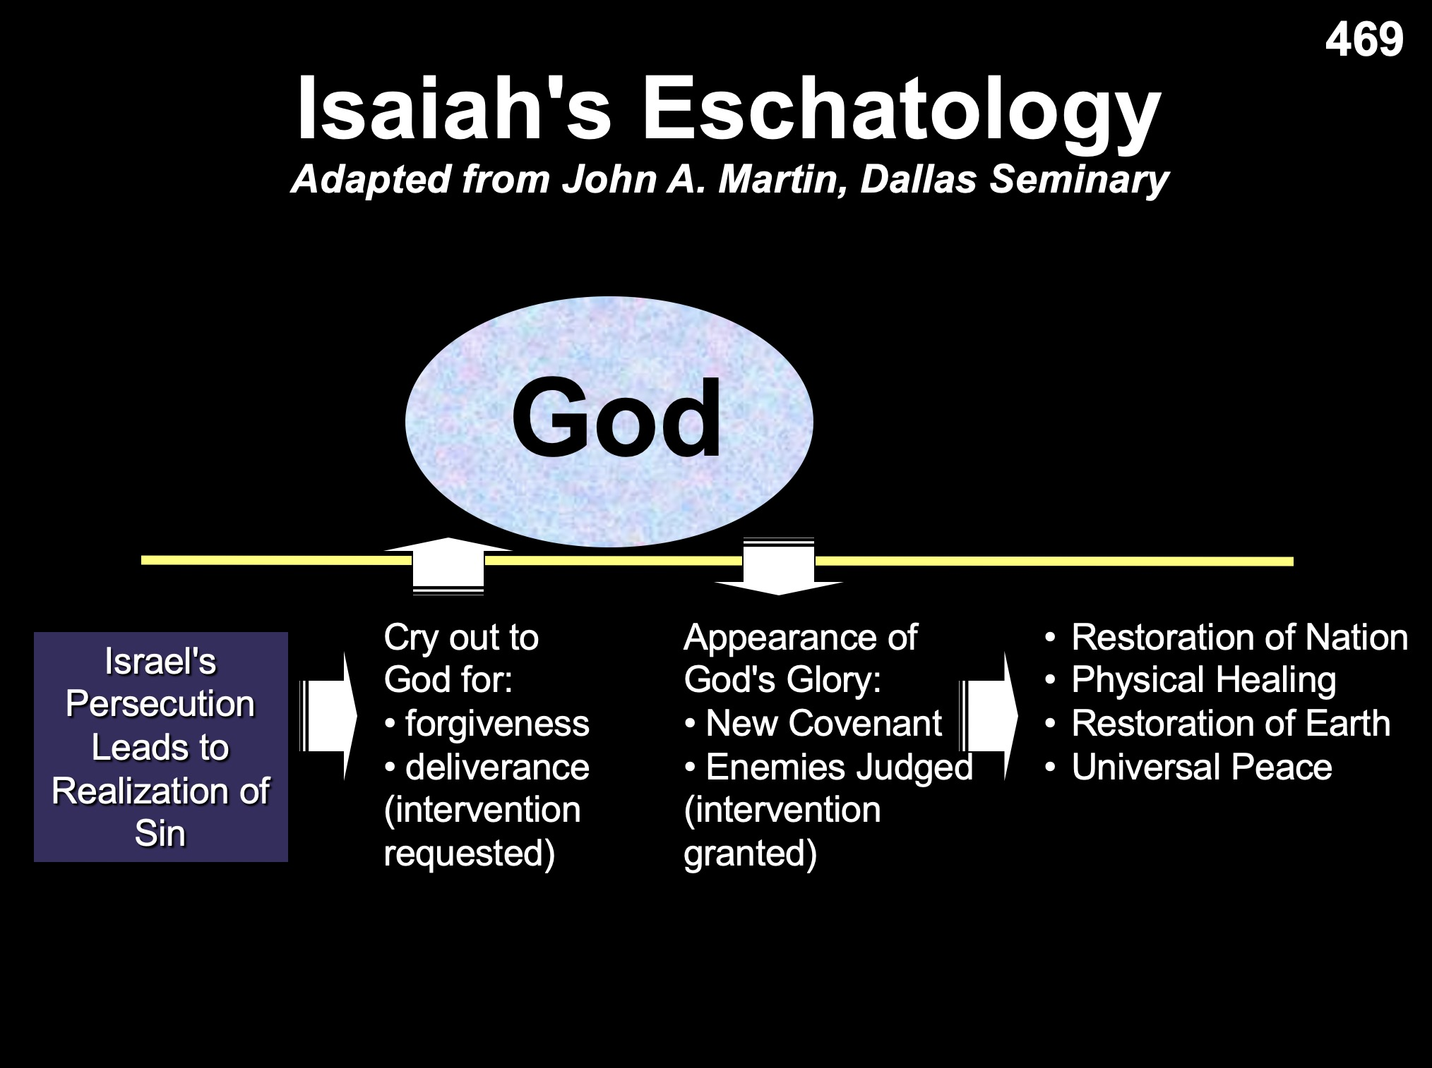

Adapted from John A. Martin, Dallas Theological Seminary

The Branch

Adapted from Huang Sabin, Singapore Bible College
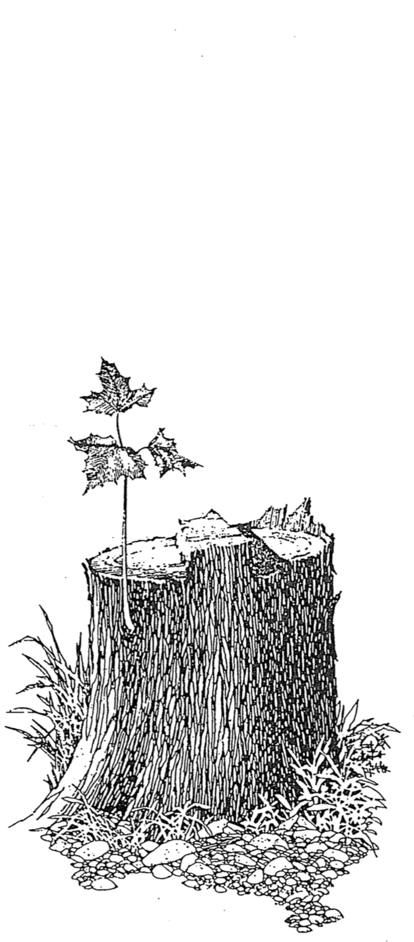
Isa 11:1-5
Stem of Jesse

Isa 4:2
Beautiful

Jer 23:5
Righteous King

Jer 33:15
Just & Righteous

Ezek 17:22-24
New Kingdom

Zech 3:8
God’s Servant

Zech 6:12-13
Priest & King

Isaiah’s versus John’s New Heaven(s) and New Earth

 | Isaiah’s New Heavens  and New Earth  (Isa. 65:17; 66:22) | John’s New Heaven  and New Earth  (Rev. 21:1)
Term Used | Plural: “new heavens” | Singular: “new heaven”
Time Period | Millennium | Eternal State
Life span of Inhabitants | Greatly extended yet not infinite life (65:20) | Eternal Life
Death | Possible, though dying at 100 years old is “young” (65:20; cf. 66:24)! | No death (Rev. 21:4) since death is abolished at the Great White Throne Judgment (Rev. 20:14)
Marriage & Childbirth | Possible (65:23) | Impossible (Matt. 22:30)
Activity | Building of houses and planting of vineyards (65:21) | Christ claimed that he himself would prepare a place for us (John 14:1f.).
Animal Activity | Peaceful cohabitation of wild animals (65:25a) | No animals are noted by John or in any other text on heaven
Associated City | Protection of God in Jerusalem (65:25b) | Focus is the new Jerusalem (Rev. 20–21)
Gathering of Nations | Brought to Jerusalem to see God’s glory (66:18-20; cf. Zech. 14:16-19) | God’s glory provides light for the nations (21:23-24)
Priesthood & Temple | Has a temple, priests, and Levites (66:20-21; cf. Ezek. 40–43) | Has no temple (21:22), so by implication no priests are needed
Celebrations | New Moon and the Sabbath (56:6-7a; 66:23) | No need for these since there will be no need for rest in eternity
Time | Still existent | Abolished (no night, Rev. 22:5), so a weekly rest day is absurd.
Place of Worship | Jerusalem (65:23) | Throne of God (22:3-4)

Differences Between the Millennium and Heaven

 | Millennium | Heaven
Duration | 1000 years (Rev. 20:1-6) | Eternal (Rev. 22:5)
Death | Possible (Isa. 65:20) | Impossible (Rev. 21:4)
Longevity  of Life | “Never again will there be an infant who lives a few days. He who dies at a hundred will be thought a mere youth” (Isa. 65:20) | No aging (Rev. 21:4 implied)
Sin Nature | Active (Rev. 20:7-9) | Abolished (Rev. 21:27)
Inhabitants | Initially Christian, but later includes unbelievers –no living with angels? (Matt. 25:34; Rev. 20:7-9) | Saints and angels alone (Rev. 21:27)
Bodies | Mortal and immortal living together (Isa. 65:20; 1 Cor. 15:42-44) | Only immortal (glorified)  (1 Cor. 15:42-44)
Satan | Bound, but then released after 1000 years (Rev. 20:3, 7) | In lake of burning sulfur, never to be released again (Rev. 20:10)
Political &  Religious Capital | Jerusalem (Isa. 2:2-3; Micah 4:1-2, 7) | New Jerusalem (Rev. 21)
Place | Earth (Rev. 5:10) | New heavens and new earth (Rev. 21:1)
Key  Passages | Psalm 72; Isaiah 2; 11; 65–66; Revelation 20:1-6 | Revelation 21–22

Views on the Millennium
Second Coming
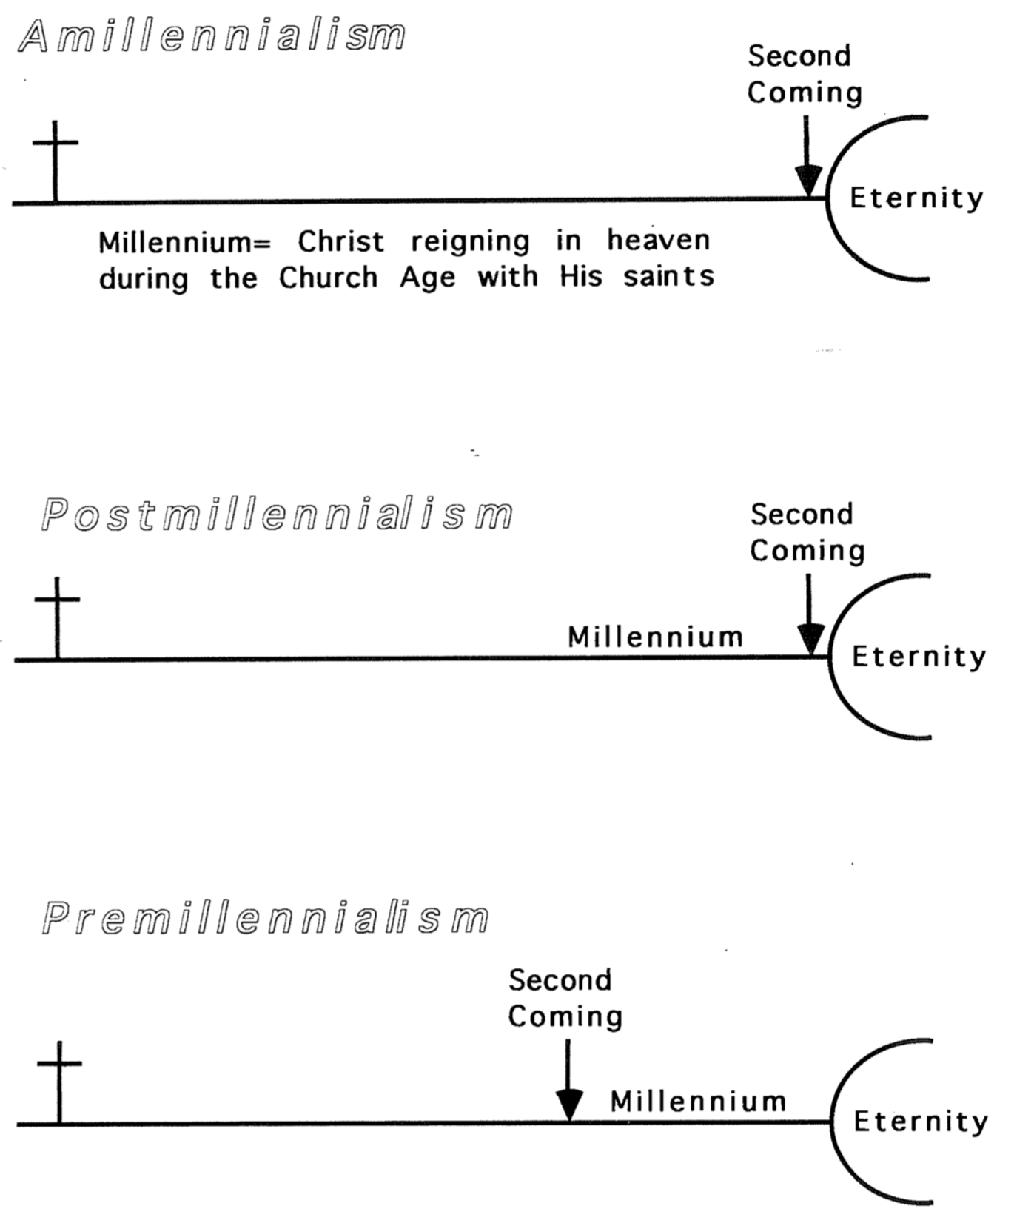
Premillennialism
Postmillennialism
Amillennialism
Eternity
Eternity
Eternity
Millennium = Christ reigning with the saints in heaven during the Church Age
Millennium
Millennium
Second Coming
Second Coming
Millennium

Views on Isaiah 11

The wolf will live with the lamb, the leopard will lie down with the goat, the calf and the lion and the yearling together; and a little child will lead them. The cow will feed with the bear, their young will lie down together, and the lion will eat straw like the ox. The infant will play near the hole of the cobra, and the young child put his hand into the viper’s nest. They will neither harm nor destroy on all my holy mountain, for the earth will be full of the knowledge of the LORD as the waters cover the sea.
Isaiah 11:6-9

This describes neither the present nor the eternal state. However, this age perfectly fits the age of Messiah’s rule detailed in the following texts (cf. see also Wayne Grudem, Systematic Theology, 1127-1131):

a. Isaiah 11:6-9 notes a time when ferocious animals are tame towards one another (e.g., “wolf will live with the lamb”) and with children (e.g., “child put his hand into the viper’s nest”). Should we take this literally? When is this? Views abound…

1) Symbolic: Some say this portrays peace between believers (John Calvin, Isaiah, 1:101). But this ignores the plain reading of the text. If the animals are believers, then who are the children? And which church has complete peace?

2) Literal: Most admit that the text does refer to the animal kingdom.

a) Present: Some amillennialists say it’s possible today. “When righteousness, faithfulness and the knowledge of Yahweh control the palace, such a scene is possible” (John D. W. Watts, Isaiah 1–33, WBC, 175). But how do even godly kings tame animals today? And where has this ever happened?

b) Never to be Fulfilled: Modern rationalists claim that this is a beautiful dream wish (cited by Delitzsch, Isaiah, 7:285). Yet this view is of little help either to Isaiah or us–and the text says that it will be fulfilled in association with Messiah’s rule (note the repeated “will…”).

c) Future: Most agree that this scene has not happened yet. But when?

1] Eternal State: Many see this fulfilled in the new heavens and new earth (e.g., Leupold, Exposition of Isaiah, 1:222; Otto Kaiser, Isaiah 1–12, OTL, 161). However, the new earth will have no death (Rev. 21:4) but Isaiah 11:10-16 says “in that day” Israel will be restored to her promised boundaries by plundering the surrounding nations. “The LORD will reach out his hand a second time to reclaim the remnant… of his people from Assyria, from Lower Egypt,” etc. (v. 11). While some say the first time was at the Exodus (NIV Study Bible, 1027), this restored the entire nation (not just a remnant). The first time He restored a remnant was in 538 BC but this will happen again at Christ’s return to restore descendants of those dispersed in AD 70.

2] Millennial State: I agree with those who see Isaiah depicting an earthly yet future scene (e.g., Delitzsch, 7:285; Ronald Clements, Isaiah 1–39, NCBC, 122; W. E. Vine, Isaiah, 49-50). After all, “the earth will be full of the knowledge of the Lord” and peace will be “on all my holy mountain” (v. 9), which is Jerusalem.

b. Isaiah 65:20 notes that those who die at 100 will be considered young. Leupold (3:366) claims this will happen in the new heavens and new earth, but death will be done away with at this time (Rev. 21:4).

c. Psalm 72 has more depictions of life under the millennial state than any psalm.

d. Zechariah 14:5-17 says that after Messiah’s return, nations will go up to Jerusalem for worship year after year. This cannot fit into an amillennial scheme where believers would be: (1) in heaven immediately following Christ’s return, or (2) on a renewed earth without the sun, night, or time (Rev. 21:22-25).

Covenant Contrasts

There are only four key eschatological covenants in Scripture. They share these traits in common:
1. Unconditional
2. Eternal
3. Partially & spiritually fulfilled at present
4. Fully & literally fulfilled in the future
5. Universal in scope

Yet they can be contrasted in many ways as well (see also pages 21-22, 55a, 59-61, 116):

 | Abrahamic | Land | Davidic | New
Definition:  God’s promise to give Israel… | land, rule, and blessing to benefit the world | physical land from the Wadi of Egypt to the Euphrates River (Gen. 15:18) | political rule  of a descendant of David forever from Zion | spiritual blessings of national cleansing and restoration
Relationship | Umbrella | Land | Seed | Blessing
Key Text | Gen. 12:1-3 | Deut. 30:1-10 | 2 Sam. 7:12-16 | Jer. 31:31-34
Recipient  Date  Place | Abraham  2060 BC  Ur of Chaldees | Moses  1445 BC  Mt. Sinai | David  1004 BC  Jerusalem | Jeremiah  595 BC  Jerusalem
Personal Blessings  to First  Recipient | Possessions & name blessed, son, enemies disciplined | Privilege of seeing Canaan from afar | Sons (“house”) never wiped out (Matt. 1:1-17) | –
National  Blessings | A great nation would come from Abraham | Reproof (exile)  Regathering  Reunited (Isa.  11:11-16)  Repentance  Restored land  prosperity | Temple (via son)  Righteous king to rule (a Davidic descendant) over a kingdom where Israel prominent (Isa. 11:1-5) | Reuniting of Israel  and Judah  Forgiveness  Indwelling Spirit  New heart  100% Christian  (Ezek. 36:25-38)
Universal  Blessings | All nations blessed through Christ | World blessed via visiting Jerusalem (Zech. 14:16-19) | Kingdom (political rule over entire world) | All the world evangelized
Present (Partial) Fulfillment | Church as spiritual seed of Abraham (Gal. 3:5) | Regathering & rebirth of modern Israel (Ezek. 37:7-8) | Church as spiritual temple (Eph. 2:19-22) & Christ as King awaiting rule | Law abolished, forgiveness, new nature and Spirit indwelling
Future  (Full)  Fulfillment | All four covenants fulfilled in the millennial kingdom | Israel given full borders (Ezek. 37:8-28; 47–48) | Christ rules world (Isa. 2, 11) with saints (Rev. 5:10) | World 100%  Christian and Israel/Judah reunited

Why I Am Premillennial

1. The best way to interpret the Scriptures is a normal, literal, historical, grammatical interpretation.

a. Of course, this does not exclude the use of figures. "The literal meaning of the figurative expression is the proper or natural meaning as understood by students of language. Whenever a figure is used, its literal meaning is precisely that meaning determined by grammatical studies of figures. Hence, figurative interpretation does not pertain to the spiritual or mystical sense of Scripture, but to the literal sense" (Bernard Ramm, Protestant Biblical Interpretation).

b. Radmacher also adds that "literalism is not the same as letterism… we realize upon our reading the statement of Jesus, 'I am the door,' that he is not a 2'8" x 6'8" birch door, but he is that which the figure literally signifies, namely, a way of entrance and, more specifically in the context, the way of entrance into eternal life. The literal meaning is the intention of the metaphor" (Earl Radmacher, “The Current Status of Dispensationalism and Its Eschatology,” in Perspectives on Evangelical Theology, eds. K. Kantzer & S. Gundry [Grand Rapids: Baker, 1979], 167-168).

2. The Second Coming of Christ will precede the Millennium (Rev. 19 precedes Rev. 20).

a. Revelation 1:19 gives an overview of the book of Revelation when the angel commanded John to write "the things which you have seen" (Rev. 1), "the things which are" (Rev. 2–3), and "the things which shall take place after these things" (Rev. 4–22). In this third section of the book the Second Coming of Christ (Rev. 19:11-21) precedes the Millennium (Rev. 20:1-6) in chronological order.

b. Since Christ will be physically present during the kingdom age (Isa. 11:3-4) ruling at Jerusalem (Isa. 24:23; Mic. 4:7; 5:2b), He must return before this age can begin. Acts 1:6-11 notes that the kingdom will not be restored to Israel until He returns.

3. The Millennium will be a literal 1000-year reign of Christ on earth (Rev. 20:1-6).

a. Revelation 20:2-7 states six times that Christ's kingdom will last 1000 years.

b. "Those who lived next to the Apostles, and the whole Church for 300 years, understood [the 1000 years] in the plain literal sense; and it is a strange sight in these days to see expositors who are among the first in reverence of antiquity, complacently casting aside [what nearly all the ancient Bible expositors taught]" (Henry Alford, The Greek New Testament, 4:372).

c. Although Christ's reign is eternal (Luke 1:30-33; 1 Tim. 1:17; Rev. 11:15), His earthly theocratic rule is limited to 1000 years according to Revelation 20:1-6.

d. The Millennium is separated by resurrections before and after, so there must be a time period to divide the two (not a general resurrection as amillennialists claim).

4. The Church Age: Premillennialism best fits the NT data about the present age. Israel rejected Christ’s kingdom offer and has been temporarily rejected by the Lord. This present era is called the “times of the Gentiles” (Luke 21:24) while the gospel is preached to the world before Israel repents at Christ’s return. Paul notes that the Church was unforeseen in the OT (Eph. 3:5-6; Rom. 16:25; Col. 1:24-27) and Israel’s kingdom promises have not been abandoned but postponed (Rom. 11:25-26).

5 The place the saints rule is not in heaven now as the amillennialists claim. They will clearly “reign on the earth” (Rev. 5:10), showing both the time (future) and place (earth). That the rule is future is noted in other texts too (Luke 19:17, 19; 1 Cor. 6:3; Rev. 2:26-27; 3:21; 20:4-6 is after a resurrection).

6. Other pages detail millennial life not descriptive of the present age or heaven. See “Kingdom Teaching in the Prophets” (pp. 442a-f), “The Kingdom in Isaiah” (pp. 461a-d), “Views on Isaiah 11” (p. 473), and “Outline of End-Time Events Predicted in the Bible” (pp. 549-550)

Returns to the Land

The OT prophets often blur the two returns of Jews back to the land of Israel promised to Abraham. Perhaps separating them in the following manner may help.

 | First Return | Second Return
Dates in Exile | 605-536 BC (Jer. 25:11) | AD 132-1948 (Jews excluded from Israel by Romans to UN Mandate)
Period Returned | 538 BC – AD 132 | AD 1948 – Present
Place of Origin | Babylon (Ezra 2:1) | Many nations (Isa. 11:11)
People Returned | Only Judah (Ezra 2:64;  Neh. 11:1) | Israel & Judah return as a united nation (Jer. 30:3; 31:31)
Israel Before Return | Prosperous (Jer. 29:4-7) | “Time of trouble” (Jer. 30:7; Matt. 24:4-14)
Nations Before Return | Victorious (Dan. 7:1-4) | Ruling over Israel in “times of the Gentiles” (Luke 21:24)
Nations at Return | Supportive (Ezra 1:1-4) | Judged (Dan. 2:44; 7:19-26; Jer. 30:6; Zech. 14:2-3; Rev. 19:11-21)
Conditions Following:
–– Freedoms | Subjects of Persia, Greece, & Rome (Dan. 7) | “No longer will foreigners enslave them” (Jer. 30:8)
–– Wars | Many (Dan. 11:1-35) | None (Isa. 2:4; Jer. 30:10)
–– Covenant | Mosaic (Jer. 31:32) | New (Jer. 31:31)
–– Temple | Second (Ezra 6:15) | Ezekiel’s (Ezek. 40:48)
–– Boundaries | Judah later expanded to Galilee (e.g., Matt. 2:2) | Wadi of Egypt to Euphrates River  (Isa. 27:12; cf. Gen 15:18)
–– Palace | None (Ezra 4:4) | Rebuilt (Jer. 30:18b)
–– King | None (Hos. 3:4) | Christ (Isa. 9:6; 11:1-5; Mic. 5:2)
–– Emotions | Regret (Mal. 3:14) | Comfort & joy (Jer. 31:13)

Isaiah 66:22 makes a comparison between the endurance of new heavens and earth and the endurance of Israel, which may indicate that a specific time period is not in view here at all. However, if a time period is indeed envisioned, it certainly cannot be the eternal state for Israel will see bodies just slain by the LORD (66:17) and this will occur at the time of the celebration of the Sabbath and New Moon.
Sabbath observance will be true of both Jews (Isa. 56:2, 4-5, 8) and Gentiles (Isa. 56:3, 6-7; 66: 23; cf. Zech. 8:20-23). As uncomfortable as this may seem to the modern Sunday observer, this is what the authoritative text indicates. The Sabbath, although not in effect in the present dispensation, will again find divine approval in the next. This teaching also supports a premillennial view of Scripture, for Isaiah affirms that Israel has a future.
Nevertheless, Young suggests that worship in the new heavens and new earth (which he sees as heaven) "will be in accordance with and in observance of the prescribed seasons of the Old Testament dispensation” (Young, Isaiah, 3:536). Similarly, the Seventh-day Adventist Bible Commentary notes that "the Sabbath is an eternal institution” (Nichol et al., eds., SDABC, 4:338). Kubo agrees by stating that glorified believers in heaven will still meet every seventh day for worship (Sakae Kubo, God Meets Man, 65).

