1 Chronicles

David’s Line Established

David’s Line |  |  |  | David’s Concern (Ark/Temple)
Chapters 1–9 |  |  |  | Chapters 10–29
Genealogy |  |  |  | History
Ancestry |  |  |  | Activity
Saul’s Throne to David |  |  |  | David’s Throne to Solomon
4143-1011 BC (3132 years) |  |  |  | 1011-971 BC (40 years)
Davidic Line  1–3 | Tribal  Lines  4–8 | Priests/  Levites  9:1-34 | Saul’s Line  9:35-44 | Accession  to Throne  10–12 | Respect for Ark  13–17 | Military Victories  18–20 | Temple  Prep.  21–29

Key Word: Establishment

Key Verse: “I declare that the LORD will build a house for you: When your days are over and you go to be with your fathers, I will raise up your offspring to succeed you, one of your own sons, and I will establish his kingdom. He is the one who will build a house for me, and I will establish his throne forever. I will be his father, and he will be my son. I will never take my love away from him, as I took it away from your predecessor. I will set him over my house and my kingdom forever; his throne will be established forever” (1 Chron. 17:10b-14).

Summary Statement:
The spiritual view on the establishment of David’s kingdom admonishes the remnant to proper temple worship—not the idolatry of the past.

Applications:

Trust in God’s unconditional promises.

Worship God in his way—not in your own.

Ask God to enable you to see history and world events from his divine perspective.

1 Chronicles

Introduction

I. Title Like the Books of Samuel and Kings, so the Books of Chronicles originally comprised one scroll. The Hebrew name (~ymyh yrbd Dibere Hayyamim) translates "The Words (Accounts, Events) of the Days," which in modern idiom means "The Events of the Times." The book was divided in the 250 BC Septuagint with the name Paraleipomenon, "Of Things Omitted," referring to data lacking in Samuel and Kings. However, this title wrongly implies that Chronicles merely supplies omissions in Kings, which does not explain the parallel accounts and different emphases. The English title "Chronicles" is perhaps best. It stems from Jerome's Latin Vulgate (ca. AD 395) as he felt it chronicles the entire sacred history.

II. Authorship

A. External Evidence: The Talmud maintains that Ezra the priest authored the work, while some Talmudists believe that Nehemiah completed the genealogical tables (1 Chron. 1–9).

B. Internal Evidence: The content verifies Ezra’s authorship since it emphasizes the temple, the priesthood, and the kingly line of David in Judah. The style is very similar to the Book of Ezra, and both share a priestly perspective: genealogies, temple worship, priestly ministry, and obeying the Law (TTTB, 100). Ezra's authorship is especially supported by the fact that Ezra 1:1-3 repeats the closing verses of 2 Chronicles 36:22-23 almost identically.

III. Circumstances

A. Date: References to Judah’s deportation (1 Chron. 6:15; 9:1) show that the work was compiled after 586 BC, but another key passage shows the books were compiled after the return from Babylon. This passage (1 Chron. 3:17-24) reveals that the latest person recorded in Chronicles is Anani (v. 24) of the eighth generation from Jehoiachin (v. 17), who was taken captive to Babylon in 598 BC. Assuming 25 years for each of these eight generations places Anani's birth ca. 425 to 400 BC. However, Ezra authored the work and his ministry in Scripture does not stretch beyond ca. 445 (cf. Neh. 12:36). Therefore, the best estimate of the time of the compilation is between about 450-425 BC. The record of the Return (2 Chron. 36:22-23) also argues for a postexilic date.

B. Recipients: Using the above date of 450-425 BC for compilation, the original readers must have been Jews who had been back in the land for about a century and probably had recently experienced the reconstruction of the Jerusalem walls under Nehemiah.

C. Occasion: The Book of Kings (covering about the same period as Chronicles) had been written a century earlier (ca. 550 BC) and would certainly have been deposited in Jerusalem. They already had the book of Kings, so why did Ezra see a need to re-write the nation’s history in Chronicles? The answer lies in his focus on the temple, designed to prevent the people from ever returning to the high places. Thus Kings records the history from a political/ethical standpoint, but Chronicles provides the spiritual/priestly view. It reminded the people that David's royal line still remained to encourage the small remnant that had returned and built a meager temple compared to Solomon's (cf. Hag. 2:3). Thus Chronicles was recorded to bolster the hopes of those who saw only a vague reminiscence of the glory of former days.

IV. Characteristics

A. “All the books of the Bible, thus far, from Genesis to II Kings have pursued a chronological succession of events, right from Adam's creation to Judah's captivity; but now with the Chronicles we come to a writing which does not carry us forward . . . but goes back and reviews the whole story in order to derive and apply a vital lesson, namely, that the nation's response to God is the decisive factor in its history and destiny” (J. Sidlow Baxter, 2:179). Technically, 2 Chronicles 36:21-23 does carry the account forward, but these three verses cover only 48 more years to the return from exile under Cyrus.

B. Chronicles covers the same period of Jewish history begun in 2 Samuel (=1 Chron.) and stretches past 2 Kings (= 2 Chron.). This kingdom period charted appears as such:

 |  | 1 Chronicles |  | 2 Chronicles
Books | 1 Samuel | 2 Samuel |  | 1 Kings |  | 2 Kings
Kings | Saul | David |  | Solomon-Ahaziah |  | Ahaziah-Zedekiah
Dates | 1043 | 1011 |  | 971 852 | 852 722 586 560 |  |  |  |  | 538
Kingdom | ----------United------------ |  | ------Divided------- |  |  |  | -Surviving- |  | -Returned-

C. By way of review (this section repeated from 1 Kings notes, p. 221), while the Books of Kings and Chronicles overlap in their records of the kingdom period, some notable differences in emphases can be cited (Constable, BKC, 1:484; Merrill, BKC, 1:591; Zuck, BTOT, 162):

 | Kings | Chronicles
Kings of… | Israel and Judah | Judah (almost exclusively)
Elements | Royal/prophetic | Priestly (temple and worship)
Evaluation | Based on Mosaic Law | Based on David/worship of Yahweh
Purpose | Ethical: Judging both nations | Covenant: Blessing Judah due to David
Author | Jeremiah the prophet/priest | Ezra the priest
Faith | Man's faithlessness | God's faithfulness
Outlook | Negative: rebellion/tragedy | Positive: hope amidst apostasy/tragedy
Recipients | Exilic Jews (ca. 550 BC) | Postexilic Jews (ca. 440 BC)
Chronology | 971-586 BC | 1011-538 BC
Emphasis | Political: emphasizes the throne | Spiritual: emphasizes the temple
Content | Historical | Theological
Attributes | God's justice | God's grace
Protagonist | Human responsibility | Divine sovereignty

Memory Acronym: KEEP A FORCE CAP (using the first letters of each category above)

D. If one includes the genealogical section (1 Chron. 1–9; beginning 4143 BC, see p. 84) with the narrative (1 Chron. 10–2 Chron. 36; concluding 538 BC) the original single book of Chronicles covers more time than any book of Scripture (3606 years!).

E. Chronicles is unique in that it contains the largest genealogy in the Bible (1 Chron. 1–9).

F. The Book of Chronicles appears last in the Hebrew Bible (see p. 51).

Argument

The central idea in Chronicles that unifies the entire account is the temple. The author emphasizes the temple to encourage the returned remnant with the spiritual/divine view that while the Davidic throne is not among them, the Davidic line and God Himself is (1 Chron. 1–9); consequently, the people should learn from the judgment of their ancestors' idolatry and worship him correctly with the temple as the center of the nation's worship. The chief matter in David's reign is his abundant preparations for building the temple (1 Chron. 10–29), the major part of the account of Solomon's reign is the construction and dedication of the temple (2 Chron. 1–9), and the remainder of the book includes only the kings of Judah as the northern kingdom is not related to the temple and the Davidic line (2 Chron. 10–36). Thus the emphasis on temple worship in Jerusalem alone is given to re-establish proper worship after many years of idolatry at various worship places.

Synthesis

David’s line established

1–9 Genealogy of Davidic line
1–3 Davidic line back to Adam
4–8 Tribes (esp. Judah, Benjamin, Levi)
9:1-34 Remnant priests/Levites
9:35-44 Saul

10–29 David's concern for the ark/temple
10–12 Accession
10 Saul's death
11–12 David's heroes
13–17 Respect for ark
13 Incorrect transport
14 Prosperity
15–16 Correct transport
17 Davidic Covenant
18–20 Military victories
21–29 Temple preparations
21 Sinful census
22 Materials and charge
23–26 Temple leader reorganization
27 Civil/Military leader reorganization
28–29 Temple priority–last acts of commissioning and offering

Outline

Summary Statement for 1 Chronicles
The spiritual view on the establishment of David’s kingdom admonishes the remnant to proper temple worship—not the idolatry of the past.

The genealogy from Adam to about 450 BC encouraged the remnant that while David’s throne was absent, his line was still present due to God’s grace (1 Chron 1–9).

Genealogies back to Adam emphasizing David’s line taught that his throne was absent but his line still existed due to God’s grace even eight generations after the exile (1 Chron 1–3).

Genealogies of the 12 tribes emphasized Judah (4:1-23), Benjamin, and Levi (6:3-80) to remind Israel to respect the Davidic and priestly lines (1 Chron 4–8).

The genealogy of priests and Levites close to the time of the compiler emphasized the legitimate priesthood required to worship the LORD (9:1-34).

The genealogy of Saul repeats 8:29-40 almost identically to introduce the death of Saul and succession of David that immediately follows (9:35-44).

God blessed David’s reign for his passion to build a temple for the ark to show Israel proper worship (1 Chron 10–29).

God made David king after God removed Saul as unfit for the kingship to show David as the ideal king (1 Chron 10–12).

Saul’s shameful death contrasts with David’s exaltation as the Messianic ideal, upon whom the rest of Chronicles is based (1 Chron 10).

David's best warriors who secured his kingdom and Jerusalem are listed to show that David as a near ideal king could rally strong support from his men (1 Chron 11–12).

God rewarded David's respect for the ark by promising the permanent dynasty of the Davidic Covenant to show how obedience leads to blessing (1 Chron 13–17).

God taught his holiness to David by killing Uzzah when David incorrectly brought the ark to Jerusalem as the new religious and political capital (1 Chron 13).

God blessed David as king though his palace, numerous wives and children, and victories over the Philistines (1 Chron 14).

God blessed David’s humility after the Uzzah incident when David respectfully transported the ark to Jerusalem with sacrifices, music, and dancing (1 Chron 15–16).

God rewarded David's desire to build God a house by promising David a house (dynasty) in the Davidic Covenant to teach blessing for obedience (1 Chron 17).

God rewarded David with victory over the Philistines and other nations to show him as a righteous king to whom God had promised an eternal dynasty (1 Chron 18–20).

God blessed David’s worship by selecting the temple site, organizing the materials and leaders, and commissioning the work to encourage temple worship (1 Chron 21–29).

God identified the temple site in David's prideful census of his military might by stopping his judgment at this site (1 Chron 21).

David prepared for the temple construction by collecting the materials and charging Solomon and Israel's leaders to build it (1 Chron 22).

David prepared for the temple service by organizing the leaders for the new temple worship since the tabernacle would soon be obsolete (1 Chron 23–26).

The Levites (Gershonites, Kohathites, and Merarites) took new maintenance roles since their tabernacle moving roles would be unnecessary (1 Chron 23).

The priests divided into 24 divisions to offer sacrifices before the LORD in two-week rotations each year (1 Chron 24).

The musicians were organized into instrumentalists and singers to offer praise to the LORD in the ministry of prophesying (1 Chron 25).

The temple officers were organized into gatekeepers, treasurers, and administrators for smooth functioning of the temple (1 Chron 26).

David organized the leaders of the nation of Israel into a unified military and political structure to safeguard the temple from enemies (1 Chron 27).

David's final acts before his death affirmed the temple's importance (1 Chron 28–29).

David commissioned Israel and Solomon to follow God’s design for the temple building and service by Levites and priests (1 Chron 28).

David gave his own wealth, accepted the people's gifts, praised God publicly, and reaffirmed Solomon as heir to affirm the temple's importance (1 Chron 29).

Chronicles vs. Samuel/Kings

What’s Missing in Chronicles  but Included in Samuel/Kings? | What’s Included in Chronicles  but Missing in Samuel/Kings?
These are generally negative elements or related to Israel and royalty. | These are generally positive elements or related to Judah and the temple.
Michal despises David at ark (2 Sam. 6:20b-23) | Levites honor God at ark (1 Chron. 16:4-42)
Discipline aspects of the Davidic covenant  (2 Sam. 7:14b) | Identification of the temple site even as God disciplines David’s prideful census (1 Chron. 21:27–22:1; cp. 2 Sam. 24:25)
David’s adultery with Bathsheba, murder of Uriah, and confrontation by Nathan (2 Sam. 11:2–12:25) | Divisions of Levites (1 Chron. 22–27)
David’s troubles with Absalom (2 Sam. 13–19) | David’s charge to Israel and Solomon and prayer (1 Chron. 28:1–29:22a)
Sheba’s rebellion put down (2 Sam. 20) | Enterprises of Rehoboam (2 Chron. 11:5-23)
The execution of the Saulites (1 Sam. 21:1-14) | Abijam of Judah defeats Jeroboam of Israel by honoring the temple (2 Chron.13:3-21)
Adonijah’s rebellion against his father David  (1 Kings 1) | Revivals under six kings of Judah, all “sons” of David (cf. p. 280)
David’s charge to Solomon to avenge his opposers (1 Kings 2:1-9) | David’s charge to Solomon to build the temple (1 Chron. 22:2-19)
Negative information on the kings of Israel and Judah (e.g., 1 Kings 13:1–14:20 on Jeroboam; 1 Kings 15:25–21:29 on others) | Positive details about kings of Judah: Asa (1 Chron. 14:6–15:15), Jehoshaphat (2 Chron. 17:1-19), Hezekiah (2 Chron. 32:27-30), etc.
Stories of Elijah (1 Kings 15:25–21:29) and Elisha (2 Kings 2:1–8:15; 13:14-25) since they ministered primarily in Israel | God’s discipline by plague and enemy invasions upon Joram of Judah for his evil ways (1 Chron. 21:11-20)
Negative events after Judah’s fall (2 Kings 25) | Renewal of Passover (2 Chron. 30) and other reforms of worship (2 Chron. 31)
Two falls of Israel (2 Kings 17:1-41 and 17:5-6; 18:9-12) | The end of Judah’s exile (2 Chron. 36:22-23)

A Synoptic Harmony of Samuel, Kings, and Chronicles
James D. Newsome, Jr. A Synoptic Harmony of Samuel, Kings, and Chronicles:
With Related Passages from Psalms, Isaiah, Jeremiah, and Ezra. Grand Rapids: Baker, 1986

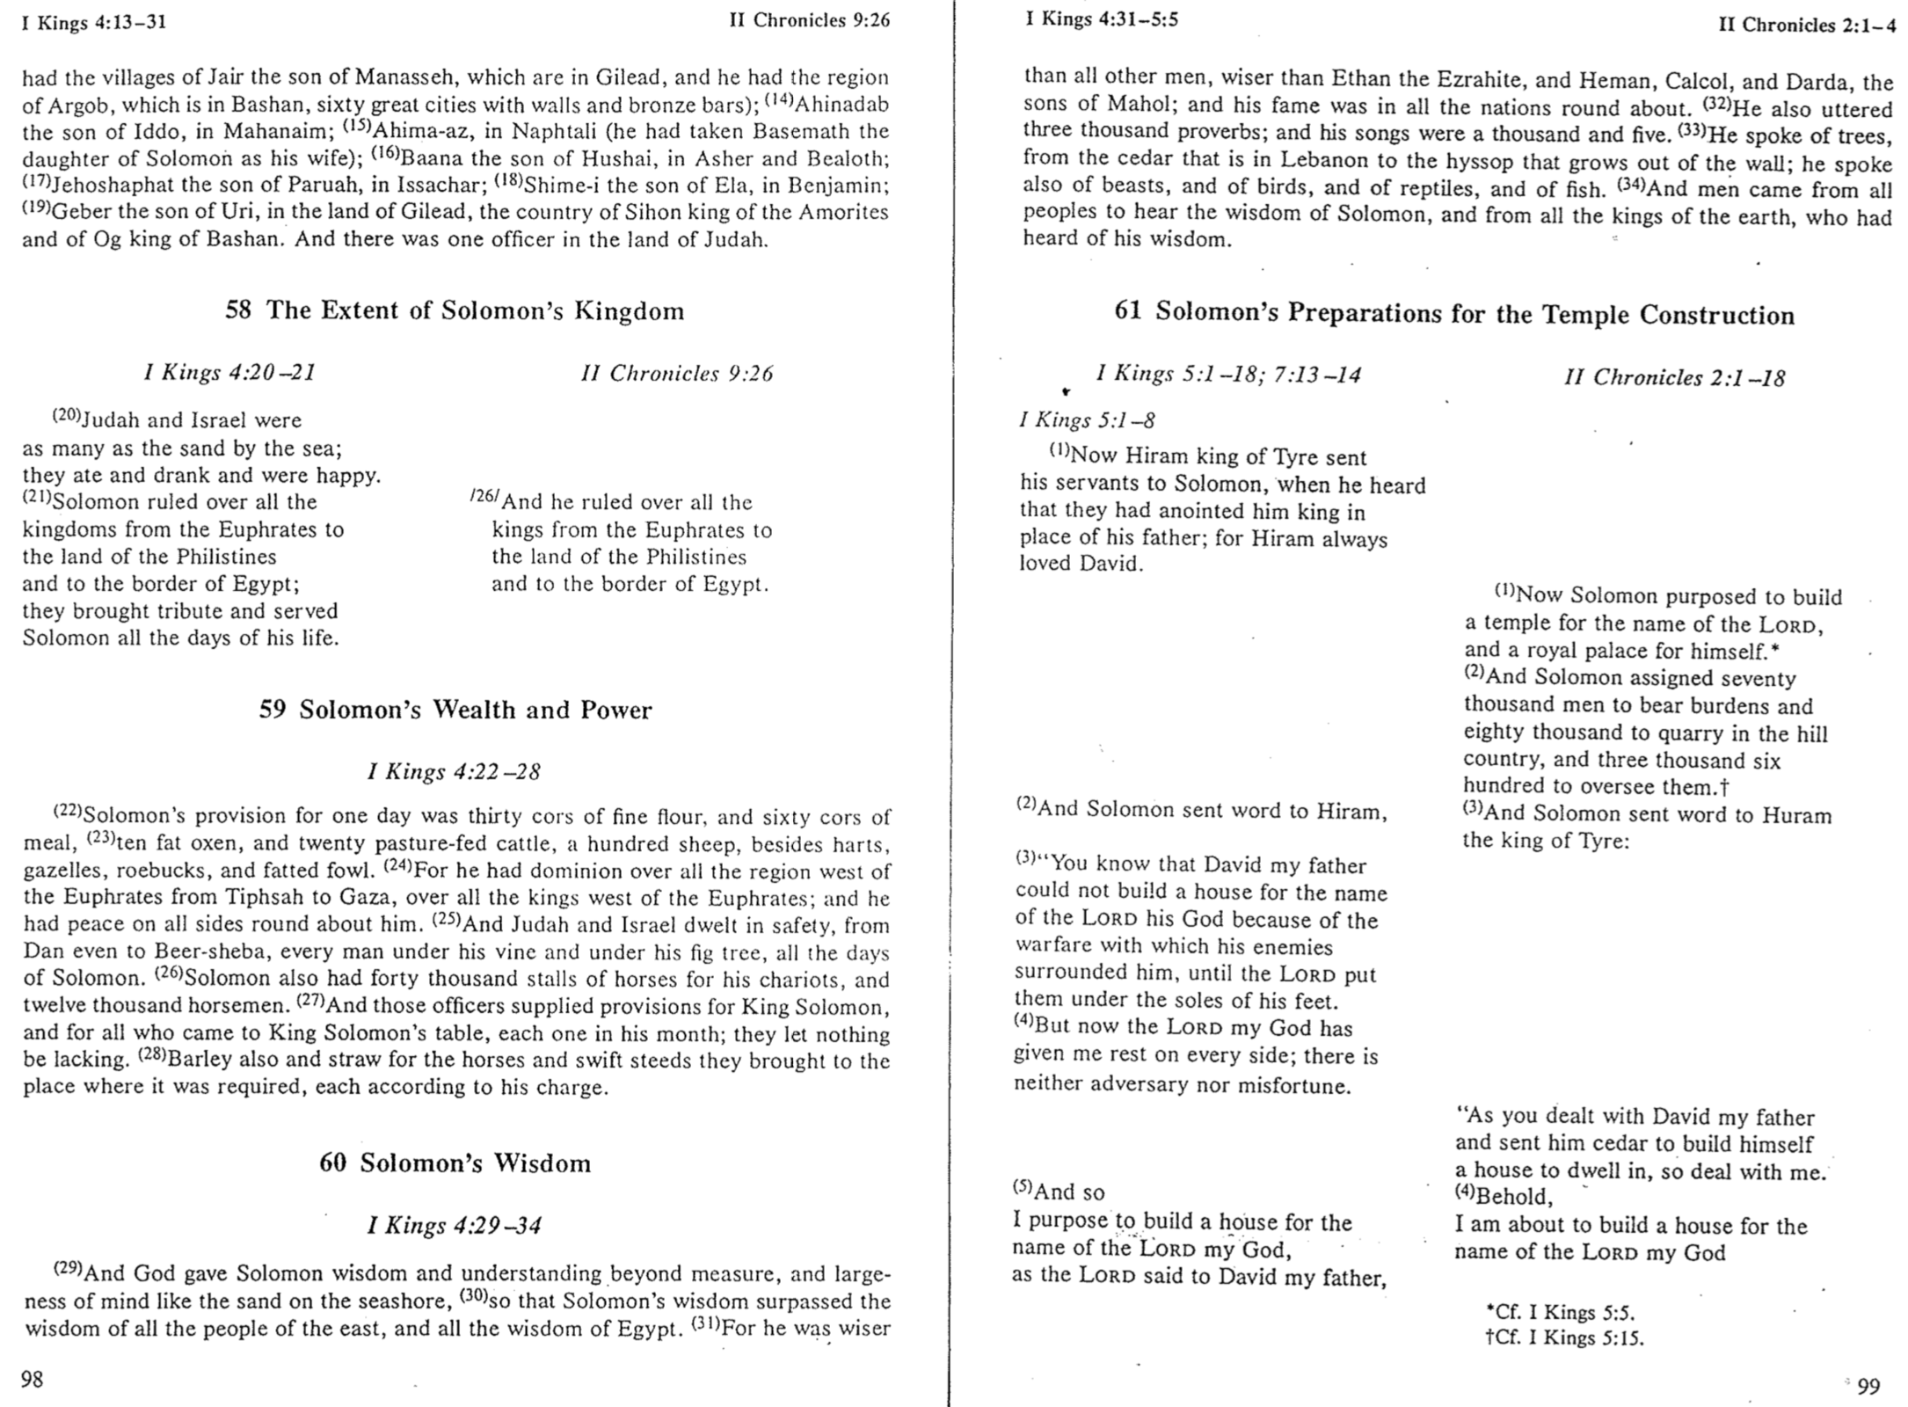

Chronicles Clip #3
C. Zanziper (Reubeni Foundation, Jerusalem)
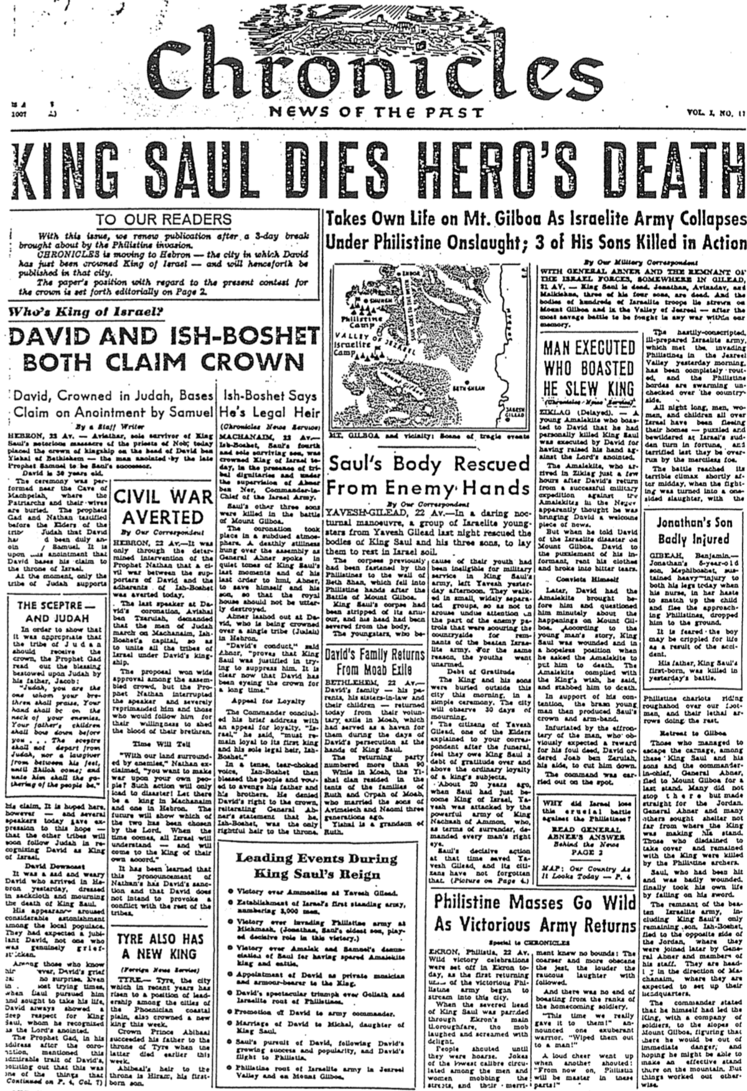

Patriarchal Family Tree

John H. Walton, Chronological and Background Charts of the Old Testament
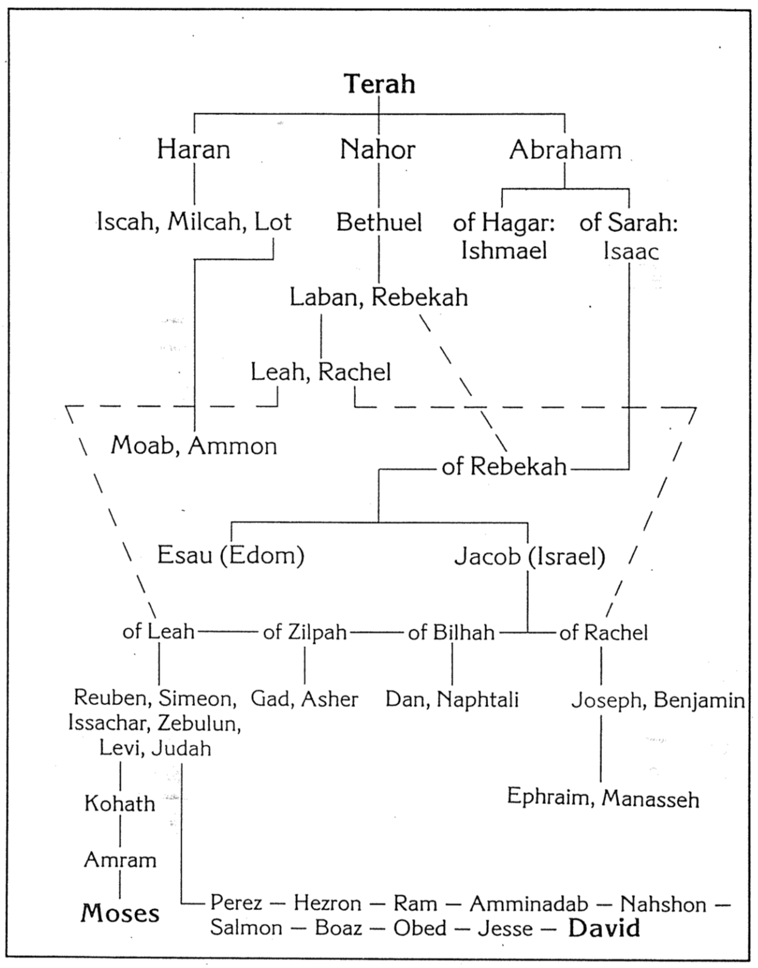
Family and Ancestry of David

John H. Walton, Chronological and Background Charts of the Old Testament

