1 Kings

Division of the Kingdom

Late United Kingdom |  |  | Early Divided Kingdom
Chapters 1–11 |  |  | Chapters 12–22
Solomon |  |  | Split
Mostly Obedience |  |  | Mostly Disobedience
Yahweh Worship |  |  | Idol Worship
Kingdom in Tranquility |  |  | Kingdoms in Turmoil
Single Capital: Jerusalem |  |  | Israel’s Capital: Samaria  Judah’s Capital: Jerusalem
40 Years  (971-931 BC) |  |  | 80 Years  (931-852 BC)
Established: Purging  1–2 | Rise: Obedience  3–8 | Decline:  Disobedience  9–11 | “J & R”  Kings  12–14 | Other  Kings  15:1–16:28 | Ahab vs. Elijah  16:29–22:40 | Other  Kings  22:41-53

Key Word: Division

Key Verse: “But I will not take the whole kingdom out of Solomon’s hand; I have made him ruler all the days of his life for the sake of David my servant, whom I chose and who observed my commands and statutes. I will take the kingdom from his son’s hands and give you [Jeroboam] ten tribes” (1 Kings 11:34-35).

Summary Statement:
Solomon’s prosperity from loyalty to the Law ends with disobedience in a divided kingdom, with mostly evil kings in Israel and Judah to remind Judah of God's loyalty to the Davidic Covenant and its need to obey the Law.

Application:

The test of a faithful servant of God is the ability to end well.

Discerning people of God learn from the mistakes of their predecessors and do not repeat these sins themselves.

1 Kings

Introduction

I. Title First and Second Kings originally comprised only one book in the Hebrew canon called "Kings" (םֶלֶכִים) after the first word in 1:1 ("Now King"; וְהַםֶּלֶךּ>). However, this single scroll was arbitrarily divided in the Septuagint (250 BC) since the Greek required more scroll space. The Septuagint titles were Third and Fourth Kingdoms (since 1 and 2 Samuel were designated 1 and 2 Kingdoms). Jerome called 1 and 2 Kings "The Book of the Kings" about six centuries later. These titles are appropriate as these books record and interpret the reign of every king of Israel and Judah except Saul (David has a brief mention in 1 Kings 1:1-2:12).

II. Authorship

A. External Evidence: Jewish tradition ascribes the authorship of the Books of Kings to Jeremiah, and this claim gains weight from literary parallels between this record and Jeremiah's prophecy.

B. Internal Evidence: The prophetic-like descriptions of Israel's apostasy indicate that the author was a prophet/historian. Also, this compiler had several historical documents at his fingertips: “the book of the acts of Solomon” (1 Kings 11:41), “the book of the chronicles of the kings of Israel” (1 Kings 14:19), and “the book of the chronicles of the kings of Judah” (1 Kings 14:29; 15:7). These books may be attributed to the official secretary Shebna and/or the official recorder Joah, son of Asaph (2 Kings 18:18; cf. Isa. 36:11). Parallels between 2 Kings 18–20 and Isaiah 36–39 also reveal that Isaiah's scroll also was a source. No firm evidence exists to refute the tradition that Jeremiah authored the Book of Kings.

III. Circumstances

A. Date: Three lines of evidence indicate that First Kings and most of Second Kings were written before the Babylonian Captivity (586 BC). The ark still resided in Solomon's temple (1 Kings 8:8), Israel was still in rebellion against Judah (1 Kings 12:19), and Samaria's idolatry persisted even after its resettlement (2 Kings 17:34, 41). However, the final two chapters of Second Kings record up to 26 years after this captivity. They may have been recorded by a Jewish captive in Babylon or by Jeremiah himself, who would have been at least 84 years old.

First Kings covers a period of history totaling 120 years, beginning in 971 BC with Solomon's inauguration and ending in 852 BC near the end of Ahaziah's reign. The year 931 BC marks the most significant date when Solomon's kingdom split into the northern nation of Israel and the southern kingdom of Judah after his death.

Second Kings picks up at 852 BC and traces the account through the fall of Samaria (722 BC) and Jerusalem (586 BC) until the release of Jehoiachin in Babylon in 560 BC—over 293 years.

B. Recipients: The Book of Kings was written to the remaining kingdom of Judah before (1 Kings 1–2 Kings 23) and after (2 Kings 24–25) its exile in Babylon.

C. Occasion: Jeremiah's prophecy and Lamentations record his eyewitness account of Babylon's siege and destruction of Jerusalem for the nation's sins. In addition to his prophetic word, the Holy Spirit moved him to record a historical compilation to give the context and justification for God's judgments on these two nations. The leaders and the people sinned through ungodliness and idolatry, and God gave them the consequences of their disobedience, faithful to the curses of Deuteronomy 28. Therefore, the purpose of the record is to show how the welfare of Israel and Judah depended upon the king's and people's faithfulness to the covenant of Moses, to teach the exiles to learn from the past mistakes of their ancestors. In large part, this purpose was accomplished in history as Israel has not, since the Captivity, had a problem with idolatry.

IV. Characteristics

A. The Books of Kings record more national leaders than any book in Scripture.

B. Kings and Chronicles overlap in their records of the kingdom era, but have some notable differences in emphasis (Constable, BKC, 1:484; Merrill, BKC, 1:591; Zuck, BTOT, 162):

 | Kings | Chronicles
Kings of… | Israel and Judah | Judah (almost exclusively)
Elements | Royal/prophetic | Priestly (temple and worship)
Evaluation | Based on Mosaic Law | Based on David/worship of Yahweh
Purpose | Ethical: Judging both nations | Covenant: Blessing Judah due to David
Author | Jeremiah the prophet/priest | Ezra the priest
Faith | Man's faithlessness | God's faithfulness
Outlook | Negative: rebellion/tragedy | Positive: hope amidst apostasy/tragedy
Recipients | Exilic Jews (ca. 560 BC) | Postexilic Jews (ca. 440 BC)
Chronology | 971-586 BC | 1011-538 BC
Emphasis | Political: emphasizes the throne | Spiritual: emphasizes the temple
Content | Historical | Theological
Attributes | God's justice | God's grace
Protagonist | Human responsibility | Divine sovereignty

Memory Acronym: KEEP A FORCE CAP (using the first letters of each category above)

C. Reconciling the chronology of the kings in Kings and Chronicles perplexed scholars for centuries until the work of Seventh-day Adventist scholar Edwin R. Thiele (pronounced Teé-lee) in the 20th century. His books, A Chronology of the Hebrew Kings (Grand Rapids: Zondervan, 1977) and especially The Mysterious Numbers of the Hebrew Kings (rev. ed.; Chicago: Univ. of Chicago Press, 1983), have insightfully answered several chronological difficulties, particularly of Judah (Constable, BKC, 1:484). Thiele notes that differences in dating can be attributed to various factors (cf. OTS, 231-32):

1. Co-regencies and vice-regencies often answer how chronologies overlap.

2. Judah and Israel used two different methods to determine when a king's reign began, and both nations changed these methods at least once!

3. Judah and Israel used different calendars, beginning their years at two different times!

4. The names of kings can often be confusing:

a. Some kings had the same name (two kings had the names Jeroboam, Jehoram, Jehoahaz, Ahaziah, etc.). Once, two kings with the same name reigned simultaneously (Jehoram of Israel and Judah)!

b. Two different names sometimes referred to the same king (e.g., Uzziah = Azariah, Abijah = Abijam, Joram = Jehoram, Joash = Jehoash).

c. Interestingly, 24 of the 39 kings had names beginning with "A" or "J."

Therefore, the chronologies are very difficult to harmonize; however, in most cases, the systems differ by only one or two years.

D. One difficult verse is 1 Kings 4:21, which states, “And Solomon ruled over all the kingdoms from the River to the land of the Philistines, as far as the border of Egypt. These countries brought tribute and were Solomon’s subjects all his life.” Is this the fulfillment of the promise to Abraham in Genesis 15:18 that his descendants would possess the land from the Wadi of Egypt to the Euphrates River (modern Iraq)? The following shows that this was only a partial fulfillment of this promise, so that a future, complete fulfillment yet awaits us:
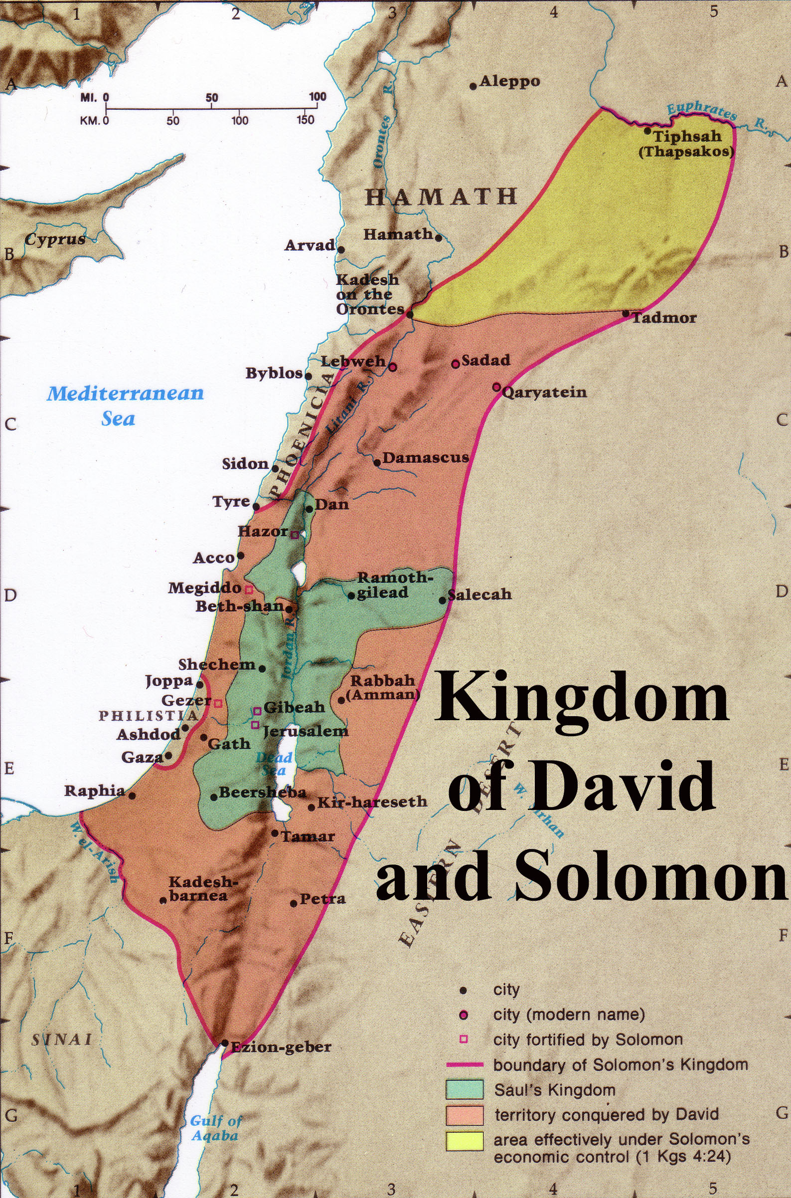
1. God clarified this promise to Abraham in Ezekiel by saying that this covenant with Jerusalem is eternal (Gen. 17:8; cf. Ezek. 16:1, 60).

2. Solomon only collected tribute from these areas, which is different from saying that Israel possessed and lived in this land (“I will give this land,” Gen. 15:18).

3. The time of fulfillment is after exile and national repentance (Deut. 30:2, 6, 8, 10; Jer. 17:24-27; 18:7-10) that would take place after the return from Babylon (Zech. 10:9-10), which was long after Solomon’s time. This will not occur until the Second Coming of Christ (Rom. 11:26-27).

Argument

The Book of 1 Kings records the first part of the history of the kings of Israel and Judah, but does so with a purpose. The author's motive seems to be an ethical one—to convince his readers from past lessons that God blesses obedience to his covenant but judges disobedience. This is observable in the greater part of the reign of Solomon (1 Kings 1–11), who prospers in a United Kingdom as he obeys (1 Kings 1–8) but loses the kingdom after his sins of materialism, intermarriage, and especially idol worship (1 Kings 9–11). After the kingdom divides, both the north and the south experience instability and division depending on the obedience of each king (1 Kings 12–22). The book also shows God's commitment to the Davidic Covenant through Solomon and the kings of Judah, who retain only one dynasty in contrast to the four dynasties of the northern kingdom that do not possess the promise of the Davidic Covenant.

Synthesis

Early divided kingdom covenant disobedience Division of the Kingdom

1–11 Solomon's prosperity from obedience
1–2 Establishment
1 Anointed king
2 Purged opposition
3–8 Rise: obedience
3 Wisdom
4 Administration
5–8 Temple
9–11 Decline: disobedience
9:1-9 Davidic Covenant reaffirmed
9:10–11:8 Disobedience
11:9-43 Judgment: Opposition & Rehoboam
12–22 Early divided kingdom Key to Morality of Kings
12–14 Jeroboam/Rehoboam I = Israel (all bad kings)
12:1-24 Division over work J = Judah (good kings in bold)
12:25–14:20 Jeroboam (1; I)–idolatry (1) = Israel dynasties
14:21-31 Rehoboam (J)–idolatry
15:1-8 Abijam (Abijah; J)
15:9-24 Asa (J)
15:25-26 Nadab (I)
15:27–16:7 Baasha (2; I)
16:8-14 Elah (I)
16:15-20 Zimri (3; I)
16:21-28 Omri (4; I)
16:29–22:40 Ahab (I) vs. Elijah/Micaiah
16:29-34 Idolatry/Baal worship
17–19 Judgment (YHWH is God!)
17 Drought vs. ravens/widow
18 Mt. Carmel
19 Murder thwarted vs. God's protection
20 Victory over Syria
21 Naboth
22:1-40 Death at Ramoth-Gilead
22:41-50 Jehoshaphat (J)
22:51-53 Ahaziah (I)

Outline

Summary Statement for the Book
Solomon’s prosperity from loyalty to the Law ends with disobedience in a divided kingdom, with mostly evil kings in Israel and Judah to remind Judah of God's loyalty to the Davidic Covenant and its need to obey the Law.

The end of Solomon’s united and prosperous kingdom due to his idolatry reminds Judah of God's loyalty to the Davidic Covenant and its need to obey the Law (1 Kings 1–11; 971-931 BC).

Solomon’s establishment as king, through his anointing and purging of the kingdom of rivals, confirmed God's loyalty to the Davidic Covenant (1 Kings 1–2).

Solomon’s anointing as king in response to his brother Adonijah's plot to seize the kingship verifies God's transfer of the Davidic Covenant from David to Solomon (1 Kings 1).

Solomon purged opposition to the throne in obedience to David's charge before his death to establish the kingdom in his hands (1 Kings 2).

David charged Solomon with obeying the Law and executing rivals to his throne before his death (2:1-12).

Solomon purged the kingdom of four competitors (2:13-46).

Adonijah died trying to steal the kingdom by marrying David's attendant Abishag (2:13-25).

Abiathar's priesthood transferred to Zadok to fulfill the prophecy that Eli's line of priests would be cut off, thus showing God faithful to his word (2:26-27; cf. 1 Sam. 2:30-35).

Joab was executed for conspiring with Adonijah and killing Abner and Amasa (2:28-35; cf. 2 Sam. 3:22-30; 20:8-10).

Shimei was executed for disobeying Solomon's exile on him and for cursing David (2:36-46).

Solomon’s rise as king shows God's blessing upon him as the legitimate heir to the Davidic Covenant promises to instruct Israel in the benefits of following the Law (1 Kings 3–8).

Solomon's wisdom, granted by God for obeying the Law and shown by judging between two prostitutes, indicates that God made him the rightful heir of the Davidic Covenant (1 Kings 3).

Solomon's administration, through chief officials, governors, and officers, received international acclaim because his great wisdom instructed Israel in the benefits of following the Law (1 Kings 4).

Solomon's temple was constructed, dedicated, and filled with God’s glory to affirm God's blessing on his obedience (1 Kings 5–8).

Construction of the temple took seven years and employed thousands of Hiram's men and 213,000 Israelite workmen (1 Kings 5–6)!

In contrast, the construction of Solomon's much larger palace took 13 years (7:1-12)!


Solomon’s… | Temple (1 Kings 6:1-2) | Palace (1 Kings 7:1-2)
Height | 30 cubits (13.5 meters) | 30 cubits (13.5 meters)
Width | 20 cubits (9 meters) | 50 cubits (23 meters)
Length | 60 cubits (27 meters) | 100 cubits (46 meters)
Construction | 966-959 BC (7 years; 1 Kings 6:38) | 959-946 BC (13 years; cf. Hag. 1:2-4)
Location | Rock of Moriah: place where Abraham offered Isaac (Gen. 22:14), later the threshing floor of Araunah (2 Sam. 24:16), and later the temple (1 Chron. 22:1; 2 Chron. 3:1) | Just south of the temple, which was next to the palace of Pharaoh’s daughter, wife of Solomon (2 Chron. 8:11)

Temple furnishings were built and brought into the temple (7:13-51).

After the return of the ark and Shekinah glory, Solomon dedicated the temple with a message and prayer that met God's and the people's approval (1 Kings 8).

Solomon's decline from disobeying the Mosaic Covenant resulted in God opposing him and granting him only one tribe of his entire kingdom for a godless son (1 Kings 9–11).

The LORD reaffirmed the Davidic Covenant to Solomon at the height of his life with a stern warning not to forsake the Mosaic Covenant (9:1-9).

Despite his great wisdom, splendor, and God's warning, Solomon disobeyed the Law (9:10–11:8).

He tried to pay Hiram 20 Israelite towns contrary to the Law (9:10-14; cf. Josh 1:3-4).

He enslaved Canaanites rather than exterminating them (9:15-28; cf. Exod 23:31-33).

He amassed wealth contrary to the Law (10:1-25; cf. Deut 17:17b).

He multiplied horses contrary to the Law (10:26-29; cf. Deut 17:16).

He intermarried with foreigners contrary to the Law (11:1-2; cf. Exod 34:15-16).

He multiplied wives contrary to the Law (11:3; cf. Deut 17:17a).

He worshipped pagan gods and built them altars contrary to the Law (11:4-8; cf. Exod 34:15-16).

God disciplined Solomon’s disobedience to the Law by opposition and succession of his godless son Rehoboam, who would rule only one tribe (11:9-43).

The LORD promised to judge Solomon's disobedience by having his heir rule only the tribe of Judah in a divided rather than a united kingdom (11:9-13).

God raised external and internal opposition to Solomon because of his disobedience to the Mosaic Covenant (11:14-40).

External opposition came from Hadad the Edomite and Rezon the Zobahite, both unconquered enemies of David (11:14-25).

Internal opposition came from God's promise to Jeroboam, one of Solomon's own officials, that he would give him the northern nation of ten tribes (11:26-40).

At Solomon's death after a 40-year rule, his throne went to his godless son Rehoboam to rule only the tribe of Judah (11:41-43).

The Kingdom in Tranquility | Chapter 12  Split  of the Kingdom | The Kingdoms in Turmoil
God rules his people through a king:  SOLOMON |  | God speaks to his people through a prophet:  ELIJAH

The Significance of 1 Kings 12
Irving L. Jensen, Jensen’s Survey of the OT, 196

The unstable divided kingdom under the early kings of Israel and Judah, by ignoring the Law, reminds Israel to obey the Law—not repeat the past (1 Kings 12–22; 931-852 BC).

The kingdom divided under the idolatry and evil reigns of Jeroboam and Rehoboam to remind Israel to obey the Law rather than repeat past sins (1 Kings 12–14).

The division of the kingdom due to Rehoboam's commitment to overworking the people teaches that God blesses righteous leadership but punishes evil (12:1-24).

God judged Jeroboam's evil reign in the first of nine dynasties in Israel for promoting idolatry to show God faithful to his word and committed to the Davidic Covenant (12:25–14:20).

Jeroboam protected his evil grasp on the northern tribes by making pagan altars at Bethel and Dan to keep his people from worship at Jerusalem (12:25-33).

God sent a prophet to warn Jeroboam of his evil ways and as an example of the perils of disobedience, yet Jeroboam persisted in idolatry (1 Kings 13).

Ahijah predicted to Jeroboam's wife her son’s death and the end of his dynasty to show God’s fidelity to his word and commitment to the Davidic Covenant in Judah (14:1-20).

God judged Rehoboam's evil reign of idolatry in the only dynasty in Judah by Shishak of Egypt stealing Solomon's gold temple shields to show the cost of defying the Law (14:21-31).

The mixed reigns of two kings in Judah saw more idolatry instead of removing it from the land (15:1-24).

Abijam (Abijah) repeated the same idolatry committed by his father Rehoboam (15:1-8).

Asa’s good reign purged idolatry except at the high places and brought some reform to Judah (15:9-24).

Gog judged the evil reigns of five kings in Israel for disobeying the Mosaic Covenant (15:25–16:28).

Nadab committed evil and was judged by the loss of his dynasty (15:25-26).

Baasha (Second Dynasty) committed evil despite the prophet Jehu’s warnings (15:27–16:7).

Elah committed evil and was judged by the loss of his dynasty (16:8-14).

Zimri (Third Dynasty) murdered Baasha's entire family and then reigned only seven days before his suicide and was therefore judged by the loss of his dynasty (16:15-20).

Omri (Fourth Dynasty) built the city of Samaria but was judged for sinning worse than any previous king, especially for enticing Israel to idol worship (16:21-28).

The prophets Elijah and Micaiah confronted wicked Ahab of Israel to show the LORD's sovereignty over Baal (16:29–22:40).

Ahab not only encouraged idolatry, but after marrying the Sidonian princess Jezebel, he introduced Baal worship in Israel (16:29-34).

God judged Ahab and Jezebel for their sin but protected Elijah from harm to teach that Yahweh, not Baal, is God (1 Kings 17–19).

Elijah predicted to Ahab a 3½-year drought, but God miraculously fed Elijah by ravens and a widow to show that Yahweh, not Baal, is God (1 Kings 17).

Elijah revealed God’s power at Carmel and murdered Baal's prophets to show Ahab and Jezebel that Yahweh, not Baal, deserves worship (1 Kings 18).

Jezebel tried to kill Elijah, but God gave him food, an appearance, and a new disciple to show that Yahweh protected Elijah, but Baal was silent (1 Kings 19).

Ahab defeated Syria at Samaria and Aphek but was prophesied death because he trusted Ben-Hadad by sparing his life instead of trusting God above false gods (1 Kings 20).

The result of Ahab’s murder of Naboth and seizure of his vineyard inheritance was God’s announcement that his family line would be cut off after his son’s rule (1 Kings 21).

The way Ahab abused his authority was to let Jezebel seize Naboth’s vineyard and kill him (21:1-16).

The result of Ahab’s abuse of his authority was God’s announcement that his family line would be cut off after his son rules (21:17-29).

God judged Ahab through death at Ramoth-Gilead to fulfill Micaiah and Elijah’s prophecies since Ahab trusted the powerless prophets of Baal instead of God’s true prophet (22:1-40).

Jehoshaphat's good reign in Judah purged the male shrine prostitutes and lacked only removal of the high places (22:41-50).

The beginning of Ahaziah's evil reign in Israel continued the Baal worship begun by his father Ahab (22:51-53). NOTE: The rest of his reign is completed in 2 Kings 1.

Note: For a helpful guide in correlating the various accounts in the lives of the kings of Israel and Judah, consult the following harmony. It generally places the narratives chronologically in parallel columns but is strongest in its literary comparisons (see a page of Newsome on p. 267b).

Newsome, James D., Jr. A Synoptic Harmony of Samuel, Kings, and Chronicles: With Related Passages from Psalms, Isaiah, Jeremiah, and Ezra. Grand Rapids: Baker, 1986. 275 pp.

Quiz on Leaders in 1 Kings

Fill in the English names of one prophet and the seven kings, all found in 1 Kings.



The Divided Kingdoms

Adapted and expanded from Huang Sabin, OT Made Simple;
Andrew E. Hill & John H. Walton, A Survey of the Old Testament, 3rd ed., 290

Israel | Judah
North | South
10 tribes | 2 tribes
9 ruling dynasties | 1 ruling dynasty*
20 kings** | 19 kings, 1 queen
20 evil kings | 12 evil kings/queens
0 good kings | 8 good kings
7 assassinations | 5 assassinations
1 suicide | 0 suicides
1 “stricken by God” | 2 “stricken by God”
0 kings exiled to foreign lands | 3 kings exiled to foreign lands
First king: Jeroboam | First king: Rehoboam
Last king: Hoshea | Last king: Zedekiah
Lasted 209 years | Lasted 345 years
People exiled in 722 BC | People exiled from 605-586 BC
Exiled to Assyria’s conquered lands | Exiled to Babylon
Never returned to land of Israel | Remnant returned after 70 years
Only tribes migrating to Judah returned | Returned in 538 BC

* Queen Athaliah of Judah interrupted the Davidic dynasty but it resumed after her death so she acted more as a parenthesis as opposed to the elimination of the previous dynasties in Israel.

** The competing reign of Tibni for three of Omri’s years is included here.

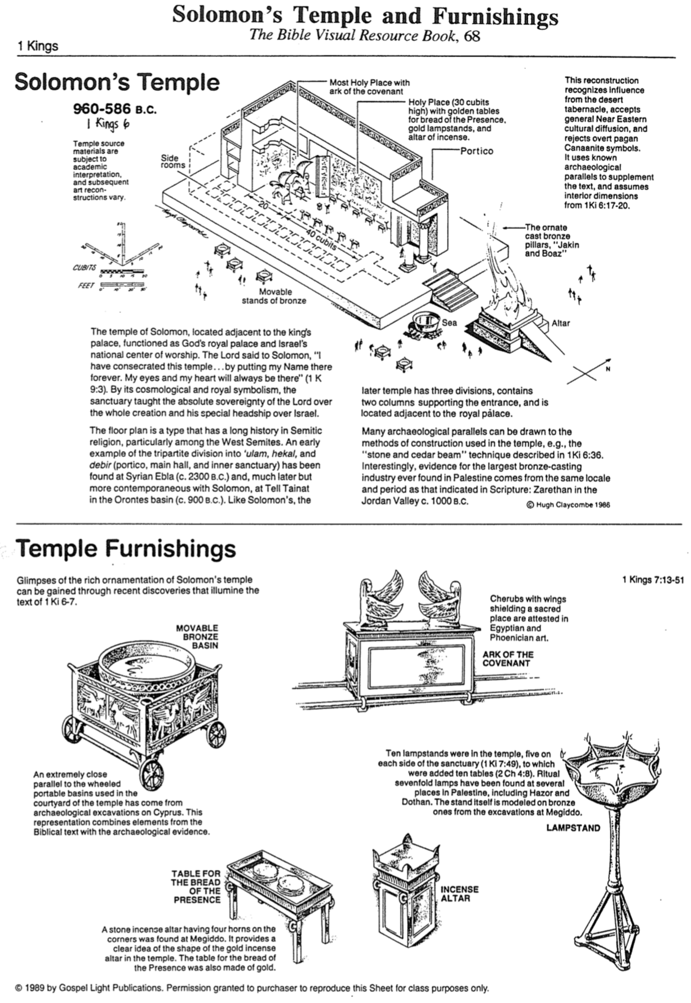
Solomon’s Temple and Furnishings

The Bible Visual Resource Book, 68

Possible Locations of Solomon’s Temple

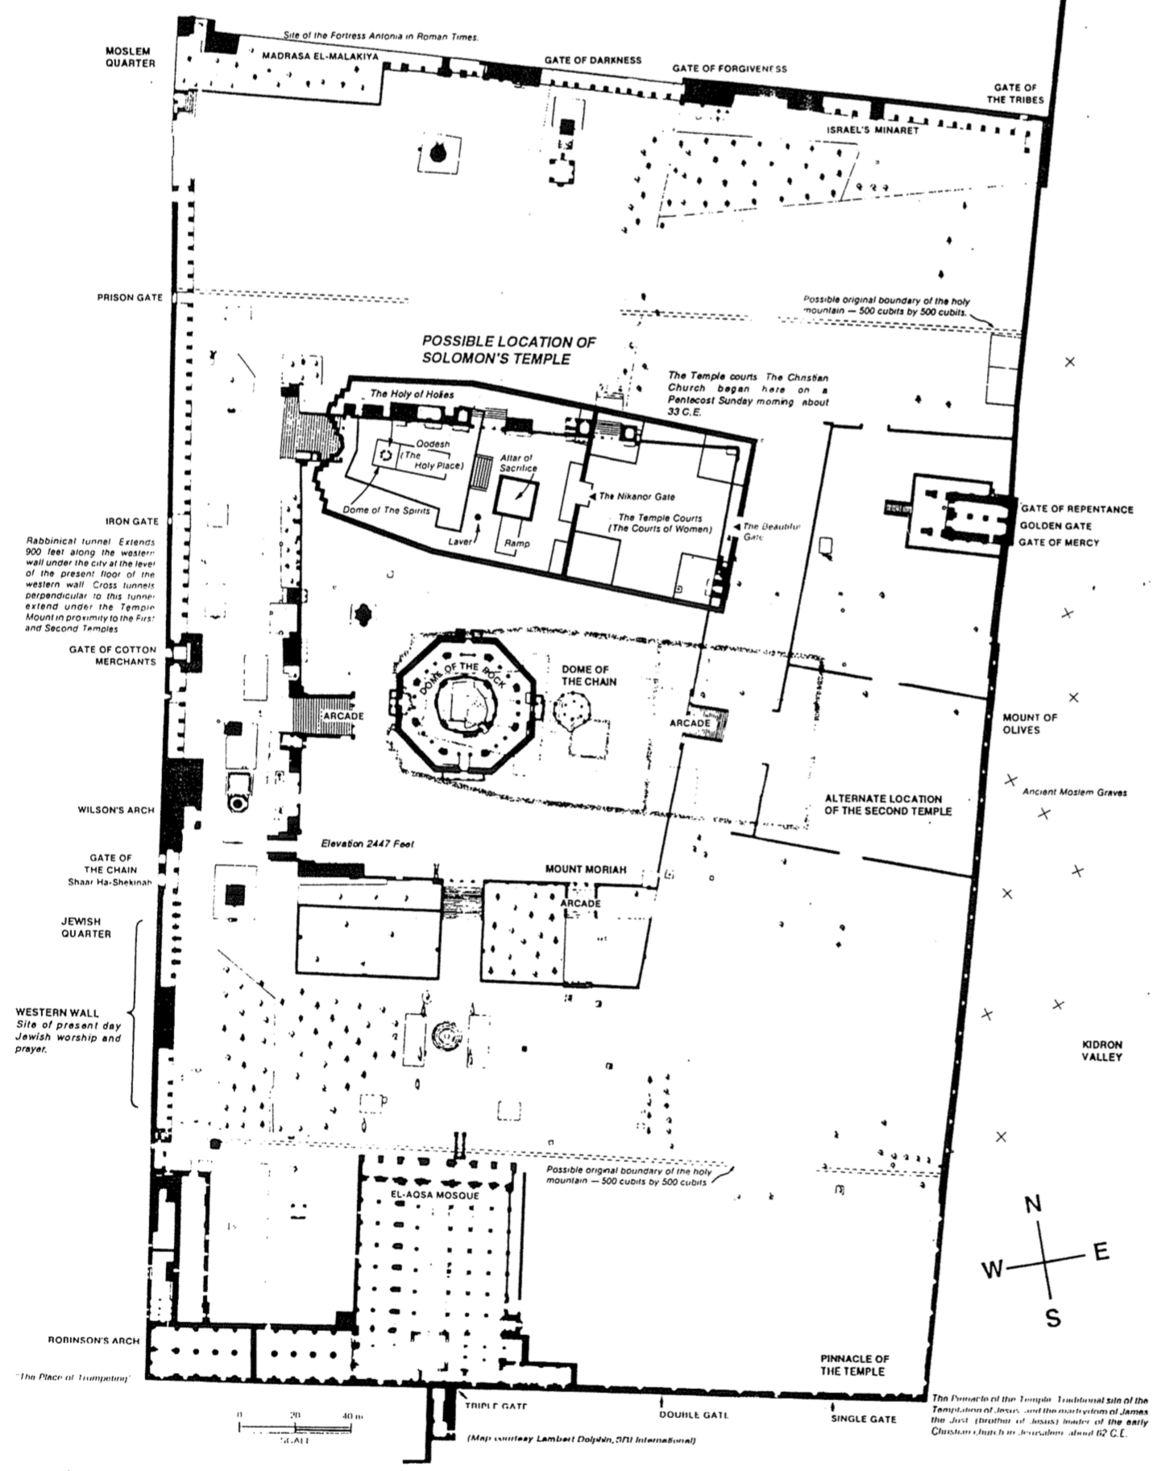
Geography of the Divided Kingdom
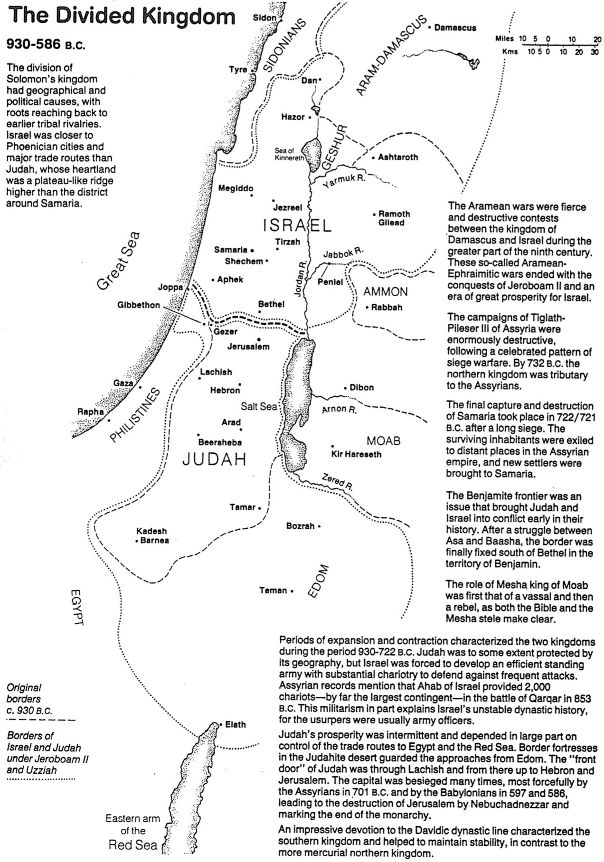
The Bible Visual Resource Book, 75

Chart of Old Testament Kings and Prophets

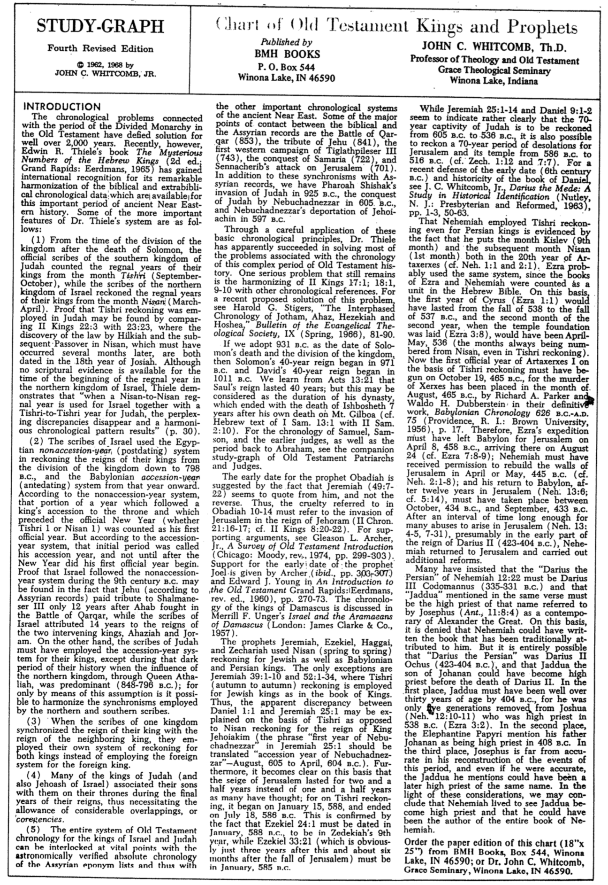
John C. Whitcomb (1 of 2)

(It’s OK to cover the above title)
Chart of Old Testament Kings and Prophets
John C. Whitcomb (2 of 2)
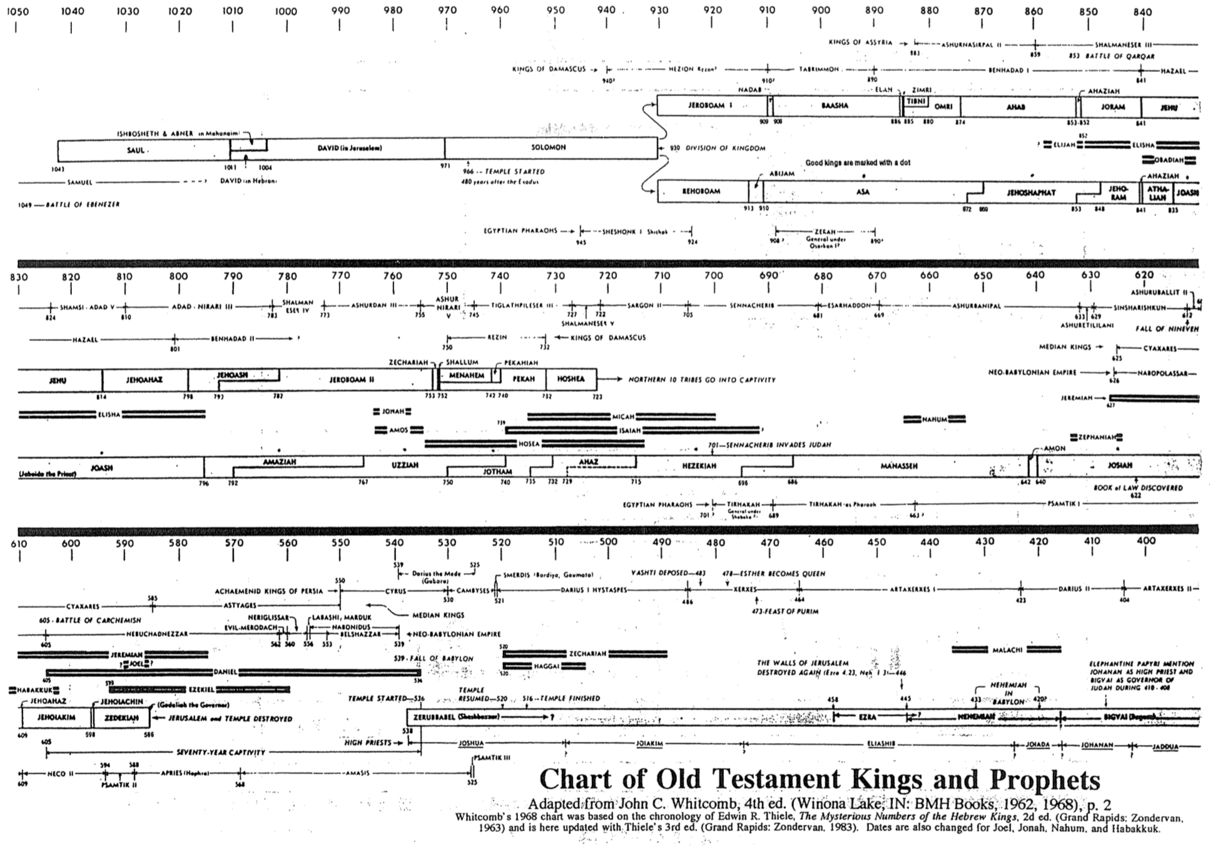

(It’s OK to cover the above title)
Chart of Old Testament Kings and Prophets (Blank)
John C. Whitcomb (Outline of the Previous Page)


Chronology of Kings and Prophets
Dr. E. N. Poulson, Grace Baptist Church, Singapore (used with permission)

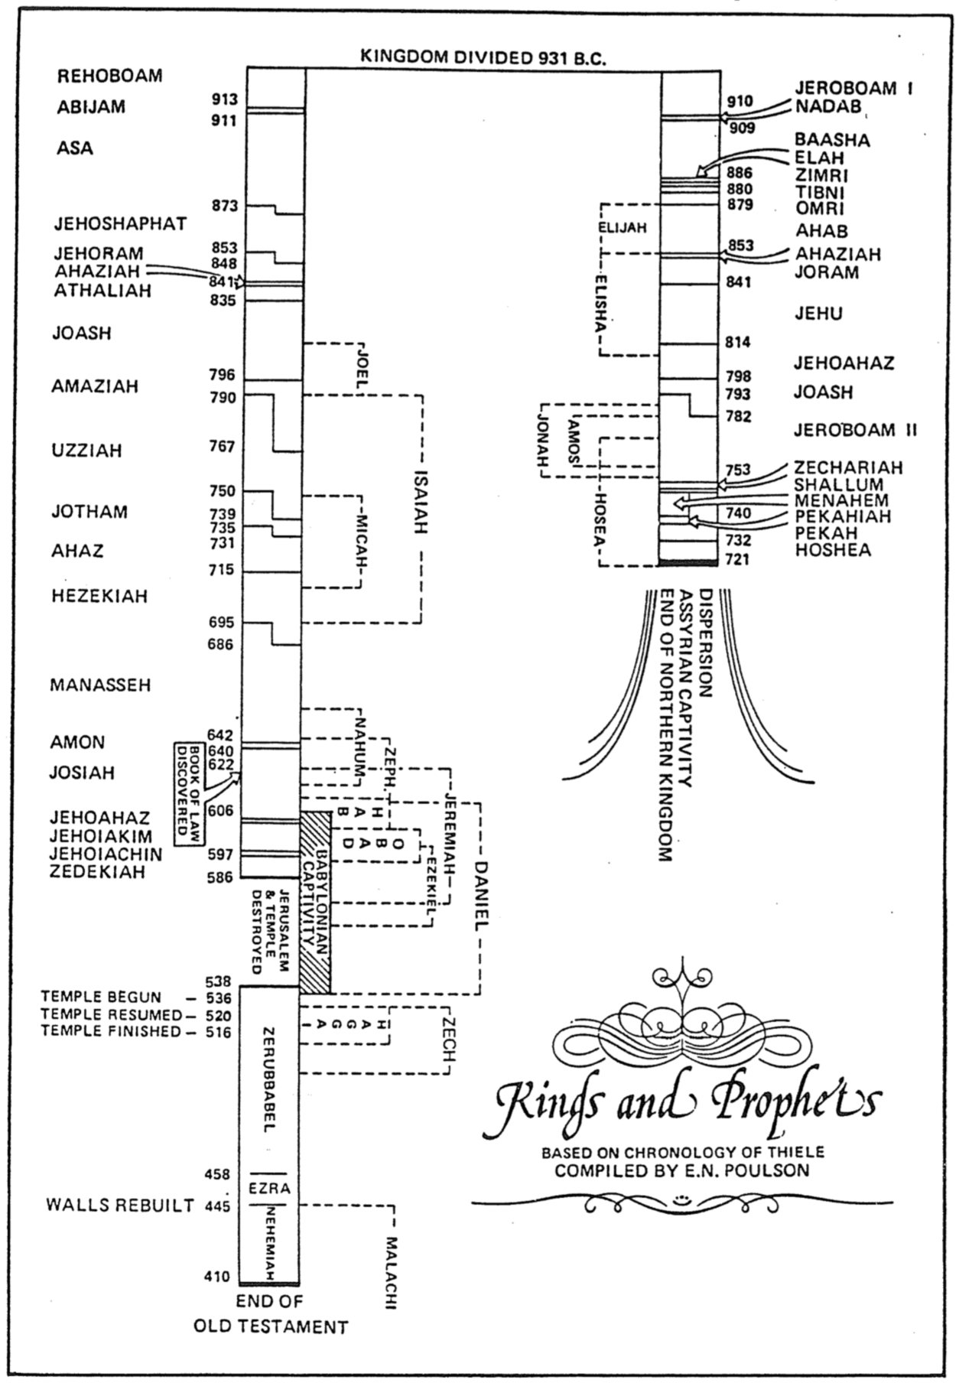
Rulers of Israel and Judah
The Bible Visual Resource Book, 71

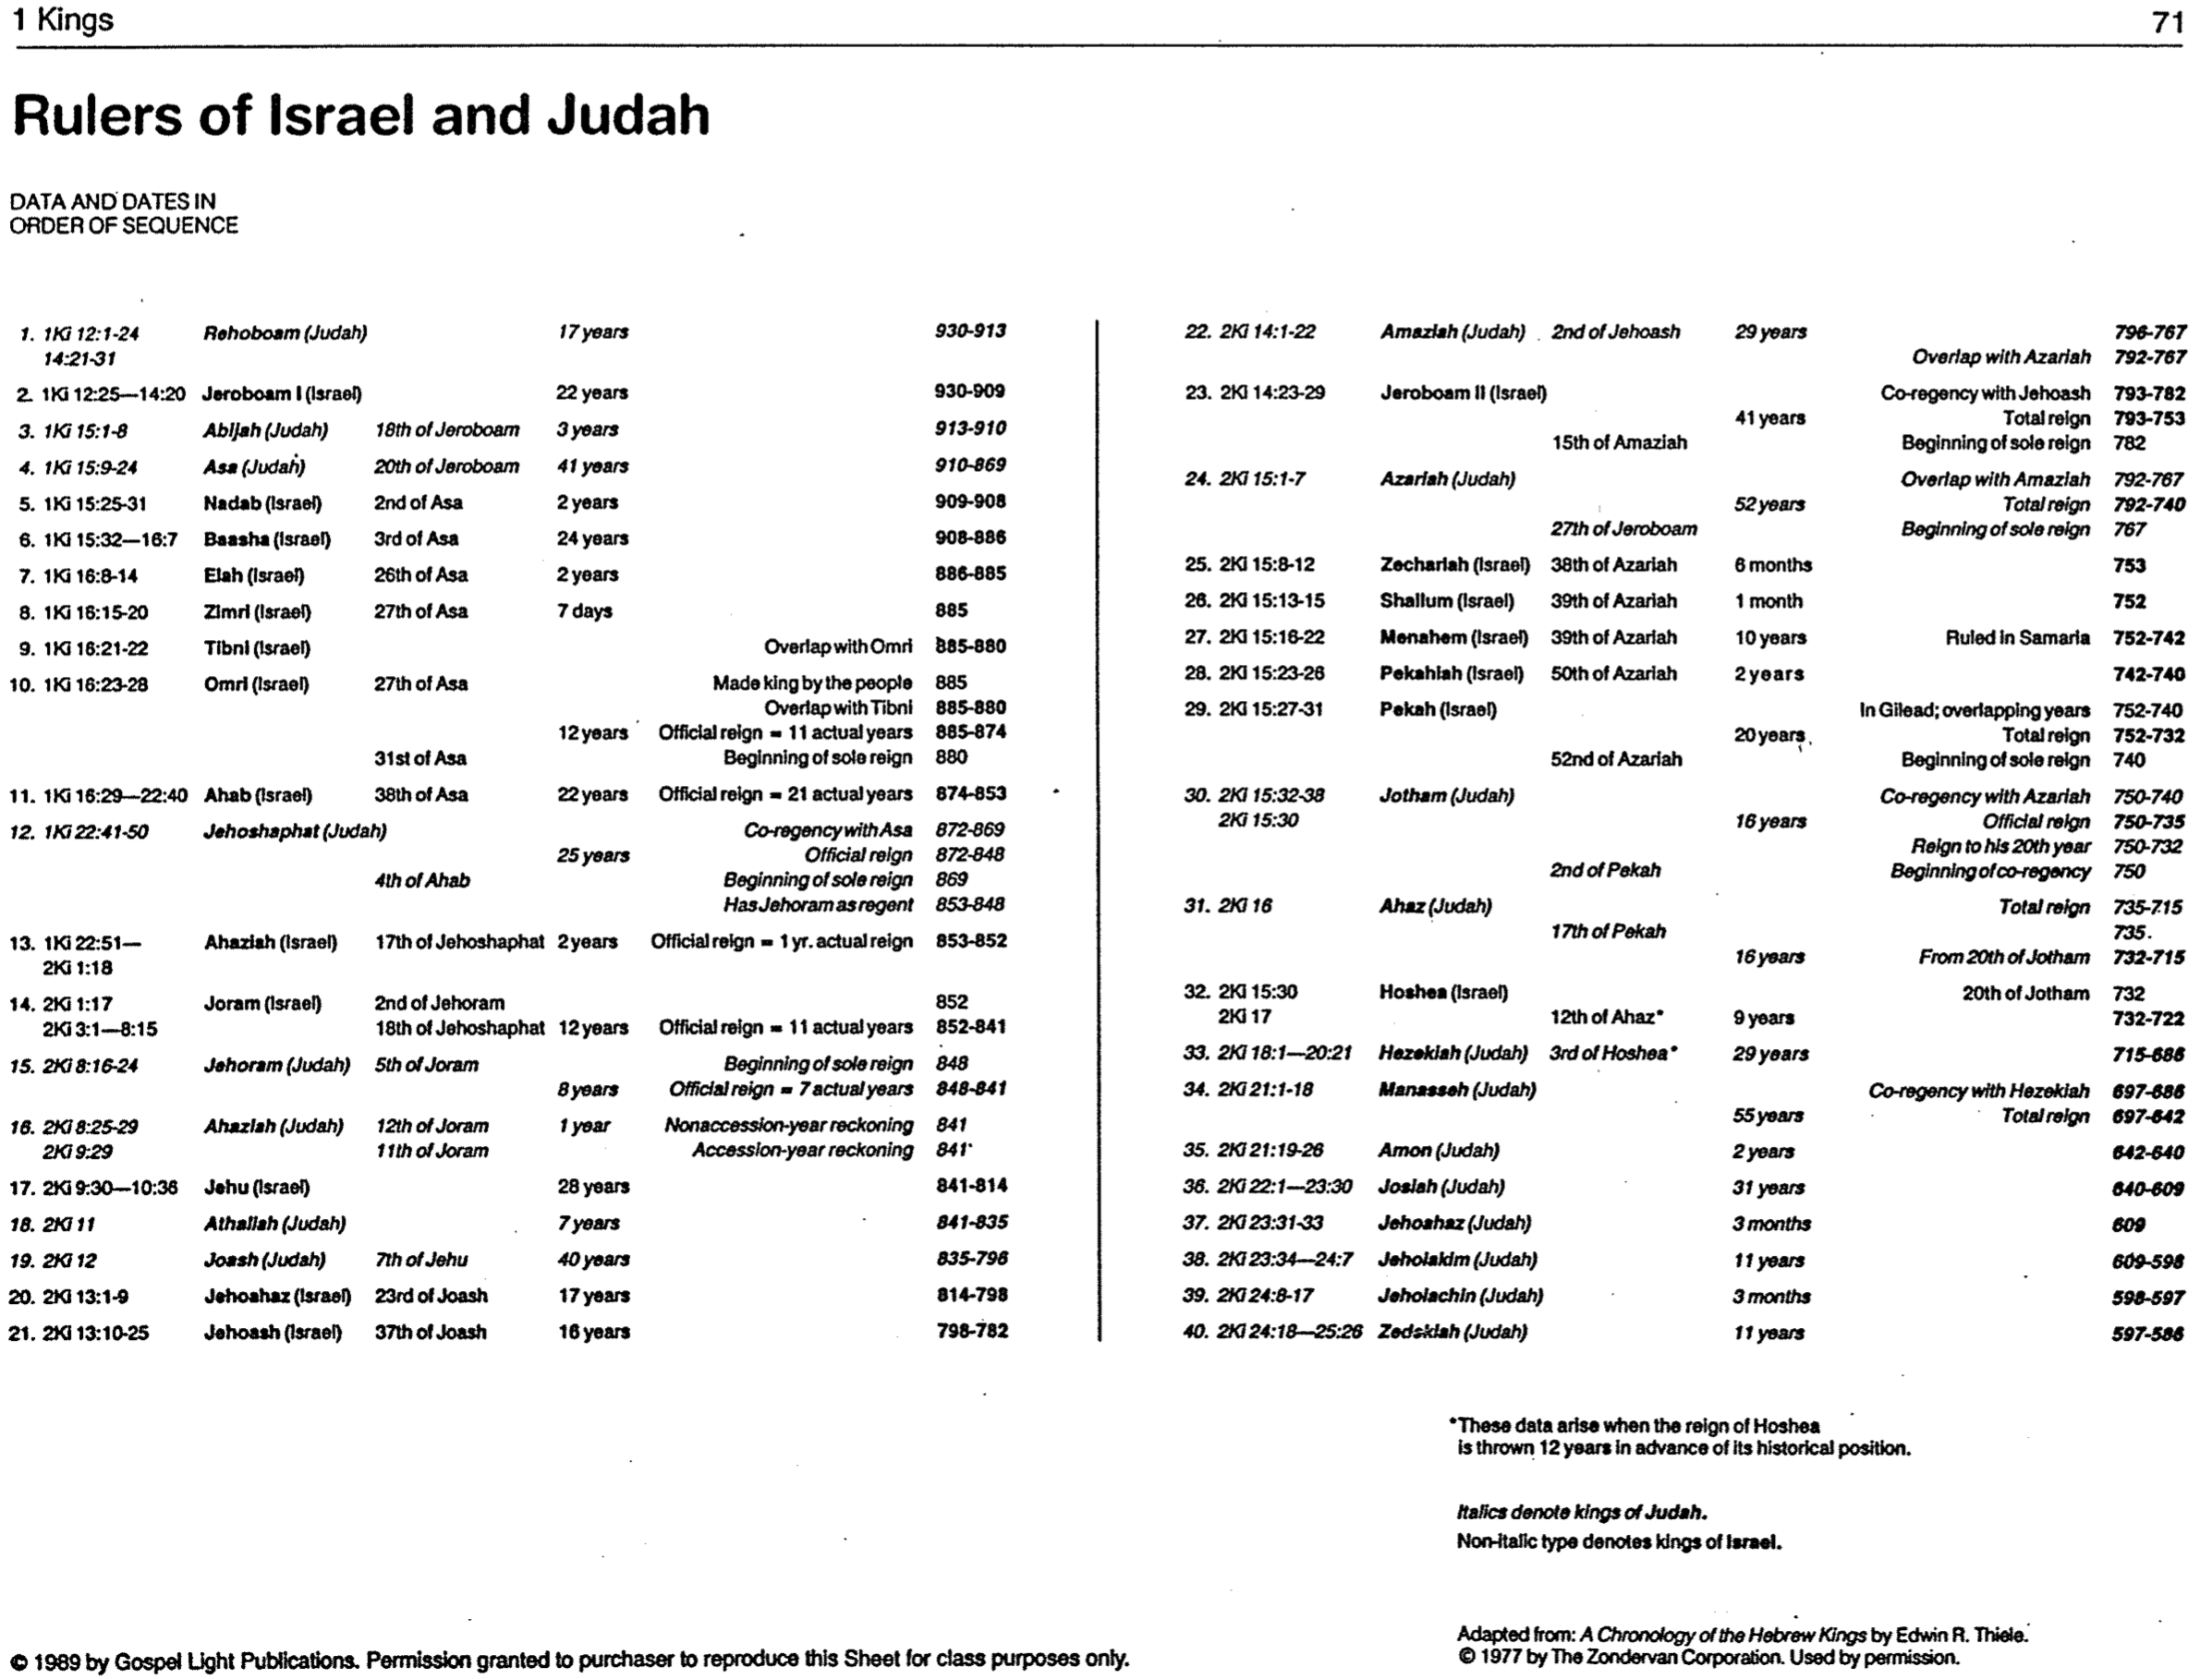

Kings of Israel

Walk Thru the Old Testament

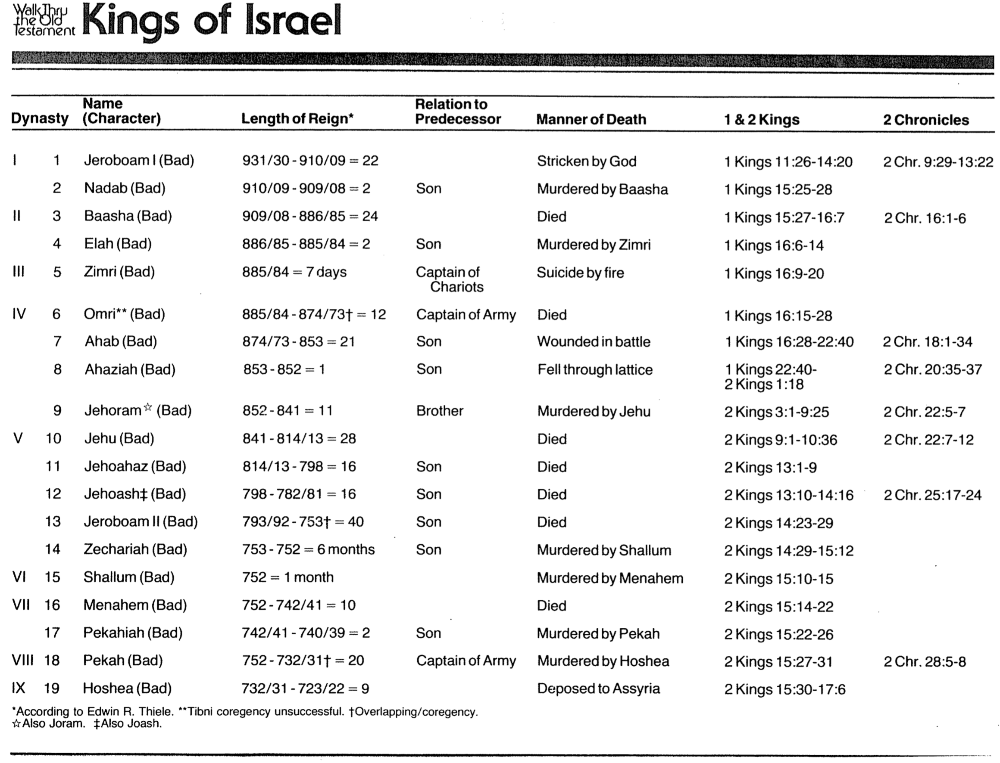

Kings of Judah

Walk Thru the Old Testament
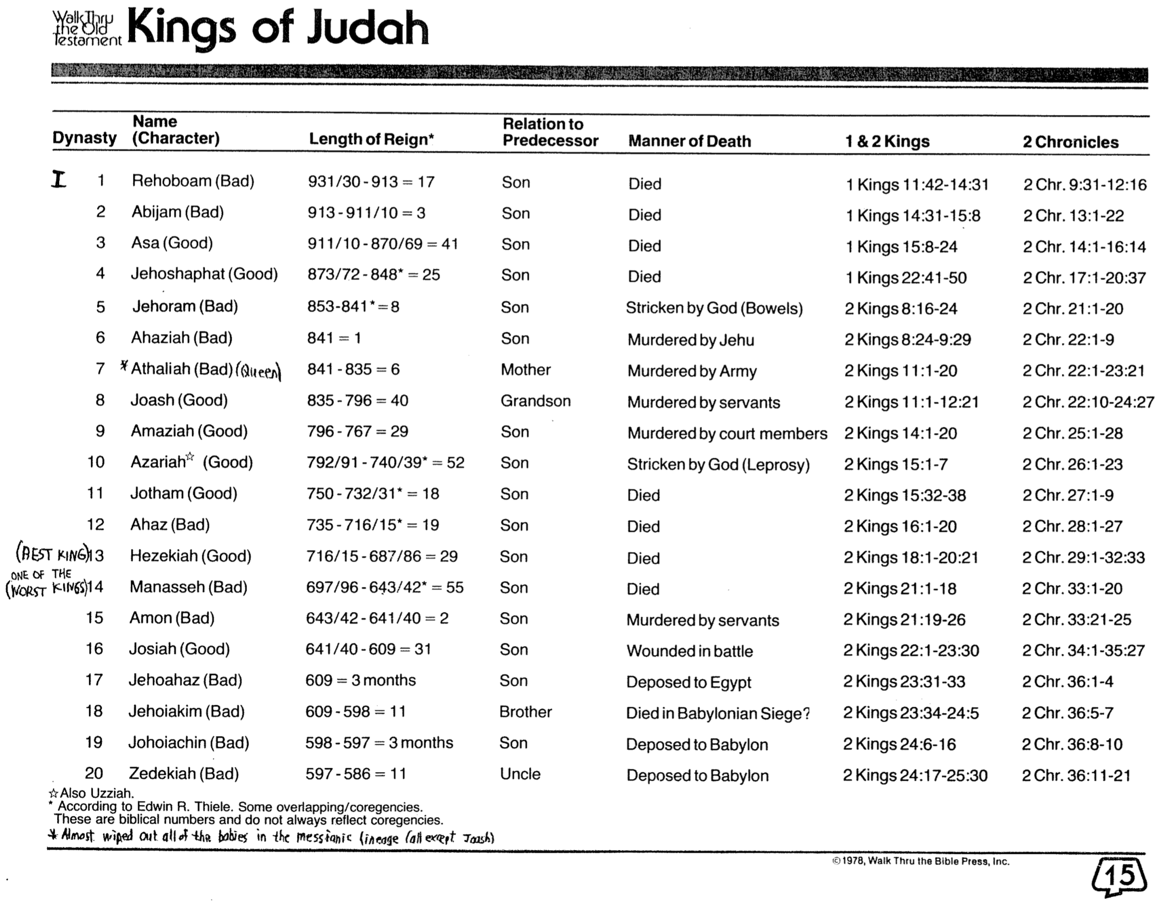

Genealogical Chart of the Kings of Judah

Paul Maier, Josephus: The Essential Writings, 388, adapted
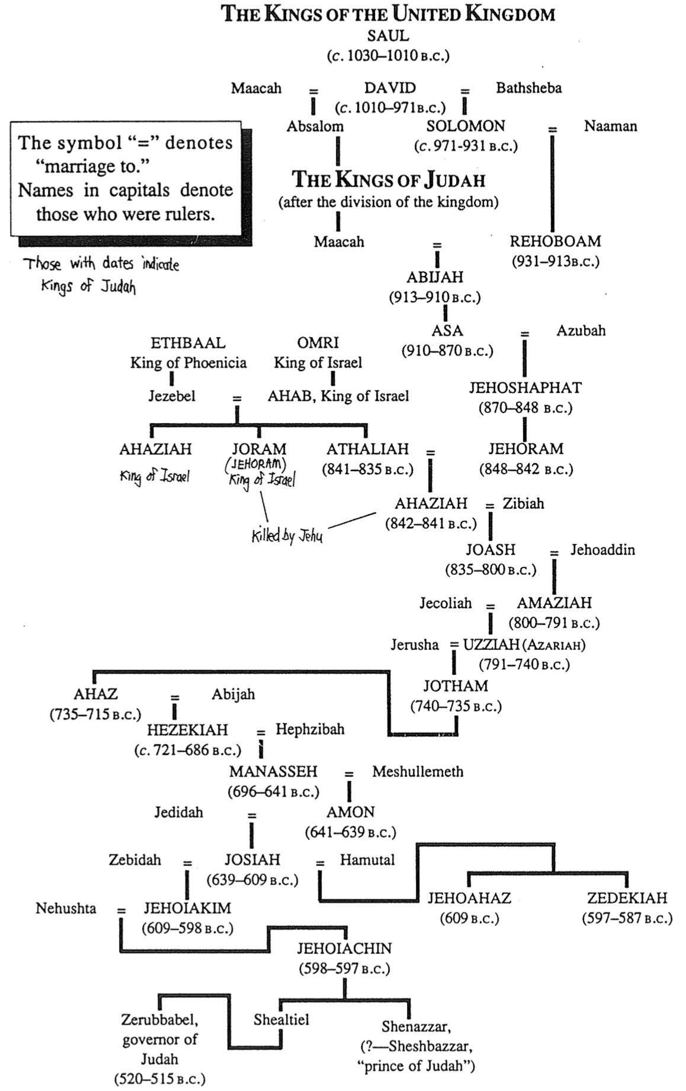

Summaries of the Kings’ Reigns
Allen P. Ross, Dallas Theological Seminary (1 of 3)
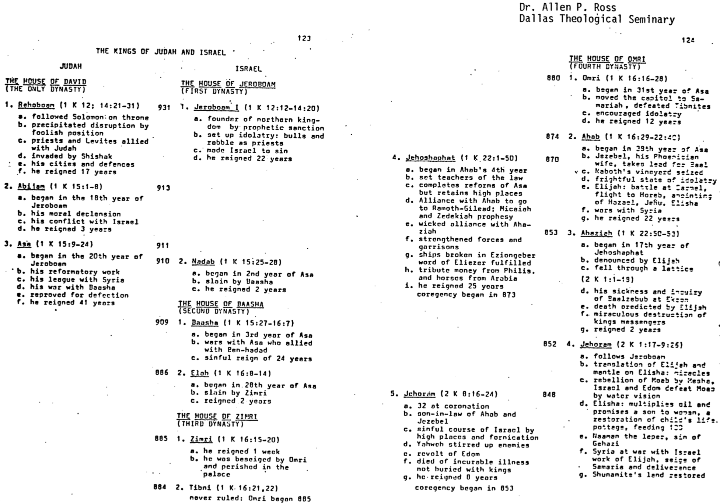

Summaries of the Kings’ Reigns
Allen P. Ross (2 of 3)
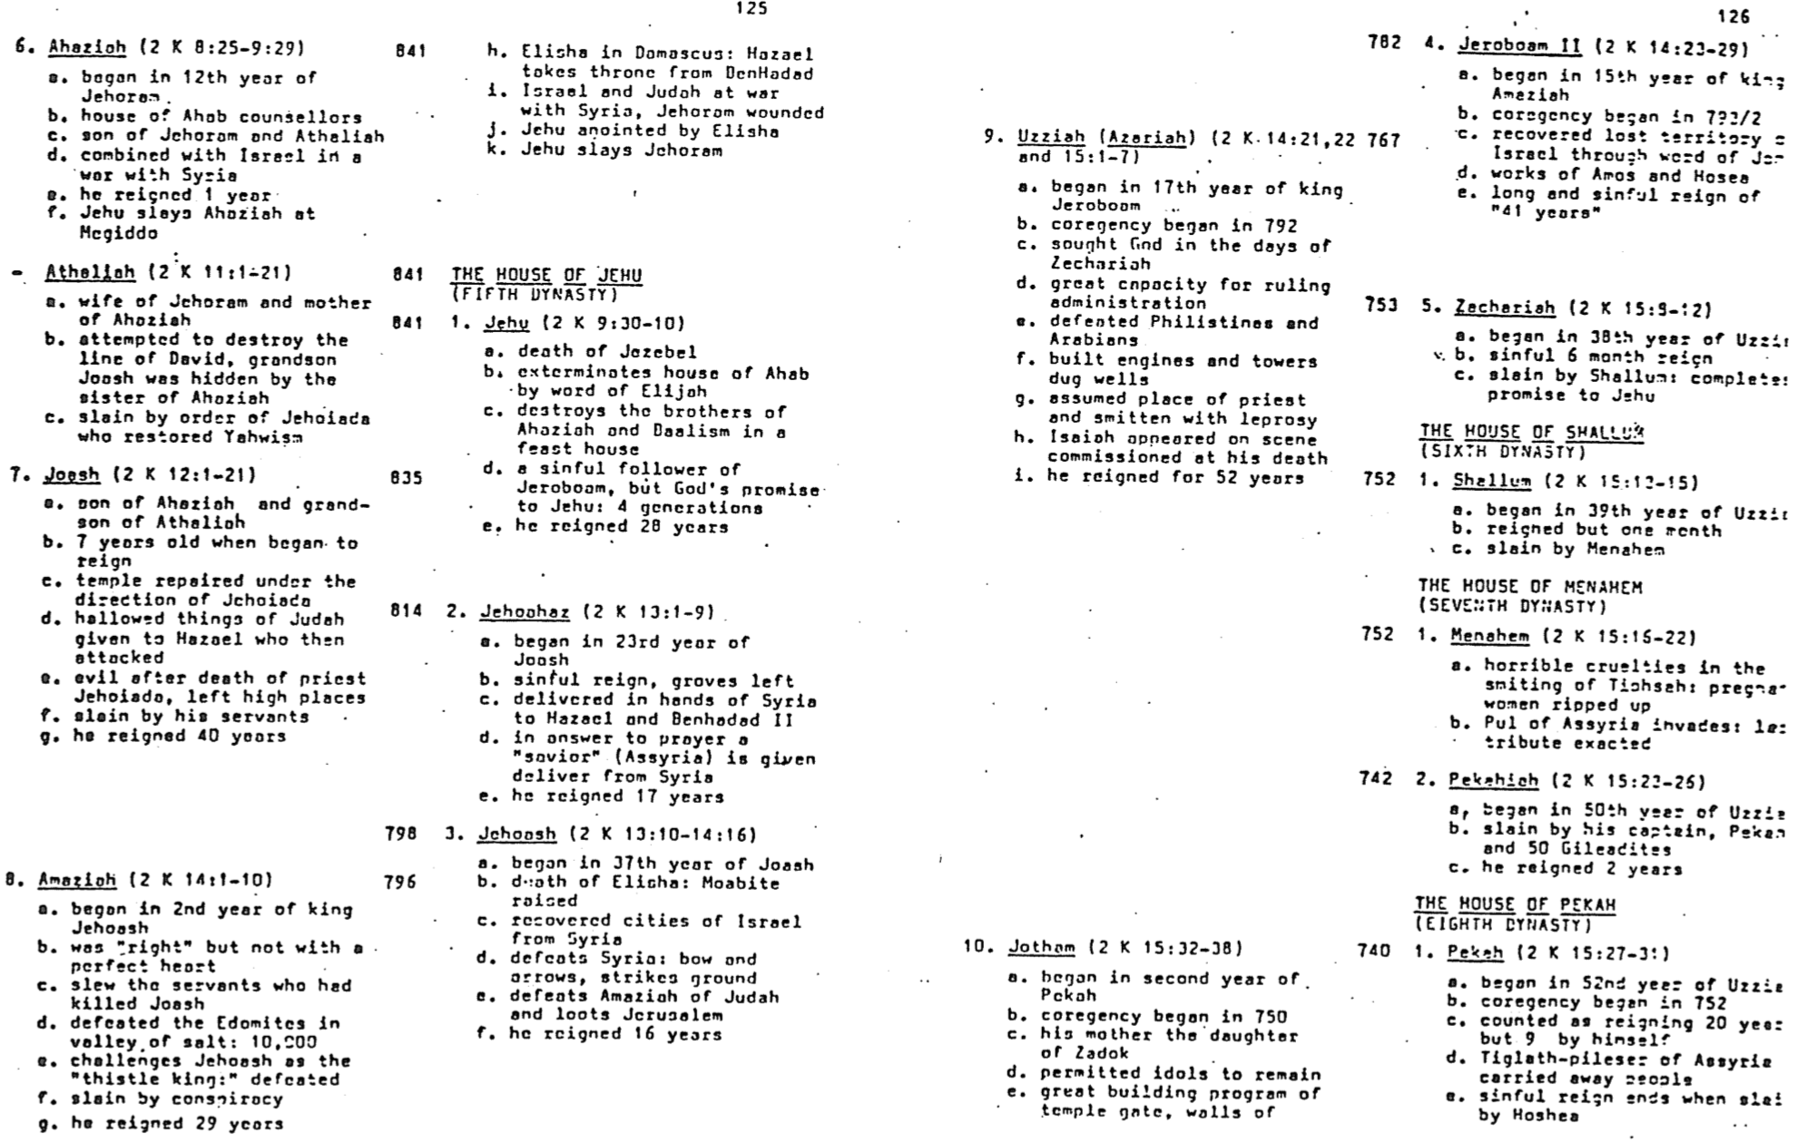

Summaries of the Kings’ Reigns

Allen P. Ross (3 of 3), adapted
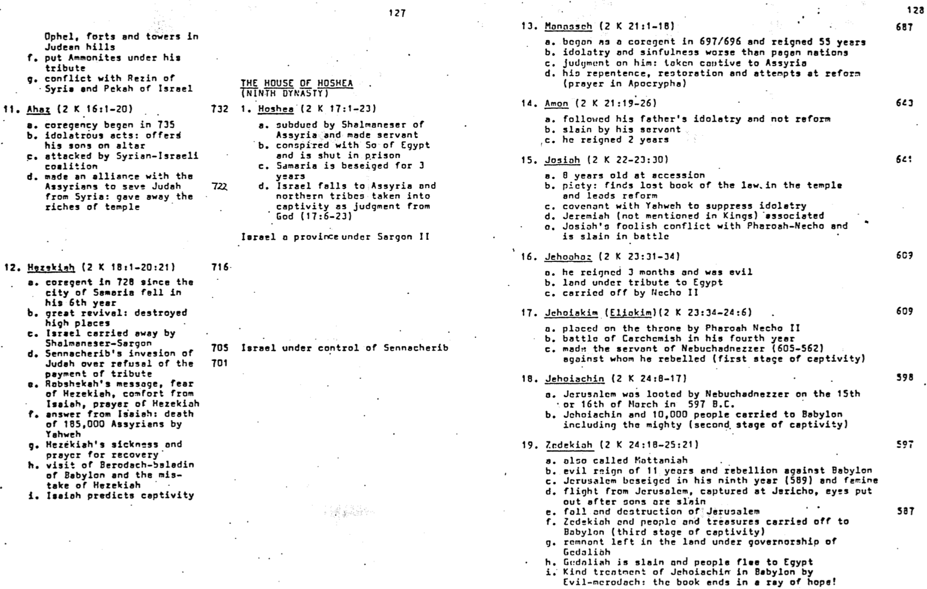

Chronicles Clip #1
C. Zanziper (Brooklyn, New York)
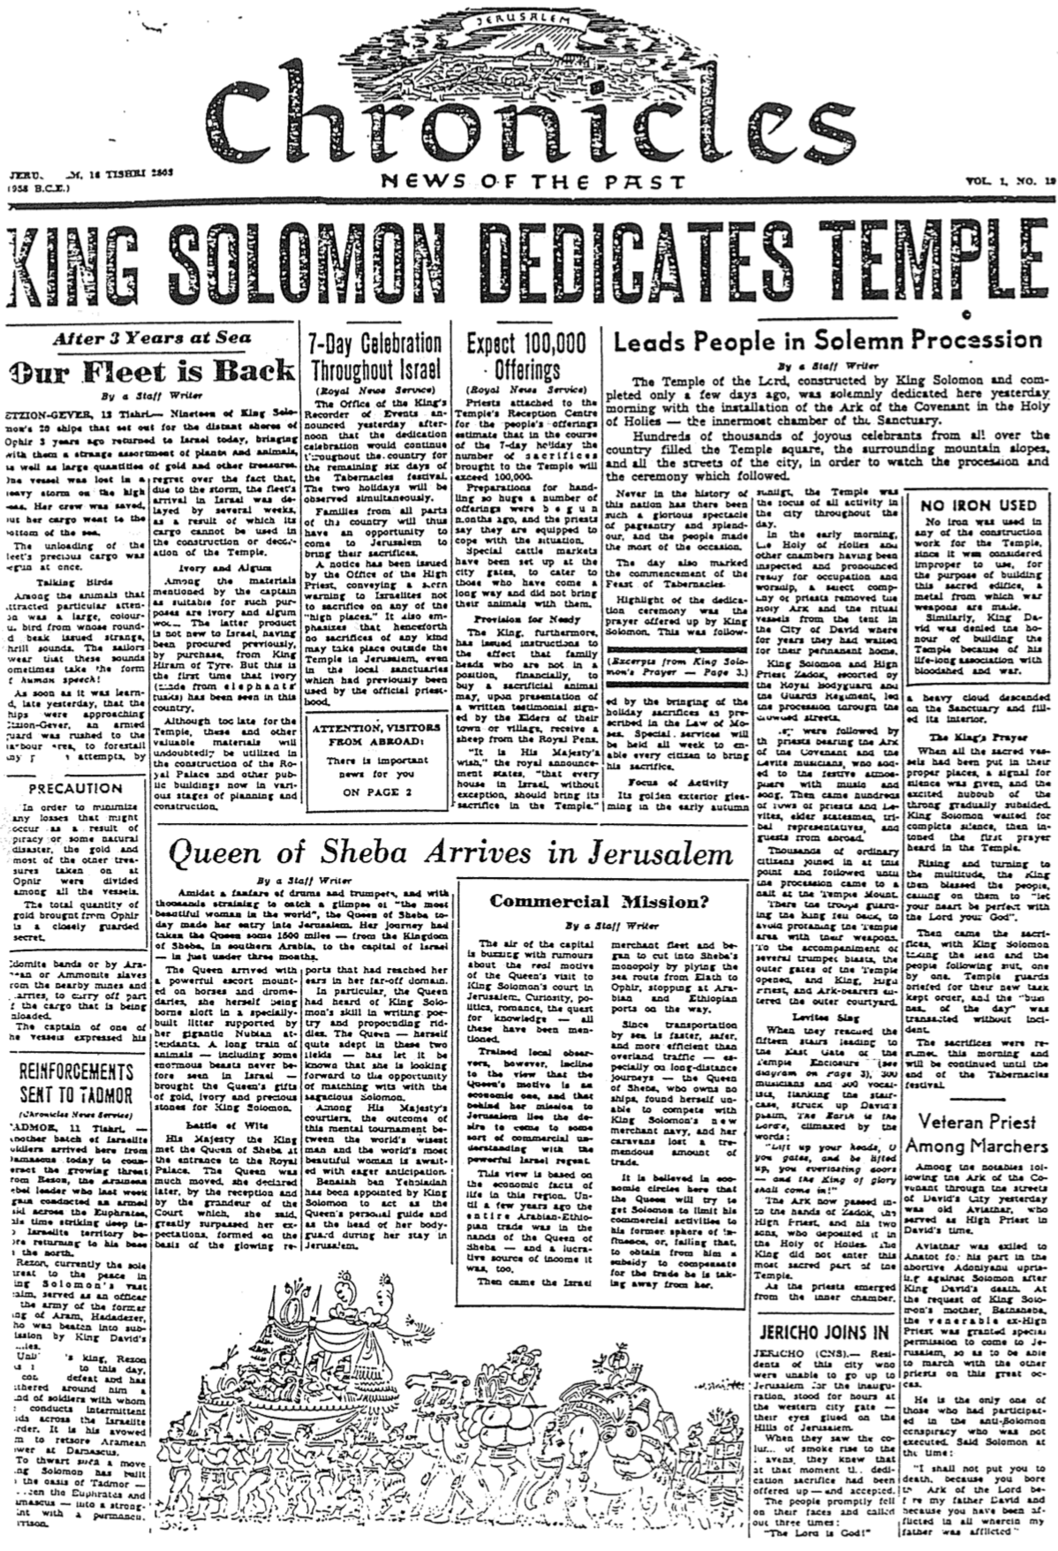

(It’s OK to cover the above title)

Chronicles Clip #2
C. Zanziper (Brooklyn, New York)

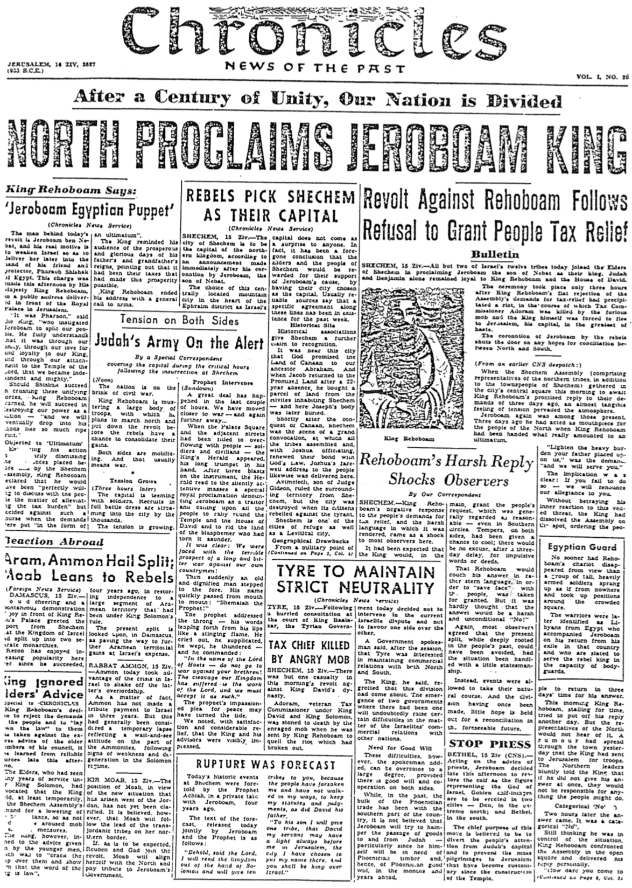
Modern News Clips on Solomon

Newspaper Sources and Dates from Dallas, Texas before 1985
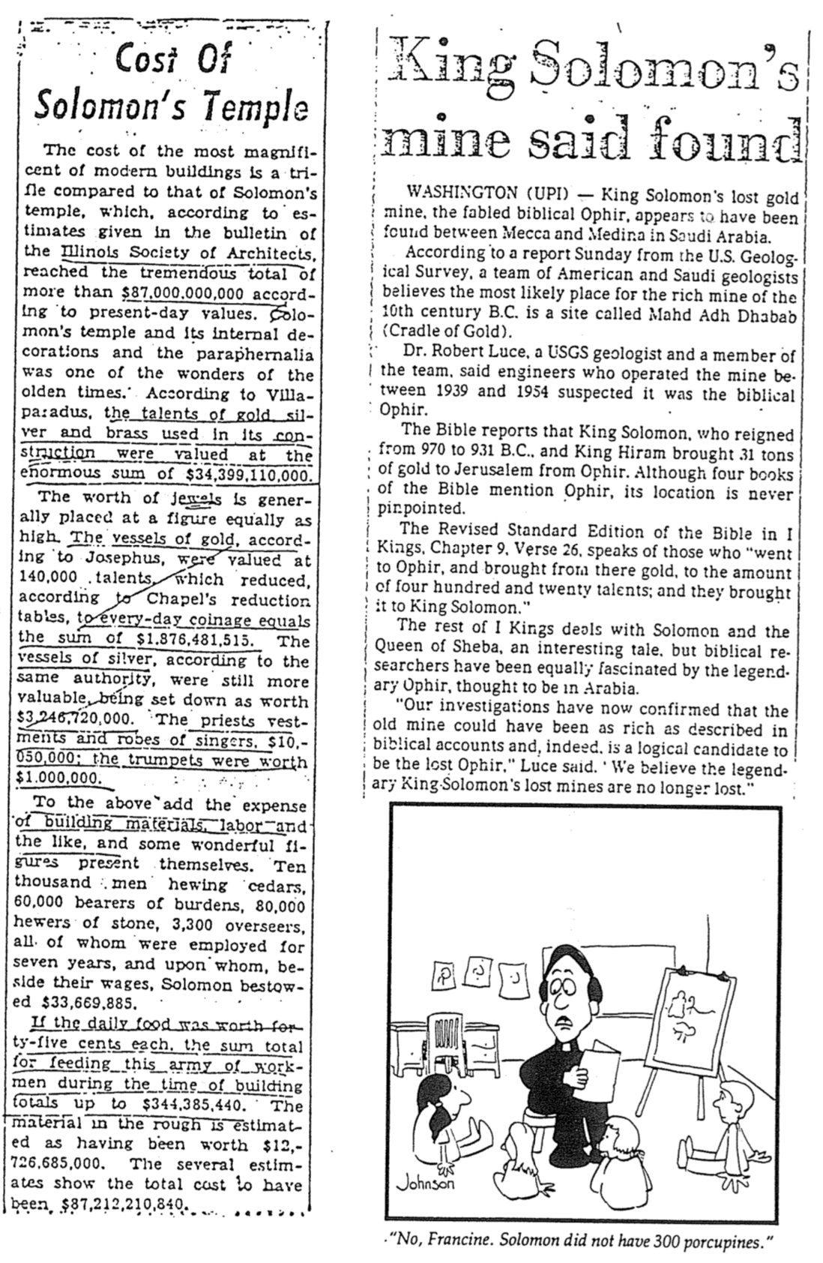

Did God Approve of Solomon’s Polygamy?
Norman Geisler, Ethics: Alternatives and Issues, 204-5
(See also page Error! Bookmark not defined. of these notes)
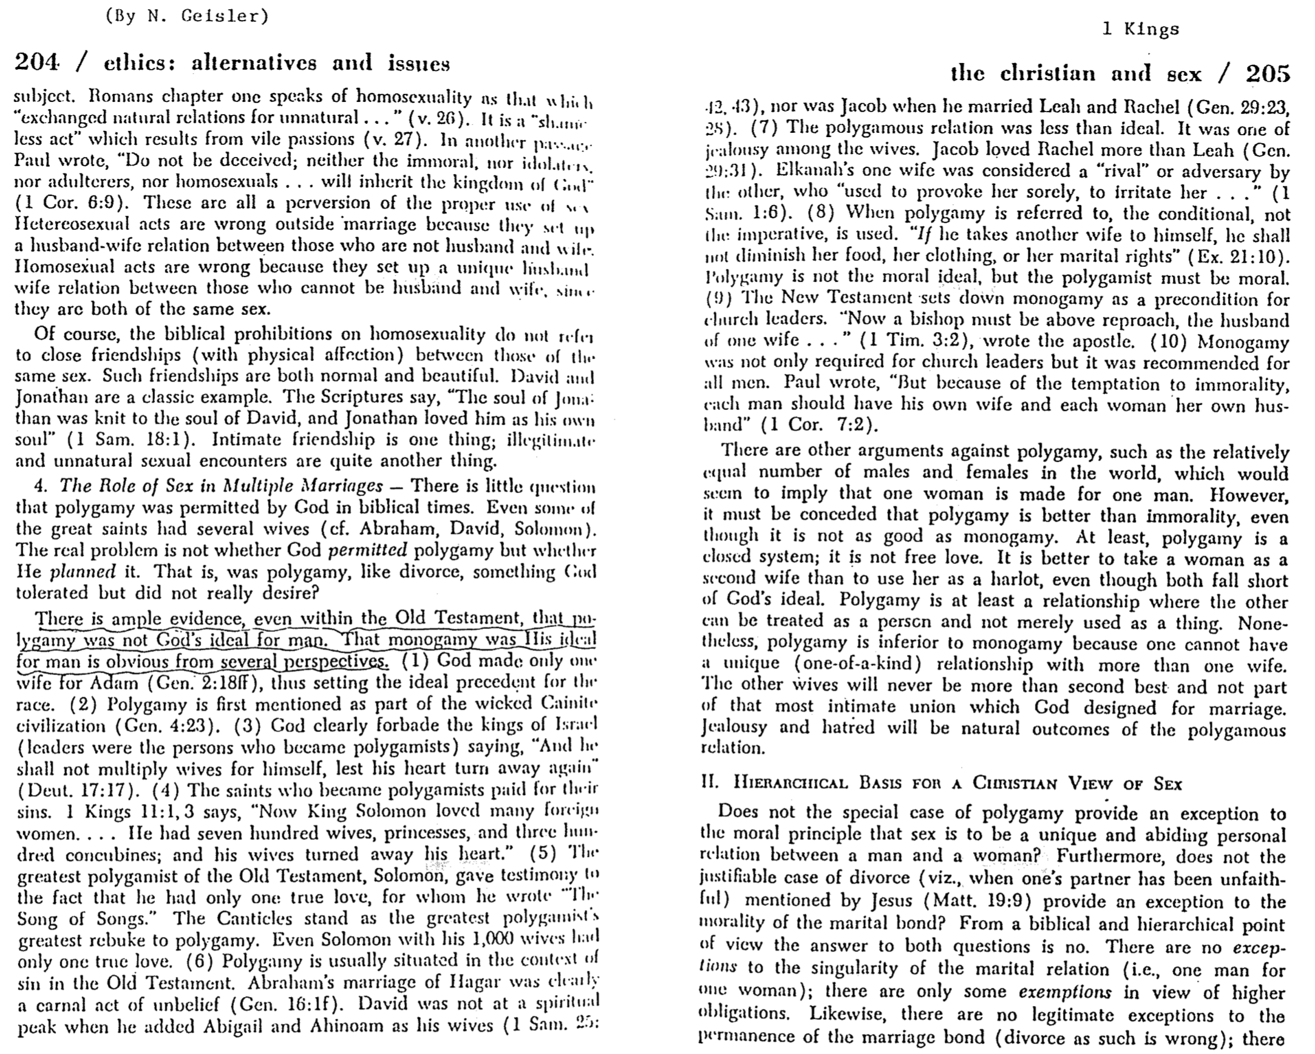

Historicity of David and Solomon
“The Bible in Its Context: A Reliable Record?” (notes based on Prof. Alan Millard, seminar at Biblical Graduate School of Theology, Singapore, 7 Sept 2004)

Introduction

The books of 2 Samuel and 1 Chronicles note that David was a famous king with a large territory.

However, scholars now say David was only a local leader, if he existed. This has become widespread by arguing several points:

The historical books were supposedly written after Alexander the Great (331 BC).

Jews invented these stories at this late date to unify the nation.

No archaeological evidence supports the existence of David and Solomon.

The earliest copies of Kings and Chronicles are the Dead Sea Scrolls (200 BC); therefore, the originals must have been written shortly before this time (which is not very good logic!).

This theory attacking the biblical view has two basic assumptions (neither is proved):

The “book of the law” found during Josiah’s reign is supposed to be Deuteronomy.

Books with a similar style to Deuteronomy are supposed to be copied from Deuteronomy and thus are called Deuteronomistic. These include Joshua, Judges, Samuel, Kings, Jeremiah, and parts of other prophets (e.g., Amos).

Therefore, our task is to determine whether the biblical descriptions of the kingdoms of David and Solomon show that they were written early.

Elements of Early Composition within Kings and Chronicles

Size of Inscriptions

The Assyrian inscriptions of Tiglath-Pileser I (1100 BC) and Sargon (720 BC) are royal writings on prisms. Even though these are 400 years apart, the prism-writing tradition lasted long.

In like manner, the tradition of writing in the style of Deuteronomy could also have lasted hundreds of years. Therefore, literary traits of later prophets, such as Jeremiah, do not prove that Kings and Chronicles were written after 300 BC.

Phrases within Assyrian Inscriptions

The same phrases appear in similar inscriptions hundreds of years later: “I slaughtered them like sheep,” “my god directed me to conquer them,” etc.

The later OT books also reiterate the exact phrases as earlier books. They even go beyond this by giving their sources: “the history of the kings of Judah,” “the history of the kings of Israel,” etc. This listing of sources was unusual for their day and pointed to the historicity of earlier writings such as the Book of Kings.

Non-Chronological Orientation:

David defeated Hadadezer and took control of Damascus (2 Sam. 8:3-10).

He also defeated the Ammonites (2 Sam. 10), but this had occurred earlier. The OT did not always list these accounts in chronological order.

Another example is 2 Kings 18–20, which shows the account of Evil-Merodach out of chronological order. One must remember that stories were sometimes listed by theme rather than chronology.

Evidence of the Large Size of the Kingdoms of David and Solomon

A fragment of an Egyptian monument highlights a victory of Pharaoh Siamun. It shows he captured a city, which may be Gezer, seized from the Canaanites and given to Solomon’s daughter as a wedding present (see Kitchen’s picture at the back of his book, On the Reliability of the OT). This is not conclusive, however.

Why didn't the Assyrians, Babylonians, and people of Tyre mention David or Solomon if they were significant kings?

In Assyria's early days (1000 BC), the kingdom of Israel was small compared with the strong Arameans who had pressed against Assyria from the west.

The 4-5 existing Babylonian inscriptions around 1000 BC only relate to building projects. One would not expect inscriptions about lands far away.

Since Tyre is still presently inhabited, no inscriptions have been discovered there. Also, the original Tyre was an island off the coast. If any letters of Solomon had indeed been kept at Tyre, they would have been on papyrus and thus unable to survive the centuries of destruction and decay.

Many kingdoms have risen and fallen quickly, like the kingdoms of David and Solomon. Therefore, it was not unusual to omit mentioning significant short-lived kingdoms.

Reasons for Lack of Written Inscriptions in Jerusalem

The Ophel Hill (later called the City of David) is the original site of Jerusalem. Its eastern slope was very steep, so houses not in good repair would have crumbled and fallen down the hill. The Steep Stepped Structure, still there, may have supported the hill, as seventh-century houses are built upon it. This is inhabited today, which has hindered excavations. With such decay, it is not surprising that inscriptions have not survived.

But why have excavations in Jerusalem gone on for 150 years, yet very little has been discovered? After the Second Jewish Revolt (132-135 AD), Emperor Hadrian rebuilt Jerusalem as a Roman city, and Ophel Hill was destroyed as it was used as a quarry. Unsurprisingly, no remains of David and Solomon have been found.

But why didn't David and Solomon set up monuments that have been found?

The city of Byblos in Lebanon was the port for cedar wood taken to Egypt. The Pharaoh of Egypt sent a statue of himself to Byblos (similar to Queen Elizabeth giving a signed picture of herself). The inscription on the statue and other inscribed stones there were used as building materials by later conquerors such as the Crusaders for steps, support for wells, etc.

In like manner, those who conquered Jerusalem used any previously inscribed stones in their buildings. They were not concerned about inscriptions that they could not read.

The Tel Dan Inscription in ancient Phoenician mentions the King of Israel from the “House of David” (Arnold/Beyer, 164-65). Others say “House of the Beloved” means devoted to a god. The most ridiculous explanation is that it means “House of the Cooking Pot,” or kitchen! This inscription is the earliest explicit mention of David, so it is inaccurate to claim that no inscriptions mention David.

The excavation of Hazor by Yadin shows a double wall with rooms inside (called casemates), whose pottery dates from the 10th century BC. Solomon fortified Megiddo, Gezer, and Hazor (1 Kings 9). The 1930s excavators of the elaborate gate of Megiddo placed it in the 9th century, but the Hazor gate matched that at Megiddo. Israeli archaeologists argue both are from the 9th century, championed by Israel Finkelstein. However, styles change over time, so various styles of pottery often coexist—no one throws away all the styles from the previous age on a specific date!

Could Solomon have used gold as he did (1 Kings 10)?

Gold was frequently used in utensils in antiquity, and most of these utensils have been pillaged through the ages anyway.

A Pharaoh of 1400 BC gave a golden bowl to his victorious general after a battle.

Assyrians drank wine from golden bowls, inscribed in cuneiform.

Darius also inscribed a golden bowl used in his palace.

Solomon had an ivory-decorated throne with lions on each side (1 Kings 10:18-20). This was common in the Ancient Near East:

Ivories of a calf giving milk to her young stand only 6-7 centimeters and are lined up on a table of a wealthy family.

Table legs in Assyria had ivory linings.

An ivory-lined wooden chair was found in an ancient tomb in Egypt.

King Tut also had a golden throne with lion heads on either side.

Solomon had made golden shields useless in battle as they were too soft (1 Kings 18:17). Critics say this must be an exaggeration.

But a golden dagger has also been discovered.

Also, a discovery of Sargon’s palace shows golden shields that match exactly with Solomon, though 250 years later.

Other second-millennium examples show golden shields in temples for the gods.

Solomon overlaid the entire temple with gold, including walls, ceiling, and floor (1 Kings 6:22). Liberals see this as an exaggeration of the Jewish community that imagined that a golden-covered table eventually became the entire room.

But extensive use of gold was commonplace in Egypt:

A pillar in an Egyptian temple carved to look like papyrus reeds shows deep slits between sections of the pillars. This likely indicates how gold overlaid all the pillars. Thutmose III (1400s BC) notes that he had 14 gold-covered pillars sheathed in gold!

King Tut’s tomb had a gold cabinet enclosing a wooden coffin, which contained an entire gold coffin inside. The pharaoh himself wore a gold mask over his head.

One pharaoh gave over 20 tons of gold to a single temple.

The Oracle of Delphi in Greece had presents from Croesus, King of Lydia, that were made of gold.

Greeks also used gold extensively:

Visitors of the pharaoh brought gold to the Egyptian pharaohs (as if he needed more gold).

The Parthenon in Athens used to have a statue of Athena and even had golden articles on hooks. This made it easy to remove them to pay off a king who attacked the city. A similar incident occurred when Pharaoh Shishak raided Jerusalem and took its shields that Solomon had made.

We should not assume that the ancients attached the same high value to gold as we do in modern times, when gold is far more valuable. The Temple of the Sacred Tooth in Kandy, Sri Lanka, has sheaths of gold provided by worshippers. The Taj Mahal in India is another example.

These examples do not prove that Solomon had extensive gold, as this cannot be proven, but they show that this would not have been out of character for its time.

Conclusion

There exists no explicit evidence for the existence of David and Solomon. However, much circumstantial evidence does exist. “Absence of evidence is not evidence of absence.”

Polygamy in the Line of Judah

Introduction

Polygamy is the practice of a single husband having more than one wife. This is practiced for a variety of reasons, chiefly being men’s sexual desires and desire to have as many sons as possible to continue their lineage and secure their throne.

Since God blessed Adam with Eve in Eden, God’s ideal has always been one woman for one man. However, pagan views of antiquity convinced kings and wealthy men that their strength and blessing were shown in having multiple wives.

How Large were the Families in the Kingdom of Judah?

King | Wives | Concubines | Total | Sons | Daughters | Ref
David | 8+ | Yes | Many | 20+ | Many | 1 Sam 27:3;  2 Sam. 3:2-5; 5:13-16
Solomon | 700 | 300 | 1000 |  |  | 1 Kings 11:3; 1 Chron. 3:10
Rehoboam | 18 | 60 | 78 | 28 | 60 | 2 Chron. 11:21
Abijah | 14 |  | 14+ | 22 | 16 | 2 Chron. 13:21
Jehoram | Many |  |  |  |  | 2 Chron 21:14
Joash | 2 |  |  |  |  | 2 Chron. 24:3

Applications Today

Scripture shows the many problems of deviating from God’s ideal in the Garden of Eden. These problems follow those with multiple sexual partners:

Bitterness and rivalry often resulted from the numerous wives.

Various sons who each had a different mother complicated the second generation, too

.

The blessings of faithfulness to a single partner are numerous:

Lack of guilt—the sexual life of a monogamous husband is blessed (Prov. 5:15-19)

Simplicity in the home rather than jealousy between wives or sexual partners

Do You Agree or Disagree?
To explore your ideas on this vital subject, please mark them as A, U, or D beside each statement below to show whether you agree, are Uncertain, or disagree with the teaching.

God allowed the kings of Judah to marry several wives.

Polygamy is always wrong.

Polygamists who become Christians should divorce the rest of their wives who came after their initial marriage.

Conclusion

In today’s so-called “sexual revolution,” people are honored if they have had multiple sexual partners. The late NBA basketball star Wilt Chamberlain was said to have had sex with over 50,000 women (this averaged three daily during his ages 20-60).

However, man is never happier than when he follows God’s instructions, which applies particularly in the sexual realm.

Elijah’s Travels
Adapted from Donald Campbell, Dallas Theological Seminary (class handout)

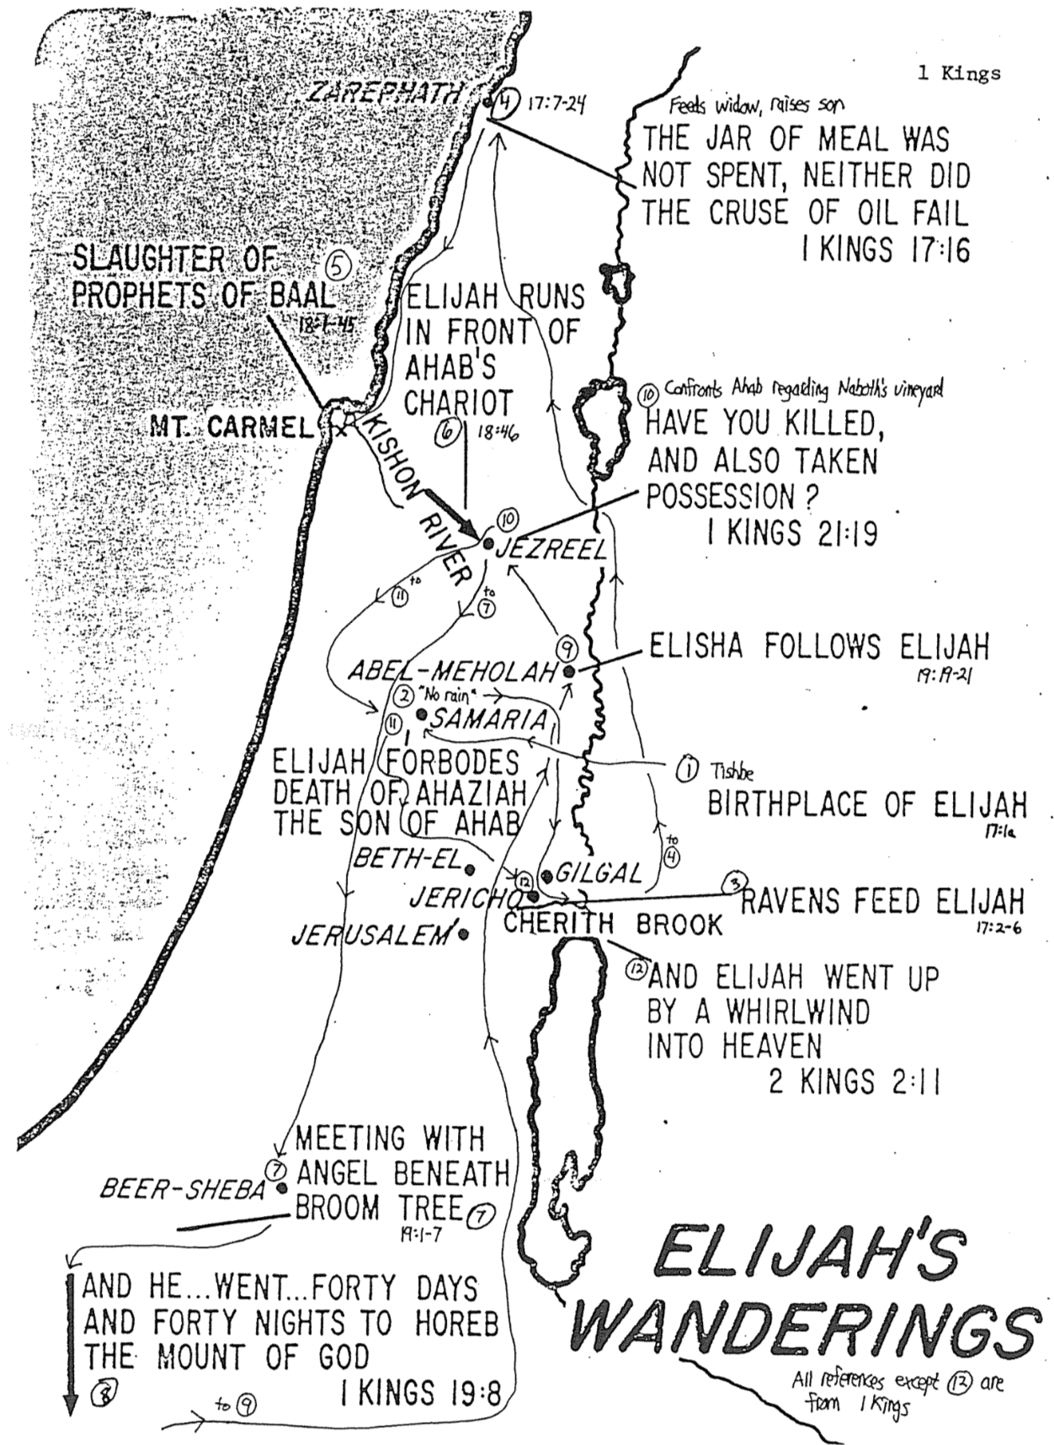

Solomon’s Jerusalem, Elijah and Elisha

The Bible Visual Resource Book, 73

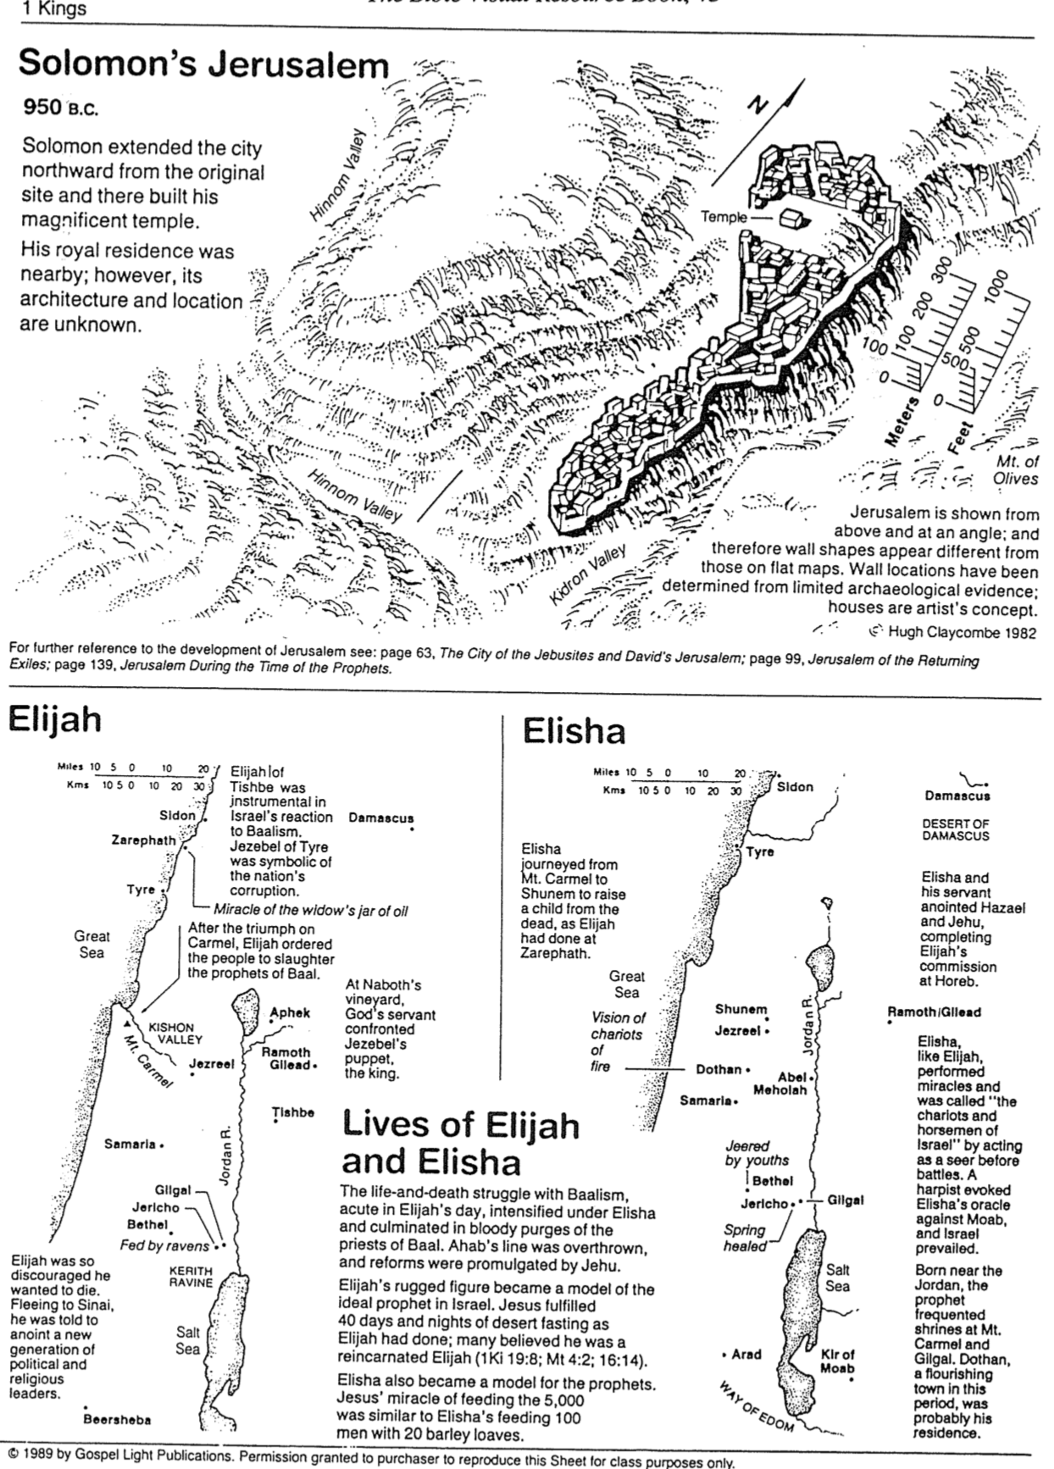

The Appeal of Idols

Life Application Bible, 575

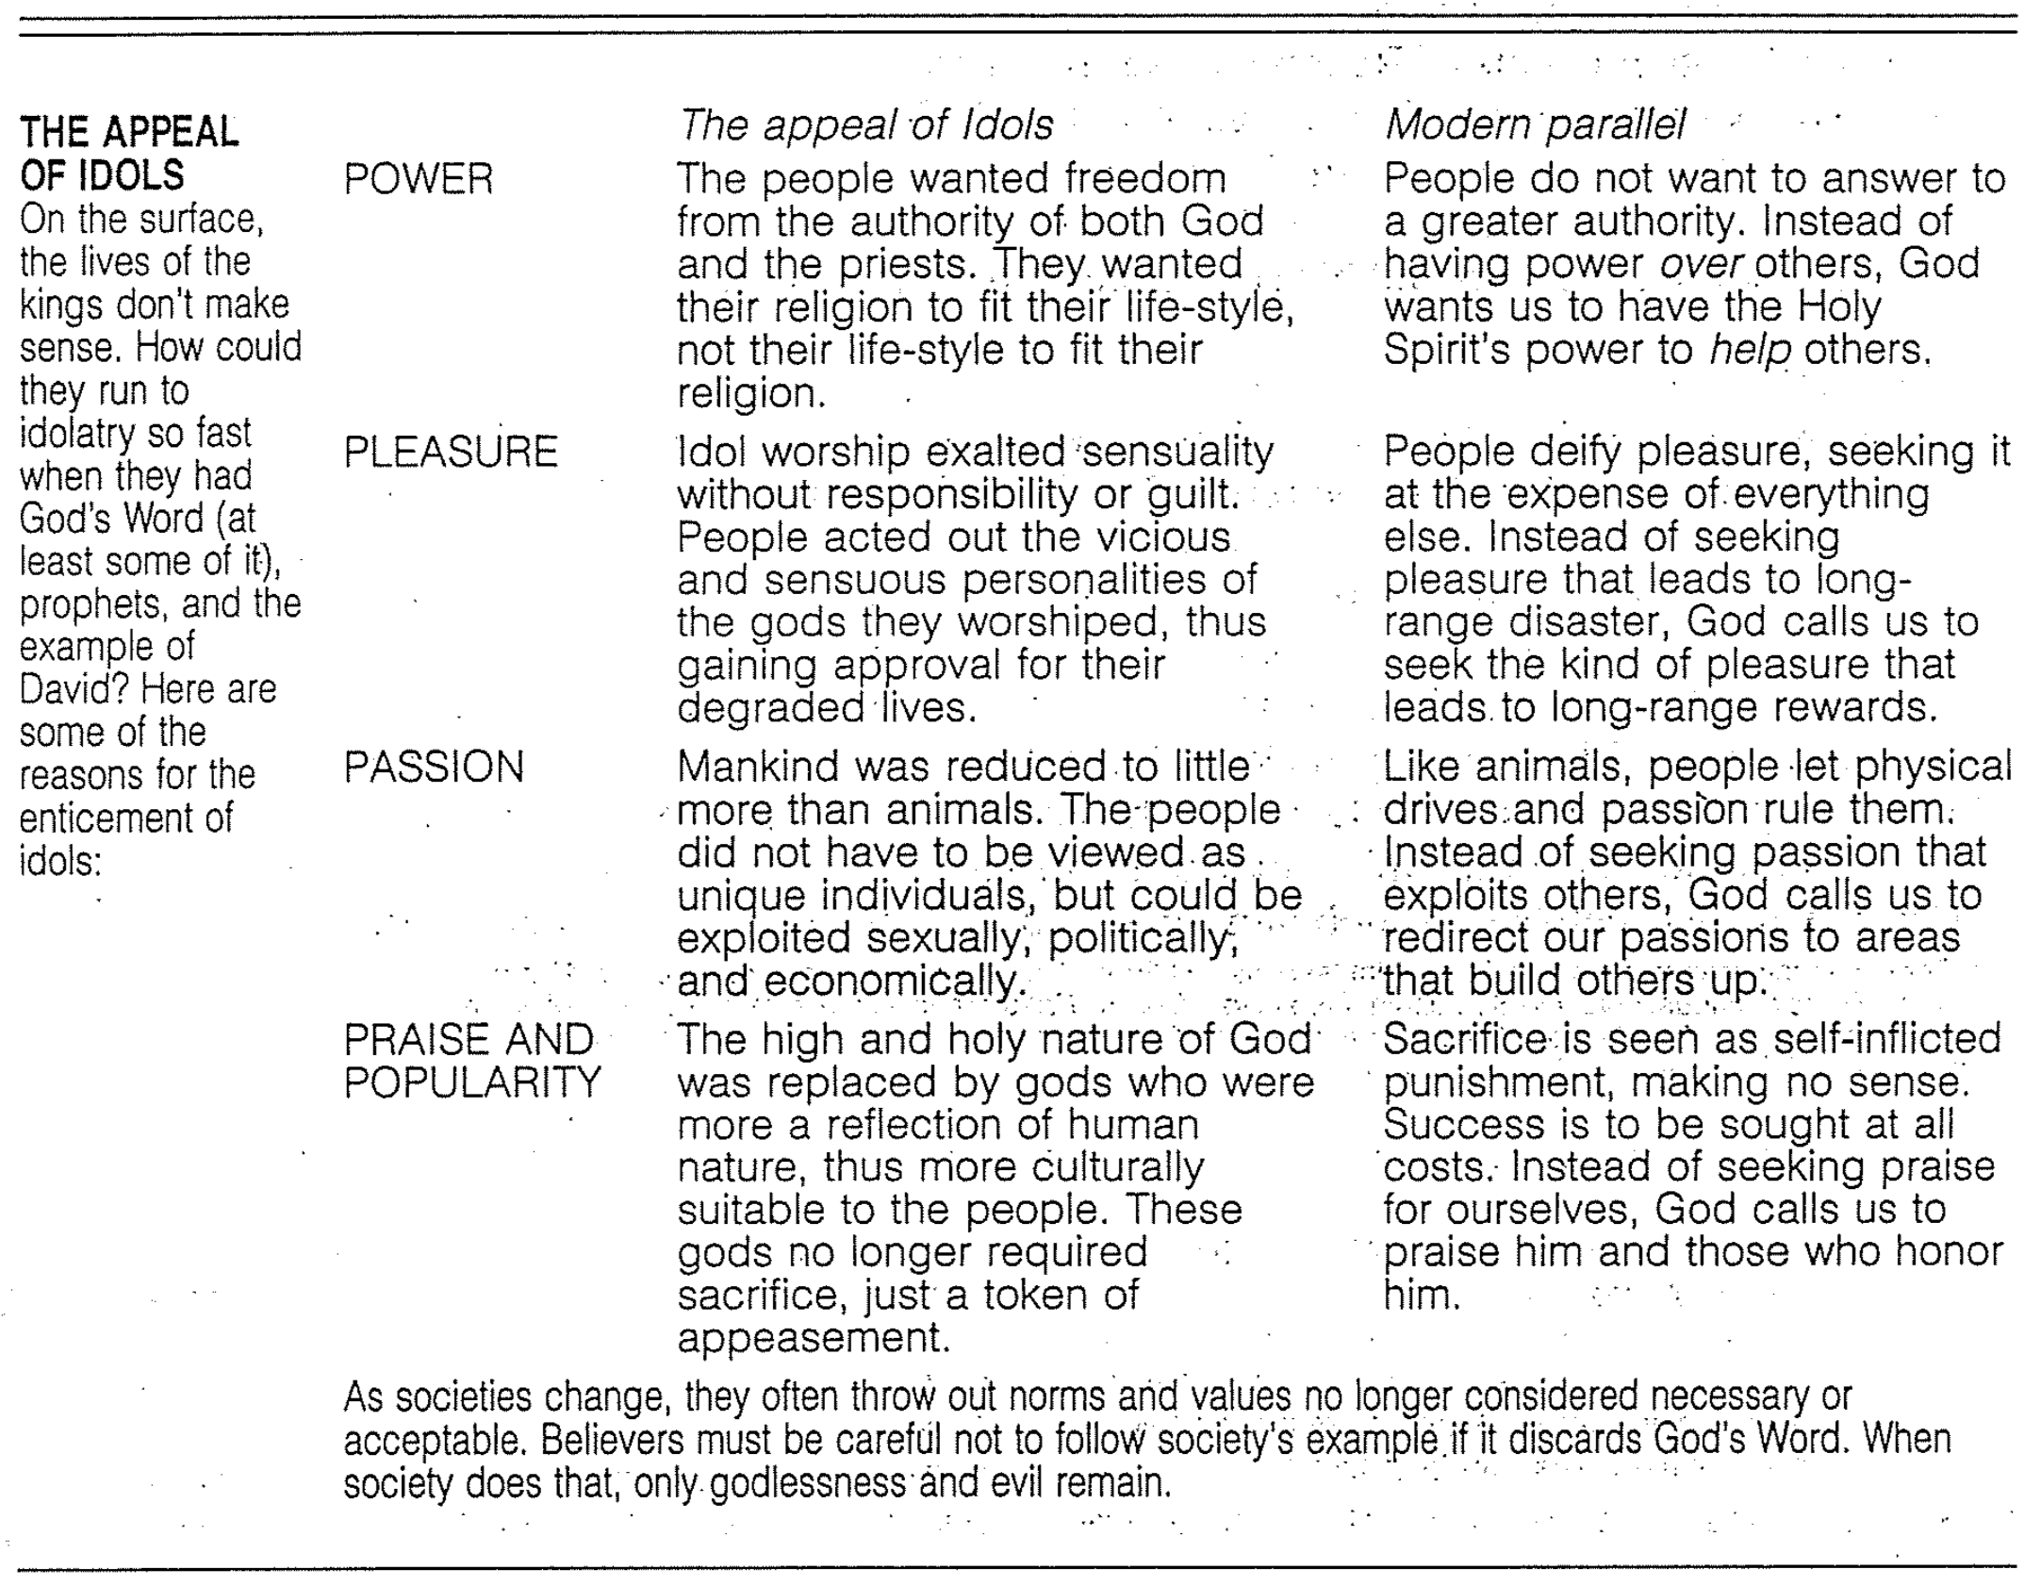

Contrasting Elijah and Elisha
Huang Sabin, OT Made Simple, except * from Leon Wood, A Survey of Israel’s History
and # from J. Hampton Keathley III, Biblical Studies Foundation (www.Bible.org)

Prophets | Elijah | Elisha
Background* | Poor | Wealthy
Emotional  Make-up* | Man of moods—extreme courage & despair | Self-controlled & even-tempered
Kings | Ahab & Ahaziah | Jehoram & Jehu
Nature of Ministry | Mainly public & confrontational with  sins of kings | Mainly private & ministering to people’s needs
Miracles# | 9 | 14
Duration* | 22 years | 50 years
Message | Repentance | Deeds of kindness
Mentored by | God? | Elijah
Mentored | Elisha | Gehazi
Memorable Incident | Confrontation with prophets of Baal at  Mount Carmel | Judgment upon 42 insulting youths at Bethel

Kingdom Crossword Puzzle

Adapted from Mr. Ashley Bryant, International Community School, Singapore (undated)

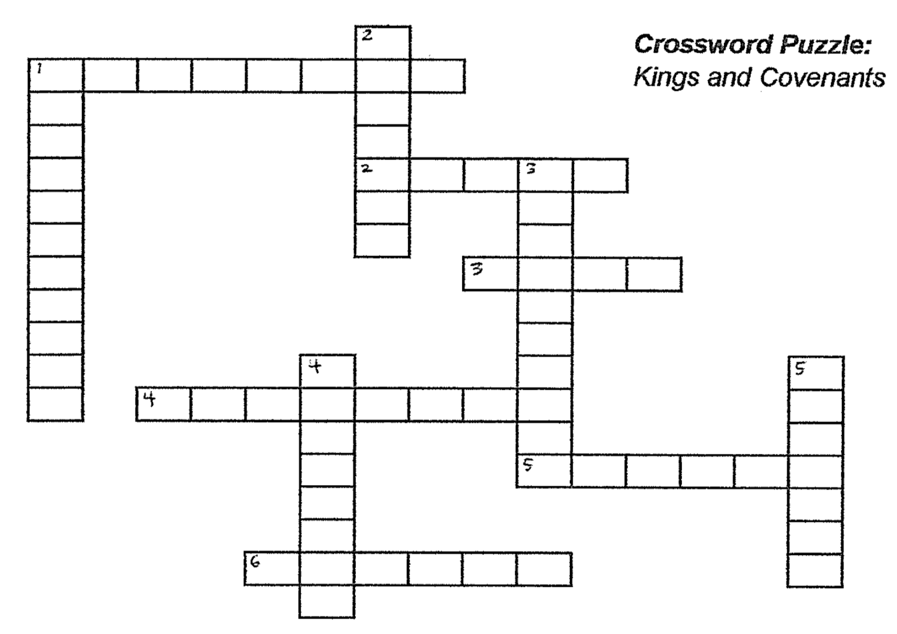



ACROSS

- He was the son of Nabat and a servant of David, who rebelled against Solomon to establish his kingdom, which split the kingdom of Israel (1 Kings 12:3-4)
- This man was God’s choice for king over Israel so that God would establish his kingly line forever (1 Sam. 16:13; 2 Sam. 7)
- He was chosen king by the people because of his stature (1 Sam. 8:19; 10:1)
- How God establishes a relationship of responsibility between Himself and his people. It is a divine promise.
- He anointed both Saul and David as king (1 Sam. 10:1; 16:13)
- God revealed both his promise and his judgment to David through this man (2 Sam. 7:4-7; chapter 12)

DOWN

- The King of kings and Lord of lords who descended from the line of David to establish his kingdom forever (2 Sam. 7; 1 Tim. 6:14-15)
- This is the covenant God established with David, promising him that his throne would be established forever (2 Sam. 7:12-16)
- They wanted a king they could see and touch to rule over them, just like the other nations (1 Sam. 8:19)
- He was the son of Solomon, through whom the line from David to Christ would continue (Matt. 1:7; 1 Kings 12:1)
- He was the son of David, though whom God’s promise to David would continue (1 Kings 1:30)

