Exodus

Formation into a Nation Begun

Chapters 1–18 |  |  |  | Chapters 19–40
Receive Freedom from Slavery |  |  |  | Receive Law from God
Getting Israel Out of Egypt |  |  |  | Getting Egypt Out of Israel
Narration |  |  |  | Legislation
Free People |  |  |  | Government
Subjection |  | Deliverance |  | Instruction
Egypt |  | Wilderness |  | Sinai
400 Years |  | 2 Months |  | 10 Months
Toil & Confrontation  (1–11) |  | Redemption &  Protection  (12–18) |  | Covenant  Revealed  (19–31) |  | Covenant  Ratified  (32–40)
Moses as  Returned Fugitive |  | Moses as  Wilderness Leader |  | Moses as  Intermediary |  | Moses as  Lawgiver
Preparation  (1:1–7:13) | Plagues  (7:14–11:10) | Memorials  (12:1–15:21) | Provisions  (15:22–18:27) | Preparation  (19) | 3-Part Covenant  (20–31) | Broken &  Renewed  (32–34) | Tabernacle  Built/Filled  (35–40)

Key Word: Formation

Key Verse: “Now if you obey me fully and keep my covenant, then out of all nations, you will be my treasured possession. Although the whole earth is mine, you will be for me a kingdom of priests and a holy nation” (Exodus 19:5-6).

Summary Statement:
Israel's formation as a nation begins under God as King by a miraculous redemption from Egypt and revelation of the Mosaic Law to provide a kingdom over which a descendant of Judah could rule and to promote holiness and trust in God.

Application:
We as believers need to remember God’s provisions to form us into a people of God (Christ’s death) and make us individual believers in Christ (specific events God has accomplished on your behalf).

Exodus

Introduction

I. Title The Hebrew title for Exodus is "And These Are the Names" (וְאֵלֶּה שְׁםוֹת we'elleh shemoth), taken from the first phrase which follows ancient custom for naming a text (LaSor, 131). The English title Exodus ("a going out") transliterates the Septuagint title Exodus, a compound word composed of έκ, "out," and ὅδος, "way," meaning an exit, departure, or going out. Although Israel's departure from Egypt constitutes only a few chapters, this is a significant emphasis in the book and, therefore, is a fitting title.

II. Authorship

A. External Evidence: Scripture and tradition have attributed the authorship of Exodus to Moses since the time of Joshua (Josh. 8:30-32). Other persons in Scripture name Moses as the author, including Malachi (Mal. 4:4), the disciples (John 1:45), Paul (Rom. 10:5), and, most importantly, Christ Himself (Mark 7:10 quotes Exod. 3:6; 12:26; cf. Luke 20:37; John 5:46-47; 7:19, 22-23). Jewish and Samaritan traditions also held to Mosaic authorship, although early in the Christian era, some theologians vacillated between Moses and Ezra as the author of the entire Pentateuch (Ross, BKC, 1:15).

B. Internal Evidence: Portions of Exodus are directly attributed to Moses (ch. 15; 17:8-14; 20:1-17; 24:4, 7, 12; 31:18; 34:1-27). This makes sense since no one else could have been better qualified than Moses to write the book. "Moses was educated in all the wisdom of the Egyptians" (Acts 7:22) and had the literary skills necessary to compose such a work. The author was an eyewitness of the Exodus, as the book shows acquaintance with the customs and climate of Egypt and the plants, animals, and terrain of the wilderness (TTTB, 13). The book also evidences a consistency of style characteristic of a single author.

III. Circumstances

A. Date: Mosaic authorship of Exodus places the writing during his lifetime (1525-1405 BC). More specifically, Exodus covers Israel's history only up to the encampment at Mt. Sinai in 1444 BC, assuming the early date of the Exodus. Logically, Moses would have recorded these incidents shortly after these events took place in 1444 BC

B. Recipients: Moses died before Israel entered the Promised Land, so the original readers comprised the Jews in the wilderness with him.

C. Occasion: Since Moses knew that he would be passing on while the nation of Israel continued for generations, he wisely and, under the direction of the Spirit, recorded the history of Israel's birth as the nation that would bring God's rule on the earth (TTTB, 14). This historical work was written to provide the nation with a lasting remembrance of God's work on its behalf, especially in its deliverance from Egypt.

IV. Characteristics

A. Many Bible students are fooled by the book's title, thinking Exodus only records the narrative of Israel's redemption from Egypt. The fuller understanding is that Exodus contains more information about the Passover, the Law, and the Tabernacle than any book in Scripture. Exodus lays the foundation for the entire Mosaic Law.

B. The date of the Exodus falls into two scholarly camps: late-date advocates postulate a 13th-century BC Exodus (ca. 1290 BC, in the reign of Rameses II), and early-date adherents date it in the 15th century BC (ca. 1445 BC, in the reign of Amenhotep II). A comparison of the chronological systems supplements these Exodus notes (pp. 108-110), but the best evidence supports the early date (so more evangelicals advocate it):
1. Scriptural Evidence:

a. 1 Kings 6:1 claims that 480 years transpired between the beginning of Solomon's temple construction (966 BC, the fourth year of his reign) and the Exodus, which dates back to 1446 BC.

b. Judges 11:26 records that Israel had been in the land for 300 years during Jephthah’s life (ca. 1100 BC). Adding the 40-year wilderness wanderings places the Exodus date in the middle of the 15th century BC.

2. Archaeological evidence from Egypt during the 15th century corresponds to the biblical record of the Exodus, which includes the use of bricks and huge building projects. Also, the best evidence indicates that Jericho, Ai, and Hazor were destroyed about 1400 BC.

Argument

The Book of Exodus begins where Genesis concludes–Jacob's family in Egypt awaiting the fulfillment of God's promise initially given to Abraham. Exodus records how God intervenes to fulfill this promise by beginning to form Jacob's family into a nation that operates under God's own rule as a theocracy.

To become a nation, Israel needed three things: (1) freedom, (2) a charter/government, and (3) land. Exodus records two of these three necessities. First, Israel must be free from foreign control to be under God's rule, so Moses records the nation's miraculous redemption from Egyptian bondage in the Exodus (Exodus 1–18). Second, the redeemed nation must have its charter under which God may rule, so the book's latter half reveals the Mosaic Covenant and the nation's agreement to its terms (Exodus 19–40). The only characteristic of a nation lacking is a land secured in the Book of Joshua. The final verses (40:34-38) demonstrate that God accepts the Covenant by agreeing to dwell among the people as King. Exodus does not simply record historical events but does so to reveal Israel's sin and motivate the people to trust in God, who demonstrates his sovereignty over Egypt and faithfulness to his covenant given to Abraham.

Synthesis

Formation into a nation begun National Elements:

1–18 Receive Freedom People
1–11 Toil and Moses confronts Pharaoh
1 Redemption needed
2–4 Moses prepared
5–11 The LORD introduced in confrontation
5:1–6:12 Words - Work
6:13-27 Genealogy
6:28–7:13 Rods
7:14–11:10 Plagues
7:14-25 1 Blood
8:1-15 2 Frogs
8:16-19 3 Gnats
8:20-32 4 Flies
9:1-7 5 Livestock
9:8-12 6 Boils
9:13-35 7 Hail
10:1-20 8 Locusts
10:21-29 9 Darkness
11 10 Firstborn
12–18 Redemption and protection
12:1–15:21 Memorials
12 Passover
13:1-16 Consecration
13:17–14:31 Sea
15:1-21 Songs
15:22–18:27 Wilderness provisions
15:22-27 Marah/Elim water
16 Manna/Quail/Sabbath
17:1-7 Rock water
17:8-16 Amalekites
18 Jethro

19–40 Receive Law Government
19–31 Covenant revealed
19 Preparation
20–31 Covenant in three parts:
20:1-21 1 Decalogue
20:22–24:18 2 Book of the Covenant–holiness
25–31 3 Ceremonial regulations–worship via priests
25–27 Tabernacle
28–29 Priests
30–31 Service/Sabbath
32–40 Covenant ratified
32 Israel breaks
33–34 God renews
35–40 Tabernacle built/filled

Outline

Summary Statement for the Book
The reason God begins to form Israel into a nation by delivering her from Egypt and giving her the Law and Tabernacle is to motivate holiness as a priestly kingdom where God dwells as King.

The reason God begins to form Israel into a nation by delivering her from Egypt and preserving her in the wilderness is for her to see God’s care and power over Egypt’s gods (Chs. 1–18).

God uses Moses to urge Pharaoh to free Israel from slavery to show Israel that the LORD cares, is faithful to the Abrahamic Covenant, and is sovereign over Egypt’s gods (Chs. 1–11).

Egypt’s enslavement of Israelites and attempt to kill their newborn boys shows Israel's need for redemption from bondage to become a nation of promise in its land (Ch. 1).

God's preparation of Moses as Israel's leader despite his inadequacy shows Israel’s need to trust in God's adequacy and faithfulness to the Abrahamic Covenant (Chs. 2–4).

God prepares Moses to lead Israel through his upbringing by his mother and Pharaoh's household and his self-imposed forty-year desert exile as a shepherd to convey that God is committed to the Abrahamic Covenant (Ch. 2).

God calls Moses back to Egypt to lead Israel out despite his inadequacy to remind Israel to trust in God’s adequacy as it prepares to conquer Canaan (3:1–4:17).

Moses returns to Egypt and Israel accepts him as leader to recall for the nation God's concern for the suffering of his people (4:18-31).

Moses confronts Pharaoh with words and signs to affirm God will lead Israel from Egypt, but his refusal shows that God is sovereign over Pharaoh and Egypt’s gods (Chs. 5–11).

Moses confronts Pharaoh with words alone, but Israel gets more work, and Moses despairs at the rejection of the Israelite foremen to teach Israel the cost to follow the sovereign LORD (5:1–6:12).

The genealogy of Moses and Aaron reveals their prominent position before Pharaoh and Israel (6:13-27).

Moses confronts Pharaoh with the miracle of Aaron's rod becoming a snake and Pharaoh's magicians duplicate it but Aaron's snake eats their snakes to show the LORD’s superior power (6:28–7:13).

Moses confronts Pharaoh with ten plagues that show the LORD's sovereignty over Egypt’s gods (cf. 12:12) and reminds Israel to rely upon God’s strength (7:14–11:10).

The water becoming blood shows God sovereign over Hapi (god of the Nile), Khnum (guardian of the river's source), Osiris (the Nile was his bloodstream), Hapi (god of crocodiles), and various fish-deities (7:14-25).

The frog plague shows God sovereign over Heqet, goddess of birth with a frog head (8:1-15).

The gnat plague shows God sovereign over Set, god of desert or earth (8:16-19).

The fly plague shows God sovereign over Re, a sun god (or possibly the god Uatchit, perhaps represented by the fly) (8:20-32).

The livestock deaths show God sovereign over Hathor (goddess with a cow head), Apis (bull god and symbol of fertility), and other gods associated with bulls and cows (9:1-7).

The boils plague shows God sovereign over Sekhmet (goddess of power over disease), Sunu (pestilence god), and Isis (goddess of healing) (9:8-12).

The hail, thunder, and lightning plague shows God sovereign over Nut (sky-goddess), Osiris (god of crops and fertility), Set (god of storms), and Shu (god of the atmosphere) (9:13-35).

The locust plague shows God sovereign over Serapia (protector of locusts), Nut (sky goddess), and Osiris (god of crops and fertility) (10:1-20).

The darkness plague shows God sovereign over Re, Amon-Re, Aten, Atum, Harakite, Horus (sun-gods), Thoth (moon-god), Nut, and Hathor (sky-goddesses) (10:21-29).

The death of all firstborn men and animals shows God sovereign over all of Egypt's gods, especially Min (god of reproduction), Heqet (goddess who attended women at childbirth), Isis (goddess who protected children), and Pharaoh's firstborn son, also considered a “god” (Ch. 11).

God redeems Israel from Egypt and protects them in the desert to show his sovereignty, ability, and care for the nation until she has her land (Chs. 12–18).

Israel celebrates the first Passover in her redemption from Egypt, the consecration of her firstborn, and Moses’s and Miriam’s songs to recall God’s sovereign care (12:1–15:21).

The Passover plague on the firstborn and freedom from bondage shows God's sovereignty and unique concern for Israel, his covenant community (Ch. 12).

The tenth plague kills the firstborn in Egypt while Israel is redeemed through the Passover to verify God's unique concern for his people (12:1-30).

Pharaoh demands that Israel leave that very night—precisely 430 years of dwelling in Egypt and Canaan (1875-1445 BC; cf. Samaritan Pentateuch & LXX on 12:40)—to show God's sovereign control for his people (12:31-43).

God restricts future Passovers only to Israelites and circumcised proselytes to convey that people outside the covenant community have no reason to celebrate since they are not under the blood (12:43-51).

God commands the consecration of the firstborn sons of Israel as a perpetual reminder of their deliverance by God in the tenth plague (13:1-16).

The miraculous crossing of the Sea of Reeds and the death of the pursuing Egyptians show God's sovereign redemption of Israel from their power (13:17–14:31).

Moses and Miriam lead Israel in praising God through songs of redemption as a permanent musical tribute to God's sovereign work in the Exodus (15:1-21).

God miraculously protects Israel from Egypt to Mount Sinai to show his concern and ability to care for the nation until she has her land (15:22–18:27).

The miracles of sweetening the bitter water at Marah and providing the waters of Elim show God’s ability and concern to protect his people from thirst (15:22-27).

The miracles of manna and quail show God’s ability and concern to deliver his people from hunger (Ch. 16).

The miracle of water from a rock shows God’s ability and concern to protect his people from thirst again (17:1-7).

The miracle of defeating the Amalekites shows God’s ability and concern to protect his people from destruction by enemies (17:8-16).

The wise counsel of Jethro shows God’s ability and concern to protect his people from chaos resulting from an overburdened Moses (Ch. 18).

The reason God begins to form Israel into a nation by giving the Law and filling the new tabernacle is to motivate holiness in a kingdom where God dwells as King (Chs. 19–40).

God reveals his Law to his prepared people through Moses to motivate them to holy living in a unique covenantal relationship with a holy God (Chs. 19–31).

Israel prepares to receive God's covenant on Mount Sinai by agreeing to its terms and sanctifying themselves to be mediators for pagan nations as a kingdom of priests (Ch. 19).

The covenant’s three parts (Decalogue, Book of the Covenant, and ceremonial regulations) reveal Israel’s sin in contrast to God's holiness (Chs. 20–31).

The Decalogue (Ten Commandments) condemns Israel by revealing its sin in contrast to God's righteousness (20:1-21).

God recalls Israel’s redemption from Egypt as the basis for the ten commands (20:1-2).

Ten commandments in both vertical and horizontal relationships condemn the nation by revealing its sinfulness in contrast to God's holiness (20:3-17).

The people remain at a distance for fear of God (20:18-21).

The Book of the Covenant provides various stipulations to motivate Israel to holy living as a theocracy where God dwells as King (20:22–24:11).

Social, moral, religious, and conquest stipulations motivate Israel to holy living in a special covenantal relationship with God (20:22–23:33).

The people confirm the covenant to make Israel a theocracy—a government ruled by God (24:1-11).

The ceremonial regulations show Israel that proper worship must be through divinely appointed priests who serve at the Tabernacle (24:12–31:18).

Moses climbs Sinai to receive two stone tablets that contain the Decalogue and commands for Israel's worship (24:12-18).

Instructions on how to build the Tabernacle describe its pieces and furniture to prepare for God to live among his people (Exod 25–27).

Instructions on God’s appointed priests specify their clothing and consecration to represent the people before God in the nation's religious life (Exod 28–29).

Instructions on the tabernacle service convey how to use the tabernacle and the importance of the sign of the covenant—the Sabbath (Exod 30–31).

Epilogue (31:18) Moses receives two stone tablets to witness the strict obedience to God's covenant.

God dwells with Israel in his newly constructed Tabernacle after Israel breaks the covenant and then repents to show the gracious hand of God who dwells as King (Chs. 32–40).

Israel breaks the covenant by worshipping a golden calf despite agreeing not to worship idols (cf. 20:4-6), which is recorded to teach the nation not to revert to old ways (Ch. 32).

God renews the covenant after Israel repents and Moses prays for the nation to teach Israel that God is faithful to his promises (Chs. 33–34).

The people repent when they hear from Moses that God will not accompany them to the Promised Land (33:1-6).

Moses prays for God's presence to attend the nation and even sees some of God's glory (33:7-23).

God renews the covenant on two new stone tablets that Moses chisels out and inscribes to teach Israel that God is faithful to his promises (Ch. 34).

Israel obeys the covenant by building the Tabernacle precisely as God intends so that his glory fills it to show his guiding presence and rule as King (Chs. 35–40).

The people obey the covenant by giving many offerings to construct the Tabernacle (35:1–36:7).

The tabernacle and courtyard are built with their furnishings and priestly clothes, then inspected and erected precisely as God intends (36:8–40:33).

The tabernacle is erected with its curtains, boards, and veils (36:8-38).

The tabernacle furnishings are erected: the ark, the table of showbread, the gold lampstand, and the altar of incense (Ch. 37).

The courtyard furnishings are erected: the altar of burnt offerings and the bronze basin (38:1-8).

The courtyard itself is erected (38:9-20).

The priestly garments are fashioned for Aaron and his sons (39:1-31).

Moses inspects the Tabernacle and blesses it as completed as God commanded (39:32-43).

The tabernacle is erected (40:1-33).

God's glory fills the Tabernacle in a cloud and remains a sign of his guiding presence and rule as King (40:34-38).

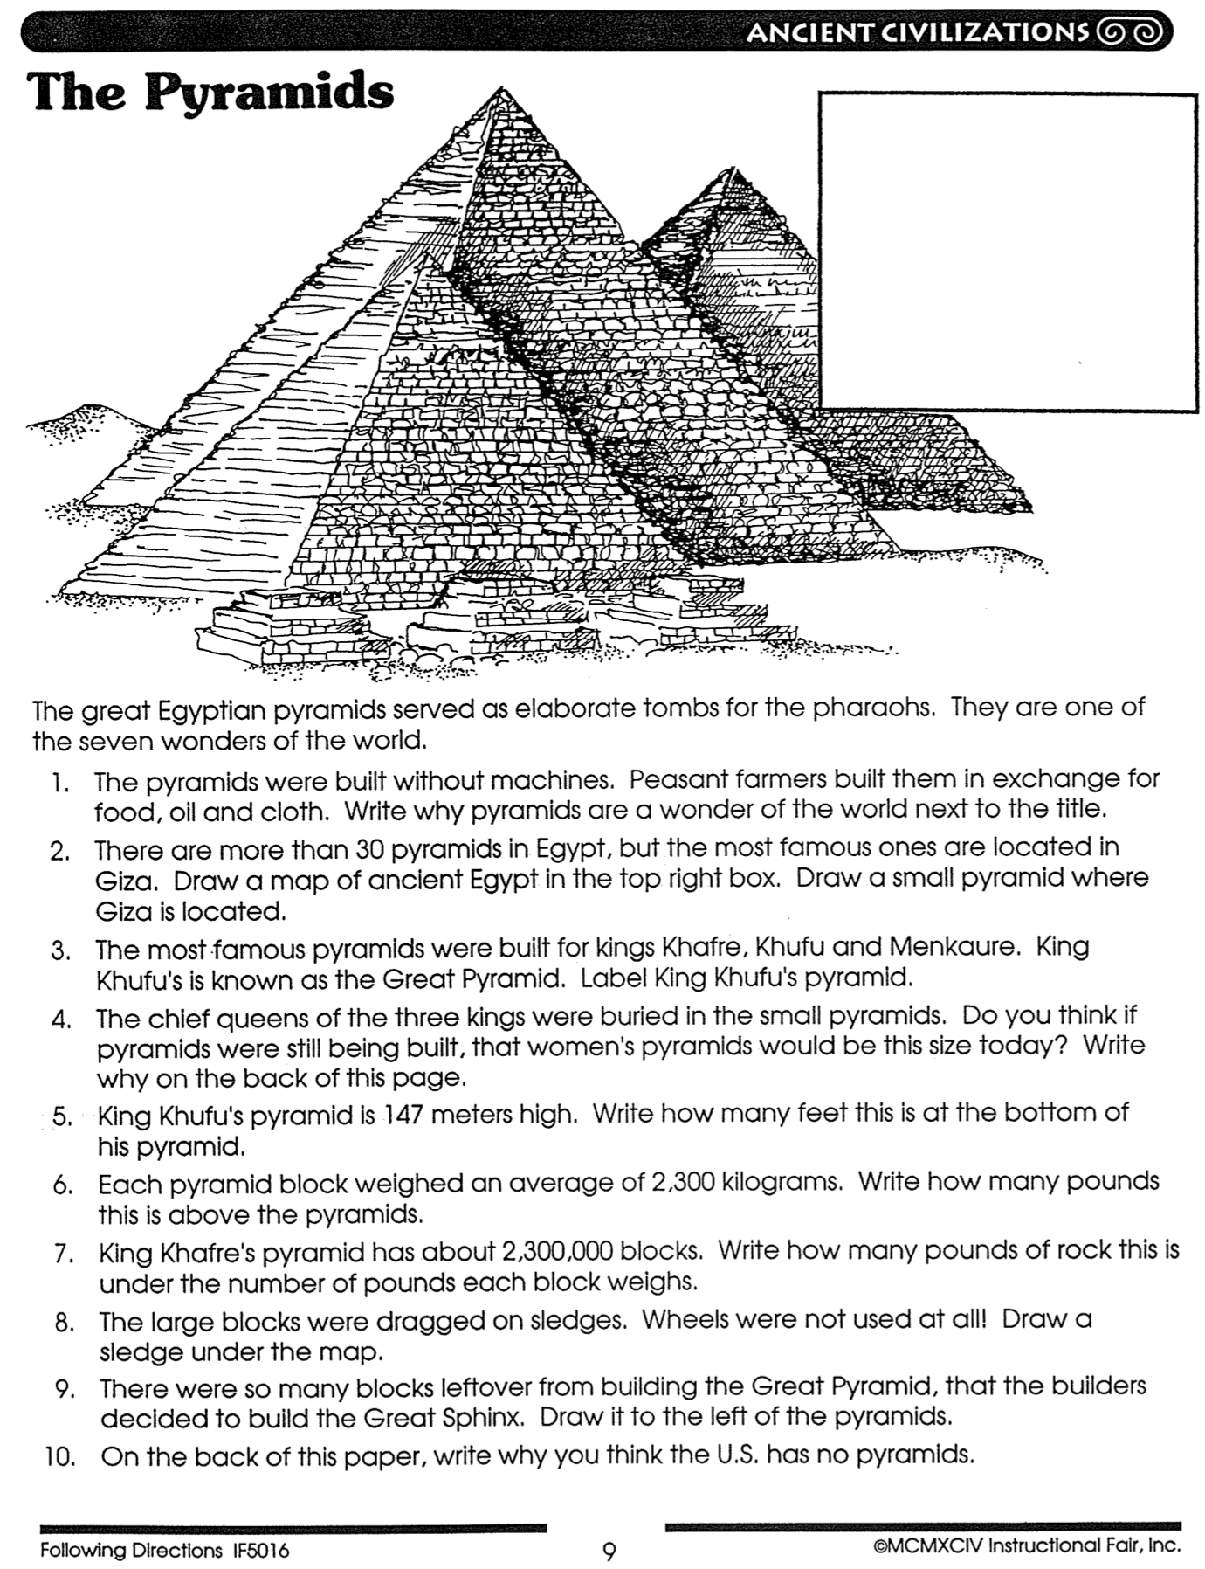
The Pyramids

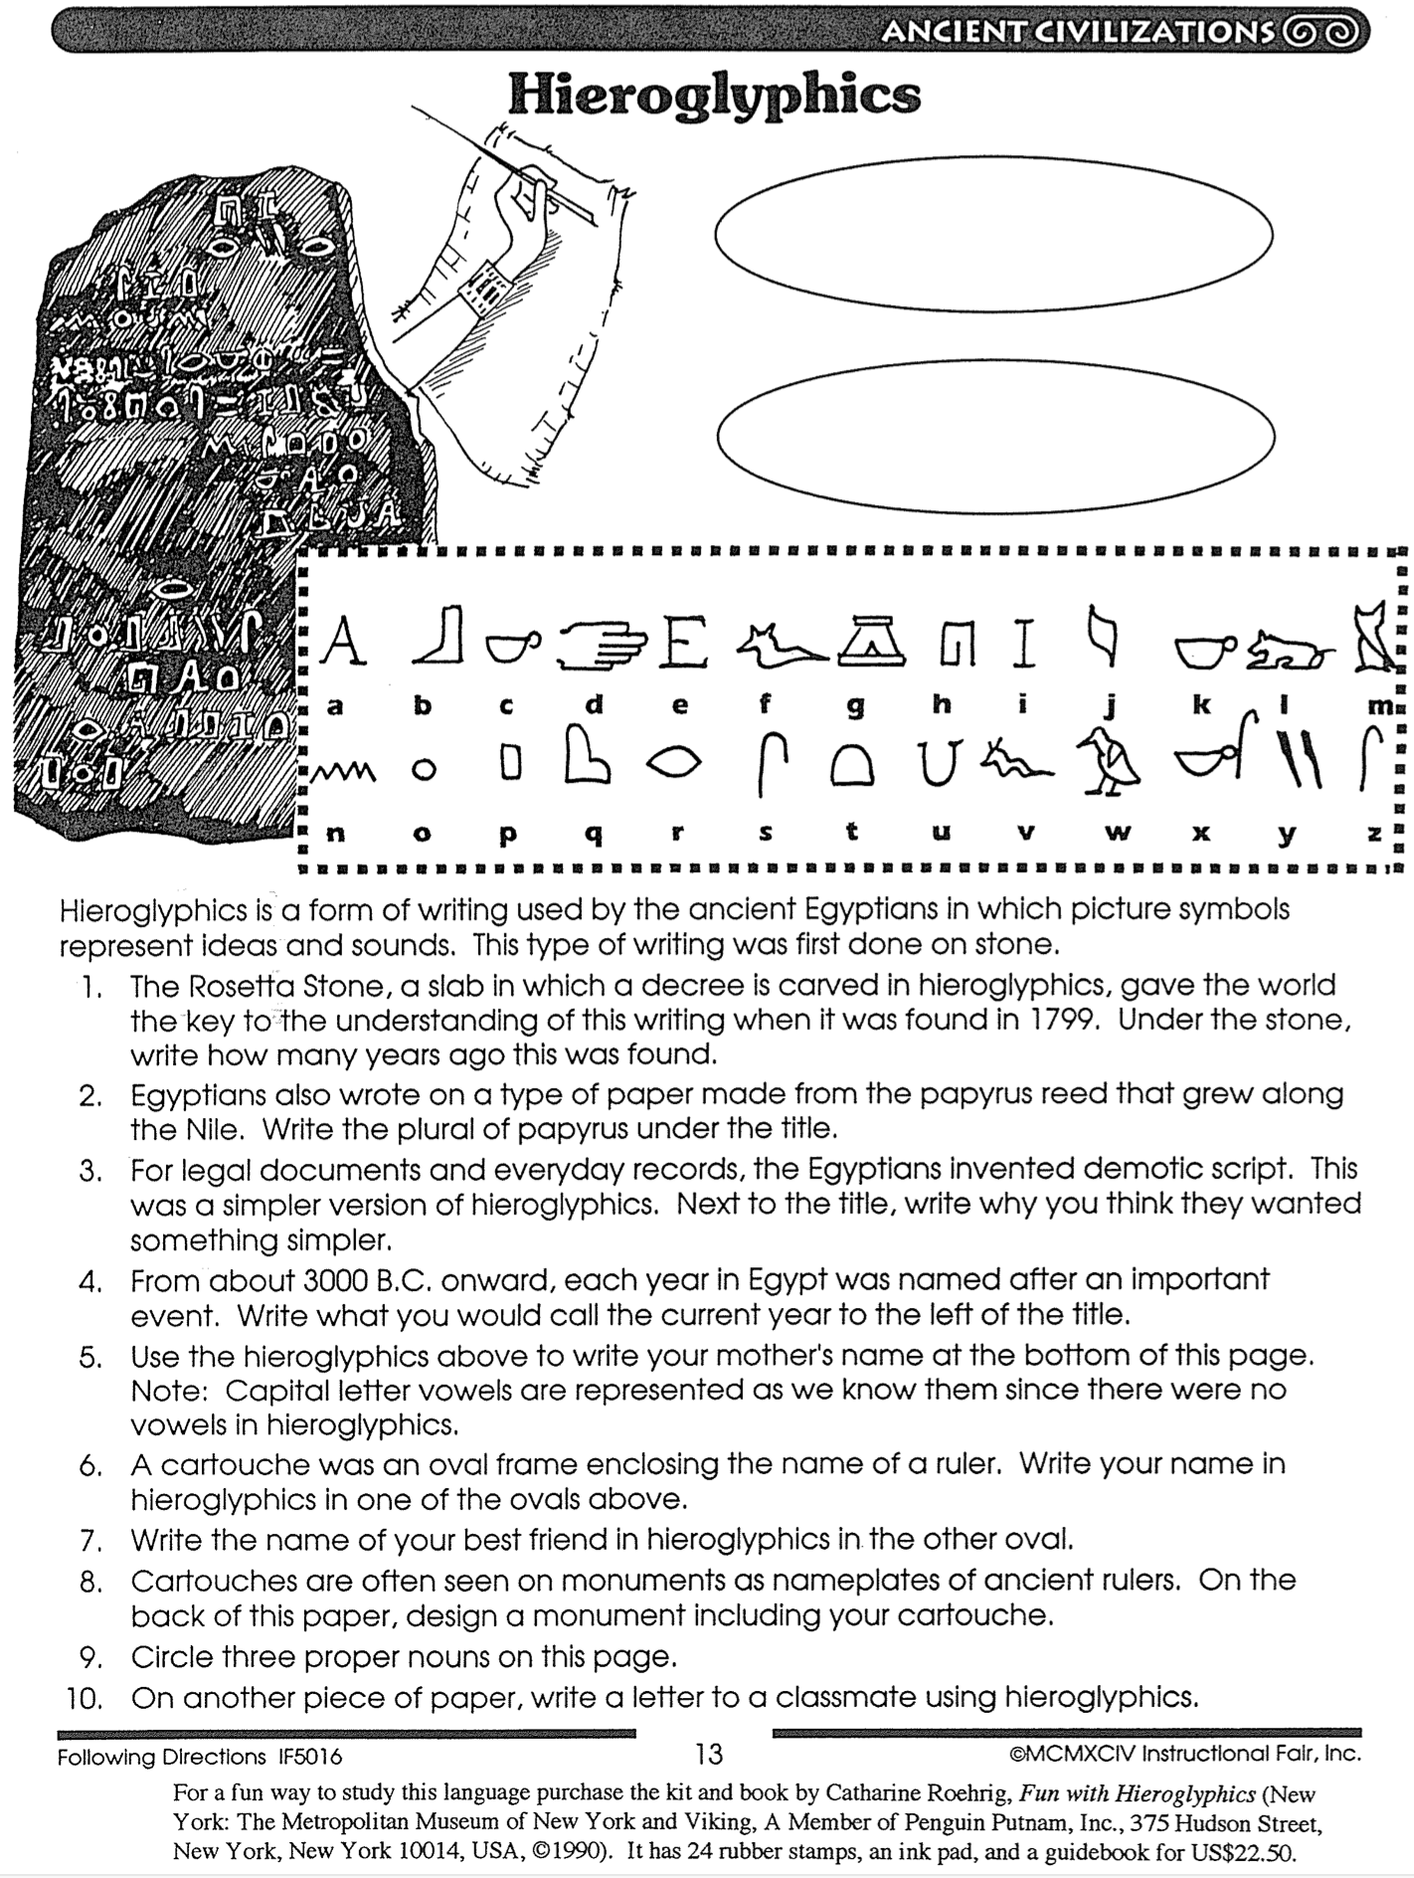
Hieroglyphics

How Hieroglyphics Were Deciphered
P. Kyle McCarter, Jr., Ancient Inscriptions: Voices from the Biblical World (Washington, DC: Biblical Archaeology Society, 1996), 35

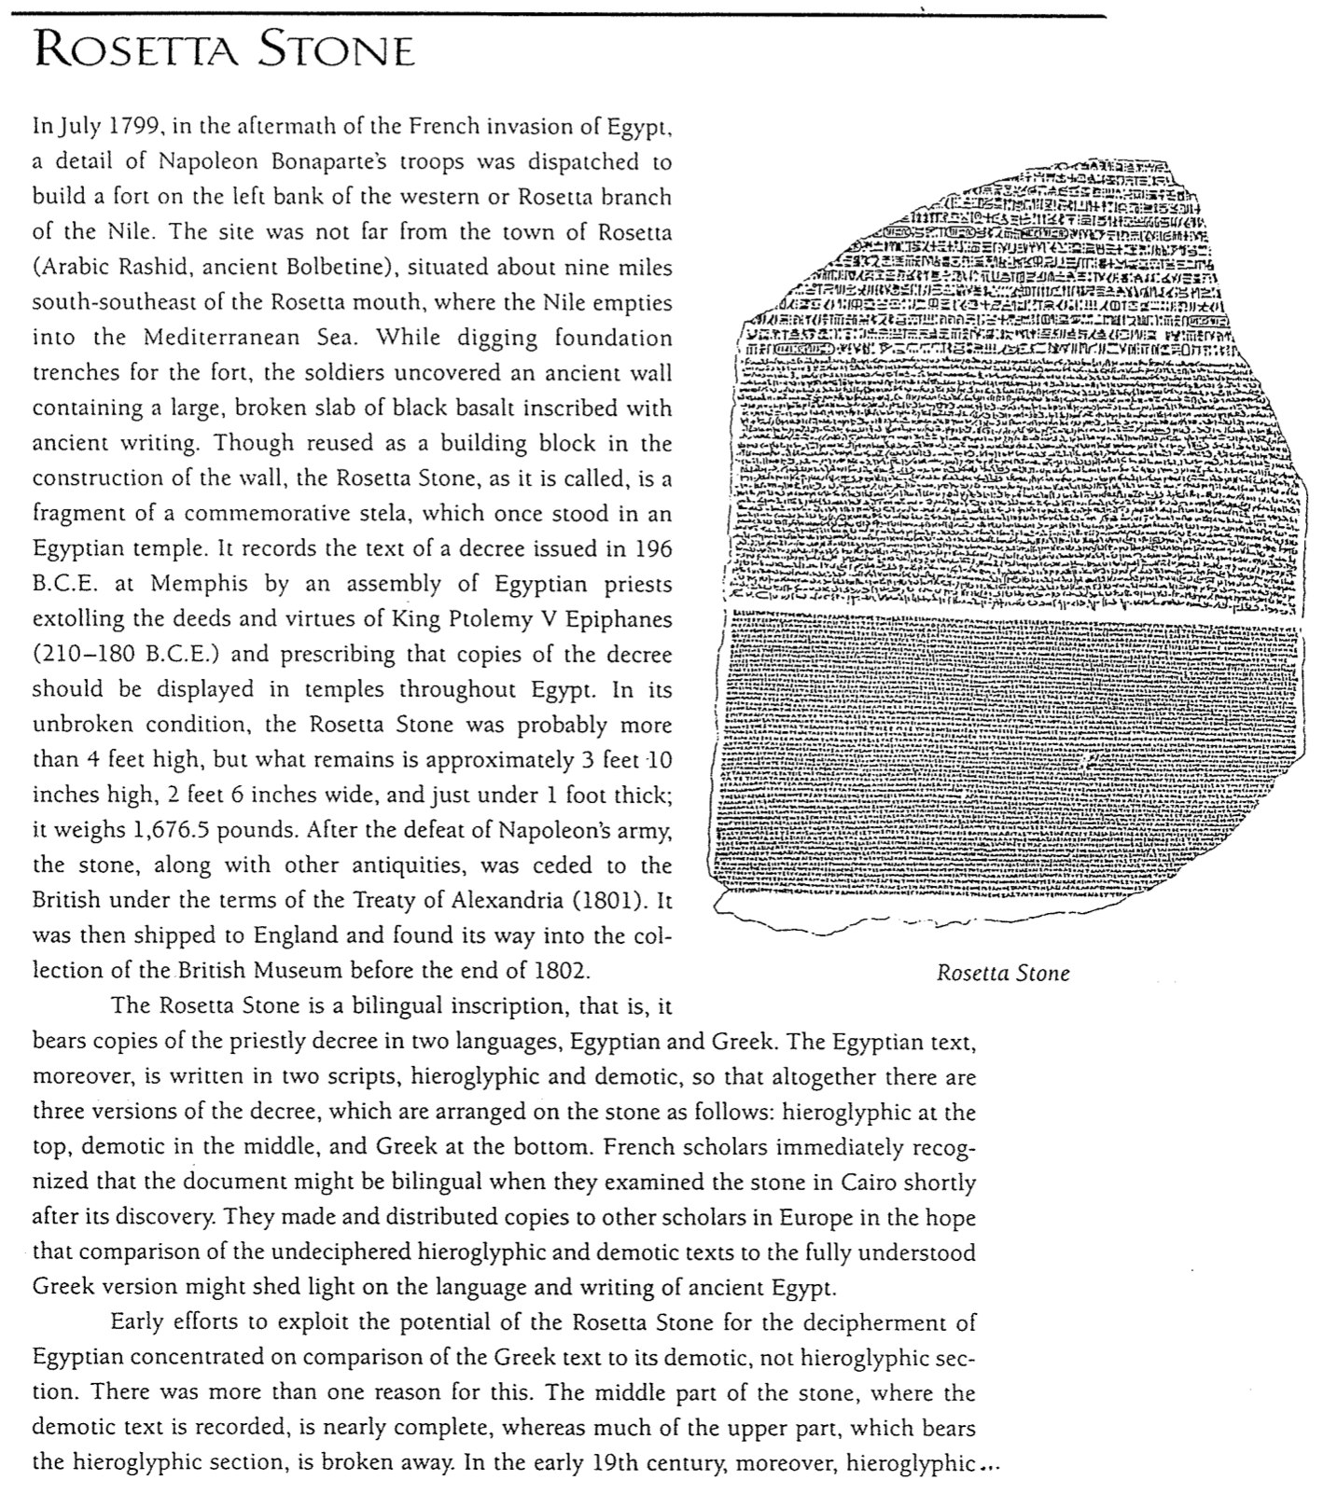

The Plagues and the Gods of Egypt
John H. Walton, Chronological and Background Charts of the OT, 2d ed., 85

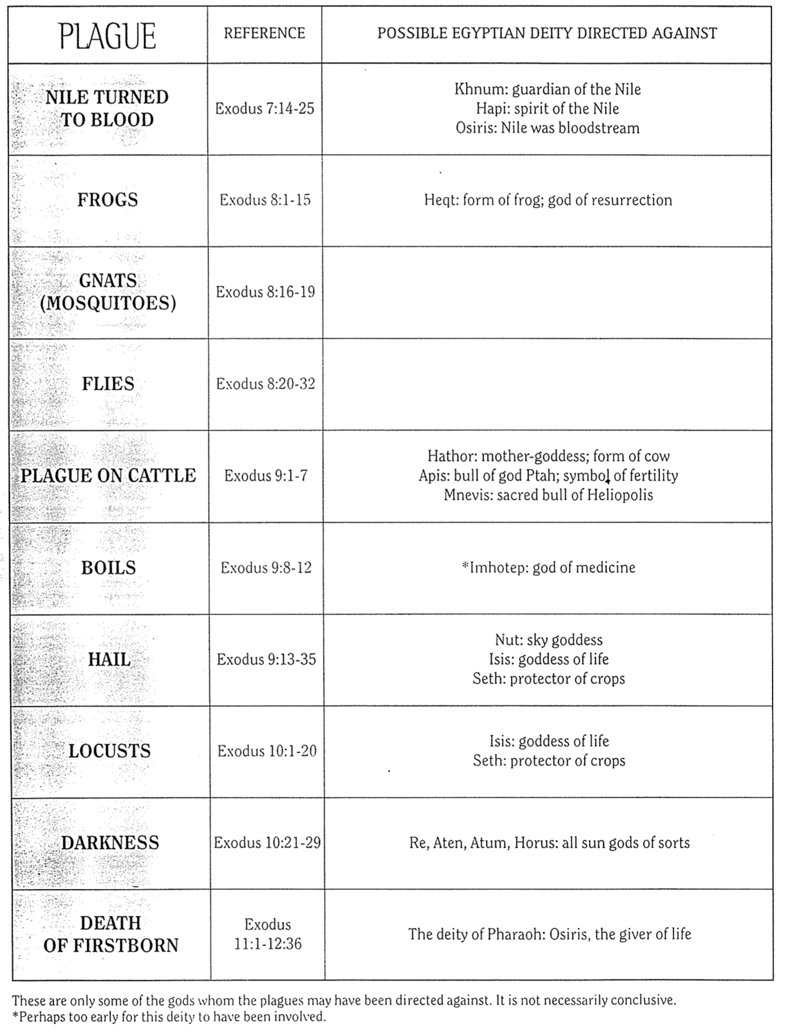

Map of the Exodus

The Bible Visual Resource Book, 23

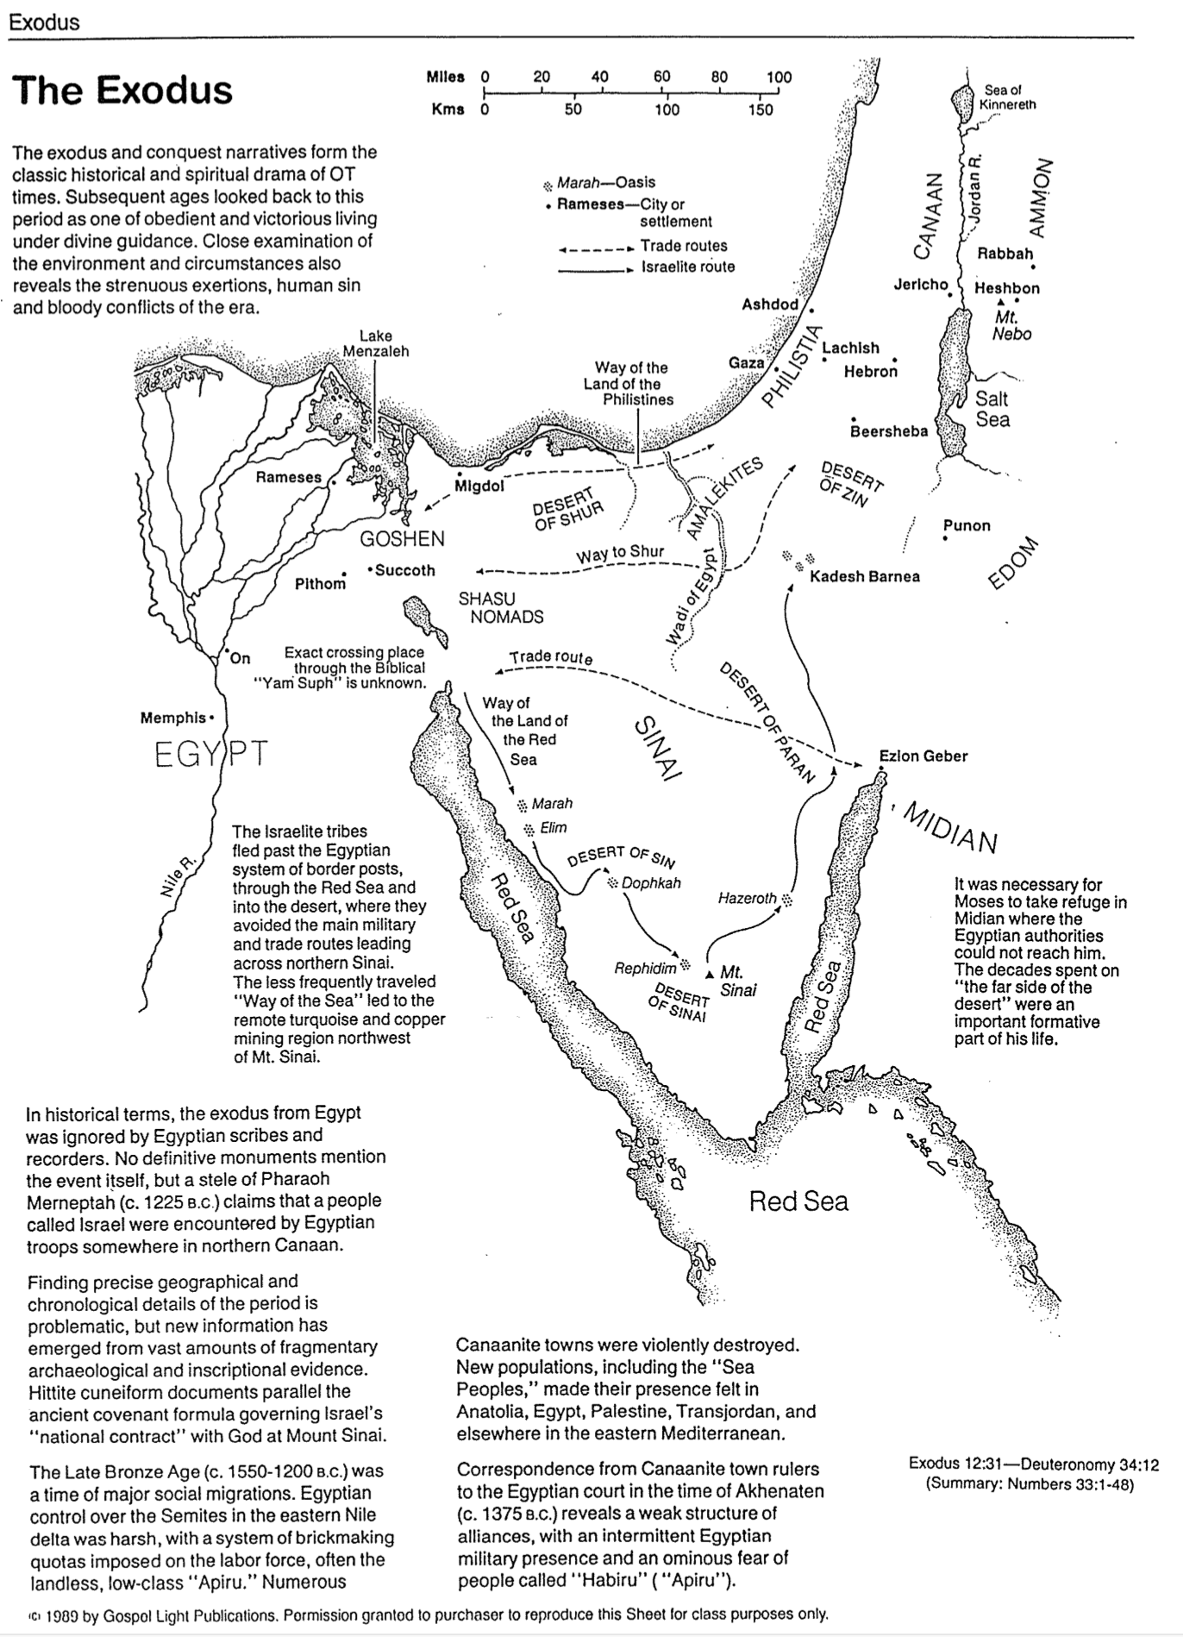

Egyptian Sojourn Chronologies Contrasted

Adapted (column 1 added) from John H. Walton, Chronological and Background Charts of the OT, 2d ed., 99 (cf. OTS, 108a-b)

400 YEAR SOJOURN | 430 YEAR SOJOURN | 215 YEAR SOJOURN |  | LATE  EXODUS | CRITICAL
2100
The Patriarchs
2166-1805

Canaan Sojourn
2090-1876

Migration to Egypt
1875

EXODUS
The Patriarchs
2135-1774

Abr birth to Joseph death

Canaan Sojourn
1875-1845

AC conf at Bethel to migr

Migration to Egypt
1845

2000

The Patriarchs
1950-1650

Canaan Sojourn
?-1650

Migration to Egypt
1650
The Patriarchs
1952-1589

Canaan Sojourn
1875-1660

Migration to Egypt
1660
1900

Egyptian Sojourn
1875-1446

Slavery
1730 or 1580

Egyptian Sojourn
1845-1445

Slavery
1730?
1500
1600
1800

1700

Egyptian Sojourn
1660-1446

Slavery
1580

Egyptian Sojourn
1650-1230

Slavery
1580

The Patriarchs
1500-1300

Gradual Migration to Egypt

Wandering
1445-1405

Conquest and Judges
1405-1050

EXODUS

EXODUS

EXODUS

Wandering
1446-1405

Conquest and Judges
1406-1050

Wandering
1446-1405

Conquest and Judges
1406-1050

Wandering
1446-1405

Conquest and Judges
1406-1050

Wandering
1445-1405

Conquest and Judges
1405-1050

1400

Egyptian Sojourn
1350-1230

EXODUS
1300

(No Exodus or
40 Yr. Wandering)

Migration, Conquest and Judges
1230-1025

(No Wandering)

Conquest and Judges
1230-1025

1200

United Kingdom
1050-931

United Kingdom
1050-931

United Kingdom
1050-931

United Kingdom
1025-931
United Kingdom
1025-931
1100

1000

900

Egyptian Sojourn Chronologies Evaluated
Correlate with my adaptation of John H. Walton, Chronological and Background Charts of the OT, 2d ed., 99 (cf. OTS, 108)

The following views appear from the best (left) to the worst (right).

View |  | 400  YEAR SOJOURN | 430  YEAR SOJOURN |  | 215  YEAR SOJOURN | LATE  EXODUS | CRITICAL
Exodus |  | Early |  | Early | Early | Late | Gradual Migration
Egyptian Sojourn | 400 |  |  | 430 | 215 | 420 | 120
Years of Freedom |  | Unspecified |  | 295 or 145 | 80 | 70 | 120
Years of Slavery |  | <400 |  | 135 or 285 | 135 | 350 | none (a myth)
Exod. 12:40 Text |  | LXX & Samaritan Pentateuch |  | MT | LXX & Samaritan Pentateuch | MT | Unimportant
Exod. 12:40  Reading |  | “Now the length  of time the Israelite  people lived in  Egypt and Canaan  was 430 years” |  | “Now the length  of time the Israelite  people lived in  Egypt  was 430 years” | “Now the length  of time the Israelite  people lived in  Egypt and Canaan  was 430 years” | “Now the length  of time the Israelite  people lived in  Egypt  was 430 years” | Unimportant
Popularity |  | Few |  | Most common | Common | Few Evangelicals  Many Liberals | Many Liberals
Support: |  | • Gen. 15:13 (sojourn 400 yrs.)  • Acts 13:19-20 "about 450 years" =  400 + 40 + 7  = 447 yrs.  • Exod. 12:40 "children of Israel" points to Gen. 35:10 (1875 BC) to begin 430 years since this is when nation called “Israel” |  | • Follows MT of Exod. 12:40  • Scripture sometimes uses round numbers  (See the next few pages for more early date arguments) | • Follows MT of Exod. 12:40  • The new king of Exod. 1 was a native Egyptian who followed the Hyksos  • Their later date for Abr. Cov. (1875 BC) to Jacob entering Egypt (1660 BC) is 215 yrs. | • Archaeology supports the destruction of some Canaanite cities in the 13th century  (See the next few pages for more late date arguments) | • The city of Rameses (Exod. 1:11) must have been built after Rameses II (1300 BC) since it was named after him

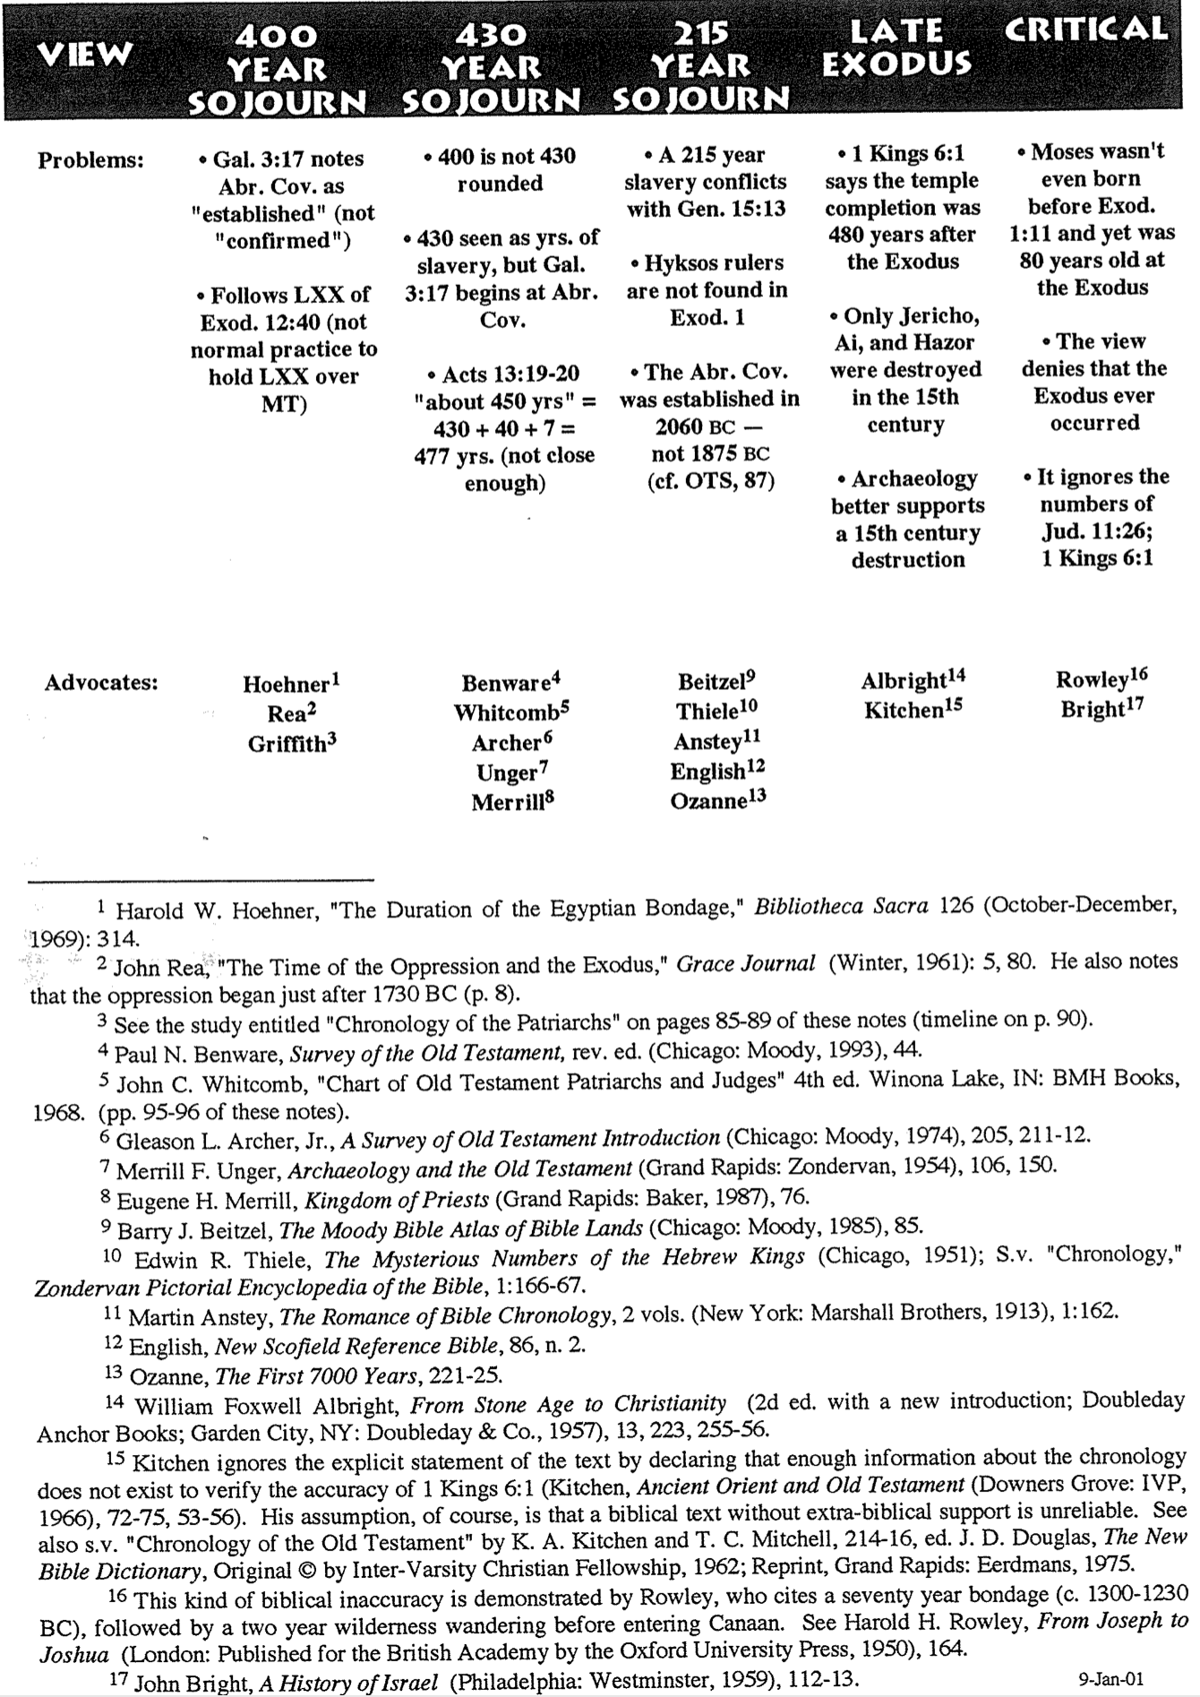  View | EARLY EXODUS  400 YEAR SOJOURN | EARLY EXODUS  430 YEAR SOJOURN | EARLY EXODUS  215 YEAR SOJOURN | LATE  EXODUS | RECON-STRUC-TIONIST
Problems: | • Gal. 3:17 notes Abr. Cov. as "established" (not "confirmed")  • Follows LXX of Exod. 12:40 (not normal practice to hold LXX over MT) | • 400 is not 430 rounded  • 430 seen as yrs. of slavery, but Gal. 3:17 begins at Abr. Cov.  • Acts 13:19-20 "about 450 yrs." = 430 + 40 + 7 = 477 yrs. | • A 215 year slavery conflicts with Gen. 15:13  • Hyksos rulers are not found in Exod. 1  • The Abr. Cov. was established in 2060 BC –not 1875 (cf. OTS, 87) | • 1 Kings 6:1 says the temple completion was 480 years after the Exodus  • Only Jericho, Ai, and Hazor were destroyed in the 15th century  • Archaeology better supports a 15th century destruction | • Moses wasn't even born before Exod. 1:11 and yet was 80 years old at the Exodus  • The view denies that the Exodus ever occurred  • It ignores the numbers of Jud. 11:26; 1 Kings 6:1

Do not print this page as the last row of advocates always skips to the next page due to footnote bugs. This page is in a separate file in the OT handouts folder (Exodus Views Probs, p. 108b)

The Egyptian Bondage Chronology Problem
Harold W. Hoehner, "The Duration of the Egyptian Bondage," Bibliotheca Sacra 126 (October-December 1969): 306-16

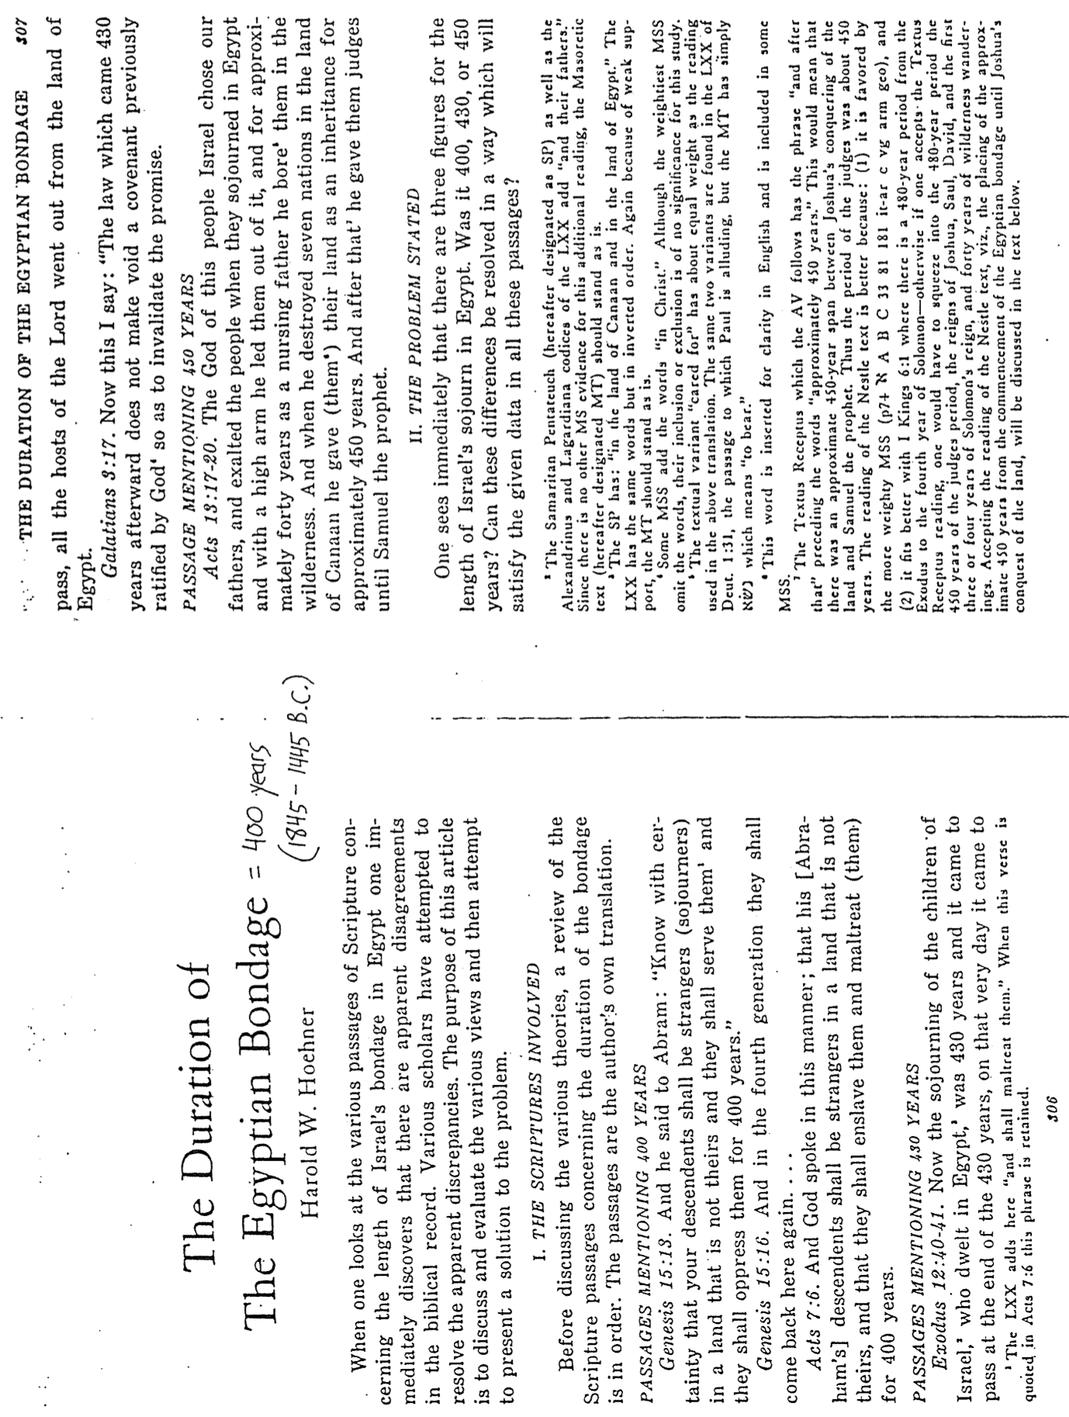

Support for a 400-Year Egyptian Bondage
Harold W. Hoehner, "The Duration of the Egyptian Bondage," Bibliotheca Sacra 126 (October-December 1969): 315-16

This view is the one advocated on pages 85-90 of these notes.

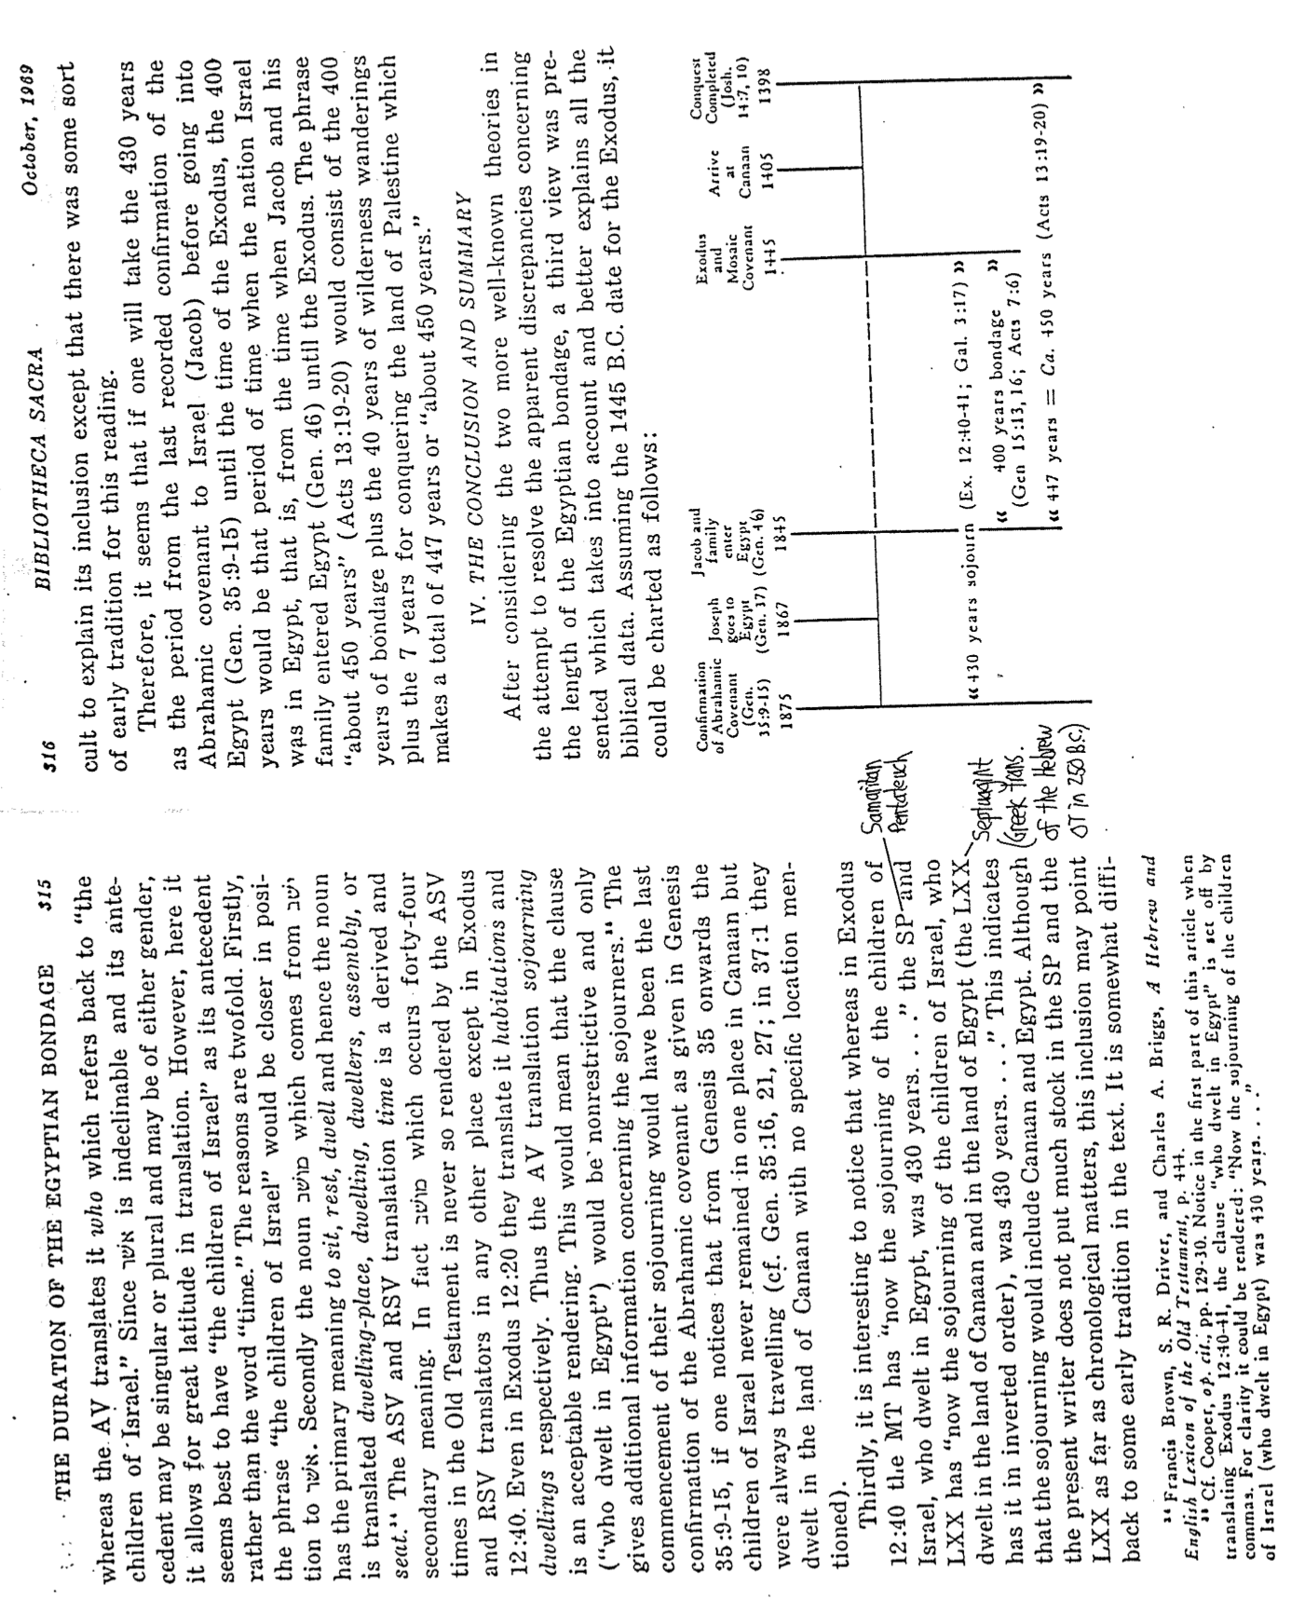

Date of the Exodus
John H. Walton, Chronological and Background Charts of the OT, 2d ed., 102-3 (1 of 2)

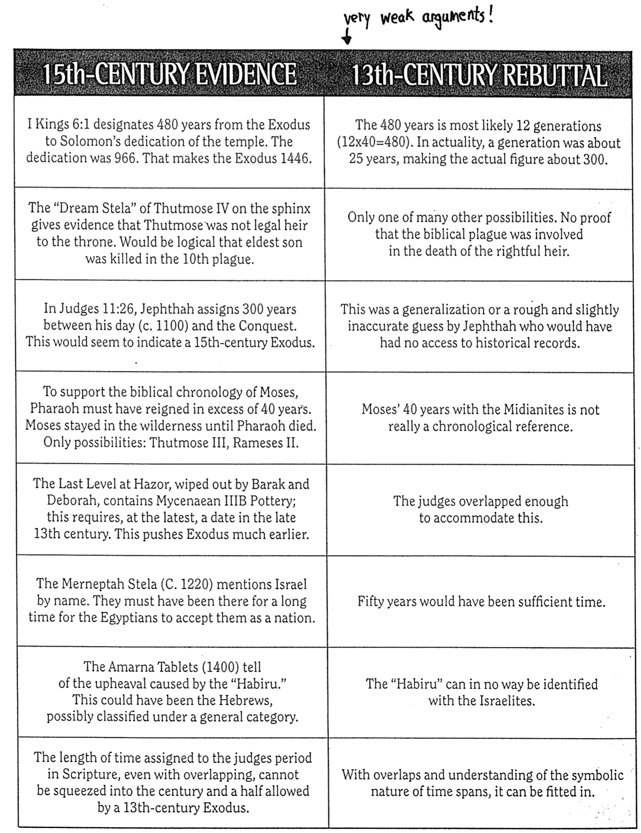

Date of the Exodus

John H. Walton, Chronological and Background Charts of the OT, 2d ed., 102-3 (2 of 2)

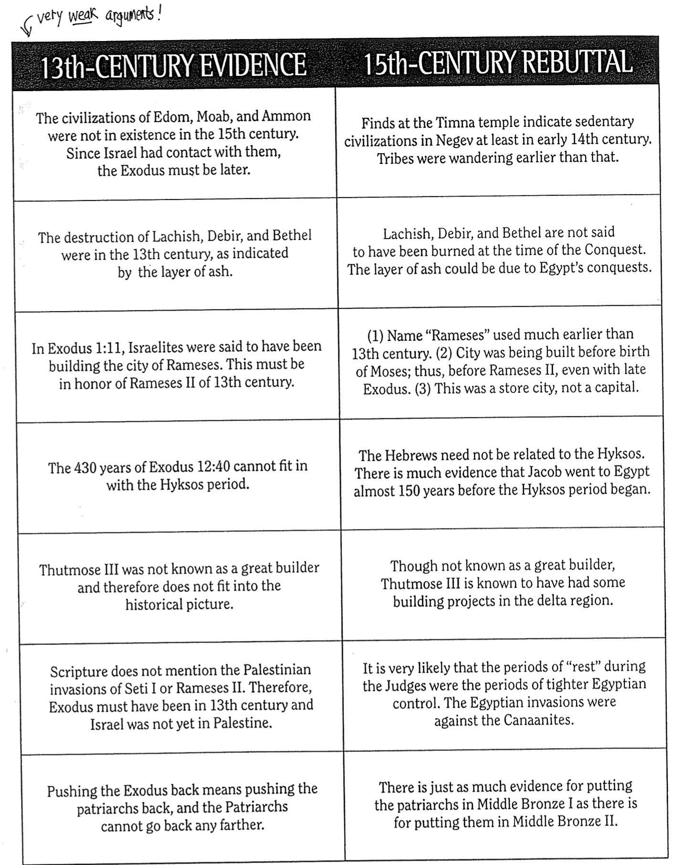

Hebrew Calendar and Selected Events
The Bible Visual Resource Book, 21; NIV Study Bible note on Exodus 12:2 (lower right)

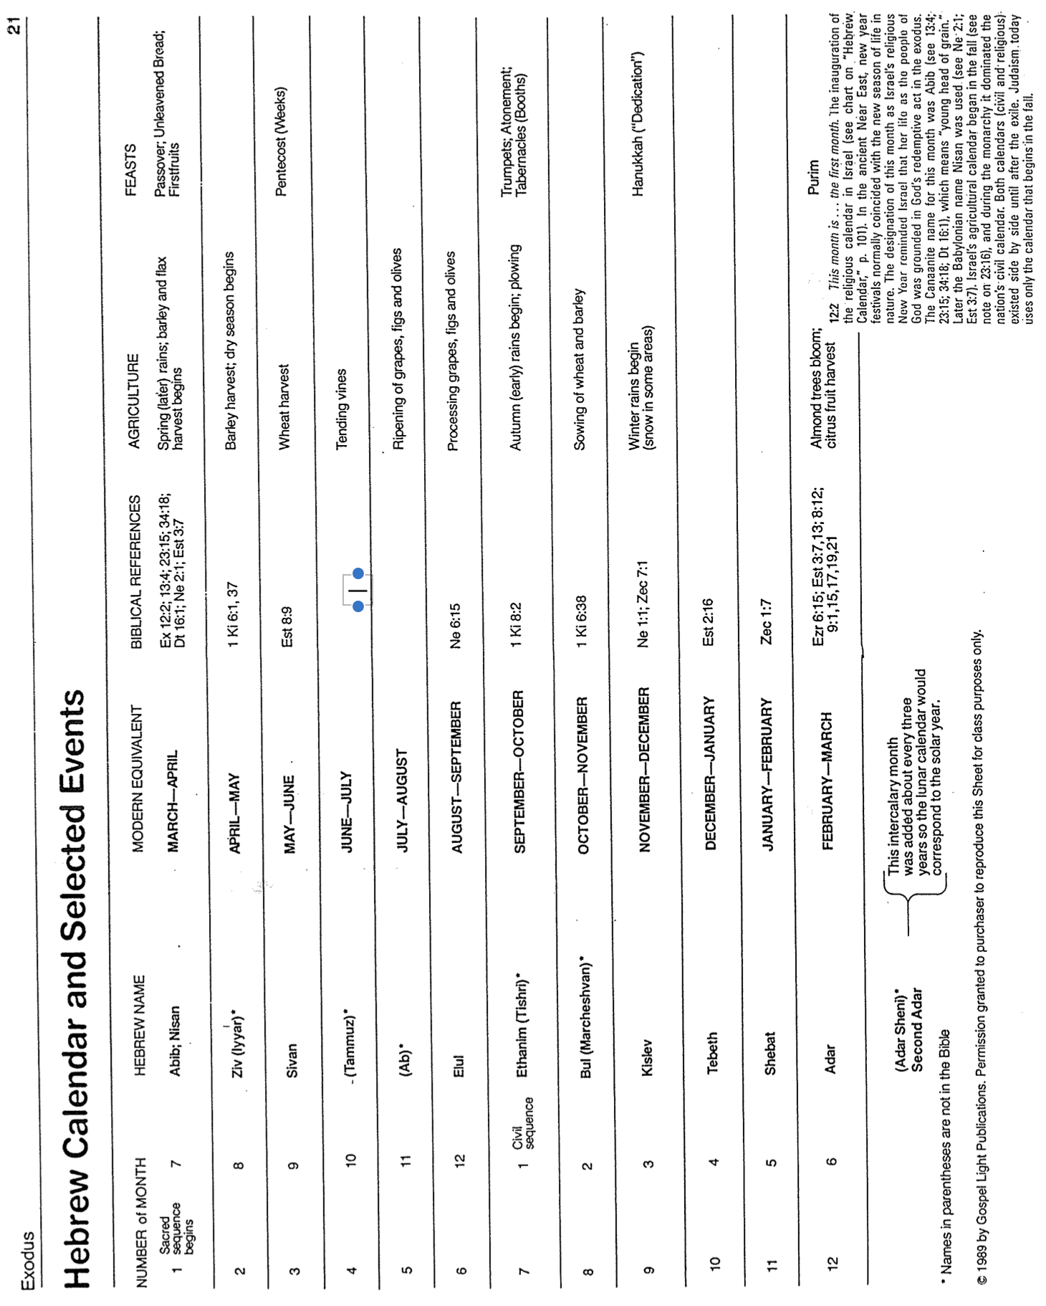

The Location of Mount Sinai

Where was Mount Sinai? Interpreters have differed on this question through the centuries, but this study discusses two key locations—in the southern Sinai and northwestern Saudi Arabia.

Southern Sinai Peninsula (Traditional View)

Support

Historical

Nearly all Bible atlases place Mt. Sinai at the traditional Jebel al-Musa ("Mountain of Moses") in the southern Sinai Peninsula.

This site has been known since the fourth century AD by Saint Helena, Emperor Constantine's mother, who built a chapel and tower at the foot of the altar to commemorate the place. Later, St. Catherine's monastery was built to identify it even more permanently. Thus, "the major strand of Christian tradition has been woven around J. Musa…"

Biblical

Assuming that the Egyptians chased the Israelites the following day after the Exodus, there would not have been enough time for Israel to cross the entire Sinai Peninsula within a day (Exod. 13:17-22). The alternate view must assume they traveled this far in a day unless more time is allowed to travel farther across the Sinai to be poised for entrance into Arabia by crossing the Gulf of Aqaba.

Biblical atlases note that the Desert of Sin lies in the southern portion of the Sinai Peninsula, on the way to Mount Sinai (Exodus 16:1).

Problems

No archaeologists have found the ancient sites that Israel visited between Egypt and southern Sinai (e.g., the bitter springs of Marah and the springs at Elim).

Israel was hemmed between the Egyptians and the sea, but the Egyptians could have quickly gone around the Great Bitter Lake or Small Bitter Lake.

Exodus 12 does not say that Pharaoh chased Israel the day after the Exodus. Perhaps it occurred days after he grieved for the dead firstborn sons of Egypt. If this is true, enough time could have elapsed for the people to reach the Gulf of Aqaba.

Saudi Arabia (Alternate View)

Support

Scripture

Paul mentions "Mount Sinai in Arabia" (Gal. 4:25). Jebel al-Lawz is the tallest peak in Arabia and thus the likely spot, though others have been proposed.

The path from Mt. Sinai to Kadesh Barnea follows the Mount Seir road (Deut. 1:2). Jebel al-Lawz lies east of Mount Seir, so if the road were on the eastern side of the Jordan Rift, then it would lead south into Arabia rather than into the Sinai.

That the Israelites "fled" rather than "left" (Exod. 5:14) may indicate that their initial permission was only to worship the Lord for three days. Their fleeing may suggest that they continued past what Pharaoh had granted.

Logic

Moses likely brought Israel back to Midian, where he had lived for 40 years. Midian lies on the eastern side of the Gulf of Aqaba. Since Moses lived in Midian (Exod. 2:15) and the burning bush incident took place on Mount Sinai (Exod. 3:1), then Mount Sinai must have been in Midian since the text does not say that he left Midian to go to Mount Sinai. (The assumption is that the "far side of the desert" is still in Midian unless the text says it is not.)

The Saudi government has outlawed visits to this alternate site, Jebel al-Lawz, and to the Caves of Moses en route to Jebel al-Lawz.

Mount Sinai had much volcanic or earthquake activity (Exod. 19:18; 24:17; etc.), and Saudi Arabia has more volcanoes than the Sinai. This was noted as far back as the third century BC by the Jewish historian Demetrius, who lived in Egypt.

Archaeology has been used to support the Saudi Arabia location.

A submerged land bridge extends from the SE Sinai to the Arabian side. Miraculously pushing away the water on either side would have allowed the Israelites to travel across the sea without descending hundreds of feet to the bottom. Otherwise, a steep climb would have made climbing up the other (eastern) side nearly impossible with their carts, women, children, and animals.

Columns claiming to have been erected by Solomon exist on both sides of the land bridge to identify where the Israelites began and ended their crossing.

Bitter springs exist 33 kilometers from the crossing point (a three-day journey), where one would expect the bitter springs of Marah (Exod. 15:22-26).

Other springs follow the route to Jebel al-Lawz, which could be the 12 springs and 70 palms of Elim (Exod. 15:27). At this location are the "Caves of Moses." Bedouins attribute the petroglyphs (rock carvings) within the caves to Moses, and their tradition identifies this site as the home of Jethro.

The mountain of Jebel al-Lawz shows evidence of a major encampment.

The Split Rock of Horeb is nearby. It is a large rock 47 feet tall with a 19-inch crack down the middle that has evidence of a large flow of water over the granite stone that empties into a lake area large enough to enable the two million Israelites to drink for a year (Exod. 17:1-7).

Two lines of evidence show burning on the mountain:

The entire top of Jebel al-Lawz is blackened (Exod. 19:18).

One minor burn mark is nearby, which could be where God appeared next to the Split Rock of Horeb. It has melted stone!

A two-mile semicircle of boundary stones encircles the mountain at 400-foot intervals (Exod. 19:12).

The mountain has a cave, which could be the one Elijah visited (1 Kings 19:8-9). No such cave has ever been found on Jebel al-Musa.

The mountain's base has a 60 x 60-foot altar of uncut stone with ashes.

Another altar with petroglyphs lies in front of the mountain. Its colossal cut stones rise 30 feet, as expected at the golden calf incident (Exod. 32). This altar is unlike any in the area, especially since the animals depicted are Egyptian cows.

An area near Mount Sinai is large enough for the battle between Israel and the Amalekites at Rephidim (Exod. 17:8-16).

Problems

Scripture

The reference to "Mount Sinai in Arabia" in Galatians 4:25 is unconvincing. It must first be established that "Arabia" in Paul's day referred only to the east side of the Gulf of Aqaba.

In Paul's time, "Arabia" covered a vast area that "included the Sinai Peninsula" as well as what we now call Saudi Arabia, according to Cambridge scholar Graham Davies.

Midian and Mount Sinai were separate since Moses sent his Midianite father-in-law "back to his own country," referring to Midian (Exod. 18:27; cf. Num. 10:29-31).

The Mount Seir road may derive its name only from the road ending up at Mount Seir rather than the entire road extending only on the eastern Jordan Rift. It may have stretched into the Sinai Peninsula as well.

The Israelites' "fleeing" (Exod. 5:14) more naturally refers to their initial flight from Egypt rather than a hastened pace after the third day. Earlier in the account, they requested a three-day trip from the Pharaoh, but it is an argument from silence that the king granted them only a three-day journey after the tenth plague.

Logic

While Moses did live in Midian for 40 years, Mount Sinai was on the "far side of the desert" (Exod. 3:1). Let's assume that the Midianites lived on the east side of the Gulf of Aqaba. If so, the natural reading of the "far side of the desert" would be the opposite side of the Gulf of Aqaba or the western side (southern Sinai Peninsula), especially since Jethro's traditional home and Jebel al-Lawz would be nearby. Also, Midianites were a nomadic people who resided in many places: Moab (Gen. 36:35; 1 Chron. 1:46), the Mishor region of the Transjordan (Num. 25:6-7; Josh. 23:21), the wilderness east of Moab and Ammon (Jud. 7:25; 8:18-19), the northern Sinai (1 Kings 11:18), and even within Canaan itself (Jud. 6:1-6; 7:1). Thus, the location of Midian cannot help to determine the location of Mount Sinai with any certainty.

The Saudi government's prohibition on people visiting Jebel al-Lawz could be due to their military establishment there as much as preventing archaeological exploration. Numerous sites in Saudi Arabia are off-limits to visitors, so Jebel al-Lawz is not unusual.

The higher volcanic activity of the Saudi Peninsula over the Sinai Peninsula is not convincing in the case of the Exodus generation. The Bible does not speak in terms of general characteristics of the land but instead of a single instance. Besides, the Sinai Peninsula experienced a quake exceeding 6.0 on the Richter scale in 1982 that was centered in Nuweiba though felt on J. Musa.

Archaeology

Since no one knows where Israel crossed Yam Suf (Red Sea or Sea of Reeds), no one knows that a submerged land bridge would be necessary, and the depth of the sea is also unknown. Since God could miraculously part the waters, we should assume that He could also help them across—no matter the incline!

Columns claiming to have been erected by Solomon only show, at best, that this spot was believed to have been the location nearly five centuries after Moses. The long period between the crossing and the commemorative columns leaves much room for doubt about whether these are the correct locations.

Israel was unlikely to cross the salt-water Gulf of Aqaba since Yam Suf means “Sea of Reeds,” and reeds grow only in fresh water.

Signs of an encampment need not refer only to the encampment by Israel.

The water from the rock incident was at the town of Rephidim (Exod. 17) rather than in front of Mount Horeb. Also, one need not find the water source since this was a miraculous yet probably temporary water supply only for Israel. The rock need not be an imposing stone, either.

The blackened top of Jebel al-Lawz is due to manganese rock. Many mountains in this region are dark for this reason. Besides, Scripture does not say that God blackened Mount Sinai. Also, the claim to have melted stone does not sound convincing. Jebel al-Lawz is in a volcanic zone, so melted stone here is not unusual.

The Jebel al-Lawz view assumes that rock piles at 400-foot intervals are boundary markers, but one must prove that marking boundaries is their purpose.

The cave at Jebel al-Musa does not exist now, but that does not mean it did not exist in Elijah's time. An earthquake or shifting rocks could easily cover it after nearly 30 centuries.

The altar at the base of Jebel al-Lawz is not of Israelite origin. God told Moses to make an altar of earth—not stone—on Mount Sinai (Exod. 20:24; 24:4) for burnt offerings and fellowship offerings.

The discovery of petroglyphs (rock carvings) at Jebel al-Lawz only proves that someone wrote there—not that it was Moses. The surrounding area is filled with numerous rock carvings over the ages. (And does an Egyptian cow drawing look significantly different from a non-Egyptian one?)

The existence of an area large enough to fight the Amalekites does not prove that such a battle occurred near Jebel al-Lawz. The area near Jebel al-Musa also has areas large enough for fighting.

Perhaps the most explicit argument favoring the traditional view is that the Desert of Sin (which included Mount Sinai) is located on all Bible atlases in the southern Sinai Peninsula. Since this desert is not in Arabia, Mount Sinai within the desert would not be in Arabia either (cf. Gal. 4:25).

Conclusion

The debate continues whether Mount Sinai is in the traditional location of the southern Sinai Peninsula (Jebel al-Musa) or east of this in northwestern Saudi Arabia (Jebel al-Lawz). While both views have supporting arguments and problems, the alternate view deserves a closer look. I can not explain the two springs in Saudi Arabia that support the Eastern view, though these are only supporting rather than conclusive arguments. At least tentative support from Frank Moore Cross and Hershel Shanks also supports the view.

On the other hand, the traditional view should not be abandoned until the Desert of Sin can be proven in [Saudi] Arabia. The location of the Desert of Sin has been a long-standing problem that seemingly will not be answered decisively until more evidence is forthcoming.

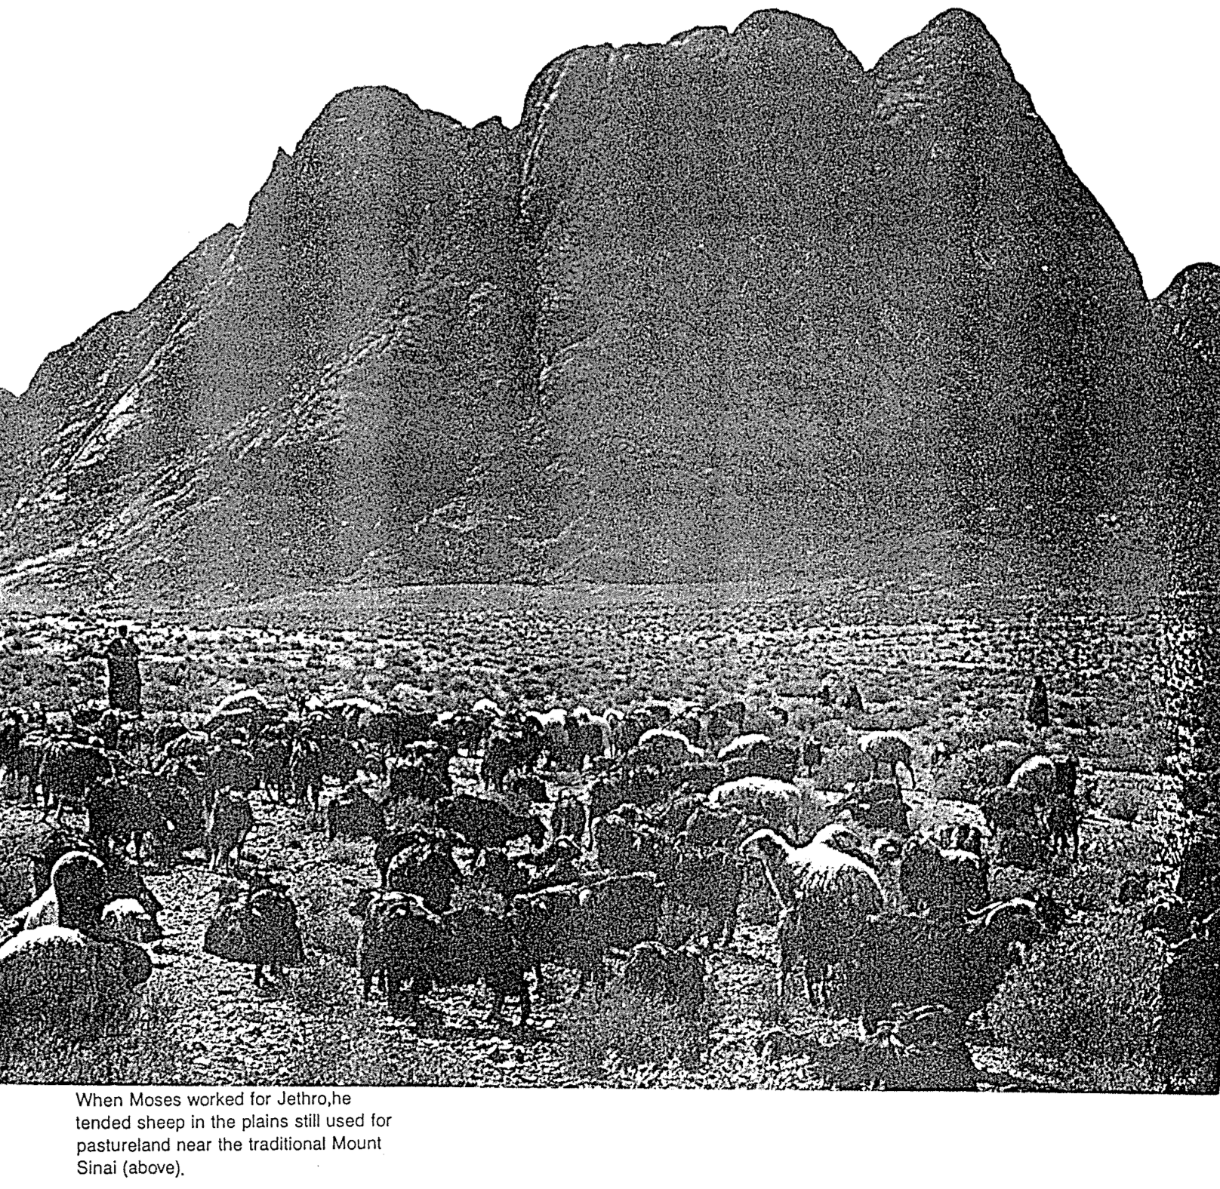

Interpreting and Preaching Legal Literature
(From the Romans notes, pages 155o-p)

A. A quick quiz to get you thinking…

1. T or F Christians should keep parts of the OT law that are not repeated in the NT.
2. T or F There are two laws: the moral (Ten Commandments) and ceremonial/civil.
3. T or F The Sabbath should still be obeyed by Christians.
4. T or F Believers must keep all of the Ten Commandments today.
5. T or F All followers of Christ should tithe today.
6. T or F Christians today are prohibited from eating blood (e.g., yong tau foo, blood pudding, pig or duck blood at Chinese New Year).
7. T or F Believers must not charge other Christians interest based upon the Law (Deut. 23:19; Exod. 22:25; Lev. 25:36-37; Ezek. 18:8, 13, 17; 22:12; Prov. 15:5; 28:8).

B. Defining the Meaning of Law (adapted from Fee/Stuart, 135-36)

1. Sometimes, “Law” refers to the Pentateuch as a single book (e.g., Josh. 1:8).

2. Sometimes, Christians refer to the “Law” as the five books of the Pentateuch, even though Genesis has no legal codes.

3. NT usage of the term “Law” sometimes refers to the Pentateuch and sometimes the entire OT (e.g., Luke 16:17).

4. Oftentimes, “Law” refers to only the legal formation from Exodus 20–Deuteronomy 33. (It always refers to at least this portion of Scripture.)

C. The Christian’s Relationship to the Law (adapted from Fee/Stuart, 136-39; these issues are addressed in detail in my ThD dissertation, Richard James Griffith, “The Eschatological Significance of the Sabbath,” Dallas Seminary, 1990, esp. pp. 144-56, found at https://biblestudydownloads.org/resources/future/).

1. The OT law is a covenant between Israel and God–not between the church and God. The church and Israel must be kept distinct.

2. Our loyalty to God is shown differently than Israel’s. In other words, God expected Israel to be loyal, and He expects the same of us, but Israel’s loyalty was shown through observing the sacrificial system. In contrast, our loyalty is shown by obeying NT commands. (However, faith is what pleased God then and now–Heb. 11:6.)

3. Most OT stipulations are not repeated in the NT–primarily the civil (penalties for crimes) and ritual (worship, especially sacrificial regulations) laws. Therefore, most of the OT does not directly apply to believers.

4. Some OT stipulations are repeated in the NT, such as nine of the Ten Commandments, except the Sabbath.

5. All of the OT law is still the Word of God for us even though it is not still the command of God for us. As such, it is still helpful for teaching and preaching, though applications must be made based on the principles undergirding the laws (2 Tim 3:16).

6. Only that which the NT explicitly renews from the OT law can be considered part of the NT “law of Christ” (Gal. 6:2). [Note: Fee/Stuart put all of the Ten Commandments in this category, which makes modern believers guilty of Sabbath breaking. I disagree that the Sabbath is binding in the present age. I worship corporately on Sunday, not Saturday!]
D. The Purposes of the Law (adapted from J. Dwight Pentecost, BibSac 128 [July 1971]: 227-33)

Paul’s letter to the Galatians teaches sanctification not by the Law but by faith in Christ alone. For example, Abraham was justified by faith centuries before the Law came (Gal. 3:17). After that, the Law and the Promise (Gen. 12:1-3) co-existed for years without conflict. This led Paul to ask, “What, then, was the purpose of the law?” (Gal. 3:19). Actually, there were at least ten purposes for the Law:

1. It revealed or exposed man’s sinfulness (Gal. 3:19).

2. It revealed the holiness of God (1 Pet. 1:15).

3. It revealed the standard of holiness for people in fellowship with God (Ps. 24:3-5).

4. It supervised the redeemed Israelite’s physical, mental, and spiritual development until he matured in Christ (Gal. 3:24).

5. It unified the people to establish the nation in voluntary submission to God’s decrees (Exod. 19:5-8; Deut. 5:27-28).

6. It separated Israel among the nations as a kingdom of priests to mediate God’s truth to these nations (Exod. 31:13).

7. It provided forgiveness of sins for individual Israelites to restore their fellowship with God, even though they already functioned as a redeemed people (Lev. 1–7).

8. It made provision for Israel to worship God as a redeemed people (Lev. 23).

9. It tested if one was in the kingdom or the theocracy over which God ruled (Deut. 28). Faith led to obedience and blessing; lack of faith led to disobedience and judgment.

10. It revealed Jesus Christ (typology in the sacrificial system; Luke 24:27).

Pentecost suggests that the revelatory aspect of the Law is permanent as it still reveals the holiness of God today (1 Tim. 1:8), but the regulatory purpose is temporary as it regulated the life and worship of the Israelite (Gal. 4:8-10; Col. 2:16-17). However, this view does not seem correct, as the entire Law has been abolished (see the next two pages, i.e., pp. 114-115). I feel that a better approach is the one below…

E. A Suggested Strategy for Expounding Old Testament Law

1. Interpretation: Study the intent behind the legal command, asking, “Why was this command given in Israel?” It is beneficial to answer this question by showing how the law reveals the character of God. For example:

“God told Israel in Leviticus 19:9-10 not to harvest the corners of the fields because He had compassion on the poor who could glean there for their food.”

2. Principlizing: State the law's intent as a general principle.

“God wants his people to give the underprivileged the chance to earn a living.”

3. Application: Show how this principle relates to a contemporary parallel situation.

“As an employer, you should provide opportunities for the poor to support themselves.”

You can probably tell by now that I think the answers to each question on the previous page’s quiz are false.

The Ten Commandments

(From the Romans notes, pages 155n)

# | Old Testament Commands | New Testament Repetitions
1 | And God spoke all these words: “I am the LORD your God, who brought you out of Egypt, out of the land of slavery. You shall have no other gods before me” (Exod. 20:1-3). | “Men, why are you doing this? We too are only men, human like you. We are bringing you good news, telling you to turn from these worthless things to the living God…” (Acts 14:15; mentioned at least 50 times).
2 | “You shall not make for yourself an idol in the form of anything in heaven above or on the earth beneath or in the waters below… for I… am a jealous God, punishing the children for the sin of the fathers to the third and fourth generation … but showing love to a thousand generations of those who love me…” (Exod. 20:4-6). | “Dear children, keep yourselves from idols” (1 John 5:21; cf. 1 Thess. 1:9; Rev. 2:14, 20; 9:20; mentioned in the NT 12 times = 12x).  * This chart is adapted and expanded from one by Lewis Sperry Chafer, Systematic Theology, 4:209-10
3 | “You shall not misuse the name of the LORD your God, for the LORD will not hold anyone guiltless who misuses his name” (Exod. 20:7). | “Above all…do not swear–not by heaven or by earth or by anything else. Let your ‘Yes’ be yes, and your ‘No,’ no, or you will be condemned” (James 5:12; 4x).
4 | “Remember the Sabbath day by keeping it holy. Six days you shall labor and do all your work, but the seventh day is a Sabbath to the LORD your God. On it you shall not do any work, neither you, nor your son or daughter, nor your manservant or maidservant, nor your animals, nor the alien within your gates. For in six days the LORD made the heavens and the earth… but he rested on the seventh day. Therefore the LORD blessed the Sabbath day and made it holy” (Exod. 20:8-11). | No NT text requires this of Christians.  However, one passage clearly prohibits the practice as required for believers: “Therefore do not let anyone judge you by what you eat or drink, or with regard to a religious festival, a New Moon celebration or a Sabbath day. These are a shadow of the things that were to come; the reality, however, is found in Christ” (Col. 2:16-17; 0x).
5 | “Honor your father and your mother, so that you may live long in the land the LORD your God is giving you” (Exod. 20:12). | “Children, obey your parents in the Lord, for this is right. ‘Honor your father and mother’–which is the first commandment with a promise–that it may go well with you and that you may enjoy long life on the earth” (Eph. 6:1-3; cf. Matt. 15:4-6; 19:19; Mark 7:10; 10:19; 6x).
6 | “You shall not murder” (Exod. 20:13). | “Anyone who hates his brother is a murderer, and you know that no murderer has eternal life in him” (1 John 3:15; cf. Matt. 19:18; Mark 10:19; Luke 18:20; Rom. 13:9; James 2:11; 6x).
7 | “You shall not commit adultery” (Exod. 20:14). | “Marriage should be honored by all, and the marriage bed kept pure, for God will judge the adulterer and all the sexually immoral” (Heb. 13:4; cf. Mark 10:19; 12x).
8 | “You shall not steal” (Exod. 20:15). | “He who has been stealing must steal no longer, but must work, doing something useful with his own hands…” (Eph. 4:28; cf. Matt. 27:64; Mark 10:19; Luke 18:20; Rom. 13:9; Titus 2:10; 6x).
9 | “You shall not give false testimony against your neighbor” (Exod. 20:16). | “Do not lie to each other, since you have taken off your old self with its practices” (Col. 3:9; cf. Eph. 4:25; 4x).
10 | “You shall not covet your neighbor’s house… wife, or his manservant or maidservant, his ox or donkey, or anything that belongs to your neighbor” (Exod. 20:17). | “Then he said to them, ‘Watch out! Be on your guard against all kinds of greed; a man’s life does not consist in the abundance of his possessions’” (Luke 12:15; Rom. 7:7; 13:9; Eph. 5:3; James 4:2; 2 Pet. 2:3, 14; 9x).

Does the Law of Moses Apply to Me?
(From Galatians notes, 174h-i)

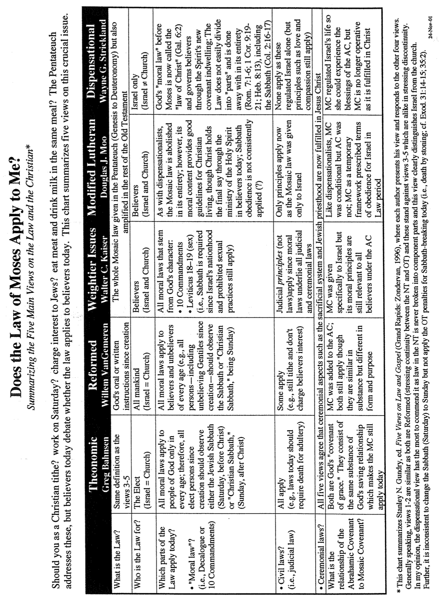

Does the Law of Moses Apply to Me (2 of 2)?

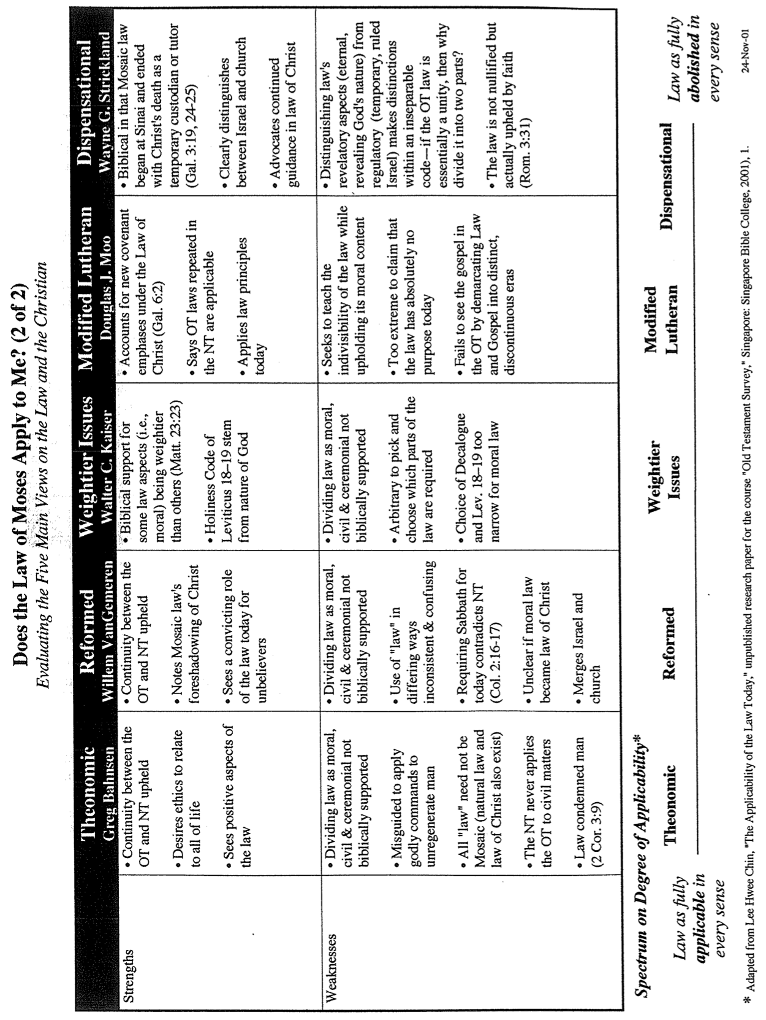

Should Christians Follow the Ten Commandments (Rom. 7)?
Adapted from my 1990 dissertation, “The Eschatological Significance of the Sabbath,” Dallas Seminary, 148-53 (cf. Romans notes, 155l-m)

Despite the popularity of the belief that the Law is presently valid for believers, the New Testament treats the entire law as abrogated. This is a significant tenant of the Book of Galatians, written in response to the error of supposing that some of the law was still in effect. Paul's readers were falsely led into believing that most of the law was repealed (e.g., the sacrificial system, dietary laws, etc.), but certain laws remained, particularly circumcision. Paul forcefully took issue with such teaching:
Mark my words! I, Paul, tell you that if you let yourselves be circumcised, Christ will be of no value to you at all. Again I declare to every man who lets himself be circumcised that he is obligated to obey the whole law (Gal. 5:2-3).

The issue to be emphasized here is Paul's view of the law as a whole. His point is that if one is required to keep any part of it, he is obligated to keep all of it. Conversely stated, if the believer is free from the law, he is free from all of it. This applies whether the part referred to is circumcision, the Sabbath, or any other part.

The Pauline epistles uphold the abolishment of the entire law, not only part of it. Paul affirmed emphatically that believers are dead to the law (Rom. 7:1-6) and not under its rule (Rom. 6:14; Gal. 3:19, 23-29; 4:25, 31; 5:18). This is because Christ is the fulfillment (cf. Matt. 5:17-18) and termination or end of the law (Rom. 10:4) since His death abolished the law (Eph. 2:15). Further, Paul taught that the Mosaic Covenant had passed away (2 Cor. 3:6-11) and that the Abrahamic Covenant both preceded and followed the period of the law since the law served only temporarily (Gal. 3:14-25). The result is that "now that faith has come, we are no longer under the supervision of the law" (Gal. 3:25). Also, "the fact that God has (manifestly) accepted Gentiles as sons demonstrates that the period of the law is at an end; the custodian has finished his task, and the son has become an heir (4:1-6)." Finally, in 1 Corinthians 9:20, Paul very clearly declares himself free from the law:
To the Jews I became like a Jew, to win the Jews. To those under the law, I became like one under the law (though I myself am not under the law), so as to win those under the law.

Paul could not have more clearly stated that he was not under the law. He also makes the same claim for his Roman readers: "You are not under law but under grace" (Rom. 6:14). The preceding verses represent only a select group of passages that indicate that the law has been abolished and thus has no jurisdiction over the believer. Indeed, when comparing the Mosaic dispensation with "the dispensation in Christ, Paul found the former, glorious as it had been, to be worthless."
Paul and the Decalogue
While many passages have been cited above to show the end of the law, those most pertinent to the present study are two texts explicitly pointing to the end of the Ten Commandments in the present age. The first text is Romans 7. Here, Paul emphatically states that the believer has died to the law by being joined to Christ (v. 4) with the result that he is released from the law (v. 6). His following illustration specifies this "law" as the Decalogue by referring to the tenth commandment which prohibits coveting (vv. 7f.). The purpose of this prohibition was to reveal Israel's inability to obey the law of God. Specifically, Paul claims freedom from the law because it has already fulfilled its purpose in exposing sin. Further, since the Decalogue is an essential unity, the abolition of one of its commandments (coveting) shows the abolition of them all. In other words, since his illustration denotes that believers are free from one of the Ten Commandments, and the Decalogue is a unity, it follows that believers are also free from all of the commandments, which includes the Sabbath.

Second Corinthians 3 is a second passage that even more clearly shows the believer's freedom from the Ten Commandments. In this chapter, Paul contrasts his apostolic authority as a minister of the New Covenant with that of his opponents at Corinth, who, by implication, were ministers of the Old Covenant (cf. 2:17; 3:14). One reason the New Covenant is more glorious than the Old is that this New Covenant is internal, written on men's hearts through the Person or activity of the Spirit (3:3b). Conversely, the Old Covenant was engraved upon tablets of stone (3:3, 7). The crucial issue is what was written on stone in the Old Testament. Was it the entire law? No, only the Ten Commandments were engraved upon the tablets at Sinai (Deut. 4:13; 5:22). In other words, Paul equates the Old Covenant with the Decalogue. This law had a fading glory (i.e., lacked permanent validity) "because only in Christ is it taken away" (v. 14b). Therefore, since Paul contrasts his continuing ministry of blessing with the ministry of cursing in the Ten Commandments, he in effect teaches the abolishment of the Decalogue as a system by which one should live, including the Sabbath. That the Sabbath is included within this abolished Decalogue also finds support in that the New Testament never enforces the death penalty for disobeying the Ten Commandments. It is inconsistent to argue for the continuance of the Sabbath requirement in the present age without a continued penalty for neglecting it.

Contrasting the Abrahamic & Mosaic Covenants
Distinguishing these covenants provides a foundation for interpreting the OT and NT, especially the prophets as they look back on covenants with both Abraham (e.g., Ezek. 36–37, p. 508) and Moses (e.g., Lam. 1:3, p. 496). Knowing the conditional and temporal nature of the Law prevents misapplying obsolete commands to the Church today (e.g., Sabbath, charging interest to believers, tithing). Also, God’s faithfulness to sinners becomes clear due to Abraham.

 | Abrahamic Covenant | Mosaic Covenant
Recipient  (Date & Place) | Abraham as mediator for all nations  2060 BC, Ur of the Chaldees | Moses as mediator for Israel  1445 BC, Mount Sinai
Scripture | Genesis 12:1-3 (but formalized into a covenant in Genesis 15) | Exodus 20–31 is the heart of the covenant
Between God & | A person (for a future nation) | A nation
Scope | Universal (“all peoples will be blessed through you”) | Only Israel received the Law (Deut. 4:8; Ps. 147:20)
Character & Significance | Grace (promises)  –primary (what God will do) | Works (laws)  –secondary (how God will do it)
Promises | Land, seed, and blessing (without indication of time of fulfillment) | Blessing for obedience and cursing for disobedience (Lev. 26; Deut. 28)
Conditions | Unconditional: “I will…” | Conditional: “If you will…then I will…”
Participation | Abraham asleep (Gen. 15:17) | Israel agreed to obey (Exod. 19:8)
Analogy | Father to son (royal grant) | Suzerain (superior king) to vassal (servant nation)
Purpose | Clarified Israel’s blessings in general terms to motivate the nation towards righteousness by faith in God’s provision of a wonderful future (Gen. 12:1; 15:1, 6) | Clarified how Israel could be blessed in the Abrahamic Covenant as soon and full as possible; didn’t restate or expand the Abrahamic Covenant but revealed sin (Rom. 5:20; Gal. 3:19, 24)
Form | Oral (no written stipulations) | Written on tablets of stone & Pentateuch
Emphasis | Blessing over discipline/judgment  (five “blessings” in Gen. 12:1-3) | Judgment/discipline over blessing  (contrast Deut. 28:1-14 & vv. 15-68)
Christology | Ultimate seed (Gen. 12:3) | Typified in tabernacle (Heb. 8–10)
Sign | Circumcision (Gen. 17:11) | Sabbath (Exod. 31:13, 17)
End | Never ended (Gal. 3:15-18) as an eternal covenant (Gen. 17:8) | Ended at Christ’s death (Rom. 7:6; 10:4; 2 Cor. 3:7-11; Gal. 5:1; Heb. 7:11-12)

While most of the above is original, some are based on Thomas L. Constable, “A Theology of Joshua, Judges, and Ruth,” in A Theology of the Old Testament, ed. Roy B. Zuck (Chicago: Moody, 1991), 100-101. For a more complete evangelical picture of the relevance of the OT law to the Christian, see Five Views on Law and Gospel (Zondervan), including modified Lutheran (Douglas J. Moo), Dispensational (Wayne G. Strickland), "weightier issues" apply (Walter C. Kaiser), Non-theonomic Reformed (Willem VanGemeren), and Theonomic Reformed (Greg Bahnsen).

Israel & the Church: Continuity & Discontinuity
(From Romans 9–11 notes, 155u-v)

How does Israel relate to the Church? Amillennialists, postmillennialists, and covenant premillennialists argue that the Church is the “new Israel” with full or near complete continuity between these entities. Thus, the Church is seen to have simply replaced Israel and assumed her promises and covenants.

The other side of the spectrum is classical and revised dispensationalism, which sees more discontinuity. In this scheme, there are two separate peoples of God: Israel and the Church. The only overlap is that the believers today participate in some of the aspects of the Abrahamic and New Covenants (see Eschatology notes, pages 20-25).

I have held both views in the past, but recently have adopted a third model with some elements of progressive dispensationalism. This newer system (since 1987) emphasizes both continuity and discontinuity yet still holds the dispensational distinctive that the Church is not the “new Israel.” Rather, it is a continuation of God’s covenant plan begun with Israel and continuing with a believing remnant of Israel today, along with Gentile believers grafted into the Abrahamic Covenant (see Romans 9–11; Galatians 3). Here are some points of difference and contact between these two entities:

Discontinuity

 | Israel | Church
Identity | Physical seed of Abraham (Gal. 6:12-16) | Spiritual seed of Abraham (Gal. 3:7, 29)
Palestinian Covenant | Still outstanding (Deut. 30:1-10) but partly fulfilled since 1948 (Ezek. 37:1-7) | No land promise (Palestinian Covenant) can be claimed by present believers
Law | Required to obey the law (Exod. 19–20) | Freedom from the law (Rom. 7; Gal. 3)
Duration | Abraham (Gen. 12:1-3) to eternity (Jer. 31:35-37) | Pentecost (Acts 2) to Rapture (1 Thess. 4:13-18) or even later (?)
Wrath | Experienced in Tribulation (Jer. 30:7) | Free from wrath (1 Thess. 5:9; Rev. 3:10)
Faith | Shown in offering sacrifices | Shown in trusting Christ’s sacrifice
Priesthood | Has one: a special class by heredity | Is one: all are priests (1 Pet. 2:5)
Activity | Set aside between 69th & 70th “Weeks” (Dan. 9:24-27)—a part of the “times of the Gentiles” (Luke 21:24) | Between 69th & 70th “Weeks” the church is a mystery unforeseen in the OT (Eph. 3:1-9; Col. 1:26)
Qualification | Ethnic—descendants of Abraham or Gentile proselytes who became Jews through circumcision as blessing is through Israel (1 Kings 8:41-43; Isa. 2:2-3; 19:19-25; 49:6; 51:4; 56:6-8; Zech. 14:16-19) | Nonethnic—”Neither Jew nor Gentile” (Gal. 3:28) means a combination of Jews and Gentiles without need to become Jewish proselytes (Acts 15; Eph. 3:3, 6)
Continuity

 | Israel | Church
Abrahamic Covenant | Origin in Abraham as the father of the nation (Gen. 12:1-3) | Believers today are grafted into this same covenant (Rom. 11:17-21; cf. Gal. 3:29)
Davidic Covenant | Promise of a literal temple (2 Sam. 7:13) fulfilled by Solomon (1 Kings) | Functions now as a spiritual temple  (Eph. 2:19-22; 1 Pet. 2:4-10)
New Covenant | Promised forgiveness of sins, indwelling Spirit, new heart, reunification of Israel and Judah, and knowledge of God throughout the earth (Jer. 31:31-34) | The first three aspects (forgiveness of sins, indwelling Spirit, new heart) true today in a progressive fulfillment of the covenant (Luke 22:20)
Law | Required to obey the Mosaic law (Exod. 19–20) | Required to obey the “law of Christ” (Gal. 6:2) or “law that gives freedom” (James 1:25; 2:12)
Salvation by | God’s grace through faith (Gen. 15:6) | God’s grace through faith (Rom. 4:3)
Basis of Salvation | Sacrificial lamb | Sacrificial Lamb
Spirit | Filling on leaders | Indwelling of all believers (Rom. 8:9)
Prophets | Provided revelation of God’s word | Foundation of the church (Eph. 2:20)
Election | Based on grace (Mal. 1:2) | Based on grace (Eph. 1:4-6, 11)
Disobedience | Lead to God’s discipline | Leads to God’s discipline (1 Cor. 11:30)
Leadership | Elders (Exod. 3:16, 18; 4:29, 31;12:21; Num. 11:16-17; Josh. 24:31; 1 Sam. 15:30; 2 Sam. 17:4, 15; 1 Kings 21:8, 11 and many other texts) | Elders (Acts 11:30; 14:23-24; 15:1-6; 16:4; 20:17-38; 21:17-26; 1 Thess. 5:12-13; Phil. 1:1; 1 Tim. 3:1-7; 4:14; 5:17-25; Tit. 1:5-9; Jas. 5:14; 1 Pet. 5:1-5; Heb. 13:17)
Witness | “light for the Gentiles” (Isa. 49:3-6)  “kingdom of priests” (Exod. 19:6)  “holy nation” (Exod. 19:6) | “light of the world” (Matt. 5:14-16)  “holy…royal priesthood” (1 Pet. 2:5, 9)  “holy nation” (1 Pet. 2:9)

The Tabernacle and Furnishings

The Bible Visual Resource Book, 25

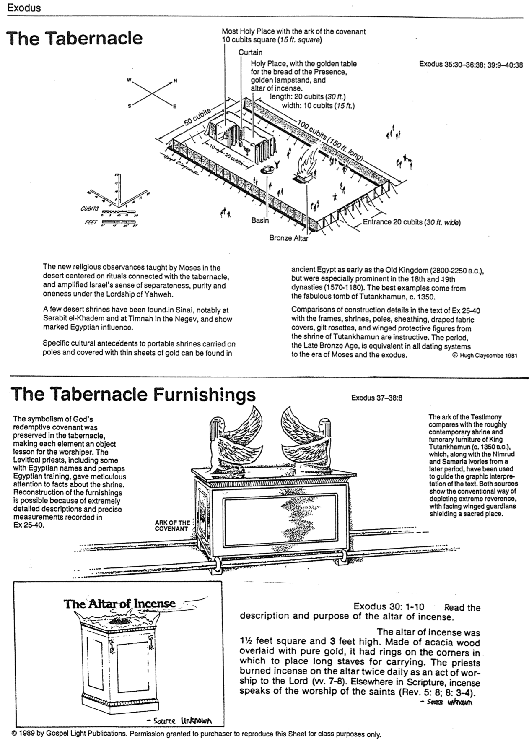

The Tabernacle Furnishings

Source Unknown

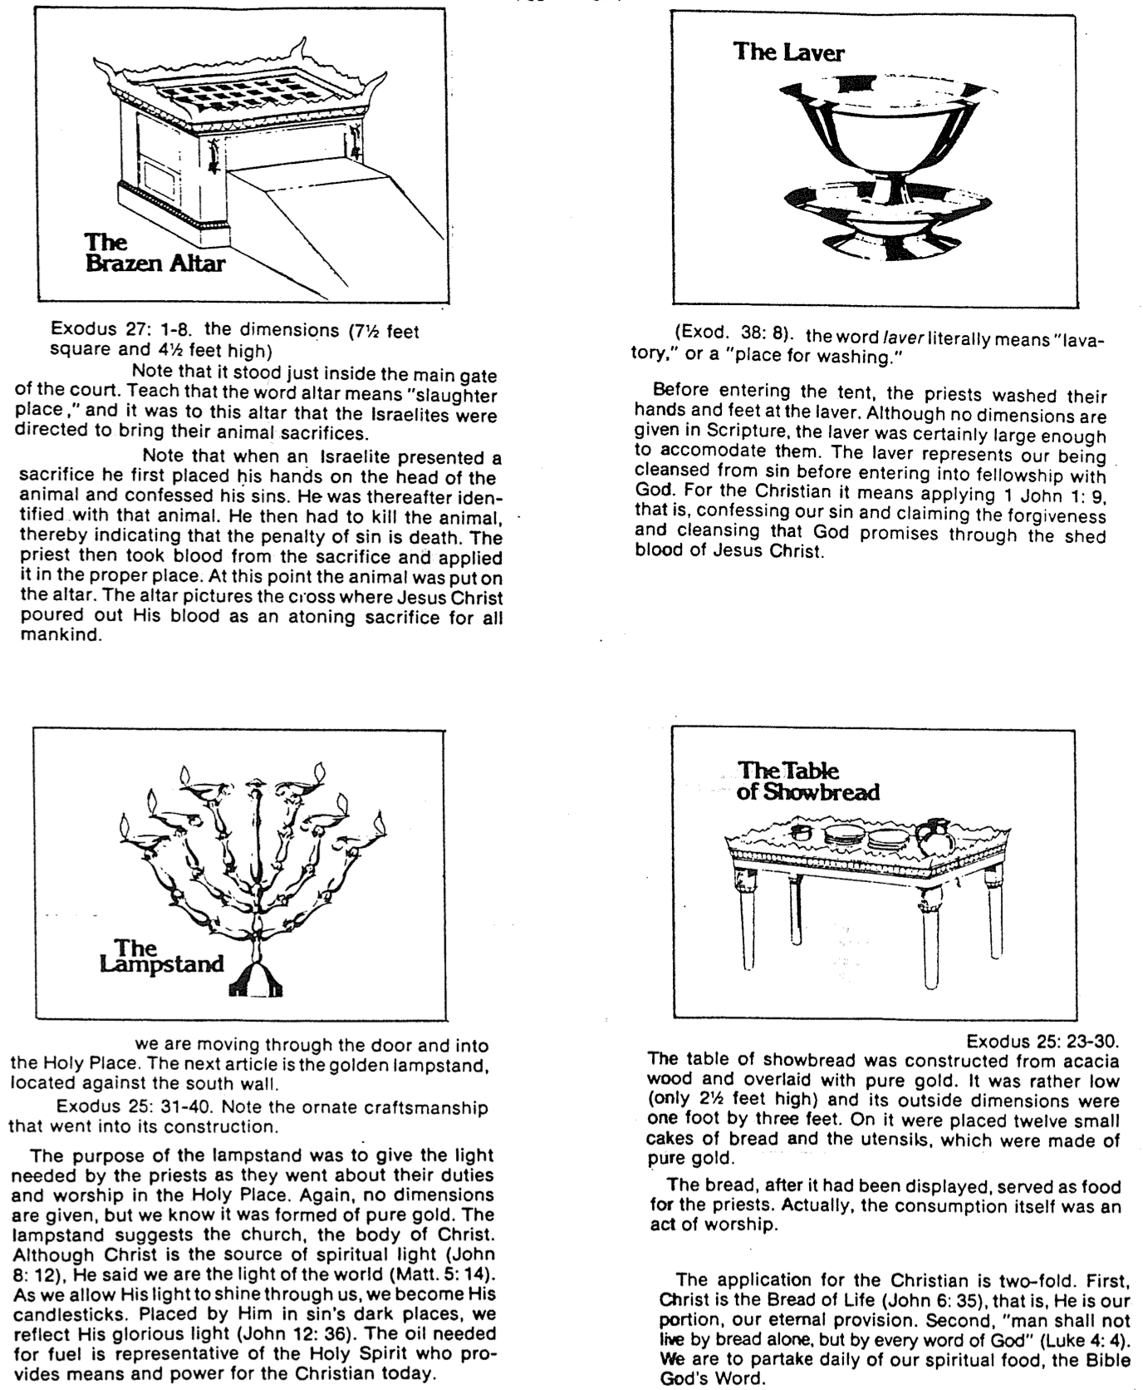

The Living Tabernacle

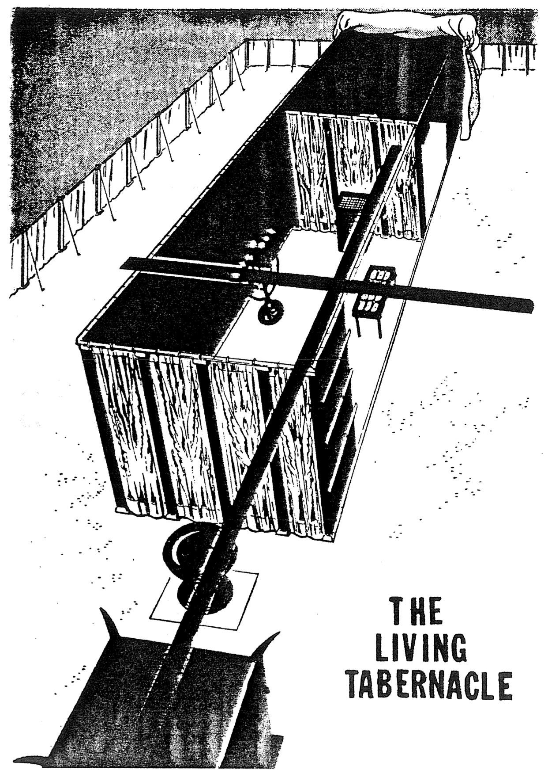

The High Priest

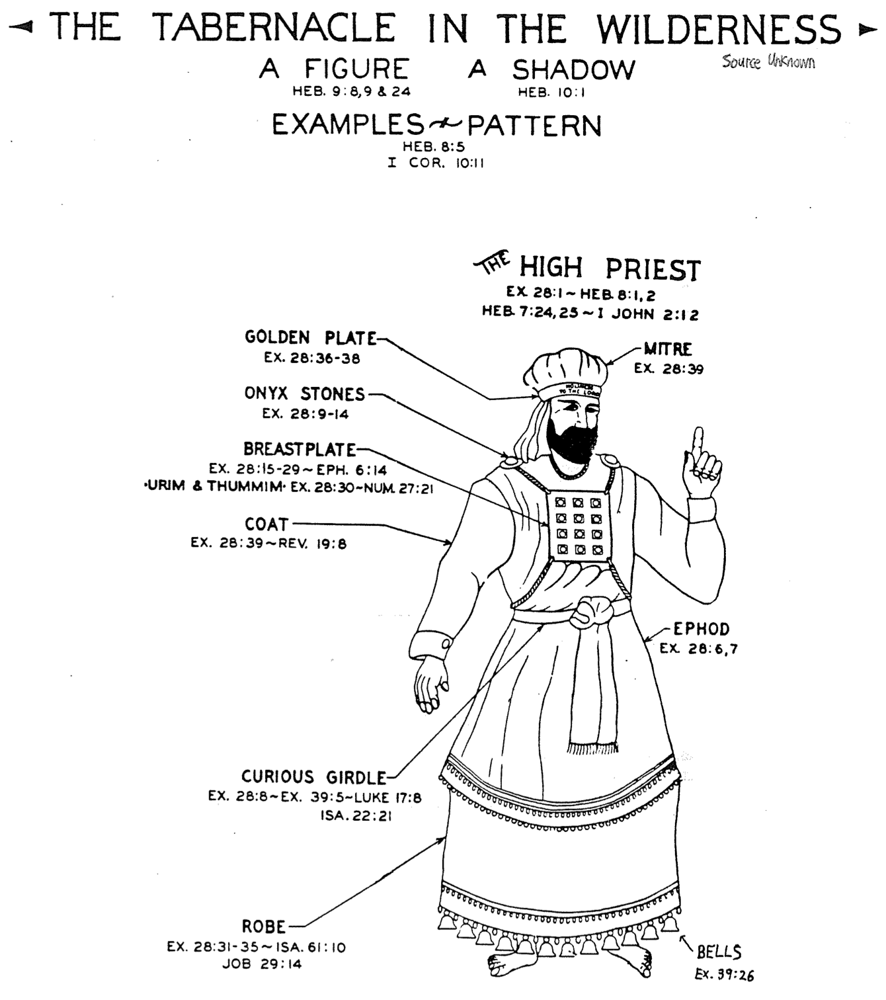

The Tabernacle & Creation

The typological significance of the Tabernacle has been widely taught, for truly, the Tabernacle looked forward to the finished work of Christ (see previous pages). However, a little-discussed topic is how the Tabernacle looked back–specifically, to the creation event.

John H. Sailhamer, The Pentateuch as Narrative: A Biblical-Theological Commentary (Grand Rapids: Zondervan, 1992): 298-300 shows many interesting parallels between these two events:

 | Creation | Tabernacle
Text | Genesis 1-2 | Exodus 25-31
Content | Creation of the heavens and earth | Building of the tabernacle
Significance | Arena in which God would have fellowship with humans | Means of restoring man’s lost fellowship with God
Structure | Seven acts marked by divine speech: “And God said” (Gen. 1:3, 6, 9, 14, 20, 24, 26; cf. vv. 11, 28, 29) | Seven acts marked by divine speech: “And the LORD said” (Exod. 25:1; 30:11, 17, 22, 34; 31:1, 12)
Contents | Pure gold (Gen. 2:12a) and precious jewels (Gen. 2:12b) | Pure gold (Exod. 25:3) and precious jewels (Exod. 25:7)
Final Inspection & Blessing | “And God saw all he had made, and behold, it was very good” (Gen. 1:31); God blessed man (Gen. 1:28) | “And Moses saw all the work, and behold, they had done it just as the LORD had commanded” (Exod. 39:43a) and Moses blessed them (Exod. 39:43b)
Closing | Reminder that God rested on the sabbath (Gen. 2:1-3) | Reminder to observe the sabbath (Exod. 31:12-18)
Patterns | Man and woman made in God’s image (Gen. 1:26-27) | Tabernacle made based on the pattern God showed Moses (Exod. 25:9)
Sequel | Fall of man into the sin of eating the forbidden fruit (Gen. 3) | Fall of Israel into the worship of the golden calf (Exod. 32)
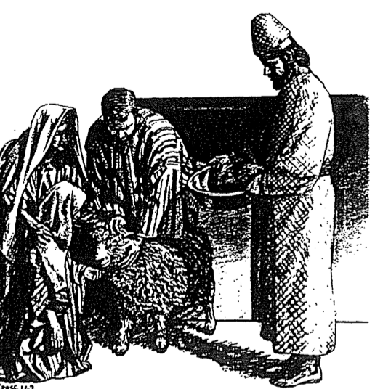

What, then, is the significance of these parallels?

1. The tabernacle was intended as a model of God’s heavenly abode in that God’s presence would dwell with his people.

2. As the tabernacle followed the “pattern” of something in heaven, it had a symbolic as well as practical purpose. The physical forms also had spiritual meaning or sense to them (typology).

However, the text gives no hints as to their typology, leaving their meanings a mystery. We have to wait until we get to the NT to see it as a picture of the work of Christ (John 2:19-21; Heb. 8:2; 9:11-12), the individual believer (1 Cor. 6:19), and the church (1 Tim. 3:15; Heb. 3:6; 10:21).

Salvation in the Old Testament
(From Galatians notes, 73e)

How were people saved during Old Testament times? Were only Jews saved? How? Was it through the Tabernacle and temple sacrifices? Did killing these animals forgive sin? When encountering the OT, these questions will naturally arise in a thinking person’s mind.

First, salvation has always been by faith, not the works of the Law. This is Paul’s key point in Galatians and Romans, and it applies to all times. Paul gives Genesis 15:6 as support: “Abraham believed God, and it was credited to him as righteousness” (Rom. 4:3; cf. vv. 11, 16-24; Heb. 11). Salvation in all ages is based on God’s grace, not our works (Eph. 2:8-9). The ways He has shown His grace have changed over the ages, but His method of salvation by grace through faith is constant.

OT believers expressed their faith in many ways: worshipping God, offering sacrifices, or doing good deeds, but it was their faith that saved them—not their sacrifices or worship or deeds. Their faith was placed in God’s provision of a coming Saviour (1 Pet. 1:10-12), though they did not realize that this Redeemer specifically was Jesus Christ. Further, there is no hint that their salvation could be lost.

One may ask, “But doesn’t the OT say sacrifices forgave people?” Leviticus promises Israelites that they “will be forgiven” by sin offerings and guilt offerings (4:20, 26, 31, 35; 5:10, 13, 16, 18; 6:7; 19:22; cf. Heb. 9:13). However, these refer to any specific sin rather than forgiveness from all sin for salvation; also, rituals without repentant faith were useless (Ps. 40:6-8; Isa. 1:11-20; Jer. 7:21-26).

This parallels our experience. We are saved from the penalty of sin by faith, just like Jews (and Gentiles identifying with Israel) in the OT—but we show faith by trusting Christ as our past sacrifice instead of looking forward to a future sacrifice. We still sin, but 1 John 1:9 promises, “If we confess our sins, he is faithful and just and will forgive us our sins and purify us from all unrighteousness.” We have positional forgiveness for all sins (past, present, and future) and a secure relationship with God. However, confession helps us experience practical forgiveness and restoration of our fellowship with Him. In like manner, Job sacrificed for cleansing and restored fellowship while saved (Job 42:7-9).

But why can’t the “blood of bulls and goats…take away sins” (Heb. 10:4)? Sacrifices forgave and cleansed only from external ceremonial impurity (Heb. 9:13), but Christ removed all sin and cleansed internally. See John S. Feinberg, “Salvation in the Old Testament,” Tradition and Testament, eds. John S. and Paul D. Feinberg (Chicago: Moody, 1981), 39-77, for an excellent treatment of this issue, adapted into chart form below. Issues 1-3 are the same for OT and NT, but 4-5 are different:

 | OT Times  (Moses to Christ’s Death) | NT Times  (Christ’s Death to Today)
Basis  of Salvation | God’s gracious provision of the death of Christ since “it is the blood that makes atonement for one’s life” (Lev. 17:11b) | God’s gracious provision of the death of Christ (“without the shedding of blood there is no forgiveness” Heb. 9:22)
Requirement  of Salvation | Faith in the provision that God has revealed–as a gift (Ps. 51:16-17) | Faith in the provision that God has revealed–as a gift (Gal. 2:16)
Ultimate Content  of Salvation | Object of faith is God Himself–prophets exhorted repentance, not sacrifices (Jer. 3:12; Joel 2:12) | Object of faith is God Himself–heroes of faith are cited to exhort faith in God (Heb. 11)
Specific  Revealed Content  of Salvation | Cumulative content of faith involved sacrifices & promises: animals (Gen. 3:21); Abel’s sacrifice (Gen. 4:4); Abrahamic covenant (Gen. 15), etc. | New content of faith is the shed blood of Jesus Christ (1 Pet. 1:18-21) which removes sin removes sin while OT sacrifices merely covered sin
Believer’s Expression  of Salvation | Obey moral law, offer animal sacrifices, obey Mosaic law (civil and ceremonial aspects) | Obey moral law, observe Lord’s Supper and baptism, etc. through the Spirit’s enabling (Rom. 8:9)

Israel versus Pagan Culture
Summarized and expanded from Homer Heater, Jr., “Ancient Middle Eastern Culture and the Bible”
(Professor’s unpublished paper in a doctoral seminar, Dallas Theological Seminary, 1989, page 1 of 2)

Two dangers must be avoided when comparing Scripture with the many archaeological finds present today. First, one must not assume that Israel took all of its beliefs from the nations surrounding it so that the nation had nothing different about it. Many unique elements do exist in the Old Testament.

The second danger is at the opposite extreme: to assume that since Israel’s religion had a divine origin, none of the elements find parallels in the Ancient Near East. God’s institution of Israel at Mount Sinai had several points of contact with other religions of that time.

In summary, Israel’s relationship with pagan cultures had both similarities and differences:

Similarities | Differences (Unique Elements)
Mesopotamian Filial Adoption: A childless couple could adopt an adult outside the family to take care of them in their old age and perform religious rites in exchange for an inheritance (Gen. 15:2-4; cf. Kenneth Kitchen, The Bible and Its World, 70). | Monotheism: Whereas all Ancient Near East cultures worshipped more than one god (polytheism), Israel worshiped Yahweh alone (monotheism). While many scholars advocate that monotheism began with Moses, the Bible begins with one Creator God (Gen. 1:1).
Mesopotamian Birthright: The oldest (or principal) son received a double share of the inheritance (Deut. 21:15ff.). | Unconditional Covenants: God called Abraham and made a unique covenant with him in that Abraham need not fulfill any requirements (Gen. 12:1-3). This is seen in particular in the Mesopotamian ceremony in which Abraham did not accompany God between the animal halves (Gen. 15:17).
Law-Code Form: The Bible uses the suzerain-vassal treaty form common during the 15th century (Book of Deut.). This included many of the same elements due to common institutions (marriage, government, private ownership) and common problems (death, murder, theft, slavery, etc.). | Law-Code Basis: Israel was commanded not to sin because the LORD so willed it, which is a moral-ethical element lacking in all other law codes of antiquity.  Also, whereas other codes were based upon a civil government, Israel’s was divinely instituted under a theocratic government.
Canaanite Language: The Canaanites (northwest Semitic people of western Syria and Palestine before 12th century BC) shared a similar Semitic language as Israel, making borrowing possible, as seen in the Psalms. However, Canaanites had two alphabetic writing systems: at Ugarit and one also influencing later Phoenician. In this respect they surpassed Israel linguistically. | Canaanite Technology: Canaanites were also more technologically advanced than Israel, especially in working with metals. Thus their iron chariots controlled the western plains and Valley of Jezreel in Palestine. The Phoenicians were the same people as the Canaanites, but after the 12th century. Forced out of Palestine in the 13-12 centuries, they became the greatest mariners and traders of all times. They spread the Canaanite culture, religion, language, and alphabet all over the Mediterranean area.

Israel versus Pagan Culture
Summarized and expanded from Homer Heater, Jr., “Ancient Middle Eastern Culture and the Bible”
(Professor’s unpublished paper in a doctoral seminar, Dallas Theological Seminary, 1989, page 2 of 2)

Similarities | Differences (Unique Elements)
Animal Sacrifice was part of all ancient religious systems. Conservative scholars assume that God instituted sacrifice to Adam and his descendants (Gen. 3:21), but after Noah it was perverted. | Demoralizing Canaanite Cultic Practices held them back from being a truly great culture. These practices were the worst in the entire near east, including human sacrifice, sacred prostitution, eunuch priests, serpent worship, and brutal mythology with gods against gods. Canaanite sexual religion with its high god El, wife Asherah, and offspring in Baal and Dagon are related to the pagan “Queen of Heaven” (Jer. 7:18; 44:17), Roman sexual deities (Venus, Diana, Aphrodite) and Catholic Mariology. All these were part of the virgin cult that originated from earliest times in Babylonian mystery religion.
The Tabernacle instituted and built at Mt. Sinai had many similarities with those of pagan religions: portability, inner and outer courts, use of gold, sacrificial altars, priesthood, etc. (cf. p. 119 of these notes). | The Tabernacle of Judaism was also unique in some respects. For one, God himself designed its specifics (Exod. 25–27) though men built it (Exod. 36:8–40:33). Also, it had God’s very presence in the form of a pillar of fire at night and a pillar of cloud at daytime (Exod. 40:34-38).
Prophets: Men who delivered “messages” from Dagon or other deities to pagan kings such as to the king at Mari appear in societies other than Israel. | Prophecy: Pagan prophets gave briefer messages that were always in the king’s political or military interests and sometimes with promise or threat, depending upon the king’s response (Kitchen, 54-55). In contrast, Israel’s prophets such as Nathan, Amos, Hosea, or Isaiah reproved and admonished even kings on issues of personal morality, social justice, or obedience to God. For a contrast between pagan and Israelite prophets, consult 1 Kings 22.
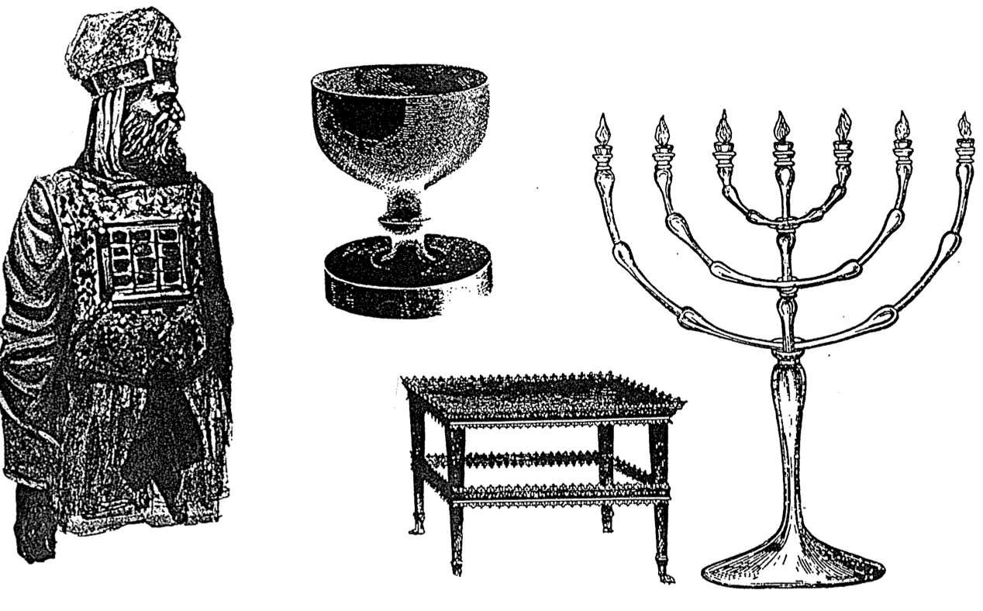
Here’s an Issue for your small group…

Which is the most accurate depiction of salvation in the OT and NT?

Salvation by…

Faith Alone

Faith Alone

Faith + Works

Faith Alone
Works

Faith
Faith + Works

Faith + Works

OT

NT

Which verses in the Bible support your answer?

Distinguishing Salvation and Sanctification

 | Man’s  Role | God’s Response | Life of  Faith | Restored Fellowship
OT

NT

Barry J. Beitzel, Moody Atlas of Bible Lands (Chicago: Moody, 1985), 90-93 has an extensive treatment of the issue, including interaction with a third location in the northern Sinai. He holds to the southern Sinai view. It would not have taken Elijah 40 days to travel from Beersheba to a northern location (1 Kings 19:8) but the 250 miles to southern Sinai fits well. Also, other texts indicate a large distance from Kadesh Barnea to Sinai (Num. 33:16-36; Deut. 1:2).
Atlases arguing for the traditional site include R. K. Harrison, "The Exodus and Conquest of Canaan," in The Zondervan Pictorial Bible Atlas, E. M. Blaiklock, ed. (Grand Rapids: Zondervan, 1969, 1972), 65; Joseph L. Gardner, ed., Reader's Digest Atlas of the Bible (Pleasantville, NY: Reader's Digest, 1987), 66-68; Beitzel, 92.
Beitzel, 92.
Harvard professor Frank Moore Cross does not specifically identify Jebel al-Lawz as the Mount Sinai site but he does note that Midian is the land of Mount Sinai and that Midian is in northwestern Saudi Arabia (BAR July/August 1999, p. 54).
See Roland de Vaux, Ancient Israel: Its Life and Institutions, translated by John McHugh (New York: McGraw-Hill, 1961), 435; cited by Beitzel, 90, n. 19.
Most of these archaeological arguments come from a 1988 visit to Saudi Arabia chronicled in Bob Carnuke and Larry Williams, "The Search for the Real Mount Sinai," 46 minute video tape (Monument, CO: Reel Productions, 1998 and P.O. Box 1798, Colorado Springs, CO 80901-1798: Biblical Archaeology, Search and Exploration Institute, 1998; Tel. 1-800-680-3300), $24.95). See also Larry Williams, The Mountain of Moses (140 Marine View, Office 204, Solana Beach, CA 92075: CTI Publishing, 1999; Tel. 1-800-748-5843) or Larry Williams, The Mountain of Moses: The Discovery of Mount Sinai (Wynwood Press, New York, 1990); Howard Blum, The Gold of Exodus: The Discovery of the True Mount Sinai (NY: Simon & Shuster, 1998), $25.00 hb, 364 pp.; Ron Wyatt also has a sensationalistic video ("Presentation of Discoveries" $30.00) as well as a web page (including many pictures) claiming a Saudi location (http://www.ronwyatt.org/exodus/index.html); Even Hershel Shanks, editor of Biblical Archaeology Review, says, "…all identifications of Mount Sinai are highly speculative. A good case has been made that it is somewhere in northwest Saudi Arabia, and Jebel al-Lawz is the highest point in this area" (BAR, Nov/Dec ‘99, p. 67). However, Brad Sparks documents many errors in Williams’ book at http://www.ldolphin.org/sinai.html. Recent advocates of the Saudi location include the Patterns of Evidence movies.
Brad Sparks provides a convincing case against a Saudi location (http://www.ldolphin.org/sinai.html). Sparks cites evidence for "Arabia" including the Sinai Peninsula on his note 27 quoting Graham I. Davies, The Way of the Wilderness (Cambridge Univ. Press, London, 1979): "Davies, Wilderness (1979) pp. 30, 99 n. 1, emphasis added. In Herodotus ca. 450 BC, not only was the Sinai Peninsula considered PART OF ARABIA but, surprisingly, so was all of the eastern desert half of what WE now call EGYPT on the continent of AFRICA. In Greek and Roman Empire days, the bulk of the Sinai Peninsula was left to the Nabateans as "Arabia Petrea," until their conquest by the Romans in 106 AD The southern and central Sinai were then merged into the new Province of Arabia. Even in modern times, Wilhelm Gesenius listed both MT. SINAI and the Sinai Peninsula as PART OF "ARABIA," in his famous 1834 Hebrew Lexicon (Herodotus II:8, 11, 158; Michael Avi-Yonah, "Sinai," Encycl. Judaica, vol. 14, p. 1595; Eckenstein, Hist. Sinai, p. 91; Davies, Wilderness, p. 30; Avraham Negev (ed.), The Archaeological Encyclopedia of the Holy Land [AEHL] (Thomas Nelson, Nashville, Tenn., 1986 rev.) pp. 65, 221-223, 276, 292, 351; Samuel P. Tregelles (trans.), Gesenius...Hebrew and Chaldee Lexicon (Baker, Grand Rapids, Mich., 1979 reprint [London, 1847, 1857]) p. 584 (Strong's no. 5514).)."
Noted by Beitzel, 91. This is not as convincing as it may sound, however, since Nuweiba lies on the Gulf of Aqaba closer to J. Lawz than to J. Musa.
See Ronald S. Hendel's review of Blum's book noted above and particularly of the video by Carnuke and Williams (BAR July/August 1999, p. 56).
For further support of the traditional view, see Gordon Franz's newsletter for members of Associates for Biblical Research entitled "The Bible and Spade" (http://www.ChristianAnswers.net/abr/abrhome.html).
Douglas J. Moo, "Jesus and the Authority of the Mosaic Law," JSNT 20 (February 1984): 3-49; Roy L. Aldrich, "Causes for Confusion of Law and Grace," BS 116 (July-September 1959): 221-29; id., "Has the Mosaic Law Been Abolished?" 322-35; id., "The Mosaic Ten Commandments Compared to Their Restatements in the New Testament," BS 118 (July-September 1961): 251-58.
One may object to this reasoning based upon that fact that Paul used circumcision (in the so-called ceremonial law) rather than the Sabbath (in the so-called moral law), but Paul's teaching on the present applicability of the Ten Commandments is noted later in this discussion.
Douglas R. de Lacey, "The Sabbath/Sunday Question and the Law in the Pauline Corpus," in From Sabbath to Lord's Day: A Biblical, Historical, and Theological Investigation, ed. D. A. Carson, 159-95 (Grand Rapids: Zondervan, 1982), 166.
E. P. Sanders, Paul, the Law, and the Jewish People (Philadelphia: Fortress Press, 1983), 144.
This is certainly not to say that believers are now free to covet, for this is prohibited elsewhere in the New Testament (e.g., James 4:2). What Paul means is that the prohibition of coveting in the Decalogue revealed man's inability to follow God's commands.
Bernardin Schneider, "The Meaning of St. Paul's Antithesis 'The Letter and the Spirit,'" CBQ 15 (1953): 193-207.
Charles Hodge, A Commentary on 1 & 2 Corinthians, GCS, 428. See also Exodus 24:12; 31:18; 32:15-16 for other verses mentioning the tablets. Many argue that Paul's reference to "tablets of stone" serves as a figurative designation for the entire law or Old Covenant (e.g., Victor Paul Furnish, II Corinthians, AB, 200; Bultmann, 73-75; Frederick W. Danker, II Corinthians, ACNT, 54; Colin Kruse, The Second Epistle of the Paul to the Corinthians, TNTC, 91-93; Knofel Staton, Second Corinthians, SBS, 56-57). However, the passage compares in graphic terms the actual writing (content) on the cold, external tablets with that "written" on the warm, internal heart; thus, the comparison drawn is between the Decalogue and that which replaces it–the work of the Spirit in the inner man. However, even if the tablets represent the entire law (the Old Covenant is the implied contrast in verse 6 and specifically mentioned in verse 14), this still argues for the abolition of the Sabbath as part of that law.
De Lacey, "The Sabbath/Sunday Question and the Law in the Pauline Corpus," 167.
Ernest Best, Second Corinthians, Interp., 31.
Even Paul's statement that circumcision is nothing but rather what matters is "keeping the commandments of God" (1 Cor. 7:19) is inadequate proof that believers are to keep the Ten Commandments. There is no evidence that "commandments of God" refers exclusively or even primarily to the Decalogue (C. K. Barrett, 1 Corinthians, 169; de Lacey, "The Sabbath/Sunday Question and the Law in the Pauline Corpus," 176). Objection to the preceding presentation of Paul's view of the Decalogue may also be based upon his appeal to the fifth commandment in Ephesians 6:1-3. However, here the primary motive for children obeying their parents is not the Decalogue, but because this is part of one's calling in Christ (4:1) and is right (v. 1b). The appeal to the Ten Commandments is at best a third motivation (ibid., 176).
For an evaluation of the penalties for each of the Ten Commandments, see Aldrich, "The Mosaic Ten Commandments Compared to Their Restatements in the New Testament," 251-58. He shows how the believer is not under the Decalogue, but instead "he is under the eternal moral law of God which demands far more than the Ten Commandments. It calls for nothing less than conformity to the character of God" (p. 257).

