Advanced Preaching Course, Singapore Bible College Dr. Rick Griffith
2002 Message 1 of 1
NIV 30 Minutes
God’s Watchcare
Psalm 121
A Declarative Praise Individual Thanksgiving Psalm

Topic: Security
Subject: How should we respond to having God as our security?
Complement: Trust God as your ultimate security! He’s trustworthy everywhere and always.
Purpose: The listeners will trust in God’s care.
Attribute: We worship the God who Cares for Us

Introduction

Interest: We all feel vulnerable—so where do we put our trust?

Introduce Partial Main Idea: The Lord is our security when we feel vulnerable.

Subject: So what? How should we respond to having God as our security?

Background: Travel to Jerusalem three times yearly was required by the Mosaic law but still dangerous.

Preview: We will first see God as our security (1-2), and then why to trust him (3-8).

Text: Psalm 121

(So where is our security?)

(I. Confess that your security ultimately lies in the Lord [1-2].)

A. Don’t trust in what the world trusts (money, people, job, locks, bars, etc.).

B. Admit that God alone can give you security (1-2).

(But why should we trust the Lord?)

II. Trust Him since God’s security system operates 24-hours daily and worldwide (3-8).

A. He’ll never fall asleep on you (3-4) in contrast to other sources of trust (e.g., people).

B. He protects you from all hazards (5-6) in contrast to other sources of protection (examples).

C. He protects you wherever you go (7-8) unlike sources geographically limited (examples).

(How should we respond to having God as our security?)

Conclusion

Main Idea: Trust God as your ultimate security! He’s trustworthy everywhere and always.

Main Points

Confess that your security ultimately lies in the Lord (1-2).

Trust Him since God’s security system operates 24-hours daily and worldwide (3-8).

Application: But how do you trust Him?

Pray during vulnerable times and

See your problem in light of His creative power (v. 1), limitless time constraints, and omnipresence.

Preliminary Questions

Verses Questions

Context: What did the author record just prior to this passage?

The context is that of pilgrimage from lower places of Israel up to the hill country of Judea, and ultimately to Jerusalem.

Some, however, see the psalmist as finished with his worship at Jerusalem about to return from Jerusalem to his home (cf. Allen).

Psalm 121 is the second of this group of “ascent psalms” (Pss. 120—134).

Purpose: Why is this passage in the Bible?

We trust anything for security except God!

God is typically our last resort.

Background: What historical context helps us understand this passage?

Roads to Jerusalem were dangerous.

But God still required the journey three times a year.

Questions

Interpretive Issues:

1. How would a pilgrim en route to Jerusalem see “the hills” (v. 1; citations by Allen, WBC, 151)?

a. Negatively: Some scholars see the hills as a source of danger because of the rugged terrain around Jerusalem (Kraus) or en route back to the pilgrim’s home (Weiser, Anderson) or on any desert journey (Morgenstern) or culticly due to pagan high places (Ehrlich, Mowinkel, Gunkel).

b. Positively: Other scholars see a positive connotation such as heaven (Volz, Eissfeldt), the divine title of Yahweh (Dahood), other hills where God made his presence known such as Sinai and Carmel (Williams) or Jerusalem itself with a positive cultic sense (Briggs, Habel, Allen). This last view finds support from “the other cosmic mountain(s) on which Yahweh dwells: cf. 48:1-3; 87:1-3 and the reference to the sanctuary of Zion as the source of divine help in 20:3 (2)” (Allen, 151).

2. How does the structure best divide? This psalm divides nicely into four couplets, each with a second idea to complete the first. Should this then produce a fourfold outline?

a. Williams (CC, 404-5) notes, “The thought moves from the admission of need for help (vv. 1-2) to the nature of the help (vv. 3-8)” and “from personal address (vv. 1-2) to a reflection upon the God who is our help,” specifically, the fact that he keeps (3-4), protects (5-6) and preserves us (7-8). It changes from first person (1-2) to second person (3-8; Allen, 152).

b. For the above reasons it seems best to make the major division after verse 2. However, I would disagree with Williams that the main thought of verses 1-2 is the psalmist’s need. It seems to better describe the source of his help. Also, the distinctions between keeps (3-4), protects (5-6) and preserves (7-8) are not helpful to me as they seem synonymous.

3. How can verses 3-8 be reconciled with the fact that Christians do experience suffering, sickness, and other difficulties? And how can this fit verse 1 where the psalmist already acknowledges that he needs help?

a. “God does not promise that we will never have problems; He does promise to be with us in our problems, and He assures us that nothing can touch our souls and separate us from His love (Rom. 8:37-39)” (Williams, CC, 406).

b. The focus of the psalm is definitely God’s watchcare, not necessarily the worshipper’s total protection. Watchcare is seen in the sixfold use of rm'v; (shamar, “to watch, protect”; cf. vv. 3, 4, 5, 7bis, 8). The NIV translates this word as “watches” five times and “will keep you” once in verse 7. The other key word is “the LORD,” the covenant name for God noted five times (vv. 2, 5bis, 7, 8). Therefore, the central idea concerns the LORD’s watchcare.

4. Some specific phrases in the psalm are difficult to grasp:

a. Is the second line of verse 1 a question (NIV) or a completion of the first line?
b. If “He will not let your foot slip” (3a) is not to be taken literally, then what does it mean (cf. 6a, 7a)?
c. What does “shade at your right hand” mean (5a)?
d. How could the moon harm one at night (6b)?

Tentative Main Ideas

Text

Illustrations That Apply

Text

Old Testament Survey Notes

Title
Book

Exegetical Outline (Steps 2-3)

Exegetical Idea: The proper response to God’s continual and competent watchcare is trust in Him as security despite the hazards of pilgrimage.

I. The proper response of the psalmist in pilgrimage dangers is trust the Creator LORD (1-2).

A. (1) He confidently asks for the source of protection against enemies on his pilgrimage as he sees the hills surrounding Jerusalem.

B. (2) He answers his own question by reminding himself that since the LORD created not simply Jerusalem but all creation, He will certainly protect the psalmist on his journey.

II. (3-8) The reason trust in the LORD is proper is because the LORD watches over each pilgrim continually and competently.

A. (3-4) The time when the LORD watches over him is always since Yahweh needs no sleep.

1. (3) All accidents affecting him do not escape his notice since he never sleeps.

2. (4) He watches over all Israel all day long, so He can take care of each individual as well.

Note: There may be a contrast to Baal, who needs sleep (cf. 1 Kings 18:27).

B. (5-6) The hazards the LORD protects him from include those of the day and night.

1. (5) His watchcare is a shade of protection when traveling to Jerusalem in the blazing sun.

2. (6) He protects us from dangers both in the daytime and night.

C. (7-8) The place where the LORD watches over his life is wherever he travels.

1. (7) All accidents affecting him do not escape his notice as he protects him throughout life.

2. (8) He protects His child wherever he goes throughout his life.

Purpose or Desired Listener Response (Step 4)
The listeners will

Homiletical Exposition (cyclical deductive form) Title: “Guardian Father”

Introduction

Interest: We all feel vulnerable—so where do we put our trust?

Introduce Partial Main Idea: The Lord is our security when we feel vulnerable.

Subject: So what? How should we respond to having God as our security?

Background: Travel to Jerusalem three times yearly was required by the Mosaic law but still dangerous.

Preview: We will first see that God is our security (1-2), and then why we should trust him (3-8).

Text: Psalm 121

(So where is our security?)

(I. Confess that your security ultimately lies in the Lord [1-2].)

A. Don’t trust in what the world trusts (money, people, job, locks, bars, etc.).

B. Admit that God alone can give you security (1-2).

(But why should we trust the Lord?)

II. Trust Him since God’s security system operates 24-hours daily and worldwide (3-8).

A. He’ll never fall asleep on you (3-4) in contrast to other sources of trust (e.g., people).

B. He protects you from all hazards (5-6) in contrast to other sources of protection (examples).

C. He protects you wherever you go (7-8) unlike sources geographically limited (examples).

(How should we respond to having God as our security?)

Conclusion

Main Idea: Trust God as your ultimate security! He’s trustworthy everywhere and always.

Main Points

Application: But how do you trust Him?

Pray during vulnerable times and

See your problem in light of His creative power (v. 1), limitless time constraints, and omnipresence.

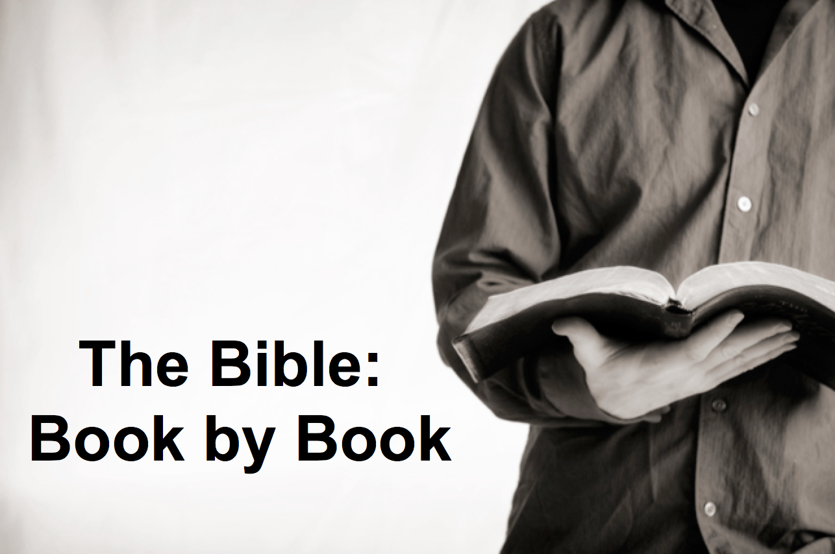

Rick Griffith
2018
Message of 66

Title
Passage

Introduction

Subject with a blank for the key word _______________

I. MP has a blank for the key word ________________ (verses).

SP has a blank for the key word ________________ (verses).

SP has a blank for the key word ________________ (verses).

SP has a blank for the key word ________________ (verses).

II. MP has a blank for the key word ________________ (verses).

SP has a blank for the key word ________________ (verses).

SP has a blank for the key word ________________ (verses).

Conclusion

Main Idea has a blank for the key word ________________ (verses).

Application question

Download this sermon PPT and notes for free at BibleStudyDownloads.org/resource/old-testament-preaching/
Listen to this message online at cicfamily.com/sermon-listing/

BOOK CHART

