Crossroads International Church Singapore Dr. Rick Griffith
28 July 2018 Message 20 of 66
NLT 60 Minutes
Be Wise
Title
Book of Proverbs

Topic: Wisdom
Subject: How can you be wise?
Complement:
Purpose: The listeners will pursue wisdom above all else.
Attribute: We worship our wise God
Reading: Proverbs 1:1-7
Song: The Perfect Wisdom of Our God (Getty), Wisdom Song (Laura Woodley Osman)

Introduction

Interest: People are passionate about many things.
Passion

Money—so Singapore has the highest percentage of millionaires worldwide (16.5%)

Education—few feel you could be overeducated

Power—many are not happy with their job

Sex—few people remain with one person for life

Fun—the last experience didn’t satisfy, so try another

Travel—never before have so many traveled

Food—some travel across the country for a certain stall

Sports—depression if their team loses, elation if it wins

Need: But have you ever met someone who said he or she was passionate about gaining wisdom? Are you passionate about pursuing wisdom?
Want Wisdom

God gave Solomon one wish (since God is not a genie who gives three wishes!).

Solomon had the wisdom to want wisdom (1 Kings 3).

How much do you want wisdom?

But even if you desire to be wise, it still won’t just happen, so…
How Be Wise?

Subject: How can you be wise?

God wants us to be wise—but he is wise enough to tell us how as well.

Proverbs tells that the way to wisdom is by fearing God and valuing wisdom in our relationships.

Background: Solomon was the wisest man every to live and he wrote 3000 proverbs to share it with us.
Book by Book

In Solomon’s time people did not idolize political leaders, sports figures, or attractive people who pretend to be someone else (=Hollywood and Bollywood).

Instead, many sages of this time taught wisdom as the people then seemed to pursue wisdom more than they do today.
1:10-33

We all should be familiar with proverbs since we see many of them today (15 examples).
Proverbs
(15 slides)

Proverbs teach wisdom in four main sections that sum up wisdom in short, pithy sayings that stand for many words.
Intro
(4 slides)

Themes in the book are all practical, such as speech, money, success, laziness and relationships.
Themes
(10 slides)

Preview: This book is especially written to youth (“sons”). However, Proverbs will give all of us three ways to be wise.
3 ways

Text: The Book of Proverbs tells us how to be wise in three ways.

(What is the first way to be wise?)

Learn discipline and fear of the LORD (1:1-7).
MP
[A wise person is never a lazy person, but rather one who diligently seeks God.]
Prov 1
(5 slides)

Solomon gave proverbs to teach discipline and discernment (1:1-6).

Knowledge begins with fearing the LORD (1:7)

What is wisdom?

Is knowledge the same as wisdom?

How do we get wisdom?

What does it mean to fear the LORD?

(Besides heeding proverbs to fear God, how else can you be wise? It must include the desire for wisdom when we see how important wisdom is. This is the second way to be wise, which is to…)
MPI

Value wisdom that leads to a prosperous life (1:8–9:18).
MP
Prov 6
(4 slides)
Prov 3
(6 slides)
[A wise person really wants wisdom and then experiences wisdom’s benefits.]

Wisdom gives honor to keep youth from the shame of foolishness (1:8-9).
1:8-9
Prov 4
(4 slides)
Prov 2
(3 slides)
Prov 5
(6 slides)

Wisdom preserves youth from disaster (1:10-33).

Wisdom helps maintain moral behavior (Prov 2).

Wisdom helps us relate with God and man (Prov 3).

Wisdom provides a gracious life (4:1-9).

Wisdom preserves youth from trouble (4:10-19).

Wisdom produces healthy young people (4:20-27).

Wisdom helps avoid sexual sin (Prov 5).

Wisdom preserves from poverty (6:1-11).

Wisdom preserves from dissension (6:12-19).

Wisdom preserves youth from sexual immorality (6:20–7:27).

Wisdom has valuable virtues, rewards and was used in creation (Prov 8).
Prov 8
(2 slides)

Wisdom is valuable compared to the claims of foolishness (Prov 9).
Prov 9
(2 slides)

(So once we fear God and value wisdom, how can we build upon this? This shows us the third way to be wise, which is to…)
MPs
(2 slides)

Heed advice of wise men on relationships (Prov 10–31).
MP
[A wise person isn’t a loner, but relies on others to relate better with people.]

About 375 two-line proverbs of Solomon teach the practical benefits of wisdom over wickedness in everyday life (10:1–22:16).
Prov 10-11
(4 slides)
Prov 22
(2 slides)

Longer sayings of wise men admonish practical wisdom in many areas (22:17–24:34).

The final collection of Solomon's proverbs by Hezekiah's scribes 250 years later guide social relationships and various activities (Prov 25–29).
Prov 25
(2 slides)
MPI

Sayings of the unknown Agur to the unknown Ithiel and Ucal show insights from nature and social relationships (Prov 30).
Prov 30
(3 slides)

The unknown Lemuel’s mother prepares him for kingship by advising him to avoid the excesses of women and wine, and to protect the rights of the underprivileged (31:1-9).
31:1-9
(2 slides)
31:10-31
(9 slides)

An acrostic and anonymous poem of a noble wife exhorts young women to be godly and diligent and exhorts young husbands to praise these qualities in their wives (31:10-31).
Subject
(How can you be wise?)

Conclusion

Fear God by heeding his proverbs on the value and path of wisdom (Main Idea).
MI

How can you be wise (Main Points)?

Learn discipline and fear of the LORD (1:1-7).
MPII

Value wisdom that leads to a prosperous life (1:8–9:18).
MPIII

Heed advice of wise men on relationships (Prov 10–31).

Exhortation
App

Teach youth (& children) proverbs.
• Teach

Memorize proverbs.
• Memory

Read one chapter of Proverbs every day to make one month.
• Read

Prayer
Black/Con
(2 slides)

Preliminary Questions

Verses Questions

Context: What did the author record just prior to this passage?

Solomon likely wrote Song of Songs before this book.

He also probably wrote Ecclesiastes after it.

Purpose: Why is this passage in the Bible?

God wants us to be wise—but he is wise enough to tell us how as well.

Proverbs tells that the way to wisdom is by fearing God and valuing wisdom in our relationships.

Background: What historical context helps us understand this passage?

In Solomon’s time people did not idolize political leaders, sports figures, or attractive people who pretend to be someone else (=Hollywood and Bollywood).

Instead, many sages of this time taught wisdom as the people then seemed to pursue wisdom more than they do today.

Questions

How can we find wisdom?

What is wisdom?

What does it mean to fear the LORD?

Tentative Main Ideas

God wants you to be a wise guy.

Illustrations That Apply

Text

Old Testament Survey Notes

Proverbs

Value and Path of Wisdom

Solomon |  |  | Wise Men  (Anonymous) | Solomon | Wise Men  (Agur, Lemuel,  Anonymous)
1:1–22:16 |  |  | 22:17–24:34 | Chapters 25–29 | Chapters 30–31
13 sayings  (1:1–9:18)  375 two-line  (10:1–22:16) |  |  | 36 sayings | ±100 two-line | 3 sayings
Aims  1:1-7 | Value of Wisdom  1:8–9:18 | Contrasts  &  Godliness  10:1–22:16 | Social  & Miscellaneous | Social  & Miscellaneous | Social  & Nature  Ch. 30 | Ruling  31:1-9 | Godly  Wife  31:10-31
Prologue | Principles of Wisdom |  |  |  |  | Epilogue
ca. 950-700 BC

Key Word: Wisdom

Key Verse: “Trust in the LORD with all your heart and lean not on your own understanding; in all your ways acknowledge him and he will make your paths straight” (Proverbs 3:5-6)

Summary Statement:
The proverbs of Solomon and various sages teach youth the value of wisdom over folly so they will obey God in every area of life.

Application:

Memorize proverbs to promote wise living.
Seek wisdom in every area to avoid the pitfalls of life.

Proverbs

Introduction

I. Title The word “proverb” (lv;m; masal ) is apparently derived from a root meaning "to be like" or "compared with" (LaSor, 547; cf. "represent, be like" BDB 605a; Archer, 465); therefore, a proverb is a statement which makes a comparison or describes a common experience. The Hebrew and Greek titles for the book read "Proverbs of Solomon" (hmoløv] ylev]mi 1:1) so the English title "Proverbs" shortens it to include other authors of the collection as well. The Latin title Liber Proverbiorum, "Book of Proverbs," combines the words pro "for" and verba "words" to affirm how a proverb is a "word (verb) that stands for" many words, i.e., combined into one short saying (TTTB, 162).

II. Authorship

A. External Evidence: Solomon spoke 3000 proverbs (1 Kings 4:32), and hundreds of them are contained in this collection bearing his name. However, the Book of Proverbs is a collection by compilers other than Solomon since Hezekiah's men copied his proverbs and presumably added them to the already existing collection (25:1). Some believe Isaiah and Micah contributed to the collecting process since they lived in Hezekiah's time (TTTB, 162).

B. Internal Evidence: The heading "The Proverbs of Solomon" (1:1) identify the following section (Prov 1–9) as his work, as does the same title repeated in 10:1 (which introduces 10:1–22:16 as Solomonic) and a similar title in 25:1 (introducing chapters 25–29). The remainder of the book is written by Jewish wise men (22:17–24:34), Agur (ch. 30), and Lemuel (ch. 31), of which nothing is known outside the Book of Proverbs. Stylistic differences in 31:10-31 may indicate another unknown author other than Lemuel (31:1-9), especially since it is an acrostic poem separate from Lemuel's work (Buzzell, BKC, 1:901). Some (e.g., LaSor, 551) feel that the repetition of the Solomonic title in 10:1 indicates that chapters 1–9 are also the product of anonymous sages, but 1:1 probably argues against this.

III. Circumstances

A. Date: Most of the proverbs date from Solomon's era (before his death in 931 BC), probably during his middle years (as contrasted with Song of Songs probably penned in his early adult years and Ecclesiastes at the end of his life). The entire collection could not have been completed before Hezekiah's time 250 years later (ca. 715-686 BC) since his men acted as compilers (25:1; cf. LaSor, 558). The latest date is revealed in the last two chapters written by the otherwise unknown Agur and Lemuel, which "may well have been added during or shortly after the Exile (ca. 500)" (LaSor, 558; cf. Kidner, Proverbs, 26); however, "the final date of compilation is generally considered to be around 700 BC, assuming Agur and Lemuel wrote before then" (Buzzell, BKC, 1:901).

B. Recipients: The frequent use of the phrases "my son" and "my sons" may indicate either a home setting or a school environment where students were called "sons" of their teachers. Since the sayings are collections, both views may be correct as proverbs were collected from various situations and audiences.

C. Occasion: King Hezekiah sought the Lord fully during his life, so he likely saw the existing collection proverbs of Solomon (Prov 1–24) and authorized other proverbs of Solomon to be added to the book under the direction of the Holy Spirit (Prov 25–29). Many of the Ancient Near East cultures had similar wisdom writings (cf. the Egyptian proverbs of Amenemope, ca. 1000 BC). The book actually compiles eight separate collections (distinguishable by either an introductory subtitle or sudden change in literary style; cf. LaSor, 548), which makes it difficult to speak with any certainty how the book obtained its present form, except that the Holy Spirit guided the process.

IV. Characteristics

A. Proverbs say little about the afterlife as the emphasis is on life now (Buzzell, BKC, 1:904).

B. Proverbs is one of the few books in Scripture with various authors (cf. Psalms, 1 Samuel, portions of Deuteronomy and Joshua, etc.).

C. Humor is important to many of the proverbs (11:22; 19:24; 23:13, 35; 24:33; 25:24; 26:13-16; 27:15-16; 30:15, 21-23; cf. TTTB, 164).

D. Proverbs are unique at least five ways (Jim Wilhoit and Leland Ryken, Effective Bible Teaching, 237-39):

1. Proverbs meet the human urge for order. They systematize our understanding about life.

2. Proverbs are striking and memorable. This makes us take notice as opposed to the clichés of certain statements or ideas. For example, “He who loves money will not be satisfied with money” (Eccles. 5:10).

3. Proverbs are simultaneously simple and profound. The proverb is a meditative form, inviting us to pause and consider it carefully.

4. Proverbs are often poetic in form. Use of concrete images heightens effect: “Through sloth the roof sinks in” (Eccles. 10:18).

5. Proverbs are often specific and universal at the same time. “Through sloth the roof sinks in” talks about more than houses—it comments about laziness in any area of life.

E. Types of proverbs fall into three different categories (Wilhoit and Ryken, 240, adapted):

1. Descriptive: some proverbs describe how things are…

“Because sentence against an evil deed is not executed speedily, the heart of the sons of men is fully set to do evil” (Eccles. 8:11)

“One sinner destroys much good” (Eccles. 9:18)

“Money is the answer for everything” (Eccles. 10:19 NIV) actually expresses an immoral viewpoint but not with approval—it just states what many people think.

2. Prescriptive: other proverbs prescribe how we should live such as “Do not wear yourself out to get rich” (Prov. 23:4 NIV).

3. Combination: still other proverbs both describe and prescribe by expressing observations that exhort a mode of behavior. Proverbs 27 has such examples…

“Faithful are the wounds of a friend;
profuse are the kisses of an enemy” (v. 6)

“He who blesses his neighbor with a loud voice,
rising early in the morning,
will be counted as cursing” (v. 14)

“A continual dripping on a rainy day
and a contentious woman are alike” (v. 15)

F. This literary type (genre) requires greater discernment in interpretation. In particular, too often people understand a proverb as an absolute promise or principle that has no exceptions. For example, consider the proverb about child rearing:

“Train a child in the way he should go,
and when he is old he will not turn from it” (Proverbs 22:6)

This has often been taken to be an unconditional promise. The problem comes when godly parents raise a child in a godly manner but the child later rejects these values. Questions like “Did they really do a good job in raising the child” and “How can they say they raised the child properly?” arise based upon this verse.

G. In response, some guidelines to interpretation may help to interpret Proverbs properly:

1. Do not consider the proverbs as promises from God but rather as general observations and principles that are usually valid but not always (cf. Zuck, A Biblical Theology of the OT, 234). Thus, in the case above, as a rule godly parents generally do raise godly children, but exceptions occur—even biblical ones such as Samuel whose sons were dishonest (1 Sam. 8:1-5) and Hezekiah, one of the most godly Judean kings, whose son Manasseh was one of Judah’s most evil kings (2 Kings 21–22). Solomon also had David as his godly father, yet Solomon later became an idolater. Other proverbs also are not promises (e.g., 10:4; 12:11, 24).

2. Understand Old Testament teaching in line with revelation for the church (Acts and Epistles). At least three types of statements apply (Homer Heater, DTS class notes, 210-11):

a. Reiterated statements: These appear in the NT epistles in the same or similar form. “Do not bear false witness against your neighbor” (Exod. 20:16) is reiterated in “Stop lying to one another” (Eph. 4:25).

b. Quoted statements: When the NT quotes an OT passage to apply truth, it applies to the Church. “If your enemy is hungry, feed him” (Prov. 25:21) reappears in Paul’s instructions (Rom. 12:20; cf. Matt. 5:44).

c. Parallel statements: While similar to the reiterated statements above, these are more general. Wise words which “keep you from the adulteress” (Prov. 7:24) find a parallel idea in the NT: “It is God’s will that you should be holy; that you should avoid sexual immorality” (1 Thess. 4:3).

3. Proverbs with no repetition, quote, or parallel in the NT should not be treated as commands. However, if they do not contradict NT teaching they may be applied as principles. Tithing serves as an example. It is not taught in the NT and therefore not binding on the church. Though many Christians may follow tithing, they should not impose it on others.

Argument

The Book of Proverbs is a collection of eight collections of short sayings designed to produce wisdom, especially for youth. The collection begins with its purpose (1:1-7), though this probably only originally introduced the first section by Solomon (1:8–9:18). Another Solomonic section follows, using antithetical and indicative two-line proverbs (10:1–22:16), followed by longer sayings of the wise men (22:17–24:34) and the final section of Solomon's proverbs—this section collected by Hezekiah's men 250 years after Solomon (Prov 25–29). The book concludes with three short sections by Agur (Prov 30), Lemuel (31:1-9) and an anonymous acrostic poem depicting the noble wife (31:10-31). The purpose of all of these sections in 1:1-7 is to give the value and path of wisdom so readers will obey God in every area of life.

Synthesis

Value and path of wisdom

Author Theme

1:1-7 Solomon’s Purpose Wisdom for obedience

1:8–9:18 Solomonic miscellaneous Value of wisdom

10:1–22:16 Solomonic two-line Contrasts/godliness

22:17–24:34 Wise men sayings Various situations

25–29 Solomonic via Hezekiah's scribes Social

30 Agur Nature/social

31:1-9 Lemuel Leadership

31:10-31 Anonymous Noble wife

Outline

Summary Statement for the Book
The proverbs of Solomon and various sages teach youth the value of wisdom over folly so they will obey God in every area of life.

The introduction to the first collection cites Solomon's purpose to give wisdom so readers will obey God in every area of life (1:1-7).

The title introduces Solomon as the author of the proverbs in chapters 1–9 (1:1).

Solomon gave proverbs to teach discipline and discernment (1:2-6).

Knowledge begins with fearing the LORD (1:7).

Solomon's proverbs show the value of wisdom because it leads to a prosperous life while foolishness leads to a despicable life (1:8–9:18).

Wisdom is valuable because it gives honor to prevent youth from the shame of foolish living (1:8-9; cp. Solomon's own son Rehoboam).

Wisdom is valuable because it preserves youth from disaster (1:10-33).

Wisdom is valuable because it helps maintain moral behavior (Prov 2).

Wisdom is valuable because it helps us relate with God and man (Prov 3).

Wisdom is valuable because it provides a gracious life (4:1-9).

Wisdom is valuable because it preserves youth from trouble (4:10-19).

Wisdom is valuable because it produces healthy young people (4:20-27).

Wisdom is valuable because it helps avoid sexual sin (Prov 5).

This section will help youth discern between right and wrong (5:1-2).

Sexual purity’s many benefits will help readers avoid the stupidity of sexual sin (5:3-23).

Sexual sin is enjoyable in the short run but bitter in the end (5:3-6).

Immoral people’s advances are genuinely enticing in touch and sound (5:3).

However, following such advances leads to certain ruin (5:4-5).

Sex addicts can’t discern momentary pleasure from long-term goals (5:6).

Sexual sin has many physical, financial, and emotional woes (5:7-14).

Don’t expose yourself to temptations in the sexual arena (5:7-8).

Exposure to sexual sin leads to poor health, poverty, and regret (5:9-14).

Sexual sin gives strangers the bodily strength and money for one’s spouse (5:9-10).

Sexual sin leads to a life of public regret for disobeying teachers (5:11-14).

Sex with one partner in marriage is the most enjoyable experience (5:15-20).

Sex should be shared with only one person (5:15-17).

Sex is most satisfying with one’s spouse (5:18-20).

Avoid sexual sin because God calls it evil and will judge us for it (5:21-23).

Resist sexual sin because God sees all we do and judges each deed (5:21).

Resist sexual sin because it is an evil deed that causes personal ruin (5:22-23).

Wisdom is valuable because it preserves from poverty (6:1-11).

Wisdom is valuable because it preserves from dissension (6:12-19).

Wisdom is valuable because it preserves youth from sexual immorality (6:20–7:27).

Wisdom is personified in its valuable virtues, rewards and use in creation (Prov 8).

Wisdom is valuable in its many virtues and rewards (8:1-21).

Wisdom was valuable to God himself when creating the earth (8:22-36).

Wisdom is valuable compared to the claims of foolishness (Prov 9).

About 375 two-line proverbs of Solomon teach the practical benefits of wisdom over wickedness in everyday life (10:1–22:16).

Solomon's antithetical proverbs contrast righteous and wicked attitudes and conduct along with their results to exhort living in wisdom (Prov 10–15).

Solomon's indicative proverbs observe from experience how wisdom applied to everyday life leads to godliness (16:1–22:16).

Longer sayings of wise men admonish practical wisdom in many areas (22:17–24:34).

Sayings of Jewish wise men admonish practical wisdom in many areas, with explanation of the reasons to heed their advice, especially due to Israel's faith in God (22:17–24:22).

Additional sayings of other wise men emphasize moral and social responsibility but with little stress on spiritual motivations for obedience (24:23-34).

The final collection of Solomon's proverbs by Hezekiah's scribes 250 years later guide social relationships and various activities (Prov 25–29).

Proverbs about relationships guide wise living in the social dimension (Prov 25–26).

Proverbs about various activities guide wise living in other dimensions of life (Prov 27–29).

Sayings of the unknown Agur to the unknown Ithiel and Ucal show insights from nature and social relationships (Prov 30).

The unknown Lemuel’s mother prepares him for kingship by advising him to avoid the excesses of women and wine, and to protect the rights of the underprivileged (31:1-9).

An acrostic and anonymous poem of a noble wife exhorts young women to be godly and diligent and exhorts young husbands to praise these qualities in their wives (31:10-31).

Note that nothing is said about her “personal relationship with her husband, her intellectual or emotional strengths, or her religious activities” (Ross, EBC, 5:1129).

"The model of women in tribal patriarchalism is a brood mare;
in hedonistic naturalism, she is the bunny or plaything;
in feminist ideology, she is the self-sufficient career woman;
in romanticism, she is the fairy princess or maiden in distress waiting to be rescued;
in biblical faith, she is the partner in ministry."

— Theologian Donald Bloesch (1928-2010)

Topical Arrangements of Proverbs

Only portions of Proverbs are arranged by topic. However, some resources have done this:

Hubbard, D. A. Proverbs. Communicator’s Commentary. Waco, TX: Word, 1989. 487 pp.
A more scholarly work in tone than the other preaching oriented commentaries in this series, but still readable. Includes six principles of interpretation and important guidelines to the proper understanding of the literary devices. Discusses Proverbs 10ff. topically rather than verse-by-verse but is somewhat difficult to use.

Voorwinde, Stephen. Wisdom for Today’s Issues: A Topical Arrangement of The Proverbs. Phillipsburg, NY: Presbyterian & Reformed, 1981. 186 pp.
A small paperback which reprints the NASB text topically in 55 chapters such as adultery, anger, food, giving, greed, kindness, laziness, prayer, political leaders, speech, women, etc.

Woodcock, Eldon. Proverbs. Grand Rapids: Zondervan, 1988. 237 pp. Paper, US$8.95.
Introductory matters and topical arrangement of the book. Chapters conclude with questions and suggestions for further study.

Words and Speaking in Proverbs

Wrong Uses of Words | Right Uses of Words
Lying  6:16-17a; 10:18a; 12:17b, 19, 22a: 14:5b, 25b; 17:4b, 7; 19:5, 9b, 22b, 28a; 21:6, 28; 25:18; 26:28a | Truthfulness  12:17a, 19a, 22b; 14:5a
Slandering  10:18b; 30:10 | Speak to help and encourage  10:11a, 20a, 21a; 12:14a, 18b; 15:4a; 18:4, 20-21
Constant talking  10:8, 10b, 19; 17:28; 18:2; 20:19b | Few words  10:19; 11:12b; 13:3a; 17:27a
Mocking  13:1b; 14:6a; 15:12; 17:5a; 19:29a; 21:11a; 22:10; 24:9b; 30:17 | Carefully chosen words  13:3a; 15:28; 16:23a; 21:23
Harsh talk: perverse, reckless, evil, sly words  10:31b-32; 12:18a; 13:3b; 14:3a; 15:1b, 28b; 17:4a; 19:1, 28b | Fitting words: kind, appropriate, pleasant  10:32a; 12:25; 15:1a, 4a, 23; 16:24; 25:11, 15
Ignorant or foolish words  14:7; 15:2b, 7-14; 18:6-7 | Words expressing wisdom  10:13a, 31a; 14:3b; 15:2a, 7a; 16:10, 21b, 23b; 20:15
Gossiping
11:13; 16:28b; 17:9b; 18:8; 20:19; 26:20, 22

Boasting
17:17a; 20:14; 25:14; 27:1-2

Quarreling
13:10; 15:18; 17:14, 19; 19:13; 20:3; 21:9, 19; 22:10; 25:24; 26:17, 20-21; 27:15

Flattering
26:28b; 28:23; 29:5
Adapted from The Bible Knowledge Commentary, 1:918

Positive and Negative Topics and Other Subjects in Proverbs

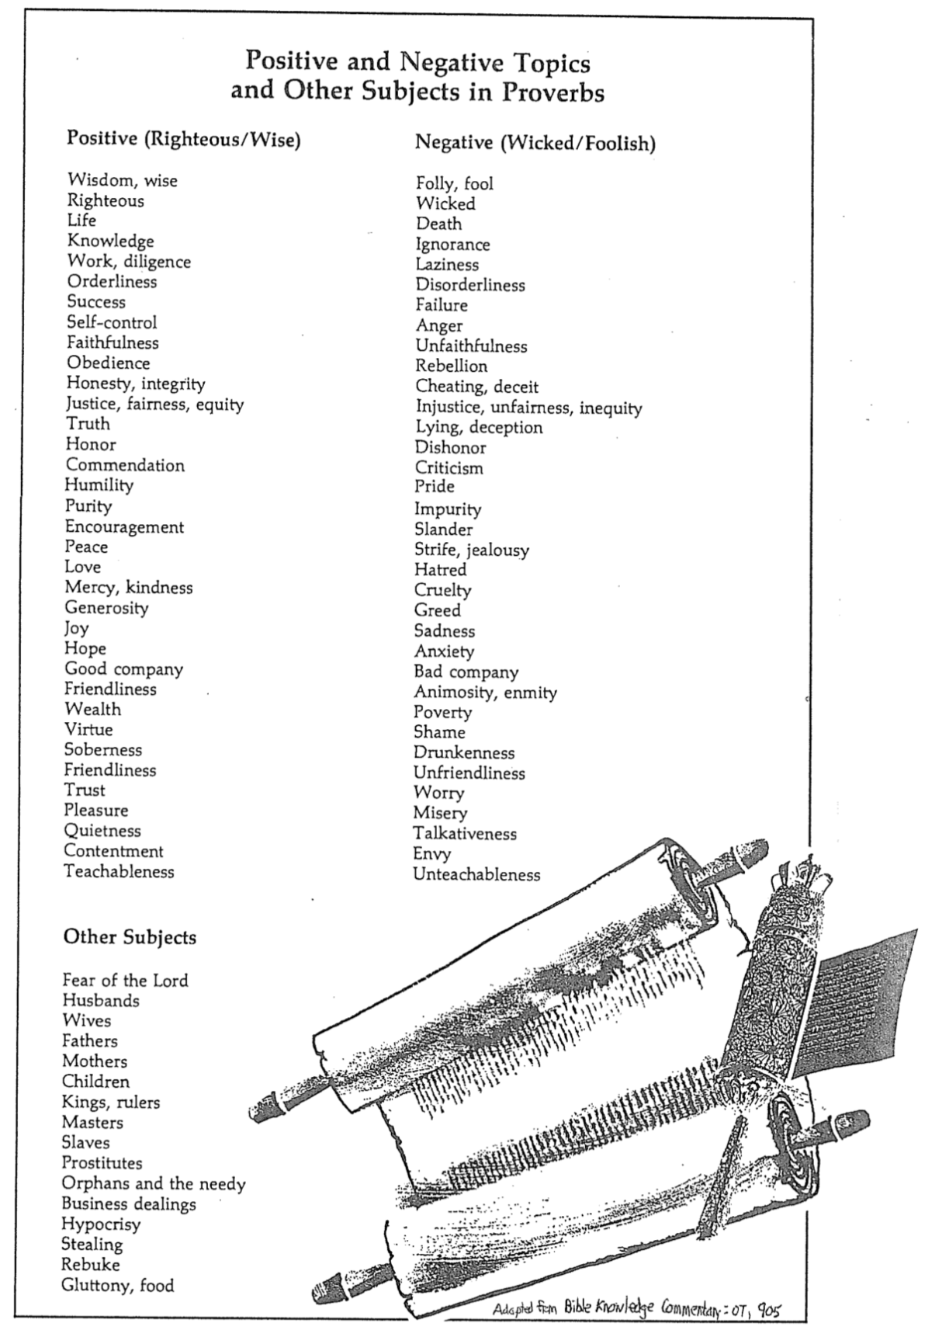

Proverbs and Problem Solving
Charles Swindoll, Proverbs Bible Study Guide, 2

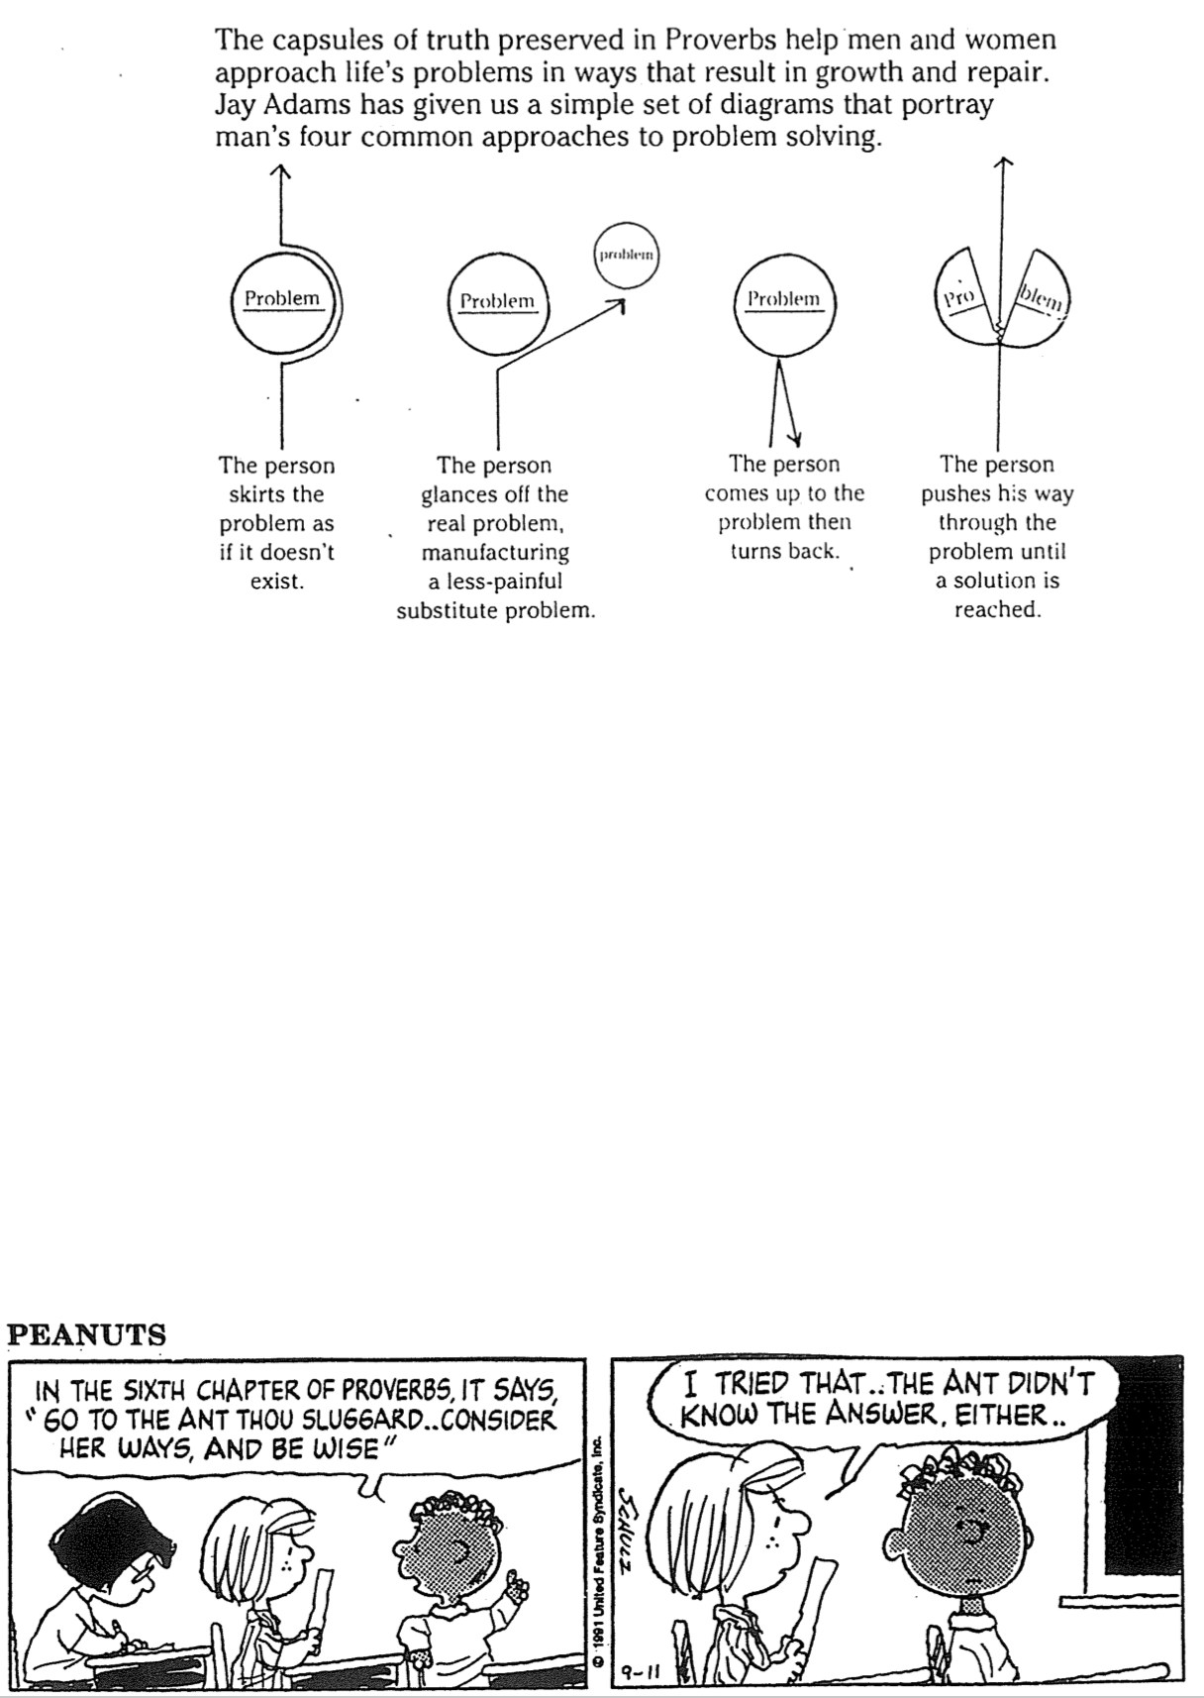

Proverbs versus Ecclesiastes

Proverbs and Ecclesiastes are both wisdom books with similar teaching in content and style. Both contain proverbs, both are written by Solomon to help youth deal with life, and both are likely written after Solomon had experienced many of life’s challenges. However, the books are different in some radical ways:

Proverbs | Ecclesiastes
Challenges of life | Meaning of life
Practical advice | Philosophical musings
How to live for God | Why to live for God
Ideals | Reality
Several authors | One man's testimony
Godly wisdom only | Godly and worldly wisdom
Positive | Negative
General | Exceptions
Present orientation | Eternal orientation
Black & white orientation | Gray areas
Wisdom praised | Wisdom doubted

Be Wise
Proverbs

Exegetical Outline (Steps 2-3)

Exegetical Idea: The way to be wise is to value wisdom that teaches discipline and the fear of the LORD and heed proverbs on relationships and every area of life.

The way to be wise is to heed proverbs that teach discipline and fear of the LORD (1:1-7).

The title introduces Solomon as the author of the proverbs in chapters 1–9 (1:1).

Solomon gave proverbs to teach discipline and discernment (1:2-6).

Knowledge begins with fearing the LORD (1:7).

The way to be wise is to value wisdom that leads to a prosperous life (1:8–9:18).

Wisdom is valuable because it gives honor to prevent youth from the shame of foolishness.

Wisdom is valuable because it preserves youth from disaster (1:10-33).

Wisdom is valuable because it helps maintain moral behavior (Prov 2).

Wisdom is valuable because it helps us relate with God and man (Prov 3).

Wisdom is valuable because it provides a gracious life (4:1-9).

Wisdom is valuable because it preserves youth from trouble (4:10-19).

Wisdom is valuable because it produces healthy young people (4:20-27).

Wisdom is valuable because it helps avoid sexual sin (Prov 5).

Wisdom is valuable because it preserves from poverty (6:1-11).

Wisdom is valuable because it preserves from dissension (6:12-19).

Wisdom is valuable because it preserves youth from sexual immorality (6:20–7:27).

Wisdom is personified in its valuable virtues, rewards and use in creation (Prov 8).

Wisdom is valuable compared to the claims of foolishness (Prov 9).

The way to be wise is to heed advice of wise men on relationships and every area of life (Prov 10–31).

About 375 two-line proverbs of Solomon teach the practical benefits of wisdom over wickedness in everyday life (10:1–22:16).

Longer sayings of wise men admonish practical wisdom in many areas (22:17–24:34).

The final collection of Solomon's proverbs by Hezekiah's scribes 250 years later guide social relationships and various activities (Prov 25–29).

Sayings of the unknown Agur to the unknown Ithiel and Ucal show insights from nature and social relationships (Prov 30).

The unknown Lemuel’s mother prepares him for kingship by advising him to avoid the excesses of women and wine, and to protect the rights of the underprivileged (31:1-9).

An acrostic and anonymous poem of a noble wife exhorts young women to be godly and diligent and exhorts young husbands to praise these qualities in their wives (31:10-31).

Purpose or Desired Listener Response (Step 4)
The listeners will pursue wisdom above all else.

Homiletical Outline (Cyclical inductive form)

Introduction

Interest: People are passionate about pursuing many things.

Need: But are you passionate about pursuing wisdom?

Subject: How can you be wise?

Background: Solomon was the wisest man every to live and he wrote 3000 proverbs to share it with us.

Preview: Today these proverbs will give us three ways to be wise.

Text: The Book of Proverbs tells us how to be wise in three ways.

(What is the first way to be wise?)

Learn discipline and fear of the LORD (1:1-7).

Solomon gave proverbs to teach discipline and discernment (1:1-6).

Knowledge begins with fearing the LORD (1:7).

Value wisdom that leads to a prosperous life (1:8–9:18).

Wisdom gives honor to prevent youth from the shame of foolishness (1:8-9).

Wisdom preserves youth from disaster (1:10-33).

Wisdom helps maintain moral behavior (Prov 2).

Wisdom helps us relate with God and man (Prov 3).

Wisdom provides a gracious life (4:1-9).

Wisdom preserves youth from trouble (4:10-19).

Wisdom produces healthy young people (4:20-27).

Wisdom helps avoid sexual sin (Prov 5).

Wisdom preserves from poverty (6:1-11).

Wisdom preserves from dissension (6:12-19).

Wisdom preserves youth from sexual immorality (6:20–7:27).

Wisdom has valuable virtues, rewards and was used in creation (Prov 8).

Wisdom is valuable compared to the claims of foolishness (Prov 9).

Heed advice of wise men on relationships (Prov 10–31).

About 375 two-line proverbs of Solomon teach the practical benefits of wisdom over wickedness in everyday life (10:1–22:16).

Longer sayings of wise men admonish practical wisdom in many areas (22:17–24:34).

The final collection of Solomon's proverbs by Hezekiah's scribes 250 years later guide social relationships and various activities (Prov 25–29).

Sayings of the unknown Agur to the unknown Ithiel and Ucal show insights from nature and social relationships (Prov 30).

The unknown Lemuel’s mother prepares him for kingship by advising him to avoid the excesses of women and wine, and to protect the rights of the underprivileged (31:1-9).

An acrostic and anonymous poem of a noble wife exhorts young women to be godly and diligent and exhorts young husbands to praise these qualities in their wives (31:10-31).

(How can you be wise?)

Conclusion

Fear God by heeding his proverbs on the value and path of wisdom (Main Idea).

How can you be wise (Main Points)?

Learn discipline and fear of the LORD (1:1-7).

Value wisdom that leads to a prosperous life (1:8–9:18).

Heed advice of wise men on relationships (Prov 10–31).

Exhortation

How much do you want wisdom? You can tell by the price you’re willing to pay for it.

How disciplined are you in hearing from God through his Word? How can you improve here?

Prayer

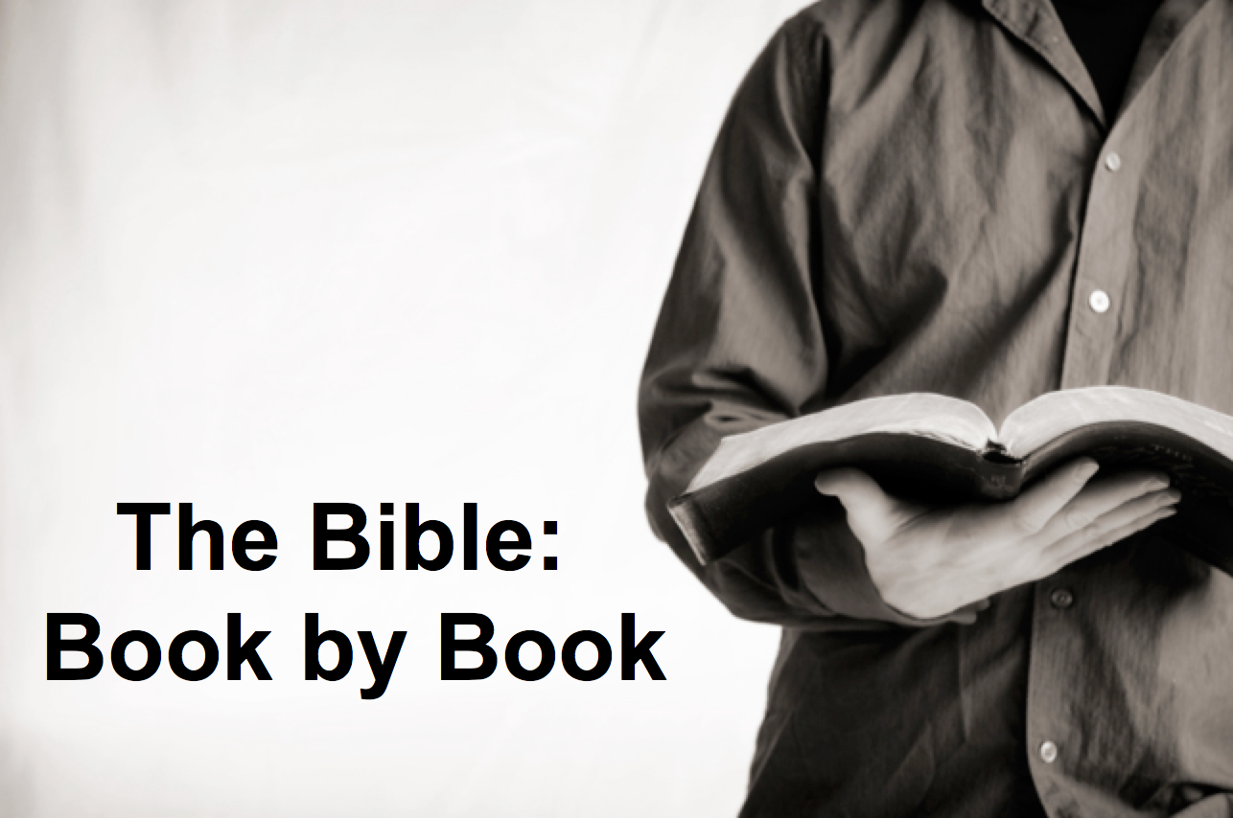

Rick Griffith
29 July 2018
Message 20 of 66

Be Wise
Book of Proverbs

Introduction
___________ can you be wise?

Learn _______________________ and _________________ of the LORD (1:1-7).

____________________ wisdom that leads to a prosperous life (1:8–9:18).

Wisdom gives honor to keep youth from the shame of foolishness (1:8-9).

Wisdom preserves youth from disaster (1:10-33).

Wisdom helps maintain moral behavior (Prov 2).

Wisdom helps us relate with God and man (Prov 3).

Wisdom provides a gracious life (4:1-9).

Wisdom preserves youth from trouble (4:10-19).

Wisdom produces healthy young people (4:20-27).

Wisdom helps avoid sexual sin (Prov 5).

Wisdom preserves from poverty (6:1-11).

Wisdom preserves from dissension (6:12-19).

Wisdom preserves youth from sexual immorality (6:20–7:27).

Wisdom has valuable virtues, rewards and was used in creation (Prov 8).

Wisdom is valuable compared to the claims of foolishness (Prov 9).

Heed advice of wise men on _____________________________ (Prov 10–31).

Conclusion

Fear God by heeding his proverbs on the _________ and _____ of wisdom (Main Idea).

How much do you want wisdom? You can tell by the price you’re willing to pay for it.

How disciplined are you in hearing from God in his Word? How can you improve here?

Download this sermon PPT and notes for free at BibleStudyDownloads.org/resource/old-testament-preaching/
Listen to this message online at cicfamily.com/sermon-listing/

Proverbs

Value and Path of Wisdom

Solomon |  |  | Wise Men  (Anonymous) | Solomon | Wise Men  (Agur, Lemuel,  Anonymous)
1:1–22:16 |  |  | 22:17–24:34 | Chapters 25–29 | Chapters 30–31
13 sayings  (1:1–9:18)  375 two-line  (10:1–22:16) |  |  | 36 sayings | ±100 two-line | 3 sayings
Aims  1:1-7 | Value of Wisdom  1:8–9:18 | Contrasts  &  Godliness  10:1–22:16 | Social  & Miscellaneous | Social  & Miscellaneous | Social  & Nature  Ch. 30 | Ruling  31:1-9 | Godly  Wife  31:10-31
Prologue | Principles of Wisdom |  |  |  |  | Epilogue
ca. 950-700 BC

Key Word: Wisdom

Key Verse: “Trust in the LORD with all your heart and lean not on your own understanding; in all your ways acknowledge him and he will make your paths straight” (Proverbs 3:5-6)

Summary Statement:
The proverbs of Solomon and various sages teach youth the value of wisdom over folly so they will obey God in every area of life.

Application:

Memorize proverbs to promote wise living.
Seek wisdom in every area to avoid the pitfalls of life.

