Word of Life Bible Institute, Jeju, Korea Men’s Meeting/CIC Dr. Rick Griffith
30 May 2012/8 March 2020 Ten Habits of Highly Wise People (Prov) Message 1 of 10
NIV 30 Minutes
Stay Pure
Title
Proverbs 5

Topic: Sex
Theme: Why should we avoid sexual sin?
Thrust: Because purity shows genuine wisdom.
Purpose: The listeners will guard themselves from sexual sin in a new way.
Attribute: We worship our Holy God
Reading: Prov 7:1-5
Songs: Holy is the Lord God Almighty (opening), We Fall Down, Holy (Redman), closing: Purify My Heart (Nelson)
Benediction: Prov 5:21-23

Introduction

Interest: Moral purity has been a challenge for men for millennia (Prov 5:1-2).

Solomon highlights how wisdom should be valued above anyway other virtue in chapters 1–4.

Now he shifts to get practical by going for the jugular in a very specific area—sex.

Sex is the area where men fail the most in life, so it is no wonder that Proverbs devotes two entire chapters to it—chapters 5 and 7.

Need: How are you doing at moral purity?

Need for Men: Men, do you need to grow in the area of moral purity?

There is not a man who has not struggled with lust.

There is no man who has not been tempted in the area of sex.

This is why the key book on it is called Every Man’s Battle.

Millions of men have defeated the advance of entire armies of other men but have fallen to the advances of a single woman!

Are your thoughts about women completely honorable?

Are you tempted to look at images that you know you shouldn’t online?

If so, you need this passage today.

Need for Women: Women, do you have a porn problem also? Of porn addicts, 17% are women. And if not, how can you help us men be morally pure?

Do you know what you might do—or not do—to make this more difficult for us?

If so, you need this passage today.

Subject: Why should we avoid sexual sin?

Background:

Solomon didn’t avoid sexual sin (1 Kings 11; Eccl. 2).

But he wrote today’s text to spare us the pain of this particular sin that trips men up.

Text: Proverbs 5 is the focus but a similar chapter would be Proverbs 7.

Preview: Today we will see four basic reasons to avoid this trap of sexual sin.

Transition: What reason(s) should we avoid sexual sin?

I. Proverbs 5 gives four good reasons to avoid sexual sin.

Sexual sin is enjoyable in the short run but bitter in the end (5:3-6).

Immoral people’s advances are genuinely enticing in touch and sound (5:3).

Isn’t that just realistic?

Isn’t that why we have internet sites devoted to getting people to commit adultery?

However, following such advances leads to certain ruin (5:4-5).

Should we want to be with people who will make our values better rather than worse?

How many people have you met that extolled the benefits of adultery?

Sex addicts can’t discern momentary pleasure from long-term goals (5:6).

Avoid sexual sin to escape its physical, financial, and emotional woes (5:7-14).

Don’t expose yourself to temptations in the sexual arena (5:7-8).

Why do you click on the news stories or images that you do?

Commit not to select anything primarily because the woman is attractive.

Exposure to sexual sin leads to poor health, poverty, and regret (5:9-14).

Sexual sin wastes strength and money for one’s spouse on strangers (5:9-10).

We all have a certain amount of money available.

How many men have confessed to me that their money went to the wrong woman?!

Sexual sin leads to a life of public regret for disobeying teachers (5:11-14).

In October 2017, following sexual abuse allegations, Harvey Weinstein was dismissed from his company and expelled from the Academy of Motion Picture Arts and Sciences.

More than 80 women had made allegations against Weinstein by October 31 (Wikipedia).

Sex with one partner in marriage is the most enjoyable experience (5:15-20).

Sex should be shared with only one person (5:15-17).

Sex is most satisfying with one’s own spouse (5:18-20).

Avoid sexual sin because God calls it evil and will judge us for it (5:21-23).

Resist sexual sin because God sees everything we do and judges each deed (5:21).

Resist sexual sin because it is an evil deed that causes personal ruin (5:22-23).

II. Here are ideas to avoid the trap of sex sin.

Keep Google image search on the “strict” setting only.

The same could be said of using facebook. For many it wastes their time playing their games and just watching silly videos. But it can be worse when it puts you in contact with someone who leads you into adultery.

Jesus warned us to train our eyes not to stimulate lust (Matt 6:22).

He also told us to guard our hands (Matt 5:30; cf. Ps 119:9-10).

We also should hug right.

Do not look at the internet when someone cannot look over your shoulder.

Stop making excuses for porn or immorality—like Bill Clinton did in respect to his adultery back in the 1990s.

The general principle is to flee situations rather think we can stand under this temptation (1 Cor 6:18).

Use covenanteyes.com based on Job’s promise: “I made a covenant with my eyes not to look with lust at a young woman.”

A free option to internet accountability is XXXXChurch.com.

PluggedIn provides movie reviews that tells you exactly how many occurrences a movie has of immorality, blasphemy, etc.

Covenant with God NOW that you will remain sexually pure until marriage—and in marriage if you are already married.

Follow Joseph’s example when tempted by Potipher’s wife where he saw immorality first as a sin against God (Gen 39:9).

One source gives six steps to quit porn.

(So why should you guard yourself from sexual sin? Here is the question that we started with.)

Conclusion

Genuine wisdom will teach us many reasons to avoid sexual sin (Main Idea).

Why should we avoid sexual sin? Because purity shows genuine wisdom.

Main Points: Preserving yourself will…

Keep you from regret (5:3-6).

Guard your body, money, emotions, and reputation (5:7-14).

Help you enjoy sex in marriage (5:15-20).

Keep you accountable to God (5:21-23).

Application

Have you promised purity to God?

Are you going down the path of the simpleton right now? How?

What should you do about it?

Prayer

Study Questions (Step 1)

Context: What did the author record just prior to this passage?

Solomon highlights how wisdom should be valued above anyway other virtue in chapters 1–4.

Now he shifts to get very practical by going for the jugular in a very specific area—sex.

Purpose: Why is this passage in the Bible?

Sex is the area where men fail the most in life, so it is no wonder that Proverbs devotes two entire chapters to it—chapters 5 and 7.

Millions of men have defeated the advance of entire armies of other men but have fallen to the advances of a single woman!

Background: What historical context helps us understand this passage?

Questions

Tentative Theme/Thrust Statements (Step 5)

Text

Possible Illustrations (Step 6)

Text

Bill Clinton (Sort of) Apologizes to Monica Lewinsky: ‘I Feel Terrible’ That It ‘Defined’ Her
https://www.thedailybeast.com/bill-clinton-sort-of-apologizes-to-monica-lewinsky-in-hillary-doc-i-feel-terrible
Accessed 7 March 2020
In the documentary series “Hillary,” the Clintons are more candid and go deeper than ever before about the Lewinsky scandal, their marriage, and why they stayed together.

By Kevin Fallon

Senior Entertainment Reporter

Updated Jan. 26, 2020 4:03AM ET / Published Jan. 25, 2020 9:30PM ET
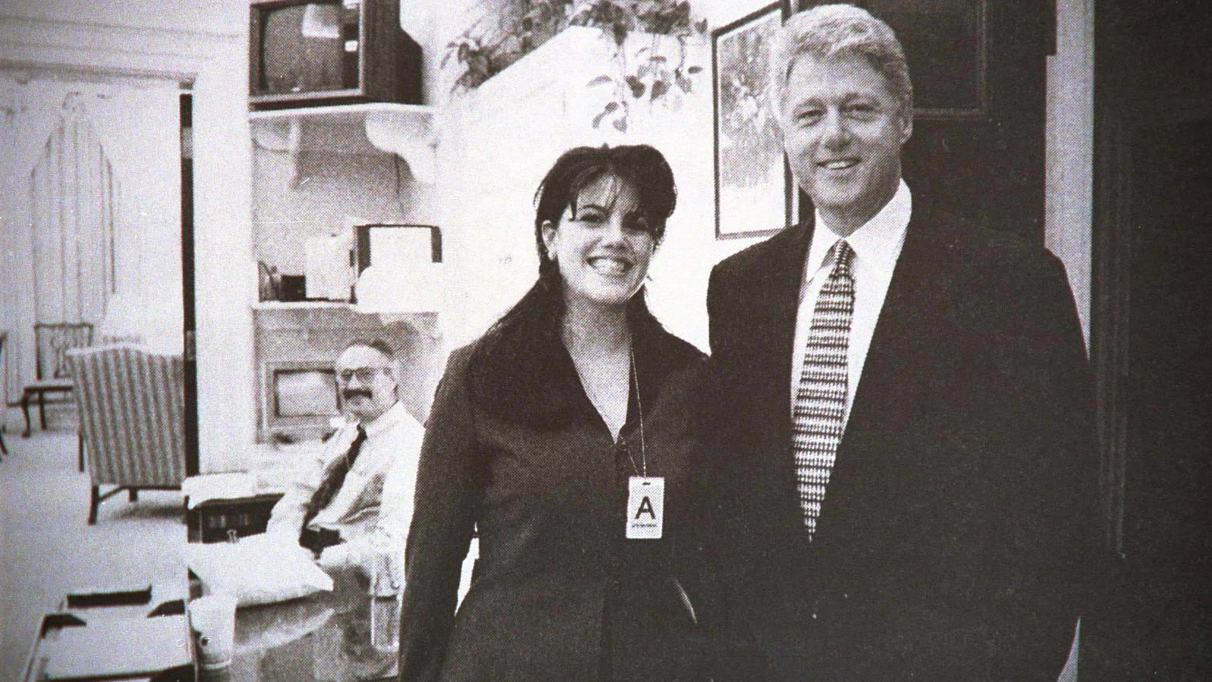
Globe Photos/ZUMAPRESS/Alamy
On a January morning in 1998, Bill Clinton sat at the edge of the White House bed he shared with his wife, Hillary. “There’s going to be a story in the newspaper…” he said.
The new Hulu documentary series Hillary contains what may be the most detailed and emotionally candid account yet of the Monica Lewinsky scandal and how it affected the marriage of the then-president and first lady, featuring lengthy interviews with both Bill and Hillary.
Told in four hour-long episodes, Hillary premiered Saturday afternoon at the Sundance Film Festival, ahead of its debut March 6 on Hulu. Directed by Nanette Burstein (On the Ropes), the series juxtaposes the major themes, controversies, and mistakes of Clinton’s 2016 presidential campaign with the formative experiences and news stories from her early life, relationship with Bill Clinton, and time in the public eye as first lady, senator, and secretary of state.
NEWSLETTERS
The Daily Beast’s Obsessed
Everything we can’t stop loving, hating, and thinking about this week in pop culture.
Top of Form
Bottom of Form
By Clicking "Subscribe" you agree to have read the Terms of Use and Privacy Policy
Most of the content relating to Bill Clinton’s affair and impeachment trial comes in the third episode of the series, titled “The Hardest Decision,” which details the ways in which Hillary’s decision to stay married to Bill became a cultural and political lightning rod that followed her to the point that, for some voters, it was a defining issue in her presidential campaign almost 20 years later.
That first morning, Bill was adamant that nothing had happened between Lewinsky and himself that rose above the level of flirting. “It was convincing to me,” Hillary says.
When it later became clear that he’s going to have to tell the grand jury that there was a sexual relationship, he went to the edge of the bed again and told Hillary what had actually happened and when. “I was just devastated,” she says. “I could not believe it. I was so personally just hurt.” She told him that if this was going to be public, he was going to have to tell their daughter, Chelsea.
Bill’s interviews in Hillary are laden with remorse and regret. A producer asks him why he would take such a risk with not only his marriage and family, but with the country by foolishly engaging in an affair with a White House intern.
“Nobody thinks about that,” he says. “Nobody thinks about why did I take that risk. That’s not why people do stupid things. That’s not what happened. Nobody sits down and thinks I think I’ll take a really irresponsible risk that’s bad for my family, bad for my country, bad for the people that work with me.”
He likens it to a decision made by a person in a high-pressure situation and has been pummeled by it, like weathering a 15-round prize fight that’s been extended to 30 rounds. “Here’s someone who’s going to take your mind off it for a while. That’s what happened... It’s not a defense. It’s an explanation. I feel awful. I feel terrible about it.”
Immediately after, Hillary wanted to get away from Washington and go to Martha’s Vineyard where they could be near friends. “I still didn’t talk to him,” she says. “I didn’t want anything to do with him. He spent a lot of time I guess playing golf and talking to a couple of his friends.”
As footage plays of the family walking across the White House lawn to board the helicopter to Massachusetts, with Chelsea in between Bill and Hillary and holding both of their hands, Hillary tears up when talking about the moment. “That wasn’t anything other than her trying to keep us together. And when she did that, oh my gosh, I thought that’s just so incredible.” After a pause to clear the lump in the throat, she continues: “So strong and so wise.”
“I feel terrible about the fact that Monica Lewinsky’s life was defined by it, unfairly I think. Over the years I watched her trying to get a normal life back again. But you gotta decide how to define normal.”
Friends and aides talk about the theory that Hillary must have known the truth about Bill’s affair the whole time, the suspicion that she was lying to protect him and her own proximity to power. But, they unanimously insist, she was hurt by him, blindsided by the affair, and devastated for a long time over the whole thing. If there was any sort of calculation behind it, it would have made the horrible experience so much easier.
Her feelings about what Bill had done to her aside, Hillary vehemently opposed impeachment. There was a purely professional reason for that. As a young lawyer, she was on the Richard Nixon impeachment staff in 1974, responsible for a memo that outlined the articles of impeachment and what merited the process.
“I defended and stood by him because I thought the impeachment process was wrong,” she says. “But that wasn’t the necessary answer to what I would do with my marriage. It was not to me the same thing. I still had to decide whether I wanted to stay in the marriage, whether I thought it was worth saving. We saw a counselor. Painful, painful discussions.”
Bill calls those counseling sessions the hardest things he’s gone through in his life, calling them “necessary” because Hillary deserved it and Chelsea deserved it. As he reiterates his remorse and regret again, he surprisingly includes Monica Lewinsky in the list of people to whom he owes amends.
“I feel terrible about the fact that Monica Lewinsky’s life was defined by it, unfairly I think,” he says. “Over the years I watched her trying to get a normal life back again. But you gotta decide how to define normal.”
Asked about the fact that her decision to stay with Bill has been a talking point that has defined everything from the women’s movement and gender wars to the 2016 election for nearly 20 years, Hillary is even-handed about the whole thing.
“I made a decision to stay with my husband,” she says. “Look, I think that some people thought I made the right decision and some people thought I made the wrong decision. I have gotten both affirmation and criticism for the decision I made. That was true from the very beginning of deciding that. It’s a funny time we live in. Public opinion shifts and people say, ‘Oh, it’s noble she stayed in the marriage’ to ‘oh, it’s so incomprehensible she stayed in the marriage.’ There are forces at work in society that people are working out themselves.”
As for Bill? “I’m grateful she made the decision to stick it out. God knows the burden she paid for that.”

Possible Applications (Step 6)

Text
Outlines (Steps 2-5)

Straight Talk on Sex
Proverbs 5

Exegetical Outline (Steps 2-3)

Exegetical Idea (CPT): The reason wisdom is valuable is because it preserves from sexual sin.

I. (5:1-2) The introduction exhorts listening to the following proverb in order to have the ability to discern and to teach the difference between right and wrong.

II. (5:3-23) Solomon gave reasons to maintain sexual purity so that young men might see the stupidity of sexual sin and avoid it.

Sexual sin is enjoyable in the short run but bitter in the end (5:3-6).

Immoral people’s advances are genuinely enticing in touch and sound (5:3).

However, following such advances leads to certain ruin (5:4-5).

Sex addicts can’t discern momentary pleasure from long-term goals (5:6).

Avoid sexual sin to escape its physical, financial, and emotional woes (5:7-14).

Don’t expose yourself to temptations in the sexual arena (5:7-8).

Exposure to sexual sin leads to poor health, poverty, and regret (5:9-14).

Sexual sin wastes strength and money for one’s spouse on strangers (5:9-10).

Sexual sin leads to a life of public regret for disobeying teachers (5:11-14).

Sex with one partner in marriage is the most enjoyable experience (5:15-20).

Sex should be shared with only one person (5:15-17).

Sex is most satisfying with one’s own spouse (5:18-20).

Avoid sexual sin because God calls it evil and will judge us for it (5:21-23).

Resist sexual sin because God sees everything we do and judges each deed (5:21).

Resist sexual sin because it is an evil deed that causes personal ruin (5:22-23).

Purpose or Desired Listener Response (Step 4)
The listeners will guard themselves from sexual sin in a new way.

Sermon Outline (Cyclical inductive form)—Steps 5-6

Introduction

Interest: Moral purity has been a challenge for millennia.

Need: How are you doing at moral purity?

Are your thoughts about women completely honorable?

Are your tempted to look at images that you know you shouldn’t—especially online?

If so, you need this passage today.

Subject: Why should we avoid sexual sin?

Background:

Solomon didn’t avoid sexual sin (1 Kings 11; Eccl. 2).

However, he wrote today’s text to spare us the pain of this particular sin that trips men up.

Text: Proverbs 5

Preview: Today we will see four basic reasons to avoid this trap of sexual sin.

Transition: What reason(s) should we avoid sexual sin?

I. Proverbs 5 gives four good reasons to avoid sexual sin.

Sexual sin is enjoyable in the short run but bitter in the end (5:3-6).

Immoral people’s advances are genuinely enticing in touch and sound (5:3).

However, following such advances leads to certain ruin (5:4-5).

Sex addicts can’t discern momentary pleasure from long-term goals (5:6).

Avoid sexual sin to escape its physical, financial, and emotional woes (5:7-14).

Don’t expose yourself to temptations in the sexual arena (5:7-8).

Exposure to sexual sin leads to poor health, poverty, and regret (5:9-14).

Sexual sin wastes strength and money for one’s spouse on strangers (5:9-10).

Sexual sin leads to a life of public regret for disobeying teachers (5:11-14).

Sex with one partner in marriage is the most enjoyable experience (5:15-20).

Sex should be shared with only one person (5:15-17).

Sex is most satisfying with one’s own spouse (5:18-20).

Avoid sexual sin because God calls it evil and will judge us for it (5:21-23).

Resist sexual sin because God sees everything we do and judges each deed (5:21).

Resist sexual sin because it is an evil deed that causes personal ruin (5:22-23).

II. Here are ideas to avoid the trap of sex sin.

Keep Google image search on the “strict” setting only.

Do not look at the internet when someone cannot look over your shoulder (or use covenanteyes.com based on Job’s promise: ““I made a covenant with my eyes not to look with lust at a young woman”).

Covenant with God NOW that you will remain sexually pure until marriage (for singles) or in marriage (for those married).

Conclusion

Why should we avoid sexual sin? Because purity shows genuine wisdom.

Genuine wisdom will teach us many reasons to avoid sexual sin (MI).

Main Points: Preserving yourself will…

Keep you from regret (3-6).

Guard your body, money, emotions, and reputation (7-14).

Help you enjoy sex in marriage (15-20).

Enable yourself to account to God (21-23).

Application

Have you promised purity to God?

Are you going down the path of the simpleton right now? How?

What should you do about it?

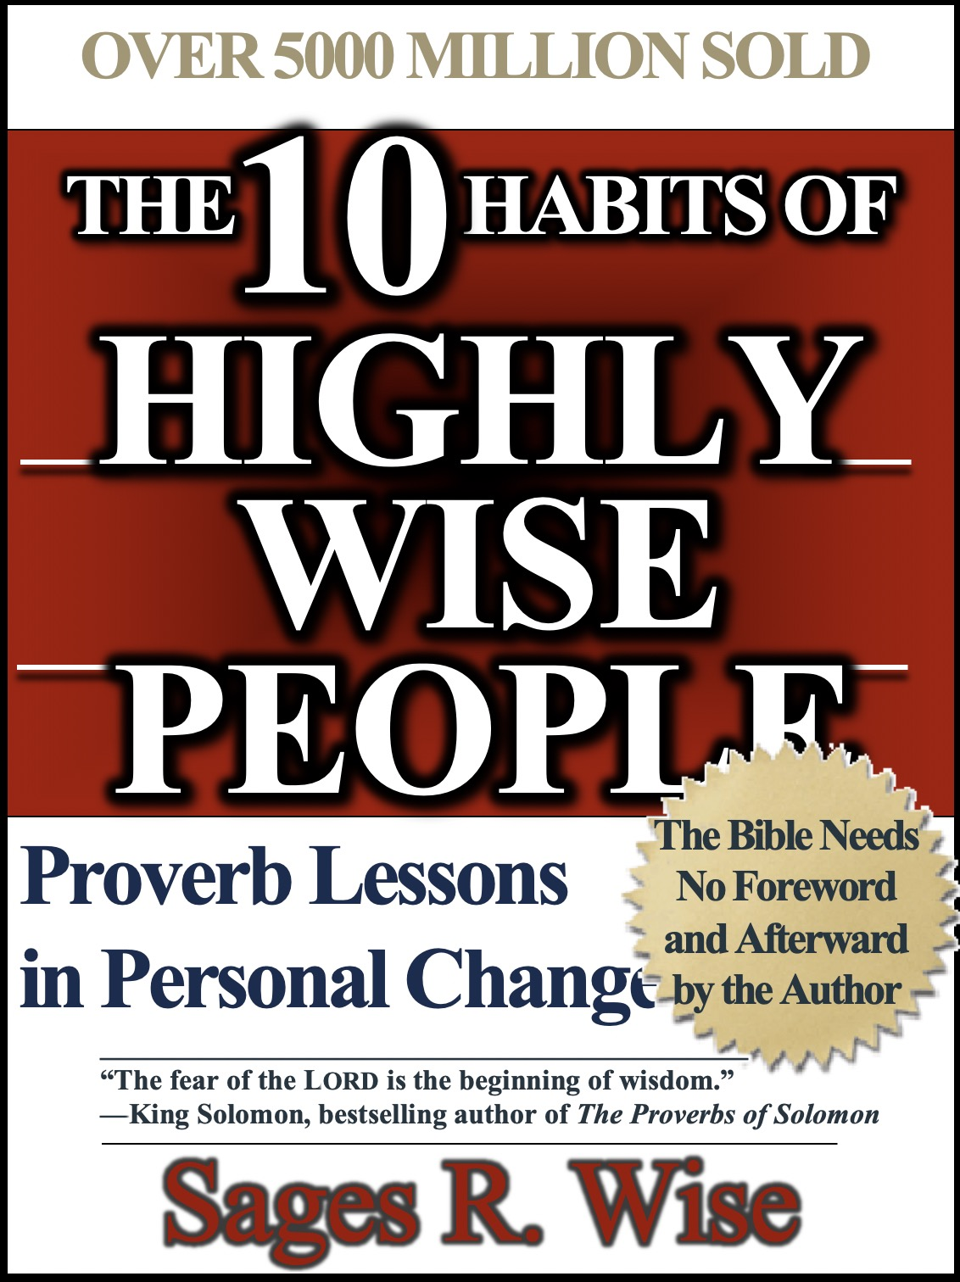

Rick Griffith
8 March 2020
Message 1 of 10

Straight Talk on Sex
Proverbs 5

Introduction

Moral purity has been a challenge for millennia.

How are you doing at moral purity?

Why should we avoid sexual sin?

I. Proverbs 5 gives _____________ good reasons to avoid sexual sin.

Sexual sin is enjoyable in the short run but bitter in the end (5:3-6).

Immoral people’s advances are genuinely enticing in touch and sound (5:3).

However, following such advances leads to certain ruin (5:4-5).

Sex addicts can’t discern momentary pleasure from long-term goals (5:6).

Avoid sexual sin to escape its physical, financial, and emotional woes (5:7-14).

Don’t expose yourself to temptations in the sexual arena (5:7-8).

Exposure to sexual sin leads to poor health, poverty, and regret (5:9-14).

Sexual sin wastes strength and money for one’s spouse on strangers (5:9-10).

Sexual sin leads to a life of public regret for disobeying teachers (5:11-14).

Sex with one partner in marriage is the most enjoyable experience (5:15-20).

Sex should be shared with only one person (5:15-17).

Sex is most satisfying with one’s own spouse (5:18-20).

Avoid sexual sin because God calls it evil and will judge us for it (5:21-23).

Resist sexual sin because God sees everything we do and judges each deed (5:21).

Resist sexual sin because it is an evil deed that causes personal ruin (5:22-23).

II. Here are ideas to avoid the ____________ of sex sin.

Keep Google image search on the “strict” setting only.

Do not look at the internet when someone cannot look over your shoulder (or use covenanteyes.com based on Job’s promise: “I made a covenant with my eyes not to look with lust at a young woman”).

Covenant with God NOW that you will remain sexually pure until marriage (for singles) or in marriage (for those married).

Conclusion

Why should we avoid sexual sin? Because purity shows genuine wisdom.

Genuine _____________ will teach us many reasons to avoid sexual sin (Main Idea).

Application

Have you promised purity to God?

Are you going down the path of the simpleton right now? How?

What should you do about it?

On Your Own…

- Read Proverbs 7 aloud. List every principle you can about sexual sin:

Verse | Principle

- What motivates others to seduce us that makes us so easily fall (7:14-23)?

- What one thing should you do to better protect you from sexual sin now that you are presently not doing? What new habit can you cultivate?

Download this sermon PPT and notes for free at BibleStudyDownloads.org/resource/old-testament-preaching/
Listen to this message online at cicfamily.com/sermon-listing/

