Jordan Evangelical Theological Seminary (JETS) Chapel Dr. Rick Griffith

8 September 2025 Single Message

NLT 20 Minutes

Title

**Complain Not**

***Numbers 14***

**Topic:** Complaining

**Subject:** How should we respond to God’s will?

**Complement:** Instead of complaining, pray like Moses.

**Purpose:** The listeners will pray instead of complaining about God’s will.

# Introduction

Syllabus Shock

### Interest: Syllabus shock is real.

#### We are now starting our second week of classes, when we all have God’s will for our lives.

5 Steps

#### You can even find on the Internet “Five Steps to Avoid Syllabus Shock.”

### Need: How have you responded to getting all of your assignments at the beginning of the semester last week?

#### Some of us are grateful for the work.

#### Others of us wonder how we will ever manage.

#### Yet it is God’s will for you to be here. So…

Subject

### Subject: How should we respond to God’s will? What is the best way to handle the Lord's plan? (Restatement)

3 Boxes  
• 3 animate

### Background: God’s syllabus for Israel was to bring them from Egypt to Canaan.

Route Map

#### God promised the Land to Abraham 600 years earlier (Gen 15:18; 17:8).

#### God brought them out of Egypt to give them their land (Exod 12).

Tabernacle Tribes

#### God gave them a mobile worship system for the wilderness, and until they built the temple in the Land (Exod 40—Leviticus).

Marching Line

#### God organized the people for the march toward the land (Num 2, 10).

#### God showed them how to be holy or sanctified en route to the Land (Num 5:1–10:10).

#### God brought them from Sinai to Kadesh at the border of the Land (10:11–12:16).

Sinai to Kadesh

#### The sent spies who returend 40 days later. Despite the bountiful grapes… (Num 13:31-33).

Spies Return

##### The majority report said that the land was good, but the giants made them feel like grasshoppers.

Minority

Majority

##### The minority report focused of God!

### Preview: Let’s see how the people responded, how Moses responded, and how God responded. We will see that the people complained—so we shouldn't complain. • We should pray instead, like Moses. • And follow God's wanting.

### Text: Numbers 14 shows us these three responses.

Subject

(So, back to to our question for today. How should we respond to God’s will? First, let's see what NOT to do…)

# I. Don’t complain (1-12).

MP

[Accept God’s plan without grumbling.]

## Complaining: The people’s *response* to God’s command to take the land was one of complaining (1-12). Follow along as Eyad reads verses 1-12.

### They cried all night (1).

### They disrespected Moses and Aaron (2a).

### They feared their wives and children would die in the wilderness (2b-4).

### They rejected pleas from Moses, Aaron, Joshua, Caleb, and God (5-12).

### In Numbers, we see Israel's commitment in both the first and last sections. But in the middle, we see Israel's complaining. They complained throughout the wilderness wanderings.

Book   
Chart

### One account shows ten times Israel complained and the responses from Moses and God (explain).

Woman

Grumbling Chart

## We often complain instead of obeying God’s will.

Man Computer

### Men are often as good at complaining as women.

Phil 2:14

### Philippians 2:14 prohibits complaining.

Phil 4:13

### Philippians 4:13 promises strength.

God’s   
Hand

(Instead of complaining, how else should we respond to God’s will?)

# II. Pray instead of complaining (13-19).

MP

[Without grumbling, intercede based on God’s power, presence, and pardon.]

## Intercession: Moses’ response to Israel’s complaining was to pray for them (13-19).

### Moses prayed based on God’s power (13).

### Moses prayed based on God’s presence (14-16).

### Moses prayed based on God’s pardon (17-19).

## Like Moses, God’s will should lead us to prayer instead of complaining.

### The Gaze-Glance Principle helps us focus on God rather than our problems.

### Follow the Gaze-Glance Principle. This is a straightforward, biblical approach to seeking guidance.

#### When a struggle enters our lives, we usually gaze at this request

#### …with occasional glances at God for His help. We ask him to remove the problem because we are only seeking His hand. We're only seeking what He can give us.

### But the Bible tells us to shift our focus.

God’s   
Face

#### We should gaze at God

#### …and only glance at our request. This is seeking His face instead of seeking His hand. When and if He removes the problem becomes His business, so we don't end up resenting Him.

### Where has your focus been concerning the issue that concerns you?

#### • Have you been gazing at God or gazing at your problem?

#### • Have you been seeking God's face or seeking God's hand?

### Commit to following this method of prayer.

(Subject: How does God respond when we refuse His will?)

MP

# III. God shortens the lives of complainers (20-45).

[Grumbling takes a severe toll on us.]

OT  
Discipline

## Death: *God’s* response to Israel’s unbelief to enter Canaan was for them to die in the desert (20-45).

Trip Cancelled

### God forgave them (20).

Key   
Verses

### But God judged them with death for over 40 years in the wilderness (21-35).

Zin

### God judged the disbelieving spies with immediate death (36-38).

Cartoon

### God judged those who refused his discipline by defeat in battle (39-45).

40 Years Out Here?

## Few complainers live very long.

Inc.

### Many studies show that negative people die earlier.

#### One study is entitled, “How Complaining is Killing You (and What to Do Instead). Subtitle: Always complaining about things not going your way? Here is why you should stop.”

#### “Complaining Harms Your Body

Body

#### “Whenever we complain about something from the past, our bodies react as though we were reliving the experience. Our heart rate and blood pressure rise, and our brains release the stress hormones adrenaline and cortisol, triggering our fight-or-flight response. Our muscle tissue goes into a tense state of hyper-readiness, and non-essential systems like digestion go on temporary shutdown.”

### Besides that, no one likes to be around complainers. Michael Josephson says, “The key to a better life: Complain less, appreciate more. Talk less, listen more. Want less, give more. Hate less, love more. Scold less, praise more. Fear less, hope more.”

Josephson Quote

Subject

(How should we respond to God’s will?)

MI

# Conclusion

### Instead of complaining, pray like Moses (Main Idea). Don’t grumble—intercede instead! (Restatement)

### Main Points

MP I

#### Don’t complain (1-12).

#### Pray instead of complaining (13-19).

MP II

#### God shortens the lives of complainers (20-45).

MP III

### How can we be prepared to truly follow God’s will?

How Prepared

#### Realize that God has given you everything you need to do His will, but disobedience deserves discipline.

• Given All We Need

#### God will get His will done either through you or despite you.

• Commit or Complain

• Through or Despite

#### Are you characterized by commitment or complaining?

### Exhortation

Black

#### What are you complaining about now?

#### How should you pray instead?

### Prayer

# Preliminary Questions

**Verses Questions**

# Context: What did the author record just before this passage?

### Numbers 13 records the climactic unbelief of Israel’s leaders to enter the land. The chapter ends with a bad report from the spies:

### **Num. 13:31** But the other men who had explored the land with him disagreed. “We can’t go up against them! They are stronger than we are!” **32** So they spread this bad report about the land among the Israelites: “The land we traveled through and explored will devour anyone who goes to live there. All the people we saw were huge. **33** We even saw giants there, the descendants of Anak. Next to them, we felt like grasshoppers, and that’s what they thought, too!”

### But what about the people themselves? Would they trust God against the majority of their leaders, or would they follow their bad example and also not trust the Lord?

# Purpose: Why is this passage in the Bible?

### Numbers 14 shows that the unbelief of the spies also infected the people.

### Sadly, the people complain about the Lord and remind us all of the perils of complaining.

### Their refusal to enter resulted in God’s judgment of them dying in the wilderness.

# Background: What historical context helps us understand this passage?

### Israel had a severe complaining problem.

### Note on this chart, ten times they complained, and the results each time.

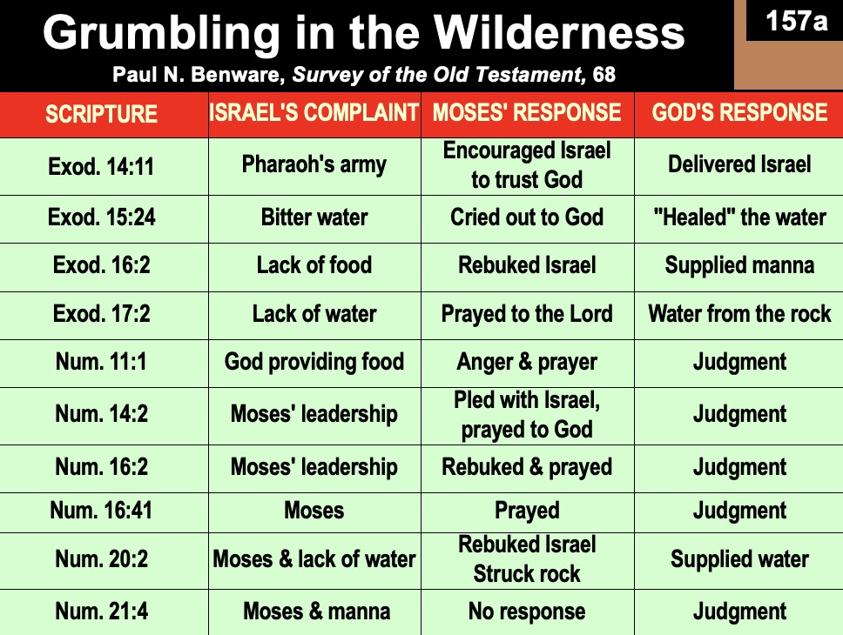

### Despite all these complaints, God had already promised them that he would bring them into the Land.

#### God promised the Land to Abraham 600 years earlier (Gen 15:18; 17:8).

#### God brought them out of Egypt to give them their land (Exod 12).

#### God gave them a mobile worship system for the wilderness and until they built the temple in the Land (Exod 40—Leviticus).

#### God organized the people for the march toward the land (Num 1–4).

#### God showed them how to be holy or sanctified en route to the Land (Num 5:1–10:10).

#### God brought them from Sinai to Kadesh at the border of the Land (10:11–12:16).

#### What would it take for them to believe in the Lord?

# Questions

### What is complaining?

### Why was God so harsh on the Israelites so that none of them saw Canaan?

# Tentative Subject/Complement Statements

Text

# Possible Illustrations

### Philippians 2:14 experiment

# Possible Applications

### PRS

**Complain Not**

***Numbers 14***

**Exegetical Outline (Steps 2-3)**

# *Exegetical Idea*: The response to God to Israel’s complaining instead of taking the land was their death.

# I. Complaining: The response of the *people* to God’s command to take the land was to complain (1-12).

## They cried all night (1).

## They disrespected Moses and Aaron (2a).

## They feared their wives and children would die in the wilderness (2b-4).

## They rejected pleas from Moses, Aaron, Joshua, Caleb, and God (5-12).

# II. Intercession: The response of *Moses* to the Israelite complaining was to pray for them (13-19).

## Moses prayed based on God’s power (13).

## Moses prayed based on God’s presence (14-16).

## Moses prayed based on God’s pardon (17-19).

# III. Death: The response of *God* to Israel’s unbelief to enter Canaan was to have them die in the desert (20-45).

## God forgave them (20).

## God judged them with death over 40 years in the wilderness (21-35).

## God judged the disbelieving spies with immediate death (36-38).

## God judged those who refused his discipline by defeat in battle (39-45).

**Purpose or Desired Listener Response (Step 4)**

The listeners will pray instead of complain.

**Homiletical Outline** (Cyclical inductive form)

# Introduction

### Interest: Syllabus shock is real.

### Need: How have you responded to getting all of your assignments at the beginning of the semester last week?

#### Some of us are grateful for the work.

#### Others of us wonder how we will ever manage.

#### Yet it is God’s will for you to be here. So…

### Subject: How should we respond to God’s will?

### Background: God’s syllabus for Israel was to bring them from Egypt to Canaan. But they feared the giants and saw themselves as grasshoppers in comparison (Num 13:31-33).

### Preview: Let’s see how the people responded, how Moses responded, and how God responded.

### Text: Numbers 14 shows us these three responses.

(How should we respond to God’s will?)

# I. Don’t complain (1-12).

[Accept God’s plan without grumbling.]

## Complaining: The people’s *response* to God’s command to take the land was one of complaining (1-12).

### They cried all night (1).

### They disrespected Moses and Aaron (2a).

### They feared their wives and children would die in the wilderness (2b-4).

### They rejected pleas from Moses, Aaron, Joshua, Caleb, and God (5-12).

## We often complain instead of obeying God’s will.

### Philippians 2:14 prohibits complaining.

### Philippians 4:13 promises strength.

(Instead of complaining, how else should we respond to God’s will?)

# II. Pray instead of complaining (13-19).

[Without grumbling, intercede based on God’s power, presence, and pardon.]

## Intercession: Moses’ response to Israel’s complaining was to pray for them (13-19).

### Moses prayed based on God’s power (13).

### Moses prayed based on God’s presence (14-16).

### Moses prayed based on God’s pardon (17-19).

## Like Moses, God’s will should lead us to prayer instead of complaining.

### The Gaze-Glance Principle helps us focus on God rather than our problems.

### Commit to following this method of prayer.

(Subject: How does God respond when we refuse His will?)

# III. God shortens the lives of complainers (20-45).

[Grumbling takes a severe toll on us.]

## Death: *God’s* response to Israel’s unbelief to enter Canaan was for them to die in the desert (20-45).

### God forgave them (20).

### God judged them with death for over 40 years in the wilderness (21-35).

### God judged the disbelieving spies with immediate death (36-38).

### God judged those who refused his discipline by defeat in battle (39-45).

## Few complainers live very long.

### Many studies show that negative people die earlier.

### Besides that, no one likes to be around complainers.

(How should we respond to God’s will?)

# Conclusion

### Instead of complaining, pray like Moses (Main Idea).

### Main Points

#### Don’t complain (1-12).

#### Pray instead of complaining (13-19).

#### God shortens the lives of complainers (20-45).

### Exhortation

#### What are you complaining about now?

#### How should you pray instead?

### Prayer



**Dr Rick Griffith**

4 Sept 2025

**Complain Not**

***Numbers 14***

# Introduction

### Subject: How should we respond to God’s will?

### Background: God’s syllabus for Israel was to bring them from Egypt to Canaan. But they feared the giants and saw themselves as grasshoppers in comparison (Num 13:31-33).

# I. Don’t complain (1-12).

## Complaining: The people’s *response* to God’s command to take the land was one of complaining (1-12).

### They cried all night (1).

### They disrespected Moses and Aaron (2a).

### They feared their wives and children would die in the wilderness (2b-4).

### They rejected pleas from Moses, Aaron, Joshua, Caleb, and God (5-12).

## We often complain instead of obeying God’s will.

(Instead of complaining, how else should we respond to God’s will?)

# II. Pray instead of complaining (13-19).

## Intercession: Moses’ response to Israel’s complaining was to pray for them (13-19).

### Moses prayed based on God’s power (13).

### Moses prayed based on God’s presence (14-16).

### Moses prayed based on God’s pardon (17-19).

## Like Moses, God’s will should lead us to prayer instead of complaining.

# III. God shortens the lives of complainers (20-45).

## Death: *God’s* response to Israel’s unbelief to enter Canaan was for them to die in the desert (20-45).

### God forgave them (20).

### God judged them with death for over 40 years in the wilderness (21-35).

### God judged the disbelieving spies with immediate death (36-38).

### God judged those who refused his discipline by defeat in battle (39-45).

## Few complainers live very long.

(How should we respond to God’s will?)

# Conclusion

### Instead of complaining, pray like Moses (Main Idea).

### To think about…

#### What are you complaining about now?

#### How should you pray instead?

Download this sermon PPT and notes for free at BibleStudyDownloads.org/resources/old-testament-preaching/