Bukit Panjang Gospel Chapel Singapore Dr. Rick Griffith
27 Jan 2019 Single Message
NIV & ESV 30 Minutes
Title
Our Faithfulness
Malachi 2:10-16

Topic: Marriage
Subject: How do we best show our faithfulness to God?
Complement: Guard your closest relationship in thought and deed.
Purpose: The listeners will guard their closest relationship in thought and deed.
Attribute: We worship the God of Relationships
Reading: Malachi 2:10-16
Be Faithful
Song: Great is Thy Faithfulness

Introduction

Interest: We all see the need to be faithful.

We all hate it when others are late. We say, “Hey! Be faithful to be on time!”

We want people to be faithful to their job—not switch jobs every time we will get paid $100 more!

We think we should be paid on time. Those sending our paychecks ought to be faithful to do it right and with punctuality.

We expect others driving the opposite way to stay in their lane—or even those next to us. “Hey! Be faithful to keep to your lane so you don’t kill me!”

Need: I bet you believe that we should be faithful to God.

Has God been faithful to you?

Or have you been the victim of God’s first mistake?

Since God has been faithful to us, then…
Subject

Subject: How do we best show our faithfulness to God?

Is the best evidence of our faithfulness to God our church attendance?

Is it Bible reading?

Prayer?

What is the best evidence that we are close to God?

What do you think?

Is it what you do when no one is watching?

Background: The Jews had returned to the land 100 years earlier but were deemed unfaithful.
Postexilic Era

The people of Judah had returned from Babylon a century earlier with an eagerness to worship the LORD.

But it does not take long for religiosity and tradition to become more important in our lives than a genuine relationship with God. We see this in the entire book of Malachi that addresses the hypocrisy of the people who needed to be genuine.
Overview
(6 slides)

Preview: Today we will see three evidences of our faithfulness to God. We’ll discover three ways we show loyalty to him.
3 Ways

Text: These three handles on spiritual faithfulness are in Malachi 2:10-16.
• Text
2:10

(What’s the first way to show faithfulness to God? It is to…)

I. Be relational (2:10).
MP
[We show our faithfulness to God best by showing faithfulness to others.]

God alone is our spiritual Father (2:10a).

Every Jew had the same God, since God was earlier called their father (1:6).

Therefore, the same standards of that one God would apply equally to all Jews. Some Jews couldn’t hold a lower priority of relationships than other ones.

God alone created us (2:10b).

God had created Israel to be a distinct people.

Amos 3:2 says that with Israel alone God had been “intimate,” so this marriage imagery applies to what he is about to say about their marriages.

Making relationships a low priority breaks our longstanding covenant with God (2:10c).
Be Relational

Here he is ambiguous but he does say that their faithfulness related to their relationships.

Don’t be a loner—see how your own independence affects the group (Israel in this case).

We will see later in the passage that he will zero in on their marriages as the most important of these relationships, but at this point all we know is that God considers horizontal relationships a high priority.
Subject
(So God is greatly concerned about our horizontal relationships. What’s the second way to show faithfulness to God? Here it gets even more specific to the most important of those human relationships. You show faithfulness to God when you…)
MPI

II. Protect your marriage (2:11-16a).
MPII
[We show our faithfulness to God best by marrying believers and staying married.]
Unbeliever Betrays

Marriage to unbelievers betrays our walk with God (2:11-12).
2:11

The sin of faithlessness to God is seen in marrying pagans (2:11).

Why is intermarriage detestable (NIV) or an abomination (ESV) in God’s sight (11b)?

We all must interact with those who do not love God—and, in fact, we should have an influence in the lives of those who oppose God.

But what are we saying when we enter into the most important relationship in all of life with those who do not love the Lord? Is there anything that is more detestable?

No wonder this is called an abomination, for we are beginning a lifelong relationship with one who fights against the Lord!
Start Right
Title
Title
Title
Title
Title
Title
Title
Title
Title
Title

Why is intermarriage called “marrying the daughter of a foreign god” (11c)?

Being the “daughter” means a close relationship with pagan idols.

BKC: “Such marriages had been expressly forbidden because they would lead the people into idolatry (Ex. 34:11-16; Deut. 7:3-4; Josh. 23:12-13). Intermarrying was a big problem after the return from the Exile (cf. Ezra 9:1-2, 10-12; Neh. 13:23-27).”

The result of intermarriage was either death or no children (2:12).
2:12

What does it mean to be “cut off from the tents of Jacob” (12)? Does this mean he is banished or killed or childless?

A man’s highest priority then was that his descendants continue. We don’t seem to be that concerned about this much today.

God wanted the men to realize that by marrying a pagan, they would essentially make the decision not to carry on their family line—whether they died before having children or they never had kids. The point is that one of God’s chief goals for marriage is to propagate a godly offspring, so it does not make sense to marry someone who will not raise godly children.

We all know that it is not the father who invests the most into his children. A mother has a far greater influence, so why would you want to marry a woman who doesn’t even know the Lord?

Why did Jewish men who gave offerings think that they could still offer sacrifices at the temple (12b)? How could they imagine that God would accept them?

We deceive ourselves to think that our spiritual life and our family life can be kept separate. We think, “As long as I sacrifice to God and show up to worship, God is OK with the fact that my home life doesn’t honor him.”

Who are we fooling? Ourselves! We certainly are not fooling God!
Ox & Donkey

A Christian who marries a non-Christian is acting like a non-Christian.

Our relationships tell more about us than almost anything.

More than that, the standards we have for the spouse that we marry is most revealing in terms of how God’s Word impacts our lives.

I realize that this is especially problematic for Christian women. One study in Singapore showed only one Christian man of marriageable age for every 3 Christian women. Since polygamy is illegal, we have a problem! But does evangelistic marriage really work?
Two Oxen
Title
Title
Title
Title
Title
Title
Title

(That’s not to say that marriage to Christians doesn’t have problems. It does! We must fight for our marriage like it’s under attack from the powers of hell—because it is! Yet the text continues to say…)
Attack from Hell

Seeking divorce reveals our lack of faithfulness to God (2:13-16a).
Divorce Heart

The result of divorce is a lack of God’s blessings (2:13).
2:13

How did the worshippers know that God had not accepted their offerings (13b)?

Perhaps their crops were measly or they didn’t experience the same material blessings as in the past.

Too often we think that our weeping or sorrow is sufficient, when God in fact wants us to change our behavior rather than change our emotions.

The sin of divorce by older men betrayed their wives of many years (2:14-16a).
2:14

How did these men break faith with the wife of their youth (14a)?

The ambiguity here is clarified in verse 16 where God claims that he hates divorce.

It looks like they had been married for some time—since their youth—but they had divorced their older wives to marry younger, pagan women.

This is supported in Ezra 9 and Nehemiah 13 where over 100 leaders were listed at this time who had married godless women.

What does it mean that marriage is a covenant (14b)?
50-50

We don’t use the word covenant much today, which is too bad. It refers to our solemn promise with our wife.

Is there any marriage vow that does not promise “until death do us part”? Doesn’t everyone who marries make a promise to be faithful until death?
Older Couple

This is often masked with archaic language: “till death us do part, according to God's holy ordinance; and thereto I plight thee my troth.” What in the world does that mean?

We recently had our 35th anniversary [explain slides].
Anniversary
(3 slides)

The night I got married, I said it to Susan plain and simple: “I covenant to cherish you uniquely among women, being faithful to you until death. I vow before God and these witnesses that I will never divorce you—nor will I ever even consider it as an option.”

Marriage is not simply a temporary contract with an escape clause. Have you ever heard an escape clause in the vows at a wedding? Until bankruptcy do we part? Until someone more attractive or more interesting or sexier do we part?
Romeo & Juliet

How does marriage make a husband and wife one “in flesh and spirit” (15b)?
2:15

There is no closer union than marriage, which joins a man and women in body.
Title
Title
Title
Title
Title
Title
Title
My Vow

The sexual union is the most unique and powerful way that two people can relate. Those who invented the term “casual sex” were self-deceived. No such thing exists!

God made couples one because he seeks godly offspring (2:15b).
Godly Offspring

This is why we need to draw near to God. The closer we move toward God, the closer we move toward each other.
Triangle

That’s not to say marriage is easy. But, as one reporter asked the older couple, “How did you stay together for 65 years?” The woman replied, “We were born in a time when if something was broken, we would fix it, not throw it away.”
Ripped Picture
Fix it

Why does God say that he hates divorce (16a)?
I Hate Divorce

Why would God not hate divorce? He is the author of marriage itself!

He designed marriage to picture his love for Israel in the OT—and Christ’s love for the Church in the NT—so he surely wants to protect this most powerful depiction of his own love!

How did each of these men “cover himself with violence as well as with his garment” (16b)?
2:16a

Marriage is not depicted as an uncovering in the OT but rather as a covering or protecting a woman.

In Ruth 3:9 covering is seen as providing redemption for Ruth through marriage. The word for covering is the same as for wing!

In Ezek. 16:8 God says of Israel, “And when I passed by again, I saw that you were old enough for love. So I wrapped my cloak around you to cover your nakedness and declared my marriage vows. I made a covenant with you, says the Sovereign Lord, and you became mine.”

But for a man to divorce his wife is about the cruelest thing he could do to her, especially in this age when women had little ability to provide for themselves. God says it is violence against her! Wow!

We need to be careful of any marital dishonesty [read slide].
Marital Dishonesty

Sometimes our spouse divorces us so we have no choice.
Pew Alone

Paul addresses this situation in 1 Cor 7:15 where a believer is married to an unbeliever who wants to leave.

He says that God has called us to peace, which, it seems, means we must accept the stubbornness of the resistant partner who wants to leave.
Holding Hands
(But, as one article states, we need to think in terms of boundaries that will protect our marriage. What’s the third way to show faithfulness to God? It is the boundary where we…)

III. Never think about divorce or do it (2:16b-c).
2:16b
MP
Don’t Divorce
Thoughts
Porn
[We show our faithfulness to God by never pondering divorce—or doing it.]

We men should guard our attitude by never considering divorce (2:16b).

We men should never break our marriage vow by divorce (2:16c).

Actions start with thoughts, so kick porn.

One recent study of Christian men says 68% of them view porn at least monthly! I have not been able to verify this report. More reliable is the Barna 2014 report that says 41% of 18-24-year-old men view porn at least monthly.

There are many helps for men with this habit. Try Covenant Eyes. Or the Conquer Series.
Subject
(How do we best show our faithfulness to God?)

Conclusion
MI

Guard your closest relationship in thought and deed (Main Idea). Make sure that most important relationship—that’s marriage for most of us—gets most of your attention! Most of your thoughts and most of your actions!

This text tells us that the ways to show our faithfulness to God all relate to relationships (Main Points):

Be relational (2:10).
MPIII
MPII
MPI

Protect your marriage (2:11-16a).

Never think about divorce or do it (2:16b-c).
5 Ways

Here are 5 questions to ask for 5 ways to protect your marriage.
Coffee

Will you singles commit to God only to marry a Christian?

Will you accept God’s love if you have divorced?
Divorce

Will you be accountable to someone else to kick porn? Will you only look at the sites that your spouse would approve?
Porn

Will you build your marriage by regularly reading God’s Word together?
Forgive
Bible

Will you ask forgiveness of your spouse if you have ever suggested divorce?
Prayer

Prayer

Preliminary Questions

Verses Questions

Context: What did the author record just prior to this passage?

This passage addresses one of the seven problems that post-exilic Jews had that hindered their walk with God.

This one differs from the others in that it does not start with a defensive question but rather with Malachi’s three questions.

Purpose: Why is this passage in the Bible?

Our relationships tell more about us than almost anything.

More than that, the way we treat our spouse is most revealing in terms of how God’s Word impacts our lives.

Background: What historical context helps us understand this passage?

The people of Judah had returned from Babylon a century earlier with an eagerness to worship the LORD.

Unfortunately, it does not take long for religiosity and tradition to become more important in our lives than a genuine relationship with God.

This lack of commitment will show up in our marriage relationship before any other relationship. In Malachi’s day, the older Jewish men became more enamored with the attractive, younger pagan women than they were to their own Jewish wives who had been faithful to them for decades.

Questions

How does having one Father (God) relate to our marriages (10a)?

Every Jew had the same God, since God was earlier called their father (1:6).

Therefore, the same standards of that one God would apply equally to all Jews. Some Jews couldn’t hold a lower priority of marriage than other ones.

How does all of us being created by the same God relate to marriage (10b)?

God had created Israel to be a distinct people.

Amos 3:2 says that with Israel alone God had been “intimate,” so this marriage imagery applies to what he is about to say about their marriages.

How is divorce a profaning of the covenant of their fathers (10c)?

BKC notes, “Breaking faith (cf. vv. 11, 14-16) renders the word dÅgD;b, ‘to act unfaithfully with respect to a prior agreement or covenant.’ This word is often translated ‘to act treacherously’” (Craig A. Blaising, “Malachi,” in BKC, 1:1580).

Others think this refers to Israel being under covenant with God.

What specifically did Judah do to break faith with God (10d-11a; be “faithless” ESV)?

Here he is ambiguous but he does say that their faithfulness related to their relationships.

We will see later in the passage that he will zero in on their marriages as the most important of these relationships, but at this point all we know is that God considers horizontal relationships a high priority.

Why is intermarriage detestable (NIV) or an abomination (ESV) in God’s sight (11b)?

We all must interact with those who do not love God—and, in fact, we should have an influence in the lives of those who oppose God.

But what are we saying when we enter into the most important relationship in all of life with those who do not love the Lord? Is there anything that is more detestable?

No wonder this is called an abomination, for we are beginning a lifelong relationship with one who fights against the Lord!

Why is intermarriage called “marrying the daughter of a foreign god” (11c)?

Being the “daughter” means a close relationship with pagan idols.

BKC: “Such marriages had been expressly forbidden because they would lead the people into idolatry (Ex. 34:11-16; Deut. 7:3-4; Josh. 23:12-13). Intermarrying was a big problem after the return from the Exile (cf. Ezra 9:1-2, 10-12; Neh. 13:23-27).”

What does it mean to be “cut off from the tents of Jacob” (12)? Does this mean he is banished or killed or childless?

A man’s highest priority then was that his descendants continue. We don’t seem to be that concerned about this much today.

God wanted the men to realize that by marrying a pagan, they would essentially make the decision not to carry on their family line—whether they died before having children or they never had kids. The point is that one of God’s chief goals for marriage is to propagate a godly offspring, so it does not make sense to marry someone who will not raise godly children.

Does the cutting off apply to the man who sins (NIV) or his descendants (ESV) in verse 12?

BKC—"The phrase h‰nOo◊w rEo is difficult to translate. The NIV translates it whoever he may be. The NASB, which is more literal, reads, ‘everyone who awakes and answers,’ and the KJV has ‘the master and the scholar.’ Some translate it ‘who gives testimony’ (NIV marg.). Perhaps this was a proverbial expression, whose [Vol. 1, p. 1581] meaning is not clear today.”

It seems that the idea is if you can wake up and go about your day but your whole existence is devoted to raising pagan children, the Lord will fight against you.

We all know that it is not the father who invests the most into his children. A mother has a far greater influence, so why would you want to marry a woman who doesn’t even know the Lord?

Why did Jewish men who gave offerings think that they could still offer sacrifices at the temple (12b)? How could they imagine that God would accept them?

We deceive ourselves to think that our spiritual life and our family life can be kept separate. We think, “As long as I sacrifice to God and show up to worship, God is OK with the fact that my home life doesn’t honor him.”

Who are we fooling? Ourselves! We certainly are not fooling God!

Was the weeping over God not accepting their offerings sincere (13a)?

They were insincere.

This is supported by the fact that they divorced their wives—their action—was more significant to God than their emotional response.

How did the worshippers know that God had not accepted their offerings (13b)?

Perhaps their crops were measly or they didn’t experience the same material blessings as in the past.

Too often we think that our weeping or sorrow is sufficient, when God in fact wants us to change our behavior rather than change our emotions.

How did these men break faith with the wife of their youth (14a)?

The ambiguity here is clarified in verse 16 where God claims that he hates divorce.

It looks like they had been married for some time—since their youth—but they had divorced their older wives to marry younger, pagan women.

This is supported in Ezra 9 and Nehemiah 13 where over 100 leaders were listed at this time who had married godless women.

What does it mean that marriage is a covenant (14b)? What do we think it is instead of it being a covenant?

We don’t use the word covenant much today, which is too bad. It refers to our solemn promise with our wife.

Is there any marriage vow that does not promise “until death do us part”? Doesn’t everyone who marries make a promise to be faithful until death?

This is often masked with archaic language: “till death us do part, according to God's holy ordinance; and thereto I plight thee my troth.” What in the world does that mean?

The night I got married, I said it to Susan plain and simple: “I covenant to cherish you uniquely among women, being faithful to you until death. I vow before God and these witnesses that I will never divorce you—nor will I ever even consider it as an option.”

What does oneness in marriage mean (15a)?

The difficulty of this verse can be seen in the major translations:

NIV: Has not [the Lord] made them one? In flesh and spirit they are his. And why one? Because he was seeking godly offspring. So guard yourself in your spirit, and do not break faith with the wife of your youth.

NLT (very similar to NIV): Didn’t the Lord make you one with your wife? In body and spirit you are his. And what does he want? Godly children from your union. So guard your heart; remain loyal to the wife of your youth.

ESV: Did he not make them one, with a portion of the Spirit in their union? And what was the one God seeking? Godly offspring. So guard yourselves in your spirit, and let none of you be faithless to the wife of your youth.

NAU: But not one has done so who has a remnant of the Spirit. And what did that one do while he was seeking a godly offspring? Take heed then to your spirit, and let no one deal treacherously against the wife of your youth.

BKC: “2:15. This is the most difficult verse in Malachi to translate. The first phrase could be either, ‘Did not One make them?’ or ‘Did not He [the Lord] make one?’ The first rendering emphasizes the creative and sovereign work of the one God (v. 10). The second has several possibilities. It may refer to one wife, one child of Abraham (Isaac), one flesh (man and woman made one in marriage), or one covenant nation.”

BKC: “The second sentence in verse 15 is even more difficult. Literally it reads, “And a remnant of the Spirit [or spirit] to him.” The NIV follows the view of many commentators and reads flesh in place of remnant. However, the primary motivation for this is the opinion that the first phrase alludes to Genesis 2:24, which speaks of man and woman becoming one in marriage. This view is possible because marriage is being discussed in Malachi 2:10-16.

BKC: “Probably a better view is that the prophet was contrasting the Lord’s faithfulness to Israel (His one covenant people) with the marital unfaithfulness of individual Israelites. This contrast had already been drawn in verse 10 and was involved in the discussion of the sin of intermarriage (v. 11).

BKC: “In this view the one in the first clause in verse 15 refers to Israel as one people. The stress on oneness would have special significance in the postexilic period, as the former division between Israel and Judah was removed. (In v. 11 “Judah” and “Israel” are used interchangeably.) Therefore the first phrase might have an intended double reference: “Has He not made one people?” and “Has He not made the people one?” The second phrase could read, “and made them His spiritual remnant.” They [Vol. 1, p. 1582] could be His “spiritual” remnant only because He would fill them with His Spirit. Though Judah and Israel were united in Malachi’s day, the granting of the Holy Spirit to the remnant is still future (Ezek. 37). But it was described from God’s standpoint as if it had already taken place. Why was God concerned about the unity of His people? (And why one?) God is seeking a godly offspring (lit., “a seed of God”). “Seed” refers to the people corporately as the heir of His covenant promise (cf. Gen. 17:7) and parallels the phrase “spiritual remnant.”

How does marriage make a husband and wife one “in flesh and spirit” (15b)?

There is no closer union than marriage, which joins a man and women in body.

The sexual union is the most unique and powerful way that two people can relate. Those who invented the term “casual sex” were self-deceived. No such thing exists!

Why does God say that he hates divorce (16a)?

Why would God not hate divorce? He is the author of marriage itself!

He designed marriage to picture his love for Israel in the OT—and Christ’s love for the Church in the NT—so he surely wants to protect this most powerful depiction of his own love!

How did each of these men “cover himself with violence as well as with his garment” (16b)?

Marriage is not depicted as an uncovering in the OT but rather as a covering or protecting a woman.

In Ruth 3:9 covering is seen as providing redemption for Ruth through marriage.

In Ezek. 16:8 God says of Israel, “And when I passed by again, I saw that you were old enough for love. So I wrapped my cloak around you to cover your nakedness and declared my marriage vows. I made a covenant with you, says the Sovereign Lord, and you became mine.”

But for a man to divorce his wife is about the cruelest thing he could do to her, especially in this age when women had little ability to provide for themselves. God says it is violence against her! Wow!

Tentative Main Ideas

Text

Illustrations That Apply

I expect Charles to take care of his wife and two young daughters. Yet my 32-year-old son has to do this because Charles refuses to do it! Why? He is the brother-in-law.

One survey of men in church showed that 68% of them regularly view porn—but I have not been able to verify this report.

“A new generation of porn addicts is about to flood the Church – are we ready?”
By Terry Cu-Unjieng
Are we really supposed to buy into the idea that 68% of men in Church watch porn regularly? Could this just be sensational rhetoric? Not according to a national survey among churches. The survey conducted over the past five years revealed that 68 percent of Christian men and 50 percent of pastors view pornography regularly. But even more shocking is that 11-17 year-old boys reported being its greatest users. The Church is in the sexual battle of its life. As these boys become adults, the Church will be flooded with porn addicts. Pastor James Reeves of City On A Hill Church DFW has successfully tackled porn addiction in his church. He warns, “This problem is going to sweep through the Church like a tsunami wave of destruction and we’re not prepared for it.”

A Grassroots Movement for Change
In response to this growing epidemic in the Church, a group of filmmakers took it upon themselves to create a DVD teaching curriculum on sexual purity called the Conquer Series. The Series is the first of its kind to show men how to retrain a brain that’s hooked on porn, using biblical principles and powerful insights. “The shocking statistics were the game-changer for me,” says director, Jeremy Wiles. “So, we spent two years developing a five-hour discipleship curriculum, interviewing top Christian experts on this subject and shooting battle reenactments to illustrate the war that every man faces with sexual temptation. I wanted to give men proven principles on how to find freedom,” adds Wiles.
The team recruited Dr. Ted Roberts, a former U.S. Marine fighter pilot, to be the host of the Conquer Series. As a former Pastor and head of Pure Desire Ministries, Dr. Roberts has counseled men for over 30 years – mainly dealing with pornography issues. “Our goal with the Conquer Series is to give men a battle plan for purity. We’ve got a great tool here that will change lives, but we need pastors to partner with us to fight this battle,” Dr. Roberts said.

The Typical Church Approach Doesn’t Work
According to Dr. Roberts, churches often treat this issue as a moral one, but fail to recognize it’s mainly a brain problem, “We tell men to try harder, pray harder, love Jesus more.” Dr. Roberts adds, “But, what starts off as a moral problem, quickly becomes a brain problem. Telling a man to try harder is only tightening the ‘noose’ of bondage.” Today, science sheds new light on biblical truth regarding strongholds of the mind and how a person becomes enslaved to sin.

A Highjacked Brain
Understanding the brain is pivotal. When a woman is nursing her child and she’s skin-to-skin with her baby, her brain releases a neurochemical called oxytocin, which emotionally bonds her to her child. The same thing happens during sex. God designed oxytocin as the glue for human bonding. During a sexual release, oxytocin, along with other neurochemicals, are released and cause us to emotionally bond with our partner.
When you watch porn these neurochemicals are also released, which bond you to those images. This is why Satan attacks our sexuality so much, because in attacking human sexuality it actually interferes with human bonding.
According to neuropsychologist, Dr. Tim Jennings, “Any type of repetitive behavior will create trails in our brain that are going to fire on an automatic sequence.” The result is years of bondage. This is how 68% of Christian men can love the Lord with all their heart, but be trapped in sexual bondage. The repeated viewing of porn literally changes the physical structure of their brain.

A Process for Pastors to use to Fight Pornography
Wiles is confident the Conquer Series will embolden church leaders to tackle the problem by giving them a high-quality video curriculum and study guide that can be used by leaders in small men’s group meetings. “Pornography is a really tough subject for a lot of pastors to openly confront,” said Wiles. “This cinematic Series will give them confidence that they can restore men using proven Bible-based principles.”
The Conquer Series has been getting a lot of positive feedback. Jason Royalty, a men’s group leader from Springfield, Tennessee, said, “This DVD series has been so helpful to the 15-18 men that meet together for this class. Understanding how God has made us and also understanding the enemy’s tactics has been key to seeing victories in these men’s lives.”
Paul Cole, President of Christian Men’s Network, agrees, “When the Conquer Series begins to be a part of who we are, it will begin to change what we do and who we are as a church.”
The Conquer Series is a 6-disc DVD set, which includes five 1-hour long teaching DVDs and a leader’s DVD. They are currently offering a 14-day money back guarantee, so if you want to see if this is something for you or the men in your church, then here’s a chance to try it risk-free.
Order the DVD set here: http://www.conquerseries.com/shop/conquer-series-6-dvd

Teens & Young Adults Use Porn More Than Anyone Else (Barna.com)

Research Releases in Culture & Media • January 28, 2016

https://www.barna.com/research/teens-young-adults-use-porn-more-than-anyone-else/
Sex sells. Or, to put it in 21st century terms, sex gets clicks.
Smartphones, tablets and laptops have revolutionized the way people encounter images. Pictures and videos are easily accessible with one swipe or click; it takes very little effort to encounter sexually explicit content on apps like Snapchat and Instagram. Even mainstream media is infused with sexualized images and ideas—one needs only to see an Axe commercial, a primetime Miley Cyrus performance or a “reality” show like The Bachelor for confirmation.
This “pornification” of popular culture means younger generations are coming of age in a hypersexualized cultural ecosystem. They, in turn, tend to be more open to sexual experimentation and self-expression—leading to further social acceptance of sexually explicit content. One cannot help but wonder where this self-perpetuating feedback loop will end.
For a landmark study commissioned by Josh McDowell Ministry, Barna Group interviewed American teens, young adults and older adults about their views on and use of pornography. Among many notable findings, researchers discovered that teens and young adults have a more cavalier attitude toward porn than adults 25 and older. In addition, young adults ages 18 to 24 seek out and view porn more often than any other generation.
Porn Use
How often do people view porn? This is not an easy question to answer, particularly because sexually charged imagery is ubiquitous in places like online newsfeeds, pop-up ads, texts, search engines, billboards, window merchandising, TV commercials, and signs. So for instance, if someone is not actively seeking out porn, but they come across it, does it count as viewing?
Rather than merely asking how often people view porn—which would return a vague and nebulous measure, at best—Barna triangulated data related to porn viewing and a person’s intention to view porn. Researchers asked a nationally representative panel ages 13 and older 1) how often they “come across” porn, even if they are not seeking it out, and 2) how often they “actively seek out” porn. The first question ignores any intention and so returns the highest possible percentage of viewing frequency, while the latter focuses solely on intentional viewing and thus returns a lower percentage. How frequently people actually view porn likely falls somewhere between the two percentages.
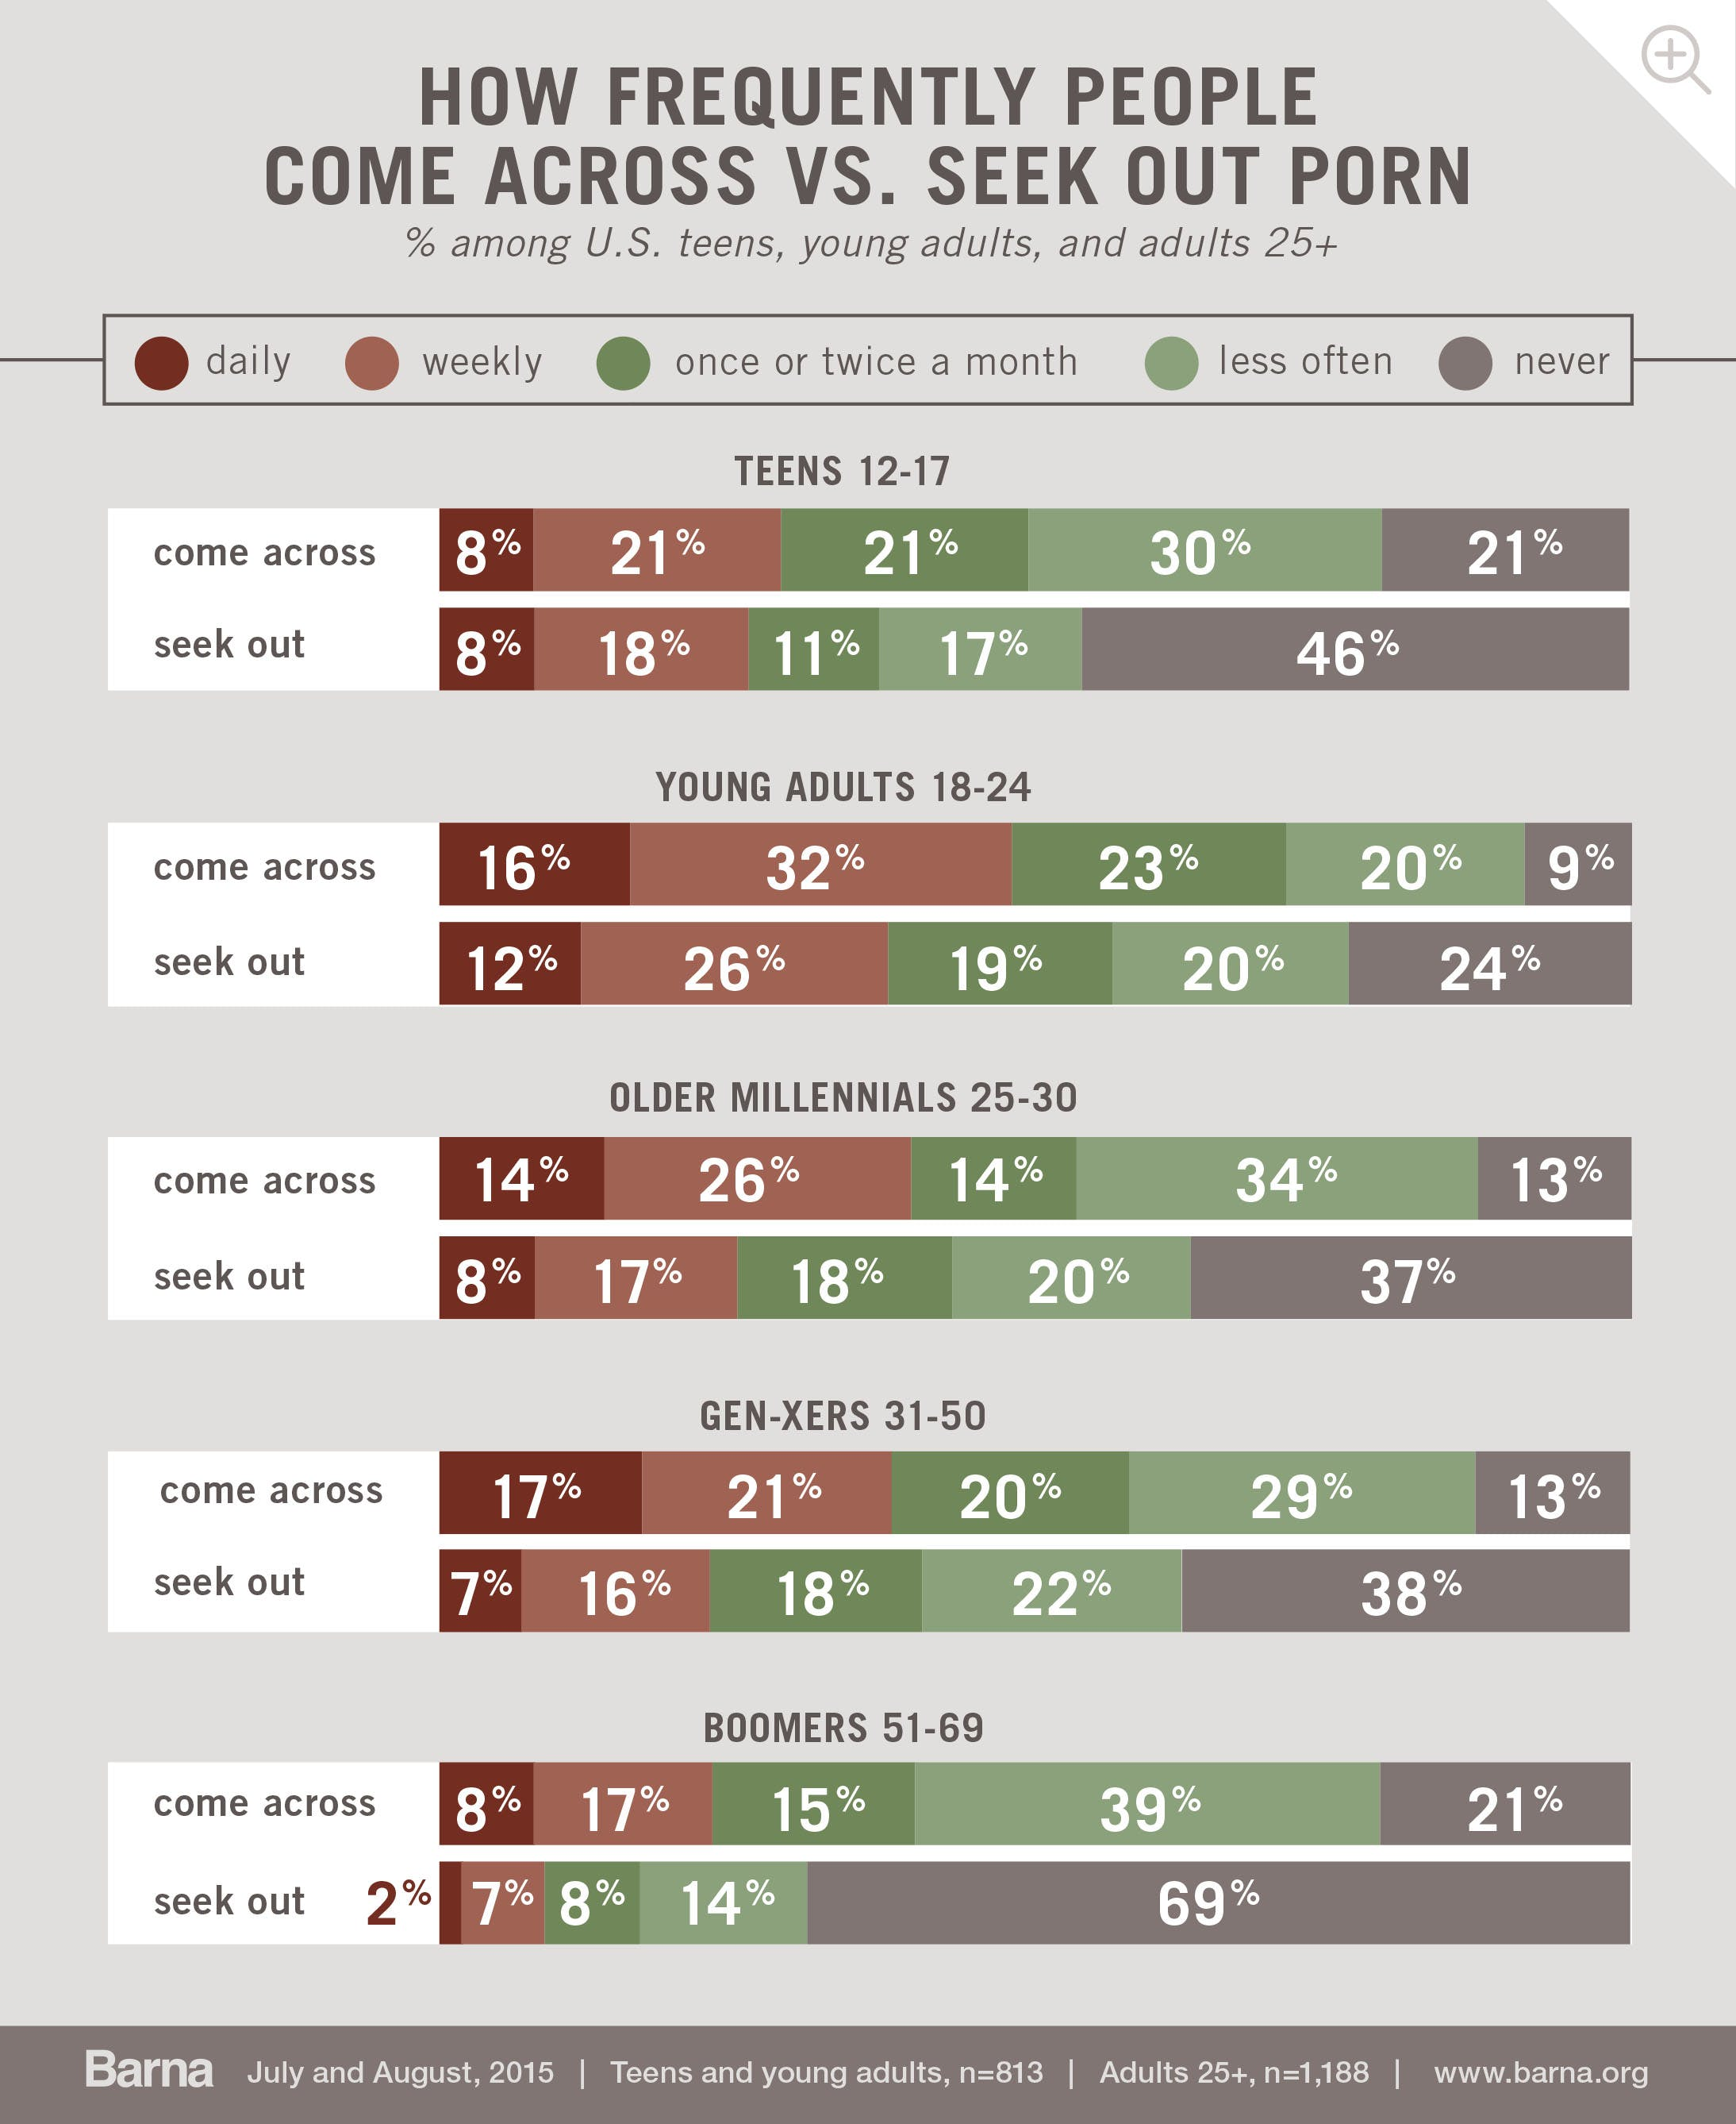
Of all the age ranges, young adults between 18 years old and 24 years old are the most likely to come across porn on a regular basis. More than seven in 10 say they come across porn at least once or twice a month (71%). Only three in 10 say they never or rarely run into pornographic content. In contrast, between 50 and 60 percent of teens (50%), older Millennials ages 25 to 30 (54%) and Gen-Xers (58%) come across porn at least once or twice a month. Roughly half report never or only rarely stumbling onto sexually explicit content. Boomers (40%) are less likely than younger Americans to say they run across porn at least once or twice a month.
The reason young adults come across porn more often is likely a result of seeking it out more often. In cross-referencing how frequently someone comes across porn with how often he or she seeks it out—you find a direct correlation. It would appear that actively searching for porn increases one’s chances of coming across porn, perhaps as a result of browser cookies and responsive advertising. If a person seeks porn on a daily basis, he or she is more likely to come across porn on a daily basis. The same goes for those who seek it out weekly, once or twice a month and less often.
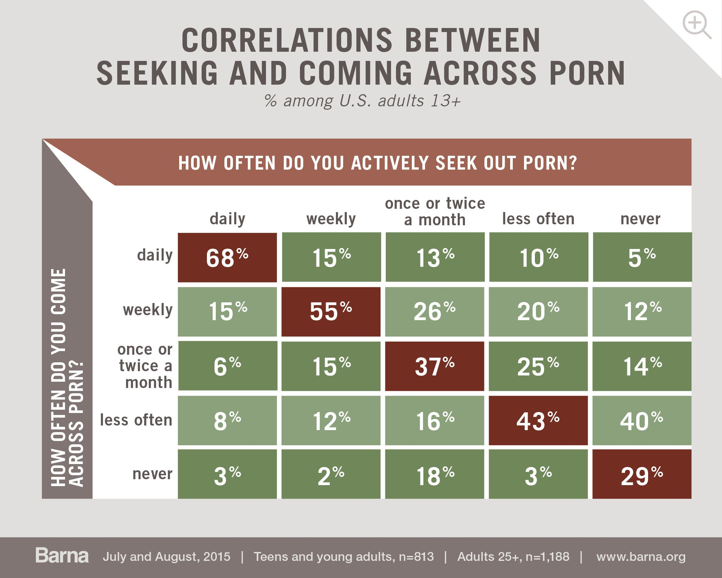
Young adults, ages 18-24 are both more likely to actively seek porn regularly and more likely to come across porn more often. Fifty-seven percent of young adults ages 18 to 24 report seeking out porn at least once or twice a month, compared to 37 percent of teens, 43 percent of older Millennials, 41 percent of Gen-Xers, and just 17 percent of Boomers.
Moral or Immoral?
Teens, young adults and adults 25 and older rated a series of action statements according to a five-point scale: “always OK,” “usually OK,” “neither wrong nor OK,” “usually wrong” and “always wrong.” Combining the percentages of those who chose always and usually wrong for each statement, a picture emerges of where using porn ranks on a list of possible immoral actions.
The short answer? Low. Barely half of adults say viewing porn is wrong (54%) and it ranks all the way down at #7 on a list of 11 actions—behind overeating (58%), which is #4.
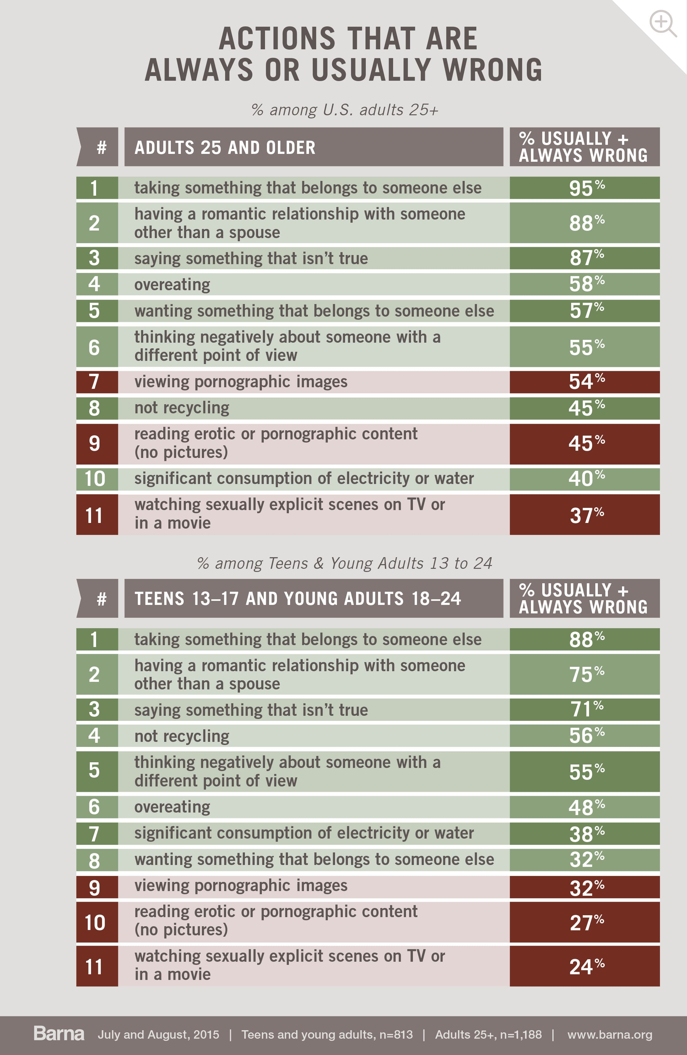
Teens and young adults are roughly 10 percentage points less likely than older adults to think each of the actions is wrong. In addition, the ranking order below the top three are quite different between the younger and older age cohorts. Actions that may negatively impact the environment rank higher among teens and young adults. And notably, teens think “not recycling” is more immoral than any of the actions related to porn use.
Younger Americans seem to have morally indifferent attitudes toward porn. Only one-third of 13- to 24-year-olds believes viewing pornographic images is always or usually wrong (32%), compared to more than half of older adults (54%). About one-quarter says reading erotic content (27%) or watching sexually explicit TV or movie scenes (24%) is immoral.
Teens’ and young adults’ nonchalance is also revealed in how, and how often, they talk with their friends about porn. One-third of 18- to 24-year-olds (34%) and one in six teens (18%) say they talk about porn very often or occasionally with their friends. And among those who do chat with their friends on the topic, half do so either in an accepting (36%) or even encouraging, lighthearted (16%) way.
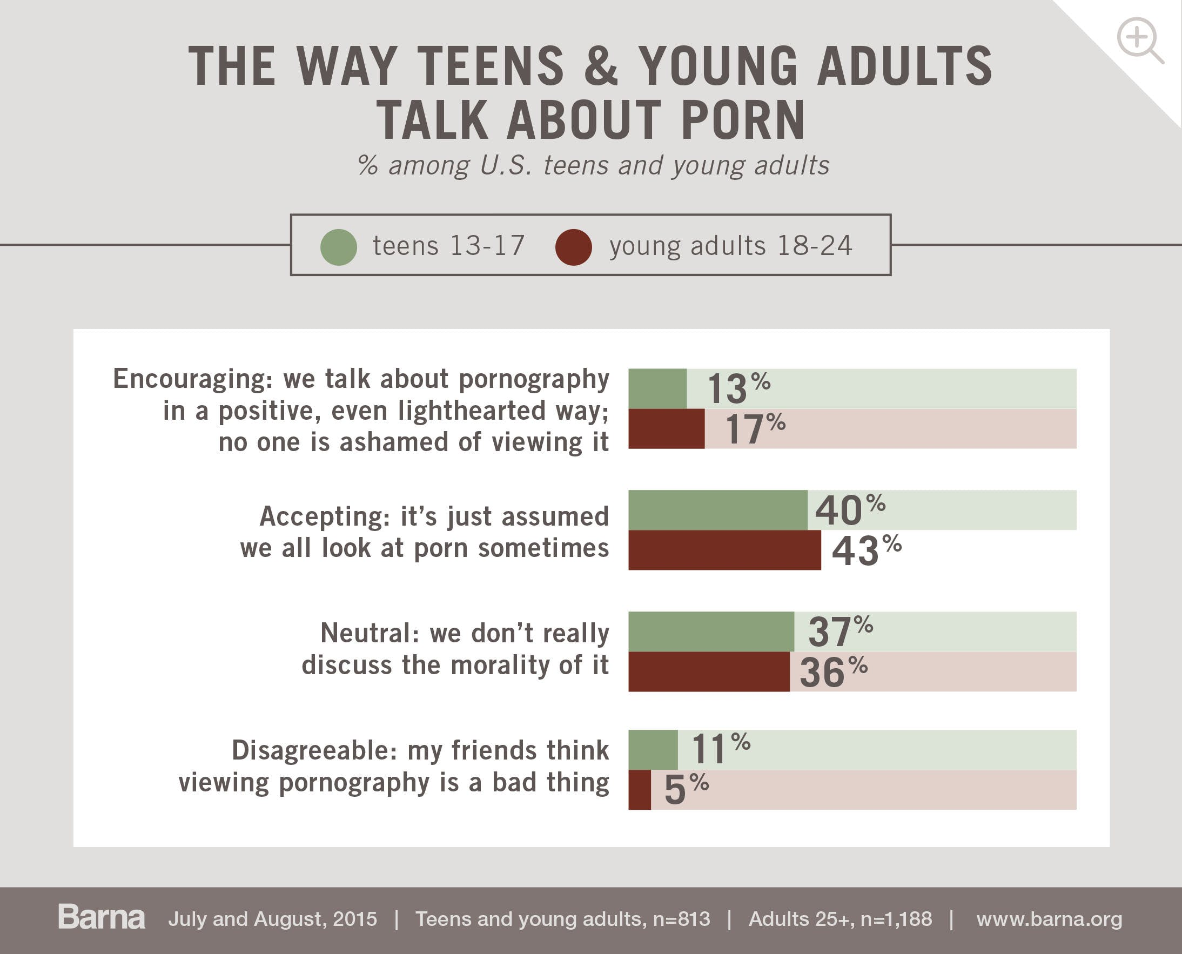
This level of casual acceptance makes sense when half of young adults (49%) and one-third of teens (32%) say that “all” or “most” of their friends regularly view porn.
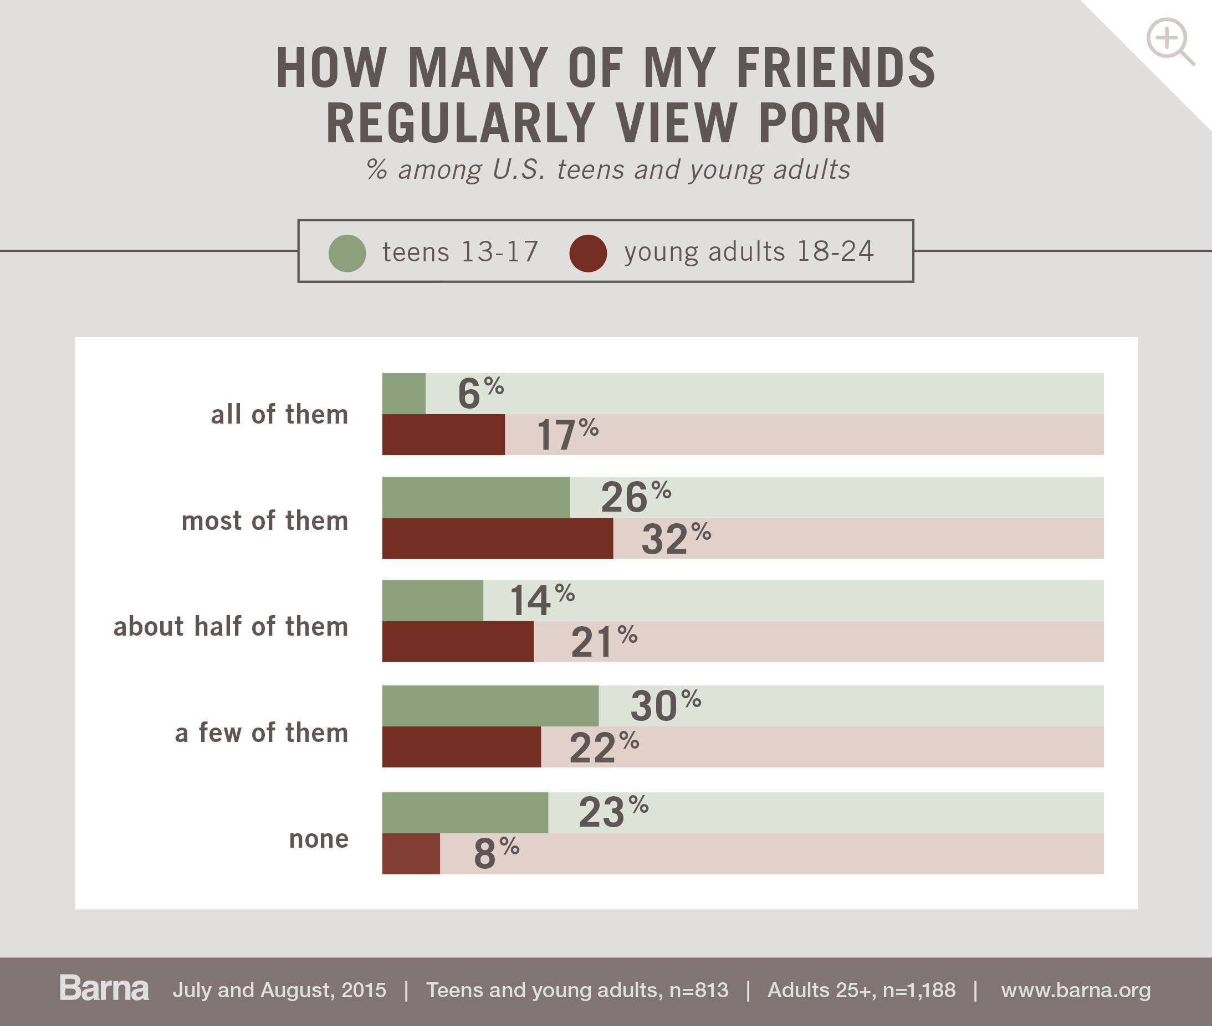
What the Research Means
“There appears to be a momentous generational shift underway in how pornography is perceived, morally speaking, within our culture,” says Roxanne Stone, editor in chief at Barna Group and one of the lead designers and analysts on the study. “This shift is particularly notable when it comes to personal choice regarding pornography use. But these attitudes and preferences toward porn among the younger generations need to take into account the broader social and cultural context that American young people inhabit.”
“For one, they are coming of age in a culture that has given preference to personal experience and personal morality,” continues Stone. “Amy Poehler summed it up nicely, ‘Good for you, not for me.’ Americans are increasingly uncomfortable prescribing a morality for other people—and aren’t eager to have someone else prescribe one for them. Teens and young adults have embraced this ethos and in turn place a high value on personal freedom and autonomy, tending to shirk restrictions, particularly censorship.”
“Further, the mainstream acceptance of pornography, and the broader pornification of popular culture send a powerful message to young people about the moral condition of porn. We’ve seen cultural icons such as Kim Kardashian, Paris Hilton and Miley Cyrus generously rewarded for their public displays of private moments. And now, with broadcast tools at their fingertips, young people have the ability to produce their own personal pornography—via Instagram, Snapchat or just plain ‘sexting.’ Such personal, interactive porn is something we are calling ‘Porn 2.0’ and we will be releasing more of our research on that in the coming months.”
“These realities are fueling more cavalier attitudes and high rates of porn usage among the younger generations,” says Stone. “This is concerning for a number of reasons: studies have shown that seeing a vast amount of pornography long before becoming sexually active can have damaging effects because of the amount of sexual conditioning that occurs in adolescence. Ill-timed exposure to explicit material could cause lifelong problems with relationships and personal sexual health, and create unrealistic beliefs about sex and sexuality.”
“In our research, we’re finding that many adults—especially parents and even pastors—feel ill equipped to face the reality and ubiquity of porn and its use,” continues Stone. “But, without guidance, today’s young people are often left to their own devices to navigate the complex task of developing beliefs about sexuality. As young people develop beliefs and behaviors in a hyper-sexualized technological age where pornography is more accessible than ever, parents must be willing to discuss sexual topics with their children, and the church at-large needs to provide a robust—and appealing—counter narrative to the one perpetuated by pornography. This would entail challenging the distorted narrative of the porn industry by creating realistic expectations for sex and its purpose, and acknowledging the beauty and promise of sex within its proper context.”
Comment on this research and follow our work:
Twitter: @davidkinnaman | @roxyleestone | @barnagroup
Facebook: Barna Group
About the Research
Barna conducted five online surveys in July and August 2015 for The Porn Phenomenon research study, among a total sample of 3,771 participants.
In a survey among U.S. teens and young adults, 813 participants between the ages of 13 and 24 were recruited and surveyed through a national consumer panel. The panel is nationally representative by age, gender, region and socioeconomic grade. The sample error on this survey is plus or minus 3.4 percentage points at the 95-percent confidence level.
In a general U.S. population survey, 1,188 adults 25 years and older were recruited and surveyed separately through a national consumer panel. The panel is nationally representative by age, gender, region and socioeconomic grade. The sample error on this survey is plus or minus 2.8 percentage points at the 95-percent confidence level.
In a survey of U.S. clergy, 338 Christian youth pastors and 432 Christian senior pastors were recruited and surveyed through publically available lists and email invitations. The data was weighted to be nationally representative of churches by denomination, church size and region. The sample error on the youth pastor survey is plus or minus 5.2 percentage points at the 95-percent confidence level. The sample error on the senior pastor survey is plus or minus 4.7 percentage points at the 95-percent confidence level.
In a separate survey on views about sex and women, a total of 1,000 interviews were conducted among U.S. adults 18 years and older. The panel is nationally representative by age, gender, region and socioeconomic grade. Minimal statistical weighting was used to calibrate the sample to known population percentages in relation to demographic variables. The sample error in this survey is plus or minus 3.0 percentage points at the 95-percent confidence level.
About Barna Group
Barna Group is a private, non-partisan, for-profit organization under the umbrella of the Issachar Companies. Located in Ventura, California, Barna Group has been conducting and analyzing primary research to understand cultural trends related to values, beliefs, attitudes and behaviors since 1984.
If you would like to receive free e-mail notification of the release of each update on the latest research findings from Barna Group, you may subscribe to this free service at the Barna website (www.barna.org).
© 2016 by Barna Group.

Old Testament Survey Notes

Our Faithfulness
Malachi 2:10-16

Exegetical Outline (Steps 2-3)

Exegetical Idea: The response Israel should have to their unfaithfulness shown in intermarriage and divorce was to protect their attitude and actions.

I. The charge was that Israel had been unfaithful to their relationships (2:10).

God alone was their spiritual Father (2:10a).

God alone created the nation to be in a special relationship with him (2:10b).

Their low priority of relationships broke their longstanding covenant with God (2:10c).

II. The evidence of Israel’s unfaithfulness was their intermarriage and divorce (2:11-16a).

Intermarriage revealed their lack of faithfulness to God (2:11-12).

Their sin of faithlessness to God was seen in their marrying pagans (2:11).

The result of intermarriage was for these people to either die or have their descendants cut off (2:12).

Divorce revealed their lack of faithfulness to God (2:13-16a).

The result of their divorces was a lack of God’s blessings (2:13).

The sin of divorce was practiced of older men despite being married for many years (2:14-16a).

III. The response God desired for Israel was to protect their attitude and actions (2:16b-c).

The men should guard their spirit, or attitude (2:16b).

The men should never break their marriage vow through divorce (2:16c).

Purpose or Desired Listener Response (Step 4)
The listeners will guard their closest relationship in thought and deed.

Homiletical Outline (Cyclical inductive form)

Introduction

Interest: We all see the need to be faithful.

Need: But we have different ideas how that faithfulness should be shown.

Subject: How do we best show our faithfulness to God?

Background: The Jews had returned to the land 100 year earlier but were deemed unfaithful.

Preview: Today we will see three evidences of faithfulness to God.

Text: These three handles on spiritual faithfulness are in Malachi 2:10-16.

(What’s the first way to show faithfulness to God? It is to…)

I. Be relational (2:10).

God alone is our spiritual Father (2:10a).

God alone created us (2:10b).

Making relationships a low priority breaks our longstanding covenant with God (2:10c).

(What’s the second way to show faithfulness to God? It is to…)

II. Protect your marriage (2:11-16a).

Marriage to unbelievers betrays our walk with God (2:11-12).

The sin of faithlessness to God is seen in marrying pagans (2:11).

The result of intermarriage was either death or no children (2:12).

A Christian who marries a non-Christian is acting like a non-Christian.

Seeking divorce reveals our lack of faithfulness to God (2:13-16a).

The result of divorce is a lack of God’s blessings (2:13).

The sin of divorce by older men betrayed their wives of many years (2:14-16a).

Sometimes our spouse divorces us so we have no choice (cf. 1 Cor 7:15).

(What’s the third way to show faithfulness to God? It is to…)

III. Never think about divorce or do it (2:16b-c).

We men should guard our attitude by never considering divorce (2:16b).

We men should never break our marriage vow by divorce (2:16c).

Actions start with thoughts, so kick porn.

(How do we best show our faithfulness to God?)

Conclusion

Guard your closest relationship in thought and deed (Main Idea).

Main Points

Questions

Will you singles commit to God only to marry a Christian?

Will you accept God’s love if you have divorced?

Will you be accountable to someone else to kick porn?

Will you ask forgiveness of your spouse if you have ever suggested divorce?

Prayer

Dr Rick Griffith Bukit Panjang Gospel Chapel
27 Jan 2019 NIV
Our Faithfulness
Malachi 2:10-16

Introduction

We all see the need to be faithful.

How do we best show our _______________________ to God?

I. Be _______________________ (2:10).

God alone is our spiritual Father (2:10a).

God alone created us (2:10b).

Making relationships a low priority breaks our longstanding covenant with God (2:10c).

II. Protect your _______________________ (2:11-16a).

Marriage to unbelievers betrays our walk with God (2:11-12).

The sin of faithlessness to God is seen in marrying pagans (2:11).

The result of intermarriage was either death or no children (2:12).

A Christian who marries a non-Christian is acting like a non-Christian.

Seeking divorce reveals our lack of faithfulness to God (2:13-16a).

The result of divorce is a lack of God’s blessings (2:13).

The sin of divorce by older men betrayed their wives of many years (2:14-16a).

Sometimes our spouse divorces us so we have no choice (cf. 1 Cor 7:15).

III. Never ____________________ about divorce or do it (2:16b-c).

We men should guard our attitude by never considering divorce (2:16b).

We men should never break our marriage vow by divorce (2:16c).

Actions start with thoughts, so kick porn.

Conclusion

*** Guard your closest _______________________ in thought and deed (Main Idea). ***

Will you singles commit to God only to marry a Christian?

Will you accept God’s love if you have divorced?

Will you be accountable to someone else to kick porn?

Will you build your marriage by regularly reading God’s Word together?

Will you ask forgiveness of your spouse if you have ever suggested divorce?

Download this sermon PPT and notes for free at BibleStudyDownloads.org/resource/old-testament-preaching/

