Crossroads International Church Singapore Dr. Rick Griffith
2 July 2017 Message 10 of 12
NLT 40 Minutes
Be Restored
Title
Book of Haggai

Topic: Priorities
Subject: How can you restore God’s blessing when you only see his discipline?
Complement: Align with God’s priorities.
Purpose: The listeners will realign worldly priorities to God’s priorities.
Attribute: We worship the God of Reward
Reading: Haggai 1
Song: This is Amazing Grace

Introduction

Interest: Sometimes things don’t go our way even when we follow God’s leading. Can you relate?
Don’t Go Our Way

You moved to Singapore because God clearly called you.

He made that abundantly evident that you—not someone else more qualified—got the privilege. So you obeyed and came.

But then you discovered that this place is far more expensive than anyone ever let on. It’s also hotter—and wetter. And the relationships that started sweet began to sour, and here you are. Things are hard.

Is God trying to get your attention?

Perhaps you didn’t choose to move here at all. You got a special blessing. You were born here.

But the LORD gave you an opportunity to serve elsewhere for a while. It changed you for the better.

But now you’re back and this country doesn’t seem so special. You find yourself more able to relate to foreigners than to your own people. Believe me, I understand. When return to my country of origin, I don’t fit there. I wonder if I fit anywhere. Is God disciplining me?

Need: Is God trying to get your attention right now even though you’ve made sacrifices for him?
Get Attention

You have been faithful to him, as far as you know. You have obeyed.

You weren’t so thrilled to come to a church with an afternoon service that stole your Sunday nap, but you still come.

But things aren’t going so well at home, or work, or with friends, or with someone special to you.

“What’s happening to me?” you ask. “Is God speaking to me through difficulty? What’s he trying to say? What do I do?”

Subject: How can you restore God’s blessing when you only see his discipline?
Subject

Background: You aren’t the first one that’s needed to be restored. In today’s text, Judah had faithfully returned to their homeland but the people were still not seeing his full blessing.
Backgrd

The historical context is a mixed bag.

We’ve been in this series on the Minor Prophets lately. These prophets stretch nearly the entirety of Israel’s history. Most were ignored, from the United Kingdom Golden Age under David and Solomon, then ignored after the nation divided, then ignored when Judah was the Solitary kingdom.
Major Message
Timeline

Their ancestors had not heeded the nine prophets we have already studied. Through varying prophets, God had told them to be…humble, caring, etc. Yet they stubbornly worshipped idols and God, faithful to his warning, sent them away to Babylon in modern-day Iraq.
Be…

But the people and temple exiles were not permanent. God promised to restore them because the exiles would last only 70 years, and the time and opportunity to return had come to return home. Remember centuries earlier when Israel entered Canaan and had 600,000 soldiers? Now, only 50,000 men of Judah had trusted the LORD to bring them back to Israel.
70-year Exiles

In some sense, you can’t blame them. They had separated from idolatry, developed the synagogue, and been cured of idolatry. Besides these, they were making good money in Babylon—so who would want to return to a ruined country? No money, no homes, no friends—just enemies occupying their country now. But they still came, and they trusted God’s leading. They eagerly rebuilt the temple foundation and altar in 536 BC.
Opposed External
Develop Map

However, opposition struck externally from pagans left in the land as recorded in Ezra 4.
Ezra 4

Next week we will see the external threats in the book of Zechariah, but today we address the internal problems within the community itself. Often our most severe problems lie within our own midst!
Opposed Internal

These issues had already stopped the temple project for 16 years. They had started well, but made excuses and forgot God.

God hadn’t forgotten them though. He finally speaks in his land.

The word came to the governor.
1:1

On 29 August 520 BC Haggai prophesied to Zerubbabel the governor and Joshua the high priest his first message from the LORD (1:1).
Arrow
1:1
Postexilic Era

This was King Darius’s second year, in 520 BC (1:1). It was the first of four messages through Haggai that year.

This book interrupts the 50+ silent years of prophets in Judah while the people were exiled to Babylon. God was ready to tell them how to restore his blessing. Would they listen?
Placing Prophets

They had come back to the land, but they had not fully come back to the LORD of the land.

The context may sound familiar since our faithfulness often is also a mixed bag.
Would they Listen?

Our salvation begins when we believe the simple message of trust in Christ instead of trusting ourselves. The people of Judah had that kind of faith—placed their trust in YHWH instead of the worthless gods of the pagans.

However, that was but a start for them, as it is for us. God has so much more in store for us, so Haggai shows how to realign with his priorities for blessing.

Preview: Haggai alternates from rebuke to promise to rebuke to promise in a four-fold pattern restore his blessing. That makes four ways to restore God’s blessing.
Parallel Structure

Text: Today we’ll study the entire prophecy of Haggai.
Chart
Hag 1

(This short book will show how you can restore God’s blessing when you only see his discipline. The first thing you need to do is to…)
Subject

I. Realign your priorities (Haggai 1).
MPI
[Seeking your own comforts first invites the LORD’s reproof.]

On 29 August 520 BC the LORD rebuked Judah’s wrong priorities so they would finish rebuilding the temple (Ch. 1).
1:2-4

The remnant’s wrong priorities by paneling their own houses instead of rebuilding the temple resulted in a dire economy (1:2-6).
Temple
(4 slides)

The people’s financial poverty was shown to be from postponing the temple rebuilding so that they would resume the task to please God and eliminate the drought (1:7-11).
1:5-11
(3 slides)
Priorities

The resuming the temple rebuilding three weeks later earned God's promise of His presence (1:12-15).
1:12-15
(2 slides)

See if God might be rebuking any selfish priorities you have today.

God’s priority is unseen, eternal realities over seen, temporary ones (2 Cor 4:18).
2 Cor 4:18

Making a living is tough but sometimes our priority is to please our boss over our family.
Jacuzzi
Money

Pleasure is a priority, as seen in the luxuries we too often prioritize.
iPhone & Baby

This week is the 10th anniversary of the iPhone, and gaming is epidemic today.
Golf

We also struggle with the priority of marriage.

Christians often don’t use their time any better than unbelievers.
Clock
Sign/Bible
(3 slides)

Instead, God has called us to read and follow his Word.
Subject
(So if you really want God’s blessing, then you must follow his warning to align your priorities to his values. God doesn’t just rebuke priorities though. To restore us, chapter 2 says we must…)
Haggai 2
MPI

II. Recall God’s presence (Haggai 2:1-9).
MPII
[If you have trusted Christ, the LORD guarantees that he is with you—so don’t forget that.]

On 17 October 520 BC the LORD promised his presence and greater glory to encourage them to rebuild the temple (2:1-9).

Two months after the first message, on 17 October 520 BC, Zerubbabel, Joshua and the remnant received Haggai’s second message from the LORD (2:1-2).
2:1-2
(2 slides)

God encouraged continued temple reconstruction with his own presence even though the new temple looked inferior to Solomon's (2:3-5).
2:3-9
(17 slides)

God promised that the millennial temple will be more glorious even than Solomon's because it will include the wealth of the nations and bring His peace (2:6-9).

Recall that God also has promised you his presence today.
Sheep on Rock

God’s presence with them was past, present and future—the same with us!
God’s Presence

The divine name Yahweh (LORD) occurs 34 times in the 38 verses of this book, and 14 of these stress divine omnipotence with the name the LORD of Hosts.
YHWH

Hebrews 13:5 is Christ’s promise given in the context of money.
Heb 13:5
Sub/MP1-2
(3 slides)
(We’ve seen both God’s rebuke and blessing so far. Now the pattern begins to repeat itself with a second rebuke. You can restore God’s blessing when you…)

III. Renew your worship (Haggai 2:10-19).
MP3
[Don’t fool yourself to think you can honor the LORD with defiled heart or hands.]

On 18 December 520 BC the LORD rebuked the temple neglect resulting in drought to exhort resuming the task with renewed crops (2:10-19).
2:10-19
(6 slides)
Dates

Two months after the second message, on 18 December 520 BC, Haggai prophesied to the priests his third message from the LORD (2:10-11).

God showed the priests that consecration couldn’t be transferred while defilement can to illustrate the nation's defiled service and worship (2:12-14).

Drought from temple neglect would change to God's blessing in renewed crops since the people had been building for three months (cf. 1:14-15) to finish the foundation that very day (2:15-19).

Evaluate what God thinks about your worship—not what you think.
God & Your Worship

We watch movies that destroy God’s values and then come to worship the next day.

Some believers withhold their tithe so they can have a better vacation.

Defiled worship today includes singing while trying to convince God to let you marry an unbeliever.
Subject
(What’s the final way you can restore God’s blessing when you only see his discipline?)

IV. Re-envision God’s kingdom (Haggai 2:20-23).
MP4
[Focus again on the fantastic future the LORD has for you.]

Later on 18 December 520 BC the LORD promised Zerubbabel authority resulting in Messiah in the future kingdom (2:20-23).

Later on the same day, on 18 December 520 BC, Haggai prophesied to Zerubbabel alone his fourth message from the LORD (2:20-21a).
2:20-22
(2 slides)

God promised to show His power by overthrowing the nations [at the coming of the millennial kingdom] (2:21b-22).

God promised Zerubbabel divine authority that foreshadowed the Messiah’s authority in the future messianic kingdom (2:23).
2:23
(6 slides)
Title
Title
Title

You will also inherit the kingdom when you are faithful now.
Wheat
MP1

Too often we’re obsessed with our earthly inheritance.
GO

Romans 8:17 distinguishes between being an heir of God for eternal life and being an heir of Christ as a reward for faithfulness.
Rom 8:17
Subject
(How can you restore God’s blessing when you only see his discipline?)

Conclusion
MI

Align with God’s priorities (Main Idea).

God will restore you when you value what he values (restated MI).

Main Points: How can you align with him? Notice each “R” alternates between looking at you (1 & 3) and looking at God (2 & 4):

Realign your priorities (Haggai 1).
MP2

Recall God’s presence (Haggai 2:1-9).

Renew your worship (Haggai 2:10-19).
MP3

Re-envision God’s kingdom (Haggai 2:20-23)
MP4

How do you need to realign your priorities to God’s today?
Eternal Priorities

Which matters more? God or Money?
1. God

Do you give proportional to God’s supply?

Do you incur credit card debt so you can live above your means?
2. God’s Word

God’s Word

How is your Bible reading?

What is your goal in God’s Word? Have you committed to read chapter a day? Have you committed to read a verse a day? If you don’t have a target, you are sure to miss it.

Souls of People
3. Souls of People

Are you committed to getting to minister to God’s people here at this church? How?

How much are you praying for the lost?

Prayer
Prayer

Preliminary Questions

Verses Questions

Context: What did the author record just prior to this passage?

This book interrupts the 50+ silent years of prophets in Judah while the people were exiled to Babylon.

They had come back to the land, but they had not fully come back to the LORD of the land.

Purpose: Why is this passage in the Bible?

Our salvation begins when we adopt God’s priority of trust in him instead of ourselves. The people of Judah had done that—placed their trust in YHWH instead of the worthless gods of the pagans.

However, that was but a start for them, as it is for us. God has so much more in store for us, so Haggai shows how to realign with his priorities for blessing.

Background: What historical context helps us understand this passage?

About 50,000 people of Judah had trusted the LORD to bring them back to Israel. They had eagerly rebuilt the temple foundation and altar in 538 BC.

However, opposition struck—both externally from pagans left in the land as well as internally within their own midst.

Next week we will look at the external threats in the book of Zechariah, but today we address the problems within the community internally.

These issues had stopped the temple project for 16 years already.

Questions

Tentative Subject/Complement Statements

Text

Possible Illustrations

God has a better home in my future than the one we gave up in 1991 to serve him.

Possible Applications

Have we decided on our own that we have already done enough for God? Wouldn’t it be good to ask what he thinks? Does he agree with us?

Our priorities are clear in our mission and vision:

Our mission is…

Our vision is…

Old Testament Survey Notes

Haggai

Drought for Neglected Temple Rebuilding

Temple |  | Blessings
Wrong  Priorities | Greater  Glory | Drought  Judgment | Zerubbabel’s Authority
1 | 2:1-9 | 2:10-19 | 2:20-23
Rebuke #1 | Promise #1 | Rebuke #2 | Promise #2
“Is it a time for you yourselves to be living in your paneled houses, while this house remains in ruins? …Go…and build the house” (1:4, 8a) | “I will fill this house with glory…The glory of this present house will be greater than the glory of the former house”  (2:7b, 9a) | “Whatever [my people] do and whatever they offer is defiled… [yet] from this day on I will bless you”  (2:14b, 19b) | “I will shake the heavens and the earth. I will overturn royal thrones and shatter the power of the foreign kingdoms”  (2:21-22)
Present | Kingdom | Present | Kingdom
Drought | Sadness | Food Shortage | Leadership
August 29,  520 BC | October 17,  520 BC | December 18,  520 BC | December 18,  520 BC
Jerusalem

Key Word: Priorities

Key Verse: (God to Judah) “‘You expected much, but see, it turned out to be little. What you brought home, I blew away. Why?’ declares the LORD Almighty. ‘Because of my house, which remains a ruin, while each of you is busy with his own house’”
(Haggai 1:9).

Summary Statement:
Haggai rebukes the remnant to correct its wrong priorities judged in a drought to encourage the rebuilding of the temple that God might bless the nation with crops and Zerubbabel with authority, foreshadowing Messiah's authority in the kingdom.

Application:

Don’t pursue personal prosperity more than you pursue God’s work.
(i.e., prioritize God’s work over wealth)

Honestly, which is more important to you—God or money?

Haggai

Introduction

I. Title: The name Haggai (yG:x; haggay) is derived from an uncertain origin (BDB 291b), but may be from hag (Gx;), which means "festival-gathering, feast, pilgrim-feast" (BDB 290d). Thus, his name may mean "festal" or "feast," possibly because he was born on the day of a major feast, perhaps Tabernacles (LaSor, 482). Haggai's second message takes place on that feast (2:1; TTTB, 283).

II. Authorship

A. External Evidence: Haggai is known only from this book and two references to him by Ezra (5:1; 6:14).

B. Internal Evidence: Some have supposed that the book was composed from several sources, especially since it is written in the third person. However, authors often used the third person in ancient writings (e.g., Moses, Jonah, etc.). Since Haggai's name appears nine times (1:1, 3, 12-13; 2:1, 10, 13-14, 20) few challenge his authorship of the book.

III. Circumstances

A. Date: Haggai is the most precisely dated book of the entire Bible, so it is virtually uncontested. The prophecy divides itself up into four sections with three different dates ranging from August 29, 520 BC to December 18 that same year. The reign of King Darius I Hystaspes establishes the basis for such an accurate accounting (1:1).

B. Recipients: The original readers of Haggai constituted the returning Jewish exiles who had begun to settle in Jerusalem.

C. Occasion: In 538 BC, near the end of the seventy year captivity, Cyrus of Persia decreed that the Jews living in Babylon could return to their homeland (Ezra 1:1-4). However, after living away from Jerusalem for nearly fifty years or more (605 or 597 or 586 to 538 BC), most considered Babylon their home and were not thrilled about "returning to their homeland" which they had never even visited. Following Jeremiah's advice, the exiles had built houses, planted gardens, married, and raised families (cf. Jer. 29:4-7). Some had done well in business and some Jews born in exile fifty years earlier undoubtedly had children and grandchildren of their own. Why move to a "foreign" land devastated years earlier that didn't even have a city wall?

As a result, the initial return a few months later comprised a mere 50,000 who came back with Zerubbabel (September 538 BC; cf. Ezra 2:64-65). They quickly began work on the temple foundation, rebuilt the altar, and resumed the sacrifices (537 BC; cf. Ezra 3), but opposition by Samaritans caused the project to cease (536 BC; cf. Ezra 4).

The story picks up in the Book of Haggai, which shows how the returnees adopted a similar lifestyle of comfort as their brethren who remained in Babylon. They lived in paneled houses while God's own house lay in ruins (1:4). Therefore, God raised up Haggai and Zechariah, who prophesied so that the temple work resumed on September 21, 520 at their encouragement (1:15). Not only did Haggai write to encourage the rebuilding of the temple, but he also explained why the returnees experienced crop failure from a drought sent by God to cause them to return to correct their priorities (1:11).

IV. Characteristics

A. Haggai is the most precisely dated book in the Scripture.

B. Haggai is the only scriptural writing organized by dates of prophetic revelations.

C. Haggai is the first of the three post-exilic prophets (the others are Zechariah and Malachi).

Argument

Haggai's purpose in writing to the returned exiles is to explain that the drought they experienced was due to their neglect of the Lord's temple. His aim was to encourage them to resume the rebuilding of the temple so they could once again know God's blessing. He accomplishes this by first rebuking them for concern for their own homes more than for God's house (ch. 1), promising God's presence with glory even greater in the new temple than in Solomon's (2:1-9), then explaining that neglect of the temple resulted in judgment by drought but the resumption of the task would bring God's blessing in renewed crops (2:10-19), and finally promising Zerubbabel divinely bestowed authority in foreshadowing the authority of Messiah in the future messianic kingdom (2:20-23).

Synthesis

Drought for neglecting temple rebuilding

1 Wrong priorities Rebuke
1:1 Setting
1:2-6 Homes–not temple
1:7-11 Drought for motivation
1:12-15 Work resumes

2:1-9 Greater glory Promise
2:1-2 Setting
2:3-5 God's presence despite inferior reconstruction
2:6-9 Greater glory

2:10-19 Drought judgment Rebuke
2:10-11 Setting
2:12-14 Defiled worship
2:15-19 Crops with rebuilding

2:20-23 Zerubbabel's authority Promise
2:20-21a Setting
2:21b-22 Judgment of the nations
2:23 Foreshadowed authority

Outline

Summary Statement for the Book
Postexilic Jews must correct their wrong priorities judged in a drought and rebuild the temple for God to bless them with crops and Zerubbabel with authority that foreshadows Messiah's kingdom power.

On 29 August 520 BC the LORD rebuked Judah’s wrong priorities so they would finish rebuilding the temple (Ch. 1).

On 29 August 520 BC Haggai prophesied to Zerubbabel the governor and Joshua the high priest his first message from the LORD (1:1).

The remnant’s wrong priorities by paneling their own houses instead of rebuilding the temple resulted in a dire economy (1:2-6).

The people’s financial poverty was shown to be from postponing the temple rebuilding so that they would resume the task to please God and eliminate the drought (1:7-11).

The resuming the temple rebuilding three weeks later earned God's promise of His presence (1:12-15).

On 17 October 520 BC the LORD promised the remnant God's presence and a glory greater in the new temple than that of Solomon's to encourage them in the rebuilding (2:1-9).

Two months after the first message, on 17 October 520 BC, Zerubbabel, Joshua and the remnant received Haggai’s second message from the LORD (2:1-2).

God encouraged continued temple reconstruction with his own presence even though the new temple looked inferior to Solomon's (2:3-5).

God promised that the millennial temple will be more glorious even than Solomon's because it will include the wealth of the nations and bring His peace (2:6-9).

Note: Some understand the glory in 2:7, 9 to be Christ’s presence in Zerubbabel’s temple during His first advent (cf. Matt. 12:6; Luke 2:32; John 2:13-22). However, the treasures in the millennial temple in verse 6 show that Christ’s second advent is more likely (cf. 2:21-22; Isa. 2:12-21; 13:13; Ezek. 38:20; Amos 8:8; Joel 3:16; Matt. 24:29-30).

On 18 December 520 BC the LORD rebuked the temple neglect resulting in drought but resuming the task will bring renewed crops to encourage the remnant that its effort will be rewarded (2:10-19).

Two months after the second message, on 18 December 520 BC, Haggai prophesied to the priests his third message from the LORD (2:10-11).

God showed the priests that consecration couldn’t be transferred while defilement can to illustrate the nation's defiled service and worship (2:12-14).

Drought from temple neglect would change to God's blessing in renewed crops since the people had been building for three months (cf. 1:14-15) to finish the foundation that very day (2:15-19).

Later that day on 18 December 520 BC the LORD promised Zerubbabel authority that foreshadowed Messiah’s authority in the future millennial kingdom (2:20-23).

Later on the same day, on 18 December 520 BC, Haggai prophesied to Zerubbabel alone his fourth message from the LORD (2:20-21a).

God promised to show His power by overthrowing the nations [at the coming of the millennial kingdom] (2:21b-22).

God promised Zerubbabel divine authority that foreshadowed the Messiah’s authority in the future messianic kingdom (2:23).

Temples in Scripture

The Jerusalem temples all relate to the same spot where God’s Spirit dwelt in the Holy of Holies on Temple Mount. However, some notable differences exist between these various structures.

 | Solomon | Zerubbabel/  Herod | Tribulation | Millennial
Temple Period | First | Second | Third | Fourth
Description | 1 Kings 6–7 | Ezra 3–6 | Rev. 11:1-2 | Ezek. 40–43
Haggai Texts | Haggai 2:3a, 9b | Haggai 1:4, 8-9; 2:3b | – | Haggai 2:7, 9a
Construction | 966-959 BC | 536-516 BC | Materials being gathered now | Still future
Desecrated by | Israelites and pagan kings such as Nebuchadnezzar  (2 Kings 25:9) | Antiochus, money changers (John 2:16), Pompey, Titus (Dan. 9:25) | Antichrist  (Dan. 9:27) | No one  (Zech. 14:20-21)
Destruction | 586 BC | AD 70 | End of Great Tribulation? | Before new heavens and new earth (Rev. 21:22)
Longevity | 380 years | 606 years | Under 7 years? | 1000 years
Sacrifices | Before Christ | Before (approved) and after Christ (unapproved) | After Christ (unapproved) | After Christ (approved)
God’s Glory | Filled it  (1 Kings 8:10-11) | Didn’t fill it | Won’t fill it | Will fill it  (Ezek. 43:1-5)
Sanctuary | 90’ x 30’ =  2,700 sq. ft. | ? | ? | 87.5’ x 175’ = 15,312 sq. ft.
Inner Court | 150’ x 400’ = 60,000 sq. ft. | ? | ? | 175’ x 427.5’ = 74,812.5 sq. ft.
Outer Court | 500 x 500 cubits (875’ x 875’) or else six times as large (see note 9 on OTS, 520) | ? | ? | 875’ x 875’ = 765,625 sq. ft.

The Temple Mount

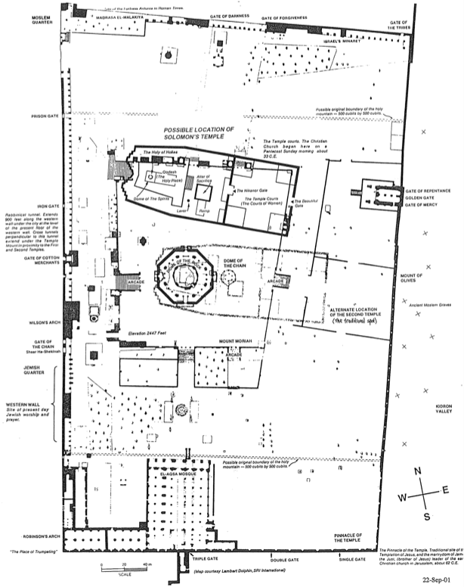

Post World Trade Center Priorities

The world was shocked at the "911 Tragedies" on September 11, 2001 when terrorists flew passenger planes into the World Trade Center in New York and the Pentagon in Washington D.C. As I watched the WTC buildings collapse on TV, I could identify with millions of other people that Osama bin Laden and others who did this must be brought to justice. Since this killing of thousands of innocent lives must be strongly opposed, the USA defeated the Taliban in Afghanistan to counter this threat.

As heinous as this tragedy is, where is the public outcry over another tragedy that has taken far more innocent lives? In 1973 the US Supreme Court's Roe v. Wade decision legalized abortion at any stage of the baby's life. Since then in the USA alone, over 40 million Americans have been killed within the supposed sanctuary of their mother's wombs! Is this not an equally appalling terrorist act? Is this not even worse in terms of the number of people murdered, especially since these are planned attacks by family members with government approval?

The problem has become so severe that in recent years even partial-birth abortions have gained legal protection in the USA (but not in Singapore). The US Congress twice put legislation before President Clinton to abolish this practice of killing babies during birth, but both times Clinton vetoed it.

The prophecy of Haggai urges us to make God's priorities our priorities. As God's holy people, we should fight terrorism on all fronts–public and private, illegal and legal.

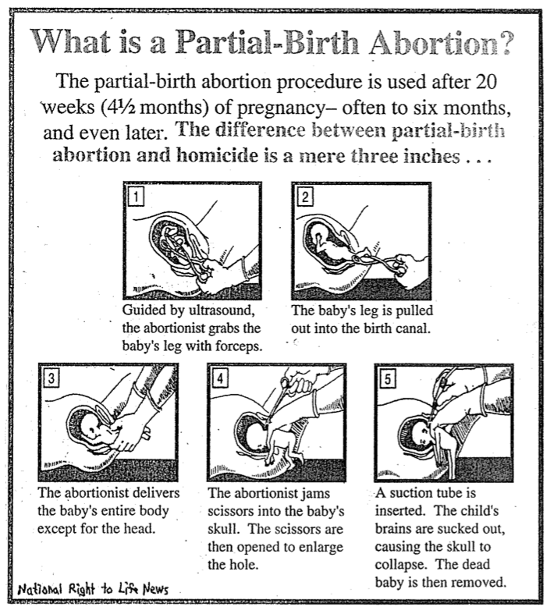

Haggai and the Second Coming
Clifton L. Fowler, 1934 (Book Unknown)

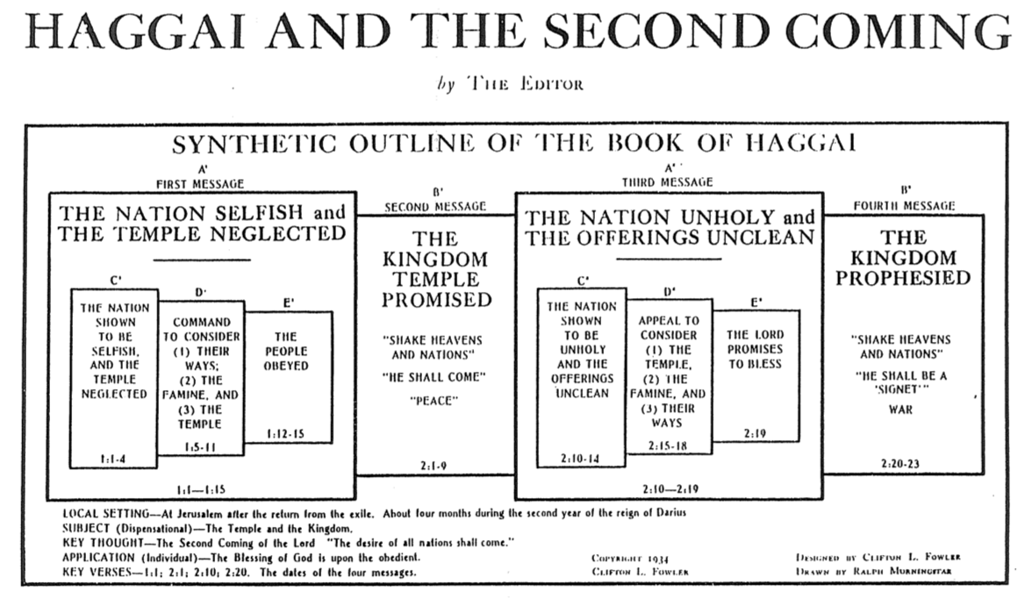

Applications from Haggai

Adapted from Mark Bailey, Dallas Theological Seminary

1. The work of the Lord should never be procrastinated (1:3).

2. Misplaced priorities hinder the work of God (1:4, 9).

3. The goal of God’s work is His glory and pleasure (1:8).

4. God sometimes uses natural disasters for spiritual discipline (1:6, 10, 11).

5. Obedience and reverence are prerequisites for spiritual blessing (1:12-14).

6. It is never too late to start obeying God (1:12-15).

7. Courage comes from knowing that God is present (2:1-4).

8. The remedy for a discouraged heart is to see the divine perspective (2:6-7).

9. Everything belongs to God and is under His control (2:7-8).

10. Holiness is not transferable (2:11-12).

11. Sin contaminates everything one does (2:13-14).

12. Disobedience brings discipline while obedience guarantees blessing (2:15-19).

13. God is sovereign over all the nations and kingdoms of the world (2:20-22).

14. The LORD guarantees that he will fulfill his covenants (2:23).

Zerubbabel’s Authority

Talk Thru the Bible, 285

Haggai portrayed the Messiah in the person of Zerubbabel when God said to Zerubbabel, “I will make you like my signet ring, for I have chosen you” (2:23). As a signet ring denoted authority, so Zerubbabel became the center of the Messianic line in which both Joseph and Mary’s lines merged:

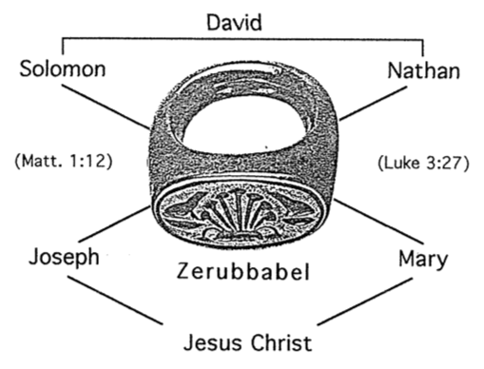

In both genealogies the father of Zerubbabel is Shealtiel, but each genealogy follows a different son of Zerubbabel until they end with Joseph and Mary. This makes Zerubbabel and his father the common link in each lineage.

Haggai and Zechariah Contrasted

Talk Thru the Bible, 291, adapted

Haggai | Zechariah
Rebuke | Encouragement
Priorities | Messiah
More Concrete | More Abstract
Concise  (2 chapters) | Expanded  (14 chapters)
Present Concern | Future Concern
4 visions | Many visions
Take Part! | Take Heart!
Older Activist | Younger Visionary

Be Restored
Book of Haggai

Exegetical Outline (Steps 2-3)

Exegetical Idea: The way the postexilic Jews could restore God’s blessing of crops and Zerubbabel’s authority that foreshadows Messiah's kingdom power was to realign to God’s priorities by rebuilding his temple.

On 29 August 520 BC the LORD rebuked Judah’s wrong priorities so they would finish rebuilding the temple (Ch. 1).

On 29 August 520 BC Haggai prophesied to Zerubbabel the governor and Joshua the high priest his first message from the LORD (1:1).

The remnant’s wrong priorities by paneling their own houses instead of rebuilding the temple resulted in a dire economy (1:2-6).

The people’s financial poverty was shown to be from postponing the temple rebuilding so that they would resume the task to please God and eliminate the drought (1:7-11).

The resuming the temple rebuilding three weeks later earned God's promise of His presence (1:12-15).

On 17 October 520 BC the LORD promised the remnant God's presence and a glory greater in the new temple than that of Solomon's to encourage them in the rebuilding (2:1-9).

Two months after the first message, on 17 October 520 BC, Zerubbabel, Joshua and the remnant received Haggai’s second message from the LORD (2:1-2).

God encouraged continued temple reconstruction with his own presence even though the new temple looked inferior to Solomon's (2:3-5).

God promised that the millennial temple will be more glorious even than Solomon's because it will include the wealth of the nations and bring His peace (2:6-9).

Note: Some understand the glory in 2:7, 9 to be Christ’s presence in Zerubbabel’s temple during His first advent (cf. Matt. 12:6; Luke 2:32; John 2:13-22). However, the treasures in the millennial temple in verse 6 show that Christ’s second advent is more likely (cf. 2:21-22; Isa. 2:12-21; 13:13; Ezek. 38:20; Amos 8:8; Joel 3:16; Matt. 24:29-30).

On 18 December 520 BC the LORD rebuked the temple neglect resulting in drought but resuming the task will bring renewed crops to encourage the remnant that its effort will be rewarded (2:10-19).

Two months after the second message, on 18 December 520 BC, Haggai prophesied to the priests his third message from the LORD (2:10-11).

God showed the priests that consecration couldn’t be transferred while defilement can to illustrate the nation's defiled service and worship (2:12-14).

Drought from temple neglect would change to God's blessing in renewed crops since the people had been building for three months (cf. 1:14-15) to finish the foundation that very day (2:15-19).

Later that day on 18 December 520 BC the LORD promised Zerubbabel authority that foreshadowed Messiah’s authority in the future millennial kingdom (2:20-23).

Later on the same day, on 18 December 520 BC, Haggai prophesied to Zerubbabel alone his fourth message from the LORD (2:20-21a).

God promised to show His power by overthrowing the nations [at the coming of the millennial kingdom] (2:21b-22).

God promised Zerubbabel divine authority that foreshadowed the Messiah’s authority in the future messianic kingdom (2:23).

Purpose or Desired Listener Response (Step 4)
The listeners will realign worldly priorities to God’s priorities.

Homiletical Outline (Cyclical inductive form)

Introduction

Interest: Sometimes things don’t go our way even when we follow God’s leading. Can you relate?

Need: Is God trying to get your attention right now even though you’ve made sacrifices for him?

Subject: How can you restore God’s blessing when you only see his discipline?

Background: You aren’t the first one that’s needed to be restored. In today’s text, Judah had faithfully returned to their homeland but the people were still not seeing his full blessing.

Preview: Haggai alternates from rebuke to promise to rebuke to promise in a four-fold pattern restore his blessing. That makes four ways to restore God’s blessing.

Text: Today we’ll study the entire prophecy of Haggai.

(This short book will show how you can restore God’s blessing when you only see his discipline. The first thing you need to do is to…)

I. Realign your priorities (Haggai 1).

On 29 August 520 BC the LORD rebuked Judah’s wrong priorities so they would finish rebuilding the temple (Ch. 1).

See if God might be rebuking any selfish priorities you have today.

II. Recall God’s presence (Haggai 2:1-9).

On 17 October 520 BC the LORD promised his presence and greater glory to encourage them to rebuild the temple (2:1-9).

Recall that God also has promised you his presence today.

III. Renew your worship (Haggai 2:10-19).

On 18 December 520 BC the LORD rebuked the temple neglect resulting in drought to exhort resuming the task with renewed crops (2:10-19).

Evaluate what God thinks about your worship—not what you think.

IV. Re-envision God’s kingdom (Haggai 2:20-23).

Later on 18 December 520 BC the LORD promised Zerubbabel authority resulting in Messiah in the future kingdom (2:20-23).

You will also inherit the kingdom when you are faithful now.

(How can you restore God’s blessing when you only see his discipline?)

Conclusion

Align with God’s priorities (Main Idea).

Main Points: How can you align with him?

Realign your priorities (Haggai 1).

Recall God’s presence (Haggai 2:1-9).

Renew your worship (Haggai 2:10-19).

Re-envision God’s kingdom (Haggai 2:20-23).

How do you need to realign your priorities to God’s today? There exist three eternal priorities:

God

God’s Word

Souls of People

Prayer

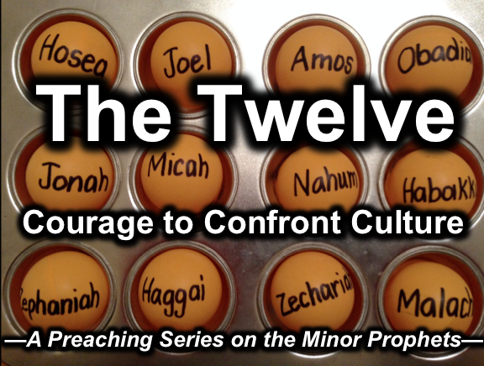
Rick Griffith
2 July 2017
Message 10 of 12

Be Restored
Book of Haggai

Introduction

Sometimes things don’t go our way even when we follow God’s leading. Can you relate?

Is God trying to get your attention right now even though you’ve made sacrifices for him?

How can you restore God’s _____________________ when you only see his discipline?

Judah had faithfully returned to their homeland but hadn’t seen his full blessing.

I. Realign your ____________________ (Haggai 1).

On 29 August 520 BC the LORD rebuked Judah’s wrong priorities so they would finish rebuilding the temple (Ch. 1).

See if God might be rebuking any selfish priorities you have today.

II. Recall God’s ____________________ (Haggai 2:1-9).

On 17 October 520 BC the LORD promised his presence and greater glory to encourage them to rebuild the temple (2:1-9).

Recall that God also has promised you his presence today.

III. Renew your _____________________ (Haggai 2:10-19).

On 18 December 520 BC the LORD rebuked the temple neglect resulting in drought to exhort resuming the task with renewed crops (2:10-19).

Evaluate what God thinks about your worship—not what you think.

IV. Re-envision God’s ___________________ (Haggai 2:20-23).

Later on 18 December 520 BC the LORD promised Zerubbabel authority resulting in Messiah in the future kingdom (2:20-23).

You will also inherit the kingdom when you are faithful now.

(How can you restore God’s blessing when you only see his discipline?)

Conclusion

Align with God’s ___________________ (Main Idea).

How do you need to realign your priorities to God’s today? There exist three eternal priorities:

God

God’s Word

Souls of People

Thought Questions

- Read the book of Haggai aloud. Contrast how the people and God looked at situations:

Judah | The LORD

- What one way should you realign your priorities today to what God values?

Download this sermon PPT and notes for free at BibleStudyDownloads.org/resource/old-testament-preaching/
Listen to this message online at cicfamily.com/sermon-listing/

