Crossroads International Church Singapore Dr. Rick Griffith
Title
23 Sept 2018 Message 26 of 66
NLT 60 Minutes
Be Expectant
Ezekiel

Topic: Expectancy
Subject: How can you be expectant of God’s glory once again in your life?
Complement: Expect God to discipline and restore you for his glory.
Purpose: The listeners will be expectant of God’s glory returning in their lives.
Attribute: We worship the God of Glory
Reading: Ezek 1:1-12
Benediction: Ezek 36:25-27
Songs:
1. Glory: https://www.youtube.com/watch?v=qNjJRbZgypY
2. Greatest Hallelujah: https://www.youtube.com/watch?v=ahh8SdaQCnQ
3. Our Father: https://www.youtube.com/watch?v=ajMqhFz3FIk
4. Let Your glory fall: https://www.youtube.com/watch?v=UnnHSxW3N0w

Introduction

Interest: Are you expectant? I don’t mean pregnant! But when a baby is born, we can’t help but look ahead. Yet sometimes it seems that our best days are past.
Expectant

Need: Do you feel that God’s glory has departed from your life? Do you find yourself thinking about the “good ol’ days”?
Gone

We are in a current difficulty.

We make errors that we used to not make.

Our relationships have seen better days.

We suffer for our faith.

Depression sets in.

So today we will look at Ezekiel where the key word is GLORY! We will address this question…
Glory

Subject: How can you be expectant of God’s glory once again in your life?
Subject

Our hope is in God, so when God himself removes his glory and presence in our lives, we need to know what to do!

We often can tell that something is wrong. However, knowing what to do about it escapes us.

What can you do to restore that sense of blessing that you used to have—those times when the presence of the Lord was real? This isn't simply a feeling, for that time may have been one of the most difficult periods of your life. Yet you knew that God was showing himself to you in new ways, there was a sense of expectancy at what he would do next. How can that return?

Background: Ezekiel was an exile with the exiles, yet he witnessed God’s glory departing the temple in Jerusalem and then returning in the future.
Animated

The Babylonians had conquered the world north of Judah—and then in 586 BC they destroyed Jerusalem, which is addressed in Jeremiah and Lamentations.
Threat
Map

The Babylonians had six deportations of Israelites. Ezekiel was taken away from Jerusalem along with 10,000 others in 597 BC.
Chart

Both Daniel and Jeremiah were ministering at the same time in their various capacities.
Josiah’s Sons

Daniel was playing a vital role in the palace to shape public policy by advising the king.

Jeremiah was also playing his key role back in Jerusalem by living among the people as well as giving messages to Judah’s kings.

Ezekiel was an exile with the exiles. As the people in Babylon waited to see what will happen to their homeland, they needed to be expectant of what God will do once again with the temple and their land.

Preview/Text: Through the entire book of Ezekiel, we will see three steps to expect God’s glory to return in your life.
3
Steps

(What is the first step to expect God’s glory to return in your life? To see a solution, we must first confess there is a problem, so…)

I. Admit that God’s glory left (Ezek 1–24).
Ezek 1
(11 slides)
MP
[The sense of God's presence will not remain when we insist on sin.]

God judged Judah’s sin by his glory leaving Solomon’s temple (Ezek 1–24).

God reveals his glory with Judah to prepare Ezekiel as a prophet to deliver his messages of judgment and blessings (Ezek 1–3).

Before Jerusalem’s fall, Ezekiel sees a vision of God’s glory to show his sovereignty and holiness as the basis for the book (Ezek 1).
Ezek 2
(2 slides)

God calls Ezekiel as a prophet to judge Israel and the Spirit empowers him as Israel's watchman despite his trials (Ezek 2–3).

God tells Ezekiel to fearlessly deliver his message despite Israel’s rebellion so they would know that he is a true prophet (2:1-7).

Ezekiel eats a scroll to receive God's word of judgment on the nation (2:8–3:3).

God sends Ezekiel to deliver his judgment written on the scroll but warns that the nation will not listen (3:4-11).

The Spirit gives Ezekiel power as a watchman for Israel despite physical restraints imposed on him by the LORD (3:12-27).

God’s pre-exile judgment shows him justified for his glory departing the temple as Jerusalem is hopeless (Ezek 4–24).
Ezek 4
(2 slides)

Signs, sermons, and visions reveal that the nation needs judgment due to its rebellion (Ezek 4–11).

Ezekiel prophesies four signs of judgment to reveal Judah’s disobedience (Ezek 4–5).

He symbolizes Jerusalem under attack by using a clay tablet (4:1-3).

He symbolizes Israel's 390 years of sin and Judah's 40 years of sin by lying on his sides fourteen months (4:4-8).

He symbolizes eating unclean food cooked with cow dung to show Jerusalem's future scarcity of food and water (4:9-17).

He symbolizes Jerusalem's division and destruction despite God's warnings by dividing and burning his hair (Ezek 5).

Two sermons show that Judah needs judgment due to its disobedience (Ezek 6–7).

Four visions show God as just to judge Judah due to its disobedience and culminate in the exit of God's glory (Ezek 8–11).
Ezek 8-11
(9 slides)

Idolatry in temple worship of the jealousy idol, paintings, Tammuz, and the sun depicts God’s hatred of idolatry (Ezek 8).

The execution of the godless in Jerusalem while sparing the righteous shows that God will end open rebellion (Ezek 9).

God's glory departing the temple depicts how God cannot dwell among a wicked and idolatrous people (Ezek 10).

Jerusalem will be judged for its wicked rulers and the captives restored after the removal of God's glory (Ezek 11).

God shows that Jerusalem's fate has been sealed so optimism is futile (Ezek 12–19).
APP

Be honest that while the Spirit is present, you may have quenched him.

Paul taught that the Holy Spirit indwells every believer (Rom 8:9; Eph 1:13-14).
Rom 8:9

Jesus promised that the Holy Spirit would never leave us when we truly know him (John 14:15-17).
John 14

However, we can certainly quench the Spirit through sin (1 Thess 5:19). “Do not put out the Spirit’s fire” (NIV) is more literal.
1 Th 5:19

Is God trying to ignite a fire in you but you keep throwing cold water on him?

Do you want God’s glory in your life but also want to hold onto your sin?

It doesn’t work that way!
Sub/MPI
(2)

(What is the second step to expect God’s glory to return in your life?)
MP

II. Allow God to handle all rivals to his glory (Ezek 25–32).
[Know that the Shekinah presence of the LORD will purge all forms of darkness.]
Ezek 25
(3 slides)

God promised to destroy Israel’s enemies (Ezek 25–32).

God will judge Ammon for rejoicing at the temple’s destruction to show his sovereignty (25:1-7).

God will judge Moab for thinking that Israel was like all of the other nations to show God's sovereignty (25:8-11).

God will judge Edom for avenging Judah to show God's sovereignty (25:12-14).

God will judge Philistia for avenging Judah to show God's sovereignty (25:15-17).

God will judge Tyre so it will never be rebuilt due to its pride in its beauty, power, trade, and leaders to show God's sovereignty (26:1–28:19).

In 573/72 after a 13-year siege, Nebuchadnezzar and others will ruin Tyre so that it will not be found or rebuilt (Ezek 26; 585-573/72 BC).

Tyre's beauty, might and trade will be lamented after its fall to show the awesome sovereignty of God (Ezek 27).

The prince of Tyre will be overthrown for his claim to be God in order to prove God's sovereignty (28:1-10).
Ezek 28
(6 slides)

As Satan was cast to the earth at his fall, so the king of Tyre will be overthrown to prove God's sovereignty (28:11-19).

God will judge Sidon for maliciousness against Judah to show his sovereignty by gaining glory in the judgment (28:20-26).

God will judge Egypt by Nebuchadnezzar who will take exiles to Babylon to show God's sovereignty (Ezek 29–32; fulfilled in 571 BC).

God’s glory will not shine with competitors in your life.
Chess

One wonders why Israel ever trusted any of these nations that were doomed themselves.

But the same question can be asked of us: Why do we trust anything or anyone other than Almighty God? Why trust something weaker and that does not have our best interest in mind?

Who will be king in your life?
MPs (3)

(What is the third step to expect God’s glory to return in your life?)
MP

III. Anticipate God’s glory to return (Ezek 33–48).
[Live as if the future really does include God’s blessing once again.]

God will restore his glory to Israel in the millennial temple (Ezek 33–48).

God will restore Israel to the land in a new life with new millennial leaders and destroyed enemies to prepare for God's glory to return (Ezek 33–39).

God appoints Ezekiel as a watchman to declare Jerusalem’s fall so Judah will repent of their idolatry, immorality and greed (Ezek 33).
Ezek 33
(2 slides)

New life will come by replacing Judah’s false, self-serving shepherds with God as the true, selfless Shepherd after his glory returns (Ezek 34).

New life will come to Judah by God judging her enemies, represented by Edom, who pridefully opposed Israel (Ezek 35).

God will restore the united nation by blessing, cleansing, and restoring them to the land to show his holiness and sovereignty (Ezek 36–37).

Judah will be restored to the land in national blessing and cleansing under the New Covenant to show God's holy character (Ezek 36).
Ezek 36
(3 slides)

Judah’s "deadness" will be restored to fulfill the Land Covenant (Deut. 30:1-10), begun in AD 1948 in the State of Israel (37:1-14).
Ezek 37
(16 slides)

Messiah will rule Judah and Israel together to fulfill the Davidic Covenant (2 Sam. 7:13-14) and show God's holiness (37:15-28).

God will protect Israel against an attack by the area of Gog and its allies in the Tribulation to show his sovereignty (Ezek 38–39).
Ezek 38
(5 slides)

The area of Gog and her allies (a northern Arab alliance) will attack Israel with great might that will reveal God's power (38:1-16).

God will destroy these enemies by natural setbacks and fire in the Tribulation to protect Israel and show his sovereignty (38:17–39:29).
Ezek 39
(2 slides)

Israel’s new, millennial order will prove God faithful to the Abrahamic and New Covenants when his promised glory returns to his people (Ezek 40–48).
Ezek 40
(4 slides)

The millennial temple filled with God's glory and with sacrifices will show Israel’s new covenant bond with God (Ezek 40–43).

In 573 BC Ezekiel has a vision of a stunning temple to cheer Judah when the temple lay in ruins (40:1-4).

The inner and outer courts form perfect squares (40:5-47).

The temple has a rectangular nave, most holy place, rectangular separate building and interior galleries of carvings (40:48–41:26).

The two sets of chambers enable the changing and dining of the priests (42:1-14).

The wall surrounding the entire complex forms another square separating the holy from the profane (42:15-20).

The glory of the LORD fills the temple where God will dwell with his people in fulfillment of his promise (43:1-12).
Ezek 43
(4 slides)

Sin offerings commemorate the death of Christ to show Israel in fellowship with God (43:13-27).

A new service of worship including priests, Levites and Jewish rituals will be followed in the millennium (Ezek 44–46).
Ezek 44
(2 slides)

The duties and land of the priests and Levites reveal the standards for temple ministers (44:1–45:8).

Princes must be honest and offerings, feasts, the Sabbath and Year of Jubilee will recall the death of Christ in the millennium (45:9–46:24).

The princes must be honest in their dealings with the people (45:9-12).

All the people must present sacrifices for David, the prince of Israel, as memorials to the death of Christ (45:13-17).

Feasts, Sabbath worship, and the Year of Jubilee will be reinstituted in the millennium (45:18–46:24).
Ezek 46
(7 slides)

New land boundaries equal for each tribe and a renewed city will fulfill the Abrahamic Covenant and show God’s returned glory (Ezek 47–48).
Ezek 47
(7 slides)

A river flowing eastward from the temple to make Dead Sea fresh water with fish will show the temple’s cleansing power (47:1-12).

New, equal allotments for each tribe with Gentile lands will prove the Abrahamic Covenant fulfilled (47:13-23; cf. Gen. 15:18).

Land inheritances with firstborn sons of Jacob in the center will also have lots for priests, Levites, city and prince (48:1-29).
Ezek 48
(4 slides)

Twelve gates (one per tribe) will surround the city for access from any side (48:30-34).

The circumference of the city will be 18,000 cubits [about two miles] (48:35).

The city named "the LORD is there" will feature the return of God’s glory to dwell with his millennial people (48:36).
Puzzle
Pieces

Things are not falling apart—they are falling together.
Alliance
(3 slides)

God has restored Israel and is preparing nations to attack Israel to fulfill Ezek 38–39.
Third Temple
Heifer

Plans for the Third Temple are continuing.
Priests

The priesthood is being prepared.

A perfect red heifer was born 28 August 2018.

Serve the Lord Jesus like he really is coming back to reward you.
Sub
(How can you be expectant of God’s glory once again in your life?)

Conclusion
MI

Expect God to discipline and restore you for his glory (Main Idea).

Here again are the three ways to be expectant of God’s glory once again in your life (Main Points):
MPI

Admit that God’s glory left (Ezek 1–24).
MPII

Allow God to handle all rivals to his glory (Ezek 25–32).
MPIII

Anticipate God’s glory to return (Ezek 33–48).
APP

Applications: Are you expectant?
• Glory
• Discipline
• Hand
• Return

How do you reveal the glory of God in your life?

How has God disciplined you for your sin but restored you by His grace?

Do you see his hand in world events?

Will you return to him so he can return to you?

Prayer
Prayer

Preliminary Questions

Verses Questions

Context: What did the author record just prior to this passage?

Both Daniel and Jeremiah are ministering at the same time in their various capacities.

Daniel is playing a vital role in the palace to shape public policy by advising the king.

Jeremiah is also playing his key role back in Jerusalem by living among the people as well as giving messages to Judah’s kings.

Purpose: Why is this passage in the Bible?

Our hope is in God, so when God himself removes his glory and presence in our lives, we need to know what to do!

We often can tell that sometime is wrong. However, knowing what to do about it escapes us.

Background: What historical context helps us understand this passage?

The Babylonians had six deportations of Israelites. Ezekiel was taken away from Jerusalem along with 10,000 others in 597 BC.

Ezekiel is an exile with the exiles. As the people in Babylon wait to see what will happen to their homeland, they need to be expectant of what God will do once again with the temple and their land.

Questions

Tentative Main Ideas

Text

Illustrations That Apply

Videos to show in the message:

26-Ezekiel-Israel's 70th - Do You See The Miracle.mp4 at http://biblestudydownloads.org/files/eng/os/26-Ezekiel-Israel's%2070th%20-%20Do%20You%20See%20The%20Miracle.mp4

33-Micah-Netanyahu UN Speech Slams Antisemitism Sep 22 2016.mp4 at http://biblestudydownloads.org/files/eng/os/33-Micah-Netanyahu%20UN%20Speech%20Slams%20Antisemitism%20Sep%2022%202016.mp4

Old Testament Survey Notes

Ezekiel

Sovereign Departing and Return of Glory

Glory Departs |  | Nations Judged (No Glory) |  |  | Glory Returns
Chapters 1–24 |  | Chapters 25–32 |  |  | Chapters 33–48
Exile |  | Sovereignty Vindicated |  |  | Restoration
Judgment  of Judah |  | Judgment  of Nations |  |  | Blessing  of Israel
Judah’s Fall |  | Judah’s Foes |  |  | Judah’s Future
Before the Siege  (592-588 BC) |  | Through the Siege  (587-586 BC) |  |  | After the Siege  (586-573 BC)
Call in Glory  1–3 | Pre-Exile  Hopelessness  4–24 | Ammon, Moab, Edom, Philistia  25 | Tyre  and  Sidon  26–28 | Egypt  29–32 | New Life  33–39 | New Order  40–48
Babylon (592-570 BC)

Key Word: Glory

Key Verse: (God to Israel) “For I will take you out of the nations; I will gather you from all the countries and bring you back into your own land. I will sprinkle clean water on you, and you will be clean; I will cleanse you from all your impurities and from all your idols. I will give you a new heart and put a new spirit within you; I will remove your heart of stone and give you a heart of flesh. And I will put my Spirit in you and move you to follow my decrees and be careful to keep my laws” (36:24-27).

Summary Statement:
The way the exiles could expect the glory of the LORD to return was for God to judge his people, destroy their enemies, and restore them to a new life in a new temple.

Application:

Expect God to discipline your sin but restore you for his glory.

Ezekiel

Introduction

I. Title: The name Ezekiel (laqe’z>x,y> yehezke'l ) means literally "God strengthens" (BDB 306b 1). He was indeed strengthened by the God who called him to a hard-headed people (3:8-9).

II. Authorship

A. External Evidence: Not until recent years has the unity, authorship, or exilic date for Ezekiel been challenged. First to question the authorship was Spinoza (1632-1677), whose work led to Oeder publishing in 1771, claiming that the prophecy ended with chapter 39 while chapters 40–48 were a “spurious addition to the genuine work” (noted by Harrison, 823). Also, the rabbinic traditions said that the Great Synagogue men wrote Ezekiel and the twelve minor prophets (Bab. Bath. 15a), but this probably means that they copied or edited the book (ibid.).

B. Internal Evidence: Only two verses note Ezekiel as author and he appears nowhere else in the Old Testament. It says that Ezekiel, a priest and the son of Buzi (1:3), penned the work (24:24). He grew up in Israel, probably in Jerusalem, but lived in Babylon among the exiles in a transplanted Jewish colony most of his life (1:1). His wife died as a sign to Judah when Nebuchadnezzar began his final siege of Jerusalem (24:16-24). Some scholars question the book's unity, but the text: (1) identifies the author as Ezekiel, (2) maintains a consistent style, language, and theme throughout, and (3) repeats key phrases throughout, such as "they shall know that I am the LORD," "Son of man," "the word of the LORD came to me," and the "glory of the LORD" (TTTB, 213).

III. Circumstances

A. Date: Ezekiel's Babylonian exile began in 597 BC (33:21) at age 25. We know this because five years after his and Jehoiachin’s exile to Babylon (1:2-3) he began prophesying at age 30 (1:1). This makes his birth year 622 BC. He ministered from 592 to at least 573 BC, which is the last recorded date in the prophecy (see. p. 519). Thus, his ministry lasted at least 33 years (LaSor, 461-62).

B. Recipients: Ezekiel preached to the captives in Babylon (1:1) who had been there 5-13 years. Some, like Daniel, were taken captive in 605 BC and had been there 13 years. Others, taken into exile with Ezekiel himself, had waited in Babylon for five years to see what would happen to Judah.

C. Occasion: Nebuchadnezzar destroyed Jerusalem in three stages: 605 BC (Daniel and friends taken), 597 BC (Ezekiel, Jehoiachin, and 10,000 others taken), and 586 BC (the final stage which leveled Jerusalem and destroyed the temple). Between this second and third siege the captives in Babylon waited with anticipation as they watched Judah. Ezekiel proclaimed that the exiles waited with a false hope as God had decreed that the entire nation pay for its sins through exile. However, he also prophesied of a future restoration of the nation. The people needed to know the truth about their punishment, but also the reality that they would be restored once again. Ezekiel taught both.

IV. Characteristics

A. After Jeremiah 31:31-34, Ezekiel has one of the key texts on the new covenant (36:24-28).

B. Ezekiel used prophecies, signs, symbols, drama, and parables to express God's word in creative and interesting ways. Because of this "strange behavior" he has been called ecstatic, visionary, neurotic, psychotic, and schizophrenic (cf. LaSor, 462).

C. Ezekiel and Daniel were the only prophets of God whose entire prophetic ministry was outside the borders of Israel. Yet Ezekiel alone wrote in the first person (except 1:3).

D. God’s glory first hovered over the waters of creation (Gen. 1:2), then descended on Mount Sinai (Exod. 19:16-17), and later filled the tabernacle (Exod. 40:34-35). Since Solomon’s time (ca. 959 BC) the shekinah glory had been above the ark in the Holy of Holies in the Jerusalem temple (1 Kings 8:10-11). After Ezekiel saw God’s glory in Babylon (1:28; 3:23), he sadly reported God’s glory departing from the temple in stages followed by a future return:

8:4 North gate of inner court (assuming “there” means outside sanctuary; cf. 9:3)
9:3 Ark to temple threshold
10:4 Ark to temple court
10:18-19 Threshold to east gate of the temple court
11:23 City to east mountain (Mount of Olives)
43:1-5 Glory returns to Millennial temple (yet future)

E. Ezekiel provides one of the two most important passages in all of Scripture (cf. Isa. 14:12-15) on the sin and fall of Satan from heaven, given in a dual sense by referring to the King of Tyre as well as to the devil (28:11-19). This difficult passage actually has several views:

1. A literal ruler alone is in view (not Satan in any sense).
a. A literal ruler based upon a myth is depicted.
b. An exaggerated, satirical, hyperbole view of a literal ruler is portrayed.
c. The literal ruler is the king of Tyre alone.

2. Satan is in view.
a. The “literal ruler” is Satan, who is the person behind the human ruler.
b. Only Satan is in view (no literal king).
c. Both Satan and the literal king of Tyre are in view (double reference––my view).

3. Man is in view (Eugene Merrill, ed. Roy B. Zuck, Biblical Theology of the OT, 384)

- Ezekiel 40–48 discuss in detail a new temple and sacrificial system. These are among the most difficult OT chapters as the temple dimensions and modified sacrificial system find no parallel in Scripture or history. The views abound (“ideal” temple, Solomon’s temple, Zerubbabel’s temple, Herod’s temple, or even the church), but this study takes the perspective that a literal, millennial temple is in view (see pages 520-28).

Argument

The predominant themes of Ezekiel's writing are the sovereignty and glory of God, shown in the repeated phrases "they shall know that I am the LORD" and "the glory of the LORD." God's sovereignty and glory is shown in the books’ threefold outline: his calling of Ezekiel and impending judgment on the nation (Ezek 1–24), his judgment of nations that oppressed Judah (Ezek 25–32), and his restoration of the nation with the return of the glory of the LORD (Ezek 33–48). Within these sections three visions of this glory show his holiness (1:1–3:27; 8:1–11:25; 40–48). The book first shows the glory of God with the people (1:28; 3:23) that departs before the fall of Jerusalem (10:4, 18). This "glory of the LORD" does not appear with Israel in chapters 12–32, that deal not with Judah but with the surrounding nations although God does declare that even in their judgments that his glory would be displayed (25:9; 28:22; 39:21). However, this glory will return when the millennial temple is constructed (43:1-5).

Despite exile and the glory departing, Ezekiel gives a message of comfort that his glory will again dwell with His people. Therefore, these revelations of God's holiness and sovereignty are given to encourage the exiles in Babylon that, though God will judge them by removing his glory from the temple, he will also restore his glory to the temple according to his sovereign purpose.

Synthesis

Sovereign departing and return of glory

1–24 Glory departs—exile
1–3 Glory revealed in call
1 Glory seen
2–3 Commission given
4–24 Pre-exile hopelessness
4–11 Judgment necessary
4–5 Four signs: tablet, laying on sides, cow dung food, burned hair
6–7 Two sermons: mountains, people
8–11 Four visions: idolatry, executions, glory departing, judgment
12–19 Optimism futile
12:1-20 Two signs: packs bags, trembles while eating
12:21–14:23 Five sermons: doom, soon, false prophets, idolatry, remnant
15–17 Three parables: fruitless vine, adulterous wife, eagles/vine
18 One message: individual responsibility
19 Two parables: two lions, withered vine
20–24 Judgment deserved
20 Present corruption/future restoration
21 Nebuchadnezzar = God's sword
22 Siege for sin
23 Parable of two harlot sisters = judgment justified
24:11-14 Parable of cooking pot = day siege begins
24:15-27 Wife dies

25–32 Judgment of the nations—sovereignty vindicated
25:1-7 Ammon
25:8-11 Moab
25:12-14 Edom
25:15-17 Philistia
26:1–28:19 Tyre
26 Never rebuilt
27 Lamented
28:1-10 Prince overthrown
28:11-19 King overthrown like Satan fell
28:20-26 Sidon
29–32 Egypt

33–48 Glory returns—restoration
33–39 New life
33 Ezekiel's reappointment
34 New Shepherd
35 Judgment on enemies
36–37 Restoration
36 to land
37:1-14 to life
37:15-22 to unity
37:23-27 to obedience under David
37:28 to witness
38–39 Defeat of Russia (?) and allies
38:1-16 Attack
38:17–39:29 Defeat
40–48 New order
40–43 New temple
44–46 New worship
47–48 New inheritances

Outline

Summary Statement for the Book
The way the exiles could expect the glory of the LORD to return was for God to judge his people, destroy their enemies, and restore them to a new life in a new temple.

The way God judged Judah was by having his glory leave Solomon’s temple (Ezek 1–24).

God reveals his glory with Judah to prepare Ezekiel as a prophet to deliver his messages of judgment and blessings (Ezek 1–3).

Before Jerusalem’s fall, Ezekiel sees a vision of God’s glory to show his sovereignty and holiness as the basis for the book (Ezek 1).

God calls Ezekiel as a prophet to judge Israel and the Spirit empowers him as Israel's watchman despite his trials (Ezek 2–3).

God tells Ezekiel to fearlessly deliver his message despite Israel’s rebellion so they would know that he is a true prophet (2:1-7).

Ezekiel eats a scroll to receive God's word of judgment on the nation (2:8–3:3).

God sends Ezekiel to deliver his judgment written on the scroll but warns that the nation will not listen (3:4-11).

The Spirit gives Ezekiel power as a watchman for Israel despite physical restraints imposed on him by the LORD (3:12-27).

God’s pre-exile judgment shows him justified for his glory departing the temple as Jerusalem is hopeless (Ezek 4–24).

Signs, sermons, and visions reveal that the nation needs judgment due to its rebellion (Ezek 4–11).

Ezekiel prophesies four signs of judgment to reveal Judah’s disobedience (Ezek 4–5).

He symbolizes Jerusalem under attack by using a clay tablet (4:1-3).

He symbolizes Israel's 390 years of sin and Judah's 40 years of sin by lying on his sides fourteen months (4:4-8).

He symbolizes eating unclean food cooked with cow dung to show Jerusalem's future scarcity of food and water (4:9-17).

He symbolizes Jerusalem's division and destruction despite God's warnings by dividing and burning his hair (Ezek 5).

Two sermons show that Judah needs judgment due to its disobedience (Ezek 6–7).

Prophecies against the mountains of Israel depict judgment for the nation’s idolatry on the high places (Ezek 6).

Prophesies against the people of the land show that judgment is certain, soon, complete, and continuous (Ezek 7).

Four visions showing God as just to judge Judah due to its disobedience culminate in the exit of God's glory (Ezek 8–11).

Idolatry in temple worship of the jealousy idol, paintings, Tammuz, and the sun depicts God’s hatred of idolatry (Ezek 8).

The execution of the godless in Jerusalem while sparing the righteous shows that God will end open rebellion (Ezek 9).

God's glory departing the temple depicts how God cannot dwell among a wicked and idolatrous people (Ezek 10).

Jerusalem will be judged for its wicked rulers and the captives restored after the removal of God's glory (Ezek 11).

God shows that Jerusalem's fate has been sealed so optimism is futile (Ezek 12–19).

Two signs show that judgment is inescapable (12:1-20).

Ezekiel packs and carries his bags as a sign of the exile so that the people would know that YHWH is the LORD (12:1-16).

Ezekiel trembles while he eats as a sign of the nearness of the judgment (12:17-20).

Five messages on the certainty of God's judgment remove any doubt whether Ezekiel spoke for God (12:21–14:23).

His message of doom would surely come true despite the people's skepticism (12:21-25).

The fulfillment of the predicted judgment would be soon and not far as the people had supposed (12:26-28).

The false peace proclaimed by false prophets is exposed to keep the people from basing their security on lies (Ezek 13).

Ezekiel preaches against the elders engaged in idolatry to warn them either to repent or suffer judgment (14:1-11).

The righteous are comforted with the pronouncement of escape for them but judgment for the wicked (14:12-23).

Three parables stress the impossibility of deliverance for Israel (Ezek 15–17).

The fruitless vine parable depicts God's certain judgment on Jerusalem for its lack of spiritual fruit (Ezek 15).

The adulterous wife parable depicts God's care for Jerusalem but even her judgment for idolatry will be restored (Ezek 16).

The eagles and vine parable depicts God's judgment for trusting Egypt instead of him, yet even still he will restore them (Ezek 17).

God holds each individual liable for his sin to encourage each person to repent and escape judgment (Ezek 18).

Two parables lament the false optimism of Judah’s kings in Jerusalem that led them into captivity (Ezek 19).

The parable of two lions laments the evil rule of Jehoahaz and Jehoiakim ending in exile in Egypt and Babylon (19:1-9).

The withered vine parable laments Zedekiah's rule that will culminate in the nation (vine) in exile in Babylon (19:10-14).

Jerusalem deserves judgment so Nebuchadnezzar is laying siege because of Judah’s evil history (Ezek 20–24).

God's righteous judgment is fair due to Judah's history of corruption but afterward, he will restore them (Ezek 20).

Israel's history of unfaithfulness in Egypt, the wilderness, and the Promised Land proves God’s fair judgment (20:1-31).

God will keep Judah from imitating its idolatrous neighbors and will restore them in the future (20:32-44).

The “fire” in Judah is God’s judgment so that all will see it as God's doing (20:45-49).

The coming judgment under Nebuchadnezzar will be God's sword against the nation and Ammon (Ezek 21).

Three messages reveal Jerusalem's sins, God’s punishment under Nebuchadnezzar and the people to be judged (Ezek 22).

The parable of the two harlot sisters depicts God's upright judgment due to the sins of Samaria and Jerusalem (Ezek 23).

The parable of the cooking pot denotes that on that very day Nebuchadnezzar began his siege of Jerusalem (24:1-14).

The death of Ezekiel's wife signifies that everyone will lose close relatives in Jerusalem’s siege (24:15-27).

The way the exiles could expect the glory of the LORD to return was by God destroying their enemies (Ezek 25–32).

God will judge Ammon for rejoicing at the temple’s destruction to show his sovereignty (25:1-7).

God will judge Moab for thinking that Israel was like all of the other nations to show God's sovereignty (25:8-11).

God will judge Edom for avenging Judah to show God's sovereignty (25:12-14).

God will judge Philistia for avenging Judah to show God's sovereignty (25:15-17).

God will judge Tyre so it will never be rebuilt due to its pride in its beauty, power, trade, and leaders to show God's sovereignty (26:1–28:19).

In 573/72 after a 13-year siege, Nebuchadnezzar and others will ruin Tyre so that it will not be found or rebuilt (Ezek 26; 585-573/72 BC).

Tyre's beauty, might and trade will be lamented after its fall to show the awesome sovereignty of God (Ezek 27).

The prince of Tyre will be overthrown for his claim to be God in order to prove God's sovereignty (28:1-10).

As Satan was cast to the earth at his fall, so the king of Tyre will be overthrown to prove God's sovereignty (28:11-19).

God will judge Sidon for maliciousness against Judah to show his sovereignty by gaining glory in the judgment (28:20-26).

God will judge Egypt by Nebuchadnezzar who will take exiles to Babylon to show God's sovereignty (Ezek 29–32; fulfilled in 571 BC).

Egypt will be exiled 40 years due to her violence and pride but then restored to a weak standing among the nations (29:1-16).

Egypt will be plundered by Nebuchadnezzar unlike Tyre that gave him no reward but both Egypt and Israel will be restored (29:17-21).

The destruction of Egypt is foretold in a lament to show God's sovereign workings in poetic form (30:1-19).

God will break Pharaoh through Babylon as his instrument to show his sovereignty (30:20-26).

As Assyria was cut down by Babylon (612-605 BC), so Nebuchadnezzar will ruin Pharaoh’s pride to show God's sovereignty (Ezek 31).

The downfall of Pharaoh by Babylon is foretold in a lament to show God's sovereign workings in poetic form (32:1-16).

Babylon will destroy Egypt as it did Assyria, Persia (Elam), Meshech, Tubal, Edom, and Sidon to show God's sovereignty (32:17-32).

The way the exiles could expect the glory of the LORD to return was by God restoring them to a new life and order in the millennium (Ezek 33–48).

God will restore Israel to the land in a new life with new millennial leaders and destroyed enemies to prepare for God's glory to return (Ezek 33–39).

God appoints Ezekiel as a watchman to declare Jerusalem’s fall so Judah will repent of their idolatry, immorality and greed (Ezek 33).

New life will come by replacing Judah’s false, self-serving shepherds with God as the true, selfless Shepherd after his glory returns (Ezek 34).

New life will come to Judah by God judging her enemies, represented by Edom, who pridefully opposed Israel (Ezek 35).

God will restore the united nation by blessing, cleansing, and restoring them to the land to show his holiness and sovereignty (Ezek 36–37).

Judah will be restored to the land in national blessing and cleansing under the New Covenant to show God's holy character (Ezek 36).

Judah’s "deadness" will be restored to fulfill the Land Covenant (Deut. 30:1-10) that began in AD 1948 in the State of Israel (37:1-14).

Messiah will rule Judah and Israel together to fulfill the Davidic Covenant (2 Sam. 7:13-14) and show God's holiness (37:15-28).

God will protect Israel against an attack by the area of Gog and its allies in the Tribulation to show his sovereignty (Ezek 38–39).

The area of Gog and her allies (a northern Arab alliance) will attack Israel with great might that will reveal God's power (38:1-16).

*Many dispensationalists argue that Magog is Russia, but many Bible atlases equate this area with modern-day Turkey (e.g., Beitzel, 76, 78). J. Paul Tanner, “Daniel’s ‘King of the North’: Do We Owe Russia an Apology?” Journal of the Evangelical Theological Society 35 (September 1992): 315-28 claims it is a group of northern Arab nations.

God will destroy these enemies by natural setbacks and fire in the Tribulation to protect Israel and show his sovereignty (38:17–39:29).

Israel’s new, millennial order will prove God faithful to the Abrahamic and New Covenants when his promised glory returns to his people (Ezek 40–48).

The millennial temple filled with God's glory and with sacrifices will show Israel’s new covenant bond with God (Ezek 40–43).

In 573 BC Ezekiel has a vision of a stunning temple to cheer Judah when the temple lay in ruins (40:1-4).

The inner and outer courts form perfect squares (40:5-47).

The outer court forms a square with many gates and chambers (40:5-27).

The inner court also forms a square with its gates, slaughtering tables, and priests' chambers (40:28-47).

The temple has a rectangular nave, most holy place, rectangular separate building and interior galleries of carvings (40:48–41:26).

The two sets of chambers enable the changing and dining of the priests (42:1-14).

The wall surrounding the entire complex forms another square separating the holy from the profane (42:15-20).

The glory of the LORD fills the temple where God will dwell with his people in fulfillment of his promise (43:1-12).

Sin offerings commemorate the death of Christ to show Israel in fellowship with God (43:13-27).

A new service of worship including priests, Levites and Jewish rituals will be followed in the millennium (Ezek 44–46).

The duties and land of the priests and Levites reveal the standards for temple ministers (44:1–45:8).

The priests will lead temple affairs and sons of Zadok will offer sacrifices and teach the people (Ezek 44).

The land of the priests and Levites comprises two separate rectangles with the temple in the middle of the priests (45:1-8).

Princes must be honest and offerings, feasts, the Sabbath and Year of Jubilee will recall the death of Christ in the millennium (45:9–46:24).

The princes must be honest in their dealings with the people (45:9-12).

All the people must present sacrifices for David, the prince of Israel, as memorials to the death of Christ (45:13-17).

Feasts, Sabbath worship, and the Year of Jubilee will be reinstituted in the millennium (45:18–46:24).

New land boundaries equal for each tribe and a renewed city will fulfill the Abrahamic Covenant and show God’s returned glory (Ezek 47–48).

A river flowing eastward from the temple to make the Dead Sea fresh water with fish will show the temple’s cleansing power (47:1-12).

New, equal allotments for each tribe with Gentile lands will prove the Abrahamic Covenant fulfilled (47:13-23; cf. Gen. 15:18).

Land inheritances with the firstborn sons of Jacob in the center will also have lots for priests, Levites, the city, and the prince (48:1-29).

Twelve gates (one per tribe) will surround the city for access from any side (48:30-34).

The circumference around the city will be 18,000 cubits [about two miles] (48:35).

The city named "the LORD is there" will feature the return of God’s glory to dwell with his millennial people (48:36).

Map of Babylon
Merrill F. Unger, Archaeology and the Old Testament

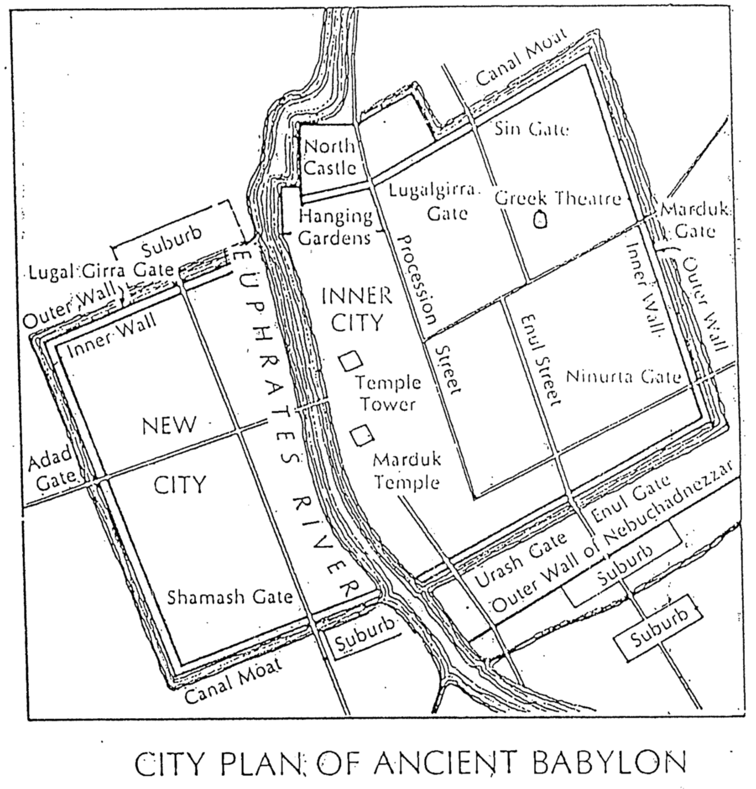

Ezekiel’s Prophecies of Restoration
Adapted from a doctoral research paper by Rev. Michael Shen, Dallas Theological Seminary

Throughout the Book of Ezekiel God promises that he will continue to be faithful to his despairing and rebellious people in exile because of his unconditional covenant to give Israel their land (cf. Gen. 12:1-3; 15:17-21; Deut. 30:1-10). This restoration is depicted in Ezekiel 36–37 more than any other section of the prophecy, but key elements of the restoration appear throughout the book in many other chapters:

Chapter | Land  Restored |  | Cleansing  from Sin |  |  | Spirit  Given | New  Heart | New  Covenant |  | David  Ruling | Permanent  Restoration |  | Whole  House |  |  | Recognition  Formula
11 |  | x |  | x |  |  | x |  |  |  |  |  |  | x
16 |  |  |  | x |  |  |  | x |  |  |  | x |  | x | x
17 |  |  |  |  |  |  |  |  | x |  |  |  |  |  | x
20 |  | x |  | x |  |  |  | x |  |  |  |  |  | x | x
28 |  | x |  |  |  |  |  |  |  |  |  |  |  | x | x
34 |  | x |  |  |  |  |  | x | x |  |  | x |  | x | x
36 |  | x |  | x | x |  | x | x |  |  |  | x |  | x | x
37:1-14 |  | x |  |  | x |  |  |  |  |  |  |  |  | x | x
37:15-28 |  | x |  | x |  |  |  | x | x |  |  | x |  | x | x
39 |  | x |  |  | x |  |  |  |  |  |  |  |  | x | x

The above chart shows that no passage contains all elements of the restoration, but put together all the texts paint a picture of a glorious future. The three aspects that appear consistently are the promise of the land, the promise that the whole house of Israel (both Israel and Judah) will inherit the land, and the recognition formula whereby God promises that the restoration will show that “I am the LORD.” Indeed, even in our generation (1948) we have seen a partial physical (or national) restoration of Israel to the land (37:1-8, 11-13). However, the full (spiritual) restoration of the nation will not occur until Israel trusts in Jesus Christ as Messiah at Christ’s return (37:9-10, 14-28).

Signs in Ezekiel
Irving L. Jensen, Jensen’s Survey of the Old Testament, 366

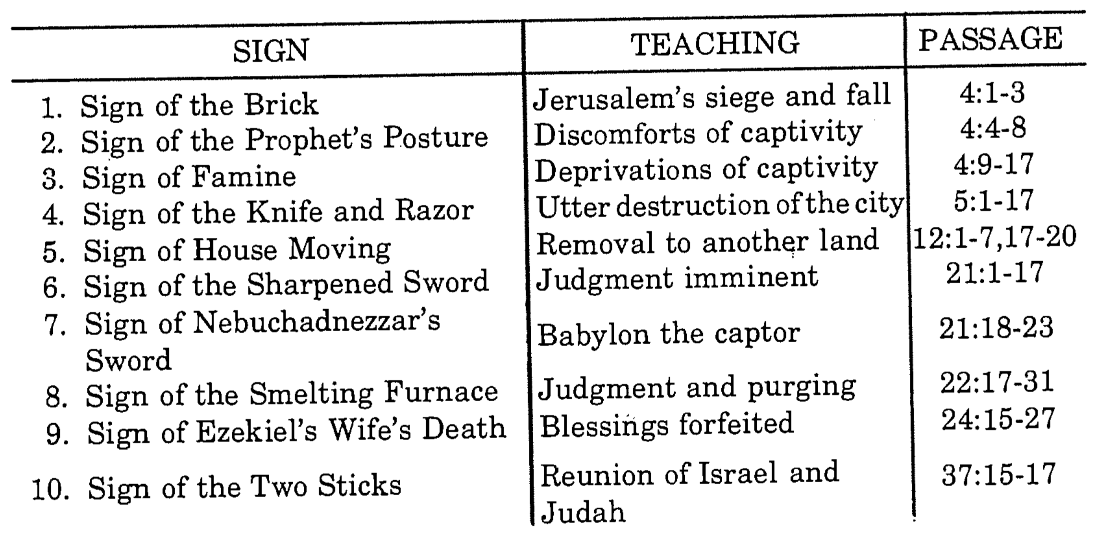

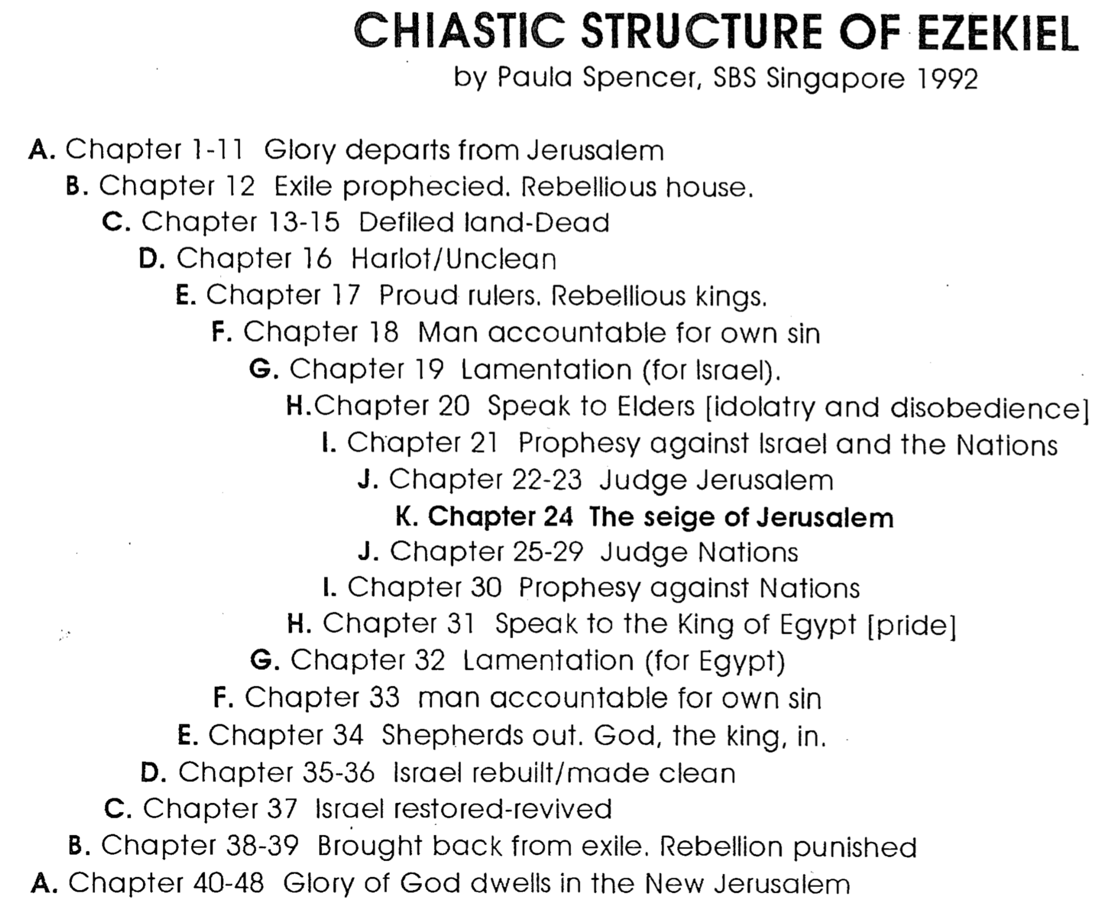

Chiastic Structure of Ezekiel

Restoration of Edenic Ideals
Vincent Richard Lee, OT Theology III Class Presentation (SBC: MDiv3 course, 26 April 2002)

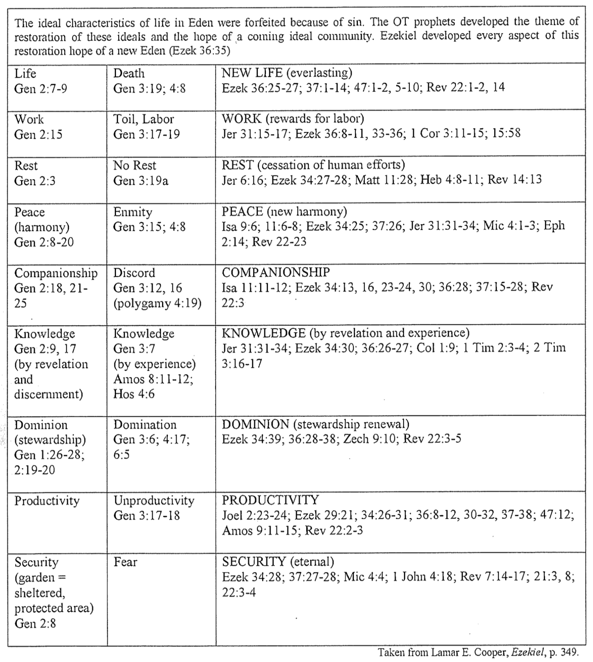

Tyre’s Trading Partners

Ezekiel 27:12-25

Bible Knowledge Commentary, 1:1281

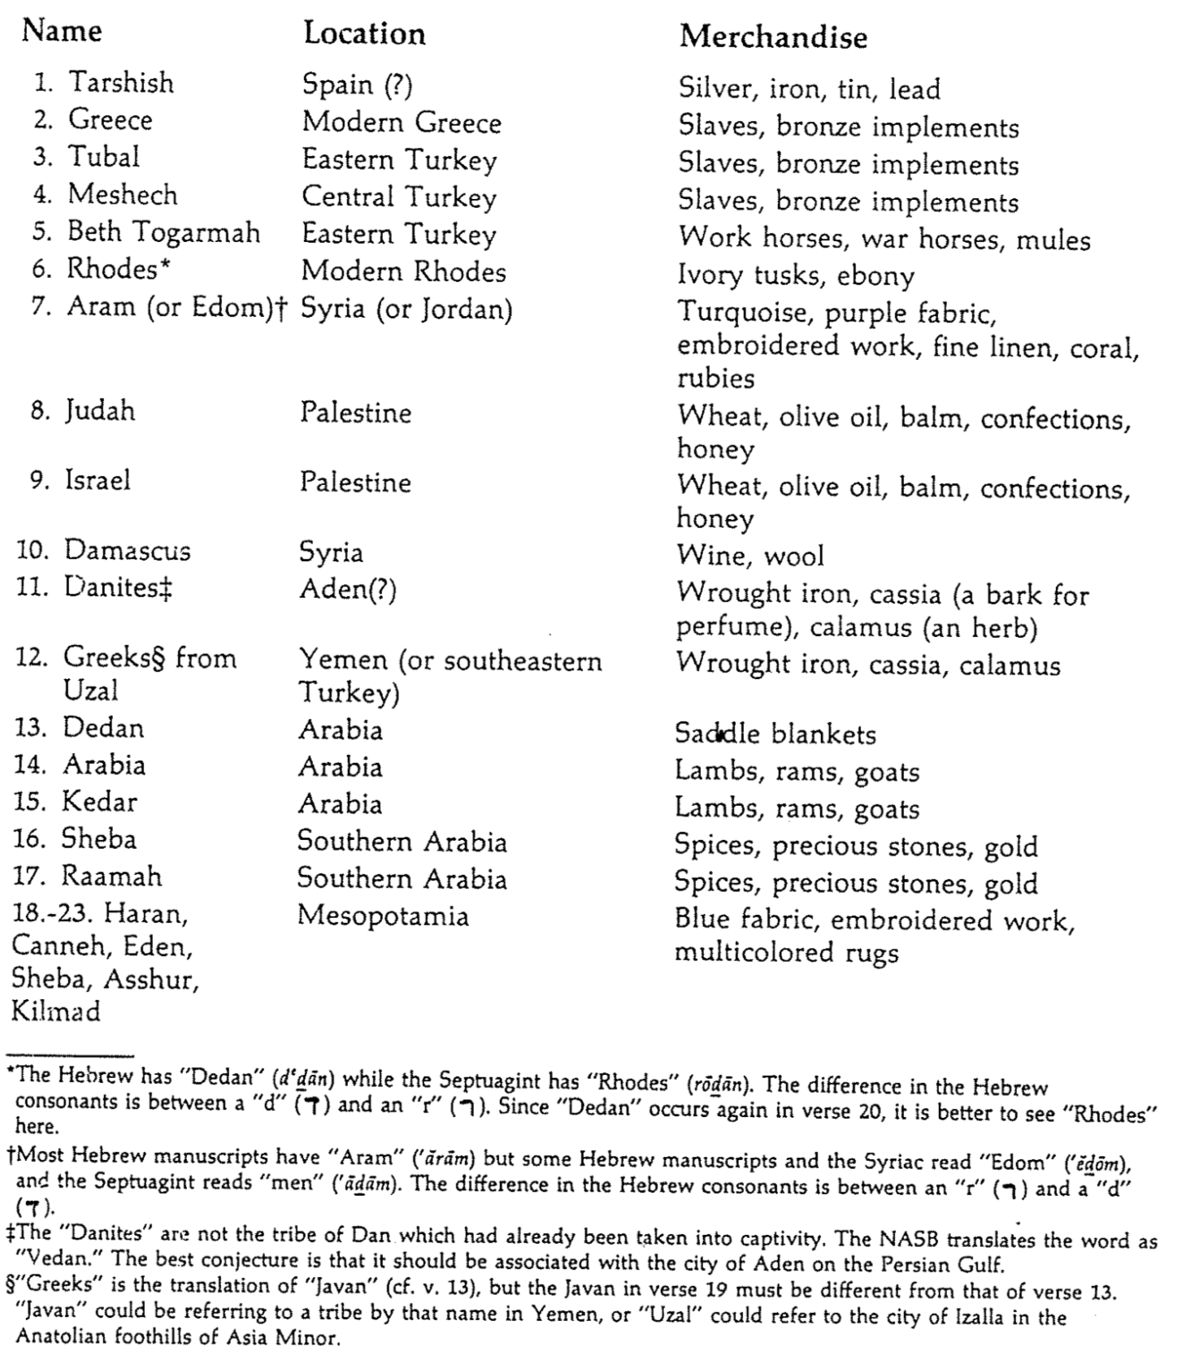

When Will the Invasion of Gog Occur (Ezekiel 38–39)?
Vincent Richard Lee, OT Theology III Class Presentation (SBC: MDiv3 course, 26 April 2002)

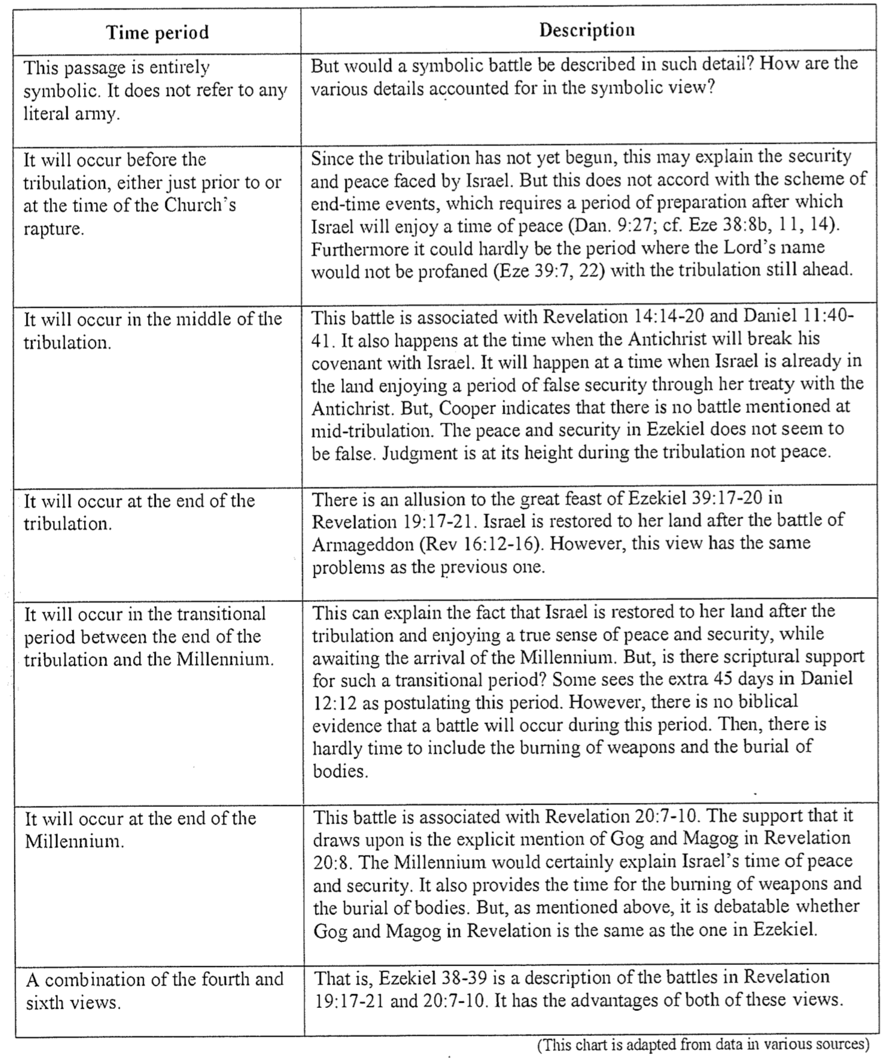

Gog & Magog in Ezekiel and Revelation

Contrasting Ezekiel 38–39 with Revelation 20

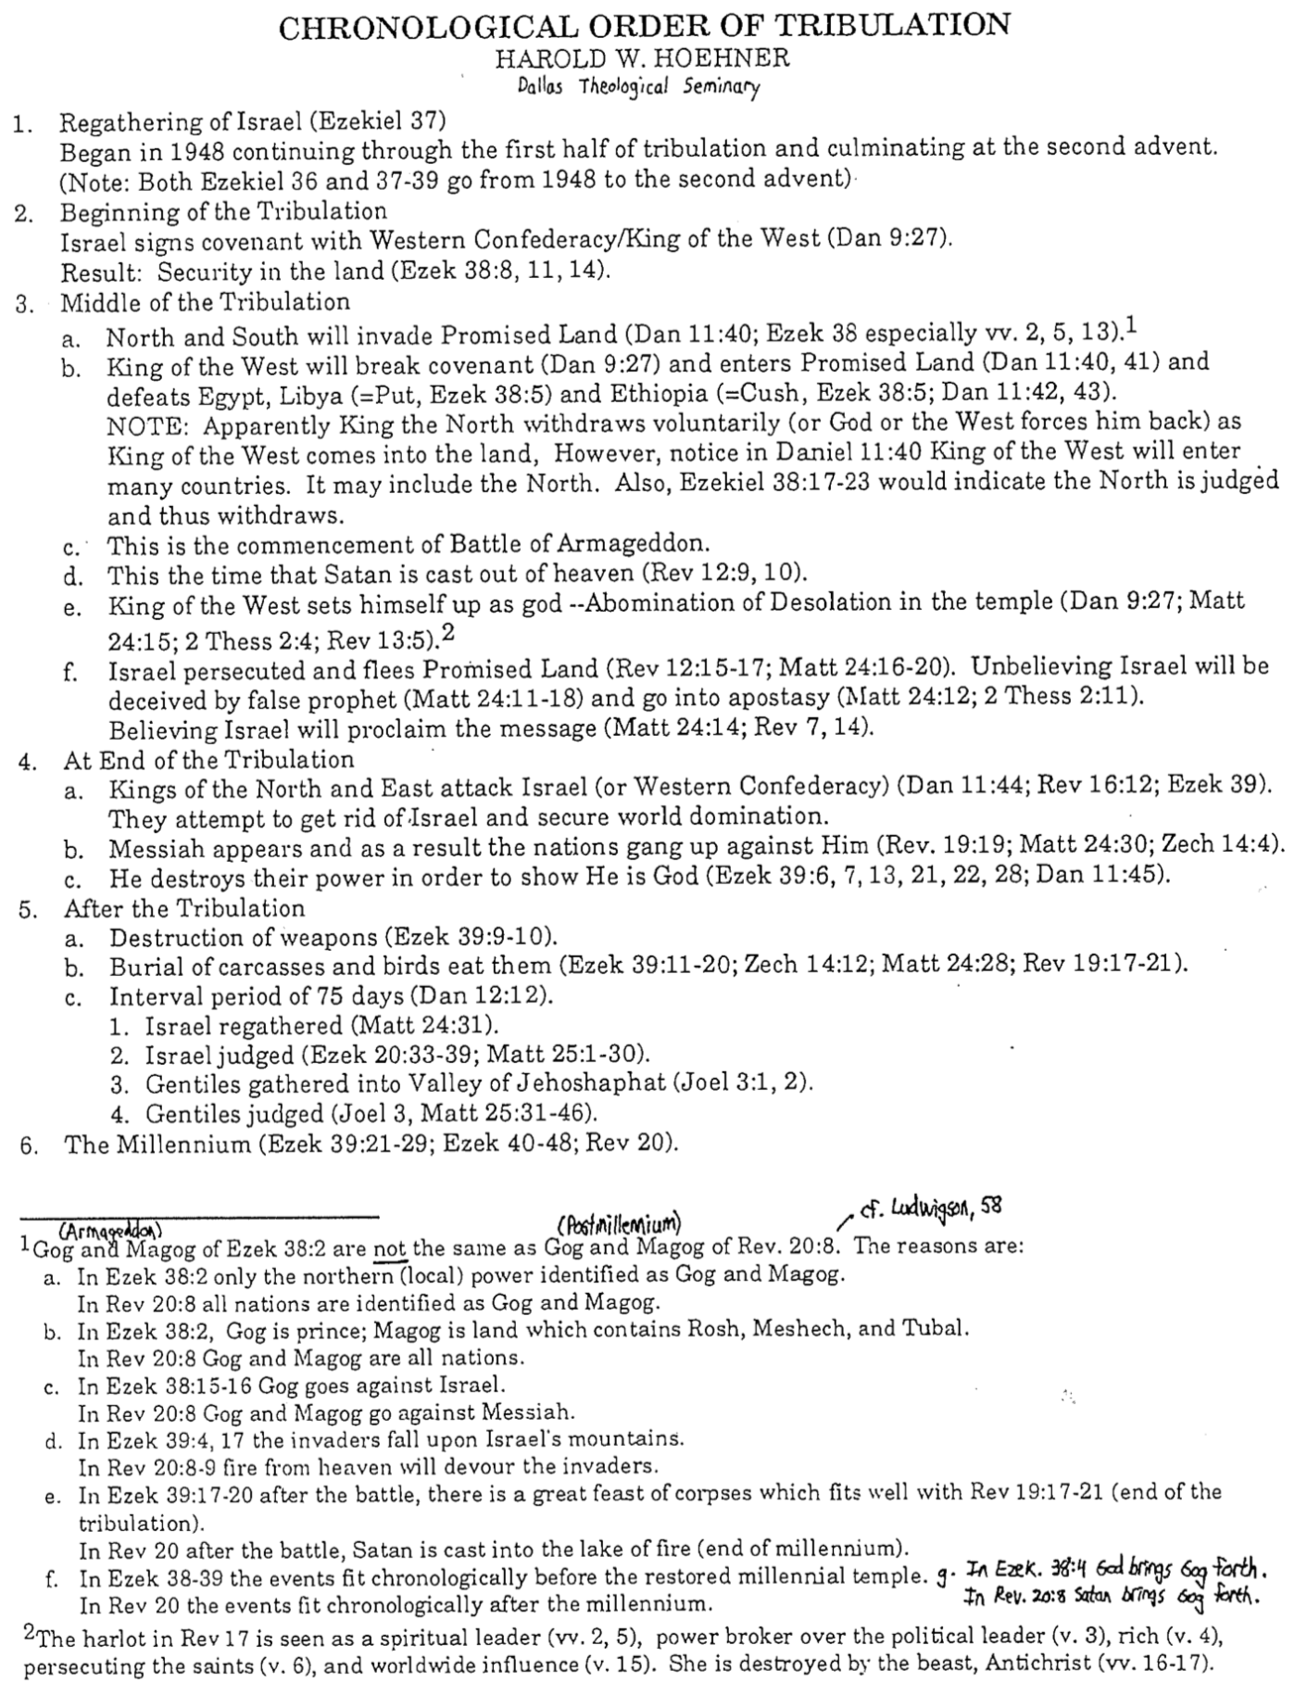

End Time Battles

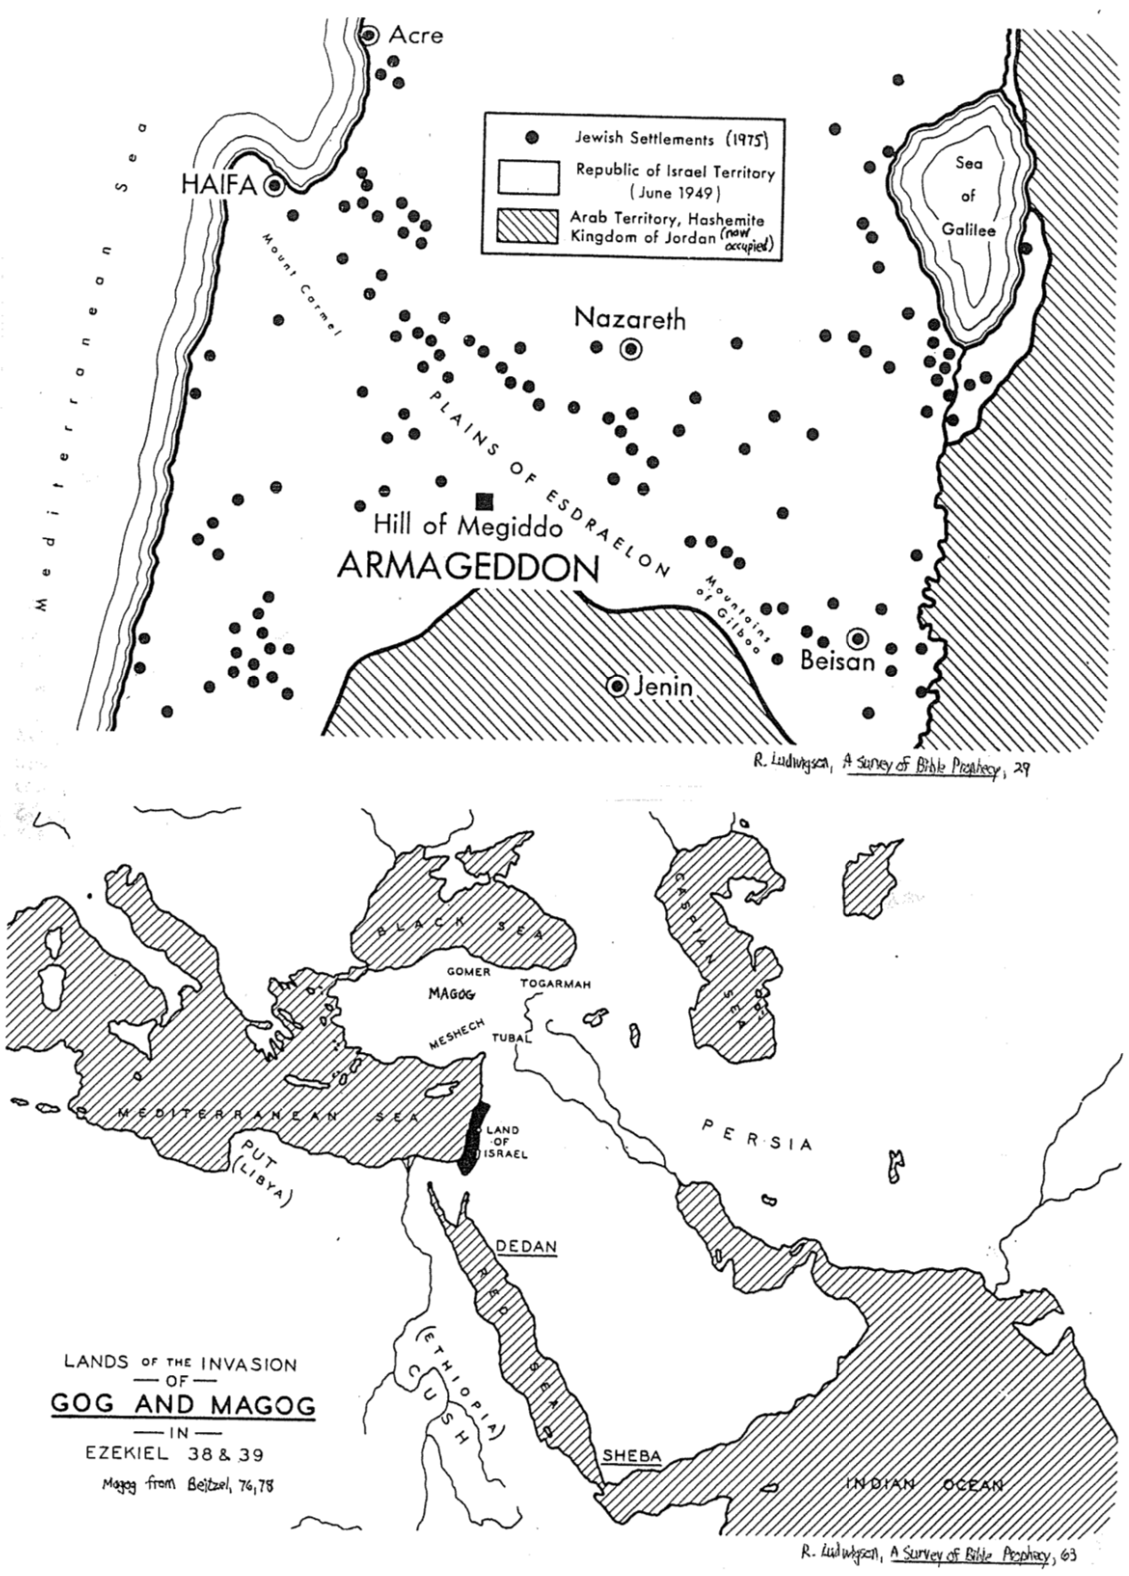

Different Sanctuaries of Israel
Vincent Richard Lee, OT Theology III Class Presentation (SBC: MDiv3 course, 26 April 2002)

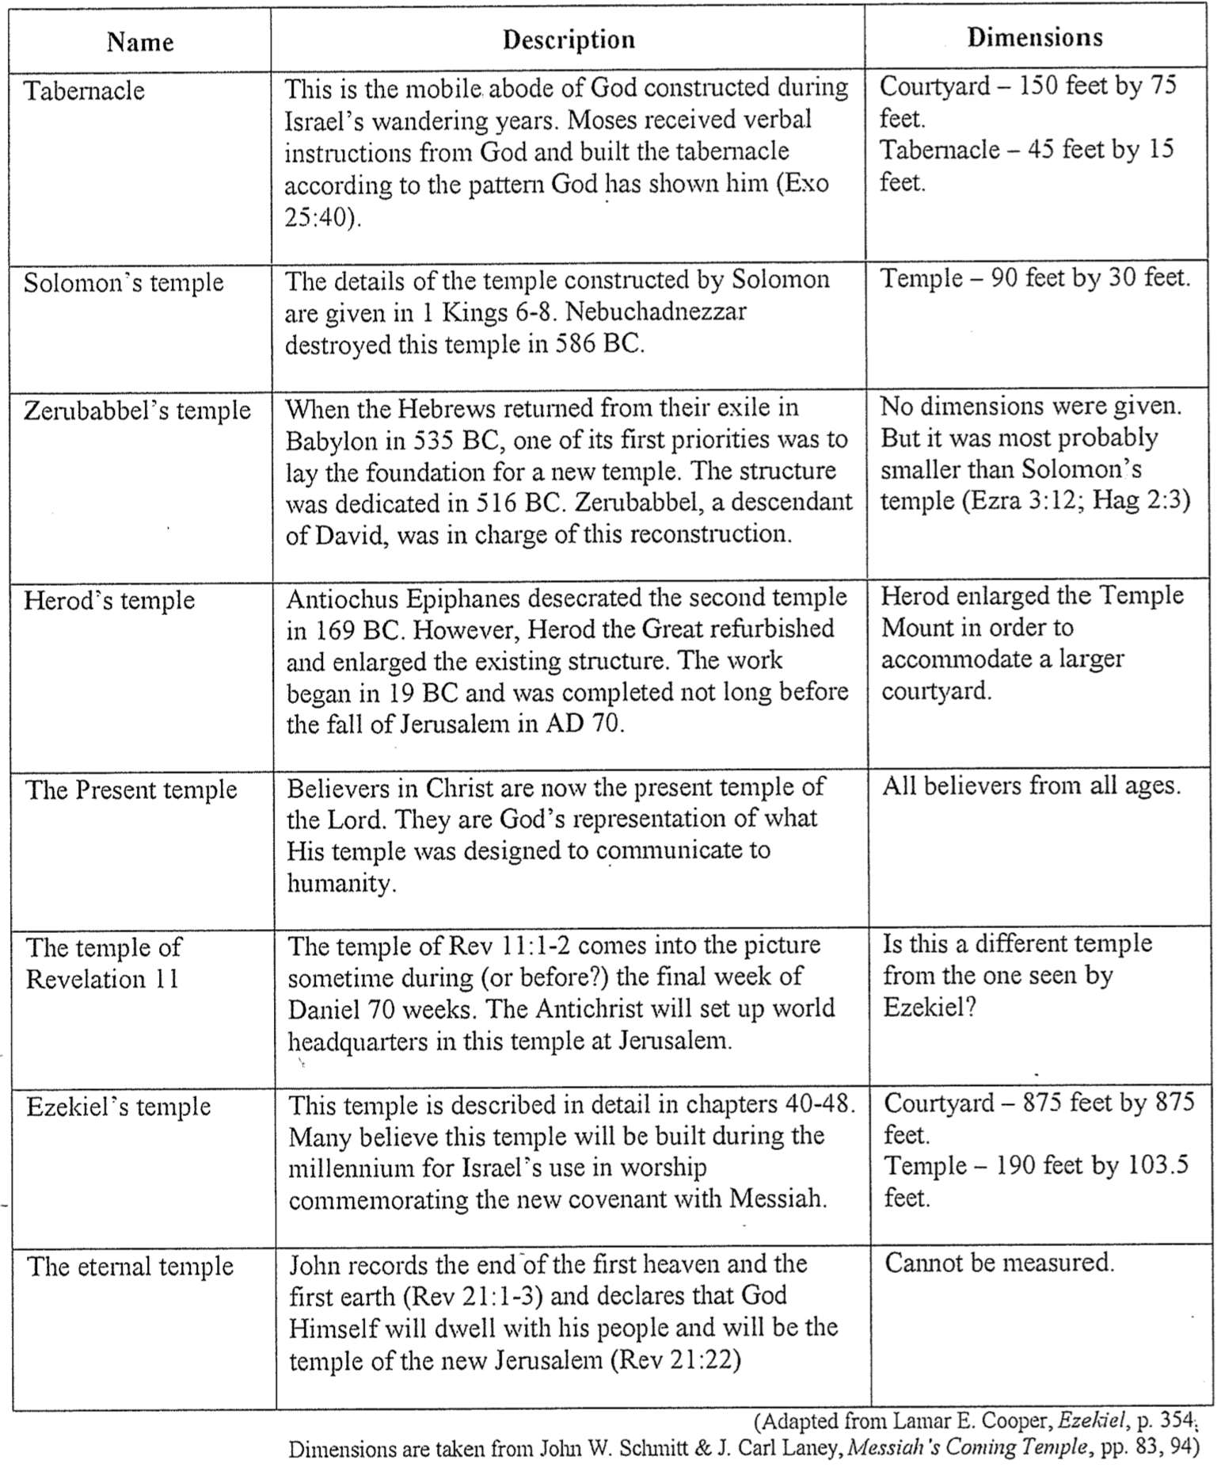

Different Interpretations of Ezekiel 40–48
Vincent Richard Lee, OT Theology III Class Presentation (SBC: MDiv3 course, 26 April 2002)

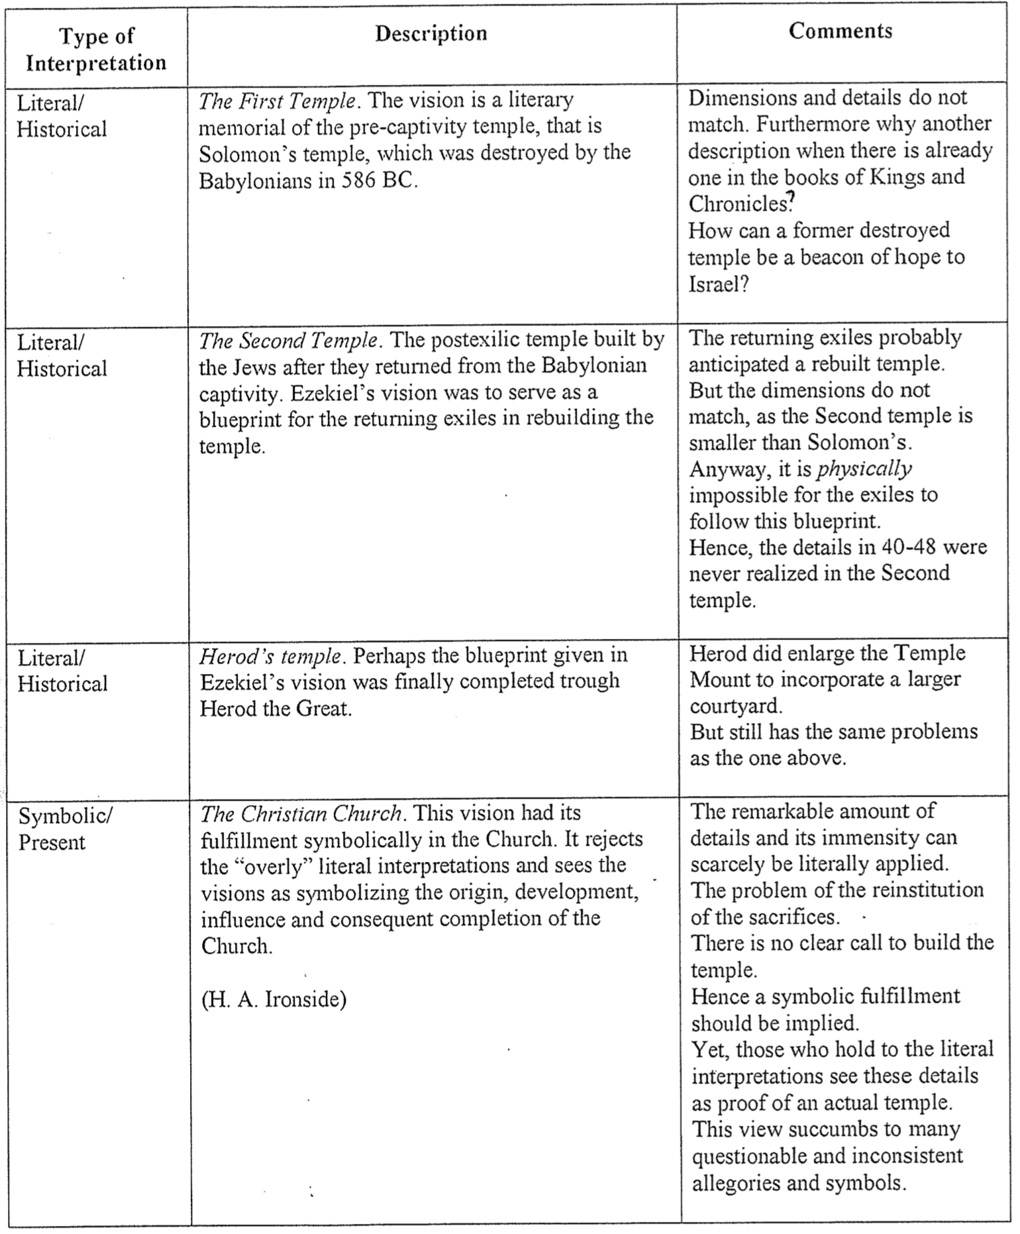

Different Interpretations of Ezekiel 40–48 (2 of 2)
Vincent Richard Lee, OT Theology III Class Presentation (SBC: MDiv3 course, 26 April 2002)

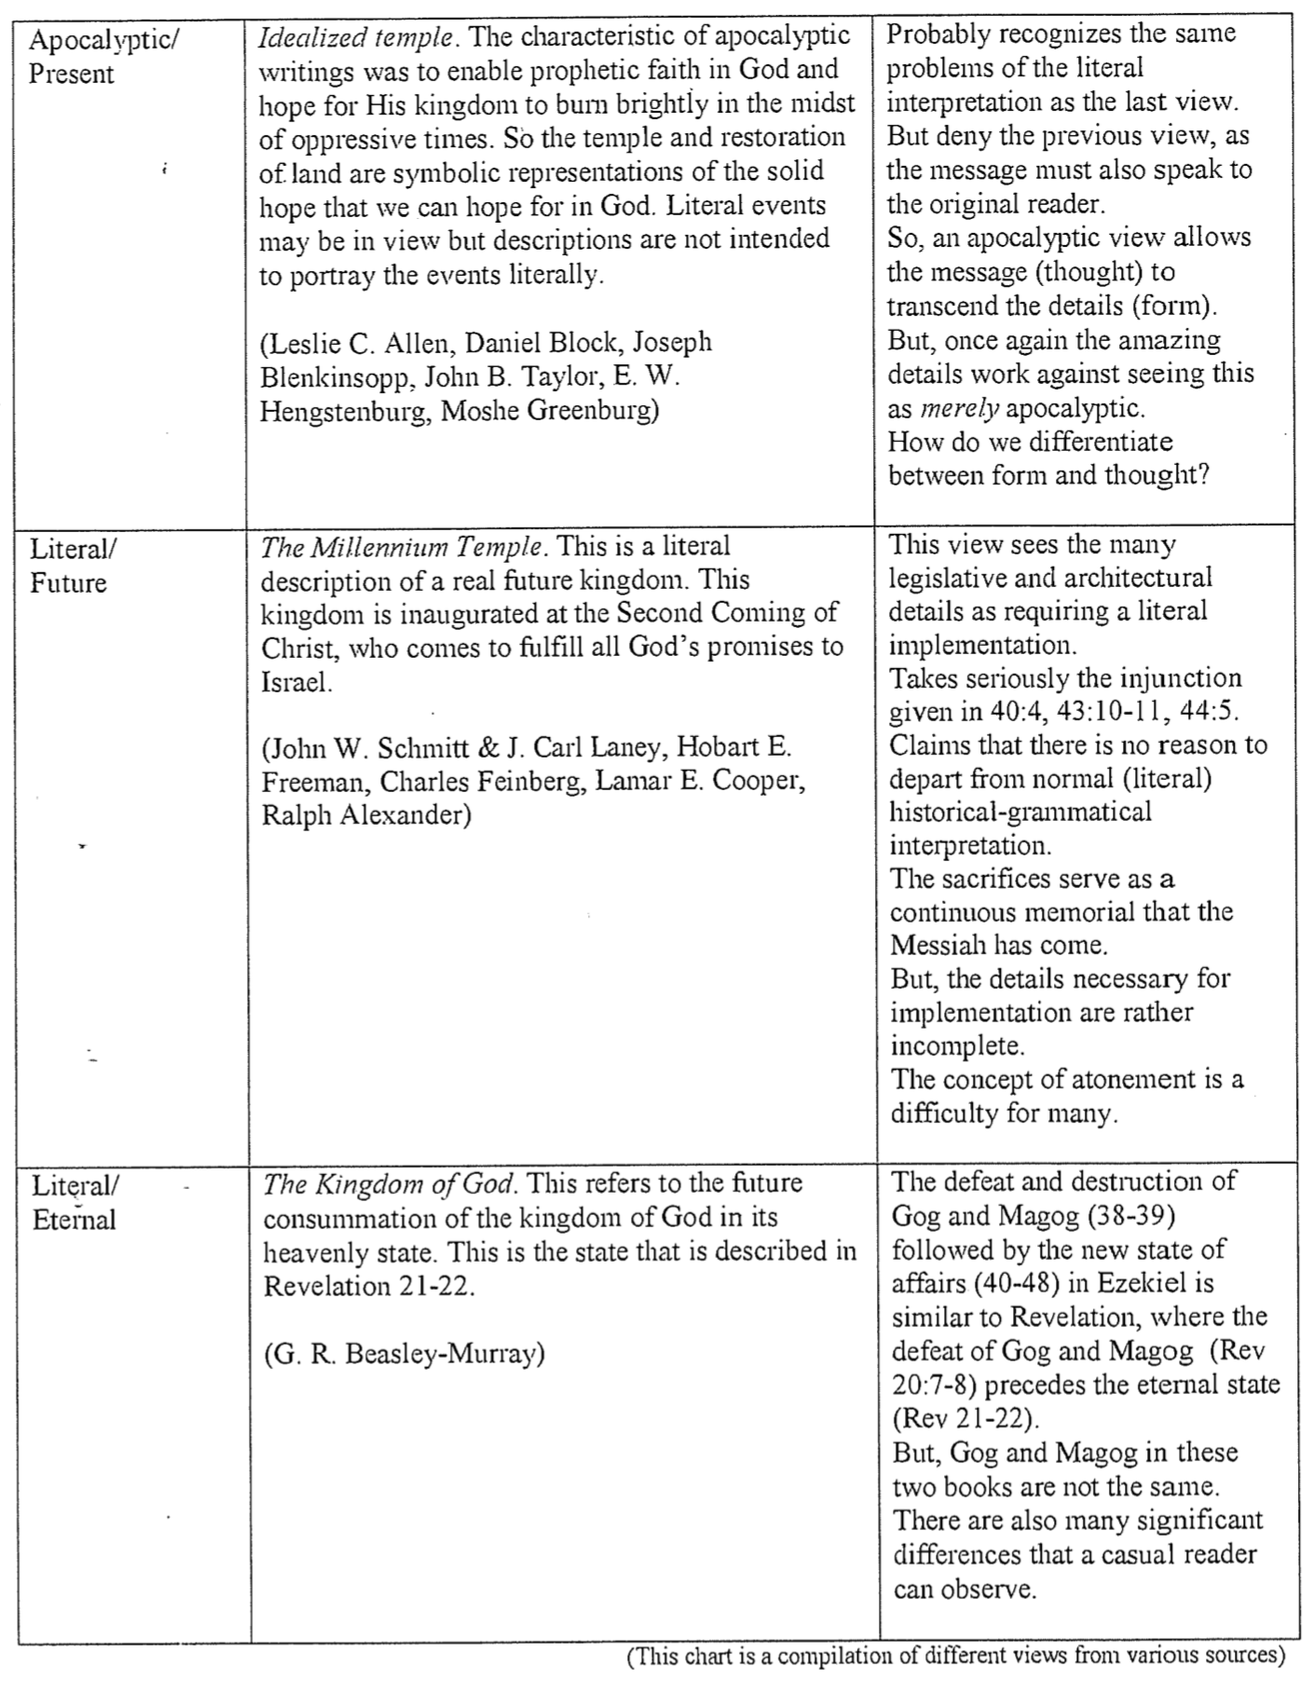

Ezekiel’s Millennial Temple

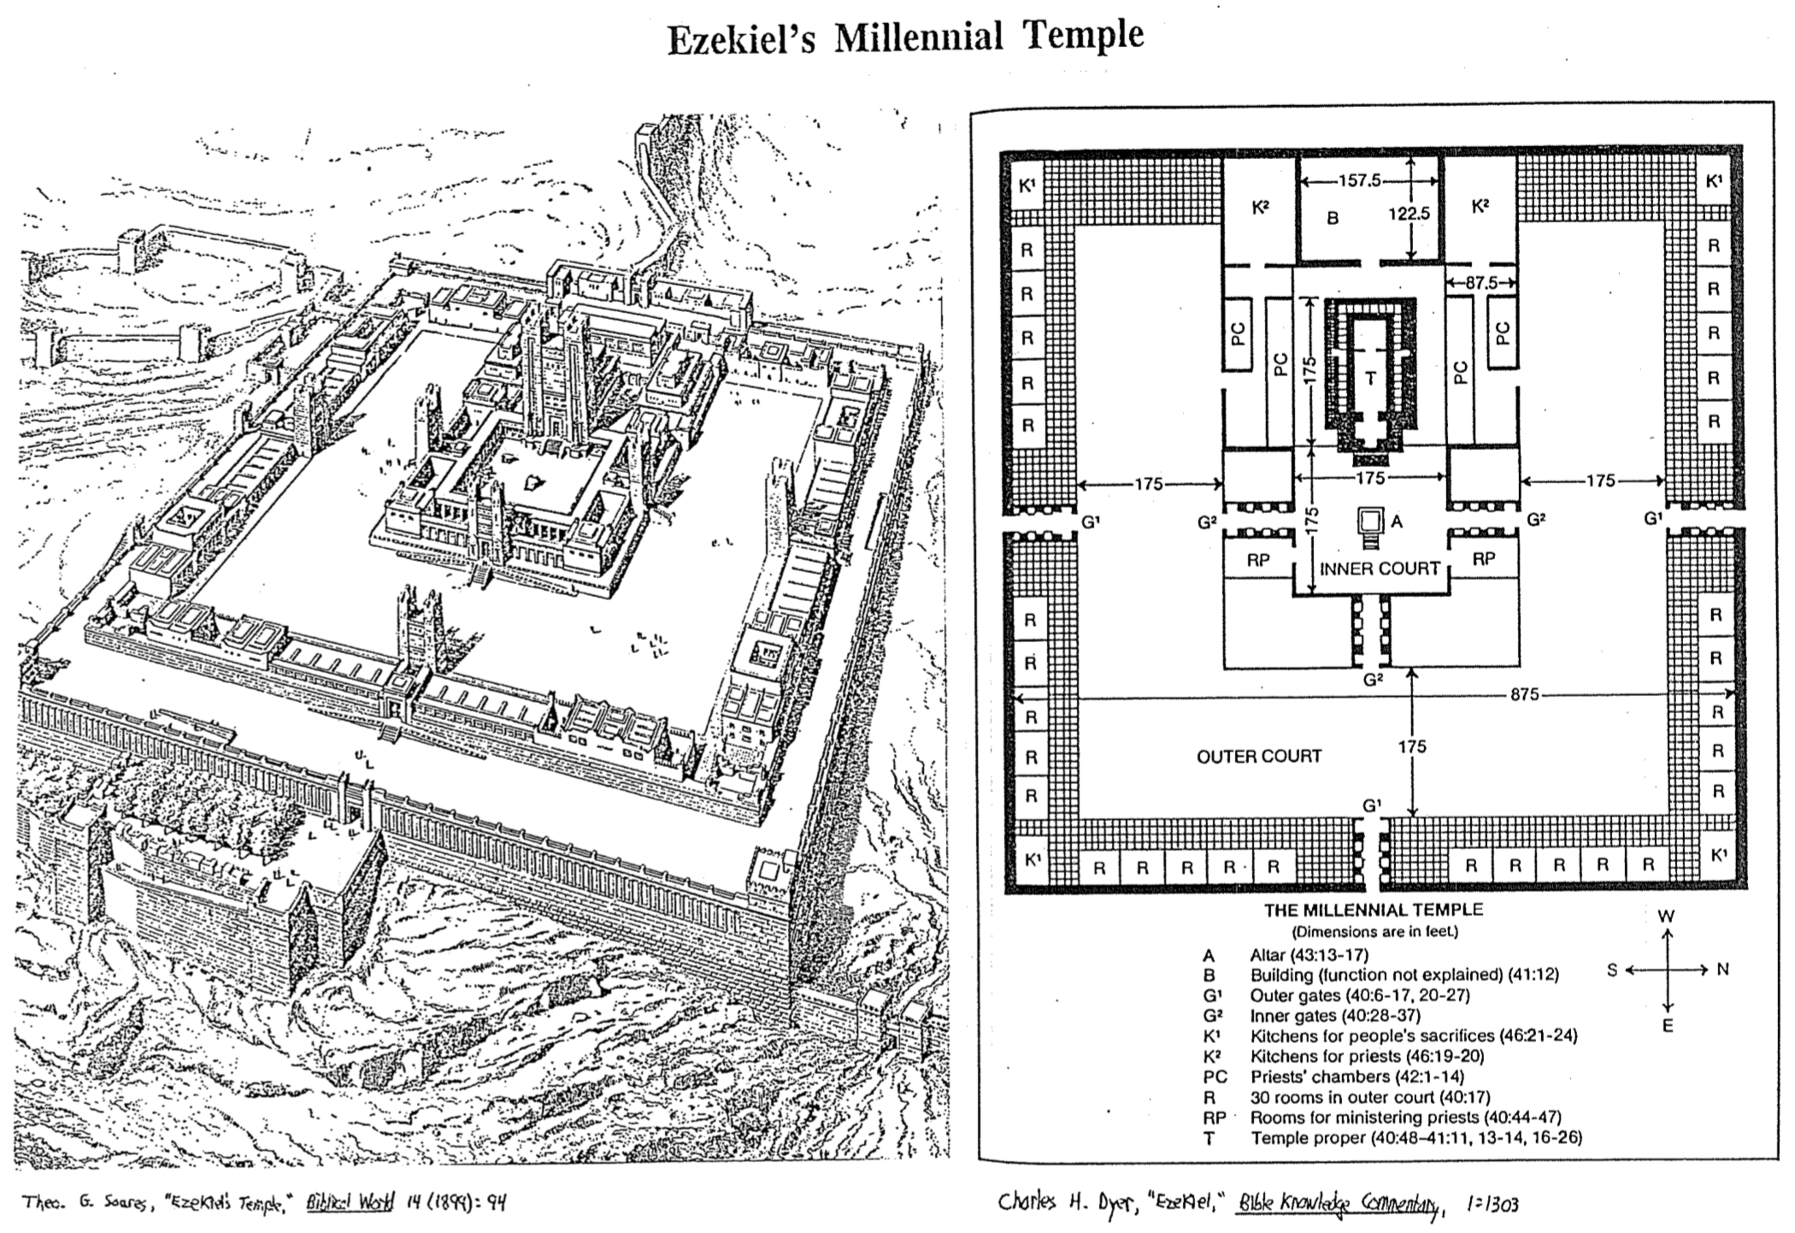

Solomon’s and Ezekiel’s Temples Contrasted

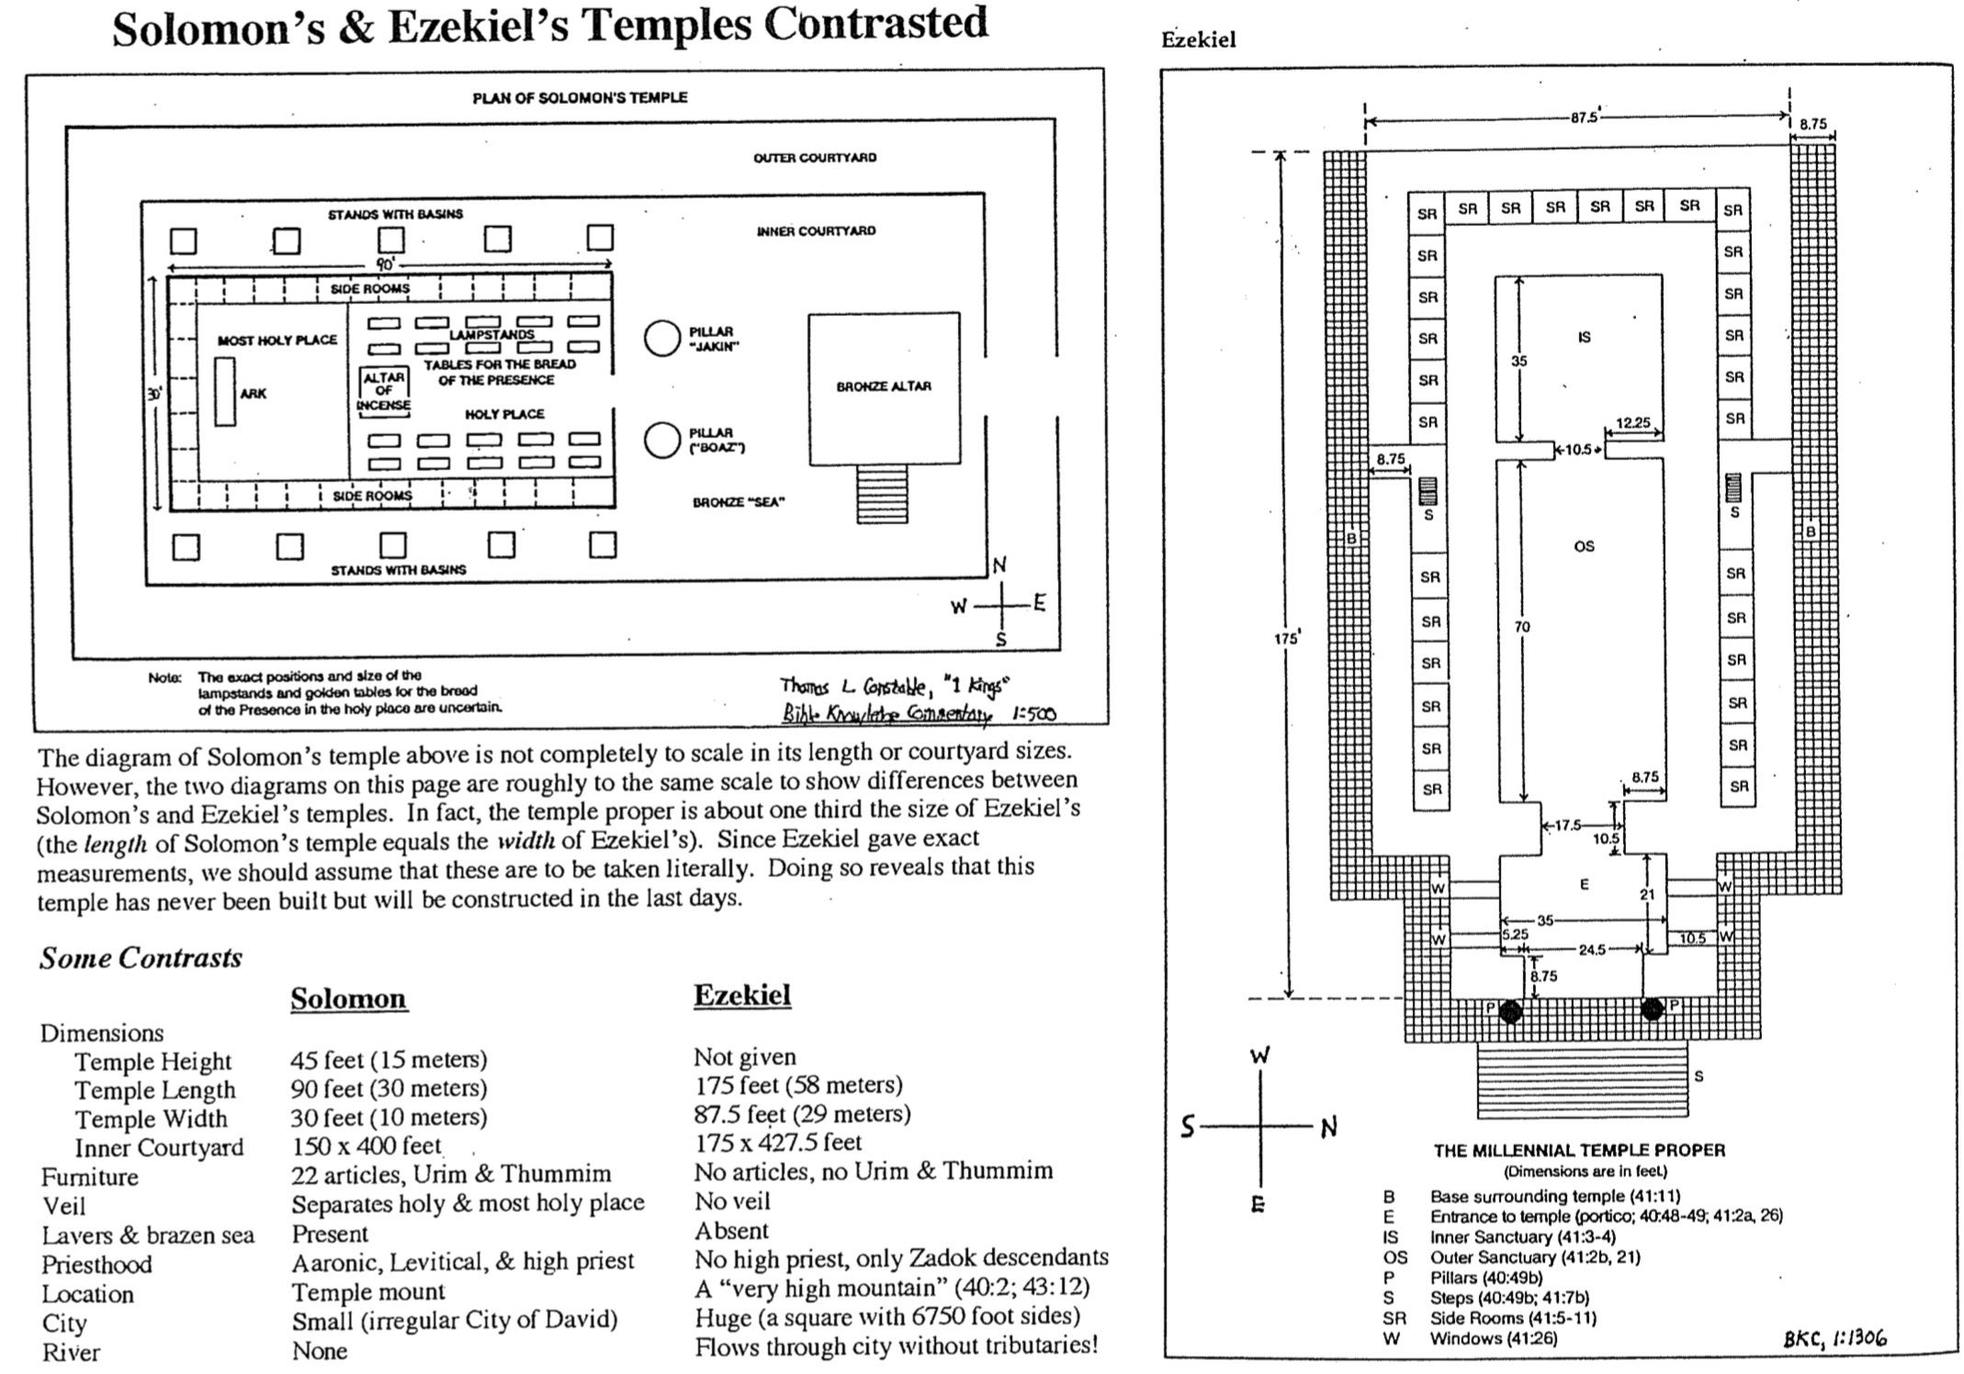

The Millennial Temple Gate and Altar

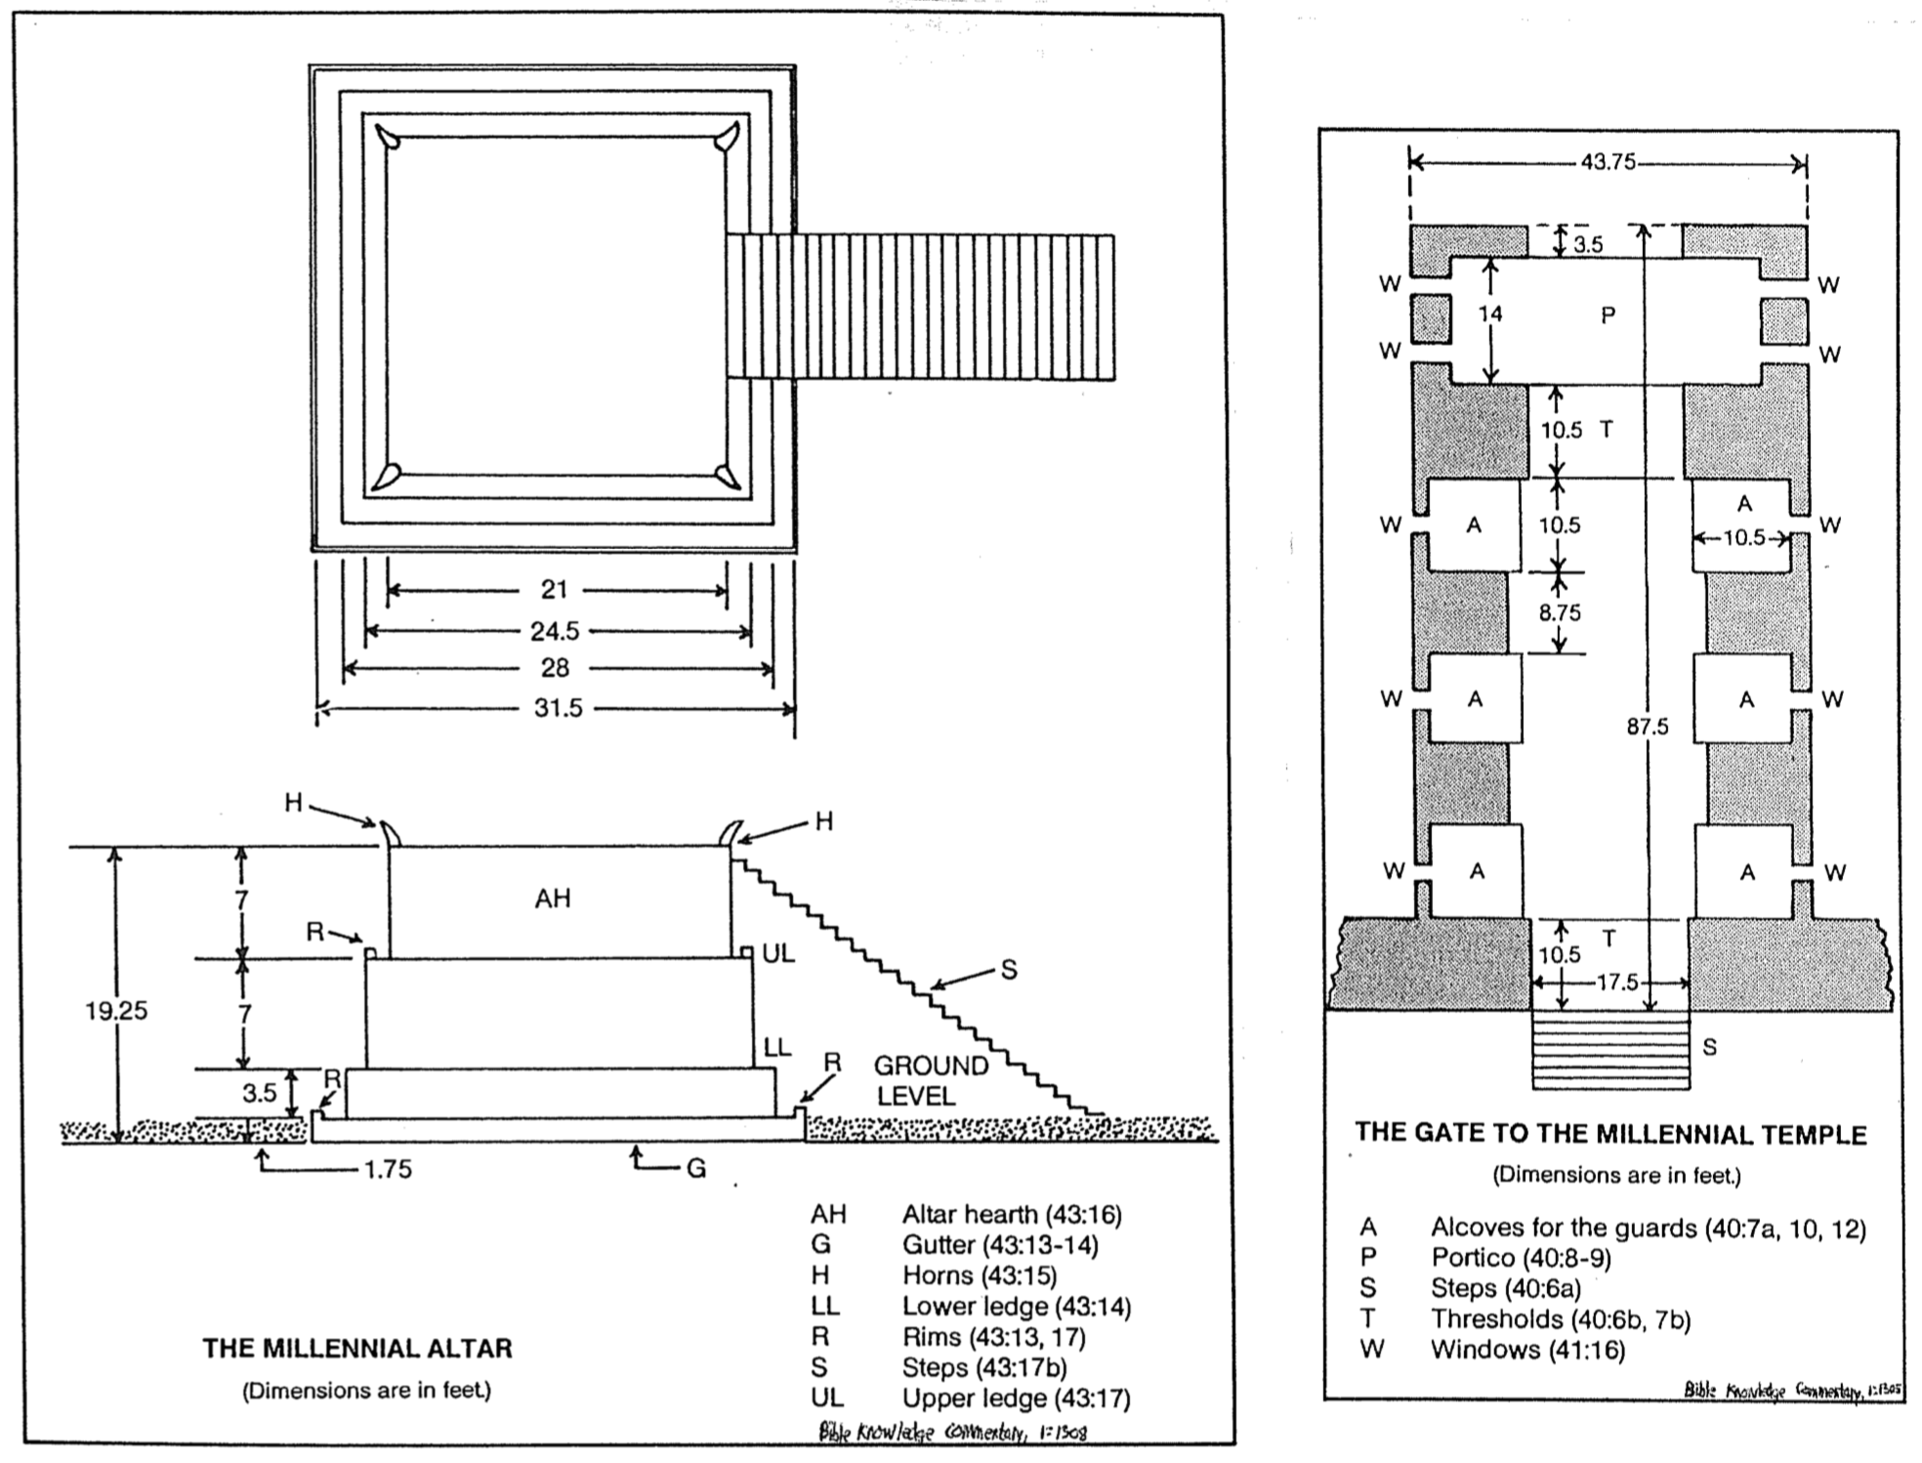

Problems with a Millennial Temple
Adapted from Richard James Griffith, “The Eschatological Significance of the Sabbath,”
ThD dissertation, Dallas Theological Seminary, 1990, pp. 235-66

The particular temple and time period mentioned here [Ezek. 46:1] have long perplexed scholars. A proper understanding must address both the nature of the temple and the time of its institution (along with the Sabbath). This verse falls within the much-debated section of Ezekiel's book (chaps. 40–48) which describes a new temple (chaps. 40–43), a new order of worship (chaps. 44–46), and new boundaries for Israel in the land (chaps. 47–48). Ezekiel wrote his prophecy while in exile in Babylon. The Solomonic temple had been destroyed decades earlier and all hope of a national restoration was lost. Nevertheless, God gave him from an eschatological perspective detailed dimensions of a temple not elsewhere described in Scripture. Included with the temple restoration is also a restoration of the national life, animal sacrifices, and priesthood. These chapters have so puzzled commentators that some deny Ezekiel's authorship and many are ambiguous on the time and nature of the prophecy's fulfillment. However, among those who have proclaimed a position, at least seven different views of these chapters have been proposed.

One suggestion is that this is Solomon's temple, but this view has several flaws. First, the dimensions of these two temples are different. While Solomon's temple was fairly small (90 feet long, 30 feet wide, and 45 feet high), Ezekiel's temple measures much larger (175 feet long and 87.5 feet wide). "The square of the temple in 42:20 is six times as large as the circuit of the wall enclosing the old temple, and, in fact, is larger than the former city itself." Second, if this description depicted the former temple, it must be asked what hope Ezekiel could offer his oppressed brethren by reminding them of the glory of Solomon's temple which at that time lay in ruins. Third, the Books of Kings and Chronicles already provide detailed descriptions of Solomon's temple, so another record would be unnecessary. For these reasons, Ezekiel's temple is not the same as Solomon's.

A second interpretation supposes that the temple in view here is the post-exilic temple built under Zerubbabel. A plan of Zerubbabel's temple is not provided anywhere in Scripture which makes an exact size comparison of the two impossible. However, since the post-exilic temple failed in comparison to the Solomonic (Hag. 2:3), and the Solomonic failed in comparison to Ezekiel's temple, it follows that the temple of Ezekiel is greater than the post-exilic structure. Therefore, Ezekiel's temple is so large that it cannot be one and the same with that built by Zerubbabel. One searches the Books of Ezra, Nehemiah, Haggai, and Zechariah in vain to find even an attempt on the part of the remnant to follow Ezekiel's plan. Another problem with the post-exilic view is that Ezekiel's temple sits upon a very high mountain (40:2) in contrast to the post-exilic temple, which was built in Jerusalem. A third difference between the two temples relates to those whom they benefited. Whereas Zerubbabel's temple was for the two tribes of Judah and Benjamin, this temple serves all twelve tribes (chaps. 47–48) and aliens as well (47:22-23). Fourth, God promised to dwell in this temple perpetually with the nation never defiling his name (43:7), which obviously did not occur with Zerubbabel's temple as it was defiled by Antiochus Epiphanes IV and eventually removed by Rome. Further, never does the prophecy indicate a conditional aspect to its fulfillment. Fifth, the dimensions of the mysterious sanctuary area (750 feet by 750 feet) exceed those of the temple mount (525 feet by 660 feet). Finally, the filling of the temple by the Spirit also mitigates against this Zerubbabel view. This return of the glory of God is prophesied in Ezekiel 43:1-5 but never is the filling mentioned in conjunction with the dedication of the post-exilic temple under Zerubbabel (Ezra 6:13-18). It is inconceivable that Ezra could neglect to record such a happening if it had occurred.

A third temple view is actually a modified version of the preceding perspective. This view perceives the temple as an ideal one (especially apocalyptic in nature), some scholars believing it was planned for the post-exilic community but never built. The Seventh-day Adventist Bible Commentary expresses it thus: "According to [this view] the temple vision would have been literally fulfilled if the people had been faithful to their trust, but because they failed, the prophecy could not be fulfilled in its original intent." The main objection to this view is whether God would provide such a detailed prophetic description if it was never to be fulfilled. Surely, He would not invest a full nine chapters of Ezekiel's prophecy in vain. Again, God's promise to dwell in this temple perpetually (43:7) indicates that an actual, not ideal, temple must be in view.

A fourth historic temple which could possibly be in view is that built by Herod and completed just prior to Jerusalem's fall in AD 70. However, this view has the same problems as the two above, namely, the dimensions do not match. Further, the sacrificial procedure of Ezekiel 43–46 was not followed during the Herodian era.

All four preceding views (Solomonic, post-exilic, ideal, Herodian) lack the necessary characteristics of the mysterious temple and do not match the worship procedure of chapters 43–46. Recognizing such, a fifth perspective has been proposed, favored especially by amillenarians. This view considers Ezekiel 40–48 as a symbolic description of the church rather than a literal temple. Greenhill represents such a view, for he soundly refutes the notion that Ezekiel's and Zerubbabel's temples are the same by comparing the locations and measurements of the temples; however, he then surprisingly states, "The vision, therefore, points out the introduction of a better hope, viz. the church of Christ under the gospel." If this is true, one must wonder how all the specific designations here can be matched with the blessings of the church in the present age. Such a view must spiritualize descriptions which appear to be very physical and literal. The chapters include measurements, topographical descriptions, etc.; therefore, it is not surprising that those who deny the normal sense of these terms also do not believe in a literal kingdom. Finally, Gray notes that those who hold to this symbolic church perspective differ widely in their explanations and thus cannot explain the symbolism of which they speak. This inconsistency and subjectivity is shown in the fact that adherents of this view "interpret Ezekiel's earlier, now-fulfilled prophecies literally, yet interpret his yet unfulfilled prophecies symbolically." There is no reason to abandon the normal grammatical-historical hermeneutic when approaching Ezekiel's prophecy.

A sixth view interprets the passage literally but sees the eternal state in view. Allis champions this perspective which distinguishes between the kingdom and the Millennium, seeing the "Millennium" as a limited period (the church age) which precedes an endless "kingdom" (the eternal state). He asserts that the passages studied thus far in Isaiah and Ezekiel both apply to this latter period. This view which sees eternity in Ezekiel's prophecy cannot be accepted because of the existence of the temple itself, which is not part of the new heavens and new earth (cf. Rev. 21:22). Other dissimilarities between the temple of this prophecy and the eternal state are evident:
The city's [sic: cities'] dimensions are different (Ezek. 48:30-35; Rev. 21:15-17). The waters that flow toward the east have different sources: the temple in Ezekiel (43:7; 47:1-5) and God's throne in the Revelation (22:1, 3) . . . . The tribal allotments of Ezekiel include the sea as the western boundary (47:15-20), whereas in the Revelation John declares that the sea no longer exists (Rev. 21:1).

All of the above views fail to consider the unique character of these chapters. In contrast, Jewish and premillennial scholarship recognizes that the most natural reading of this section indicates that it refers to a literal, future temple in the kingdom period. Allis considers the problems associated with the millennial view to be so insurmountable that he calls Ezekiel 40–48 "the Achilles' heel of the Dispensational system of interpretation." Nevertheless, several lines of evidence suggest this to be the best view.

The first merit of the millennial view is that it fits the argument of Ezekiel's prophecy. The book follows a threefold design: the impending judgment upon Judah by Babylon (chaps. 1–24), followed by the judgment upon the nations (chaps. 25–32), and concluding with God's unconditional restoration of the nation (chaps. 33–48). This last section first promises Israel a new life through restoration to the land and national cleansing (chaps. 33–39). This restoration of Israel includes God's defeat of Gog and her allies (chaps. 38–39), which premillennialists place during the seven-year Tribulation Period preceding the Millennium. This premillennial chronology follows Ezekiel's precisely, as he details events in the Tribulation first (chaps. 38–39), followed by the millennial order (chaps. 40–48). It would be strange and misleading for Ezekiel to depict Israel's restoration as a people possessing His Spirit in 39:29 (the verse preceding chapters 40–48), then to suddenly revert back to some historical period in the remaining nine chapters. These chapters, the climax of the prophecy, aptly describe Israel's climax as a nation in her final restoration.

The millennial interpretation is also favorable because it does not abandon the normal grammatical-historical hermeneutic. None of the measurements of the temple need be spiritualized or reconciled with previous temples whose descriptions do not match. The canonical text can stand on its own when one interprets these nine chapters as depicting a future kingdom period.

A related support for the millennial age is Ezekiel's description of the topography differences characteristic of the kingdom age. Such changes are prophesied about elsewhere in the prophets. For example, Zechariah prophesied that at the return of Messiah the Mount of Olives will undergo a radical change:
Then the LORD will go out and fight against those nations, as he fights in the day of battle. On that day his feet will stand on the Mount of Olives, east of Jerusalem, and the Mount of Olives will be split in two from east to west, forming a great valley, with half of the mountain moving north and half moving south (Zech. 14:3-4).

It is obvious that Zechariah's prophecy has not yet been fulfilled. "According to this prophecy God is to rearrange the land so that the millennial temple will fit into it." Ezekiel verifies this as the temple area alone encompasses a three by eight mile area (45:3). Such a catastrophic realignment in geography is necessary not only for the enormous temple and the "very high mountain" upon which it sits (40:2; 43:12), but also for the new city. The new boundaries of this city will comprise a square with each side measuring 6,750 feet, which is much larger than the Jerusalem of Ezekiel's day. This city also has a river without tributaries flowing from the temple to the east with trees bearing fruit monthly for healing (45:1f., 12)—obviously a depiction which has yet to occur in the land. Further, while the size of Israel as a whole will not change, the inheritances for each tribe will be equal (47:14) and include portions for the priests and Levites (45:1-5), which never was the case under Joshua (Josh. 13–19). All of these topographical changes point to a time period which has not yet occurred.

Furthermore, the exilic prophet Ezekiel is not the only prophet who mentions a millennial temple. Other citations are provided by the pre-exilic prophets Isaiah (2:3; 60:13) and Joel (3:18), as well as the post-exilic prophet Haggai (2:7, 9). Although not an inspired source, 1 Enoch 90:26b-29 also indicates that the "ancient house" would be replaced with a new temple at the end of the age. Many other rabbinic references convey the same idea of a restored earthly temple. Such references show that the idea of a temple in Israel's kingdom age was not unique to Ezekiel but stretched throughout the pre-exilic, exilic, and post-exilic periods even up to New Testament times.

Finally, the absence of many features associated with the Law of Moses is consistent with a temple which is chronologically subsequent to Israel's other temples. The account lacks a high priest and only Levitical priests descending from Zadok serve in the temple. Also missing are the Urim and Thummim, anointing of the temple, ark with its mercy seat and tablets of commandments, lampstands, a distinction between the holy place and most holy place (i.e., no veil), and the lavers or brazen sea. Feasts which are not celebrated include Firstfruits, Pentecost (Weeks), Trumpets, and the Day of Atonement. While these omissions do not prove Ezekiel's is a millennial temple, the lack of many features of the Mosaic dispensation hints that an age other than under the Mosaic law is in view.

The most commonly voiced objection to the millennial interpretation of Ezekiel 40–48 concerns the reinstitution of the sacrifices (40:38-43; 43:13-27), especially the sin offerings (40:39; 43:19, 21-22, 25). The claim is that such animal sacrifices would constitute a retrogression or return to weak and beggarly elements. However, such is not the case. The Millennium, rather than being a retrogression, will be an advancement as it will complete the many prophetic promises which God made to Israel (Ezek. 37:15-28). This era will see the culmination of the many promises in all of Israel's covenants: Abrahamic (37:26; cf. Gen. 12:1-3), Land (37:21-22; cf. Deut. 30:1-10), Davidic (37:24-25; cf. 2 Sam. 7:14-16), and New Covenants (37:15-21; cf. Jer. 31:31-34). Moreover, even the Mosaic Covenant will be fulfilled at Israel's restoration, shown in Ezekiel's repetition of the covenant formula "I will be their God, and they will be my people" (37:27).

One must not take the prophecy of Ezekiel in isolation, for millennial sacrifices are affirmed elsewhere in the prophetic writings. Isaiah notes that God will accept burnt offerings from both Israelites (Isa. 60:7; 66:20) and foreigners who bind themselves to the LORD (Isa. 56:6-7). Zechariah's last statement in his prophecy affirms the presence of millennial sacrifices in the temple (Zech. 14:21). While Ezekiel's description provides the fullest explanation of these sacrifices, other prophets besides Ezekiel obviously had no problem with their reinstitution at the national restoration after Messiah's coming.

Another objection, on the basis of the Book of Hebrews, is that the blood of bulls and goats can never take away sin and that Christ's one sacrifice is sufficient (Heb. 10:4, 14). This is not a concern in relation to millennial sacrifices for several reasons.

First, the context in Hebrews relates to the believer's possible return to the Jewish sacrificial system during the age of grace. Sacrifices in this present age in which the church is prominent should not be confused with sacrifices in the future Millennium when Israel is restored as nation. The writer of Hebrews deals not with atonement in a future age but only with atonement in the present dispensation.

Second, the point of Hebrews is that animal sacrifices never took away human sin anyway. The offerings under the Mosaic system were designed for a people who had already entered into a relationship with God under the Abrahamic Covenant. Specifically, the sin and guilt offerings under the law functioned to restore one's fellowship with God, not to establish one's relationship with Him in a way analogous to confession of sin in the present age (e.g., 1 John 1:9). Old Testament Israelites were saved by grace through faith just as believers in the present age (Rom. 4:3, 9). The point of the Hebrews passage is that Old Testament sacrifices were inadequate in that that they could not provide permanent cleansing and found their efficacy only in the Ultimate Sacrifice to which they pointed. However, while some do not view Old Testament sacrifices as efficacious, this view is difficult to reconcile with the indications in the Old Testament that the worshipper actually was forgiven when he offered his sacrifice according to the law (Lev. 1:4; 4:26-31; 16:20-22). Nevertheless, under the Mosaic dispensation all Israelites functioned under the theocracy even if they were not related to God spiritually. This will be the case even to a greater degree in the Millennium when Christ rules the theocracy. For this reason, it is best to see the millennial sacrifices as restoring Israelites to the covenant community in the theocratic state.

A third reply may be made as to how millennial sacrifices do not stand in contradiction with the atonement of Christ. New Testament saints freely took part in temple worship (Acts 2:46; 3:1; 5:42) without seeing a contradiction with faith in Christ, and Paul even offered a sacrifice in good conscience (Acts 21:26), perhaps because he viewed it as memorial to the death of Christ. As Mosaic sacrifices prior to the cross looked to Christ's finished work of redemption, so millennial sacrifices after the cross could possibly look back upon this completed work. Further, as the Lord's Supper commemorates Christ's death in the present, so millennial sacrifices may accomplish this same memorial function in the future. As such these sacrifices would replace the Lord's Supper as vivid object lessons of Christ's supreme sacrifice on Calvary. Admittedly, nothing in the passage indicates that Ezekiel saw these sacrifices as memorial and this view alone does not explain the expiatory nature of the sacrifices, so it does not marshal as much evidence as does the theocratic view; however, the memorial and theocratic perspectives are not mutually exclusive.

Therefore, one need not be perplexed about the existence of millennial sacrifices when viewed in light of their proper purpose. They form a part of the height of Israel's history as a nation (not a return to "beggarly elements"), they are taught by other prophets, they are inappropriate in the present age but not in the future, and they serve both theocratic and commemorative functions as they look back to the finished work of Christ at Calvary.

The preceding discussion on Ezekiel 40–48 has been quite involved. However, it has been necessary to provide the proper millennial context which is vital to understanding the nature of the Sabbath mentioned in Ezekiel 46:1. The evidence indicates that the Sabbath will indeed be reinstituted during this time. Alexander elaborates on the legitimacy of this millennial Sabbath observance:
The Sabbath and the observance of the new moon would [will] be part of the worship ritual during the Millennium. It may seem incongruous that the Sabbath, the sign of the Mosaic covenant (cf. Exod. 31:13, 16-17), would be observed in the millennial kingdom when it is not observed in the church age under the new covenant. Is this a retrogression in God's purposes? Not if it is understood that all God's covenants would be fulfilled and operating in the messianic kingdom (cf. 37:15-28) . . . . The Mosaic covenant showed Israel how to live a holy life in a relationship with God, and that type of life is still valid under the new covenant (cf. Jer. 31:33-34; Rom. 8:4). Therefore, for the Mosaic covenant and the new covenant to be fulfilled side by side is not incongruous . . . .

This reinstitution of the Sabbath along with the sacrifices may seem problematic to some Bible interpreters. However, one should not be troubled about the reinstitution of the Sabbath during the Millennium if the predominantly Jewish nature of this period is remembered. As the Sabbath was the sign of the Mosaic covenant, so it will be elevated again to prominence when Israel is restored to the Lord in the millennial kingdom.

The millennial era is characterized by many other features of the Mosaic system, including some of the great feasts celebrated under the law (46:9, 11). Ezekiel specifically mentions two of these appointed feasts: Passover (45:21a) and Unleavened Bread (45:21b, 25). The millennial prophecy of Zechariah adds the Feast of Tabernacles or Booths as a third feast (Zech. 14:16-19). Since these three feasts will be operative in the kingdom, this should not evoke surprise that the Sabbath also will be in effect at this unique time. These changes function as part of the Jewish nature of this era. [See the following pages for diagrams relating to the reinstitution of certain practices.]
The Eschatological Significance of the Sabbath
Adapted from Richard James Griffith, “The Eschatological Significance of the Sabbath,” ThD dissertation, Dallas Theological Seminary, 1990
A summary of my dissertation relating to the reinstitution of the Sabbath in Ezekiel 46:1

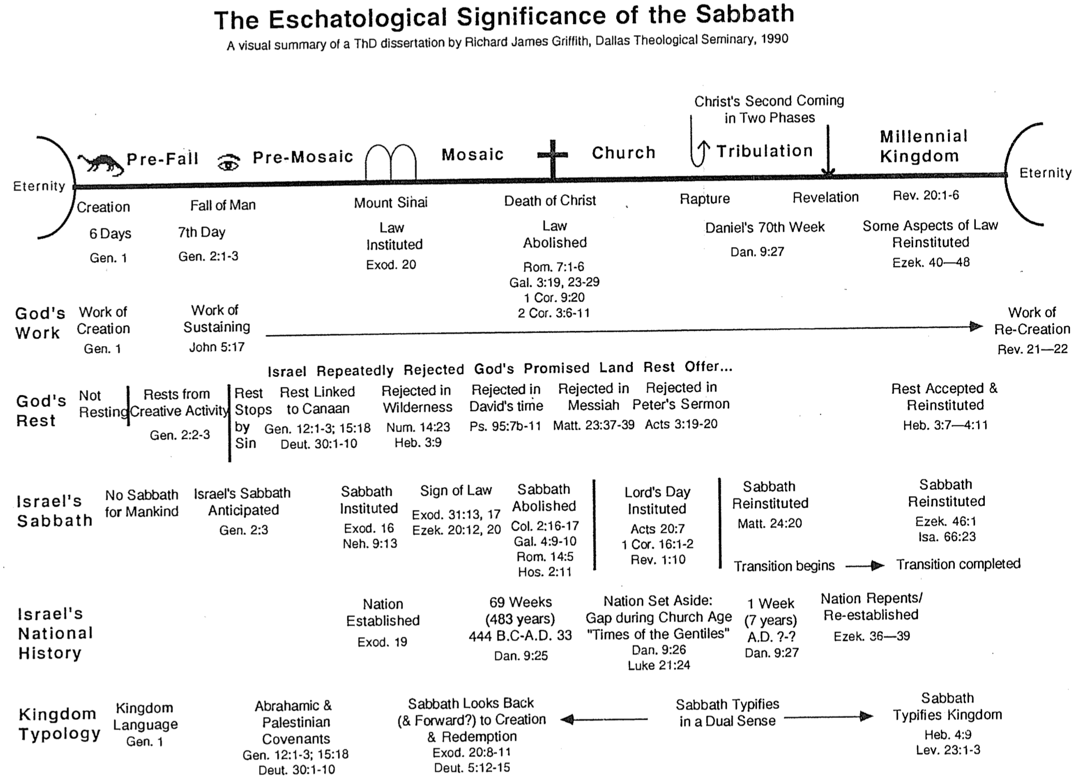
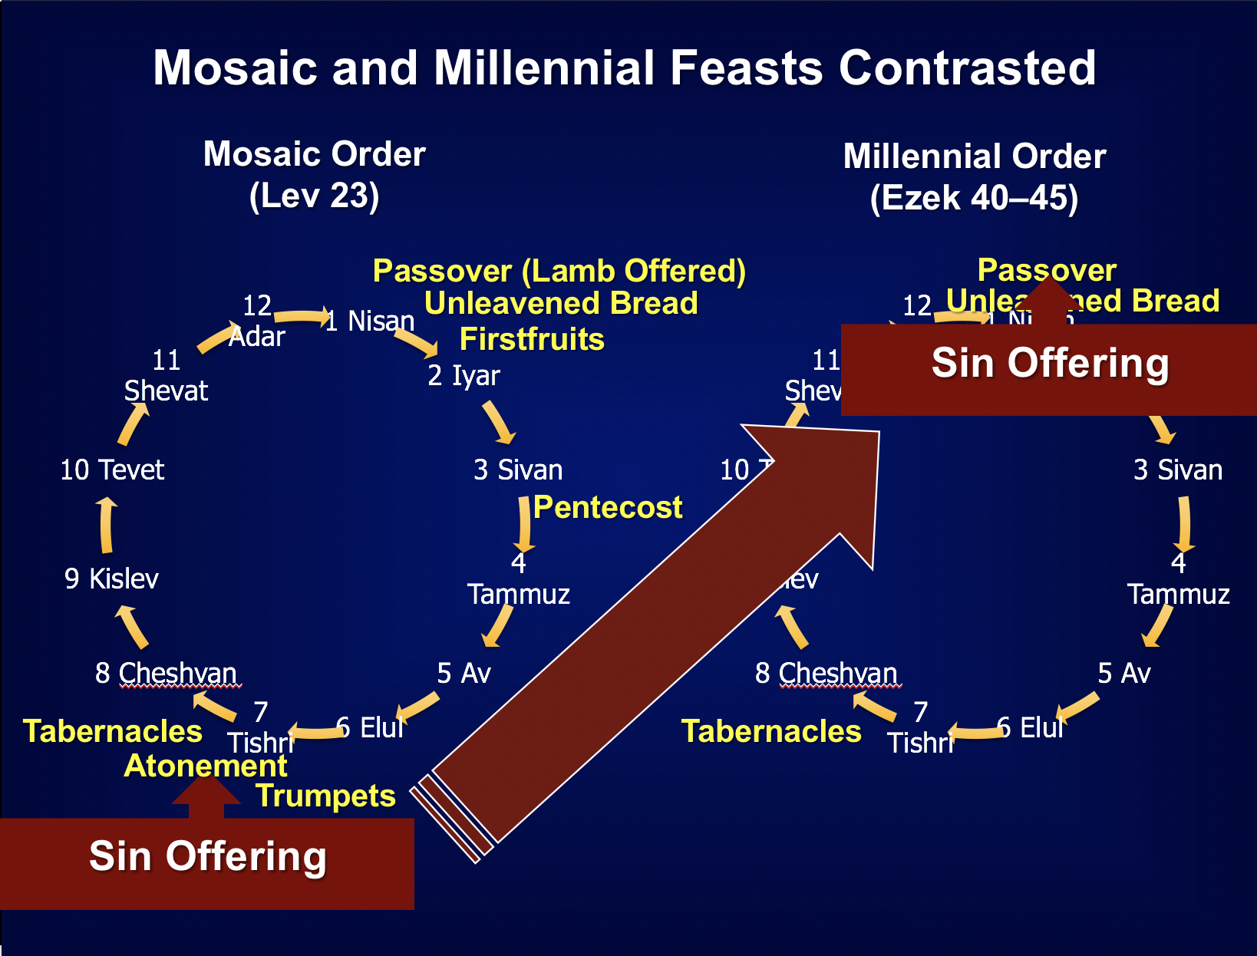
Mosaic and Millennial Feasts Contrasted

The annual Hebrew calendar of Leviticus 23 will find a partial repetition in the millennium.

• Jews even to today celebrate seven feasts each year.

• However, in the millennium only the first and last will be celebrated. Passover with Unleavened Bread will occur annually for seven days as in the past (Ezek 45:21), as will Tabernacles (Zech 14:16).

• As the sin offering in the Day of Atonement was central to the year, so this offering will be central to millennial worship. However, there will be no Day of Atonement then as the blood of Jesus is the final atonement for sin.

• Instead, the sin offering will be offered to commemorate Christ’s death, yet at Passover (Ezek 45:21-25). This is because there will be no ark of the covenant in the millennial temple (Jer 3:16, “’And when your land is once more filled with people,’ says the Lord, ‘you will no longer wish for ‘the good old days’ when you possessed the Ark of the Lord’s Covenant. You will not miss those days or even remember them, and there will be no need to rebuild the Ark”). Passover will be a fitting time to look back on Israel’s redemption from Egypt (Exod 12) as well as redemption from sin through Christ (1 Cor 5:7).

The Passover Lamb previously offered at Passover will have been fulfilled by Christ, yet the need for ongoing forgiveness related to ongoing sin will require a sin offering for the prince and those in mortal bodies (Ezek 40:39; 43:19, 21-22, 25).

One must not take the prophecy of Ezekiel in isolation, for millennial sacrifices are affirmed elsewhere in the prophetic writings. Isaiah notes that God will accept burnt offerings from both Israelites (Isa. 60:7; 66:20) and foreigners who bind themselves to the LORD (Isa. 56:6-7). Zechariah's last verse of his prophecy after the return of Christ (Zech 14:4) also affirms the presence of millennial sacrifices in the temple (Zech. 14:21).

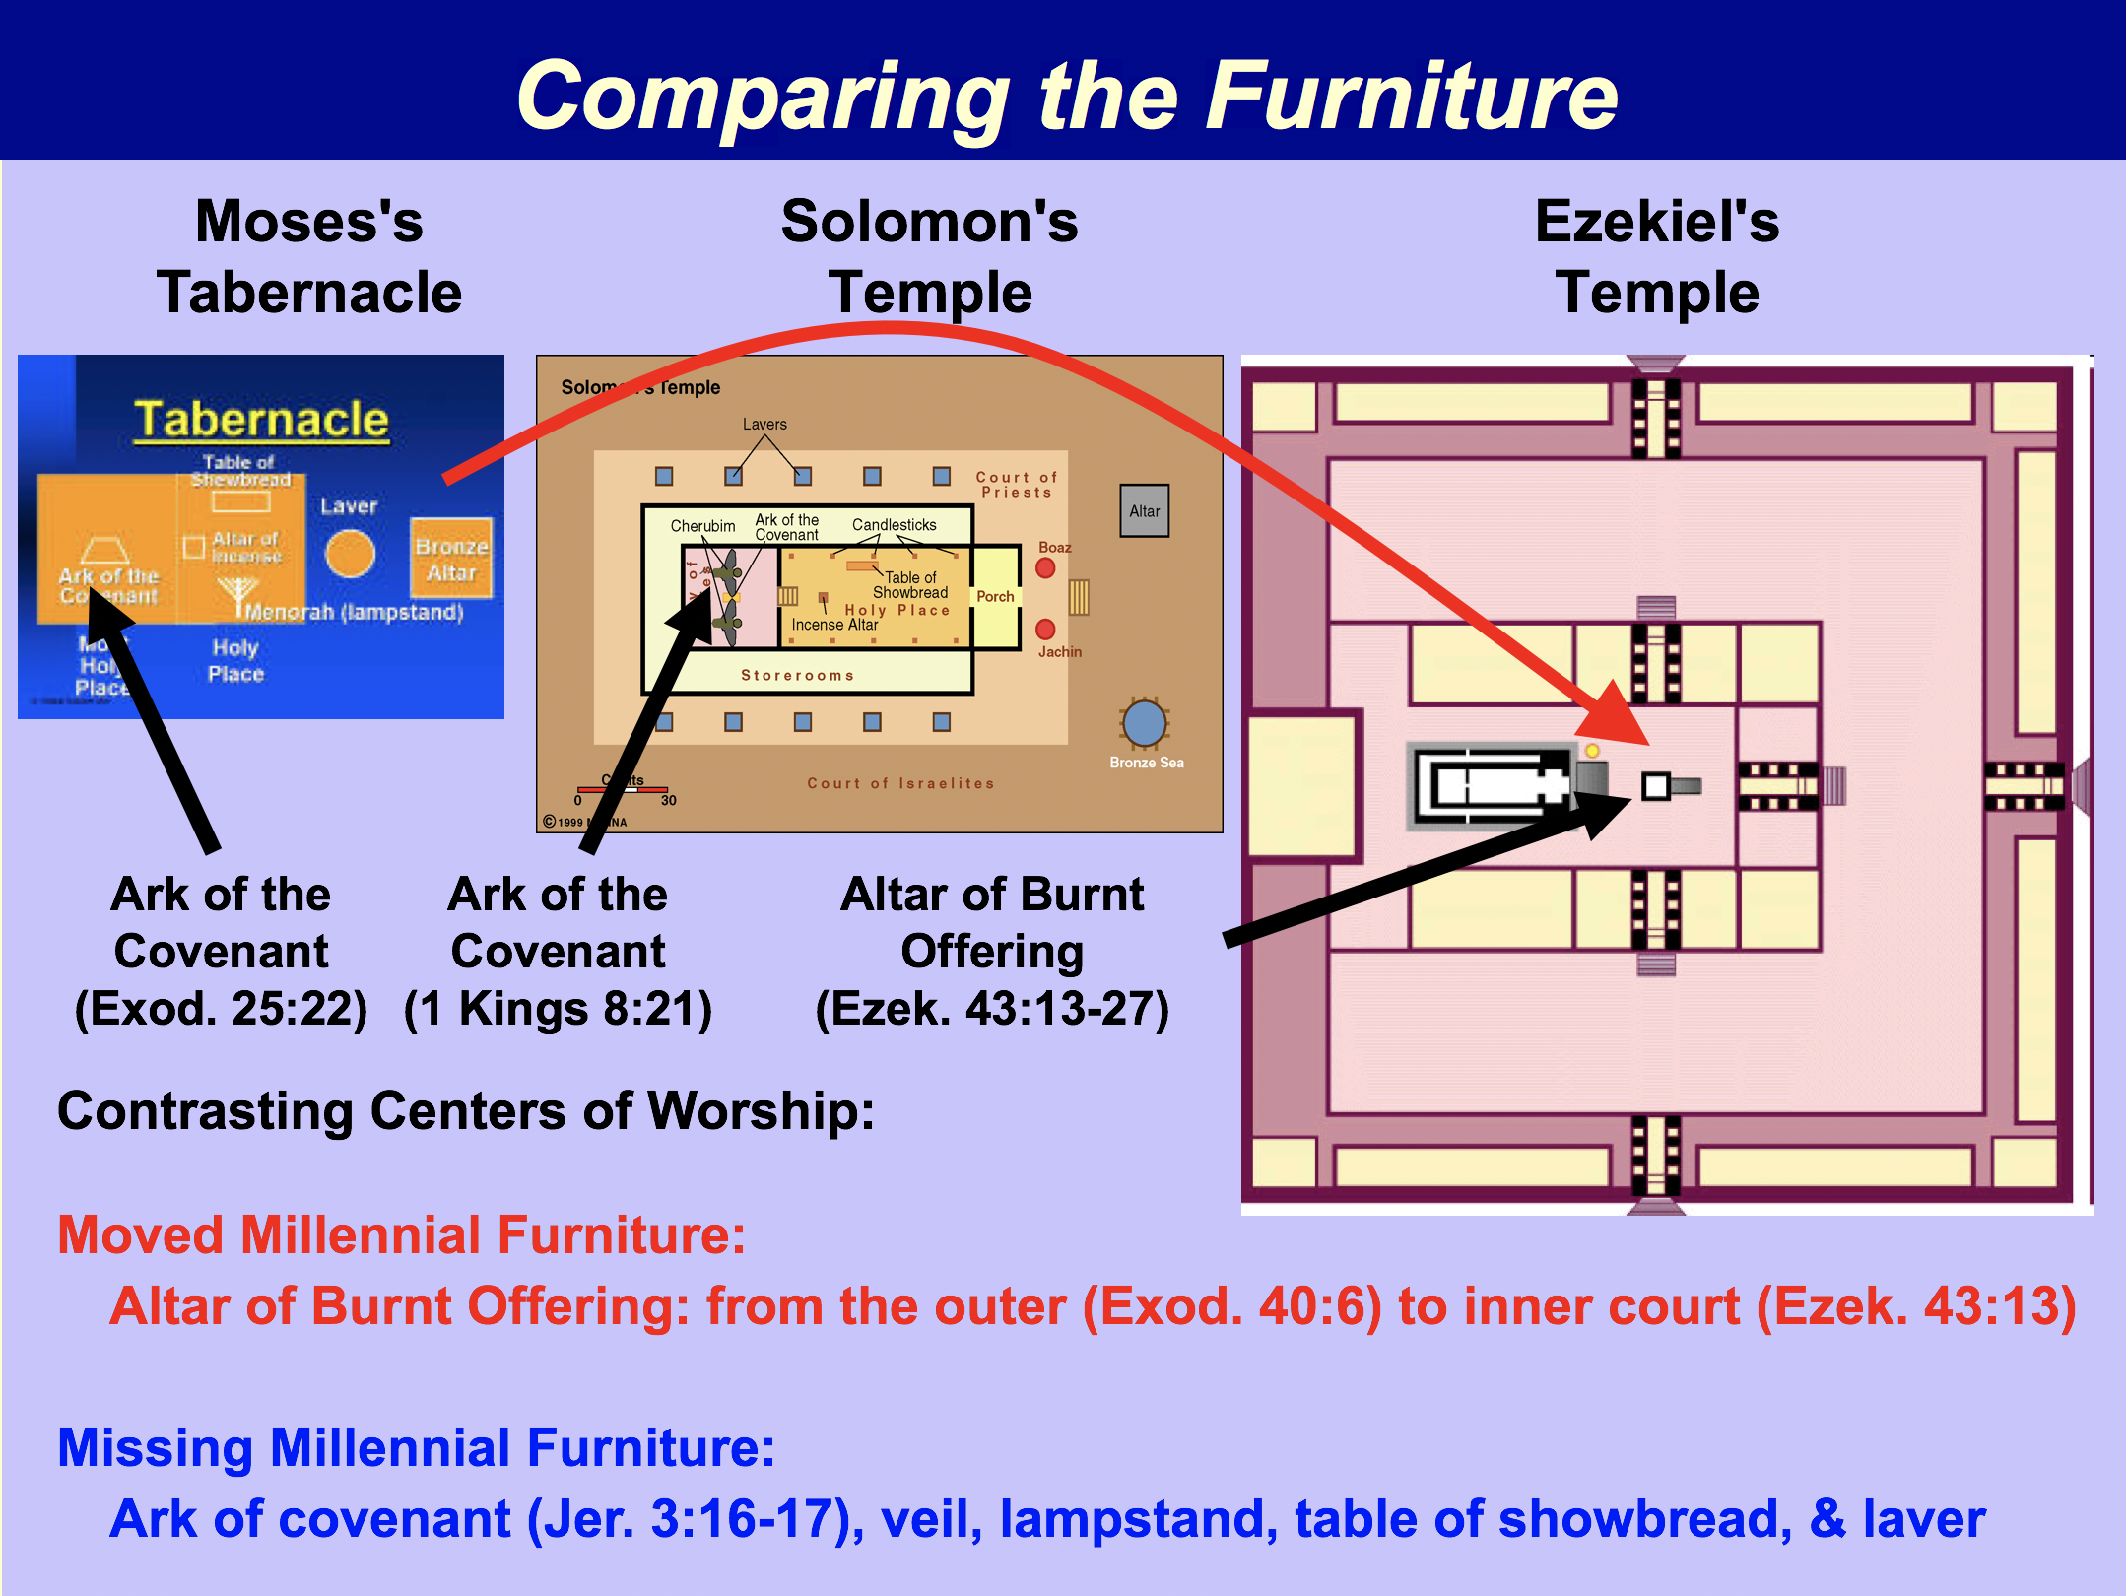

Who is the Prince in Ezekiel 40–48?

When do Ezekiel’s final nine chapters (Ezek. 40–48) take place? This section depicts a sacrificial system, temple in Jerusalem, and division of land up to the Mediterranean Sea that has never been seen in Israel’s past history. Yet in the future eternal state there will be no temple (Rev. 21:22), no sea (Rev. 21:1), and no Jerusalem with its traditional boundaries since believers will live in the new Jerusalem that is 2200 kilometers square (Rev. 20:16). Further, Ezekiel 40–48 certainly does not describe the present era. Therefore, they must depict a period yet future but before the eternal state. Since the kingdom era spoken by the prophets (cf. OTS, 442a-f, 461a-c) fits this era of the Messiah’s rule from Jerusalem (cf. Isa. 2:2-4), this period is the likely time in view.

But if Christ rules then, who then is this prince noted fifteen times in these chapters?

The Prince cannot be Christ.

He provides sin offerings for himself (45:22). Thus, he is a human in a mortal body rather than the glorified body that Jesus has that cannot sin (Luke 24:31, 39).

Priests offer burnt offerings and fellowship offerings for the prince (46:2). While Joseph and Mary did this for the infant Jesus, it would seem strange for others to present sacrifices for Christ after He has sacrificed himself for man.

The prince has sons (46:16-18). Thus, by implication, he must also have a wife. This obviously omits Christ from consideration since Jesus never married.

The Prince is a Human Serving under Christ.

Objection: It is unlikely that Ezekiel would speak more of the prince than of the Messiah.
Response: Even though Christ is not noted at all in these nine chapters, the rest of the prophetic writings clearly show his kingdom rule. Why would Ezekiel have to maintain the same ratio as the other prophets? He is certainly free to emphasize the prince more than the king, especially in his time when no king ruled over Israel.

Objection: A prince would be reigning on David’s throne that is reserved for Christ.
Response: None of the verses say that this prince will rule. Each relates to the prince’s religious functions (44:3; 45:16-17; 45:22; 46:2-18) or land (45:7; 48:21-22).

Objection: It is unlikely that a mortal man would rule over the twelve tribes that Jesus promised to the twelve apostles (Matt. 19:28).
Response: The text shows the prince involved in temple worship rather than in ruling.

Objection: God would not vest millennial worship (or rule) in a person able to sin.
Response: Why not? Worship leaders have always been morally capable of sin. The prince in his human state will better relate to the others also in mortal bodies since he will need to offer sacrifices just as they do (45:22).

Objection: Since the prince is "David” (34:24; 37:25), he must be Jesus, a “son of David.”
Response: Nothing prohibits this prince from being another man in the Davidic line. Further, he cannot be the resurrected David himself, for this David will not be able to sin in his glorified body and thus will not need sin sacrifices.

Conclusion: While some difficulties yet remain, it seems that the millennial prince indeed is a mortal man other than the resurrected David who will perform religious functions in Jerusalem.

Passages on the Prince

Ezek. 44:3 The prince himself is the only one who may sit inside the gateway to eat in the presence of the LORD. He is to enter by way of the portico of the gateway and go out the same way.”

Ezek. 45:7 “ ‘The prince will have the land bordering each side of the area formed by the sacred district and the property of the city. It will extend westward from the west side and eastward from the east side, running lengthwise from the western to the eastern border parallel to one of the tribal portions.

Ezek. 45:16 All the people of the land will participate in this special gift for the use of the prince in Israel.

Ezek. 45:17 It will be the duty of the prince to provide the burnt offerings, grain offerings and drink offerings at the festivals, the New Moons and the Sabbaths —at all the appointed feasts of the house of Israel. He will provide the sin offerings, grain offerings, burnt offerings and fellowship offerings to make atonement for the house of Israel.

Ezek. 45:22 On that day the prince is to provide a bull as a sin offering for himself and for all the people of the land.

Ezek. 46:2 The prince is to enter from the outside through the portico of the gateway and stand by the gatepost. The priests are to sacrifice his burnt offering and his fellowship offerings. He is to worship at the threshold of the gateway and then go out, but the gate will not be shut until evening.

Ezek. 46:4 The burnt offering the prince brings to the LORD on the Sabbath day is to be six male lambs and a ram, all without defect.

Ezek. 46:8 When the prince enters, he is to go in through the portico of the gateway, and he is to come out the same way.

Ezek. 46:10 The prince is to be among them, going in when they go in and going out when they go out.

Ezek. 46:12 When the prince provides a freewill offering to the LORD —whether a burnt offering or fellowship offerings —the gate facing east is to be opened for him. He shall offer his burnt offering or his fellowship offerings as he does on the Sabbath day. Then he shall go out, and after he has gone out, the gate will be shut.

Ezek. 46:16 “ ‘This is what the Sovereign LORD says: If the prince makes a gift from his inheritance to one of his sons, it will also belong to his descendants; it is to be their property by inheritance.

Ezek. 46:17 If, however, he makes a gift from his inheritance to one of his servants, the servant may keep it until the year of freedom; then it will revert to the prince. His inheritance belongs to his sons only; it is theirs.

Ezek. 46:18 The prince must not take any of the inheritance of the people, driving them off their property. He is to give his sons their inheritance out of his own property, so that none of my people will be separated from his property.’ ”

Ezek. 48:21 “What remains on both sides of the area formed by the sacred portion and the city property will belong to the prince. It will extend eastward from the 25,000 cubits of the sacred portion to the eastern border, and westward from the 25,000 cubits to the western border. Both these areas running the length of the tribal portions will belong to the prince, and the sacred portion with the temple sanctuary will be in the center of them.

Ezek. 48:22 So the property of the Levites and the property of the city will lie in the center of the area that belongs to the prince. The area belonging to the prince will lie between the border of Judah and the border of Benjamin.

Dates in Ezekiel
Bible Visual Resource Book

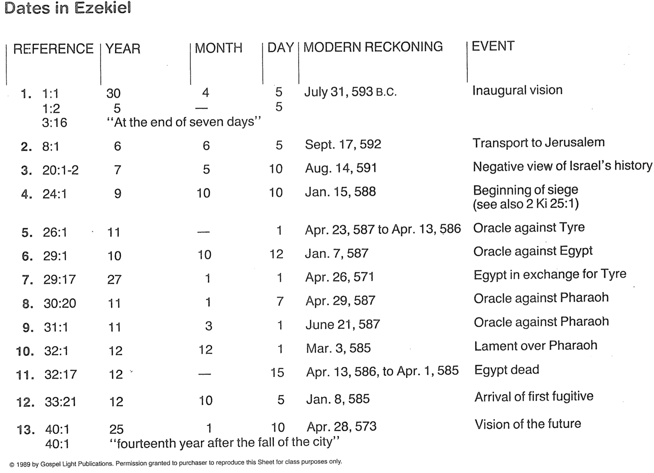

Resurrections & Judgments

I. Introduction

A. Amillennarians teach from John 5:28-29 one resurrection of the saved and lost, but the Bible records at least four different resurrected groups in three separate time periods (see below).

B. It is inaccurate to speak of a single judgment day as Scripture records seven judgments.

C. Multiple judgments should not sound strange to our ears as there has already been multiple judgments in the past: Lucifer and angels (2 Pet. 2:4; Jude 6), Flood (Gen. 6–7), Babel (Gen. 11:1-9), Northern nation of Israel (2 Kings 17:1-6), Judah (2 Kings 25:1-12), Ananias and Sapphira (Acts 5:1-11), and even the present (Rom. 1:18).

D. Past judgments only applied to some people, but future judgments will apply to all people who have ever lived (Heb. 9:27). The general guide for severity of punishment will be: the greater the knowledge of the truth, the greater the judgment (Matt. 11:24; Luke 12:48).

II. Chart of Resurrections and Judgments

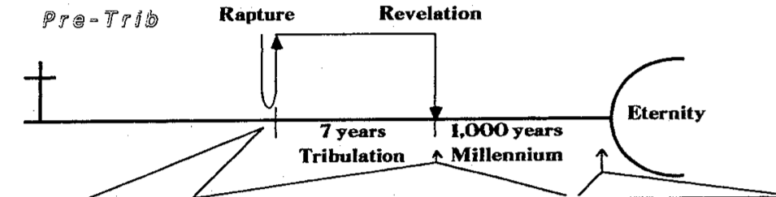
Time | Rapture | Second Coming at End of the Tribulation |  |  |  | End of Millennium
Resurrection | Yes | Yes | Yes | No | No | No | Yes
Judgment | Judgment Seat of Christ | Old Test. Saints | Tribulation Saints | Nation of Israel | Nations (Gentiles) | Satan and Fallen Angels | Great White Throne
Persons | Believers of church age | Believers of OT times | Martyred Tribulation Believers | Jews who survive the Tribulation | Gentiles who survive the Tribulation | Satan and demons | Unbelievers of all times (except the Tribulation) + Millennium mortals
Place | Bema of Christ (heaven) | Earth? | Earth? | Wilderness (Ezek. 20:35) | Valley of Jehoshaphat (Joel 3:1-2) | Angelic sphere? | Great White Throne in Heaven
Basis | Works and walk of the Christian life | Faith in God | Faith in Christ | Faith in Christ shown in works (Mal. 3:2-3) | Faith in Christ shown in treatment of Israel (Matt. 25:40, 45) | Satan’s fall (Isa. 14:12-17; Ezek. 28:12-19); demons follow Satan | Rejection of God’s general revelation and/or special revelation in Christ
Results | Rewards or loss of rewards | Rewards | Reign with Christ in the Millennium | Believers to kingdom; rebels sent to Hades | Believers to kingdom; rebels sent to Hades | Lake of Fire (hell) | Lake of Fire (hell)
Scripture | 1 Cor. 3:10-15; 2 Cor. 5:10; 1 Thess. 4:13-18; 1 Cor. 15:20-54 | Dan. 12:1-3 | Rev. 20:4-6 | Ezek. 20:34-38; Matt. 25:1-30; Zech. 14:4 | Joel 3:1-2; Isa. 34:1-2; Matt. 25:31-46 | Matt. 25:41; 2 Pet. 2:4; Jude 6; Rev. 20:10 | Rev. 20:11-15

The Jewish Calendar

Source Unknown

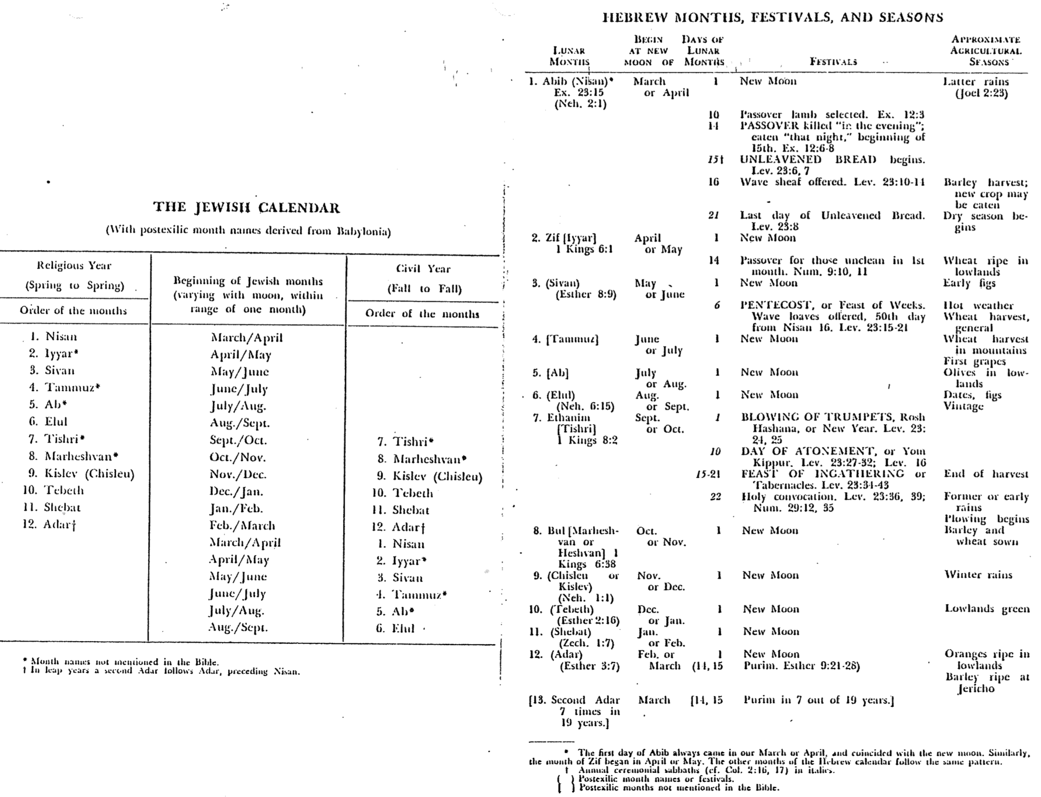
End Time Geography

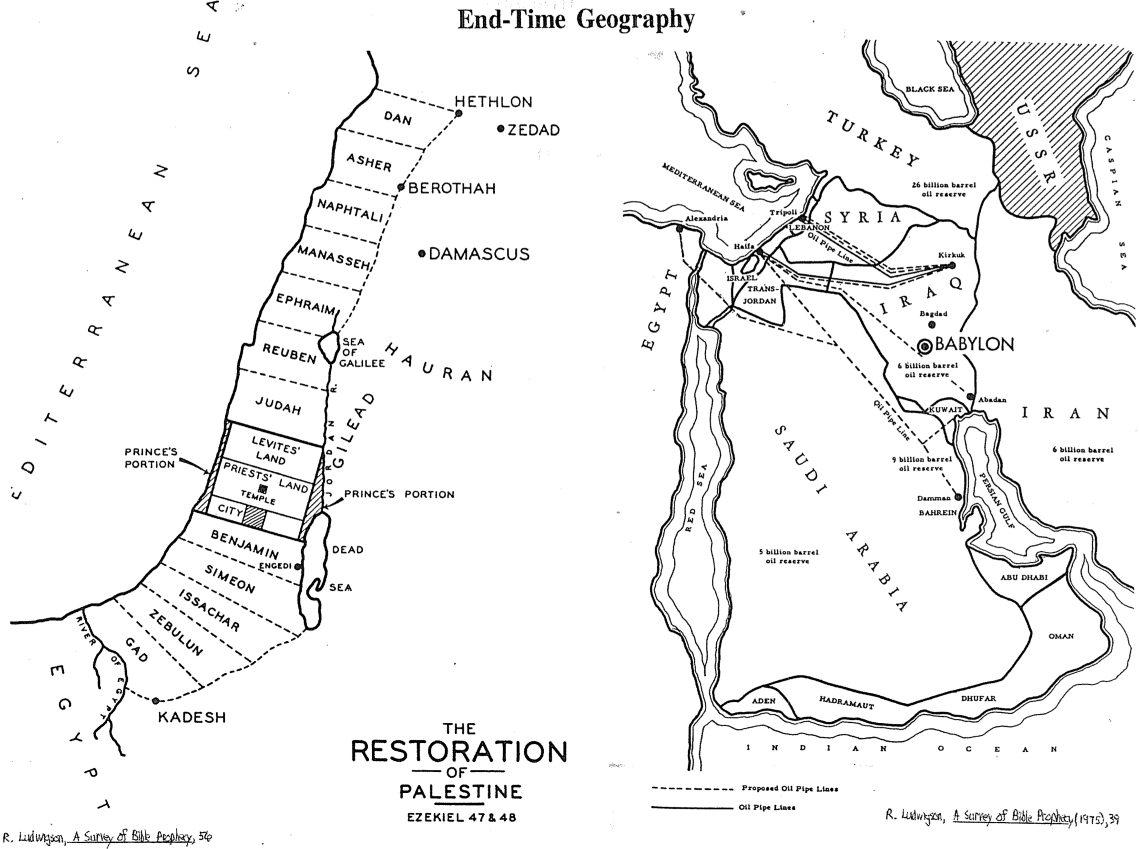

Division of the Land in the Millennium
Ezekiel 47–48
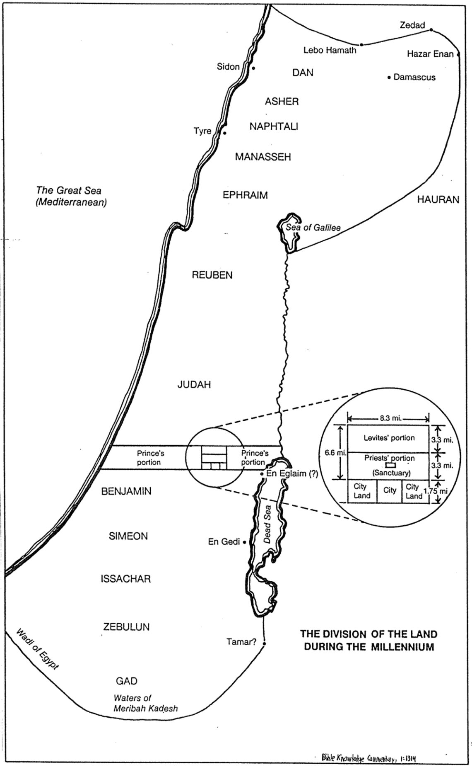

Be Expectant
Ezekiel

Exegetical Outline (Steps 2-3)

Exegetical Idea:

The way the exiles could expect the glory of the LORD to return was for God to judge his people, destroy their enemies, and restore them to a new life in a new temple.

I. The way God judged Judah was by having his glory leave Solomon’s temple (Ezek 1–24).

II. The way the exiles could expect the glory of the LORD to return was by God destroying their enemies (Ezek 25–39).

III. The way the exiles could expect the glory of the LORD to return was by God restoring them to a new life and order in the millennial temple (Ezek 40–48).

Purpose or Desired Listener Response (Step 4)
The listeners will be expectant of God’s glory returning in their lives.

Homiletical Outline (Cyclical inductive form)

Introduction

Interest: Sometimes it seems that our best days are past.

Need: Do you feel that God’s glory has departed from your life? Do you find yourself thinking about the “good ol’ days”?

Subject: How can you be expectant of God’s glory once again in your life?

Background: Ezekiel was an exile with the exiles, yet he witnessed God’s glory departing the temple in Jerusalem and then returning in the future.

Preview/Text: Through the entire book of Ezekiel, we will see three steps to expect God’s glory to return in your life.

(What is the first step to expect God’s glory to return in your life? To see a solution, we must first confess there is a problem, so…)

I. Admit that God’s glory left (Ezek 1–24).

God judged Judah by his glory leaving Solomon’s temple (Ezek 1–24).

Be honest that while the Spirit is present, you may have quenched him.

II. Allow God to handle all rivals to his glory (Ezek 25–32).

God promised to destroy Israel’s enemies (Ezek 25–32).

God’s glory will not shine with competitors in your life.

III. Anticipate God’s glory to return (Ezek 33–48).

God will restore his glory to Israel in the millennial temple (Ezek 33–48).

Things are not falling apart—they are falling together.

God has restored Israel and is preparing nations to attack Israel to fulfill Ezek 38–39.

Serve the Lord Jesus like he really is coming back to reward you.

(How can you be expectant of God’s glory once again in your life?)

Conclusion

Expect God to discipline and restore you for his glory (Main Idea).

Main Points

Applications

How do you reveal the glory of God in your life?

How has God disciplined you for your sin but restored you by His grace?

Do you see his hand in world events?

Will you return to him so he can return to you?

Prayer

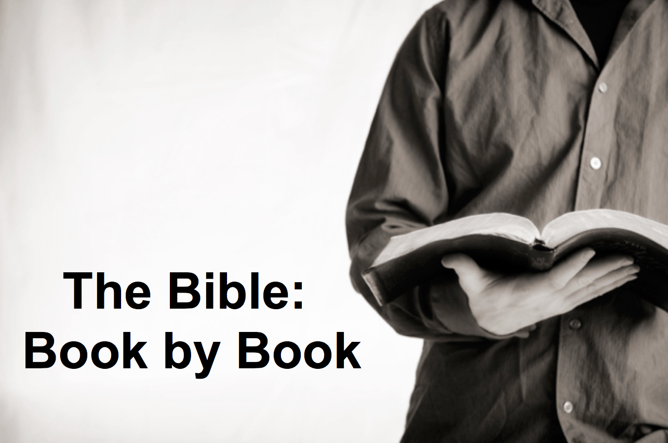

Rick Griffith
23 Sept 2018
Message 23 of 66

Be Expectant
Ezekiel

Introduction

Sometimes it seems that our best days are past.

How can you be ______________________ of God’s glory once again in your life?

Ezekiel was an exile with the exiles, yet he witnessed God’s glory departing the temple in Jerusalem and then returning in the future.

I. _________________ that God’s glory left (Ezek 1–24).

God judged Judah’s sin by his glory leaving Solomon’s temple (Ezek 1–24).

Be honest that while the Spirit is present, you may have quenched him.

II. _________________ God to handle all rivals to his glory (Ezek 25–32).

God promised to destroy Israel’s enemies (Ezek 25–32).

God’s glory will not shine with competitors in your life.

III. _________________ God’s glory to return (Ezek 33–48).

God will restore his glory to Israel in the millennial temple (Ezek 33–48).

Things are not falling apart—they are falling together.

(How can you be expectant of God’s glory once again in your life?)

Conclusion

Expect God to discipline and restore you for his _____________________ (Main Idea).

Applications

How do you reveal the glory of God in your life?

How has God disciplined you for your sin but restored you by His grace?

Do you see his hand in world events today?

Will you return to him so he can return to you?

Download this sermon PPT and notes for free at BibleStudyDownloads.org/resource/old-testament-preaching/
Listen to this message online at cicfamily.com/sermon-listing/

Ezekiel

Sovereign Departing and Return of Glory

Glory Departs |  | Nations Judged (No Glory) |  |  | Glory Returns
Chapters 1–24 |  | Chapters 25–32 |  |  | Chapters 33–48
Exile |  | Sovereignty Vindicated |  |  | Restoration
Judgment  of Judah |  | Judgment  of Nations |  |  | Blessing  of Israel
Judah’s Fall |  | Judah’s Foes |  |  | Judah’s Future
Before the Siege  (592-588 BC) |  | Through the Siege  (587-586 BC) |  |  | After the Siege  (586-573 BC)
Call in Glory  1–3 | Pre-Exile  Hopelessness  4–24 | Ammon, Moab, Edom, Philistia  25 | Tyre  and  Sidon  26–28 | Egypt  29–32 | New Life  33–39 | New Order  40–48
Babylon (592-570 BC)

Key Word: Glory

Key Verse: (God to Israel) “For I will take you out of the nations; I will gather you from all the countries and bring you back into your own land. I will sprinkle clean water on you, and you will be clean; I will cleanse you from all your impurities and from all your idols. I will give you a new heart and put a new spirit within you; I will remove your heart of stone and give you a heart of flesh. And I will put my Spirit in you and move you to follow my decrees and be careful to keep my laws” (36:24-27).

Summary Statement:
The way the exiles could expect the glory of the LORD to return was for God to judge his people, destroy their enemies, and restore them to a new life in a new temple.

Application:

Expect God to discipline your sin but restore you for his glory.

For example, see George Ricker Berry, "The Authorship of Ezekiel, 40–48" JBL 34 (1915): 17-40. Arguing to the contrary is Moshe Greenberg, "The Design and Themes of Ezekiel's Program of Restoration," Int 38 (1984): 181-208.
G. A. Cooke, "Some Considerations on the Text and Teaching of Ezekiel 40–48," ZAW 42 (1924): 105-15; Peter C. Craigie notes that the chapters express "in a profoundly symbolic manner the nature of the restored Israel that God would establish in the future," but then he never explains whether such a restoration has ever occurred (Ezekiel, 275).
Adam Clarke, "Ezekiel," in Clarke's Commentary, 4:535.
Solomon's temple measurements in 1 Kings 6:2 are noted at 60, 20, and 30 cubits; the above measurements in feet were obtained by multiplying these three lengths by the standard 18 inches per cubit.
This is the minimum measurement based upon Ezekiel 41:13 using Ezekiel's long (21-inch) cubit explained in 40:5 (cf. 43:13) where a rod is equal to 6 long cubits, each of which is an 18-inch cubit plus a 3-inch handbreadth; therefore, a rod must be 10.5 feet long since 6 cubits at 21 inches equals 126 inches, or 10.5 feet. Nowhere does the account provide the height of the temple although the entire temple area is enclosed by a wall one rod (hn<q;, "stalk, reed" BDB 889d) in height (40:5), or 10.5 feet. (If the measurement is with the normal, or shorter [18-inch] cubit, the temple dimensions must be adjusted slightly to 150 feet by 75 feet.) This issue becomes even more confusing as the temple area measurements in 42:16-19 are plagued with textual difficulties. In each verse the MT measures in "rods" (~ynIq;; cf. NASB, NIV margin, KJV, NKJV, Ampl), but the LXX follows the Qere which reads the transposed "cubits" (twam; cf. NIV, RSV, GNB). Therefore, a single temple court side in the MT is "500 rods" (~ynIq; t/mae-vmej}) or 5250 feet, but in the LXX it is "500 cubits" (pentakosi,ouς) or 875 feet (using the long cubit). Furthermore, the situation is complicated by the fact that Ezekiel uses the cubit (40:5b, 9, 11–42:20; etc.), the rod (40:3, 5a-7; 42:16-19), and an ellipsis (45:1-6; 48:8-21, 30-35) for measurement. Most commentators agree that the cubit is the proper unit since use of the rod would make four sides of the temple area nearly one mile in length, an unlikely size. For further study on the measurements of the temple in cubits see Theo G. Soares, "Ezekiel's Temple," BW 14 (1899): 93-103. Adhering to the rod view is Cameron M. MacKay, "The City and the Sanctuary: Ezekiel 48," PTR 20 (1922): 399-417 (cf. MacKay, "Prolegomena to Ezekiel 40–48," ET 55 (1943/44): 292-95), who advocates an enormous temple situated in the Valley of Shechem (cf. MacKay, "Ezekiel's Sanctuary and Wellhausen's Theory," PTR 20 [1922]: 661-65, which argues against the documentary hypothesis). MacKay's first article (pp. 399-417) is critiqued by W. F. Lofthouse, "The City and the Sanctuary," ET 34 (1922/23): 198-202 and rebutted by MacKay in "The City and the Sanctuary," ET 34 (1922/23): 475-76. In either case, whether rods or cubits are used, the temple is one that has never been constructed in Israel.
Hobart E. Freeman, An Introduction to the Old Testament Prophets, 313.
Walther Zimmerli, Ezekiel 2, Herm, 345.
Haggai's prophecy notes that the postexilic temple failed to compare with Solomon's in glory and makes no mention of size differences. However, since Ezekiel's temple necessitates topographical changes to fit into Jerusalem (explained later in this section) it exceeds both of these other temples in both size and glory.
See the paragraph immediately above for size comparisons.
It is difficult to determine the exact location of the temple, whether outside of the city (45:1-6) just north of Jerusalem (40:2) and outside Judah (48:8, 15), or within the city itself (40:1-2; cf. Isa. 2:2-3). In any case, other descriptions of topographical changes indicate that this is a vastly altered city from that of Zerubbabel's time.
The temple lies within a sacred area five hundred cubits square (45:2).
M.-Jos. Lagrange, "Topographie de Jérusalem," RevBib 1 (1892): 4; Yohanan Aharoni and Michael Avi-Yonah, The MacMillan Bible Atlas, 127. This comparison assumes the smaller temple size.
Keith W. Carley, The Book of the Prophet Ezekiel, 267; John W. Wevers, Ezekiel, NCBC, 207; E. W. Hengstenberg, The Prophecies of the Prophet Ezekiel Elucidated, 353; Crawford Howell Toy, The Book of Ezekiel, SBOT, 177, n. 3 ("the vision is here a literary device . . . the work of reflection," italics his); G. C. M. Douglas, "Ezekiel's Temple," ET 9 [1897/98]: 517; F. W. Farrar, "The Last Nine Chapters of Ezekiel," Exp 3d series 9 (1899): 7-9; Toni Craven, Ezekiel, Daniel, CoBC, 83. A modification of this view is that the temple in view is a hybrid structure resembling both Solomon's temple and the "walled and fortified sanctuaries in Babylonia" (G. A. Cooke, A Critical and Exegetical Commentary on the Book of Ezekiel, ICC, 425); Walther Eichrodt maintains that "the temple makes its appearance as a heavenly reality created by Yahweh himself and transplanted to earth," with the implication that such a transfer to earth never occurred (Ezekiel, OTL, 542).
Moshe Greenberg, "The Design and Themes of Ezekiel's Program of Restoration," Interpretation 38 (1984): 181-208; John B. Taylor, Ezekiel, TOTC, 253.
Nichol et al., eds., SDABC, 4:715.
Ibid.
The Adventist response to this question is: "God left no method untried to induce Israel to accept the high destiny originally planned for them. Up to this point their history had been one of repeated failures. God was now offering them another opportunity to begin again" (Nichol et al., eds., SDABC, 4:717). This answer fails to address how the post-exilic community was to initiate the topographical alterations necessary for the temple construction. Ezekiel's temple is to be built upon a high mountain (40:3) with a river flowing from it which extends to the Dead Sea (47:1, 7; cf. Joel 3:18) and supernaturally makes it fresh (47:8). The miraculous trees which bear fruit monthly (47:12) and several other supernatural descriptions in the prophecy indicate that its fulfillment was not possible during the post-exilic age.
T. Whitelaw, "Temple," ISBE, 5:2935, notes of Ezekiel's temple "that in important respects it forecasts the plans of the second (Zerubbabel's) and of Herod's temples."
Carl Friedrich Keil, Biblical Commentary on the Prophecies of Ezekiel, K&D, 2:180, applies the vision to "the new kingdom of God . . . in which the announcement of salvation for Israel is brought to its full completion," then explains this "Israel" to be the church (2:425); Milton S. Terry, Biblical Hermeneutics, 437; William Greenhill, An Exposition of the Prophet Ezekiel, 774-75.
Greenhill, 774.
The passage includes a description of a river (47:1-12) with fishermen (47:10) and salty swamps (47:11) which "lend a touch of realism to the passage. These details become meaningless if the passage is only symbolic of spiritual blessing" (Charles H. Dyer, "Ezekiel," BKC, 1:1313).
James Martin Gray, Christian Worker's Commentary on the Old and New Testaments, 265.
Dyer, 1:1304.
Keil holds a modification of this view in which the vision is a symbolic representation of the entrance of spiritual Israel (the church) into the heavenly Canaan, i.e., it "sets forth the kingdom of God established by Christ in its perfect form" (Carl Friedrich Keil, Biblical Commentary on the Prophecies of Ezekiel, K&D, 2:417).
Allis, Prophecy and the Church, 238 (cf. 50, 325-26).
Alexander, 6:945.
Rabbi Fisch acknowledges that the coming invasion of Gog (Ezek. 38–39) "is apocalyptic and relates to the indefinite future, the advent of the Messiah, indicated by the phrase the end of days," followed in chapters 40–48 by "a design of the Temple, the sacrificial worship, the people and the land in the new era which follows the overthrow of Gog" (S. Fisch, Ezekiel, SBB, 253, 265, italics his).
Alexander, 6:942-46; Gleason L. Archer, Encyclopedia of Bible Difficulties, 280-81; Dyer, 1:1302-1304; Paul P. Enns, Ezekiel, BSC, 180; Charles Lee Feinberg, The Prophecy of Ezekiel, 233-39, 267-68; Walter DeMotte Forsythe, "The Restoration of Ezekiel's Temple," Th.M. thesis, Dallas Theological Seminary, 1957, 40-54; Freeman, An Introduction to the Old Testament Prophets, 312; Arno C. Gaebelein, The Prophet Ezekiel, 271, 273; Gray, 265-67; Ironside, Expository Notes on Ezekiel the Prophet, 289, 314-15; Raymond Norman Ohman, "The Biblical Doctrine of the Millennium," Th.D. diss., Dallas Theological Seminary, 1949, 151-163; Soares, "Ezekiel's Temple," 93; Henry Sulley, The Temple of Ezekiel's Prophecy, 13; Merrill F. Unger, "The Temple Vision of Ezekiel," BS 106 (January-March 1949): 60, 169-77.
Allis, Prophecy and the Church, 248.
Ezekiel's premillennial argument is traced in further detail by Alexander, 6:943-44, 952.
Homer Heater, Jr., Zechariah, BSC, 114; F. Duane Lindsey, "Zechariah," BKC, 1:1570.
Ohman, "The Biblical Doctrine of the Millennium," 158.
It also includes a large (180 feet by 105 feet) and mysterious extra building (41:12, 15) which appears along with no other known temple in Jerusalem.
Eichrodt suggests that the city is the Zion of Ezekiel's time and that "the assertion of its great height is a strange piece of poetic license. To be sure, we have here the influence of the idea, widespread in the ancient East, including Israel, that the mountain of God is the highest of all mountains (cf. Isa. 2.2; Ps. 48.2; Zech. 14.10) and that the river of paradise had its source in it (Zech. 14.8; Ps. 46.4; Ezek. 47.1ff.)" (Ezekiel, 541; emphasis mine). This "poetic license" does not fit the general context which is not given to exaggeration but rather to minute detail.
A renewed Jerusalem was commonly taught in extra-biblical literature (e.g., 2 Baruch 4.1-6; for other references see Hermann L. Strack and Paul Billerbeck, Kommentar zum neuen Testament, 3:531-32, 573).
Ezekiel 48:15b-16 notes that each of the city's four sides stretch 4,500 cubits. With the standard cubit equal to 18 inches (1.5 feet), this yields a measurement of 1.5 X 4500=6,750 linear feet.
Terry, 345, describes this depiction as one of the "insuperable difficulties in the way of any literal exposition of the vision," but the miraculous will be commonplace in the Millennium (Paul Lee Tan, The Interpretation of Prophecy, 322).
The divisions for each tribe stretch from east to west in regular portions which seem to ignore topographical differences, or, more likely, seem to indicate a regular contour. "We may well question whether Ezekiel's arrangement ever could be carried out in actual life until that day when Jehovah was to return in glory, and every mountain and hill was to be brought low; see Isa. 40:3-5; Zech. 14:10" (G. C. M. Douglas, "Ezekiel's Vision of the Temple," ET 14 [1902/03]: 425).
For a fuller discussion of topographical changes in the Millennium, see Carl Eugene Bollinger, "The Land of Palestine in the Millennium," Th.M. thesis, Dallas Theological Seminary, 1949.
E. Isaac, trans., 1 (Ethiopic Apocalypse of) Enoch, in James H. Charlesworth, ed., The Old Testament Pseudepigrapha, 1:71.
Eth. En. 89:73 (135 BC); 91:13 (prior to 167 BC); Tob. 14:5 (2nd/1st cent. BC); Jub. 1:17, 27 (Maccabean). That the temple will function as a universal sanctuary of the nations is seen in Eth. En. 90:33; Tob. 13:13; Jub. 4:26. A few sources advocate a heavenly temple and heavenly Jerusalem (Wis. 9:8; Slav. En. 55:2), but the exegesis for such is questionable as it is based largely upon texts which supposedly indicate that the earthly temple and Jerusalem serve as a copy of the heavenly (e.g., Exod. 25:9, 40; 26:30; 27:8; Ps. 122:3). For further study see Gottlob Schrenk, to, i`ero,n, TDNT, 3:239-40; Otto Michel, nao,ς, TDNT, 4:882.
The fragmentary 1 Enoch dates from various sources in the second century BC to the first century AD (ibid., 2:5-7), with chapter 90 dating probably from about 165-161 BC (ibid., 2:7).
The following factors are explained by Douglas, "Ezekiel's Temple," 365-67, 420-22, 468-70, 515-18; Douglas, "Ezekiel's Vision of the Temple," 365-68, 424-27.
The work of the high priest has already been completed in the once-and-for-all death of Jesus Christ (Heb. 10:11-12), who is the high priest now (Heb. 4:14; 7:26–8:6) and presumably will continue to act as such in the Millennium.
Serving in the temple are not just anyone in the Aaronic line, but only priests who were Levites and sons of Zadok (40:46; 43:19; 44:15; cf. Mal. 3:3) because of their faithfulness during Israel's apostasy (48:11).
Decisions will not need to be settled through this ancient method as the omnipotent Lord will be reigning personally and available for counsel.
The glory of God will not be confined to a particular place within the temple.
These are unneeded as God's glory has returned to the house (43:6f.). In heaven the situation is even more significant as there will be no need for even the temple itself (Rev. 21:22-23).
These items will be replaced with a river of living water flowing from Jerusalem (47:1-13; cf. Zech. 14:8). By "living water" perhaps that which has no natural source is meant.
"The atonement is already complete, the most holy place stands open, and perhaps all priests appear habitually clothed as the high priest used to be on that great day" (Douglas, "Ezekiel's Temple," 421).
That the sacrifices play an important part in Ezekiel's description is evident in that he gives a more detailed account of the altar than of anything else in the temple, and in its enormous size in comparison to the altar associated with Solomon's temple (43:13-17).
Oswald T. Allis, Prophecy and the Church, 247; cf. Nichol et al., eds., SDABC, 4:715, "It is impossible to conceive that animal sacrifices could ever again be restored by divine command and find acceptance with God."
Tan, 293-98, elaborates on the legitimacy of a reinstitution of the sacrificial system (cf. Alexander, 6:946-52).
This formula is used of both the Mosaic Covenant (Lev. 26:12; Exod. 19:5-6; Deut. 26:18-19) and the New Covenant (Jer. 30:22; 31:33; 32:38).
Similarly, Malachi explains that after the coming in judgment of the messenger of the covenant (Christ), grain offerings will be presented to God: "The LORD will have men who will bring [grain] offerings in righteousness, and the [grain] offerings of Jerusalem and Judah will be acceptable to the LORD, as in former years" (Mal. 3:3b-4). While some consider these to be animal sacrifices (e.g., Beth Glazier-McDonald, Malachi, SBL 98, 155), they are actually grain offerings ("hj;n“mi," BDB 585b 4). Instead of viewing Malachi's description as depicting Christ's judgment associated with His second coming, some commentators suggest that it portrays the Mosaic period as the ideal era (Joyce G. Baldwin, Haggai, Zechariah, Malachi, 244) or that it is "symbolic of a cleansed and sanctified church" (Robert L. Alden, "Malachi," EBC, 7:719). However, neither of these views adequately considers the judging nature of the arrival of the messenger (Mal. 3:2-3a).
Allis, Prophecy and the Church, 247.
Hughes responds sarcastically to this argument: "To restore all these today, under the New Covenant, would be apostasy. But, in a millennium, under the same New Covenant, it is supposed to be according to prophecy!" (Archibald Hughes, A New Heaven and a New Earth, 157).
Jerry Hullinger, "The Problem of Sacrifices in Ezekiel's Temple," doctoral seminar paper for the course 375 Seminar in the Exilic and Postexilic Prophets, Dallas Theological Seminary, 1989, 26.
Alexander, 6:949; Alva McClain, The Greatness of the Kingdom, 250; Feinberg, The Prophecy of Ezekiel, 234; John Mitchell, "The Question of Millennial Sacrifices," BS 110 (1953): 344.
Hobart E. Freeman, "The Problem of Efficacy of Old Testament Sacrifices," BETS 5 (Summer 1962): 73-79; John C. Whitcomb, "Christ's Atonement and Animal Sacrifices in Israel," GTJ 6 (1985): 208-12.
Whitcomb, "Christ's Atonement and Animal Sacrifices in Israel," 201-17; Charles Caldwell Ryrie, Dispensationalism Today, 128.
Gaebelein, The Prophet Ezekiel, 312; Mitchell, "The Question of Millennial Sacrifices," 267; Merrill F. Unger, "The Temple Vision of Ezekiel," BS 106 (January-March 1949): 60; Clive A. Thomson, "The Necessity of Blood Sacrifices in Ezekiel's Temple," BS 123 (July-September 1966): 237-48. Archer seeks to explain the view as such: "It is true that the same Hebrew terms are used in Ezekiel 43 as were employed in the law of Moses [e.g., "sin offering"], but they will have a new meaning. They were used by the Old Testament prophet because they furnished the closest analogy to the millennial offerings that the Hebrew believer had any acquaintance with. But like so many other terms employed in connection with the end times, so these designations of sacrifice were sublimated and altered to fit the new conditions of the new age yet to come" (Archer, Encyclopedia of Bible Difficulties, 280-81).
Debate remains whether the Lord's Supper will be celebrated in the Millennium. It is claimed that the celebration will continue since Jesus said He would not "drink of the fruit of the vine again until the kingdom of God comes" (Luke 22:18; cf. Matt. 26:29; Mark 14:25; Alexander, 6:951). However, it is also argued that there will be no more need for the Lord's Supper in the Millennium since it "proclaims the Lord's death until he comes" (1 Cor. 11:26; Dyer, 1:1305; cf. Archer, Encyclopedia of Bible Difficulties, 280). It appears to the present writer that the latter view is correct since Christ's statement in the gospels relates to His celebration of the Passover (Luke 22:15-16), not the Lord's Supper. In either case, nothing prohibits the coexistence of the memorial sacrifices and memorial Supper in the future age.
Alexander, 6:951, "Consequently, the sacrifices in the millennial sacrificial system of Ezekiel appear to be only memorials of Christ's finished work and pictorial reminders that mankind by nature is sinful and in need of redemption from sin."
Ibid., 6:986.
An attempt at this problem by one amillennial interpreter is that the Sabbath signifies Christian worship on the Lord's day, the open gate signifies the gate of heaven open to believers for blessing, the prince's worship is representative of civil officials' need for worship without meddling in church affairs (or symbolic of Christ's incarnation and intercession), and the six working days designate the term of man's life with its labor and sorrow (Greenhill, 810-11). Such is the imaginative exegesis of those who abandon the normal, literal hermeneutic.
One premillennialist sees a typical (N.B., not allegorical) significance to this account: "The six working days (typical of 6,000 years) are forever gone, the seventh day, the seventh thousand, the Day of the Lord, has come. And when the Millennium ends, the complete, eternal rest comes for all the people of God. The new moon is typical of Israel's re-establishment as a nation. The nation, like the moon, had waned and disappeared, but now she shines again like the new moon" (Gaebelein, 326-27).
Alexander suggests that the Feast of Firstfruits is included by implication but does not present his evidence (6:947).
Some might claim that since Jesus is the King, he cannot be called a prince as well. However, Jesus is also called the prince of peace (Isa. 9:6) and David is called both king (37:24) and prince (34:24; 37:25).
The first four objections are from Raymond Ludwigson, A Survey of Bible Prophecy, 54.

