Jordan Evangelical Theological Seminary Dr. Rick Griffith

9 Sep 2024 Single Message

NLT 20 Minutes

Title

**When God Calls**

***Exodus 3–4***

**Topic:** Calling

**Subject:** How can you follow God’s calling?

**Complement:** Admit your inadequacy to know God’s sufficiency.

**Purpose:** The listeners will respond to God’s calling by prioritizing His sufficiency over their inadequacy.

# Introduction

Phone

### Interest: [God calls us.]

#### We are all used to ignoring spam calls, but what if God calls us?

#### God is calling believers today to obey him. If he has called you to serve him, raise your hand.

God’s Call

### Need: Do you want to follow God’s calling for your life?

• Follow?

#### How many of us want to obey the Lord?

#### Raise your hand again if that includes you.

#### Good. Willingness is the first step.

#### Now the key question is *how to obey.*

Subject

### Subject: *How* can you follow God’s calling?

Backgrd

### Background: Exodus 1–2 shows how God prepared the scene to call his servant Moses.

#### Exodus 1

Exod 1

##### The Sphinx and the Great Pyramid, still visible today, remind us of Egypt’s great power.

Sphinx

##### In contrast, Egyptians despised Israelites for being shepherds.

Oppress

Sheep

##### Egyptians also ruthlessly oppressed the Israelites.

##### Pharaoh was viewed as the ultimate power.

Pharaoh

##### This raised the question of who had the greater power—Pharaoh or Yahweh, the Lord of the Hebrews.

Greater

##### Pharaoh even abused his power by commanding the Hebrew midwives to kill the baby Hebrew boys.

Midwives

#### Exodus 2

Drawn

Thrown

Exod 2

##### So the mother of Moses “obeyed” Pharaoh’s command and gently tossed Moses into the Nile!

##### But God worked amazingly, so Pharaoh’s daughter found the baby Moses.

##### God even used Miriam—Moses's older sister—to pay Moses's mother to nurse him!

Flees

Map

Miriam

Raised

Pharaoh

Greater

Midwives

Exod 2

Thrown

Drawn

Pharaoh

Greater

Midwives

Exod 2

Thrown

Drawn

##### Acts 7 notes that Pharaoh’s daughter raised Moses as if he were her son!

##### But Moses grows up and takes matters into his own hands and Pharaoh seeks to kill him, so Moses flees.

##### In Exodus 3, we find Moses far away in Midian, traveling to Mount Sinai with his sheep.

God’s   
Role

Moses  
• Subject

• Our  
Role

### Subject: How can Moses follow God’s calling at this point—and how can you follow God’s calling?

### Preview & Text: Today, in Exodus 3–4, we will first see God’s role and then our role regarding God’s call on our lives.

### Restatement: We will summarize Exodus 3–4 in two principles relating to (1) God’s calling and (2) our response.

Exod 3

(How does the LORD convince us to respond to Him? It starts when…)

MI

# I. God calls His servant (Exodus 3:1–4:17).

[The Lord tells us to do the impossible to show us our inadequacy and need.]

Moses Called

## God called Moses to lead all Israel out of Egypt (3:1-10).

## Moses revealed his inadequacy in five excuses (3:11–4:13).

Excuse 1

### Who am I (3:11)?

#### This is not a relevant question, but Moses asked it.

#### God could have focused on Moses, "You are my chosen servant with the perfect balance of 40 years in Egypt and 40 in the wilderness."

#### But God answered, “I will be with you. And this is your sign that I am the one who has sent you: When you have brought the people out of Egypt, you will worship God at this very mountain” (3:12).

### Who are you (3:13)?

Excuse 2

#### So Moses then questioned who God was!

#### But this wasn't any better an excuse.

#### "God replied to Moses, 'I Am Who I Am. Say this to the people of Israel: I Am has sent me to you'" (Exodus 3:14 NLT).

Excuse 3

• I Am

### "What if they do not believe me?" is essentially, "What if I fail?" (4:1)

#### But God Doesn't Call the Qualified.

Qualified

#### He Qualifies the Called.

Excuse

### I’m not gifted (4:10).

#### **Ex. 4:10**  But Moses pleaded with the LORD, “O Lord, I’m not very good with words. I never have been, and I’m not now, even though you have spoken to me. I get tongue-tied, and my words get tangled.”

#### This is like saying, “But God, I need a translator!”

#### His self-perception was poor, but Stephen in Acts 7 notes, “Moses was educated in all the wisdom of the Egyptians and was powerful in speech and action."

Acts 7

Excuse 5

### I don’t want to get involved (4:13).

#### Ex. 4:13 But Moses again pleaded, “Lord, please! Send anyone else.”

#### This is like saying, “Here am I, Lord! But please, send Aaron!”

## The conversation between Moses and God ended only after Aaron's appointment as ministry partner (4:14-17).

Aaron

Exod 3

(This is God’s role—to call us. What is our role? How should we respond to God’s calling?)

# II. God’s servant must present himself as God’s instrument (Exodus 4:18-31).

MP

[Offer yourself to God as an inadequate vessel trusting in God’s sufficiency.]

## Moses finally obeyed God’s call by returning to Egypt (4:18-31).

## Moses’ life had three distinct periods that helped him see God’s sufficiency.

Moses’   
Life

Subject

(So, back to our first question: how can you follow God’s calling?)

# Conclusion

MI

### Admit your inadequacy to know God’s sufficiency (Main Idea).

### God's servant who understands his inadequacy will show God's sufficiency (Main Idea Restated).

### Main Points: How does the LORD convince us to respond to Him?

Exod 3

#### God calls His servant (Exodus 3).

#### God’s servant must present himself as God’s instrument (Exodus 4).

Exod 4

### Can you relate to God’s calling in my life and how I have felt inadequate for the tasks?

My Life

• 10x

#### Witness at Hayward High School—but my parents opposed it.

#### Teacher in Barnabas Brothers—but I knew only one more week of the Bible than them.

#### Music evangelist in Crossroads—but I had never preached before.

#### Student at DTS—but it took me much more time to learn than it did others.

#### Pastor at Grace Fellowship—but the people were 75% divorced with many issues.

#### Professor at Singapore Bible College—but I never fit the academic mold as an author.

#### School planter at ICS—but I had never had a child in primary school before.

#### Church planter at CIC—but I had too little time and no idea how to start a church.

#### Professor at JETS—but I started teaching five days after arrival and have little capacity to learn Arabic.

#### Academic Dean at JETS—but I am closest to retirement and know Arabic the least of anyone at JETS.

### How is God calling you?

How God calling you?

#### What is he telling you to do that shows your inadequacy and his sufficiency?

• What?

#### Will you tell him YES?

• Yes?

### Prayer

Prayer

# Preliminary Questions

**Verses Questions**

# Context: What did the author record just before this passage?

### Israel was oppressed by the Egyptians (Exodus 1).

### But God was working in a miraculous way not only to save the life of Moses, but to raise him in Pharaoh’s palace (Exodus 2).

# Purpose: Why is this passage in the Bible?

### God is always preparing his leaders.

### He also wants us to see that he is working his plan through us.

# Background: What historical context helps us understand this passage?

### Since Egypt considered the pharaoh a god, he demanded absolute loyalty.

### But Moses fled for his life once pharaoh learned that he had killed an Egyptian.

### Humanly speaking, the riskiest place for Moses was in Egypt! This was especially true when he was called to confront pharaoh with a message that the king would not welcome.

# Questions

### Where was Midian?

### Was Mount Sinai in Midian (Jebel Lawz in Saudi Arabia), or would Moses traveling “far into the wilderness” put him in the Sinai Peninsula at the traditional location at Jebel Musa?

# Tentative Subject/Complement Statements

God calls the inadequate (by the way, that is all of us).

# Possible Illustrations

### God called me to be…

#### Witness at Hayward High School—but my parents opposed it.

#### Teacher in Barnabas Brothers—but I knew only one more week of the Bible than them.

#### Music evangelist in Crossroads—but I had never preached before.

#### Student at DTS—but it took me much more time to learn than it did others.

#### Pastor at Grace Fellowship—but the people were 75% divorced with many issues.

#### Professor at Singapore Bible College—but I never fit the academic mold as an author.

#### School planter at ICS—but I had never had a child in primary school before.

#### Church planter at CIC—but I had too little time and no idea how to start a church.

#### Professor at JETS—but I started teaching five days after arrival and have little capacity to learn Arabic.

#### Academic Dean at JETS—but I am closest to retirement and know Arabic the least of anyone at JETS.

# Possible Applications

### When God calls, say YES!

### What ministry is God calling you to?

**When God Calls**

***Exodus 3–4***

**Exegetical Outline (Steps 2-3)**

# *Exegetical Idea*: The way that God convinced Moses to follow his calling was to show his sufficiency over Moses’ inadequacy.

# I. The way God called Moses was by revealing his servant’s inadequacy (Exodus 3:1–4:17).

## God called Moses to lead all Israel out of Egypt (3:1-10).

## Moses gave excuses instead of obeying God’s call (3:11–4:17).

### Moses revealed his inadequacy in five excuses (3:11–4:13).

### The conversation between Moses and God ended only after Aaron's appointment as ministry partner (4:14-17).

# II. The response of Moses was to present himself as God’s instrument (Exodus 4:18-31).

**Purpose or Desired Listener Response (Step 4)**

The listeners will respond to God’s calling by prioritizing His sufficiency over their inadequacy.

**Homiletical Outline** (Cyclical inductive form)

# Introduction

### Interest: God is calling believers today to obey him. If he has called you to serve him, raise your hand.

### Need: Do you want to follow God’s calling for your life?

#### How many of us want to obey the Lord?

#### Raise your hand again if that includes you.

### Subject: How can you follow God’s calling?

### Background: Exodus 1–2 shows how God prepared the scene to call his servant Moses.

### Preview & Text: Today, in Exodus 3–4, we will first see God’s role, and then our role concerning God’s calling on our lives.

### Restatement: We will summarize Exodus 3–4 in two principles relating to (1) God’s calling and (2) our response.

(How does the LORD convince us to respond to Him? It starts when…)

# I. God calls His servant (Exodus 3:1–4:17).

## God called Moses to lead all Israel out of Egypt (3:1-10).

### Moses revealed his inadequacy in five excuses (3:11–4:13).

### The conversation between Moses and God ended only after Aaron's appointment as ministry partner (4:14-17).

(How should we respond to God’s calling?)

# II. God’s servant must present himself as God’s instrument (Exodus 4:18-31).

## Moses finally obeyed God’s call by returning to Egypt (4:18-31).

## Moses’ life had three distinct periods that helped him see God’s sufficiency.

(So, back to our first question: how can you follow God’s calling?)

# Conclusion

### Admit your inadequacy to know God’s sufficiency (Main Idea).

### God's servant who understands his inadequacy will show God's sufficiency (Main Idea Restated).

### Main Points: How does the LORD convince us to respond to Him?

#### God calls His servant (Exodus 3).

#### God’s servant must present himself as God’s instrument (Exodus 4).

### Can you relate to God’s calling in my life and how I have felt inadequate for the tasks?

### How is God calling you?

#### What is he telling you to do that shows your inadequacy and his sufficiency?

#### Will you tell him YES?

### Prayer

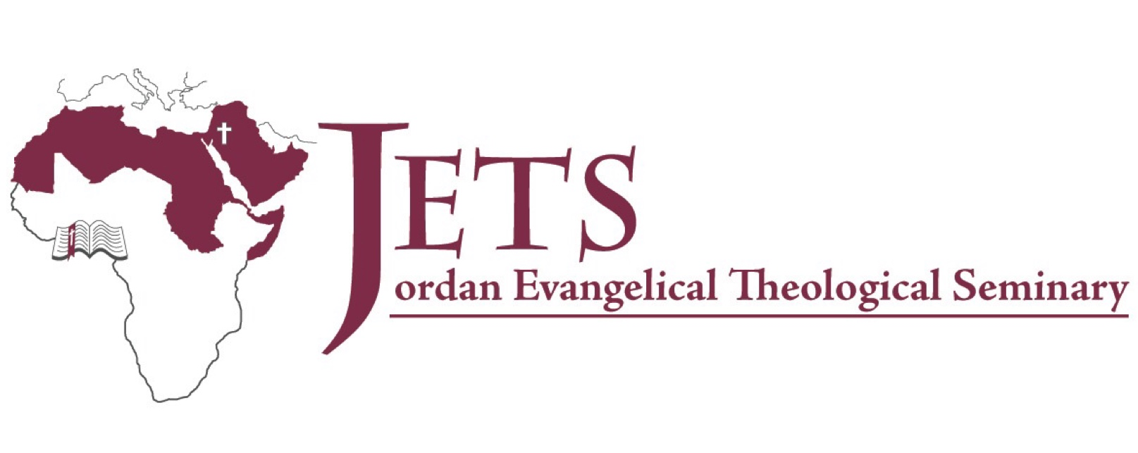

**Rick Griffith**

9 Sept 2024

Single Message

**When God Calls**

***Exodus 3–4***

# Introduction

How can we follow God’s _____________? calling

# I. God calls His __________________ (Exodus 3:1–4:17). servant

# II. God’s servant must present himself as God’s ________________ instrument (Exodus 4:18-31).

(So, back to our first question: how can you follow God’s calling?)

# Conclusion

### Admit your inadequacy to know God’s ____________ sufficiency (Main Idea).

### How is God calling you? Will you tell him YES?

Download this sermon PPT and notes for free at BibleStudyDownloads.org/resources/old-testament-preaching/