Crossroads International Church Dr. Rick Griffith
12 October 2014 Message 12 of 17
NLT 40 Minutes
Our Certain Future
Title
Ecclesiastes 9:1-10

Topic: Uncertainty
Subject: How should you respond to an unknown future?
Complement: Since you don’t know the future, work hard and enjoy life.
Purpose: The listeners will work hard and enjoy life in light of their uncertain future.
Meditation: God’s Omniscience
Reading: Psalm 139
Song: “The Perfect Wisdom of Our God” (Keith & Kristyn Getty)

Introduction

Interest: We live in a day when the future is so uncertain. (Of course, it's always been like this!)
Uncertain

Need: How do most people deal with their uncertain future?
How?

How have you seen others respond to their uncertain future? Tell your neighbor in the next 30 seconds. People today show various reactions to their unknown future. This affects their lives through the following philosophies (adapted from Swindoll, LOTRE Study Guide, 89-90).

Materialism: "You can only enjoy the good life now—so supply yourself!"
• Materialism

Hedonism: "Pleasure's the only thing you can enjoy before you die—so live it up!"
• Hedonism
• Humanism

Humanism: "There is no afterlife to live for anyway—so exalt yourself!"
• Fatalism

Fatalism: "The game of the future is rigged—so resign yourself!"

How do you respond to an unknown future? What is your greatest fear or struggle as it relates to the future? Write this down on your notes.

Subject: How should you respond to an unknown future?
Subject

Background: The latter half of Ecclesiastes often refers to what we don’t know. That’s because, even though this is inspired, the author still didn’t know the future.
• Reality

Preview: In light of our ignorance of the future, Solomon still gives some great truths to live by. Today we will first see our reality (9:1-6) and then see how to respond (9:7-10).
• Response

Text: Solomon gives us some practical advice on how to live life even with an uncertain future in Ecclesiastes 9:1-10.
• 9:1-10

(Solomon first tells us the reality that we all face...)

I. Your uncertain future includes certain death (9:1-6).
MP
[You know nothing of what will happen to you except that you will die.]

Even godly and wise people don't know if God will allow others to love or hate them (9:1).
1

We don’t know God’s plan but we do know He cares for the godly and wise (9:1a).
Bummer Baby

We have no idea if others will love or hate us (9:1b).

(Verse 1 refers to the uncertain future of the good person, but what about the future for the evil man? Is his future any more certain? Nope!)

No one will escape death, the common fate for all (9:2-3).
2
RIP OFF

No matter what kind of life we live, we'll still die (9:2).

You can find all kinds of statistics about death, but, no matter what they say, the morality rate is still 100%.
Mortality Chart

The Onion: America’s Finest News Source, reports… “GENEVA, SWITZERLAND—World Health Organization officials expressed disappointment Monday at the group's finding that, despite the enormous efforts of doctors, rescue workers and other medical professionals worldwide, the global death rate remains constant at 100 percent. Death, a metabolic affliction causing total shutdown of all life functions, has long been considered humanity's number one health concern. Responsible for 100 percent of all recorded fatalities worldwide, the condition has no cure.
Bar Chart

"I was really hoping, what with all those new radiology treatments, rescue helicopters, aerobics TV shows and what have you, that we might at least make a dent in it this year," WHO Director General Dr. Gernst Bladt said. "Unfortunately, it would appear that the death rate remains constant and total, as it has inviolably since the dawn of time."
Tombs on Grass

The Onion continues in this article entitled “World Death Rate Holding Steady At 100 Percent”… “Many are suggesting that the high mortality rate represents a massive failure on the part of the planet's health care workers.

"The inability of doctors and scientists to adequately address this issue of death is nothing less than a scandal," concerned parent Marcia Gretto said. "Do you have any idea what a full-blown case of death looks like? Well, I do, and believe me, it's not pretty. In prolonged cases, total decomposition of the corpse is the result."

"What about the children?" the visibly moved Gretto added.

"At this early date, I don't want to start making broad generalizations," Citizens for Safety's Robert Hemmlin said, "but it is beginning to seem possible that birth—as well as the subsequent life cycle that follows it—may be a serious safety risk for all those involved."

Death, experts say, affects not only the dead, but the non-dead as well.”

The unfortunate part of this common destiny is that it causes people to sin terribly in their madness (9:3).
3

Ben Franklin is credited with the famous quote, “In this world, nothing can be said to be certain except death—and taxes.”
IRS merged
Ben Franklin

So the Internal Revenue Service (IRS) and death seem to have merged.
Death
Tax

The USA even has a death tax so we can still pay after we have gone!

It seems that taxes everywhere are going up.
Obama Tax Plan

(But wouldn't this knowledge that we all share the same ultimate destiny cause us to despair of life? After all, who would want to live if he didn't know whether good or bad awaits him, and that he won't escape the clutch of death itself? Should we then despair of life? Solomon says “no…”)
Despair

Life is still better than death (9:4-6).
Facades

People alive have hope for future enjoyment on earth (9:4-5a).
Girl-Lady
4

Even an old dog is better than a dead lion!

My friend, Dan West, had dreams of becoming a missionary to South America. But God hindered this plan and he ended up as an engineer in the aerospace industry. In 2001, he got a debilitating disease that took away his coordination so that he can think brilliantly but cannot form his words very well anymore. So what do you do when God changes your plans? He rejoiced—and wrote a book called “Life in the Electric Chair.”
• Book
Dan

Dan can relate to Ecclesiastes 6:1-2 that we studied a few weeks back.
6:1-2

I also want you to meet Ben and Barb Cornelius. Ben is an amazing calculus teacher who loves Jesus. In 2012 he got melanoma and almost died, but Barb helped him through this. Then in 2013 Barb got cancer and entered heaven. For over a year Ben has struggled with her death, writing emails of great depth every Monday. Two weeks ago he shared how his own cancer returned, so he will meet Jesus in a few days now. Through it all, he has kept his faith and integrity.
Ben & Barb

Another friend, Randy, was my high school almost 40 years ago. He worked all his life to pay off his home to live with his wife alone in the mountains. Just as he was paying his last house payment and ready to sell the house, he contracted cancer. His treatments forced him to stay in the city, so his house and money and dream will go to others.
Randy & Janise

Of course, verse 4 is talking about life from a human view in the sense that the dead do not have the chance to inform us of anything.
5a
5b-6

The dead have no hope for future enjoyment on earth (9:5b-6).

Solomon is not denying the existence of an afterlife.

He is only seeing these things from the OT perspective of the living going to the “place of the departed” (Heb. Sheol] which was unclear in his day.
Transfer of Paradise

The transfer of Paradise is an issue we can study in greater detail some other time, but I will explain it briefly now [explain slide].

(In that the future is uncertain with the exception of death itself and that life is better than death, we should continue to live. But how should we live?)
MPI
MP

II. Since you’ll die, enjoy life and work hard now (9:7-10).
[Death is inevitable, so live and labor while you can.]

Enjoy life as God enables (9:7-9).
Church Sign

Eat and drink in happiness, realizing that enjoying God's good gifts shows that God approves of your works (9:7).
7

Let’s learn from babies, who have but three responsibilities: eat, play, and sleep!
Baby

Let’s learn from wild and crazy adults too—like my friend Pepper who tries everything new, including glasses that doubt as flashlights!
Pepper

We see this same encouragement to enjoy life in 5:18-19.
5:18-19
(2 slides)

Dress nicely (9:8a). So I wore my nice shirt, pants and shoes today!
8

Use pleasant lotion (9:8b). I even put on cologne for this sermon! I had to look all over my apartment to find it, and Susan said to throw it away. It was a cheap gift.

Enjoy your spouse as a reward in life (9:9).
9a
9b

(There is a second application besides enjoying life in verse 10…)

Work hard while you can (9:10).

Expend all your energies doing your best at what you do (9:10a).
Work hard
10

Work hard because at death you won’t be able to serve God anymore (9:10b).
Study hard

(So how can we sum up this text in a sentence? Simply this…)

Conclusion

Since you don’t know the future, work hard and enjoy life (MI).
MI

Today we've discussed how important it is to respond positively in light of our uncertain future. We've discovered that we should enjoy life as God enables and labor diligently while we can (MI restated).
God holds future

Main Points

Your uncertain future includes certain death (9:1-6).
MPI
MPII

Since you’ll die, enjoy life and work hard now (9:7-10).

Refer back to the fear that you noted earlier. What one practical step can you take this week in this area in order to enjoy life more, including diligence in work? Make this goal both:
Fear

Measureable: The goal should be specific enough to be able to pinpoint whether it was achieved or not.
Make goal
• Measure

Realistic: The goal should be attainable in a week's time.
• Realistic

Believers, who will you serve in your future? Make it your priority to serve Jesus Christ!
City over water

Are you ready for death? [Read Swindoll, LOTRE, 258]
Ring ‘round rosies

We might think that death and taxes will always be with us—however, when it comes to death, there’s a “loophole.” Romans 6:23 says, “The free gift of God is eternal life in Christ Jesus.”
Loophole

Albert Einstein said this quite well, “As a child I received instruction both in the Bible and in the Talmud. I am a Jew, but I am enthralled by the luminous figure of the Nazarene. No one can read the Gospels without feeling the actual presence of Jesus. His personality pulsates in every word. No myth is filled with such life” (Albert Einstein, Saturday Evening Post, Oct 26, 1929).
Einstein on Jesus

Jesus said, “I tell you the truth, those who listen to my message and believe in God who sent me have eternal life. They will never be condemned for their sins, but they have already passed from death into life” (John 5:24 NLT).
John 5:24

Prayer
Black

Preliminary Questions

Verses Questions

Context: What did the author record just prior to this passage?

Purpose: Why is this passage in the Bible?

Background: What historical context helps us understand this passage?

Questions

Does verse 1 read, “No one knows whether God will show them favor” (NLT) or “no man knows whether love or hate awaits him” (NIV)?

Does Solomon deny that there is an afterlife or teach soul sleep (9:5, 10)?

Has God already approved of all our works, even sin (9:7)? If not, what does this verse mean?

Where is Solomon advocating that we spend our energies (9:10)?

Tentative Subject/Complement Statements

Text

Possible Illustrations

Text

Possible Applications

Text
Our Certain Future
Ecclesiastes 9:1-10

Exegetical Outline (Steps 2-3)

Exegetical Idea: The proper response to not knowing the future is to enjoy life and work hard while you can (9:1-10).

I. The reality of life is that our uncertain future includes certain death (9:1-6).

Even godly and wise people don't know if God will allow others to love or hate them (9:1).

We don’t know God’s plan but we do know He cares for the godly and wise (9:1a).

We have no idea if others will love or hate us (9:1b).

No one will escape death, the common fate for all (9:2-3).

No matter what kind of life we live, we'll still die (9:2).

The unfortunate part of this common destiny is that it causes people to sin terribly in their madness (9:3).

Life is still better than death (9:4-6).

People alive have hope for future enjoyment on earth (9:4-5a).

The dead have no hope for future enjoyment on earth (9:5b-6).

II. The proper response to knowing our certain death is to enjoy life and work hard while you can (9:7-10).

Enjoy life as God enables (9:7-9).

Eat and drink in happiness, realizing that enjoying God's good gifts shows that God approves of your works (9:7; cf. 5:18-6:2).

Dress nicely (9:8a).

Use pleasant lotions (9:8b).

Enjoy your spouse as a reward in life (9:9).

Work hard while you can (9:10).

Expend all your energies doing your best at what you do (9:10a).

Work hard because at death you won’t be able to serve God anymore (9:10b).

Purpose or Desired Listener Response (Step 4)
The listeners will work hard and enjoy life in light of their uncertain future.

Homiletical Outline (Cyclical inductive form)

Introduction

Interest: We live in a day when the future is so uncertain. (Of course, it's always been like this!)

Need: How do people deal with their uncertain future?

How do others respond to their uncertain future?

Materialism: "You can only enjoy the good life now—so supply yourself!"

Hedonism: "Pleasure's the only thing you can enjoy before you die—so live it up!"

Humanism: "There is no afterlife to live for anyway—so exalt yourself!"

Fatalism: "The game of the future is rigged—so resign yourself!"

How do you respond to an unknown future? What is your greatest fear or struggle as it relates to the future? Write this down on your notes.

Subject: How should you respond to an unknown future?

Background: The latter half of Ecclesiastes often refers to what we don’t know. That’s because, even though this is inspired, the author still didn’t know the future.

Preview: In light of our ignorance of the future, Solomon still gives some great truths to live by. Today we will first see our reality (9:1-6) and then see how to respond (9:7-10).

Text: Solomon gives us some practical advice on how to live life even with an uncertain future in Ecclesiastes 9:1-10.

I. Your uncertain future includes certain death (9:1-6).

Even godly and wise people don't know if God will allow others to love or hate them (9:1).

We don’t know God’s plan but we do know He cares for the godly and wise (9:1a).

We have no idea if others will love or hate us (9:1b).

No one will escape death, the common fate for all (9:2-3).

No matter what kind of life we live, we'll still die (9:2).

The unfortunate part of this common destiny is that it causes people to sin terribly in their madness (9:3).

Life is still better than death (9:4-6).

People alive have hope for future enjoyment on earth (9:4-5a).

The dead have no hope for future enjoyment on earth (9:5b-6).

II. Since you’ll die, enjoy life and work hard now (9:7-10).

Enjoy life as God enables (9:7-9).

Eat and drink in happiness, realizing that enjoying God's good gifts shows that God approves of your works (9:7; cf. 5:18-6:2).

Dress nicely (9:8a).

Use pleasant lotion (9:8b).

Enjoy your spouse as a reward in life (9:9).

Work hard while you can (9:10).

Expend all your energies doing your best at what you do (9:10a).

Work hard because at death you won’t be able to serve God anymore (9:10b).

Conclusion

Since you don’t know the future, work hard and enjoy life (MI).

Today we've discussed how important it is to respond positively in light of our uncertain future. We've discovered that we should enjoy life as God enables and labor diligently while we can (MI restated).

Main Points

What one practical step can you take this week in this area in order to enjoy life more, including diligence in work? Make this goal both:

Measureable: The goal should be specific enough to be able to pinpoint whether it was achieved or not.

Realistic: The goal should be attainable in a week's time.

Hans Anderson, "The Old Oak Tree's Last Dream" from Forty-Two Stories (London: Faber and Faber, 1930), 287-292

Prayer

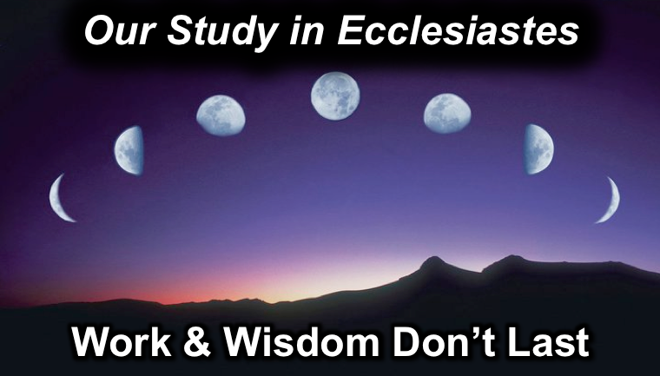
Rick Griffith
12 October 2014
Message 12 of 17

Our Certain Future
Ecclesiastes 9:1-10

Introduction

We live in a day when the future is so uncertain. (BTW, it's always been like this!)

How do people deal with their uncertain future?

How do others respond to their uncertain future?

Materialism: "You can only enjoy the good life now—so supply yourself!"

Hedonism: "Pleasure's the only thing to enjoy before you die—so live it up!"

Humanism: "There is no afterlife to live for anyway—so exalt yourself!"

Fatalism: "The game of the future is rigged—so resign yourself!"

How do you respond to an unknown future? What is your greatest fear or struggle as it relates to the future? Write this down here.

How should you respond to an _______________ future?

Today we will first see our reality (9:1-6) and then see how to respond (9:7-10).

I. Your _______________ future includes _______________ death (9:1-6).

Even godly and wise people don't know if God will allow others to love or hate them (9:1).

No one will escape death, the common fate for all (9:2-3).

Life is still better than death (9:4-6).

II. Since you’ll die, _____________ life and work _____________ now (9:7-10).

Enjoy life as God enables (9:7-9).

Eat and drink in happiness, realizing that enjoying God's good gifts shows that God approves of your works (9:7; cf. 5:18-6:2).

Dress nicely (9:8a).

Use pleasant lotion (9:8b).

Enjoy your spouse as a reward in life (9:9).

Work hard while you can (9:10).

Conclusion

Since you don’t know ____________________, enjoy life and work hard (Main Idea).

What one practical step can you take this week in this area in order to enjoy life more, including diligence in work? Make this goal both:

Measureable: The goal should be specific enough to be able to pinpoint whether it was achieved or not.

Realistic: The goal should be attainable in a week's time.

This week I will…

Thought Questions

- Read the passage aloud. Contrast those things that are certain and uncertain:

Certain | Uncertain

- How does the chart below help us understand verses 4-6?

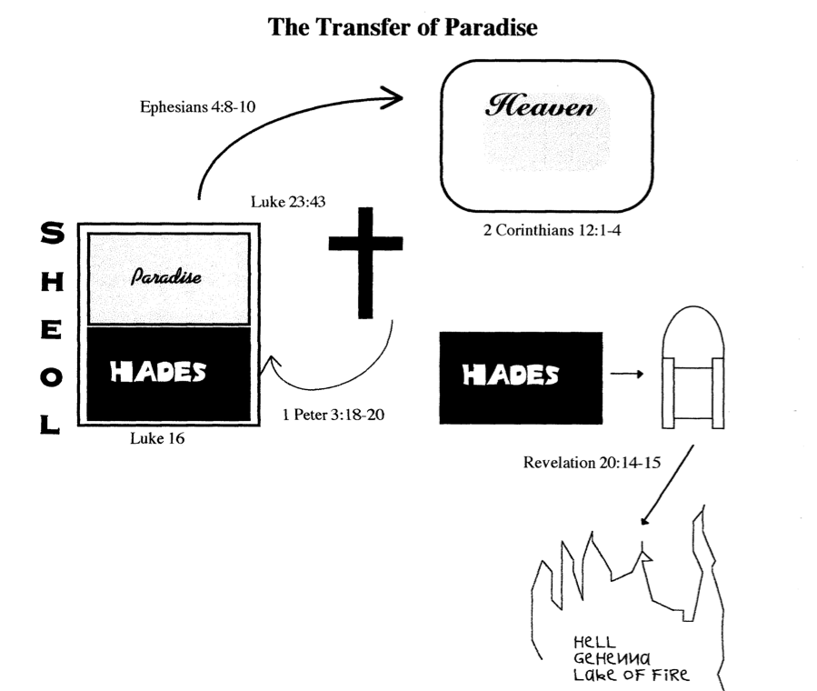

- What “This week I will…” did you make at the end of the sermon?

