The Riley Center, Fort Worth, TX (Dr. Sing Dedication Service) Dr. Rick Griffith

7 Dec 2024 Single Message

NLT 15 Minutes

Title

**The Great Commandment**

***Deuteronomy 6:4-6***

**Topic:** Love

**Subject:** What is the ***most important command*** that you could follow?

**Complement:** Love the LORD above all else.

**Purpose:** The listeners will love the LORD above all else.

**Attribute:** Love

**Meditation:** Deut 6:4-6

**Reading:** Ps 126; Matt 9:35-38

# Introduction

Most important?

### Interest: What is the most important thing you can do? If you had to sum up all the thousands of things you could do, what is the number 1 activity?

### Need: Tell the person next to you. Maybe you said…

• 4 animations

#### Some think ***reading the Bible*** is most important.

#### Others might say ***prayer***, singing, or fellowship.

#### Still, others may claim that others may claim that serving the Lord by ***telling others about Jesus*** is most important.

#### Others might claim that the most critical activity is obedience, investing your money in eternity, or something else. But…

### Subject: What is the ***most important command*** that you could follow?

Subject

Past & Future

### Background: Dr Sing stands on the edge of a whole new stage of his post-PhD life, so the words of Moses for Israel’s future in Canaan can instruct us.

Moses Preaching

#### Literary

Moses at Moab (1:1)

##### Moses was preaching to Israel just before they entered the Land.

Big Ten

##### He had just reiterated the Ten Commandments to them, as they had been given to the previous generation 40 years earlier.

##### But which of these ten is most important? Most of us cannot grasp a ten-point sermon!

##### We see him in the next chapter sum it all up for us. Which is most important? Is there just one of them to help us follow the other nine?

##### Actually, there is one command outside of The Ten that will help us follow all Ten! Do you want to know what it is?

#### Historical

40 Years?

##### Moses taught the new generation of Israel just before they entered the Land. Their parents had failed to trust the LORD to bring them into their inheritance nearly 40 years earlier. Would the next generation make the same mistake?

##### After all, before them lay tall, fortified walled cities. Some even had giants! Over 40 kingdoms spread out across Canaan, but if they worked together against Israel, they could destroy them.

Cross to Jericho

##### The one command Moses says here can help not only Dr Sing as he faces his future but all of us! How can we face a challenging future with confidence?

### Text: Deuteronomy 6:4-6 shows us this most essential command.

Deut 6:4-6

### Preview: The focus of these three verses is the middle one that commands us what to do. Before that is the basic confession of faith in Judaism. After it is how we can do what he tells us to do. So, we have the basis (4), the command (5), and the way to follow the command (6).

• 5-4-6

Basis

(What is the ***most important foundation*** of our faith? = Intro to MPI)

Circle

# I. Know that you have but one God (4).

[Realize that the LORD—and only the LORD—exists.]

Shema

## “The LORD (Yahweh) is totally unique” (Jack Deere, BKC).

## Israel must listen (4a).

## Israel’s God is the LORD alone (4b).

## The LORD alone is God (4c).

## Some may think that there exist other gods, but worshipping them is devotion to unpredictable, sinful, bloodthirsty, immoral beings.

## But the true God provides security and simplicity.

Command

(But how should we relate to this true God? Fear? Dread? What is the ***most important command*** that you could follow? The next verse tells us that our key role is to…)

# II. Love the LORD above all else (5).

Heart

[Show utmost devotion to God instead of to lesser things.]

6:4-5 Text

## What does it mean to love the LORD?

### This is not a feeling but a commitment. When I tell my wife I love her, I am not saying I feel gushy towards her. It means that I am devoted to her.

### Loving the LORD means being devoted to him as your priority.

## We all love something and someone, but loving anything more than the LORD God does not make sense. Jesus said to love people but as ***equally*** important, while most see it as ***more*** important (Mark 12:29-31). Jesus was also asked which commandment was most important, and he responded by quoting the Shema —and he added loving him with our minds.

Jesus Quotes

## We must love God in three ways:

### Love Him with all your heart—wholehearted, not half-hearted.

### Love Him with all your soul—permeating every aspect of your being.

### Love Him with all your strength—not wasting your energy on lesser pursuits.

## Israel considered this command to love the LORD the most important.

Shema

### Moses shouts, “Listen, O Israel,” to get the people’s attention on the most important thing he can say.

### Jews today recite this verse daily as the *Shema* (“Listen!”) because it is the most fundamental recitation of the entire Law of Moses.

Synagogue

### Jews place this verse at the front of their synagogues.

Way

6

(What is the ***most important way*** that you could follow God’s command to love him?)

CIC   
Vision

# III. Obedience flows from love (6-9).

[We cannot love God without obeying; we cannot obey without loving God.]

6:6-7

## Repeat God’s Word everywhere! If you love God, you will do all you can to know what he says so that you can obey him (6-7).

### If you speak of God’s love on the road and at home, that is every place!

### If you share his words from getting up to going to bed, that is all day.

## The idea is for parents to continually teach their children God’s laws so they can love him (8).

6:8

### If you tie these commands to love him on your heads and hands, the Word of God will impact what you think and do.

### This is also the verse that Jews tied on their wrists and put into little boxes on their foreheads in Jesus’ day. They still do it today.

Phylactery (2 slides)

### If you remind yourself of his laws while entering your house and yard, you will have no excuse not to obey him.

6:9

### Jews also put it into mezuzahs on their doorframes.

Subject

Mezuzah

(So, Dr Sing, as you stand on the threshold of this new stage of life, what is the most critical command you could follow?)

# Conclusion

Main Idea

### Love the LORD above all else (MI).

### Jesus called loving God the Great Commandment.

Great Command

### Main Points: How do you love God the most?

MPI

#### Know that you have but one God (4).

MPII

#### Love the LORD above all else (5).

MPIII

#### Obedience flows from love (6).

### Exhortation

#### Paul said that of the three essential virtues—faith, hope, and love—that love was the greatest.

1 Cor 13

#### Make your love for God the most significant thing about you.

Prayer

### Prayer

# Preliminary Questions

**Verses Questions**

# Context: What did the author record just prior to this passage?

### Moses was preaching to Israel just before they entered the Land.

### Moses had just reiterated the Ten Commandments to them, as they had been given to the previous generation 40 years earlier.

# Purpose: Why is this passage in the Bible?

### But which of these ten is most important? Most of us cannot grasp a ten-point sermon!

### Here we see him in the next chapter sum it all up for us. Which is most important? Is there just one of them that will help us follow the other nine?

### Actually, there is one command outside of these ten that will help us follow all Ten! Do you want to know what it is?

# Background: What historical context helps us understand this passage?

### Moses was preaching to the new generation of Israel just before they entered the Land. Their parents had failed to trust the LORD to bring them into their inheritance nearly 40 years earlier. Would the next generation make the same mistake?

### After all, before them lay tall, fortified walled cities. Some even had giants! Over 40 kingdoms spread out across Canaan, but if they worked together against Israel, they could destroy them.

### What Moses says here can help not only Dr Sing as he faces his future, but all of us! How can we face a challenging future with confidence?

# Questions

### How can we tell which of the Ten Commandments is most important?

#### Moses shouts, “Listen, O Israel” to get the people’s attention on the most import thing that he can say.

#### Jews today recite this verse daily as the *Shema* (“Listen!”) because it is the most fundamental recitation of the entire Law of Moses.

#### This is also the verse that Jews tie on their wrists and put into little boxes on their foreheads.

#### They also put it into mezuzahs on their doorframes and put at the front of their synagogues.

#### Jesus was also asked which commandment is most important, and he responded by quoting the Shema.

### What does it mean that “The LORD is our God, the LORD is one!” (6:4 NASB)?

### Why would love be the most important command?

### What does it mean to love God?

### What is the difference between loving God with your heart and soul?

# Tentative Subject/Complement Statements

Love the LORD above all else.

# Possible Illustrations

## Deuteronomy commands love for the LORD at least 11 times:

### Deut. 6:5 And you must love the LORD your God with all your heart, all your soul, and all your strength.

### Deut. 7:9 Understand, therefore, that the LORD your God is indeed God. He is the faithful God who keeps his covenant for a thousand generations and lavishes his unfailing love on those who love him and obey his commands.

### Deut. 10:12    “And now, Israel, what does the LORD your God require of you? He requires only that you fear the LORD your God, and live in a way that pleases him, and love him and serve him with all your heart and soul.

### Deut. 11:1    “You must love the LORD your God and always obey his requirements, decrees, regulations, and commands.

### Deut. 11:13    “If you carefully obey the commands I am giving you today, and if you love the LORD your God and serve him with all your heart and soul,

### Deut. 11:22    “Be careful to obey all these commands I am giving you. Show love to the LORD your God by walking in his ways and holding tightly to him.

### Deut. 13:3 do not listen to them. The LORD your God is testing you to see if you truly love him with all your heart and soul.

### Deut. 19:9 you must designate three additional cities of refuge. (He will give you this land if you are careful to obey all the commands I have given you—if you always love the LORD your God and walk in his ways.)

### Deut. 30:6    “The LORD your God will change your heart and the hearts of all your descendants, so that you will love him with all your heart and soul and so you may live!

### Deut. 30:16 For I command you this day to love the LORD your God and to keep his commands, decrees, and regulations by walking in his ways. If you do this, you will live and multiply, and the LORD your God will bless you and the land you are about to enter and occupy.

### Deut. 30:20 You can make this choice by loving the LORD your God, obeying him, and committing yourself firmly to him. This is the key to your life. And if you love and obey the LORD, you will live long in the land the LORD swore to give your ancestors Abraham, Isaac, and Jacob.”

# Possible Applications

### Text

**The Great Commandment**

***Deuteronomy 6:4-6***

**Exegetical Outline (Steps 2-3)**

# *Exegetical Idea*: The way Israel could follow the vital command was to show their love for the LORD above all else by obeying his commands.

# I. The focus of Israel’s attention should be on the LORD instead of any other God (4).

## Israel must listen (4a).

## Israel’s God is the LORD alone (4b).

## The LORD alone is God (4c).

# II. The most important command that Israel could follow was to love the LORD above all else (5).

## Love Him with all your heart—wholehearted, not half-hearted (5a)

## Love Him with all your soul—pervading every aspect of your being (5b).

## Love Him with all your strength—not wasting your energy on lesser pursuits (5c).

# III. The way Israel could love God with all their hearts was to obey him (6).

**Purpose or Desired Listener Response (Step 4)**

The listeners will love the LORD above all else.

**Homiletical Outline** (Cyclical inductive form)

# Introduction

### Interest: What is the most important thing you can do? If you had to sum up all the thousands of things you could do, what is the number 1 activity?

### Need: Tell the person next to you. Maybe you said…

#### Some think ***reading the Bible*** is most important.

#### Others might say ***prayer***.

#### Still, others may claim that ***telling others about Jesus*** is most important.

#### Others might claim that the most important activity is fellowship, obedience, investing your money in eternity, or something else. But…

### Subject: What is the ***most important command*** that you could follow?

### Background: Dr Sing stands on the edge of a whole new stage of his post PhD life, so the words of Moses for Israel’s future in Canaan can instruct us.

#### Literary

##### Moses was preaching to Israel just before they entered the Land.

##### He had just reiterated the Ten Commandments to them, as they had been given to the previous generation 40 years earlier.

##### But which of these ten is most important? Most of us cannot grasp a ten-point sermon!

##### We see him in the next chapter sum it all up for us. Which is most important? Is there just one of them that will help us follow the other nine?

##### Actually, there is one command outside of The Ten that will help us follow all Ten! Do you want to know what it is?

#### Historical

##### Moses taught the new generation of Israel just before they entered the Land. Their parents had failed to trust the LORD to bring them into their inheritance nearly 40 years earlier. Would the next generation make the same mistake?

##### After all, before them lay tall, fortified walled cities. Some even had giants! Over 40 kingdoms spread out across Canaan, but if they worked together against Israel, they could destroy them.

##### The one command Moses says here can help not only Dr Sing as he faces his future, but all of us! How can we face a challenging future with confidence?

### Text: Deuteronomy 6:4-6 shows us this most important command.

### Preview: The focus of these three verses is the middle one that commands us what to do. Before that is the basic confession of faith in Judaism. After it is the way we can do what he tells us to do. So, we have the foundation (4), the command (5), and the way to follow the command (6).

(What is the ***most important foundation*** of our faith? = Intro to MPI)

# I. Know that you have but one God (4).

[Realize that the LORD—and only the LORD—exists.]

## “The LORD (Yahweh) is totally unique” (Jack Deere, BKC).

## Israel must listen (4a).

## Israel’s God is the LORD alone (4b).

## The LORD alone is God (4c).

## Some may think that there exist other gods, but worshipping them is devotion to unpredictable, sinful, bloodthirsty, immoral beings.

## But the true God provides security and simplicity.

(But how should we relate to this true God? Fear? Dread? What is the ***most important command*** that you could follow? The next verse tells us that our key role is to…)

# II. Love the LORD above all else (5).

[Show utmost devotion to God instead of to lesser things.]

## What does it mean to love the LORD?

### This is not a feeling but a commitment. When I tell my wife I love her, I am not saying I feel gushy towards her. It means that I am devoted to her.

### Loving the LORD means being devoted to him as your first priority.

## We all love something and someone, but loving anything more than the LORD God does not make sense.

## We must love God in three ways:

### Love Him with all your heart—wholehearted, not half-hearted.

### Love Him with all your soul—permeating every aspect of your being.

### Love Him with all your strength—not wasting your energy on lesser pursuits.

## Israel considered this command to love the LORD the most important.

### Moses shouts, “Listen, O Israel,” to get the people’s attention on the most important thing he can say.

### Jews today recite this verse daily as the *Shema* (“Listen!”) because it is the most fundamental recitation of the entire Law of Moses.

### This is also the verse that Jews tie on their wrists and put into little boxes on their foreheads.

### They also put it into mezuzahs on their doorframes and placed this verse at the front of their synagogues.

### Jesus was also asked which commandment was most important, and he responded by quoting the Shema.

(What is the ***most important way*** that you could follow God’s command to love him?)

# III. Obedience flows from love (6-9).

[We cannot love God without obeying; we cannot obey without loving God.]

## Jesus said, “If you love me, you will obey me.”

## We see a similar truth here: if you love God, you will do all you can to know what he says so that you can obey him (6).

## The idea is for parents to continually teach their children God’s laws so they can love him (7-9).

### If you speak of God’s love while on the road and at home, that is pretty much all the time!

### If you share his words, from getting up to bed, that is all day.

### If you tie these commands to love him on your heads and hands, the Word of God will impact what you think and do.

### If you remind yourself of his laws while entering your house and yard, you will have no excuse not to obey him.

(What is the most critical command you could follow?)

# Conclusion

### Love the LORD above all else (MI).

### Main Points: How do you love God the most?

#### Know that you have but one God (4).

#### Love the LORD above all else (5).

#### Obedience flows from love (6).

### Exhortation

#### Jesus called loving God the Great Commandment.

#### Paul said that of the three essential virtues—faith, hope, and love—that love was the greatest.

#### May your love for God be the most significant thing about you.

### Prayer

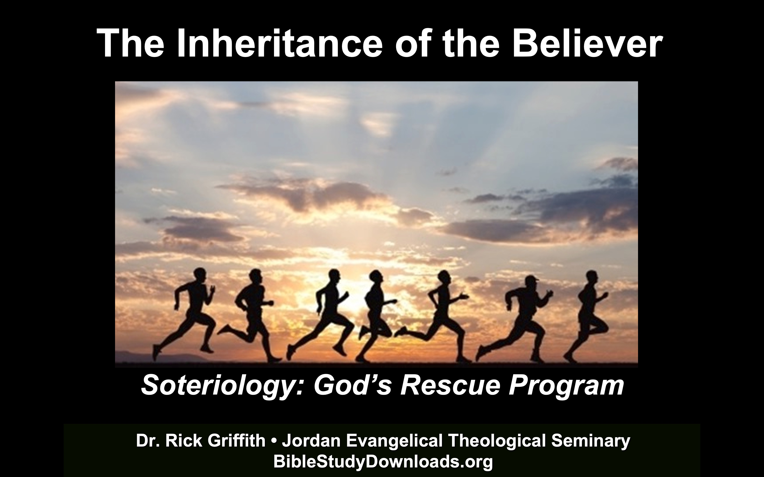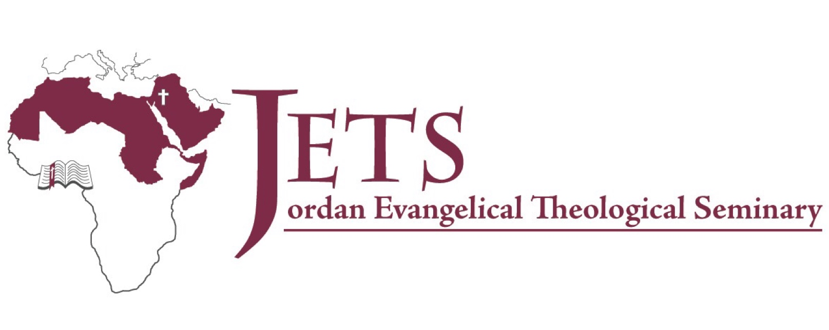

**Rick Griffith**

2024

Message of 4

**Title**

***Passage***

# Introduction

Subject with a blank for the key word _______________ blank answer in hidden text

# I. MP has a blank for the key word ________________ answer (verses).

## SP has a blank for the key word ________________ answer (verses).

## SP has a blank for the key word ________________ answer (verses).

## SP has a blank for the key word ________________ answer (verses).

# II. MP has a blank for the key word ________________ answer (verses).

## SP has a blank for the key word ________________ answer (verses).

## SP has a blank for the key word ________________ answer (verses).

## SP has a blank for the key word ________________ answer (verses).

# Conclusion

### Main Idea has a blank for the key word ________________ answer (verses).

### Application question

**Thought Questions**

1. Read the passage aloud. Contrast:

|  |  |
| --- | --- |
| **Issue** | **Contrast** |
| Text | Text |
| Text | Text |
| Text | Text |
| Text | Text |
| Text | Text |
| Text | Text |
| Text | Text |
| Text | Text |
| Text | Text |

1. Text-based question

Text

Text

Text

Text

1. Application to your own Christian experience

Text

Text

Download this sermon PPT and notes for free at BibleStudyDownloads.org/resources/new-testament-preaching/