Singapore Bible College Homiletics 1 Course Dr. Rick Griffith
Title
Peter Kwon, 2020 Message 3
NLT 15 Minutes
The Last Opportunist
2 Samuel 2:12–3:39

Topic: Faithfulness
Subject: God complete his will
Complement: God makes the man he chooses strong to win, but the opponent weakens and punishes him.
Purpose: The listeners will replace their opportunistic attitude with trust in God.
Meditation: How can we trust God more in the midst of hardship?
Benediction: Matthew 16:24

Introduction

Interest: What do you do when your interests and benefits conflict with God's will?

Sometimes there are moments when we know God's will but hesitate to obey because of our interest.

For example, will we work for a famous company that requires work on Sundays rather than a company where we can keep the Lord's Day even with a small salary?

Need: What decision would you like to make?

What principles do you have to resolve these conflicts?

We shouldn't be opportunistic depending on the situation.

Main Idea: God makes opportunists who rely on themselves and pursue their own interests fall.

Background: David’s rival Abner was such an opportunist.

David was crowned king by the people in Hebron (2:1-7). But Ish-Bosheth, son of Saul, ruled Mahanaim with the help of Abner. But Abner was real ruler in Mahanaim. How would Abner act when he knew what God's will would be? Sadly, he continued to act opportunistically for his own benefit.

But unlike Abner, David, whom God chose, showed interest in what God would do. God brought these two men to radically different outcomes.

Preview/Subject: Today we will see three ways that God responds to the opportunist.

(So what is first way that God responds to the opportunist?)

I. God sometimes allows opportunists to succeed (2:12-32).
[The Lord lets selfish people serve themselves and still benefit—for a time.]

An opportunist always seeks his own interests. (2:12-17)

Abner wars against David (2:12-13).

Opportunists like Abner do anything for their own benefit.

He provokes war to show off his strength.

Abner doesn't value his men's lives (2:14-16)

And he doesn't value the lives of his men in that war.

He throws away his men's lives in a playful manner.

Abner loses the war and runs away (2:17).

Eventually, the loyal army of David defeats Abner soldiers.

Abner is chased away by David's soldiers.

Trials also make a man of faith suffer as in Asahel’s death (2:18-23).

Asahel follows Abner to the end.

But Asahel is stabbed to death by Abner's skilled spear.

The war stops (2:24-32).

His true nature is revealed in disadvantageous circumstances (2:24-25).

Abner requests to Joab an end to the war.

This happens even though Abner started the war.

The war stops and Abner comes to life (2:27-30).

Joab buries Asahel in Jerusalem.

Joab accepts his demands and stops the war. And he holds a funeral for his brother in Jerusalem.

(What is second way that God responds to the opportunist?)

II. God makes the wicked weak (3:1-5).
[The LORD assures that the opportunist gets feebler.]

God gives us proof of his company (3:1).

God sometimes allows the intentions of the wicked as they are. The righteous suffer from it. But God has a big plan beyond that. God allows the intentions of the wicked, but it is temporary.

God's way of treating evil men makes them weaker and weaker.

God shows the evidence of company with David he chose. God makes David stronger and stronger, while the house of Saul becomes weaker and weaker.

Blessings of God appear to the man of God (3:2-5).

God allows many children to David.

Sons were a symbol of blessing.

(What is third and final way that God responds to the opportunist?)

III. God eventually makes an opportunist fall (3:6-39).
[The LORD assures that the opportunist will finally fail.]

How does God deal with the wicked at the end?

Illustration: Sometimes we become shortsighted and end up doing things that are penny wise and pound foolish.

A church friend chose a company with a high salary after graduation, but was unable to attend Sunday services. after time passes, he became exhausted and left the company in less than three years. He lost his health and faith while following his immediate interests.

Abner thinks only of his own interests in every situation. (3:6-11).

Abner was alienated from Ish-Bosheth (3:6-8).

Abner takes the concubine of Saul.

Abner was scolded by Ish-Bosheth for this and thought of another benefit.

Abner decides to betray Ish-Bosheth (3:9-11).

Abner made a covenant with David and returned Michal (3:12-21).

The opportunist takes God's will and makes decisions favorable to himself.

Abner would have thought he could have more power in a unified Israel. Or he might have tried to check on David's situation under the pretext of reconciling. It's not clear what he intended, but what's clear is that he went after his own interests.

God upsets the opportunist's plans (3:22-39).

God punishes Abner, the opportunists (3:22-30).

God hit him at the last minute.

God killed him by hand of Joab when Abner thought his intentions were successful.

God makes all the intentions of the faithful manifest (3:31-39).

All Abner's intentions became a tool for David, who obeys God's will.

As a result, David became king of a unified Israel.

Conclusion

God judges the opportunist who only seeks his own interests (MI).

Main Points

MPI : God sometimes allows opportunists to succeed (2:12-32).

MPII : God makes the wicked weak (3:1-5).

MPIII : God eventually makes an opportunist fall (3:6-39).

Exhortation

Don’t envy the opportunist for being temporarily prosperous. God will treat them with righteousness.

Don’t worry about spending money for obeying God's will because God will surely repay you.

Those who desire God's favor should not disobey God's will for the sake of a temporary immediate benefit. Let's find a small task that obeys God's will, not for our own benefit today.

Preliminary Questions

Verses Questions

Context: What did the author record just prior to this passage?

David is moving to Hebron from Philistine.

The Judah made David their king.

David blessed Jabesh-Gilead because they buried Saul faithfully.

Purpose: Why is this passage in the Bible?

This passage describes the process of how a unified Israel kingdom is formed by David following the God will.

It shows that God's promise is faithfully kept.

It shows that God is behind all the events.

Background: What historical context helps us understand this passage?

David was crowned king by the people in Hebron.

Ish-bosheth son of Saul rules Mahanaim with the help of Abner.

David praises Jabesh-gilead for his loyalty to Saul.

Abner was real ruler in Mahanaim.

Questions

Why did Asahel pursue Abner to the end?
: Expression his royalty to David.
: God also uses his death to become an important event for the unification of Israel.

What is the connection between Abner and Rizpah, and David and Michal?
: Abner is a manifestation of his human desire to show his power in Mahanaim through Rizpah. David revealed his ambition for the king of unified Israel through Michal.

What is revealed through David's house becoming strong and Saul's house becoming weak?
: God’s will complete. Man's greed cannot prevail over God's will.

What is the reason that David required Michal to Abner?
: David want to get the heart of whole Israel by reuniting with Saul’s daughter.

Why did David mourn for Abner's death so much?
: To reveal that David, who wants a peaceful reunification of Israel, had nothing to do with the death of Abner.

Why did Joab kill Abner without David knowing it?
: This is because he wanted revenge for Asahel's death and thought he could become a rival when unification came in the future.

Why didn't David hold Joab responsible for the death of Abner?
: Revealing one's innocence was considered more important than punishing Joab. He may have guessed that God would unify Israel peacefully through the death of Abner, so he might have understood it as an event in which God's will was completed.

What is the meaning of David's marriage to the daughter of King Geshur in the north?
: It shows that David also wanted to get strength through a political marriage. It shows that David is not perfect.

Sources

McCarter, P. Kyle, Jr. 2 Samuel A New Translation with Introduction, Notes and Commentary.The Anchor Bible. (NY: Doubleday & Company, 1984).

Barron, Robert, Brazos Theological Commentary On the Bible, (MI; Grand Rapid Publisher, 2015).

Vannoy, J Robert, and Philip W. Comfort., ed, Tyndale Cornerstone Biblical Commentary, (IL; Tyndale House Publishers, 2009).

Tentative Main Ideas

Text

Illustrations That Apply

Text

Old Testament Survey Notes

The Last Opportunist
2 Samuel 2:12-3:39

Exegetical Outline (Steps 2-3)

Exegetical Idea (CPT): The way God completed his will was to choose David to win and weaken the opportunist Abner.

I. The way God accomplished His will was by using a war through the wicked Abner (2:12-32).

God made David’s men win Abner’s (2:12-17).

Asahel died in the war field by Abner (2:18-23).

Abner proposed a cease-fire in opportunistic behavior (2:24-32).

II. The way God completed His will was to strength David whom He chose (3:1-5).

David's house grew stronger and Saul's house grew weaker (3:1).

David had six sons born in Hebron (3:2-5).

III. The way God completed His will was to punish Abner who opposed him (3:6-39).

Abner betrayed Ish-Bosheth (3:6-11)
  - Abner promised to help David become king of Israel. (3:12-21)

Abner was murdered by Joab (3:22-30)

David mourned Abner (3:31-39)

Purpose or Desired Listener Response (Step 4)
The listeners will replace their opportunistic attitude with trust in God.

Homiletical Outline (Cyclical deductive form)

Introduction

Interest: What do you do when your interests and benefits conflict with God's will?

Sometimes there are moments when we know God's will but hesitate to obey because of our interest.

For example, will we work for a famous company that requires work on Sundays rather than a company where we can keep the Lord's Day even with a small salary?

Need: What decision would you like to make?

What principles do you have to resolve these conflicts?

We shouldn't be opportunistic depending on the situation.

Main Idea: God makes opportunists who rely on themselves and pursue their own interests fall.

Background: David’s rival Abner was such an opportunist.

David was crowned king by the people in Hebron (2:1-7). But Ish-Bosheth, son of Saul, ruled Mahanaim with the help of Abner. But Abner was real ruler in Mahanaim. How would Abner act when he knew what God's will would be? Sadly, he continued to act opportunistically for his own benefit.

But unlike Abner, David, whom God chose, showed interest in what God would do. God brought these two men to radically different outcomes.

Preview/Subject: Today we will see three ways that God responds to the opportunist.

(So what is first way that God responds to the opportunist?)

I. God sometimes allows opportunists to succeed (2:12-32).
[The Lord lets selfish people serve themselves and still benefit—for a time.]

An opportunist always seeks his own interests. (2:12-17)

Abner wars against David (2:12-13).

Opportunists like Abner do anything for their own benefit.

He provokes war to show off his strength.

Abner doesn't value his men's lives (2:14-16)

And he doesn't value the lives of his men in that war.

He throws away his men's lives in a playful manner.

Abner loses the war and runs away (2:17).

Eventually, the loyal army of David defeats Abner soldiers.

Abner is chased away by David's soldiers.

Trials also make a man of faith suffer as in Asahel’s death (2:18-23).

Asahel follows Abner to the end.

But Asahel is stabbed to death by Abner's skilled spear.

The war stops (2:24-32).

His true nature is revealed in disadvantageous circumstances (2:24-25).

Abner requests to Joab an end to the war.

This happens even though Abner started the war.

The war stops and Abner comes to life (2:27-30).

Joab buries Asahel in Jerusalem.

Joab accepts his demands and stops the war. And he holds a funeral for his brother in Jerusalem.

(What is second way that God responds to the opportunist?)

II. God makes the wicked weak (3:1-5).
[The LORD assures that the opportunist gets feebler.]

God gives us proof of his company (3:1).

God sometimes allows the intentions of the wicked as they are. The righteous suffer from it. But God has a big plan beyond that. God allows the intentions of the wicked, but it is temporary.

God's way of treating evil men makes them weaker and weaker.

God shows the evidence of company with David he chose. God makes David stronger and stronger, while the house of Saul becomes weaker and weaker.

Blessings of God appear to the man of God (3:2-5).

God allows many children to David.

Sons were a symbol of blessing.

(What is third and final way that God responds to the opportunist?)

III. God eventually makes an opportunist fall (3:6-39).
[The LORD assures that the opportunist will finally fail.]

How does God deal with the wicked at the end?

Illustration: Sometimes we become shortsighted and end up doing things that are penny wise and pound foolish.

A church friend chose a company with a high salary after graduation, but was unable to attend Sunday services. after time passes, he became exhausted and left the company in less than three years. He lost his health and faith while following his immediate interests.

Abner thinks only of his own interests in every situation. (3:6-11).

Abner was alienated from Ish-Bosheth (3:6-8).

Abner takes the concubine of Saul.

Abner was scolded by Ish-Bosheth for this and thought of another benefit.

Abner decides to betray Ish-Bosheth (3:9-11).

Abner made a covenant with David and returned Michal (3:12-21).

The opportunist takes God's will and makes decisions favorable to himself.

Abner would have thought he could have more power in a unified Israel. Or he might have tried to check on David's situation under the pretext of reconciling. It's not clear what he intended, but what's clear is that he went after his own interests.

God upsets the opportunist's plans (3:22-39).

God punishes Abner, the opportunists (3:22-30).

God hit him at the last minute.

God killed him by hand of Joab when Abner thought his intentions were successful.

God makes all the intentions of the faithful manifest (3:31-39).

All Abner's intentions became a tool for David, who obeys God's will.

As a result, David became king of a unified Israel.

Conclusion

God judges the opportunist who only seeks his own interests (MI).

Main Points

MPI : God sometimes allows opportunists to succeed (2:12-32).

MPII : God makes the wicked weak (3:1-5).

MPIII : God eventually makes an opportunist fall (3:6-39).

Exhortation

Don’t envy the opportunist for being temporarily prosperous. God will treat them with righteousness.

Don’t worry about spending money for obeying God's will because God will surely repay you.

Those who desire God's favor should not disobey God's will for the sake of a temporary immediate benefit. Let's find a small task that obeys God's will, not for our own benefit today.

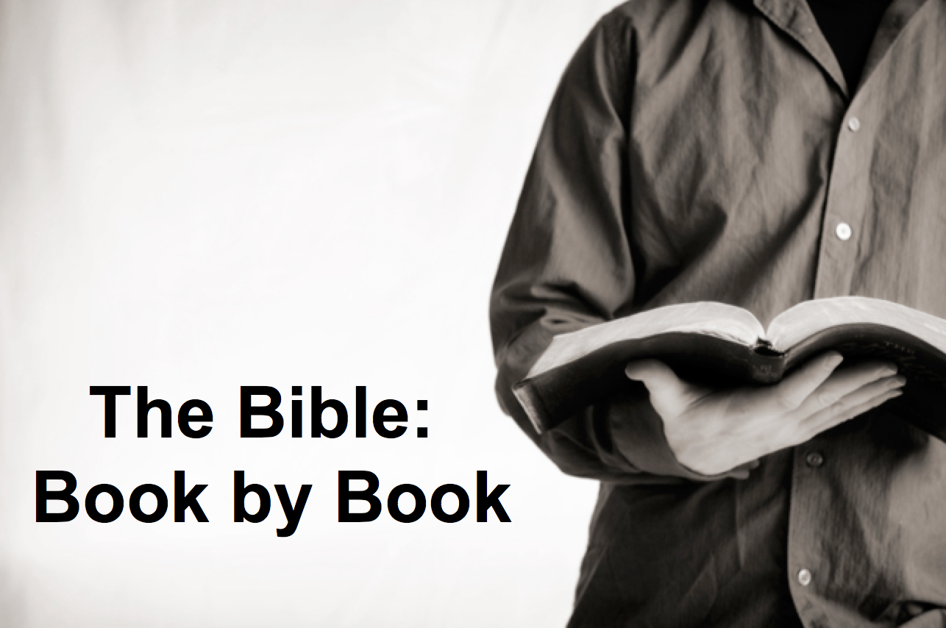

Rick Griffith
2018
Message of 66

Title
Passage

Introduction

Subject with a blank for the key word _______________

I. MP has a blank for the key word ________________ (verses).

SP has a blank for the key word ________________ (verses).

SP has a blank for the key word ________________ (verses).

SP has a blank for the key word ________________ (verses).

II. MP has a blank for the key word ________________ (verses).

SP has a blank for the key word ________________ (verses).

SP has a blank for the key word ________________ (verses).

Conclusion

Main Idea has a blank for the key word ________________ (verses).

Application question

Download this sermon PPT and notes for free at BibleStudyDownloads.org/resource/old-testament-preaching/
Listen to this message online at cicfamily.com/sermon-listing/

BOOK CHART

