Jordan Evangelical Theological Seminary Dr. Rick Griffith
Title
12 April 2022 Message 1 of 13
NLT 15 Minutes
Who Do You Trust?
2 Kings 1

Topic: Trust
Subject: What is the result of idolatry?
Complement: Fight idolatry—not God—or you’ll regret it.
Purpose: The listeners will trust God instead of idols in one area of their lives.
Meditation: 1 Sam. 2:2 “No one is holy like the LORD! There is no one besides you; there is no Rock like our God.”
Reading: 2 Kings 1:1-18 (whole chapter)
Video: “Everyone Worships” (see immediately below)

Introduction

Interest: “Everyone Worships Something” (2:33 video for $14.95 at https://www.worshiphousemedia.com/mini-movies/22223/everyone-worships-something).

Need: What do you worship? Who or what do you ultimately trust in your life? What you trust is what you worship.

Do you trust in money?

Do you seek to trust yourself and your own wisdom?

Where does your current trust ultimately lead?

Of course, if we worship something other than God, the Bible calls that thing idolatry. An idol is anything that we trust or worship that takes the place of God—whether money, sex, friends, education, power, relaxation, whatever. And whatever it is that is priority has certain affects.

Subject: What is the result of idolatry? What happens when we worship something other than God? Where does all this lead?

Background: Israel consistently trusted in idols after the kingdom divided in 931 BC.

For about 100 years, each king in the north was considered evil because he worshipped something other than the true God of Israel.

During Elijah’s day, so God raised up this prophet to confront these kings. Before our text today, he had just warned Ahab of his idolatry, and Ahab had just died in 1 Kings 22 for his misplaced trust.

Text: Our text in 2 Kings 1 picks up just after Ahab’s death to see what happened to Ahab’s son Ahaziah.

Preview: Today we will see God’s warning, what we do instead of trusting God, and ultimately where idolatry leads.

(What is God’s warning that we need to heed?)

I. God warns us not to trust idols (1-8).
[The LORD cautions us that it is foolish to trust anyone or anything else.]

God warned Ahaziah through Elijah not to trust in Baal-zebub (1-8).

God warned Ahaziah that he was not with him by Moab’s rebellion as soon as the king received the crown (1).

God gave Ahaziah a chance to trust him with his serious injury (2a).

But Ahaziah sought the Philistine god Baal-zebub instead of the LORD (2b).

The LORD gave Ahaziah an opportunity to seek him through Elijah (3-8).

God also warns us against trusting in puny idols.

In March 2022, Senator Marsha Blackburn of Tennessee asked Supreme Court nominee Ketanji Brown Jackson, “Can you provide a definition for the word woman?” The judge replied, “I can’t… I am not a biologist!” In other words, her trust was not in the God who made us male and female, but in her own judgment based on her feelings at that moment.

It is idolatry to let others do our thinking for us. God’s Word is clear on many subjects, but too often we trust in our own judgment or the judgment of others rather than what the Bible says.

One result of this is that we have a man swim on the University of Pennsylvania woman’s swim team! Will Thomas swam on the men’s swim team as an average swimmer but then later claimed to be a woman. In 2022 he took all the records as the fastest woman ever—no wonder, since he is a foot taller with a far longer stroke and male muscle mass. It is idolatry to place our trust in what others might think if we don’t admit that the emperor has no clothes. So we fight reality, we fight science, we fight biology, we fight God. What we don’t fight is idolatry!

(Instead of fighting idolatry, what do we often fight instead? Too often…)

II. We fight God’s messengers (9-15a).
[Instead of rejecting dumb idols, we reject teachers of truth!]

Ahaziah tried to arrest Elijah instead of repenting (9-15a).

Instead of repenting of his false trust in an idol, Ahaziah tried to arrest Elijah for telling him the painful truth of his soon death (9a).

Elijah thwarted arrest three times by killing Ahaziah’s solders but Ahaziah still refused to repent (9b-15a).

Too often we fight those representing God instead of fighting idolatry!

Some years ago in Singapore I put 50 practices in the NT before my students and asked them which they thought should be practiced today.

Should we draw straws to determine church leaders (Acts 1)? That is a biblical practice, you know!

Should we practice foot washing? Jesus said to do it (John 13).

Should we have elders in our churches (Acts 13)?

Then I asked the students how they determined which ones they should obey. One particularly honest student admitted, “I practice the ones I want to obey!”

At least he was honest!

You can be sure that you will get pushback if argue for something the Bible teaches but your culture does not like—so we fight Bible teachers with a biblical view of women and we exalt those teachers who go against the Word!

Don’t pick and choose which verses you want to follow.

(Is idolatry a real problem? It is! So where does seeking idols lead? What is the result?)

III. Idolatry leads to our ruin (15b-18).
[Our wrong trust results in a sad end.]

Ahaziah’s idolatry led to his death (15b-18).

Elijah appeared before Ahaziah without being arrested and repeated God’s message of judgment (15b-16).

Ahaziah then died which turned the throne over to his brother Jotham (1:17-18).

Our idolatry has horrible results too.

Maybe we don’t immediately die from idolatry like Ahaziah, but eventually we do die from it.

The cause of death might be listed as a different source on each death certificate, but the cause is ultimately idolatry.

We all die from the same sin of pride and self-sufficiency shown in Genesis 3.

Actually, idolatry has a result even worse than physical death. Our unbelief in the gospel leads us to eternal death in our rejection of God’s offer in Christ so we can trust some other idol. Does that describe you?

(What is the result of idolatry? What happens when we worship something other than God? Where does all this lead and what should we do?)

Conclusion

Fight idolatry—not God—or you’ll regret it (Main Idea).

Main Points: How is this truth seen in the movements of our text?

God warns us not to trust idols (1-8).

We fight God’s messengers (9-15a).

Idolatry leads to our ruin (15b-18).

Exhortation

What idol are you trusting?

If you are that idol, trust in Jesus instead of trusting in your own works to bring you to God.

But you can know Christ and yet still have another idol—like porn, like your savings, like a relationship that you know does not honor God.

How can you actively trust the LORD instead?

Place your faith in Christ’s death for you.

Place your idol on the altar of your heart and ask God to consume it.

Then replace that idol with trust in the true and living God who can give you a new habit to replace that old idol.

Prayer

Preliminary Questions

Verses Questions

Context: What did the author record just prior to this passage?

This division of the book of Kings begins the second half that we call 2 Kings 1.

The main event in the previous chapter in 1 Kings 22 is Ahab’s stubbornness to obey the LORD resulting in his death.

Purpose: Why is this passage in the Bible?

Here we find that Ahab’s son Ahaziah is just like his father in seeking false gods instead of the LORD—and the result is the same.

This teaches us the futility of idolatry.

Background: What historical context helps us understand this passage?

The northern kingdom of Israel up to this point has had only terrible kings whose evil led to horrible consequences.

God led Elijah to confront these kings over their evil ways, but their message was largely ignored.

Questions

How does the rebellion of Moab after Ahab’s death fit the context about Ahaziah’s trust in idols (1)?

Why would Ahaziah trust in Ekron’s god Baal-zebub (2)?

How was it right for Elijah to kill Ahaziah’s soldiers for the sins of their king?

Tentative Subject/Complement Statements

Reasons God punishes us

Possible Illustrations

Text

Possible Applications

Text
Who Do You Trust?
2 Kings 1

Exegetical Outline (Steps 2-3)

Exegetical Idea: The result of Ahaziah’s idolatry by fighting Elijah was the king’s death.

I. The warning of Ahaziah by Elijah was not to trust in Ekron’s god Baal-zebub (1:1-8).

God warned Ahaziah that he was not with him by Moab’s rebellion as soon as the king received the crown (1).

God gave Ahaziah a chance to trust him with his serious injury (2a).

But Ahaziah sought the Philistine god Baal-zebub instead of the LORD (2b).

The LORD gave Ahaziah an opportunity to seek him through Elijah (3-8).

II. The response of Ahaziah to God warning that he will die from idolatry was to unsuccessfully seek to arrest Elijah (1:9-15a).

Instead of repenting of his false trust in an idol, Ahaziah tried to arrest Elijah for telling him the painful truth of his soon death (9a).

Elijah thwarted arrest three times by killing Ahaziah’s solders but Ahaziah still refused to repent (9b-15a).

III. The result of Ahaziah’s idolatry was his death that turned the throne over to his brother Jotham (1:15b-18).

Elijah appeared before Ahaziah apart from being arrested and repeated his message of judgment (15b-16).

Ahaziah died which turned the throne over to his brother Jotham (1:17-18).

Purpose or Desired Listener Response (Step 4)
The listeners will trust God instead of idols in one area of their lives.

Homiletical Outline (Cyclical inductive form)

Introduction

Interest: Everyone worships something (video).

Need: Who or what do you ultimately trust in your life?

Do you trust in money?

Do you seek to trust yourself and your own wisdom?

Where does your current trust ultimately lead?

Subject: What is the result of idolatry?

Background: Israel trusted in idols during Elijah’s day, so God raised up this prophet to confront the kings—previously Ahab, but he had just died for his misplaced trust.

Preview: Let’s see God’s warning, what we do instead, and where idolatry leads.

Text: Our passage is 2 Kings 1.

(What is God’s warning that we need to heed?)

I. God warns us not to trust idols (1-8).

God warned Ahaziah through Elijah not to trust in Baal-zebub (1-8).

God warned Ahaziah that he was not with him by Moab’s rebellion as soon as the king received the crown (1).

God gave Ahaziah a chance to trust him with his serious injury (2a).

But Ahaziah sought the Philistine god Baal-zebub instead of the LORD (2b).

The LORD gave Ahaziah an opportunity to seek him through Elijah (3-8).

God also warns us against trusting in puny idols.

(Instead of fighting idolatry, what do we often fight instead?)

II. We fight God’s messengers (9-15a).

Ahaziah tried to arrest Elijah instead of repenting (9-15a).

Too often we fight those representing God instead of fighting idolatry!

(Where does seeking idols lead? What is the result?)

III. Idolatry leads to our ruin (15b-18).

Ahaziah’s idolatry led to his death (15b-18).

Our idolatry has horrible results too.

(What is the result of idolatry?)

Conclusion

Fight idolatry—not God—or you’ll regret it (Main Idea).

Main Points: How is this truth seen in the movements of our text?

God warns us not to trust idols (1-8).

We fight God’s messengers (9-15a).

Idolatry leads to our ruin (15b-18).

Exhortation

What idol are you trusting?

How can you actively trust the LORD instead?

Prayer

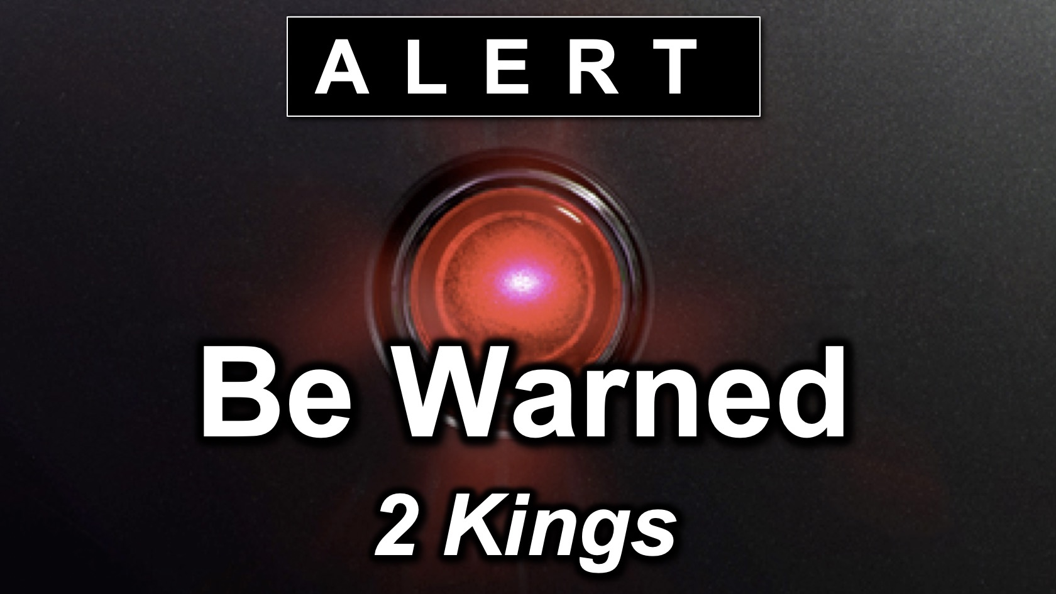
Rick Griffith
12 April 2022
Message 1 of 13

Who Do You Trust?
2 Kings 1

Introduction

Everyone worships something. Who or what do you ultimately trust in your life?

What is the result of idolatry?

Israel trusted in idols during Elijah’s day and Ahab just died for his misplaced trust.

Let’s see God’s warning, what we do instead, and ultimately where idolatry leads.

(What is God’s warning that we need to heed?)

I. God warns us not to trust idols (1-8).

God warned Ahaziah through Elijah not to trust in Baal-zebub (1-8).

God also warns us against trusting in puny idols.

(Instead of fighting idolatry, what do we often fight instead?)

II. We fight God’s messengers (9-15a).

Ahaziah tried to arrest Elijah instead of repenting (9-15a).

Too often we fight those representing God instead of fighting idolatry!

(Where does seeking idols lead? What is the result?)

III. Idolatry leads to our ruin (15b-18).

Ahaziah’s idolatry led to his death (15b-18).

Our idolatry has horrible results too.

(What is the result of idolatry?)

Conclusion

Fight idolatry—not God—or you’ll regret it (Main Idea).

What idol are you trusting?

How can you actively trust the LORD instead?

Download this sermon PPT and notes for free at BibleStudyDownloads.org/resource/old-testament-preaching/

