Advanced Preaching Course, Singapore Bible College Dr. Rick Griffith
2002 Message 1 of 1
NIV 30 Minutes
Dedication of Solomon’s Temple
2 Chronicles 5–7

Topic: Indwelling
Subject: Can God’s people expect God’s blessing throughout their lives?
Complement: God’s presence is as sure as His discipline of our disobedience.
Purpose: The listeners will address sin that hinders God’s blessing.
Attribute: We worship the God who Indwells Us

Issues

Exegetical

1. What was the purpose of Israel having a temple? sacrifice (7:12)? God’s presence (5:13; 7:1)? stability? national identity? a combination of reasons?

2. Did God’s glory fill the temple before (5:14) or after (7:1-2) Solomon’s prayer? or was the temple filled with the glory of God twice in this passage?

3. How could the priests have possibly offered in a single day on a single altar 142,000 animals (7:5) and even more than this (beyond counting in 5:6)? or was this offered in a special place (7:7) over a seven day period (7:8) or a fourteen day period (7:9)?

4. How can the verses about God’s unconditional presence forever at the temple (7:16) be reconciled with the conditional promise of His presence relating to Israel’s obedience (7:20)?

Homiletical

1. How can I preach this entire section of three chapters in a single sermon?

2. Since no temple exists today, where is the point of continuity found in applying this ancient Israelite passage to Christians today?

Exegetical Outline

Prologue: The theme of the books of Chronicles is God’s unconditional faithfulness to the Davidic line in contrast to these descendants’ inconsistent attitude towards the temple. In the first book (1 Chronicles) one can see that the Davidic line is still present throughout the nation’s history (chaps. 1—9) and David models worship with his concern for the ark and abundant temple preparations. In the second account (2 Chronicles) Solomon continues this concern for the temple as the heart of Israel’s worship (chaps. 1—9) but his descendants despise the temple and experience God’s judgment as a result. The text before us is preceded by Solomon’s proper worship and building and furnishing of the temple (chaps. 1—4).

Exegetical Idea: The condition by which God promised continued blessing of his presence after Solomon dedicated the temple was Israel’s repentance and obedience.

I. The result of Solomon’s temple dedication (through bringing the ark into the finished temple, praying, and sacrificing) was God’s presence indwelling the temple. (5:1–7:10)

A. (5:1-3) The setting of the following account was that the temple was finished and furnished with the newly made articles.

B. (5:4-14) The result of the ark being brought from Zion into the new temple was the cloud of God’s presence filling the temple area.

C. (6:1-42) The content of Solomon’s dedicatory prayer was mostly supplication.

1. (6:1-11) Solomon announced God’s blessing on him to the people.
2. (6:12-42 Solomon prayed a public prayer of praise and supplication.
a. (6:12-13) He publicly prostrated himself on the bronze platform.
b. (6:14-15) He praised God for His faithfulness.
c. (6:16-17) He claimed God’s promise to David of a perpetual Davidic ruler.
d. (6:18-21) He prayed for God’s blessing upon the temple.
e. (6:22-39) He requested God’s blessing after His discipline for sins of false oaths, military defeat, drought, famine and plague, and exile and blessing for Gentile prayers from the temple and Israelite military victories.
f. (6:40-42) He prayed for the filling of the temple with God’s presence.

D. (7:1-10) The manner in which Solomon’s temple dedication took place was through numerous sacrifices over a fourteen day period following the appearance of God’s glory and fire.

II. (7:11-22) The conditional, verbal response of the LORD to Solomon’s temple dedication was a promise that it would remain the place of God’s presence only as long as Israel obeyed.

A. (7:11) The time in which God appeared to Solomon in a vision was after completion of both the temple (966-959 BC) and palace (971?-958? BC or 959?-946? BC; cf. 1 Kings 7:1).

Note: Solomon’s temple was 20 (w) x 60 (l) x 30 (h) cubits and took 7 years to complete (1 Kings 6:17, 20, 38) while his palace measured 50 (w) x 100 (l) x 50 (h) cubits and took 13 years to construct (1 Kings 7:1).

B. (7:12-22) The LORD acknowledged that His presence would not abide forever at the temple despite because of His commitment to discipline disobedience of Solomon and Israel.

1. (7:12-16) God warned Solomon that divine discipline was designed to cause God’s people to repent since His intent was for His presence to remain at the temple forever.

2. (7:17-18) God promised Solomon the blessing of a secure throne for obedience.

3. (7:19-22) God warned Israel (plural “you”) of the curse of exile for idolatry.

Homiletical Exposition (simple inductive form) Title: “Temple Treasure”

Arouse Interest and Introduce MPI: Do you like to be with people who despise you? God does!

I. Amazingly, God has always desired to dwell with man.

A. His Spirit hovered over the waters at creation (Gen. 1)

B. He walked with Adam in the cool of the day (Gen. 2).

C. He accompanied Israel in His shekinah glory through the wilderness day-cloud and night-pillar (Numbers).

D. At Solomon’s temple dedication God dwelt with Israel at one, divine location (5:1—7:10).

1. Read 5:1, summarize the ark’s return (5:2-12), and read 5:13-14.
2. Summarize chapter 6 briefly, read 7:1-3, and summarize 7:4-10.

E. God promised that the temple would remain the place of God’s presence only as long as Israel was obedient (7:11-22).

(Introduce Subject: What about God’s presence with us? Can God’s people expect God’s blessing throughout their lives?)

II. God’s presence with us is in some sense contingent too.

A. We Christians have an even more incredible privilege than Israel because we have God’s shekinah Spirit indwelling us (1 Cor. 6:19).

B. While He will not leave us (Heb. 13:5), He will discipline us like He did Israel (Heb. 12:4-13 and illustrations).

Main Idea: God’s presence is as sure as His discipline of our disobedience.

Applications: Have you thanked Him for His indwelling lately? or are you under discipline and need to repent?

Preliminary Questions

Verses Questions

Context: What did the author record just prior to this passage?

Purpose: Why is this passage in the Bible?

Background: What historical context helps us understand this passage?

Questions

Tentative Main Ideas

Text

Illustrations That Apply

Text

Old Testament Survey Notes

Title
Book

Exegetical Outline (Steps 2-3)

Exegetical Idea:

I.

II.

III.

Purpose or Desired Listener Response (Step 4)
The listeners will

Homiletical Outline (Cyclical inductive form)

Introduction

Interest:

Need:

Subject:

Background:

Preview:

Text:

(Transition into MPI here.)

I.
[Restate MP here.]

(Transition into MPII here.)

II.
[Restate MP here.]

(Transition into MPIII here.)

III.
[Restate MP here.]

(Transition into the MI here.)

Conclusion

(MI).

Main Points

Exhortation/Application

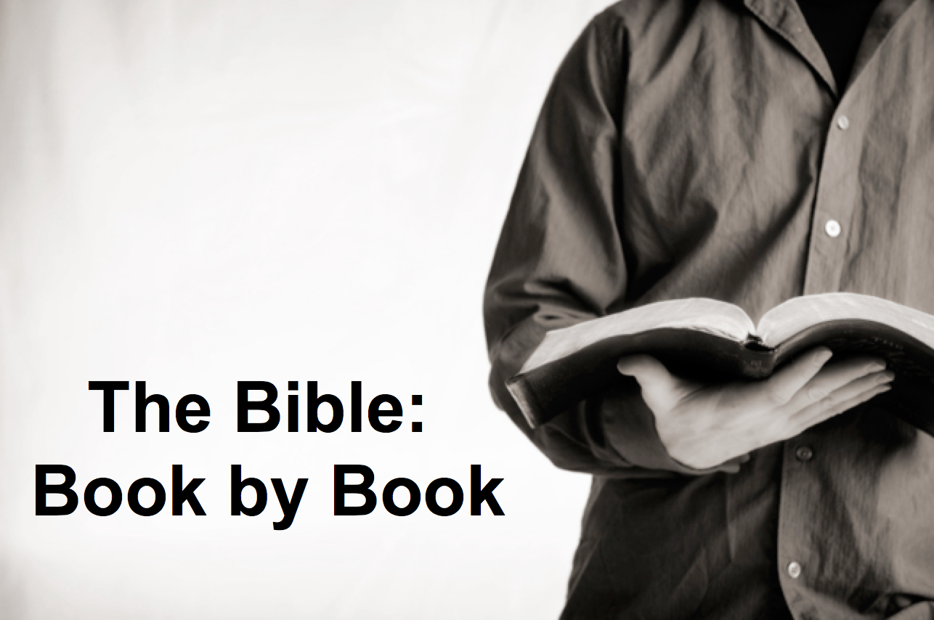

Rick Griffith
2018
Message of 66

Title
Passage

Introduction

Subject with a blank for the key word _______________

I. MP has a blank for the key word ________________ (verses).

SP has a blank for the key word ________________ (verses).

SP has a blank for the key word ________________ (verses).

SP has a blank for the key word ________________ (verses).

II. MP has a blank for the key word ________________ (verses).

SP has a blank for the key word ________________ (verses).

SP has a blank for the key word ________________ (verses).

Conclusion

Main Idea has a blank for the key word ________________ (verses).

Application question

Download this sermon PPT and notes for free at BibleStudyDownloads.org/resource/old-testament-preaching/
Listen to this message online at cicfamily.com/sermon-listing/

BOOK CHART

