Singapore Bible College Dr. Rick Griffith
Title
Sermon edited from Timothy Pang Single Message
NLT 15 Minutes

How to Recognize God’s Calling
1 Samuel 3:1–4:1a

Topic: Calling
Subject: What are the characteristics of God’s calling?
Complement: God’s calling is unexpected, challenging and continuing.
Purpose: The listeners will see that God’s calling is unexpected, challenging and continuing.
Attribute: We worship the God Who Calls

Introduction

Interest: My personal testimony how I was called by God raises the question: this is a call from God?

Need: All of us are called to full time service. How do we know it is God’s calling? How do you know when God wants you to move away from your current ministry? Is it your own call to do what you want rather than what God wants?

Subject: What are the characteristics of God’s calling?

Background: Samuel was called to be a prophet to Israel. His mother dedicated him to the Lord when he was an infant. But what was the role of Samuel in all this?

Preview/Text: Today, we will look at 1 Samuel 3 to find out three characteristics of God’s calling. Let’s look at the process of Samuel’s calling from God. I will split the process of Samuel’s calling into three parts.

(The first characteristic of God’s calling is…)

I. God’s calling is unexpected (3:1-10).
[God often surprises us when he appoints us.]

You do not have duty roster from Heaven (3:1).

Illustration: We do not have audible voice every night telling us what to do.

Too often we expect church leaders to give us direction (3:1-8).

Illustration: We depend more on church leaders rather than on God.

(The second characteristic of God’s calling is…)

II. God’s calling is challenging (3:11-18)
[God wants you to do great things for Him]

You will face difficulties when you serve God (3:11-15).

Illustration: I received negative comments when I quit my job to go to SBC.

You will be supported by God (3:16-18).

Illustration: What is the reason you start a ministry? Jesus Christ is the reason.

(The third characteristic of God’s calling is…)

III. God’s calling is continuing (3:19–4:1a)
[God’s calling is not short term]

You will continue to grow in the Lord (3:19)

Illustration: Who stops growing after answering God’s calling?

You will be recognized as God’s servant (3:20)

You will continue to receive God’s word and preach it to others (3:21-4:1a)

Illustration: No matter what ministry we are in, we still need to read the Bible.

(So what are the characteristics of God’s calling?)

Conclusion

God’s calling is unexpected, challenging and continuing (Main Idea).

Application: Are you called by God or yourselves? Check the process of your calling by asking these three questions:

Are you expecting God will call you into another ministry?

Do you have challenges in your ministry? Every ministry has challenges!

Are you continuing doing what God’s want you to do?

Preliminary Questions

Verses Questions

Context: What did the author record just prior to this passage?

Purpose: Why is this passage in the Bible?

Background: What historical context helps us understand this passage?

Questions

Bibliography

Bergen, Robert D. The New American Commentary; 1, 2 Samuel. Nashville, TN: Broadman & Holman, 1996.

Klein, Ralph W. Word Biblical Commentary: 1 Samuel. Waco, TX: Word, 1983

Tentative Main Ideas

Text

Illustrations That Apply

Text

Old Testament Survey Notes

How to Recognize God’s Calling
1 Samuel 3:1–4:1a

Exegetical Outline (Steps 2-3)

Exegetical Idea: The characteristics of God’s calling for Samuel to become the prophet of Israel were unexpected, challenging and continuing.

I. The characteristic of God’s calling of Samuel was unexpected (3:1-10).

Words of the LORD and visions were rare during the days of Eli (3:1).

Samuel mistook God's calling as Eli's three times (3:2-10).

II. The characteristic of God’s calling of Samuel was challenging (3:11-18).

Samuel was afraid to tell God's judgment to Eli (3:14-15).

Samuel told Eli and Eli accepted the judgment (3:16-18).

III. The characteristic of God’s calling of Samuel was continuing (3:19-4:1a).

Samuel continued to grow with the Lord (3:19).

Samuel was recognized by the Israel as their prophet (3:20).

Samuel continued to receive God’s word and spread it to all Israel (3:21-4:1a).

Purpose or Desired Listener Response (Step 4)
The listeners will see that God’s calling is unexpected, challenging and continuing.

Homiletical Outline

How to Recognize God’s Calling
1 Samuel 3:1–4:1a
(Cyclical Inductive)

Homiletical Outline (Cyclical inductive form)

Introduction

Interest: My personal testimony how I was called by God raises the question: this is a call from God?

Need: All of us are called to full time service. How do we know it is God’s calling? How do you know when God wants you to move away from your current ministry? Is it your own call to do what you want rather than what God wants?

Subject: We can recognize God’s calling by examining the characteristics of God’s calling.

Background: Samuel was called to be a prophet to Israel. His mother dedicated him to the Lord when he was an infant. But what was the role of Samuel in all this?

Preview/Text: Today, we will look at 1 Samuel 3 to find out three characteristics of God’s calling. Let’s look at the process of Samuel’s calling from God. I will split the process of Samuel’s calling into three parts.

(The first characteristic of God’s calling is…)

I. God’s calling is unexpected (3:1-10).
[God often surprises us when he appoints us.]

You do not have duty roster from Heaven (3:1).

Illustration: We do not have audible voice every night telling us what to do.

You always expect church leader’s to give your direction (3:1-8).

Illustration: We depend more on church leaders rather than on God.

(The second characteristic of God’s calling is…)

II. God’s calling is challenging (3:11-18)
[God wants you to do great things for Him]

You will face difficulties when you serve God (3:11-15).

Illustration: I received negative comments when I quit my job to go to SBC.

You will be supported by God (3:16-18).

Illustration: What is the reason you start a ministry? Jesus Christ is the reason.

(The third characteristic of God’s calling is…)

III. God’s calling is continuing (3:19–4:1a)
[God’s calling is not short term]

You will continue to grow in the Lord (3:19)

Illustration: Who stops growing after answering God’s calling?

You will be recognized as God’s servant (3:20)

You will continue to receive God’s word and preach it to others (3:21-4:1a)

Illustration: No matter what ministry we are in, we still need to read the Bible.

(So what are the characteristics of God’s calling?)

Conclusion

The characteristics of God’s calling are unexpected, challenging and continuing (MI).

Application: Are you called by God or yourselves? Check the process of your calling by asking these three questions:

Are you expecting God will call you into another ministry?

Do you have challenges in your ministry? Every ministry has challenges!

Are you continuing doing what God’s want you to do?

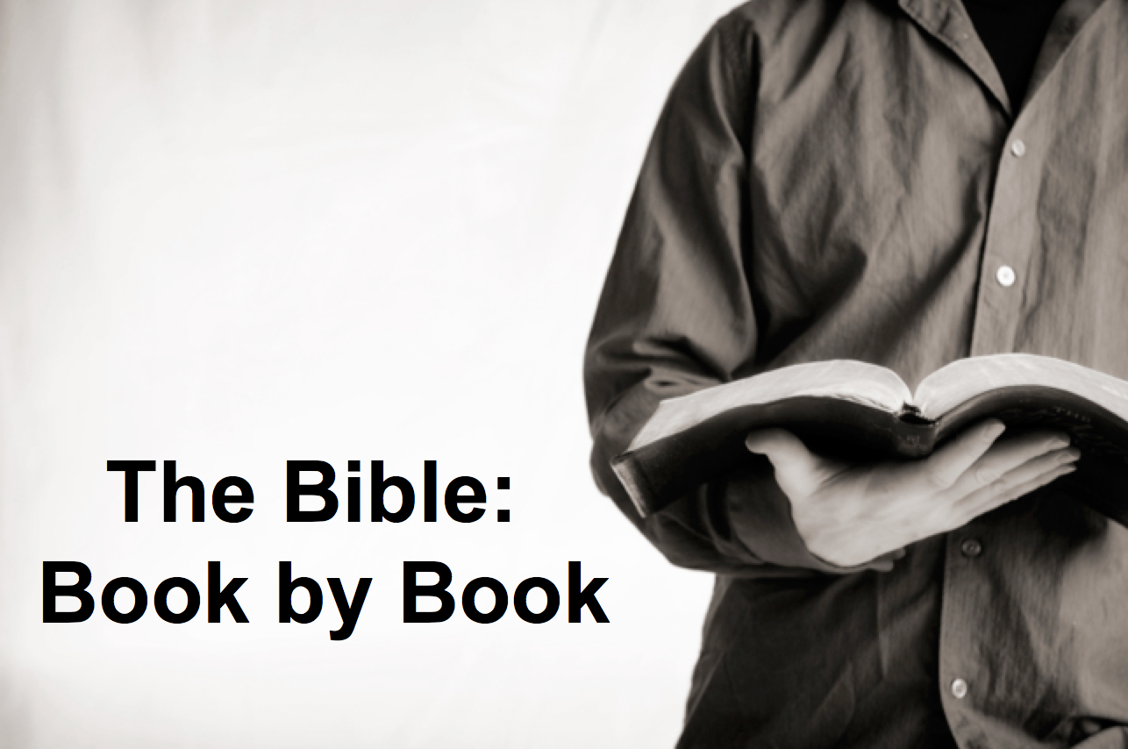

Rick Griffith
2018
Message of 66

Title
Passage

Introduction

Subject with a blank for the key word _______________

I. MP has a blank for the key word ________________ (verses).

SP has a blank for the key word ________________ (verses).

SP has a blank for the key word ________________ (verses).

SP has a blank for the key word ________________ (verses).

II. MP has a blank for the key word ________________ (verses).

SP has a blank for the key word ________________ (verses).

SP has a blank for the key word ________________ (verses).

Conclusion

Main Idea has a blank for the key word ________________ (verses).

Application question

Download this sermon PPT and notes for free at BibleStudyDownloads.org/resource/old-testament-preaching/
Listen to this message online at cicfamily.com/sermon-listing/

BOOK CHART

