Homiletics 1 Course Singapore Bible College Dr. Rick Griffith
Title
2006 Adaptation from Student Lee Sung Hun (Socu) Single Message
NLT 15 Minutes

Our Strength During Trials
1 Samuel 1:1-20

Topic: Trials
Subject: When you are overwhelmed by troubles, how should you resolve them?
Complement: God allows difficulties so we can trust in his strength.
Purpose: The listeners will trust in the Lord during difficulty.
Attribute: We worship the God Who Strengthens Us
Reading: 1 Samuel 1:1-20
Song: When Trials Come

Introduction

Interest: We all face various trials—adjusting to living alone, trouble when we feel we are not ready to handle them. Etc.

Need: Where do you really turn during your difficulties?

Subject: When you are overwhelmed by troubles, how should you resolve them?

Background: For the answer, let’s see how Hannah addressed her troubles. She lived during the pagan period of the judges when “everyone did what was right in their own eyes” (Judges 21:25).

Preview: Let’s identify with Hannah’s trials, see how she responded, and then the results.

Text: We will study 1 Samuel 1:1-20.

(So how are our lives like Hannah’s?)

I. Like Hannah, we also have struggles.
[Trials do not seem to escape any of us.]

Hannah had the twin problems of barrenness and her rival Peninnah (1:1-8).

She had no children who were considered God’s blessing (1:1-5).

She had an opponent, Peninnah, who provoked her (1:6-8).

We also have similar difficulties.

(But why does God—who can solve all our troubles—why does he allow them?)

II. God allows troubles so we can learn to rely on him.
[Difficulties come so we can seek the Lord.]

Hannah responded to the Lord by praying and vowing (1:9-18).

She prayed when she was in bitterness of soul (1:9-10).

She vowed that she will return the son if God grant her one (1:11-18).

We also need to turn to the Lord in our difficulties.

(What is the result of relying on God during difficulty?)

III. God answers us when we cry out to him.
[He has compassion on us in our time of need.]

The LORD took away Hannah’s troubles by giving her the son Samuel (1:19-20).

God also grants us our requests or the strength to endure our trials.

(So back to our first question: When you are overwhelmed by troubles, how should you resolve them)

Conclusion

God allows difficulties so we can trust in his strength (Main Idea).

Main Points

Application: Trust in God’s strength. How?

Pray during your troubling times.

Be patient with the circumstances.

Attune to God to discern his will.

Appreciate every blessing from God.

Preliminary Questions

Verses Questions

Context: What did the author record just before this passage?

The period of the judges shows that rejecting the LORD by replacing the law of God with their own values (Judges 21:25).

Purpose: Why is this passage in the Bible?

God long planned to put his Son into a lineage of kings in light of the kingdom theme of Scripture.

Background: What historical context helps us understand this passage?

Questions

Tentative Main Ideas

Text

Illustrations That Apply

Text

Old Testament Survey Notes

Summary Statement for the Book
The reason God transitioned Israel from a degenerate theocracy to a righteous monarchy was to delegate his rule to Davidic kings.

The reason God prepared Israel for a king in the transfer of leadership from Eli to Samuel was because the nation did not know God's character (1 Sam 1–7).

Israel’s first national leadership transition from Eli to Samuel came by Samuel's birth, call, and acceptance over Eli's wicked house to prepare for the prophesied monarchy (1 Sam 1–3).

Samuel's unique birth and childhood show that God saw that Israel needed a new leader due to the pathetic state of the era of the judges (1 Sam 1).

Hannah's prophetic prayer praised God's attributes and his future provision of kings (2:1-11).

Eli's wicked priesthood by his sons’ immorality with tabernacle women like the priests of Baal contrasts with Samuel's holy lifestyle to show the need for a new leader for Israel (2:12-36).

Samuel's call by the LORD and acceptance by the people verified the leadership transition from Eli to Samuel (1 Sam 3).

Israel showed its need for Samuel's leadership in their ignorance of the character of God evident in their superstitious use of the ark to fight the Philistines (1 Sam 4–7).

The Philistines taking the ark with deaths of Eli and his sons fulfilled God's prophecy against Eli to show the need for Samuel due to confusion over God's omnipresence (1 Sam 4).

The ark’s superiority over Dagan in the Philistine camp showed God's omnipotence over all gods and grace even in Israel’s disobedience (1 Sam 5).

The ark’s return to Beth-Shemesh prompted sacrifices and 50,070 Israelite deaths by high-handedly looking into the ark to display God’s sovereignty and holiness (1 Sam 6).

The ark’s restoration to Kiriath Jearim and Israel’s victories over the Philistines show God's presence with the nation and its need for Samuel, a new leader (1 Sam 7).

The reason God led a leadership transfer from Samuel to Saul to David despite their evil motives was to show that he delegated rule to Davidic kings (1 Sam 8–31).

Our Strength During Trials
1 Samuel 1:1-20

Adapted from Lee Sung Hun (Homiletics 2006)
Background: Hannah’s afflictions illustrate the tumultuous situation of Israel as a nation. Judges 21:25 denotes “everyone did what was right in his own eyes.” It was the time God’s presence was absent. This extended to 1 Sam. 3:1 “And a word from the LORD was rare in those days, visions were infrequent.”

Exegetical Idea: The reason God allowed Hannah’s troubles was to show that he was her strength.

I. The nature of Hannah’s problem was both barrenness and her rival Peninnah (1:1-8).

She had no children who were considered God’s blessing (1:1-5).

She had an opponent, Peninnah, who provoked her (1:6-8).

II. The ways in which Hannah responded to the Lord was by praying and vowing (1:9-18).

She prayed when she was in bitterness of soul (1:9-10).

She vowed that she will return the son if God grant her one (1:11-18).

III. The means by which the LORD took away her troubles was by giving her the son Samuel (1:19-20).

Purpose or Desired Listener Response (Step 4)
The listeners will trust in God during their trials.

Homiletical Outline (Cyclical inductive form)

Introduction

Interest: We all face various trials—adjusting to living alone, trouble when we feel we are not ready to handle them. Etc.

Need: Where do you really turn during your difficulties?

Subject: When you are overwhelmed by troubles, how should you resolve them?

Background: For the answer, let’s see how Hannah addressed her troubles. She lived during the pagan period of the judges when “everyone did what was right in their own eyes” (Judges 21:25).

Preview: Let’s identify with Hannah’s trials, see how she responded, and then the results.

Text: We will study 1 Samuel 1:1-20.

(So how are our lives like Hannah’s?)

I. Like Hannah, we also have struggles.
[Trials do not seem to escape any of us.]

Hannah had the twin problems of barrenness and her rival Peninnah (1:1-8).

She had no children who were considered God’s blessing (1:1-5).

She had an opponent, Peninnah, who provoked her (1:6-8).

We also have similar difficulties.

(But why does God—who can solve all our troubles—why does he allow them?)

II. God allows troubles so we can learn to rely on him.
[Difficulties come so we can seek the Lord.]

Hannah responded to the Lord by praying and vowing (1:9-18).

She prayed when she was in bitterness of soul (1:9-10).

She vowed that she will return the son if God grant her one (1:11-18).

We also need to turn to the Lord in our difficulties.

(What is the result of relying on God during difficulty?)

III. God answers us when we cry out to him.
[He has compassion on us in our time of need.]

The LORD took away Hannah’s troubles by giving her the son Samuel (1:19-20).

God also grants us our requests or the strength to endure our trials.

(So back to our first question: When you are overwhelmed by troubles, how should you resolve them)

Conclusion

God allows difficulties so we can trust in his strength (Main Idea).

Main Points

Application: Trust in God’s strength. How?

Pray during your troubling times.

Be patient with the circumstances.

Attune to God to discern his will.

Appreciate every blessing from God.

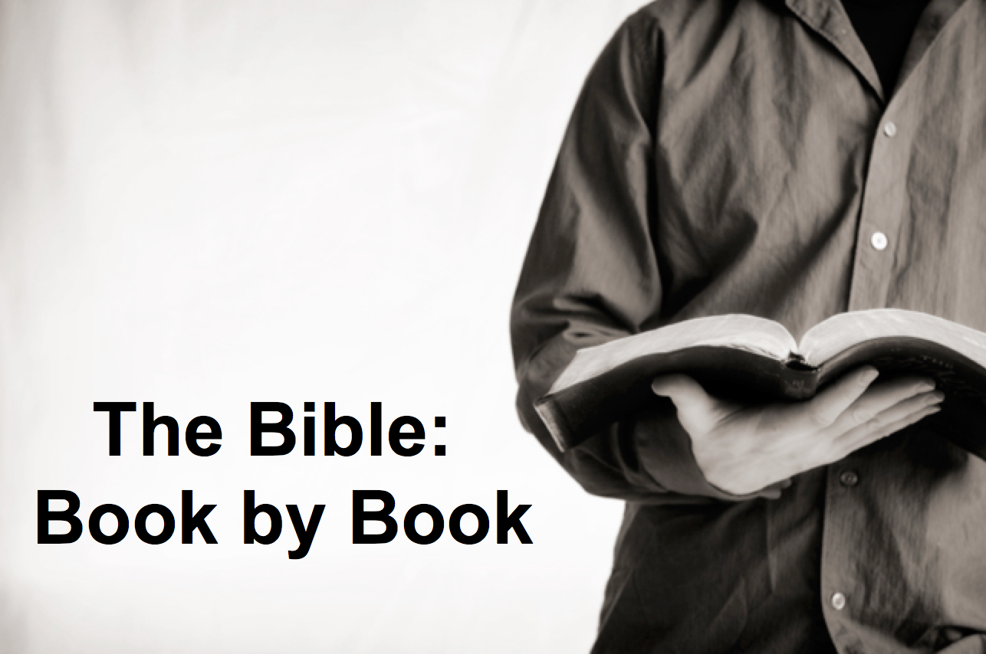

Rick Griffith
2019
Message of 66

Title
Passage

Introduction

Subject with a blank for the key word _______________

I. MP has a blank for the key word ________________ (verses).

SP has a blank for the key word ________________ (verses).

SP has a blank for the key word ________________ (verses).

SP has a blank for the key word ________________ (verses).

II. MP has a blank for the key word ________________ (verses).

SP has a blank for the key word ________________ (verses).

SP has a blank for the key word ________________ (verses).

Conclusion

Main Idea has a blank for the key word ________________ (verses).

Application question

Download this sermon PPT and notes for free at BibleStudyDownloads.org/resource/old-testament-preaching/
Listen to this message online at cicfamily.com/sermon-listing/

BOOK CHART

