SBC Homiletics Class Jennet (2B)
08-March-2022 Message 1 of 2
15 Minutes

Commit Your Ways to God and You Will Prosper
Outline Manuscript for 1 Kings 2 (Cyclical Inductive Form)

Topic: Commitment
Subject: How can you commit your ways to God?
Complement: Obey God with mercy and justice.
Purpose: The listeners will commit their ways to God with mercy and justice.

Introduction

Get attention: What is your idea of commitment? For some signing a paper is commitment and others say marriage is.

A chicken and a pig were talking about contributing to the farmer’s breakfast. The chicken said, “Look at the commitment I made.”

The pig replied, “But for me it would be a total sacrifice.”

Raise Need: Have you shown commitment to the Lord by just giving an offering—or have you genuinely committed your ways to God?

Subject: Today I’ll share how you can commit your ways to God.

Background: In 1 Kings 1, King David was in his old age so he was attended by a young virgin Abishag. His son Adonijah plotted to seize the kingship of his father’s David with the help of Joab, David’s chief military commander, and Abiathar, the priest. Their plan was not successful as David appointed Solomon to be his successor as he has promised to his wife, Bathsheba. David then was about to die—so what would true commitment look like for Solomon?

My text is from 1 Kings 2. I will only be reading verses 1-4.

(I will be sharing you how we can commit all our ways to God. First…)

I. Commit your way to the Lord by obedience (2:1-12).

David instructed his son Solomon to obey God by showing kindness to Barzillai and justice to Joab and Shimei (2:1-12).

Commitment to God means obedience.

(Besides obeying the Lord, the second way to commit your way is …)

II. Commit your way to the Lord by showing both mercy and justice (2:13-27).

Solomon showed mercy to Adonijah by letting him live but judged him after he tried to steal the throne (2:13-25).

Why was Adonijah executed?

In chapter 1 of 1 King, Adonijah plotted to seize the kingship of his father's David.

In chapter 2, he tried again to steal the kingdom by marrying his father's attendant, Abishag so that Solomon executed him.

But note that we should first show mercy before we show judgment.

Solomon showed mercy to Abiathar by dismissing him from the priesthood and sparing his life (2:26-27)

Why was Abiathar's priesthood transferred to Zadok?

Abiathar was once David's trusted priest. Later, he betrayed David, so that Solomon banished him.

This is the fulfillment of Eli's priestly line ending as prophesied in 1 Samuel 2:31. To fulfill the faithfulness of God's word, Abiathar's priesthood was transferred to Zadok.

Again, note that we should first show mercy before we show judgment.

(Finally, the third way to commit your way to the Lord is …)

III. Commit your way to the Lord by exercising justice (2:28-46).

Solomon ordered Joab to be killed when he conspired against the king and for murdering Abner and Amasa (2:28-35).

What is significant about the horns of the altar?

Joab ran clinging onto the horns of the altar to escape death. It signifies a holy place and refuge. It was a place where an offering was made and served as a safety net.

Sadly, Joab used a holy spot to try to save himself when he had lived a godless lifestyle. Such is the pattern of many ungodly people who try to use God only for their own selfish ends.

Why was Joab executed?

Joab joined Adonijah's conspiracy to seize the kingship of David.

He also murdered Abner and Amasa. Thus, David asked Solomon to punish Joab.

Why did Joab murder Abner and Amasa?

2 Samuel 3:22-30 described that without King David's knowledge, Joab killed Abner to avenge his brother Asahel in the battle at Gibeon.

Joab also murdered Amasa, the commander of David's army.

Solomon displayed empathy to Shimei by not killing him until he disobeyed his orders (2:36-46).

Why was Shimei executed?

Shimei cursed David when he fled to Mahanaim.

But at this point he also broke the law imposed by Solomon not to leave his home.

Again, note that we should first show mercy before we show judgment.

Solomon showed mercy first to Joab, Adonijah, Shimei, and Abiathar.

None of them go to God to ask for forgiveness.

None of them tried to make things right with Solomon also.

But Solomon showed them mercy for he committed them to God and let God handle these situations.

What is justice?

Sanskrit scholar Pandit Kharak Singh was asked how he could reconcile the death of Christ.

For the scholar, the human ideas of justice are imperfect. One person will always get punished. But God's justice is different. It results in gain and joy!

(So how do you commit your ways to God?)

Conclusion

Obey God with mercy and justice (Main Idea).

Main Points (MPs restated):

We are to commit our way to the Lord by obedience.

We are to commit our life to God by being merciful.

We are to commit our life to God by justice.

[Miner died signing his daughter’s Bible]

A young Colombian girl was given a New Testament. She read it until one day her father caught her reading it and told her not to read it anymore because it was full of lies. But the girl kept on reading it until one day her father found her with the NT, grabbed it from her hands, and put it in his pocket. He went off to work in a mine. Several hours later sirens went off, as there had been a cave in at the mine. The father was trapped. The rescue workers took 5 days to finally reach the men, but it was too late. All 31 men died including the father of this little girl. Workers found the man clutching the NT between his praying hands. When they opened it they read a note “To my daughter: Keep reading this NT, it is true and right, and I will see you one day in heaven.” Then they turned to the back page where the father had signed the commitment card after having said the sinner’s prayer. Turning the page there were signed the names of the other 30 workers (Gideons International).

Let’s be sure to obey God with mercy and justice (Main Idea).

Application

Solomon committing everything to God established for him a firm kingdom.

Like Solomon, show mercy and grace to those who are not nice to us.

God's mercy and justice are in balance. We have justice and mercy from Jesus who died on the cross for our sin.

Other Commentaries and Bibliography

- “Justice Sermon Illustrations,” n.d. Accessed April 10, 2021. http://www.moreillustrations.com/Illustrations/justice.html.
- “Sermon Illustration » A Chicken And a Pig Discuss Commitment vs Sacrifice,” n.d. Accessed April 10, 2021. https://www.family-times.net/illustration/Commitment/201014/.
- “Sermon Illustration » Miner Died Signing His Daughter’s Bible.” Accessed April 10, 2021. https://www.family-times.net/illustration/Commitment/201312/.
- Donald J. Wiseman, 1 and 2 Kings: An Introduction and Commentary, vol. 9, Tyndale Old Testament Commentaries (Downers Grove, IL: IVP, 1993), 81.

- Paul R. House, 1, 2 Kings, vol. 8, The New American Commentary (Nashville: Broadman & Holman, 1995), 95

- William H. Barnes, 1-2 Kings, ed. Philip W. Comfort, vol. 4b, Cornerstone Biblical Commentary (Carol Stream, IL: Tyndale, 2012), 41.

Preliminary Questions

Study Questions (Step 1) 1Kings 2

Context: What did the author record just prior to this passage?

King David was in his old age. His son Adonijah makes himself a king with the help of Joab, David's military commander. However, as David had promised to Bathsheba, David appointed Solomon to be his successor. Nathan, the prophet, and Zadok, the priest, anointed Solomon and David make Solomon the king of Israel and Judah.

Purpose: Why is this passage in the Bible?

1 Kings 2 records King David's last teaching to his son Solomon on keeping God's commandments and David's death. The execution of the rebels Adonijah, Joab, and Shimei are also recorded.

Background: What historical context helps us understand this passage?

1 Kings and 2 Kings is one book in the Hebrew canon called Kings. The author is believed to be a prophet or historian. Some say it's the prophet Jeremiah. 1 Kings records more national leaders than any book in Scripture.

The book also describes how God blesses obedience of his covenant and judges disobedience.

The book accounts the division of Solomon's kingdom from the northern nation of Israel and the southern kingdom of Judah.

Questions & Answers (cf. p. 22 #1)

Who is the author of 1Kings?
Jeremiah is the author.

What does the tent of the Lord mean?
The tent of the Lord is defined as Yahweh dwelling place.

What is significant about the horns of the altar?
Joab ran clinging onto the horns of the altar to escape death. It signifies a holy place and refuge. It was a place where an offering was made and served as a safety net.

Why was Adonijah executed?
In chapter 1 of 1 King, Adonijah plotted to seize the kingship of his father's David. In chapter 2, he tried again to steal the kingdom by marrying his father's attendant, Abishag so that Solomon executed him.

Why was Joab executed?
Joab joined Adonijah's conspiracy to seize the kingship of David. He also murdered Abner and Amasa. Thus, David asked Solomon to punish Joab.

Why did Joab murder Abner and Amasa?
2 Samuel 3:22-30 described that without King David's knowledge, Joab killed Abner to avenge his brother Asahel in the battle at Gibeon. Joab also murdered Amasa, the commander of David's army.

Why was Abiathar's priesthood transferred to Zadok?
Abiathar was once David's trusted priest. Later, he betrayed David, so that Solomon banished him. This is the fulfillment of Eli's priestly line ending as prophesied in 1 Samuel 2:31. To fulfill the faithfulness of God's word, Abiathar's priesthood was transferred to Zadok.

Why was Shimei executed?
Shimei cursed David when he fled to Mahanaim, and he also broke the law imposed by Solomons not to leave his home.

Who was Abishag?
Abishag was David's nurse who kept David warm. Adonijah later used her as bait to claim to the throne.

Tentative Main Ideas

Text

Illustrations That Apply

Text

Old Testament Survey Notes

Commit Your Ways to God and You Will Prosper
1 Kings 2

Exegetical Outline (Steps 2-3)

Exegetical Idea: The way David and Solomon committed their ways to God was by practicing mercy and justice.

I. The way David commanded Solomon to commit his ways to the LORD was by obedience shown in kindness to Barzillai and justice to Joab and Shimei (2:1-12).

David commanded Solomon to obey the LORD (2:1-4).

David commanded Solomon to give Joab justice with an early death (2:5-6).

David commanded Solomon to show mercy to Barzillai’s sons for helping him by providing food for them (2:7).

David commanded Solomon to give Shimei justice with an early death (2:8-9).

David died and Solomon’s rule was firmly established (2:1-12).

II. The way Solomon committed his ways to the LORD was by showing mercy (2:13-27).

Solomon showed mercy to Adonijah by letting him live but judged him after he tried to steal the throne (2:13-25).

Solomon showed mercy to Abiathar by dismissing him from the priesthood and sparing his life (2:26-27)

III. The way Solomon committed his ways to the LORD was by showing justice (2:28-46).

Solomon ordered Joab to be killed when he conspired against the king and for murdering Abner and Amasa (2:28-35).

Solomon displayed empathy to Shimei by not killing him until he disobeyed his orders (2:36-46).

Purpose or Desired Listener Response (Step 4)
The listeners will commit their ways to God with mercy and justice.

Homiletical Outline (Cyclical inductive form)

Introduction

Get attention: What is your idea of commitment? For some signing a paper is commitment and others say marriage is.

Raise Need: Have you shown commitment to the Lord by giving an offering—or have you genuinely committed your ways to God?

Subject: Today I’ll share how you can commit your ways to God.

Background: In 1 Kings 1, King David was in his old age so he was attended by a young virgin Abishag. His son Adonijah plotted to seize the kingship of his father’s David with the help of Joab, David’s chief military commander, and Abiathar, the priest. Their plan was not successful as David appointed Solomon to be his successor as he has promised to his wife, Bathsheba. David then was about to die—so what would true commitment look like for Solomon?

My text is from 1 Kings 2. I will only be reading verses 1-4.

(I will be sharing you how we can commit all our ways to God. First…)

I. Commit your way to the Lord by obedience (2:1-12).

David instructed his son Solomon to obey God by showing kindness to Barzillai and justice to Joab and Shimei (2:1-12).

Commitment to God means obedience.

(Besides obeying the Lord, the second way to commit your way is …)

II. Commit your way to the Lord by showing both mercy and justice (2:13-27).

Solomon showed mercy to Adonijah by letting him live but judged him after he tried to steal the throne (2:13-25).

Solomon showed mercy to Abiathar by dismissing him from the priesthood and sparing his life (2:26-27)

(Finally, the third way to commit your way to the Lord is …)

III. Commit your way to the Lord by exercising justice (2:28-46).

Solomon ordered Joab to be killed when he conspired against the king and for murdering Abner and Amasa (2:28-35).

Solomon displayed empathy to Shimei by not killing him until he disobeyed his orders (2:36-46).

Solomon showed mercy first to Joab, Adonijah, Shimei, and Abiathar.

What is justice?

(So how do you commit your ways to God?)

Conclusion

Obey God with mercy and justice (Main Idea).

Main Points (MPs restated):

[Miner died signing his daughter’s Bible]

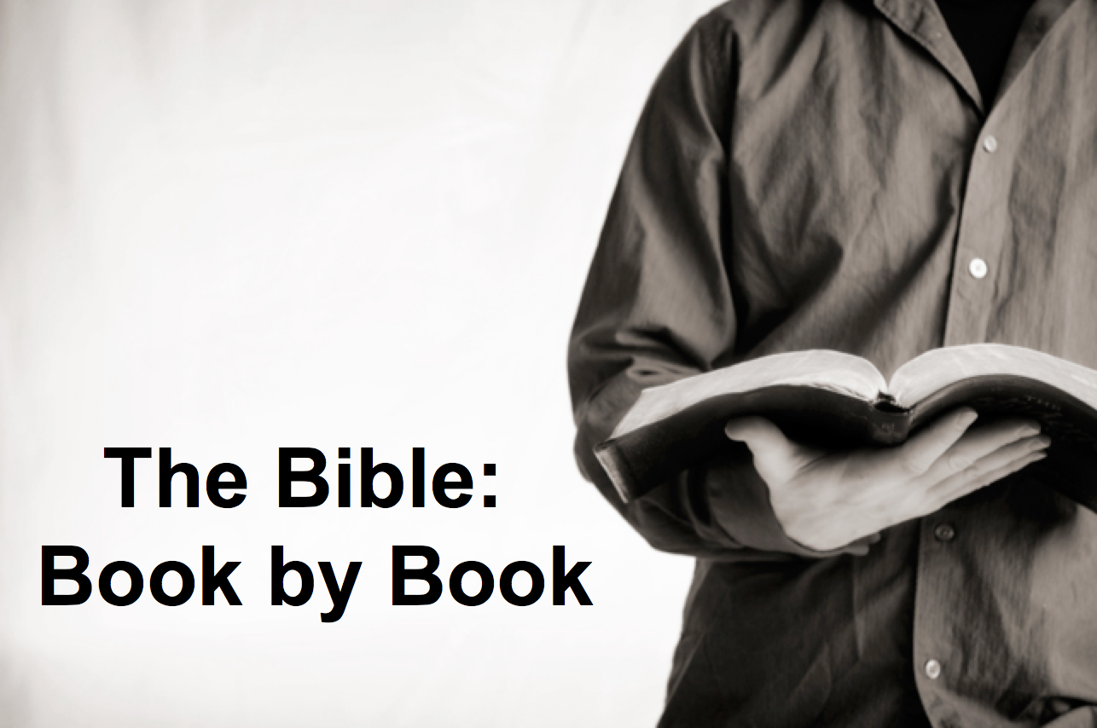

Rick Griffith
2018
Message of 66

Title
Passage

Introduction

Subject with a blank for the key word _______________

I. MP has a blank for the key word ________________ (verses).

SP has a blank for the key word ________________ (verses).

SP has a blank for the key word ________________ (verses).

SP has a blank for the key word ________________ (verses).

II. MP has a blank for the key word ________________ (verses).

SP has a blank for the key word ________________ (verses).

SP has a blank for the key word ________________ (verses).

Conclusion

Main Idea has a blank for the key word ________________ (verses).

Application question

Download this sermon PPT and notes for free at BibleStudyDownloads.org/resource/old-testament-preaching/
Listen to this message online at cicfamily.com/sermon-listing/

BOOK CHART

“Justice Sermon Illustrations,” n.d., accessed April 10, 2021, http://www.moreillustrations.com/Illustrations/justice.html.
“Sermon Illustration: Miner Died Signing His Daughter’s Bible,” accessed April 10, 2021, https://www.family-times.net/illustration/Commitment/201312/.

