Jordan Evangelical Theological Seminary Chapel Dr. Rick Griffith

September 2025 Single Message

NLT 20 Minutes

Title

**The Genealogies of Israel**

***1 Chronicles 1–9***

**Topic:** Faithfulness

**Subject:** During difficulty, how can we be reminded that God is faithful to us?

**Complement:** God shows His faithfulness to us by preserving us through difficulty.

**Purpose:** The listeners will

**Attribute:** Faithfulness

**Meditation:**

**Reading:**

**Benediction:**

**Songs:**

# Introduction

### Interest: We often employ unsuccessful strategies during difficulty (give examples).

### Need: What is your pattern of dealing with difficulty(give examples)?

### Subject: During difficulty, how can we be reminded that God is faithful to us? When we are going through tough times, how can we be assured to trust the Lord?

### Background: Postexilic Judah had no king, despite having returned to the land.

### Main Idea: God shows His faithfulness to us by preserving us through difficulty.

### Preview: We will first see how God was faithful to the remnant, then how he is faithful to us today.

### Text: Our text is probably the least preached nine chapters of the Bible in 1 Chronicles 1–9.

(How was Judah reminded that God was faithful to them?)

# I. God showed His faithfulness to Israel by preserving the genealogical lines of David and Levi (1 Chron. 1–9).

[Restate MP here.]

## Genealogies back to creation show that God preserved the Davidic line (chs. 1–3).

## Tribal genealogies show that God preserved the Davidic and priestly lines (chs. 4–8).

## Jerusalem genealogies show that God preserved the priestly line (9:1-34). [vv. 35-44 omitted]

(Was God faithful only to Israel? Of course not…)

# II. God shows His faithfulness to us by preserving us through difficulty (Main Idea).

[He fulfilled His promises to Israel in exile, and He does the same for us despite many trials.]

## Corporately: Many have sought to destroy the Church through the ages but each attempt was unsuccessful because of God’s faithfulness (examples; cf. Matt. 16:18).

## Individually: Despite Satan’s many attempts to crush us, God preserves us (examples).

(When we are going through tough times, how can we be reminded that God is faithful to us?)

# Conclusion

### God shows His faithfulness to us by preserving us through difficulty (MI).

### The God who was faithful to Israel is also worthy of our trust (restatement).

### Application: In what area are you struggling to trust God? Give this issue over to Him.

# Preliminary Questions

**Verses Questions**

# Context: What did the author record just prior to this passage?

### The Book of Kings preceded the Book of Chronicles by about 100 years.

# Background: What historical context helps us understand this passage?

### God had promised Israel through the Davidic Covenant (2 Sam. 7; 1 Chron. 17) that He would preserve for the nation an unbroken succession of *Davidic kings.* Similarly, through Ezekiel, He promised that legitimate *priests and Levites* would serve at “Ezekiel’s temple” (Ezek. 40—44).

### However, hopes were crushed at the return when only a small portion of Judah, which had gone into exile, returned to the land under Zerubbabel and Ezra (Ezra 1–2, 8) and when the rebuilt temple failed compared to Solomon’s (Hag. 1–2). Even worse, while legitimate priests once again resumed their work in the rebuilt temple, a Davidic king was not enthroned. Would Israel ever have such a king again?

# Purpose: Why is this passage in the Bible?

### The nation needed to know that the Davidic and Levitical lines were both intact.

### Therefore, Ezra showed that God had been faithful to these promises through an extensive genealogical record.

# Questions

### Why do we have boring sections in the Bible, such as these nine chapters of genealogies?

# Tentative Subject/Complement Statements

Text

# Possible Illustrations

### Text

# Possible Applications

### Text

**The Genealogies of Israel**

***1 Chronicles 1–9***

**Exegetical Outline (Steps 2-3)**

Prologue: God had promised Israel through the Davidic Covenant (2 Sam. 7; 1 Chron. 17) that He would preserve for the nation an unbroken succession of *Davidic kings.* Similarly, through Ezekiel, He promised that legitimate *priests and Levites* would serve at “Ezekiel’s temple” (Ezek. 40—44). However, hopes were crushed at the return when only a small portion of Judah, which had gone into exile returned to the land under Zerubbabel and Ezra (Ezra 1—2, 8) and when the rebuilt temple failed compared to Solomon’s (Hag. 1—2). Even worse, while legitimate priests once again resumed their work in the rebuilt temple, a Davidic king was not enthroned. Would Israel ever have such a king again? The nation needed to know that the Davidic and Levitical lines were both intact, so Ezra showed that God had been faithful to these promises through an extensive genealogical record.

# *Exegetical Idea*: The way God showed faithfulness to the Davidic Covenant to the remnant was by genealogies that revealed the Davidic and priestly lines present while the throne was absent.

# I. The way God showed faithfulness to the Davidic Covenant was by post-exilic to Adam genealogies of the royal line of David, while the Davidic throne was absent (1 Chron 1–3).

## The patriarchal genealogy narrows the focus on one of the tribes—Judah (1 Chron 1).

## The genealogy of Judah narrows the focus on one of the clans—David (1 Chron 2).

## The genealogy of David traces his line far past the Return to the Land (1 Chron 3).

# II. The way God showed faithfulness to the Davidic Covenant was by genealogies of the Davidic and priestly lines, emphasizing Judah, Benjamin, and Levi (1 Chron 4–8).

# III. The way God showed faithfulness to the Davidic Covenant was by genealogies of the priests and Levites to prove a legitimate priesthood for proper worship of Yahweh (9:1-34).

# IV. The purpose of the genealogy of Saul repeated from 8:29-40 was to transition to the death of Saul (ch. 10) and succession of David (9:35-44; cf. 11:1-3)

**Purpose or Desired Listener Response (Step 4)**

The listeners will trust in God’s faithfulness in their difficulty.

**Homiletical Outline** (simple deductive form)

# Introduction

### Interest: We often employ unsuccessful strategies during difficulty (give examples).

### Need: What is your pattern of dealing with difficulty(give examples)?

### Subject: When we are going through tough times, how can we be reminded that God is faithful to us?

### Background: Postexilic Judah had no king, despite having returned to the land.

### Main Idea: God shows His faithfulness to us by preserving us through difficulty.

### Preview: We will first see how God was faithful to the remnant, then how he is faithful to us today.

### Text: Our text is probably the least preached nine chapters of the Bible in 1 Chronicles 1–9.

(How was Judah reminded that God was faithful to them?)

# I. God showed His faithfulness to Israel by preserving the genealogical lines of David and Levi (1 Chron. 1–9).

[Restate MP here.]

## Genealogies back to creation show that God preserved the Davidic line (chs. 1–3).

## Tribal genealogies show that God preserved the Davidic and priestly lines (chs. 4–8).

## Jerusalem genealogies show that God preserved the priestly line (9:1-34). [vv. 35-44 omitted]

(Was God faithful only to Israel? Of course not…)

# II. God shows His faithfulness to us by preserving us through difficulty (Main Idea).

[He fulfilled His promises to Israel in exile, and He does the same for us despite many trials.]

## Corporately: Many have sought to destroy the Church through the ages, but each attempt was unsuccessful because of God’s faithfulness (examples; cf. Matt. 16:18).

## Individually: Despite Satan’s many attempts to crush us, God preserves us (examples).

(When we are going through tough times, how can we be reminded that God is faithful to us?)

# Conclusion

### God shows His faithfulness to us by preserving us through difficulty (MI).

### The God who was faithful to Israel is also worthy of our trust (restatement).

### Application: In what area are you struggling to trust God? Give this issue over to Him.

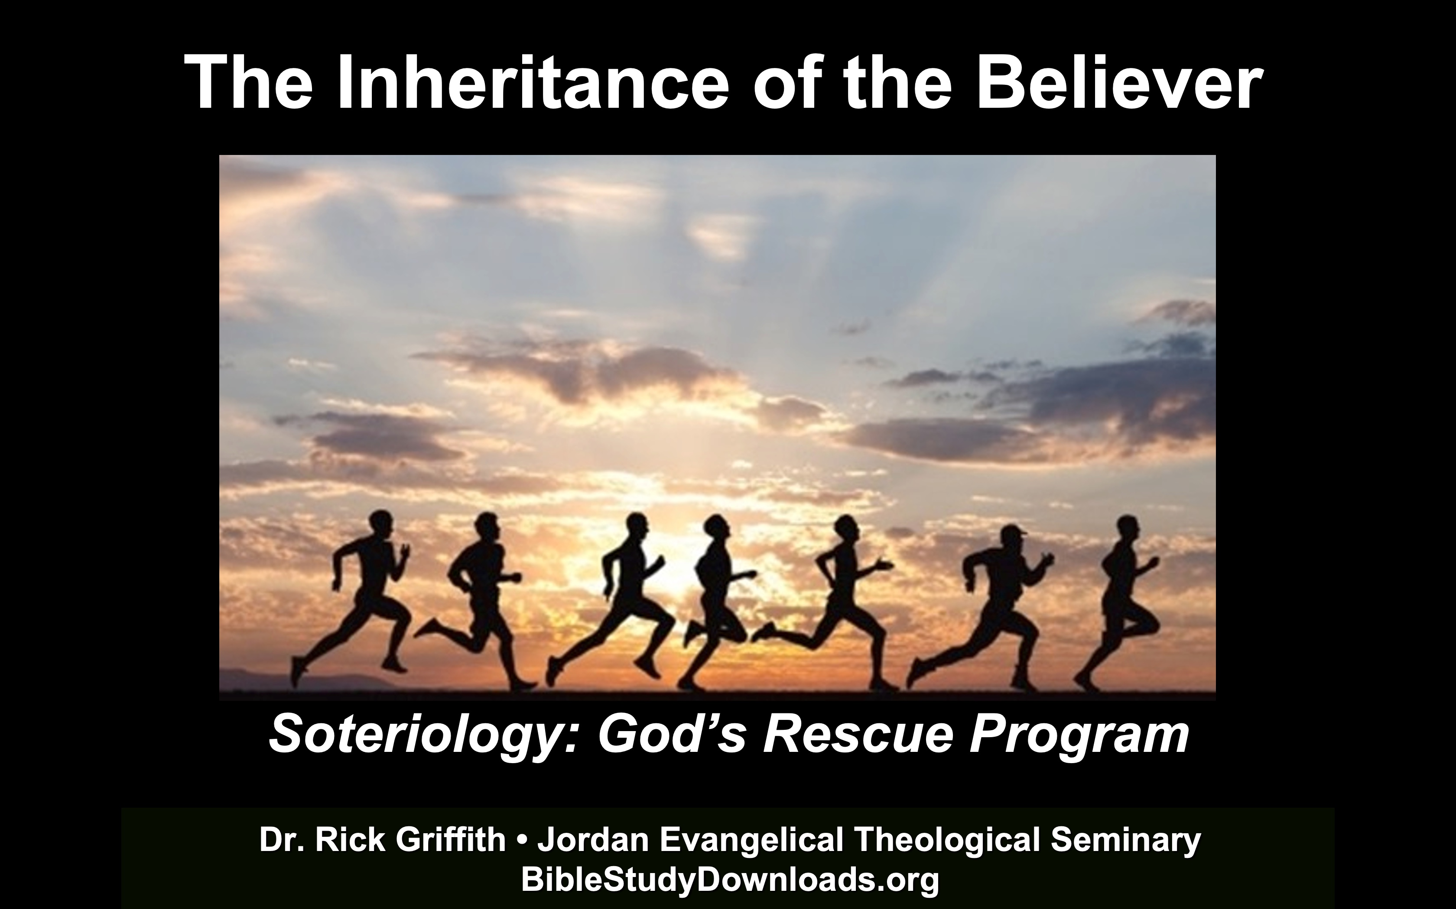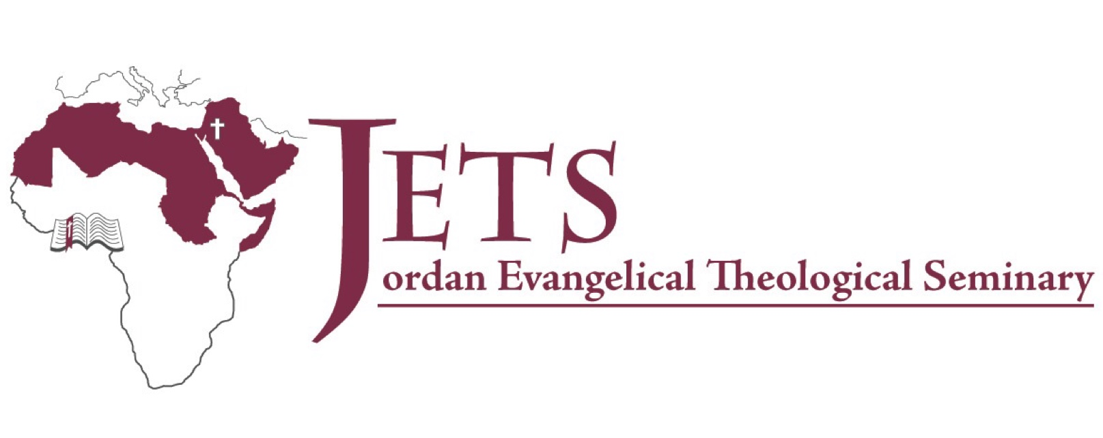

**Rick Griffith**

September 2025

Single Message

**The Genealogies of Israel**

***1 Chronicles 1–9***

# Introduction

Subject with a blank for the key word _______________ blank answer in hidden text

# I. MP has a blank for the key word ________________ answer (verses).

## SP has a blank for the key word ________________ answer (verses).

## SP has a blank for the key word ________________ answer (verses).

## SP has a blank for the key word ________________ answer (verses).

# II. MP has a blank for the key word ________________ answer (verses).

## SP has a blank for the key word ________________ answer (verses).

## SP has a blank for the key word ________________ answer (verses).

## SP has a blank for the key word ________________ answer (verses).

# Conclusion

### Main Idea has a blank for the key word ________________ answer (verses).

### Application question

**Thought Questions**

1. Read the passage aloud. Contrast:

|  |  |
| --- | --- |
| **Issue** | **Contrast** |
| Text | Text |
| Text | Text |
| Text | Text |
| Text | Text |
| Text | Text |
| Text | Text |
| Text | Text |
| Text | Text |
| Text | Text |

1. Text-based question

Text

Text

Text

Text

1. Application to your own Christian experience

Text

Text

Download this sermon PPT and notes for free at BibleStudyDownloads.org/resources/new-testament-preaching/