Genesis Authorship

Introduction

The reader of the Pentateuch will quickly see that it claims Moses as author—and the Jews and Christians have long believed this—so why would this issue be so hotly debated? This study will seek to answer that very question.

Reasons Mosaic Authorship is Attacked

Genesis has many vital teachings—if they are true, then the critics are accountable to the God of Genesis for its teachings on creation, man’s beginnings and temptation in Eden, and the many historical events in Genesis 1–11, including the Flood and tower of Babel with the confusion of languages.

In Genesis 49, Jacob foretells the destinies of the 12 tribes of Israel in surprising detail (such as the kingly line coming from Judah, 49:9-10). This shows that God knows the future, but it was written hundreds of year later, then the critics are correct that God is deceiving us to think that Moses wrote it. It also shows us God’s blessing on Israel, so anti-Semitic voices certainly hate this section.

Believers are linked with the Abrahamic Covenant in the rest of the Bible with its foundation in Genesis. If Genesis is not written by Moses but it only a collection of disconnected stories.

The Bible’s chiasm makes Genesis 1–2 and Revelation 21–22 parallel to show that God will restore the old creation. Similarly, man’s rule lost at the Fall (Gen 3) will be restored in the Millennium (Rev 20). This brings the Bible’s focus to Christ as redeemer (Gen 3:15) and ruler (Gen 49:10). Critics, on the other hand, do all they can to take the focus away from Jesus as the Christ.

Support for Mosaic Authorship

External Evidence

Scripture teaches that Moses wrote the Pentateuch.

Although Genesis does not directly specify its author, the other four books of the Pentateuch affirm Mosaic authorship (cf. Exod. 17:14; 24:4, 7; 34:27; Lev. 1:1-2; Num. 33:2; Deut. 1:1; 31:9).

The rest of the OT contains even more explicit references to his authorship of the Pentateuch (cf. Josh. 1:7; 8:32-34; 1 Kings 2:3; 2 Kings 14:6; 21:8; Ezra 6:18; Neh. 13:1; Dan. 9:11-13; Mal. 4:4).

The NT also subscribes to Mosaic authorship (cf. Matt. 8:4; Mark 12:26; Luke 16:29; John 5:46-57; 7:19; Acts 26:22; Rom. 10:19; 1 Cor. 9:9; 2 Cor. 3:15).

Tradition throughout the ages has attributed the authorship of Genesis to Moses.

The early church held to Moses as author.

The Jerusalem Talmud agreed with Mosaic authorship.

The first-century Jewish historian Josephus (Boa & Wilkinson, Talk Thru the Bible, 6).

But early in the Christian era, some theologians vacillated between Moses and Ezra as the author of the entire Pentateuch (Alan P. Ross, “Genesis,” in Bible Knowledge Commentary, eds. Walvoord & Zuck [Wheaton: Victor, 1983], 1:15).

Internal Evidence

Qualifications of the Author

The book itself does not name its author. However, no one was better qualified than Moses to write the book since "Moses was educated in all the wisdom of the Egyptians" (Acts 7:22) and had the literary skills necessary to compose such a work. What Jew knew Egypt better than Moses? Who else ever spoke with God face-to-face?

Gleason Archer notes, "We have the witness of the incidental allusions to contemporary events or current issues, to social or political conditions, or to matters of climate or geography. When all such factors are fairly and properly weighed, they lead to this conclusion: the author of these books and his readers must originally have lived in Egypt" (Encyclopedia of Bible Difficulties, 46).

See Archer’s book for extensive internal evidence for Mosaic authorship and refutation of the Documentary Hypothesis (ibid, 46-54).

Written for Those Familiar with Egypt

“Lot lifted up his eyes and saw all the valley of the Jordan, that it was well watered everywhere—this was before the LORD destroyed Sodom and Gomorrah—like the garden of the LORD, like the land of Egypt as you go to Zoar” (Genesis 13:10, NASB).

The above description of the Jordan Valley makes sense only to those familiar with Egypt, which limits the original audience to the Exodus generation. This, then, strongly argues for Moses as the author of Genesis.

The JEDP Attack on Mosaic Authorship

JEDP Explained

Despite this almost unanimous evidence from Scripture and tradition, modern critical scholars adhere to the Documentary Hypothesis as developed originally by Jean Astruc in 1753 and forcefully developed by Julius Wellhausen in 1877.

The theory claims that the Pentateuch is not authored by Moses but is compiled from four sources represented by the letters J, E, D, and P. The "J" material gives preference to the name "Jehovah" (Yahweh) from 850 BC, "E" emphasizes the Eloheim name from 750 BC and was written by the “Elohist,” "D" was written by the Deuteronomistic school likely composed under Hilkiah in 621 BC, and "P" dates from the Priestly Code of Ezra from 570-445 BC (which includes "H," the Holiness Code). The effect is to chop up the Pentateuch into many parts, with many authors, composed at different times.
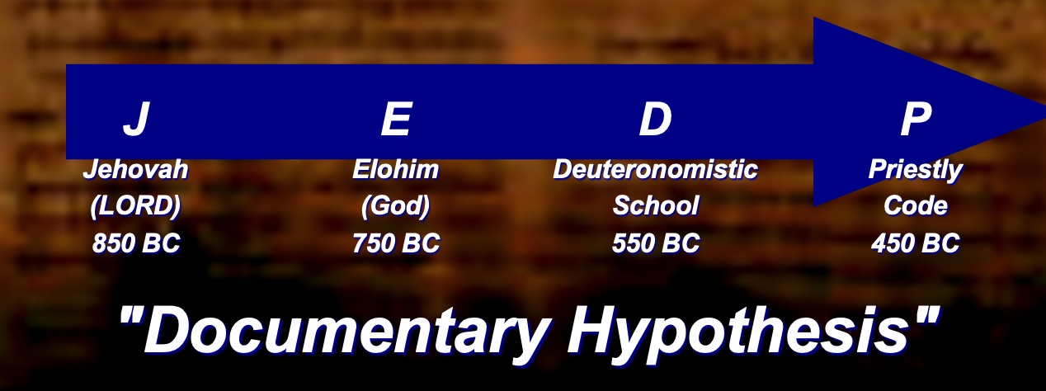

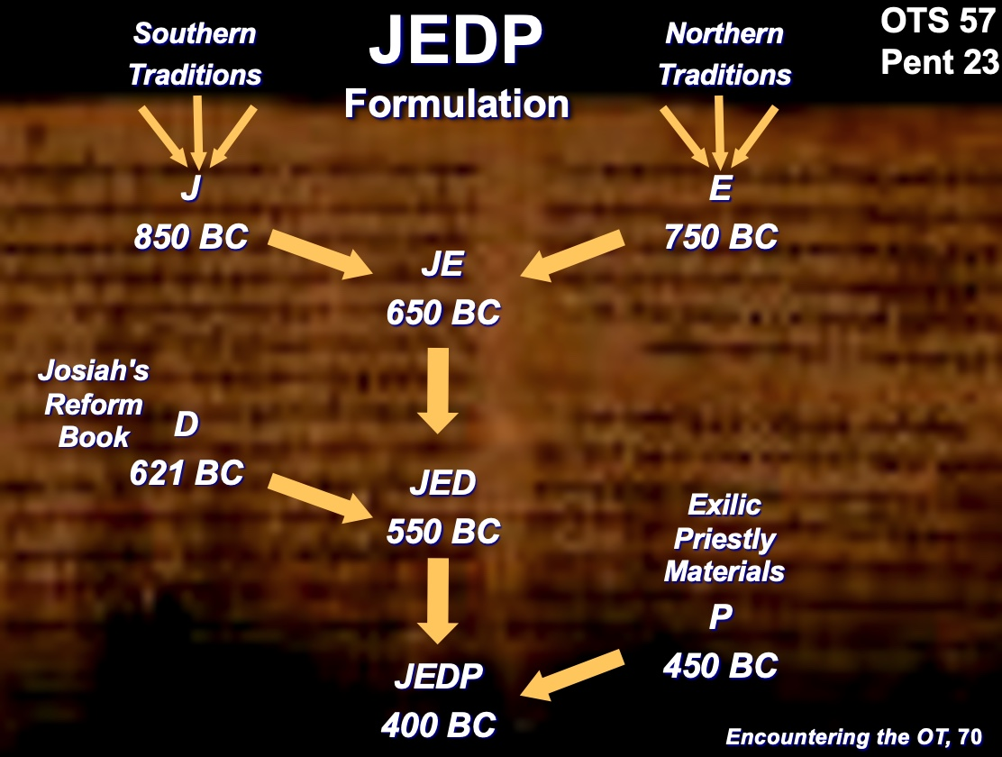

Some Terms

Lower Criticism: Constructive textual studies.

Higher Criticism: Attacks the inspiration and authenticity of the Scriptures.

Interpretive Problems: Honest differences of opinion exist as to possible answers to problems of scriptural interpretation.

JEDP Illustrated

Genesis 1–2 is deemed to be written by two sources.

Genesis 1 repeated uses Elohim as the name of God, so JEDP advocates suppose that the text stemmed from authors who favored Elohim as the divine name, so the chapter has an “E” source.

Genesis 2 adds Yahweh (LORD) to call him “LORD God,” so JEDP theorizes that “J” sources were the original.

Therefore, JEDP supposes that “J” (Gen 2) was composed first (850 BC), and then “E” was placed before it as Genesis 1.

Of course, JEDP fails to consider that it makes good sense for the Genesis 1:1–2:4 creation account to refer to God with his term Elohim indicating his majesty, while Genesis 2 employs the personal and covenant term Yahweh as it recounts his relationship with Adam.

The "Sources" of Genesis 6–9 alternate back and forth between J and P believing that P (priestly material) was later added into the existing J text.

The Gettysburg Address is understood by all Americans as written and spoken by President Abraham Lincoln in 1963. But a spoof on this has been composed in like manner to the JEDP hypothesis to show how the silliness of the theory.

(But the JEDP Theory, though widely held today, is fraught with numerous problems…)

JEDP Problems

It violates internal self-claims of Pentateuch where Moses is deemed the author.

It begins with an anti-supernatural bias, viewing the Bible as an unreliable human book.

It is based on inaccurate 19th century evolution ideas, supposing against the evidence that books in antiquity developed gradually.

No unanimity exists concerning which passages are supposedly from the various sources.

JEDP is thus subjective, often arguing in circles. It cannot be checked by an objective source to evaluate its claims.

One would think that if Moses was not the basic author, various editions of the books of Moses would be available to compare with one another. However, while scribal errors in copies exist, not even one manuscript has ever been discovered that shows J, E, D, or P alternate readings of a text within the Pentateuch.

Modern archaeology has disproved many of the JEDP claims in the discovery of the Ebla, Nuzi and Mari tablets that give evidence for vocabulary and similar literary styles of other patriarchal cultures comparable of those found in the Pentateuch (cf. Ross, BKC, 1:15-18 for bibliographic data).

It rejects the NT evidence that subscribes to Mosaic authorship (John 5:46-47; Rom. 10:5).

Editorial Activity

Hebrew Consistency

The whole OT shows a consistent use of Hebrew so that the Pentateuch does not look like it was written 1000 years before Malachi. Certainly, the Hebrew language changed over time—like all languages—so JEDP teachers say that this is because the whole OT was written around the same time period.

In reality, the “Pentateuch, though written earlier, was edited or updated at a later period so that its language would conform to that of the remainder of the Bible.”

Anachronisms

Genesis 14:14 notes the city of Dan 500 years before it had that name. This would indicate that a “later hand” undated the original Leshem (Josh. 19:47) or Laish (Judges 18:29) name so clarify where the battle occurred.

The enslaved Israelites built the city of Rameses (Exod 1:11), but Rameses did not live until more than a century later. Probably the best explanation of this is that they built the city of Avaris, upon which the city of Rameses was later built. This is akin to someone in 200 BC writing that the Greeks lived in the Hellenistic city Philadelphia but a later hand changing it to Amman to prevent confusion by those who do not know that the modern Amman used to be called Philadelphia.

Unlikely statements

Numbers 12:3 refers to Moses as the humblest man on earth: “(Now Moses was very humble—more humble than any other person on earth.)” This seems to be an addition since for Moses to say it would be self-contradictory.

Deuteronomy 34 records the death of Moses, but Talmudic (Rabbinic Jewish) tradition has always been that these were added, under divine inspiration, by Joshua. Yet Deuteronomy is still essentially the last of the “Books of Moses.”

Conclusion

While others may have done some editorial work under the inspiration of the Holy Spirit, no substantial evidence exists that Moses did not compose the Pentateuch. To think otherwise is to contradict the clear testimony of both tradition and Scripture.

Russell Grigg, “Who Wrote Genesis?” at https://creation.com/did-moses-really-write-genesis (accessed 31 Oct 2021).
Travis Campbell, “Did Moses Write the Torah? A Brief Positive Case for Mosaic Authorship, Part 1,” 27 Dec 2019 blog at https://reasons.org/explore/blogs/voices/did-moses-write-the-torah-a-brief-positive-case-for-mosaic-authorship-part-1 (accessed 31 Oct 2021).

