Old Testament Backgrounds (TEOT4020)
Singapore Bible College
Rick Griffith, ThM, PhD

Tenth Edition
© July 2018

1^{st-}9th printings (275 copies; 1^{st-}6th eds. July 02-Feb 08)

10th printing (40 copies, 7th ed. July 08)
11th printing (20 copies July 09)
12th printing (5 copies, Mar 10)
13th printing (10 copies, 8th ed. July 12)
14th printing (10 copies, 9th ed. July 14)
15th printing (25 copies, 10th ed. July 18)

Table of Contents

I. Syllabus 1
A. Catalogue Course Description 1
B. Course Objectives 1
C. Course Requirements 1
D. Course Bibliography and Abbreviations 2
E. Other Matters 7
F. Course Load 7
G. Schedule (Reading Report) 7
H. Grading 10

II. Geographical Backgrounds to the Old Testament 1
A. Ancient Near East 14
B. The Land of Israel 14
C. Jerusalem: Geography and Significance 23

III. A Biblical Theology of the Old Testament 36
A. Ancient Covenants that Parallel Biblical Covenants 36
B. Comparative Views on the Theme of the OT 53

IV. Chronological Backgrounds to the Old Testament 59
A. Chronology of the Patriarchs 59
B. Egyptian Sojourns a
C. The Date of the Exodus 70a
D. Unlocking the Mysteries of OT Chronology 70c

V. Peoples of the Old Testament World 71
A. Why Study Ancient Peoples? 71
B. Chart of Ancient Near Eastern History 73
C. Geography of Western Ancient Near East Peoples 74
D. Sumerians (later Akkadians) 75
E. Egyptians 81
F. Canaanites and Amorites 89
G. Ammonites 95
H. Moabites 98
I. Edomites 101
J. Philistines 104
K. Phoenicians 115
L. Arameans 121
M. Assyrians 127
N. Babylonians (Neo-Chaldeans) 136
O. Persians 145

VI. Socio-Economic Backgrounds to the Old Testament 153
A. Family Life 153
B. Education 154
C. Towns & Villages 154
D. Hospitality 154
VII. Religious Backgrounds to the Old Testament 159
A. Pagan Religions of the Ancient Near East 159
B. Jewish Religion 164
C. Summary: Key Theological Distinctions Between Israel and Her Neighbors 185
D. Pagan versus Biblical Views on Prophecy 186
E. Pagan versus Biblical Views on Prayer 187

VIII. Literary Backgrounds to the Old Testament 188
A. Ancient Near Eastern Literature with Parallels to the Old Testament 188
B. Pagan 189
C. Old Testament 192

IX. Archaeological Backgrounds to the Old Testament 196
A. Definitions of Biblical Archaeology 196
B. Brief History of Biblical Archaeology 197
C. Methods of Biblical Archaeology 197
D. The Typology (Pottery Analysis) Method of Biblical Archaeology 198
E. Archaeological Periods 200
F. Major Finds in OT Archaeology 201
G. Value of Biblical Archaeology 206
H. Dangers and Limits of Biblical Archaeology 209
I. Resources 212
J. The Archaeology of Jerusalem from David to Jesus 213
K. Biblical Archaeology’s “10 Great Finds” 216

X. Supplements 228
A. If I Forget Thee: Does Jerusalem Really Matter to Islam (Daniel Pipes)? 228
B. Other Class Readings 174
C. Final Exam Study Questions 447
D. The Dead Sea Scrolls 306

Syllabus

Catalogue Course Description

This course enhances the understanding of the Old Testament by exploring background issues outside of Scripture. Areas covered include geography, history, customs, religions, people groups, archaeology, chronology and writings that shed light on what the Bible says. PowerPoint and small group discussions illustrate passages and apply them to today (2 hours).

Course Objectives

By the end of this course the student should be able to…

Show how the geography of Israel and the Ancient Near East provides one a better comprehension of the OT and the mission of both Israel and the modern church.

Survey the biblical theology of the Old Testament, including the place of the various biblical covenants.

Place the OT writings in their historical, political, socio-economic, religious, and linguistic world and compare these to present society.

Show how cultural values and practices in Sumerian, Canaanite, Egyptian, Philistine, Phoenician, Ammonite, Moabite, Edomite, Arab, Aramean, Assyrian, Babylonian, Persian and Jewish societies illuminate the OT and find parallels in the church and society today.

Show how OT archaeology confirms and shapes our understanding of the Bible.

Articulate the general chronology of Israel’s history with corresponding key dates (creation, Exodus, fall of Samaria and Jerusalem, archaeological periods, etc.).

Course Requirements

Readings (10%) will be assigned for most class periods. The Schedule in this syllabus serves as a Reading Report to be reported on each quiz. Many readings will be from the Baker book by Arnold and Beyer called Readings from the Ancient Near East, so each student should buy a copy.

Quizzes (20%) over the current reading assignments will be given at various times via the SBC website before some class periods. The lowest grade may be dropped and not counted towards the final grade. Be prepared for each class session by making sure you have a general understanding of the readings.

A Research Paper (10%) of 5-8 pages, double-spaced, including footnotes (not end notes) will be written on one of the three topics below. Include a table of contents, footnotes and a bibliography (incl. maximum three websites and 5-8 books). Follow the guidelines of the Research Paper Grade Sheet and Research Paper Checklist at the end of this syllabus. Here are the topics:

Prophecy: Show what OT prophecy was and how it shared common ground and yet also differed from ancient pagan prophecy. What was the foundation of the message of each type of prophecy (pagan and Jewish)? Make sure you include key texts (e.g., Deut. 18; 1 Chron. 25:1-5). Cite primary (ancient) sources and give specific examples of how understanding this helps us discern God’s Word to us today.

Creation: What views of the origin of the universe existed in Mesopotamia, Canaan, Egypt, and other ancient societies? How can we as believers explain how these stories originated? When were they written? What do these views reveal about these peoples? Do you think Moses would have known about these when he wrote Genesis 1-2? If so, how would that have influenced his account of creation?

Women: Compare and contrast the OT (Jewish) view of women with pagan perspectives. Which treated them better and how? How were women viewed and treated in the family, civic and social order? Draw parallels for believers today (e.g., are women on the same par in OT Israel and the NT or modern church?) Cite primary (ancient) sources.

The Project (30%) can be done in one of three ways:

Translate one PPT presentation of the course teaching into your native tongue. At the end of the course I will give these presentations to each language group for all to use.

Translate one “The Bible… Basically” presentation or script. We need help especially in Burmese, Dutch, French, Hindi, Japanese, Khmer, Kiswahili, Malayalam, Mao, Mizo, Mongolian, Nepalese, Sinhala, Tagalog, Tamil, Tangkhul, Tenyidie, Thai, and Vietnamese.

Teach at least four class presentations in at least four sessions to a group of four or more people. This can be done via the pulpit, home Bible study, cell group, or Sunday school class.

The Online Final Exam (30%) will cover class lectures, PowerPoint presentations, and class notes for the entire course. The readings will have already been examined on the quizzes.

N.B. Each of the preceding requirements has a 10% grade penalty per class day late. Also, points may be deducted for not including your full name and box number on assignments, exceeding the page limit, and improper grammar and spelling.

Course Bibliography and Abbreviations

* Books with an asterisk are on reserve in the library.
† Books with a cross as well include required readings.
Underline words indicate abbreviations used in these notes

Alexander, T. Desmond. From Paradise to Promised Land: An Introduction to the Main Themes of the Pentateuch. Carlisle, UK: Paternoster, 1995. 227 pp.
Covers major themes in the Pentateuch in a simplified manner without getting bogged down addressing hypothetical source theories; readable, helpful maps and diagrams; unfortunately sees no reason for Israel to possess Canaan in the future (p. 30).

Arnold, Bill T. and Baker, David W. The Face of Old Testament Studies: A Survey of Contemporary Approaches. Grand Rapids: Baker, 1999. 221.609045 BAK
A nice primer for quick views of recent OT literature on various topics from theology to archaeology. Arnold teaches at Asbury Seminary.

Arnold, Bill T. and Beyer, Bryan E. Encountering the Old Testament: A Christian Survey. Grand Rapids: Baker, 1999. S$64.00 hb. (with SBC discount) + CD-ROM. 512 pp.
A first year Bible college OT survey in an attractive format of simple text, graphics, backgrounds, colour photographs, and an interactive CD with video clips, photos, maps, and review questions. The authors teach at Asbury and Columbia, respectively.

†*_________ . Readings from the Ancient Near East: Primary Sources for Old Testament Study. Grand Rapids: Baker, 2002 (release in August 2002). 240 pp. Pb. $21.99.
Master’s level texts (e.g., from Mesopotamia) in canonical order to supplement the OT.

†Backhouse, Robert. The Student Bible Guide to the Temple. Tim Dowley, ed. Grand Rapids: Kregel, 1996. 32 pp. Formerly The Kregel Pictorial Guide to the Temple.
Stunning, full-colour. close-up pictures of Herod’s temple from a beautiful model built by Alec Garrard of England. Research is based on the Bible, Talmud, Mishna and latest archaeological discoveries. Includes many photos and helpful drawings as well.

BDB: Gesenius, William. The New Brown-Driver-Briggs-Gesenius Hebrew and English Lexicon. Trans., Edward Robinson. Rev. and augmented by Francis Brown with S. R. Driver and Charles A. Briggs. N.p., 1906; reprint, Peabody, MA: Hendrickson, 1979.
BDB is the standard OT lexicon for Hebrew/Aramaic studies, gives brief translations and selected verses for each translation, and includes words from related languages (Aramaic, Assyrian, Arabic, etc.). This edition of BDB is called “New” as it has the Strong/NASB numbering system plus an index for those who do not know Hebrew.

†*Beitzel, Barry J. The Moody Atlas of Bible Lands. Chicago: Moody, 1986. xviii+234 pp. CBD for S$50.31 or SBC Book Centre for S$54.00 (with student discount).
Evangelical, excellent in both physical geography (70 pp.) and historical geography (119 pp.) with maps superior to the NIV Atlas below, maps nicely tied in with the text; weak in that it lacks regional maps, often lacks Scripture references on the maps themselves (though cited in supporting material), and has few full colour photos. One advantage of this atlas is that 44 of its maps are available as colour transparencies available from CBD for US$130, though even at this price these transparencies lack titles! Beitzel teaches at Trinity Evangelical Divinity School in Deerfield, IL.

*BKC: The Bible Knowledge Commentary. 2 vols. Eds. John F. Walvoord and Roy B. Zuck. Wheaton: SP Pub., Victor Books, 1983 (NT, 991 pp.), 1985 (OT, 1589 pp.).
The best single buy in a Bible commentary, based on NIV, excellent book outlines, maps, charts, cross references, book introductions, evangelical, gives special attention to difficult texts (in contrast to many single volume commentaries which skim or skip controversial texts), theologically consistent (whereas most single volume commentaries are by authors of various theological persuasions and thus have inconsistent data, all BKC authors are present or former faculty of Dallas Theological Seminary, which makes it theologically consistent.

Bright, John. A History of Israel. 4th ed. Intro and appendix by William P. Brown. Philadelphia: Westminster, 2000. US$34.95 hb.
A standard critical OT text that says that Israel’s faith shaped the people’s stories (e.g., the exodus account was invented to increase the Jews’ faith).

*Coleman, William L. Today’s Handbook of Bible Times and Customs. Minneapolis, MN: Bethany House, 1984. 303 pp.
Many cultural insights on both OT and NT. Content is similar to Wight’s book. Many photographs but no drawings. Three of his chapters are in these notes.

Cooper, Bill. After the Flood. Chichester, England: New Wine Press, 1995.
Verifies both the accuracy of the Table of Nations (Gen. 10-11) and the early date of creation (5200-4000 BC) from ancient European and Middle Eastern texts.

Dyrness, William. Themes in Old Testament Theology. Downers Grove, IL: IVP, 1979. 252 pp.
Addresses the themes of the self-revelation of God, the nature of God, creation and providence, man and woman, sin, covenant, law, worship, piety, ethics, wisdom, the Spirit of God, prophecy and the hope of Israel. Dyrness teaches theology at the Asian Theological Seminary in Manila.

*Gospel Light Publishers. The Bible Visual Resource Book: For Do-it-Yourself Scholars. Ventura, CA: Gospel Light, 1989.
Another subtitle reads “Reproducible Maps, Charts, Timelines, and Graphics for Groups or Individual Study.” Written by Keith Kaynor (?—his name is not mentioned).

†*Gower, Ralph. The New Manners and Customs of Bible Times. Chicago: Moody, 1987. 408 pp.
Updates and expands upon Fred Wight’s similar book published in 1953 (see entry below). Part 1 addresses “The Individual in Family Life” (e.g., family, education, work) and Part 2 concerns “National Institutions and Customs” (e.g., hospitality, travel, leisure, social/political groupings). Excellent colour photographs.

†*Hoerth, Alfred J.; Mattingly, Gerald L.; and Yamauchi, Edwin M., eds. Peoples of the Old Testament World. Grand Rapids: Baker, 1994. 400 pp. 221.95 HOE
Conservative articles on 14 OT peoples (20-30 pages each, with many pictures, diagrams, bibliographies, and extensive subject index) from Mesopotamia (Sumerians, Babylonians, Assyrians, Persians), Anatolia, Syria-Palestine and Egypt (Hittites, Canaanites and Amorites, Phoenicians, Arameans, Philistines, Egyptians), and Transjordan (Ammonites, Moabites, and Edomites). Hoerth is Director of Archaeology at Wheaton College.

de Lange, Nicholas. Atlas of the Jewish World. New York & Oxford: Fact on File [distributed by Thomas Nelson], 1984. 240 pp.
Impressive maps, texts, drawings, and photographs of worldwide Jewish migration in history. Includes historical and cultural background and the Jewish world today.

†Marshall, I. Howard; Millard, A. R.; Packer, J. I.; and Wiseman, D. J., eds. New Bible Dictionary. 3d ed. Leicester, England: IVP and Wheaton, IL: Tyndale, 1962, 1982; Downers Grove, IL: IVP, 1996. 1326 pp. US$40 hb.
Many helpful articles for NT backgrounds. A highly acclaimed Bible dictionary

McCarter, P. Kyle, Jr. Ancient Inscriptions: Voices from the Biblical World. Washington, DC: Biblical Archaeology Society, 1996. 180 pp. US$30 for book alone and US$140 for book and slides. SBC Library 411 (R) McC.
Contains the story of how writing came into being, starting from Mesopotamian cuneiform and ending in the Roman period at the time of Christ by tracing the evolution of the alphabet from pictographs to symbols which each represent a single sound. Includes 97 drawings cross-referenced to 140 separately available slides. McCarter teaches at John Hopkins Univ.

†*Merrill, Eugene H. Kingdom of Priests: A History of Old Testament Israel. Grand Rapids: Baker, 1987. 546 pp. S$40.00 at SBC Book Centre. SBC library 221.95 MER
An up-to-date and well-written treatment of OT history with particular emphasis on Israel’s responsibility to be a light to the nations. Dr. Merrill teaches OT at Dallas Seminary (dispensational premillennial). Supplemented with several helpful indexes.

Ollenburger, Ben C.; Martens, Elmer A.; and Hasel, Gerhard F., eds. The Flowering of Old Testament Theology: A Reader in Twentieth-Century Old Testament Theology, 1930-1990. Sources for Biblical and Theological Study, vol. 1. Winona Lake, Indiana: Eisenbrauns, 1992. 547 pp.
Mostly samples of OT theology by various authors, but also includes articles on the future of OT theology and an appendix distinguishing biblical from dogmatic theology.

Pritchard, James B., ed. Ancient Near Eastern Texts Relating to the Old Testament. 3rd ed., Princeton: Univ. Press, 1950, 1955, 1969. Abbreviated ANET. hb. approx. $100.
The classic translation of Sumerian creation myths (e.g., Enuma Elish), Babylonian flood stories (e.g., Gilgamesh Epic), and other non-biblical texts that give backdrop to the OT.

____________, ed. The Ancient Near East. 2 vols. Princeton: Princeton Univ. Press, 1958. 380 pp. and 251 pp. + 110 illustrations, respectively. pb.
Abridged material from ANET in a highly condensed and more affordable form.

†____________ The Harper Atlas of the Bible. New York: Harper & Row, 1987. 254 pp. CBD for $34.95.
Most of the 134 maps are two pages and complemented by smaller maps, charts, diagrams, photographs, drawings and text; comprehensive (covers from 10,000 BC to AD 600, though only one map addresses Genesis 1—11); maps and detailed full-colour paintings of terrain have a three dimensional look, appearing as if viewed from the ground or on larger maps taking into account the curvature of the earth’s surface; probably the best atlas for backgrounds (other ancient peoples, pagan temples, writing, commerce, archaeology, practices of everyday life, etc.); indexes include summaries of events in the lives of significant biblical characters and a map index which includes variant, Arabic, Palestinian Grid Reference numbers, and Modern Hebrew names for cities. However, some maps are difficult to read due to lack of compass directions and excess supplementary material; mostly conservative, but the 50 contributors from varied perspectives (Christian, Jewish, liberal, etc.) tend to be moderately critical in the narrative and hold to late date for the Exodus. The book is also difficult to fit upright on most bookshelves due to its enormous size (nearly 11” x 14 1/2” or 27.5 cm. x 37 cm.).

†Rasmussen, Carl G. The Zondervan NIV Atlas of the Bible. Regency Reference Library. Grand Rapids: Zondervan, 1989 and Jerusalem: Carta, 1989. 256 pp. CBD for $30.00?
Similar in features to Beitzel with a comprehensive geographical section (57 pp.) and historical section (131 pp.), so purchasing both Beitzel and Rasmussen will have much overlapping. However, they are not the same. This is better than Beitzel in its topological overview of Palestine, extra graphs and diagrams, and its inclusion of excellent regional maps but worse in that the maps throughout are poorly colored and not tied into the text with coordinates as is true of Beitzel; too few color photographs (Beitzel’s weakness too but strengths in Rogerson and Pritchard).

†Rogerson, John. Atlas of the Bible. New York: Facts on File [distributed by Thomas Nelson], 1986. 237 pp. CBD for US$32.50.
Visually stunning, includes regional maps and many full color photographs (Beitzel’s weaknesses), but weak in physical geography and too-brief summaries of biblical events (Beitzel’s strengths).

Schultz, Samuel J. The Old Testament Speaks. 4th ed. New York: Harper & Row, 1960, 1970, 1980, 1990. 436 pp.
Conservative archaeological and historical OT survey with good attention to backgrounds. Holds to undated creation (p. 13), local Flood (p. 16), and early date for the Exodus (p. 49). Schultz taught Bible and theology at Wheaton College for many years. He often presents alternate views but holds his own with reserve.

Thompson, J. A. Handbook of Life in Bible Times. Downers Grove, IL: IVP, 1986. 384 pp.
A comprehensive guide to the people of the OT, home life, food and drink, industry and commerce, culture and health, warfare, and religion during the OT times.

*Walton, John H. Chronological and Background Charts of the Old Testament. Rev. & expanded. Grand Rapids: Zondervan, 1978, 1994. 124 pp.
Provides over 100 OT charts. Many are used in this course and about 20 are provided in a separate packet as overhead transparencies in the first edition.

*Wight, Fred H. Manners and Customs of Bible Lands. Chicago: Moody, 1953. 336 pp.
Older than Coleman’s work but very readable and interesting with short chapters on subjects such as marriage customs, dress, education, music, etc. Helpful line drawings but no photographs.

Wilson, Clifford and Wilson, Barbara. The Stones Still Shout! Sensational Highlights of the Bible and Archaeology. Springfield, MO: Pacific International University and Victoria, Australia: Pacific Christian Ministries, 1999. 224 pp.
A collection of photographs by this husband-wife team from Australia provides many images and briefs descriptions of how archaeology has confirmed the OT and NT.

Youngblood, Ronald. The Heart of the Old Testament. Grand Rapids: Baker, 1971. 108 pp. 221.13 YOU

†The Zondervan Pictorial Encyclopedia of the Bible. 5 vols. Ed. Merrill C. Tenney. Grand Rapids: Zondervan, 1975, 1976. Abbreviated ZPEB.
This may be the best multi-volume evangelical Bible encyclopedia available today. Clearly written, comprehensive articles.

† Zuck, Roy B., ed. A Biblical Theology of the Old Testament. Chicago: Moody, 1991. S$37.80 in SBC Book Centre (with student discount).
A concise and well-written treatment of how theological ideas within each OT book support a kingdom theme in which God’s purpose is to re-establish His rule on earth through mankind which was lost at the Fall. Faculty members of Dallas Theological Seminary write each chapter. It is insightful but heavy reading. Required reading is copied in these notes, 318-28.

Other Matters

Contacting Me: You can contact me at SBC by box L19 or by phone (6559-1555 ext. 7130). Also, my home on campus is on the third floor of Block 2 at 2-302 and home phone number is 6762-2011 (email griffith@sbc.edu.sg). My office hours when I can talk are typically from 11:00-12:45 Tuesdays to Fridays. Let’s have lunch too!

Copying Class Notes: Permission granted until you make a lot of money publishing them. The same applies to taping lectures.

Course Load

Readings/Quiz Study (418 pp. x 4 min./page) 32 hours
Paper 10 hours
Project 6 hours
Final Exam 8 hours
Total (28 sessions x 2 hours/each) 56 hours

Schedule (Reading Report)
Name Box Sem. Grade

Please tick the box column if completed in full on time. Note if completed late and/or partially. Also, each quiz begins the class period of its day—even though its listed at the end of the class period—and it covers everything above it since the previous quiz.

Session | Date (T) | Subject | Assignment | √ | Pp
1 | 22 July | Intro & Syllabus  Geography  Ancient Near East | No assignments
2 | 22 July | Israel Topography | No assignments
3 | 29 July | Jerusalem Topography | Beitzel, Moody Atlas of Bible Lands, 156-65 in notes, 308-317  Pipes, “If I Forget Thee: Does Jerusalem Really Matter to Islam?” in notes, 228-32 |  | 10  4
4 | 29 July | Biblical Theology | Beyer, B. E., “The Practice of Covenant Making” in Biblical Illustrator (Fall ’93): 36-39 in notes, 233-36  Arnold/Beyer, 96-103 (Covenants & Treaties) |  | 4  8
5 | 5 Aug | Literature  Pagan | Arnold/Beyer, 13-50, 66-70 (Creation/Flood) |  | 41
6 | 5 Aug | Old Testament Canon | Hall, “How We Got Our OT,” Moody (Jan ’87): 32-34 in notes, 195d-f  Hubbard, “The Quest for the Original Bible,” Moody (Sept ’86): 13-17 in notes, 195h-i  Quiz #1 |  | 3  6
7 | 12 Aug | Prophecy | Assignment #1: Prophecy  Arnold/Beyer, 207-26 (Prophecies, Visions, Apocalyptic, Divination, Incantations, Lamentations) |  | 19
8 | 12 Aug | Kingdom Theology | Merrill, “Theology of Pentateuch” in Zuck, Bib. Theol. of OT, ix-16 in notes, 318-28 |  | 15
9 | 19 Aug | Archaeology  History & Methods | Assignment #2: Creation  Randall Price, “Archaeology and the Bible”  in notes, 329-36 |  | 19
10 | 19 Aug | Significant Finds  Dead Sea Scrolls | Coogan, Michael D. “10 Great Finds,”  Biblical Archaeology Review 21 (May/June 1995): 36-47 in notes, 216-27 |  | 10
11 | 26 Aug | Chronology | Merrill, Kingdom of Priests (KOP), 66-78 in notes, 337-343  Arnold/Beyer, 171-72 (Hebrew Inscriptions) |  | 14  2
12 | 26 Aug | Peoples  Introduction & Sumerians | Merrill, KOP, 25-34 in notes, 344-49  10 pages from Hoerth, 19-41 (Sumerians) in notes, 350-61  Arnold/Beyer, 71-73 (Tower of Babel), 104-117 (Laws), 150-59 (Lists/Chronicles)  Quiz #2 |  | 10  10  27

Session | Date (Th) | Subject | Assignment | √ | Pp
 | 1-5 Sep | Mid-Sem. Break | No class or assignments
13 | 9 Sep | Assyrians | Arnold/Beyer, 137-47 (Royal Records)  Hunt, H. “Sixth Century Siege Warfare” in Biblical Illustrator (Fall ’96): 43-45 in notes, 254-56 |  | 10  3
14 | 9 Sep | Egyptians | Arnold/Beyer, 62-66 (Creation), 160-62 (Stela), 192-96 (Love Songs)  Quiz #3 |  | 12
15 | 16 Sep | Babylonians | Arnold/Beyer, 155-59 (Chronicles), 168-70 (Ostraca), 197-204 (Hymns/Prayers) |  | 10
17 | 16 Sep | Persians | Arnold/Beyer, 147-49 (Cyrus Cylinder)  Hoerth, 107-123 (Persians) in notes, 362-70  Quiz #4 |  | 3  17
19 | 23 Sep | Socio-Economic  • Family Life  • Education | Assignment #3: Women  Gower, Ralph, The New Manners & Customs of Bible Times, 57-86 in notes, 371-80 |  | 30
20 | 23 Sep | • Slavery  • Towns & Villages | Gower, 186-201, 234-49 in notes, 381- |  | 16
21 | 30 Sep | Religions  Pagan Worship | Gower, 331-37 in notes, 257-60  Arnold/Beyer, 118-33 (Cultic Texts), 175-91 (Wisdom Lit.) |  | 7  32
22 | 30 Sep | Judaism:  • Monotheism | Youngblood, The Heart of the OT, 7-15 in notes, 281-85  Quiz #5 |  | 8
23 | 7 Oct | Great Flood movies | Dr Rick in USA
24 | 14 Oct | Archaeology movie | Dr Rick in USA
25 | 21 Oct | • Salvation | John S. Feinberg, “Salvation in the OT,” in Tradition & Testament, eds. John & Paul Feinberg (Chicago: Moody, 1981): 39-77 in notes, 427-46 |  | 38
26 | 21 Oct | • Feasts | Gower, 354-73 in notes, 403-12  Thompson, J. A. Handbook of Life in Bible Times, 125-45 in notes, 286-96 |  | 20  21
 | 28 Oct | Deepavali | No class or assignments
28 | 4 Nov | • Priesthood  • Sacrifices | Matthews, V. H., Manners and Customs in the Bible, 75-84 in notes, 297-302 |  | 10
28 | 4 Nov | • Temple  (reading not in notes) | Backhouse, Robert. The Student Bible Guide to the Temple, 1-32  Quiz #6 |  | 32
28 | 11 Nov | Final Exam | Study, pray, then take online final by tonight

Grading

Research Paper Grade Sheet

Student Topic Paper Grade Box

Parts 1-4 below concern the paper’s content (70% of the grade). The Form grade (30%) is based on Kate L. Turabian, A Manual for Writers of Term Papers, Theses, and Dissertations, 6th edition (Chicago: Univ. of Chicago Press, 1996). See also the Research Paper Checklist.

1 2 3 4 5
Poor Minimal Average Good Excellent
Introduction
Purpose (the paper addresses what issue?)
Scope of the issue defined/narrowed down
Procedure for addressing the issue introduced

Body
Wide research (other views, good sources)
Individual work (not excessive quotations)
Key passages addressed adequately
Development (proves points, not just lists verses)
Interpretation of passages accurate (exegesis)

Conclusion
Solution given to issue raised in introduction
Main points reviewed and/or restated
Length (1/2 to 1 page, w/o unnecessary info.)

Miscellaneous
(These can be addressed anywhere in the paper)
Application (shows why the topic is important)
Depth (leaves any questions unanswered?)
Overall content

Form

Format (typed, title page, length, pages numbered)
Spelling and typographical errors, punctuation
Grammar (agreement of subject/verb and tenses)
Footnoting (better than endnoting; biblio. incl.)
Arranged logically (not a collection of thoughts)
Sections clearly stated without orphan headings

Summary
Number of ticks per column ____ ____ ____ ____ ____
Multiplied by point values of the column x 1 x 2 x 3 x 4 x 5
Equals the total point value for each column ____ ____ ____ ____ ____

Net points ______ minus 10 points per day late (____ points) equals % grade of %

Comments:

Research Paper Checklist
* Asterisks show the most common mistakes SBC students make on research papers. Give special attention to these areas!

1. General Format
1.1 Obtain your own copy of the handout "Why Write Papers?" by Dr. Henry Baldwin.
1.2 The most complete and widely used format guide is Kate L. Turabian, A Manual for Writers of Term Papers, Theses, and Dissertations, 6th ed. rev. by John Grossman and Alice Bennett (Chicago & London: Univ. of Chicago Press, 1937, 1955, 1967, 1973, 1987, 1996). 308 pp.
1.3 Questions not answered by Turabian can probably found in The Chicago Manual of Style.

2. Preliminaries
2.1 The title page should follow the typical format in Turabian.
2.1.1 Only “SINGAPORE BIBLE COLLEGE” and the TITLE should be in capital letters.
2.1.2 Please include your mail box number after your name.
2.1.3 The same size type (and font) should be used throughout the paper.
2.2 The margins should not change (e.g., should not be in outline form) but should be 2.5 cm on all sides.
2.3* Include a Table of Contents.
2.3.1 The Contents page should include only the first page number of each section.
2.3.2 Subtitles within the Contents page should be indented.
2.3.3 Note this is called a “Table of Contents” and not a “Table of Content.”
2.3.4 “Table of Contents” should not be an entry on the Table of Contents.
2.4 Page numbers should be at the top right in the preliminaries (except no number on Title Page and Table of Contents) and at the bottom centre from the first page to the end.

3. Body & Style
3.1* Provide an introduction that summarizes the problem(s) your paper aims to answer.
3.2* Check your grammar for confusion of tense, plural, verb/noun, etc. (cf. section 9)
3.3 Use a spell checker if you have one on your computer to avoid careless spelling mistakes.
3.4 Double-space the paper throughout in prose form (not outline form).
3.5* Write in the third person rather than the first person (“This author…” and not “I” or “we” or “us”).
3.6 Follow these guidelines for headings within the text:
3.6.1 Headings should match your Contents page.
3.6.2 Headings should not have periods (full stops or colons) after them.
3.6.3* Headings should not be in outline form (no “I,” “II,” “A,” “1,” “a,” “-,” etc.).
3.6.4 Avoid widow headings (at the bottom of a page without the first sentence of a paragraph).
3.6.5 Don’t repeat a heading on the next page even if it covers the same section of the paper.
3.6.6 Each research paper should have at least 2-3 headings or divisions.
3.6.7 As an exception to 3.6 above, in short papers (6-8 pages) without chapters, (1) main headings should be centred capitals, followed by (2) subheadings which are underlined centred small letters, (3) underlined left column small letters, (4) non-underlined left column small letters, and finally (5) underlined small letters which begin an indented paragraph. If only two levels are needed then (2) above may be skipped.
3.7* Do not clutter your paper with unnecessary details that do not contribute to your purpose.
3.8* Make every statement a full sentence within the text (the exception is headings).
3.9 Critically evaluate your sources; do not believe a heresy just because it’s in print!
3.10 Make sure your reasoning is solid and logical.
3.11* Provide a conclusion which solves/summarizes the problem addressed in the introduction

4. Abbreviations
4.1* Do not use abbreviations or contractions in the text or footnotes (except inside parentheses).
4.2 Cite from 1-3 verses inside parentheses in the text but 4 or more verses in the footnotes.
4.3* Use proper biblical book abbreviations with a colon between chapter and verse.
4.4 Do not start sentences with an Arabic number. Write “First Kings 3:16…” (not “1 Kings 3:16…”).
4.5 Write out numbers under ten in the text (e.g., “three”); abbreviate those over ten (e.g., “45”).
4.6 “For example” (e.g.) and “that is to say” (i.e.) are abbreviated only within parentheses.

5. Quotations
5.1* When quoting word-for-word use quotation marks and footnote the source. Do not plagiarize!
5.2 Use proper quotation formats with single quotation marks within double ones.
5.3 Use indented single-spaced block quotations (no quotation marks) when three or more lines.
5.4* Avoid citing long texts of Scriptures or other sources so the paper mostly reflects your own thinking.
5.5 Provide biblical support for your position rather than simply citing your opinion.
5.6 If your source quotes a more original source, then quote the original in this manner: R. N. Soulen, Handbook, 18 (cited by Rick Griffith, New Testament Backgrounds, 7th ed. [SBC, 1999], 165).
Research Paper Checklist (2 of 2)

6. Punctuation
6.1 Periods & commas go before quote marks and footnote numbers (e.g., “Marriage,” not “Marriage”,)
6.2 Periods & commas go outside parentheses (unless a complete sentence is within the parentheses). For example: “Jesus wept” (John 11:35). but never “Jesus wept.” (John 11:35)
6.3 A space should not precede a period, comma, final parenthesis, semicolon, apostrophe, or colon.
6.4 A space should not follow a beginning parenthesis or beginning quotation mark.
6.7 A space should always follow a comma and two spaces always follow a period.

7. Footnotes
7.1* The first reference to a book includes (in this order) the author's given name first then family name, title (in italics or underlined but not in quotes), publication data in parentheses (place, colon, publisher, comma, then year), volume (if more than one), and page number. For example: Ralph Gower, The New Manners and Customs of Bible Times (Chicago: Moody, 1987), 233. In footnotes, use a period only once at the end of the citation. Indent the first line of each footnote entry.
7.2* Cite later references to the same book but a different page number with only the author's family name (not given name) and new page number. For example: Gower, 166.
7.3 If the next citation has the same book and same page number, then type “Ibid.” (Latin abbreviation for “in the same place”). For example: Ibid. However, if a different page number is referred to, then “Ibid.” should be followed by a period and comma. For example: Ibid., 64.
7.4 If the next citation is by the same author but a different work, type “Idem” (Latin abbreviation for “by the same author”) before the new book. For example: Idem, Marriage and Family, 221.
7.5* Encyclopedia, Bible dictionary, or other books with multiple authors under an editor should first cite the article’s author, then article title within quotes, book, editor, publication data in parentheses, volume, and page. For example: P. Trutza, “Marriage,” The Zondervan Pictorial Encyclopedia of the Bible, 5 vols., ed. Merrill C. Tenney (Grand Rapids: Zondervan, 1975, 1976), 4:92-102. (If needed, look up the author’s name after the Contents page by tracing the initials at the end of the article.) Later citations should read like this: Trutza, “Marriage,” 4:93.
7.6 Footnote numbers are raised with no parentheses and go after a quotation’s punctuation (e.g., period).
7.7 Always cite your footnote numbers in sequence rather than using a former number again.
7.8 Use only numbers as footnotes references (don’t use letters or *#@^% etc.).
7.9 Cite translations in parentheses within the text rather than the footnotes—for example, “trust” (NIV).
7.10 Cite book, chapter, and paragraphs of primary (ancient) sources with Arabic numerals and full stops (e.g., “Josephus, Jewish Antiquities 18.1.3,” not “Josephus, Jewish Antiquities, Book XVIII, Chapter 1, Section 3”).
7.11 Page numbers may be added to primary sources in parentheses. For example: War 2.1 (Whiston, 44).

8. Bibliography
8.1 Alphabetize all sources by family name without numbering the sources.
8.2 Make entries single-spaced with the second line indented and with a double space between entries.
8.3 Do not cite an author’s title in a footnote or the bibliography (no “Dr.,” “Rev.” etc.).
8.4 Cite book references differently than in the footnotes by including the author's family name first (not given name), title (in italics or underlined but not in quotes), publication data without parentheses (place, colon, publisher, comma, then year), and volume (if more than one). For example: Gower, Ralph. The New Manners and Customs of Bible Times. Chicago: Moody, 1987. Use full stops (not commas) after each first name, title, and date; don’t use parentheses (but do use them in footnotes). Indent each line after the first line in an entry.
8.5* Encyclopedia, Bible dictionary, or other books with multiple authors under an editor should first cite the article’s author, then article title within quotes, book, editor, publication data, volume, and page. For example: Trutza, P., “Marriage,” The Zondervan Pictorial Encyclopedia of the Bible. Ed. Merrill C. Tenney. 5 vols. Grand Rapids: Zondervan, 1975, 1976. 4:92-102. (You may need to find the author’s name after the Contents page by tracing the initials at the end of the article.)
8.6 Put the bibliography on a separate page rather than tagging it on to the conclusion.
8.7 Consult as many sources as you have pages in your paper (e.g., 8 sources for an 8-page paper).
8.8* Include the bibliography even if the lecturer has assigned the sources.
8.9 Primary sources should be listed under the ancient author’s name, followed by the translator’s name. For example: Josephus. The Works of Josephus. Translated by William Whiston…
8.10 Primary sources with several or unknown authors should be listed by editor and/or translator’s name. For example: Danby, Herbert, trans. The Mishnah. Oxford: University, 1933.

9. Common Grammatical and Spelling Mistakes
9.1 “Respond” (verb) is used for “response” (noun). “The respond” should be “The response.”
9.2* Events in biblical times should be noted in the past tense.
9.3 Write “BC” dates before “BC” but “AD” dates after “AD” (“AD 70” and “70 BC” but never as “70 AD” or “BC 70”).
9.4 Always capitalize the words “Christian,” “Bible,” “Christ,” “Word of God,” and “Scripture(s).”
9.5 The current trend is to avoid capitalization, especially in the adjectives “biblical,” “scriptural,” etc.
9.6 Avoid words in all CAPITALS in the text (except acronyms and 3.6.7).
9th ed.

PowerPoint Presentation Grade Sheet

Student Topic Presentation Grade Box

The Introduction, Body, Conclusion, and Miscellaneous concern the presentation content (70% of the grade). The form grade (the other 30%) concerns how you present your material.

1 2 3 4 5
Poor Minimal Average Good Excellent
Introduction
Attention (focuses listener's need on the theme)
Procedure for addressing the book introduced

Body
Look (charts, other helpful info.)
Individual work (not excessive quotations)
Key passages shown with insightful comments
Problem Texts (fair to views, own view supported)
Interpretation of passages accurate (exegesis)

Conclusion
Solution given to issue raised in introduction
Main points reviewed and/or restated
Application (exhorts life change)

Miscellaneous
(These can be addressed anywhere in the presentation)
Depth (leaves any questions unanswered?)
Interesting in voice, illustrations, presence
Theological content
Handouts given with attractive layout/script

Form
Format (slides attractive, clear, readable font size)
Spelling and typographical errors, punctuation
Grammar (agreement of subject/verb and tenses)
Arranged logically (not a collection of slides)
Length (30-40 minutes w/o unnecessary info.)
CD & MS Word File Submitted

Summary

Number of ticks per column ____ ____ ____ ____ ____

Multiplied by point values of the column x 1 x 2 x 3 x 4 x 5

Equals the total point value for each column ____ ____ ____ ____ ____

Net points ______ minus 10 points per day late (____ points) equals % grade of %

Comments:

Geographical Backgrounds to the Old Testament

Ancient Near East

Bodies of Water (cf. p. 15)

Seas

Persian Gulf: Not noted in Scripture but received the two key rivers

Great Sea: ancient name for the Mediterranean Sea

Sea of Kinnereth (Num. 34:1; Josh. 12:3; 13:27): Sea of Galilee = “harp”

Salt Sea (Sea of the Arabah): Called Dead Sea by Crusaders (AD 1100)

Red Sea: two forks which make up the Sinai Peninsula

Rivers

Tigris: northern river of Mesopotamia upon which Nineveh sat

Euphrates: southern river of Mesopotamia that flowed though Babylon

Jordan: steep, winding connection from Sea of Kinnereth and Salt Sea

Wadi of Egypt: lower limit of the land promised to Abraham (Gen. 15:18)

Nile: longest river in the world and “lifeblood” of Egypt

Land (cf. p. 15)

Fertile Crescent: arc-shaped agricultural land from Mesopotamia to Egypt

Mesopotamia (lit. “between rivers”) refers to the “Cradle of Civilization” between the Tigris and Euphrates Rivers.

Arabian Desert: little-traveled land from Mesopotamia to Egypt

Peoples (cf. p. 17) are listed in Genesis 11 with Semitic people descended from Shem and Genesis 5 & 10 giving genealogical accounts of patriarch life spans

The Land of Israel

Five Major Longitudinal Regions (cf. p. 18)

Mountains (cf. p. 20)

Left Stage vs. Right Stage (cf. p. 15): regions of differing lifestyles
Maps of the OT and Modern Mid-East (complete)
Terry Hall, Bible Panorama, 49, adapted (top) and Alfred Hoerth et. al., People of the Old Testament World, 16, adapted (bottom)

Map of the OT Mid-East (incomplete)
Terry Hall, Bible Panorama, 181

Table of Nations
The Bible Visual Resource Book, 15

Regions and Elevations of Israel
LaSor, Old Testament Survey, 44, 47, and Hill & Walton, A Survey of the Old Testament, 51
Cross-Sectional Map of Israel
Barry Beitzel, Moody Atlas of Bible Lands, 28-29
Travel in Ancient Israel
Marjie Mehlis, Maps of the Holy Land for Overhead Projection (Elgin, IL: David C. Cook Pub. Co., 1973)

Division of Canaan
Irving L. Jensen, Jensen’s Survey of the OT, 140 (adapted based on Barry Beitzel, Moody Atlas of Bible Lands, 100)
Levitic Cities and Cities of Refuge
Barry Beitzel, Moody Atlas of Bible Lands, 101

Jerusalem: Geography and Significance

Topography

Jerusalem’s obscure location would seem to make it an unlikely capital city:

Off International trade route

Off regional (hill country) trade route

No river flows through it or even near it

However, it also had advantages that made it an excellent capital:

Location in a country of cross-roads (Ezek. 5:5; cf. p. 26)

Between Judah and Benjamin tribes but still close to the northern kingdom at the centre of the land (Ezek. 38:11-12)

Protective Hills

Difficult to attack on east, west, and south

Threshing Floor of Araunah the Jebusite in the north (2 Sam. 24:16-25)

Water Source: Gihon Spring

Walls: These changed much over the years (cf. p. 27)

Gates: These many doors into the city connected to roads

Holy significance (see below)

Stages of Jerusalem's History: It grew in every direction except south (cf. p. 27)

Significance of Jerusalem

Jewish

Rabbinic tradition on Gen. 1:9 is that dry land first appeared on Mt. Moriah in Jerusalem.

Abraham & Isaac (Gen. 22:2; 2 Chron. 3:1)

David conquered it from the Jebusites (2 Sam. 5:6-9)

Solomon (First Temple Period: 966-586 BC)

A second eastern wall built by Hezekiah (2 Chron. 32:5) and rebuilt by his son Manasseh (2 Chron. 33:14) was discovered in 1999 (see pages 33-34)

Zerubbabel (Second Temple Period (516 BC-AD 70)

Nehemiah’s rebuilding embellished by Herod the Great

Present State of Israel

Third Temple Period

Messiah (Isa. 2:1-2)

Christian

Christ's death

Ascension on Mt. Olives (Acts 1:9-12)

First church (Acts 2)

Return (Zech 14:4)

Reign (Isa. 2:2)

Muslim

"If I Forget Thee: Does Jerusalem Really Matter to Islam?" (OTB, 228-231) argues that the city has only had political significance in Muslim periods to deter Jews and Christians.

Present Temple Mount

Dome of the Rock built in AD 690s

Al Aksa Mosque

Potential Palestinian nation

All Nations

Future Worldwide prominence (Isa. 2:1-3)

Destruction and replacement with the New Jerusalem (Rev. 21)
History of Jerusalem

The history of Jerusalem is long and complicated. It has been one of the most destroyed and rebuilt cities in the world, so deciphering the various layers of civilizations is no easy task.

Jerusalem is divided into two general sections: the New City (developed largely since 1967) and the Old City (surrounded by a wall built by the Muslim Turks in AD 1530). Eastern Jerusalem includes the Mount of Olives and Kidron Valley and has a large Arab population whereas western Jerusalem is entirely Jewish. This Arab population has grown significantly since 1967:

In 1967, 68,600 Arabs lived in Jerusalem, whereas in 1995, that number had grown to 174,400, a rise of 154 per cent. By contrast, the Jewish population rose by 111 per cent, from 197,700 in 1967 to 417,000 in 1995. The number of Arabs in Jerusalem had risen faster than the number of Jews in the city.

In 1967, the city's population consisted of 74,2 per cent Jews and 25,8 per cent Arabs. Currently, Jews comprised 70,5 per cent of the population, a drop of 3,7 percent, the statement said (ICEJ News, 19 March 1997).

Jerusalem means “City of (the god) Salim,” for it originally was a Canaanite city. This Egyptian, West Semitic, and Akkadian “Salim” in Hebrew sounds much like “Shalom,” or “peace.” Thus it has been called the “City of Peace,” but perhaps no other city has been fought over more! The Bible also calls this city Salem, Jebus, Zion, Ariel, and the City. Other names include Aelia Capitolina (Roman name after the AD 132 Jewish revolt to fourth century) and El-Quds (Muslim).

Jerusalem is the most populated city in Israel (600,000). Tel Aviv is larger when the outside metropolitan areas are included and most nations consider Tel Aviv the capital. However, Israel regards Jerusalem the “real” capital.

Every foot of Israel walks with history. Look at the 14 periods of control over this incredible city:

Dates | Period
3150-1006 BC | Canaanite/Jebusite (not conquered by Joshua)
1006-586 BC | Israelite (David until Nebuchadnezzar's destruction)
586-538 BC | Babylonian (Judah’s exile)
538-331 BC | Persian (Judah’s return)
331-143 BC | Hellenistic (Greek)
143-63 BC | Hasmonean (limited Jewish self-rule under Greeks)
63 BC-AD 324 | Roman (time of Christ and early church)
AD 324-638 | Byzantine (“Christian” Roman Empire—i.e., Eastern Orthodox control)
AD 638-1099 | Early Moslem (Dome of Rock built)
AD 1099-1187 | Crusader (“Christian”)
AD 1187-1517 | Mamluk (Moslem)
AD 1517-1917 | Ottoman (Turkish Moslem, built present walls)
AD 1917-1948 | British Rule (under League of Nations mandate)
AD 1948-1967 | State of Israel (but Jordan controlled East Jerusalem)
AD 1967-1993 | East Jerusalem, West Bank, Gaza Strip, Golan controlled by Israel
AD 1993-now | Gaza Strip, Jericho, Bethlehem conceded to Palestinian self-rule
Israel’s Strategic Location
Jerusalem in Various Periods
Charlesworth, Jesus Within Judaism, 113

Note that “BCE.” below means “Before Common Era” which most of us generally refer to as BC (“Before Christ”). It follows, then, that “CE” means “Common Era” or AD (“Anno Domini—the Year of Our Lord”). Many scholars use these alternate abbreviations to show sensitivity to Jewish scholars who take offense at dating based on Jesus’ life.

Jerusalem in the Time of Christ
Charlesworth, Jesus Within Judaism, 114
Jerusalem at AD 66
Jerusalem’s Water System
BAR (July/August 1994): 23-24 (1 of 3)
Jerusalem’s Water System
BAR (July/August 1994): 23-24 (2 of 3)
Jerusalem’s Water System
BAR (July/August 1994): 23-24 (3 of 3)

Hershel Shanks is now convinced that Warren’s Shaft could not have been used as a water shaft for several reasons. Here are his reasons with my responses.

- Access: It is difficult to get to without a platform over the top (but why couldn’t there have been an ancient wood platform built over it? And must we assume that since it was difficult for the 69-year-old Shanks to climb with a rope ladder that Joab couldn’t have done it? After all, they admit that others in the 20th century have climbed it even without a rope.)

- Protrusions: The sides down the shaft are uneven (but this presumes that the ancients would have smoothed them out whereas they may have not wanted to take the risk; in fact, these footholds would be just what Joab would have needed to climb it).

- Lack of Rope Marks: Other wells have marks on the sides where the bucket rope marred the surface of the rock yet this one does not (but why assume that the rope must have touched the wall? Their picture [BAR Nov/Dec 99, p. 33] shows the rope does not need to touch the wall and the caption even says they could “easily lower a rope down Warren’s Shaft.” Besides, they offer no alternate suggestion for the location of the tsinnor [“water shaft,” 2 Sam. 5:8]).

- Water Marks at the Bottom Indicate Only One Foot of Water: Shanks says this is too shallow to lower a bucket and ancients would have dug out the bottom for a greater depth (but these water marks only indicate a one foot level most of the time—the level could have been much higher at other times).

A Revised Jerusalem Wall
Hershel Shanks, Biblical Archaeology Review (Nov-Dec. 1999): 22-23 (1 of 2)
Jerusalem’s Kidron Wall & Gate
Biblical Archaeology Review (Nov-Dec. 1999): 24, 27 (2 of 2)
Temple Mount
Modern Jerusalem
Carl G. Rasmussen, Zondervan NIV Atlas of the Bible (Grand Rapids: Zondervan, 1989), inside cover

A Biblical Theology of the Old Testament

Ancient Covenants that Parallel Biblical Covenants

Definitions

"The Hebrew word translated 'covenant' (berith) [be-REETH] has many shades of meaning in the Old Testament. It may refer to a treaty between nations (1 Kings 5:12), an alliance of friendship (1 Sam. 18:3), or an agreement between a king and his subjects (2 Sam. 5:3). The word may also denote a covenant between God and His people. In the covenant, God bound Himself to fulfill certain commitments on behalf of His people. The covenant also called God's people to live in faithful, loving obedience to God and His Word."

One definition of a covenant is "a solemn promise made binding by an oath which may be either a verbal formula or a symbolic action."

Thus it is not simply an expression of intent but a serious commitment, whether written or oral or symbolic.

Marriage is called a covenant in Malachi 2:14 because it is the most serious commitment one person can make to another.

The term "testament" actually means "covenant," meaning an agreement or legal witness. Thus the Old Testament refers to the agreement that God made with Israel, grounded in the grace of His redemptive purpose for humanity and not simply the obedience or blessing of Israel.

Two Basic Types of Covenants


Conditional Covenants

Swearing of an oath was deemed a serious covenant even though no paper was used to record it.

Shaking of hands also indicated a covenant relationship.

Removal of the sandal is seen in Ruth 4:7-8 where Boaz commits to a marriage covenant with Ruth.

Written treaties were common in the ancient world in two basic types.


Parity: This agreement between equals swore mutual allegiance between the parties for each other's benefit.

A Mesopotamian example of a parity treaty occurred between Naram-Sin, king of Agade, who covenanted with the Elamites. This treaty enabled mutual protection if one was attacked, as well as economic benefits.

A biblical example is the agreement between David and Hiram, king of Lebanon (1 Kings 5:1). Cities within Israel were exchanged for timber.

Suzerain-vassal: This constituted an agreement between a superior king (suzerain, referred to as "father") and the state subject to him (vassal, referred to as "son").

An early extra-biblical Suzerain-vassal treaty occurred around 2500-2300 BC when the Sumerian king Eannatum required the conquered Enakalle (king of Umma) to fulfill certain conditions. In like manner, Israel imposed upon the subdued Gibeonites that the latter must be woodcutters and water carriers (Josh. 9:27).

Hittite treaties follow the suzerain-vassal format with these elements:

Introduction of the speaker

Historical introduction

Terms of the treaty

Statement concerning the document

Naming of divine witnesses

Curses and blessings

As the chart on the next page shows, Exodus 19–24 follows this six-part structure, but the Book of Deuteronomy is the best biblical example of this type of treaty where God as the ruling king writes out his expectations of Israel as his subject people. The structure of Deuteronomy is unique in Scripture as it follows a similar, though not identical, pattern of the fifteenth-century international vassal treaty. When a king (the suzerain) made a treaty with a subject country (vassal) the treaty generally included the following six elements, many of which find parallel in Deuteronomy.

Why is this significant?

The covenant nature reveals the Mosaic Covenant as a conditional agreement patterned after the suzerain-vassal relationship. God did not design this covenant with all people, but only with Israel and only until the death of Christ, which began the new covenant for all who trust in Christ as Messiah (Jew and Gentile alike).

It also upholds Mosaic authorship of the Pentateuch:

The argument against Moses as author of the Pentateuch by critical scholars of the 1800s went like this: The language and structure of Deuteronomy is too advanced for Moses to have written it in the 15th century BC, so it must have been written much later by others in the 8th century BC under King Josiah.

In response, Acts 7:22 notes that “Moses was taught all the wisdom of the Egyptians, and he was powerful in both speech and action.” This is proven right in his use of the suzerain-vassal literary format of his day. Since he used 15th century BC writing style, it makes sense that he wrote in the 15th century!
 | Element | Explanation | Parallel in Deuteronomy | Parallel in Exodus 19–24
1. | Preamble | Introduction to the treaty | Introduction: Historical Setting/Moses as Covenant Mediator (1:1-4) | Identification of the Suzerain: "I am the Lord…" (20:1-2a)
2. | Historical Prologue | History of the king's dealings with the vassal | Sermon #1: Historical Prologue (1:5–4:43) | Deliverance from Egypt established the relationship (20:2b)
3. | General Stipulation | Call for wholehearted allegiance to the king | Sermon #2: Covenant Obligations (4:44–11:32) | Israel promised to obey the stipulations (19:8), esp. noted in the ten commandments (20:3-17)
4. | Specific Stipulations | Detailed laws required of vassal to show allegiance | Sermon #2 cont'd: Specific Laws (Chs. 12–26) | Other specific laws are noted in the Book of the Covenant (20:22–24:18) and Ceremonial regulations (25–31)
5. | Divine Witnesses | Deities called to witness the treaty | Heaven and earth witness since no deities exist (4:26; 30:19; 31:28; 32:1) | (No deities are called on to witness since the Lord is above them all)
6. | Blessings and Curses | Results for obeying or disobeying the treaty | Sermon #3: Blessings and Curses (Chs. 27–28)
 |  |  | Sermon #4: Covenant Summary (Chs. 29–30)
 |  |  | Narrative/Sermons: Transition of the Covenant Mediator from Moses to Joshua (Chs. 31–34)

Although chapters 29—34 do not follow the suzerain-vassal format, nevertheless certain parallels exist even in this section (Deere, BKC, 1:316): depositing of the treaty document in a sacred place (31:24-26), provision for dynastic succession (31:7-8), and provision for the future reading of the covenant and other covenant ceremonies (31:9-13).

Unconditional Covenants

A Promissory Covenant (or Royal Grant) included no obligations (stipulations) of the weaker party. As such it bound only the greater party in an unconditional manner.

It is based upon the Babylonian kudurru documents. Rather than the curse being placed on the vassal, the curse is instead placed upon others who violate the rights of the vassal.

Thus the Royal Land Grant covenant protects the servant while the suzerain treaty protects the rights of the master.

Micah 7:20 notes in this regard, "You will be true to Jacob, and show mercy to Abraham, as you pledged on oath to our fathers in days long ago." Thus the grantee (Israel) can rightfully possess the land once the master has granted title to the land.

Abrahamic Covenant: God’s promise to Abraham committed the Lord to provide him land, descendants (seed in the form of a nation), and the privilege of blessing the entire world. Several arguments show its unilateral (unconditional) nature:

God made the covenant to Abraham strictly from His own good will as seen in the repeated "I will…" formula (12:1-3). This is in contrast to the Mosaic Covenant "If you… then I will…" pattern (Lev. 26; Deut. 28).

The covenant was not a reward for any action on Abraham's part. Abraham was an idolater (Josh. 24:2) who even slept with his handmaiden Hagar. He also was declared righteous even before he was circumcised (Gen. 15:6 vs. Gen. 17), so the covenant came not through any of his works.

No conditions are attached except for leaving his homeland/relatives (e.g., Terah and Lot, 13:14-17) and going to the Promised Land (Gen. 12:2-3)

It is promised despite disobedience on Abraham's part (Gen. 12:10-20)

This covenant is eternal (Gen. 13:15; 17:7, 13, 19; 1 Chron. 16:16-17; Ps. 105:9-10; Jer. 31:35-36).

It is also unchangeable (Heb. 6:13-18; cf. Gen. 15:8-21; Jer. 34:18-20).

Israel herself is eternal (Jer. 31:36; Isa. 55:10)

Perhaps the clearest example of the unilateral nature of this covenant is how God enacted it with Abraham in Genesis 15. Here the Mesopotamian covenant ritual from the ancient city of Mari serves as the backdrop to understanding Genesis 15. This ritual was followed by Hittite, Sefire, Assyrian (during the reign of Esarhaddon), and Aramean peoples.

This covenant required sacrifice of an animal (sheep, bull, or especially the foal of a donkey). Both parties would touch their throats, likely at the same time as the animal's throat was cut. This indicated that, should either party fail to keep his part of the covenant, the gods would take his life. The sacrificed animal was then cut in half and separated enough to walk between. Then the two parties walked between the pieces. This signified the commitment to death each had towards fulfilling their part of the covenant. God referred to this practice in Jeremiah 34:18, "The men who have violated my covenant and have not fulfilled the terms of the covenant they made before me, I will treat like the calf they cut in two and then walked between its pieces."

However, in Genesis 15 God adapted the typical Suzerain-vassal style of the Mesopotamian covenant ritual.

Normally only the foal of a donkey was killed. Yet in the case of Abraham, the covenant was so serious that a single animal would not do. God required five animals for sacrifice.

Normally the parties walked through the pieces of the dead animal together. However, even though God was the ruling king over Abram, He alone walked through the pieces in the form of a blazing firepot as Abram slept.

Normally only the vassal would pledge loyalty to the suzerain. But in this case God alone spoke an oath. This signified that "Abram's duty is not to swear an oath, but simply to trust in the goodness of His Lord. The change introduced in the covenant procedure pointed to His grace and love toward Abram" (Beyer, 39).

Normally the oath was sworn by calling the gods as witness. This element was missing in Abraham's case, however, since God cannot swear by anyone higher! Since no one is greater, He swore by Himself (Heb. 6:13).

Finally, when vassal states became strong enough they often rebelled against the sovereign. However, in the case of those under the Abrahamic Covenant, becoming stronger than God is impossible. This is why God deems this an unchangeable covenant (Heb. 6:17).

The modification of the normal treaty pointed to even more than this. It signified that God alone was making a treaty, thus making it an unconditional one. The only conditional part was Abram's faith and the faith of His descendants to claim God's promise of the land. In other words, God guarantees to uphold the covenant, but it will only come into fulfillment with a believing nation that comes from Abraham.

A more recent development is an article arguing for both conditional and unconditional elements in the Abrahamic Covenant. Various arguments have convinced some that the covenant with Abraham is actually a conditional treaty:

Waltke says that God’s oaths here presume an existing spiritual relationship and apply only towards obedient Israelites (especially those circumcised; cf. Gen. 17:9-14; 18:19). After all, God told Abraham, "Walk before me and be blameless" (Gen. 17:1), which seems to indicate conditions. Response: This is not actually a condition, for if it was then the covenant would not have continued. The narrative shows how Abraham was not blameless in that he lied about his wife Sarah and he laid with his handmaiden Hagar. It is true that while God gave the promise to Abraham and through him to the whole nation, only those who are obedient will participate in its blessings. But God never says that His faithfulness to the nation depends on an individual’s obedience to the sign of the covenant (i.e., circumcision). Any Jew without faith will not participate in its fulfillment, for “not all who are descended from Israel are Israel” (Rom. 9:6). Blessings in an unconditional covenant are still conditioned by obedience.

Genesis 22:16-18 seems to indicate that Abraham's willingness to offer Isaac resulted in God's promise to fulfill the covenant. Response: God had already previously promised Abraham the land as an eternal possession (Gen. 17:8) and He had said already that the covenant would pass via Isaac (Gen. 17:21). Rather, what we see in chapter 22 is a reconfirmation of previous promises.

The promise to Isaac seemed to be contingent on his father Abraham's obedience. God told Isaac, "I will make your descendants as numerous as the stars in the sky and will give them all these lands, and through your offspring all nations on earth will be blessed, because Abraham obeyed me and kept my requirements, my commands, my decrees and my laws” (Gen. 26:4-5).



The Land Covenant

Definition: God’s unconditional amplification of the land promise in the Abrahamic Covenant in which Israel will forever possess the physical land from the Euphrates River to the Wadi of Egypt (W. el ‘Arish) after disobedience and restoration.

Note: Some amillennialists believe this wadi (stream) is the Nile River (e.g., Leupold, Genesis, 1:490). However, Genesis 15:18 makes a deliberate contrast between a small river and a great one (Euphrates), so a reference to the great Nile would not fit such a contrast. The Wadi of Egypt was the extent of Solomon’s empire later (1 Kings 8:65), a border that did not extend to Egypt (Beitzel, 121; cf. notes, 146-47; cf. Ezek. 47:19).

Map
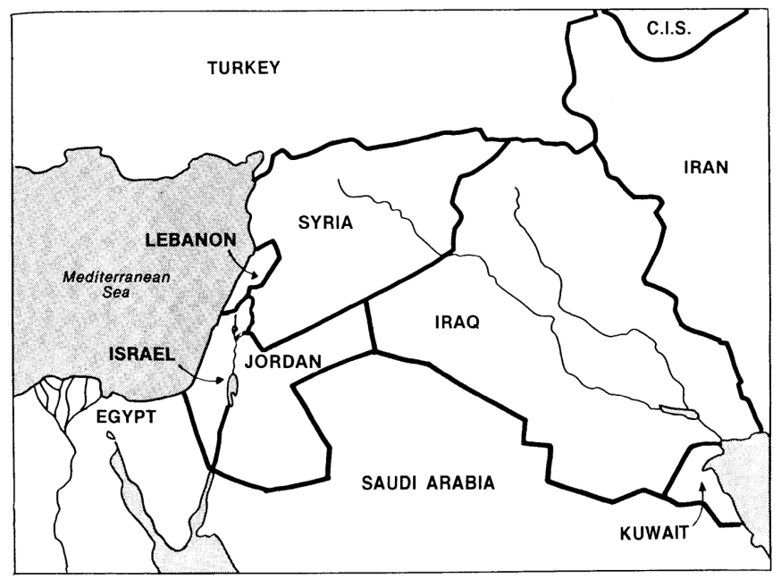

RUSSIA
Terry Hall, Bible Panorama, 49 (adapted)

Key Passage: Deut. 30:1-10

“When… (vv. 1-2)

all these blessings and curses come upon you

and you take them to heart wherever the Lord God disperses you…

and when you and your children return to the Lord…

“Then… (vv. 3-10)

the LORD your God will restore your fortunes…

and gather you again…

and circumcise your hearts…”

Provisions:

National: the land is Israel’s forever (Gen. 13:15; 17:8; Ezek. 16:60)

Universal: possession of the land to benefit all nations (Isa. 14:1-2)

Unconditional Nature

Eternal (Ezek. 16:60) as God will do it for His holy name (Ezek. 36:21-24, 32; cf. 2 Chron. 20:7; Isa. 43:25; Ezek. 20:9, 14, 17, 22, 33-44).

Amplification of the Abrahamic Covenant, which is unconditional

Possession of the land based on obedience (“if…” Deut. 30:10) so the only conditional element is the time (Deut. 30:1-3, “When…then…”)

Time of Fulfillment: follows national repentance (Deut. 30:2, 6, 8, 10; Jer. 17:24-27; 18:7-10) to take place after the return from Babylon (Zech. 10:9-10). This will not occur until the Second Coming of Christ (Rom. 11:26-27).

The Davidic Covenant

Definition: God’s unconditional amplification of the seed promise in the Abrahamic Covenant in which David was promised that his lineage would never be broken as the royal line in a literal, political kingdom.

Key Passage: 2 Sam. 7:12-16 (cf. Ps. 89)

Provisions:

House: perpetual lineage (physical descendants never wiped out)

Kingdom: would never pass away permanently (cf. Ps. 89:4, 36)

Throne: permanent right to rule in a literal kingdom is seen in…

Ordinary language used

Prophets interpreted it literally

Nation of Israel interpreted it literally

The kingdom overthrown is the same nature as the kingdom restored

Associated with Israel only

Portions were literally fulfilled: partial but not permanent fulfillment by Solomon and only a portion of the land was occupied (not owned)

David understood the promise as applying to a literal throne

NT Usage: “Of the 59 references to David in the New Testament, there is not one connecting the Davidic throne with the present session of Christ” (John F. Walvoord, Israel in Prophecy, 96).

John, Jesus, the 12, and the 70 all offered Israel a literal kingdom

Jerusalem Council decision to not require Gentile obedience to the Law (Acts 15:14-17) is based upon Gentiles living as Gentiles (not Jews) in the future kingdom (Amos 9:9-10)

The present mystery form of the kingdom (Matt. 13) does not cancel out the promise for a future, literal kingdom

Unconditional Nature

Eternal (2 Sam. 7:13, 16; 23:5; Isa. 55:3; Ezek. 37:25)

Amplification of the Abrahamic Covenant, which is unconditional

Reaffirmed even after repeated disobedience by the nation (e.g., Christ came and offered this kingdom after generations of apostasy)

Fulfillment: This will follow Israel’s preservation as a nation, restoration to her land, return of her King, and establishment of her earthly kingdom.

Amillennialists claim that the Davidic Covenant is being fulfilled now in the spiritual (not political) kingdom of the Church, which has replaced Israel and fulfilled promises made to her. Christ presently sitting at the right hand of God is equated with His sitting on the throne of David.

Dispensationalists have typically argued against this view, noting that the throne of God and the throne of David are not the same. However, dispensationalists more recently have claimed that the Davidic Covenant is being fulfilled in the present age. This began in the mid-1980s when Darrell Bock, Craig Blaising, and Robert Saucy postulated a progressive fulfillment of this covenant. They coined the term “Progressive Dispensationalists” for their view, and, despite the displeasure of older dispensationalists, the term has stuck. Part of the support for this view is the NT teaching that the Church is a spiritual temple (Eph. 2:19-22) in partial fulfillment of the literal temple that God promised David would be built (2 Sam. 7:13).

The New Covenant

Definition: God’s unconditional amplification of the blessing promise in the Abrahamic Covenant in which Israel and Judah will experience national and spiritual redemption.

Key Passage: Jer. 31:31-34

Provisions:

Indwelling of the Holy Spirit (Jer. 31:33 with Ezek. 36:27)

New nature, heart, and mind (Jer. 31:33; Isa. 59:21)

No need for evangelism (Jer. 31:34a)

Forgiveness of sins (Jer. 31:34b)

Unconditional Nature

Eternal (Jer. 31:36, 40; 32:40; 50:5; Isa. 61:2, 8-9; 24:5; Ezek. 37:26)

Amplification of the Abrahamic Covenant, which is unconditional

Unqualified “I will” statements of God (Jer. 31:31-34; Ezek. 16:60-62)

Time of Fulfillment (cf. chart on next page)

Partial fulfillment in the present church age: Three premillennial views have been given on how to correlate Jeremiah 31:31ff. with the NT passages (Luke 22:20; 1 Cor. 11:25; 2 Cor. 3:6; Heb. 8:8; 9:15).

Only one New Covenant for Israel (Darby)

Two New Covenants: one for Israel and one for the church (Chafer)

One New Covenant with a two-fold application: to the church now and to Israel in the future (Scofield and others)

Complete fulfillment after return of Christ

Note that the time of fulfillment began as soon as the old covenant (Mosaic) was no longer in force. On the night before Christ’s death, He instituted the new covenant in his blood, knowing full well that the next day the old covenant would be abolished (cf. Rom. 7).

In fact, only the Mosaic Covenant is called the “old covenant” in Scripture. Grudem emphasizes this point (p. 521, emphases his):
What then is the “old covenant” in contrast with the “new covenant” in Christ? It is not the whole of the Old Testament, because the covenants with Abraham and David are never called “old” in the New Testament. Rather, only the covenant under Moses, the covenant made at Mount Sinai (Ex. 19-24) is called the “old covenant” (2 Cor. 3:14; cf. Heb. 8:6, 13), to be replaced by the “new covenant” in Christ (Luke 22:20; 1 Cor. 11:25; 2 Cor. 3:6; Heb. 8:8, 13; 9:15; 12:24).

No Scripture refers to the Abrahamic, Land, or Davidic Covenants as “the old covenant” as they are still in effect. God has not finished fulfilling promises made to His people Israel.
Views on the New Covenant

Issue: How can the OT and NT data on the New Covenant be reconciled? Jeremiah 31 declares it is for Israel and Judah but the NT (Luke 22:20; 1 Cor. 11:25; 2 Cor. 3:6; Heb. 8:8; 9:15) apply it to the church. Is there actually no New Covenant, is it only for Israel or only for the church, or are there two New Covenants, or does the church participate in some of its aspects while awaiting the final fulfillment of the covenant? This study takes the last view, as do most modern premillennialists.

View Explanation School/Scholars Problems

Restated No New Critical 1. OC/NC distinctions in text ignored
Mosaic Covenant -Couturier 2. OC=conditional, NC=unconditional
-Duhm 3. OC=temporal, NC=eternal
-Schmidt 4. OC=external, NC=internal
-Potter 5. OC=no enabling, NC=enabling
6. NC=peace, prosperity, sanctuary, Spirit (parallel passages)

Church No Israel Amillennial/ 1. Ignores OT data by equating
Alone Participation Postmillennial Israel and the Church
-Allis 2. NC introduced ≠ fulfilled to Israel
-Cox 3. Present need to know YHWH
-Smick (need for Great Commission)
-Boettner 4. AD 70 Jerusalem vs. Jer. 31:40

Israel No Church Misc/Classical 1. Ignores NT data
Alone Participation Dispensational -Christ's Last Supper words
-Darby -Paul's statements
-Thompson -Hebrews application to Church
-von Rad 2. Ignores present work of Spirit

Two NC for Israel Early 1900s 1. Same terminology for OT & NT NCs
New NC for Church Dispensational 2. Israel/Church distinction too sharp
Covenants -Chafer 3. Basis of forgiveness the same
-Walvoord (old) 4. If 2 NCs then no OC for Church
-Ryrie (old) 5. Church doesn’t possess Israel's promises

Church Primarily Misc/Present Support:
Partici- for Israel Dispensational 1. Primary fulfillment future—Rom 11
pation Secondarily -Keil 2. Deals with both OT & NT data
for Church -Lemke 3. Forgiveness/Spirit=blessings now
-Bright 4. NC has new law
-Scofield 5. Rebuttals to above views
-Walvoord (DTS)
-Ryrie (DTS)
-Archer (TEDS)
-Kaiser (TEDS)
-Feinberg (Talbot)
-Thiessen (Talbot)
Covenant Conditions
Adapted from John F. Walvoord, “The New Covenant,” in Integrity of Heart, Skillfulness of Hands, eds. Dyer & Zuck (Baker, 1994), 186-200

Covenant |  | God’s Part |  | Man’s Part
Edenic  Gen. 1:26-31; 2:16-17 | - Gave man rule over all creatures  - Commanded man to be fruitful  - Permitted man to eat green plants |  | - Adam and Eve could not eat from the tree of the knowledge of good and evil
Adamic  Gen. 3:14-19 | - Judged Satan (3:14-15)  - Judged Adam & Eve (3:16-19)  - Cursed ground (3:17-19)  - Promised Redeemer (3:15) |  | - RESULTS (not conditions)  - Difficult to find food (3:17-19)  - Sorrow & death (3:19)
Noahic  Gen. 6:18;  9:9-16 | - Instructions on ark  - Promised no more worldwide floods  - Invented rainbow (9:13) |  | - RESULTS (not conditions)  - Noah got drunk but covenant still unconditional (9:20-23)  - Assumed that Noah would build ark
Abrahamic  Gen. 12:1-3 | - Made Abram great (12:2b)  - Made Israel great from Abram (12:2a)  - Blesses all [believing] peoples through him (12:3b)  - Will give land eternally (Gen. 12:7; 17:8; Jer. 23:5-8; 31:4-11; 35-37; Ezek. 20:33-38; 47–48) |  | - Abram left Ur (a condition?)  - Man must bless Israel as persecutors are always judged (12:3a)  - Circumcision is the sign (Gen. 17)  - Land possession conditioned on obedience (Deut. 28; 30:1-10) but the covenant is unconditional as its ultimate fulfillment is certain
Mosaic  Exod. 20;  Lev. 26;  Deut. 28 | - Imposed this works covenant on Israel (not on any other nation)  - Warned of blessings & cursings  - Set standards for temporal blessing (not eternal salvation) |  | - “Be holy, because I, the LORD your God, am holy” (Lev. 19:2)  - Obey covenant stipulations such as Ten Commandments (Exod. 20)
Land  Gen. 15:18; 17:7-8;  Deut. 30:1-10 | - Provide Abraham’s descendents the land from the Wadi of Egypt (south) to the Euphrates River (Gen. 15:18)  - Land an eternal, unconditional possession for the nation (17:7-8) |  | - Possession based on conditions of repentance and a changed heart towards Christ as Messiah (Deut. 30:2, 6, 8, 19)
Davidic  2 Sam. 7:12-17;  1 Chron. 17:10b-14; Ps. 89 | - Promised far beyond what David deserved (thus unconditional)  - Descendent will rule Israel forever (7:13, 16)  - Never will rescind the covenant (7:15-16)  - Will fulfill at Israel’s regathering (Ps. 72; Jer. 23:5-8; Ezek. 39:25-29; Jer. 30:5-9) |  | - Accept divine discipline for sin (7:14), which would interrupt the line of kings by disobeying the Mosaic covenant (Ps. 132:11-12)  - The covenant applies only to David’s descendants and thus is limited in scope (not for all people not even for all Israel directly, though indirectly all will be blessed in Christ’s reign)
New  Jer. 31:31-37;  Isa. 61:8-9;  Jer. 32:27-41;  Ezek. 16:60-62;  Ezek. 36:26-27;  Ezek. 37:1-22 | - Will make it with Israel and Judah (31:31)  - Will make it unlike Mosaic law  - Write His laws on hearts (31:33)  - Promises that all on earth will know Him (31:34a)  - Will forgive and forget Israel’s sins (31:34b)  - Unconditional promise for Israel to be a nation forever (31:35-37; 33:25-26) |  | - The new covenant is by grace through faith in Christ (Rom. 3:21-24) and not works (Eph. 2:8-10) to bring redemption (Eph. 2:4-7) so no conditions are given beyond faith  - The sign of this covenant is the cup of the Lord’s Supper (Luke 22:20), which believers are commanded to take (1 Cor. 11:24-25)
Kingdom & Covenants Chart
Contrasting the Abrahamic & Mosaic Covenants

Distinguishing these covenants gives a foundation to interpret the OT and NT, especially the prophets as they look back on covenants with both Abraham (e.g., Ezek. 36–37, p. 508) and Moses (e.g., Lam. 1:3, p. 496). Knowing the conditional and temporal nature of the Law prevents misapplying obsolete commands to the Church today (e.g., Sabbath, charging interest to believers, tithing). Also, God’s faithfulness to sinners becomes clear due to Abraham.

 | Abrahamic Covenant | Mosaic Covenant
Recipient  (Date & Place) | Abraham as mediator for all nations  2060 BC, Ur of the Chaldees | Moses as mediator for Israel  1445 BC, Mount Sinai
Scripture | Genesis 12:1-3 (but formalized into a covenant in Genesis 15) | Exodus 20—31 is the heart of the covenant
Between God & | A person (for a future nation) | A nation
Scope | Universal (“all peoples will be blessed through you”) | Only Israel received the Law (Deut. 4:8; Ps. 147:20)
Character & Significance | Grace (promises)  —primary (what God will do) | Works (laws)  —secondary (how God will do it)
Promises | Land, seed, and blessing (without indication of time of fulfillment) | Blessing for obedience and cursing for disobedience (Lev. 26; Deut. 28)
Conditions | Unconditional: “I will…” | Conditional: “If you will…then I will…”
Participation | Abraham asleep (Gen. 15:17) | Israel agreed to obey (Exod. 19:8)
Analogy | Father to son (royal grant) | Suzerain (superior king) to vassal (servant nation)
Purpose | Clarified Israel’s blessings in general terms to motivate the nation towards righteousness by faith in God’s provision of a wonderful future (Gen. 12:1; 15:1, 6) | Clarified how Israel could be blessed in the Abrahamic Covenant as soon and full as possible; didn’t restate or expand the Abrahamic Covenant but revealed sin (Rom. 5:20; Gal. 3:19, 24)
Form | Oral (no written stipulations) | Written on tablets of stone & Pentateuch
Emphasis | Blessing over discipline/judgment  (five “blessings” in Gen. 12:1-3) | Judgment/discipline over blessing  (contrast Deut. 28:1-14 & vv. 15-68)
Christology | Ultimate seed (Gen. 12:3) | Typified in tabernacle (Heb. 8–10)
Sign | Circumcision (Gen. 17:11) | Sabbath (Exod. 31:13, 17)
End | Never ended (Gal. 3:15-18) as an eternal covenant (Gen. 17:8) | Ended at Christ’s death (Rom. 7:6; 10:4; 2 Cor. 3:7-11; Gal. 5:1; Heb. 7:11-12)

While most of the above is original, some is based on Thomas L. Constable, “A Theology of Joshua, Judges, and Ruth,” in A Theology of the Old Testament, ed. Roy B. Zuck (Chicago: Moody, 1991), 100-101. For more on the relevance of the OT law to the Christian, see Five Views on Law and Gospel (Zondervan), including modified Lutheran (Douglas J. Moo), Dispensational (Wayne G. Strickland), "weightier issues" apply (Walter C. Kaiser), Non-theonomic Reformed (Willem VanGemeren), and Theonomic Reformed (Greg Bahnsen).
Covenant Contrasts

There are only four key eschatological covenants in Scripture. They share these traits in common:
1. Unconditional
2. Eternal
3. Partially & spiritually fulfilled at present
4. Fully & literally fulfilled in the future
5. Universal in scope

Yet they can be contrasted in many ways as well (see also Eschatology pages 21-22, 55a, 59-61, 116):

 | Abrahamic | Land | Davidic | New
Definition:  God’s promise to give Israel… | land, rule, and blessing to benefit the world | physical land from the Wadi of Egypt to the Euphrates River (Gen. 15:18) | political rule  of a descendant of David forever from Zion | spiritual blessings of national cleansing and restoration
Relationship | Umbrella | Land | Seed | Blessing
Key Text | Gen. 12:1-3 | Deut. 30:1-10 | 2 Sam. 7:12-16 | Jer. 31:31-34
Recipient  Date  Place | Abraham  2060 BC  Ur of Chaldees | Moses  1445 BC  Mt. Sinai | David  1004 BC  Jerusalem | Jeremiah  595 BC  Jerusalem
Personal Blessings  to First  Recipient | Possessions & name blessed, son, opposers disciplined | Privilege of seeing Canaan from afar | Sons (“house”) never wiped out (Matt. 1:1-17) | —
National  Blessings | A great nation would come from Abraham | Reproof (exile)  Regathering  Reunited (Isa.  11:11-16)  Repentance  Restored land  prosperity | Temple (via son)  Righteous king to rule (a Davidic descendant) over a kingdom where Israel prominent (Isa. 11:1-5) | Reuniting of Israel  and Judah  Forgiveness  Indwelling Spirit  New heart  100% Christian  (Ezek. 36:25-38)
Universal  Blessings | All nations blessed through Christ | World blessed via visiting Jerusalem (Zech. 14:16-19) | Kingdom (political rule over entire world) | All the world evangelised
Present (Partial) Fulfillment | Church as spiritual seed of Abraham (Gal. 3:5) | Regathering & rebirth of modern Israel (Ezek. 37:7-8) | Church as spiritual temple (Eph. 2:19-22) & Christ as the King awaiting rule | Law abolished, forgiveness, new nature and Spirit indwelling
Future  (Full)  Fulfillment | All four covenants fulfilled in the millennial kingdom | Israel given full borders (Ezek. 37:8-28; 47–48) | Christ rules world (Isa. 2, 11) with saints (Rev. 5:10) | World 100%  Christian and Israel/Judah reunited
Signs of the Covenants

God has made several covenants with man throughout the ages. With each of them he has attached a sign or memorial on an ongoing basis. These function as reminders of his and/or our responsibilities to keep these covenants.

Covenant | Definition | Promise | Fulfillment | Sign
Noahic | Unconditional promise not to flood the earth again | Gen. 9:12-17 | No more sea  (Rev. 21:1) | Rainbow  (Gen. 9:12-17)
Abrahamic | Promise to provide Israel a land, rule, and spiritual blessing | Gen. 12:1-3; 15:13-18 | Continues at present (Gal. 3:17) but Israel still has a future (see Rom. 11:25-27) | Circumcision  (Gen. 17:11)
Mosaic | Conditional stipulations for blessing on Israel | Exod. 19—31; Deut. 28 | Death of Christ (Rom. 7:4-6) | Sabbath  (Exod. 31:13)
Land | Promise of physical land from the Wadi of Egypt to the River Euphrates | Deut. 30:1-10 | Land blessed (Amos 9:13-15) | Israel’s partial restoration to the land in unbelief (Ezek. 37:8, 21)
Davidic | Promise of eternal,  political rule of a descendant of David | 2 Sam. 7:12-17 | Rule renewed (Amos 9:11-12) | Christ seated at the right hand of the Father (Acts 2:34-36)
New | Promise of spiritual indwelling of the Spirit (“law written on hearts”), forgiveness, and total evangelization of Israel | Jer. 31:31-34 | Paul & the Apostles (2 Cor. 3–4)  All Israel saved (Rom. 11:26-27) | Cup of the Lord’s Supper (Luke 21:20; 1 Cor. 11:25)

Comparative Views on the Theme of the OT

The Problem

It’s helpful to know various facts about the Old Testament such as when the people lived, what they did, lessons we can learn from them, etc.

However, often we can “get lost looking at the trees without ever seeing the forest.” So before we discuss this issue as a class let’s first get your opinion.

In the next 5 minutes write out what you consider to be the theme of the Old Testament in the space below. In other words, what is the OT all about? What is it trying to prove? By all means use your Bible to look up key passages. Try to avoid reading the New Testament into your statement so that it sounds like a NT theme. Make this an OT theme, O.K.?

My View

Other Views in the Class

What criteria should be used to determine the theme of the Old Testament?

Solutions (cf. also Gerhard Hasel, Old Testament Theology, 3d ed. [Grand Rapids: Eerdmans, 1982], 117-43)

Redemption of Man (Salvation History or Soteriological Purpose)

Proponents: J. Barton Payne, The Theology of the Older Testament (Grand Rapids: Zondervan, 1962), 3; Graeme Goldsworthy, According to Plan (Leicester, England: IVP, and Homebush West, Australia: Lancer, 1991), 8; Hasel, 141 (but see him under the “God” and “No Center” views below). This is popular at SBC as well.

Statement: The Bible has at its focus the salvation of mankind (as many as will believe) through Jesus Christ. Similar to this theme is viewing the centre of biblical revelation as missiological (e.g., “I do all things for the sake of the gospel,”1 Cor. 9:23; cf. John 4:34).

Critique: Redemption is prominent in the NT but seeing this as the primary theme has a few problems:

This is an external structure imposed on the OT from systematic theology.

It focuses too much on man rather than God.

While Christ is the central person of the Bible, the OT emphasizes Him as King more than as Saviour (the OT rarely notes the salvation of individuals.)

This view also does not include God’s program for angels, those not redeemed, and creation as a whole, so it is too restrictive.

The view is not traced in the wisdom books (not supported in Eccles., Prov., etc.).

Finally, it neglects the physical (land) aspects prominent in the OT.

Glory of God (Doxological Purpose)

Proponents: Calvinistic (predestination) scholars (cf. Westminster Confession); The holiness of God is a similar theme advocated by E. Sellin, Theologie des Alte Testamente (2d ed., Zeipzig, 1936), 19 and J. Hänel, Die Religion der Heiligkeit (Glütersloh, 1931), iii; Paul Lee Tan, A Pictorial Guide to Bible Prophecy, 56 (Eschatology notes, 30).

Statement: The Bible has as its focus the glory and worship of God (by as many as God has foreordained). The Westminster Shorter Catechism (1647) states, “Man’s chief end is to glorify God and to enjoy him forever” (cf. Rev. 1:6; 4:11; 5:12-13).

Critique: This view is certainly true in that it states the end to which all things point but it is incomplete in that it does not state how God seeks to glorify Himself.

Sovereignty of God

Proponents: Ludwig Köhler, OT Theology, trans. A. S. Todd (Philadelphia, 1957), 30

Statement: God is the controller of all events and persons throughout history.

Critique: While God does control all things, this view fails to show the end to which God is working in the world.

God

Proponents: The later von Rad, ThLZ 88 (1963), 406; Hasel, 140 (but see him under the “Redemption” view above and “No Center” view below).

Statement: “The OT is in its essence theocentric just as the NT is christocentric. In short, God is the dynamic center of the OT” (Hasel, 140).

Critique: This view is correct in identifying God as the key subject of the Scripture, but it fails in identifying what God seeks to do in the world. Thus it is too general a theme.

Creation Faith

Proponents: H. H. Schmidt, 1973 (cited by Hasel, 139)

Statement: God is working in the world to create faith in His creatures (?).

Critique: More study needs to be done here to determine what Schmidt really means, but at first glance the idea of creation seems too narrow to encompass the whole OT.

Deuteronomistic Theology of History

Proponents: S. Hermann (cited by Hasel, 135)

Statement: The OT is history written not simply to record facts but to present the theology of the school of scholars who wrote the book of Deuteronomy.

Critique: While it is true that OT history is theological in nature, this perspective denies that Moses wrote Deuteronomy and it fails to show how this book alone is broad enough to encompass the whole OT.

Worship

Proponents: Let the Nations Be Glad (John Piper)

Statement: God’s purpose is to provide worshippers from every nation (Rev. 5:9; 7:9). This view combines the glory of God and the redemption perspectives.

Critique: Revelation 5:9; 7:9 teaches that God will save people from every nation to worship him. However, while this takes place in heaven, these texts are in a Tribulation context. More accurate is Revelation 22:5 because it takes place in the eternal state.

Promise Theme (Blessing or Covenant)

Proponents: Walter C. Kaiser, Toward an Old Testament Theology (Grand Rapids: Zondervan, 1978), 33 and Toward an Exegetical Theology: Biblical Exegesis for Preaching and Teaching (Grand Rapids: Baker, 1981), 139; Walther Eichrodt, Theology of the Old Testament, 2 vols., trans. J. A. Baker (Philadelphia: Westminster, 1961); Paul N. Benware, Survey of the OT (rev. ed., Chicago: Moody, 1993), 14, 18, 35).

Statement: “Such a textually derived center, what the NT eventually was to call the “promise” (epangelia), was known in the OT under a constellation of terms. The earliest such expression was ‘blessing.’ It was God’s first gift to the fish, fowl (Gen. 1:22), and then to mankind (v. 28). For men, it involved more than the divine gift of proliferation and ‘dominion-having.’ The same word also marked the immediacy whereby all the nations of the earth could prosper spiritually through the mediatorship of Abraham and his seed… But there were other terms. McCurley counted over thirty examples where the verb dibber (usually translated ‘to speak’) meant ‘to promise’” (Kaiser, 33).

Texts: Gen. 12:1-3 (Abraham); 2 Sam. 7:11-16 (David); cf. Gen. 3:15; 9:25-27

Critique: This is good but it does not take into account Genesis 1—11. For support, Kaiser cites Genesis 1:22, 28 but these verses give commands rather than a promise. The promise theme is, however, very prominent throughout the OT in the progressive establishment of various unconditional covenants by God.

No Overall Theme or Center

Proponents: The earlier Gerhard von Rad, Old Testament Theology (German ed.), 2:376; Gerhard Wright, Interpreter’s One Volume Commentary on the Bible, 983; Hasel, 123 (but see “Redemption” and “God” views above).

Statement: There are many themes in Scripture but no single theme can be said to be the dominant one. “One needs to be on guard that one does not yield to the temptation to make a single concept or a certain formula into an abstract divining-rod with which all OT expressions and testimonies are combined into a unified system” (Hasel, 123). Von Rad notes, “On the basis of the Old Testament itself, it is truly difficult to answer the question of the unity of that Testament, for it has no focal point as is found in the New Testament” (Die Mitte des AT, 49).

Critique: This theory assumes that because we don’t see an overall purpose in the OT, it must not be there. It faults the text rather than our inability to understand. Instead, we should assume that God knows what He is saying but we need to dig deeper to discern it.

Kingdom Theme (Rule of God)

Proponents: Kenneth L. Barker, “The Scope and Center of Old and New Testament Theology and Hope,” in Dispensationalism, Israel and the Church, eds. Craig A. Blaising and Darrell L. Bock, 305; Eugene H. Merrill, Kingdom of Priests: A History of Old Testament Israel (Grand Rapids: Baker, 1987); J. Dwight Pentecost, Thy Kingdom Come (Wheaton: SP Pub., 1990), 9; Roy B. Zuck, ed., A Biblical Theology of the Old Testament (Chicago: Moody, 1991), ix; Klein, EvTh 30 (1970): 642-70; H. Schultz, OT Theology (Edinburgh, 1892), 1:56.

Others advocate a modified kingdom theme. Seebass (1965) says the theme is the rule of God; Georg Fohrer, ThZ 24 (1965), 161 advocates “the rule of God and the communion between God and man”; and R. Schnackenburg, NT Theology Today (New York, 1965) says the key biblical theme is a dual kingdom-covenant idea. I agree with Schnackenburg in this dual kingdom-covenant theme as the central focus of the OT.

Statement: “I am in essential agreement with the authors’ stated center of biblical theology—basically the kingdom principle of Genesis 1:26-28. Most statements of a theological center are too limited (e.g., promise or covenant), too broad (God), or too man-centered (e.g., redemption or salvation-history). It seems clear that, although there are several great theological themes in Scripture, the central focus of biblical theology is the rule of God, the kingdom of God, or the interlocking concepts of kingdom and covenant (but not covenant alone). This theocratic kingdom is realized and consummated primarily through the mediatorial work of God’s (and David’s) messianic Son. Significantly, Ephesians 1:9-10 appears to indicate that God’s ultimate purpose in creation was to establish His Son—the ‘Christ’—as the supreme Ruler of the universe” (Kenneth L. Barker in Zuck, ed., ix).

This is similar to the sovereignty view [see “(c)” above], yet more complete in that it shows that God delegates limited sovereignty/rule to man in the various ages until ultimate sovereignty is given to His Son (Ps. 2). The end that God will bring is to glorify Himself by restoring the original order He set up in Eden. This is why Revelation 21–22 has so many parallels to Genesis 1–2.

My View of the OT’s Theme

The Old Testament narrates
God’s restoring man to participate in His kingdom rule for His own glory
mandated in Eden but lost in the Fall
and accomplished by redeeming man
through Israel’s role as a kingdom of priests
and ultimately through the Messiah,
who will reign as Saviour and King
in fulfillment of the Abrahamic Covenant

Key Texts: Gen. 1:26-28; 12:1-3; Exod. 19:5-6; Eph. 1:9-10

 | Gen. 1:26-28 | Gen. 12:1-3 | Exod. 19:5-6 | Eph. 1:9-10
Event | Creation Mandate | Abrahamic Covenant | Mosaic Covenant | Messianic Kingdom Rule
Mediator or Co-Ruler  with God | Man (Adam) | Abraham | Israel | Jesus Christ
Subordinates  (what is ruled over) | All creation except people (animals & all nature) | All peoples | All peoples | All creation (people, animals & all nature)
Passage | “Then God said, ‘Let us make man in our image, in our likeness, and let them rule over the fish … birds … livestock … all the earth, and over all the creatures that move along the ground…’ God blessed them and said to them, ‘Be fruitful and increase in number; fill the earth and subdue it. Rule over the fish of the sea and the birds of the air and over every living creature that moves on the ground.’” | “…I will make you into a great nation and I will bless you; I will make your name great, and you will be a blessing. I will bless those who bless you, and whoever curses you I will curse; and all peoples on earth will be blessed through you.” | “Now if you obey me fully and keep my covenant, then out of all nations you will be my treasured possession. Although the whole earth is mine, you will be for me a kingdom of priests and a holy nation.” | “And he made known to us the mystery according to his good pleasure, which he purposed in Christ, to be put into effect when the times will have reached their fulfillment —to bring all things in heaven and on earth together under one head, even Christ.”  Note that “all things” includes both animals (cf. Isa. 11:6-9) and nature (cf. Matt. 17:27; Mark 4:36-41; 6:45-51; 11:2)

Chronological Backgrounds to the Old Testament

Chronology of the Patriarchs

Contrary to popular opinion, the dates on the next six pages are based upon a strict chronology in the genealogies of Genesis 5 and 11. There are several reasons for adhering to a genealogy without gaps:

1. These genealogies state lengths of time in contrast to other genealogies (as in Matt. 1:1-17), which are not strict genealogies but only show bloodlines. Genesis 5 and 11 give the age of each father when a son is born, which is useless data apart from a strict chronology. Also, Methuselah’s death at the Flood fits perfectly.

2. The Genesis genealogies deal with shorter lengths of time (only from creation to Abraham) whereas later ones go from Abraham to Jesus (Matt. 1) or even Adam to Jesus (Luke 3).

3. A no-gaps sequence is the most natural, straightforward, objective method of interpretation.

4. The Genesis genealogies seem to indicate a direct father-son relationship. This is the natural usage of the term “begot” or “was the father of” (dly), especially when the Hebrew Hiphil (causative) tense is used as it is here. When a father-son relationship is not meant, either the Hebrew Qal tense (Gen. 36:10-12; 46:18, 25; Exod. 6:20) or the Hebrew Niphal tense is used (Deut. 23:8). Also, no one questions that Adam had a son named Seth who had Enosh (Gen. 4:25-26), or that Noah had Shem, or that Terah had Abraham.

5. Jude 14 says that Enoch was the 7th generation from Adam so there can be no gaps between these two men. Since the subsequent names have the same structure it is likely that they too lack gaps.

6. Ancient extra-biblical records support a strict chronology. The earliest European and Middle Eastern records verify the accuracy of the Table of Nations (Gen. 10-11) and the early date of creation (5200-4000 BC).

Dates are first determined by starting at the zero year AH (Latin anno Homo sapiens) for “in the year of man’s beginning.” AH dates are then reckoned up to the substantiated date of 1845 BC and then BC dates are counted backwards to creation.

Event | Reference | AH | BC
World created | "By the seventh day God had finished the work He had been doing…" (2:2a) | -6 days | 4143
Adam created | "When God created man [Adam], he made him in the likeness of God" (5:1b) | 0 | 4143
Seth born to Adam | "When Adam had lived 130 years, he had a son in his own likeness…and he named him Seth" (5:3) | 130 | 4013
Enosh born to Seth | "When Seth had lived 105 years, he became the father of Enosh" (5:6) | 235 | 3908
Kenan born to Enosh | "When Enosh had lived 90 years, he became the father of Kenan" (5:9) | 325 | 3818
Mahalel born to Kenan | "When Kenan had lived 70 years, he became the father of Mahalel" (5:12) | 395 | 3748
Jared born to Mahalel | "When Mahalel had lived 65 years, he became the father of Jared" (5:15) | 460 | 3683
Enoch born to Jared | "When Jared had lived 162 years, he became the father of Enoch" (5:18) | 622 | 3521
Event | Reference | AH | BC
Methuselah born to Enoch | "When Enoch had lived 65 years, he became the father of Methuselah" (5:21) | 687 | 3456
Lamech born to Methuselah | "When Methuselah had lived 187 years, he became the father of Lamech" (5:25) | 874 | 3269
Adam died | "Altogether, Adam lived 930 years…" (5:5a) | 930 | 3213
God took Enoch away | "Altogether, Enoch lived 365 years…" (5:23-24) | 987 | 3156
Seth died | "Altogether, Seth lived 912 years…" (5:8a) | 1042 | 3101
Noah born to Lamech | "When Lamech had lived 182 years, he became the father of Noah" (5:28-29) | 1056 | 3087
Enosh died | "Altogether, Enosh lived 905 years…" (5:11a) | 1140 | 3003
Kenan died | "Altogether, Kenan lived 910 years…" (5:14a) | 1235 | 2908
Mahalel died | "Altogether, Mahalel lived 895 years…" (5:17a) | 1355 | 2788
Jared died | "Altogether, Jared lived 962 years…" (5:20a) | 1422 | 2721
Shem, Ham, and Japheth  all born to Noah | "After Noah was 500 years old, he became the father of Shem, Ham and Japheth" (5:32) | 1558+ | 2585
Lamech died | "Altogether, Lamech lived 777 years…" (5:31a) | 1651 | 2492
Methusaleh died | "Altogether, Methusaleh lived 969 years…" (5:27a) | 1656 | 2487
The Flood | "Two years after the flood… Shem was 100 yrs. old" (11:10b) | 1656 | 2487
Arphaxad born to Shem | "Two years after the flood, when Shem was 100 yrs. old, he became the father of Arphaxad " (11:10) | 1658 | 2485
Shelah born to Arphaxad | "When Arphaxad had lived 35 years, he became the father of Shelah" (11:12) | 1693 | 2450
Eber born to Shelah | "When Shelah had lived 30 years, he became the father of Eber" (11:14) | 1723 | 2420
Peleg born to Eber | "When Eber had lived 34 years, he became the father of Peleg" (11:16) | 1757 | 2386
Reu born to Peleg | "When Peleg had lived 30 years, he became the father of Reu" (11:18) | 1787 | 2356
Event | Reference | AH | BC
Serug born to Reu | "When Reu had lived 32 years, he became the father of Serug" (11:20) | 1819 | 2324
Haran born to Terah | "After Terah had lived 70 years, he became the father of Abram, Nahor [II], and Haran" (11:26) | 1948 | 2195
Nahor II born to Terah | "After Terah had lived 70 years, he became the father of Abram, Nahor [II], and Haran" (11:26) | 1949-2007 | 2194-2136
Peleg died | "After he became the father of Reu, Peleg lived 209 years…" (11:17a) | 1996 | 2147
Nahor I died | "After he became the father of Terah [1878 AH], Nahor [I] lived 119 years…" (11:25a) | 1997 | 2146
Noah died | "Altogether, Noah lived 950 years…" (9:29) | 2006 | 2137
Abram born to Terah | "After Terah had lived 70 years, he became the father of Abram, Nahor [II], and Haran" (11:26) | 2008 | 2135
Sarai born | Sarai was 10 years younger than Abram since he was 100 when she was 90 (17:1, 17) | 2018 | 2125
Reu died | "And after he became the father of Serug, Reu lived 207 years…" (11:21a) | 2026 | 2117
Serug died | "And after he became the father of Nahor [I], Serug lived 200 years…" (11:23a) | 2049 | 2094
Shem died | "And after he became the father of Arphaxad, Shem lived 500 years…" (11:11a) | 2058 | 2085
Terah died | "Terah lived 205 years, and he died in Haran" (11:32) | 2083 | 2060
Abram left Haran | Abram went to Canaan at age 75 just after the Abrahamic Covenant was given in Haran (12:4-5) | 2083 | 2060
Abram went to Egypt | "Now there was a famine in the land, and Abram went down to Egypt…" (12:10) | 2085? | 2058?
Abrahamic Covenant ratified | "Lift up your eyes… All the land you see I will give to you and your offspring forever" (13:14-15) | 2089? | 2054?
Ishmael born | "Abram was 86 years old when Hagar bore him Ishmael" (16:16) | 2094 | 2049
Event | Reference | AH | BC
Arphaxad died | "And after he became the father of Shelah, Arphaxad lived 403 years…" (11:13a) | 2096 | 2047
Abrahamic Covenant reconfirmed | Abraham was circumcised at age 99 and Ishmael at age 13; "Sarah will bear [Isaac] to you by this time next year" (17:21, 24-25) | 2107 | 2036
Destruction of Sodom | Cities of the Plain destroyed between Abraham's circumcision and Isaac's birth | 2107 | 2036
Isaac born | "Abraham was 100 years old when his son Isaac was born to him" (21:5; cf. 17:17) | 2108 | 2035
Isaac taken to Mt. Moriah | "Some time later… Do not lay a hand on the boy" (22:1, 12)—estimates Isaac to be 17 years old | 2125? | 2018?
Shelah died | "And after he became the father of Eber, Shelah lived 403 years…" (11:17a) | 2126 | 2017
Sarah died | "Sarah was 127 years old" (23:1) | 2144 | 1991
Isaac marries | "Isaac was 40 years old when he married Rebekah" (25:20) | 2148 | 1995
Shem died | "After he became the father of Arphaxad, Shen lived 500 years…" (11:11) and died at 600 years (11:10) | 2158 | 1985
Jacob and Esau born | "Isaac was 60 years old when Rebekah gave birth to them" (25:26) | 2168 | 1975
Abraham died | "Altogether, Abraham lived 175 years" (25:7) | 2183 | 1960
Eber died | "And after he became the father of Peleg, Eber lived 430 years…" (11:17a) for a total of 464 years | 2187 | 1956
Esau marries | "When Esau was 40 years old, he married Judith… and also Basemath…" (26:34) | 2208 | 1935
Ishmael died | "Altogether, Esau lived 137 years" (25:17) | 2231 | 1912
Jacob fled to Laban | Jacob was 77 years old | 2245 | 1898
Jacob married both  Leah and Rachel | So Jacob. . . loved Rachel more than Leah, and served Laban for another seven years (29:30) | 2252 | 1891
Joseph born | Jacob was 91 at Joseph’s birth (see footnote below) | 2259 | 1884
Event | Reference | AH | BC
Jacob returned to Canaan | At age 97, Jacob returned to Canaan after 20 years and was restored with his brother Esau (31:38, 41) | 2265 | 1878
Abrahamic Covenant confirmed to Jacob at Bethel | At age 100, God confirmed his covenant to Jacob one final time and changed his name to Israel (35:9-15); This is the beginning of the 430 years in Canaan and Egypt (Exod. 12:40). | 2268 | 1875
Joseph sold | "Joseph, a young man of 17, was tending his flocks…" (37:2, 28) | 2276 | 1867
Joseph interpreted dreams of baker and cupbearer | "When 2 full years had passed, Pharaoh had a dream" (41:1); Since Joseph was 30 upon entering Pharaoh's service (41:46), his dream interpretations for the baker and cupbearer were at age 28. | 2287 | 1856
Isaac died | "Isaac lived 180 years" (35:28); Jacob was 120 at Isaac's death since Isaac was 60 at Jacob's birth (25:26) | 2288 | 1855
Joseph interpreted Pharaoh's dream | "Joseph was 30 years old when he entered the service of Pharaoh" (41:46) | 2289 | 1854
Seven years of Abundance | Joseph was immediately appointed by Pharaoh to administer the food of Egypt (41:41, 46) | 2289-2296 | 1854-1847
Seven years of Famine | These immediately followed the 7 years of abundance | 2296-3003 | 1847-1840
Jacob and family go to Egypt | Jacob was 130 (47:9) while entering Egypt during the second year of the famine (45:6); this occurred 400 years before the Exodus in 1445 BC. Joseph was 39. | 2298 | 1845
Jacob died | Jacob died at 147 after living in Egypt 17 years (47:28), so Joseph was 56 years old. | 2315 | 1828
Joseph died | Joseph died at 110 (50:26), so he lived another 71 years in Egypt after his family arrived there. | 2369 | 1774

Sumerian King Lists

Thee lists are obviously exaggerated reigns of the kings. However, they do point out an early belief in the longevity of life consistent with Genesis 5.

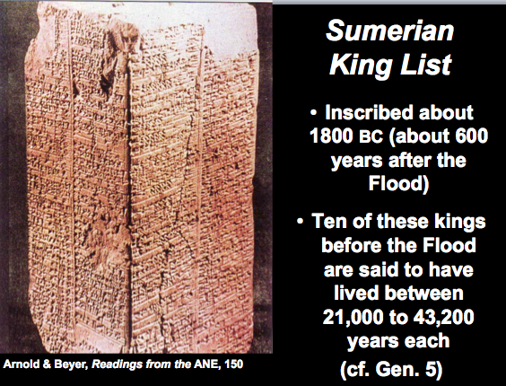

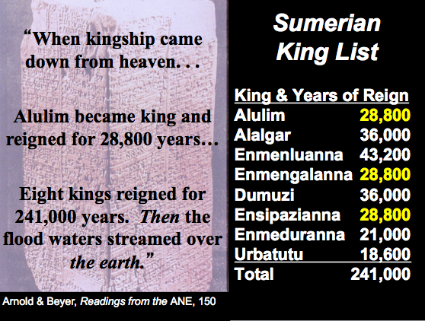

Evangelicals & the Age of the Earth

Evangelical scholars hold two basic views on the age of the earth. Most accept the old age dating of the modern scientific community and then seek to fit Genesis 1 into this framework. This typically results in a type of theistic evolution. However, others see Genesis 1 in a straightforward manner, resulting in the Young Earth Creation model.

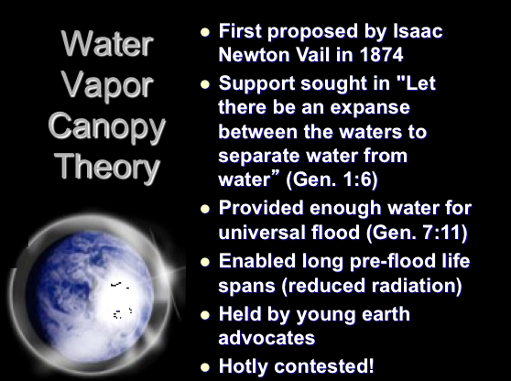

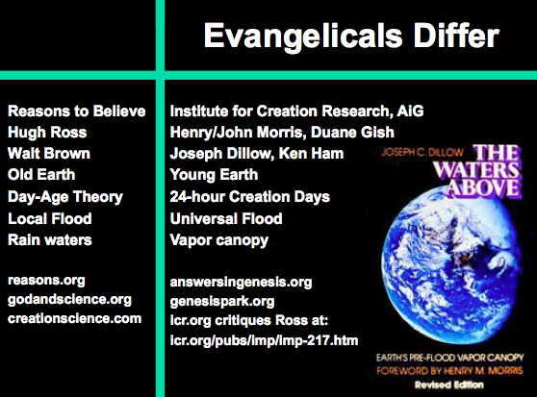

Timeline of the Patriarchs

Other chronological charts added after this page (see next few pages)

Chart of Old Testament Patriarchs & Judges
John C. Whitcomb
Chronological Problems with Cycles in Judges

Judges is similar to Numbers in that it also contrasts the faithful, patient love of God with the faithless, impatient ingratitude of Israel in cycles.

1. Pattern: This sin of Israel follows a cyclical pattern which occurs in a five stage progression from sin to servitude to supplication to salvation to silence, then back to sin again as the cycles repeat themselves seven times (see below).

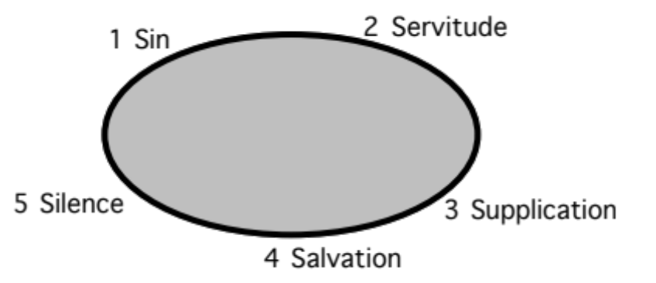

2. The Seven Cycles of the Book of Judges (see chronology on previous page):

Cycle | Oppressor | Location  in Israel | Years of Oppression |  | Deliverer |  | Years of Peace
1 (3:7-11) | Mesopotamians | South | 8 | Othniel |  | 40
2 (3:12-30) | Moabites | Southeast | 18 | Ehud |  | 80
Parenthesis (3:31) | Philistines | Southwest | – | Shamgar |  | –
3 (chs. 4–5) | Canaanites | North | 20 | Deborah & Barak |  | 40
4 (6:1–8:32) | Midianites | Northcentral  (Ophrah) | 7 | Gideon |  | 40
5 (8:33–9:57) | Abimelech | Central | 3 | Unnamed Woman |  | –
Parenthesis (10:1-2) | – | Central  (Shamir) | – | Tola |  | 23
Parenthesis (10:3-5) | – | East  (Komon,Gilead) | – | Jair |  | 22
6 (10:6–12:7) | Ammonites | East  (Zaphon, Gilead) | 18 | Jephthah |  | 6
Parenthesis (12:8-10) | – | Southeast  (Bethlehem) | – | Ibzan |  | 7
Parenthesis (12:11-12) | – | Northwest | – | Elon |  | 10
Parenthesis (12:13-15) | – | Central  (Pirathon) | – | Abdon |  | 8
7 (chs. 13–16) | Philistines | Southwest  (Zorah) | 40 | Samson |  | 20
Totals |  |  | 114 |  |  | 296

Chart of Old Testament Kings and Prophets
John C. Whitcomb
Chronology of Kings and Prophets
Dr. Ernie Poulson, Grace Baptist Church, Singapore (used with permission)

Egyptian Sojourns
Egyptian Sojourns (p. 67)
Egyptian Sojourns (p. 68)
Egyptian Sojourns (p. 69)

The Date of the Exodus

Unlocking the Mysteries of OT Chronology

Peoples of the Old Testament World

Why Study Ancient Peoples?

Knowing the differences between various ANE (Ancient Near East) peoples can help us better grasp certain OT passages.

A study of other cultures can help us grasp our own cultural values as well.

What cultural values do you observe in Singapore?

How do Singaporean values differ from the values of your own culture or from yours as an individual?

Differences between American and Singaporean Values

Chart of Ancient Near Eastern History

Geography of Western Ancient Near East Peoples

Israel’s Exodus from Egypt shows the triumph of a Semitic people (Israel) over a Canaanite people (Egypt), or more accurately, the God Yahweh of the Israelites over the gods of Egypt. Though Egypt was considered a superpower of its day, God chose an obscure, migrant people whose God was Lord over all—even Egypt. Israel originated from another superpower (Mesopotamia), but God also chose to place Israel in a land between these two superpowers as his witness to all the nations!

Alternate Routes of the Exodus
Bible Atlas Online
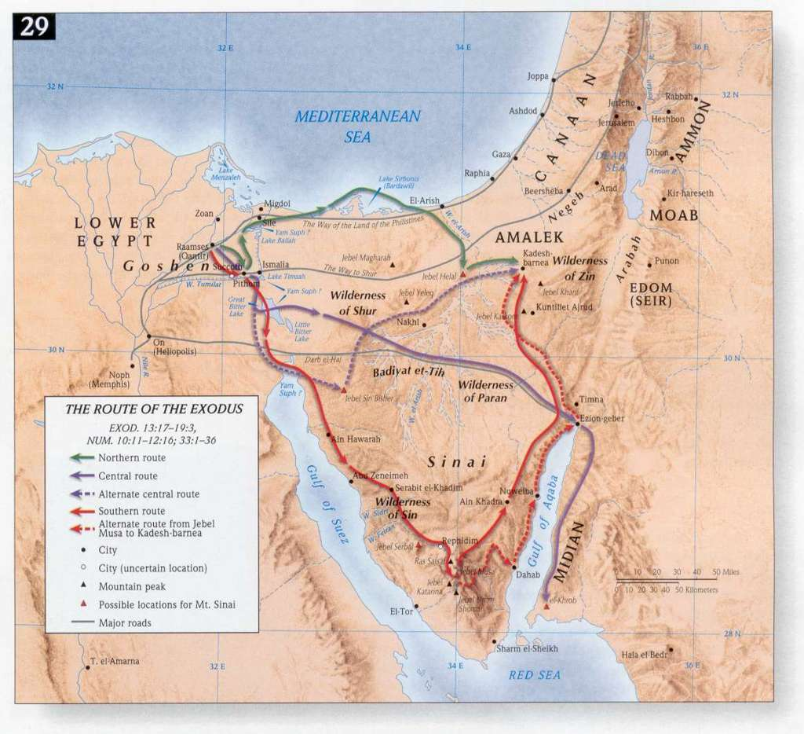

Sumerians (later Akkadians)

Identity:

Who Sumerians Were:

The Sumerians were perhaps the most significant ancient people who are not noted in the Bible, yet their very existence was discovered only at the end of the 19th century.

Due to the merging of Sumer and the Old Babylonian or Akkadian peoples, in later years they are virtually synonymous.

When Sumerians Lived:

During the Protoliterate ("before writing") Period (ca. 3400-2900) they had reached their height culturally—even before writing began! By 2500 BC they had deeply affected the Syrians as the Ebla tablets in Syria show much Sumerian influence.

In the Early Dynastic Period (2900-2335 BC) the kings of Sumer and Akkad may have been united.

The Semites (Old Babylonians) then conquered Sumer but absorbed the entire culture into their own. The Kingdom of Akkad was founded by Sargon the Great (2334-2279), a Semite who founded the new capital of Akkad and respected Sumerian culture and religion. This dynasty ended when foreign Gutians conquered Akkadian civilization and ruled for a while.

The rise of the city-state of Ur (2112-2004) followed during the time of Abraham. It is known for advanced administration, education, building programs, the arts and literature.

Isin-Larsa Period was the final period that ended when Amorites took control.

Geography: Where Sumerians Lived (cf. pp. 15, 17)

Southern Mesopotamia (between the Tigris and Euphrates rivers) was the main centre of Sumerian civilization.

Key cities included Ur and Nippur.

Sumerian Deities: An or Anu (high but rather inactive god), Enlil (powerful ruler and judge), Enki (god of wisdom and cunning), Inanna (goddess of storehouse, thunderstorms, early morning and evening stars) was identified with Akkadian Ishtar, who became the most important goddess of western Asia.

Akkadian and Sumerian Literature (cf. see more texts on pp. 188-188a)

Enuma Elish is an Akkadian account of creation written in about 1100 BC (cf. p. 188d).

The Gilgamesh Epic is the most significant as it contains the story of a flood similar to Genesis 6–9 (cf. pp. 188e-f).

The Code of Hammurapi (Hammurabi) from the time of Ur's dominance prescribes financial penalties for crimes of varying degrees and social class. This is similar to Deuteronomy, though the Bible makes the penalties the same irrespective of social standing. This discovery of a complicated law code dating 500 years before Moses has refuted the liberal claim that Deuteronomy is a code "too detailed for its time"!

Significance: Why Sumerians Were Important

They were the first civilization to develop culturally in an advanced manner.

Thus the Sumerians deeply influenced the other civilizations of the ancient Near East in many ways, including Greece and Rome (and thus all western civilizations). Inventions included:

Writing: The Sumerian language is linguistically unrelated to the Semitic languages, although it does illuminate Akkadian. "The earliest texts are still largely unintelligible, as are some features of the language throughout its history." However, some of this literature parallels the Bible (see above).

The city-state as the earliest form of government comprised an assembly of free adult citizens

The accumulation of capital (saving money)

The wheel

The potter's wheel

The sexagesimal numbering system (use of the number 60 as a base is still seen our measurement of time, circles and angles)

Written legal documents

Schools in which children can all learn to read and write

Cylinder seal (for writing)

Architecture that included monuments (esp. dome, arch, and vault): The ziggurats (temple towers) were especially significant and reached 21 meters high. The first was built in the late 3000s BC.
“Ziggurats were large temple towers made of mud bricks. Their shape resembles a pyramid with tall platforms built on top of one another. The temple was at the top” (source unknown).

Summary: How Sumerians Affected Israel

Abraham came from Ur, a Sumerian city. Thus he carried the culture of his home area to Canaan and undoubtedly affected his descendants with a high level of culture. We can assume that Abraham was literate, given this heritage.

The highly organized bureaucracy administered the temple cult from the temple at the centre of the city. Israel (and the other nations) also saw themselves as sacred states wherein the people viewed themselves as servants of the deity.

Cuneiform (wedge-shaped) writing developed by the Sumerians was not linguistically related to the Hebrew of the Jews. However, the heritage of communicating in this permanent manner forever changed the Middle East and later enabled Jews to communicate God's Word in written form. See the cuneiform system of writing on the next page.
Sumerian Cuneiform
S. N. Kramer, Sumerian Mythology, p. 17

Lessons to Learn from Sumerians

Egyptians

Identity:

Who Egyptians Were: Egyptians of biblical times descended from Hamites after the dispersion at the tower of Babel (Gen. 11:1-9).

When Egyptians Lived: Although not as old as Sumer, Egypt still exists today and thus is one of the world's oldest civilizations. Some believe its "prehistory" (before writing began around 3100 BC) stems back to 250,000 BC. However, no one can accurately date artifacts before the introduction of writing as there exists no outside source of verification to test the accuracy of Carbon-14 or other dating method. Incredibly, Egyptian rulers are traced 3000 years through 31 separate dynasties in seven separate periods.

Geography: Where Egyptians Lived (cf. pp. 15, 17)

The presence of deserts on both the east and west of Egypt in northeast Africa could have made it somewhat cut off from the rest of the world. Yet Egypt, being a super power to Israel's southwest, paralleled the countries of Mesopotamia to the northeast, where the other biblical super powers originated. The link between these two major centers traveled directly through the land of Israel, meaning that Egypt's influence over Israel continued throughout the OT era to varying degrees.

Egypt is one of the few Ancient Near East countries that occupies roughly the same geographical area today. This land still divides into Upper (southern) and Lower (northern) Egypt, taking their names from the northward flow of the Nile.

The Nile was said to be the country's bloodstream in this 6000-kilometer oasis within the African desert. Each year the Nile overflowed it banks, depositing rich silt (soil) along it banks. On this narrow strip the Egyptians cultivated wheat and barley to make bread and beer, and flax for linen to make most of their clothes. To protect this attractive land (Gen. 13:10) the Egyptians continually fought invaders from Libya to the west, Nubia (Ethiopia) to the south, and Semitic-speaking peoples of Syria-Palestine. See the Nile map on the next page.
Map of the Nile
Source Unknown

Egyptian Religion

Deities: Egyptians were polytheistic, believing the pharaoh (king) to be a god. Prominent deities included Amon (king of gods), Re (sun god), Horus, Isis, Osiris (god of crops, fertility, and the afterlife), and Hapi (god of the Nile).

Embalming: They also were obsessed with the afterlife, which brought about a highly sophisticated custom of embalming the dead (even dead animals such as dogs and cats!).

Egyptian Literature

Hieroglyphics ("sacred pictures") was the Egyptians' advanced form of picture-writing. It contrasts with the Sumerian cuneiform (3200 BC) with its wedge-shaped pictures engraved into clay tablets. Originally written on stone, hieroglyphics were written on papyrus from 2600 BC. The Chinese and Indus Valley glyphs of modern-day Pakistan also developed early forms of writing. All four types of writing were based on pictures that were later simplified. The difference with Hieroglyphics is that each picture represented not a word but a letter, deciphered interestingly by a 21-year-old French scholar who studied the Rosetta Stone discovered during Napoleon's occupation of Egypt in 1799 (cf. pp. 87c-d).

Literature Samples (cf. pp. 188-188a)

Memphite Theology notes creation by a spoken word (Gen. 1).

Hymn to the Aten has parallels to Psalm 104.

Instruction of Amenemope reminds readers of Proverbs 22:17–24:22 in its practical wisdom and maxims (sayings). See portions on page 188b.

Egyptian Love Songs are similar in content and style to the Song of Solomon.

Noticeably absent are epic poems (no heroes) and law codes (since the word of the pharaoh was considered divine and unquestioned).

Significance: Why Egyptians Were Important

Egyptians provided the world with many "firsts," such as papyrus (paper).

The Pyramids of Giza from the Old Kingdom era (2700-2200 BC) remain one of the seven wonders of the world (cf. OTS, 105a).

Summary: How Egyptians Affected Israel

God used Egypt to enslave his people for 400 years and thus be his means of motivating the Israelites to trust the Lord for their own promised land.

Egypt served as the most pointed example of the Lord's superiority of any other so-called god. The ten plagues of Moses' time each in effect attacked a specific god in the Egyptian pantheon (cf. OTS, 102, 106).

Egypt, Hieroglyphics and the Bible on the Web (Supplement)

Subject: Egypt, Hieroglyphics and the Bible
Date: Wed, 20 Jun 2001 10:46:57 +0100
From: Dr David Instone-Brewer <Technical@Tyndale.cam.ac.uk>
To: "Tyndale Readers & Staff"; "Tyndale Scholars"

T.T_____T.T_____T.T_____T.T_____T.T_____T.T_____T.T_____T.T_____T.T
Tyndale Technical - from David Instone-Brewer at Tyndale House, Cambridge.
These notes are free, so there is no guarantee that they are useful or accurate.
If you want to go on receiving them, do nothing. If you don't want them, tell me.
T.T_____T.T_____T.T_____T.T_____T.T_____T.T_____T.T_____T.T_____T.T

===================================================================
Egypt, Hieroglyphics and the Bible on the Web
==================================================================

My daughter recently bought an artifact from a suspicious looking Egyptian in a London street. It is a small Anubis (the god who weighs one's heart before allowing entry into the afterlife) with hieroglyphics round the base, about two thirds of which are readable. We have enjoyed learning to read these and deciphering a little. In the process, I discovered that the Web is a surprising treasure house of Egyptian studies, from tourist introductions to the highly academic information.

1) GENERAL BACKGROUND - LIFESTYLE ETC.
2) EGYPTIAN HISTORY AND RELIGION
3) BIBLE PARALLELS AND CHRONOLOGY
4) READING HIEROGLYPHICS - TUTORS AND SIGN LISTS
5) WRITING HIEROGLYPHICS - TRANSLATORS AND FONTS

Even if Egypt isn't your 'thing', do try out the last link on this page.
It will print out your name in Hieroglyphics in large high-quality signs
- good enough to hang on the wall.

===================================================================
1) GENERAL BACKGROUND - LIFESTYLE ETC.

Egyptian Antiquities
- interesting info put in an interesting way.
http://touregypt.net/antiq.htm

Ancient Egypt Links
- links from academic archaeology to tourism.
http://personalwebs.myriad.net/steveb/egypt.html

Teachernet links for Egypt
- very organized, serious, though somewhat 'popular'
http://member.aol.com/TeacherNet/AncientEgypt.html

Who's Who of Egypt
- huge number of people, though very brief notes on each.
http://touregypt.net/who/

===================================================================
2) EGYPTIAN HISTORY AND RELIGION

Ptolemaic Egypt
- links to academic sites for Egypt from 3rd C BCE to Byzantine times
http://www.houseofptolemy.org/

Index of Egyptian History
- all 32 Dynasties. Good overview linked to detailed essays
http://www.friesian.com/notes/oldking.htm

Genealogy of the Egyptian Kings
- a superb example of genealogies on the web, with academic references.
http://www.geocities.com/christopherjbennett/

Egyptian Book of the Dead
- translation of the Papyrus of Ani
http://www.lysator.liu.se/~drokk/BoD/

Religion and Philosophy of Egypt
- academic treatise suggests Egypt was the source of Greek thought
http://www.friesian.com/greek.htm

===================================================================
3) BIBLE PARALLELS AND CHRONOLOGY

Evidence for Israel in Egypt
- straightforward article on Joseph in Hyksos Egypt
http://www.christiananswers.net/q-abr/abr-a027.html

Dating the Exodus
- a proposed redating of virtually everything.
http://www.ldolphin.org/montgochron.html

- David Rohl site, challenging traditional Egyptian chronology.
http://www.nunki.net/index.html

- criticism of David Rohl
http://www.bga.nl/en/discussion/echroroh.html

- the Hyksos date and Bible chronology
http://bibleorigins.homestead.com/Exodus1540BCHyksos.html

==================================================================
4) READING HIEROGLYPHICS - TUTORS AND SIGN LISTS

Short Introduction to Hieroglyphics
- a fairly straightforward 'teach yourself Hieroglyphs'
http://webperso.iut.univ-paris8.fr/~rosmord/Intro/Intro.html

Hieroglyphics.net
- a good visual hieroglyphic dictionary, to and from English
http://hieroglyphs.net/000501/html/000-016.html

Hieroglyphics Sign Lists
- comprehensive sign list with a proposal for computer coding
http://24.8.193.241/1563/Hieroglyphica.htm

- a huge collection of 4700 hieroglyphic ideograms
http://www.ccer.ggl.ruu.nl/hiero/

Egyptology Resources
- academic resources, compiled by Cambridge Egyptologists
http://www.newton.cam.ac.uk/egypt/index.html

Pronunciation of Ancient Egyptian
- a detailed examination, with example sound files
http://www.friesian.com/egypt.htm

==================================================================
5) WRITING HIEROGLYPHICS - TRANSLATORS AND FONTS

Hieroglyphic Translator
- claims to translate sentences into Hieroglyphics
http://www.torstar.com/rom/egypt/

Hieroglyphic fonts
- 800 signs distributed across 4 font sets for Windows. Free.
http://personalwebs.myriad.net/steveb/egyptian/glyphttf.zip

- collection of fonts, Mac & Windows, free and demos
http://www.sil.org/computing/fonts/lang/Egyptian.html

- 4700 signs with a program to write them. Good but pricey.
http://www.ccer.ggl.ruu.nl/ccer/EXTLIB.HTML

Write your name in Hieroglyphics
- lots of sites offer this, but none as pretty as this one.
http://www.upennmuseum.com/cgi-bin/hieroglyphsreal.cgi

David

/// Dr David Instone-Brewer
dib Research Fellow & Technical Officer, Tyndale House, Cambridge
^ Work: dib10@cam.ac.uk http://www.tyndale.cam.ac.uk
\_/ Private: David@Instone-Brewer.com
http://www.Instone-Brewer.com

Mail: Tyndale House, 36 Selwyn Gardens, Cambridge, CB3 9BA, UK
Phone: UK (44) 01223 566675. Fax: UK (44) 01223 566608

New Kingdom Pharaohs
Adapted from http://en.wikipedia.org/wiki/Pharaoh#Eighteenth_Dynasty

Eighteenth Dynasty
Name | Comments | Dates
Ahmose, Ahmosis I | Successor to Kamose | 1570-1546
Amenhotep I |  | 1551-1524
Djehutymes I (Tuthmosis I) |  | 1525-1518
Djehutymes II (Tuthmosis II) |  | 1518-1504
Djehutymes III (Tuthmosis III) |  | 1503-1450
Hatshepsut | A rare female ruler | 1498-1483
Amenhotep II | Early Exodus ruler | 1453-1419
Djehutymes IV (Tuthmosis IV) |  | 1419-1386
Amenhotep III |  | 1386-1349
Amenhotep IV Akhnaten | Founded brief monotheism period worshiping Aten | 1350-1334
Smenkhkare |  | 1336-1334
Tutankhamun |  | 1334-1325
Kheperkheprure Ai |  | 1325-1321
Horemheb | Former General and advisor to Tutankhamun | 1321-1293

Nineteenth Dynasty
Name | Comments |  | Dates
Rameses I |  | 1293-1291
Seti I |  | 1291-1278
Rameses II the Great | The ruler of Moses by late date advocates | 1279-1212
Merneptah |  | 1212-1202
Amenemses |  | 1202-1199
Seti II |  | 1199-1193
Merneptah Siptah |  | 1193-1187
Twosret | A rare female ruler | 1187-1185

Twentieth Dynasty
Name | Comments | Dates
Setnakhte |  | 1185-1182
Rameses III |  | 1182-1151
Rameses IV |  | 1151-1145
Rameses V |  | 1145-1141
Rameses VI |  | 1141-1133
Rameses VII |  | 1133-1126
Rameses VIII |  | 1126
Rameses IX |  | 1126-1108
Rameses X |  | 1108-1098
Rameses XI |  | 1098-1070

Lessons to Learn from Egyptians

Canaanites and Amorites

Identity:

Who the Canaanites Were:

The words Canaan and Canaanite occur 160 times in the Bible. Canaanites descended from Ham, son of Noah who looked upon his father's nakedness (Gen. 9:18-23). Canaan's offspring migrated westward after the tower of Babel dispersion (ca. 2350 BC), then southward from Syria.

This also explains the origin of the Amorites, who were probably a different Syrian (Aramean) clan but of the same ethnic group. Consistent with this is the OT tendency to mix usage of the terms Canaanite and Amorite (Gen. 36:2-3; Ezek. 16:3). The Canaanite language is one of two main branches of Northwest Semitic (the other branch is Aramaic). Closely related to Canaanite language were the Hebrew, Phoenician, and Moabite dialects.

The Phoenicians were a mixed race of Canaanites and Semites who came later. They were not interested in conquering Israel but had commercial interests instead. Phoenician ships sailed throughout the Mediterranean from their key ports of Tyre and Sidon. The OT does not use the term "Phoenicia" but instead notes these cities (Judg. 1:31; 2 Sam. 5:11; 24:7; 1 Kings 7:14; 17:9; 16:31; Isa. 23:17; Jer. 47:4).

When Canaanites Lived: Canaanites had already been in the land for hundreds of years when Abraham went to the land of Canaan (Gen. 12:1-7; 2060 BC).

Geography: Where Canaanites Lived (cf. pp. 15, 17)

Canaan is an old name for Palestine. While Moses was in Egypt, God promised the Israelites the land of "the Canaanites, Hittites, Amorites, Perizzites, Hivites and Jebusites" (Exod. 3:8). These names are probably listed from greater to lesser in terms of size and influence, making the Canaanites the major occupants of the land.

Canaanites lived in the flat, coastal areas of what eventually was to become Israel's land, stretching from the River of Egypt to Lebanon. Life in the flat lands enabled them to advance technologically with use of chariots. Joshua fought the Canaanite commander Sisera from Hazor in the far north (Judg. 4:2, 23-24; 5:19; 11:10).

Numbers 13:29 notes, "The Amalekites live in the Negev; the Hittites, Jebusites and Amorites live in the hill country; and the Canaanites live near the sea and along the Jordan." This reference to life "along the Jordan" includes the large, flat plain of Jezreel that stretches from the coast to the Jordan in north-central Israel.

In contrast to the Canaanites, Amorites lived in the hills on the eastern side of the Jordan as well as the western side in what was later called the hill country of Judah.

Canaanite Religion

Deities: Baal (god of rain, thunder and lightening; also known as Hadad), Yam (god of the sea; cf. yam in Hebrew means "sea"), El (the patriarchal deity as Baal's father) and his wife Athirath (Asherah = Astarte, goddess of sexual life), Mot (god of the underworld, death, and sterility; cf. mot in Hebrew means "death"), and Anat, the sister of Baal (sometimes his wife).

Agricultural Cycle: Since the Canaanites lived on the plains and thus became farmers of the land, they turned to these deities for assistance—especially during the dry summer months. Canaanite myths depict Mot (Death) killing Baal for a time but after Baal's burial he was revived.

Practices: The saddest aspect of Canaanite religion was the appeasement of these deities to perpetuate the agricultural cycle.

They believed their gods must have sex to make the land fertile—male gods such as El and Baal with female deities such as Asherah. This resulted in abhorrent sexual practices in their worship: adultery, incest, homosexuality, and bestiality. These practices are forbidden in Leviticus 18 precisely because the people of Canaan practiced them (18:3, 24-30). Sadly, the people believed that their own sexual perversions stimulated the deities to also engage in sex that brought about the seasonal cycles. This led to "sacred prostitution" in their temples.

Canaanite worship also involved placing live babies into the burning hot hands of statues of Baal. After the baby burned alive, they were pushed into a hole in the statue. Archaeologists have discovered the remains of hundreds of infants beneath these altars in the Canaanite cult—all this supposedly to guarantee their financial security. The only modern parallel to this practice that can be imagined is the wholesale slaughter of millions of unborn babies also for financial reasons.

Canaanite religion is by far the worst of all ancient religions:

"The brutality, lust and abandon of Canaanite mythology is far worse than elsewhere in the Near East at the time. And the astounding characteristic of Canaanite deities, that they had no moral character whatever, must have brought out the worst traits in their devotees and entailed many of the most demoralizing practices of the time, such as sacred prostitution, child sacrifice and snake worship."

Canaanite Literature (cf. see more texts at OTS, 79g)

The Amarna Letters (in Canaanite Akkadian) comprise hundreds of diplomatic letters between city rulers of Canaan and the Egyptian pharaohs (mid 1500s BC). These give much information on social, political, and religious life at this time.

Ras Sharma Tablets were written during the time of the Exodus (15th century) but never discovered until 1929. Prior to this scholars did not even know that this language of Canaan called Ugaritic existed. These writings of Canaanite deities have illuminated modern understanding of Hebrew poetry as Yahweh is often depicted as triumphing over these deities (e.g., the Lord over the waters).

Significance: Why Canaanites Were Important

Understanding the horrors of Canaanite religion with its child sacrifice helps us see why God commanded Israel under Joshua to rid the land of this menace. Israel was commanded never to make a treaty with them but to destroy them completely (Exod. 23:31-33; 34:11-17; Lev. 18:24-25; Deut. 7:1-2; 9:4-5; 12:29-31; 20:16-18). God told them, "You must not worship the LORD your God in their way, because in worshiping their gods, they do all kinds of detestable things the LORD hates. They even burn their sons and daughters in the fire as sacrifices to their gods" (Deut. 12:31). W.F. Albright notes that the decline of Canaanite civilization was due largely to the low moral level of its religion.

Canaanite deities are often alluded to in the psalms and other biblical poetic literature. The Lord is often seen as "over the waters (Yam = god of the sea)"

The pattern of Canaanite temples resembles the three-part form that God revealed to Moses (porch, long hall, and holy place; cf. pp. 167-68 ). Both temple types were also seen as the dwelling place of their deity (and thus both would not allow worshippers inside for religious gatherings). However, the courts were used for festival assemblies in both cases. One key difference is that Israel's tabernacle and temple had no statue set up to depict their deity.

Canaanite culture was advanced on many fronts: engineering, art, metallurgy, inventions, trade, government, language/literature (Isa. 19:18), and especially writing. Your ability to read words on this page is directly attributable to the invention of the alphabet by the Phoenicians, descendants of the Canaanites. In fact, every alphabet in the world owes its origin to the Phoenicians except Korean, which developed independently in the 13th century BC.

Summary: How Canaanites Affected Israel

Religion: In the early days of the divided kingdom Israel began to mix Canaanite and true worship. However, after Ahab's marriage to Jezebel (daughter of the priest of Baal), the king brought Baal worship into central focus in Israel. God raised up Elijah to defeat Baal at Mount Carmel where this "god of rain" could not produce a single drop (1 Kings 18). Yet ultimately Israel imitated the depraved Canaanite religion with its materialism, idolatry and irresistible immorality. For this they experienced God's discipline in exile.

Buffer: The Canaanite military superiority over Israel seen in their use of iron chariots held Israel captive in the hills. Yet even this was used of God to keep the pagan influences of the plains from corrupting His people. The Canaanites controlled the international trade route, but this left them open to the corrupting practices of the super-powers of the day (Egypt and Mesopotamia).

Technology: Similarly, though Israel never completely destroyed the Canaanites and paid the price in a degenerated religion, by God's grace Israel also benefited technologically from those who were left behind.

From the Canaanite remnant they learned "dry-land farming, the digging of cisterns to hold water in the dry season—in short, adaptation to subsistence agriculture and animal husbandry."

Canaanites were also more technologically advanced than Israel at working with metals. Thus their iron chariots controlled the western plains and Valley of Jezreel in Palestine.

Trade: The Phoenicians were the same people as the Canaanites, but after the 12th century. Forced out of Palestine in the 13-12 centuries, Phoenicians became the greatest mariners and traders of all times. They spread the Canaanite culture, religion, language, and alphabet all over the Mediterranean area.

Language: The Canaanites (northwest Semitic people of western Syria and Palestine before 12th century BC) shared a similar Semitic language as Israel, making borrowing possible, as seen in the Psalms. However, Canaanites had two alphabetic writing systems: at Ugarit and one also influencing later Phoenician. In this respect they surpassed Israel linguistically.

Lessons to Learn from the Canaanites and Amorites

Sometimes societies with the best technology are also morally debase.

God is patient, having given the Amorites 400 years from the time of Abraham to sin (Gen. 15:16).

God knows that believers need total separation from sins of the flesh rather than allowing us to mingle with such people (Deut. 7; 2 Tim. 2:22).
Canaanite Jewelry
V. Gilbert Beers, The Book of Life (Grand Rapids: Zondervan, 1980), 8:86

Ammonites

Identity:

Who Ammonites Were: This ancient people on the eastern side of the Jordan River and Salt Sea were distantly related to Israel as they descended from Abram’s nephew Lot. Ammonites became the product of Lot’s incestuous relationship with his daughter (Gen. 19:38). The name of their ancestor, Ben-‘ammi, means “son of my people.”

When Ammonites Lived: Lot was a contemporary to Abraham around 2000 BC, so his Ammonite descendants had occupied the Transjordan Plateau long before Israelites arrived to push them back in the Conquest (ca. 1400 BC).

Geography: Where Ammonites Lived (cf. pp. 15, 17)

After Israel had been in their land for 300 years (ca. 1100 BC), “The king of the Ammonites answered Jephthath’s messengers, ‘When Israel came up out of Egypt [1405 BC], they took away my land from the Arnon to the Jabbok, all the way to the Jordan” (Judg. 11:13).

The most prominent boundary of the Ammonites was the Jabbok River (Deut. 3:16; Josh. 12:2), which begins at present Ammon (ancient Rabbah Amman). From there it flows 62 miles northeast to the Jordan River so that the Jabbok forms a complete circle around the kingdom of Ammon.

Deities: The primary god Milcom or Molech became a snare to Israel in the time of Solomon (1 Kings 11:7).

Literature was not a significant contribution of the Ammonites (cf. no Ammonite texts appear in the lists of literature on pp. 188-188a)

Significance: Why Ammonites Were Important

Ammonites were not a great people in comparison to other ancient peoples.

They did, however, have well-planned agricultural complexes and impressive buildings which Jeremiah accused as cause for pride (Jer. 49:4).

Ammonites humiliated David’s servants and this lead to Joab and Abishai capturing their capital (2 Sam. 11:1; 12:26-31; 1 Chron. 20:1-3).

Summary: How Ammonites Affected Israel

Ammonites were one of the neighbor nations God used to discipline Israel. Battles against God’s people began in Judges 3:12-14 when the Ammonites joined forces with the Moabites and Amalekites, resulting in Israel being subject to King Eglon of Moab for eighteen years.

One key way the people of Ammon subdued Israel was through marriage of their women to Solomon (1 Kings 11:1). This resulted in Solomon building a pagan sanctuary to Milcom or Molech (1 Kings 11:7). Solomon’s son and heir to the throne, Rehoboam, had an Ammonite mother (1 Kings 14:21, 31; 2 Chron. 12:13). His stubbornness led to the division of the kingdom.

Lessons to Learn from Ammonites

Moabites

Identity:

Who Moabites Were: “36So both of Lot's daughters became pregnant by their father. 37The older daughter had a son, and she named him Moab; he is the father of the Moabites of today. 38The younger daughter also had a son, and she named him Ben-Ammi; he is the father of the Ammonites of today” (Gen. 19:36-38).

When they Lived: Lot was a contemporary to Abraham around 2000 BC, so his Moabite descendants had occupied the Transjordan Plateau long before Israelites arrived to push them back in the Conquest (ca. 1400 BC).

Geography: Where Moabites Lived (cf. pp. 15, 17)

Moabites occupied the region southeast of the Salt (Dead) Sea. Since the Edomites to their south were a strong people, the southern boundary of Moab was fixed at the dividing line between Moab and Edom at the brook Zered (modern Wadi el-Hẹsa).

The northern boundary at the Arnon Gorge (present Wadi el-Mujib) became the boundary of Southern Moab in times of weakness, but when strong the Moabites extended across the gorge to the north as far as Heshbon (Num. 21:12; Deut. 2:13-14). This region between the Arnon and Heshbon was called Northern Moab, known in the Bible as the “Plains of Moab” (Num. 22:1; Deut. 34:1).

Deities: The god of war, Chemosh (Kemosh), was unquestionably the chief god of Moab. This is probably the same as the god Kamish in the Ebla tablets.

Moabite Stone
Hoerth, 329

This horrible worship even incited the Moabite king Mesha who was losing in his battle against Israel to offer his own son as a sacrifice (2 Kings 3:27).

Other texts mention the influence of Chemosh over the Moabites (1 Kings 11:7; Num. 21:29; Jer. 7:31).

Literature

The discovery of the Mesha Steele (Moabite Stone or Mesha Inscription) in AD 1868 confirms the biblical account of King Mesha’s rebellion against Omri’s son around 830 BC.

This stele is the most important discovery in Moab as it commemorates Mesha’s achievements and rebellion after Omri’s death (see these notes, 188a, 203).

Significance: Why Moabites Were Important

The King’s Highway through the heartland of Moab was the major north-south transportation artery on the east side of the Dead Sea (Num. 20:17; 21:22; Deut. 2:27).

“Moabite religion included a priesthood (Jer. 48:7) and a sacrificial system (Num. 22:40-23:30; 25:1-5; 2 Kings 3:27; Jer. 48:35). What has been identified as a Moabite sanctuary has been uncovered at Dhiban; both the Mesha Inscription and the Hebrew Bible (1 Kings 11:7-8; 2 Kings 23:13) indicate that such structures existed.”

Summary: How Moabites Affected Israel

Animosity between Israel and Moab was seen as early as Israel’s march to conquer the Promised Land. After being denied access to even pass through Moab, Israel conquered the Amorite towns which were previously held Moabite towns in the north (Num. 21:13, 21-35).

In response, Balak, king of Moab, requested the pagan prophet Balaam to curse Israel (Num. 22-24). This attempt serves to underscore God’s blessing of Israel.

Nevertheless, Moab still served as a thorn in Israel’s side by seducing some Israelite men sexually, leading to the worship of the Baal of Peor. This horrendous sin took the lives of 24,000 Israelites by plague (Num. 25:1-9).

Lessons to Learn from Moabites

God judges idolatry.

God can divinely protect His people, but His people can destroy themselves by choosing the path of sin.

God's mercy and grace always extends to those willing to turn to Him (e.g. Ruth).

The Lord only needs to lift His blessings for nations to disappear from history...

Moab in the Book of Ruth
The Bible Visual Resource Book, 53

Table of Alphabets
E. Kautzsch, ed., 2d. English ed., Gesenius’ Hebrew Grammar (Oxford: Clarendon Press, 1910), xvii

Israel’s Early Eastern Neighbors
John H. Walton, Chronological and Background Charts of the OT, 2d ed., 71

Edomites

Identity:

Who Edomites Were: The brothers Jacob and Esau both became the fathers of nations (Gen. 25:23). From Jacob came Israel whereas from Esau came the Edomite people. Thus the Edomites were the closest blood brothers to Israel of all the pagan peoples that surrounded Israel.

When Edomites Lived: Esau was a twin son to Isaac along with his brother Jacob. Both were born in 1975 BC (Gen. 25:26; cf. OTS, 88). Therefore, the Edomites are new comers in comparison to the Jews whose ancestry is traced back to Abraham. One key difference from Israel, however, is that they were Semites who intermarried with the pagan Canaanites (Gen. 36:2).

Geography: Where Edomites Lived (cf. pp. 15, 17)

After Jacob returned from Paddan Aram and reconciled with his brother Esau, the two agreed to live separately. Esau continued to live in Seir (Gen. 32:3; 33:14, 16) in the region southeast of the Dead Sea, whereas Jacob lived on the western side of the Jordan (Gen. 36:8).

The western boundary between Edom and Israel below the Dead Sea changed continually over the years as Edom was conquered and then regained freedom. During Judah's exile the Edomites took advantage of the situation by occupying much of southern Judah. This area, known as Idumea, was the home of Herod's family in NT times.

The northern boundary between Edom and Moab to its north was the natural barrier known as the river Zered (modern Wadi el-Hasa). On the west lay the wilderness of Judea and the Sinai Peninsula farther south. This area was formerly occupied by the Horites (Gen. 14:6), whom the Edomites dispossessed and settle in their place (Deut. 2:12, 22).

Deities: Scholars know very little about the deities that the Edomites worshipped.

The shrine at Horvat Qitmit (the only known Edomite place of worship) has three rooms and podiums of identical size. This may imply that a plurality of gods was honored but their names still remain a mystery.

Unlike other pagan groups, the OT does not attack Edom's gods by name nor note their practices as "abominations." The OT gives Edom a respect not given to any other neighboring people.

Literature

The language was also called Edomite. It appears to be within the Northwest Semitic languages with its structure resembling Hebrew and Phoenician. However, some of its unusual letters clearly distinguish Edomite from related languages, but how widespread literacy among the Edomites was is uncertain.

The Edomites left no significant literary works that have yet been discovered (cf. no Edomite texts appear on pp. 188-188a).

Significance: Why the Edomites Were Important

Edom in the OT often stands for pagan nations as a whole (Isa. 34:5-17; cf. Obadiah 15-21).

Edomites traded goods along the ancient Spice Route.

As the Babylonians conquered land from Babylon to Egypt, they apparently did not touch Edom (Jer. 40:11-12).

Summary: How the Edomites Affected Israel

Animosity existed between Israel and Edom.

Early animosity between Israel and Edom began when Edom's king refused Israel right to pass through his land en route from Mt. Sinai (Num. 20:14-21).

Edom gloated over Judah's demise (Obad. 11-14) and even possessed the southern territory of Judah after the Babylonian attack (Ezek. 35:10-12; cf. Ps. 137:7; Jer. 40:11-12).

King Herod was an Idumean (a later Edomite) who massacred the Bethlehem babies (Matt. 2).

Yet some level of friendship is also evident.

Israel revered Edomite wisdom traditions (Jer. 49:7).

Job lived in the land of Uz somewhere in Edom (Lam. 4:21), so he had some level of connection with them.

Edomites served in Saul's army (1 Sam. 21:7; 22:9).

Lessons to Learn from Edomites

Philistines

Identity:

Who Philistines Were (Biblical Evidence):

Philistines descended from Ham (Gen. 10:13-14).
NOAHH
HAM
MIZRAIM
CASLUHIM

Jeremiah 47:4 and Amos 9:7 also record the origins of Philistines. They came from Caphtor, a term that occurs in cuneiform documents in several languages as Kaptara and in Egyptian texts as Keftiu. Caphtor or Kaptara or Keftiu can be identified with the island of Crete and its environs.

Evidentally the Philistines originated in Egypt, migrated to Crete, then migrated back to Egypt. Ezekiel 25:15-16 and Zephaniah 2:4-5 use the term Cherethites in poetic parallelism with Philistines, meaning they were one and the same.

When Philistines Lived (Non Biblical Evidence)

The Philistines were a complex people, incorporating several groups and cultures from different times and places. Their zenith in world history was a brief period around 1150-1100 when they settled in southwestern Canaan.

The Egyptian Pharaoh Rameses III noted the Philistines because of an eight year war between Egypt and “the peoples of the sea” or “Sea People.” This inscription was found in the temple at Medinet Habu near Thebes.

Philistines were called one of the Sea Peoples because many of them came to the eastern Mediterranean by sea and because they seem to have come from island or coastal areas in the Aegean or Anatolia (i.e., Asia Minor).

When these Sea People came to Egypt as part of a large-scale migration shortly after 1200 BC, it lead to a war in southwestern Canaan and the Nile Delta.
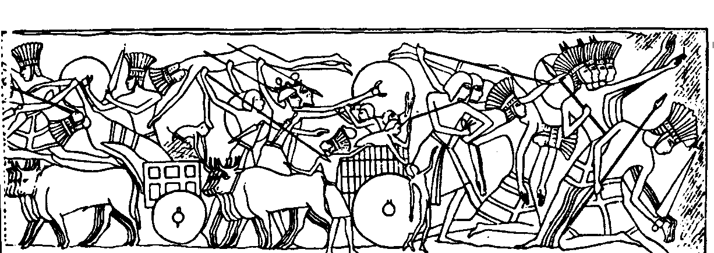

The result of the war was that Rameses III claimed a great victory but he allowed the Philistines and other groups to settle in the southwestern Canaan.

Geography: Where Philistines Lived (cf. pp. 15, 17)

Region

Philistines settled in the coastland of Canaan and then the area developed into the five city-states which are often called the Pentapolis.

The cities of the Pentapolis can be remembered with the acronym “AGE”: Ashkelon, Ashdod, Gaza, Gath and Ekron.

Cities

Ashkelon

An ancient city on the Palestinian coast 20 km north of Gaza even before the Philistines arrived

It lays on the international highway (Via Maris) that led to Egypt

Its agriculture supplied Egypt with cattle, sheep, honey and oil. This city was also world famous for its wine

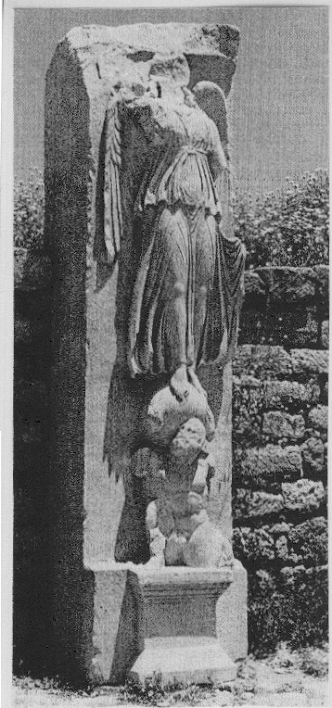
The first excavation was carried out in 1920-1921 by John Garsbang. He found these archaeological discoveries:

New kinds of military devices

The earth rampart

Statue of Greek’s goddess of victory in the city council chamber

The biblical record for this city can be found in Judges 1:18 when Judah took Ashkelon as their territory. Judges 14:19 also notes Ashkelon in the story of Samson.

Ashdod

Ashdod was another ancient city in Palestinian area that fell under the Philistine conquest. It was founded about the sixteenth century BC.

It sits on the summit of a grassy hill fifty feet above sea level near the Mediterranean coast. It lays between Ashkelon and Ekron.

There were no formal excavations of this city until M. Dothan and D. N. Freedman began work there in 1962.

Some archeological discoveries were found in this city according to this topographical map.

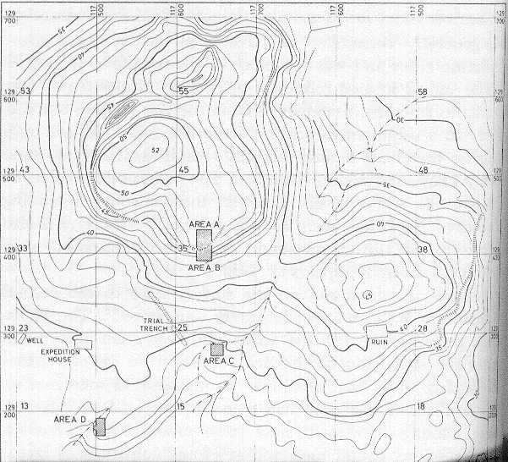
Area A
Area B
Area C
Area D

Some findings in this city were:

Area A:

Pottery, lamps and Rhodian stamps

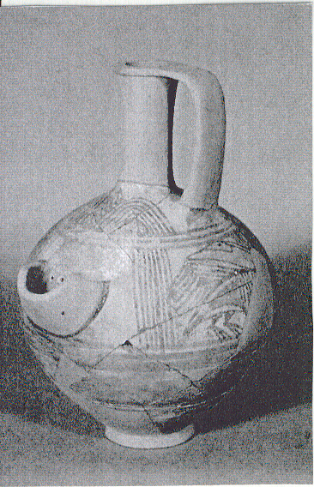
“Fish Plate” of the Hellenistic Period

Area B:

Ring base pottery

Another pot from Mycenaean and Cypriot shows Ashdod as a key trading center on the eastern Mediterranean

The most interesting find was an inscribed potsherd of the Iron Age

Area C had more Philistine ware, including several beer mugs

Area D: A thirteen-foot thick portion of the outer wall was also discovered. It evidently encircled the lower city and was linked to the wall of the fortress on the acropolis.

Joshua 11:22 notes Ashdod: “There were no Anakim left in the land of the sons of Israel; only in Gaza, in Gath and in Ashdod some remained”

Another key passage on Ashdod is 1 Samuel 5 when the Philistines had a victory over Israel. They took the ark of God to Ashdod and placed it next to Dagon, one of their gods. Because of this God struck the Ashdodites with tumors. They finally returned the ark to Israel.

Gaza

Gaza is the most southwesterly town in Palestine.

The British School of Archeology in Egypt excavated this spot at the mouth of the Wadi Ghazzeh between 1930 and 1934 under Sir Flinders Petrie. The actual city of Gaza cannot be identified, though it is probably Tell el-`Ajjul which lies two miles from the coast and six miles south of the modern city of Gaza.

Albright has also indicated that because of the appearance of pottery and weapons of the Early Bronze age the town was occupied even earlier.

Joshua conquered this city while it was under Canaanite control with some Anakim remaining there (Josh. 10:41, 11:21).

After the Philistines caught Samson, they brought him to Gaza where he got his revenge by killing 3000 men and women (Judg. 16).

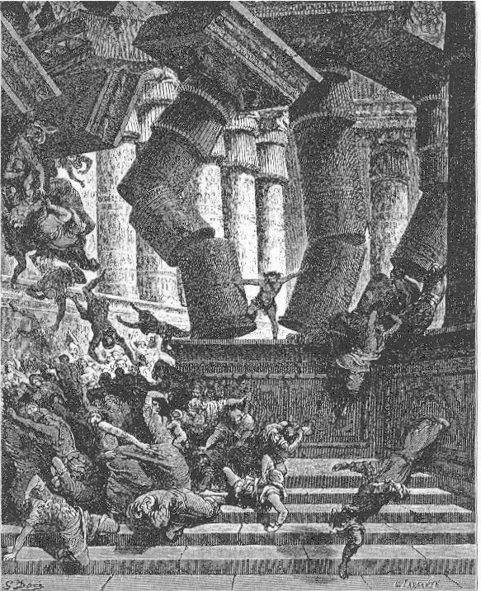

Gath

The actual site of Gath has never been identified with certainty. In 1956 the Israel Exploration Society began excavating Tell el-`Aerini (20 miles north of Gaza) supposing it to be ancient Gath.

Gath means “winepress.” It was the farthest city inland of the Philistines cities, bordering Israel on the edge of the Shephelah. “Winepress” seems an appropriate name for the city of Goliath, who had squeezed the life out of Israel until his own death.

The captured Ark of God was brought to Gath (Judg. 5). The people of Gath (Gittites) were struck with what many consider to be a bubonic plague.

Ekron

This city has never been positively identified, though many feel it is the modern Khirbet al-Muqanna.

Some explorations in 1957 revealed the site to have been occupied in the Early Bronze Age. The city was walled and covered forty acres at its peak.

Many examples of typical Philistine pottery were found on this site, as well as a double wall that included gates and towers.

When the ark of God gave the Philistines trouble, they tried to send it to Ekron. However, the Ekronites cried out, saying “They have brought the ark of God of Israel around to us, to kill us and our people” (see 1 Sam. 5:10-6:12).

Philistine Deities:

Astaroth

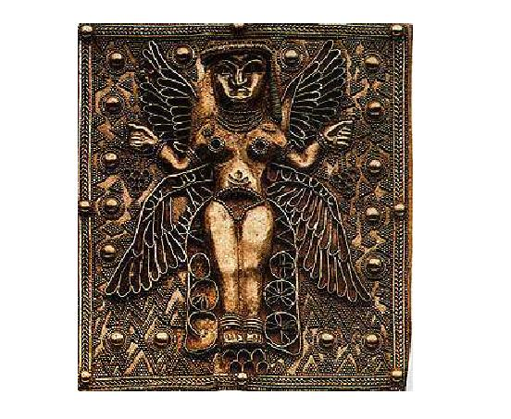
Other names: Athtart, `Athtartu (Ugarit), `Ashtart (Phoenicia), Astarte (Greek), Ishtar (Mesopotamia).

The mother goddess, the goddess of fertility, love and war (depicted at the right as a four-winged golden goddess)

Meaning of her name: “shame”

Israel worshipped Ashtoreth soon after they arrived in the Promised Land (Judg. 2:13).

After his death, Saul’s body was placed in the Astaroth temple (1 Sam. 31:10).

Baal Zebub

“Baal” means “lord, master” while “Zebub” means “flies.” But why would anyone—even a pagan—name his god “the lord of the flies”? Three suggestions have been proposed:

Flies are everywhere, so does it mean the “omnipresence” of Baal Zebub is akin to the “omnipresence” of flies?

Did it refer to the god who guards them from flies?

Perhaps it is a mockery from the Israelites?

Jesus was called Beelzeboul – Lord Prince / Lord Baal / lord of the heavenly dwelling (Matt. 10:25; 12:24, 27, etc…).

Perhaps Hebrews sarcastically referred to the Philistine god with this designation that sounds similar.

Dagon

This god was believed to be half fish and half man.

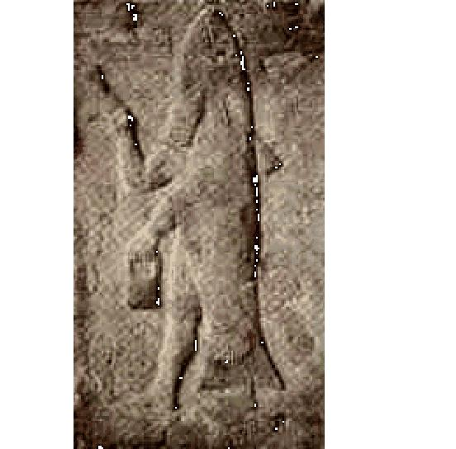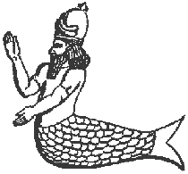

Dagon was a pagan deity with the body of a fish, and head and hands of a man. He was probably the god of agriculture. Dagon was worshiped in Mesopotamia and Canaan, with temples in Ashdod (1 Sam. 5:1-7), Gaza (Judg. 16:21-30), and in Israel (1 Chron. 10:10). Samson destroyed the temple [of Dagon] in Gaza (Judg. 16:30)” (“Dagon,” Naves Topical Bible).

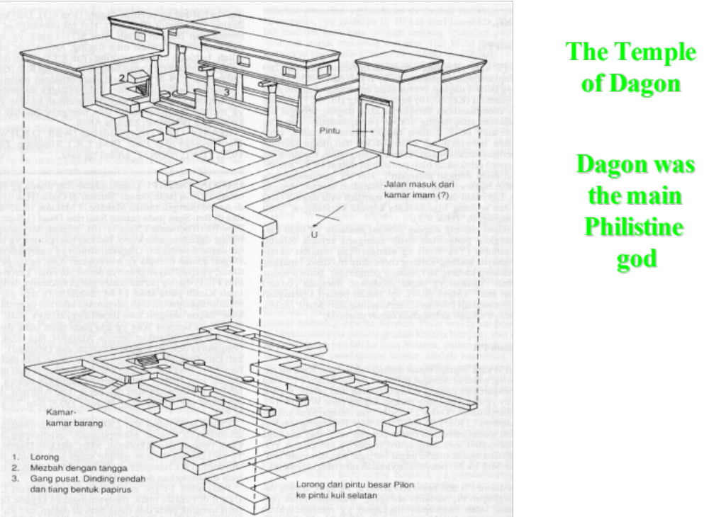

Literature (cf. no texts on OTS, 79f-79g)

Philistines are known not for great literary accomplishments, but for warfare. There exist few if any significant finds.

Little is known of the Philistine language, although there seemed to be no language problem between Philistines and Israelites.

Perhaps the Philistines adopted the local language after migrating to the area.

Their names are usually Semitic (Abimelech, Gen. 26:8; Mininti, Dagon) but some are Asiatic (Achish and Goliath).

Some Hebrew words are from the Philistines, such as the Hebrew word for “helmet” (qoba). This word is borrowed from the Philistines.

Significance: Why Philistines Were Important

The period of transition from the Bronze to Iron Age

The Philistines are first mentioned by name: prst in the annals of Rameses III (ca. 1185 BC) and subsequent years. One Egyptian relief shows the prst armed with lances, round shields, long broadswords, and triangular daggers (see picture). They arrived in Palestine at the period of transition from the Bronze to Iron Age.

These archaeological finds are consistent with the biblical statements that they bound Samson with fetters of bronze (Judg. 16:21) but by time of Saul controlled the iron industry of the area (1 Sam. 17:4-7).

The Philistine military organization

The description of Goliath’s battle gear (1 Sam 17:5-7):

bronze helmet on his head

coat of scale armor of bronze weighing five thousand shekels (57.5 kilograms)

bronze greaves on his legs

bronze javelin slung on his back

spear shaft was like a weaver’s rod

iron point weighed six hundred shekels (6.9 kilograms)

shield bearer went ahead of him (note: 1 shekel = 11.5 grams)

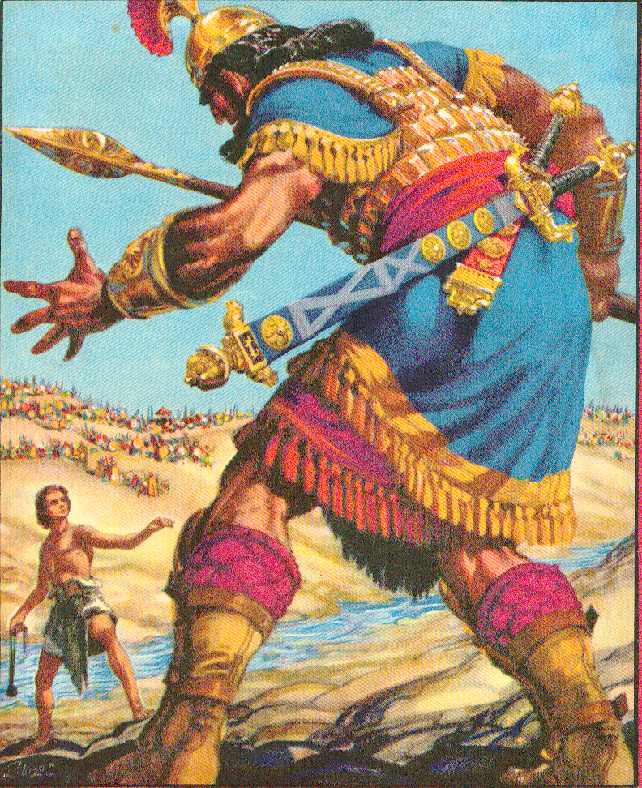

Multi-faceted Forces (1 Sam. 13:5; 31:3)

chariotry

cavalry

infantry

archers

Egyptian Reliefs of Rameses III:

The sea people fought with infantry, ships, and chariots. Each foot soldier carried two spears, a round shield, and a long straight sword. They fought in groups of four. The chariots were pulled by two horses, had two six-spoke wheels, and were operated by crews of three who were also armed with two long spears. They could only engage in short-range combat, a disadvantage against the Egyptian charioteers equipped with bow and arrows.
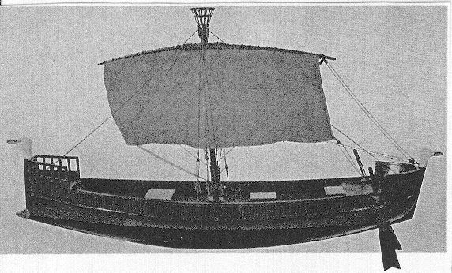
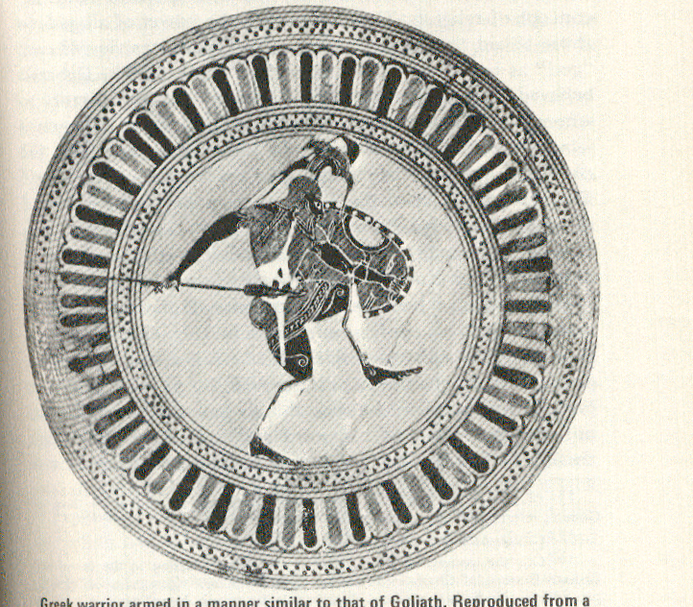

Summary: How the Philistines Affected Israel

More culturally and technologically superior than Israel, the Philistines advanced life for the Jews in certain respects:

God taught warfare to the Israelites through the Philistines (Judg. 3:1-3).

Farming methods in Israel were improved through Philistine technology.

Israel's worship of Dagon and Baal made God jealous (Judg. 10:6-7).

Philistines were a tool of God to chastise His wayward people.

Their threat motivated Israel into wanting a strong military leader (king) to lead them into battle (1 Sam. 8).

Since Israel was God’s chosen people, no matter what the Philistines did to Israel, God still controlled all events that happened between the two countries.

Lessons to Learn from Philistines: Some Thought Questions Based on 1 Samuel 17:

How did David’s view of the Philistines differ from that of the Israelites?

Why was his view different?

Why do non-Christians often have superior technology to Christians?

Or do they?

Israel’s Early Western Neighbors

John H. Walton, Chronological and Background Charts of the OT, 2d ed., 73

The Sea Peoples

Bible Atlas at www.swartzentrover.com (Map 34)
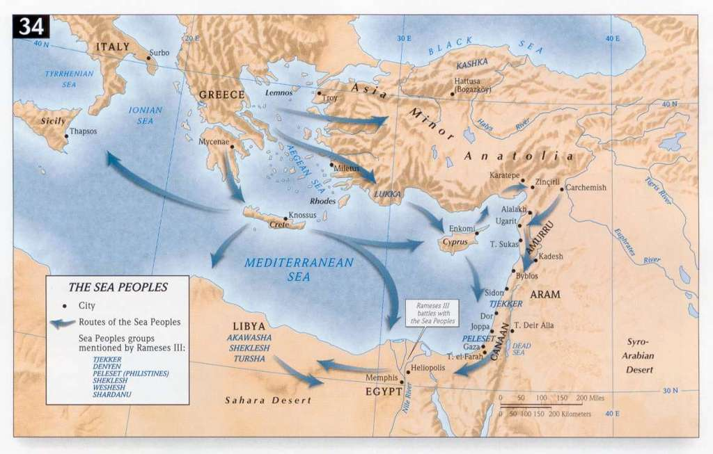

Phoenicians

Identity:

Who Phoenicians Were:

Along with the Philistines (but even superior to them), the Phoenicians were the greatest seafaring people of the ancient world.

The word “Phoenicia” or “Phoenicians” never appears in the Bible. These people were referred to by the two key cities: Tyre and Sidon. The word “Phoenicia” means “[land of the] purple dye.”

When Phoenicians Lived:

The Greek historian Herodotus (1:1 and 7:89) notes that Phoenicia was inhabited by a “Mediterranean” race around 3500 BC.

They were replaced with Semites migrating from Mesopotamia and Arabia (3000 BC), and were joined by other groups until a flourishing trade between Phoenicia and Egypt existed around the 18th century BC.

However, the “Golden Age” of Phoenicia occurred simultaneously with the “Golden Age” of Israel. Contemporary to David and Solomon was Hiram, king of Tyre (c. 981-947), who provided timber for the building of the temple.

Geography: Where Phoenicians Lived (cf. pp. 15, 17)

The small coastal stretch of land comprising Phoenicia stretched started its southern boundary at Acco and Mount Carmel, directly west from the Sea of Kinnereth (NT: Galilee). Going north, the land stretched past Tyre and well past Sidon and Ugarit 120 miles to the north. At no point does the land stretch even past five miles wide.

Phoenicia is also a mountainous but also very fertile region. Vegetation included evergreen shrubs, pine, oak, mulberry and beech trees, grape vines, fig trees, date palms, olive trees, wheat and barley, onions and garlic. However, the most notable trees were cedars, cypress, juniper, and almug. Unfortunately, these trees were not replaced so that modern Lebanon has but two small groves of cedars of less than a few hundred trees.

Phoenicia had strong neighbors to the north (Hittites) and south (Israelites & Philistines). This fact, coupled with the narrowness of their land with its limited food supply, forced ancient Phoenicians to supplement their food production with an extensive array of ships. They were famous in antiquity as sailors (cf. Isa. 23). Phoenician colonies extended across the Mediterranean to include Carthage (850 BC) and even one in southern Spain. Some believe their trade even included the Atlantic.

Deities:

The high god of Phoenician religion was El, whose wife-consort took the name Ashtoreth.

The most horrible of Phoenician beliefs was the worship of Baal (Hadd, the son of Dagan), meaning “lord.” The high priest Ethbaal gained the throne and maintained an alliance with Israel by the marriage of his daughter Jezebel to Ahab, king of Israel (1 Kings 16:31).

Lesser deities included:

‘Anat and ‘Ashtart, two young female goddesses who consorted with Baal

Yam, sea god

Mot, god of death

Yarih, sun god

Adoni, vegetation and fertility god (Gr. Adonis, “my lord”), supposedly died when the summer heat began and then rose again annually.

Literature (cf. see more texts on pages 188-188a)

Ugaritic was the language of the Phoenicians, stemming from the city of Ugarit.

Until modern times no one even knew that this language existed. It has provided much insight into the Hebrew text (esp. the Psalms) by showing that YHWH’s victory over the sea (Yam), death (Mot), etc. is actually a play on words by declaring the LORD’s greatness over Ugaritic deities.
The Phoenician Alphabet

Significance: Why Phoenicians Were Important

They were one of the first peoples to show that colonization can successfully be done across international waters.

As seafaring traders, the Phoenicians introduced many products of other lands into the eastern Mediterranean.

The Phoenician phonetic alphabet became the foundation of what later became the Romanized script, from which the languages of western civilization influenced the rest of the world. You can thank the Phoenicians that you can read this sentence! After all, this is where we get our word “phonetic”!

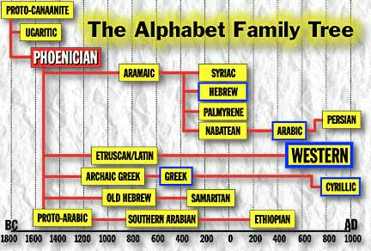

Summary: How Phoenicians Affected Israel

Positive

Phoenician craftsmen helped build Solomon’s temple (2 Sam. 5:11; 1 Kings 5:1). They were superior in knowledge to Hebrew craftsmen, so they helped train them (2 Chron. 2:13-14).

Our knowledge of Hebrew has been greatly advanced by the study of the forerunner of their language called Ugaritic.

Devotion to Baal provided Elijah opportunities to show YHWH as the only true God. He acted as the main representative of the LORD at Mount Carmel (1 Kings 18) as well as in his travels to Zarephath to provide oil for a widow, which Baal could not do even on “his own territory” (1 Kings 17:9-23).

As the greatest of the maritime peoples, Phoenicians advanced life in Israel from trade with Tyre and Sidon. Their sailors taught Israelite men how to sail in the Red Sea (1 Kings 9) and the various Phoenician colonies brought wealth to the whole region due to extensive trade with Phoenicia.
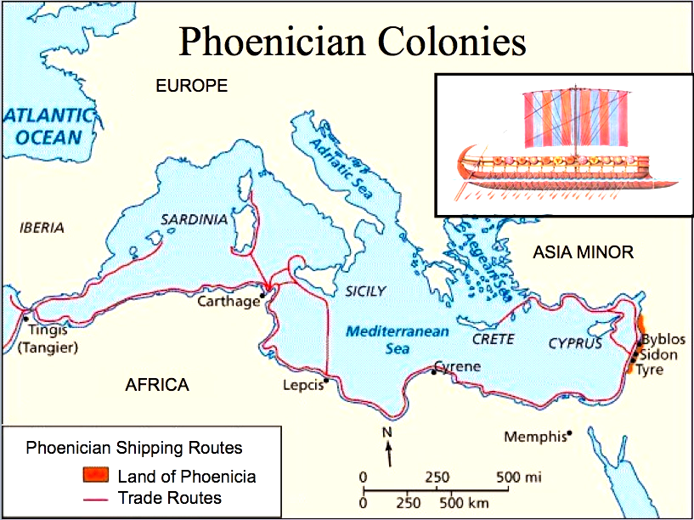

Negative

Jezebel, daughter of a Phoenician pagan priest, brought Baal worship into the northern nation of Israel which quickly contributed to it demise due to several elements:

Idol worship contrary to Exodus 20:4, “"You shall not make for yourself an idol in the form of anything in heaven above or on the earth beneath or in the waters below.”

Ritual prostitution (both male and female) used to entice the fertility god and goddess to have sex in hopes that this would benefits the crops

Human sacrifice may have been practiced in association with Baal worship.

Baal worship also led to violence between worshippers of Baal with loyalists of Yahweh (1 Kings 18:3, 4, 25-40; 19:10).

Lessons from Phoenicia: What life principles can we learn from…

Isaiah 23 (Phoenician economy)

1 Kings 18 (Phoenician religion)

Arameans

Identity:

Who Arameans Were:

Arameans are also called Syrians.

Terah, of the line of Shem, had three sons: Haran, Abraham, and Nahor. The line of Nahor’s grandson Aram yielded the Arameans.

Noah
Ham
Shem
Japheth
Nahor
Abraham
Haran
Terah
Kemuel
Isaac
Aram
Jacob
Arameans
Israelites

The above chart shows that Arameans and Israelites were related as they both looked to Terah as their common ancestor.

This association was so close that Isaac sent Jacob back to Aram for a wife. Laban and his brother Bethuel were both Arameans (Gen. 25:20), so Jacob’s marriage to Rebekah was considered marriage within the family line.

The close relationship between the Israelites and the Arameans is also confirmed in Deuteronomy 26:5, “Then in the Lord’s presence you will recite these words: ‘My ancestor was a wandering Aramean.’”

This quotation uttered each time Jews went to the temple makes clear that the Jewish people were originally Arameans.

Since Arameans were pastoralists and villagers, with no political centralization, the recitation above also reminded Israelites that their ancestors (Abraham, Isaac and Jacob) were wanderers and thus should behave modestly, not be proud and conceited.

When Arameans Lived: As noted above, since the lineage of the Arameans is parallel to Israel, their common roots go back to Terah who was born about 2265 BC (cf. OTS, 86-87).

Geography: Where Arameans Lived (cf. pp. 15, 17)

Ancient and modern-day Syria and southern Mesopotamia comprised the boundaries of Aram.

The ancient capital of Aram was Damascus. It also serves as the present capital of Syria.

Deities:

As God called Elijah to show His superiority to Baal of Phoenicia, so Elisha demonstrated the inferiority of the Aramean deity Rimmon.

The Aramean commander Naaman had to journey to Israel for healing from Yahweh through Elisha (2 Kings 5). His deities couldn’t help him.

Elisha’s ministry among the Arameans is summarized thus:

Elisha healed Naaman of leprosy (ch. 5) and rescued a young prophet's borrowed ax head (6:1-7). He gave timely warning, repeatedly saving Israel from defeat by the Arameans (6:23). When the Arameans came to Dothan to capture Elisha, he prayed and his servant was shown the armies of God protecting the city. The Arameans were stricken with blindness, and Elisha led them to Samaria and persuaded the king of Israel to feed and release them.

After Aram defeated Ahaz in battle, Ahaz sacrificed to Aramean deities—yet this led to his downfall (2 Chron. 28:22-23).

Literature (see more texts on pages 188-188a; cf. Arnold/Beyer, 163-68)

Aramean political structure, art, and architecture never became influential.

However, the Arameans transmitted their language called Aramaic to many other cultures. It actually is an alphabet and has a long tradition, surviving the Assyrian, Babylonian, and Persian empires.

It is important to observe that the Greeks received their alphabet from the Phoenicians and Arameans, perhaps through contact with their merchants. The Hellenic tribal groups found written expression for their language through the Phoenician alphabet, which supplied the first twenty-two letters of the Greek alphabet (i.e., alpha through tau). Those Semitic letters that expressed sounds not used by the Greeks were adapted to express vowels.

The Elephantine Papyri in Egypt was written in Aramaic, even though Egypt is a long way from Syria.

Significance: Arameans were important due to their language.
.
Aramaic Alphabet (Alep-beet)

This is a consonant alphabet with no vowel indication.

Written from right to left in horizontal lines.

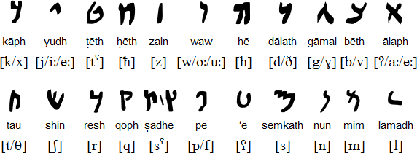

20

The Lord’s Prayer in Aramaic
Aramaic was the language of the Semitic culture, the language of the Hebrew patriarchs, and in the older days, the lingua franca of the Fertile Crescent.
The term “Hebrew” may come from “Eber,” the common ancestor of several Semitic peoples and founder of the Hebrew race (Gen. 10:21-25; 11:14-17; 1 Chron. 1:18-19, 25; Luke 3:35).
Others believe it derives from the Aramaic word Abar or Habar, which means “to cross over.” This name may have been given to the Hebrew people because Abraham and those with him crossed the Euphrates River and went into Palestine. Migration of this form is one reason all branches of the Semitic people had a common speech.
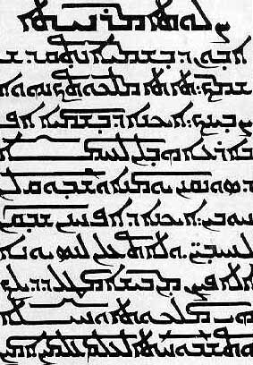

Summary: How Arameans Affected Israel

The Aramaic language developed in Aram but influenced Israel significantly.

This northeastern Semitic language was the first one to use alphabetic letters for long vowel sounds. Other nations adopted this pattern and even Jews of the 8th century AD added vowel pointing so Hebrew words could be pronounced correctly (prior to this written Hebrew had only consonants).

It was known by Hebrews in Hezekiah’s time (2 Kings 18:26).

Parts of Daniel and Ezra were written in Aramaic.

Under the Persians it became the official inter-province (political) and trade language of the Mid-East. Those opposing the rebuilding of the wall of Jerusalem wrote to Artaxerxes in Aramaic (Ezra 4:4-7).

The Arameans were a military force until Damascus fell to the attacking Assyrians (732 BC). Although the Aramean nation fell, its language did not; Aramaic, which is very similar to Hebrew, was adopted not only by Babylonian Jews as the "Jewish tongue," but also by the well-informed as the language of choice. It was not until Greek emerged several centuries later (ca. 300 BC) that Aramaic lost its prestige as the most sophisticated language. Jewish practices are still performed in Aramaic, including the Ketubah (wedding contract), the Get (divorce contract), and the Kaddish (mourner’s prayer). Interestingly, much of the Kabbalah (Jewish mysticism) was written in Aramaic. Also, the Talmud was written in a combination of Aramaic and Hebrew.

Well-known Bible places have Aramaic names:

John 5:1-2

John 19:13-15

John 19:16-18

Jesus and NT Jews spoke Aramaic as their everyday tongue.

John 1:42

Mark 14:36

Mark 15:34

John 20:16

Aramaic is still the modern-day liturgical language of several Eastern churches.

The success of the Aramaic language should not be attributed as merely a “stronger” language than others in the ANE. Perhaps God sought to preserve the language since Aram was a descendent within the line of Shem (the line of blessing). This way even many generations later God’s people would have a more accurate picture of His Word than would have happened if Babylonian or Egyptian or some other more distant language had become the trade language of the ancient world.

Aram was often used by God to discipline Israel when the nation strayed into idolatry (e.g., Ahab was killed by Ben-Hadad of Aram in 1 Kings 22). However, at several points Aram and Israel had friendly relations (see the article on pages 252-53).

Lessons to Learn from Arameans

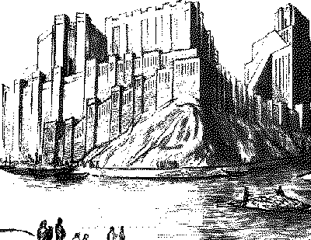
Assyrians

Identity:

Who Assyrians Were:

They were descendants of Asshur, one of the sons of Shem (Gen. 10:22). “Asshur” in Greek became “Assyria,” which was applied to the kingdom.

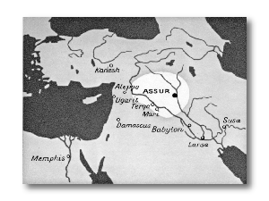
The name “Asshur” is used for:

The original capital of Assyria

The Assyrian’s national god

When Assyrians Lived:

The original key city and later capital of Assyria was Nineveh, located north of Babylon within Mesopotamia.

GEN 10:8 Cush was the father of Nimrod, who grew to be a mighty warrior on the earth. 9 He was a mighty hunter before the LORD; that is why it is said, "Like Nimrod, a mighty hunter before the LORD." 10 The first centers of his kingdom were Babylon, Erech, Akkad and Calneh, in Shinar. 11 From that land he went to Assyria, where he built Nineveh, Rehoboth Ir, Calah 12 and Resen, which is between Nineveh and Calah; that is the great city.

Old Assyria (1813-1781 BC) began the national heritage.

The time when Assyria became prominent in OT history was over 1000 years later when the nation conquered Israel and most of Judah (ca. 732-701 BC).

See the more detailed chart later in this study.

Geography: Where Assyrians Lived (cf. pp. 15, 17)

The original Assyrian territory occupied the northern and middle sections of Mesopotamia between the Tigris and Euphrates rivers.

Assyria at its height stretched its empire mostly southwesterly to include all the nations up to Egypt (650 BC).

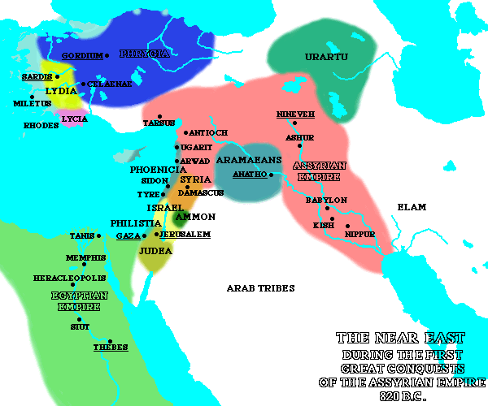

Deities:

As noted earlier, the name “Assyria” derives from the ancient deity worshipped in Mesopotamia called Asshur.

However, worship was syncretistic:

The Assyrians early added to their worship of the primitive national god Asshur the Babylonian deities with their cultic apparatus. Wherever they influenced Israel and Judah, the effort was demoralizing, as the historical books of the Bible and the prophets bear abundant witness.

The Assyrians also added to their pantheon several protective spirits:

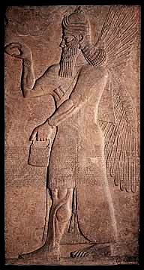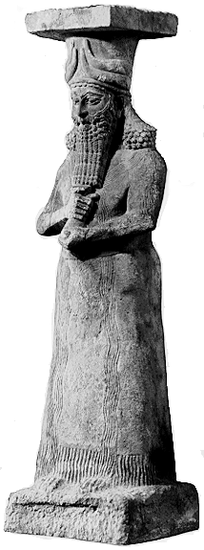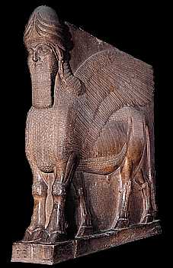
- An Apkallu was a spirit which protected the king and those in the palace from evil spirits

Assyrian Deity Lamassu: a protective spirit

Art & Literature (cf. see more texts at OTS, 79f-79g)

Assyrians excelled in several capacities:

Art revealed many huge winged bulls and lions which guarded palace entrances similar to Buddhist homes today.
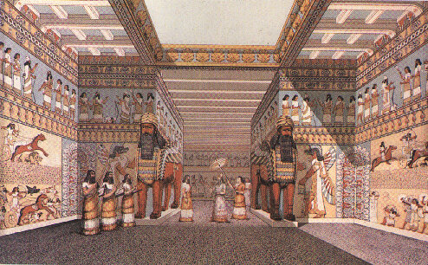

Huge lions guarded the entrances to Assyrian palaces

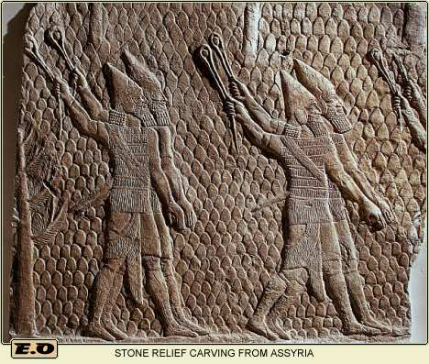
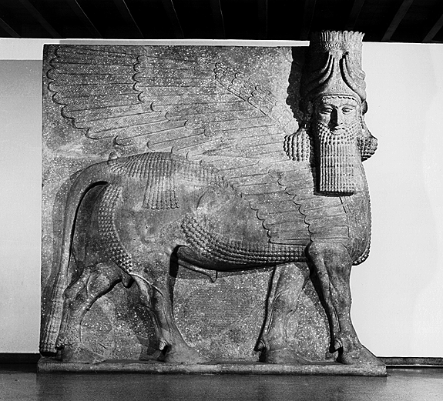

Bas-reliefs of Assyrian kings hunting | The human-headed winged bull from the palace of King Sargon II at Khorsabad (721-705 BC)

Architectural achievements include wall carvings and sculptures made with mud bricks and stone.

Literature

One of the unifying features of the Assyrians was their languages.

Two languages of the Assyrians:-

Akkadian (Ancient Assyrian)

Akkadian was written with the cuneiform writing system.

Their administrative and legal documents were written in Akkadian

Neo-Syriac (Modern Assyrian)

Assyrians used the Aramaic language from Aram as the second official language of the empire in 752 BC.

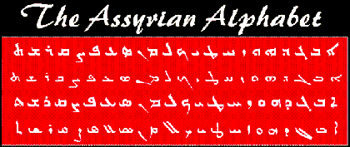

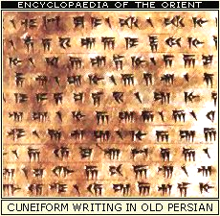

Baked clay tablet in Akkadian Cuneiform, Egypt, ca. 1400 BC

Significance: Why Assyrians Were Important

The literary contributions are notable (mentioned above).

The Assyrian war machine was quick, efficient, and deadly. The motives for war and expansion were threefold:

Political ambitions: to expand the kingdom

Economy: to plunder enemies of their money

Spiritual reasons: to serve their god Asshur

Intermarriage was commonplace as it made national identity more important than ethnic origin. Assyrians did not care so much about one’s background as long as loyalty to the state was maintained. This became a test case for Israel after the northern kingdom fell; Israel fell miserably by adopting the Assyrian value for intermarriage (2 Kings 17).
Naughty Ninevites
Elliott E. Johnson, “Nahum,” in The Bible Knowledge Commentary, 1:1493-1494

ASSYRIAN MILITARY HISTORY & TIMELINE

1845-1445 Egyptian bondage | 1830-1531 Old Babylonian
 | Old Assyrian
 | 1813-1781 Assyrian power grew under the Amorite ruler Shamshi-Adad I
 | 1700-1500 Hurrian Invasions
 | 1600-1150 Kassite
1525-1405 Moses | 1500-1380 Assyria was a vassal to Mitanni
1445-1405 Wandering
1405-1050 Conquest and Judges | 1356-1078 Middle Assyrian
 | 1365-1330 Under Ashur-ubalit I, Assyria regained her power
 | 1319-1308 Territories regained as far west as Carchemish
 | 1307-1275
 | 1274-1245 Shalmaneser I was a vigorous fighter who fought the Iranian tribes
 | 1244-1208 His son, Tukulti-Ninurta I was determined to rule Babylon as well as Assyria
 | 1115-1077 The next strong leader was Tiglath-pileser I
 | 1078-935 Aramean and Chaldean
1050-971 Early United Kingdom
971-931 Solomon: Late United Kingdom
931-852 Early Divided Kingdom:  Israel’s kings at this time: | 935-612 Neo-Assyrian
931-910 Jeroboam I
909-886 Baasha
885-874 Omri | 890-885 A new Assyrian dynasty began with Tukulti-Ninurta II (885-860) whose son Ashurnasirpal II began a period of sustained pressure on the west by marching into Syria and Phoenicia
874-853 Ahab
855-856 Syria attacked Israel twice but loses twice
 | 859-824 Shalmaneser III
 | 853 A battle was fought at Karkar (Qarqar) in northern Syria in which Ahab of Israel joined a coalition of 12 kings against Shalmaneser III; Israel supplied two thousand chariots and fourteen thousand men (according to the Assyrian annals).
853-852 Ahaziah
852-841Joram | 841 The coalition broke up and Shalmaneser was able to overrun the territory of Hazael, although the city of Damascus was bypassed. He continued westward to the Dog River in Lebanon where he received tribute from the state of Tyre and Sidon and from Jehu of Israel (recorded on the Black Obelisk of Shalmaneser).
841-814 Jehu
814-798 Jehoahaz defeated Ben-Hadad, son of Hazael (Syria) three times, recovering the Israelite towns | 804 Adad-nirari invades Syria (Aramean ruler, Hazael of Damascus, who sought to build an empire by subduing Israel Genesis 13:22 and other states). His annals claim that he also received tribute from the land of Omri (Israel).
798-782 Jehoash
793-753 Jeroboam II | 781-722 Shalmaneser IV continued Assyrian pressure on Syria  2 Kings 14:25-28 Jeroboam II profited from this Assyrian policy and was able to extend Israel's borders northward.
752-742 Menahem | 745-727 Early in the reign of Tiglath-pileser III he took the throne of Babylon under the name Pulu, or Pul (2 Kings 15:19; 1 Chron. 5:26). His annals claim that he received tribute from Menahem (2 Kings 15:19-20)  Isaiah 7; 2 Kings 16:5 Pekah of Israel and king Resin of Damascus tried to remove Ahaz of Judah.
752-732 Pekah
 | 2 Kings 16:7-9 Ahaz sought help from Assyria with silver and gold found in the temple of the LORD and the treasuries of the royal palace.
732 Tiglath-pileser III captured Damascus and put an end to the Aramean state.
2 Kings 16:9 He put king Rezin of Damascus to death. His annals also tell us that he replaced Pekah, the murderer of Pekahiah, son of Menahem by 'Auzi (2 Kings 15:29-30)
2 Kings 15:29 Tiglath-pileser III took northern Israel and deported the people to Assyria.
2 Kings 16:10-18 Religious renovations in Judah in deference to the king of Assyria

732-722 Hoshea | 727-722 Shalmaneser V, son of Tiglath-pileser III, continued to campaign in western Asia.  2 Kings 17:3-6 records how Hoshea of Israel stopped paying tribute to Assyria. Shalmaneser V besieged Samaria and it fell 3 years later. During the siege Shalmaneser evidently died.
722 Israel: exiled to Assyria | 722-705 Sargon II claims to have taken the city and to have deported 27,270 people, settling them in the eastern provinces of his empire.
 | 626-539 Neo-Babylonian
 | 539-332 Persian
 | 332 Alexander

Summary: How Assyrians Affected Israel

Fall of Israel: Assyria had conquered the northern kingdom of Israel (capital, Samaria) due to Israel’s sin (722 BC). Thus the Assyrians became God's instrument of judgment upon His wayward people.

The Lost Ten Tribes of Israel: These Jews exile from the northern kingdom were transplanted to Assyria (northern Iraq today) and other nations where they intermarried with pagan peoples (2 Kings 17:1-6, 24-26).

Rise of Samaritans: Assyria brought other conquered peoples into Israel who married the few poor Israelites that remained. Their mixed-breed offspring were called Samaritans (cf. p. 59).

Lessons to Learn from Assyrians
❒
3.1 Worship only the Lord your God:-

1. Have no idols.
2. Submit only to God, not men.
3. Give God His due – do not rob Him of sacrifices & offerings.

  - Trust in the Lord:-

- To deliver you in times of trouble
- Trust God to provide

“If you do not stand firm in your faith, you will not stand at all” (Isa. 7:9).

3.3 Repent While You Can:-

- Return to God when you hear His voice.

“If you return to the Lord … He will not turn His face from you if you return to Him” (2 Chron. 30:9).

- Stubbornness results in stern judgment (e.g. Manasseh)

3.4 Don’t Compromise:-

- Under pressure (e.g. threat or danger)

“Be careful, keep calm and don’t be afraid” (Isaiah 7:4).

- For self-gain (e.g. political, economical reasons)

3.5 Don’t Be Unequally Yoked with an Unbeliever:-

- Unholy alliances (e.g. partnerships)
2. Subordination & service to an unbeliever instead of God

3.6 Let Your Light Shine:-

- Make use of every opportunity you have to be the light & salt of the earth.
- Otherwise your lamp stand will be removed from you.

Babylonians (Neo-Chaldeans)

Identity:

Who the Babylonians Were:

The Babylonians descended from Shem but unlike the Hebrews (also Semites) they did not migrate from the Mesopotamian basin.

They had a different language from the Persians to their north, who also traced their lineage to Shem (cf. pp. 17, 145). Likewise, today’s Iraqis (modern descendents of Babylonians) speak Arabic while Iranians (modern Persians) speak Farsi.

Babylon in Akkadian is “babilani” which means “the gate of God.” This capital of the region led to the entire land being called Babylonia.

When Babylonians Lived:

Mesopotamian history is a complicated series of people-groups who took over the previous society and occupied their land.

The Babylonians rose to power in two periods separated by nearly a millennium. Thus, one must distinguish between Old Babylon and Neo (New) Babylon as these peoples were separated by many groups who controlled the same land area:

DOMINANT PEOPLES IN MESOPOTAMIAN HISTORY

Proto-Literate (3200-2850)
Early Dynastic (2850-2360)
Akkad (2360-2180)
Guti (2180-2082)
Ur III (2070-1960)
Isin-Larsa (1960-1700)
Old Babylonian (1830-1531)
Old Assyrian
Hurrian Invasions (1700-1500)
Kassite (1600-1150)
Mitanni (1500-1380)
Middle Assyrian (1366-1078)
Aramean & Chaldean (1078-935)
Neo-Assyrian (935-612)
Neo Babylonian (625-539)
Persian (539-332)
Alexander (332- )

Due to the similarities between Old Babylon with Assyria, and the fact that the Babylon of the OT is primarily the latter group, this study concerns itself with Neo-Babylon.

Neo-Babylon was glorious but short-lived. With the exception of Nebuchadnezzar, Neo-Babylonian rulers generally had short reigns as seen in this king list:

- Nabopolassar – 625-604 BC
- Nebuchadrezzar II (son) – 604-568 BC
- Evil-Merodach (son) – 561-560 BC
- Neriglissar (brother-in-law) – 559-556 BC
- Labosoarchad (son – 556 BC
- Nabonidus – 555-539 BC
- Belshazzar – 539 BC

Geography: Where Babylonians Lived (cf. pp. 15, 17)

Babylon conquered Nineveh in Assyria in 612 BC. After a final victory over the fleeing Assyrians in Carchemish in 605 BC the Babylonians occupied roughly the same territory as Assyria.
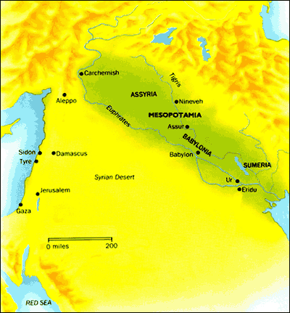

The cities of Babylon and Nineveh were both built by Nimrod, a descendent of Ham (Gen. 10:8-12). However, these Hamites migrated to Cush (modern Ethiopia) and Semites occupied these cities. These Semites became the Old Babylonian empire (1830-1531 BC). Later the Neo-Babylonians occupied roughly the same area as modern Iraq.

Nebuchadnezzar’s Babylon was an incomparable city of its day:

- The city formed a grand square, 14 miles on each side
- The brick wall was 56 miles long, 300 feet high, 25 feet thick with another wall 75 feet behind the first wall, and the wall extended 35 feet below the ground
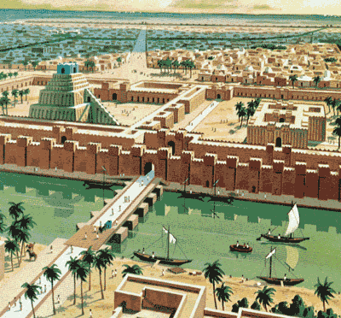
- Watchmen occupied 250 tall towers around the wall
- A deep and wide moat encircled the city
- The Euphrates River flowed through the middle of the city. Ferry boats and a 1/2 mi. long bridge with drawbridges closed at night
- The "Hanging Gardens" (one of the wonders of the ancient world) had water raised from the river by hydraulic pumps
- Eight massive gates led to the inner city and 100 brass gates
- Streets were paved with stone slabs 3 feet square
- The great Tower (Ziggurat) and 53 temples included the "Great Temple of Marduk" with 180 altars to Ishtar
- The golden image of Baal and the Golden Table (both weighing over 50,000 lbs. of solid gold) dazzled visitors
- The city had two golden lions and a solid gold human figure (18 feet high)

Deities:

Babylonians had many gods – Sumerian, Akkadian, and gods imported from mountainous regions (N & E of Mesopotamia). These gods reflected the people’s needs and fears

Marduk (Bel/Baal)

Son of Ea (wisdom)

Chief of Babylonian gods (rising sun)

Temples & a huge ziggurat (the temple of Esgalia)

Wife called Sarpanitu / Son - Nabu

Sacred number 10 / Planet Jupiter

Statue of pure gold – Babylon

Made men and fashioned the world

Other Babylonian Gods

Pantheons – overlapped many cities

Every street bore the name of one of the gods

A RELIGIOUS METROPOLIS
- 53 temples of the chief gods
- 55 chapels of Marduk
- 300 chapels for earthly deities
- 600 chapels for heavenly deities
- 180 altars for the goddess Ishtar
- 180 for the gods Nergal and Adad
- 12 other altars for various gods

RITUALS
- Daily presentation of offerings
- Cleaning garments of divine statues
- Purification of temples
- Special festivals (Akitu – New Year)

TEMPLES
- Each city had its own god and temple
- Temples had their own land, slaves, animals & precious stones
- Priests foretold by reading nature & other elements
- Selling of charms and magical formulae

PERSONAL IDOLS
- Each Babylonian had a ‘personal’ god
- People made special requests to their deities (e.g., relief from illness)
- Idols acted as mediators to higher gods
- “Benefit-driven” – people abandoned their god if prayers were unanswered

ZIGGURATS
- Abundance of them showed the city and king’s devotion to their city god
- These were huge stepped structures

Literature (cf. see more texts at OTB, 188-188a; OTS, 79f-79g)

Ancient Sumerian culture highly influenced the literature of Neo-Babylon.

- Babylon had been immersed in Sumerian culture since 3000 BC
- Adopted Sumerian system of formal education
- Nabu (god of scribal arts) said to have given Babylon her cuneiforms
- Cuneiform in Latin – ‘cuneus’ (wedge) / an ideogrammatical script (symbols)
- Transformed later to syllogrammatical script (simplified symbols) on clay tablets
- Sumerian writings were translated to Akkadian (lingua franca of ANE)
- Schools of scribes copied compositions and created catalogs
- Sumero-Babylonian dictionaries - imitation of the myths, epics, hymns etc
- After Babylon’s fall in 539 BC Aramaic and Greek became the common languages

Types of Literature

POETRY
- Parallelism - rendition of ideas two different ways side by side
- Couplets, singlets and triplets
- No Rhyme and Meter
- Several Epics - Enuma Elish & Gilgamesh Epic

MUSIC
- Story telling or chanting of a verse - religious ceremonies & entertainment
- Used reed, flute, lyre, drum, trumpet and harp

BABYLONIAN VERSION OF THE FLOOD (2000 BC)

Babylonian Mythology | Biblical Account
Many gods (Polytheism) | One God (Monotheism)
Gods quarrel /disagree | A Holy God
Confusion as to why the Flood came | God saw evil and corrupt people
Adad - thunder | Yahweh:
Ninurta- winds | - Created
Annunaki - lightning | - Sustained
 | - executed judgment

WISDOM LITERATURE
- Many such writings – problem of evil and suffering / devout pious observers
- Examples – The Theodicy, Dialogue of Pessimism

PROPHECY
- Babylonian prophecy – forerunner of many occult religions and mystical books
- Describe past events in prophetic terms – validate his foretelling.

LAW & ORDER

- RELIGIOUS INFLUENCE
  - SHAMASH- the sun god was also god of law and justice
  - Hammurapi (1792-1760 BC) – Punishments for crimes varied according to the crime; death penalty (drown / burn / decapitation)

- CIVIL LAW
  - Business practices led to a growing trade
  - Courts administered laws
  - 4 judges in each court / appeals could be made to the king
  - Capital punishment – flogging/ reduction to slavery & banishment

- LAW CODES
  - Many Law Codes unearthed (written 2350 to 1750 BC)
  - Almost all in verbal agreement
  - King’s divine mission was to administer justly and fairly

- THE CODE OF HAMMURAPI (1780 BC)
  - Established legal practice in Babylon – institutions & customs
  - Retaliation – tit for tat in cases of physical injuries (lex talionois)

Significance: Why Babylonians Were Important

All false worship traces its way back to Babylon eventually. The Catholic Church in particular has propagated many of Babylon’s false teachings, such as:

Mother and child worship

Obelisks, temples, and towers

Relics

Pilgrimages

Indulgence selling

Purgatory

Supreme pontiffs

Celibacy of priests

Transubstantiation

Easter Festival

Winter Festival

Civil law today owes much to Babylonian order.

Courts & judges gave punishments (capital, slavery, floggings, banishment, etc.)

The Code of Hammurapi (1780 BC) predated the laws of Moses. It also established legal practice and many political, social economic, and religious institutions.

Technological achievements

Mathematics (geometry, algebra, sexagesimal numbering system, measurement of time and degrees of angles)

Science: astrology and astronomy (correct calculations of the solar and lunar year)

Calendar of 12 lunar months

Measurement by a water or sun clock

Medicine: surgery, anatomy, physiology

Circulation of blood, pulse

Irrigation systems with canals

Art: tapestries, rugs, gold and silver goods, gem cutting, manufactured textiles

Organized trade was the key to Babylon’s wealth, financed also by taxation to protect citizens from bandits

Summary: How the Babylonians Affected Judah

Babylon was God’s instrument to repeatedly judge His people by bringing them into exile. They conquered Judah at least six times, though typically three are considered the most significant in impact (605, 597, and 586):

Nebuchadnezzar’s Six Deportations to Babylon

Sequence & Size | Date | King of Judah | Number Taken | Key Captives | Results/  Comments
1  Minor | 605 BC | Jehoiakim | Few  (Dan. 1:3) | Daniel, his 3 friends, & other nobility & royalty | Tribute imposed.  Egypt powerful.
2  Moderate | 598 BC | Jehoiakim | 3,023  (Jer. 52:28) | — | Minor deportation before the 597 BC deportation
3  Major | 597 BC | Jehoiachin | 10,000  (2 Kings 24:14) | Jehoiachin (2 Kings 24:12b), Ezekiel (Ezek. 1:2), Mordecai (Esther 2:6) | Large deportation.  Jehoiachin replaced with his uncle Zedekiah.
4  Minor | 587 BC | Zedekiah | 832  (Jer. 52:29) | — | Minor deportation before the 586 BC destruction
5  Major | 586 BC | Zedekiah | ca. 10,400*  (2 Kings 25:11) | Zedekiah | Jerusalem & temple destroyed after  30 month siege
6  Minor | 582 BC | — | 745  (Jer. 52:30) | — | Four years after Jerusalem’s destruction

The Babylonian exile helped Judah preserve its national heritage: The Babylonian policy of deportation required conquered countries to follow their pagan cult (cf. Dan. 2, 6). In contrast to the ten northern tribes that merged into Assyrian society, the Judean Jews in exile successfully resisted this.

Separation: They were forbidden to carry on sacrifices, but they held fast to the law of God, the Sabbath, and circumcision. All these ways kept them a distinct people.

Rise of the Synagogue: With the Jerusalem temple destroyed, local Jewish places of worship sprung up throughout Babylon.

Elimination of Idolatry: The people repented from sin and finally learned the lesson that God abhors idols (Exod. 20:3-6) and that idolatry had caused the devastation of Jerusalem.

Life in Babylon motivated prophets such as Ezekiel and Daniel to minister in exile. They anticipated and prayed for the restoration of Jerusalem (cf. Ezek. 34:13; 36:38; Dan. 6:10; 9:16, 25). Previously Jeremiah had limited the time of captivity to 70 years (Jer. 25:11-12; 29:10). These prophets also provide us with a glorious view of the restoration of Israel in the last days.

All this had a positive effect to prepare the people intellectually and spiritually for a new beginning in Palestine.

However, the exile in Babylon also had a negative influence.

Materialism reigned in the Jews who prospered in exile. They still applied Jeremiah’s advice two generations earlier to settle down, plant gardens, marry, start businesses, and even support the city of Babylon itself (Jer. 29:5-7).

As a result, 50 years later very few were willing to return to Judah once freedom was allowed under the Persian era that followed Babylonian rule. The number of exiles who returned with Zerubbabel, Ezra and Nehemiah, from captivity in Babylon were far less than those who stayed in the “Diaspora” (Jews who lived outside of Israel).

Lessons to Learn from Babylonians

Idols are worthless.

Affluence and materialism do not last.

Do not get entangled in the influences of Babylon that still exist today (religious formalism, erroneous Catholic teachings, etc.).

Avoid the Babylon of the future.

“And on her forehead a name was written, ‘MYSTERY, BABYLON THE GREAT, THE MOTHER OF THE PROSTITUTES AND OF THE ABOMINATIONS OF THE EARTH’” (Rev. 17:5).

What is the identity of this end-times Babylon?

World system

Religions (Islam, Roman Catholic, Astrology, One World Religion)

Cities (Rome, Jerusalem)

Countries (Iraq, USA)

Sometimes a “bad thing” is good for us because it is actually God’s discipline that leads to repentance.

To cure Israel of her idolatry, God forced them into the most idolatrous nation of antiquity—yet this cured Israel from ever becoming idol-worshippers again.

God sometimes forces us to be “in the world” as this is the only way we will become His unique people.
Map of Babylon

Persians

Identity:

Who Persians Were:

Persians were Semites who descended from Elam, son of Shem (Gen. 10:22). One can speak of the ancient Persians and Elamites as virtually the same.

“The name Persia came from Persis, the Greek name for the region. The Persians themselves called the region the land of the Aryans, from which the name Iran comes. The Persians called their language Aryan.”

When Persians Lived:

Being descendants of Shem’s grandson, Persians had a long history dating back to as early as 3000 BC.

However, as far the OT interaction with Israel, Persia came on the scene at the end of the OT era. Isaiah “around 700 BC foretold how a man named Cyrus would subdue nations and ‘open before him two leaved gates; and the gates shall not be shut’ (Isa. 45:1). In 539 BC, seventy years after the destruction of Judah, Cyrus left Persia and attacked Babylon. The high walls around the city and the brass gates across the river meant the city was impenetrable. But Cyrus went upstream along the Euphrates and diverted the river (believed by most historians, but not confirmed). He then marched his armies along the river bed, under the brass gates and took the city with barely a shot. The city again prospered, but water was not so abundant (Jer. 50:38).”

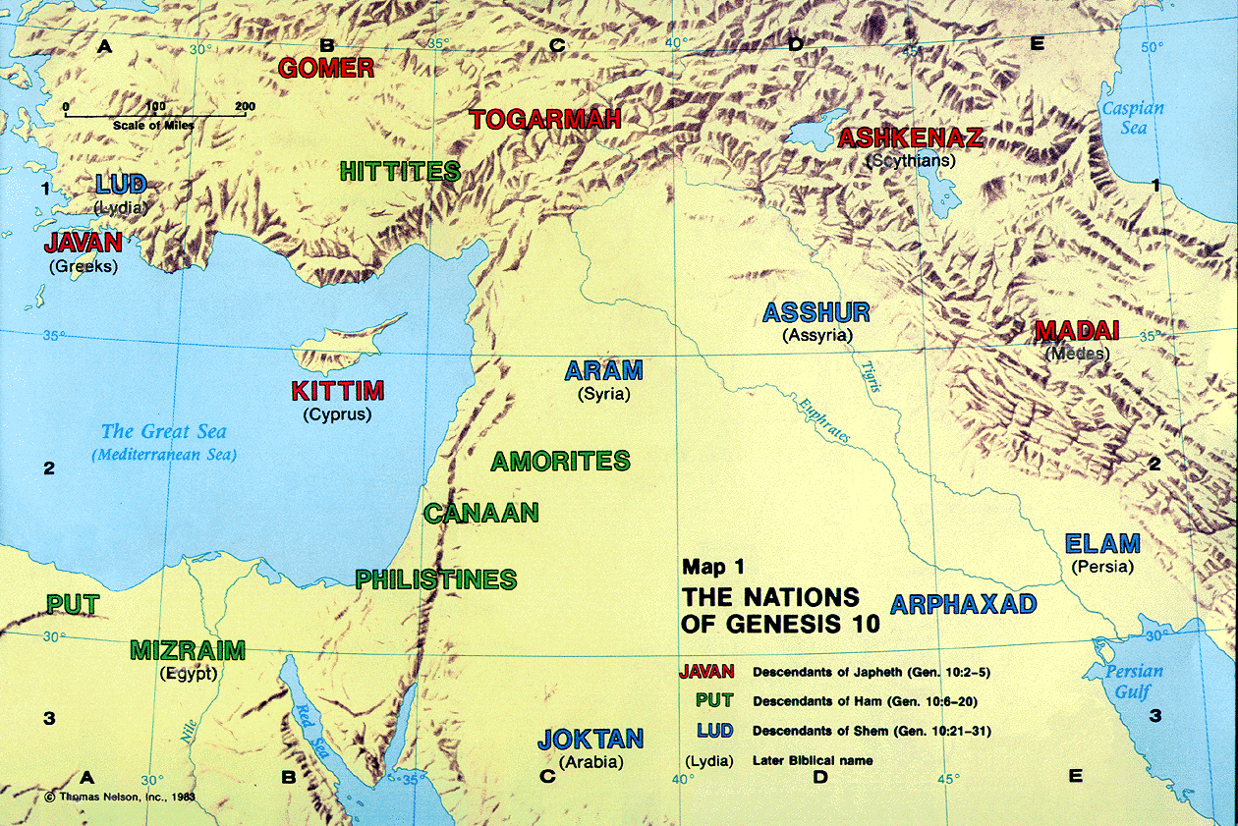
Geography: Where Persians Lived (cf. pp. 15, 17)

Persia was north and east of Babylon, across the Tigris River.

“The Elamites gave their name to Elymais, the region on the left or E. bank of the Tigris, opposite Babylonia, between it on the W. and Persia proper on the E., and S.W. of Media. The region is also named Susiana or Susis from its capital Susa, called Shushah in Dan 8:2, where Nehemiah (Neh 1:1) waited on king Artaxerxes, and where Ahasuerus (Xerxes) held his court in Esther's (Est 1:2; 2:5) time. Daniel mentions the river Ulai near, i.e. the Greek Euloeus. From Darius Hystaspes' time to Alexander the Great it was the Persian king's court residence.”

However, once Persia seized Babylon’s conquests westward, it also proceeded even farther both to the west (to Greece) and to the east (to India). The kingdom ended up becoming several times larger than Babylon.

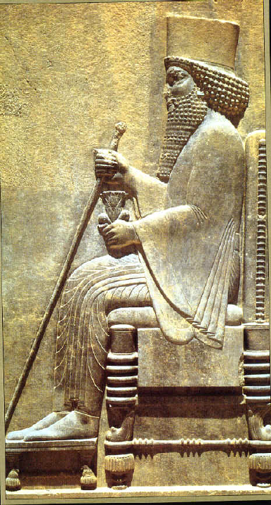
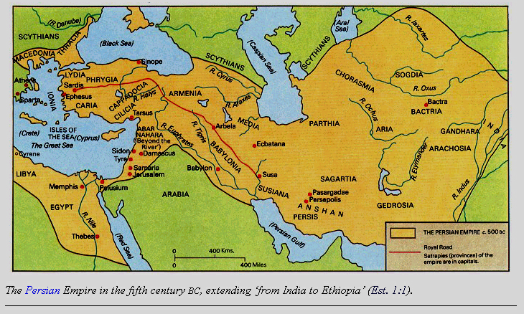
Darius the Great
(521-486 BC)

As modern Iraqis descended from the Babylonians, so modern Iranians owe their heritage to Persia. This may partly explain the animosity between the two groups since the Babylonians were conquered by Persia.
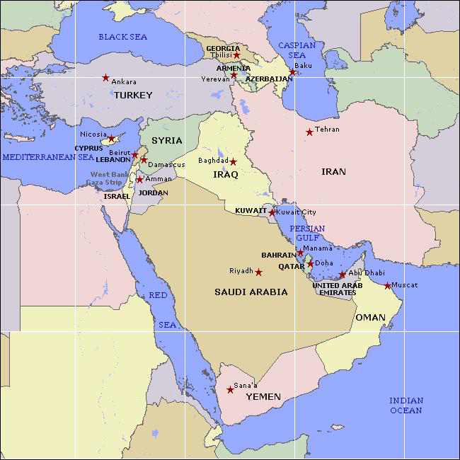

Persian Deities:

“The Persians believed in gods of nature, such as the sun and sky. The people believed the gods had social powers. Mithra, the god of light, for example, controlled contracts. The Persians had no temples. They prayed and offered sacrifices on mountains.

Zoroaster (or Zarathustra), a prophet who lived sometime between 1400 and 1000 B.C., reformed the ancient religion. He preached a faith based on good thoughts, words, and deeds, emphasizing a supreme god called Ahura Mazda, "the wise spirit." Zoroaster's followers, called Zoroastrians, gradually spread his religion throughout Persia. The teachings of Zoroaster are found in the Gathas, part of a holy book known as the Avesta.”

Persian Literature (cf. see more texts at OTS, 79f-79g)

Unlike Babylon, the Persians were not masters of literature. They did, however, have a similar script made with wedge writing.

Although they did have their own language, Persians borrowed Aramaic as their basic written language since it was widely used in Syria, Palestine, and Mesopotamia. The Persians extended Aramaic both east to India and west to Asia Minor (now Turkey).

The Cyrus Cylinder is one of the most significant finds from Persia (Arnold/Beyer, Readings from the Ancient Near East, 147).

It cites the victory of Cyrus over Babylon by Marduk’s command without even fighting (Dan. 5:30).

After his victory, Cyrus then praises Marduk and releases all of Babylon’s captives, allowing them to return home (Ezra 1:2-4; 6:1-5; 2 Chron. 36:23).

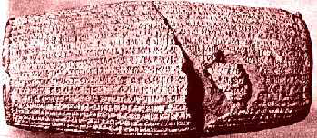

Significance: Why Persians Were Important

Persians were masters at administration that set a model for other nations.

Their organizational skills are noted in Esther 1:1 where it says that Xerxes “ruled over 127 provinces stretching from India to Cush.”

They even developed an efficient “pony express” form of mail delivery throughout the vast empire.

“Cyrus established the Persians as the dominant tribe in 549 B.C. He then moved west to defeat the Lydian Empire of Croesus in 545, and south to defeat Nabonidus of Babylon in 538. The conquest of Lydia gave Cyrus Asia Minor; the overthrow of Babylon made him master of the Euphrates River plain, Assyria, Syria, and Palestine. It was the first of the world's great imperial organizations, foreshadowing Rome; it was humane when compared with the Assyrian Empire. The conflict between Samaria and Jerusalem, depicted in the life of Nehemiah, is an illustration of the problems of such a large empire. Nehemiah was working by royal decree and yet found his work hampered by armed interference. Ezra's fear (Ezra 8:22) suggests similar pockets of anarchy. The four books of the OT in which Persia forms a background (Ezra, Esther, Ezekiel, and Daniel) all illustrate the royal tendency to delegate special authority to individuals for specific tasks.”

“It will be useful to list the Persian kings whose reigns have significance in OT history:

Cyrus, 538-529 B.C. (2 Chron 36:22-23; Ezra 1-5 passim; Isa 44:28; 45:1; Dan 1:21; 6:28; 10:1).

Cambyses, 529-522 B.C. Some have suggested that Cambyses is the mysterious Darius the Mede (Dan 5:31; 6:9, 25; 9:1; 11:1). Others think this obscure person was Gobryas, governor of Media, who exercised authority for Cyrus in Babylon.

Gaumata, a usurper, who held brief royal authority until put down by Darius, 522-521 B.C.

Darius I (Hystaspis), 521-486 B.C., the great imperialist, whose seaborne attack on Greece was defeated at Marathon in 490. This is the Darius (mentioned by Ezra) under whose protection permission was given for the temple to be built.

Xerxes I (Ahasuerus), 486-465 B.C. (Esth 1:1-2; 2:16). This mad king in a mighty combined operation sought to avenge Marathon and was defeated by the Greeks at Salamis (480) and Plataea (479).

Artaxerxes I (Longimanus), 464-424 B.C. It was this monarch who permitted Ezra to go to Jerusalem to restore the affairs of the Jewish community (Ezra 7-8), and who promoted the mission of his cupbearer Nehemiah, 13 years later. Darius the Persian (Neh 12:22) is Codomannus, the last king of Persia, overthrown by Alexander in 330.”

Chronology of Persian History
Prophet Zoroaster | 688-551 BC
The ACHAEMENIAN DYNASTY | 559-330 BC
Death of Cyrus the Great, the founder of the Achaemenians | 530 BC
Rule of Darius, the second great Achaemenian ruler | 522-486 BC
Xerxes, the king | 486-465 BC
Alexander, the Macedonian, conquers Persia | 330 BC
THE SELEUCID DYNASTY | 312-247 BC
THE PARTHIAN DYNASTY | 247 BC-AD 226
THE SASSANID DYNASTY | 226-651
Rule of Ardeshir, the founder of the Sassanids | 226-240
Death of the Sassanid king Shapur 1 | 272
Death of the prophet Mani, the founder of Manichaesim | 274
Mazdakism | End of 5th and 6th c.
Rule of Chosroes I (Anosharvan) | 531-579
Sassanid invasion of Byzantiun | 603
Sassanid conquest of Alexandria | 619

Summary: How Persians Affected Israel

Restoration of Temple Worship (first return under Zerubbabel): Initially only the sacrifices were reestablished, but following the completion of the temple rebuilding came the reinstitution of the entire temple system (Ezra 1:1-3).

Law of Moses Reestablished as the Law of the Land (second return under Ezra): Ezra the priest and scribe (1 Chron. 6:3-15; Ezra 7:6-7) taught the law and enforced it by order of the king (Ezra 7:14, 25-26), especially in respect to prohibiting intermarriage (Ezra 9—10; Neh. 10:30; 13:23-31). This led to copying scrolls of the OT used even in the time of Jesus.

Economic and Spiritual Life Revived (third return under Nehemiah): The restoration of the walls, repopulating of Jerusalem, reinstitution of the Sabbath, spiritual revival among the people, and renewal of the intermarriage prohibition under Nehemiah all contributed to the placing of Israel more firmly in the land.

Rise of the Temple State: Though Judah was still a vassal state, Persia allowed the people a great deal of local autonomy (especially in cultural and religious matters) to win their allegiance. This resulted in peace, prosperity, and security. Eventually the Persian governor was replaced by a council of elders closely allied with the leading priestly families and directly accountable to the Persian king. The Temple was the place of power, the Mosaic Law was “the constitution,” and the High Priest (from the ancient line of Zadok) was the highest official. However, there still was no Jewish king on the throne of Israel.

Aramaic Language Widespread: Although Aramaic was the language of Aram (Syria), during the Persian period it became the official language of the empire so that Hebrew began to die out as the everyday language of the Jews. By the time of Christ few Jews knew Hebrew and Aramaic was the common language of Palestinian Jews.

Jewish Diaspora: Although Persian policy allowed the Jews to return to Palestine and reestablish their religion and customs, very few did so. Those remaining in foreign lands became known as the Diaspora so that many Jewish settlements could be found around the empire. Paul later used the synagogues of these groups as points of contact in evangelizing the Roman world.

Samaritans, the inhabitants of Samaria to the north of Jerusalem, had earlier resulted from intermarriage with pagan peoples who occupied the land during Israel’s Assyrian exile. Jews would not recognize them as true Israelites due to their “mixed blood” (2 Kings 17). Therefore, during Persian rule the Jerusalem community separated from them (Ezra 4:1-2) and this alienation and rivalry finally led to two political provinces (Samaria and Judea) and two sanctuaries of worship (Mt. Gerizim and Jerusalem) later under Alexander the Great. Years later the Samaritan woman spoke with Jesus at the well about these two sanctuaries (John 4:20).

Purim celebrated national redemption for Jews. It was added to the feasts of Israel during the reign (486-465 BC) of the Persian monarch Xerxes I (Ahasuerus). The story is recorded in the Book of Esther how Haman, Xerxe’s prime minister and an enemy of the Jews, sought to annihilate all Jews on a certain day (14th of Adar), but his plot was foiled by the courage and intervention of Queen Esther, a Jewess. Xerxes reversed Haman’s diabolical scheme and permitted the Jews to defend themselves on that day and the day after. Because Haman had selected the day by the throwing of purim (“lots”), the 14th and 15th of Adar (Feb./March) was chosen for a memorial festival called the Feast of Purim (cf. also 2 Maccabees 15:36; Josephus, Antiquities, 11.6.13).

Judaism became the term depicting the Jewish way of life in both its cultural and religious aspects from the post-exilic period onward. Orthodox Judaism strictly resisted outside influences that would seek to absorb or change it.

Close of OT canon: The prophet Malachi was the last OT prophet during the Persian era.

Lessons to Learn from Persians

God knows the future:

He knew that Persians would conquer Babylon (Dan. 5:30).

He knew that the Jews would return to Israel (Ezra 1:2-4).

He even knew 150 years earlier that the king who would restore Israel from exile would be named Cyrus (Isa. 44:28; 45:1, 13).

God is a restoring God

He brought His people back to their homeland after two generations of exile (book of Ezra-Nehemiah).

Even those who did not return received His protection (book of Esther).

Socio-Economic Backgrounds to the Old Testament

Family Life

Perspectives on Men

See separate file on OTB Women for pages 153-154g or something like that!

Perspectives on Women

What are the key differences between women of pagan cultures and Israelite women?

What do these differences tell us about God?

Perspectives on Children

Mesopotamian Filial Adoption: A childless couple could adopt an adult outside the family to take care of them in their old age and perform religious rites in exchange for an inheritance (Gen. 15:2-4; cf. Kenneth Kitchen, The Bible and Its World, 70).

Mesopotamian Birthright: The oldest (or principal) son received a double share of the inheritance (Deut. 21:15ff.).

Value: Children (especially sons) were seen as the family’s greatest asset.

^{Psalm 127}

³ Sons are a heritage from the LORD, children a reward from him.
⁴ Like arrows in the hands of a warrior are sons born in one's youth.
⁵ Blessed is the man whose quiver is full of them. They will not be put to shame when they contend with their enemies in the gate.

Education

Towns & Villages

Hospitality

See separate study on Education for pages 155-158

See separate study on Rural Life for pages 158a-m

Religious Backgrounds to the Old Testament

Pagan Religions of the Ancient Near East

Thought Questions

Compare and contrast the Gilgamesh Epic with the biblical record of this event (cf. OTS, 83a).

Comparisons: both have multi-level boat, persons saved, birds (raven & dove), sacrifices, dimensions & chronology given, acts of worship, heroes blessed

Contrasts: planned by council of gods, to stop noise disturbing gods' rest, hero saved secretly, cube-shared boat, 6 days & night, landed on Mount Nisir, sacrifice of appeasement, punishment later regretted, hero became immortal

What characteristics were common of most, if not all, Ancient Near East pagan religions?

How was Israel's religion distinct from these other religions of the OT era?

How did reading pagan writings for today's class help you appreciate Judaism? How did it aid your own walk with God?

What principles regarding how Israel dealt with Ancient Near East pagan religions should the church today also follow in respect to other religions?
Principle for Israel | Modern Parallel
Ancient Near Eastern Deities

Religion | High God | Characteristics | Influence on Israel
Sumerian | Nannar (moon god), known in Akkadian as Sin |  | Worshipped originally by Abraham (Josh. 24:2)
Assyrian | Anu (king of heaven) |  | None
Babylonian | Marduk (god of cosmic order) | Marduk promoted to supreme god | Moderate
Egyptian | Amon (king of gods and protector of the pharaoh) | Most polytheistic ancient people (over 1000 gods and goddesses) | None
Canaanite | Baal (god of rain, thunder & lightening) or El (patriarchal deity as Baal's father) | Depraved practices (e.g., child sacrifice, sacred prostitution) | High
Sidonian | Ashtoreth |  | 1 Kings 11:5, 33
Philistine | Dagon |  | None
Ammonite | Molech |  | 1 Kings 11:5, 33
Moabite | Chemosh |  | 1 Kings 11:5

Polytheism

One key difference between pagan and Israelite religion is that every Ancient Near East religion taught the existence of several gods. Israel stood unique in its insistence upon monotheism. Even the monotheism in Egypt during the reign of Amehotep IV (Akhnaten) lasted only briefly (1350-1334 BC).

“Indeed, in every major culture throughout the ancient world of which we have any record, the overwhelming consensus was that the universe had been created by often a single and usually supreme divine being (even in notoriously polytheistic cultures).” Thus, even polytheistic cultures had a tradition of monotheistic creation—a belief that undoubtedly went back to Adam and his descendants.

The polytheism of antiquity does not mean that these religions lacked a high god in their pantheon of deities. See the chart at the end of this study.

Monotheism

One should not assume that the true knowledge of God was lost completely in antiquity (as monotheistic creation above noted in the ANE). This makes sense since man innately knows there is but one God from creation (Rom. 1:20). In fact, other societies outside of the ANE also taught monotheism as well:

China: Knowledge of God is innate, preceding Christian missions. Taoist pagan philosopher Lao-Tzu of China wrote (6th cent. BC), “Before time, and throughout time, there has been a self-existing being, eternal, infinite, complete, omnipresent . . . Outside this being, before the beginning, there was nothing.” He obviously did not get this concept from Genesis as the Bible reached China centuries later!

Greece:

Even in Greece with its well-known pantheon of deities the concept of a Creator God appears in remarkably close parallel to Genesis 1. Hesiod wrote in his 8th century BC Theogony, “First of all the Void came into being . . . next Earth . . . Out of the Void came darkness . . . and out of the Night came Light and Day . . .” Yet the fact that Hesiod had a debased view of this Creator shows that he did not get this information from Genesis.

Xenophanes lived two centuries after Hesiod and showed a much higher view of God: “Homer and Hesiod attributed to the gods all the things which among men are shameful and blameworthy—theft and adultery and mutual deception . . . [But] there is one God, greatest among gods and men, similar to mortals neither in shape nor in thought . . . he sees as a whole, he thinks as a whole, he hears as a whole . . . Always he remains in the same state, changing not at all . . . But far from toil he governs everything with his mind.”

Plato also sought to replace Hesiod’s perverse thoughts with a more reasonable model that was undoubtedly based on concepts that preceded Hesiod. Plato wrote, “Let us therefore state the reason why the framer of this universe of change framed it at all. He was good, and what is good has no particle of envy in it; being therefore without envy, he wished all things to be as like himself as possible. This is as valid a principle for the origin of the world of change as we shall discover from the wisdom of men . . .”

Atheism

But did the Ancient Near East have atheists? These were virtually nonexistent. To date anthropologists have not discovered an atheistic civilization of any age. This is why the Bible says only fools claim there is no God (Ps. 14:1). Even Buddhism, which is technically atheistic, gives the impression of worship of many gods due to its emphasis on appeasing spirits.

One key exception in antiquity was Greece. While other Greek philosophers taught monotheism, it appears that others arose to combat this true depiction of God:

Thales of Miletus (ca. 635-545 BC) is generally thought of as the first materialist since Aristotle called him the “founder of natural philosophy.” But other statements attributed to Thales teach creationism.

Anaximander (ca. 610-540 BC) studied under Thales and provides the first recorded challenge to creationism. He seems to be the first written evolutionist in his statement that Plutarch recorded as from Anaximander: “. . . originally, humans were born from animals of a different kind . . .” However, his theory is so developed that he probably had built upon the teaching of many before him.

Nature of Pagan Deities

Morality of the gods was sinful—judgments were arbitrary.

Many were only local deities (esp. Canaanite).

Nature was often seen as personal (vs. inanimate in Judaism)

Syncretistic: religions of the plains (right-stage, cf. p. 19)

Myth was acceptable, as these religions were not historically based.

Pagan Worship Practices in the Ancient Near East

Sacrificial system

Blood sacrifice (origin in Gen. 3:21?)

Child sacrifice practiced by Ahaz (2 Kings 16:3) and others (Ezek. 23:39)

Priesthood

Not genealogically based

Open to both men and women (which led to cult immorality)

High places

2 Kings 16:4

God's plan (Deut. 12)

Detestable elements

Masochism—1 Kings 18

Sacred prostitution—Baal and fertility religions

Child sacrifice—at least for Canaanites

Hittite concept of "sin" was an offense to the deity as the gods were unconcerned with the "righteousness" of their worshippers.

Contrasts Between Monotheism and Polytheism

 | Monotheism | Polytheism
Truth | Absolute | Relative
Idols | Prohibited | Accepted
Religions | Judaism, Christianity, Islam | Hinduism, Mormonism

How One’s View of God Affects Morality & Mission

Pagan
Israel

Horrible god
Holy God

Man seen as OK in comparison
Man seen as sinful

Seeks pleasure & material needs
Seeks spiritual needs

Sacrifices appease deity for sex, food & money
Sacrifices atone sin to reconcile God & man

Local deity makes them rich
God forgives sin

Massacre others for wealth
Mission to others for their good

Note above the logical and chronological progressions. The point here is that people always become like the deity they worship. The pagans that God told Israel to annihilate worshipped horrendous deities (demons). As the Canaanites, Philistines, Amorites, etc. focused upon these bad examples, the people in turn became like them—bloodthirsty for more wealth and pleasure with no real spiritual concerns.

In like manner, the right side shows how Israel should have functioned. When God is properly seen as the sinless ruler of the universe who loves man, Israelites would naturally put spiritual concerns above their physical, material, sexual, and social needs. This eventually should have resulted in Israelites discharging their duties to reach the pagan nations with an evangelistic purpose.

Of course, it didn’t work out like this in reality. The Lord knew that these nations would be a snare to his people, so he commanded them to eliminate them from the land (Deut. 13). God knew that Israel would become as morally corrupt as these pagans were if they worshipped their gods, so they should be destroyed and intermarriage was forbidden. Israel obeyed only to a limited extent, as even in the book of Joshua and at the time of David the land was not completely rid of the Philistines and Canaanites. The pagan people left in the land became a snare to Israel. This resulted in a miserable failure of Israel reaching any of the other nations with the truth of God.

What lessons do you think are here for the church of God?

Salvation

Appeasement was a greater concern than relationship. "It is fairly common to hear Christians say that Christianity is not so much a religion as a relationship; it is not often realized that exactly the same was true for the Jewish people."

Deuteronomy 6

Judaism/Christianity vs. Islam

As far as I know, none of these religions taught salvation by faith alone. Only in worship of Yahweh do we have a God of grace who acted to redeem humans.

Individual salvation was not an emphasis within pagan nations in the Ancient Near East. Their concern was the here-and-now rather than the afterlife. Israel also shared this lack of concern. OT verses addressing salvation and redemption generally reflect deliverance from one's enemies rather than deliverance from the power and guilt of sin (exceptions include passages such as Isa. 53).

Jewish Religion

Perspective

As we now move into study of Judaism, first think through the worship service at your own church. How do the elements of your main church service reflect your theological understanding?

Dangers

When comparing Scripture with the many archaeological finds present today, two dangers must be avoided. First, one must not assume that Israel took all of its beliefs from the surrounding nations so that the nation had nothing different about it. Many unique elements do exist in the Old Testament.

The second danger is at the opposite extreme: to assume that since Israel’s religion had a divine origin, none of the elements find parallels in the Ancient Near East. God’s institution of Israel at Mount Sinai had several points of contact with other religions of that time.

So Israel had both similarities and differences with pagan cultures:

Similarities | Differences (Unique Elements)
Animal Sacrifice was part of all ancient religious systems. Conservative scholars assume that God instituted this to Adam and his descendants (Gen. 4), but after Noah it was perverted. | Demoralizing Canaanite Cultic Practices held these pagans back from being a truly great culture. These practices were the worst in the entire Near East, including human sacrifice, sacred prostitution, eunuch priests, serpent worship, and brutal mythology with gods against gods. Canaanite sexual religion with its high god El, wife Asherah, and offspring in Baal and Dagon are related to the pagan “Queen of Heaven” (Jer. 7:18; 44:17), Roman sexual deities (Venus, Diana, Aphrodite) and Catholic Mariology. All these were part of the virgin cult that originated from earliest times in Babylonian mystery religion.
The Tabernacle instituted and built at Mt. Sinai had many similarities with those of pagan religions: portability, inner and outer courts, use of gold, sacrificial altars, priesthood, etc. (cf. p. 119 of these notes). | The Tabernacle of Judaism was also unique in some respects. For one, its specifics were designed by God Himself (Exod. 25—27) though it was built by men (Exod. 36:8—40:33). Also, it had God’s very presence in the form of a pillar of fire at night and a pillar of cloud at daytime (Exod. 40:34-38).
Prophets: Men who delivered “messages” from Dagon or other deities to pagan kings such as to the king at Mari appear in societies other than Israel. | Prophecy: Pagan prophets gave briefer messages that were always in the king’s political or military interests and sometimes with promise or threat, depending upon the king’s response (Kitchen, 54-55). In contrast, Israel’s prophets such as Nathan, Amos, Hosea, or Isaiah reproved and admonished even kings on issues of personal morality, social justice, or obedience to God. For a contrast between pagan and Israelite prophets, consult 1 Kings 22.

Monotheism

As already noted earlier, Israel stood unique among the pagan nations in its insistence upon monotheism. While many scholars advocate that monotheism began with Moses, the Bible begins with one Creator God (Gen. 1:1).

Although strictly monotheistic, Israel borrowed Canaanite religious language.

Yahweh is depicted as storm-god (Ps. 18:7-15).

Psalm 116:8 and other texts say the LORD triumphs over death: "For you, O LORD, have delivered my soul from death..." The Hebrew for "death" (mot) is the same word as the Canaanite god of death named Mot.

"El" (e.g., "El-Shaddai") is the same as "El," head of the Canaanite pantheon.

The Jewish Temple

That temples played a huge part in OT life is seen in the fact that the NIV word for temple(s) appears 604 times!

Similarities between Jewish and Pagan Temples

Purpose

Both temple types worshiped a single deity. Although pagan religions were polytheistic, a single god had a separate temple dedicated to them rather than several gods being worshipped in the same temple.

Sacrifices and offerings were characteristic of all ancient temples, pagan or Jewish. In the former they were to appease, whereas in the latter they atoned for sin.

Both Jews and pagans viewed the temple not so much as the place where a deity was worshipped, but rather the place where the deity dwelt. These were in fact palaces of their divine king, although Solomon acknowledged that no “house” (beth) could contain God Himself (1 Kings 8:27). Interestingly, the Hebrew word hêcãl (lk'yhe) means either "temple" or "palace" (BDB 228a).

Infrequently it referred to the palace of Ahab (1 Kings 21:1) or of the king of Babylon (2 Kings 20:18 = Isa. 39:17; 2 Chron. 36:7; Dan. 1:4) or other pagan palaces such as those at Nineveh (Nahum 2:7).

The same word hêcãl (lk'yhe) is translated as the palace of God or "house of God," such as Solomon's temple (1 Kings 6:17)—which included the bet (tyIB;) or holy place as distinguished from the inner sanctuary (1 Kings 6:1-2). Interestingly, though God's presence resided in the Holy of Holies, it was the holy place that was deemed the palace of the LORD. Jesus called the temple his "Father's house" (Luke 2:49; John 2:16).

The Tabernacle and Furnishings
The Bible Visual Resource Book, 25
The Furnishings
The Living Tabernacle
Contrasting Levites and Priests

 | Levites | Priests
Descendants of… | Levi | Aaron (also a descendant of Levi)
Population | Many (the larger group) | Few (a subset of the Levites, Josh. 21:4)
Role | Assisted priests (1 Chron. 23:28) and supervised religious activities permitted outside of the sanctuary: teaching (Deut. 33:10a), singing (1 Chron. 15:16-24), leading worship (1 Chron. 16:4-6; 23:5), officials, administration, judges & gatekeepers (1 Chron. 23:4-5) | Mediators between God and Israel whom David made into 24 divisions (1 Chron. 24:3-4), each which served two weeks annually so that their service would gradually move around the calendar (BKC, 1:613); taught God’s Word (Mal. 2:7)
Sacrificial Role | Couldn’t offer sacrifices nor incense (Num. 16:2-7, 38) | Offered sacrifices (Deut. 33:10b)
Location of Homes | Extensive–in 35 cities throughout the tribes in the central, northern, and eastern parts of Israel (Josh. 21:5-8) | Limited to 13 cities in the southern territories of Judah, Simeon, and Benjamin which were near the temple (Josh. 21:4, 9-13)

Abraham

Isaac

Jacob

Reuben–Simeon–Levi–Judah– etc. (12 sons of Jacob)

All other lines Aaron

Levites Priests
see OTS, 171a see OTS, 202

Only priests in both pagan and Solomon's temples could enter the temple. In the case of Israel, this conveyed the holiness of Yahweh for only the high priest could enter here—and this only once a year (Lev. 16; 2, 29-34). Likewise, Egyptian priests alone entered their temples.

State treasuries were sometimes emptied to pay tribute from both Jewish (1 Kings 14:26; 15:18; 2 Kings 12:18; 16:8; 18:15-16; 24:13) and pagan (Judg. 9:4) temples. As such both pagan temples and Israel's temple served as the "national bank." Egyptian temples stored food (wheat) and clothes, as did Israel's. Yet in Israel this was a minor purpose for the temple in contrast to its religious role.

Both pagan and Israelite temples were the primary gathering place or center of religious, social, educational, political and economic life for their people. This contrasts with modern society's different icons to symbolize various aspects of life: Singapore's National Mosque, Church of the Good Shepherd, and Hindu and Buddhist temples (religious) versus the Treasury Building (economic), MOE (educational), Parliament (political) and National Stadium (social). As pagan temples depicted the political prominence of their king (esp. in Egypt), so the constructing Solomon's temple provided God's affirmation upon the line of David (Psalm 132). The Jewish temple was so important that the Psalmist noted that a single day spent in the sanctuary is better than one thousand elsewhere (Ps. 84:10).

Location

All ancient peoples (Jewish and heathen) built their temples on higher elevations. Worshippers needed to generally climb up to these places of worship. Pagans felt that this brought them closer to their gods. The threshing floor with its higher location for Solomon's temple, however, had deeper significance. It was the spot where Abraham nearly sacrificed Isaac (according to tradition) and where David's intercession stopped the slaying of more people from a horrible plague (2 Sam. 24:16-24; 2 Chron. 3:1).

Pagan temples typically were built near the palace of their kings. Likewise, the site of the Jewish temple was just north of David's palace (and Solomon's).

Architecture

Pagans had portable shrines similar to the tabernacle (cf. OTS, 119). They also built temples as did Israel. (Israel's temple was twice the size of the tabernacle.)

One would expect a similarity in architecture between the two types of temples, especially since Hiram's builders (1 Kings 5) assisted Solomon's workmen. Many pagan temples had the same tripartite division as Solomon's temple, such as those of Canaan (Arad and Hazor), Aram (Tell Tainat on the Orontes River) and in Babylon: This conveyed a sense of the greatness of the deity with a gradation of sacredness as one enters farther into the temple until finally arriving at the most sacred, innermost room. Common temple sections were:

Courtyard with portico (vestibule or porch; cf. 1 Kings 6:3) wherein the people gather for festivals

Grand hall (sanctuary, nave or holy place), usually with posts to support the roof, benches against one or more walls, and an altar for offerings (cf. Solomon's temple had the table of showbread, lamp stand and altar of incense in this place of daily service)

Inner sanctuary called the Holy of Holies in Jerusalem (cf. 1 Kings 6:16, 27; 8:10) whereas pagan temples contained a pedestal or niche for the image of the deity at this point (though this room was sued in the Jewish temple only once a year)

Twin pillars of Solomon's temple (1 Kings 7:21; 2 Chron. 3:17) find parallels in the Canaanite Orthostat temple at Hazor and in Syrian temple supports for the roof.

Decorations were similar by using flowers and palms overlaid with gold.

Temples in general had cosmological significance where the building represented the world. In Egyptian temples the floor became the earth, the walls depicted nature, wild life and human activities, and the roof was painted with astrological signs. Similarly, Solomon’s temple portrayed the earth as God's footstool by designs from nature on its walls (1 Kings 7:36; Isa. 49:16) and heaven His throne.

Yet Israel's temple was unique from heathen temples in many ways. The right column below contrasts several purposes for the Jewish temple.

Pagan Temples | Jewish Temple
More than one temple typically existed for a single god so that competing shrines existed for the same deity—for example, temples for the god Amon-Re spread throughout Egypt | God commanded that a single temple be built, perhaps to underscore Israel's belief in one God (Deut. 12) and/or to avoid competition (unify the tribes). However, Jews in Elephantine, Egypt built another temple (not noted in OT)
Place to appease a deity such as Dagon (Judg. 16:23-27; 1 Sam. 5:2), Baal-berith (Judg. 9:4) or el-Berith (Judg. 9:46), Ashtoreths (1 Sam. 31:10), Baal (1 Kings 16:32; 2 Kings 10:21-27), Rimmon (2 Kings 5:18), Nisroch (2 Kings 19:37), etc. | Place to receive communication with the LORD (1 Kings 8:27-29)— Solomon prayed at the dedication of the temple that it would draw pagan peoples to Jerusalem to learn about the true God (1 Kings 8:41-43), such as the Queen of Sheba (1 Kings 10), which showed her that Israel was no longer a tribal nation but a monarchy of significance blessed by Yahweh
Place where people prayed to a deity, with a supposed "better chance" of being heard before the image of the god | Place of prayer for people of all nations (Isa. 56:7), though prayers were not necessarily answered more by praying at the temple itself
Worship motivation was personal or financial gain (increased fertility of crops, etc.) | Worship motivation is to glorify the true God (1 Kings 3:2; 8:12-13; cf. Jesus opposed using it for commerce in Matt. 21:12-13, quoting Isa. 56:7)
Sacrificial ritual was more diversified in usage of many types of animals | Only an unblemished bull, lamb, sheep, goat, dove or pigeon (Lev. 1:3, 10, 14) or ram (Lev. 5:14) underscored the holiness of the worshipper and the final Lamb of redemption in Christ
Sacrifices could also be performed at the high places as well as the temples (Jer. 32:35) | The temple alone was the proper place for sacrifices (Deut. 12:11) except for Samuel's sacrifice prior to the temple building (1 Sam. 9:12-13; cf. 1 Kings 3:2)—though high place sacrifice was later done contrary to God's command (2 Chron. 33:17)
Human sacrifice acceptable | Human sacrifice in the temple prohibited by God (Jer. 32:35) yet practiced on occasion (Judg. 11:30-39; Ezek. 20:31; Jer. 19:5; Hos. 13:2)
Lacked any redemptive elements since atoning for sin was not one of their purposes | Pointed to final salvation and atonement in Christ (Heb. 8:1–10:20)
Built for a so-called "god" which was not really a god at all (cf. 1 Cor. 8:4-6); in reality these temples honored demons (1 Cor. 10:20-21) | Built for the One who said, “Heaven is my throne, and the earth is my footstool. Where is the house you will build for me? Where will my resting place be?" (Isa. 66:1; cf. 1 Kings 8:27)
Idol (and/or carved images) as the centerpiece such as in the Philistine temple to Dagon (1 Sam. 5:2-5) and worship of Hadad at Hazor. with no ark of a covenant or cherubim | Ark of the covenant was the focus with no physical depictions of God (1 Kings 6:23-27) or idols allowed; sacred stones were supposed to be destroyed (Exod. 23:24), though cherubim covered the ark but without seeking to depict God
Canaanite fertility symbols such as the lotus flower ornamented temples in Palestine as tribute to gods which supposedly made the land produce rain and crops | Solomon had "engraved cherubim, lions and palm trees on the surfaces of the supports and on the panels, in every available space, with wreaths all around" (1 Kings 7:36), thus avoiding Canaanite fertility symbols
Lack of a covenant relationship with the deity being worshipped | Showed a covenant relationship between Israel and Yahweh as ark of the covenant was central
Worshippers need not be concerned with sin in their lives (since concern was simply appeasement of gods to win their favor) | Worshippers must come before the LORD at the temple with a clean heart and clean hands (Ps. 15)
Priests need not be concerned with sin in their lives and could recruit whomever they wished to help serve in the temple | Priests must offer sacrifices first for their own sin before ministering for others and maintain utmost standards of conduct, the most basic being that they must be descended from Aaron
So-called sacred prostitution characterized Canaanite temples (Gen. 38:21; Job 36:14) as temples included both men and women with all the sexual immorality this entailed | Prostitution was abhorrent to true Yahweh worship (Deut. 23:17-18). However, while having only male priests prevented temple heterosexual activity, at points male shrine prostitutes disgraced Judah (1 Kings 14:23-24; 15:12; 22:46; Hosea 4:14), even in the temple itself (2 Kings 23:7).
Altars had steps which exposed worshippers under their robes | Steps were prohibited at the temple altar to promote modesty and curb sexual sin (Exod. 20:24-25)
Pagan priests took care of their gods' daily needs | Priests of Yahweh themselves ate the consecrated bread since no one needs to take care of the true God
Political power with the ability to tax and administrate (Egyptian high priest of Amen-Re at Karnak took over kingship) | Had political significance but more separation between priests and kings
No false deity ever made a decision or command to build him a temple, not did any deity select a location or builder! Thus man decided the fate of the deity of his own making. | The LORD initiated the temple idea (Deut. 12:5) and the time (1 Kings 5:3-4), person (1 Kings 5:4), and location to build it (1 Chron. 22:1; 2 Chron. 28:3)
Built by man's design—as a result, the Egyptian temple of Amun at Karnak has been added to and altered over millennia | Built according to God's specific instructions in size and purpose (1 Chron. 28:11-12)
Was never inhabited by deities since there exists but one true God | Contained God's actual presence (1 Kings 8:10-11) over the ark of the covenant and seen in God consuming the burnt offerings and sacrifices at the temple dedication (2 Chron. 7:1)
Was never approved by the LORD | Approved by the LORD as a single place of worship due to man's tendency towards worshipping local deities (Judges 17)
Did not begin to match the magnificence of Solomon's temple— small size of Palestinian temples show for priests, cultic and oracular usage rather than for professional adherents of Baal | Unsurpassed beauty and greatness testified to pagan nations that Israel's deity is also unparalleled (1 Kings 8:13, 41-43; 10:9)
Their law, places, occasions, objects and rituals were not genuinely holy | Developed its own holy law, places, occasions, objects and rituals
Canaan had regular festivals in conjunction with the agricultural cycle but required attendance unknown | Israel's festivals required attendance of all men three times yearly in coordination with the agricultural cycle (Deut. 12:12)
Did not represent a heavenly temple in their religion | Represented the heavenly temple of God (Heb. 8:5; Rev. 11:19; 14:17; 15:5)
Encouraged idolatry though idols cannot speak or walk (Jer. 10:5; Hab. 2:18-20) | Designed to turn Israel's hearts away from idolatry in Canaan (Deut. 12)
Ate blood in temple worship | Eating of blood was prohibited in general, so more so in the temple itself (Lev. 19:26; Ps. 50:13)
Little emphasis on use of music | Israel alone used music extensively (see below)

Corollary question: What is the NT parallel to the temple today for believers since no temple exists in Jerusalem anymore? Many denominations have priests, altar and church buildings patterned after the Jewish temple, but what does the Scripture say about this?

While the church building serves many similar functions to the OT temple (gathering for worship, teaching, etc.), the first church structures were built in the third century AD. Thus, there exists no NT parallel to a church building since no such buildings existed in the early church.

All believers in Christ are considered priests (1 Pet. 2:5, 9), so there exists no parallel priesthood in the sense of a special class of people who mediate between people and God. Instead, all believers have direct access into God's presence.

The bodies of believers are now the temples of God (1 Cor. 3:16; 6:19). Thus they should be as pure as the OT temple since we are living sacrifices (Rom. 12:1).

The universal church is called a temple (Eph. 2:19-22; 2 Cor. 6:16). One might say that a single, worldwide church parallels the OT practice of a single temple for Israel. This points to the unity that should exist in the universal church (Eph. 4:3-6). Since the veil of the temple was torn (Matt. 27:51; Mark 15:38; Luke 23:45), all Christians are "stones" that make up the spiritual temple, the church (1 Pet. 2:4-5).

However, two future temples will be built:

The tribulation period will have a temple in which the Antichrist declares himself to be God (2 Thess. 2:4; cf. Dan. 9:27).

A future temple will exist in the millennium (Ezek. 40–43).

Heaven will also have a temple in the tribulation period (Rev. 7:15; 11:1, 19; 14:15, 17; 15:5-8; 16:1, 17) but not in the eternal state (Rev. 21:22).

Church buildings today follow the design of the Jewish synagogue more than of the Jewish temple (cf. NT Backgrounds notes, 138-39). Catholic and Anglican teachings that the altar is a place where only the priest can step parallels the OT temple's Most Holy Place, but without biblical warrant.

The demise of Solomon's temple has negative parallels today in the demise of church congregations who also become proud, materialistic and introverted by using the institution as a social club, amusement center, or business center to raise money. My concern here is not that "sacred ground" is desecrated but rather that the church's mission to be a light to the nations is undermined. Israel's role as a "light to the nations" (Isa. 51:4) parallels the church's task to bring the gospel to the nations (Mark 16:16).

In light of the teaching above, how would you evaluate this song?

We have come into His house, and gathered in His name to worship Him (2x).
We have come into His house, and gathered in His name to worship Christ the Lord,
Worship Him, Jesus Christ our Lord.

So forget about yourself, and concentrate on Him, and worship Him (2x).
So forget about yourself, and concentrate on Him, and worship Christ the Lord,
Worship Him, Jesus Christ our Lord.

Worship

Family Worship: The primary place for children to learn worship was the home where Jews were commanded to "impress" the laws of God upon their children (Deut. 6:6-9). Fathers and mothers have always been in the most strategic role of teaching worship.

Active Worship: The responsibility of the worshipper was to slay the animal himself (Lev. 1:4-5). Many people incorrectly think that the priest did this job, but actually the one being atoned for took the knife and slit the throat of the bull. This is far more active participation than the modern passivity of sitting in a service hearing about the blood of Christ shed for our sin.

Ritualistic Worship: This happened in OT times (Isaiah 1:2-31; Amos 4:4-5) as well as the present. There is nothing new under the sun (Eccles. 1:9).

Thought question: Why do you think God did not provide an order of service for the temple worship as a model for us?

Music in Worship

In the history of religions, only two religions in the world have developed the art of music to the point of proficiency. "In all religions, we find the dirge and the chant being used. For the most part, they produce a cacophony of sound. Only Judaism and Christianity have developed music as an integral part of worship." Our God has placed in our hearts a reality that is vital to sing about.

Music permeated Israel's life and was not simply found in worship services. It played an important part in each of the following activities:

Music transmitted God's word orally to younger generations. Exodus 15 records Miriam's song to teach Israel how God brought the nation through the Red Sea.

Music in prophecy is evident.

Samuel told Saul that he would meet a band of prophets playing musical instruments (1 Sam. 10:5).

David appointed instrumentalists to declare God's messages accompanied by harps, lyres and cymbals (1 Chron. 25:1).

Music in warfare led to victory when Jericho's walls fell from the blasts of horns (Josh. 6:4-20) and Jehoshaphat's singers went ahead of the army into battle (2 Chron. 20). Normally singers lead the parade after a victorious battle, so Jehoshaphat showed contempt for the enemy and confidence in the Lord. This psychological warfare strengthened the faith of his own people too.

Music as part of ministerial training (?) may have been employed in the development of the prophets being trained under Elisha and Elisha. Evidence for this must first be proved from the text, however.

Music in court also was commonplace.

Enthronement celebrations (1 Kings 1:39-40; 2 Kings 11:14; 2 Chron. 13:14)

Solomon employed many male and female singers (Eccles. 2:8)

Music in community celebrations also was important.

Feasts (Isa. 5:12; 24:8)

Harvesting (Isa. 16:10; Jer. 48:33)

Well-digging (Num. 21:17-18)

Music to comfort the afflicted became the means that David used to cheer up Saul with his harp (1 Sam. 16:14-23).

Music expressed love.

The love of Solomon and his maiden expressed in the Song of Songs is deemed the best song Solomon ever composed (Song 1:1)—and he wrote 1005 of them (1 Kings 4:32).

Songs also praised love from God (Ps. 31:21) and love for God (Ps. 18:1).

Music expressed lament.

David composed a funeral song about Saul and Jonathan and had it taught to the people (2 Sam. 1:17-18).

Jeremiah composed funeral songs about Josiah's death and these were still sung by choirs long after his tragic end (2 Chron. 32:25).

Music in praise and worship is its chief role in the OT.

Even before the temple became organized, the high priest wore bells so that music would come before the LORD in the tabernacle.

“Make the robe of the ephod entirely of blue cloth… The gold bells and the pomegranates are to alternate around the hem of the robe. Aaron must wear it when he ministers. The sound of the bells will be heard when he enters the Holy Place before the LORD and when he comes out, so that he will not die" (Exod. 28:31, 34-35).

The book of Psalms is the Bible's hymnbook. Interestingly, though, in Psalms God left us only with the lyrics as we have only a vague idea of some of the musical terms used (no musical score appears in Psalms).

"Selah" is probably the most common term that perplexes scholars today. The NIV Study Bible footnotes "Selah" in Psalm 3:2 with little clue to its meaning: "A word of uncertain meaning, occurring frequently in the Psalms: possibly a musical term."

Thought question: Why do you think God left us the words but not the music?

Music was also used to gather pagan people for worship as illustrated by Nebuchadnezzar's instruments before his gold statue (Dan. 3:4-7).

David appointed a vast array of musicians to lead in temple worship (1 Chron. 6:31-47; ch. 25):

Choir directors

Singers

Instrumentalists (1 Chron. 9:33)

Music is one of the few things that we do on earth that we will do forever in heaven. So if you don't appreciate music now, get used to it!

Salvation in the Old Testament

As noted earlier, individual salvation from the guilt of sin was not a key OT theme. Yet since people did enter into a relationship with God, the question still remains, "How were people saved during Old Testament times? Were only Jews saved? How? Was it through the tabernacle and temple sacrifices? Did killing these animals actually forgive sin?" These questions will naturally arise in a thinking person’s mind when encountering the OT.

First, salvation has always been by faith and not by works of the Law. This is Paul’s key point in Galatians and Romans and it applies to all times. Paul gives Genesis 15:6 as support: “Abraham believed God, and it was credited to him as righteousness” (Rom. 4:3; cf. vv. 11, 16-24; Heb. 11). Salvation in all ages is based in God’s grace, not our works (Eph. 2:8-9). The ways He has shown His grace has changed over the ages, but His method of salvation by grace through faith is constant.

OT believers showed their faith in many ways: worship, offering sacrifices, or doing good deeds, but it was their faith that saved—not their sacrifices or worship or deeds. Their faith was placed in God’s provision of a coming Saviour (1 Pet. 1:10-12), though they did not realize that this Redeemer specifically was Jesus Christ. Further, there is no hint that their salvation could be lost.

One may ask, “But doesn’t the OT say sacrifices forgave people?” Leviticus promises Israelites that they “will be forgiven” by sin offerings and guilt offerings (4:20, 26, 31, 35; 5:10, 13, 16, 18; 6:7; 19:22; cf. Heb. 9:13). However, these refer to a specific sin rather than forgiveness from all sin for salvation; also, ritual without repentant faith was useless (Ps. 40:6-8; Isa. 1:11-20; Jer. 7:21-26).

This parallels our experience. We are saved from the penalty of sin by faith, just like Jews (and Gentiles identifying with Israel) in the OT—but we show faith by trusting Christ as our past sacrifice rather look forward to a future sacrifice. We still sin, but 1 John 1:9 promises, “If we confess our sins, he is faithful and just and will forgive us our sins and purify us from all unrighteousness.” We have positional forgiveness for all sins (past, present, and future) and a secure relationship with God. However, confession helps us experience practical forgiveness and restoration of our fellowship with Him. In like manner, Job sacrificed for cleansing and restored fellowship while saved (Job 42:7-9).
Here’s an Issue for your small group…

Which is the most accurate depiction of salvation in the OT and NT?

Salvation by…

Works

Faith
Faith + Works

Faith Alone
Faith Alone

Faith Alone

Faith + Works

Faith + Works

OT

NT

Which verses in the Bible support your answer?

Distinguishing Salvation and Sanctification

 | Man’s  Role | God’s Response | Life of  Faith | Restored Fellowship
OT

NT

Old Testament Sacrifices
The Bible Visual Resource Book, 29

Rituals for Levitical Offerings
F. Duane Lindsey, “Leviticus,” The Bible Knowledge Commentary, 1:168-69

Special Sacrificial Rituals
F. Duane Lindsey, “Leviticus,” The Bible Knowledge Commentary, 1:168-69

But why can’t the “blood of bulls and goats…take away sins” (Heb. 10:4)? Sacrifices forgave and cleansed only from external ceremonial impurity (Heb. 9:13), but Christ removed all sin and cleansed internally. A clear treatment of OT sacrifices is John S. Feinberg, “Salvation in the Old Testament,” Tradition and Testament, eds. John S. and Paul D. Feinberg (Chicago: Moody, 1981), 39-77 (adapted below into chart form). Issues 1-3 are the same for OT and NT but 4-5 are different:

 | OT Times  (Moses to Christ’s Death) | NT Times  (Christ’s Death to Today)
Basis  of Salvation | God’s gracious provision of the death of Christ (“it is the blood that makes atonement for one’s life”  Lev. 17:11b) | God’s gracious provision of the death of Christ (“without the shedding of blood there is no forgiveness” Heb. 9:22)
Requirement  of Salvation | Faith in the provision that God has revealed—as a gift (Ps. 51:16-17) | Faith in the provision that God has revealed—as a gift (Gal. 2:16)
Ultimate Content  of Salvation | Object of faith is God Himself—prophets exhorted repentance, not sacrifices (Jer. 3:12; Joel 2:12) | Object of faith is God Himself—heroes of faith are cited to exhort faith in God (Heb. 11)
Specific  Revealed Content  of Salvation | Cumulative content of faith involved sacrifices & promises: animals (Gen. 3:21), Abel’s sacrifice (Gen. 4:4), Abrahamic covenant (Gen. 15), etc. | New content of faith is the shed blood of Jesus Christ (1 Pet. 1:18-21) which removes sin (cp. OT sacrifices merely covered sin)
Believer’s Expression  of Salvation | Obey moral law, offer animal sacrifices, obey Mosaic law (civil  and ceremonial aspects) | Obey moral law, observe Lord’s Supper and baptism, etc. through the Spirit’s enabling (Rom. 8:9)

Sacrifices

The focal point of Jewish worship was sacrifice.

One could not approach God apart from giving Him something as King or apart from offering a substitute for atonement.

How is atoning sacrifice also the focal point of Christian worship today (1 Cor. 2:2)?

Jewish sacrifices had to be performed only on a perfect animal.

God prescribed five types of sacrifices (Lev. 1–6; OTS, 128).

Three non-required sacrifices of consecration expressed communion by one already in fellowship with God (dedicatory).

Burnt offering

Grain offering

Drink offering

One non-required sacrifice of communal worship

Two mandatory sacrifices of confession expressed repentance from sin by one seeking restored fellowship with God (expiatory).

Sin offering

Guilt offering

The proper order of these sacrifices was sin and guilt offerings first, followed by burnt offerings and ending with cereal offerings (Lev. 8:14–9:22; 2 Chron. 29:20-36). In like manner, believers today should first confess their sins and offer themselves wholly to God, which is followed by fellowship with God.

Worship today needs to also accomplish parallel purposes:

Confession:

Believers need restored fellowship with a holy God (cf. Isa. 6:1-7).

Believers must confess sin (James 5:16).

Consecration: Believers must express their love for the Lord.

Sacrifice (even to the LORD) at the high places was prohibited from the time of Moses (Lev. 17:3-5) as God wanted the people to worship in a single sanctuary (Deut. 12:10-14; cf. 14:23-25; 16:6, 11, 15-16). See the study on the next page.
Sacrifices at the High Places

One of the perplexing issues in the OT historical books concerns the high places. Were these spots alternate places to sacrifice to the LORD or did they always relate to pagan deities?

In patriarchal times, men like Job, Abraham, and Jacob built altars in many places and offered sacrifices. However, the first prohibition of sacrifices in various places is probably in Leviticus, which was revealed to the people at Mount Sinai even before they entered Canaan.

Any Israelite who sacrifices an ox, a lamb or a goat in the camp or outside of it instead of bringing it to the entrance to the Tent of Meeting to present it as an offering to the LORD in front of the tabernacle of the LORD —that man shall be considered guilty of bloodshed; he has shed blood and must be cut off from his people. This is so the Israelites will bring to the LORD the sacrifices they are now making in the open fields. They must bring them to the priest, that is, to the LORD, at the entrance to the Tent of Meeting and sacrifice them as fellowship offerings (Lev. 17:3-5).

A similar text commands sacrifice at only one spot (later revealed to be Jerusalem):

But you will cross the Jordan and settle in the land the LORD your God is giving you as an inheritance, and he will give you rest from all your enemies around you so that you will live in safety. Then to the place the LORD your God will choose as a dwelling for his Name —there you are to bring everything I command you: your burnt offerings and sacrifices, your tithes and special gifts, and all the choice possessions you have vowed to the LORD. And there rejoice before the LORD your God, you, your sons and daughters, your menservants and maidservants, and the Levites from your towns, who have no allotment or inheritance of their own. Be careful not to sacrifice your burnt offerings anywhere you please. Offer them only at the place the LORD will choose in one of your tribes, and there observe everything I command you (Deut. 12:10-14; cf. 14:23-25; 16:6, 11, 15-16).

The judgments for disobeying the Mosaic law included God’s destruction of these places. God said if Israel persisted in sin, “I will destroy your high places, cut down your incense altars and pile your dead bodies on the lifeless forms of your idols, and I will abhor you” (Lev. 26:30). For this reason God commanded the people, “Drive out all the inhabitants of the land before you. Destroy all their carved images and their cast idols, and demolish all their high places” (Num. 33:52; Deut. 33:29).

But Israel did not destroy them. In fact, after entering the land we find Samuel offering a sacrifices at a high place (1 Sam. 9:12-25; cf. 10:5, 13) where they were certainly legitimate (Homer Heater, “A Theology of Samuel and Kings,” Biblical Theology of the OT, ed. Roy B. Zuck, 117, 126).

God even granted Solomon’s request for wisdom at “the most important high place” (1 Kings 3:4)! How are we to deal with these texts, especially the last one which is preceded by the clear statement, “Solomon showed his love for the LORD by walking according to the statutes of his father David, except that he offered sacrifices and burned incense on the high places” (1 Kings 3:3). It appears that God is both blessing and condemning high place sacrifice in the same text.

Perhaps the solution is found one verse earlier still: “The people, however, were still sacrificing at the high places, because a temple had not yet been built for the Name of the LORD” (1 Kings 3:2). Maybe God evidently made a concession to His command in Leviticus until the temple was built.

Yet after the temple was built, high place sacrifice was prohibited outright. Pagan high places were built by Solomon (1 Kings 11:7)—the very king who built the temple! And Jeroboam built them at Bethel and Dan to prevent the people in the north from going down to Jerusalem to sacrifice at the temple (1 Kings 12:31-32; 13:2, 32-33). Many kings made the mistake of allowing these places to continue (1 Kings 14:23; 15:14; 22:43; 2 Kings 12:3-4; 14:4; 15:4, 35; etc.). Brief revivals occurred when these places were torn down by Hezekiah (2 Kings 18:4) and Josiah (2 Kings 23:5-20), but the general practice was to rebuild them.

Disagreeing with this analysis is Heater, who states, “When David brought the ark to Jerusalem, the centralization of worship began. The high places, legitimate places of worship, continued throughout the history of the monarchy, but Jerusalem, the home of the Ark, increasingly became the center of worship” (ibid., 126-27, italics mine).
The Line of Aaron
Donald K. Campbell, Dallas Theological Seminary, 1986

Priesthood

That Yahweh worship was open to men only "stands counter to the whole thrust of Ancient Near East religion in which the interaction of male and female principals was an absolute necessity." This assured that heterosexual sin would not be characteristic of the priesthood. If no female priestesses were allowed, this would assure that the men would never justify themselves in sexual sin with them in a supposed worship of YHWH.

Jewish priests needed a much higher moral standard than did pagan priests.

They could allow themselves to become unclean only in the case of the death of a close relative (Lev. 21:1-4).

“Priests must not shave their heads or shave off the edges of their beards or cut their bodies" (Lev. 21:5).

They could not marry a woman who was divorced or a former prostitute (Lev. 21:7, 14).

They must not be physically disabled (Lev. 21:17-21).

Other unique elements of Israel's priests:

Genealogically determined

Appointed by God

Salary paid by worshippers (not the state)

No tribal allotment

Served two weeks annually at the temple (otherwise taught in towns)

Calendar

Although the Canaanite religion negatively influenced Israel in numerous ways, one positive contribution could have been annual agricultural festivals that Israel adapted for her own purposes.

Perhaps God instituted holy festivals associated with the seasonal cycles as a deterrent to Israelites who would otherwise be tempted to join in the pagan celebrations.

Believers today also have annual commemorations in addition to the normal weekly worship: Maundy Thursday, Good Friday, Easter, Lent, Christmas, etc.

Synchronized Annual Jewish Calendar

We all use different calendars today—the civil calendar begins in January, the school calendar begins at SBC in July, the fiscal calendar begins when company books are cleared, and the lunar calendar begins at Chinese New Year in late January or February.

In like manner, the Israelites had three systems of naming months.

Civil—Abib, Bul, etc. were Canaanite names designating the secular calendar beginning in our present September-October. This was likely the calendar the patriarchs used.

Sacred—At the Exodus a new, sacred calendar was employed identifying months by number (beginning at Passover in March-April). Later Nisan, Tishri, Kislev, etc. became adapted Babylonian names attached to these religious months. These names are still used today though the modern Jews begin the new year according to the civil reckoning (September-October).

Numbered—First, second, third, etc. designated months of the sacred calendar (Lev. 23:5, 24)

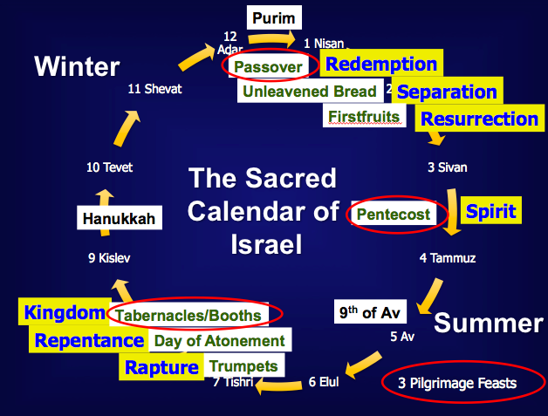

The Jewish Calendar is best seen on the following chart.

Each calendar had twelve months of 30 days each. Thus they were all approximate to the actual solar (astronomical) calendar of 365.24219879 days (see the extra month needed above for accuracy).

SIMCHAT TORAH

"Jews in Israel and everywhere also celebrate the holiday of Simchat Torah ("Rejoicing in the Torah"), also known as Shemini Atzeret ("The Eighth Day of Assembly").

"Simchat Torah immediately follows the last day of Succot (the Feast of Tabernacles). Its observance is mandated by Leviticus 23:36.

"The day's prayer services at synagogues include special memorial prayers for the deceased, as well as a prayer for plentiful rainfall during the coming winter.

"The day centers around special scriptural readings: the yearly cycle of weekly Torah (Genesis to Deuteronomy) reading is completed, and begins again. This is accompanied by dancing and singing which—in religious neighborhoods—often spill out into the streets.

"Although Leviticus 23:36 commands an offering on this day, since no temple is present, such a command is not possible. Therefore, the reading of the Torah is substituted instead."

Other Calendar Events in Intervening Years

The Sabbath year was to be celebrated every seventh year as a year of rest for the land (Exod. 23:10-11; Lev. 25:1-7).

Israel neglected this rest time and again. During the 814 years from Moses to the last king to rule, Zedekiah (1400-586 BC), there should have been 116 Sabbath years. Since Judah refused to let the land rest for 70 of these years, God forced the land rest during the 70 years exile (2 Chron. 36:21).

Nehemiah reestablished the seventh-year Sabbath rest practice after the exile was complete (Neh. 10:31).

The Year of Jubilee canceled all debts and returned land to its original family every 50th year (Lev. 25:8-55; 27:17-24; Num. 36:4).

Summary Observations on Festivals

Festivals of worship on an annual basis clustered in two major months—the first and the seventh month. This provided balance in the yearly cycle by allowing periods of celebration every half year or so.

The feasts included both times of rejoicing and sober reflection.

Three feasts were to be celebrated in Jerusalem (see next page) whereas variety was offered in that the others could be observed at home.

Festivals came in conjunction with the harvest cycle in Israel (note the chart below from http://www.wcg.org/lit/law/festivals/harvest.htm). God addressed the reality that the people would be tremendously busy at certain times, but before and after these times they were to acknowledge His provision. Thus, Firstfruits preceded the busy April to early May period while Pentecost celebrated the completed harvest in late May. Interestingly, the final harvest was of olives and Christ will return on the Mount of Olives at the end of the age (Zech. 14:4)!

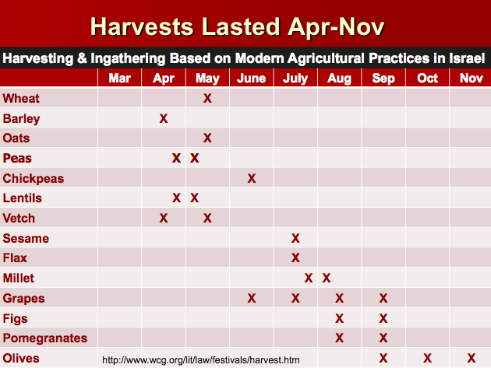

Feasts united the nation on the same calendar with communal festivities. By gathering together, Israelites saw themselves as a holy community.

Feasts provided rest—but why would God have to command us to rest? Don’t we already want rest?

Feasts typically looked both back on how God had acted on behalf of the nation as well as typologically to Israel's future history (see next page).
Eschatology of Israel’s Feasts (Leviticus 23)

 | Date | Length |  | Feast | Significance (Past) | Typology (Future)
1. | Weekly | 1 day |  | Sabbath*  (Shabbat) | Reminder of:  • Creation rest of God  • Deliverance from Egypt  Sign of Mosaic Covenant  (Exod. 20, 31; Deut 5) | Millennial rest  (Heb. 4:1-11)
2. | 1-14  (Nisan) | 1 day  (Read Song  of Songs) |  | Passover*†  (Pesach) | Redemption from Egypt by blood of the sacrificial lamb (Exod. 12) | Redemption from sin by Christ's death as Lamb  (1 Cor. 5:7b)
3. | 1-15  to 1-21  (Nisan) | 7 days |  | Unleavened  Bread*† | Separation/break from dependence upon Egypt to dependence upon God | Separated life of the redeemed for God  (1 Cor. 5:7a, 8)
4. | 1-16  (Day after Harvest Sabbath) | 1 day |  | Firstfruits  (barley sheaf ceremony) | Anticipation of God's future material provisions  -begins grain harvest | Resurrection of Christ  (1 Cor. 15:20)
5. | 3-6  (Sivan) | 1 day  (Read Ruth) |  | Pentecost†  (Shavuoth)  (Weeks)  (Harvest) | Thanksgiving for God's past material provisions  -ends grain harvest (Deut. 16:9-12) | Coming of the Holy Spirit to complete Christ's resurrection (Acts 2)
— | Spring-Summer | no feasts |  | — | Enjoyment of the harvest | Church Age
6. | 7-1  (Tishri) | 1 day |  | Trumpets  (New Year)  (Rosh Hashanah) | Preparation for national redemption and cleansing on Day of Atonement | Rapture (1 Thess. 4:13f.) Revelation (Matt. 24:31)  —Kingdom preparation
7. | 7-10  (Tishri) | 1 day |  | Day of Atonement (Yom Kippur) | National repentance and cleansing from sins of the people (Lev. 16) | National repentance of Israel in the Tribulation (Rom. 11:26-27; Zech 12:9-14)
8. | 7-15  to 7-21  (Tishri) | 7 days  (Read  Eccles.) | Tabernacles*†  (Booths/Tents)  (Succot)  (the Lord)  (Ingathering) |  | Remembered wilderness wanderings in tents (Lev. 23:42-43; Neh. 8:13-18) & celebrated final harvest of the year (Deut. 16:13) | Fulfillment of the Abrahamic Covenant in Millennium  —Judgment (Matt. 13:30,  39; Rev. 14:15)  —Kingdom (Matt. 17:4)
9. | 7-22  (Tishri) | 1 day | Shemini Atzeret  (Simchat Torah) |  | “Eighth Day of Assembly” “Rejoicing in the Torah”
The following days are not commanded in Scripture and probably have no eschatological significance:

10. | 5-9  (Ab) | 1 day  (Read Lam.) |  | 9th of Ab  (Tish’ah be’ab) | Destructions of Jerusalem:  586 BC & AD 70 | ↑
11. | 9-25  (Kislev) | 1 day  + 7 more days of candle lighting |  | Hanukkah  (Dedication)  (Lights)  (Illumination)  (Maccabees) | Saving of the nation  under Judas Maccabeus  in 164 BC  (cf. John 10:22) | This Typology column shows that the order of Israel’s annual feasts prophetically parallels her experience as a nation throughout history!
12. | 12-14/15  (Adar) | 2 days  (Read Esther) |  | Purim  (Lots) | Saving of the nation  under Esther (9:21) | Note: 10% of the year was for celebrations!

* Feasts celebrated in the Millennium (Isa. 66:23; Ezek. 45:21; 46:1; Zech. 14:16-19; Luke 22:16)
† Feasts celebrated in three annual Jerusalem pilgrimages by all male Israelites (Exod. 23:14-17)

Summary: Key Theological Distinctions Between Israel and Her Neighbors

Pagan versus Biblical Views on Prophecy

Pagan versus Biblical Views on Prayer

Literary Backgrounds to the Old Testament

Ancient Near Eastern Literature with Parallels to the Old Testament
Ancient Texts Relating to the Old Testament

The Instruction of Amen-em-opet

Major Social Concerns in the Mosaic Covenant

The Bible Visual Resource Book, 39

Biblical vs. Babylonian Creation Accounts

Biblical vs. Babylonian Flood Accounts

The Gilgamesh Epic

Flood Legends
(1 of 2)
Flood Legends
(2 of 2)

Pagan

Historical

Historical literature is especially plentiful in the Assyrian and Egyptian records as these writings attempt to chronicle the exploits of their kings in warfare. In addition, we have the Babylonian Chronicles and Persian histories such as in the Cyrus Cylinder.

For Assyrian records, see OTS, 2:614 from the translations of David Luckenbill, Ancient Records of Assyria and Babylonia, 2 vols. (Chicago: Univ. of Chicago Press, 1926-27).

Wisdom

Instruction of Amenemope (Egyptian, 1200 BC) shows similarities to Proverbs 22:17–24:22 (see p. 188b).

Egyptian Love Songs (1300-1150) also use poetic form in like manner to the Song of Songs.

Prophetic

Mari Prophecy Texts (Akkadian, 1700 BC) are similar to those of the OT prophets in terms of military activity and religious themes.

However, Israel's prophets differed from pagan "prophets" as they never were paid advisors to the king (cf. Ahab's prophets in 1 Kings 22). In fact, often they spoke against the king in ethical matters (e.g., Nathan vs. David in 1 Samuel 12).

Letters

The Amarna Letters record correspondence from Canaanite scribes to Egypt in Akkadian in the 14th century BC.

The Lachish Ostraca (writing on pottery fragments) depict the desperate conditions in the city of Lachish near Jerusalem during Babylon’s siege of Jerusalem in 598-596 BC (cf. Jer. 34:7).

Legal

Law-Code Form Similarities to Scripture:

Hittite treaties of the second millennium BC followed a basic form of about six different parts (see page 188c).

The Bible uses this same suzerain-vassal treaty form common during the 15th century. This included many of the same elements due to common institutions (marriage, government, private ownership) and common problems (death, murder, theft, slavery, etc.). This is seen in Exodus-Leviticus, Deuteronomy, and Joshua 24.

Treaty Format and Biblical Covenants find many parallels:

Legal Texts of the Ancient Near East

Specific Law-Code Penalties of the Babylonians vs. the OT:

Hammurapi (sometimes less accurately spelled Hammurabi) reigned long as king of Babylon (1792-1750 BC). His collection of laws became the longest and best organized (Arnold & Beyer, 111), but the penalties are generally stricter than in the OT and also favored the rich. For an introduction and full text of the sections referred to below, see http://www.fordham.edu/halsall/ancient/hamcode.html.

 | Hammurapi | Moses
Stealing | Death (§ 4) | Restore 2x (Exod. 22:9)
Burglary | Death (§ 21) | Restore 2x (Exod. 22:7)
Harboring a slave | Death (§ 16) | No offense (Deut. 23:15)
Injuring a slave | Master paid (§ 199) | Slave freed
Injuring a rich man | Injurer gets same injury (§§ 196-197) | Injurer gets same injury
Injuring a poor man | Fined one mina of silver (§ 198) | Injurer gets same injury
Killing rich man’s daughter | Kill injurer’s daughter (§ 209) | No class distinctions
Injuring a slave | Fined five silver shekels (§§ 211, 213) | No class distinctions
 | 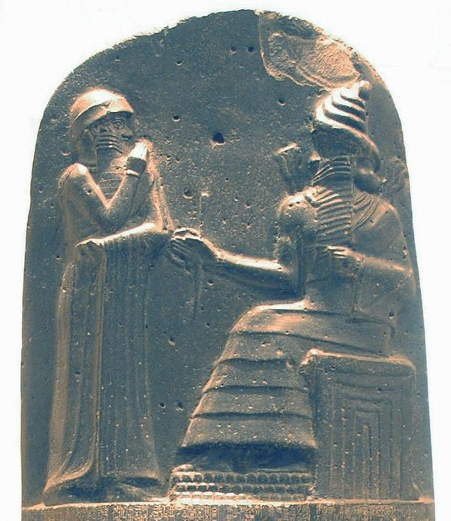
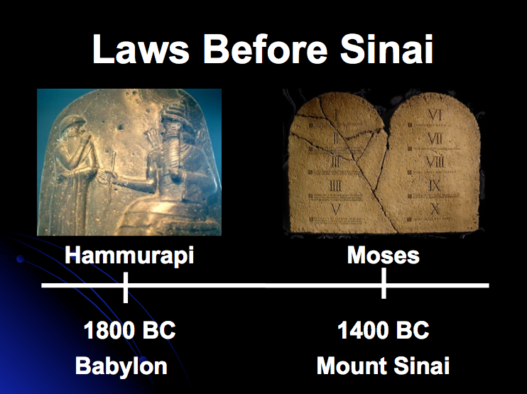

Hammurapi receives his law code from the sun god Shamash

Hammurapi’s Laws in Genesis
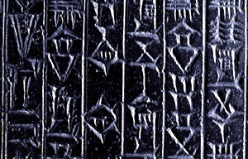
The book of Genesis assumes knowledge of several laws from Hammurapi (sometimes less accurately spelled Hammurabi), king of Babylon (1792-1750 BC). For an introduction and full text of the sections referred to below, see http://www.fordham.edu/halsall/ancient/hamcode.html.

The adoption law made Eliezer Abram's heir (Gen. 15). § 191.

The giving of Hagar to Abraham (Gen. 16) and of Bilhah (Gen. 30:4) and Zilpah (Gen. 30:9) to Jacob, accorded with this code. § 146.

The purchase of Machpelah by Abraham (Gen. 23) was conducted in strict conformity with its commercial enactments. § 7.

The taking of life for stealing, proposed by Jacob to Laban (Gen. 31:32), was enacted by this code, which punished sacrilege with death. § 6.

The taking of life by burning, with which Judah threatened his daughter-in-law Tamar (Gen. 38:24), is also according to the Babylonian code. § 110.

The proposal of Joseph's steward, that the one with whom the cup was found should die (Gen. 44:9), harmonized with the law punishing with death any theft from a palace. § 6.

The giving of a special portion by Jacob to his favourite son Joseph (Gen. 48:22) was provided for by this code. § 165.

The cutting off of Reuben from his birthright (Gen. 49:4) was the prescribed way of punishing his offence according to Hammurapi's law. § 158.

The inability of Abram to sell Hagar (Gen. 16:6) accords with Hammurapi’s prohibition of selling a maidservant who bears the owner children. § 119.

General Law-Code Differences of the Babylonians vs. the OT:

 | Hammurapi | Moses
Law-Code Basis | The king’s word | The character of Yahweh
Motive not to sin | Offense to a god’s whims | God’s holiness: "Be holy as I am holy" (Lev. 19:2) and love for Him (Deut. 6:4-5)
Enforcing Government | Civil | Theocratic
Social distinctions | Many | None
Punishment | Harsh (death penalty common) | Reasonable (capital punishment sparingly)
Deities | Polytheistic | Monotheistic
Women | Abuse allowed | Respected
Slaves | No rights (no rest, permanent) | Rights (Sabbath rest, freed after 7 years)
Human life | Cheap and Expendable | Highly valued
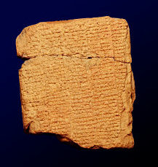

Old Testament

Hebrew Order of OT Books

The Hebrew Bible contains the exact same books as our present OT except in a different order under different classifications:
Hebrew | Bible | Christian | Old Testament
The Law | Genesis | Genesis | The Law
(Pentateuch) | Exodus | Exodus | (Pentateuch)
 | Leviticus | Leviticus
 | Numbers | Numbers
 | Deuteronomy | Deuteronomy
The Prophets | Joshua | Joshua | Historical Books
 | Judges | Judges
 | Samuel | Ruth
 | Kings | Samuel (1 & 2)
 | Isaiah | Kings (1 & 2)
 | Jeremiah | Chronicles (1 & 2)
 | Ezekiel | Ezra
 | Hosea | Nehemiah
 | Joel | Esther
 | Amos | Job | Poetical Books
 | Obadiah | Psalms | (Wisdom Literature)
 | Jonah | Proverbs
 | Micah | Ecclesiastes
 | Nahum | Song of Solomon
 | Habakkuk | Isaiah | Prophets
 | Zephaniah | Jeremiah
 | Haggai | Lamentations
 | Zechariah | Ezekiel
 | Malachi | Daniel
The Writings | Psalms | Hosea
(Hagiographa) | Proverbs | Joel
 | Job | Amos
 | Song of Solomon | Obadiah
 | Ruth | Jonah
 | Lamentations | Micah
 | Ecclesiastes | Nahum
 | Esther | Habakkuk
 | Daniel | Zephaniah
 | Ezra | Haggai
 | Nehemiah | Zechariah
 | Chronicles | Malachi

Note differences in the Hebrew Bible column that designate those classified by Christians as historical writings (italics) and wisdom writings (bold).

The twofold designation of “Law and the Prophets” (Matt. 5:17; 7:12; 22:40) was used in NT times, probably as a reference to the entire OT. In Luke 24:44, Jesus used this threefold designation: “Law of Moses, the Prophets, and the Psalms” (this first book of the Writings was used as representative of the whole section)

The Masoretic Text (MT): The Hebrew text circulated for 1000+ years with only consonants, but about AD 600-1000 a family of Hebrew scholars (the Masoretes) copied the text in Babylon and Tiberias (the latter became the standard). They also added vowels (pointing), accents, and masora (notations), leaving us the Masoretic Text (MT). Thus ancient Hebrew differs from present Hebrew Bibles as it lacks vowel points under each letter. Modern Hebrew also has no vowels.

Jews revered the Hebrew Scriptures in NT times. Even though most Jews did not have their own copy of the scrolls due to their size and expense, one wonders whether Jews then knew it better from hearing it read than Christians do today from having their own copy to collect dust on their shelves!

Greek: The Septuagint (LXX)

History: The LXX (Roman numeral 70) translated the Hebrew OT into Greek by 72 scholars in Alexandria, Egypt (c. 250 BC) for Ptolemy II (285-247 BC). This provided an OT for many Diaspora Jews who couldn’t read Hebrew or Aramaic.

Content: 39 OT books with 15 Apocryphal books added later (except 2 Esdras and Additions to Esther) included differences in the text and order of the books.

Value: Why does the LXX merit study?

It is the earliest translation of the Hebrew Scriptures. Since each translation is in reality an interpretation, this earliest interpretation of the text helps us better understand the meaning attached to texts by very early scholars (pp. 235-36).

It was valued highly by most Hellenistic Jews & Jewish converts to Christianity.

In some form it constitutes the parent text from which several early Bible versions derive (Coptic, Ethiopic, Arabic, Armenian, etc.).

It provides the Jewish intertestamental history since it includes the Apocrypha.

OT Canonicity: The term “canon” comes from the Greek kanon, for “rule” or “standard.” Thus “canonicity” refers to the authoritative list of books in the OT or NT. Our present list of 39 OT books was formalized in AD 90-100 in the city of Jamnia, where these books were identified as the inspired OT. Why this late date given that the final book (Malachi) was completed almost 500 years previously?

Why did it take until the first century AD to record the official list of OT books?

Apocrypha: Until the emergence of the Apocrypha in the intertestamental era, no other Jewish writings besides the MT had received widespread circulation. In fact, no extant Jewish documents exist from before the Apocryphal books! It is easy to see from this vast and recent literature that the orthodox Jews would see the need to list those books that had long been considered sacred.

Many LXX manuscripts mixed Apocryphal books among the canonical, confusing the issue as to which books were indeed authoritative.
OT Apocrypha and Pseudepigrapha Jewish Literature
(This section adapted from John D. Grassmick, NTI Class notes, DTS, 1985)

a. Definitions

1) The OT Apocrypha (“hidden, secret”) is a collection of 15 extrabiblical Jewish writings mostly composed from 250 BC—AD 100 (cf. list on p. 164).

a) Acceptance: None of these 15 was included in the Hebrew Masoretic Text (MT) though all but 2 Esdras were appended to the Septuagint (LXX). The Catholic Church has accepted 12 of these as Scripture since the Council of Trent (1546) and called them the “deuterocanonical” books (“second canon”).

b) Terms: Don’t confuse apocrypha with the similar-sounding apocalypse (“revelation, disclosure”) with the opposite meaning! Apocalyptic denotes a writing style with symbolic imagery about future events similar to Revelation, Daniel, and Zechariah. To further confuse things, two books of the Apocrypha are apocalyptic in style (p. 162)! Also, note that there exists a huge body of literature called the NT Apocrypha that was penned in the centuries following NT times (cf. pp. 186-87).

2) The Pseudepigrapha (“falsely ascribed”) is 63+ extrabiblical Jewish writings mostly composed from 200 BC—AD 200. Some were written in Hebrew/Aramaic (Palestinian origin) and others in Greek (non-Palestinian, most from Alexandria, Egypt).

a) Acceptance: None of these 63 is included in the MT, LXX, or Catholic Bibles. They are used simply as background literature to better understand Scripture.

b) Names: Some Pseudepigraphal writings bear the names of key OT persons such as Enoch, Moses, etc. These men did not actually write these books (thus the name meaning “falsely ascribed”), but these names were used to add authenticity to the books (yet some make no such claim and are anonymous). Catholics call the Apocrypha “Deuterocanonical” writings, and the Pseudepigrapha “the Apocrypha”!

b. Literary Categories
(Only 14 of the 78 Apocryphal and Pseudepigraphal writings are listed here. Each is in the Apocrypha unless otherwise noted.)

1) History
These works provide invaluable information on the intertestamental period.

a) 1 Esdras (ca. 150 BC) contains portions of Ezra-Nehemiah and 2 Chronicles (“Esdras” is Greek for the Hebrew “Ezra”). Josephus referred to 1 Esdras.

b) 1 Maccabees (ca. 100 BC) is the best historical source between the testaments as it provides very accurate information on the Sabbath, wars, etc.—especially the discussion of Antiochus IV and the Maccabean Revolt (167-164 BC).

c) 2 Maccabees (ca. 100 BC) is a theological, less historically accurate work.

2) Fiction (romances or novels or apologies)
These works extol the virtues of the Jews and their way of life. They contend that God blesses and rewards His people who are faithful to Him.

a) Tobit (ca. 200 BC) chronicles the story of how God rewards the faith of the man Tobit who is dedicated to the Torah in the midst of Babylonian idolatry.

b) Judith (ca. 150 BC) is a historical romance of how the heroine Judith delivers Judah from the Babylonians by beheading the commander of Babylon.

c) Letter of Aristeas (ca. 150 BC) is a Pseudepigraphal work about how the 72 scholars came together to translate the LXX in Alexandria for Ptolemy II’s library. Unfortunately, only one verse describes the actual translation process.

d) Susanna (ca. 100 BC) records how this virtuous wife of a Babylonian Jew is accused of adultery but vindicated by Daniel’s wisdom. He questions her accusers separately, showing their conspiracy and leading to their deaths.

e) Bel & the Dragon (ca. 100 BC) provides two stories as an addition to the book of Daniel. In the first account Daniel proves that the Babylonian idol “Bel” does not actually eat food and in the second Daniel refuses to worship a dragon, kills it, then is rescued from the lions’ den—both stories depicting how God sustains those who worship Him in the face of idolatry.

f) 3 Maccabees (ca. late first cent. BC) has a misleading name as it records struggles of Alexandrian Jews who suffered under Ptolemy IV Philopator (221-204 BC), events which occurred a half century before the Maccabees. Both 3 & 4 Maccabees are noncanonical to Catholics and Protestants, though Eastern Orthodox churches accept them as canonical.

g) Sibylline Oracles (300 BC to AD 700) depict aged women (Sibyls) uttering ecstatic prophecies. These did not have reliable or factual data as they were continually changed and used for political propaganda. Some contain allusions to Christianity as well as paganism (Charlesworth, 1: vi, 317).

3) Wisdom literature (didactic)
These books read very much like the book of Proverbs. Jewish sages (wise men) were held almost in as high regard as the priest and prophet.

a) Ecclesiasticus—also called Sirach (ca. 190 BC) contains two-line proverbs and is very helpful in providing Greek parallels to NT Greek constructions.

b) Wisdom of Solomon (ca. 50 BC) is deemed the “Gem of the Apocrypha” due to its emphasis on encouraging Jews to live wisely to please the LORD. A Hellenistic Jew who tried to impersonate Solomon wrote it in Greek.

4) Apocalyptic literature
This highly symbolic literature claims to reveal the future. It views human history in two ages: the “present evil age” that will grow worse until God brings in the “age to come” (Messianic age). Such writings served to encourage Jews to endure persecution with the promise of the soon coming of the Messiah and the kingdom. It was extremely popular during Israel’s period of foreign domination (intertestamental and NT era) but quickly faded after Jerusalem’s destruction revealed that the kingdom was not indeed at hand.

a) 1 Enoch or Ethiopic Enoch (ca. 150 BC) is a Pseudepigraphal work trying to answer riddles such as why the angels fell (due to cohabiting with women in Genesis 6:1-4), the meaning of “son of man” (a preexistent heavenly Messiah), and especially eschatological themes such as the coming of Messiah and the kingdom, which is quoted in Jude 14-15. This book was well known in NT times and likely influenced NT theology (Charlesworth, 1:10).

b) 2 Esdras (ca. AD 90) is a theodicy, or explanation of some of the great mysteries of the moral world (how a good God can be reconciled with a sinful world), including why Jerusalem fell to the Romans. This apocalyptic apocryphal writing provided hope for salvation and restoration for the Jews.

c. Canonicity: Why was the Apocrypha/Pseudepigrapha rejected as inspired?

1) Not Recognized as Authoritative by the Early Church: The Apocrypha was added to the LXX, but various LXX editions contain different books and most do not claim inspiration for them. Both Jews and Christians limited the OT canon to the present 39 books (e.g., Josephus Against Apion 1.8)

2) False Theology: Teachings incompatible with Scripture are numerous, such as…

a) Purgatory is taught in the Apocrypha. Judas Maccabeus in 2 Maccabees 12:41-46 discovered that some of his men killed in battle were wearing pagan amulets. Judas took up a collection from his surviving soldiers and sent it to Jerusalem as an “expiatory sacrifice,” with the result, “And thus he made atonement for the dead that they might be freed from their sin” (v. 46).

b) Salvation by works is taught in the Pseudepigrapha. Two angels each record sins and good deeds, respectively, then place these records on a balance to see if a person goes to heaven or hell (Testament of Abraham 13:9-14 in Charlesworth, 1:890).

3) Lack of Claim to be the Word of God: Since it never makes a “thus saith the Lord” claim, why should we make such a claim on its behalf?

4) Lack of Dynamic Character: It does not read like an inspired writing.

5) Suspicious History of Acceptance by the Roman Catholic Church: Catholics did not affirm inspiration for the Apocrypha until the Council of Trent (AD 1546) in a counter-offensive to Protestant claims (that faith alone is sufficient for salvation and prayers for the dead are meaningless). While Pope Gregory I developed the purgatory idea much earlier (AD 593), indulgences were added to reduce purgatory time (AD 1190), and purgatory was elevated from doctrine to dogma in AD 1438 (Council of Florence), the Catholic Church obtained the “best” support for purgatory by canonising the Apocrypha in AD 1546 so that 2 Maccabees 12:41-46 (above) would be considered authoritative.

d. Value of the Apocrypha and Pseudepigrapha

How have the Apocrypha and Pseudepigrapha helped interpret the NT? They provide…

1) History of the Jewish intertestamental era—the dashed hopes and disillusionments of the returning from the exile

2) Origins of Jewish sects and institutions—the shift from a covenant nation to a mix of conflicting religious communities

3) Development of theological beliefs—God shifts from direct revelation to intermediaries (angels), and emphasizes resurrection and salvation by obeying the Torah

4) Lexical background to many NT terms (e.g. “son of man”), images (e.g. apocalyptic imagery), and ideas (e.g., doctrine of the two ages)

5) Backdrop for new literary forms (e.g. letters)

6) Balance to rabbinical writings in understanding Judaism
e. List of Apocrypha Books and Acceptance by Various Groups...

Terminology of Authoritative Writings

Jews and those claiming to be Christians differ widely on which books are considered Scripture, as well as what to call them. Below is a summary to try to clear up some of the confusion.

 | Jews | Protestants & Anglicans | Catholics | Eastern Orthodox
39 OT Books | Bible | Old Testament | Old Testament | Old Testament
27 NT Books | New Testament (uninspired) | New Testament  (inspired) | New Testament  (inspired) | New Testament  (inspired)
4 Apocryphal Books (Tobit, Judith, Wisdom of Solomon, Ecclesiasticus) | Apocrypha  (uninspired; not in MT but in LXX) | Apocrypha  (uninspired) | Deuterocanonical  (confirmed as canonical in 1546) | Apocrypha  (confirmed as canonical in 1673)
8 Apocryphal Books (Baruch, Letter of Jeremiah, Additions to Esther, Song of Three Young Men, Susanna, Bel & the Dragon, 1-2 Maccabees) | Apocrypha  (uninspired; not in MT but in LXX except Additions to Esther) | Apocrypha  (uninspired) | Deuterocanonical  (confirmed as canonical in 1546) | Apocrypha  (not confirmed as canonical in 1673 but generally accepted as authoritative now)
3 Apocryphal Books (1-2 Esdras, Prayer of Manasseh) | Apocrypha  (uninspired; not in MT but in LXX except 2 Esdras) | Apocrypha  (uninspired) | Non-canonical  (but often in the appendix since 1592, except Jerusalem Bible) | Apocrypha  (not confirmed as canonical in 1673 but generally accepted as authoritative now)
3 Pseudepigraphal Books (Psalm 151,  3-4 Maccabees) | Pseudepigrapha  (3-4 Maccabees only in LXX?) | Pseudepigrapha  (uninspired) | Apocrypha  (but in the appendix of the NRSV New Oxford Annotated Bible, 1977) | Apocrypha  (not confirmed as canonical in 1673 but generally accepted as authoritative now)
60+ Pseudepigraphal Books (1 Enoch is the largest and most influential work) | Pseudepigrapha  (uninspired, not in any OT editions) | Pseudepigrapha  (uninspired, not in any Bible editions) | Apocrypha  (uninspired, not in any Bible editions) | Pseudepigrapha  (uninspired,  not in any Bible editions)

Antilegomena (“spoken against”) designate the five disputed books below which may have encouraged the compilers at Jamnia to officially affirm them as inspired. These books were not added to the canon then; more probable was that the synod met to discuss if these should be removed or not. “The ‘Council’ was actually confirming public opinion, not forming it.”

Ezekiel was thought to contradict Solomon’s temple (cf. Ezek. 40–43)

Esther did not mention God’s name, prayer, or anything religious

Ecclesiastes appeared Epicurean (advocating indulgence of the flesh)

Proverbs had supposed contradictions (e.g., 26:4-5)

Song of Songs was disputed due to its sensuality

Samaritans considered only the five books of Moses as inspired, so perhaps the rabbis felt they must distinguish themselves from this limited tradition.

Pharisaical tradition had become equal in authority to many, so perhaps the Jamnia council met in part to clarify the non-authoritative nature of these rabbinic writings.

What criteria were used to determine which OT books were inspired?

History of Authoritative & Enduring Usage: Note that these rabbis did not decide which books were scriptural. They only put into an official list the OT writings that had been revered as Scripture by Jews for centuries.

Doctrinal Suitability: The 39 OT books teach no doctrinal inconsistencies (truthfulness and harmony with progressive revelation). While Apocryphal and Pseudepigraphal writings were considered valuable as historical literature, they did not read like Scripture due to doctrinal inconsistencies.

Prophetic Authorship (Samuel, David, etc.)

Claim to be the Word of God (“The word of the Lord came to me…”)

The NT repeatedly refers to the OT as inspired. Jesus often referred to OT books as the word of God (e.g., Luke 18:31-33; 24:25-27; John 10:35; etc.), as did Peter (Acts 1:16), Stephen (Acts 7:38), Paul (Rom. 3:2), and James (Jas. 4:5).

While NT usage was not influential at Jamnia due to the rabbinic (non-Christian) makeup of the council, nevertheless, it does confirm for Christians the authority of the 39 OT books. In contrast, only one Pseudepigraphal book is quoted in the NT (1 Enoch 1:9 in Jude 14-15), and this quote does not imply inspiration.

Dynamic Character (Heb. 4:12): God’s Word is alive and changes lives. This cannot be said of other so-called inspired writings.
Old Testament Canonicity (1 of 3)
Old Testament Canonicity (2 of 3)
Old Testament Canonicity (3 of 3)
How We Got Our Old Testament (1 of 3)
How We Got Our Old Testament (2 of 3)
How We Got Our Old Testament (3 of 3)
The Quest for the Original Bible (1 of 5)
The Quest for the Original Bible (2 of 5)
The Quest for the Original Bible (3 of 5)
The Quest for the Original Bible (4 of 5)
The Quest for the Original Bible (5 of 5)

Archaeological Backgrounds to the Old Testament

Definitions of Biblical Archaeology

Archaeology

“The science or study of history from the remains of early human cultures as discovered chiefly by systematic excavations” (Funk & Wagnall's)

“The scientific study of material remains (as fossil relics, artifacts, monuments) of past human life and activities” (Webster’s)

Biblical Archaeology

“‘Biblical Archaeology’ selects those material remains of Palestine and its neighboring countries which relate to the biblical period and narrative. These include the remains of buildings, art, inscriptions and every artifact which helps the understanding of the history, life and customs of the Hebrews and those peoples who, like the Egyptians, Phoenicians, Syrians, Assyrians and Babylonians, came into contact and influenced them.”.

Notice that none of the three definitions above specifically include literature.

Archaeological Terms

Classification of Objects

Artifacts—man-made objects (e.g., pots, jewelry, tools)

Epigraphs—materials with writing on them (e.g., inscribed stones, clay tablets, coins)

Excavation Terminology

Tell—a mound containing the debris of human occupation that has accumulated at a site, built up in successive layers over the centuries through a sequence of habitation, destruction and reconstruction.

Field—a particular spot selected for excavation that is laid out in squares, usually five meters in dimension.

Square—a marked out division of a field

Bench Mark (datum point)—a permanent reference point in relation to sea level with which all other measurements must ultimately correlate.

Locus—a relative reference point based on a distinct and recognizable feature in the course of excavation (e.g. surface of a floor, wall, an oven, etc.).

Stratum (plural, strata)—a layer of debris that consists of occupational phases that have a common cultural association and are distinguishable from earlier and later strata by evidence of major destructions, gaps in occupation, or other clear stratigraphical features.

Balk surface or wall—the vertical face of the side of a square that allows visual examination of the excavated stratum.

In situ (Latin)—in its original position. Photographs are taken in situ.

Dump—the location where the unwanted excavated material is thrown away.

Brief History of Biblical Archaeology

The origin of biblical archaeology can be seen in the pages of the Scripture itself.

Joshua specifically set up stones at the miraculous crossing of the Jordan River so that succeeding generations would ask what they meant (Josh. 4:20-23).

During the reign of Judah's godly king Josiah, the "book of the law" (Deuteronomy?) was discovered during the temple cleaning (2 Kings 22:8).

Modern studies of biblical archaeology perhaps began in 1799 with the discovery of the Rosetta Stone in Egypt (a trilingual inscription which unlocked Egyptian hieroglyphics), but this was an accidental discovery during Napoleon’s conquests.

Americans Edward Robinson and Eli Smith were the first to explore the surface of Palestine (1838), but the first excavations took place by the Frenchman DeSaulcy near Jerusalem in 1863. Yet for nearly a century no one could decipher the dates of any artifacts or strata.

Excavations still continue even 200 years later, typically in the summer when volunteers can be recruited from colleges and seminaries. Recently it was noted that Jerusalem alone had over 100 sites being excavated! There is much work to be done and much interest, especially noted in the tremendous success of the Biblical Archaeology Review (BAR).

Methods of Biblical Archaeology

A sounding consists of a vertical pit dug straight down, typically as a quick way to see if more accurate but difficult methods should be used (below).

The stepped trench removes more dirt than the sounding and it continues up the tell at each successive stage.

Stratification is the most elaborate (and expensive) method.

Most biblical archaeological sites appear on levels (strata) on a tell (mound of successive layers of destruction and rebuilding). Thus the stratigraphical method is the careful excavation of all objects found at each level or strata of a tell.

Here’s a typical tell with its various periods cut away (Wiseman, 72-73):
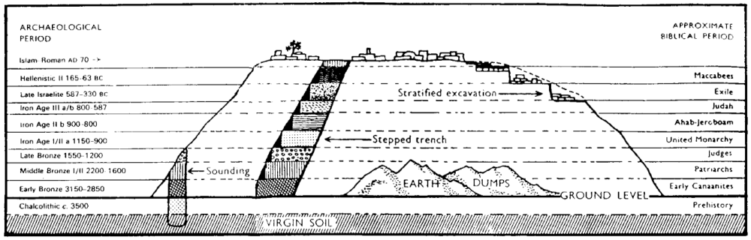
Schematic drawing of an ancient Palestinian tell showing methods of excavation and levels (strata) of occupation

How can archaeologists tell the age of a tell?

Sometimes Carbon-14 dating is performed on remains. But this is only accurate if one knows how much carbon existed in the artifact when it was made, so it is not the best method to use. It also is not typically accurate beyond about 4000 BC and no literature exists older than this anyway which could confirm potential dates.

The better way to date the tell is through means of pottery (see below).

The Typology (Pottery Analysis) Method of Biblical Archaeology

History: After archaeologists had no success in determining the ages of tells for many years, finally in 1890 Flinders Petrie discovered at Tell el-Hesi that pottery changed over the years but had a distinctive style for each age.

The ages can be determined by comparing styles with those of Egypt (for which dates are certain).

Now pottery within strata is the chief means of determining dates all the way back to about 4000 BC (Wiseman, 71).

Note the various pottery types in each age:

Pottery Types in Various Biblical Ages

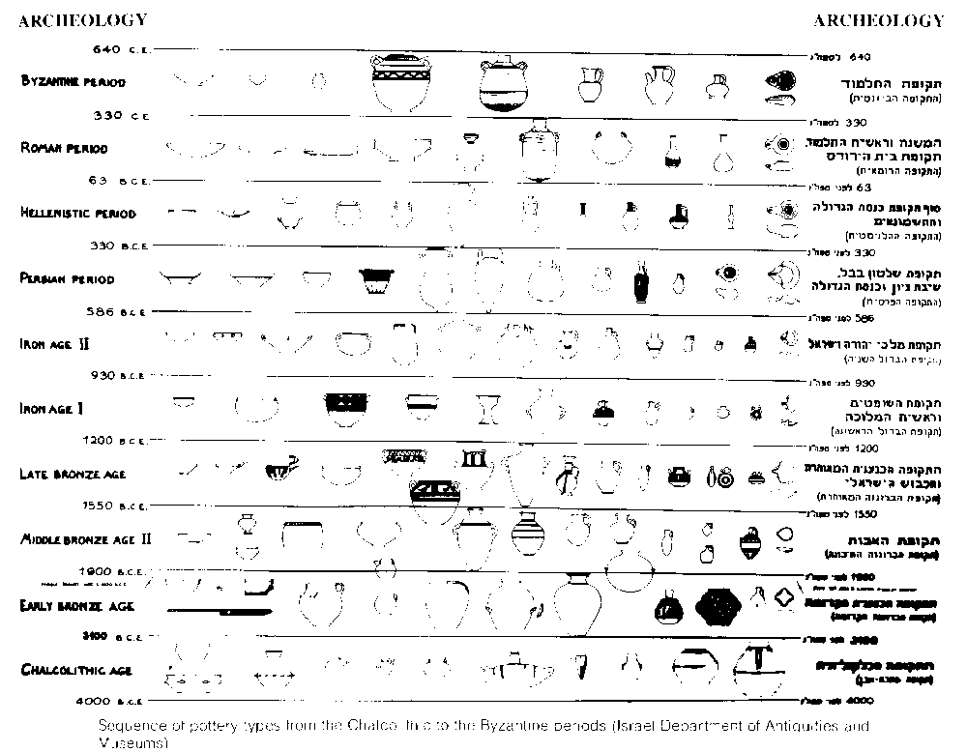

Archaeological Periods

Major Finds in OT Archaeology

Major Inscriptions of Old Testament Significance

Major Tablets of Old Testament Significance

Other Significant Finds that Confirm and Illuminate the Old Testament

Other Significant Finds that Confirm and Illuminate the Old Testament (2 of 2)

Major Sites of Palestinian Archaeology
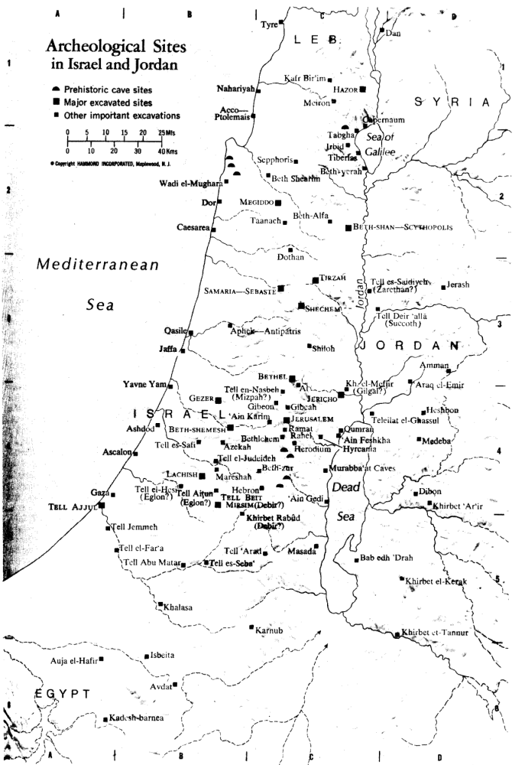

Value of Biblical Archaeology

Confirmation of Biblical History

The truth of Scripture stands whether or not it has confirmation from archaeology. (We do not need archaeology to prove the divine inspiration of the OT or NT.)

No archaeological discovery has ever contradicted a single biblical reference (although archaeology has at times contradicted some theories about the Bible).

Many archaeological finds have confirmed the accuracy of the OT:

Israel

Negev: No one can rightfully dismiss the stories of Abraham, Isaac, and Jacob as folklore. The excavation of Ur (birthplace of Abraham) shows it to be a major centre of industry and religion at the height of its splendor just as noted in Genesis. The worship of the moon god Sin there is consistent with biblical notes of Abraham as a former idolater (Josh. 24:2).

Jerusalem

The Western Wall & Arches at the present time stand many feet above the wall of Solomon's temple (cf. OTB, 35).

Holy of Holies etching is notable in the large bedrock of the Dome of the Rock, indicating that the Ark of the Covenant within Solomon's temple stood at this spot.

The Place of Trumpeting at the southwest corner of the temple mount was recently discovered, verifying that this indeed was a Jewish place of worship (cf. OTB, 211).

The Gihon Spring wall and gate (1999 excavation) illuminate 2 Chronicles 33:14 which notes an outer wall in the Kidron valley, contrary to the long-held belief that the City of David had but one eastern wall (cf. OTB, 33-34).

The discovery of Hezekiah's tunnel from the Gihon Spring testifies to the accuracy of the Bible (cf. OTB, 30-32).

Babylon

Sumerian flood stories and the 270 flood stories from around the world confirm an ancient belief in a worldwide flood (cf. OTB, 188g-h). One would expect to find this widespread belief for such a significant event (Gen. 6–9).

Liberal scholars used to doubt the existence of King Belshazzar since his father (King Nabonidus) ruled during the fall of Babylon (Dan. 5). Later archaeology revealed that Belshazzar was, in fact, co-ruler with his father who was outside the capital for ten years. This enabled Belshazzar to offer Daniel position as "the third highest ruler in the kingdom" rather than second in command (Dan. 5:16).

Previously, the law code of Moses in Deuteronomy was considered too advanced for his time. Yet after the discovery of Hammurapi's law codes that predate Moses, no one levels this attack any more.

Assyria

The Nuzi tablets provide contemporary descriptions of laws and customs of the patriarchal age.

The Display Inscription and the Annals of the Assyrian King Sargon note that 27,290 citizens of Samaria were exiled to Assyria, confirming the scriptural account (2 Kings 17:23).

Judah's king Jehu bows and gives tribute in the Black Obelisk of Shalmaneser, king of Assyria. This 1846 discovery confirms the existence of this king of Judah and also his being a vassal to Assyria.

Persia

The Cyrus cylinder notes that this Persian king's policy towards captive peoples was to allow them to return to their home country.

This finding clearly put the return of Israel into a larger framework, making the biblical account not seem so extraordinary.

Syria

It used to be doubted that a people known as Hittites ever existed since there initially were no archaeological remains of the Hittite empire.

Since the discovery of 40 Hittite nations and the Ugaritic language in 1905, this criticism has disappeared.

Confirmation of the Transmission of Scripture

The Dead Sea Isaiah Scroll demonstrates the accuracy of transmission of the OT text. Comparing the DSS Isaiah scroll (ca. 200 BC) with one copied in the AD 800’s shows minimal differences.

Thus archaeology shows that the Jewish scribes over the centuries showed extreme care to produce reliable copies of their sources.

Insight into Interpretation of Scripture

The meaning of words has become clearer by studying clearer texts and languages related closely to Hebrew (e.g., Ugaritic, Assyrian).

Formerly higher critics claimed that the language of the Pentateuch was too advanced for Israel (esp. Moses) to write it. Therefore, they concluded that it was written hundreds of years after Moses died. However, findings at Mari and Nuzi refute these speculations with language contemporary to Moses.

The KJV of Isaiah 21:8 reads, "And he cried, a lion." But the Dead Sea Scrolls discovery of the Isaiah scroll has a clearer text that clarifies that it should be translated, "And he who saw cried…"

Discoveries in Ugarit note that the many references to the LORD being over the sea (Heb. Yam) actually mean that YHWH is superior to Yam, the sea god of the religion of Baal (see Ps. 29:3; 89:25).

For years translators did not know how to render the unusual Hebrew word tsinnor in 2 Samuel 5:8 where the text describes how Jerusalem was secretly entered and conquered. The KJV translates the sentence, "Whosoever getteth up to the gutter, and smiteth the Jebusites… shall be chief and captain." How could a gutter relate to conquering the city? Archaeological excavations of Jerusalem's eastern wall in the 19th century revealed that a water shaft extended down from the city to tunnels leading to water outside the city walls. Now modern translations translate tsinnor as "water shaft" instead of "gutter" which makes much more sense. See OTB, 31.

Cultural backgrounds provide facts that the Bible does not mention.

Sir Charles Leonard Woolley through the excavation of Ur (1922-1934) highlighted the idolatrous background that Abraham came from in Ur. He found that every woman was required to offer her body to the priests at least once in her life (or else pay a temple prostitute to take her place). This gives added insight as to why God wanted Abraham to separate himself from Ur and it debase religion so that he could make a new nation out of his family.

A discovery of the Lachish potsherds found in the city of Lachish close to Jerusalem confirmed that public opinion of Jeremiah was divided into those who believed he spoke with authority and others who thought he discouraged the people.

The size of Hazor north of the Sea of Galilee was confirmed in the excavation of the site. Whereas most ancient cities comprised only 20 acres, Hazor covered 200 acres! This verifies the description of it being the head of several of the northern kingdoms (Josh. 11:10).

Source of Revenue for Israel and Neighbor Nations: The Middle-East would be economically impoverished without oil. Though to a lesser degree, archaeological excavations also have brought significant amount of money into this part of the world.

Dangers and Limits of Biblical Archaeology

Priority: There exists an assumption among many archaeologists to hold the supremacy of archaeology over Scripture.

Too often archaeologists pit their own findings against the Bible in order to “prove the Bible wrong.” For example:

The Moabite Stone confirms that Mesha was indeed the king of Moab, but this stone says that Moab was victorious in battle while 2 Kings 3:26-27 claims victory for Israel. Both records cannot be correct, but it is inaccurate to say that the biblical record is thus disproved.

While Joshua 8:26-28 claims that Joshua destroyed Ai around 1400 BC and made it a "heap forever," archaeological excavations indicate the city was destroyed in 2400 BC. Joseph A. Callaway, the archaeologist who worked on the site for nine years, claimed that "there was no Canaanite city here for Joshua to conquer." This is a claim that archaeology supersedes the biblical record and that archaeology cannot be mistaken.

We must make a choice: an inerrant Bible, an inerrant archaeologist, or neither (most choose the last)!

Subjectivity: Archaeology is not an exact science, so its results are interpreted with the biases of each archaeologist.

The archaeological record is incomplete and it will always remain so. One estimate is that less than two percent of the sites have been excavated.

Not even one biblical site has been completely excavated.

The following commentary exposes some modern critical NT scholar biases:

----- Original Message -----
From: "Crosswalk.com" <breakpoint.UM.A.3.6761@lists.crosswalk.com>
Sent: Tuesday, 26 March, 2002 2:07 AM
Subject: BreakPoint: The Stones Cry Out

BreakPoint cultural commentary with Prison Fellowship's Chuck Colson
http://news.crosswalk.com

The Stones Cry Out
Archeology Bears Witness To The Gospels
By Charles Colson

A few years ago, people exploring caves outside Jerusalem came across the find of a lifetime: an ancient burial cave containing the remains of a crucified man.

This find is only one in a series of finds that overturn a century-old scholarly consensus. That consensus held that the Gospels are almost entirely proclamation, and contain little, if any, real history.

The remains belonged to a man who had been executed in the first century A.D., that is, from the time of Jesus. As Jeffrey Sheler writes in his book Is the Bible True? the skeleton confirms what the evangelists wrote about Jesus' death and burial in several important ways.

First, location -- scholars had long doubted the biblical account of Jesus' burial. They believed that crucified criminals were tossed in a mass grave and then devoured by wild animals. But this man, a near
contemporary of Jesus, was buried in the same way the Bible says Jesus was buried.

Then there's the physical evidence from the skeleton. The man's shinbones appeared to have been broken. This confirms what John wrote about the practice of Roman executioners. They would break the legs of the crucified to hasten death, something from which Jesus, already dead, was spared.

This point is particularly noteworthy, since scholars have long dismissed the details of John's Passion narrative as theologically motivated embellishments.

Another part of John's Gospel that archeology has recently corroborated is the story of Jesus healing the lame man in John 5. John describes a five-sided pool just inside the Sheep Gate in Jerusalem where the sick came to be healed. Since no other document of antiquity -- including the rest of the Bible -- mentions such a place, skeptics have long argued that John simply invented the place. Apparently John didn't make up the pool, after all.

The dismissal of biblical texts without bothering to dig points to a dirty little secret about a lot of scholarly opinion: Much of the traditional suspicion of the biblical text can only be called a prejudice. That is, it's a conclusion arrived at before one has the facts.

Scholars long assumed that the Bible, like other documents of antiquity, was essentially propaganda, what theologian Rudolf Bultmann called "kerygma" or proclamation.

But this prejudice does an injustice to biblical faith. Central to that faith are history and memory. Christians believe that God has acted, and continues to act, in history. For us, remembering what God has done is an act of worship -- something that brings us closer to God.

Thus, while these discoveries in the desert may come as a surprise to some skeptics, they're no surprise to Christians.

While archeology alone cannot bring a person to faith, these finds are an eloquent argument for not dismissing the truth of Scripture before at least examining the evidence -- because, as we are learning every day, Jesus meant it when he said that "the very stones will cry out."

Copyright 2002 Prison Fellowship Ministries. All Rights Reserved.

Visit the Breakpoint website at http://www.breakpoint.org.

For more information about Chuck Colson and Prison Fellowship Ministries,
visit http://www.prisonfellowship.

Incomplete Record: Many Biblical Accounts cannot be Proven by Archaeology.

Of course, they can’t be disproved either (e.g., miracles)! Since we will always have insufficient proof, each individual must choose whether to believe the Bible until disproved by archaeology or to believe archaeologists until disproved by a new understanding of Scripture.

Biblical archaeology sometimes seeks to prove whether the Bible is true or not. This misguided motive tempts archaeologists to try to provide answers that they cannot provide and it tempts their readers to believe theories without extra-biblical support. As an anonymous person has said, "Absence of proof is not proof of absence."

One example of the failure of archaeology to provide convincing evidence is the lack of evidence for Israel's wilderness wanderings. Given that the desert sands buried most of the cities noted in Numbers several centuries ago, the Exodus and Wanderings must be accepted by faith without archaeological evidence at the present time.

Complexity: Biblical Archaeology is the oldest archaeology in the world: This makes it the most complicated, with more strata than any other branch of archaeology and with the least amount of supporting literary sources.

Limited Apologetic Value: Archaeology cannot prove God's existence nor bring a person to faith in Christ. This is the work of the Holy Spirit. It can, however, confirm with solid evidence some of the claims made by Scripture.

Resources

Books Defending Scriptural Reliability

Dever, William G What Did the Biblical Writers Know and When Did They Know It?: What Archaeology Can Tell Us about the Reality of Ancient Israel. Grand Rapids: Eerdmans, 2001. Hardcover $25.00 $17.50

"In this fascinating book noted Syro-Palestinian archaeologist William G. Dever attacks the minimalist position head-on, showing how modern archaeology brilliantly illuminates both life in ancient Palestine and the sacred scriptures as we have them today. Assembling a wealth of archaeological evidence, Dever builds the clearest, most complete [case] yet of the real Israel that existed during the Iron Age of ancient Palestine (1200-600 BC). Dever's exceptional reconstruction of this key period points up the minimalists' abuse of archaeology and reveals the weakness of their revisionist histories. Dever shows that ancient Israel, far from being an ‘invention,’ is a reality to be discovered. Equally important, his recovery of a reliable core history of ancient Israel provides a firm foundation from which to appreciate the aesthetic value and lofty moral aspirations of the Hebrew Bible" (The Dove Booksellers review).

Hoerth, Alfred. Archaeology and the Old Testament. Grand Rapids: Baker, 1998.

Price, Randall. The Stones Cry Out: How Archeology Confirms the Truth of the Bible. Harvest House, 1997.

Sheler, Jeffrey. Is the Bible True? HarperCollins, 1999.

Journals (of varying perspectives)

Michael D. Coogan, "10 Great Finds," Biblical Archaeology Review 21 (May/June 1995): 36-47.

Johnson, Gary. "What Has Archaeology to Do with Faith?" Biblical Archaeologist 57 (1994): 3.

Websites (of varying perspectives)

http://www.bib-arch.org/ (Biblical Archaeology Society publishes Biblical Archaeology Review)

http://www.centuryone.org/arch-bible.html

http://www.biblearning.org/code.nsf/wps/home

http://www.probe.org

http://www.infidels.org/library/magazines/tsr/1998/982front.html

The Archaeology of Jerusalem from David to Jesus

Part 1: From the Beginning to the Babylonian Destruction

Introduction

Jerusalem topography (cf. NTB [New Testament Backgrounds], 21-24a)

Jerusalem’s water source (cf. NTB, 21, 24b-c)

The Jebusite (Canaanite) wall built about 1800 BC

Israel’s emergence in Canaan: 1200 BC but see my OT Survey, 99-100, 108-110

David’s capture of Jerusalem & the City of David 1000 BC (cf. NTB, 23 #1)

Solomon’s expansion to the north (cf. NTB, 23 #2)

Jerusalem in the Divided Kingdom (cf. NTB, 23 #3)

Hezekiah’s reign and Sennacherib’s invasion of Judah (cf. NTB, 23 #3)

Hezekiah’s Tunnel (cf. NTB, 24 lower right)

The Siloam Inscription (cf. NTB, 24 lower right)

Hezekiah’s Tunnel, again (cf. NTB, 24 lower right)

Warren’s Shaft and its relation to David’s conquest of Jerusalem (cf. NTB, 24c)

The Stepped-Stone Structure

The returning exiles build a new eastern wall (cf. NTB, 23 #4)

Israelite houses of the 8th-7th centuries BC

Tombs in the City of David

The Ivory Pomegranate from Solomon’s Temple

The Babylonian conquest of Jerusalem—the tower and arrowheads

Tombs at the Shoulder of Hinnom and contents (cf. NTB, 21 far left)

Silver amulet with oldest biblical quotation (cf. NTB, 216)

Evidence that Jewish life in Jerusalem continued during Babylonian Exile

Part 2: From the Return of the Exiles to the World of Jesus

Introduction

The wall built by returnees from the Babylonian exile

Hellenistic tombs in the Kidron Valley include Absalom’s Tomb (built 1000 yrs. after his birth)

Mattathias Tomb Inscription

Herod the Great (cf. NTB, 79, 81-85)

Herod’s Temple Mount (cf. NTB, 85)

Herodian masonry

Eastern wall of Herod’s Temple Mount, including the Straight Joint (cf. NTB, 24) and the southeast corner tower which divides Solomon’s Temple Mount from Herod’s extension of it.

Solomon’s Stables is the area built by Herod the Great under his southern extension of temple mount but named after Solomon by Crusaders who used them as horse stables (AD 1000).

“Keep Off” inscription warned Gentiles not to enter the temple courts

Southern wall of Herod’s Temple Mount included Double Gate and Triple Gate (cf. Hulda’s gates of NTB, 21, 24, 25)

Robinson’s Arch (cf. NTB, 25 lower left) was named after American scholar who thought it was a bridge; now we know it was a huge staircase (cf. NTB, 21, 24a).

Tower at the southwestern corner of the Temple Mount includes Trumpeting Inscription (cf. NTB, 25 lower left, 204 bottom).

Theodotus Inscription inscribed in Greek shows evidence of a Jerusalem synagogue (cf. Acts 6:9 synagogue of the freedmen).

Wilson’s Arch supported a bridge from the western wall (cf. NTB, 25); it was named after Charles Wilson (British explorer).

Herodian mansion and artifacts

Earliest depiction of menorah is 7 branched

Roman destruction of Herodian temple and Jerusalem

Gethsemane—this was a cave within a garden (cf. my “Bible Geography,” 115-16)

Golden Gate and gate beneath the Golden Gate discovered by Jim Fleming

“Lithostratus” disproved—couldn’t be the Roman soldiers’ game board since the stones were not laid until AD 41.

Site of Jesus’ burial: Holy Sepulchre Church or Garden Tomb (cf. NTB, 24)? The tradition surrounding the Church goes back to the 4th century AD, it was a cemetery in Jesus’ time, and it was outside the city wall in AD 33.

Pilgrim Ship in the Holy Sepulchre Church

Roman emperor Hadrian (ca. AD 132) renamed Jerusalem as Aelia Capitolina to removed any Jewish influence; Aelia was his second name and Capitolina reflected the three gods of Capitolina Hill in Rome.

The Roman Gate below the Damascus Gate

The Jerusalem Cardo (Roman main street in Byzantine era) is depicted on the Madaba map in a church in Jordan (cf. NTB, 218).

Isaiah Inscription: In the 6th century AD Julian the Apostate began rebuilding the temple but died and the work stopped.

The Dome of the Rock (cf. NTB, 25) was built by Muslims over the Holy of Holies (ca. AD 690) to “outshine” the dark Holy Sepulchre dome; King Hussein of Jordan covered the aluminum bronze alloy with gold in 1994.

Biblical Archaeology’s “10 Great Finds”
Michael D. Coogan, Biblical Archaeology Review 21 (May/June 1995): 36-47 (1 of 12)
Michael D. Coogan, “10 Great Finds,” BAR 21 (May/June 1995): 36-47 (2 of 12)
Michael D. Coogan, “10 Great Finds,” BAR 21 (May/June 1995): 36-47 (3 of 12)
Michael D. Coogan, “10 Great Finds,” BAR 21 (May/June 1995): 36-47 (4 of 12)
Michael D. Coogan, “10 Great Finds,” BAR 21 (May/June 1995): 36-47 (5 of 12)
Michael D. Coogan, “10 Great Finds,” BAR 21 (May/June 1995): 36-47 (6 of 12)
Michael D. Coogan, “10 Great Finds,” BAR 21 (May/June 1995): 36-47 (7 of 12)
Michael D. Coogan, “10 Great Finds,” BAR 21 (May/June 1995): 36-47 (8 of 12)
Michael D. Coogan, “10 Great Finds,” BAR 21 (May/June 1995): 36-47 (9 of 12)
Michael D. Coogan, “10 Great Finds,” BAR 21 (May/June 1995): 36-47 (10 of 12)
Michael D. Coogan, “10 Great Finds,” BAR 21 (May/June 1995): 36-47 (11 of 12)
Michael D. Coogan, “10 Great Finds,” BAR 21 (May/June 1995): 36-47 (12 of 12)

Supplements

If I Forget Thee: Does Jerusalem Really Matter to Islam (Daniel Pipes)?

The architects of the Oslo peace accords understood Jerusalem's power. Fearing that even discussing the holy city's future before less combustible issues are resolved would detonate the fragile truce between Israelis and Palestinians, they tried to delay this issue to the end. But they failed: riots met the opening a new entrance to an ancient tunnel last September and now the building of apartments on an empty plot in eastern Jerusalem has brought the negotiations to a halt. As it becomes clear that the struggle for Jerusalem will not wait, the outside world must confront the conflicting claims made by Jews and Muslims on the city that King David entered three millennia ago.

When they do, they will no doubt hear relativistic clichés to the effect that Jerusalem is "a city holy to both peoples," implying a parallel quality to the Jewish and Islamic claims to Jerusalem. But this is false. Jerusalem stands as the paramount religious city of Judaism, a place so holy that not just its soil but even its air is deemed sacred. Jews pray in its direction, mention its name constantly in prayers, close the Passover service with the wistful statement "Next year in Jerusalem," and recall the city in the blessing at the end of meals.

What about Jerusalem's role in Islam? Its significance pales next to Mecca and Medina, the twin cities where Muhammad lived and which hosted the great events of Islamic history. Jerusalem is not the place to which Muslims pray, it is not once mentioned by name in the Qur'an or in prayers, and it is directly connected to no events in Muhammad's life. The city never became a cultural center and it never served as capital of a sovereign Muslim state. Jerusalem has mattered to Muslims only intermittently over the past 13 centuries, and when it has mattered, as it does today, it has done so because of politics. Conversely, when the utility of Jerusalem expires, the passions abate and its status declines.

In AD 622, the Prophet Muhammad fled his home town of Mecca for Medina, a city with a substantial Jewish population. On arrival, if not earlier, he adopted a number of practices friendly to Jews, such as a Yom Kippur-like fast, a synagogue-like house of prayer, and kosher-style dietary laws. Muhammad also adopted the Judaic practice of facing the Temple Mount in Jerusalem during prayer; "He chose the Holy House in Jerusalem in order that the People of the Book [i.e., Jews] would be conciliated," notes At-Tabari, an early Muslim commentator on the Qur'an, "and the Jews were glad." Modern historians agree: W. Montgomery Watt, a leading biographer of Muhammad, interprets the prophet's "far-reaching concessions to Jewish feeling" as part of his "desire for a reconciliation with the Jews."

But Jews criticized the new faith and rejected Muhammad's gestures, leading Muhammad to eventually break with them, probably in early 624. The most dramatic sign of this change came in a Qur'anic passage (2:142-52) ordering the faithful no longer to pray toward Syria but toward Mecca instead. (The Qur'an and other sources only mention the direction as "Syria"; other information makes it clear that "Syria" means Jerusalem.)

This episode initiated a pattern that would be repeated many times over the succeeding centuries: Muslims take religious interest in Jerusalem because it serves them politically and when the political climate changes, their interest flags.

In the century after Muhammad's death, politics prompted the Damascus-based Umayyad dynasty, which controlled Jerusalem, to make this city sacred in Islam. Embroiled in fierce competition with a dissident leader in Mecca, the Umayyad rulers sought to diminish Arabia at Jerusalem's expense. They sponsored a genre of literature praising the "virtues of Jerusalem" and circulated accounts of the prophet's sayings or doings (called hadiths) favorable to Jerusalem. In 688-91, they built Islam's first grand structure, the Dome of the Rock, on top of the remains of the Jewish Temple.

In a particularly subtle and complex step, they even reinterpreted the Qur'an to make room for Jerusalem. The Qur'an, describing Muhammad's Night Journey (isra'), reads: "[God] takes His servant [i.e., Muhammad] by night from the Sacred Mosque to the furthest mosque." When this Qur'anic passage was first revealed, in about 621, a place called the Sacred Mosque already existed in Mecca. In contrast, the "furthest mosque" was a turn of phrase, not a place. Some early Muslims understood it as metaphorical or as a place in heaven. And if the "furthest mosque" did exist on earth, Palestine would have seemed an unlikely location, for that region elsewhere in the Qur'an (30:1) was called "the closest land" (adna al-ard).

But in 715, the Umayyads built a mosque in Jerusalem, again right on the Temple Mount, and called it the Furthest Mosque (al-masjid al-aqsa, or Al-Aqsa Mosque). With this, the Umayyads not only post hoc inserted Jerusalem into the Qur'an but retroactively gave it a prominent role in Muhammad's life. For if the "furthest mosque" is in Jerusalem, then Muhammad's Night Journey and his subsequent ascension to heaven (mi`raj) also took place on the Temple Mount.

But, as ever, Jerusalem mattered theologically only when it mattered politically, and when the Umayyad dynasty collapsed in 750, Jerusalem fell into near-obscurity. For the next three and a half centuries, books praising the city lost favor and the construction of glorious buildings not only stopped, but existing ones fell apart (the Dome over the rock collapsed in 1016). "Learned men are few, and the Christians numerous," bemoaned a tenth-century Muslim native of Jerusalem. The rulers of the new dynasty bled Jerusalem and its region country through what F. E. Peters of New York University calls "their rapacity and their careless indifference."

By the early tenth century, notes Peters, Muslim rule over Jerusalem had an "almost casual" quality with "no particular political significance." In keeping with this near-indifference, the Crusader conquest of the city in 1099 initially aroused a mild Muslim response: "one does not detect either shock or a sense of religious loss and humiliation," notes Emmanuel Sivan of the Hebrew University, a scholar of this era.

Only as the effort to retake Jerusalem grew serious in about 1150 did Muslim leaders stress Jerusalem's importance to Islam. Once again, hadiths about Jerusalem's sanctity and books about the "virtues of Jerusalem" appeared. One hadith put words into the Prophet Muhammad's mouth saying that, after his own death, Jerusalem's falling to the infidels is the second greatest catastrophe facing Islam.

Once safely back in Muslim hands after Saladin's reconquest, however, interest in Jerusalem dropped, to the point where one of Saladin's grandsons temporarily ceded the city in 1229 to Emperor Friedrich II in return for the German's promise of military aid against his brother, a rival king. But learning that Jerusalem was back in Christian hands again provoked intense Muslim emotions; as a result, in 1244, the city was again under Muslim rule. The psychology at work here bears note: that Christian knights traveled from distant lands to make Jerusalem their capital made the city more valuable in Muslim eyes too. "It was a city strongly coveted by the enemies of the faith, and thus became, in a sort of mirror-image syndrome, dear to Muslim hearts," Sivan explains.

The city then lapsed back to its usual obscurity for nearly eight centuries. At one point, the city's entire population amounted to a miserable four thousand souls. The Temple Mount sanctuaries were abandoned and became dilapidated. Under Ottoman rule (1516-1917), Jerusalem suffered the indignity of being treated as a tax farm for non-resident, one-year (and so very rapacious) officials. The Turkish authorities raised funds by gouging European visitors, and so made little effort to promote Jerusalem's economy. The tax rolls show soap as the city's only export item. In 1611, George Sandys found that "Much lies waste; the old buildings (except a few) all ruined, the new contemptible." Gustav Flaubert of Madame Bovary fame visited in 1850 and found "Ruins everywhere." Mark Twain in 1867 wrote that Jerusalem "has lost all its ancient grandeur, and is become a pauper village."

In modern times, notes the Israeli scholar Hava Lazarus-Yafeh, Jerusalem "became the focus of religious and political Arab activity only at the beginning of the present century, and only because of the renewed Jewish activity in the city and Judaism's claims on the Western Wailing Wall." British rule over city, lasting from 1917 to 1948, further galvanized Muslim passion for Jerusalem. The Palestinian leader (and mufti of Jerusalem) Hajj Amin al-Husayni made the Temple Mount central to his anti-Zionist efforts, for example raising funds throughout the Arab world for the restoration of the Dome of the Rock. Arab politicians made Jerusalem a prominent destination; for example, Iraqi leaders frequently turned up, where they demonstrably prayed at Al-Aqsa and gave rousing speeches.

But when Muslims retook the Old City with its Islamic sanctuaries in 1948, they quickly lost interest in it. An initial excitement stirred when the Jordanian forces took the walled city in 1948 as evidenced by the Coptic bishop's crowning King `Abdallah as "King of Jerusalem" in November of that year but then the usual ennui [boredom] set in. The Hashemites had little affection for Jerusalem, where some of their most devoted enemies lived and where `Abdallah himself was shot dead in 1951. In fact, the Hashemites made a concerted effort to diminish the holy city's importance in favor of their capital, Amman. Jerusalem had served as the British administrative capital, but now all government offices there (save tourism) were shut down. The Jordanians also closed some local institutions (e.g., the Arab Higher Committee) and moved others to Amman (the treasury of the Palestinian waqf, or religious endowment).

Their effort succeeded. Once again, Arab Jerusalem became an isolated provincial town, now even less important than Nablus. The economy stagnated and many thousands left Arab Jerusalem. While the population of Amman increased five-fold in the period 1948-67, Jerusalem's grew just 50 percent. Amman was chosen as the site of the country's first university as well as of the royal family's many residences. Perhaps most insulting of all, Jordanian radio broadcast the Friday prayers not from Al-Aqsa Mosque but from a mosque in Amman.

Nor was Jordan alone in ignoring Jerusalem; the city virtually disappeared from the Arab diplomatic map. No foreign Arab leader came to Jerusalem between 1948 and 1967, and even King Husayn visited only rarely.

King Faysal of Saudi Arabia often spoke after 1967 of yearning to pray in Jerusalem, yet he appears never to have bothered to pray there when he had the chance. Perhaps most remarkable is that the PLO's founding document, the Palestinian National Covenant of 1964, does not even once mention Jerusalem.

All this abruptly changed after June 1967, when the Old City came under Israeli control. As in the British period, Palestinians again made Jerusalem the centerpiece of their political program. Pictures of the Dome of the Rock turned up everywhere, from Yasir Arafat's office to the corner grocery. The PLO's 1968 Constitution described Jerusalem as "the seat of the Palestine Liberation Organization."

Nor were Palestinians alone in their renewed interest. "As during the era of the Crusaders," Lazarus-Yafeh points out, many Muslim leaders "began again to emphasize the sanctity of Jerusalem in Islamic tradition," even dusting off old hadiths to back up their claims. Jerusalem became a mainstay of Arab League and United Nations resolutions. The formerly stingy Jordanian and Saudi governments now gave munificently to the Jerusalem waqf.

As it was under the British mandate, Jerusalem has since 1967 again become the primary vehicle for mobilizing international Muslim opinion. A fire at Al-Aqsa Mosque in 1969 gave Faysal the occasion to convene twenty-five Muslim heads of state and establish the Organization of the Islamic Conference, a United Nations for Muslims. Lebanon's leading Shi`i authority regularly relies on the theme of liberating Jerusalem to inspire his own people to liberate Lebanon. Since the Islamic Revolution, Iran's 1-rial coin and 1000-rial banknote have featured the Dome of the Rock. Iranian soldiers at war with Saddam Husayn's forces in the 1980s received primitive maps marking a path through Iraq and onto Jerusalem. Ayatollah Khomeini decreed the last Friday of Ramadan as Jerusalem Day, and the holiday has served as a major occasion for anti-Israel harangues.

Since Israeli occupation, some ideologues have sought to establish the historical basis of Islamic attachment to Jerusalem by raising three main arguments, all of them historically dubious. First, they assert a Muslim connection to Jerusalem that predates the Jewish one. Ghada Talhami, a scholar at Lake Forest College, typically asserts that "There are other holy cities in Islam, but Jerusalem holds a special place in the hearts and minds of Muslims because its fate has always been intertwined with theirs."

Always? Jerusalem's founding antedated Islam by about two millennia, so how can that be? Ibrahim Hooper, national communications director for the Washington-based Council on American-Islamic Relations explains: "the Muslim attachment to Jerusalem does not begin with the prophet Muhammad, it begins with the prophets Abraham, David, Solomon and Jesus, who are also prophets in Islam." In other words, the central figures of Judaism and Christianity were really proto-Muslims.

Second, and equally anachronistic, is the claim that the Qur'an mentions Jerusalem. Hooper (and others) argue that "the Koran refers to Jerusalem by its Islamic centerpiece, al-Aqsa Mosque." But this makes no sense: a mosque built a century after the Qur'an was delivered cannot establish what a Qur'anic verse originally meant.

Third, some Muslims deny Jerusalem any importance to Jews. `Abd al- Malik Dahamshe, an Arab member of Israel's parliament, flatly stated last month that "the Western Wall is not associated with the remains of the Jewish Temple." A fundamentalist Israel Arab leader went further and announced that "It's prohibited for Jews to pray at the Western Wall." Or, in the succinct wording of a protest banner: "Jerusalem is Arab."

Despite these deafening claims that Jerusalem is essential to Islam, the religion does contain a recessive but persistent strain of anti-Jerusalem sentiment. Perhaps the most prominent adherent of this view was Ibn Taymiya (1263-1328), one of Islam's strictest and most influential religious thinkers. (The Wahhabis of Arabia are his modern-day successors.)

In an attempt to purify Islam of accretions and impieties, Ibn Taymiya dismissed the sacredness of Jerusalem as a notion deriving from Jews and Christians, and from the long-ago Umayyad rivalry with Mecca. More broadly, learned Muslims living in the years following the Crusades knew that the great publicity given to hadiths extolling Jerusalem's sanctity resulted from the Countercrusade-that is, from political exigency-and treated it warily.

Recalling that God once had Muslims direct their prayers toward Jerusalem and then turned them instead toward Mecca, some early hadiths suggested that Muslims specifically pray with away from Jerusalem, a rejection that still survives in vestigial form; he who prays in Al-Aqsa Mosque not coincidentally shows his back precisely to the Temple area toward which Jews pray.

In Jerusalem, theological and historical claims matter, serving as the functional equivalent of legal documents elsewhere. Whoever can establish a deeper and more lasting association with the city has a better chance of winning international support to rule it. In this context, the fact that politics has so long fueled the Muslim attachment to Jerusalem has two implications. First, it points to the relative weakness of the Islamic connection to the city, one that arises as much from transitory considerations of mundane need as from the immutable claims of faith.

Second, it suggests that the Muslim interest lies not so much in controlling Jerusalem as it does in denying control over the city to anyone else. Jerusalem will never be more than a secondary city for Muslims.

In contrast, Mecca is the eternal city of Islam, the place where Muslims believe Abraham nearly sacrificed Isaac's brother Ishmael and toward which Muslims turn to pray five times each day. Non-Muslims are strictly forbidden there, so it has a purely Muslim population. Mecca evokes in Muslims a feeling similar to that of Jerusalem among Jews: "Its very mention reverberates awe in Muslims' hearts," writes Abad Ahmad of the Islamic Society of Central Jersey. Very roughly speaking, what Jerusalem is to Jews, Mecca is to the Muslims. And just as Muslims rule an undivided Mecca, so Jews should rule an undivided Jerusalem.

_________________

The author (Daniel Pipes) is editor of the Middle East Quarterly and author of The Hidden Hand: Middle East Fears of Conspiracy (St. Martin's Press).

Originally appeared in slightly different form in The New Republic April 28, 1997

This essay was received courtesy of Dr. Aaron Lerner of Independent Media Review and Analysis (IMRA), imra@netvision.net.il. Views expressed are not necessarily those of IRIS or its staff.

Though this essay is substantially longer that the typical IRIS mailing, we believe its content is well worth the exception.

Jason and Leiah Elbaum
IRIS
http://www.netaxs.com/people/iris

Other Class Readings
Jerusalem Through the Ages
Barry J. Beitzel, The New Moody Atlas of Bible Lands, 2d ed. (Chicago: Moody, 2009), 220-231 (1 of 12)
Jerusalem Through the Ages
Barry J. Beitzel, The New Moody Atlas of Bible Lands, 2d ed. (Chicago: Moody, 2009), 220-231 (2 of 12)
Jerusalem Through the Ages
Barry J. Beitzel, The New Moody Atlas of Bible Lands, 2d ed. (Chicago: Moody, 2009), 220-231 (3 of 12)
Jerusalem Through the Ages
Barry J. Beitzel, The New Moody Atlas of Bible Lands, 2d ed. (Chicago: Moody, 2009), 220-231 (4 of 12)
Jerusalem Through the Ages
Barry J. Beitzel, The New Moody Atlas of Bible Lands, 2d ed. (Chicago: Moody, 2009), 220-231 (5 of 12)
Jerusalem Through the Ages
Barry J. Beitzel, The New Moody Atlas of Bible Lands, 2d ed. (Chicago: Moody, 2009), 220-231 (6 of 12)
Jerusalem Through the Ages
Barry J. Beitzel, The New Moody Atlas of Bible Lands, 2d ed. (Chicago: Moody, 2009), 220-231 (7 of 12)
Jerusalem Through the Ages
Barry J. Beitzel, The New Moody Atlas of Bible Lands, 2d ed. (Chicago: Moody, 2009), 220-231 (8 of 12)
Jerusalem Through the Ages
Barry J. Beitzel, The New Moody Atlas of Bible Lands, 2d ed. (Chicago: Moody, 2009), 220-231 (9 of 12)
Jerusalem Through the Ages
Barry J. Beitzel, The New Moody Atlas of Bible Lands, 2d ed. (Chicago: Moody, 2009), 220-231 (10 of 12)
Jerusalem Through the Ages
Barry J. Beitzel, The New Moody Atlas of Bible Lands, 2d ed. (Chicago: Moody, 2009), 220-231 (11 of 12)
Jerusalem Through the Ages
Barry J. Beitzel, The New Moody Atlas of Bible Lands, 2d ed. (Chicago: Moody, 2009), 220-231 (12 of 12)
Archaeology and the Bible
Randall Price, World of the Bible Ministries (http://www.worldofthebible.com/Bible%20Studies/biblearch.pdf)

At the beginning of the Easter week Jesus rode a donkey down from the Mount of Olives toward the great rock-built walls of the city of Jerusalem. His journey that day had been long ago predicted by the prophet Zechariah who had told the Jewish People to expect their Messiah to come to them in this humble way (Zechariah 9:9). While crowds of palm-waving Jews rejoiced at His “triumphal entry,” the religious establishment demanded that he silence these newfound disciples. But Jesus responded, “I tell you, if these become silent, the stones will cry out!” (Luke 19:40). Jesus’ words perhaps referenced the huge stone blocks that surrounded Him at every turn in the Holy City. Today, even though disciples multiplied by millions still rejoice over Him, the stones have also added their voice. In fact, the very stones of which Jesus spoke today have been unearthed at the foot of the Temple Mount in Jerusalem. Fulfilling Jesus own prophecy that they would fall (Luke 19:43-44), they still cry out to our age that the triumph of that first Easter continues still. Such stones are part of the historic witness of archaeology, a science that has come to the service of Scripture at a time when other sciences have sought to subvert it.
We live in an exciting time! New discoveries are being unearthed throughout the world often faster than our newspapers can report them. They open a new window on the ancient world that permits us to view the stories of the Bible with an accuracy never known before. The first generation of Jewish-Christians who were bequeathed the Gospels no doubt had such a first-hand experience of the history and places they describe. Until the advent of archaeology, Christians were left to reconstruct the world of the Bible and the drama of the events of Easter as best they could. Masterpieces of religious art from previous centuries pictured the crucifixion, entombment and resurrection of Christ with the only reference point they had - their own world. Even if they included Oriental models, the look was still more that of seventeenth-century turbaned Turks rather than first-century Jews and Romans. While not detracting from the drama, and certainly with every good intention toward history, such scenes nevertheless portrayed an unrealistic image that was more faith than fact. Today, archaeology has restored much of the first-century world, enabling us to experience the reality of Easter in a way not available to previous centuries of Christians.

In the late 18th century, no one could have dreamed what wonders archaeology was to reveal. The world of the past was itself a dream, forgotten except for the Bible’s parade of ancient names and places. However, the Bible stood as the only surviving testimony to itself. The reader was the blessed by its truths, yet often left baffled by the sites and subjects it recorded. Archaeology has reclaimed mankind’s lost heritage, chasing away the spiders of time whose webs of ruin have hidden our past from us. It has resurrected the faded glory of forgotten eras so that future generations can approach their faith with greater facts than any other in history. In many cases it has also chased away skeptical views of the Bible introduced to our Christian culture by the invasion of biblical higher criticism over a century ago. No longer can the Bible be thought to have been the late product of fanciful Hebrew editors seeking to create a religious history for a race without origins. Rather, as Professor William Foxwell Albright, the renown Dean of American biblical archaeology professed decades ago: "Discovery after discovery has established the accuracy of innumerable details, and has brought increased recognition of the value of the Bible as a source of history." As a result, archaeology has been of special importance to those who seek to capture the original context of scripture. In this regard, Joseph Callaway once observed: “The real business of archaeology is to establish factual benchmarks in the world of the Bible to guide interpreters.”

The Purposes of Archaeology
Archaeology has revealed the cities, the palaces, the temples, the houses of those who lived shoulder to shoulder with those whose names were inscribed in scripture. It makes possible for us what the apostle John once voiced to authenticity his message: "What was from the beginning, what we have heard, what we have seen with our eyes, what we have beheld and our hands handled, concerning the Word of Life" (1 John 1:1). Tangible things assist faith in its growth toward God. Archaeology brings forth the tangible things of history so that faith can have a reasonable context in which to develop. It also keep faith in balance with facts, confirming the reality of the people and events of the Bible so that skeptics and saints alike might clearly perceive its spiritual message within an historical context. Many people wrongly assume that the purpose of archaeology is to “prove” the Bible. However, since the Bible describes itself as the "Word of God," it cannot be proved or disproved by archaeology anymore than God Himself is subject to the limited evidence of this world. The proper use of archaeology in relation to the Bible is to confirm, correct, clarify, and complement its theological message.

Confirming the Word of the Bible
According to Webster's English Dictionary one of the meanings of the word "confirm" is "to give new assurance of the validity" of something. Archaeology provides us new assurance from the stones to accompany the assurance we already have from the Spirit. For instance, a little more than 100 years ago higher critical scholars doubted the existence of the Hittites, a people mentioned 47 times in the Old Testament and among whose ranks were Ephron the Hittite, who sold Abraham his burial cave (Genesis 23:10-20), and Uriah the Hittite, the husband of Bathsheba, the mother of Solomon (2 Samuel 11). Then in 1876 the ruins of the Hittite empire was discovered at Boghaz-Koy with more than 10,000 clay tablets chronicling their history. Archaeology has produced the same confirmation of the historical sites of Nineveh, Babylon, and countless lost cities in Israel and Jordan. Such confirmation is constantly occurring with new archaeological excavations. Until recently there was no material evidence from the archaeological record to confirm the biblical account of the existence of a biblical King David. That changed in 1993-1994 when Professor Avraham Biran unearthed a monumental inscription in the northern Israelite city of Dan. The inscription, written by one of Israel’s ancient enemies (so no Israelite can be accused of fabricating it) recorded the name of one of Judah’s kings “of the house of David.” These tell-tale words give new assurance of scripture’s most famous warrior and psalmist, since if there was a “house of David” there had to be a David to have a house! In like manner, only a few years ago a startling confirmation of one of the biblical prophets was discovered. The Bible tells us that the Prophet Jeremiah, who stood against an ungodly empire in the last days of Judah’s history, had an associate named Baruch who served as his scribe. The biblical book of Jeremiah, once burned by a rebellious king, was personally written by the hand of this Baruch. In excavations in the ancient City of David more than 50 clay seals were discovered, preserved by the fire that had destroyed the city according to Jeremiah’s prophecy. One of the seals from this site, once used to seal an ancient papyrus document, contained the name of Jeremiah’s scribe Baruch. More astonishing, on the upper left corner of the seal is the imprint of Baruch’s own finger, made in the soft clay the day his letter was sealed and baked by the fire to a hardness that protected it against time. Here, then, is the very fingerprint of a man who wrote one of the books of the Bible and served at the side of one of Israel’s great prophetic figures.

Correcting our Wording of the Bible
One of the first steps in the understanding of the scriptures is to discern the text as originally written by its authors. While it is unlikely that archaeologists will ever dig up one of the autographs (original texts of the Bible), the ancient copies that have come to us have been preserved and passed down to us in such a manner as to give us confidence that we have the very “Word of God” in our hands. From the sands of Egypt to the caves of Qumran, archaeology has unearthed hundreds of copies of Old Testament books and thousands of copies of the New Testament books. In the first category are hundreds of Hebrew, Aramaic inscriptions which contain vocabulary familiar to the Old Testament. Our oldest copy of a biblical text comes from an inscription discovered only in 1979 by Israeli archaeologist Gabriel Barcay in a tomb in Jerusalem’s Hinnom Valley. Among the more than 1,000 objects taken from the tomb were several tiny silver scrolls dating from before the Judean exile of 586 B.C. One contained the complete text of the Aaronic benediction in Numbers 6:24-26. This text showed scholars how well our later versions of the Bible preserved this important biblical blessing as well as forced a re-evaluation of the old higher critical theory that the authorship of most of the Pentateuch had only taken place after the Judeans return from exile. One of the greatest manuscript discoveries of all time has been the fabulous Dead Sea Scrolls. Included in this collection of 1,100 documents are 233 whole or fragmentary copies of every book of the Old Testament (except the book of Esther), most written at least a hundred years before the birth of Christ. Yet, even greater than our discovery of these Old Testament documents are those for the New Testament. Some 14,000 whole or partial copies are now available to scholars. To this we can add the sensational discoveries of ancient manuscripts in Nag Hammadi which contain Gnostic gospels and texts as well as thousands of newly recovered texts long lost in Saint Catherine’s monastery at the foot of traditional Mt. Sinai. These ancient manuscripts provide the basis for restoring the precise form, grammar, and syntax of Hebrew, Aramaic, and Greek words of the Bible, as well as their exact meaning in the time in which they were written. Such archaeological literary treasures have given us a far greater collection of biblical manuscripts than that possessed by the Church in previous centuries and have enabled scholars to make better translations from the ancient languages, thus improving our own English language versions of the Bible.

Clarifying the World of the Bible
Since the "Word" was announced to people in this world, at particular places and times, the historical, cultural, and religious context of those addressed must be understood. However, we in the United States are 8,000 miles and some 4,000 years removed from such times and places. Therefore, the better we are able to understand the original meaning of the message, as first communicated in the ancient world of the Bible, the better we will be able to apply its timeless truths to our lives in the modern world. Professor Amihai Mazar, director of the Hebrew University in Jerusalem's Institute of Archaeology explains the importance of this when he says: “archaeology is our only source of information that comes directly from the biblical period itself ... a whole picture of daily life from this period... which is the only ... evidence that we have from the biblical period except the Bible itself ... We can now imagine the size and type of settlements people lived in, what type of town plan there was, what kind of vessels they used in every day life, what kind of enemies they had and what kind of weapons they used against these enemies - everything related to the material aspect of life in the Old Testament period can be described by archeological finds from this particular period.” All of these archaeological details assists us in our reconstructing this original context of the Bible so that the theological truth it contains will not be misinterpreted and misapplied. The monumental excavations in Egypt, Mesopotamia, and Israel have now revealed much of the shape and substance of these long buried empires. Based on paintings from Egyptian tombs and reliefs on their temples we know what the biblical patriarchs may have looked like as well as many of the foreign armies that attacked both Egypt and ancient Israel throughout its history. We even have in some instances stone “snapshots” of actual biblical personalities. From the high cliffs of Behistun we have the portrait of the Persian monarch Darius the Great, from an Assyrian obelisk a picture of the Judean King Jehu, and from Israel a painted image of an enthroned King Hezekiah. Such archaeological trivia has made possible the wonderfully accurate recreations of these ancient civilizations in television documentaries and feature films.

Complementing the Witness of the Bible
The 66 books of the Bible were written on at least five continents over 4,000 years of history by prophets, poets and peasants as well as by shepherds and statesmen. While a vast and diverse witness, the scriptures only mention certain people and record specific events that were necessary to their larger theological purpose. As a consequence, much of significance is deliberately excluded that truths of a greater importance might be included. However, such necessary deletions cause some to question the historical accuracy of the biblical authors. Archaeology through its revelation of the context and culture of the lands and civilizations in which the biblical drama was enacted, adds a complementary witness as fills out the outline drawn by the biblical authors verifying that the particulars they present they faithful to the facts. For example, although the Israelite King Omri who built up Samaria and made it the capital of the Northern Kingdom, was one of the most important rulers of his time (885-874 B.C.), the biblical text gives him only a passing reference (1 Kings 16:21-28). This was most likely because he was one of the most wicked of the Israelite kings and his prideful accomplishments did not deserve recognition. Archaeology complements the biblical notice of King Omri by providing the historical background for his extra-biblical exploits from the recovered records of his foreign foes. It reveals that the biblical authors are correct in their assessment of his character and command. This complementary witness has been especially helpful in understanding the time of Jesus and the correctness and context of His commentary on and extensive dialogues with the various Jewish religious sects. The problem for interpreters until recent times was that while such groups as the Pharisees and Sadducees were well known from the Gospels, no contemporary witness to them was known to have been preserved. However, when the Dead Sea Scrolls were discovered and studied it was found that they were filled with numerous descriptions and accounts of these Jewish sects, with whom the Community that hid the scrolls also had controversy. Students of the Gospels now have the advantage of reading complementary commentary on these groups from before the birth of Christ, yet employing the similar strong statements reminiscent of Jesus. In this light, archaeology has also given us countless complementary texts, such as accounts of Creation and Flood which parallel the scriptural stories, demonstrating the trustworthiness of Bible. These not only reveal the Bible’s historical character, but emphasize its uniqueness when compared with other ancient Near Eastern documents. In this regard the discoveries of the religious literatures of the Sumerians, Egyptians, Hittites, Assyrians, Babylonians and Canaanites have all highlighted the originality and theological distinctiveness of the Bible.

Archaeology and Easter
When we come to the life-changing message of Easter, with its account of the crucifixion and resurrection of Jesus, archaeology again confirms that even though miracles are involved they are being enacted in the arena of actual history. This is important for Christians on two counts. First, our stories of the season, preached with passion in Easter services and performed with pageantry in Easter productions, may connote an air of unreality. As with any truth that has become tradition we can lose the sense of its original setting in this world and feel it belongs to some other. Such a loss of connection with the real world context of Christianity - and especially of the defining facts of our faith - imperils our practice of the real significance of the season, namely our personal salvation provided at the cross and of resurrection life and the future hope of our own bodily resurrection. Archaeology transforms our flannelgraph conceptions of Jesus in pressed linen walking on carpet grass and it replaces it with a real figure from a real world that calls for real faith. As archaeology rightly informs our understanding of the events of Easter, it does not diminish the miracle of the message but increases our faith in its historical fulfillment.

A second concern for archaeology’s importance to Easter grows out the first and relates to the problem of the present postmodern concept of Christianity as an experience transcending history. This is well expressed by Marcus Borg, Oregon State University professor and Chairman of the Jesus Seminar: “The truth of Easter does not depend on whether there really was an empty tomb ... It is because Jesus is known as a living reality that we take Easter stories seriously, not the other way around. And taking them seriously need not mean taking them literally.” However, archaeological excavations (see sidebars) have given sufficient evidence that there is every reason to take the Easter stories both seriously and literally.

Touching the Tomb of Jesus
The most serious events of the Easter story are centered around the burial and resurrection of Jesus. Archaeology has revealed many first-century Judean tombs which correspond in type to the Gospels’ description of the tomb of Jesus. However, is it possible to identify the actual tomb in Jerusalem recorded in these accounts? Christian tourists most favor the Protestant site known as "the Garden Tomb" discovered in 1883 by the British officer Charles Gordon. Here in a serene setting outside the present -day walls of Jerusalem can be found a weathered tomb situated next to a deeply eroded limestone hill which Gordon identified as "Skull Hill" (now known as “Gordon’s Calvary”). However, archaeological examination of the site by Jerusalem archaeologists Gabriel Barkay and Amos Kloner have shown that the Garden Tomb is part of a system of Iron Age II type tombs in the area all dating from the First Temple period (8th-7th centuries B.C.). The most prominent of these tombs are located next door to the Garden Tomb on the property of the French School of Archaeology, the École Biblique. Since the New Testament says that Jesus was buried in "a new tomb, in which no one had yet been laid" (John 19:41), the Garden Tomb, already some 800 years in the time of Jesus, cannot meet the Gospel’s explicit criteria.

However, the traditional site of the Church of the Holy Sepulchre, which has a history going back at least to the fourth century A.D., based on its description in Byzantine sources and the existence of columns still in use today from the church of Constantine the Great, has significant archaeological support. Although today it is located within the present walls of the Old City, and the Gospels specify that Jesus was crucified "outside the walls" (John 19:20; Hebrews 13:11-12), the modern walls do not follow the ancient course. This was proven in the late 1960's when British archaeologist Kathleen Kenyon discovered that the wall now enclosing the Church of the Holy Sepulchre was a "Second Wall" constructed after the time of Jesus (about A.D. 41). Therefore, when Jesus was crucified the site would have been outside the earlier "First Wall." Furthermore, in 1976 Israeli archaeologist Magen Broshi uncovered a portion of the original Herodian wall in the northeast section of the church. This revealed that the area upon which the church is built was just outside the western wall of the city on the line of the First Wall. In addition, other archaeologists have discovered that a "Garden Gate" was on this wall, a fact which agrees with the Gospel’s mention of a garden in this area. Examination of the tombs in the vicinity of the Church of the Holy Sepulchre confirm that they are from the late Second Temple period (first century A.D.), the very time in which Jesus would have lived. The type of tomb also matches the precise type of tomb in which Jesus was laid. In the first century two types of tombs were in use. One was the more common kokim tomb which employed long narrow niches cut into the chamber of the burial cave walls at right angles. The other known as thearcosolia tomb had shallow benches cut parallel to the wall of the chamber with an arch-shaped top over the recess. These type of tombs were reserved for those of wealth and high rank. This seems to be the type of tomb in which Jesus was laid because Jesus tomb was said to be a wealthy man's tomb (Matthew 27:57; cf. Isaiah 53:9), the body could be seen by the disciples as laid out (something only possible with a bench cut tomb), John 20:5, 11, and the angels were seen sitting at both His head and feet (John 20:12). The “Tomb of Jesus” at the traditional site, though deformed by centuries of devoted pilgrims, is clearly composed of an antechamber and a rock-cut arcosolium.

The Church of the Holy Sepulchre also encloses a portion of a hill thought to be the true site of Calvary. Excavations to expose more of this rock have revealed that it was a rejected portion of a pre-exilic white stone quarry, as evidenced by Iron Age II pottery at the site. In this light, if this is the actual site it has been suggested that Peter's citation of Psalm 118:22: "The stone which the builders rejected ..." may have a double meaning (see Acts 4:11; 1 Peter 2:7). By the first century B.C. this rejected quarry had made the transition from a refuse dump to a burial site. It also gives evidence that it was located near a public road in Jesus' time, another factor which helps to qualify it as the authentic site since the Gospels record that those passing by the place where Jesus’ cross was situated were able to mock Him (see Matthew 27:39).The nature of the rock site fits both the Jewish and Roman requirements as an execution site and it may be because of its association with a place of death that it was called in Jesus’ time the "place of the skull." This rock upon which the Church was built can still be seen in part today through a section preserved for viewing which bears evidence of earthquake activity, a fact which accords with the Gospel story (Matthew 27:51).

Excavations conducted in the late 1970's at the site revealed further evidence for this being the place where the original Easter drama was performed. In the lower sections of the Church were discovered the foundations of the Roman emperor Hadrian's “Forum,” in which his Temple of Aphrodite had been erected around A.D.135. Hadrian followed Roman custom in building pagan temples and shrines to supercede earlier religious structures. This was done at the site of the Jewish Temple, located not far from the Holy Sepulchre Church, and the fourth century church historian and Bishop of Caesarea Eseubius confirms that it was also done in this case: “Hadrian built a huge rectangular platform over this quarry, concealing the holy cave beneath this massive mound." If the Church of the Holy Sepulchre is the actual site venerated by Christians as the tomb of Jesus, it would explain this location for the Roman building.

Final Thoughts
When the disciples first came to the tomb on that first Easter morning, the Gospels record: "the body of Jesus they did not find." In the same manner down through the ages skeptics and critics have also come, whether literally or figuratively, and the verdict of history has remained the same as in ancient times - "His body they did not find." In the final analysis, archaeology may bring us to the tomb, but only faith - informed by the facts - can bring us to Christ. Yet, because archaeology has shown us that the facts that support faith are accurate - an identifiable tomb attesting to literal events - our faith in the Christ of history does depend upon an historically empty tomb for its reality. Archaeology has revealed the persons (Caiaphas, Pilate) and events (crucifixion, entombment) which make up the story of Easter. The resurrection is interwoven with these facts so as to command the same consideration. And when considered along with the historical, social and psychological facts of the first century that surround the claim that Christ arose, the stones still cry out concerning Him Who was and is and is to come!

Side Bar #1: Caiaphas - No Bones of Contention
One of the prominent figures in the Easter story is the Jewish High Priest Caiaphas. From A.D. 18-36 he served as the leader of the Sandhedrin, the supreme Jewish counsel responsible for legal affairs in Jesus’ day. It was Caiaphas who prophesied that Jesus would die for the Nation and set in motion the plan to kill Him (John 11:49-53; 18:14). And it was Caiaphas who presided over the late night trial at which Jesus confessed Himself to be the Messiah and was subsequently condemned (Matthew 26:57-68). It was also in the courtyard of Caiaphus' house that Peter waited for word about Jesus, but instead betrayed Him three times as the cock crowed (Matthew 26:69-75). Today, thanks to archaeology, almost 2,000 after his death, Caiaphus has made a reappearance in Jerusalem. His physical remains were discovered accidentally in November of 1990 by construction workers who were beginning construction for a new park in Jerusalem's Peace Forest just south of the Temple Mount. As the work crew was digging, the ground suddenly collapsed exposing a first-century burial chamber with 12 limestone ossuaries (burial boxes). One exquisitely ornate ossuary, decorated with incised rosettes, obviously belonged to a wealthy or high-ranking patron who could afford such a box. On this box, however, was also an inscription. It read in two places: Qafa and Yehosef bar Qayafa ("Caiaphas," "Joseph, son of Caiaphas"). The New Testament refers to him only as Caiaphas, but the first-century Jewish historian Flavius Josephus gives his full name as "Joseph who was called Caiaphas of the high priesthood." Inside were the bones of six different people, including those of a 60-year old man. At the time of the discovery Steven Feldman, associate editor of the Biblical Archaeology Review observed: "the find should be particularly exciting to some believing Christians because to them it may bolster the Bible's accuracy ..." Indeed it does.

Side Bar #2: Pontius Pilate - Evidence that Demands a Verdict
During the Easter Passion perhaps no person is more memorable than the troubled figure of Pontius Pilate who uttered the immortal words "What is truth?" For ten years from A.D. 26-36 Pilate was the Roman officer in charge of Judea and therefore destined to confront Jesus of Nazareth. That day arrived when the High Priest Caiaphas turned Jesus over to Roman authority for official trial and punishment. Pilate has the distinction of being the only person during Jesus’ trials that He chose to talk with. He refused to answer the Judean king Herod Antipas and only under oath did so for Caiaphas. Pilate alone was given the much sought explanation for Jesus' messianic claims, namely that He was a King sent from beyond this world to bring truth to the world (John 18:36-37). Based on his interrogation of Jesus, Pilate found insufficient evidence for a verdict, and would have apparently released Jesus had it not been for the political pressure brought by the Jewish Sandhedrin (John 19:12-15). Perhaps it was for this reason that Pilate, defying the Sandhedrin’s protest, placed a placard (known as a titulus ) in public display above Jesus on the cross which read in Hebrew, Latin and Greek: "Jesus the Nazarene, the King of the Jews" (John 19:19-22). Today, Pilate has spoken again to bring evidence to our age that demands an historical verdict to the Gospel’s account. From Pilate's official residence at the Mediterranean seaboard city of Caesarea Maritima in excavations at Caesarea's Roman theater came a stone plaque bearing the name of Pilate. The two-foot by three-foot slab, now known as the Pilate Inscription, was found re-used as a building block in a fourth century remodeling project, but it was an authentic first-century monument, apparently written to commemorate Pilate's erection and dedication of a Tiberium, a temple for the worship of Tiberias Caesar, the Roman emperor during Pilate's term over Judea. The Latin inscription of four lines gives his title as "Pontius Pilate, Prefect of Judea," a title very similar to that used of him in the Gospels (see Luke 3:1). This archaeological evidence of Pilate again testifies to the accuracy of the Gospel writers. Their understanding of such official terms indicate they lived during the time of their use and not a century or two thereafter when such usage would have been forgotten.

Side Bar #3: A Witness of Crucifixion
One of the central events of the Easter story is Jesus’ death by Roman crucifixion. When Jesus and the two criminals were crucified it was on both the afternoon of the greatest festival in Judaism and the Sabbath. Therefore, the Jewish rulers had demanded a quick crucifixion so as to not desecrate the approaching holy day (John 19:31-32). Such archaeological details reveal that the Gospel writers had been historical eyewitness of the crucifixion, just as they said (John 19:35). Nevertheless, because no material evidence of any crucified victim had ever been uncovered in the holy land skeptics and scholars dismissed the Gospels accounts as either imagined or inaccurate. They argued that nails could not have been used to fasten a crucified victim to a cross, because the anatomy of hands and feet could not support them. They were rather bound by ropes. This directly contracted Jesus’ own testimony when after His resurrection He showed His crucified body to His disciples and said "See My hands and My feet ..." (Luke 24:39). In like manner, these same critics contended that Jesus' body, as the body of most criminals and insurrectionists, would not have received a proper burial, but instead would have been dumped into a common grave set aside for the corpses of those defiled by crucifixion. Therefore, the narrative concerning Jesus' burial in the tomb of Joseph of Arimathea (Luke 23:51-56), from which He was resurrected, was nothing more than a fictitious tale. However, archaeology has since produced a witness to the contrary. In 1968 the remains of a crucified man from Giv'at ha-Mivtar, a northern suburb of Jerusalem, was discovered in an ossuary from near the time of Jesus. The name of the man, from an Aramaic inscription on the ossuary, was Yohanan ben Ha'galgol, and from an analysis of his skeletal remains he was in his thirties, approximately the same age as Jesus at the time of His crucifixion. His ankle bone was still pierced with a 7 inch-long crucifixion nail and attached to a piece of wood from a cross. Apparently the nail had hit a knot in the olive wood patibulum (the upright section of a cross) and become so lodged that the victim could not be removed without retaining both the nail and a fragment of the cross. In addition, according to one anthropological analyst, there were marks of nails also on the wrist bones and of a board had been used to support the feet. This find reveals afresh the horrors of the Roman punishment as recorded in the Gospels. They indicate that the position the body assumed on the cross was with the legs nailed on either side of the upright stake. Therefore, rather than the body being straight, it was pushed up and twisted, causing terribly painful muscle spasms and eventually death by the excruciating process of asphyxiation. The discovery refutes the theory that crucified victims were simply tied to the cross. The fact that the bones of Yohanan were found in secondary burial within a tomb also disproves the second hypothesis, for this crucified victim, like Jesus, had received a proper Jewish burial.

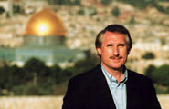
Randall Price is the Founder and President of World of the Bible Ministries, Inc. and is Distinguished Research Professor and Executive Director of the Center for Judaic Studies at Liberty University (Lynchburg, Virginia). He is also Adjunct Professor of Apologetics at Veritas Evangelical Seminary in California. He has taught at the University of Texas (Austin), The International School of Theology, Trinity Southwest University, and Criswell College.
He has done post-graduate work at the Hebrew University in Jerusalem and has served as Director of Excavations on the Qumran Plateau in Israel since 2002. He has written numerous articles and contributed to the New Eerdmans Dictionary of the Bible, Encyclopedia of Apologetics, Popular Encyclopedia of Bible Prophecy (Harvest House), Premillennial Dictionary of Theology, Handbook to the Book of Acts (Kregel), and was co-author of the Zondervan Handbook of Biblical Archaeology. His books include Secrets of the Dead Sea Scrolls, Searching for the Original Bible, The Temple in Bible Prophecy, Jerusalem in Prophecy, The Stones Cry Out, Unholy War, Fast Facts on the Middle East Conflict (Harvest House), Charts on Bible Prophecy (Zondervan), and a commentary on Ezekiel and Daniel in the Popular Bible Prophecy Commentary (Harvest House).

Final Exam Study Questions

Format: The online final exam has various types of questions: multiple-choice, sentence fill-ins, chart completion and analysis, and (probably) essays. You have two hours for it.

Content: The areas addressed may include the following:

The exam covers only the class notes. It will NOT cover class readings from Arnold/Beyer and other readings as these have already been tested on the quizzes.

Make sure you have a grasp of the overall big picture of OT Backgrounds. Being able to walk yourself through the Table of Contents should help.

Be familiar with the basic biblical theology (kingdom view, pp. 57-59) and tenants/timing of the major covenants (Abrahamic, Mosaic, Land, Davidic, New) on the following summary pages:
37-40 Ancient covenants that parallel biblical covenants
40-46 The Abrahamic Covenant and its fulfillment
50 Contrasting the Abrahamic & Mosaic Covenants
51 Nature & relationship of the Abrahamic to other covenants
52 Kingdom & covenants timeline

Know the following for each of the pagan people groups:
Location (see p. 15)
Identity (see p. 17)
Major deity (pp. 160-61)
Period when they were prominent and/or influencing Israel
Significance, especially as they relate to Israel

Know where to put the key ANE geographical locations of pagan peoples (see above), rivers, and bodies of water on pages 15 and 17 on “The Old Testament World” map (p. 16) as well as the location of Israel’s tribes (p. 21). The “Travel in Israel” map (p. 20) will also help you grasp the significance of OT events.

Know the geographical stages of Jerusalem (p. 27) and Israel’s regions (p. 18)

Know the basic dates of chronology: creation, exodus, division and fall of kingdoms, etc. (pp. 60, 66, 70a-b).

Identify the key pagan literature that parallels Scripture (p. 188).

Know how archaeology has influenced and supported the study of Scripture, including basic periods of archaeology (pp. 200-202, 206-208).

Know the nature of pagan deities (p. 162) and some differences between pagan religion and Judaism (p. 185).

Review your quizzes to refresh your memory on key background issues.

Pray that you will retain your learning to help others into a closer walk with God.

The Dead Sea Scrolls
Previously used text
Assignments (30%) of 3-5 pages (double or single-spaced) will be written on all of the topics below. Include your sources both in footnotes and a bibliography (including web sites).
Covenants: Explain the types of pagan and biblical covenants, showing parallels between the Suzerain-vassal treaties and the OT and contrasting the Mesopotamian covenant ritual with biblical examples. Explain God’s covenant with Abraham and your reasons for considering it a bilateral or unilateral agreement. Cite your sources.
Temples: Compare and contrast Solomon’s temple with pagan temples of its day. Explain the purpose(s) of the temple and why this was such an important part of Israel’s worship and way of life. Draw parallels for believers today (e.g., is a church building parallel to the OT temple?). Cite your sources.
Archaeology: Show how biblical archaeology has affected biblical studies in both positive and negative ways. Cite your sources and give specific examples of archaeological finds.

V. Schedule (Reading Report) (First Time to teach it in 2001)

(Please tick the final column if completed in full on time. Note if completed late and/or partially.)

Session Date Subject Assignment 

 | 28 July | Lecturer in USA | No class or assignments
 | 4 Aug | Faculty Prayer Retreat | No class or assignments
1 | 11 Aug | Introduction/Syllabus  Geography  Ancient Near East | No assignments
2 | 11 Aug | Israel Topography | Rasmussen, ????? |  | 29
3 | 18 Aug | Jerusalem Topography | Beitzel, Moody Atlas of Bible Lands, 156-65  Walker, P.W.L. Jerusalem: Past and Present in the Purposes of God, 21-51 |  | 10  31
4 | 18 Aug | Biblical Theology | Beyer, B. E., “The Practice of Covenant Making” in Biblical Illustrator (Fall ’93): 36-39 |  | 4
5 | 25 Aug | Covenants  (Guest lecturer) | Assignment #1: Covenants  Dyrness, William, Themes in OT Theology, 113-26 |  | 14
6 | 25 Aug | Kingdom Theology  (Guest lecturer) | Zuck, Biblical Theology of OT, ix-16 |  | 15
 | 1-8 Sept | Mid-Semester Break | No class or assignments
7 | 15 Sept | Peoples | Merrill, Kingdom of Priests, 25-34 |  | 10
8 | 15 Sept | Sumerians, Canaanites, Amorites & Egyptians | 10 pages from Hoerth, Peoples of the OT World, 19-41 (Sumerians),157-81 (Canaanites/Amorites), 251-89 (Egyptians) |  | 10
9 | 22 Sept | Philistines & Phoenicians | Group Presentation #1: Philistines  10 pages from Hoerth, Peoples of the OT World, 183-206 (Phoenicians), 231-50 (Philistines)  Turnham, T., “Philistia vs. Israel” in Biblical Illustrator (Fall ’94): 3-9 |  | 10  7
10 | 22 Sept | Arameans | Group Presentation #2: Arameans  10 pages from Hoerth, Peoples of the OT World, 207-229  Smith, M.E., “Syria and Israel in the Ninth Century BC” in Biblical Illustrator (Fall ’98): 54-57 |  | 10  4
11 | 29 Sept | Assyrians | Group Presentation #3: Assyrians  10 pages from Hoerth, Peoples of the OT World, 77-105  Hunt, H. “Sixth Century Siege Warfare” in Biblical Illustrator (Fall ’96): 43-45 |  | 10  3
12 | 29 Sept | Babylonians | Group Presentation #4: Babylonians  10 pages from Hoerth, Peoples of the OT World, 43-74 |  | 10
13 | 6 Oct | Persians | Group Presentation #5: Persians  10 pages from Hoerth, Peoples of the OT World, 107-123 |  | 10
14 | 6 Oct | Chronology | Merrill, Eugene, Kingdom of Priests, 66-78 |  | 9
15 | 13 Oct | Socio-Economic  Family Life  Education | Gower, Ralph, The New Manners & Customs of Bible Times, 57-86 |  | 30
16 | 13 Oct | Towns & Villages  Hospitality | Gower, Ralph, The New Manners & Customs of Bible Times, 186-201, 234-49 |  | 16
17 | 20 Oct | Religions  Pagan | Gower, Ralph, The New Manners & Customs of Bible Times, 331-37 |  | 7
18 | 20 Oct |  | Pritchard, James B., ed. The Ancient Near East, 1:1-2, 28-45, 63-75, 226-30 |  | 20
19 | 27 Oct | Jewish | Gower, Ralph, The New Manners & Customs of Bible Times, 354-73 |  | 20
20 | 27 Oct | • Monotheism | Youngblood, The Heart of the OT, 7-15 |  | 8
21 | 1 Nov (Th) | • Sacrifices | Matthews, V. H., Manners and Customs in the Bible, 75-84 |  | 10
22 | 1 Nov (Th) | • Temple | Assignment #2: Temples  Backhouse, Robert. The Kregel Pictorial Guide to the Temple, 1-32 |  | 32
23 | 3 Nov | • Priesthood | Childs, B. S. Old Testament Theology in a Canonical Context, 145-54 |  | 10
24 | 3 Nov | • Calendar | Thompson, J. A. Handbook of Life in Bible Times, 125-45 |  | 21
25 | 8 Nov (Th) | Literature  Pagan | Pritchard, James B., ed. Ancient Near Eastern Texts, 1:138-67, 237-43, 357-58, 260-62; 2:26-28, 42-45, 136-41, 145-48, 160-67 |  | 30
26 | 8 Nov (Th) | Old Testament | Hall, Terry, “How We Got Our OT,” Moody (Jan ’87): 32-34 in OTS, 1:52a-c  Hubbard, Robert L., “The Quest for the Original Bible,” Moody (Sept ’86): 13-17 in OTS, 1:52d-h |  | 3  6
27 | 10 Nov | Archaeology  History & Methods | Assignment #3: Archaeology  Blaiklock, E. M., “Archaeology,” in ZPEB, 1:255-65, 278-85 |  | 19
28 | 10 Nov | Significant Finds | Coogan, Michael D. “10 Great Finds,”  Biblical Archaeology Review 21 (May/June 1995): 36-47 |  | 10
29 | 12-16 Nov | Final Exam | Study and pray

26 | 8 Nov (Th) | Water | Thompson, J. A. Handbook of Life in Bible Times, 111-24  Shaddix, G. H. “The Latter and Former Rains” in Biblical Illustrator (Fall ’98): 54-57  Tatum, L. “Hezekiah’s Water Tunnel” in Biblical Illustrator (Summer ’96): 65-68 |  | 14  4  4

Group 1: Philistines (22 Sept) | Group 3: Assyrians (29 Sept)
Chandra Koewoso | Sim Joo Yee
Dany Christopher | Sun Wai Wai
Budianto Lim
 | Group 4: Babylonians (29 Sept)
Group 2: Arameans (22 Sept) | Michael Yeong
Bobby Lee | Ong Sim Chuan
Joy Ong
Shani Perera | Group 5: Persians (29 Sept)
 | Samuel Joseph Ticoalu
 | Michael Go Ting

Group Project Grade Sheet

Class Date
Topic/Project
Group Members

1 2 3 4 5
Poor Minimal Average Good Excellent
Creativity (25%)

Project idea well conceived
Use of audiovisuals
Communicated in a “fresh” manner
Handouts page layout/scripting attractive
Appropriately illustrated (vs. theoretical)
Creativity Grade _____

Expositional (Teaching) Value (25%)

True to the text of Scripture (interpretation)
Reflects intent of original author (history)
Exposes and solves controversial texts
Exposure to Scripture (quantity)
Applies text to life (relevant exposition)

Expositional Grade _____

Teamwork (25%)

Appeared to involve the whole group
Coordination between parts of the project
Depth (for a group project of 20% of final grade)
Copies of project distributed to class members
Use of time (not too long or too short)

Teamwork Grade _____

Interesting Presentation (25%)

Kept the interest of the class
Provided the right mood for the content
Clear & appropriate introduction
Appropriate conclusion
Overall impression

Interest Grade _____

Final Grade _______

Comments:
Schedule (Reading Report) 2002 without Readings book
Name Box Sem. Grade

(Please tick the box column if completed in full on time. Note if completed late and/or partially.)

Session Date Subject Assignment √ Pp.

1 | 24 July | Introduction/Syllabus  Geography  Ancient Near East | No assignments
2 | 24 July | Israel Topography | No assignments
3 | 31 July | Jerusalem Topography | Beitzel, Moody Atlas of Bible Lands, 156-65  Pipes, Daniel, “If I Forget Thee: Does Jerusalem Really Matter to Islam?” (notes, 228-31) |  | 10  4
4 | 31 July | Biblical Theology | Beyer, B. E., “The Practice of Covenant Making” in Biblical Illustrator (Fall ’93): 36-39 |  | 4
5 | 7 Aug | Prophecy  ─Jeremiah Video | Assignment #1: Prophecy
6 | 7 Aug | ─Jeremiah Video | Farnell, David, “The Gift of Prophecy in the Old and New Testaments,” Bib Sac 149 (Oct-Dec 1992):: 387-410 |  | 24
7 | 14 Aug | Covenants | Dyrness, William, Themes in OT Theology, 113-26 |  | 14
8 | 14 Aug | Kingdom Theology | Zuck, Biblical Theology of OT, ix-16 |  | 15
9 | 21 Aug | Chronology | Group Presentation #1: Chronology  Merrill, Eugene, Kingdom of Priests, 66-78 |  | 9
10 | 21 Aug | Peoples  Introduction | Merrill, Kingdom of Priests, 25-34 |  | 10
11 | 28 Aug | Sumerians, Canaanites, Amorites & Egyptians | 10 pages from Hoerth, Peoples of the OT World, 19-41 (Sumerians),157-81 (Canaanites/Amorites), 251-89 (Egyptians) |  | 10
12 | 28 Aug | Philistines & Phoenicians | 10 pages from Hoerth, 183-206 (Phoenicians), 231-50 (Philistines)  Turnham, T., “Philistia vs. Israel” in Biblical Illustrator (Fall ’94): 3-9 |  | 10  7
 | 3 Sep | Mid-Semester Break | No class or assignments
13 | 11 Sep | Arameans | 10 pages from Hoerth, 207-229  Smith, M.E., “Syria and Israel in the Ninth Century BC” in Biblical Illustrator (Fall ’98): 54-57 |  | 10  4
14 | 11 Sep | Assyrians | 10 pages from Hoerth, 77-105  Hunt, H. “Sixth Century Siege Warfare” in Biblical Illustrator (Fall ’96): 43-45 |  | 10  3
15 | 18 Sep | Babylonians | 10 pages from Hoerth, 43-74 |  | 10
16 | 18 Sep | Persians | 10 pages from Hoerth, 107-123 |  | 10

17 | 25 Sep | Socio-Economic  Family Life  Education | Assignment #2: Women  Gower, Ralph, The New Manners & Customs of Bible Times, 57-86 |  | 30
18 | 25 Sep | Towns & Villages  Hospitality | Group Presentation #2: Education  Gower, 186-201, 234-49 |  | 16
19 | 2 Oct | Religions  Pagan religions, Part 1 | Group Presentation #3: Pagan Religions  Gower, 331-37 |  | 7
20 | 2 Oct | Pagan religions, Part 2 | Pritchard, James B., ed. The Ancient Near East, 1:1-2, 28-45, 63-75, 226-30 |  | 20
21 | 9 Oct | Judaism: | Gower, 354-73 |  | 20
22 | 9 Oct | • Monotheism | Youngblood, The Heart of the OT, 7-15 |  | 8
23 | 16 Oct | • Sacrifices | Thompson, J. A. Handbook of Life in Bible Times, 125-45 |  | 21
24 | 16 Oct | • Temple | Backhouse, Robert. The Student Bible Guide to the Temple, 1-32 |  | 32
25 | 23 Oct | • Priesthood | Assignment #3: Prayer  Childs, B. S. Old Testament Theology in a Canonical Context, 145-54 |  | 10
26 | 23 Oct | • Calendar | Matthews, V. H., Manners and Customs in the Bible, 75-84 |  | 10
27 | 30 Oct | Literature  Pagan | Pritchard, James B., ed. Ancient Near Eastern Texts, 1:138-67, 237-43, 357-58, 260-62; 2:26-28, 42-45, 136-41, 145-48, 160-67 |  | 30
28 | 30 Oct | Old Testament | Group Presentation #4: Canonicity  Hall, Terry, “How We Got Our OT,” Moody (Jan ’87): 32-34 in OTS, 1:52a-c  Hubbard, Robert L., “The Quest for the Original Bible,” Moody (Sept ’86): 13-17 in OTS, 1:52d-h |  | 3  6
29 | 6 Nov | Archaeology  History & Methods | Blaiklock, E. M., “Archaeology,” in Zondervan Pictorial Encyclopedia of the Bible, 1:258-65, 278-85 |  | 19
30 | 6 Nov | Significant Finds | Coogan, Michael D. “10 Great Finds,”  Biblical Archaeology Review 21 (May/June 1995): 36-47 |  | 10
31 | 11-15 Nov | Final Exam | Study and pray

Chronology: Present the basic issues of OT studies that inform us of how scholars determine ancient dates. Include views on Genesis 5 & 11 (whether a strict chronology or genealogical gaps should be employed), the date of the Exodus, and issues related to the judges and kings.

Education: Explain how children learned in ancient days in Israel and the pagan nations. Who taught them? What subjects were included and why?

Pagan Religions: Compare and contrast the major pagan religions of antiquity. How did Philistine, Babylonian, and other peoples worship differ?

Canonicity: With so much Jewish and pagan literature of antiquity, why do we subscribe exclusively to the 39 books of the OT as inspired? What criteria affected whether literature made its way into the OT?
Schedule (Reading Report) 2003 with first time to use Arnold/Beyer (only 6 quizzes as this one was adapted in 2004)
Name Box Sem. Grade

(Please tick the box column if completed in full on time. Note if completed late and/or partially.)

Session | Date | Subject | Assignment | √ | Pp
1 | 20 Aug (Wed 11:10-1:00) | Introduction/Syllabus  Geography  Ancient Near East | No assignments
2 | 20 Aug (Wed 11:10-1:00) | Israel Topography | No assignments
3 | 21 Aug (Th) | Jerusalem Topography | Beitzel, Moody Atlas of Bible Lands, 156-65  Pipes, Daniel, “If I Forget Thee: Does Jerusalem Really Matter to Islam?” in notes, 228-32 |  | 10  4
4 | 21 Aug (Th) | Biblical Theology | Beyer, B. E., “The Practice of Covenant Making” in Biblical Illustrator (Fall ’93): 36-39 in notes, 233-36  Arnold/Beyer, 96-103 (Covenants & Treaties) |  | 12
5 | 27 Aug (Wed 11:10-1:00) | Prophecy | Assignment #1: Prophecy  Arnold/Beyer, 207-26 (Prophecies, Visions, Apocalyptic, Divination, Incantations, Lamentations) |  | 19
6 | 27 Aug (Wed 11:10-1:00) | Kingdom Theology | Zuck, Biblical Theology of OT, ix-16 |  | 15
7 | 28 Aug (Th) | Literature  Pagan | Arnold/Beyer, 13-50, 66-70 |  | 41
8 | 28 Aug (Th) | Old Testament | Quiz #1  Hall, Terry, “How We Got Our OT,” Moody (Jan ’87): 32-34 in notes, 52a-c  Hubbard, Robert L., “The Quest for the Original Bible,” Moody (Sept ’86): 13-17 in notes, 52d-h |  | 3  6
9 | 3 Sep (Wed 11:10-1:00) | Archaeology  History & Methods | Blaiklock, E. M., “Archaeology,” in Zondervan Pictorial Encyclopedia of the Bible, 1:258-65, 278-85 |  | 19
10 | 3 Sep (Wed 11:10-1:00) | Significant Finds | Coogan, Michael D. “10 Great Finds,”  Biblical Archaeology Review 21 (May/June 1995): 36-47 |  | 10
11 | 4 Sep (Th) | Chronology | Merrill, Eugene, Kingdom of Priests, 66-78  Arnold/Beyer, 171-72 (Hebrew Inscriptions) |  | 14  2
12 | 4 Sep (Th) | Peoples  Introduction & Philistines | Quiz #2  Merrill, Kingdom of Priests, 25-34  10 pages from Hoerth, Peoples of the OT World, 231-50 (Philistines)  Turnham, T., “Philistia vs. Israel” in Biblical Illustrator (Fall ’94): 3-9 |  | 10  10  7
 | 10 Sep | Mid-Semester Break | No class or assignments
13 | 17 Sep (Wed 11:10-1:00) | Sumerians | Presentation #1: Sumerians  10 pages from Hoerth, 19-41 (Sumerians)  Arnold/Beyer, 71-73 (Tower of Babel), 104-117 (Law Codes), 150-59 (Lists/Chronicles) |  | 10  27
14 | 17 Sep (Wed 11:10-1:00) | Assyrians | Arnold/Beyer, 137-47 (Royal Records) or 10 pages from Hoerth, 77-105  Hunt, H. “Sixth Century Siege Warfare” in Biblical Illustrator (Fall ’96): 43-45 in notes, 254-56 |  | 10  3
15 | 18 Sep (Th) | Egyptians | Presentation #2: Egyptians  Arnold/Beyer, 62-66 (Creation), 160-62 (Stela), 192-96 (Love Songs) or 10 pages from Hoerth, 251-89 (Egyptians) |  | 10
16 | 18 Sep (Th) | Arameans | Quiz #3  Arnold/Beyer, 163-68 (#53-55 Zakkur Stela, Tel Dan, Amarna Letters) or 10 pages from Hoerth, 207-229  Smith, M.E., “Syria and Israel in the Ninth Century BC” in Biblical Illustrator (Fall ’98): 54-57 in notes, 250-53 |  | 10  4
17 | 24 Sep (Wed 11:10-1:00) | Canaanites/Amorites | Presentation #3: Canaanites/Amorites  Arnold/Beyer, 50-62 (Baal Cycle) or 10 pages from Hoerth, 157-81 (Canaanites/Amorites) |  | 10
18 | 24 Sep (Wed 11:10-1:00) | Babylonians | Arnold/Beyer, 155-59 (Chronicles), 168-70 (Ostraca), 197-204 (Hymns/Prayers) or 10 pages from Hoerth, 43-74 |  | 10
19 | 25 Sep (Th) | Phoenicians | Presentation #4: Phoenicians  Arnold/Beyer, 162-63 ($52 Karatepe Inscr.)  10 pages from Hoerth, 183-206 (Phoenicians) |  | 2  10
20 | 25 Sep (Th) | Persians | Quiz #4  Arnold/Beyer, 147-49  10 pages from Hoerth, 107-123 |  | 3  10
21 | 2 Oct (Th) | Socio-Economic  Family Life  Education | Assignment #2: Women  Gower, Ralph, The New Manners & Customs of Bible Times, 57-86 |  | 30
22 | 2 Oct (Th) | Towns & Villages  Hospitality | Gower, 186-201, 234-49 |  | 16
23 | 9 Oct (Th) | Religions  Pagan religions, Part 1 | Gower, 331-37  Arnold/Beyer, 175-91 (Wisdom Lit.) |  | 7  17
24 | 9 Oct (Th) | Pagan religions, Part 2 | Quiz #5  Arnold/Beyer, 118-33 (Cultic Texts) |  | 16
 | 16 Oct | Day of Prayer | No class or assignments
25 | 23 Oct (Th) | Judaism: | Gower, 354-73 |  | 20
26 | 23 Oct (Th) | • Monotheism | Youngblood, The Heart of the OT, 7-15 in notes, 281-85 |  | 8
27 | 30 Oct (Th) | • Sacrifices | Matthews, V. H., Manners and Customs in the Bible, 75-84 in notes, 297-302 |  | 10
28 | 30 Oct (Th) | • Temple | Quiz #6  Backhouse, Robert. The Student Bible Guide to the Temple, 1-32 |  | 32
29 | 6 Nov (Th) | • Priesthood | Assignment #3: Prayer  Childs, B. S. Old Testament Theology in a Canonical Context, 145-54 in notes, 303-7 |  | 10
30 | 6 Nov (Th) | • Feasts | Quiz #7  Thompson, J. A. Handbook of Life in Bible Times, 125-45 in notes, 286-96 |  | 21
31 | 11-14 Nov | Final Exam | Study and pray

Schedule (Reading Report)
Name Box Sem. Grade

(Please tick the box column if completed in full on time. Note if completed late and/or partially.)

Session | Date | Subject | Assignment | √ | Pp
1 | 28 July | Intro & Syllabus  Geography  Ancient Near East | No assignments
2 | 28 July | Israel Topography | No assignments
3 | 4 Aug | Jerusalem Topography | Beitzel, Moody Atlas of Bible Lands, 156-65  Pipes, Daniel, “If I Forget Thee: Does Jerusalem Really Matter to Islam?” in notes, 228-32 |  | 10  4
4 | 4 Aug | Biblical Theology | Beyer, B. E., “The Practice of Covenant Making” in Biblical Illustrator (Fall ’93): 36-39 in notes, 233-36  Arnold/Beyer, 96-103 (Covenants & Treaties) |  | 4  8
5 | 11 Aug | Prophecy | Assignment #1: Prophecy  Arnold/Beyer, 207-26 (Prophecies, Visions, Apocalyptic, Divination, Incantations, Lamentations) |  | 19
6 | 11 Aug | Kingdom Theology | Zuck, Biblical Theology of OT, ix-16 |  | 15
7 | 18 Aug | Literature  Pagan | Arnold/Beyer, 13-50, 66-70 (Creation & the Flood) |  | 41
8 | 18 Aug | Old Testament | Quiz #1  Hall, Terry, “How We Got Our OT,” Moody (Jan ’87): 32-34 in notes, 195d-f  Hubbard, Robert L., “The Quest for the Original Bible,” Moody (Sept ’86): 13-17 in notes, 195h-i |  | 3  6
9 | 25 Aug | Archaeology  History & Methods | Assignment #2: Creation  Blaiklock, E. M., “Archaeology,” in Zondervan Pictorial Encyclopedia of the Bible, 1:258-65, 278-85 |  | 19
10 | 25 Aug | Significant Finds  Dead Sea Scrolls | Coogan, Michael D. “10 Great Finds,”  Biblical Archaeology Review 21 (May/June 1995): 36-47 in notes, 216-27 |  | 10
11 | 1 Sept | Chronology | Merrill, Eugene, Kingdom of Priests, 66-78  Arnold/Beyer, 171-72 (Hebrew Inscriptions) |  | 14  2
12 | 1 Sept | Peoples  Introduction & Sumerians | Quiz #2  Merrill, Kingdom of Priests, 25-34  10 pages from Hoerth, 19-41 (Sumerians)  Arnold/Beyer, 71-73 (Tower of Babel), 104-117 (Laws), 150-59 (Lists/Chronicles) |  | 10  10  27
 | 8 Sep | Mid-Semester Break | No class or assignments

13 | 15 Sept | Edomites | Presentation #1: Edomites  10 pages from Hoerth, 335-47 (Edomites) |  | 10
14 | 15 Sept | Assyrians | Arnold/Beyer, 137-47 (Royal Records) or 10 pages from Hoerth, 77-105  Hunt, H. “Sixth Century Siege Warfare” in Biblical Illustrator (Fall ’96): 43-45 in notes, 254-56 |  | 10  3
15 | 22 Sept | Egyptians | Quiz #3  Arnold/Beyer, 62-66 (Creation), 192-96 (Love Songs) or 10 pages from Hoerth, 251-89 (Egyptians) |  | 10
16 | 22 Sept | Moabites | Presentation #2: Moabites  Arnold/Beyer, 160-62 (Stela)  10 pages from Hoerth, 317-33 (Moabites) |  | 3  10
17 | 29 Sept | Ammonites | Presentation #3: Ammonites  Arnold/Beyer, 50-62 (Baal Cycle) or 10 pp. from Hoerth, 293-315 (Ammonites) |  | 10
18 | 29 Sept | Babylonians | Arnold/Beyer, 155-59 (Chronicles), 168-70 (Ostraca), 197-204 (Hymns/Prayers) or 10 pages from Hoerth, 43-74 |  | 10
19 | 6 Oct | Arabs | Presentation #4: Arabs No readings ☺
20 | 6 Oct | Persians | Quiz #4  Arnold/Beyer, 147-49  10 pages from Hoerth, 107-123 |  | 3  10
21 | 13 Oct | Socio-Economic  Family Life  Education | Assignment #2: Women  Gower, Ralph, The New Manners & Customs of Bible Times, 57-86 |  | 30
22 | 13 Oct | Towns & Villages  Hospitality | Presentation #5: Rural Life  Gower, 186-201, 234-49 |  | 16
23 | 20 Oct | Religions  Paganism | Gower, 331-37  Arnold/Beyer, 118-33 (Cultic Texts), 175-91 (Wisdom Lit.) |  | 7  32
24 | 20 Oct | Judaism:  • Monotheism | Quiz #5  Youngblood, The Heart of the OT, 7-15 in notes, 281-85 |  | 8
25 | 27 Oct | • Sacrifices | Matthews, V. H., Manners and Customs in the Bible, 75-84 in notes, 297-302 |  | 10
26 | 27 Oct | • Temple | Quiz #6  Backhouse, Robert. The Student Bible Guide to the Temple, 1-32 |  | 32
27 | 3 Nov | • Feasts | Presentation #6: Calendar  Gower, 354-73  Thompson, J. A. Handbook of Life in Bible Times, 125-45 in notes, 286-96 |  | 20  21
28 | 3 Nov | • Priesthood | Quiz #7  Childs, B. S. OT Theology in a Canonical Context, 145-54 in notes, 303-7 |  | 10
29 | 10 Nov | Final Exam | Study and pray

GROUPS FOR 2004  1-Edomites |  | 4-Arabs
Zajamo Odyuo | M-MDiv-Nagaland | Lim Chung Wei | M-GDCS-Singapore
Chan Suet Fong | F-MAPC-Singapore | Lion Soegiharto | M-MDiv-Indonesia
Chia Choon Yee | F-GDCS-Singapore | Loke Puay Yin | F-MDiv-Singapore
Fung Ho Wang | M-GDCS-Singapore | Low Pek Soon, Edwin | M-GDCS-Singapore
Razovelhu Vasa | M-MDiv-Nagaland | Tam, Angelina | F-MAIS-Singapore
2-Moabites |  | 5-Rural Life
Goh Chay Giam, Eugene | F-MABS-Singapore | Goh-Chew, Angie | F-MAPC-Singapore
Chong Wong Mui | M-GDCS-Singapore | Cheam Heng Wee | M-GDCS-Singapore
Han Lee Yen, Jemaine | F-MABS-Singapore | Ng Wee Hua | M-GDCS-Singapore
Hans Gouw | M-GDCS-Netherlands | Quong, Alex | M-MDiv-Singapore
Ip Kwok Chung, Leslie | M-GDCS-Hong Kong | Tan Mia Huan | F-GDCS-Singapore
3-Ammonites |  | 6-Calendar
Kwan Chun Wah | M-GDCS-Hong Kong | Pang, Timothy | M-MDiv-Singapore
Ong Pang Tian, James | M-MABS-Singapore | Tang Teng Foong | M-GDCS-Singapore
Lau Geoffrey | M-GDCS-Singapore | Thomas R Thomin | M-MDiv-USA
Lee May Sze, Astrid | F-GDCS-Singapore | Yeo Pin Pin | F-MDiv-Singapore
Dennis Oh | M-MABS-Canada | Leny Salim | F-GDCS-Indonesia
The Bible… Basically |  | The Bible… Basically
Badamdorj J | M-MDiv-Mongolia | Jun Ji Chun | M-MDiv -Korea
Suresh Appathurai | M- MDiv-Sri Lanka | Lee Sung Hun | M- MDiv-Korea
No Pum | M-MDiv-Myanmar | Prasad Thomas | M-MAPC-India

Removed in 2005 Schedule:

13 | 14 Sept | Edomites | Presentation #1: Edomites  10 pages from Hoerth, 335-47 (Edomites) |  | 10
16 | 21Sept | Moabites | Presentation #2: Moabites  Arnold/Beyer, 160-62 (Stela)  10 pages from Hoerth, 317-33 (Moabites) |  | 3  10
17 | 28 Sept | Ammonites | Presentation #3: Ammonites  Arnold/Beyer, 50-62 (Baal Cycle) or 10 pp. from Hoerth, 293-315 (Ammonites) |  | 10

Schedule (Reading Report)
Name Box Sem. Grade

(Please tick the box column if completed in full on time. Note if completed late and/or partially.)

Session | Date | Subject | Assignment | √ | Pp
1 | 27 July | Intro & Syllabus  Geography  Ancient Near East | No assignments
2 | 27 July | Israel Topography | No assignments
3 | 3 Aug | Jerusalem Topography | Beitzel, Moody Atlas of Bible Lands, 156-65 in notes, 308-317  Pipes, “If I Forget Thee: Does Jerusalem Really Matter to Islam?” in notes, 228-32 |  | 10  4
4 | 3 Aug | Biblical Theology | Beyer, B. E., “The Practice of Covenant Making” in Biblical Illustrator (Fall ’93): 36-39 in notes, 233-36  Arnold/Beyer, 96-103 (Covenants & Treaties) |  | 4  8
5 | 10 Aug | Literature  Pagan | Arnold/Beyer, 13-50, 66-70 (Creation/Flood) |  | 41
6 | 10 Aug | Old Testament Canon | Hall, “How We Got Our OT,” Moody (Jan ’87): 32-34 in notes, 195d-f  Hubbard, “The Quest for the Original Bible,” Moody (Sept ’86): 13-17 in notes, 195h-i  Quiz #1 |  | 3  6
7 | 17 Aug | Prophecy | Assignment #1: Prophecy  Arnold/Beyer, 207-26 (Prophecies, Visions, Apocalyptic, Divination, Incantations, Lamentations) |  | 19
8 | 17 Aug | Kingdom Theology | Merrill, “Theology of Pentateuch” in Zuck, Bib. Theol. of OT, ix-16 in notes, 318-28 |  | 15
9 | 24 Aug | Archaeology  History & Methods | Assignment #2: Creation  Blaiklock, E. M., “Archaeology,” in Zondervan Pictorial Encyclopedia of the Bible, 1:258-65, 278-85 in notes, 329-36 |  | 19
10 | 24 Aug | Significant Finds  Dead Sea Scrolls | Coogan, Michael D. “10 Great Finds,”  Biblical Archaeology Review 21 (May/June 1995): 36-47 in notes, 216-27 |  | 10
11 | 31 Aug | Chronology | Merrill, Kingdom of Priests (KOP), 66-78 in notes, 337-343  Arnold/Beyer, 171-72 (Hebrew Inscriptions) |  | 14  2
12 | 31 Aug | Peoples  Introduction & Sumerians | Merrill, KOP, 25-34 in notes, 344-49  10 pages from Hoerth, 19-41 (Sumerians) in notes, 350-61  Arnold/Beyer, 71-73 (Tower of Babel), 104-117 (Laws), 150-59 (Lists/Chronicles)  Quiz #2 |  | 10  10  27
 | 7 Sep | Mid-Semester Break | No class or assignments

13 | 14 Sept | Assyrians | Arnold/Beyer, 137-47 (Royal Records)  Hunt, H. “Sixth Century Siege Warfare” in Biblical Illustrator (Fall ’96): 43-45 in notes, 254-56 |  | 10  3
14 | 14 Sept | Egyptians | Arnold/Beyer, 62-66 (Creation), 192-96 (Love Songs)  Quiz #3 |  | 10
15 | 21 Sept | Babylonians | Arnold/Beyer, 155-59 (Chronicles), 168-70 (Ostraca), 197-204 (Hymns/Prayers) |  | 10
16 | 21Sept | Phoenicians & Philistines | Turnham, T., “Philistia vs. Israel” in Biblical Illustrator (Fall ’94): 3-9 in notes, 245-49 |  | 7
17 | 28 Sept | Persians | Arnold/Beyer, 147-49 (Cyrus Cylinder)  Hoerth, 107-123 (Persians) in notes, 362-70 |  | 3  17
18 | 28 Sept | Arabs | Quiz #4; No readings ☺
19 | 5 Oct | Socio-Economic  • Family Life  • Education | Assignment #3: Women  Gower, Ralph, The New Manners & Customs of Bible Times, 57-86 in notes, 371-80 |  | 30
20 | 5 Oct | • Slavery  • Towns & Villages | Presentation #1: Slavery  Gower, 186-201, 234-49 in notes, 381-402 |  | 16
21 | 12 Oct | Religions  Pagan Worship | Presentation #2: Worship  Gower, 331-37 in notes, 257-60  Arnold/Beyer, 118-33 (Cultic Texts), 175-91 (Wisdom Lit.) |  | 7  32
22 | 12 Oct | Judaism:  • Monotheism | Quiz #5; Youngblood, The Heart of the OT, 7-15 in notes, 281-85 |  | 8
23 | 19 Oct | • Salvation | Presentation #3: Salvation  John S. Feinberg, “Salvation in the OT,” in Tradition & Testament, eds. John & Paul Feinberg (Chicago: Moody, 1981): 39-77 in notes, 427-446 |  | 38
24 | 19 Oct | • Feasts | Gower, 354-73 in notes, 403-12  Thompson, J. A. Handbook of Life in Bible Times, 125-45 in notes, 286-96 |  | 20  21
25 | 26 Oct | • Sacrifices | Matthews, V. H., Manners and Customs in the Bible, 75-84 in notes, 297-302 |  | 10
26 | 26 Oct | • Temple  (reading not in notes) | Backhouse, Robert. The Student Bible Guide to the Temple, 1-32  Quiz #6 |  | 32
27 | 2 Nov | • Prayer  (reading not in notes) | Presentation #4: Priesthood  http://www.fordham.edu/halsall/ancient/1600babylonianprayers.html in notes, 447-50 |  | 15
28 | 2 Nov | • Priesthood | Childs, B. S. OT Theology in a Canonical Context, 145-54 in notes, 303-7  Quiz #7 |  | 10
29 | 9 Nov | Final Exam | Study and pray

2005 Groups

1-Slavery |  | 2-Worship
Goa Kong Yong | GDCS | Tan Gek Woo | GDCS
Chua Hock Chuan, Jeffrey | GDCS | Ng Chee Chin, David | GDCS
Lim Teng Lye, Mark | GDCS | Lee Wan Yee | GDCS
Tan Kim Tian | GDCS | Lee Sue Yeong, Abel | MDivPM
 |  | Henry Sujaya Lie | GDCS
3-Salvation |  | The Bible… Basically
Jose Philip | MDivBS | Hwang Jae Myeong | MDivBS (Korean)
Akshay Rajkumar | MDivBS | Jebaseeli Roselind | MABS (Tamil)
Wong Hin Sim, John | MDivBS | Kiran Kumar Pariyar | MABS (Nepalese)
Yiu Yee Ting, Wendy | MDivPM | Thanit Lokeskrawee | MDivBS (Thai)
4-Priesthood |  | Withdrawn from Course | Or Audit
Wong Shin Hoe | MDivBS | Lee Weng Wai, Vincent | GDCS
Lim Lay Kwan | MDivBS | Liew Vern Syn, Kenneth | GDCS
Grace Eu Soo Hwa | GDCS | Lim Cheng Geok | GDCS
Koh Hong Joo, Melvin | MDivPM | Hung Mein Kwang, Jason | GDCS Audit

Bryan Beyer, "The Practice of Covenant Making" Biblical Illustrator [Fall 1993]: 36.
William Dyrness, Themes in Old Testament Theology (Downers Grove, IL: IVP, 1979), 113.
Helpful articles on ancient parallels to biblical covenants include D. J. McCarthy, "Covenant in the Old Testament," Catholic Biblical Quarterly 27 (1965): 237-38; G. M. Tucker, "Covenant Forms and Contract Forms," Vetus Testamentum 15 (1965): 487.
David Roper, New Covenant in the Old Testament (Waco, TX: Word, 1976), 10-12.
Christopher Wright, Knowing Jesus through the Old Testament (London: Marshall Pickering, 1992), 77-80.
Beyer, 36.
Beyer, 38.
One of the first modern scholars to see the suzerain parallels to Deuteronomy was G. E. Mendenhall, "Covenant Forms in Israelite Tradition," Biblical Archaeologist 17 (1956): 50-76. See also Jack Deere, "Deuteronomy" in The Bible Knowledge Commentary, eds. John F. Walvoord and Roy B. Zuck, 1:260; William Sanford LaSor, David Allen Hubbard, and Frederic William Bush, Old Testament Survey: The Message, Form, and Background of the Old Testament (Grand Rapids: Eerdmans, 1982), 144-146, 176. For a recent study showing how Nahum convinced Josiah to rebel against the Assyrian king Esarhaddon's suzerain-vassal treaty with Judah, see Gordon H. Johnston, "Nahum's Rhetorical Allusions to Neo-Assyrian Treaty Curses," Bibliotheca Sacra 158 (October-December 2001): 415-36.
Moses told the Levites, "Take this Book of the Law and place it beside the Ark of the Covenant of the LORD your God. There it will remain as a witness against you" (Deut. 31:24; cf. Exod. 25:16). Others see an earlier "depositing of treaty" in that the Law was recorded on two tablets, similar to the Hittite custom of making two copies of the treaty so that each party could have a copy. See Ronald Youngblood, The Heart of the Old Testament (Grand Rapids: Baker, 1971), 50.
M. Weinfeld, "The Covenant of Grant in the Old Testament and in the Ancient Near East," Journal of the American Oriental Society 90.2 (1970): 184-203.
A. E. Hill, "The Ebal Ceremony as Hebrew Land Grant," Journal of the Evangelical Theological Society 31 (1988): 402.
See Bruce K. Waltke, “The Phenomenon of Conditionality within Unconditional Covenants,” in Israel’s Apostasy and Restoration, ed. Avraham Gileadi (Grand Rapids: Baker, 1988), 123-39; cf. Ronald Youngblood, ed., The Living and Active Word of God.
J. Dwight Pentecost, Thy Kingdom Come (Wheaton: SP Pub., 1990), 52-54, 59-62.
Paul Benware, Understanding End Times Prophecy, 2d ed. (Chicago: Moody, 1995, 2006), 59.
cf. OTS, 31-33.
Bill Cooper, After the Flood (Chichester, England: New Wine Press, 1995), 36-39, 121-29.
The plus (+) means 5:32 says Noah's three sons were born after he was 500 years old but does not specify the time of Ham and Japheth's births. Since Methuselah was born in 687 AH (see 5:21 above) and lived 969 years (5:27), the 687 + 969 = 1656 AH (Scripture does not record Methuselah as having survived the Flood, so he must have died in the Flood or earlier). Since Shem was 98 years old at the Flood (Gen. 11:10), this Flood date of 1656 AH minus 98 years gives 1558 AH as the probable date of Shem's birth as the oldest son. However, it must be admitted that this chronology assumes that Shem was the oldest brother, whereas Genesis 10:21 may indicate either Shem or Japheth as the eldest.
The text does not tell the time of the births of Abram, Nahor and Haran. However, Haran had a son (Lot) even before Abram and Nahor were married (11:27-28), so he was the oldest son and was born when Terah was 70 years old.
Obviously, this Nahor is a different Nahor than his grandfather by the same name.
Since Nahor was the middle son he must have been born between Haran (1948 AH) and Abram (2008 AH).
Abram was 75 years old when he set out from Haran (2083 AH or 2060 BC; 12:4), which was immediately after Terah's death (Gen. 11:32; Acts 7:4), probably in the same year. Therefore, his birth 75 years earlier would have been 2008 AH or 2135 BC (2083 - 75 = 2008, or 2060 + 75 = 2135).
The logic for Jacob's age of 77 when he fled to Laban at Paddam Aram is such: "Joseph stood before Pharaoh, aged 30 (41:46). At the end of 7 years' of plenty Joseph was 37 (41:29-30). At the end of 2 years' famine, when Jacob came down into Egypt, Joseph was 39 (45:6). At the end of 2 years' famine, when Jacob came down into Egypt, Jacob was 130 (47:9). Therefore Jacob was 130 when Joseph was 39. Therefore Jacob was 91 when Joseph was born. Jacob had served Laban 14 years when Joseph was born (29:30; 30:25-26). Therefore Jacob was 91 - 14 = 77 when he left home for Paddan Aram" (Martin Anstey, The Romance of Bible Chronology: An Exposition of the Meaning, and a Demonstration of the Truth, of Every Chronological Statement Contained in the Hebrew Text of the Old Testament, 2 vols. [London, Edinburgh, and New York: Marshall Bros., 1913], 1:115); cited by Hoehner, 2).
Harold W. Hoehner, "The Duration of the Egyptian Bondage," Bibliotheca Sacra 126 (October-December 1969): 306-16). Note that many evangelical OT scholars believe that Jacob's family entered Egypt in 1875 BC (see these notes, 96, 108) since this is 430 years before the Exodus in 1445. In contrast, Hoehner's chronology followed here follows the LXX and Samaritan Pentateuch reading of Exodus 12:40 which cites the 430 years as applying to the time the Israelites lived in "Egypt and Canaan." This is preferred since they were not called Israelites until Jacob's name was changed to Israel in 1875. "The commencement of their sojourning would have been the last confirmation of the Abrahamic covenant as given in Genesis 35:9-15, if one notices that from Genesis 35 onwards the children of Israel never remained in one place in Canaan but were always traveling (cf. Gen 35:16,21,27; in 37:1 they dwelt in the land of Canaan with no specific location mentioned)… Therefore, it seems that if one will take the 430 years as the period from the last recorded confirmation of the Abrahamic covenant to Israel (Jacob) before going into Egypt (Gen 35:9-15) until the time of the Exodus, the 400 years would be that period of time when the nation Israel was in Egypt, that is, from the time when Jacob and his family entered Egypt (Gen 46) until the Exodus. The phrase 'about 450 years' (Acts 13:19-20) would consist of the 400 years of bondage plus the 40 years of wilderness wanderings plus the 7 years for conquering the land of Palestine which makes a total of 447 years or ‘about 450 years’" (ibid., 315, 316).
This 1845 BC date is actually the starting point of the BC dates on these pages. The year 1845 BC has been determined as the year Jacob entered Egypt (400 years before the early date for the Exodus in 1445 BC). The dates between Abram’s birth and 1845 BC are adapted from Harold W. Hoehner, "From the Birth of Abram to the Death of Joseph" (class handout in Th.D. course "Bible Chronology," Dallas Theological Seminary, June 1988, 3 pp.).
Walter Bodine, class handout in the course "Old Testament Introduction," Dallas Seminary, 1986.
See the popular book by Samuel N. Kramer, History Begins at Sumer: Thirty-Nine Firsts in Man's Recorded History, 3rd ed. (Philadelphia: Univ. of Pennsylvania Press, 1981).
Walter R. Bodine, "Sumerians" in Peoples of the Old Testament World, eds. Alfred J. Hoerth, Gerald L. Mattingly, and Edwin M. Yamauchi (Grand Rapids: Baker, 1994), 20. Most of the information in this section is from Dr. Bodine's article.
James K. Hoffmeier, "Egyptians" in Peoples of the Old Testament World, 253.
See "Chart of Ancient Near Eastern History," OTB notes, 73.
Charlotte Evans, gen. ed., Illustrated History of the World (New York, NY: Kingfisher, 1993), 29.
Keith N. Schoville, "Canaanites and Amorites," in Peoples of the Old Testament World, 157. Much of the material above is taken from this article.
William F. Albright, Yahweh and the Gods of Canaan, 110-11 argues for a migration nearly a thousand years earlier than I have noted, probably arriving just before 3000 BC.
Schoville, 167.
Paul N. Benware, Survey of the Old Testament (Chicago: Moody, 1993), 273. Although the NIV/NLT reads “Phoenicia” in Isaiah 23:11, the Hebrew reads “Canaan” here (cf. NAS, NAU). However, the reference is certainly Phoenicia.
Schoville, 179, disagrees by attributing this sacrifice to the Phoenicians: "Though there is little evidence in Syria-Palestine of child sacrifice among the Canaanites, ample evidence of the practice exists among their descendants, the Phoenicians, at Carthage in North Africa and at other colonies scattered around the Mediterranean basin." After the fall of Samaria, pagan peoples imported into the northern kingdom practiced child sacrifice (2 Kings 17:31).
Merrill F. Unger, Archeology and the Old Testament (Grand Rapids: Zondervan, 1960), 175; cited by Benware, 276.
Schoville, 180.
Randall W. Younker, “Ammonites, " in Peoples of the Old Testament World, eds. Alfred J. Hoerth, Gerald L. Mattingly, and Edwin M. Yamauchi (Grand Rapids: Baker, 1994), 295.
Ibid., 296-97.
Gerald L. Mattingly, “Moabites," in Peoples of the Old Testament World, eds. Alfred J. Hoerth, Gerald L. Mattingly, and Edwin M. Yamauchi (Grand Rapids: Baker, 1994), 318-19.
Ibid., 330.
Kenneth G. Hoglund, "Edomites," in Peoples of the Old Testament World, eds. Alfred J. Hoerth, Gerald L. Mattingly, and Edwin M. Yamauchi (Grand Rapids: Baker, 1994), 345.
Ibid.
Much of the material in this section is adapted from the 2001 OT Backgrounds class presentation by Budianto Lim, Chandra Koewoso, and Dany Christopher.
Frederick W. Bush, “Caphtor,” ISBE, 1:610-11; Richard S. Hess, “Caphtor,” in ABD 1:869-70; Gary A. Rendsburg, “Genesis 10:13-14: An Authentic Hebrew Tradition Concerning the Origin of the Philistines,” Journal of Northwest Semitic Languages 13 (1987): 90, n. 3.
Kenneth A. Kitchen, “The Philistines,” in People of the Old Testament Times, ed. Donald J. Wiseman (Oxford: Clarendon, 1973), 56, n.15
Richard D. Barnett, “The Sea People,” in CAH 2/2:360-69; Nancy K. Sandars, The Sea Peoples (London: Thames & Hudson, 1978), 105-15, 198-201.
M. Dothan, “First Season Excavations at Ashdod, 1962,” Israel Exploration Journal 12 (1962), 147-48 and D. N. Freedman, “The Second Season at Ancient Ashdod,” Biblical Archeologist 26 (1963), 134-39
Ibid., 84-85
Ibid., 109
Ibid., 137
Edward E. Hindson, “The Philistines and the Old Testament” (Grand Rapids: Baker, 1983), 58
W. F. Albright, “The Chronology of a South Palestinian City,” American Journal of Semitic Languages and Literature 40 (1938), 21-37.
See Yeivin’s articles in Israel Exploration Journal 6 (1956), 258-59; 7 (1957), 264-65; 10 (1960); 122-23.
T.C. Mitchell, “Gath” in NBD, p.454
The reports of J. Naveh, IEJ, 8 (1958), 87-100, 165-170 and Y. Aharoni, PEQ 90 (1958), 27-31.
T.C. Mitchell, “Ekron”, NBD, 355.
Naveh, IEJ, 87f.
Aharoni, Y. “Forerunners of the Limes: Iron Age Fortresses in the Negev,” Israel Exploration Journal, 1-17.
H. A. Hoffner, Jr., “Phoenicia,” Zondervan Pictorial Encyclopedia of the Bible, 5 vols., ed. Merrill C. Tenney (Grand Rapids: Zondervan, 1975, 1976), 4:778.
Ibid.
This section is indebted to the class presentation on the Arameans in OT Backgrounds, 2001, by Joy Sim, Shani Perera,, and Bobby Lee.
“Elisha,” in New Bible Dictionary.
“Writing,” in New Bible Dictionary.
This point is adapted from the previously noted class presentation by Sim, Perera, and Lee, p. 12.
Much of the material on Assyrians is adapted from the 2001 OT Backgrounds class presentation by Sim Joo Yee and Sun Wai Wai.
“Assyria,” in New Bible Dictionary.
This section is indebted to Ong Sim Chuan, Rick Toh, and Michael Yeong, paper on “The Chaldean (Neo-Babylonian) Empire, OT Backgrounds Class Presentation (SBC: 2001).
Ralph Woodrow, Babylon Mystery Religion (Ralph Woodrow, P.O. Box 124, Riverside, CA 92502: Ralph Woodrow Evangelistic Association, 1966, 1981). Interestingly, much of Woodrow’s research comes straight from the Catholic Encyclopedia (New York: Robert Appleton, 1911). See also Alexander Hislop, The Two Babylons (New York: Loizeaux Brothers, 1853, reprinted 1959).
See Rick Griffith, “The Identity of Mystery Babylon,” in the notes for New Testament Survey, 366-378.
This section used as a major source Michael Ting and Samuel Ticoalu, “Persia,” a paper submitted for OT Backgrounds (SBC, 2001).
Ibid., 2.
Ibid.
“Persia,” Fausset's Bible Dictionary (Electronic Database: Biblesoft, 1998).
Ibid., 4.
“Persia,” New Bible Dictionary (electronic edition, italics mine).
Ibid.
Gower, 57-75.
Gower, 76-86.
Gower, 186-201, 234-40.
Gower, 241-49.
Eugene H. Merrill, Kingdom of Priests (Grand Rapids: Baker, 1987), 26.
Joseph's sons were accepted despite being sons of a pagan priest's daughter (Gen. 41:50; 48:5-6) but still Egyptian religion had little affect on Israel's worship.
Bill Cooper, After the Flood (Chichester, England: New Wine Press, 1995), 18.
Lao-Tzu, Tao-te-ching. Trans. Derek Bryce (Lampeter, UK: Llanerch Pub., 1991), 13; cited by Cooper, 16.
Hesiod. Theogony, tr. Norman Brown (New York: Bobbs-Merrill, 1953), 15; cited by Cooper, 19.
Jonathan Barnes, Early Greek Philosophy (Harmondsworth, England: Penguin Classics, 1987), 95-97; cited by Cooper, 19.
Plato, Timaeus and Criteas, tr. Desmond Lee (Harmondsworth, England: Penguin Classics, 1965), 42; cited by Cooper, 20.
William S. LaSor, "Religions of the Biblical World," International Standard Bible Encyclopedia (Grand Rapids: Eerdmans, 1988), 4:79.
Barnes, 61 and 68 respectively.
Ibid, 73.
H. A. Hoffner, Jr., "Religions of the Biblical World: Asia Minor," International Standard Bible Encyclopedia (Grand Rapids: Eerdmans, 1988), 4:85.
Ralph Gower, The New Manners and Customs of Bible Times (Chicago: Moody, 987), 332.
M. J. A. Hornsnell, "Religions of the Biblical World: Assyria and Babylonia," International Standard Bible Encyclopedia (Grand Rapids: Eerdmans, 1988), 4:94.
R. A. Tomlinson, "Ancient Near Eastern and Mediterranean Temples," The Encyclopedia of Religion, ed. Mircea Eliade (New York: Macmillan, 1987), 383; cited in a research paper by Michael Lim, 2001.
Tomlinson, 383.
William Ward, "Temples and Sanctuaries: Egypt," The Anchor Bible Dictionary (New York: Doubleday, 1992), 6:371, notes that from Solomon's temple that food and clothing were distributed to temple personnel, poor families, widows, and orphans.
Not only was the Jewish temple the worship center but also the art gallery, concert plaza and poetry library of Hebrew culture (Leland Ryken, et. al., "Temple," Dictionary of Biblical Imagery (Downers Grove: IVP, 1998). Similarly, Egyptian temples were centers of formal education in astronomy and medicine (Ward, 6:371).
Gower, 333.
Robert Backhouse, The Student Bible Guide to the Temple (London: Candle, 1996), 7.
Peter C. Craigie, and G. H. Wilson, "Religions of the Biblical World: Canaanite," International Standard Bible Encyclopedia (Grand Rapids: Eerdmans, 1988), 4:101; Keith N. Schoville, "Canaanites and Amorites," in Peoples of the Old Testament World, eds. Alfred J. Hoerth, Gerald L. Mattingly, and Edwin M. Yamauchi (Grand Rapids: Baker, 1994), 174; Bill T. Arnold, "Babylonians," in Peoples of the Old Testament World, 73; Jack Finegan, Myth and Mystery: An Introduction to the Pagan Religions of the Biblical World (Grand Rapids: Baker, 1989), 125; cf. OTS, 228.
Finegan, 126.
Alfred J. Hoerth, Archaeology and the Old Testament (Grand Rapids: Baker, 1998), 281.
R. J. McKelvey, "Temple," New Bible Dictionary, 2d ed. (Leicester: IVP, 1982), 1169; J. E. Jennings, "Temples," The Zondervan Pictorial Encyclopedia of the Bible, ed. Merrill C. Tenney (Grand Rapids: Zondervan, 1976), 5:662.
Jennings, "Temples," 5:662.
Ward, "Temples and Sanctuaries: Egypt," 6:369; Jennings, "Temples," 5:657.
Jeroboam I feared that if his people in the northern kingdom traveled to Jerusalem for temple worship, they would be loyal or united with the south. His prohibition from this travel underscores the temple's unifying influence (S. Westerholm, "Temple," The New International Standard Bible Encyclopedia (Grand Rapids: Eerdmans, 1988), 4:764.
See the study a few pages later in these notes on "Sacrifices at the High Places."
Finegan, 126.
W. E. Bailey, Daily Life in Bible Times (New York: Charles Scribner & Sons, 1943), 170-75.
Ward, "Temples and Sanctuaries: Egypt," 6:370; John Robertson, "Temples and Sanctuaries: Mesopotamia," The Anchor Bible Dictionary (New York: Doubleday, 1992), 6:375.
Tomlinson, 384.
Robertson, "Temples and Sanctuaries: Mesopotamia," 6:355.
Ralph Gower, The New Manners and Customs of Bible Times (Chicago: Moody, 1987), 335.
Even Christ's body is likened to the curtain of the temple going into the Holy of Holies (Heb. 10:19-20). As the high priest needed to pass this curtain to enter into God's presence, so believers today must come into God's presence through faith in the bodily, sacrificial death of Jesus.
Contemporary titles on worship include John M. Frame, Worship in Spirit and Truth (Philipsburg, NJ: Presbyterian & Reformed, 1996); Andrew E. Hill, Enter His Courts with Praise! Old Testament Worship for the New Testament Church (Grand Rapids: Baker, 1993); Barry Liesch, People in the Presence of God (Grand Rapids: Zondervan, 1988); Robert E. Webber, Worship: Old and New (Grand Rapids: Zondervan, 1994).
Hill, 50-51, posits three types of services, each with its distinct form: sacrificial liturgy (Lev. 8:14–9:22), covenant renewal liturgy (Neh. 9–10), and temple liturgy (Ps. 95).
Pauline Ong, "Music in the Old Testament," unpublished research paper for the course "Old Testament Survey" (Singapore: Singapore Bible College, 2001), 1.
Paul McCommon, Music in the Bible (Nashville: Convention, 1956), 5; cited by Ong, 1.
The outline and verses of this section is adapted from Ong, 2-5.
McCommon, 19.
1 Kings 20:35, 41; 2 Kings 2:3, 5, 7, 15; 4:1, 38; 5:22; 6:1; 9:1 all mention the company of the prophets. McCommon, 37 notes that study of music was required as is developed patience and stimulated the powers of concentration, but first it must be proved that these prophets were required to study music.
Hill, 120.
Craigie and Wilson, "Religions of the Biblical World: Canaanite," 4:100-101.
Ibid., 4:101.
NIV Study Bible, 101; cf. J. Lilly, “Calendar,” ZBPE, 1:687-92; Nicholas de Lange, Atlas of the Jewish World, 89.
ICEJ News (October 22, 1997) of the International Christian Embassy Jerusalem (Middle East Digest/ICEJ News Service, PO Box 1192 Jerusalem 91010; website <http://www.intournet.co.il/icej/>). To subscribe (free), email a blank message to icej-news-service-subscribe@icej.org.il
John H. Walton, Chronological & Background Charts of the Old Testament, 2d ed. (Grand Rapids: Zondervan, 1994), 84.
John H. Walton, Chronological & Background Charts of the Old Testament, 2d ed. (Grand Rapids: Zondervan, 1994), 82.
John H. Walton, Chronological & Background Charts of the Old Testament, 2d ed. (Grand Rapids: Zondervan, 1994), 86.
John H. Walton, Chronological & Background Charts of the Old Testament, 2d ed. (Grand Rapids: Zondervan, 1994), 87.
Taken from Melvin K. H. Peters, “Why Study the Septuagint?” Biblical Archaeologist 49 [September 1986]: 174-81; cf. review of this article by Walter R. Bodine in Bibliotheca Sacra 144 [April-June 1987]: 219-220.
R. K. Harrison, “The Canon of Scripture,” in Young’s Analytical Concordance.
D. J. Wiseman, “Archaeology,” New Bible Dictionary, 2d ed. (Wheaton: Tyndale, 1982), 70
This section is adapted from K. Schoville, Biblical Archaeology in Focus (Grand Rapids: Baker, 1978).
William S. LaSor, “Archaeology,” International Standard Bible Encyclopedia rev. ed. (Grand Rapids: Eerdmans, 1979), 1:241.
John H. Walton, Chronological & Background Charts of the Old Testament, 2d ed. (Grand Rapids: Zondervan, 1994), 78.
Walton, 76.
Walton, 77.
These two pages are from Klaus Issler, unpublished notes from the course "Old Testament Survey," Campus Crusade for Christ, January 1980.
E. M. Yamauchi, “Archeology of Palestine and Syria,” International Standard Bible Encyclopedia, 1:271.
Nelson Glueck, Rivers in the Desert (New York: Farrar, Strous and Cudahy, 1959), 136.
E. M. Blaiklock, "Archaeology," The Zondervan Pictorial Encyclopedia of the Bible, ed. Merrill C. Tenney (Grand Rapids: Zondervan, 1976): 281.
James B. Pritchard, ed., Ancient Near Eastern Texts Related to the Old Testament (3rd ed., Princeton: Princeton Univ. Press, 1969), 284-85.
Jack P. Lewis, Archaeological Backgrounds to Bible People (Grand Rapids: Baker, 1971), 97; Pritchard, ed., ANET, 281.
Pritchard, ed., ANET, 316.
Alfred J. Hoerth, Archaeology and the Old Testament (Grand Rapids: Baker, 1998), 19.
Blaiklock, 282-284.
Clifford and Barbara Wilson, The Stones Still Shout! (Victoria, Australia: Pacific Christian Ministries, 1999), 32.
Blaiklock, 282.
Hoerth, Archaeology and the Old Testament,18.
"Joseph A. Callaway: 1920-1988," Biblical Archaeology Review (Nov-Dec 1988): 24.
Adapted from the study guide by Hershel Shanks, narrator (two video series, Washington D.C.: Biblical Archaeology Society, 1995).

