Philemon

Forgive Others and Seek Forgiveness

Greeting  1-3 |  | Prayer & Commendation  4-7 |  | Appeal for Onesimus  8-21 |  |  | Conclusion  22-25
Preface |  | Praise |  | Petition |  |  | Postscript
People  Concerned |  | Philemon’s  Character |  | Onesimus’  Conversion |  |  | Paul’s  Co-Workers
Authors  1a-b | Recipients  1c-3 | Thanks  4-5 | Relationships  6-7 | General Appeal  8-11 | Reasons for Return  12-16 | Specific  Appeal  17-21 | Preparations  Greetings  Blessing  22-25
Rome to Colosse

Fall AD 61

Key Word: Forgiveness

Key Verse: “So if you consider me a partner, welcome him [Onesimus] as you would welcome me. If he has done you any wrong or owes you anything, charge it to me” (Philemon 17-18).

Summary Statement: The way a Christian slave owner should forgive and reinstate his runaway but repentant slave is how Christ forgives us.

Application: With whom do best relate to now?
1. Philemon: Whom do you need to forgive a wrong done to you?
2. Onesimus: Whose forgiveness do you need to request?
3. Paul: How can you help two others reconcile?
4. The Church: How can you affirm the reconciliation of others?
Philemon

Introduction

I. Title: The title (Pro.j Filh,mona To Philemon) follows the standard practice of naming New Testament epistles after their recipients.

II. Authorship

A. External Evidence: All believed that Paul wrote Philemon until some raised objections in the fourth century about its lack of doctrinal content. However, Jerome and Chrysostom vindicated the epistle and Paul’s authorship has been universally held until the 19th century radical critics.

B. Internal Evidence: Paul refers to himself three times as author (vv. 1, 9, 19). It also mentions Onesimus traveling with Tychicus to deliver the Colossian letter to the same city (Col 4:9), thus arguing for authorship of both letters by Paul.

III. Circumstances

A. Date: Paul wrote the letter in his first imprisonment in Rome (AD Feb. 60-March 62), evident in the parallels between this epistle and the one to the entire Colossian church (cf. v. 23 with Col 4:7-10). Hoehner’s date for this epistle is the same as that for Colossians: fall AD 61.

B. Origin/Recipients: Philemon (v. 1b), a wealthy Christian slave owner in Colosse, is the primary addressee, but it includes others in his church by using the plural “your” (vv. 2, 25).

C. Occasion: During Paul's first imprisonment in Rome (AD Feb. 60-March 62) he led to Christ the fugitive slave of Philemon named Onesimus (v. 10b). The letter reveals that Onesimus had done some injustices to and stolen from Philemon (v. 18) before he ran away. Paul sent this letter to Philemon, whom Paul had also led to Christ (v. 19b), with Onesimus to Colosse to convince Philemon to forgive Onesimus as a brother (Col 4:9).

IV. Characteristics

A. This “New Testament email” is the shortest letter of Paul in the NT (only 25 verses).

B. The letter to Philemon gives the clearest example of forgiveness in the New Testament. The Roman government gave absolute rights to slave owners and no rights to slaves, who were deemed their masters’ property. “The slave was absolutely at his master’s disposal; for the smallest offence he might be scourged, mutilated, crucified, [or] thrown to the wild beasts” (J. B. Lightfoot, Saint Paul’s Epistles to the Colossians and to Philemon, 321). Onesimus’ commitment to return to his former master risked his life to ask forgiveness, yet he still did it.

C. This writing shows the nature of imputation perhaps better than any other. Paul requests that all of the sin of Onesimus be placed not on Onesimus but on Paul (v. 18). In like manner, Christ took the sin of humanity on himself (Rom 5:12-21).

D. In this correspondence Paul provides many reasons forgiveness is important:

1. Forgiveness solidifies friendships (vv. 8-11, 17, 20).

2. Restored relationships make people more helpful to us (v. 11).

3. Forgiveness involves one’s heart (v. 12).

4. The sacrifice that forgiveness requires is painful but good for us (vv. 13, 18-19a).

5. Forgiveness shows humility since it must be voluntary not forced (vv. 14, 21).

6. Forgiveness reminds one that God is in control of painful events (vv. 15, 16).

7. Forgiving others reminds us of how God forgave us (v. 19b).

E. The letter finishes without the end of the story ever completed. The question looms, “Did Philemon forgive Onesimus?” Three factors support that he did:

1. Philemon preserved this epistle and allowed the churches to circulate and copy it so that later it was included within the canon. If he had not forgiven Onesimus, it is unlikely that he would have allowed this lack of forgiveness to be publicized!

2. Paul expressed great confidence that Philemon would do more than even forgive Onesimus (v. 21). Perhaps this means that the apostle had no doubt that Philemon would grant Onesimus his freedom so that he would no longer be a slave.

3. Ignatius wrote a letter to the nearby church in Ephesus about AD 115 and addressed it to “Bishop Onesimus”! Are the former slave and the Ephesian bishop the same man? This took place approximately 55-57 years later when Onesimus was in his 70s.

Argument

Paul's short letter to Philemon shows both the importance of forgiving offenders and also being forgiven (making right the offenses one causes) as necessary decisions for walking with God. This views the letter from the perspective of both Onesimus and Philemon. Paul greets Philemon (vv. 1-3) and praises him (vv. 4-7) as introduction to his main request, the pardon of Onesimus (vv. 8-21), followed by closing personal remarks (vv. 22-25). The letter served not only as a personal piece of correspondence to Philemon since it addresses others in the church (v. 2) and uses the plural of “your” in verse 25.

Synthesis

Forgive others and seek forgiveness

1-3 Greeting

4-7 Prayer/commendation

8-21 Appeal for Onesimus
8-11 General appeal
8-9 Paul's credentials
10-11 Onesimus' new status
12-16 Reasons for return
12-13 Proper
14 Philemon's authority
15-16 Sovereignty
17-21 Specific appeal
17 Forgiveness
18-19a Imputation
19b Debt to Paul
20 Complete acceptance
21 Grant freedom

22-25 Conclusion
22 Preparations
23-24 Greetings from co-workers
25 Blessing

Outline

Summary Statement for the Book
The way a Christian slave owner should forgive and reinstate his runaway but repentant slave is how Christ forgives us.

Paul greets Philemon, his wife, his son and his church with wishes for God's grace and peace to prepare for his appeal for Onesimus (1-3).

Paul introduces himself in humble and friendly terms to stir Philemon's sympathy and conscience, and adds Timothy's name to add weight for his appeal (1a-b).

Paul humbly and warmly (no apostolic appeal) greets Philemon to touch his conscience from one bondsman for another (1a).

Paul adds Timothy to give weight to his appeal by affirming that Timothy agreed with Paul about the letter (1b).

Philemon and others receive the letter to show Philemon the widespread influence of his private decision about Onesimus (1c-2).

Philemon, a wealthy Christian slave owner, is the primary recipient of the letter (1c).

Apphia, Archippus, and the house church also receive the letter as additional incentive for Philemon to accept Onesimus (2).

Apphia, placed between two men instead of after, is apparently Philemon’s wife and would influence his decision about Onesimus (2a).

Archippus is probably Philemon's son and pastor of the church so would need to know about Philemon's response to Onesimus (2b).

The church in Philemon's home being addressed shows the public effects of his decision about Onesimus (2c).

Paul wishes his readers God's unmerited favor and peace to remind Philemon that grace and peace for Onesimus come from God (3).

Paul prays for and commends Philemon’s love and faith to encourage these qualities towards his runaway but repentant slave Onesimus (4-7).

The nature of Paul's thanksgiving is continual, Godward, and personal to let Philemon know he esteems him highly (4).

The reason Paul thanks God for Philemon's faith in Christ shown by loving believers is to imply that Onesimus is among them (5).

Paul prays for Philemon's faith to be active in his relationships so this same faith might be shown towards Onesimus (6).

Paul thanks God for Philemon's love shown in good deeds that refreshed believers (7).

The way Philemon should forgive and reinstate Onesimus is how Christ forgives us (8-21).

Paul makes a general appeal for mercy on Onesimus to prepare Philemon to grant his specific request later (8-11).

Paul appeals based on his credentials as Philemon’s old friend suffering for Christ to arouse Philemon's sympathy (8-9).

Paul appeals not from his apostolic authority but from brotherly love so that Philemon's decision would be voluntary (8-9a).

Paul appeals as a man having grown old through a strenuous life to add weight to his entreaty (9b).

Paul appeals as prisoner for Christ's sake to arouse Philemon's sympathies and make him favorable to grant Paul's request (9c).

Paul appeals to Onesimus' new position and usefulness as a believer so Philemon would treat him like other Christians (10-11).

Paul appeals to Philemon based Onesimus' new position in Christ so he would act properly in the family of God (10).

Paul appeals based Onesimus' new usefulness to both Philemon and Paul as a believer so he would see his true value (11).

Paul gives many reasons for sending Onesimus back to Philemon to show his real motives and so Philemon would forgive Onesimus (12-16).

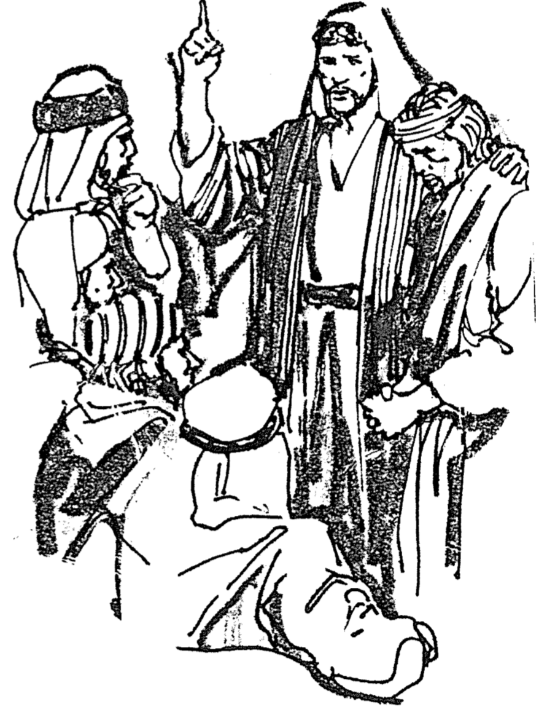
His desire for a continuing relationship with Onesimus could not overrule doing what was right (12-13).

He recognizes Philemon's authority over Onesimus as his slave so Philemon could decide if Onesimus could stay with him (14).

Perhaps God was working for the greater good by Philemon and Onesimus becoming brothers in Christ (15-16).

The way Philemon should forgive and free Onesimus is how Christ forgives us (17-21).

Philemon should accept Onesimus back as a brother to show Onesimus' equal standing with him in Christ (17).

Paul offers to pay Onesimus' debts to Philemon like Jesus forgave him unconditionally (18-19a).

Philemon owes his salvation to Paul so he should forgive Onesimus rather than require paying of his debts for stealing (19b).

Philemon accepting Onesimus would encourage Paul (20).

Paul expresses confidence that Philemon will both forgive and free Onesimus (21).

Paul closes his letter to reinforce the public nature of Philemon's decision and to remind of God's power for fulfilling his appeal (22-25).

The church should prepare for Paul’s soon visit in answer to their prayers and quickly respond to Paul's plea for Onesimus (22).

Five voluntary fellow prisoners with Paul also greet Philemon to reinforce the public nature of his decision about Onesimus (23-24).

Epaphras, who started the Colossian church (Col 1:7) and voluntarily shared Paul's confinement, greets Philemon (23).

Four other fellow workers with Paul also greet Philemon to emphasize the public influence that Philemon's decision will carry (24).

Paul blesses the Colossian church with Christ's grace to underscore the Source of power to fulfill his appeal in the letter (25).

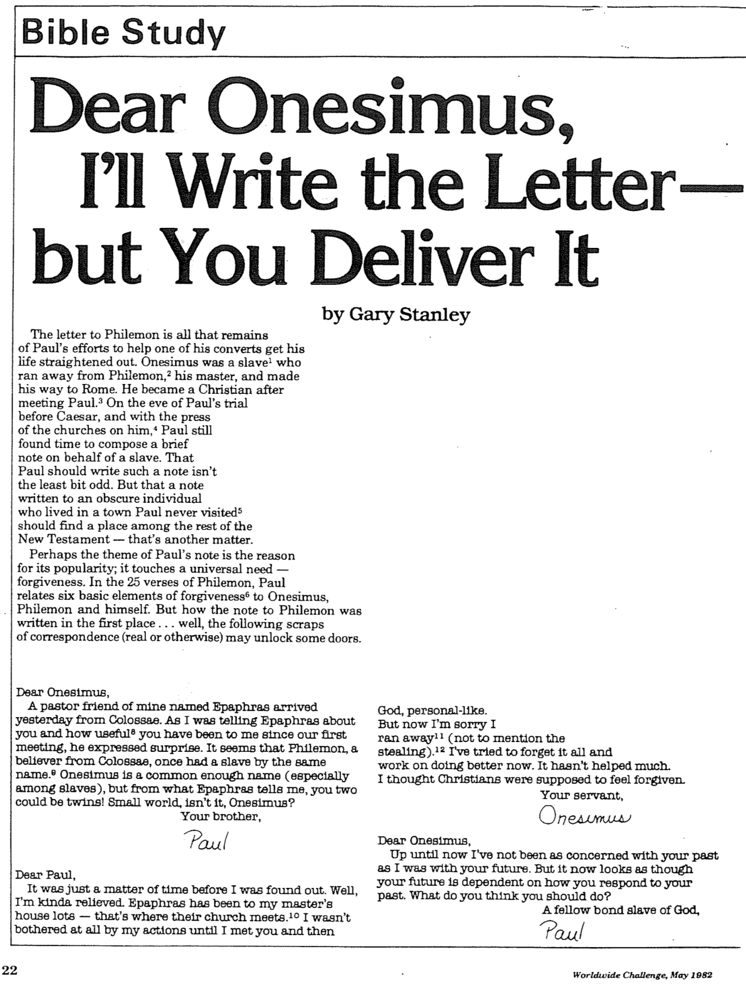
Dear Onesimus, I’ll Write the Letter–but You Deliver It (1 of 2)

Dear Onesimus, I’ll Write the Letter–but You Deliver It (2 of 2)
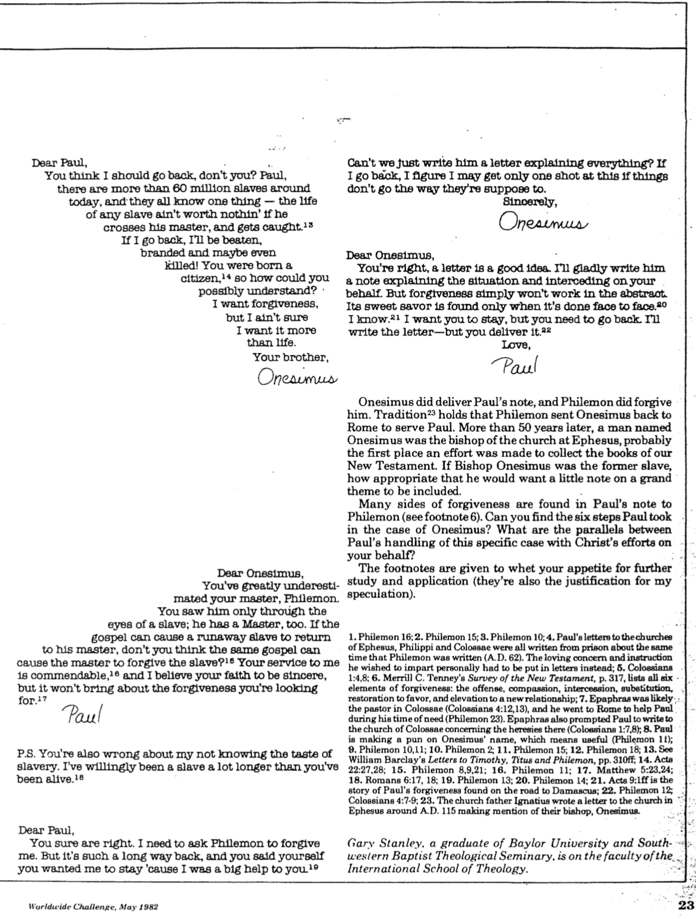

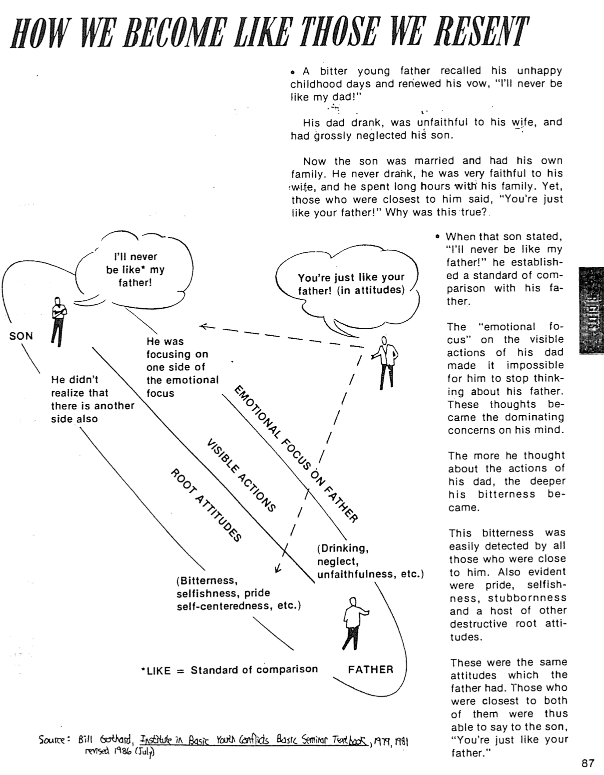
How We Become Like Those We Resent
Bill Gothard, Basic Seminar Notebook (Institute in Basic Youth Conflicts, 1986)

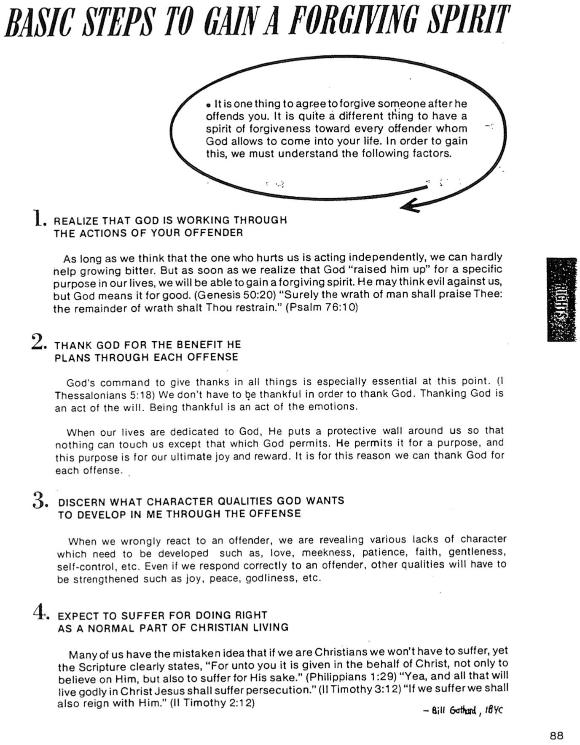
Basic Steps to Gain a Forgiving Spirit
Bill Gothard, Basic Seminar Notebook (Institute in Basic Youth Conflicts, 1986)

How Do I Ask Forgiveness?

1. Never say, “I’m sorry (full stop).”
Say, “Will you forgive me for __________ (specifically identify your offense)?”
Philemon 10, 18

2. Request forgiveness in person—not by phone or letter or fax or email or text or through mediators. . .
Onesimus traveled 1400 kilometers to speak to Philemon in person

3. Show humility without concern for saving face.
Philemon 1, 8-9, 14 (cf. Gal. 6:1b, 3-4)

4. Remember that your response is not a private issue, but public, involving many people.
Philemon 1-2, 25 (plural)

5. Make the request for forgiveness as public as the offense.

a. Public sins require public apology (1 Tim. 5:20)

b. Private sins require private apology (Matt. 18:15)

Restoring Relationships

General Principle: Romans 12:18

When Offender: GO! | When Offended: GO!
Matthew 5:23-24 | Matthew 18:15
James 5:16 | Galatians 6:1

The Value of the Philemon Postcard
Jon Courson’s Application Commentary: New Testament (© 2003), pp. 1429-1433 (1 of 4)

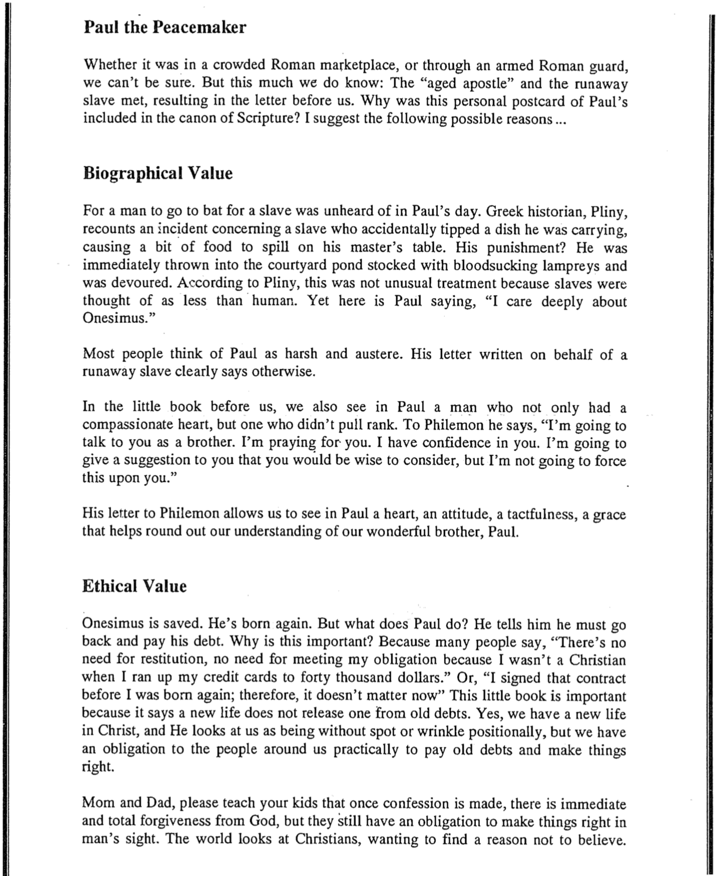
The Value of the Philemon Postcard
Jon Courson’s Application Commentary: New Testament (© 2003), pp. 1429-1433 (2 of 4)

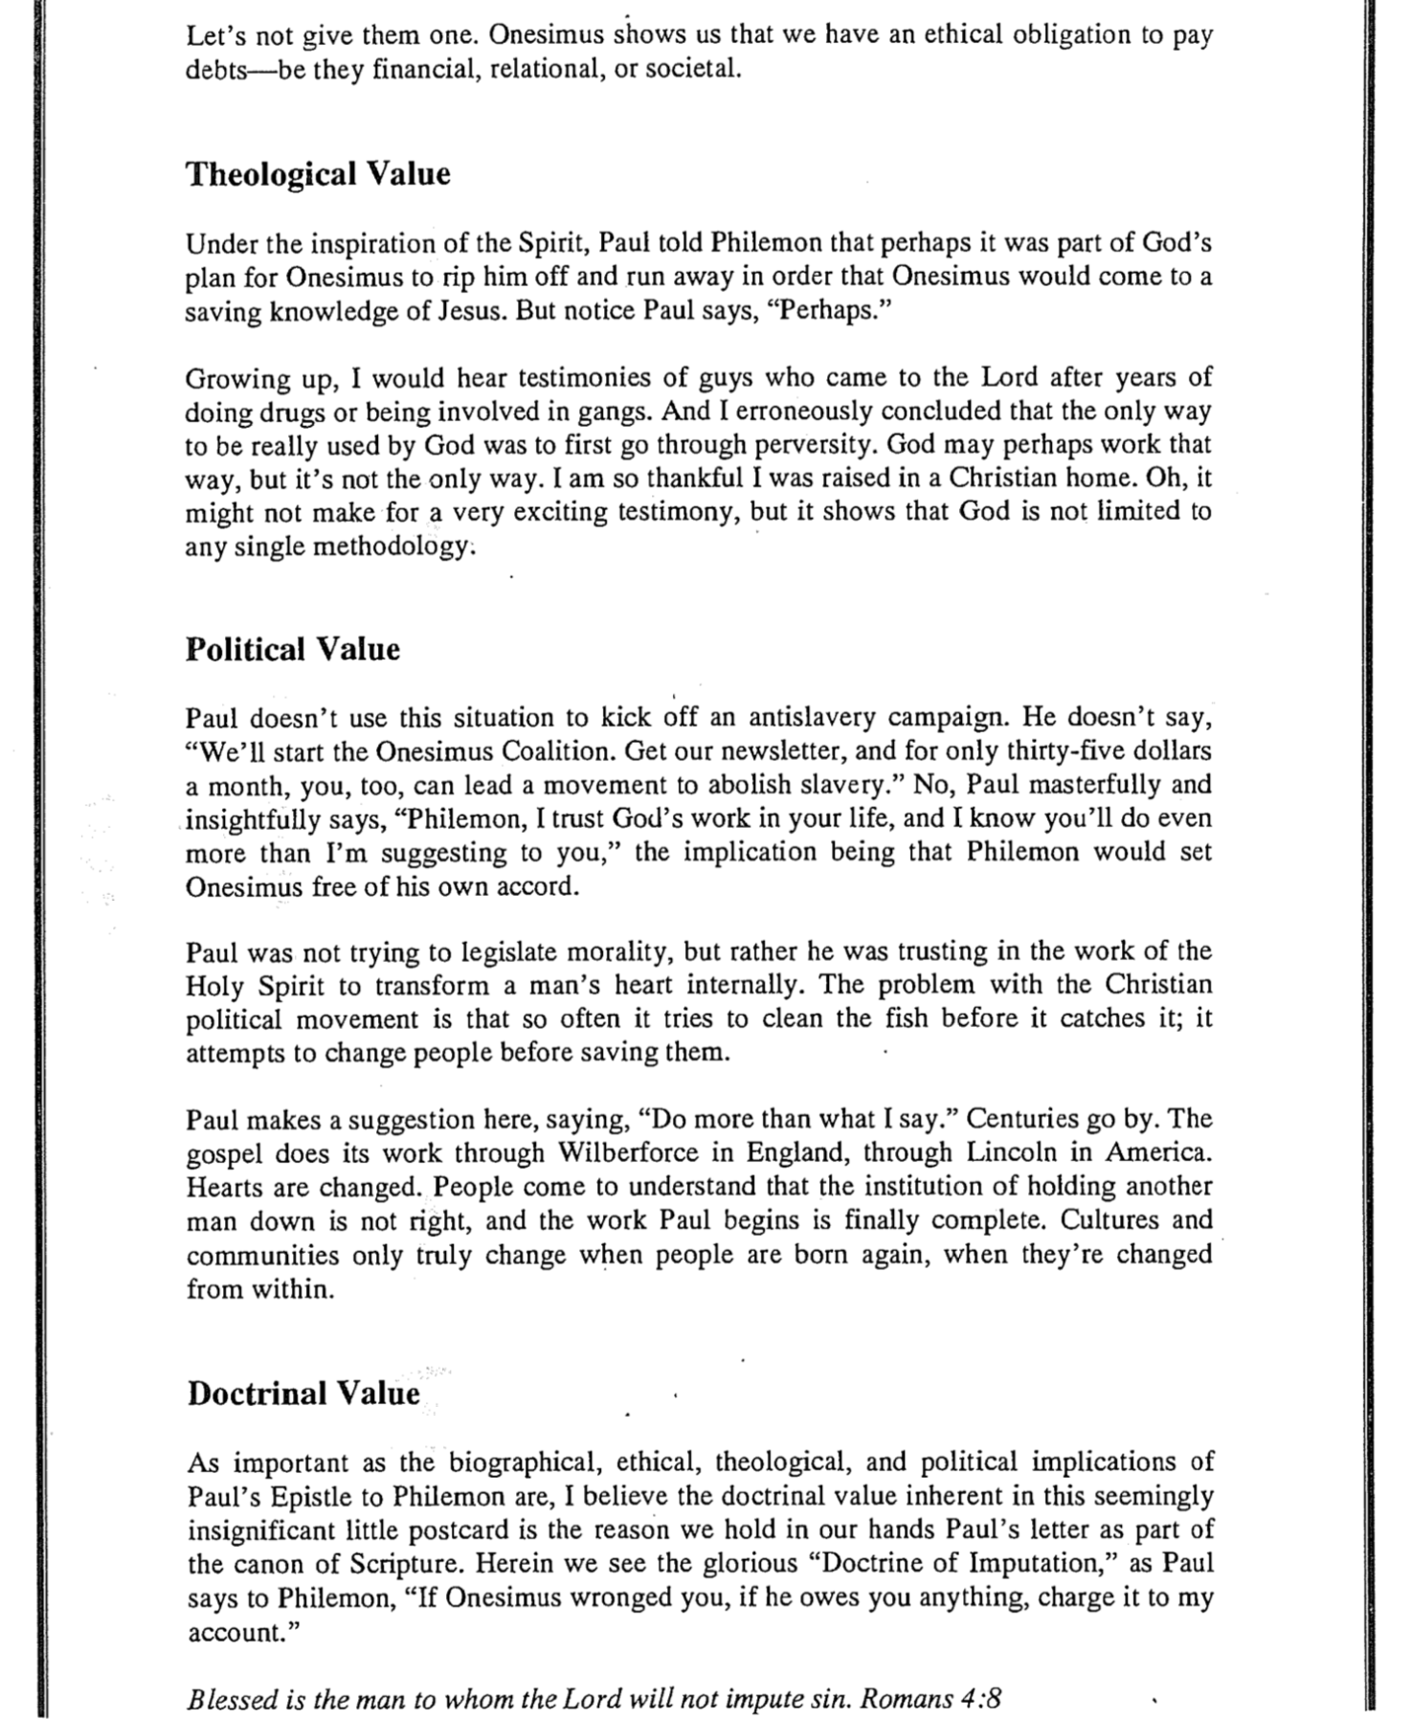

The Value of the Philemon Postcard
Jon Courson’s Application Commentary: New Testament (© 2003), pp. 1429-1433 (3 of 4)

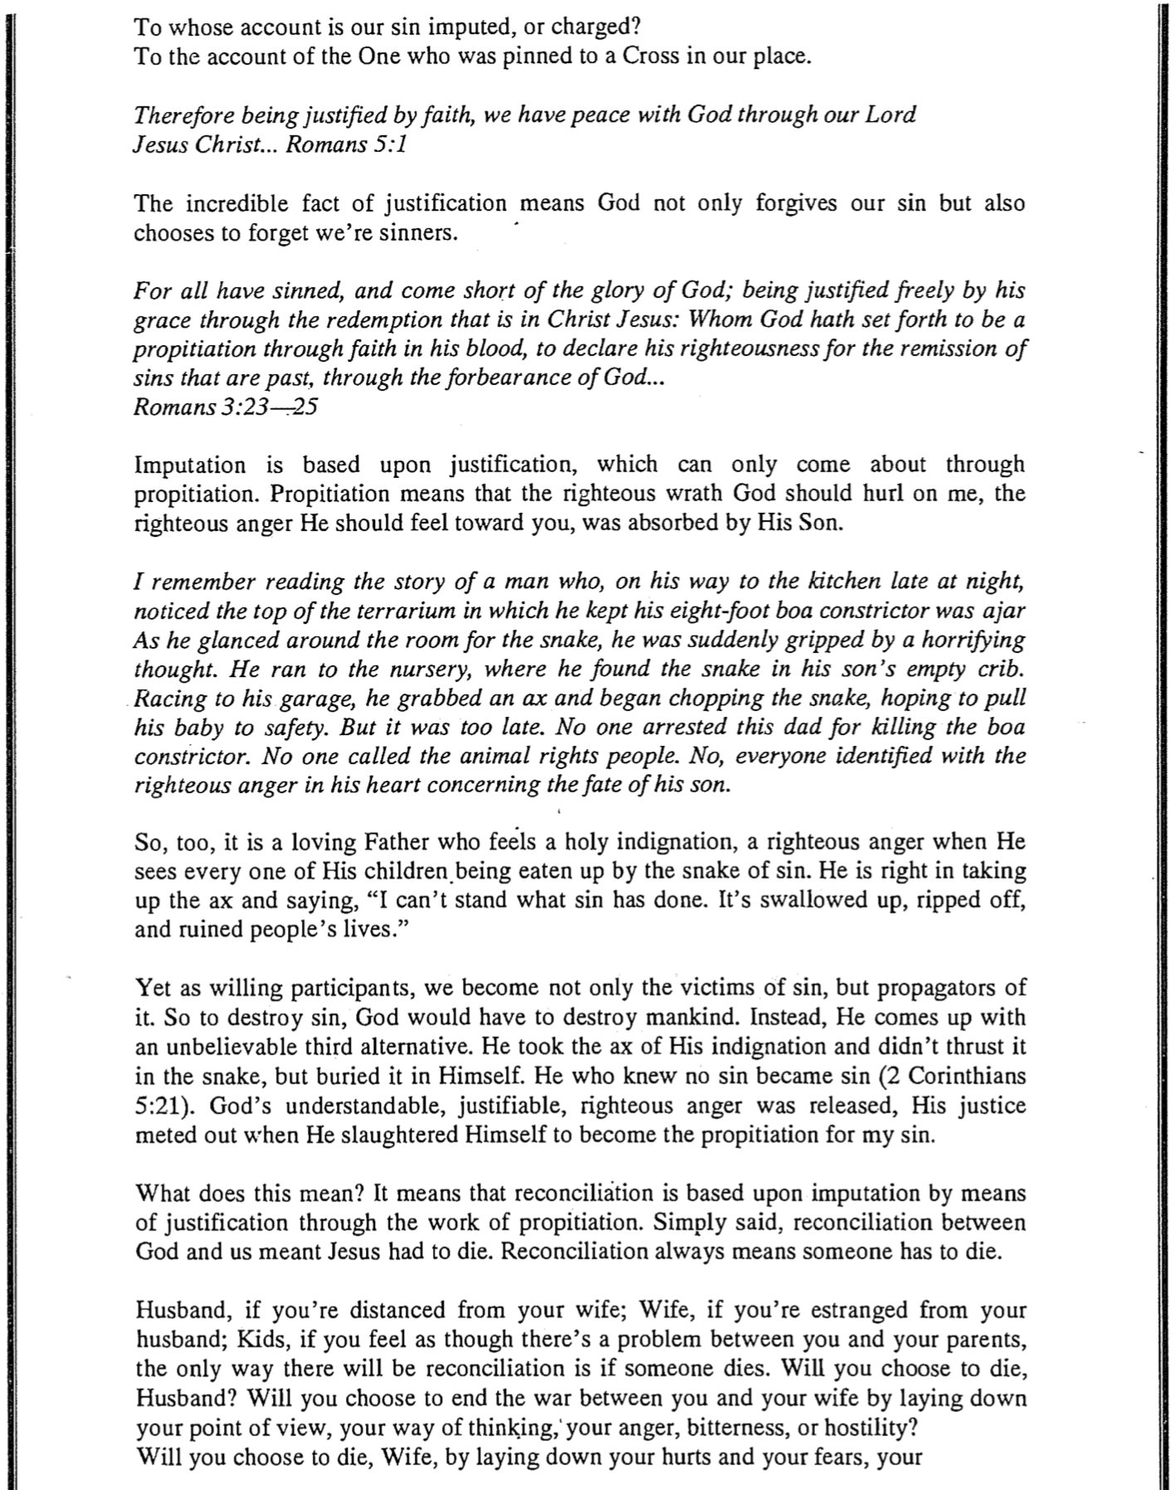

The Value of the Philemon Postcard
Jon Courson’s Application Commentary: New Testament (© 2003), pp. 1429-1433 (4 of 4)

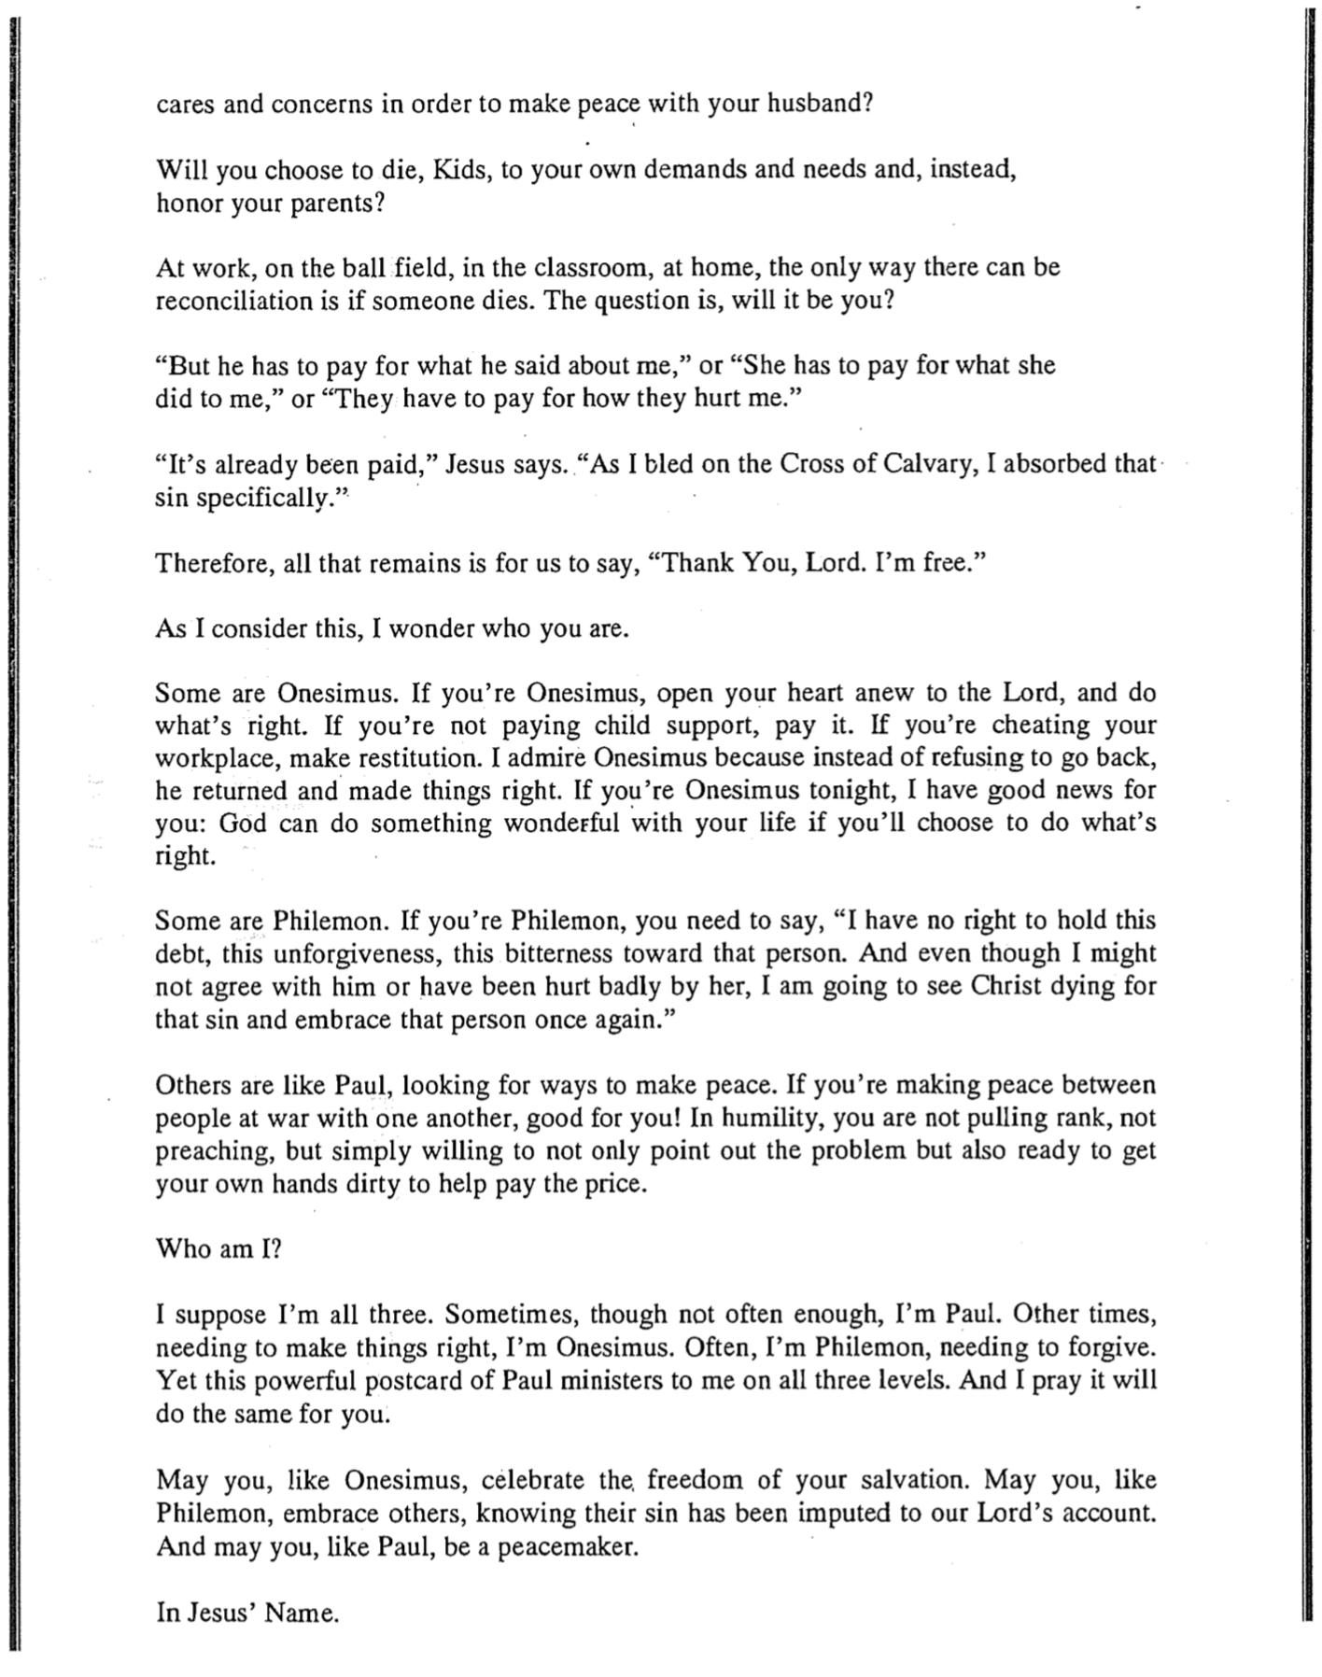
Philemon and the Domestic Maid
“Postcard to Philemon,” NT Survey Class Presentation, SBC, 2005 (1 of 2)

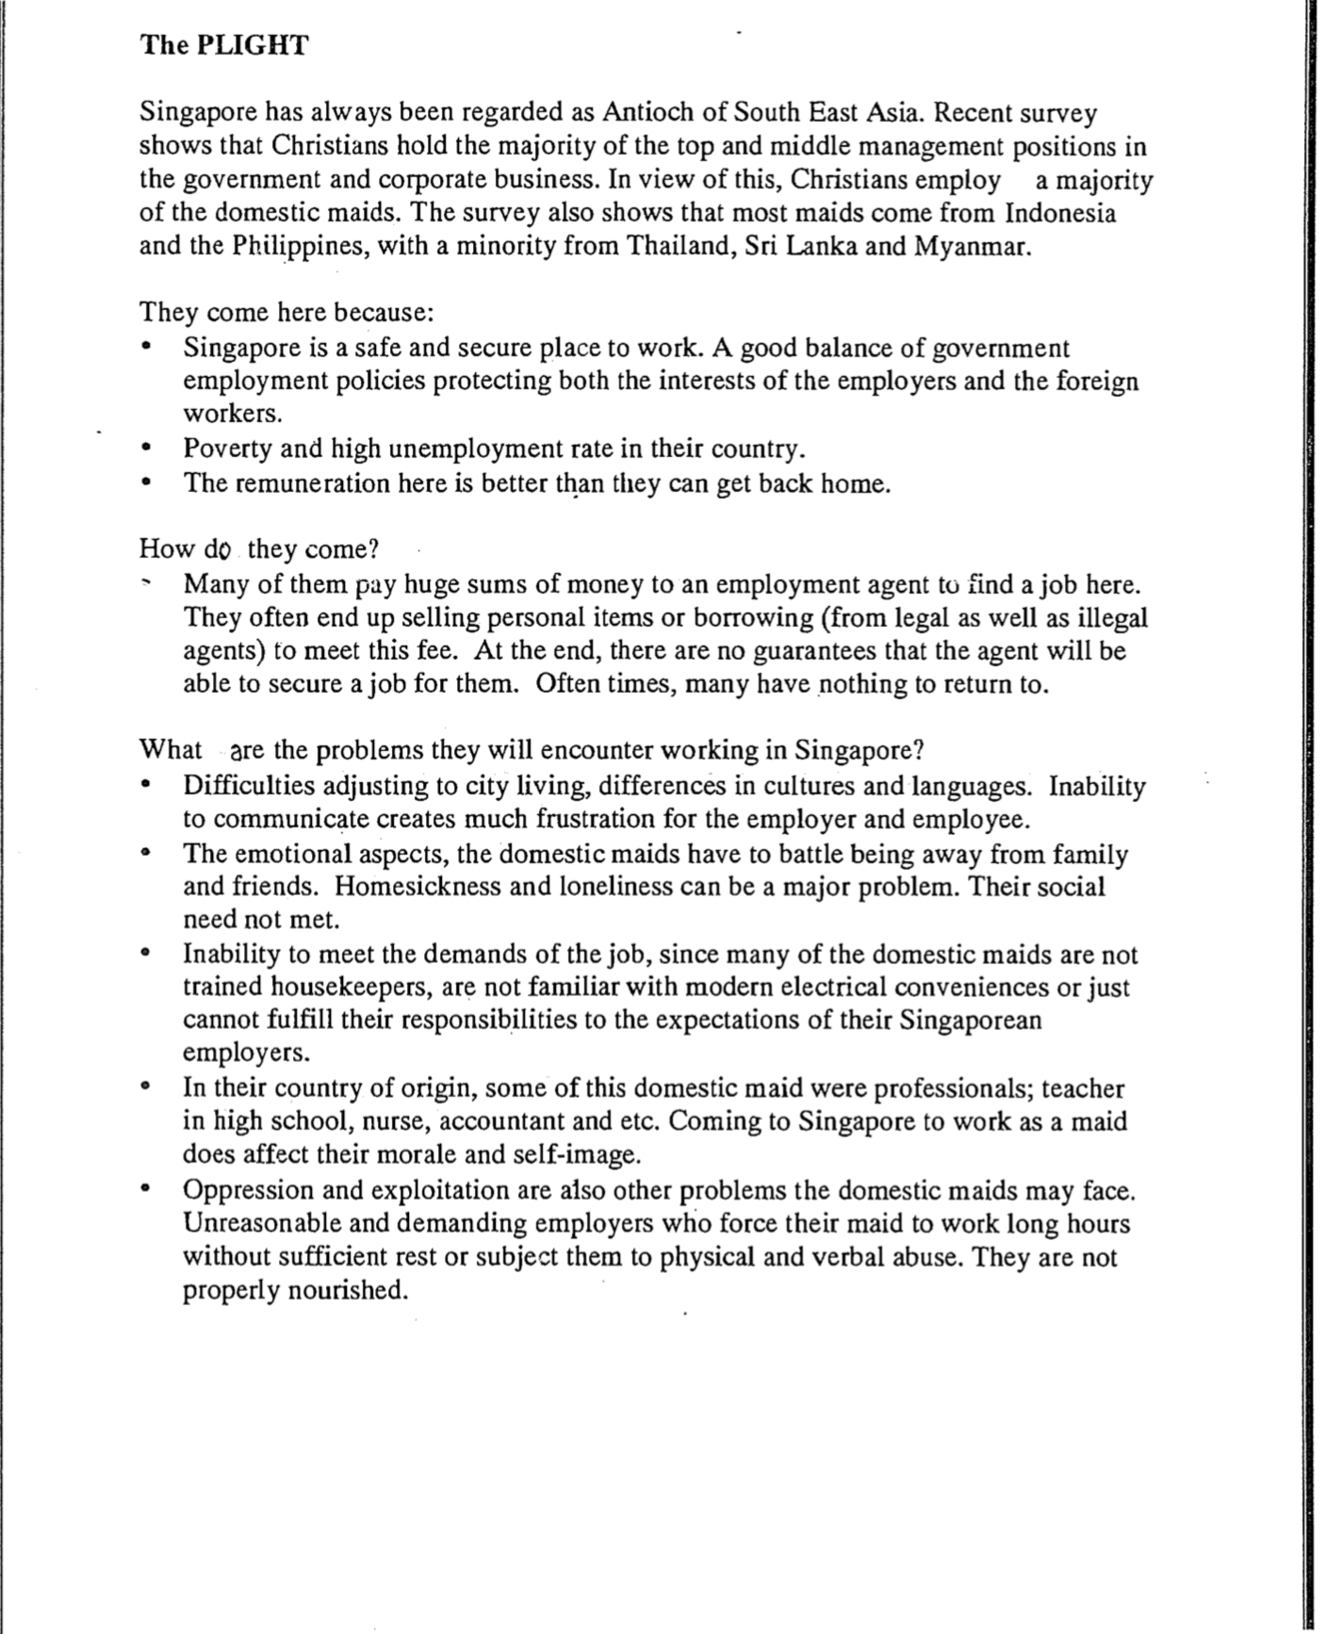

Philemon and the Domestic Maid
“Postcard to Philemon,” NT Survey Class Presentation, SBC, 2005 (2 of 2)

