The Purposes & Names of the Tribulation

If God is a God of love, then why must there be a time of great tribulation on earth?

1. To Judge the Nations: God is a God of justice as well as a God of love. His wrath must be shown to demonstrate Him to be consistent with His balanced character (e.g., Zeph. 1:15; 1 Thess. 1:10; 5:9; Rev. 11:18; 15:1; 16:1).

This will be a period when God gives those who killed His people the fruits of their sin (Rev. 6:11; cf. Ps. 2:5; Jer. 25:30-32; Zech. 12:3; 2 Thess. 2:12; Rev. 3:10; 6:15).

- God has always judged sin and does so at the present, so this period is not out of line with His actions in the past (Rom. 1:18-20).

2. To Discipline Israel: Israel will need a time of difficulty to turn her heart to the Lord in order to fulfill the prophecies of the nation’s restoration in repentance (Deut. 30:1-3; Isa. 1:25; 4:2-4, etc.; cf. Eschatology notes, 119c point D).

3. To Save Israel: God’s mercy will be shown to Israel by saving her after this time of trouble.

- Jer. 30:7 refers to the “time of Jacob’s trouble” that will lead to national salvation.

- Dan. 11:36-45 shows how God will miraculously save Israel from the attacks of Antichrist.

4. To Establish the Millennial Kingdom: The Tribulation will end with the elimination of the kingdoms of this world so they can be replaced with Christ’s kingdom (Dan. 7:17-18; cf. Rev. 17-18 removes Babylon before Rev. 19-20 sets up Christ’s reign).

The various names for this period of time reveal some of God’s purposes:

•ª “Day” or “Day of the LORD”—Isa. 30:23-25; 34:1-8; 35:1-10; Joel 2:28-32; 3:1-21; Zeph. 3:8, 16-20; Zech. 14:1-21)

• “Tribulation”—Deut. 4:30; Matt. 24:9, 21, 29; Rev. 7:14

• “Time of Jacob’s trouble”—Jer. 30:7

• “Wrath of God”—Zeph. 1:15; 1 Thess. 1:10; 5:9; Rev. 11:18; 15:1; 16:1

• “Seven”—Dan. 9:27

Correlation of Passages on the Tribulation
Kay Arthur, Revelation 4 Workbook, 277
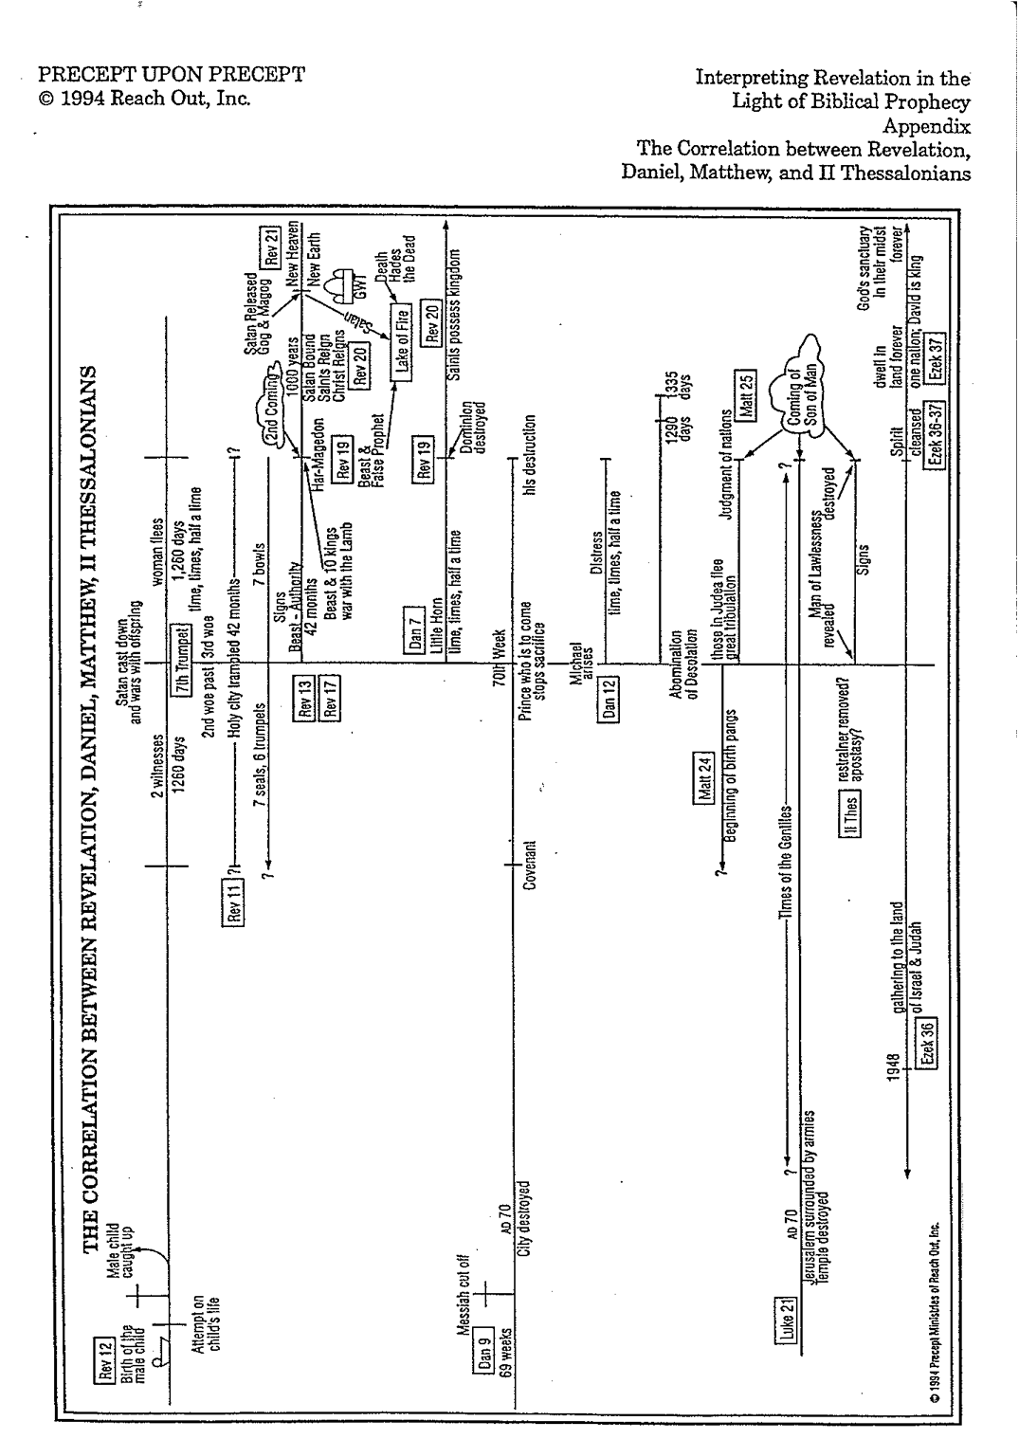
Revelation Timeline (Rev. 4:1–20:6)
Adapted from Jon Tretsven, “New Testament Survey,” BEE World/Internet Biblical Seminary

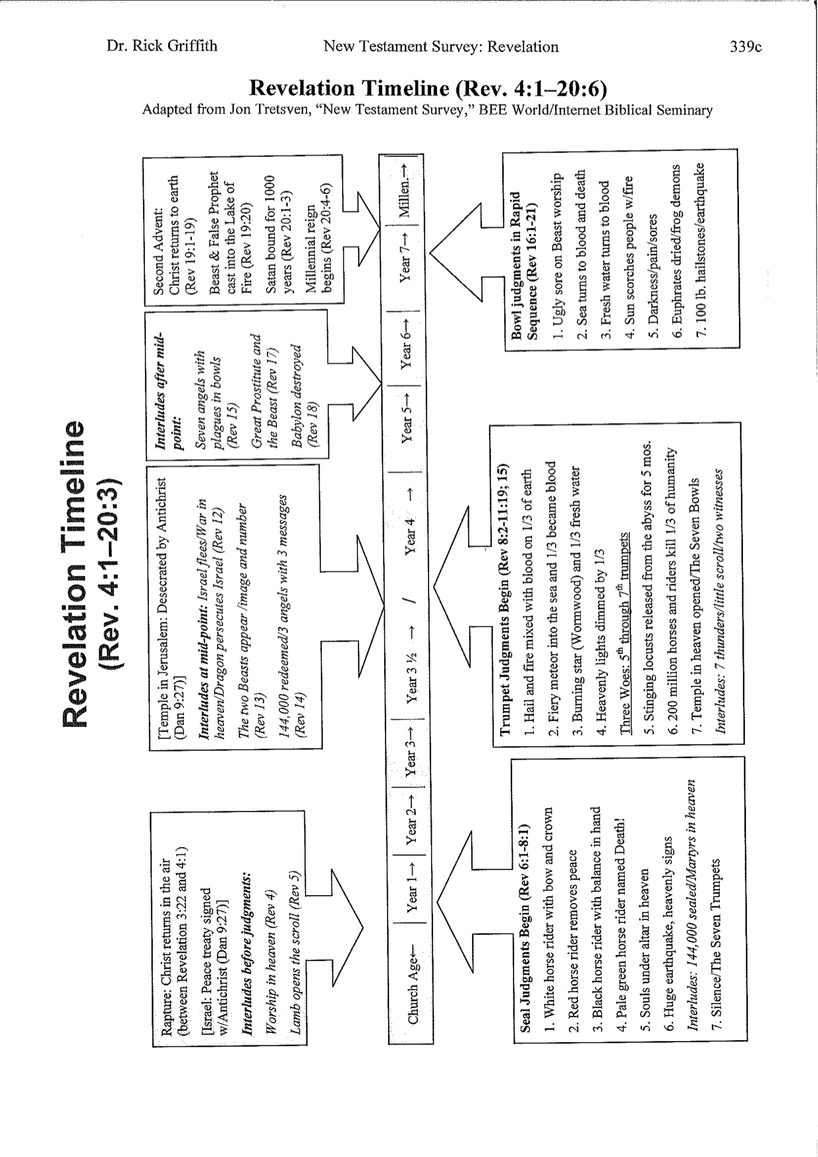
Views on the Millennium

Definitions

1. The word "millennium" means "a period of a thousand years" (Funk & Wagnalls Standard College Dictionary), stemming from the Latin mille, "thousand" and annus, "year."

2. Although the word "millennium" itself is not in the Bible, the term refers to the thousand year reign of Christ found six times in Revelation 20:2, 3, 4, 5, 6, 7. According to premillennialists it refers to the 1,000 year earthly reign of Christ in fulfillment of the Abrahamic (Gen. 12), Land (Deut. 30), Davidic (2 Sam. 7), and New (Jer. 31) Covenants.

3. The Millennium is also called “Your kingdom come” (Matt. 6:10) and “the kingdom of God (Luke 19:11), the kingdom of Christ (Rev. 11:15), the regeneration (Matt. 19:28), the times of refreshing (Acts 3:19), and the world to come (Heb. 2:5)" (Ryrie, Synopsis, 1953). The “Sabbath rest” (Heb. 4:9) also likely refers to the Millennium.

Major Questions Addressed in the Millennial Views

1. The millennial question generally concerns when Christ will come in relation to this millennium. Will He return before or after the millennium?

2. Also, “the millennial question asks what kind of Millennium there will be. That there will be a Millennium is a fact clearly taught in Revelation 20:1-6, but what kind of Millennium that will be is and has been strongly debated through the years” (Charles C. Ryrie, What You should Know About the Rapture, 10, emphasis mine).

Major Questions Answered by the Millennial Views

 | View | Time  When is the Millennium?  Before/after Christ’s Return?  How long is it? | Nature  What kind of Millennium?
1. | Amillennialism | • Between 1st & 2nd advents  • Before the Second Coming  • Indefinite length | • Spiritual kingdom of Christ  • The present age itself  • No future for national Israel
2. | Postmillennialism | • No Specific Beginning Point  • Before the Second Coming  • Indefinite length (but a few say  it is a literal 1000 years, such as  Boettner & Chilton) | • Literal rule of the Church on  earth without Christ present  • Similar to the present age  (sin, marriage, birth & death  present but greatly reduced)  • No future for national Israel
3. | Premillennialism | • Future  • After the Second Coming  • Literal 1000 years | • Literal rule of Christ on earth  • Similar to postmil except  Jewish elements, topographical  changes, etc.  • Future for national Israel
Diagrams of the Millennium
Charles C. Ryrie, What You should Know About the Rapture (Chicago: Moody, 1981), 10-11

