Hebrews

Christ's Superiority over Judaism as High Priest

Do Not Compromise Since Jesus is Better |  |  |  |  |  |  | Endure by Faith
Superior in His  Person to… |  |  | Superior in His  Priestly Work to… |  |  |  | Each Decision has Huge Results
1:1–4:13 |  |  | 4:14–10:18 |  |  |  | 10:19–13:25
Prophets  1:1-3 | Angels  1:4–2:18 | Moses  3:1–4:13 | Aaron  4:14–6:20 | Melchi-zedek  7 | Old Covenant  8 | Tabernacle & Sacrifices  9:1–10:18 | Willful Sin  10:19-39 | Models  11:1–12:3 | Don’t Despise Discipline  12:4-17 | Don’t Ignore God  12:18-29 | Press  on!  13
Christ’s Majesty |  |  | Christ’s Ministry |  |  |  | Christian’s Manifestation
Theology |  |  |  |  |  |  | Practice
Unknown Author, Recipients, Date, Origin, and Destination!

Key Word: Superiority

Key Verse: “Therefore, since we are surrounded by such a great cloud of witnesses, let us throw off everything that hinders and let us run with perseverance the race marked out for us. Let us fix our eyes on Jesus, the author and perfecter of our faith, who for the joy set before him, endured the cross, scorning its shame, and sat down at the right hand of the throne of God” (Hebrews 12:1-2).

Summary Statement: The reason believers should not compromise but rather endure by faith is because of Christ’s superiority to Judaism as High Priest.

Application: Despite the perceived advantages, never, ever let difficulties convince you to return to the religion you embraced before you were saved! See page 266t.

Hebrews

Introduction

I. Title The Greek title (Pro.j vEbrai,ouj To the Hebrews) does not follow the standard practice to name General Epistles after their authors. In this case the name identifies the Jewish recipients.

II. Authorship

A. External Evidence: The author of the Book of Hebrews is not stated in the book, but 13:18-24 shows that its original readers knew the writer. Many different authors have been suggested throughout church history. Even early church tradition divided over the authorship:

1. In Alexandria (Egypt) and in the Eastern Church the author was deemed to be Paul.

2. North African early church fathers (e.g., Tertullian of Carthage) said Barnabas wrote it.

3. In Italy and Western Europe authorship was initially debated. Paul’s authorship was originally rejected by Hippolytus (ca. 160-235), Caius (cited by Eusebius), and Irenaeus (ca. 140-203). Hebrews was not in the Muratorian Canon (AD 170), but Jerome (AD 340-420) and Augustine (AD 354-430) eventually convinced the Western Church to accept the Eastern Church view of authorship by Paul. This officially became Catholic dogma at the Council of Trent (AD 1546).

4. Reformation Protestants such as Calvin rejected the Catholic adherence to Pauline authorship. Luther and Erasmus attributed the epistle to Apollos.

5. Modern scholarship remains equally baffled by the authorship question. Additional suggestions include Luke, Clement, Silas, Priscilla, and Philip the Evangelist. Therefore, the external evidence is inconclusive.

B. Internal Evidence: In some respects the letter seems non-Pauline, but the best evidence may indicate Pauline authorship.

1. The internal evidence (i.e., in the letter itself) may point to Paul as author:

a. Timothy is mentioned in 13:23, likely as a traveling companion.

b. The author seems to be in prison (13:19) and the closing benediction sounds like Paul (13:20-21), including a greeting from Italian believers (13:24). This may show that Paul could have written it during one of his two imprisonments in Rome (AD 60-62 or 67-68).

c. It emphasizes Pauline themes of faith (Heb 11), the New Covenant (Heb 8), Israel's example (Heb 4), gifts and power (2:4) and the person of Christ (Heb 1–10).

d. Paul may have purposely omitted his name due to the hatred Jews had for him (they thought he maligned the temple and “apostatized” from Judaism to Christianity).

2. Yet many other internal observations may oppose Pauline authorship:

a. The Greek style is more polished and classical than in Paul's epistles. OT quotations are from the Septuagint (Greek), not the Hebrew text expected of one trained formally as a Jew like Paul. (But Paul does use both translations in his writings.)

b. No customary Pauline salutation appears at the beginning.

c. It seems that 2:3-4 indicates a second-generation author who received the gospel from the disciples of Jesus. Paul did not describe himself in this way (Gal 1–2).

d. While Paul’s writings emphasize the death and resurrection of Christ, Hebrews emphasizes the priesthood of Christ and his present work.

3. Any objective inquisitor of the epistle’s author must confess with the third century church father Origen who said, “Who it was that really wrote the Epistle, God only knows.”

4. Being anonymous does not affect its canonicity since the early church held to its authority.

III. Circumstances

A. Date: The date is not expressly stated in the book so must be determined by internal and external evidence. However, the following facts can be summarized:

1. Clement of Rome quoted the letter in AD 95-96 which rules out a second century date.

2. The lack of reference to the destruction of the Jerusalem temple points to a date before AD 70, especially since the sacrificial system was still in operation (cf. 8:4-5, 13: 9:6-9; 10:1-3, 11) and was “obsolete and aging” and would “soon disappear” (8:13).

3. The readers had “not yet resisted to the point of shedding blood…” (12:4), perhaps showing a date before Nero’s persecutions (AD 64-68). But this assumes persecution by the Romans (e.g., Nero), which may not have been the case had the readers lived in the Judean desert. Also, no reputable scholars date the book before AD 64.

4. Assuming Pauline authorship, the best date may be during his second imprisonment at Rome (AD 67-68), placing it during the Jewish revolt in Israel (AD 66-73).

B. Recipients: The readers were Jews due to the many allusions to and quotes from the OT that would have needed explanation if a Gentile audience was in view. This finds support in that “To the Hebrews” is the oldest and most reliable title.

These Jews, however, were second-generation (2:1-4) believers (3:1; 4:14-16; 10:19-22, 32-34; 12:7; 13:1, 20-22) who should have matured beyond their present immature state in Christ (5:11-14). They were immature, but they were true believers, not simply professing Christians. They were in danger of lapsing back into Judaism, perhaps due to persecution for Christ (although the precise nature of their temptation is not explicitly stated). A problem with dabbling in OT rites is hinted at in 7:11, 26-28; 8:4-5; 9:1–10:18.

But this letter was not a general address. It appears that these Jewish Christians composed a specific community:

1. The author knew their history, including their conversion (2:3), ministry to other Christians (6:10), sufferings for the gospel (10:32-34), and present state of spiritual maturity (5:11ff.).

2. The writer had already visited them once and desired to revisit them (13:19, 23). The readers apparently had a concern for Timothy as well (13:18).

3. The readers may have composed the leadership of a larger community since it is unlikely that the writer would expect the entire church to be teachers (5:12).

C. Origin: The letter apparently was sent from Italy (13:24, “those from Italy greet you”) to its recipients in another place. Yet Italy itself may also have been the destination since the Italians of 13:24 may have been with the author sending their greetings to their countrymen in Italy.

D. Destination: The Jewish Christians who first read the letter lived in a specific geographical location that probably was away from Jerusalem (i.e., in a mission field) since they were not among those who personally saw the Lord (2:3). Many destinations have been suggested: the Lycus Valley in Asia Minor, Rome, Cyprus, Cyrene, and the Qumran Community near the Dead Sea (see “Occasion” below). If Barnabas authored it, evidence may point to Cyrene (his home area) as the destination. The author evidently ministered in Rome at the time of writing and a relationship may have existed between Italian Christians and believers at Cyrene through Barnabas' contact with Simeon called Niger (a black) and Lucius of Cyrene (cf. Acts 13:1). No one really knows the origin or destination, but Jewish Christians in the Diaspora mixed with Gentile believers, as in Ephesus, Corinth, and Rome. In contrast, the Jewish recipients of this letter seemed to be a separate community, so a location in Israel is most likely.

E. Occasion: The admonishment not to stop meeting together (10:25) may show that the readers had sectarian tendencies, possibly separating themselves from their original, larger group. Perhaps they were believers saved from the Jewish Qumran Community who identified with a church, experienced persecution from unbelieving Jews, and then separated with the thought of a possible return to the Community and Judaism. The Dead Sea Scrolls note that the Qumran Community believed that Michael and his angels would be the rulers of the coming age. If the recipients were saved out of this background, persecution may have tempted them to again emphasize angels—so the writer began by showing how Jesus surpassed angels (1:4–2:18). No one knows the exact historical situation, but the writer had clear prophetic knowledge that the temple and sacrificial system would soon end (8:13), which happened in AD 70. He warned these believers that if they returned to Judaism, the fires of Rome would judge all involved in the Jewish revolt—believer and unbeliever alike. Thus the “raging fire that will consume the enemies of God” (10:27; cf. 6:8) refers not to eternal hellfire but to fires that burned Qumran, Jerusalem and all other cities resistant to Rome (p. 266c). See the excellent support of this view by Randall C. Gleason, “The Old Testament Background of the Warning in Hebrews 6:4-8,” Bib Sac 155 (Jan-Mar 1998): 62-91; idem., “The Old Testament Background of Rest in Hebrews 3:7-4:11,” Bib Sac 157 (July-Sep 2000): 281-303. Also see his articles in Herbert W. Bateman IV, ed., Four Views on the Warning Passages (Grand Rapids, MI: Kregel, 2007), as well as Joseph C. Dillow, Final Destiny: The Future Reign of the Servant Kings, 4th ed. (Monument, CO: Paniym Group, 2012).

Whoever these Jewish Christians were, the writer saw them in a very serious situation. Five severe warnings (2:1-4; 3:7–4:13; 5:11–6:8; 10:19-39; 12:18-29) admonish them not to reject Christianity for Judaism. The recipients had suffered persecution (10:30-32), but perhaps not actual martyrdom (12:4). They desperately needed endurance (10:36), for they were dull of hearing (5:11) and in danger of drifting away from their moorings in Christ (2:1; 3:12).

IV. Characteristics

A. Hebrews perplexes scholars as to its authorship more than any book in Scripture. The recipients, place of writing, and destination are equally baffling!

B. The five warning passages in Hebrews have caused much debate. The main issue is whether they address professing “Christians” (= non-Christians) in danger of eternal damnation, actual Christians in danger of loss of salvation, or Christians in danger of loss of reward or temporal judgment in the fires of Jerusalem. See page 266c that contrasts these views in detail.

C. Hebrews has the greatest information in Scripture on many doctrines: the “rest” for the believer (pp. 266g-k), the Melchizedek Priesthood (p. 266m), the High Priesthood of Christ (p. 266u), the New Covenant (p. 266o, 266v), and the typology of the offerings and feasts in Leviticus.

D. Hebrews lacks a salutation at the beginning, reading “more like a sermonic essay than a letter… [In fact,] only 13:18-25 sounds like a real epistle” (TTTB, 457).

E. The Greek style may be the most elegant in the NT. It has at least 157 words found nowhere else in Scripture.

F. It has over 86 OT quotes and so many allusions that it has over 100 references from 21 OT books (pp. 266m, 266aa)! This includes the longest quote in the NT (Heb. 8:8-12 quotes Jer. 31:31-34 on the new covenant).

G. Hebrews 11 is the Church’s most loved chapter in the Bible on faith (pp. 266x-z).

H. Hebrews has been called the fifth Gospel. The four Gospels relate what Christ did on earth then, but Hebrews supplements them by explaining his role in heaven now.

I. Romans shows the need for Christianity but Hebrews shows the superiority of Christianity.

J. Six key words repeated in the book affirm the superiority of Christ as the perfect and eternal high priest in heaven and thus better than Judaism (Harold L. Willmington, Willmington’s Guide to the Bible [Wheaton: Tyndale, 1991], 516):

1. “Priest, high priest” Used 32 times
2. “Heaven” Used 17 times
3. “Eternal, forever” Used 15 times
4. “Perfect” Used 14 times
5. “Better” Used 13 times
6. “Partakers” Used 9 times

K. Now fill in the “Brain Twister” crossword to see if you know the basics of Hebrews (p. 266ee).
Argument

Hebrews is a logical but passionate and stern declaration to rescue a group of persecuted Jewish Christians from abandoning Christianity by returning to Judaism. The writer affirms the superiority of Christ in a rational style, beginning first with his person and then his work. He explains Jesus’ preeminence over the prophets, angels, Moses, Aaron, the Old Covenant, the tabernacle, and the sacrifices to convince the readers that abandoning Christ for only types of him makes no sense and receives sure judgment. Five warning texts emphasize how forsaking the substance for the shadow is clearly a tragic mistake. The letter then progresses with an exhortation to endure in faith, citing the examples of many who have successfully gone before the suffering recipients of the epistle. The final chapter exhorts the church to love in both the social and religious realms, concluding with a request for prayer, a benediction, and personal greetings.

The author wrote to keep his hearers from deserting the faith by lapsing back to Judaism. He did this by showing how Christianity (and Christ specifically) is better than Judaism in many ways:

1. Christ is the final revelation of God and is God Himself (1:1-8).

2. Christ is superior to: (a) angels (Heb 1–2), (b) Moses (Heb 3–4), and (3) Aaron, the old covenant, the sanctuary, and the sacrifices (Heb 4–10).

3. The word “better” occurs 13 times (1:4; 6:9; 7:7, 19, 22; 8:6a, 6b; 9:23; 10:34; 11:16, 35, 40; 12:24; p. 266f) along with emphases in Christology and Soteriology. Each time “better” contrasts Christ with the old order.

4. Five passages warn against despising the new order by returning to the old (2:1-4; 3:7–4:13; 5:11–6:8; 10:19-39; 12:18-29).

Synthesis

Christ's superiority over Judaism as high priest

1:1–10:18 Do Not Compromise Since Jesus is Better

1:1–4:13 Superior in his person to…
1:1-3 Prophets (theme)
1:4–2:18 Angels
1:4-14 Due to deity
2:1-4 #1–Drifting away #= five warning passages
2:5-18 Due to humanity
3:1–4:13 Moses
3:1-6 Glory/position
3:7–4:13 #2–Unbelief
4:14–10:18 Superior in his priestly work to…
4:14–6:20 Aaronic priesthood
4:14-16 Due to deity
5:1-10 Due to Melchizedek order
5:11–6:20 Maturity
5:11–6:8 #3–Immaturity warned
6:9-20 Maturity exhorted
7 Melchizedek
8 Old covenant
9:1-10 Tabernacle
9:11–10:18 Sacrifices

10:19–13:25 Endure by faith
10:19-39 #4–Willful sin
11:1–12:3 Models of faithful endurance
12:4-13 Endurance as sons
12:14-17 Ethics of endurance
12:18-29 #5–Ignoring God's voice
13:1-25 Exhortations to love/conclusion

Outline

Summary Statement for the Book
The reason Hebrew believers should not compromise but rather endure by faith is because of Christ’s superiority to Judaism as High Priest.

The reason the Hebrew believers should not compromise in their faith is because Christ is superior to Judaism (1:1–10:18).

The readers should not return to Judaism because Christ is superior to Judaism’s prophets, angels, and Moses in his person (1:1–4:13).

Since Christ is superior to the OT prophets, the readers should follow Christ (1:1-3).

OT prophets ministered to Jews repeatedly and only as partial revelations of God (1:1).

Christ is the final revelation of God as his person exceeds that of the prophets (1:2-3).

Jesus is God’s Son speaking—which was never said of a prophet (1:2a).

Jesus is heir of the universe—but no prophet was destined to rule the world (1:2b).

Jesus is the Creator of the universe—but all prophets are created beings (1:2c).

Jesus is God since he exactly represents the Father—said of no prophet (1:3a).

Jesus is Sustainer of the universe by his word—but no prophet sustains the world (1:3b).

Jesus is Atonement for mankind’s sins—while prophets need his atonement (1:3c).

Jesus completed his ministry in a manner pleasing to the Father—but no prophet completely pleased God (1:3d).

Christ is superior to the angels as God and man, so we should not respect created angels more than Christ, the Creator himself (1:4–2:18).

Christ is greater than angels in his deity, so the readers should not return to their Jewish sect emphasizing angel ministry (1:4-14).

Christ has a better name than angels since he is called God’s son (1:4-5).

Angels eternally worship Christ as God and the Father calls him “God” (1:6-12).

Christ has completed his work whereas the angels continue working (1:13-14).

Warning #1: Christ surpasses angels, so the Christian readers would be punished if they discarded their faith and drifted back into Judaism (2:1-4).
No penalties are listed here, but they can’t include hell as the writer also could “drift away.” This is the first of many exhortations in Hebrews (pp. 266e, 266p).

Christ is greater than angels in his humanity, so the readers should trust Christ rather than angels (2:5-18).

God never promised angels authority to rule the future world (2:5).

Psalm 8:4-6 promises man the privilege to rule the future world (2:6-8).

Many Scriptures prophesied that Jesus would become a man with authority to rule due to his atoning death (2:9-13).

Other wonderful results of Christ’s humanity make him more worthy of worship than any angel (2:14-18).

As a man, Christ has been able to defeat Satan’s grip on other men (2:14-16).

As a man, Christ atoned for man’s sin as a compassionate high priest (2:17).

As a man who was victorious in his suffering, Christ can help people now who suffer temptation (2:18).

Christ is superior to Moses, so as unbelief under Moses forfeited inheriting Canaan, a return to Judaism will forfeit inheriting Canaan in the future kingdom era (3:1–4:13).

Christ is superior to Moses in his glory and position, so the readers should follow Christianity instead of Judaism (3:1-6).

Christ is greater than Moses in his glory because the offices of apostle (cf. Moses) and high priest (cf. Aaron) combine in Jesus (3:1-4).

Christ is greater than Moses in his position because he was not in “God’s house” (all the redeemed) as a servant, but over the house as a son (3:5-6).

Warning #2: As believing Israel forfeited Canaan rest due to later unbelief, so we must obey to inherit the same Promised Land millennial kingdom rest (3:7–4:13).

This warning applies Israel’s Psalm 95:7-11 disinheritance of Canaan to Christians now who reject Jesus, who was above Moses (3:7-19).

Psalm 95:7-11 parallels Israel's wilderness unbelief disinheriting them from Canaan to the same unbelief at the time of the psalmist (3:7-11).

Psalm 95:7-11 shows the readers that daily mutual encouragement could help them prevent such an unbelieving and hardened heart (3:12-15).

As Israel’s disbelief in gaining Canaan was due to rebellion and sin, so the readers needed to see the seriousness of their own situation (3:16-19).

Israel’s disinheritance of Canaan warns the Hebrew Christian readers (and us) of the same penalty for rejecting Christ (4:1-13; cf. 1 Cor. 3:11-15; pp. 266i-k).

The readers should not return to Judaism because Christ is superior to its priestly system in his high priestly work (4:14–10:18).

Since Christ is superior to Judaism’s high priest in his position and qualifications, the readers should follow Jesus (4:14–6:20).

Christ’s superior position over Judaism’s high priest gives him victory over temptation so the readers can draw near to him rather than drift away (4:14-16).

Judaism’s high priest entered the Holy of Holies room annually, but Jesus passed through the heavens forever as the unequaled high priest (4:14).

However, even in his greatness, Christ sympathizes with our weaknesses and provides free access to his throne of grace (4:15-16).

Christ’s superior qualifications over Judaism’s high priest make him even more worthy to follow (5:1-10).

There were two basic qualifications of the Jewish high priest (5:1-4).

He must be a man with human weakness (5:1-3).

He must be chosen by God (5:4; see p. 266l for his holy garments).

Jesus fulfilled both of these high priest qualifications even more than did the earthly high priest (5:5-10).

God chose Christ like he chose the Aaronic high priest, but Jesus was of the higher Melchizedek priesthood as God’s Son (5:5-6).

Christ became human but submitted above any man in his prayers and learning obedience, qualifying him to the Melchizedek priesthood (5:7-10).

c) Knowing the dangers of reverting to Judaism and neglecting to press on to spiritual maturity can prevent apostasy and temporal judgment (5:11–6:20).

Warning #3: Spiritual immaturity shown in returning to Judaism would lead to an irreversible apostasy and judgment in Jerusalem’s fires (5:11–6:8).

The readers should be teachers, but their spiritual laziness required basic teachings on Christ instead of higher doctrines in righteousness (5:11-14).

This dangerous situation made them susceptible to wrongly emphasize the lifeless Old Testament rituals—not mature doctrines (6:1-3).

Apostasy by denying Jesus is an irreversible decision with recommitment to Christ impossible and physical death inevitable (6:4-8).

The writer exhorts spiritual maturity that his readers will not apostatize and be judged but will be faithful to Jesus until the end of their lives (6:9-20).

Since Christ is superior to Abraham and Levi by being of the Melchizedek Priesthood, the readers should follow him (Heb 7; cf. Contrasting the Priesthoods at p. 266r).

The great angel Melchizedek was greater than both Abraham and Levi (7:1-10).

Melchizedek had such superior qualities that he must have been angel (7:1-3).

Melchizedek served as king of Salem, or ancient Jerusalem (7:1a).

Melchizedek was priest of God Most High (7:1b).

Melchizedek had such high stature that he blessed Abraham (7:1c).

Melchizedek received tithes from Abraham (7:2a).

Melchizedek’s name and title of righteousness and peace point to the Messiah (7:2b).

Melchizedek is timeless (7:3).

He was not born to a father or mother (7:3a).

He had no human ancestors (7:3b).

He was never born, nor did he ever die (7:3c).

His priesthood is eternal like that Jesus (7:3d).

Melchizedek was greater than both Abraham and Levi (7:4-10).

Both tithed to him (7:4-6a).

Melchizedek blessed both of them (7:6b-7).

Levi also paid Melchizedek tithes through Abraham (7:8-10).

Christ is high priest in the order of Melchizedek and thus better than Levitical priests, so a return to the old Levitical order is foolish and unnecessary (7:11-28).

God established the indestructible order of Melchizedek over the weak order of Levi based on heredity (7:11-19; cf. Prophet, Priest, & King at p. 266q).

God established the order of Melchizedek because the priesthood of Levi could never bring perfection (7:11).

The indestructible order of Melchizedek replaced the weak order of Levi based on heredity (7:12-19).

God recognized Jesus as high priest by oath whereas other priests do not obtain office with an oath (7:20-22).

Jesus is a permanent priest (as he is the eternal Savior and intercessor) while other priests all die in office (7:23-25).

Jesus is perfect and died for our sins once while other priests were sinners who had to repeatedly offer sacrifices for their own sins (7:26-28).

Since Christ is superior to the old covenant in that he established the new covenant, the readers should follow him (Heb 8).

Since Jesus in his priesthood supersedes the old priesthood, his new covenant also supersedes the old covenant (8:1-6).

Jeremiah 31:31-34 taught a future, new and better covenant, so this shows that the coming of the new covenant makes the old covenant obsolete (8:7-13).

Since Christ is superior to the tabernacle by his sacrifice, we must follow him (9:1–10:18).

The tabernacle and sacrificial system were glorious but only temporary (9:1-10).

The old covenant with its earthly tabernacle and furniture truly had God’s glory (9:1-5; cf. pp. 266n, 266v).

Yet the daily sacrifices of the priests and annual atonement by the high priest could not cleanse anyone’s conscience (9:6-10).

Christ’s sacrifice saves us permanently compared to the old and transitory tabernacle sacrifices (9:11–10:18; cf. pp. 266o, 266u).

Christ passed from earth to heaven after his atonement for man—not simply from the tabernacle Holy Place to the Holy of Holies (9:11; cf. p. 266s).

Christ shed his own human blood—not just the blood of animals (9:12).

Christ purifies our consciences—not just provides ceremonial cleansing (9:13-14).

Christ mediates a new covenant that frees us from sin committed under the old covenant (9:15).

Christ shed his own blood for us because forgiveness under a covenant comes only through death (9:16-22).

Christ entered heaven itself following his sacrifice to show that his sacrifice was the one perfect, permanent, and final sacrifice (9:23–10:18).

He purified us in heaven through his sacrifice (9:23-24).

He entered heaven for our redemption only once (9:25-28a).

He will return to complete our salvation (9:28b).

He permanently cleansed us from sin and guilt that bulls and goats could never do (10:1-4).

He fulfilled Psalm 40’s prophecy that he would please God by offering his body (10:5-9a).

He cancelled the Mosaic covenant (10:9b).

He made us holy once for all time (10:10-18).

The result of Christ being superior to Judaism should be to persevere by faith rather than shrink back (10:19–13:25).

The danger of willful sin where believers lose their lives highlights the need to persevere in faith despite obstacles (10:19-39).

Christ’s high priesthood gives us perseverance with God and man (10:19-25).

His superiority exhorts us to draw near to him (10:19-22).

His faithfulness exhorts us to hold fast to true doctrine (10:23).

His soon return moves us to regularly meet together to love one another in good deeds (10:24-25; cf. pp. 266ff-gg).

Warning #4: Judgment by death in Roman fires would result if these believers reverted to a willful sin of disbelief (10:26-31; cf. Parallels Between Heb 6 & 10 on p. 266w).

Past endurance in persecution by the readers is recalled to help them endure their present trials (10:32-39).

Others who faithfully endured should encourage the persecuted readers to see that their perseverance also must precede their reward (11:1–12:3; cf. p. 266z).

OT saints persevered before seeing God fulfill his promises just as the readers must endure before receiving all God promised (Heb 11; cf. pp. 266x-y).

Jesus on the cross is the best example of endurance and reward to help the readers focus on Christ to continue being faithful (12:1-3; cf. p. 266bb).

Those enduring God’s discipline experience righteousness, confidence and relationships (12:4-17).

The result of enduring hardship from God as disciplined sons is righteousness and confidence (12:4-13).

All spiritual “sons” (children) of God must endure discipline to become righteous just as human sons are trained by their earthly fathers (12:4-11).

As a result of responding correctly to God’s discipline, the Hebrews could be strong and confident (12:12-13).

Endurance must be done in the context of right relationships with others since even perseverance can be done with bad attitudes and improper motives (12:14-17).

God requires peace with others if we are to be truly holy (12:14).

God requires sanctification in relationships to prevent the spread of bitterness (12:15).

God requires purity in lifestyle to prevent sexual sin and greed like Esau (12:16-17).

Warning #5: Don’t ignore God since he disciplined believing Jews who later rejected the Sinai covenant and will also discipline new covenant saints with even greater blessings (12:18-29).

The awesome God feared and avoided at Mt. Sinai at the giving of the old covenant has now brought believers into the new covenant as citizens of heaven (12:18-24).

We come not to the unapproachable God feared in fire and smoke at Sinai under the old covenant (12:18-21; cf. Exod 19:10-25; Deut 4:11-12; 5:22-26; p. 266cc).

We come to the living God who made us new covenant citizens of heaven (Mt. Zion) with God, angels, OT saints, and Jesus (12:22-24; cf. Rev. 14:1; Ps. 2:6; 48:1-2, 8).

Never reject God when he speaks from heaven now since this will invite even more severe judgment than Israel had in Moses' time (12:25-29; cf. p. 266dd).

If God judged Israel for rejecting him in the desert, then rejecting him now will bring even more judgment (12:25).

God judged Sinai by shaking only the area near the mountain, but in the future [after the millennium] he will judge the entire earth and sky by removing them (12:26-27).

Thank God and worship him due both to his grace in providing heaven permanently and his holiness shown in judgment (12:28-29).

The epilogue has practical ways believers can continue to press on to serve God and others (Heb 13).

Exhortations to love show Christ’s supremacy (13:1-17).

Love for people shows the supremacy of Christ (13:1-6).

Show hospitality to all the saints, to strangers, and to prisoners (13:1-3).

Be sexually pure in marriage to avoid God’s judgment (13:4).

Realize that God is with us so we don’t seek refuge in money (13:5-6).

Love for God shows the supremacy of Christ (13:7-17).

Honor church leaders because they teach and live out God’s word, which is as changeless as Christ (13:7-8).

Doctrinal purity will result from separation from Judaism by leaving Jerusalem and obedience to church leaders (13:9-17).

The personal conclusion tempers the strong exhortations in the body of the letter (13:18-25).

The author requests prayer, especially that he could join the Hebrews soon to exhort them face-to-face (13:18-19).

A doxology of God’s enablement reminds them that only through God’s power could they please him (13:20-21).

Concluding remarks, especially greetings from those with him in Italy, end the letter on an affectionate note (13:22-25).

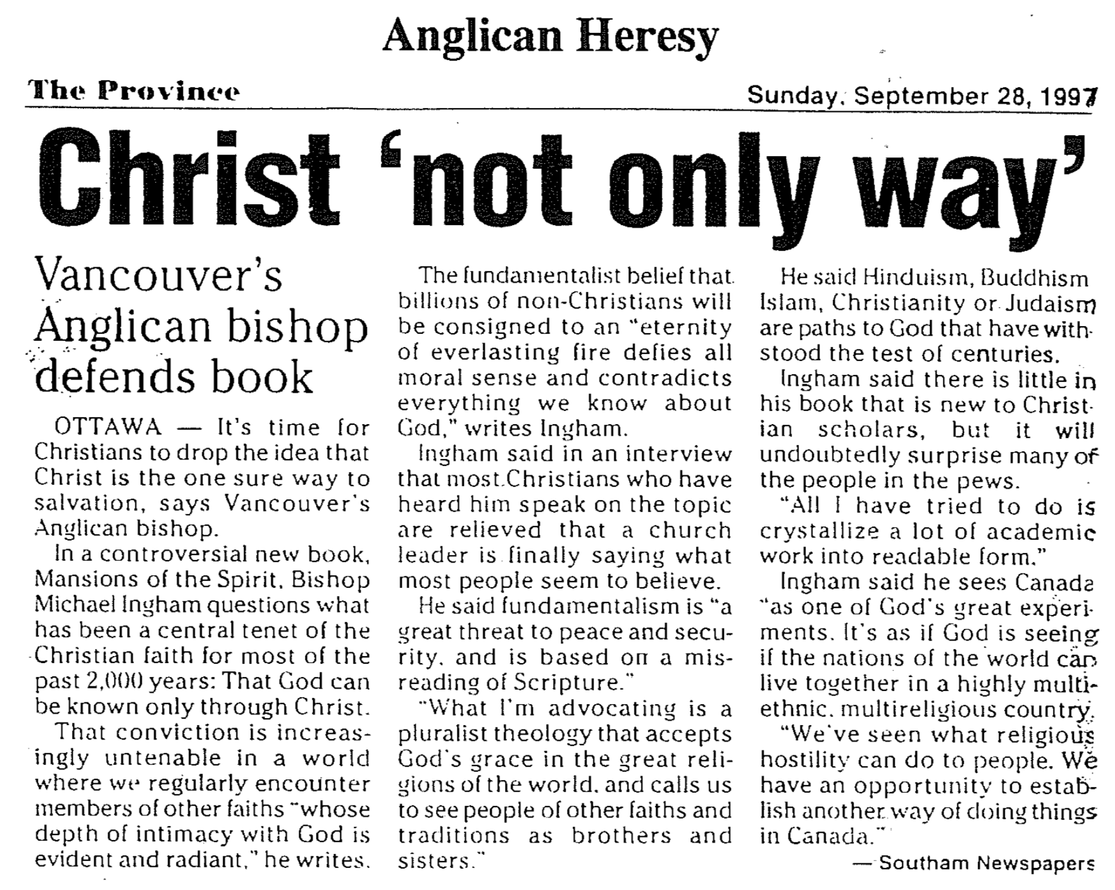

Eternal Security in Hebrews

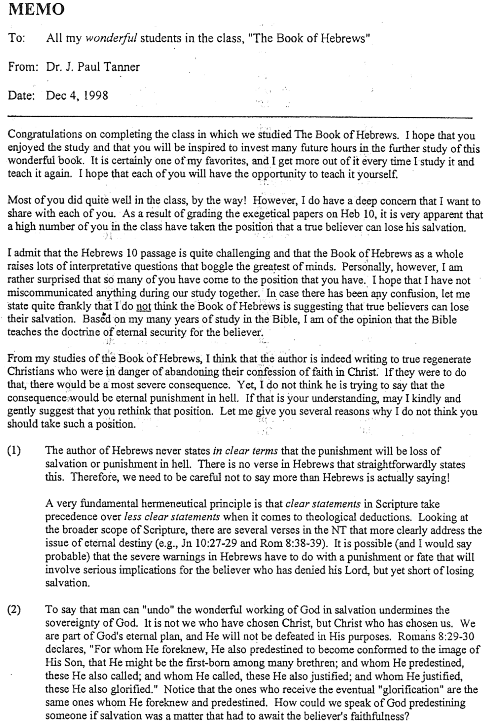
Eternal Security in Hebrews (2 of 2)

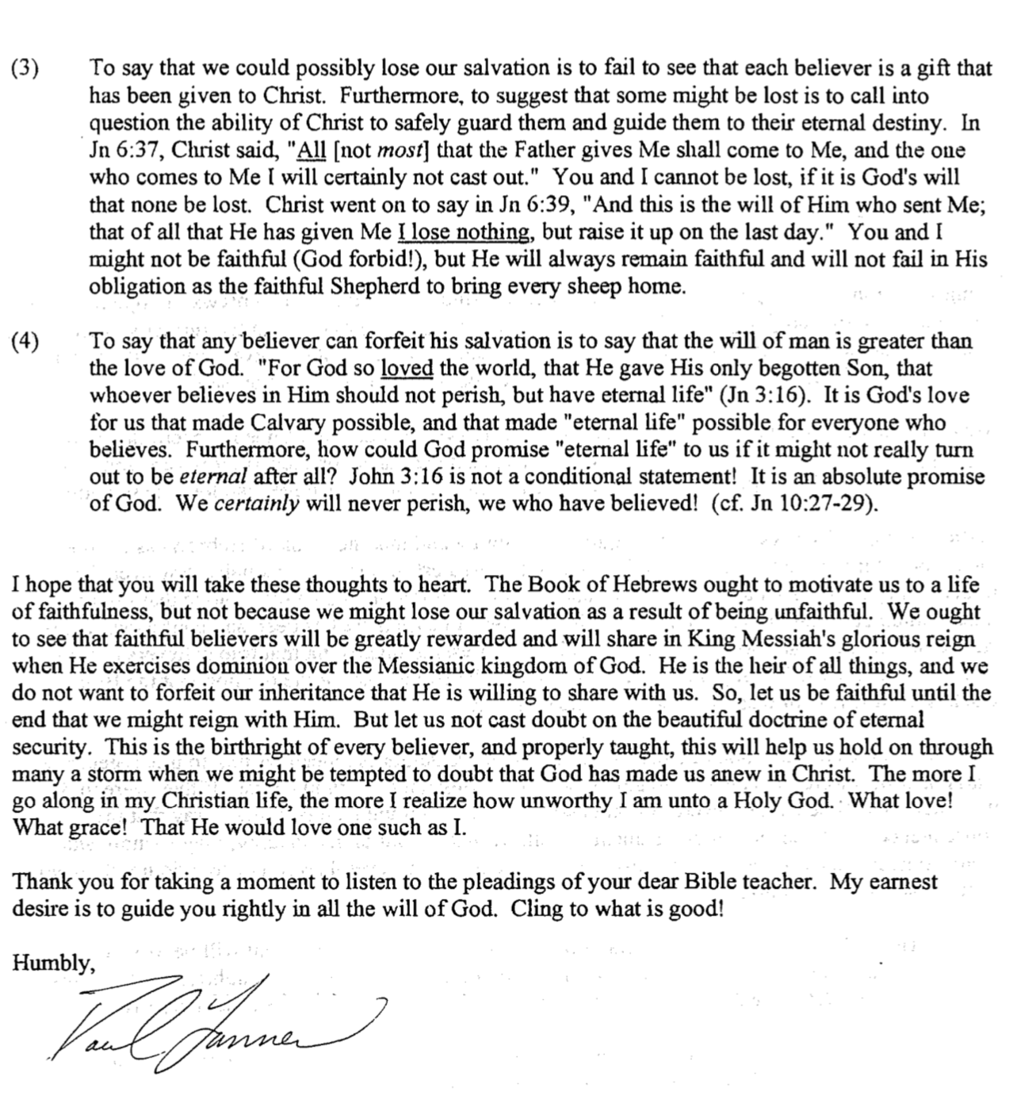
Views on the Warning Passages

Hebrews warns those who “fall away” five times (2:1-4; 3:7–4:13; 5:11–6:8; 10:19-39; 12:18-29). Each warning cautions readers not to reject Christianity for Judaism. These passages are perhaps the most controversial in the NT. But what penalty do these verses actually warn against—and to whom are they addressed? The basic issues can be contrasted in the following chart:

Views | False Believer | Former Believer | Carnal Believer
What group of Jews  is being addressed? | Unbelievers:  Professing “Christians” in the assembly who are not really believers after all | Believers:  Christians who sin because they do not see the superiority of Christ | Believers:  Christians who sin because they do not see the superiority of Christ
What is the nature of their punishment? | Never had salvation | Loss of salvation | Loss of reward
What is the result? | Hell | Hell | Divine discipline  (even by death)
Which theological perspective holds to this view? | Reformed  (Presbyterian, BP, etc.)  Some Arminians too | Arminian  (Methodist, AOG, Nazarene, etc.) | Partakers  (Baptist, Bible  Church, etc.)
Strengths | It takes the seriousness of the warnings as signifying hell | It takes the seriousness of the warnings as signifying hell | Loss of rewards as a judgment for true believers is more biblically consistent than loss of salvation
Weaknesses | Hebrews consistently speaks of the readers as genuine Christians  (3:1; 4:14; 10:23, 39) | “Temporal security” goes against the NT doctrine of justification by grace (John 3:16; Rom. 8:28-39) | Texts refer to judging persons, not deeds (“fire that will consume the enemies of God,” 10:27; cf. 6:8) though these may denote the temporal (not eternal) fire of AD 70 Jerusalem
Adherents | Hughes, Hebrews, 420;  McKnight (below), 34; Toussaint, GTJ (1982): 67, 78-79 | Attridge, Hebrews, 293-96;  Lane, Hebrews 9–13, 295-96 | Dillow, Final Destiny, 532; Pentecost, in Integrity of Heart…,140; Oberholtzer, BibSac (1988): 412-25; Gleason, BibSac (2000)

For two other views not noted above see Scot McKnight, “The Warning Passages of Hebrews: A Formal Analysis and Theological Conclusions,” Trinity Journal 13 (Spring 1992): 23-25. He says that scholars also hold to the hypothetical view (that does not see apostasy as possible) and the community view (that applies the text only to groups rather than individuals). However, neither of these views has received much of a following and thus is not treated above.
Views on Eternal Security and Perseverance

Can a Christian lose his salvation? This question is often answered from either the Calvinistic or Arminian view. However, a third, meditating view draws from both of these views. This Partakers (Inheritance) view, is taught by Joseph C. Dillow, Final Destiny: The Future Reign of the Servant Kings, 4th ed. (Monument, CO: Paniym Group, 2012). This monumental work of 1093 pages is very scholarly and yet extremely readable, comforting and convincing to me. Note the distinctions between these three views:

Issues | Reformed | Arminian | Partakers
How does each system define election and perseverance? | God sovereignly elects to salvation and helps believers persevere in faith until death | God elects those whose free will accepts Christ and preserves them unless they lose faith | God elects to salvation; some do not persevere, but the faithful will partake of rewards
What specific elements of salvation make up this system of belief? | Total depravity  Unconditional election  Limited atonement  Irresistible grace  Perseverance | Natural inability  Conditional election  Unlimited atonement  Prevenient grace*  Conditional perseverance | Total depravity  Unconditional election  Unlimited atonement  Irresistible grace  Conditional perseverance
How does this view see carnal Christians  (e.g., 1 Cor. 3:1-5)? | They aren’t Christians or have little commitment in a particular area | They spurn Christ to the point of almost losing their salvation | These believers lack blessings now and later  (but are still saved)
Do all believers persevere until death? | Yes  1 Cor. 15:2; Phil. 1:6 | No  Rom. 8:13; Gal. 5:21; 6:8 | No  1 Cor. 3:15; Rev. 3:26
Can a true Christian lose his salvation? | No,  it is eternally secure | Yes,  it is not eternally secure | No,  it is eternally secure
Is 100% assurance of salvation possible? | Yes, if one knows Christ as Saviour | No, since no one knows if  he will persevere | Yes, if one knows  Christ as Saviour
How does this system counsel believers in habitual sin? | “You better re-examine whether you genuinely trusted Christ” | “You either lost your salvation or never were really saved” | “You must turn from your sin to be fully rewarded (Heb. 3:14)”
How do those struggling with sin gain motivation? | From fear that they may not actually be saved after all | From fear that they may not have sufficiently maintained their salvation | From fear of missing rewards (their inheritance can be lost but not their salvation)
What actually results in the listeners from this teaching? | They may become carnal Christians by doubting their salvation | They believe God must always be appeased  (low view of grace) | They will more likely appreciate God’s faithfulness to them
Who holds this view? | John Calvin (d. 1564),  Reformed churches,  Bible-Presbyterians & Presbyterians,  Charles Hodge,  Arthur Pink | Jacob Arminius (d. 1609),  John Wesley, Methodists,  Wesleyans, Nazarenes, Holiness churches,  Pentecostals/Charismatics | Baptists, Bible churches,  Joseph Dillow,  Zane Hodges,  Earl Radmacher,  Charles Ryrie,  Rick Griffith

* Prevenient grace means God’s grace comes to all to enable them to believe, but it is not always successful and can be resisted.
Exhortations in Hebrews

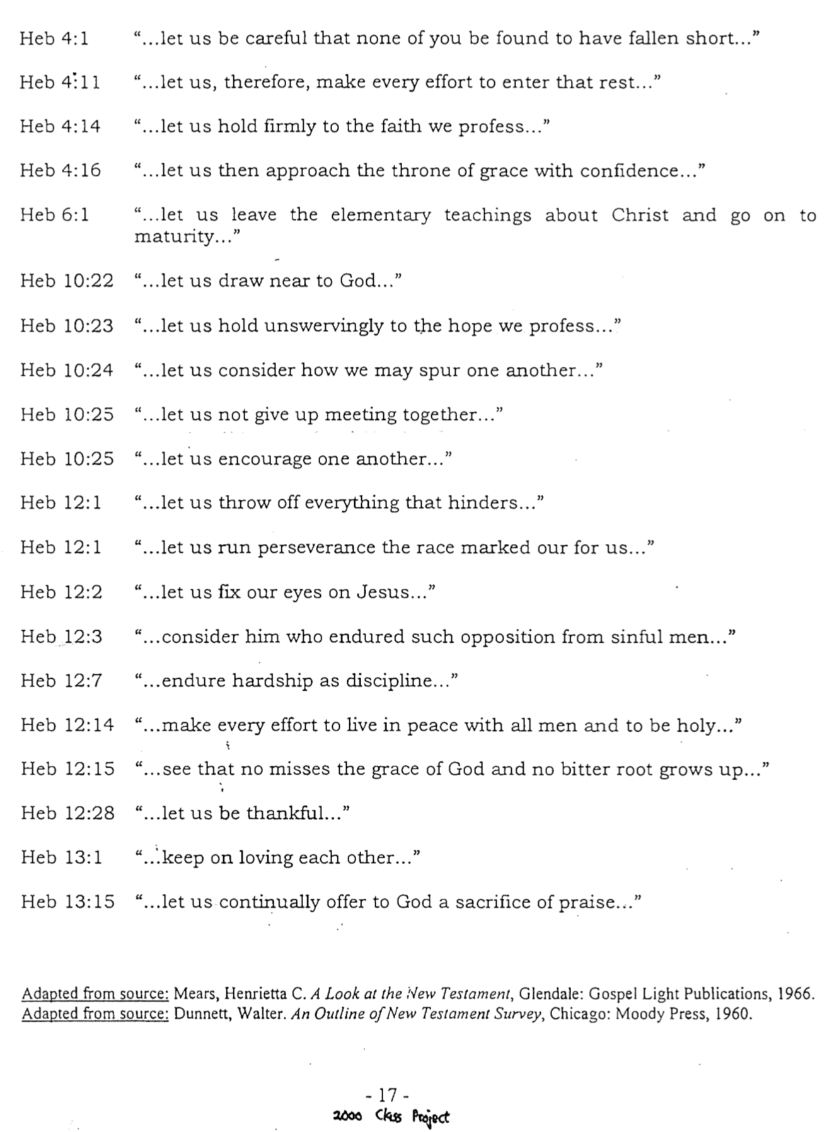
The 13 “Betters”

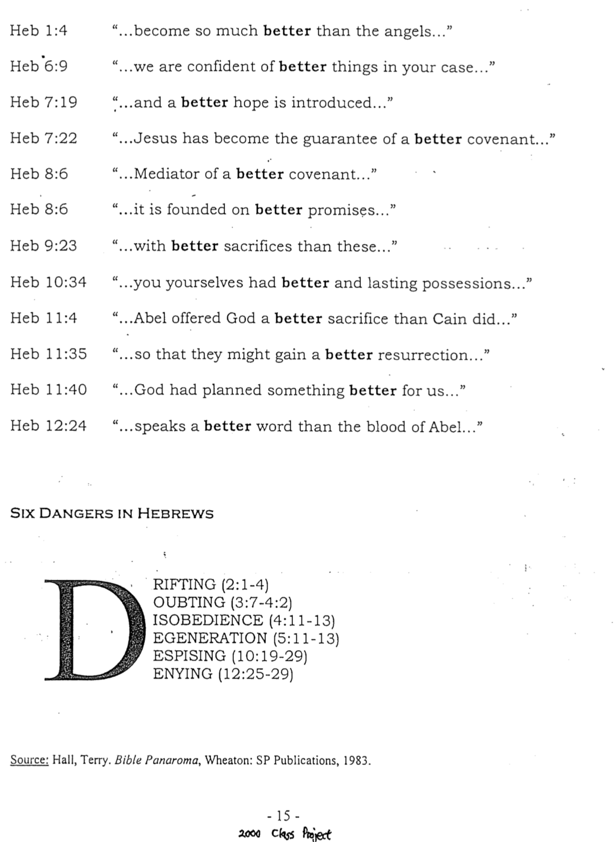
Views on the ‘Sabbath-Rest’ of Hebrews 4
Summarizing Richard James Griffith, “The Eschatological Significance of the Sabbath,” ThD diss. (Dallas Theological Seminary, 1990), 279-311

“There remains, then, a Sabbath-rest for the people of God” (Heb. 4:9). What does this mean? At least seven different views can be cited, each with their strengths and weaknesses.

View | Strengths | Weaknesses
Present Sabbath Rest and Future Heavenly Rest  (held by Seventh-day Adventist scholar Bacchiochi) | - Rest is present since those 'who have believed are entering' (4:3).  - “Remains” literally means “to leave behind” the Sabbath (4:1).  - “Strive to enter that rest” shows the Sabbath is permanent (4:11). | - But this view says the Sabbath is also future (inconsistent).  - “Remain” also appears in 4:6 and makes no sense there as “to leave behind.” In fact, 4:1 does not even mention the Sabbath.  - How could “enter” be an appropriate verb to use for “observe” (4:3, 11)?  - If the readers were Sabbath-keepers, why command what they were already doing?  - Joshua didn’t fail to lead Israel into the weekly Sabbath.  - The book emphasizes the new covenant—not a Mosaic Sabbath.  - Changes meaning from the land rest of Hebrews 3.
Present Sunday and Grace Rests and Future Heavenly Rest  (Jewett, Beckwith & Stott, J. Owen) | - Christ rose on a Sunday.  - Believers worshipped on Sunday (Acts 20:7; Rev. 1:10). | - Sunday was a day of worship (but not rest) in the early church. A required weekly day of rest for Christians is never commanded in Scripture. Sunday was not a rest day until the fourth century.  - One cannot properly argue that, because heavenly rest has not yet been consummated, we must therefore preserve the physical symbol of rest.
Present Spiritual Rest  (Chafer, Kent, Thieme, Ellen Whit, most Adventists) | - The present tense of “enter” (4:3) shows that entering is through believing.  - Enter “today” (3:7, 13, 15; 4:7).  - Believers are delivered from works-oriented salvation (4:10). | - God’s rest is physical more than spiritual as Canaan is a physical place. Just because Israel did not enter the rest in Joshua's day does not mean that the nature of the rest has changed.  - Rest is preceded by resurrection (Rev. 20:4f.).  - The Sabbath rest is “another day” (4:8) or time period (not a state of being).  - The Sabbath rest is like God’s rest from his work (4:10), which is good work (and thus is not like “works-oriented salvation,” which is bad).  - Exhortations to diligence (4:1, 11) refer to an eschatological rather than soteriological rest since believers need no effort to be saved.
Present Spiritual and Future Heavenly Rest  (Clarke, Barrett, Wiersbe) | - Since the rest is God's, it must be both present and future  - People enter it now (a present aspect) but also must strive to enter it (future) | - The parallel with the Israelite generation makes a dual focus improbable. The generation under Joshua could not in some sense have their rest spiritually without having it physically.  - The parallel between the Sabbath rest available and God's “physical” rest (4:10) suggests only the latter (physical) rest.  - To read a spiritual/salvation rest into the passage goes beyond its stated evidence.

View | Strengths | Weaknesses
Future Heavenly Rest  (Attridge, Barnes, Bruce, Delitzsch, Gaebelein, Lincoln, Moffatt, Morris, von Rad, Vos, Westcott, and others–this is the most popular view) | - The promise of entering his rest still stands (4:1).  - The believer's rest occurs after death (Rev. 14:13).  - Sabbath typified “the world to come” by rabbis.  - Rest can’t be land since believers expect 'better things' (6:9).  - Rest in Hebrews 3 is redefined in 4:4-5 as a type (cf. 1 Cor. 10:1-13).  - Rest equals the heavenly sanctuary (6:19-20; 8:2; 9:11, 23-24; 10:19), heavenly Jerusalem (11:10, 16; 12:22; 13:14), and heavenly promised land (11:14ff.).  - The rest is called “God's rest” so it must be that which He has enjoyed in heaven since creation (Gen. 2:2-3). | - The first argument is valid, for indeed the text does indicate the eschatological rest to be future. Yet this does not automatically mean heaven.  - In the second argument, those who rest after death (Rev. 14:13) “reign with Christ a thousand years” (Rev. 20:4) on earth in the kingdom (Rev. 5:10).  - The rabbinic “age to come” referred not to heaven, but to a political-geographical experience in the kingdom with the Abrahamic Covenant fulfilled.  - Why can’t the believer’s rest be in a physical place such as the renewed earth? Heaven is also a physical place. The teaching that “better” cannot be physical is without scriptural support.  - Why attach a different meaning to rest than in chapter 3? The same word (“rest”) is used. Paul's typology (1 Cor. 10:1-13) is specifically defined but Hebrews 3–4 indicates no antitype of Canaan rest.  - In response to the claim that Hebrews associates “rest” with heavenly antitypes, these depictions are found farther along in the book in Hebrews 6–13. As such they are not actually contextually related to the rest theme in 4:1-13. In contrast, the immediate context (3:7-19) clearly relates the rest with the earthly land of Canaan, which God calls his rest in accord with the meaning in Psalm 95. Thus the immediate context is a better indicator of meaning than passages later in the book.  - How do we know God’s rest has been in heaven? He resides on earth too. God’s rest in Scripture relates not to heaven but to earth. It was after he finished creating the earth (not heaven) that He “rested.” Therefore, the land is “God's rest” since it was offered according to his promise (Gen. 12:1-3; 15:18) though it will not be claimed apart from Israel's repentance (Deut. 30:1-5).
Millennial Rest with Present Day Application  (Lombard, Riesenfeld, Jehovah’s Witnesses) | - Hebrews contrasts the present age & the age to come.  - Hebrews contrasts the transient earthly life with the eternal heavenly life. | - “Age to come” is a millennial term, so this first point has merit.  - Claiming a present spiritual rest and eschatological physical rest is inconsistent; it applies two different meanings to “rest” in the same context.  - This view also must accept a dual meaning to the concept of resting from one's work (4:10): the present aspect viewing this work negatively and the future aspect seeing it positively.
Future Millennial Rest  (G. Archer, Buchanan, Griffith, Zane Hodges [BKC], Kaiser, Lang, Oberholtzer, Seiss, Toussaint) | - I believe this view has the strongest support, so see the more extensive explanation below. | - The text seems to indicate that the rest is a present rest (not future), but this is explained below.  - This view may also have other weaknesses, but these can be explained (see next three pages).
Support for the Future Millennial Rest

1. The context of the previous chapters talks much of the millennial kingdom.
a. Believers are designated “companions” (metochoi me,tocoi) with Christ in his anointing by God as messianic King (1:9 quoting Ps. 45:6-7).
b. Christ's victory over his enemies before the millennium (1:13) is linked with the promise that believers will share in that victory (swthri,a; 1:14).
c. The same eschatological salvation (swthri,a) is referred to three verses later (2:3), which Christ will share with man in “the world to come,” or Millennium (2:5).
d. That Christians are companions with Christ in his future dominion is repeated in chapter 3 (3:1, 14; cf. 6:4; 12:8). However, the saints' promise of reigning with him is contingent upon their continued faithfulness to their confession (3:6b)

2. The land promise is mentioned repeatedly in the passage itself (3:7–4:13).
a. The text quotes Psalm 95 five times (3:7-11, 15; 4:3, 5, 7) to emphasize millennial rest in Canaan. The “rest” of Psalm 95 is not eternal rest in heaven or the spiritual rest of salvation, but the repose Israel sought in her own land. As Psalm 95 is an enthronement psalm that depicts the time of the Messiah’s rule, it is appropriate that the author use this particular psalm to refer to the millennial rest.
b. The “rest” in this passage must be something that Joshua could have offered his people had they believed. Certainly he could not have offered them salvation (spiritual peace) or eternal life (heaven). However, what he did offer was access to the land so that wherever the people would tread, that land would be theirs (Josh. 1:3).
c. The millennial view best explains the “work” in 4:10: “for anyone who enters God's rest also rests from his own work, just as God did from his.” Most commentators see the work here as a figurative “abstention from servile work” or sinful deeds at all times. However, ceasing work in a literal sense makes better sense since the text compares man's rest with God's rest from his literal work of creation; certainly God does not rest from sinful deeds.

3. Other Scripture often depicts Israel as literally resting in the millennial age.
a. God says of Zion, “This is My resting place forever and ever; here I will sit enthroned, for I have desired it” (Ps. 132:14).
b. As God rests there, so will Israel, for He will give the nation rest from pain and turmoil and harsh service in which it has been enslaved (Isa. 14:3).
c. He also promises, “My people will live in peaceful dwelling places, in secure homes, in undisturbed places of rest” (Isa. 32:18; cf. Ezek. 34:15).
d. The kingdom age is spoken of as a time in which God “will rest in his love” (Zeph. 3:17).

4. Extra-biblical references taught about the Sabbath rest in the kingdom age.
a. Jews first taught the millennial Sabbath:
1. When Adam died at age 930, “he lacked 70 years from 1000 years, for 1000 years are like one day in the testimony of heaven” (Jubilees 4.30-31, 2nd cent. BC).
2. Israel “will dwell in confidence in the land. And then it will not have any Satan or any evil (one). And the land will be purified from that time and forever” (Jub. 50.5; cf. suppression of Satan’s power in Revelation 20:4).
3. In Life of Adam and Eve 51.2 (1st cent. AD), the archangel Michael says to Seth regarding Eve's death, “Man of God, do not prolong mourning your dead more than six days, because the seventh day is a sign of the resurrection, the rest of the coming age.”
4. In this age Israel will be free from laborious work (2 Enoch 65:9 late 1st cent. AD).
b. Christians followed this common Jewish idea of a literal 1000 years of Sabbath:
1. The six days of creation each represent one thousand years of history (based upon Psalm 90:4), which are followed by “the Sabbath” millennium that commences “when his Son shall come” (Epistle of Barnabas 15.4-9).
2. Augustine wrote before he became amillennial, “Therefore, the eighth day signifies the new life at the end of the world; the seventh day, the future rest of the saints on this earth” (Augustine, Sermons on the Liturgical Seasons, 259.2).
3. “A kingdom is promised to us upon the earth, although before heaven, only in another state of existence; inasmuch as it will be after the resurrection for a thousand years in the divinely-built city of Jerusalem” (Tertullian, The Five Books Against Marcion, 3.25).
4. “And 6000 years must needs be accomplished, in order that the Sabbath may come, the rest, the holy day ‘on which God rested from all his works’” (Hippolytus, Fragments on Daniel, 2.4).
5. Hebrews 4:8 refers to the Sabbath rest as a time period: “For if Joshua had given them rest, God would not have spoken later about another day.” Obviously “day” refers to another time period, not another state of being. This does not definitively argue for the millennial view since the heavenly rest view relates to a future time period; however, it is consistent with the kingdom view and inconsistent with the “present spiritual rest” orientation.

6. An Objection against the millennial view concerns verse 3a, which seems to warn against missing a present rest ("Now we who have believed enter that rest—eivjserco,meqa ga,r eivj @thvn# kata,pausin oiv pisteu,santej)." This immediate aspect is reflected in all of the major English translations (NIV, NASB, NEB, REB, KJV, NKJV, RSV, GNB, NBV, Amplified, Moffatt, Phillips, Williams).

Response: However, despite this support, there is reason to question a present nuance here. Because of these factors it is better to advocate a futuristic (proleptic) use of the present here. The use of a futuristic present is supported by these factors:

a. The preceding proves an overwhelming amount of eschatological emphases in the passage, in the Book of Hebrews as a whole, in parallel Scriptures, and in the extra-biblical literature.

b. A futuristic present could demonstrate an even more affirmative tone regarding the assurance of rest. Turner notes that futuristic presents "are confident assertions intended to arrest attention with a vivid and realistic tone or else with imminent fulfillment in mind, and they are mainly restricted to the vernacular."

c. The use of the futuristic present is not only well established, but, interestingly enough, the verb e;rcomai employs the futuristic present perhaps more than any other verb.

1) The Messiah is called the ov e;rco,menoj, the "Coming One" (Matt. 11:3), which means not one who has already arrived or who is in process of arriving (presently) but one who is expected in the future.

2) The same nuance is used of Hli,aj e;rcetai, "Elijah is coming" (Matt. 17:11), which is present in form but future in meaning.

3) The nobleman who distributed ten minas in Luke 19:13 commanded his servants, "Put this money to work . . . until I come (evn w|[ e;rcomai) back," employing a future sense.

4) Christ referred to his future return with the present form pa,lin e;rcomai, "I come again" (John 14:3), which obviously has the futuristic sense of "I will come again."

5) Paul used the futuristic present die,rcomai, "I go/am going" (1 Cor. 16:5), to designate an upcoming visit.

6) Even in other languages verbs of going often employ a futuristic present.
The Eschatological Significance of the Sabbath
A Summary of the ThD dissertation by Richard James Griffith, Dallas Theological Seminary, 1990

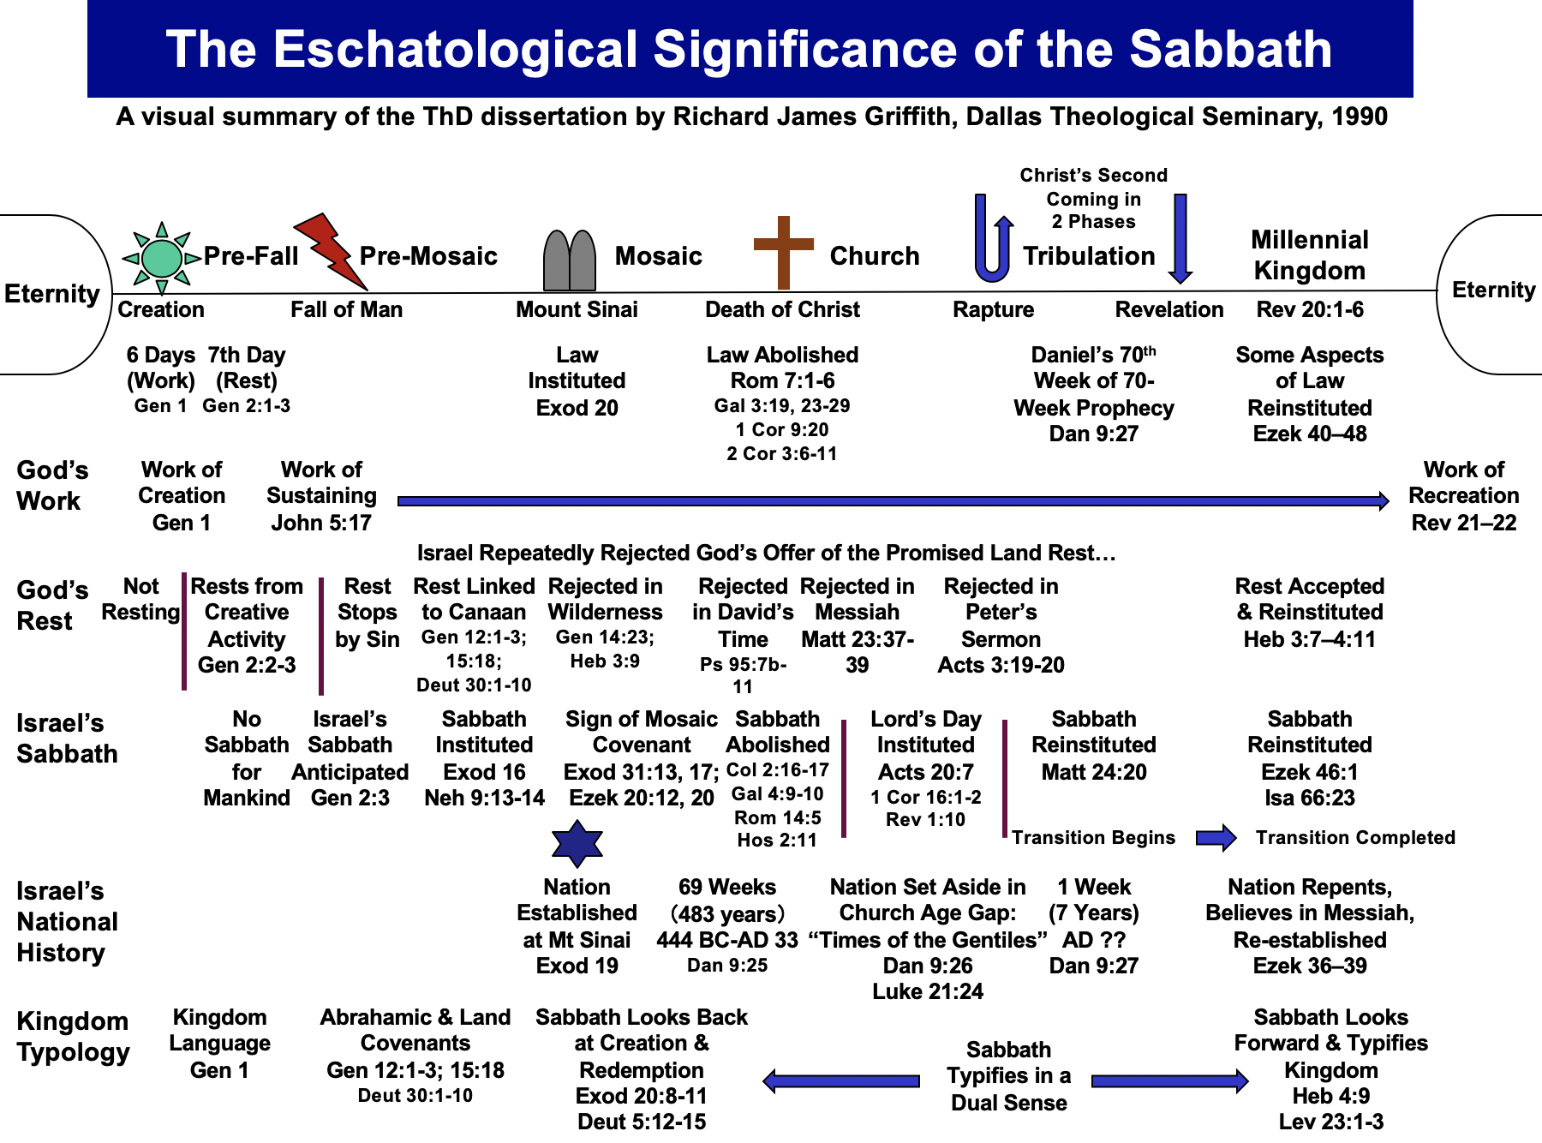
The High Priest’s Garments
The Jews for Jesus Newsletter

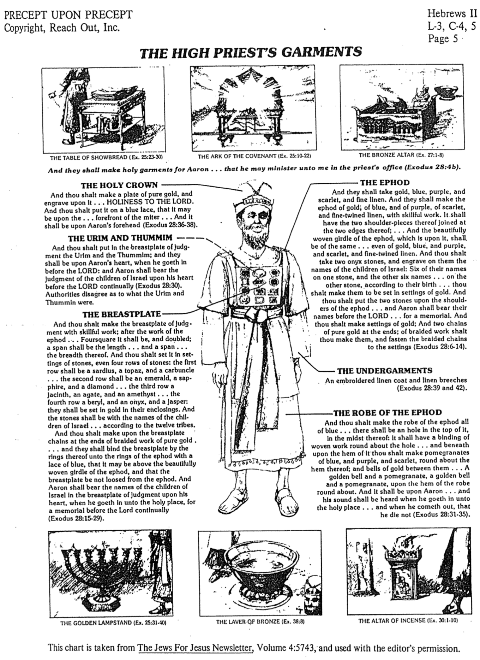
Melchizedek and OT Quotes in Hebrews

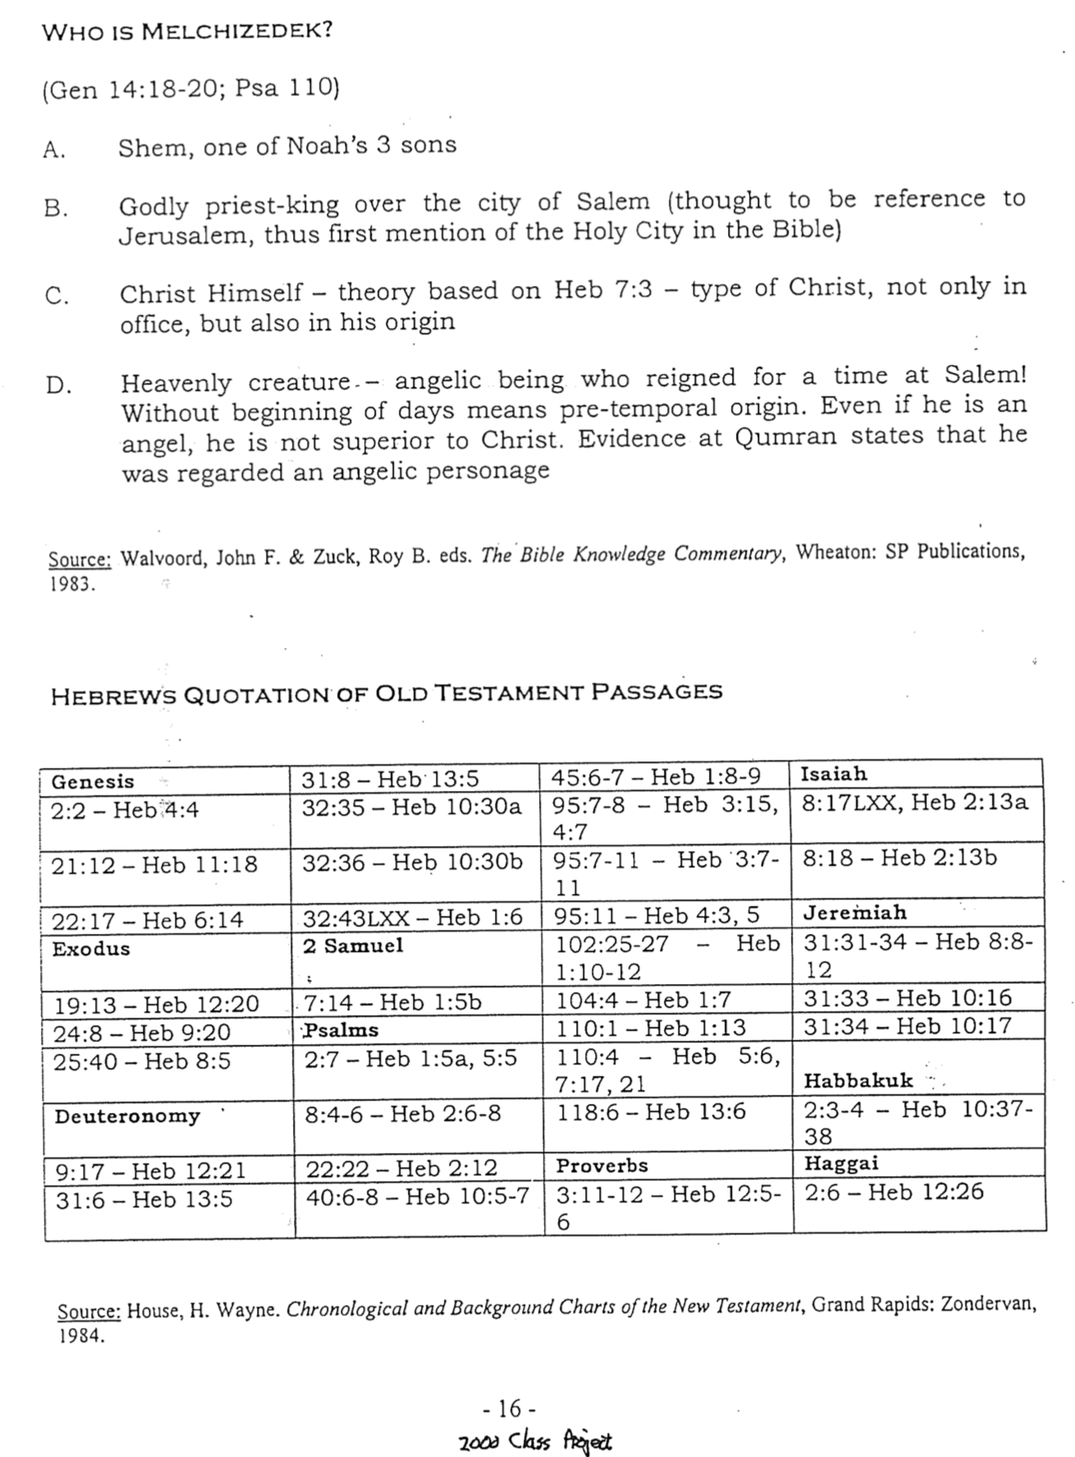
Chart and Furnishings in Hebrews

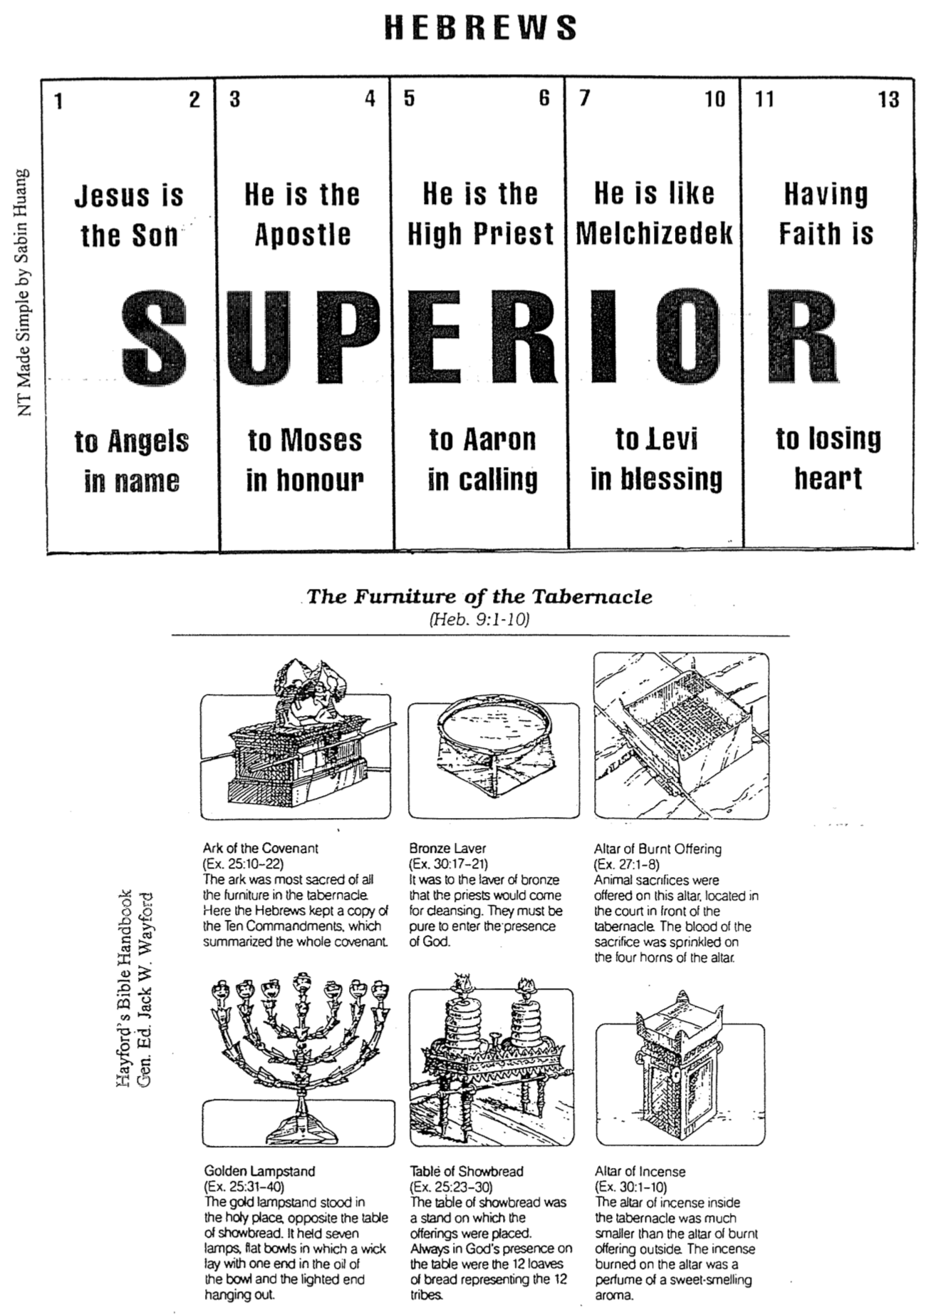
Christ vs. the Old Order

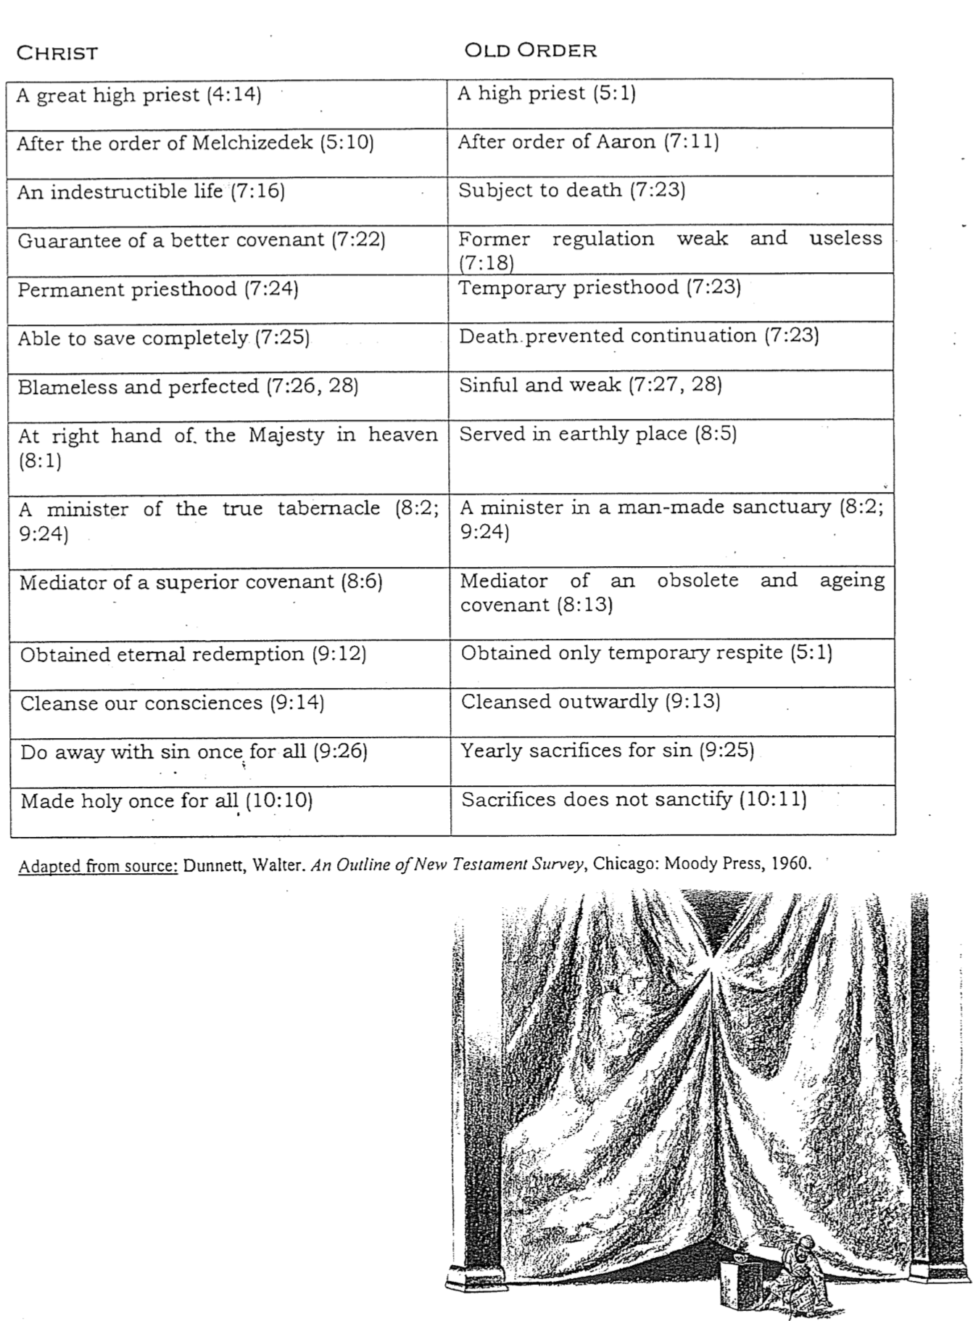
Truth in Action Through Hebrews

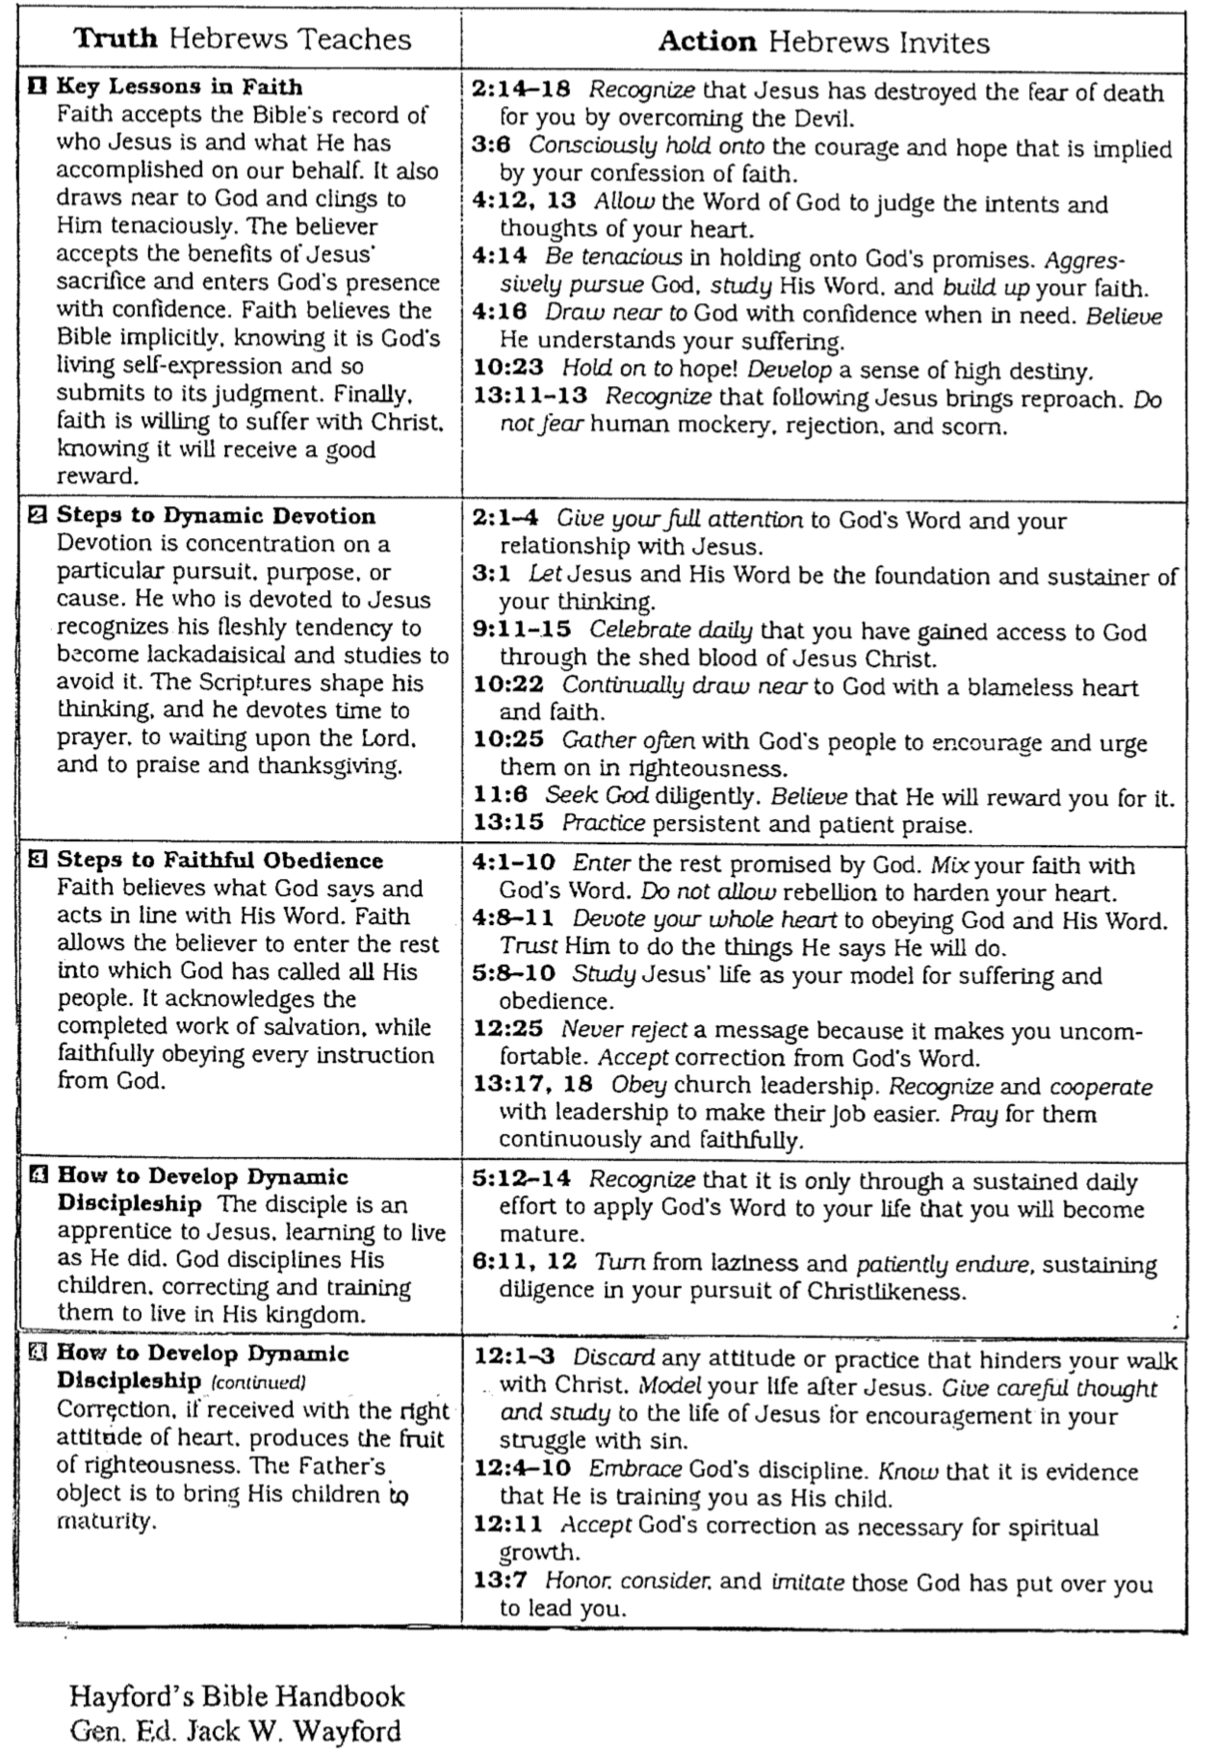
Christ as Prophet, Priest, and King
How Can He Be a Priest from the Line of Judah?

The Jewish readers addressed in Hebrews did not see how Jesus could be their high priest. After all, Christ descended from the line of Judah (the kingly line; 7:14) through David whereas all priests came from the line of Levi through Aaron (7:11). No one could be both an Aaronic priest and a Davidic descendant qualified to be Israel's king. This can be diagrammed like this:
Jacob had 12 sons but only one became the priestly line and only one the kingly line
(Gen. 49:10; Num. 3)
Jacob

Levi
Judah
10
Other Sons

Aaron
David

Priest
Prophet
King

Prophets were not selected by genealogy, so they could come from any tribe.
Jeremiah was both priest and prophet
Jewish tradition held that Isaiah was of the kingly line and also a prophet. Zephaniah also was of the kingly line (Zeph. 1:1).

However, the actual picture for Jesus is that his priesthood is not of Aaron but of Melchizedek, the ancient OT figure to whom Abraham paid tithes (Gen. 14:18-20) and had no family line. This is how Jesus can be prophet, priest, and king simultaneously (Heb. 7:11; cf. Ps. 110:4).

Prophet
King

Priest
This does not intend to teach that there were others in the order of Melchizedek who were also prophets or kings, for there were none. This only shows that Christ's priestly heritage came from Melchizedek—not Aaron.
Contrasting the Priesthoods

Hebrews 5:1-10 and Hebrews 7 provide much information on the priestly ministries of Aaron's descendants, of Melchizedek, and of Christ. Make as many observations as you can in these three columns below, then draw lines between your lines to show comparisons and contrasts.

Aaronic Priesthood | Melchizedek | Jesus as High Priest

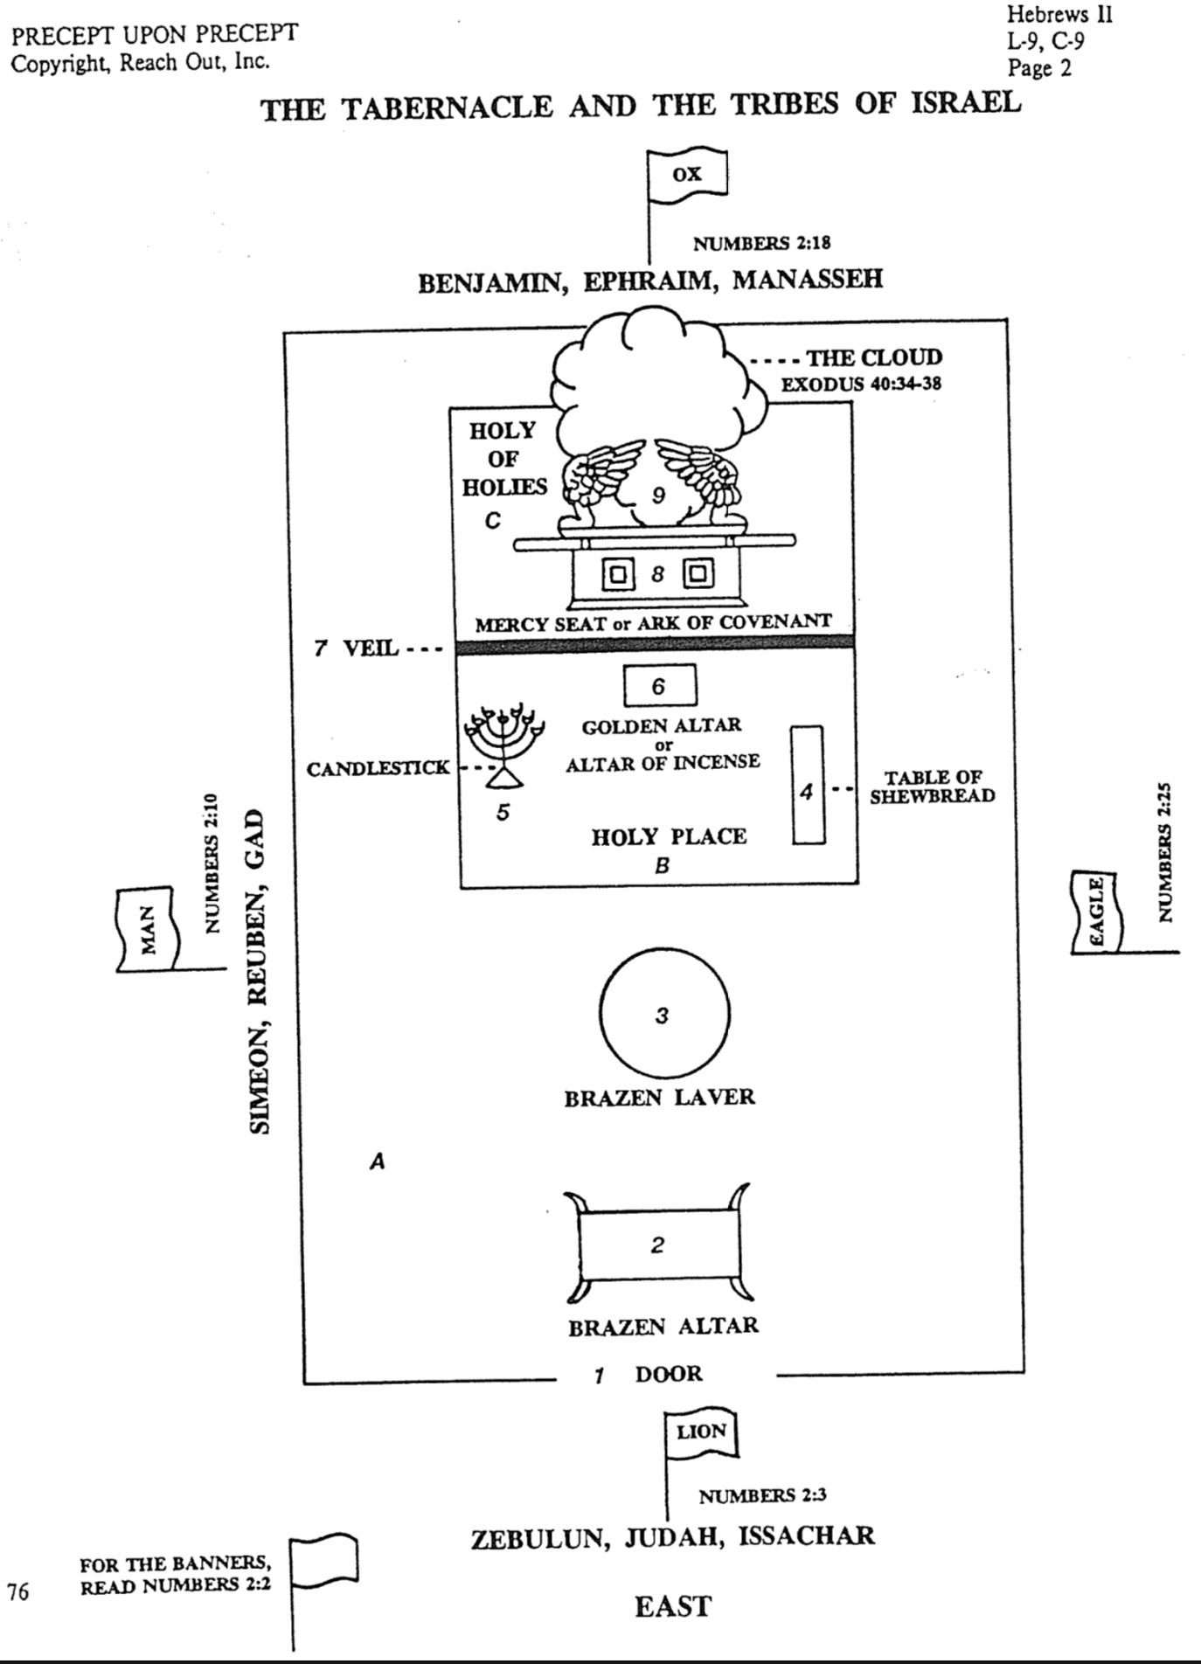
The Tabernacle and the Tribes of Israel

Backsliding Temptations

Why not start off our study in Hebrews by being really honest with one another? We often share how Christ has changed our lives. That is wonderful. But each of us also is still tempted by certain aspects of our "BC" (Before Christian) days. These things tempt so many Singaporean Christians that one third of them return to their former religion. So what was your religion or philosophy before you became a Christian (Buddhist, atheist, agnostic, nominal Christian, genuine Christian family, etc.)? What about your BC days still tempts you to return today (had more time, legalism, freedom, etc.)?

My Background | The Hebrews' Background
My Temptations | The Hebrews' Temptations

Implications of Christ's High Priesthood

Hebrews goes to great lengths to prove Christ's high priesthood (4:14). This doctrine relates better to Jewish readers than to us. Also, it is not emphasized much in the rest of the NT. So why would this truth be so important to us?

- Jesus going through the heavens makes us want to hold onto this faith (4:14).

- He also identifies with us by making atonement for our sin (5:1-2).

- Christ prays for us (5:7).

- When we understand that Christ is our high priest then we can confidently experience what it means to be truly forgiven. Jews better understood how Jesus brought his blood of atonement "behind the curtain into the holy of holies" (6:19-20), but we Gentiles also need forgiveness.

- His high priesthood means He's worthy of worship which motivates us to persevere in our faith (4:14; 6:19) so we will not lose our rewards by falling away (6:7-11).

- Christ has a heart for us. As the earthly high priest was tempted to sin, so Christ sympathizes with us–even though He didn't ever sin (4:15). He understands us!

- The high priesthood of Jesus gives us boldness to approach Christ in prayer (4:16a). Don't think He's too high and lofty to listen to you!

- Here we find mercy and grace in times of need (4:16b).
- Mercy means He doesn't give us what we deserve (hell, punishment).
- Grace means He gives us what we don't deserve (heaven, forgiveness).

- Knowing Christ's high priesthood (that He has provided atonement and is superior to the Law) is basic to learning the "solid food" of the Bible (5:11-12). Such "food" consists of learning about righteousness that mature believers alone care about to distinguish between good and evil (5:13-14). I suspect this would include aspects of holiness that immature believers consider as getting "very picky": making every word spoken a holy one, being saturated with God's Word, submitting every area of life to Christ's Lordship, etc.

- Christ's high priesthood clarifies that believers are not under the Mosaic law since the Aaronic priesthood has been superseded (7:12, 18-19). Therefore, many rules do not apply to us—food laws, Sabbath, feasts, etc.

- His priesthood also assures our salvation due to his intercession for us (7:25).

- As high priest Christ fully meets our needs since He doesn't have the limitations of the OT high priests who repeatedly had to offer sacrifices for their own sins as well as for the people (7:26-28).

Old vs. New Covenant

Hebrews 8:8-12 is the longest OT quote in the NT. It's from Jeremiah 31:31-34, the text that has the most explicit OT teaching on the new covenant. Solomon's temple was about to be destroyed in 586 BC and life under the old (Mosaic or Sinai) covenant was going to be radically altered. So God used Jeremiah to comfort Israel by revealing an even better covenant to come.

In like manner, the Hebrews passage also reminds us of this new covenant just before the temple would be destroyed a second time in AD 70 (8:13). Unless we understand the old covenant, though, we won't appreciate the new. So let's draw some contrasts between the two covenants from Hebrews 8…

Old Covenant | New Covenant
High priest stood in the tabernacle (10:11)  (atoning work was incomplete) | Christ sat down in heaven (8:1a; 9:24; 10:12)  (atoning work was complete)
Priests never ruled | Christ is next to God's throne (8:1b)
Priest served in temporary tabernacle (8:13) | Christ serves in true tabernacle (8:2a)
Tabernacle set up by man (8:2c) | Tabernacle set up by God (8:2b)
Type: Sanctuary a copy and shadow (8:5a) | Antitype: Heaven is the reality (8:5b)
Moses mediated old but good pattern (8:5c) | Christ as mediator of better promises (8:6)
Imperfect (8:7a) | Perfect (8:7b)
Obsolete, aging, and soon to disappear (AD 70) after the book of Hebrews was written (8:13b) | New and thus replacing the old covenant  (8:13a)
Holy Place and Most Holy Place (9:1-8) | Earth and Heaven (9:11)
High priest passes between rooms (9:7) | Christ passed from earth to heaven (9:11)
Could not cleanse the conscience (9:9; 10:2) | Cleanses the conscience (9:14; 10:22)
High priest entered Holy of Holies with animal blood for atonement (9:12a) | Christ entered heaven with his own blood  for atonement (9:12b)
Blood of animals covered sin temporarily  (9:13; 10:1-4) | Blood of Christ forgave sins eternally  (10:14)
Required only animal sacrifices  for purification (9:22) | Required a much greater Sacrifice  for purification (9:23)
Repeated sacrifices (10:1-2) | Once-for-all sacrifice (9:26, 28)

Parallels Between Hebrews 6:4-12 and 10:26-36
William L. Lane, Hebrews 9–13, vol. 47, Word Biblical Commentary (Dallas: Word, 1991), 2:296-97

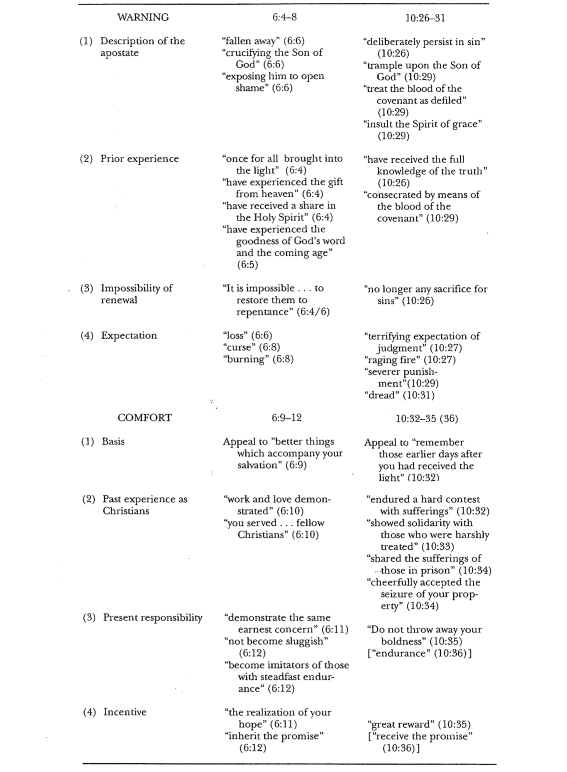
The Hall of Faith
Examples of Endurance from Hebrews 11

Why are there Halls of Fame for sports heroes? Examples have a way of spurring us on to greater heights in ways that theory can never do. The author of the book of Hebrews knew this well. This is why he listed specific people who faithfully endured amidst difficulty to encourage his readers that they were not alone in their struggle. These people are enrolled in God’s Hall of Faith!

Hero | Challenge | Demonstration | Endurance & Faith Lessons
Us Believers in Creation (3) | Explain how the world came into being when we were not there | Trust that God created the universe by speaking (3a) | Faith can see the unseen  God did not provide any eyewitnesses of creation that we might trust in his word
Abel (4) | Please God in righteous offerings (Gen. 4:2-5) | Offered a better sacrifice than did Cain (4a) | Offer what God requires  Worship in humility
Enoch (5) | People of his age did not seek to please God | Pleased God in his lifestyle of holiness | Please God (cf. Eph. 5:17)  Faith goes against the flow
Noah (7) | Had to heed God’s warning of a worldwide flood with no sign of rain | Built the ark despite ridicule  Believed it would rain | Endure patiently (120 years to build the ark!)  Do God’s “silly” will despite opposition
Abraham  (8-12, 13-19) | No land  No son, then must sacrifice him (Gen. 22) | Moved to an unknown land  Wife conceived  Gave his best | Don’t live in the past  Trust God’s renewal ability  Be generous like Abraham
Isaac (20) | Trust God to bless both Jacob & Esau (Gen. 27:27-29) | Went against tradition by blessing both boys | Trust God’s Word over tradition
Jacob (21) | Could have asked, “Should I reveal the future of each son?” | Blessed every son and worshiped God outside of Canaan | Faith does the unpleasant things  Faith looks to the future with hope
Joseph (22) | Could have felt that Israel would remain in Egypt forever | Commanded, “Bury me in Canaan” (Gen. 50:25) | Faith acts now based on God’s promises yet unfulfilled
Moses’ Parents (23) | Obey Pharaoh (Exod. 1:22) or save their son’s life (Exod. 2:1-4)? | Trusted that God would protect a baby floating in the Nile | Trust in God’s protection often is risky, humanly speaking
Moses  (24-28) | Grasp of power & materialism  Leave Egypt?  Will blood on the door save? | Chose slavery  Led the Exodus  Kept Passover | Reject worldly pleasures for difficulties that have God’s blessing

Hero | Challenge | Demonstration | Endurance & Faith Lessons
Israel at  the Red Sea (29) | Trapped by Pharaoh & water (Exod. 14:9) | Crossed between walls of water (Exod. 14:21-22) | Look up when trapped  Get God’s bearings  March in his will
Israel at Jericho (30) | Non-military plan on Canaan’s first city (Josh. 6:1-5) | Circled & shouted (Josh. 6:6-16) | Obey God’s non-conventional strategies
Rahab (31) | Hide spies or not (Josh. 2:1-3)? | Hid them and helped them escape (Josh. 2:4-16) | Show individual faith when the group won’t believe
Gideon (32) | From a wimpy clan & had his doubts (Judg. 6:11-22) | Attacked when vastly outnumbered (Judg. 7:19-21) | God equips  Move with the movers  Grow in faith
Barak (32) | Fight foot soldiers against chariots (Judg. 4:13) | Overcame doubts to attack a stronger army (Judg. 4:14f.) | Growth in faith eventually helps us stand alone
Samson (32) | Militarily superior Philistines (Judg. 13–16) | Beat them despite lust and vengeful attitude | Be dedicated for God’s service  Overcome your biggest weakness
Jephthah (32) | Illegitimate child who was thrown out (Judg. 10:11) | Returned to his people as a judge | Conquer rejection by faith  God is bigger than our biggest failure
David (32) | Goliath vs. David’s wimpy size (1 Sam. 17) | Defeated him without a sword | The bigger they are, the harder they fall
Prophets (32) | Want godly wife  Don’t get involved  Protect your wife | Hosea: loyal to harlot  Amos: confronted sin  Ezekiel: wife died | Obedience supersedes comfort  Stand alone  Bear ministry sacrifices
Women with resurrected relatives (35) | Elijah had to help widow & dead son (1 Kings 17:8-20) | Raised the boy to life (1 Kings 17:21-24) | Regular people can do great things by faith (cf. James 5:17)
Persecuted (36) | Keep believing amidst trials  (2 Tim. 3:12) | Rejoicing in suffering (James 1:2) | Faith is always optimistic
Martyrs (37a) | Life itself is the dearest possession to most people | Stephen martyred (Acts 7)  Rome’s martyrs | True faith is faithful to death
Mistreated (37b-38) | Jeremiah: temptation to preach only positive things to avoid persecution | Kept preaching truth despite being deemed “negative” preaching (Jer. 32:3, 28, 36) | Faithful obedience is often persecuted (Jer. 32:2)  Don’t abandon convictions or truth when life gets difficult
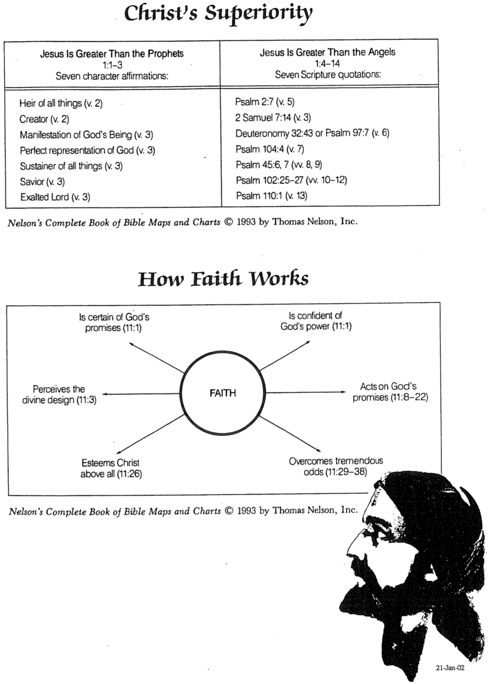
Christ’s Superiority & How Faith Works
Nelson’s Book of Maps and Charts

OT Quotes in Hebrews
Evangelical Dictionary of Biblical Theology

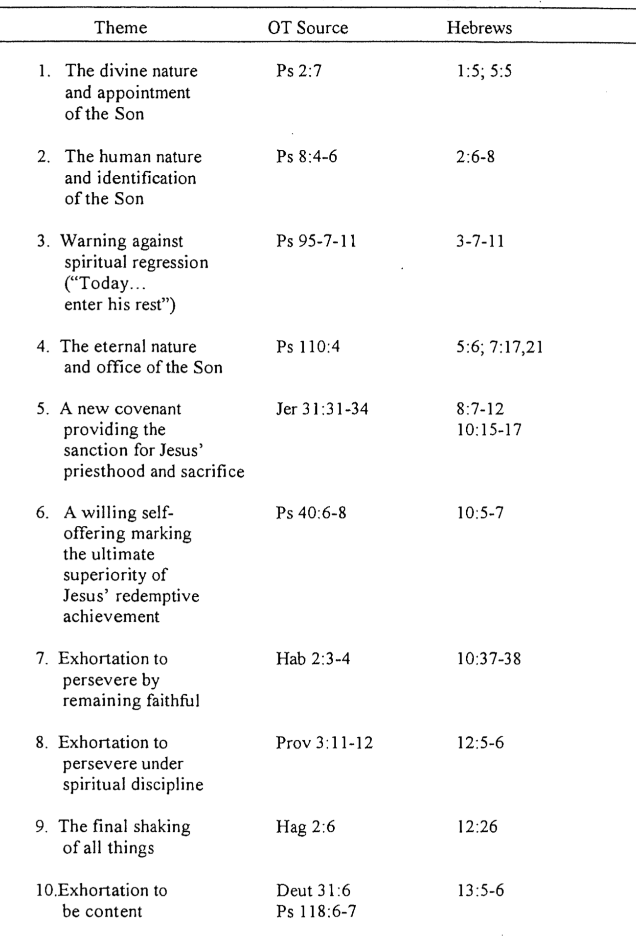

Hebrews 12:1-13

Background: The author has already provided many examples of faithful endurance (Heb. 11).

How can we endure in faith (12:1-3)?

- Remember the many faithful believers before us who cheer us on (1a).

- Rid yourself of obstacles to faith (1b-c).
- Even good things that aren’t sin must be eliminated (1b).
- Sin must be put away as well (1c).

- Run toward Jesus as He is the best example of faithful endurance (2-3).

But when we get off track (as the Hebrews did) God disciplines us.

Examples of God’s discipline…

Difference between punishment and discipline…

What results from enduring God’s discipline in faith (12:4-13)?

- Realization that we are God’s sons results from enduring God’s discipline (4-9).

- Righteousness results from enduring God’s discipline (10-11).

- Reassurance and spiritual strength results from enduring God’s discipline (12-13).

Wrap-Up

- Is the Lord disciplining you? How?

- How are you responding?

- How should you respond?
The Better Covenant Warns Us Not to Turn Back
The Warning of Hebrews 12:18-29

The author of Hebrews has one final warning to Hebrew Christians tempted to turn back to Judaism. By contrasting the first covenant with the second, he hopes they will see how inviting this new covenant is in comparison. These two covenants are figuratively depicted as two mountains:

 | Mt. Sinai | Mt. Zion
Reality | “You have not come to…” (18a) | “You have come to…” (22a) as if heaven was a present reality
Nature | Mountain of fire and darkness (18b) | City of perfection  (22b; cf. 11:10, 16; 13:14)
Mood | Gloom (18) | Joy (22)
Privileges | Feared even touching Sinai  (20) | Names recorded in heaven in  privileged status (= “firstborn,” 23)
Location | Earth  (25-26; cf. Exod. 19:10-25) | Heaven  (22, 25)
Covenant | Old/Mosaic (21) | New (24)
Atoning Blood | None was yet shed (20) | Perfect atonement (24)
Participants | Jews who could not escape living under the law (25) | God (21, 23b)  Angels (22)  Church (23a)  OT saints (23c)  Jesus (24)
Listening | Asked not to hear God  (19b) | Should listen to God speaking  (25)
Stability | Easily shaken  (26-27a) | Cannot be shaken  (27b-28)
Application | Never turn back to your  past religion (25) | Press on to your future reward with thanks and worship (28b-29)

Contrasting the Abrahamic & Mosaic Covenants

Distinguishing these covenants provides a foundation for interpreting the OT and NT, especially the prophets as they look back on covenants with both Abraham (e.g., Ezek. 36–37; OTS, 508) and Moses (e.g., Lam. 1:3; OTS, 496). Knowing the conditional and temporal nature of the Law prevents misapplying obsolete commands to the Church today (e.g., Sabbath, charging interest to believers, tithing). Also, God’s faithfulness to sinners is clear due to Abraham.

 | Abrahamic Covenant | Mosaic Covenant
Recipient  (Date & Place) | Abraham as mediator for all nations  2060 BC, Ur of the Chaldees | Moses as mediator for Israel  1445 BC, Mount Sinai
Scripture | Genesis 12:1-3 (but formalized into a covenant in Genesis 15) | Exodus 20–31 is the heart of the covenant
Between God & | A person (for a future nation) | A nation
Scope | Universal (“all peoples will be blessed through you”) | Only Israel received the Law (Deut. 4:8; Ps. 147:20)
Character & Significance | Grace (promises)  –primary (what God will do) | Works (laws)  –secondary (how God will do it)
Promises | Land, seed, and blessing (without indication of time of fulfillment) | Blessing for obedience and cursing for disobedience (Lev. 26; Deut. 28)
Conditions | Unconditional: "I will…” | Conditional: "If you will…then I will…”
Participation | Abraham asleep (Gen. 15:17) | Israel agreed to obey (Exod. 19:8)
Analogy | Father to son (royal grant) | Suzerain (superior king) to vassal (servant nation)
Purpose | Clarified Israel’s blessings in general terms to motivate the nation towards righteousness by faith in God’s provision of a wonderful future (Gen. 12:1; 15:1, 6) | Clarified how Israel could be blessed in the Abrahamic Covenant as soon and full as possible; didn’t restate or expand the Abrahamic Covenant but revealed sin (Rom. 5:20; Gal. 3:19, 24)
Form | Oral (no written stipulations) | Written on tablets of stone & Pentateuch
Emphasis | Blessing over discipline/judgment  (five “blessings” in Gen. 12:1-3) | Judgment/discipline over blessing  (contrast Deut. 28:1-14 & vv. 15-68)
Christology | Ultimate seed (Gen. 12:3) | Typified in tabernacle (Heb. 8–10)
Sign | Circumcision (Gen. 17:11) | Sabbath (Exod. 31:13, 17)
End | Never been terminated (deemed an eternal covenant in Gen. 17:8) | Ended at Christ’s death (Rom. 7:6; 10:4; 2 Cor. 3:7-11; Gal. 5:1; Heb. 7:11-12)

While most of the above is original, some is based on Thomas L. Constable, “A Theology of Joshua, Judges, and Ruth,” in A Theology of the Old Testament, ed. Roy B. Zuck (Chicago: Moody, 1991), 100-101.

Hebrews Brain Twister

- Keyword for Hebrews
S | U | P | T | A | B | E | R | N | A | C | L
T | G | V | N | D | E | M | O | N | S | O | K
E | C | H | R | I | S | T | I | O | V | E | L
H | S | W | E | R | B | E | H | V | D | J | O
P | Y | T | I | R | O | I | R | E | P | U | S
O | I | R | C | S | Y | F | Z | N | Q | D | A
R | N | I | S | F | A | I | T | H | T | A | F
P | R | I | E | N | H | P | U | S | V | I | F
R | A | R | G | C | A | V | E | T | F | S | I
I | W | E | L | G | I | S | N | T | V | M | C
E | L | E | K | Z | O | X | H | E | K | O | C
S | M | I | L | M | N | A | R | U | L | N | E
- Hebrews author shows the superiority of ________ as high priest
- Hebrews author shows the superiority of Christianity over _____________
- Hebrews has been called the ________ gospel
- Hebrews was written to prevent readers from desertion of the _______
- King of Salem & Priest of the Most High
- Christ is superior in his person to p_________, a_________ & M_____
- The “BETTER” book
2002 NT Survey Class Presentation
Why Attend Church?

Introduction

“Oh, I had to work last Sunday,” he responded when asked why he didn’t attend church. Sure, he was a Christian—but he also had to work for a living. Yet skipping worship this one time soon became two Sundays missed in a row and eventually a new habit was born—the pattern of trying to go it alone in the Christian life. Going it “alone” led to loneliness, so he rarely spoke the name of Christ or even referred to himself as a Christian. A new “me and them” language developed. He was sliding down on the slippery slope.

The problem is not new. Some Jewish Christians in Israel only about 30 years after Christ also had begun to withdraw from public worship with believers. Maybe they had to work that day too. Maybe it was too inconvenient to get up early to attend services before heading off to Sunday work. Maybe they were “just too tired” to fellowship in services after work on Sunday evenings. Maybe they still did attend Jewish Sabbath services—but these were with Jews who had not trusted in Christ as Messiah. We don’t know. We just know that they had begun to withdraw from being with true believers.

A concerned Christian leader had to do something about this. He had to write them a letter. We call his letter the “Book of Hebrews.” After ten chapters of impassioned pleas he wrote:

“Let us not give up meeting together, as some are in the habit of doing—and all the more as you see the Day approaching” (Heb. 10:25).

So Why Attend Church?

Christ is the Better Way: Huge crowds followed Christ in his ministry, but after he made some disturbing statements “many of his disciples turned back and no longer followed him” (John 6:66). When he asked the Twelve whether they also would leave, Peter spoke for them all:

“Lord, to whom should we go? You alone have the words of eternal life. We believe and know that you are the Holy One of God” (John 6:68).

So what about you? Do you have a better way? Do you have another way for people to attain eternal life? If so, follow it! If not, return to Christ. In his letter, the author of Hebrews used the word “better” thirteen times to show his readers that by not attending worship anymore, they were following an inferior way—not the better way of Christ. Since he alone has eternal life, the “second best way” is eternal death!

You should identify with people holding God’s values. It’s no surprise that we all become like those we hang around.

“Do not be deceived: “Bad company corrupts good morals’” (1 Cor 15:33).

You need exposure to God’s Word. Sure, you can study the Bible on your own. However, the sense of accountability is heightened when you study with others as the early church did:

“All the believers devoted themselves to the apostles’ teaching” (Acts 2:42).

You will renew your relationship with Christ. You are not the only person who loves Christ. When you are around others who fellowship with him, you learn to deepen in that love.

You show humility. Attending church is an admission that you cannot “go it alone.” Pride is the first and deadliest sin.

You broaden your perspective. Believers who forsake commitment to a body of believers end up critical and negative. On the other hand, the exchange of ideas at church helps keep us sharp and fresh in our walk with Christ.

You need not defend yourself any more. Once you get back into a fellowship then you won’t have to make the others all hypocrites to keep you from feeling guilty.

You get your eyes off yourself. The person who neglects ministry to other believers is basically self-focused. Change your perspective into one that looks out for others:

“³ Don’t be selfish; don’t try to impress others. Be humble, thinking of others as better than yourselves. ⁴ Don’t look out only for your own interests, but take an interest in others, too” (Phil 2:3-4).

You obey God. Face it. You know that God tells you, “Do not forsake assembling with others” (Heb 10:24). So stop disobeying God and start obeying Him—today!

Contrasts Between Believers Attending Church and Those Who Neglect Church

Issues | Attenders | Slackers
Quality | Follow the better way (John 6:68) | Follow an inferior substitute
Identification | With people holding God’s values | With people holding worldly priorities
Exposure to Word | Maintained | Lacking
Relation to Christ | Renew their first love | Forsake their first love
Relation to Others | Humility by needing them | Pride by “going it alone”
Typical spirit | Open minded to new patterns | Critical of others
Defense for actions | “I need to be accountable” | “People at church are hypocrites”
Chances to serve | “I attend to help others” | “I don’t want to help other believers”
Obedience | Obey Hebrews 10:24-25 | Disobey Hebrews 10:24-25

Do You Agree or Disagree?
To explore your own ideas on this vital subject, please mark as A, U, or D beside each statement below to show whether you Agree, are Unsure, or Disagree with the teaching.

It’s a sin to lose the habit of regular fellowship with other believers.

If it’s hard to find the right church for you, God wants you to give up.

Sometimes God doesn’t allow us to find fellowship because he wants us to begin a new one.

It is selfish to neglect going to church.

Conclusion

It’s amazing how many Christians rationalize not going to church. Don’t join their critical ranks!

Of at least seven interpretations of the "Sabbath-rest for the people of God" (Heb 4:9), the millennial kingdom view may have the most to commend it. This view sees the rest as future, which is consistent with verse 11 and accounts for the different (hapax legomena) Greek word translated "Sabbath-rest." As a Sabbath-rest in the Old Testament was a literal 24-hour day, so the kingdom rest will be limited in time to 1000 years (Rev. 20:1-6). This rest is not yet fully realized also (v. 1). The concept of rest in the kingdom age also accurately parallels the Old Testament reference to an inheritance that the Jews in the wilderness sought to attain (v. 11a) but some missed out due to their disobedience (vv. 6, 11b) stemming from lacking a walk of faith (v. 2). Likewise, only obedient believers will rule in the millennium, but believers who simply enter without reward will not. The Sabbath-rest in the passage is deemed "another day" (v. 8)––a day yet future from Joshua's time that was distinct from the 24-hour Sabbath day of Judaism. Finally, in that the Old Testament rest concerned the possession of an actual land (Canaan), the millennial interpretation likewise speaks of inheriting an actual dominion here on earth. There is no need to spiritualize this passage. See the comparison of views on the Sabbath rest on pages 266g-k.
These rituals of the old order needed to be abandoned for the new and living way. Of particular importance are the "instructions about washings." This is not a reference to New Testament baptism since the plural form is never used of baptism and the word here (baptismo,ς, "ceremonial washings") is wholly different from the normal word for baptism (ba,ptisma, "baptism"). If the letter addressed converts from the Qumran Community, this reference would have special significance due to the many ablutions in this community.
Hebrews 6:4-8 is interpreted in several ways: (1) a Christian who loses his salvation, (2) a hypothetical, impossible situation which a Christian could never find himself, (3) a profession which really was not genuine and thus results in eternal damnation, and (4) a Christian who is disqualified for Christian service and will never again return to Christian commitment. The first view must be rejected due to the clear scriptural testimony to eternal security as totally God's responsibility (cf. John 3:16; 10:28-29; Eph. 1:14; 1 John 5:11-13). The second view finds no support in the text in that a conditional element does not appear in the Greek (although many translations add "if…") and the writer speaks as if he did know some examples. The third view cannot be supported since true believers (not professing believers who are actually non-Christians) are always in view in parallel passages which use the phrases "enlightened" (cf. 2 Cor. 4:3-6), "tasted the heavenly gift" ("tasted" refers to full participation; cf. John 4:10; Rom. 6:23; James 1:17-18), and "who have shared in the Holy Spirit" (cf. 1:9; 3:1, 14). The fourth view has the best evidence. The "falling away" refers to Christians who have left the faith in apostasy. They would be judged with fire (6:8; 10:27)—not eternal hellfire but the temporal fire of the Jewish revolt against the Romans from AD 66-73 (see occasion on p. 257). The result of such disobedience was that "it is impossible to renew them to repentance" (v. 6a). Note that the text says "repentance," not "it is impossible to renew them to salvation." The issue here was a real one where Christians could drift away from Christ not to eternal damnation, but to never being renewed to commitment to Christ as they would be judged by physical death with unbelievers (10:27). The same penalty of early physical death happens today to believers who so reject Jesus that they are brought to heaven early without reward. The NT often speaks of God disciplining believers with loss of life and/or loss of reward (1 Cor 3:15; 5:5; 11:30; 1 John 5:16-17; 2 John 8; Rev 2:5, 23).
Melchizedek was "without father or mother, without genealogy, having neither beginning of days nor end of life, but made like the Son of God, he abides a priest perpetually" (7:3). The nature of these attributes suggests that he could be either an angel or a theophany (the preincarnate Christ). Supporting the angelic interpretation is that this status would not elevate him to Christ's level of stature (cf. Heb 1–2) and he would not be comparing an OT and NT Christ. Both interpretations fit the context, but evidence of Melchizedek being regarded an angelic being in the Qumran Community may support the angelic view if this epistle was originally sent to believers tempted to return to the Community.
This context as in 6:4-8 (see footnote there) refers to believers since the author includes himself among those who could possibly sin to this extent (10:26) and since he had just encouraged these people as believers to hold to their confession and to mutually build one another up in the faith (10:23-25). The NT teaches eternal security (cf. John 3:16; 10:28-29; Eph. 1:14; 1 John 5:11-13; cf. pp. 266a-b), so the fire judgment referred to here (10:27) must not mean hell, but a judgment for believers—most likely temporal fire that soon engulfed Jerusalem’s unbelieving Jews (see “Occasion,” p. 257 and pp. 266c-d).
Scholars debate whether by “Mt. Zion” (v. 22) the author means the literal Mt. Zion (Jerusalem, or the hill on its southeast portion also called the Ophal) or if he refers to Mt. Zion as symbolically representing heaven. Favoring the literal view is the earlier discussion of entering Canaan rest in the literal land of Israel (Heb 4) and the fact that he does call Mt. Zion a city here. However, it probably is better to argue for a figurative interpretation since the believers’ entrance to “Mt. Zion” is already accomplished (“you have come”) and the city is designated as the “heavenly Jerusalem” (v. 22).
Jean Héring, The Epistle to the Hebrews, 29-30; Lünemann, 481; Oberholtzer, "The Kingdom Rest in Hebrews 3:1–4:13," 192; Stuart, 323; Toussaint, "The Eschatology of the Warning Passages in the Book of Hebrews," 71.
Nigel Turner, Syntax, in J. H. Moulton, ed., A Grammar of New Testament Greek, 3:63; A. T. Robertson, A Grammar of the Greek New Testament in Light of Historical Research (Nashville: Broadman, 1934), 869.
Raphael Kühner and Bernhard Gerth, Ausführliche Grammatik der griechischen Sprache, 2:1:137-38, § 5.

