**What is the Babylon of Revelation 17–18?**

*An Evaluation of Various Views*

**Introduction**

* 1. The city of Babylon is the first city noted in Scripture, having been built by Nimrod (Gen. 10:10). It is also the origin of false teaching about God as Nimrod invented mother and son worship (later adopted by Egyptian and other religions, including Catholicism). After the city achieved prominence under King Nebuchadnezzar, who destroyed Jerusalem (605-586 BC), Persia conquered Babylon in 539 BC, and the city has lain virtually desolate for centuries.
  2. One key issue is whether the city's fall in 539 BC fulfilled prophecies that it would never again be inhabited (Isa. 13:20; cf. Jer. 50:23, 39-40; 51:37).[1] This is important because if the prophecy is unfulfilled, then Babylon will still be rebuilt and destroyed entirely.
  3. With this brief background, Revelation 17–18 describes the destruction of a world-powerful entity under the image of a harlot riding a beast. This has often been called “End Times Babylon” because of the adjective “Mystery" (17:5) in the title. However, a better translation is: "This mysterious title was found on her head: BABYLON…"[2] In the broadest sense, this entity has three main dimensions: political, economic, and religious.
  4. Major Players of Revelation 17–18
     1. The Prostitute called Babylon (17:1-6)
     2. The Waters (17:1, 15)
     3. The Beast (17:3a, 7-8, 11)
     4. The 7 Heads (17:3b, 7)
     5. The 10 Horns (17:3c, 7, 12-13, 16)
     6. The 7 Hills (17:9)
     7. The 7 Kings (17:10)
     8. The Great City reigning over the earth (17:18)

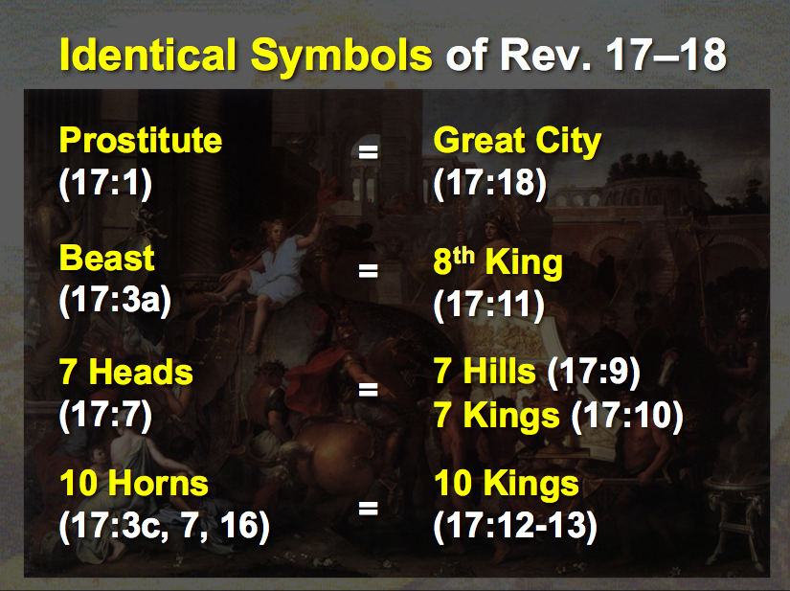

* 1. Characteristics
     1. She is guilty of religious apostasy or idolatry that contaminates the world since the image of a prostitute is used of her (17:1a, 5; cf. 14:8). The harlot in Scripture sometimes depicts one who has strayed from her religious moorings in a “spiritual adultery” (e.g., Hosea 4:10-12). However, it also describes the idolatry of nations that had never trusted in the Lord in the first place, such as Nineveh (Nah. 3:1, 4), Tyre (Isa. 23:15-17), and Babylon (Jer. 23:8-9).
        1. Her blasphemy indicates her heretical stance (17:3).
        2. She is filled with abominations (17:4-5).
        3. Her spiritual association stems from the city of Babylon (17:5), which was the original center of false worship.
     2. She has a world influence politically shown in her sitting on many waters (17:1b), which is a figure for many “peoples, multitudes, nations, and languages” (17:15), indicating an ecumenical nature. The breadth of her authority is over both the rulers and common people in the earth (17:2).

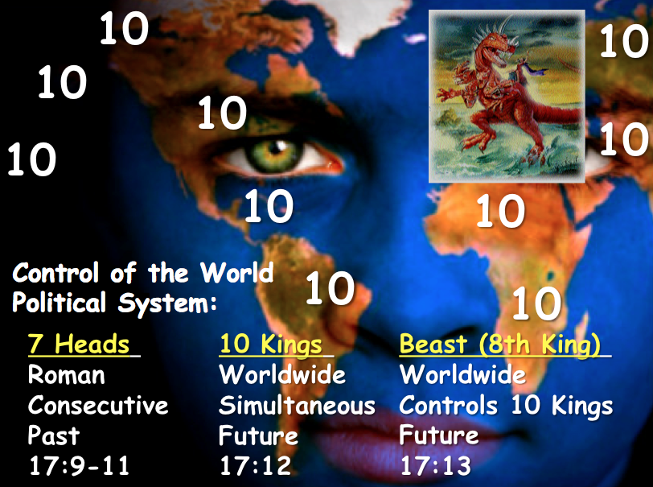

* + 1. She initially controls the Antichrist since she rides the beast (17:3). The beast is a world ruler called the Antichrist (cf. Rev 13:1-10) who himself controls two political entities: a revived Roman Empire preceded by the rule of seven kingdoms and another contemporary alignment of ten regions of the world (17:3, 9, 12).



**End-Times Babylon (Prostitute)**

**(17:1–19:2)**

*later destroyed by beast (17:16)*

*at first*

*sits on (17:3)*

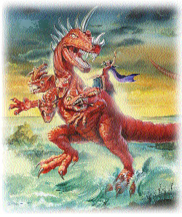

**Scarlet Beast**

**• 7 Heads**

**• 10 Horns**

**(17:3, 12)**

*rules over (17:2)*

*desires to rule over (17:17)*

**Kings of the Earth**

**(17:2)**

**All Peoples of the Earth**

**(17:2, 15)**

* + 1. She is exceptionally wealthy, as seen in her precious gems, clothes, metals (17:4), and numerous other products (18:3, 11-16, 23).
    2. She persecutes the people of God (17:6; 18:24).
    3. She associates with Rome in that she “sits” on seven hills (17:9). Given that Rome is known from ancient times as a city built upon seven hills, this confirms that the Babylon of Revelation 17–18 has a link with Rome, the kingdom “that is” in power during John’s time of writing (17:10).
    4. She will be entirely destroyed by the Antichrist and his ten-nation confederacy (17:16a) by fire (17:16b; 18:8) in only one hour (18:10, 17, 19).

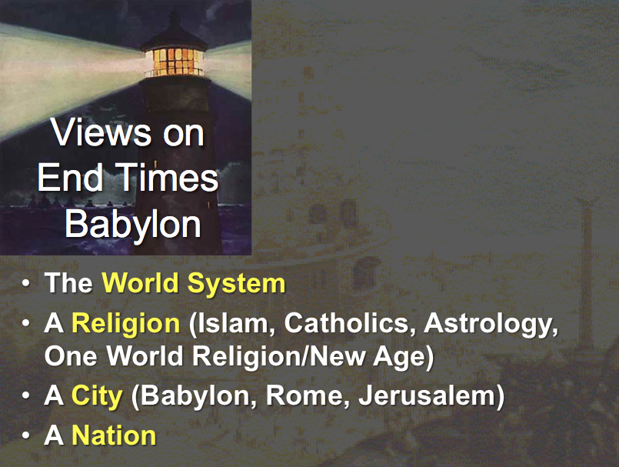

**The Identity of End Times Babylon**

* 1. World System (Political, Economic, and Religious)
     1. Support
        1. The worldwide influence of End Times Babylon could indicate that this entity is the world system itself, organized against God (17:2).
        2. All of the present kingdoms of the world must be removed before Christ sets up his own kingdom (20:1-6).
     2. Problems
        1. Reference to End Times Babylon as a city (17:18; 18:21), which influences Rome (17:9), refers to an entity smaller than the world system as a whole.
        2. The destruction of End Times Babylon will be lamented by unbelieving political rulers (18:9-10), businessmen (18:11-16), and sailors (18:17-19). Since these mourners would be part of the world system themselves, they wouldn't be able to lament the destruction of the world system from afar.
  2. Religions

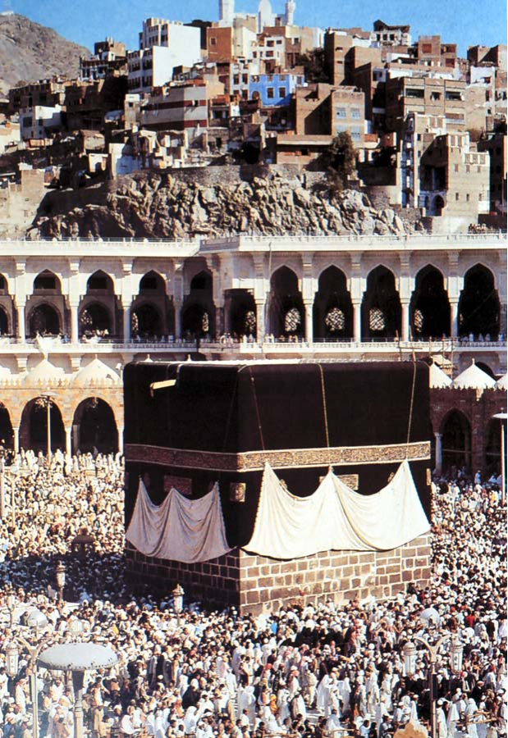

* + 1. Islam[3]
       1. Support
          1. Islam has been a great persecutor of the church (17:6).
          2. Immorality is prevalent in Islam in its polygamy and rape.
          3. Islam has recently become a wealthy religion due to the vast Mid-East oil reserves and control of OPEC.
       2. Problems
          1. Though some Mid-East sheiks are vastly affluent, Muslims generally are not wealthy (17:4).
          2. Immorality within Islam seems not to be any more common than in other institutions and religions.
          3. While Islam, through its association with OPEC, has increased its say in the world, these entities are not presently controlling a ten-nation confederacy (beast) or Rome.
    2. Roman Catholicism[4]
       1. Support

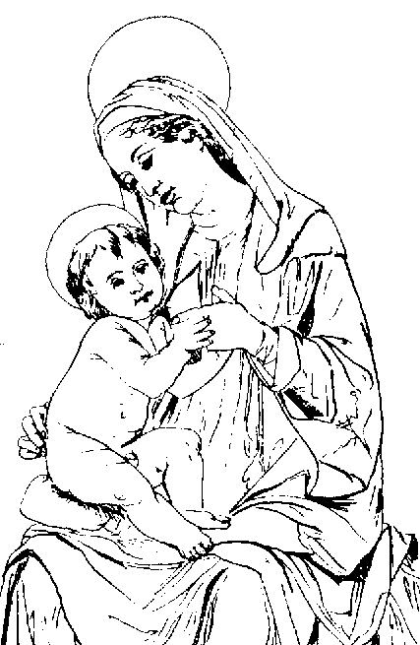

* + - * 1. Babylon was the source of false worship. Much of Catholicism has come from Babylon—mother-and-son worship in particular.[5] Add to these parallels in obelisks, relics, pilgrimages, indulgences, purgatory, pontiffs, celibate priests, transubstantiation, and both the Easter and Winter Festivals.
        2. With its seven hills, Rome is the center of Catholicism (17:9).
      1. Problems
         1. Even though the RCC derives many of its teachings from the Babylonian mystery religion, this does not equate the two entities.
         2. The seven-hilled city and End Times Babylon are not identical since the woman rides the beast with these seven heads/hills (17:3, 7).
         3. Italy has one of the weakest currencies in the world today, so it seems unlikely that the Vatican will achieve the economic envy of the planet.
         4. While Catholicism is wealthy, it is overall in decline.
    1. Astrology[6]
       1. Support
          1. The prominence of worshipping the stars is well known as horoscopes appear in every major newspaper and increasingly on the Internet.
          2. Ancient Babylon was known for emphasizing astronomy and astrology, so the association with End Times Babylon would be consistent.
          3. End Times Babylon is a home for demons (18:2), which describes the satanic associations of astrology.

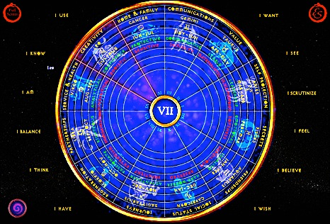

* + - 1. Problems
         1. It seems unlikely that politicians, merchants, and sailors would lament the demise of astrology (18:9-20).
         2. “Babylon” is a home for demons (18:2) and destroyed by fire (17:16; 18:8), which better indicates a physical location than a religion or philosophy.
         3. No musicians, businessmen, or marriages better indicates a place (18:21-24).
    1. One-World Religion
       1. Apostate Church Centered in Rome[7]
          1. Support

End Times Babylon is a city with significant influence (17:18; 18:18, 21). Rome has had this kind of influence both then and now through the RCC.

The harlot has a place of authority over “peoples, and multitudes, and nations, and tongues” (17:15), so she rules the entire world politically beyond the bounds of the Roman Empire. This could be said of the RCC and apostate church.

The association with the seven hills (17:9) is Roman, but the ten-nation Roman confederacy destroys End Times Babylon (17:12), thus showing they are different.

Rome could be destroyed in an hour (18:10, 19).

The Apostate Church has absorbed many demonic influences (18:2).

* + - * 1. Problems

The Apostate Church does not have the organized wealth characteristic of this Babylon (18:9, 11-13).

End Times Babylon is a limited geographical entity that has a worldwide influence, seen in its quick destruction (18:10, 19), marriages (18:23), and the fact that people will see its destruction from afar (18:9).

* + - 1. World Council of Churches[8]
         1. Support

The WCC became an entity that united various religious systems in 1948.

This view reflects the compromise of truth characteristic of the entity being deemed to be "Babylon" (17:5).

* + - * 1. Problems

The WCC influence increasingly decreases rather than increases.

End Times Babylon is repeatedly called a city (17:18; 18:18, 21).

* 1. United Religions Organization (including New Age Movement)[9]
     1. Support
        1. The diverse elements of “Babylon” (17:1, 15) also make up the UR.
        2. The UR includes members of every religion but evangelical Christians.



* + 1. Problems
       1. The UR has yet to become a significant influence in the world.
       2. End Times Babylon is often called a city (17:18; 18:18, 21).
  1. Cities
     1. Babylon, Iraq[10]
        1. Support
           1. The natural reading of "Babylon" is to take it at face value, meaning the city of Babylon.
           2. Although Babylon today is still primarily in ruins, Saddam Hussein began rebuilding it in the mid-1980s and continues to this day.
           3. John said that End Times Babylon is a city (Rev 17:18).
        2. Problems
           1. John referred to this Babylon as a "Mystery," implying that the literal city of Babylon is not meant.
           2. It would be incredible, if not impossible, for even a rebuilt city of Babylon to attain worldwide wealth and prominence as the End Times Babylon. Present-day Iraq is virtually economically bankrupt and unlikely to rebuild Babylon to be more than just a tourist site.
           3. The city referred to in Revelation 17:18 is indeed a city, but this city seems to be Rome more than Babylon: "The woman you saw is the great city that rules over the kings of the earth." Since Rome ruled the Roman Empire when John wrote this book, it is the more likely candidate than Babylon.
     2. Catholicism (papal Rome) in Revelation 17, but Babylon, Iraq in Revelation 18.[11]
        1. Support
           1. In Revelation 17, Babylon is a woman; in chapter 18, she is a city.
           2. In Revelation 17, she is End Times Babylon; in Rev 18, she is simply a city.
           3. In chapter 17, the ten kings destroy Babylon, probably in the middle of the Tribulation period; in chapter 18, these same kings lament over the destruction of literal Babylon, which is destroyed at the end of the Tribulation period or when the Lord appears.
           4. In chapter 17, Babylon is drunk with the blood of “saints and martyrs of Jesus” (17:6). In chapter 18, Babylon is intoxicated with the blood of the prophets and saints and all of them that were slain upon the earth (18:24). The inclusiveness of Babylon’s drunkenness indicates she is a different thing than End Times Babylon in chapter 17. First, we have papal Rome (Rev 17); then, we have the world of evil wrapped up in one city (Rev 18).
           5. The destruction of the city is a sudden thing. The phrase “in one hour” occurs several times in Revelation 18. This destruction is like that of Sodom and Gomorrah. There is some evidence that “End Times Babylon” (chapter 17) is destroyed over time. But literal Babylon “in one hour.”
           6. Jeremiah’s commands to “flee her” (Jer. 50:8; 51:6, 9) were not directed to the people of old Babylon since many of them did not obey (e.g., Daniel). It is intended, therefore, to the people of the end-time.
           7. Some of the expressions adopted by John in Revelation 18 are taken from Isaiah and Jeremiah’s descriptions of old Babylon. They all refer to the same literal, restored Babylon of the end times.
           8. Babylon's particular sin in chapter 17 is spiritual fornication, and Babylon's sin in chapter 18 is evil commercialism. This agrees with Zechariah 5:8, where wickedness is personified as a woman.
        2. Problems (compare these with those of the same number above)
           1. It is not true that in Revelation 17, Babylon is only a woman and in Revelation 18, she is a city, for "the woman that you saw is the great city…" (17:18). The two images are thus interchangeable. Also, the Babylon of chapter 18 is called a prostitute again later in 19:2.
           2. The introduction notes that "mystery" is likely not part of the title. Since elsewhere the title is simply "Babylon" (18:2, 10, 21), the entity probably does not have "mystery" in the title at all.
           3. The kings who lament Babylon's destruction (18:9) are not said to be the same kings as those comprising the ten horns (17:7). Also, given that this entire account (Rev 17–18) appears after the bowl judgments at the end of the Tribulation (Rev 16), the chronology of the book of Revelation shows End Times Babylon to be destroyed at the end of the Tribulation too.
           4. The supposed contrasts between whom Babylon persecuted in the two chapters are forced. In both chapters, she tormented saints (17:6; 18:20, 24). That prophets and apostles are noted in 18:20, 24, whereas martyrs ("those who bore testimony" NIV) are noted in 17:6 is not a contrast as much as an inclusive of both.
           5. Those teaching this combined papal/Iraq view do not give any support that the destruction of "End Times Babylon" (deemed papal Rome of Rev 17) is not sudden. The only time reference in chapter 17 is the same period as chapter 18. The time in which the beast shares power with the ten-nation confederacy is also "one hour" (17:12), which occurs just before the return of Christ (17:14; 19:19), probably after the hour-long destruction of Babylon (18:10, 17, 19).
           6. Even if Jeremiah’s commands to leave Babylon apply only to the end-time city, this still would not warrant changing the identity of Babylon in Revelation 17 to another entity in Revelation 18.
           7. John's use of the prophetic language of Isaiah and Jeremiah does not equate the two Babylons. John elsewhere employs prophetic language in a heightened sense. For example, in Isaiah 65:20, the "new heavens and new earth" is where most people live beyond 100, which must be the millennium since death still exists; however, John employs a new meaning to this exact phrase by declaring that death is eradicated (Rev 21:4).
           8. Spiritual fornication (Rev 17) is not contrasted with evil commercialism (Rev 18), yielding separate entities. While the emphasis of chapter 18 is indeed trade, spiritual sin is also noted in chapter 18 with Babylon's association with demons (18:2), evil spirits (18:2), adulteries (18:3, 9; *porneia* is the same word as in 17:2, 4), and her "magic spell" (18:23). Similarly, her wealth is noted in 17:4.
           9. The account flows naturally from one chapter to the next, so a change in referent would be very confusing; thus, it is unlikely that the Babylon of Revelation 17 is different than the Babylon of Revelation 18.
     3. Rome[12]
        1. Support

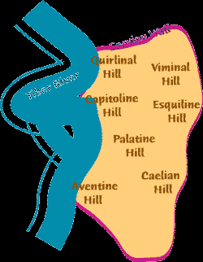

* + - * 1. "The woman you saw is the great city that rules over the kings of the earth" (Rev 17:18). Rome ruled the Roman Empire when John wrote this book.
        2. Rome also was built upon seven hills (Rev 17:9).
      1. Problems
         1. While Rome was the most influential city when John wrote, this end-times Babylon is the most powerful entity during the Tribulation when the prophecy will be fulfilled.
         2. The seven hills and kings relate to the *horns* on the beast (Rev 17:7-9), not to the *woman* who rides the beast (17:3). These two entities should remain distinct.
    1. Jerusalem[13]
       1. Support
          1. Jerusalem fits into God's prophetic program for the end times (cf. Zech. 14:1-5). The Tribulation period is called the "time of Jacob's wrath" (Jer. 30:7), indicating suffering for Jews and Israel.

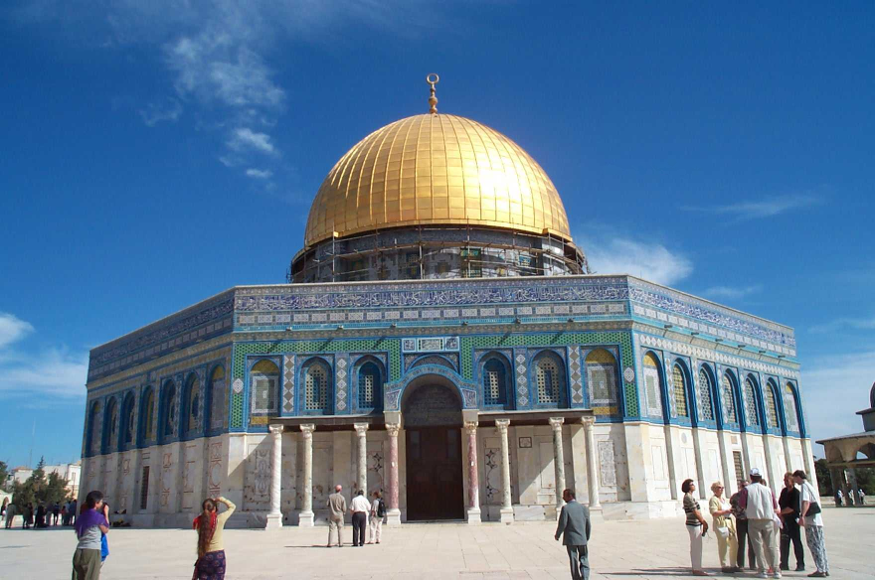

* + - * 1. The woman "sits on" (controls) seven heads (kings), which indicates power over Rome (17:9). Jerusalem's present control over Catholicism is evident in its jurisdiction over the many Roman Catholic churches throughout Israel.
        2. Jerusalem has killed many of the saints and prophets of God (17:6).
      1. Problems
         1. While Jerusalem is prominent in prophecy, its worldwide influence occurs only in the millennium (Isa. 2) rather than the Tribulation period (which is the context for Rev 17–18).
         2. Whereas the text indicates the woman controlling Rome, the opposite was true in John's day and our own. Also, though modern Israel controls the Catholic sites in her domain, she has little influence over Catholicism worldwide.
  1. USA[14]
     1. Support (arguments from Chan Kai Lok)
        1. Babylon must be a nation since no single city reigns over the earth (17:18), and a "city" is a nation in biblical symbolism.
           1. The New Jerusalem is a city (22:14, 19) and a country/nation (Heb. 11:13-16).
           2. The New Jerusalem is a city (22:14, 19) but also the Bride of Christ (21:2, 10), the latter also being designated a nation (1 Pet. 2:9).
           3. Contrasts in the text abound between End Times Babylon (an unholy city/nation, Rev 17–18) and the New Jerusalem (a holy city/nation/Bride of Christ, Rev 21–22).
        2. The US is Symbolized by a Woman (17:1-7, 18).

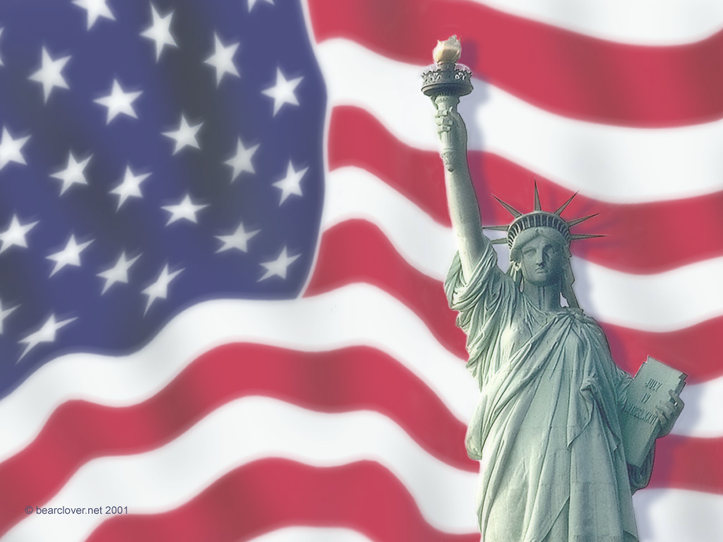

* + - * 1. The key symbol of the US is the woman of the Statue of Liberty in New York Harbor.
        2. America is the birthplace of modern feminism that has swept the globe.
      1. The US is a Prostitute in the Spiritual Realm (17:1, 15-16; 19:2)—Since the biblical meaning of adultery is to forsake one's spiritual roots, the US qualifies well in this respect as it has abandoned its Christian heritage established by the Pilgrims.
      2. The US is a Great Trading Centre (18:12-13)—End Times Babylon will be known worldwide for its commerce.
         1. The US is the largest business and financial hub in the world.
         2. Wall Street is the largest stock market worldwide.
         3. The US is the key player within the World Trade Organization.
         4. US firms produce more goods overseas than any nation.
         5. American trade spans the two major oceans in every item imaginable: precious metals and jewels (18:12a), clothing fashions and luxury items (18:12b), wheat and meat production, along with other foods (18:13a), and "the bodies and souls of men" (human trade in prostitution, drug trafficking, and pornography, 18:13b).
      3. The US is Rich and Enriches Many Great Men (18:3, 14, 23).
         1. No country or institution can match the wealth of the USA with its abundance of cars, food, goods, and multiplied luxuries.
         2. The US dollar is the standard trading currency on the globe.
         3. Former poor nations have grown rich through US investment (e.g., Singapore, China)—even previous enemies of the US (e.g., Japan, Germany).
      4. The US Controls Many Nations (17:1, 15).
         1. America's global dominance increased dramatically with the fall of the USSR, leaving the US as the sole "Superpower" nation.
         2. Washington's voice in the UN is preeminent.
         3. Some nations cannot act without US approval (e.g., Israel).
         4. The world is increasingly embracing American democracy.
      5. The US Could Be Destroyed by Russia’s Nukes (17:3).
         1. Whether the scarlet beast is Russia[15], the G7 and EC, or some other entity, the US exercises more control over them all than does any other entity.
         2. In any case, the Beast will destroy the Woman in one hour (18:8, 17, 19) by fire (17:16; 18:8-9). Even the destruction of a city by conventional fire takes several days (e.g., The Great Chicago Fire, San Francisco Earthquake and Fire of 1906), so consumption by fire in only one hour almost inevitably must mean nuclear warfare. Russia has the most significant capacity to inflict this type of damage.
      6. The US is Hedonistic, and Other Nations Copy Her (18:3, 5).
         1. The US continually boasts that it is protecting American interests globally.
         2. Americans worship sex, materialism, sports, entertainment, and pleasure—all of which are idols. The blatant idolatry of “American Idol” is mimicked worldwide.
         3. US-sponsored trends are copied worldwide (fast food, clothing, music, pornography, drugs, scientific breakthroughs, skateboards, etc.).
      7. The US is Glorified and Lives in Great Comfort (18:7).
         1. What nation or institution has the world's admiration more than the US?
         2. Glory has been accrued to the US more than any nation in numerous areas: space technology, scientific discoveries, the most Nobel Prize winners, the most inventions, and the attraction of the best brains in the world.
         3. The US is obsessed with comfort. More Americans are overweight than any other country. Homes have all the latest conveniences at bargain prices. Even Christians readily admit that they "church shop" until "we find a place that is comfortable."
      8. The US is Occultic (17:5; 18:2-3).
         1. The US association with ancient Babylon takes many forms.

Babylonian mystery religion is duplicated in the Catholic church in mother and son worship, celibate priests, purgatory, celebration of Nimrod's birthday on December 25, etc.[16] This teaching has been marketed to the world from Catholic American missionaries and, in the case of Christmas, US concerns for business profits. Over 27% of Americans claim Catholicism.

Babylonian occultism is the root of numerous US secret societies (e.g., Gnostics, Freemasons, Rosicrucians, Theosophists, Neo-Nazis, etc.).

* + - * 1. The end-times Babylon is "a home for demons and… every evil spirit" (18:2), and the US Bill of Rights safeguarding freedom of religion has enabled the country to have more cults than any nation (over 5000!).[17] Similarly, every major US city has a satanic church.
        2. Secular humanism is now the protected national religion, while prayer and anything Christian is outlawed in schools and many public arenas.
      1. The US is Immoral and Abominable
         1. American immorality gives it the highest rates in the world for prostitution, rape, sex outside of marriage, divorce, abortion (over 70 million!), child abuse, drug use, and venereal disease.
         2. The US has the distinction as the world's most influential marketer of media filth (all protected by America's "free speech" law).
      2. The US Deceives All Nations with Her Sorcery (18:23)—The Greek (*pharmakeia*) for the "sorcery" (KJV) or "magic spell" (NIV) of end-times Babylon may refer to drug use ("enchantment with drugs"),[18] of which the US is the worst. This “sorcery, magic” (BDAG) may be drug-induced.
      3. The US Sits as a Queen, is No Widow, and Sees No Sorrow (18:7).
         1. Babylon's claim, "I am not a widow," affirms that her men have not died on battlefields.[19] Such was the case in recent wars the US has fought. During the Gulf War (January 17-February 28, 1991), General Norman Schwarzkopf so overwhelmed Saddam Hussein's forces that the ground war lasted only five days. The enemy lost about 1000 troops for each American soldier lost, and most of the latter were killed by friendly fire! The USA’s overwhelming victory over the Taliban in Afghanistan was similar to the Iraq War that toppled Saddam Hussein.
         2. Babylon's claim, "I will never mourn (see no sorrow)," results from such war success. No army can better make this claim than the US Army.
         3. Given unequaled US military prowess, she sits as "queen" with increased credibility as the policeman and peacemaker of the world. In particular, US dominance over the Arab states and Russia is no longer questioned.
         4. Believing that the Cold War is over, the sale of many US bases by the Department of Defense has filled the coffers as well, just like a queen's.
      4. The US has Killed the Prophets and Saints of God (17:6; 18:24).
         1. At first, this may not seem to be characteristic of the USA, which was founded upon freedom of conscience and has championed the cause of religious freedom worldwide. Tolerance of all viewpoints is the byword of the day.
         2. Yet end-time Babylon is also guilty "of all who have been killed on the earth" (18:24). Since no entity is guilty of every murder worldwide, this is an exaggeration for effect. What is meant is that Babylon is guilty of being a partaker of other people's sins in the sense that the Pharisees were partakers of the sins of their fathers against the prophets (Matt. 23:29-32; Luke 11:47-52).
         3. In this sense, the US is passively guilty of the blood of prophets and saints, for the US has abandoned its original commission of the Pilgrim days to witness for God. Instead, it approves of these sins in its midst: Satan worship, idolatry, drug trafficking, pornography, adultery, homosexuality, and the like.
         4. In another sense, the USA is *actively* guilty of killing many saints, for the wholesale slaughter of 70 million unborn in this generation alone has murdered millions who would have grown up to serve as God's witnesses around the globe. The other countries of the world have followed the US lead in the abortion holocaust, killing untold millions of God's children.
    1. Problems
       1. Although the woman of the Statue of Liberty is *one* symbol of America, it is not the primary one. The national symbol of the US is the bald eagle.
       2. Chan Kai Lok does not attempt to prove that Russia is the beast of Revelation 13:1-10; 17:3f. He appeals instead to Revelation See’s book *The Antichrist is Now Here!* Though Chan's book appeared in 1992, he refers to the Antichrist as "USSR"—two full years after the breakup of the USSR in 1990.
       3. Chan has made numerous "prophetic" blunders. He predicted the economic collapse of the USA in 1992,[20] the return of Mikhail Gorbachev to power in 1992,[21] and the nuclear destruction of the USA by Russia in 1993.[22]
       4. Theological problems abound in the book. Dubious exegetical support is given to prove that the USA is the people of God or the "Joseph people" (descendants of Ephraim and Manasseh),[23] questionable theological teachings are based on the numbers 13 and 17,[24] adulterers are all deemed unsaved,[25] Maitreya is claimed to be the demon behind the Antichrist (other demons are also "identified"),[26] and the first three seals of Revelation 6 are incorrectly linked to events of 1990-1991.[27]

**Conclusion**

No one can identify the Babylon of Revelation 17–18 with certainty. However, for the reasons cited in this study, it would seem that Babylon is neither a city (Rome, Jerusalem, or Babylon, Iraq) nor a confederation of nations (which confuses Babylon with the beast and its ten horns and seven heads).

While one cannot be certain, the most plausible identification is the most powerful and influential nation in the world: the United States of America. This study does not endorse Dr. Chan Kai Lok’s sensationalistic features and date-setting errors. Nevertheless, comparing the characteristics of this end-time Babylon with America leaves no better option at the present time.

Of course, nothing excludes a more powerful entity than the US arising in the future, so one cannot be sure of the US as this entity. Until God reveals Babylon's identity without question, Christians should not be looking for Babylon but rather accomplishing the commission given to us by Jesus Christ to bring the gospel to the world.

**Charles Ryrie on End Times Babylon**

Charles C. Ryrie has his own summary of the nature of End Times Babylon:

*The Characteristics of End Times Babylon.*

Specific characteristics of Babylon of Revelation 17 are specified.

(1) She is a harlot (v. 1). This means she is unfaithful. She professes to be a system of religious truth and is, in reality, one of falsehood. This is confirmed by the name she assumes—“End Times Babylon” (v. 5).

(2) She is ecumenical (vv. 1,15). She sits upon many waters, which are explained as being “peoples, and multitudes, and nations, and tongues.”

(3) She unites church and state under her sway (vv. 2-3). By granting her favors to the kings of the earth, she can dominate the beast (v. 3), who heads the western confederation of nations (vv. 12-13) and whose dominion coincides with that of the whore (13:7).

(4) She is a “whited sepulcher” (v. 4). Outwardly, she has great grandeur, but inwardly, she is filled with filthiness.

(5) She is a federation (v. 5). Her name is “The Mother of Harlots,” which seems to indicate that she is a sort of mother church incorporating many equally false religious systems. Because of this designation, many understand that the apostate church will be meshed with the Roman Catholic system but not restricted to it.

(6) She persecutes the saints (v. 6).

(7) She is destroyed entirely by the beast (v. 16). This probably occurs in the middle of the tribulation period. It is described as a decisive and complete overthrow of the power of the apostate religious system (adapted from Charles C. Ryrie, “Apostasy in the Church,” *Bibliotheca Sacra* 121 [Jan-March 1964]: 51-52).

The ten-nation Roman confederacy receives power along with the beast or Antichrist (17:12), thus showing they are different.

1. Isaiah and Jeremiah both note that Babylon was to be destroyed literally, suddenly, and completely. Isaiah says: “And Babylon, the glory of kingdoms, the beauty of the Chaldeans’ pride, shall be as when God overthrew Sodom and Gomorrah. It shall never be inhabited, neither shall it be dwelt in from generation to generation: neither shall the Arabian pitch tent there; neither shall shepherds make their flocks to lie down there. But wild beasts of the desert shall lie there…” (Isa. 13:19-21). And Jeremiah says: “How is Babylon become a desolation among the nations!” (50:23); “Therefore the wild beasts of the desert with the wolves shall dwell there, and the ostriches shall dwell therein; and it shall no more be inhabited for ever; neither shall it be dwelt in from generation to generation. As when God overthrew Sodom and Gomorrah and the neighbor cities thereof, saith Jehovah, so shall no man dwell there, neither shall any son of man sojourn therein” (50:39, 40); “And Babylon shall become heaps, a dwelling-place for jackals, an astonishment, and a hissing, without inhabitant” (51:37). These authors argue that Babylon has yet to be rebuilt and destroyed: Richard Hayes McCartney, *The City of the Antichrist: Babylon in Chaldea* (New York: Revell, 1917); Charles Dyer, *The Rise of Babylon* (Wheaton: Tyndale, 1991)*.* They point out that Babylon has never been without inhabitants so that the prophecy yet remains unfulfilled. In fact, in 331 Babylon received Alexander the Great with open arms. Some say it is prophesied that Babylon’s stones will never be used to rebuild other Arab cities, yet many Arab villages and towns have been built from Babylonian stone, such as Seleucia, Ctesiphon, Al Modain, and Kufa (G. H. Pember, *The Antichrist, Babylon, and the Coming of the Kingdom* [London: Hodder and Stoughton, 2d. ed., 1888]). If this is true, these verses then indicate that Babylon has yet to be utterly overthrown, meaning that a future rebuilding of the city is in God’s plan before it is actually finally overthrown so these prophecies have a yet future fulfillment.
2. ## NIV Study Bible text note on 17:5.

  
3. James M. McKeever, "Who is End Times Babylon?" END 151 (April 1991): 1-11 declares that a Muslim-OPEC partnership is in view; Ramon Bennett, *Philistine: The Great Deception* (Jerusalem: Arm of Salvation, 1995) declares that Islam is the greatest threat in the world today.
4. Most Reformers saw Catholics as End Times Babylon (e.g., John Calvin, *Institutes of the Christian Religion,* IV, 2:12); Ralph Woodrow, *Babylon Mystery Religion* (Riverside, CA: Woodrow Evan. Assoc., Inc., 1966, 1981), 7, 12.
5. See Alexander Hislop, *The Two Babylons*.
6. Hal Lindsey, *The Late Great Planet Earth* (Grand Rapids: Zondervan, 1970; reprint, Bantam, 1973), 103-23.
7. Paul Benware, *Understanding End Times Prophecy: A Comprehensive Approach* 2d ed. (Chicago: Moody, 1995, 2006), 309. John Walvoord sees this as likely “a world religion which could conceivably embrace all branches of Christianity—Roman, Greek Orthodox, and Protestant—as well as non-Christian religions” (“Revival of Rome,” *Bibliotheca Sacra* 126 [October-December 1969]: 325; “Revelation,” *Bible Knowledge Commentary* [Wheaton: SP Publication, 1983], 17:6 notes). An adaptation of this view is to see this one world apostate church as the sum of the RCC (Roman Catholic Church) and the WCC (World Council of Churches).
8. Rene Pache, “The Ecumenical Movement, Part 4: Moving Toward the Super-Church,” *Bibliotheca Sacra* 108 (April-June 1951): 201.
9. Tim LaHaye and Jerry B. Jenkins, *Are Living in the End Times?* (Wheaton, IL: Tyndale, 1999), 177-78; W. B. Howard, *Endtime* 8 (May/June 1998): 12-14.
10. W. Glyn Evans, “Will Babylon Be Restored?” 2 Parts. *Bibliotheca Sacra* 107 (July-September 1950): 335-42 and (October-December 1950): 481-87; Robert L. Thomas, *Revelation 8–22: An Exegetical Commentary* (Chicago: Moody, 1995), 279, 283, 288-89; Charles Dyer and Angela Elwell Hunt, *The Rise of Babylon: Sign of the End Times* (Wheaton: Tyndale, 1991), 158, 209-210. Arguing against the literal Babylon, Iraq is Homer Heater, Jr., “Do the Prophets Teach that Babylonia Will Be Built in the *Eschaton*?” *Journal of the Evangelical Theological Society* 41 (March 1998): 23-43.
11. Pember cites the first four arguments; the remaining arguments are from William R. Newell, *The Revelation* (Chicago: Scripture Press, 1935).
12. Robert Mounce, *The Book of Revelation*, NICNT (Grand Rapids: Eerdmans, 1977), 306-36. Arguing against Rome and in favor of Babylon, Iraq is Thomas, 289.
13. J. Massyngberde Ford, *Revelation,* Anchor Bible (Garden City, NY: Doubleday, 1975), 283-86.
14. David Wilkerson, *Set the Trumpet to Thy Mouth* (Lindale, TX: World Challenge, 1985), 3; Chan Kai Lock, *Who is End Times Babylon?* (Singapore: by the author, 1992), 3.
15. Chan identifies the 7 heads of the USSR beast as the 7 Warsaw Pact nations (East Germany, Poland, Czechoslovakia, Hungary, Romania, Bulgaria and Russia) and the 10 horns as the 10 Soviet republics of the Commonwealth of Independent States, or CIS (p. 13). Such a specific designation can only be speculated though.
16. See Ralph Woodrow, *Babylon Mystery Religion* (Riverside, CA: Woodrow Evan. Assoc., Inc., 1966, 1981); Frederick A. Tatford, *Five Minutes to Midnight* (London: Victory Press, 1980).
17. Dave Hunt, *Peace, Prosperity and the Coming Holocaust* (Eugene, OR: Harvest House, 1983).
18. Robert Young, *Young's Analytical Concordance.*
19. *NIV Study Bible* notes on Rev 18:7.
20. Chan, 107.
21. Ibid., 140.
22. Chan, 107-8, 134, prophesies a nuclear destruction and pages 137, 145 specify the year as 1993.
23. Ibid., 28, 60.
24. Ibid., 29-39.
25. Ibid., 80, 115-34.
26. Ibid., 65.
27. Ibid., 139-45.