**1 Peter**

|  |  |  |  |  |  |  |  |  |  |  |  |  |
| --- | --- | --- | --- | --- | --- | --- | --- | --- | --- | --- | --- | --- |
| **How to Attract Others During Righteous Suffering** | | | | | | | | | | | | |
| **Sanctification** | | | **Submission** | | | | **Selflessness** | | | | | |
| **1:1–2:12** | | | **2:13–3:12** | | | | **3:13–5:14** | | | | | |
| **Holiness** | | | **Humility** | | | | **Honoring Others** | | | | | |
| Salu-tation  1:1-2 | Praise for Hope  1:3-12 | Holy Life Exhorted  1:13—2:12 | Gov’t  2:13-17 | Work  Place  2:18-25 | Marri-age  3:1-7 | Church & all of life  3:8-12 | Christ’s Triumph  3:13—4:6 | Edify Others  4:7-19 | Elders  5:1-4 | Young Men  5:5a | Humility/  Watchfulness  5:5b-11 | Purpose  5:12-14 |
| **Rome to Pontus, Galatia, Cappadocia, Asia, and Bithynia** | | | | | | | | | | | | |
| **Early AD 64** | | | | | | | | | | | | |

**Key Word: Suffering**

**Key Verses: “Dear friends, do not be surprised at the painful trial you are suffering, as though something strange was happening to you. But rejoice that you participate in the sufferings of Christ, so that you may be overjoyed when his glory is revealed…. I have written to you briefly, encouraging you and testifying that this is the true grace of God. Stand fast in it” (1 Peter 4:12-13; 5:12).**

**Summary Statement: The way to *attract others* by endurance in God’s grace in righteous suffering is to be holy, submissive, and selfless like Jesus with the hope of future glory.**

**Application: Your response to suffering for Christ will either draw unbelievers to Jesus or repel them. Do you suffer with integrity?**

**"When it is all over, you will not regret having suffered;  
rather you will regret having suffered so little —  
and suffered that little so badly."**

**- Sebastian Valfre (1629-1710)**

**1 Peter**

**Introduction**

**I. Title:** The Greek title (Πέτρου ἄ *First of Peter*) follows the standard practice of naming the General Epistles after their authors.

**II. Authorship**

A. External Evidence: Early tradition has the Apostle Peter writing this epistle bearing his name. The Church Fathers supported his authorship, including Irenaeus (*Against Heresies*; *ca.* AD 185), Tertullian (*De Orations*; *ca.* AD 200), and Eusebius (*Eccl. Hist.* 3.3; *ca.* AD 325).

B. Internal Evidence: The content of the book itself supports the long-held belief that Peter authored the epistle:

1. The opening salutation identifies Peter as the author (1:1).

2. The authoritative tone of the work is confirmed by the author's identification with the elders and his claim to be a witness to the sufferings of Christ (5:1).

3. Many similarities exist between this letter and Peter's discourses in Acts (1 Pet. 1:10-12 and Acts 3:18; 1 Pet. 1:20 and Acts 2:23; 1 Pet. 2:4 and Acts 4:11; 1 Pet. 3:22 and Acts 2:33-34).

However, in their usual manner, modern critics contradict the overwhelming external and internal evidence on literary grounds. They claim that the author wrote in the second century using Peter's name to gain acceptance of the letter (Kümmel, 296-98). The following explains their arguments and rebuttals to each:

1. Objection: Peter could not be the author because the epistle is excellent in Greek, and Peter was only a fisherman.

Response: The epistle was written 30 years after Peter gave up his fishing trade. He certainly had time to sharpen up on his Greek! Besides this, one cannot confidently assume that a businessman in the fishing industry was unskilled at writing. He would have needed some literary skill to succeed in his work.

2. Objection: Peter would never have quoted the LXX (Greek OT) as this epistle does.

Response: Given the wide Gentile readership (1:1b), using the standard Greek translation rather than Hebrew made better sense.

3. Objection: The epistle contains many Pauline conceptions.

Response: This falsely assumes Peter and Paul had divergent theologies.

4. Objection: If Peter was writing where Paul had evangelized, why does he not mention Paul's previous work?

Response: This is an argument from silence, and the same claim could be made for authors other than Paul. However, even more importantly, the five Roman provinces of Asia Minor addressed (1:1b) were areas mostly unevangelized by Paul (except south Galatia). The gospel may have reached this area through converts at Pentecost (Acts 2:9) or perhaps Peter himself (1 Cor. 9:5).

Conclusion: The evidence shows that Peter wrote this letter bearing his name.

**III. Circumstances**

A. Date: Peter was martyred in the spring of AD 64 (Hoehner, 381-84). In that 2 Peter followed 1 Peter chronologically (2 Pet. 3:1), some time must be included between the two works. Since 2 Peter was written shortly before Peter's death (2 Pet. 1:13-15), 1 Peter must be dated in early AD 64 at the latest.

B. Origin: The epistle claims to have been written from “Babylon” (5:13). Several factors indicate that this is a code word for Rome rather than the literal Babylon:

1. External Evidence:

a. There is no tradition that Peter ever visited Babylon on the Euphrates or Babylon on the Nile (now known as Old Cairo).

b. There does exist a tradition from Papias (AD 80-155) and Clement of Alexandria (AD 155-225) that “Babylon” refers to Rome (Eusebius, *Eccl. Hist.* 2.15).

c. The best-known tradition is that Peter was martyred in Rome (Guthrie, 801-803).

d. Revelation hints that Rome is “Babylon the Great” (cf. Rev. 14:8; 17:5; 18:10).

2. Internal Evidence: Since Mark was with Peter when he wrote (5:13), and Mark's residence was Rome (Col. 4:10; Philem. 24), Peter must have written from Rome.

C. Recipients: Peter addresses “God's elect, strangers in the world, scattered throughout Pontus, Galatia, Cappadocia, Asia, and Bithynia” (1:1b). These five Roman provinces are mentioned in a circle, suggesting that the letter was to be copied and sent to the next province (cf. Rev. 1:11 for a similar scenario for the churches of Asia). Several references indicate that a predominantly Gentile readership originally received the letter (1:14, 18; 4:3), yet Jewish elements are also present (Jewish coloring of 1:1; 2:9), so the readership likely included some Jews. Peter was likely addressing these northern Asia Minor groups, which he had nurtured, while Paul devoted his time to the southern Asia Minor peoples.

D. Occasion: On 19 July AD 64, one of the most significant dates for the church in the first century occurred. Beginning this day, much of Rome burned to the ground, perhaps at Nero's hand, but the event provided fuel to the already suspect opinion of the many Christians in Rome. The infamous Neronian persecutions began at this time in which Christians were thrown to the lions and dogs, mutilated by gladiators, and lit on fire on posts in Nero's garden to provide light for his evening meals.

According to Hoehner's chronology (see “Date” above), Peter was crucified upside down a few months before the Neronian persecutions broke out. However, while civil persecution was not yet in full swing, believers experienced personal persecution (2:12; 3:16-17; 4:3-4, 12, 14), and the threat of imperial persecution loomed. In this context, Peter wisely penned this manual on suffering to encourage his brethren (5:12) in the provinces of northern Asia Minor to stand firm with submissive attitudes.

Peter’s letter would soon become very applicable even in the regions beyond his intended readership, especially in Rome. The words “suffer,” “suffered,” “suffering,” and “sufferings” occur 16 times. Suffering and glory often appear together in the epistle (1:11; 4:13; 5:1, 10) as an encouragement for believers to look ahead in faith (1:5, 7, 9, 21; 5:9) to the completion of their salvation (1:5, 9, 10; 2:2) at the return of Christ (1:5, 7, 13; 4:13; 5:1, 4). It seems that all of the biblical books that provide eschatological teaching do so in light of suffering (e.g., Daniel, Ezekiel, 1 & 2 Thess., Revelation, etc.; cf. p. 28). Peter’s epistles do the same by emphasizing the Second Coming of Christ and the Christians’ present suffering.

**IV. Characteristics**

A. The epistle uses 62 *hapax legomena* (words that occur only once in the New Testament).

B. One of the most problematic NT passages is 1 Peter 3:18-22, which states that after his resurrection, Christ “preached to the spirits in prison who disobeyed long ago… in the days of Noah…” See the study on pages 283a-f.

C. Peter's advice on dealing with persecution counters the natural responses of man:

|  |  |
| --- | --- |
| **Common Responses to Persecution** | **Peter's Exhortation** |
| **“I'll get even”** | “Do not repay evil with evil or insult with insult, but with blessing, because to this you were called to inherit a blessing” (3:9; cf. 2:1) |
| **“I'm discouraged”** | “Rejoice that you participate in the sufferings of Christ…do not be ashamed…” (4:13, 16) |
| **“I'm afraid”** | “Do not fear what they [persecutors] fear; do not be frightened” (3:14b) |
| **“Forget Jesus. It's not worth it”** | “…by His wounds you have been healed” (2:24) |
| **“Why do they only persecute me?”** | “…your brothers throughout the world are undergoing the same kind of sufferings” (5:9) |
| **“Hey! I have my rights!”** | “Humble yourselves…under God's mighty hand, that He may lift you up in due time” (5:6) |

D. First Peter may well be called the “Job of the New Testament” because of its theme of undeserved suffering and steadfast submission to God's sovereignty (*TTTB*, 473).

**Argument**

While the letter has many themes, Peter explains the key purpose of his epistle near its end, “.…I have written to you briefly, encouraging you and testifying that this is the true grace of God. Stand fast in it” (5:12). Thus, the letter has these dual themes (adapted from Kay Arthur, Precepts):

|  |  |
| --- | --- |
| “This is the true grace of God.” | “Stand firm in it.” |
| 1 Peter 1:1-12 | 1 Peter 1:13–5:14 |
| Election | Endurance |
| Sovereignty of God | Responsibility of man |
| Positional sanctification | Practical sanctification |
| Initiated by Godhead (1:2) | Effected in godly living (1:13ff.) |

Therefore, Peter’s purpose is to encourage his readers that God’s grace enables them to live appropriately despite the suffering they had already experienced and undoubtedly would still suffer. He exhorts holiness resulting from salvation (1:1—2:12), submissiveness in all aspects of life (2:13—3:12), and selflessness in the midst of suffering with Christ's example as motivation (3:13—5:14). The promise reiterated again and again is that suffering precedes glory.

The letter emphasizes at least nine positive results in those persecuting us. We can *be attracting* others to Jesus when we stand fast in God’s grace during suffering, for unbelievers will: (1) *see* our good works (2:12a), (2) *glorify* God (2:12b), (3) *silence* their ignorant talk (2:15), (4) be *won* over by godly wives (3:1), (5) be *ashamed* of their slander (3:16), (6) think our purity *strange* (4:4), (7) be *accountable* to God (4:5), (8) give us a *blessing* through insulting us (4:14), and (9) be *judged* for disobeying the gospel (4:17). All of these effects work to attract unbelievers to the Lord.

**Synthesis**

**How to attract others while suffering for Christ**

**1:1—2:12 Sanctification**

1:1-2 Salutation

1:3-12 Praise for hope

1:13—2:12 Holy life exhorted

**2:13—3:12 Submission**

2:13-17 Government

2:18-25 Workplace

3:1-7 Marriage

3:8-12 Church/all of life

**3:13—5:14 Selflessness**

3:13—4:6 Christ's triumph

4:7-19 Edifying others in suffering

5:1-4 Elders

5:5a Young men

5:5b-11 Humility/watchfulness

5:12-14 Purpose: stability in God's grace

**Outline**

**Summary Statement for the Book**

**The way to *attract others* by endurance in God’s grace in righteous suffering is to be holy, submissive, and selfless like Jesus with the hope of future glory.**

# Sanctification in light of our hope of future glory helps unbelievers praise God (1:1–2:12).

## Believers in Pontus, Galatia, Cappadocia, Asia, and Bithynia are strangers in the world and elected for progressive sanctification and obedience (1:1-2).

**Characteristics of Strangers (1:1):**

**1. Reside in a foreign land**

**2. Citizenship is in another place (cf. Phil. 3:20)**

**3. Abode is temporary (not a P.R.)**

**4. Different values than the majority—sense of humor, dress, view of money, job, giving, etc.**

**5. Often persecuted for being different—laughed at, ridiculed, etc.**

|  |  |  |
| --- | --- | --- |
| ***Distinctive Roles of the Trinity (1:2)*** | | |
|  | **Role in Salvation** | **Translation** |
| **Father** | **Author** | **“chosen according to the *foreknowledge* of God”** |
| **Spirit** | **Augmenter** | **“through the *sanctifying* work of the Spirit”** |
| **Son** | **Attainer** | **“for *obedience* to Jesus Christ and *sprinkling* by his blood”** |

*Kay Arthur, Precept Ministries*

## Peter praises God that believers have hope by faith in Christ to encourage his readers that their present suffering will ultimately result in triumph in future glory (1:3-12).

### Even believers undergoing unjust suffering have reason to praise God (1:3a).

### As suffering Christians, we have several reasons to rejoice (1:3b-5).

#### We have been born into God’s family (1:3b).

#### Our life in God is based on the hope of eternal life in eternal bodies because Jesus has such a body now (1:3c).

#### We have salvation that can never be lost (1:4-5).

##### Our salvation can never be eradicated or diminished since it is reserved for us in heaven (1:4).

##### Salvation is assured until the return of Christ only by God’s power (1:5).

### Unjust suffering in persecuted believers achieves many good purposes (1:6-9). List them here:

### OT prophets prophesied with little understanding of Christ’s suffering for us, so we should appreciate this salvation we now possess (1:10-12).

**How Holy are You?**

***How factual are these statements of you?***

*1. My work (or school or neighborhood) friends know me as a believer in Jesus Christ.*

*2. How is it that during trials, believers can be deceived into lowering their commitment to a holy life? Can you diagram this peril?*

## Our sanctification as believers should be the natural result of salvation, so our holy lifestyle might cause unbelievers to praise God (1:13–2:12).

### We should replace the evil desires we had as unbelievers with moral purity now for four reasons (1:13–2:3):

#### God, our Example, is holy (1:13-16).

* *What temptation or sin have you said “no” to lately because it falls short of God’s holiness?*

#### God, our Judge, will hold us liable for our deeds without favoritism (1:17).

* *In what way do you feel like a “stranger” here on earth?*

#### God, our Redeemer, rescued us from an empty life through Christ’s blood (1:18-21).

* *How was your former way of life as a non-Christian “empty” (1:19)?*

#### God, our Communicator, purifies us to obey him through his Word (1:22–2:3).

* *Which sin in 1 Peter 2:1 has been reduced in your life through “the pure milk of the Word”? How?*

*One way I want to be more like Christ this year compared to last year is…*

### Our holiness shows skeptics that we in the church are God’s special people (2:4-12).

4 As you come to him, the living Stone—rejected by men but chosen by God and precious to him—

5 you also, like living stones, are being built into a spiritual house to be a holy priesthood, offering spiritual sacrifices acceptable to God through Jesus Christ.

6 For in Scripture, it says: "See, I lay a stone in Zion, a chosen and precious cornerstone, and the one who trusts in him will never be put to shame." {Isa. 28:16}

7 Now to you who believe this stone is precious. But to those who do not believe, "The stone the builders rejected has become the capstone," {or *cornerstone*; from Ps. 118:22}

8 and, "A stone that causes men to stumble and a rock that makes them fall." {Isa. 8:14} They stumble because they disobey the message-- which is also what they were destined for.

9 But you are a chosen people, a royal priesthood, a holy nation, a people belonging to God, that you may declare the praises of him who called you out of darkness into his wonderful light.

10 Once you were not a people, but now you are the people of God; once you had not received mercy, but now you have received mercy.

11 Dear friends, I urge you, as aliens and strangers in the world, to abstain from sinful desires that war against your soul.

12 Live such good lives among the pagans that, though they accuse you of doing wrong, they may see your good deeds and glorify God on the day he visits us.

#### Underline or circle each reference above that relates to holiness.

#### In complete sentences below, write what each reference to holiness teaches us (give the universal truth or principle relating to living a different kind of life).

#### List from the passage the privileges you have by being in the people of God.

#### Believers receive incredible privileges in Christ: eternal life and a corporate blessing to serve and worship even higher than OT priests (2:4-5).

##### We come to Christ, who was rejected by unbelievers but chosen by God (2:4).

##### God grants us eternal life and makes us a spiritual temple and holy mediators (priests) whose spiritual sacrifices please him (2:5).

#### How unbelievers reject Christ contrasts with how God blesses believers as his own people (2:6-10).

##### God chose Christ as a “new cornerstone” (source of support and strength) precious to God to secure believers eternally (2:6-7a).

##### But unbelievers reject history’s most important and debated Person and thus are destined for eternal condemnation (2:7b-8).

##### We are like OT Israel as an elect, kingly, priestly, holy people who belong to God to praise him for bringing us from sin to holiness and mercy (2:9-10).

#### Our response to God’s blessings should be to live such holy lives that this will silence opposition at the judgment (2:11-12).

##### Since our true home is in Heaven, we should avoid earthly, sinful practices (2:11).

##### Our purity will silence accusations by unbelievers when God judges them (2:12).

###### The only other NT reference to God’s “visitation” relates to the AD 70 judgment of Jerusalem in Luke 19:44 RSV, and the exact phrase for judgment appears in Isaiah 10:3.

###### However, others see this “visitation” as when God saves unbelievers (e.g., Stills, 108, and Raymer, *BKC*, 846; Peter Davids, 97, says 1 Pet. 2:12 refers to judgment, while Isaiah 10:3 relates to salvation).

**Are You Submissive?**

Please rate yourself on the following scale:

**0 1 2 3 4 5**

Never Very Rarely Seldom Sometimes Usually Always

(or only once) (hardly ever) (infrequently) (occasionally) (often) (or almost always)

1. ____ I have a problem with *complaining* (e.g., about the government, my job, family, etc.)

2. ____ I feel the need to be the one in *control*

3. ____ I struggle with admitting my *faults*

4. ____ People call me *stubborn*

5. ____ I rationalize (a) *driving* over the speed limit (if you drive) or (b) disobeying *pedestrian* laws (e.g., jaywalking—if you do not drive). If you do both, then pick where you are worst!

____ Total

Scale: 0 (Jesus, why are *you* taking this?), 1-5 (you must be my wife Susan ☺), 6-10 (could you please teach today’s class?), 11-19 (you need this class session), 20-25 (please see me after class for counseling referrals)

**The Context in Peter’s Day (AD 64)**

1. Christians were being accused of believing in another king, Jesus.

2. The Roman state assumed their respect for Jesus meant they did not honor the government.

3. Peter wrote the believers to remind them that belief in Christ made them *better* citizens.

# Submissionin all areas of life pleases both God and man (2:13–3:12).

## Believers must submit to the government so that their excellent conduct will silence those who oppose the truth (2:13-17).

### The command to submit to all human authorities prepares readers to show humility to all authorities noted in 2:13–3:12 (2:13a).

### Submit to governing authorities to show believers are good for society (2:13b-15).

#### The king is the highest human authority and, therefore, worthy to obey (2:13b).

#### Governors deserve obedience because they create order in society by punishing lawbreakers and rewarding law-abiding citizens (2:14).

#### Christians who obey laws show that they are good citizens (2:15).

* What positive and negative examples have you seen of this principle?

### Submit to God and civil laws by respecting and honoring him and others (2:16-17).

#### Believers can’t break laws just because they are servants of God (2:16).

NAU 1 Peter 2:16 *Act* as free men, and do not use your freedom as a covering for evil, but *use it* as bondslaves of God.

NIV 1 Peter 2:16 Live as free men, but do not use your freedom as a cover-up for evil; live as servants of God.

NLT 1 Peter 2:16 You are not slaves; you are free. But your freedom is not an excuse to do evil. You are free to live as God's slaves.

* What positive and negative examples have you seen of this principle?

#### Christian submission applies in every area of life (2:17).

##### Treat everyone with dignity (2:17a).

* What positive and negative examples have you seen of this principle?

##### Love fellow believers (2:17b).

##### Revere God (2:17c).

##### Respect the government [literally, *the king*] (2:17d).

**To Take Home:**

1. How can you better submit to the laws of the land?

2. How specifically will you do this?

**Submission in the Workplace**

**Net Bible—2:18** Slaves, be subject to your masters with all reverence, not only to those who are good and gentle but also to those who are perverse. **2:19** For this finds God’s favor, if because of conscience toward God, someone endures hardships in suffering unjustly. **2:20** For what credit is it if you sin and are mistreated and endure it? But if you do good and suffer and so endure, this finds favor with God. **2:21** For to this you were called, since Christ also suffered for you, leaving an example for you to follow in his steps. **2:22** He ***committed no*** sin, ***nor was deceit found in his mouth***. **2:23** When he was maligned, he did not answer back; when he suffered, he threatened no retaliation but committed himself to God, who judges justly. **2:24** He ***himself bore our sins in his body on the tree, that we may cease from sinning and live for righteousness. By*** his ***wounds you were healed***. **2:25** For you were *going astray like sheep,* *but now you have turned back to the shepherd and guardian of your souls.*

## Believers must submit in the workplace with Christ's subjection as an example to please God (2:18-25).

### The general principle of 2:18-25 is stated upfront—that slaves must submit to their masters, regardless of their treatment (2:18).

### Reasons for submission to one’s master are given to motivate Christian slaves to provide their owners with a godly response (2:19-25).

#### God is pleased with submission to a harsh master (2:19-20).

#### Submission in unjust circumstances mimics Christ’s example when he committed himself to God at his mistreatment and death for us (2:21-24).

##### Christ suffered to set an example for us (2:21).

##### Christ did not sin his suffering (2:22a).

##### Christ spoke no lies during his suffering (2:22b).

##### Christ did not answer back when accused (2:23a).

##### Christ did not verbally retaliate when he suffered but committed himself to God as the Just Judge (2:23b).

##### Christ bore our sins so we can live for righteousness rather than sin (2:24).

#### Submission in the workplace shows unbelievers a repentant rather than wandering lifestyle (2:25).

This passage speaks directly to slaves, but the same principles relate to those paid for their work. Thus, it indirectly applies to each of us in our submission to authority within our employment. Often, believers are treated unjustly for the simple fact that they are Christians. This may include the boss requiring us to work on Sunday (while giving this day off to unbelievers), being passed up for promotions due to our faith, needing to accept a lower salary, or any number of injustices.

Jesus knows what it feels like to be treated as a slave. He endured worse in his suffering and crucifixion. When you are mistreated, do you respond like him as Peter commands or…

* Are you known as a complainer at work? About what precisely (Phil 2:14)?
* Do you fight for your “rights” in your place of employment?

## Both wives and husbands must submit in marriage to please God and to see answers to prayers, respectively (3:1-7).

### A wife should submit to her husband to please him and God (3:1-6).

#### Christian wives must reverently submit in marriage so their unbelieving husbands might trust Christ by being pleased with their purity (3:1-2).

#### The true *nature* of beauty for women is an internal submission that pleases God rather than an external adornment (3:3-6).

##### Wives should not think that beauty comes from outward adornment (3:3).

##### Wives must realize that true beauty comes from an inner gentle and quiet spirit that has pleased God since OT times [i.e., interior decorating!] (3:4-6).

### A husband should submit to his wife because she is physically weaker but spiritually equal and because submission impacts his prayer life (3:7).

#### He should treat his wife by submitting to her (3:7a).

#### He should submit to her for three reasons (3:7b-d).

##### Accommodate her because she is weaker physically (3:7b).

##### Honor her because she is equal spiritually (3:7c).

##### Treat her well so nothing will hinder his prayer life (3:7d).

#### What does "in the same way" mean? The same as what?

##### Some scholars note that Peter does not say husbands should submit here (e.g., Grudem, 142). Therefore, the sense is "also" or "continuing on the same area of discussion" (BAGD 568; 1 Pet. 5:5). Grudem notes, "Peter does not command submission to, but rather considerate use of, authority" (p. 142). Michaels (WBC, 167) agrees by saying that "likewise" "functions only to connect related sections of the household duty code, not to point out any real analogy. In this case, the relationship is reciprocal: 'in turn,' or 'for your part' (cf. 5:5)." However, others say it does refer to a husband's submission (Peter Davids, 122).

##### However, there exist two problems with not seeing it referring to submission.

###### The context is not simply one of consideration but of submission!

###### This phrase is repeatedly used for *submission* (3:1 looks back on 2:18 with this phrase). A husband's submission may have been counter-cultural, but this is consistent with Ephesians 5:21.

#### What is meant by "submission"? The Greek ὑποτάσσω means "to arrange, appoint, or order under” (used in 2:18; 3:1, 5). A similar word (ὑποτάγητε) is used in 2:13.

#### How should a husband submit to his wife? It notes two ways he can submit to her: (1) being considerate with her and (2) treating her with respect.

#### What does it mean to be considerate with your wife?

##### This means το "dwell together with knowledge." A husband should genuinely know his wife. Many men live with their wives but care little for their feelings, preferences, etc. The NASB renders this "in an understanding way."

##### Peter doesn't specify what kind of knowledge is noted, but it probably includes any knowledge that benefits the husband-wife relationship (Grudem, 143):

###### Knowledge of God's principles and purposes for marriage

###### Knowledge of the wife's desires, goals, and frustrations

###### Knowledge of her strengths and weaknesses in the physical, emotional, and spiritual realms, etc.

##### "Living with" includes the total marital relationship, often with sexual overtones (Davids, 122; cf. Michaels, WBC, 168).

###### It appears only here in the NT but 8 times in the LXX: Deut. 22:13; 24:1; 25:5 are more sexually toned than Isa. 62:5; Prov. 19:14; Sir. 25:8; 42:9; 2 Macc. 1:14.

###### Paul expressed similarly regarding the bedroom or other marriage activities (1 Cor. 8:1-13; Phil. 1:19; Col. 1:9-10; 3:10 [cf. 2 Pet. 3:5-6]).

#### Does the reference to the wife as a weaker vessel point back to the first verb ("live with") or the second ("respect")? Grammatically, it could refer to either verb and thus provide a reason for living with her in an understanding way or respecting her because of her weakness (Michaels, 168).

#### What does it mean for the wife to be a weaker vessel? spiritually? emotionally? mentally? morally? physically? all of these? The notion of women being weaker in many respects was common in the ancient world, but is that true here? What all can agree upon is that women, in general, are more physically weaker than men. However, verses 2 and 4 note how women are capable of feats of moral and spiritual strength (Davids, 123). Probably three types of weakness are indicated (Grudem, 144):

##### It is easy for a husband to abuse his wife physically or sexually since he is stronger than her. The "vessel" (“partner” NIV) refers to a piece of pottery and figuratively of the human body in Scripture (1 Thess. 4:4; 2 Cor. 4:7; Michaels, 169).

##### Women are weaker regarding authority in marriage (3:1, 5-6), so husbands must be sure they do not abuse this authority for selfish ends.

##### Women are typically more emotionally vulnerable than men, too. Wives are often more deeply hurt by marital conflict than their husbands or by inconsiderate actions by their husbands.

#### What does it mean to respect your wife? It is to "apportion her honor." This word (τιμἠ) is rendered both as “respect” her (NIV) and “honor” her (NAU, NLT).

##### Peter said to honor the king in the same context of respecting him (2:17).

##### Just as one would never slander or make fun of a king in his presence, husbands should never put down their wives—publicly or privately and in words or deeds.

##### The NT honors the weak, last, or least in the eyes of the world. Paul applied this to indispensable but unseen spiritual gifts (1 Cor. 12:22-24). Elsewhere, the weak are honored (Matt. 18:1-4, 10-14; 19:30; 20:16; 23:11-12; 25:40; Mark 9:33-37; 10:42-45; Luke 14:7-11; cf. 1 Pet. 5:5-6; Michaels, 170).

#### Is the wife "an heir of the gracious gift of life" in salvation (Davids, 123; Grudem, 145; Michaels, 170; Stibbs, 127)? Yes—Paul notes in Galatians 3:28 that there is no difference between men and women in matters of salvation.

#### Does "your (plural) prayers" refer to prayer by the husband (Grudem, Davids) or both husband and wife (Michaels, 171)?

##### While this phrase follows the section dealing with both spouses (3:1-6), the nearer context addresses husbands (7a), so the prayers are theirs.

##### Also, one would wonder why a husband's mistreatment of his wife would hurt *her* prayers since she is not at fault.

#### How will an improper relationship with his wife hinder a husband’s prayers? Does this mean God won't answer these prayers? Or does this mean that the husband won’t be able to pray?

##### Many NT passages note that our horizontal relationships can disturb our vertical relationship with God:

###### Matt. 5:23 says not to offer God a gift unless we are right with our brother.

###### Matt. 6:14 notes, "If you forgive men when they sin against you, your heavenly Father will also forgive you."

###### Paul notes in 1 Cor. 11:33-34, "So then, my brothers, when you come together to eat, wait for each other. If anyone is hungry, he should eat at home so that when you meet together, it may not result in judgment."

##### Therefore, Peter warns husbands that a lack of respect for their wives can hinder their prayer life in many ways.

***So What?***

**Wives**: In what area do you have the most difficulty submitting to your husband?

**Husbands**: In what area do you have the most difficulty submitting to your wife?

## Believers must please God by submitting in the church and all of life (3:8-12).

### Relational living within the church shows submission (3:8).

#### Harmonious living shows submission (3:8a).

#### Sympathetic living shows submission (3:8b).

#### Brotherly love shows submission (3:8c).

#### Compassion shows submission (3:8d).

#### Humility shows submission (3:8e).

### Verbally blessing unfriendly outsiders allows God to reward believers (3:9).

#### Speaking a blessing rather than retaliation shows submission (3:9a).

#### Christians must speak kindly because God wants us to *speak* kindly so we can *inherit* a blessing (3:9b).

### Peter quotes Psalms 34:12-16, affirming that true enjoyment of life stems from rejecting evil and pursuing good—especially in one’s speech (3:10-12).

#### Psalms 34:12 also introduces how to live a blessed life (3:10a).

#### Psalms 34:13-16 says that a blessed life stems from submission to God in many areas (3:10b-12).

##### Submissive speech is never malicious nor deceitful (3:10b).

##### Submissive actions are always good and unifying by encouraging others to pursue peace (3:11).

##### Righteousness receives God’s protection (3:12a).

##### Righteous prayers receive God’s answers (3:12b).

**Thought Questions on Submission**

1. Under what circumstances should a believer *not submit* to authority?

2. What are the biblical steps of appeal to authority when one believes differently on an issue?

3. If, after appealing, you can’t submit to authority in good conscience, what should you do?

4. In what area do you need to submit to authority or appeal to that authority?

# Selfless living by God’s grace for all types of Christians follows Christ's example of triumph after suffering, and it receives God’s reward (3:13–5:14).

## **Believers suffering for righteousness** before future glory follow Christ's suffering before his triumph, so we should live for others selflessly (3:13–4:6).

### God rewards Christians who suffer for righteousness’s sake (3:13-17).

*Read verses 13-17 to answer these two questions:*

#### What does a selfless lifestyle look like for the believer undergoing injustice?

Eager to do good for others (3:13)

Suffers for doing what is right (3:14a, 17)

Submits to the Lordship of Christ (3:15a)

Gentle and respectful (3:15b)

#### What specific rewards do we receive for a selfless response to unjust treatment?

Blessed (3:14a)

Freedom from the fear that consumes persecutors (3:14b)

Has hope to share with others (3:15)

Clear conscience (3:16)

### God rewarded Christ after he suffered for righteousness’s sake (3:18-22).

#### Christ *proclaimed his triumph* to imprisoned demons after his death (3:18-20a; cf. 1 Peter appendix, pp. 283a-f).

#### As Noah’s ark saved people from physical death by water, so Christ’s *resurrection* saves people from spiritual death as pictured in baptism (3:20b-21).

##### Noah’s ark saved eight people from the waters of judgment (3:20a).

##### The Flood waters symbolize water baptism, which is closely linked to salvation since Christ’s resurrection cleanses our consciences toward God (3:21).

#### God gave Jesus *authority* over the angelic realm at God’s right hand after Christ’s unjust suffering (3:22).

### We should live *selflessly,* unlike godless people who abuse us and live *selfishly* (4:1-6).

#### Christians should imitate Jesus in his selfless attitude (4:1-2).

#### Unbelievers live only for themselves and abuse believers, even though they will account for their sins, and some were warned before they died (4:3-6).

Thought Questions:

* Would your friends and family say that *you* selflessly help others?
* *How* do you show a selfless spirit when relating to others?

***Today, Let’s Start with Applications on Righteous Suffering…***

*How are you suffering for Christ now? (How do you struggle for doing what is right?)*

*1. “Someone I know dislikes that I am a Christian”—how is this?*

*2. “People see me as intolerant because I’m ‘calling a spade a spade’”—in what sense?*

*3. “I work harder because others don’t serve Christ”—how does this affect your time or energy?*

*4. “I’m not getting much support in my quest to do what’s right”—how can others help?*

*5. In what other area do you struggle because you are a believer seeking what is right?*

## **Selfless believers** who praise God for their unjust suffering will be rewarded (4:7-19).

### Those suffering for righteousness’s sake must show selfless concern for others (4:7-11).

#### We should be clear-headed and self-controlled to be prayerful and ready for imminent reward (4:7; cf. Matt. 3:2; Rom. 13:12; Jas. 5:8).

#### Love is the most vital virtue as it passes “over wrongs done to a person rather than continue a dispute” (4:8; Peters, 158; 4:8 quotes Prov. 10:12; cf. 1 Cor. 13:7).

#### Hospitality without grumbling shows selflessness (4:9).

* How specifically do you work at hospitality in our fast-paced culture?

#### Speaking and serving gifts must show God’s grace to others and praise him (4:10-11).

##### God gave each spiritual gift to share his grace with others (4:10).

##### The goal of using gifts is to praise God—whether in speaking or serving (4:11; likely two categories of gifts).

**Spiritual Gift Categories**

**Speaking Serving**

Teaching Administering

Evangelism Faith

Pastor-Teacher Giving

Encouraging Service

Mercy

See gift lists in Rom. 12:6-8; Eph. 4:11; 1 Cor. 12:8-10, 28-30

###### Those gifted in *speaking* should *say what God would say* to others (4:11a).

###### Those gifted in *serving* should *rely on God’s strength* to help others (4:11b).

###### The goal of using gifts is to praise God (4:11c).

### Those suffering for righteousness will be blessed for their selfless care of others (4:12-18).

#### Suffering for Christ is natural (4:12).

* Why do we think that godly believers shouldn’t have painful trials?

#### Believers should rejoice in suffering as this brings many blessings (4:13-18).

##### Rejoicing now will bring greater *rejoicing* after Christ returns (4:13).

##### Rejoicing brings the more incredible blessing of God’s *Holy Spirit* working through us (4:14).

##### Rejoicing over proper (not deserved) suffering reminds us that we *bear Christ’s name* (4:15-16).

##### Rejoicing in difficulty reminds us that *all people will account* to God—and unbelievers even more so (4:17-18).

### Conclusion: Believers suffering for God must commit to him and bless others (4:19).

**• How specifically should you: (1) commit yourself to God and (2) bless others?**

**What Kind of Leader Are You?**

Whether you like it or not, you are a leader. People look to you for leadership—as employer or boss or parent or teacher or ministry leader or other capacity. The real question is, “What *kind* of leader are you?” To find out, honestly rate yourself on the following scale:

**0 1 2 3 4 5**

Never Very Rarely Seldom Sometimes Usually Always

(or only once) (hardly ever) (infrequently) (occasionally) (often) (or almost always)

1. ____ People seem to like to have me as their leader

2. ____ When I lead, people follow

3. ____ I lead others because I want to do it

4. ____ I serve the people who are under my care rather than expecting them to serve me

5. ____ Others tell me that I am an example of integrity for them

____ Total

Scale: 1-5 (I trust at least you are a good *follower*), 6-10 (please *listen* well to today’s teaching),   
11-19 (please *teach* today), 20-25 (have you been nominated for church *elder*? You should be!)

The Apostle Peter knew something about leadership since Jesus led him for three years. As an apostle, he addressed fellow elders at the end of his letter, but what he says can apply to leaders in other capacities. Here’s what he wrote…

1 Peter 5:1 To the elders among you, I appeal as a fellow elder, a witness of Christ's sufferings and one who also will share in the glory to be revealed:

2Be shepherds of God's flock that is under your care, serving as overseers—not because you must, but because you are willing, as God wants you to be; not greedy for money, but eager to serve;

3not lording it over those entrusted to you, but being examples to the flock.

4And when the Chief Shepherd appears, you will receive the crown of glory that will never fade away (NIV).

## **Elders** should teach and gently protect their flock to selflessly share the suffering of its members until they are rewarded in glory (5:1-4).

### Peter appeals to church elders who served as he did, saying he would be rewarded at Christ’s return for sharing in Christ’s suffering (5:1).

#### Peter appealed as a fellow elder (5:1a).

#### Peter appealed as a witness of Christ’s sufferings (5:1b).

#### Peter appealed as one who would be rewarded for his service (5:1c).

### Elders should selflessly care for the church like a shepherd cares for his sheep (5:2-3).

#### The central command for elders is to oversee the care of the church (5:2a).

* What does it mean to “shepherd the flock”?

#### The motive for caring for the body must be pure (5:2b-3).

|  |  |
| --- | --- |
| **What Not to Do— Elders should NOT…** | **What to Do— Elders should…** |
| shepherd because someone else says they should do it (5:2b) | serve because they sincerely care for people, as God desires (5:2c) |
| have a financial motive for church ministry (5:2d) | want to serve others (5:2e) |
| appeal to their authority as the motive for others to obey (5:3a) | model integrity to the saints (5:3b) |

* What does it mean not to “lord it over” the flock?

### Elders who selflessly care for their congregations will be rewarded at Christ’s return (5:4).

**Leadership & You**

We have discussed elders in 1 Peter 5. However, we have also studied God’s design for leadership, which we *all* should show.

So what has God told you through this study about your nurture of those under your care?

**Humility Before Honor**

**Thought Question: Why is genuine humility so rare?**

NIV: 5:5a Young men, in the same way be submissive to those who are older.

5b All of you, clothe yourselves with humility toward one another, because "God opposes the proud but gives grace to the humble" {Prov. 3:34}. 6 Humble yourselves, therefore, under God's mighty hand, that he may lift you up in due time. 7 Cast all your anxiety on him because he cares for you.   
8 Be self-controlled and alert. Your enemy the devil prowls around like a roaring lion looking for someone to devour. 9 Resist him, standing firm in the faith, because you know that your brothers throughout the world are undergoing the same kind of sufferings. 10 And the God of all grace, who called you to his eternal glory in Christ, after you have suffered a little while, will himself restore you and make you strong, firm and steadfast. 11 To him be the power forever and ever. Amen.

12 With the help of Silas {Gr. *Silvanus*}, whom I regard as a faithful brother, I have written to you briefly, encouraging you and testifying that this is the true grace of God. Stand fast in it. 13 She who is in Babylon, chosen together with you, sends you her greetings, and so does my son Mark. 14 Greet one another with a kiss of love. Peace to all of you who are in Christ.

## **Young men** must humbly submit to their church elders to selflessly help them in difficult times rather than show self-concern (5:5a).

### The term for “elders” here (*presbuteros* πρεσβύτερος) can refer either to the church leaders (Tit. 1:5; Jas. 5:14; 1 Pet. 5:1) or to older men in general (Acts 2:17; 1 Tim. 5:1). Which of these two meanings makes better sense here? Why?

* The context (5:1) has just addressed church leaders, so this is more likely.

* Scripture doesn’t command all youth to submit to all older persons

* However, the NT does require obedience to church leaders (cf. Heb 13:17).

### Of all the commands that could be given to younger men, why do you think Peter instructed the younger men to function under the authority of older leaders?

* Young men often struggle to balance discernment with submission.

* Youth’s idealism finds it more difficult to address the injustice of righteous suffering.

## **All believers** must suffer with humility and alertness for God to give them victory (5:5b-11).

### Humility should be our goal so that God will fight for us rather than against us (5:5b-7).

#### God grants grace to the humble (power to do his will)—so don’t be among the proud that he fights (5:5b).

#### God grants restoration to the humble—so humble yourself under him (5:6).

#### God cares for the humble—so give him your anxieties (5:7).

• Since God gives us a choice to humble ourselves or to have him humble us, which would you prefer? Why?

### Watchfulness against Satan’s temptations is needed so we can suffer successfully with other believers (5:8-9).

#### The reason we must show self-control is because Satan seeks to destroy unsuspecting Christians (5:8).

#### One encouragement to resist Satan is knowing that many other believers are also experiencing victory over him (5:9).

### God’s response to humble watchfulness is to restore these saints in character (5:10-11).

#### God graciously elects believers who suffer to be restored to a stronger foundation in faith (5:10).

#### We should humbly praise God for giving us his power to do his will (5:11).

## Peter’s purpose in writing is for believers to find stability in God's grace, finished with greetings and a benediction (5:12-14).

### Peter had Silas record this epistle to encourage the readers to endure suffering based on their election through God’s grace (5:12; cf. p. 278).

### Peter sends greetings from a woman in Rome (“Babylon,” cf. p. 277) and Mark, the younger believer with him there in Rome (5:13; cf. Gospel of Mark).

### The recipients should also greet one another affectionately (5:14a).

### The benediction affirms that, despite their suffering, believers have peace in Christ (5:14b).

**Summing Up 1 Peter 5…**

Humility and selflessness are two sides of the same coin—you can’t have one without the other.   
Peter showed humility and expected this of elders, young men, and the entire church.

### How are you doing in curbing pride in your own life?

### Would the person who knows you best agree that you are truly humble? What evidence would this person cite for genuine humility in your life?

**Summing Up 1 Peter as a Whole…**

**Exegetical Overview: Peter encourages North Asia Minor believers to *suffer properly for Christ* as holy, submissive, and selfless witnesses motivated by Christ's example and the hope of future glory to help them be people who *attract others* to hear their message.**

**Summary Statement: The way to *attract others* by endurance in God’s grace in righteous suffering is to be holy, submissive, and selfless like Jesus with the hope of future glory.**

**Application: Your response to suffering for Christ will either draw unbelievers to Jesus or repel them. Do you suffer with integrity?**

**Geography of 1 Peter**

*The Student’s Bible*

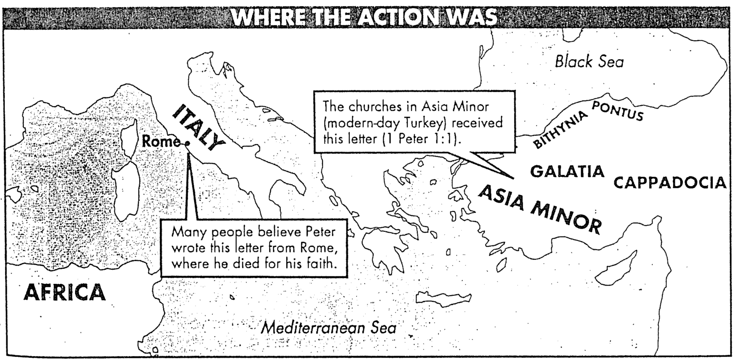

**NT Keyword Crossword Puzzle**

Designed at <http://www.crosswordpuzzlegames.com/cgi-crosswordpuzzlegames/create>

It’s time to review what we have learned so far in the course. Take the next few minutes to review all the keywords you remember up to this point. Put the ones you remember on the chart first then if you need help, go to page 24 for the answers. Have fun!

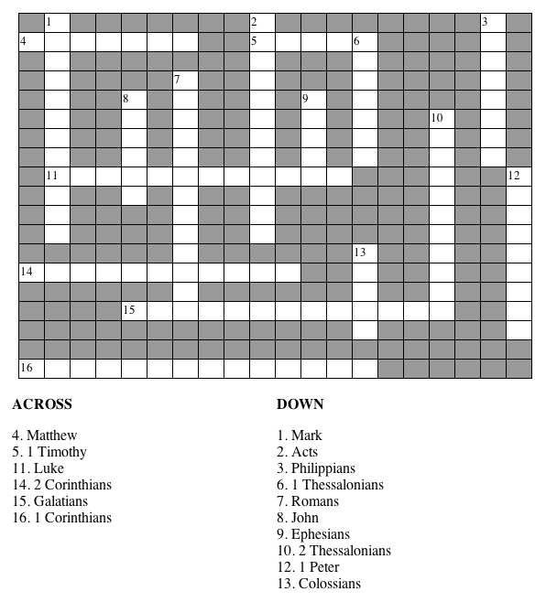

**Submit to Government**

***No Matter What Type (1 Peter 2:17)***

* Socialism:   
  You have two cows…

and you give one to your neighbor.

* Communism:   
  You have two cows…

the government takes both of them  
and *gives* you some milk.

* Fascism:   
  You have two cows…

the government takes both of them  
and *sells* you some milk.

* Nazism:   
  You have two cows…

the government takes both of them  
and *shoots you*.

* Bureaucracy:   
  You have two cows…

the government takes both of them,  
shoots one, milks the other, and pours the milk down the drain.

* Capitalism:   
  You have two cows…

you sell one and buy a bull.

**The Life of Peter**

*The Word in Life Study Bible* Nelson, 1996)

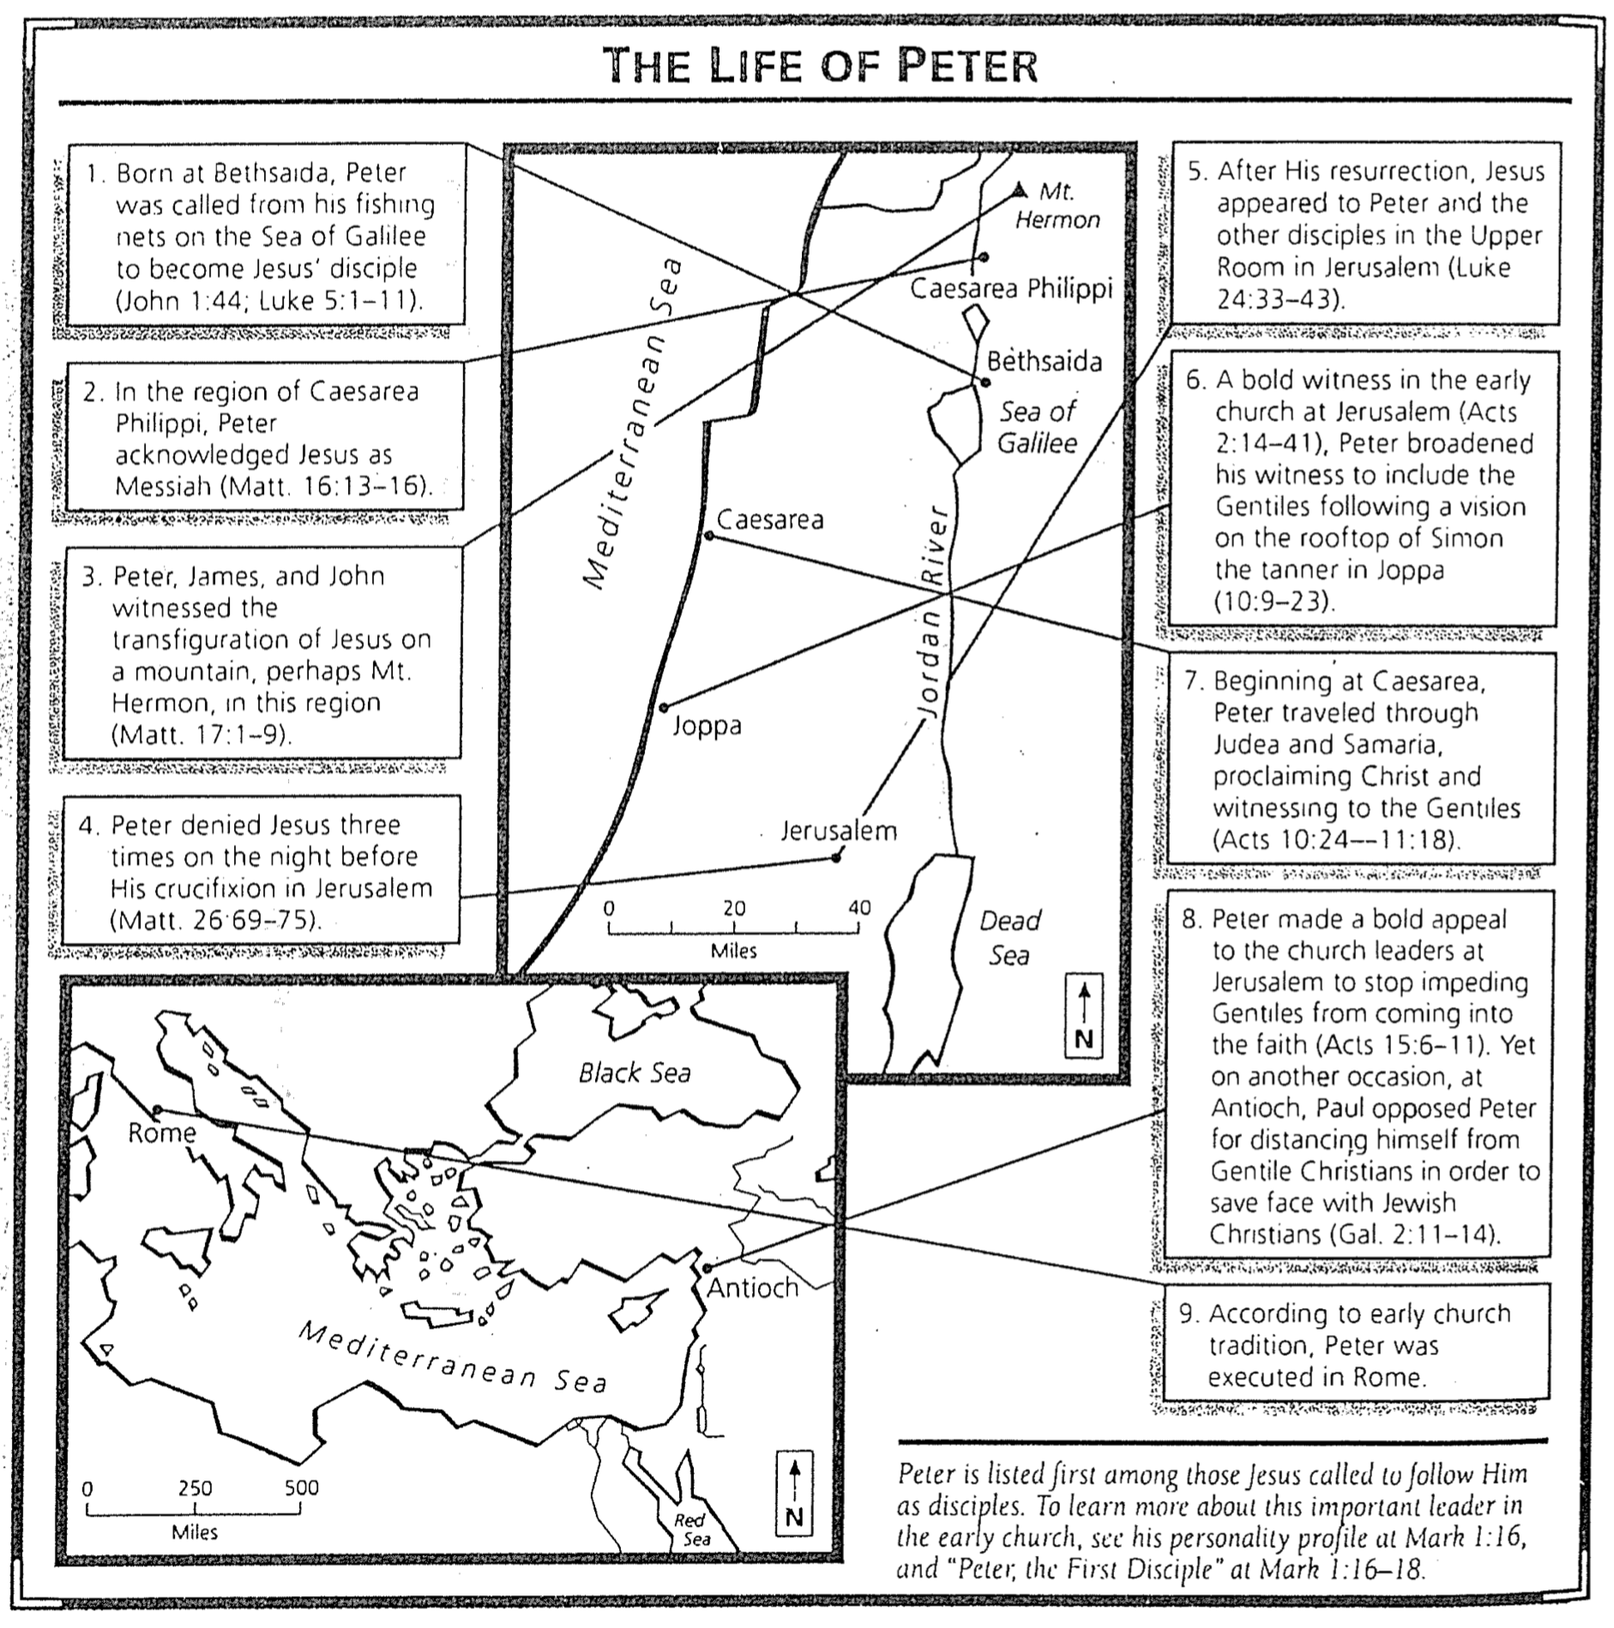

**Early Church Suffering**

Pliny the Younger was governor of Pontus/Bithynia from AD 111-113. We have many of his letters with the emperor Trajan on political matters. These two are the most famous, in which Pliny encounters Christianity for the first time.

**Pliny, Letters 10.96-97**

Pliny to the Emperor Trajan

It is my practice, my lord, to refer to you all matters concerning which I am in doubt. For who can better give guidance to my hesitation or inform my ignorance? I have never participated in trials of Christians. I therefore do not know what offenses it is the practice to punish or investigate, and to what extent. And I have been not a little hesitant as to whether there should be any distinction on account of age or no difference between the very young and the more mature; whether pardon is to be granted for repentance, or, if a man has once been a Christian, it does him no good to have ceased to be one; whether the name itself, even without offenses, or only the offenses associated with the name are to be punished.

Meanwhile, in the case of those who were denounced to me as Christians, I have observed the following procedure: I interrogated these as to whether they were Christians; those who confessed I interrogated a second and a third time, threatening them with punishment; those who persisted I ordered executed. For I had no doubt that, whatever the nature of their creed, stubbornness and inflexible obstinacy surely deserve to be punished. There were others possessed of the same folly; but because they were Roman citizens, I signed an order for them to be transferred to Rome.

Soon accusations spread, as usually happens, because of the proceedings going on, and several incidents occurred. An anonymous document was published containing the names of many persons. Those who denied that they were or had been Christians, when they invoked the gods in words dictated by me, offered prayer with incense and wine to your image, which I had ordered to be brought for this purpose together with statues of the gods, and moreover cursed Christ--none of which those who are really Christians, it is said, can be forced to do--these I thought should be discharged. Others named by the informer declared that they were Christians, but then denied it, asserting that they had been but had ceased to be, some three years before, others many years, some as much as twenty-five years. They all worshipped your image and the statues of the gods, and cursed Christ.

They asserted, however, that the sum and substance of their fault or error had been that they were accustomed to meet on a fixed day before dawn and sing responsively a hymn to Christ as to a god, and to bind themselves by oath, not to some crime, but not to commit fraud, theft, or adultery, not falsify their trust, nor to refuse to return a trust when called upon to do so. When this was over, it was their custom to depart and to assemble again to partake of food--but ordinary and innocent food. Even this, they affirmed, they had ceased to do after my edict by which, in accordance with your instructions, I had forbidden political associations. Accordingly, I judged it all the more necessary to find out what the truth was by torturing two female slaves who were called deaconesses. But I discovered nothing else but depraved, excessive superstition.

I therefore postponed the investigation and hastened to consult you. For the matter seemed to me to warrant consulting you, especially because of the number involved. For many persons of every age, every rank, and also of both sexes are and will be endangered. For the contagion of this superstition has spread not only to the cities but also to the villages and farms. But it seems possible to check and cure it. It is certainly quite clear that the temples, which had been almost deserted, have begun to be frequented, that the established religious rites, long neglected, are being resumed, and that from everywhere sacrificial animals are coming, for which until now very few purchasers could be found. Hence it is easy to imagine what a multitude of people can be reformed if an opportunity for repentance is afforded.

**Trajan to Pliny**

You observed proper procedure, my dear Pliny, in sifting the cases of those who had been denounced to you as Christians. For it is not possible to lay down any general rule to serve as a kind of fixed standard. They are not to be sought out; if they are denounced and proved guilty, they are to be punished, with this reservation, that whoever denies that he is a Christian and really proves it—that is, by worshiping our gods—even though he was under suspicion in the past, shall obtain pardon through repentance. But anonymously posted accusations ought to have no place in any prosecution. For this is both a dangerous kind of precedent and out of keeping with the spirit of our age.

This text is part of the [Internet Medieval Source Book](http://www.fordham.edu/halsall/sbook.html). The Sourcebook is a collection of public domain and copy-permitted texts related to medieval and Byzantine history. Unless otherwise indicated the specific electronic form of the document is copyright. Permission is granted for electronic copying, distribution in print form for educational purposes and personal use. If you do reduplicate the document, indicate the source. No permission is granted for commercial use. (c)Paul Halsall Mar 1996. halsall@murray.fordham.edu (http://www.fordham.edu/halsall/source/pliny1.html)

**Unjust Suffering**

Alan Andrews (Navigators) at Grace Baptist Church, June 1994

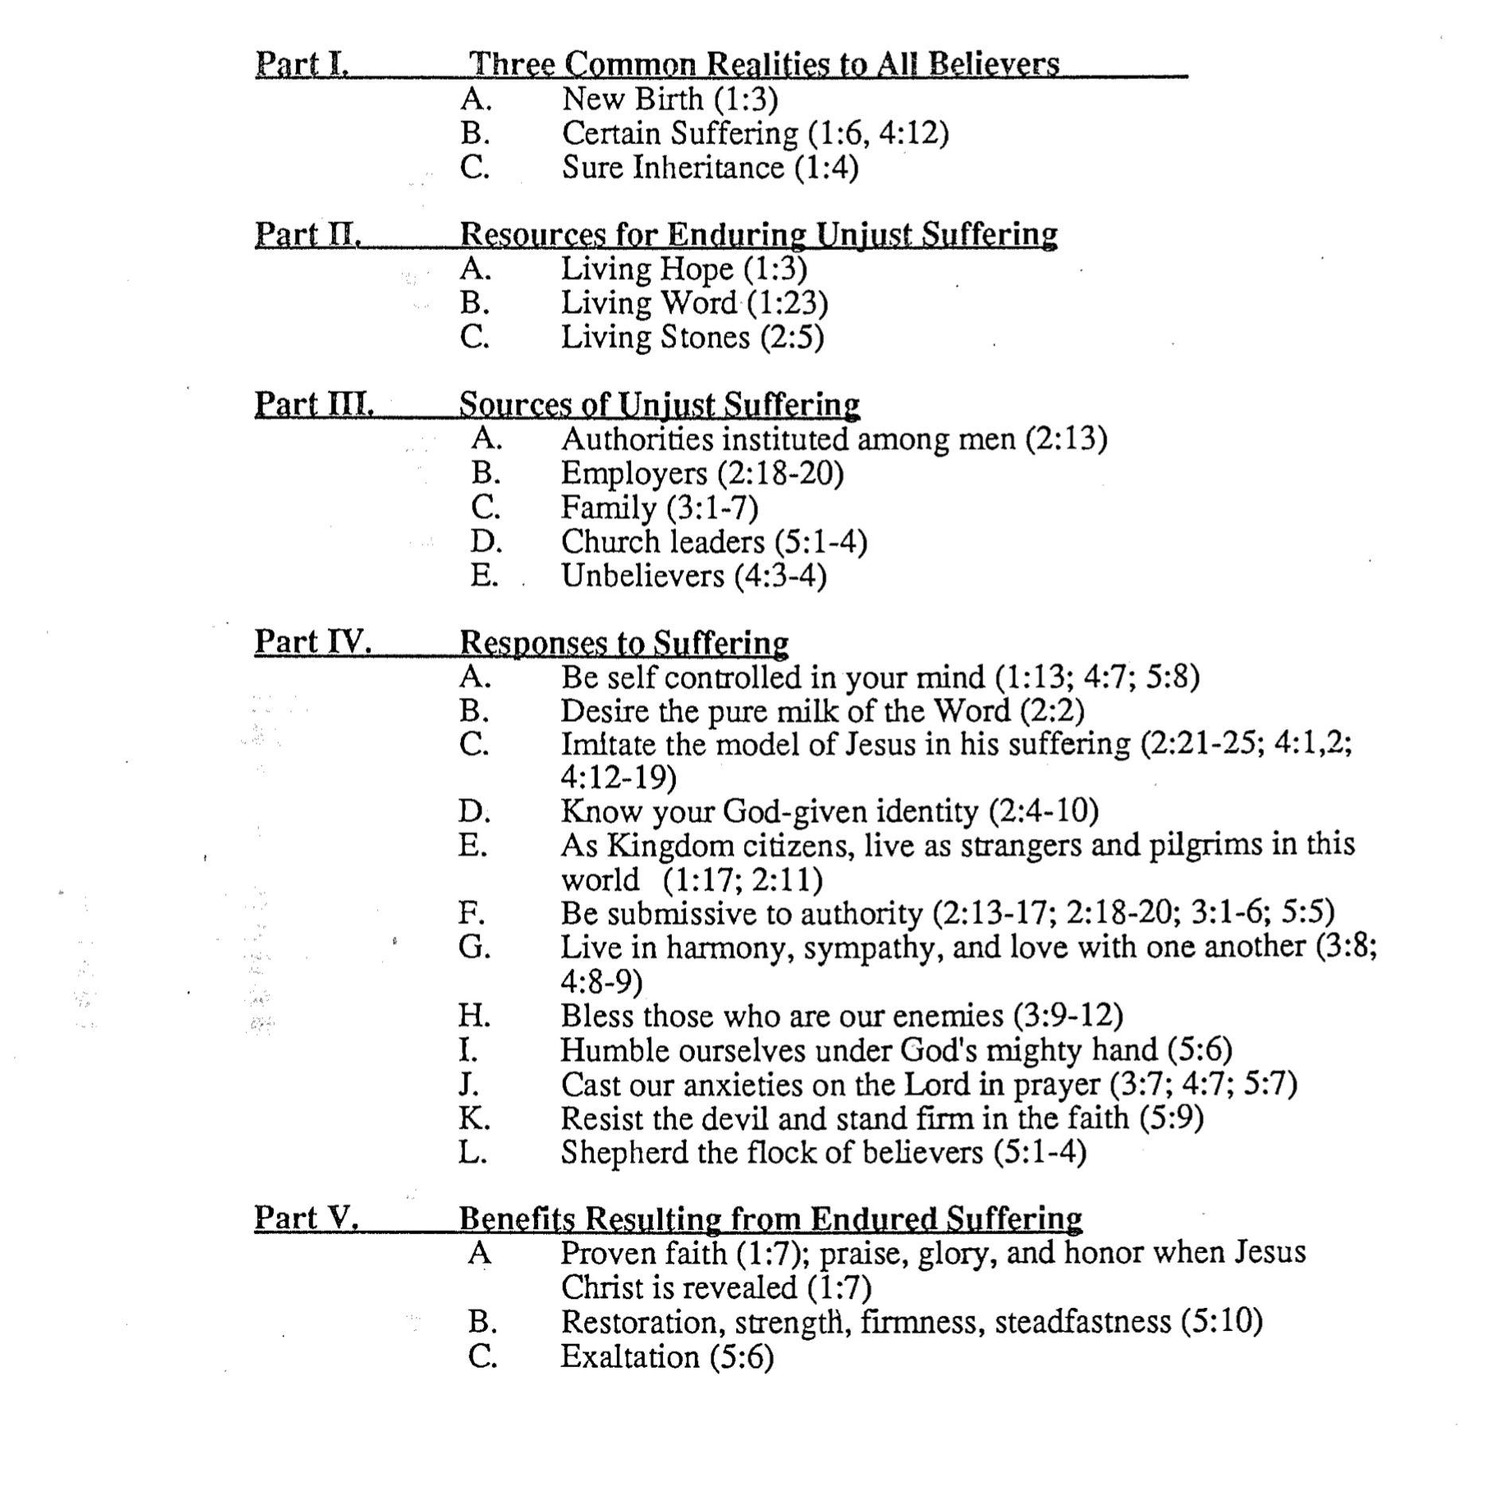

**Definitions of Suffering**

Bill Gothard, *Birthday Greetings* (Institute in Basic Youth Conflicts, 1987)

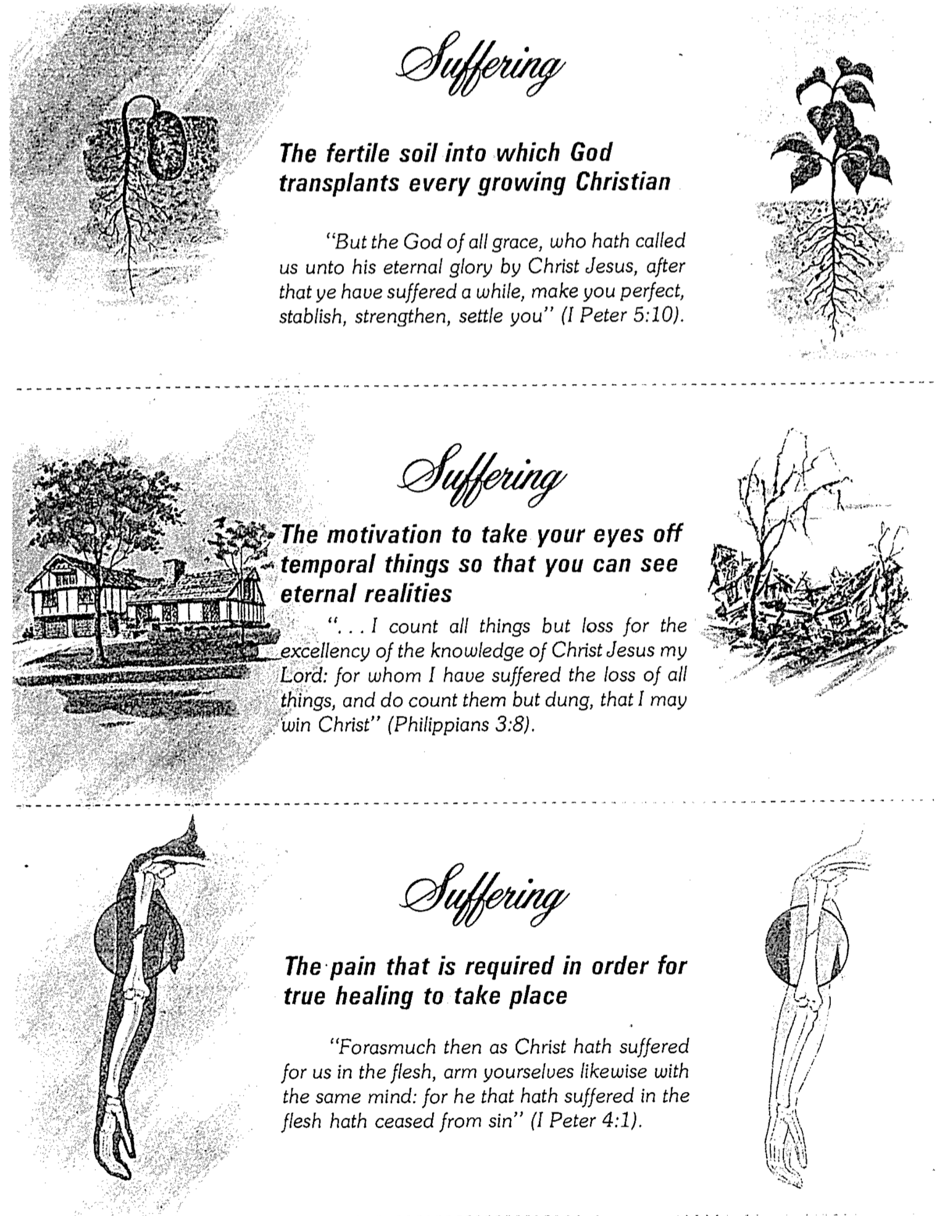**Palm Trees and Suffering**

Bill Gothard, *Birthday Greetings* (Institute in Basic Youth Conflicts, 1986)

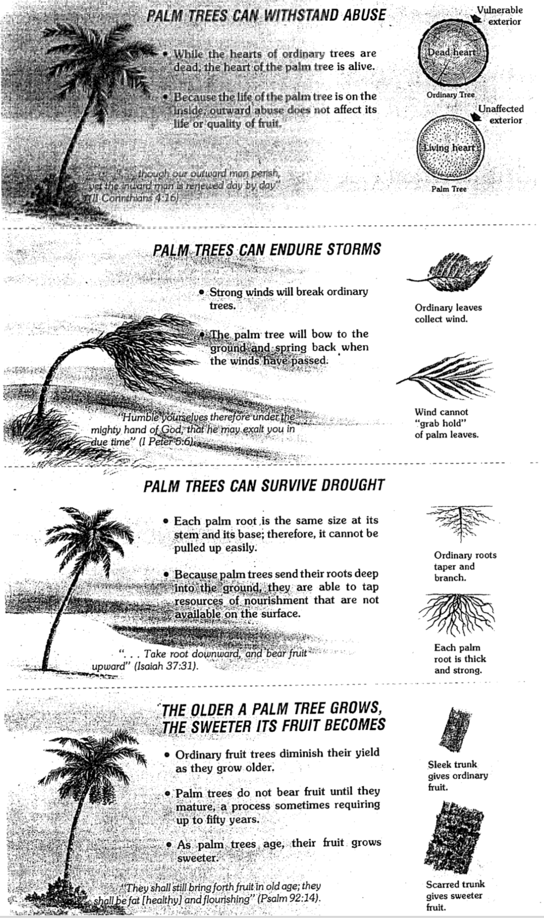

**The “Spirits in Prison” of 1 Peter 3:18-20**

One of the most problematic NT passages is 1 Peter 3:18-20, which states…

18 For Christ died for sins once for all, the righteous for the unrighteous, to bring you to God. He was put to death in the body but made alive by the Spirit, 19 through whom also he went and preached to the spirits in prison 20 who disobeyed long ago when God waited patiently in the days of Noah while the ark was being built. In it only a few people, eight in all, were saved through water.

Several attempts seek to answer six questions about this event: when it occurred, who preached, what was preached, to whom the message was preached, where it was preached, and the reason for the preaching (adapted from Grudem, *1 Peter*, TNTC, 204; Davids, *1 Peter*, NICNT, 138-39):

|  |  |  |  |  |  |
| --- | --- | --- | --- | --- | --- |
|  | **Time** | **Messenger** | **Content** | **Spirits/Place** | **Purpose** |
| 1 | Noah's day | Christ in Noah | Repentance/ righteousness | Live humans on earth (but now spirits in hell) | Judgment |
| 2 | Between Christ's Death & Resurr. | Christ | Gospel | Dead unsaved humans in Hades who perished in Noah’s flood | Judgment |
| 3 | Between Christ's Death & Resurr. | Christ | Gospel | Dead unsaved humans in Hades from OT times | Second chance  to believe |
| 4 | Between Christ's Death & Resurr. | Christ | Defeat of Death | Dead unsaved humans in Hades from OT times | Judgment |
| 5 | Between Christ's Death & Resurr. | Christ | Release | Dead humans in Purgatory who repented just before dying in Noah’s flood | Lead them to heaven |
| 6 | Between Christ's Death & Resurr. | Christ | Redemption | Dead saved humans in Hades | Lead them to heaven |
| 7 | Between Christ's Death & Resurr. | Christ | Defeat of Death | Imprisoned angels of Genesis 6 in Tartarus | Victory of Resurrection |
| 8 | Between Christ's Death & Resurr. | Christ | Defeat of Death | Imprisoned angels of Genesis 6 in Tartarus | Victory of Resurrection |
| 9 | After Christ’s Resurrection | Christ | Invasion of Place of Demon Refuge | Demonic offspring of fallen angels of Genesis 6 in the earth | Victory of Resurrection |
| 10 | After Angels Fell in Genesis 6 | Enoch | Word of  Judgment | Spirits of fallen angels of Genesis 6 | Judgment |

Views 3 and 5 have the least support (contextually and theologically), and view 8 has the best evidence. However, the following surveys the strengths and weaknesses of the above views.

**Analysis of Views:**

#1. Noah preached repentance to his generation, who are now in Hades.

A. Advocates: Augustine, Aquinas, Leighton, 354-66; Zahn, 289; Guthrie, *NTI*, 842; Grudem, 156-57, 205.

B. Strengths

1. The relative pronoun in 1 Peter often changes from its immediate antecedent in a transition from one section to another, so the “whom” of verse 19 need not refer to Christ (1:6, 8, 10; 2:4, 22; 3:21; Grudem, 157).

2. Peter says Christ preached through prophets (1 Pet. 1:11; 2 Pet. 2:5; cf. 2 Cor. 13:3).

3. Noah and Peter’s readers shared many characteristics, such as being a righteous, persecuted minority (Grudem, 160-61).

C. Weaknesses

1. A new section is not being addressed here, so the force of the above pronoun argument is not applicable.

2. Although 1 Peter 2:5 says Noah was a preacher, the present text does not teach this. Instead, the subject of the verb in verse 18 (“Christ died…”) continues into verse 19 when it notes that “he went…”

3. Christ inspiring prophets is not the same as Christ himself preaching, and there are no other parallels to Christ temporarily inhabiting OT characters (Marshall, 124).

4. *Christ* is the model of righteous suffering here—not Noah. The reference to Noah shows only the time in which the spirits lived.

5. This view doesn’t relate the event to Christ's death and resurrection, as noted in the context. This event occurred after Christ was *made alive.*

#2. Christ preached judgment to unsaved human spirits in Hades who died in Noah’s flood.

A. Advocates: C. E. B. Cranfield, “An Interpretation of 1 Peter iii.19 and iv.6” *ExpT* 69 (1957-58), 369-72; E. Stauffer, *New Testament Theology*, trans. J. Marsh (London, 1955), 133-34; commentators Beare, Goppelt, Windisch, and Wand.

B. Strengths

1. The view addresses Noah’s and Christ’s involvement in the event.

2. This view sees the recipients as remaining unsaved, and since the message is one of judgment, it avoids the problematic “second chance to believe” theory.

C. Weaknesses

1. In the NT, “spirits” always refers to nonhuman spiritual beings (angels) unless expressly noted as human (verses cited under view #7).

2. This view does not explain why Noah’s generation is singled out among the numerous wicked generations.

#3. Christ preached a second chance to accept the gospel to unsaved human spirits in Hades.

A. Advocates: Reicke, 90-91, 118, 120-22, 130-31; Cranfield, 84-86; Hart, 68-69 (to repentant disobedient angels); Bigg, 162-63; Beare, 170-73; Best, 140-47. This view is called “further probation” and is taught by Franz Delitzsch (19th-century scholar) and modern “evangelicals” such as Dale Moody (1962), Donald Bloesch, and Clark Pinnock.

B. Strengths

1. Providing a “second chance” would seem consistent with Christ's compassion.

2. Other texts support the idea of a second chance to believe. Appeal is made to Isaiah 26:19, John 5:25-29, Ephesians 4:8, and 1 Peter 4:6.

C. Weaknesses

1. The text nowhere states that any second chance to believe is provided for the message's recipients, so this is an argument from silence.

2. Hebrews 9:27 notes that judgment (not opportunity to believe) follows after each person's death. It says, “Man is destined to die once and after that to face judgment.”

3. Where persons end up immediately after death is a fixed condition with no “crossing over” possible (Luke 16:26; cf. 13:28). In the parabolic form, the irreversibility of one’s state is indicated as the door being shut (Matt. 25:10-12; Luke 13:22-30).

4. Why would a second chance to believe be offered to pre-cross persons but not to post-cross persons? Yet, the post-death opportunity to believe in Jesus today is unscriptural, as the above indicates.

5. This view is the same as the Catholic concept of purgatory, except that punishment is downplayed. Therefore, many arguments against purgatory under view #5 below would also apply here.

#4. Christ announced victory over unsaved human spirits in Hades, whose condemnation was final.

A. Advocates: Lenski, 160-69, and many 17th-century supporters (cited by Reicke, 44-45, who calls this the “Orthodox Lutheran theory”).

B. Strengths

1. This view acknowledges Christ as the preacher.

2. The timing of this event would make sense.

3. It does not argue an unscriptural “second chance” theology.

C. Weaknesses

1. “Spirits,” when unqualified, never refers to humans in the NT (only to angels).

2. Preaching to the dead is a foreign idea to the NT.

#5. Christ released human spirits from Purgatory because they repented at Noah’s Flood.

A. Advocates: Robert Bellamine (AD 1586) first proposed this view that is now common among Roman Catholic commentators (e.g., H. Willmering, *A Catholic Commentary on Holy Scripture* [London: Nelson, 1953], 1179).

B. Strengths

1. The concept of purgatory stems from a compassionate God.

2. This view ignores the contexts regarding Christ and Noah.

C. Weaknesses

1. The place where these spirits were held was a “prison,” which seems an odd description of the place of the righteous.

2. Why would people who repented before death be held in purgatory (if it existed) for the unsaved anyway?

3. The scriptural basis for purgatory is lacking. The following shows that a temporary place of punishment for those eventually going to heaven does not exist:

a. Even Catholics admit that purgatory is *not taught in the Bible*. Support used to be sought in some verses (e.g., Isa. 4:4; Micah 7:8; 1 Cor. 3:13-15), but even these are rarely cited by Catholics anymore. Hayes says, “Although there is no clear textual basis in Scripture for the later doctrine of purgatory, neither is there anything that is clearly contrary to that doctrine” (Hayes, in *Four Views on Hell*, ed. William Crockett, 107). In response, Scripture clearly says that punishment is “for ever and ever” (Rev. 20:10). Also, no text indicates a second chance to believe after death.

b. *Support for purgatory is mainly found in the Apocrypha.* Appeal for centuries has been to Judas Maccabeus in 2 Maccabees 12:41-46 (c. 200 BC), who discovered that some of his men killed in battle were wearing pagan amulets. Judas took up a collection from his surviving soldiers and sent it to Jerusalem as an “expiatory sacrifice,” with the result, “And thus he made atonement for the dead that they might be freed from their sin” (v. 46).

c. *Hebrews 9:27* says, “Man is destined to die once and after that to face judgment.” Where we are immediately after death is a fixed condition with no “crossing over” possible (Luke 16:26; cf. 13:28). In the parabolic form, the irreversibility of one’s state is indicated as the door being shut (Matt. 25:10-12; Luke 13:22-30).

d. *The foundation for purgatory is salvation by works,* which is destroyed when salvation by faith is seen clearly (Rom. 3:28; Gal. 2:21; Eph. 2:8-9). Believers are *in Christ* and enter God’s presence on this basis, not due to their works.

#6. Christ preached redemption through the Holy Spirit to save human spirits in a place where they awaited Christ.

A. Advocates: John Calvin, *Hebrews, 1-2 Peter*, 292-95

B. Strengths

1. Christ is seen to have done the preaching.

2. This view sees the recipients as already beneficiaries of the gospel and thus avoids the problematic “second chance to believe” theory.

C. Weaknesses

1. “Prison” is taken in a non-hostile sense.

2. These people disobeyed (v. 20) which is an unlikely description of believers.

#7. Between his death and resurrection, Christ proclaimed triumph over imprisoned, fallen angels who married women before the flood.

A. Advocates: Peter H. Davids, 140; Selwyn, 197-203, 314-62; Dalton, 135-201; Kelly, 151-58, Fitzmyer, *JBC*, 2:366-67; Stibbs/Walls, 142-43; Blum, 241-43; Leaney, 50-52; France, 264-81; Marshall, 128. This is the most widely held view today.

B. Strengths

1. “Spirits” can refer to angels as much as to humans (1 Enoch uses it both ways) and in the NT “spirits” always refers to nonhuman spiritual beings (angels) unless expressly noted as human (Matt. 12:45; Mark 1:23, 26; 3:30; Luke 10:20; Acts 19:15-16; 16:16; 23:8-9; Eph. 2:2; Heb. 1:14; 12:9, 23; Rev. 16:13, 14).

2. Angels (“sons of God”) were involved in the disobedience of cohabiting with women while Noah built the ark (Gen. 6).

3. This view of fallen angels being imprisoned was a commonly held interpretation during the first century (e.g., 1 Enoch 21:6, 10). A proclamation to these spirits in prison was a proclamation of judgment (1 Enoch 16:3).

4. Peter clearly indicates imprisoned angels in Tartarus in 2 Peter 2:4.

5. “In the NT the Greek term *kerysso* normally refers to the proclamation of the kingdom of God or the gospel (e.g., 1 Cor. 9:27), but it does on a few occasions retain its secular meaning of ‘proclaim’ or ‘announce’ (e.g., Luke 12:3; Rom. 2:21; Rev. 5:2). Furthermore, while Peter refers to the proclamation of the gospel four times, he never uses this verb to do so. Although the NT never speaks of evangelizing anyone’s spirits, it does speak of the victory of Christ over spirits (e.g., 2 Cor. 2:14; Col. 2:15; Rev. 12:7-11; cf. Eph. 6:11-12, which implies the same, and Isa. 61:1; Jon. 3:2, 4 in the LXX)” (Davids, 140-41).

C. Weaknesses

1. Never are angels said to have disobeyed during the building of the ark (though they did disobey just before this).

2. This view argues for the less likely (secular) meaning of the word “preached” (which is not impossible but only unusual).

3. This view assumes the possibility of sexual relations between angels and humans. (Yet an alternate view is that angels possessed human kings who committed this immorality; thus, both the humans and the angels would be judged for the sin.)

#8. Between his death and resurrection, Christ proclaimed triumph over imprisoned, fallen angels who possessed rulers who married women before the flood.

A. Advocates: I am the only advocate I know who holds this view, though probably many others also do.

B. Strengths

1. This view has the five strengths of view #7 above.

2. It also avoids the problem of angels marrying humans, which seems impossible according to Christ in Matthew 22:30, “At the resurrection, people will neither marry nor be given in marriage; they will be like the angels in heaven.”

C. Weaknesses (same as 1 and 2 in view #7 above but without weakness 3)

1. Never are angels said to have disobeyed during the building of the ark (though they did disobey just before this).

2. This view argues for the less likely (secular) meaning of the word “preached” (which is not impossible but only unusual).

#9. Christ proclaimed an invasion of the refuge of demonic offspring of fallen angels of Genesis 6.

A. Advocates: J. R. Michaels, 205-11

B. Strengths

1. Christ did invade and disarm the demonic sphere following his death (Col. 2:15).

2. This view adheres to the usual meaning of “spirits” as denoting angels.

C. Weaknesses

1. It is doubtful that demons have offspring (can reproduce themselves).

2. One wonders why, even if demonic offspring existed, they would have to be punished for the sins of their “parent demons.”

#10. Enoch preached judgment to the fallen angels of Genesis 6.

A. Advocates: William Bower (AD 1772), E. J. Goodspeed, “Some Greek Notes,” *JBL* (1954), 91-92.

B. Strengths

1. Enoch was indeed a preacher of righteousness.

2. This view addresses the context of Noah’s time (Noah and Enoch were contemporaries).

C. Weaknesses

1. The passage never mentions Enoch, so how can he be the subject?

2. This view ignores the context of the death and resurrection of Christ.

**Summary of Scripture on Hades**

1. Believers who die now do not go to Hades but to Heaven to be with Christ (Phil. 1:23; 2 Cor. 5:5-9) and the angels (Heb. 12:22, 23) at the altar of God (Rev. 6:9-11). “Whereas ‘paradise’ in the gospel account (Luke 23:43) referred to the section of Hades reserved for the righteous, by the time Paul wrote 2 Cor. 12:2-4, it was assumed that paradise had been taken out of Hades and was now placed in the third heaven” (Morey, 86). Several confessions teach that believers go directly to Christ now at death: the Heidelberg Catechism, Westminster Confession, and Second Helvetic Confession (Berkhof, Systematic Theology, 679).
2. “According to the post-resurrection teaching in the New Testament, the believer now goes to heaven at death to await the coming resurrection and the eternal state. But what of the wicked? The wicked at death descend into Hades, which is a place of temporary torment while they await the coming resurrection and their eternal torment… (2 Pet. 2:9)…until Hades is emptied of its inhabitants… (Rev. 20:13-15)” (Morey, 86-87). Thus, so far, no one has ever gone to hell.

3. Pertinent Terms (summarizing Robert Morey, *Death and the Afterlife,* 72-93)

***a. Sheol = Underworld (Hebrew)***

1) Usage: “The Hebrew word Sheol is found 66 times in the Old Testament. While the Old Testament consistently refers to the body as going to the grave, it always refers to the soul or spirit of man as going to Sheol” (Morey, 72). Paul Enns disagrees, saying that the OT concept includes the grave and where good and bad people go after death (*Moody Handbook of Theology*, 374).

2) Lexical Meaning: “the underworld… whither man descends at death” (BDB [Brown, Driver, Briggs] 982).

3) KJV Confusion: The KJV mistranslates *Sheol* as “grave” (31 times), “hell” (31 times), and “pit” (3 times). But *Sheol* cannot mean “grave” for several reasons. At least 20 contrasts exist between *Sheol* and the grave (Morey, 76-77)…

a) OT writers always use the word *kever* when they speak of the grave. Never are *Sheol* and *kever* (“grave”) used as synonymous (e.g., in parallelism).

b) The LXX never translates *Sheol* as “grave” (Gr. *mneema*) nor *kever* as Hades.

4) Sections: *Sheol* has two different parts, including a “lowest part”: “For a fire is kindled in my anger, and burns to the lowest part of Sheol” (Deut. 32:22 NASB; cf. Morey, 78).

***b. Hades = Underworld (Greek)***

1) Usage: *Hades* (ἁδης) is the Greek counterpart for the Hebrew *Sheol.* “In the Septuagint, Hades is found 71 times. It is the Greek equivalent for Sheol 64 times. The other seven times… it is the translation of other Hebrew words, some of which shed significant light on what Hades meant to the translators of the Septuagint” (Morey, 81). These seven include Job 33:22; 38:17; Prov. 2:18.

The NT uses the word 11 times, the most significant being in Acts 2:27, 31, where Peter quotes the prophecy about Christ in Psalm 16:10, “Thou wilt not abandon my soul to Sheol” (NASB), using the Greek *Hades* for the Hebrew *Sheol*—thus equating the terms. Unfortunately, here, the NIV mistranslates *Hades* as “grave.”

2) Lexical Meaning: *“the underworld* as the place of the dead” (BAGD 16).

3) KJV Confusion: “The KJV mistranslated the word Hades in every occurrence just as it did with the word Sheol” (Morey, 83). Hades does not mean “death” (*thanatos*, Rev. 1:18), nor “grave” (*mneema*), nor “hell” (*Gehenna*), nor “heaven” (*ouranos*), nor the place of eternal bliss for the righteous (the new heavens and the new earth; Rev. 21:1). Hades simply means the place of the disembodied spirits.

4) Sections: Before Christ’s death, *Sheol-Hades* had two different sections, or compartments: a place of torment for the wicked (specifically called Hades; Luke 16:23) and a place of conscious bliss for the righteous (“Paradise,” or “Abraham’s bosom”; Luke 16:22). It was often referred to as a dual compartment place in the intertestamental era (Morey, 84).

However, in Hades after His death (Acts 2:31), Christ proclaimed his resurrection to “spirits now in prison” (1 Pet. 3:18-22). Christ took the righteous out of Hades and brought them to heaven (Eph. 4:8-9; ibid, 86). One of the most problematic NT passages is 1 Peter 3:18-22, which states that after His death, Christ "preached to the spirits in prison who disobeyed long ago…" See the preceding pages.

***c. Gehenna = Hell (Greek)***

1) Usage: *Gehenna* is found 12 times in the NT with the meaning of “hell.” It describes the ultimate fate of the wicked (the lake of fire, Rev. 20:14-15) after the Great White Throne Judgment. Gehenna is the Greek equivalent for “the valley of Hinnom” (Josh. 15:8; 18:16; Neh. 11:30), which was the dump outside Jerusalem where people tossed garbage and unclean corpses. Here, “the fires never stopped burning, and the worms never stopped eating” (Morey, 87).

2) Lexical Meaning: “The place of judgment” (BAGD 152).

3) KJV: The KJV correctly translates *Gehenna* as “hell” in every instance. Unfortunately, whereas Berkhof (p. 680), the Westminster Confession, and the Second Helvetic Confession correctly identify the place of the believer after death, they all incorrectly cite that unbelievers presently enter hell at death.

4) Sections: No sections are specified in Scripture, although Christ intimated that there would be different degrees of punishment after death (Matt. 11:20-24).

**Summary: Where Did/Do the Deceased Go?**

|  |  |  |
| --- | --- | --- |
|  | **Before the Death of Christ** | **After the Death of Christ** |
| **All People** | Sheol-Hades, a “dual compartment” place (Luke 16) | Paradise compartment emptied of OT saints and brought to Heaven (Eph. 4:8; Prov. 15:24; Matt. 27:50-53; Rom. 10:7; Heb. 12:23; 2 Cor. 12:1-4; Rev. 1:18) |
| **Believers** | Paradise or “Abraham’s side” in Hades (Luke 16:22; 23:43) | Christ’s presence in Heaven  (Acts 7:55, 59; Phil. 1:23; 2 Cor. 5:8) |
| **Unbelievers** | Place of torment in Hades  (Luke 16:23) | Place of torment = Hades  (2 Pet. 2:9; Rev. 6:8) |

**The Transfer to Paradise**

Heaven/  
Paradise

Hades

S

H

E

O

L

1 Peter 3:18-20

**HADES**

**Bliss**

Luke 16

Luke 23:43

2 Corinthians 12:1-4

**Hell**

**Gehenna**

**Lake of Fire**

Revelation 20:14-15

**HADES**

Ephesians 4:8-10

4. If dead believers go to Christ and dead unbelievers go to Hades, but the resurrection of their bodies comes later (cf. p. 160), are they then bodiless until the resurrection?

a. No. Perhaps all the saved have an intermediate body (e.g., Moses in Luke 9:30).

Certain texts strongly intimate that there is such a body. There is “a building from God, a house not made with hands, eternal, in the heavens” (2 Cor. 5:1, KJV). This body is said to be eternal because it is finally merged with the resurrection body at the time of the resurrection. The preparation of the intermediate body is a miraculous operation of God. Therefore, to be clothed with this body during the intermediate state will not leave one naked (2 Cor. 5:2-4, KJV). This may be part of the explanation for the Old Testament saints who came out of their graves after the resurrection of Christ (Matt. 27:50-53, KJV). This may also explain the white robes of the tribulation martyrs under the altar (Rev. 6:9-22; cf. Rev. 7:9, 14, KJV)” (from Hoyt, 47).

b. Likewise, by implication, every unbeliever must also have an intermediate body that experiences pain and torment (?)—unless this can be felt by a soul alone (?).

5. In light of the preceding Scripture, the Bible refutes all of the following erroneous intermediate state philosophies (see these notes, 163-70; Erickson, 1176f.; Hoyt, 47; Berkhof, 686-94):

a. Universalism: all persons upon earth will be saved regardless of their belief (held by liberalism). See my response on p. 163.

b. Annihilationism: the soul of unbelievers is not immortal and will die; thus the punishment for sin is missing out on heaven since there is no eternal hell (held by Jehovah’s Witnesses and “evangelicals” such as F. F. Bruce, John Stott, Clark Pinnock, and Philip Hughes). See my response on pp. 164-67.

c. Soul-Sleep: the soul cannot be conscious without a body; “the condition of man in death is one of unconsciousness… all men, good and evil alike, remain in the grave from death to the resurrection” (*Seventh-day Adventists Answer Questions on Doctrine* [Review & Herald, 1957], 13; cited by Millard Erickson, 1176).

Response (cf. p. 170):

1) Consciousness after death is revealed repeatedly: “remember” (Luke 16:25), “today” (Luke 23:43), Stephen’s prayer (Acts 7:59), OT persons (Matt. 17:1-8).

2) Pain is experienced after death (Luke 16:24)

3) After death, Christians “live together with” Christ (1 Thess. 5:10; cf. Luke 20:38; Phil. 1:23; 2 Cor. 5:6, 8), so a soul sleep is impossible.

4) Why would a soul need to sleep? Isn’t sleep a bodily function—not of the soul? How could a disembodied soul sleep? Sleep is only a euphemism for death (Matt 9:24; John 11:11; Acts 7:60; 13:36; 1 Cor 11:30; 15:6, 18, 20, 51; 1 Thess 4:13-15).

5) A body is unnecessary for consciousness (Holy Spirit, Father, angels, demons).

d. Purgatory: an additional place for cleansing “venial" sins (but not mortal sins) between death and the resurrection awaits those who “are in a state of grace but not yet spiritually perfect”; it is “a state of temporary punishment for those who, departing this life in the grace of God, are not entirely free from venial sins or have not yet fully paid the satisfaction due to their transgressions” (Joseph Pohle, *Eschatology or The Catholic Doctrine of the Last Things: A Dogmatic Treatise* [St. Louis: B. Herder, 1917], 18). [Notice *who* pays for sin!] A related doctrine is that of *limbus infantium* whereby unbaptized babies suffer punishment for original sin, which is the loss of beatific vision or the presence of God, but they are not punished for *actual* sin. They also think Matt. 12:32 teaches forgiveness after death.

Response (cf. p. 167): The dead have a fixed state (Heb. 9:27) with no crossing over from one place to another (Luke 16:26). Matt. 12:32 teaches *no* forgiveness later.

e. Reincarnation: the intermediate state is experienced repeatedly between various times the same individual lives on earth (held by Hindus, New Agers, and many others).

**Civil Disobedience in Scripture**

When God Wants Us to Disobey Authority

Christians are obedient people—but sometimes *too* obedient! Read the texts below and fill in the missing areas to see when Christians should submit and resist authority.

|  |  |  |  |
| --- | --- | --- | --- |
| **Passage** | **Authority’s Command** | **Godly Response** | **Result** |
| Jeremiah 35 | God tested the Recabites by commanding to drink wine | They refused since their ancestor Recab had vowed for his descendants to be Nazarites who did not drink at all |  |
| Daniel 1 | King Nebuchadnezzar assigned defiled food to Daniel and his friends to eat (1:5) | Daniel respectfully appealed to be a vegetarian (1:8) | God rewarded them with better health (1:15), removal of the temptation (1:16), wisdom (1:17), and got the best jobs in the kingdom (1:18-21) |
| Daniel 3 | King Nebuchadnezzar commanded three Jewish youths to worship an idol (3:1-7) | They did not mock those who did so, but they remained standing rather than bow to an object (3:8) | They were rescued from the furnace (3:19-27), causing the king to praise God (3:28-29) and promote them (3:30) |
| Daniel 6 | King Darius prohibited Daniel to pray to any god but himself |  |  |
| Acts 4:17-18; 5:40 | The Jewish ruling council (Sanhedrin) commanded Peter and John not to share Christ |  |  |
| 1 Peter 2:13 | The Emperor Nero killed those claiming to be Christians | Some refused and still worshipped underground | Many deserted the faith, while others died for Christ |
| Revelation 1:9 | The Emperor Domitian outlawed Christianity | John continued to shepherd God’s people | John was boiled in oil but miraculously survived and wrote the book of Revelation later. |

*What overall principle can you determine from these biblical accounts of disobedience to authority?*