2 Thessalonians

Tribulation Corrections

Persevere in Persecution |  | Day Still Future |  |  | Discipline the Idle
Chapter 1 |  | Chapter 2 |  |  | Chapter 3
Emotional |  | Theological |  |  | Practical
Encouragement  in Persecution |  | Explanation  of the Day |  |  | Exhortation  in Body Life
Discouraged  Believers |  | Disturbed  Believers |  |  | Disobedient  Believers
Correct  Perspective |  | Correct  Doctrine |  |  | Correct  Behaviour
Salutation  1:1-2 | Reward vs. Judgment  1:3-12 | Pretrib  Teaching  2:1-2 | Antichrist  Prerequisite  2:3-12 | Stand  Firm  2:13-17 | Prayer  Requests  3:1-5 | Discipline  Idle  3:6-15 | Blessing  Given  3:16-18
Corinth

Late Summer AD 51

Key Word: Tribulation

Key Verse: Do not “become easily unsettled or alarmed by some prophecy, report or letter supposed to have come from us, saying that the day of the Lord has already come. Don’t let anyone deceive you in any way, for that day will not come until the rebellion occurs and the man of lawlessness is revealed, the man doomed to destruction” (2 Thessalonians 2:2-3).

Summary Statement: The way Paul affirmed others during the heresy that the day of the Lord (Tribulation) had already begun was holistic: emotional, theological and practical.

Application: How does your view of the future spur your commitment to serve Christ?

2 Thessalonians

Introduction

I. Title The Greek title (Πρὸς Θεσσαλονικεῖς Β´ Second to the Thessalonians) distinguishes this letter from Paul's first letter to the church just a few months before.

II. Authorship

A. External Evidence: Support for Pauline authorship has been upheld “very probably” since Polycarp (ca. AD 135; cf. Best, 37-38) and possibly earlier with Ignatius (ca. AD 110). One can add the Marcion Canon (ca. AD 140) and Muratorian Canon (ca. AD 170), plus the testimony of the early Church Fathers and ancient versions.

B. Internal Evidence: The letter itself strongly supports Pauline's authorship:

1. The epistle claims that Paul wrote it (1:1; 3:17).

2. The premature ending (3:1-5) suits Paul more than a conscious imitator (Kümmel, 189).

3. The similarities to 1 Thessalonians, cited by some critics as evidence against Pauline authorship, support it (Best, 50-56).

4. Critics infer discrepancies between 2 Thessalonians 2:1-12 and 1 Thessalonians 4:13–5:11, but these differences refer to two phases of Christ’s coming (Hiebert, 57).

C. Conclusion: The attacks upon Paul’s authorship have been soundly defeated so that nearly all scholars, despite their critical assumptions, believe that Paul penned this epistle.

III. Circumstances

A. Date: Hoehner suggests that Paul wrote 2 Thessalonians in the summer of AD 51 (just a few months after his first letter). The following supports this claim:

1. Paul, Silas, and Timothy (1:1) are not known to have been together again after their stay in Corinth, where Paul wrote the letter (Hiebert, 59).

2. The same general conditions exist in the church as discussed in 1 Thessalonians (e.g., idleness; cf. 1 Thess. 4:11-12; 2 Thess. 3:6-15).

3. These men stayed in Corinth for another year. This doesn’t necessarily argue for a date only a few months after 1 Thessalonians, but certainly, the second letter precedes Paul's visit to them five years later (May 56). Indeed, 2 Thessalonians followed the first letter within 12 months (Constable, BKC, 2:713).

B. Origin/Recipients: Paul wrote from Corinth to the Thessalonian believers north of him in the province of Macedonia (see “Date” above for support). Although this was his second letter to them, the congregation was still young—probably less than a year old.

C. Occasion: The historical and chronological scenario for Paul’s ministry at Thessalonica during his second missionary journey probably looks like this:

1. Paul plants the Thessalonian church November 50-January 51
2. Paul’s ministry in Berea, Athens, and Corinth February-March 51
3. Silas and Timothy report to Paul in Corinth April/May 51
4. Paul writes 1 Thessalonians and sends it from Corinth Early Summer 51
5. The carrier of 1 Thessalonians reports back to Paul Mid-Summer 51
6. Paul writes 2 Thessalonians from Corinth Late Summer 51
7. Paul departs Corinth First of September 52

Within a few months after writing 1 Thessalonians, Paul got news (probably from the letter carrier) of problems unresolved by his first letter. The persecution of the believers had increased (1:3-10), false teachers had taught that the day of the Lord had already come (2:1-12), and some of the Thessalonian Christians had become idle as they “waited for the rapture” (3:6-15). Therefore, Paul wrote the church again to help the believers handle these difficulties.

IV. Characteristics

A. Although 2 Thessalonians is Paul's shortest letter to a New Testament church, it contains significant information regarding Christ's second coming and the day of the Lord.

1. The return of Christ, the central theme of chapters 1–2, is the most mentioned doctrine in the New Testament, referred to 318 times (TTTB, 423). This averages out to every 25 verses in the New Testament or 1.2 times per chapter! (The NT has 7959 verses and 260 chapters.) In 2 Thessalonians, 18 of 47 verses (38%) stress eschatology.

2. The day of the Lord is also taught in many places in Scripture (cf. Isa. 13:6, 9; Joel 1–2; Zeph. 1:14-16; 1 Thess. 5:1-11; Rev. 6–20) and refers to a time of judgment upon God's enemies and blessing upon His children that is unsurpassed. Chronologically, it begins after the rapture (perhaps halfway through the seven-year tribulation) and continues to the end of the millennium (Constable, BKC, 2:717).

3. The rapture is the “catching up” of the saints by Christ at his return (1 Thess. 4:17). The word itself comes from around AD “1600, ‘act of carrying off,’ from Middle French rapture, from Medieval Latin raptura ‘seizure, rape, kidnapping,’ from Latin raptus ‘a carrying off, abduction, snatching away; rape’ (see rapt). The earliest attested use in English is of women and in 17c. it sometimes meant rape (v.), which word is a cognate of this” (https://www.etymonline.com/word/rapture). This negative connotation is not found in the theology of the rapture, but the act of being suddenly carried off is the common element of both rape and the rapture.

4. A problem exists concerning the day of the Lord: if the rapture can happen at any time (i.e., without preceding signs), and the day of the Lord begins after that, how then can this latter “day” be preceded by three signs (2:3-12)?

a. These verses clearly state that three signs (the apostasy, the revelation of the Antichrist, and the removal of the restrainer) precede the day of the Lord. At first, this may look like support for the posttribulational position (i.e., that the church will be removed from the earth after the tribulation).

b. However, the tribulation does not begin with the rapture. It starts when the Antichrist signs a covenant with Israel (Dan. 9:27). What 2 Thessalonians 2:3-7 notes is only that the three signs will take place before the beginning of the tribulation, which could happen days, weeks, or months after the rapture.

c. Therefore, while no signs precede the rapture, at least three signs precede the day of the Lord during the period between the rapture and the day of the Lord.

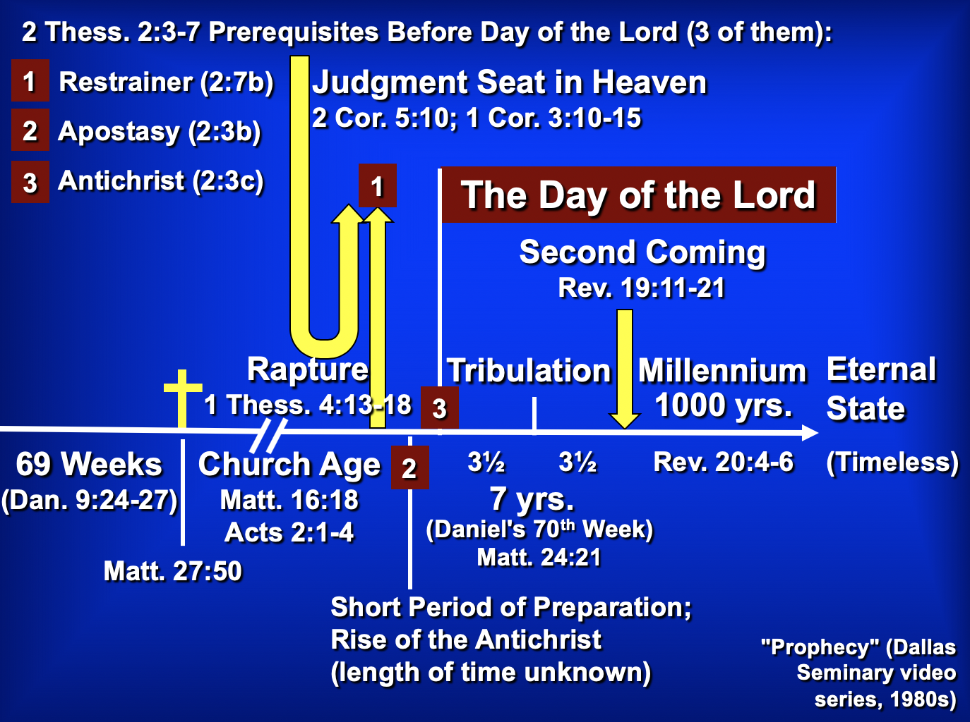

B. Whereas Paul wrote 1 Thessalonians to comfort, he wrote 2 Thessalonians to correct.

C. Paul deviates from his usual epistolary pattern with his two thanksgivings (1:3f.; 2:13f.) and two prayers (1:11-12; 2:16-17). Some believe that this indicates a merging of two separate letters. Still, there is no evidence that Paul ever felt constrained by a particular literary pattern, and no manuscript evidence exists to doubt the unity of the epistle.

Argument

As mentioned above, Paul wrote 2 Thessalonians to help the believers handle three difficulties facing the church: increased persecution (1:3-10), false teaching that the day of the Lord had already come (2:1-12), and idleness among some of the Thessalonian Christians who were “waiting for the rapture” (3:6-15). Paul's design in writing was to encourage perseverance based upon their future reward on the day of the Lord (2 Thess 1) and to correct their false notion of the day of the Lord (2 Thess 2), which had resulted in idleness (2 Thess 3). The overriding theme is the day of the Lord and its implications on behavior.

Synthesis

Day of the Lord corrections

1 Emotional: Persevere in persecution
1:1-2 Salutation
1:3-12 Church's reward vs. persecutors' judgment at the day of the Lord

2 Theological: Day still future
2:1-2 Teaching hasn't changed
2:3-7 Antichrist events preceding Day
2:3a Apostasy
2:3b-4 Worship as God
2:5-7 Restrainer removed
2:8-12 Antichrist activity and end
2:13-17 Stand firm

3 Practical: Discipline the idle
3:1-5 Pray for the spread of the gospel
3:6-15 Discipline lazy unemployed members
3:16-18 Blessing/benediction

Outline

Summary Statement for the Book
The way Paul affirmed others during the heresy that the day of the Lord (Tribulation) had already begun was holistic: emotional, theological and practical.

Emotional: Persecuted believers should persevere since God will judge their persecutors but make them mature (2 Thess 1). Swindoll: Persevering through affliction develops maturity.

Paul mentions his fellow workers, Silas and Timothy, but not his position as an apostle to begin his letter relationally (1:1-2).

God will reward the church’s perseverance during affliction but punish their persecutors by helping the church become mature (1:3-12).

Theological: Paul teaches that the day of the Lord requires the Antichrist so the church can be stable (2 Thess 2). Swindoll: Trusting amidst confusion produces stability.

Paul had kept his views on the time of the day of the Lord, meaning that they had not missed the rapture (2:1-2).

Specific events will precede the day of the Lord so that the Thessalonians can see they did not miss this event (2:3-12).

The Church will depart from the earth (or from God’s Word) before the day of the Lord comes, leaving only an apostate church (2:3a).

The Antichrist will reveal himself to the discerning before the day of the Lord begins (2:3b-4; by signing a covenant with Israel; cf. Dan. 9:27).

The Church's restraining ministry by the Holy Spirit will be removed from the earth, allowing the Antichrist to rule (2:5-7).

Then the Antichrist will prove himself in counterfeit miracles and a powerful delusion sent by God but will be destroyed at Christ’s return (2:8-12).

Paul prays that they will stand firm in good works since they will be spared from the day of the Lord by sharing Christ's glory (2:13-17).

Practical: The church must discipline lazy believers living off others so that they will work like Paul and his colleagues (2 Thess 3). Swindoll: Waiting with discipline cultivates responsibility.

Paul requests prayer for the gospel's progress and prays for them by modeling prudent behavior before the day of the Lord arrives (3:1-5).

They must discipline idle believers who live off others as they wait for the rapture to shame them into responsible work (3:6-15).

Paul signs the concluding blessing and benediction to show the genuineness of the epistle (cf. 2:2b) so that the church would act on its authority (3:16-18).

In our day, when most people talk of self-esteem, it is refreshing to find the Godhead noted more than once per verse, on average, in these books…

Focus on God in the Thessalonian Epistles
Total Verses | “God” | “Lord” | “Jesus” | “Christ” | Total
1 Thess. (89) | 36 | 24 | 16 | 10 | 86
2 Thess. (47) | 18 | 22 | 13 | 10 | 63
Total (136) | 54 | 46 | 29 | 20 | 149
Numbers of Greek occurrences from Elwell & Yarbrough, Encountering the New Testament, 332

The Day of the LORD

I. Usage

A. The “day of the LORD” concept appears in every prophetical writing in the Old Testament, although not always by that exact term.

B. The judgment aspect receives detailed treatment in Zephaniah, Joel, and Revelation 6–19. Some believe the “Lord’s day” of Revelation 1:10 also refers to this period (cf. 2 Thess. 2:2-3).

II. Definition

A. The day of the LORD is “the time of Yahweh’s final intervention in history when He will judge the wicked, deliver the righteous, and establish His kingdom” (Hobart Freeman, An Introduction to the OT Prophets, 146).

1. Judgment

a. Primarily, it refers to the destruction of Israel’s enemies (Zeph. 2–3; Amos 1:3–2:3; Joel 3; Zech. 12–14; Isa. 13:6, 9; 14:28-32; 17:1ff.; 20:1-6; 31:1-5; Jer. 46:10; Ezek. 30:3ff.).

b. However, it also includes punishment for the rebellious and disobedient in Israel (Amos 5:18-20).

c. The Great Tribulation of Revelation 6–19 finds so many parallels with descriptions by the OT prophets that the two judgments must undoubtedly be the same period.

d. Ultimately, the day of the LORD will end in the world's destruction (2 Pet. 3:10).

2. Deliverance

a. Israel’s salvation from Gentile oppressors will occur through God who preserves and delivers a remnant of Israel (Joel 2:32; Zech. 14; Zeph. 3:8-20; Isa. 2, 11; 65-66; Amos 9:11-15; Ezek. 20:33-44, etc.).

b. This salvation will enable Israel to enter the kingdom when God will fulfill all His promises to Abraham (cf. class notes, 336-37).

c. The deliverance also has many blessings (Deut. 30:3-9) for Gentiles (Zeph. 3:9).

d. Final salvation after judgment will be in the new heaven and earth (2 Pet. 3:11-13).

3. Diagram

Judgment + Salvation = Day of the LORD

Great Tribulation + Christ’s Return/ = Day of the LORD
Millennium

B. The day of the LORD also had a nearer aspect to the prophets, depicting an imminent, impending disaster—generally through the Assyrians or Babylonians. Sometimes, the near and far elements appear together in a dual sense. God did not reveal whether a close or far perspective should be understood to encourage repentance.

C. For further study, see Greg A. King, “The Day of the LORD in Zephaniah,” Bibliotheca Sacra 152 (January-March 1995): 16-32.

The Antichrist

I. The Post-Rapture Crisis for Leadership

A. The need for a world leader after the rapture cannot be overstated.
1. Someone will need to explain the disappearance of millions of Christians.
2. Communications, transportation, economics, and all other systems will be disrupted.
3. The Middle East problem especially will need to be resolved.

B. Difficult times have always set the stage for a strong man to take control. The world scene after the rapture will be a perfect environment for the Antichrist to gain power.

II. Names for the Future Fuhrer

A. The names are many, describing his multifaceted character and the great emphasis placed upon this man in the Bible.

B. List of the names in scriptural order:

Bloody and Deceitful Man Ps. 5:6
Wicked One Ps. 10:2-4
Man of the Earth Ps. 10:18
Mighty Man Ps. 140:1
Assyrian Isa. 10:5-12
King of Babylon Isa. 14:2
Sun of the Morning Isa. 14:12
Spoiler Isa. 16:4-5; Jer. 6:26
Branch of the Terrible Ones Isa. 25:5
Profane Wicked Prince of Israel Ezek. 21:25-27
Little Horn Dan. 7:8
King of Fierce Countenance Dan. 8:23
Prince that shall Come Dan. 9:26
One who causes Desolation Dan. 9:27
Vile Person Dan. 11:21
Willful King Dan. 11:36
Idol Shepherd Zech. 11:16-17
The Abomination of Desolation Matt. 24:15
One Coming in His Own Name John 5:43
Man of Sin 2 Thess. 2:3
Man Doomed to Destruction 2 Thess. 2:3
Lawless One 2 Thess. 2:8
Antichrist 1 John 2:18, 22
Angel of the Bottomless Pit Rev. 9:11
Beast from the Abyss/Sea Rev. 11:7; 13:1
[Scarlet] Beast Rev. 17:3, 8, 12

III. Summary of the Activity of the Future Fuhrer

A. Makes 7-year treaty with Jews Dan. 9:27a; 2 Thess. 2:3 (treaty reveals him?)
B. Peaceful beginning Rev. 6:1-2
C. Heads 10 nation confederacy Dan. 7:20
D. Dominated by world church Rev. 17:3-11
E. Dominates world church Rev. 17:12-16
F. Breaks covenant with Israel Dan. 9:27 (midpoint of the Tribulation)
G. Counterfeits death/resurrection Rev. 13:3a
H. Worshiped worldwide Rev. 13:3b-8, 11-15
I. Sets up image for worship 2 Thess. 2:3-4
J. False prophet promotes mark Rev. 13:16-18
K. Two witnesses slain Rev. 11:7
L. Persecutes Jews & Victorious in Israel Dan. 11:40-43
M. Defeated by Christ Rev. 19:11-19
N. Doom in Lake of Fire Rev. 19:20

