**Biblical Evidence for the Doctrine of the Trinity**

(Adapted from Dr. R. Walter Martin)

**Introduction**

“Many people think that the Trinity is impossible to understand, that it is a logical and conceptual impossibility. The cults vehemently deny the Trinity, asserting that it is a doctrine of Satan. The non-Christian religions make sport of the doctrine, saying that Christians believe in three gods.

“But it *is* possible to understand the Trinity. We may not have exhaustive knowledge of the doctrine. But we can know it enough to state it clearly and understand it deeply....”1

**How to Prove the Trinity**

1. Begin the investigation into Scripture by starting from scratch, assuming nothing.

2. Demonstrate that the Bible teaches that only one God exists (Isa. 44:6; 1 Tim. 2:52).

3. Correctly define the Trinity: “Within the nature of the one, true God exists three Person(age)s: the Father, the Son and the Holy Spirit, who share the same attributes, are the same substance (nature, essence or reality) and are in effect the one, true God.”

4. Decide who Jesus is: a lunatic (one who made false claims unknowingly), a liar (one who made false claims knowingly), or who he said he was (one who spoke the truth).3 Assuming Christ spoke only the truth, we must believe what he says. This is recorded in the Bible, so may we use only the Bible as our only authoritative source concerning this doctrine?

5. Show the person the reasonableness of this proposition: If three biblical Persons are all called God and share the same attributes of God, but there exists only one God, they are, in effect, *the* one, true God. (If this can be demonstrated, then the Trinity is true.)

6. The Bible conclusively proves the above proposition in the following passages that identify the same attributes/titles with the Father, the Son, and the Holy Spirit:

**Attribute/Title Father Son Holy Spirit**

Called “God” (deity) 2 Pet. 1:174 Heb. 1:6-85 Acts 5:3-46

Worshipped as God Matt. 4:107 John 20:288 None9

Indwells believers 1 Cor 3:16a10 Col. 1:2711 1 Cor 3:16b12

Is the truth John 3:3313 John 14:614 1 John 5:615

Raised Christ Acts 3:2616 John 10:1717 Rom. 8:1118

Omniscient (all-knowing) Ps. 139:1-519 John 16:320 1 Cor 2:10-1121

Omnipotent (all-powerful) Matt. 19:2622 Phil. 4:1323 Zech. 4:624

Omnipresent (everywhere) Jer. 23:2425 Matt. 18:2026 Ps. 139:7-1227

Has personhood John 3:1628 John 1:9-1829 John 14:1730

Helper (*Paraclete*) 2 Cor 1:3-6 1 John 2:1 John 14:2631

Forgives sin Isa. 45:2532 1 John 2:1233

Forgets sin Jer. 31:3434 Heb. 8:12 Heb. 10:1735

Immutable (changeless) Mal. 3:636 Heb. 13:837

Eternal Exod. 15:1838 John 1:1-239

“I Am” Exod. 3:14 John 8:58 40

“Alpha and Omega” Rev. 1:8 Rev. 22:13, 16

“First and the Last” Isa. 44:6 Rev. 1:17

Holy Isa. 6:341 Mark 1:2442 Luke 11:13

Note: Underlined verses are translated correctly in the Jehovah’s Witness *New World Translation.*

7. Additional evidence from both the Old and New Testament reaffirms the verses on the preceding chart to support the doctrine of the Trinity:

a. Old Testament Evidence:

1) The title *Elohim* (“God”) always appears in the plural (2570 times!), thus supporting the teaching of Scripture elsewhere that God is more than one Personage (Gen. 1:1ff.).

2) Plural personal pronouns (“Us” rather than “Me”) are used for God (Gen. 1:26; 3:22; 11:7; Isa. 6:8).

3) The three Persons of the Trinity appear together in the same passage as distinct from one another (Isa. 48:16; 59:20-21; 63:7-10).

4) Distinctions within the nature of God as Father, Son, and Holy Spirit are evident in:

a) Immanuel (Messiah) means “God with us” (Isa. 7:14).

b) The Son is called “the mighty God” (Isa. 9:6).

c) The Father delegates sovereign authority to the Son (Ps. 2:7).

d) The Father sent the Holy Spirit (Ps. 104:30).

e) One LORD is distinguished from the LORD (Gen. 19:24; Hos. 1:7).

f) The Spirit of the Lord (Holy Spirit) is distinct from the Father and Son (Isa. 48:16).

g) The Redeemer (who must be divine) is distinguished from the LORD (Isa. 59:20).

h) The Father sent the Angel of Jehovah, or pre-incarnate Christ, who is called God yet distinguished from Him (Gen. 16:7-13; 18:1-21; 19:1-28; 32:30; Mal. 3:1).

b) New Testament Evidence:

1) Jesus Christ is called the God incarnate (John 1:14) and the Son of **God** (Matt. 16:16), but He was conceived by the **Holy Spirit** (Matt. 1:18, 20); however, He is never called “the Son of the Holy Spirit.” Therefore, the Spirit must be God since God conceived Mary to produce the Son of God!

2) The three Persons of the Trinity are distinguished at the baptism of Christ, where the Father spoke from heaven and the Holy Spirit descended as a dove (Matt. 3:16-17).

3) The Father and the Comforter (Holy Spirit) are distinguished from Christ Himself (John 14:16-17).

4) The Great Commission command to baptize “in the name (singular) of the Father, the Son, and the Holy Spirit” breaks the rules of grammar by using a singular noun (“name”) with three (i.e., a plural number of) genitives (Matt. 28:19). Again, in this trinitarian prescription for baptism, the three Persons are distinguished.

5) Many other passages distinguish between the Persons in the Godhead by listing all three in the same passage (John 3:21-24; 4:2-31; 15:26; Rom. 8:9; 1 Cor 12:3-6; 2 Cor 1:21; 13:14; Eph. 1:17; 2:13-22; 3:14-19; 2 Thess. 2:13-14; Jude 20-21; Rev. 1:4-5).

**Misunderstandings of the Trinity**

1. Tritheism: three persons who are three gods

2. Modalism: one person who manifests himself in three different ways

3. Unitarianism: one person who is the only God

4. Nonsense: one person who is at the same time three persons

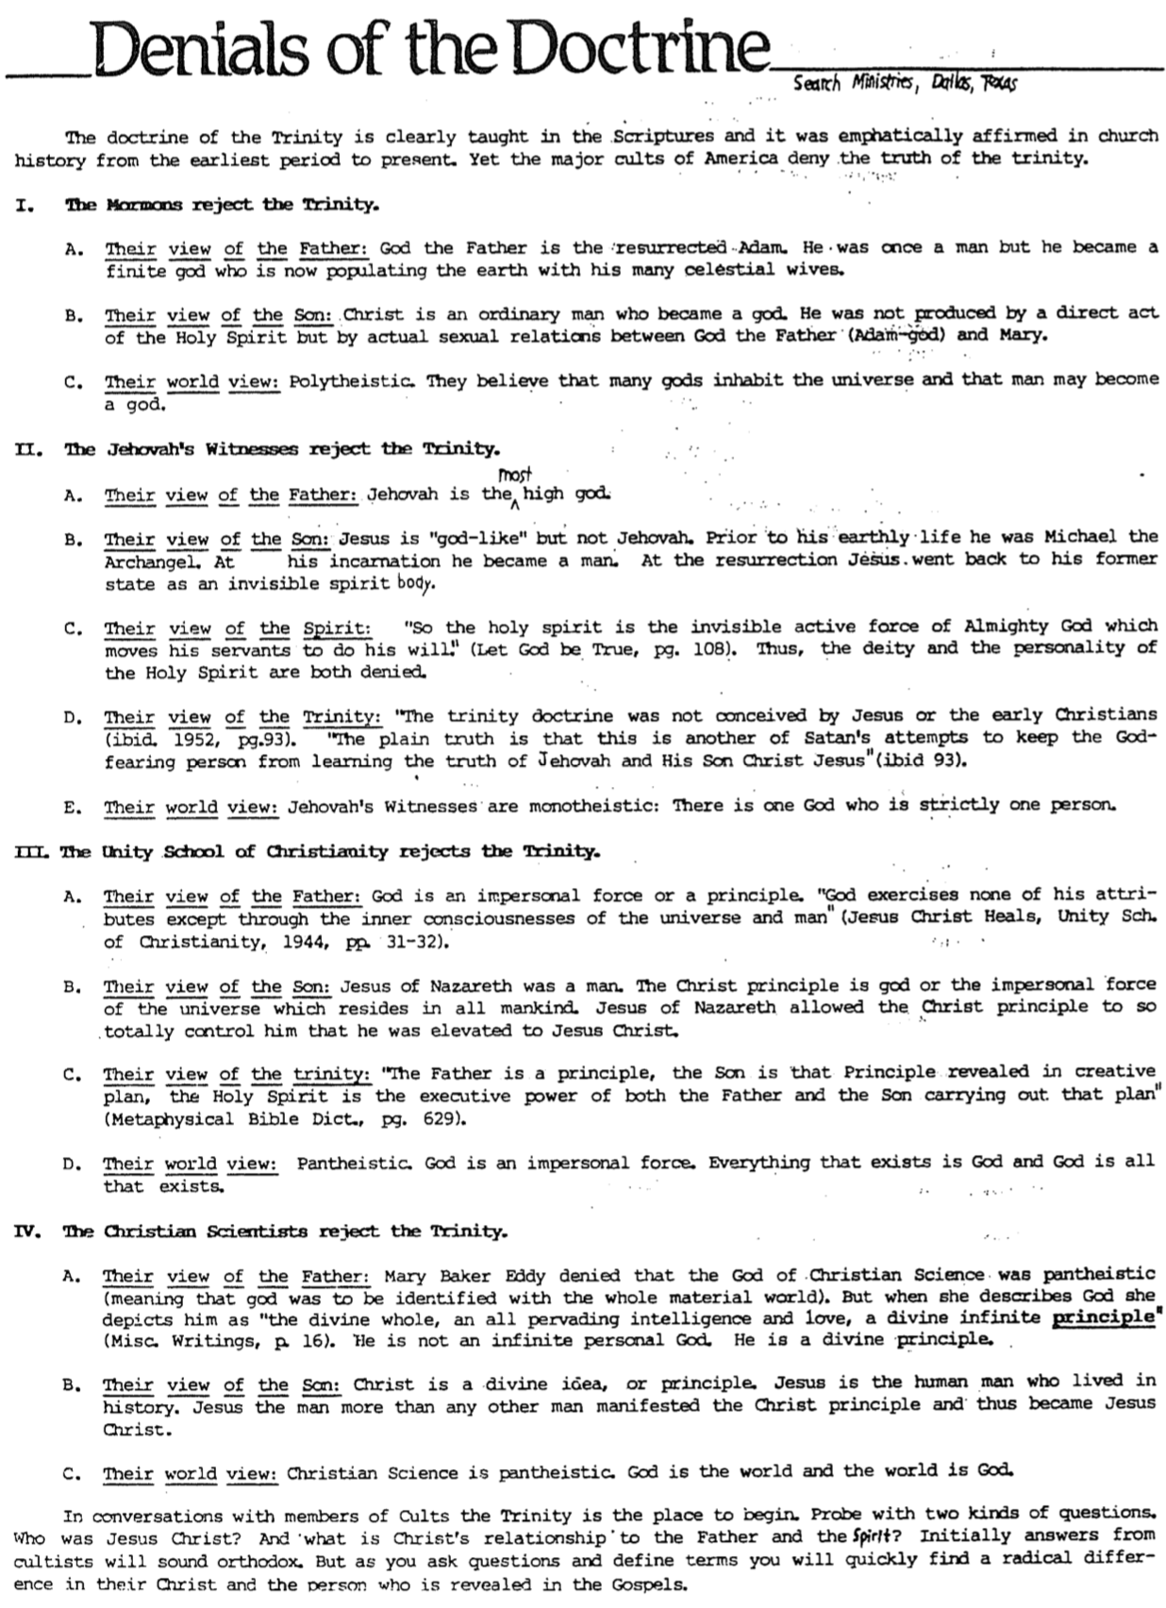**Denials of the Doctrine**

(Search Ministries)

**Different Views of God Diagrammed**

(Search Ministries)

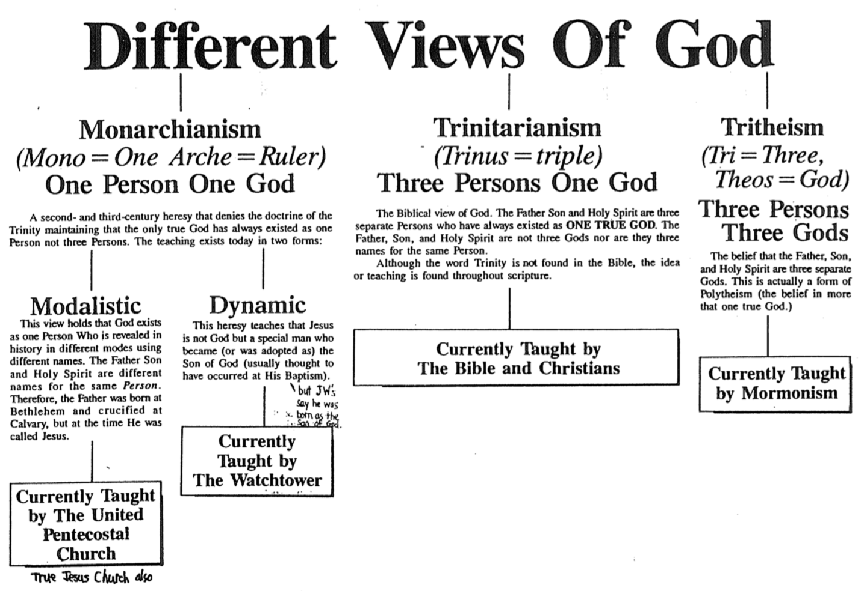

**Illustrations of the Trinity**

No illustration of the Trinity can be adequate, but the following illustrations depict some of its aspects:

1. The triple point of water: Water in a vacuum tube at zero degrees centigrade will contain liquid, ice, and vapor, yet each part will still be H2O, the same substance.

2. An Egg: An egg comprises three parts: the white, yolk, and shell. However, it is one egg.

Problem: Illustrates “parts” of God which are unscriptural

3. The Sun: The Sun is unapproachable (the Father) but is the source of beneficial light (the Son), which in turn gives power to make plants grow (the Spirit).

Problem: Impersonal illustration, whereas God is a personal being

4. A Man: A man can simultaneously be a father, son, and husband, although he is but one man.

Problem: Approaches modalism since it indicates three different functions for one man.

5. A Diagram: Here is the best Trinity diagram that I have seen (Charles Ryrie, *Basic Theology*, 55):

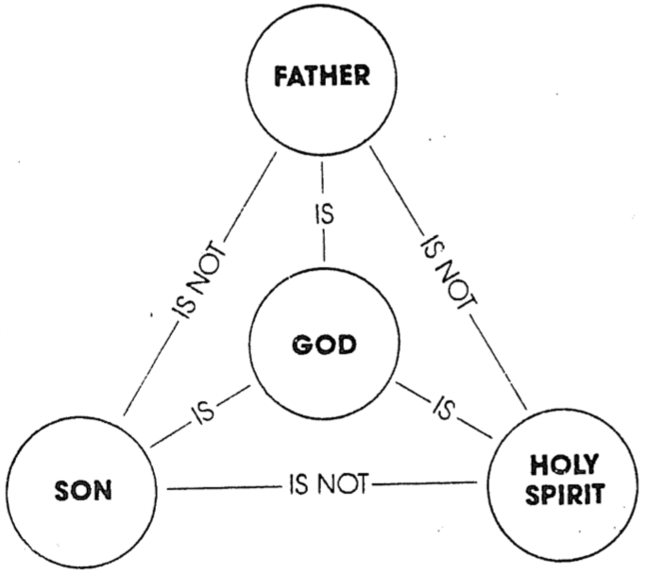

**Conclusion**

“A popular statement about the Trinity goes like this, ‘Try to understand the Trinity, and you will lose your mind but fail to understand the Trinity, and you will lose your soul.’ This betrays a misunderstanding of the doctrine. The Trinity is not a logical contradiction. For God to be three persons, yet one essence is logically possible. We do know the **what** of the Trinity: God is three persons but one essence. But the **how** of the Trinity–the exhaustive knowledge of how the persons of the Trinity relate to one another–that is a mystery. It is what we **can** know coupled with what we **cannot** know that compels us to worship such a great God.”43

**Trinity Study Endnotes**

Note: Underlined verses are translated correctly in the Jehovah’s Witness *New World Translation.* Those with double underlines are particularly clear even in this distorted version of the Bible.

1 “The Trinity.” An unpublished study outline by Search Ministries, Dallas, TX.

2 Deut. 4:39b; Isa. 43:10; 44:8; 45:22; Mark 12:29; Gal. 3:20; Eph. 4:5-6; Jas. 2:19; 1 Cor 8:4-6.

3 For a full explanation of the “Liar, Lunatic, Lord” apologetic, see Josh McDowell's *Evidence that Demands a Verdict*  (San Bernardino, CA: Here's Life Publishers, 1979), 103-107.

4 1 Cor 1:3; Eph. 6:23; Phil. 1:12; 2:10; Col. 3:17.

5 Matt. 1:23; 4:6-7; Mark 2:1-12; John 1:1, 14; 5:18; 10:30; 12:44-45; 14:9-11; 15:23; 17:11, 21; 20:28; Rom. 9:5; Phil. 2:8-11; Col. 1:15-19; 2:9; Tit 2:13; Heb. 1:1-4; 2 Pet. 1:1; 1 John 5:20; Rev. 1:8 with 1:17-18.

6 Matt. 1:18 with 16:16; 2 Cor 3:17.

7 Exod. 20:3-5.

8 Matt. 2:2, 8, 11; 28:17; Heb. 1:6.

9 No explicit NT text (that I know of) encourages us to worship the Spirit or pray to Him.

10 2 Cor 6:16.

11 Rom. 8:10.

12 John 14:17; 1 Cor 6:19.

13 John 7:28; 8:26.

14 John 1:14; 8:32 with 8:36.

15 John 15:26; 16:13.

16 1 Thess. 1:10; Col. 2:12.

17 John 2:19-21.

18 Acts 17:31.

19 Matt. 10:29-30.

20 Col. 2:3; Heb. 4:13; Rev. 2:23.

21 Isa. 11:2.

22 Gen. 18:14; Job 42:4; Jer. 32:17; Zech. 8:6; Mark 10:27; Lk 1:37; 18:27.

23 Col. 1:17; Heb. 1:3.

24 Perhaps also 1 Cor 12:13.

25 Job 22:12-14; Eph. 4:6.

26 Matt. 28:20; Col. 1:27.

27 John 14:17.

28 Matt. 6:9-13.

29 Phil. 2:6-8.

30 The Holy Spirit is not a “vapor” or a “divine influence.” Only a person is referred to by the personal pronoun “He” (John 16:8), and only a person can be quoted (Acts 13:2).

31 Mark 2:7; Ps. 103:3a, 12; Isa. 1:18; 44:22; 53:5; Jer. 31:34.

32 Mark 2:1-11; Acts 10:43; 13:38.

33 John 15:26.

34 Isa. 43:25.

35 The Father’s words (Jer. 31:34) are attributed to the Son (Heb. 8:12) and Spirit (Heb. 10:17). The author could not exercise this freedom unless all three are one.

36 James 1:17.

37 Heb. 1:12.

38 Ps. 41:13; Rev. 1:8.

39 Col. 1:15; Rev. 22:13.

40 John's seven “I am” statements are 6:35; 8:12; 8:58; 10:11; 11:25; 14:6; 15:1.

41 1 Pet. 1:15-16; Rev. 4:8; 15:4

42 Parallel in Luke 4:34; cf. Luke 1:35; John 6:69; Acts 2:27; 13:35; Rev. 3:7.

43 “The Trinity.” An unpublished study outline by Search Ministries, Dallas, TX.