**Permanent or Temporary?**

Ralph Covell & Marshall Shelly, *Wherever* magazine (Spring 1982)

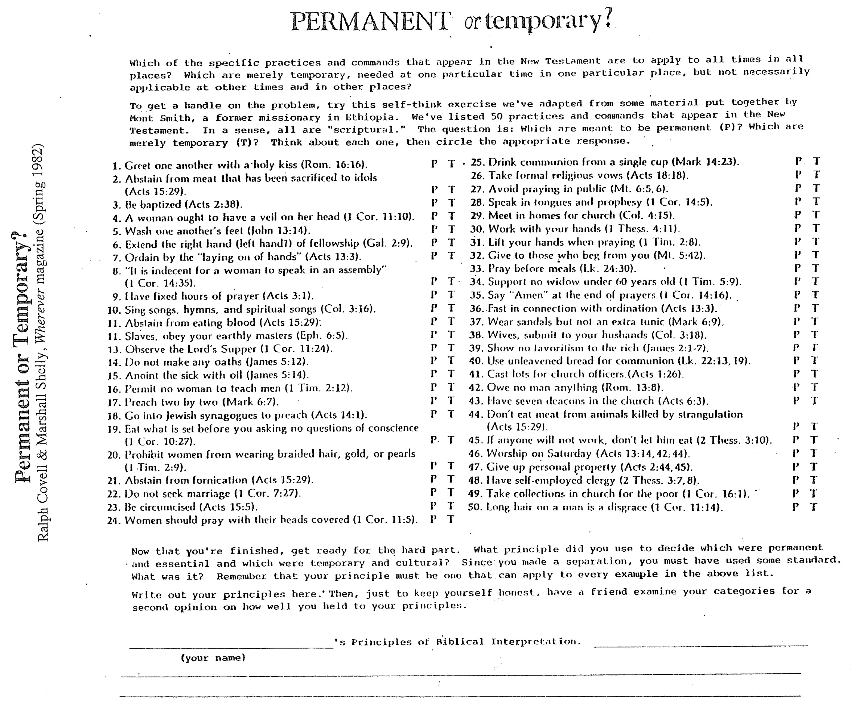

**How Do We Know Whether a Bible Passage Is “Culturally Conditioned”?**

Dr. Roy Zuck, unpublished class handout, “Hermeneutics & Bible Study Methods”   
(Dallas Theological Seminary, 1983)

