**Does the Law of Moses Apply to Me?**

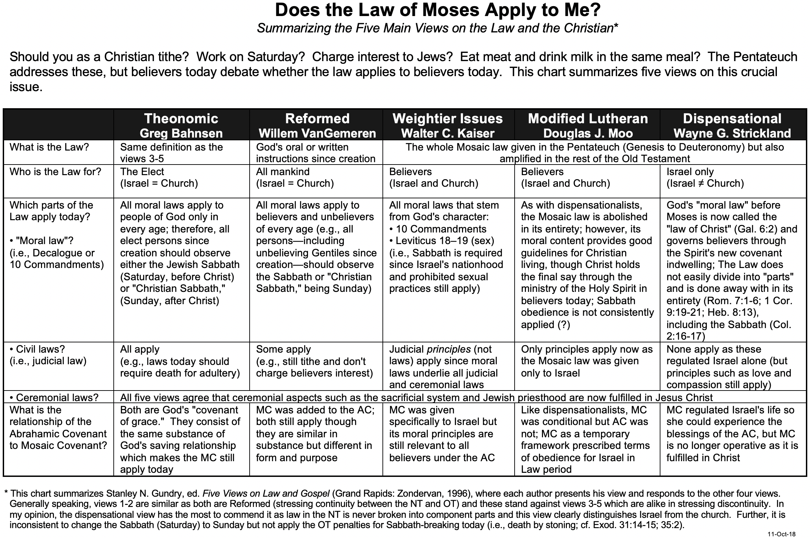

**Does the Law of Moses Apply to Me (2 of 2)?**

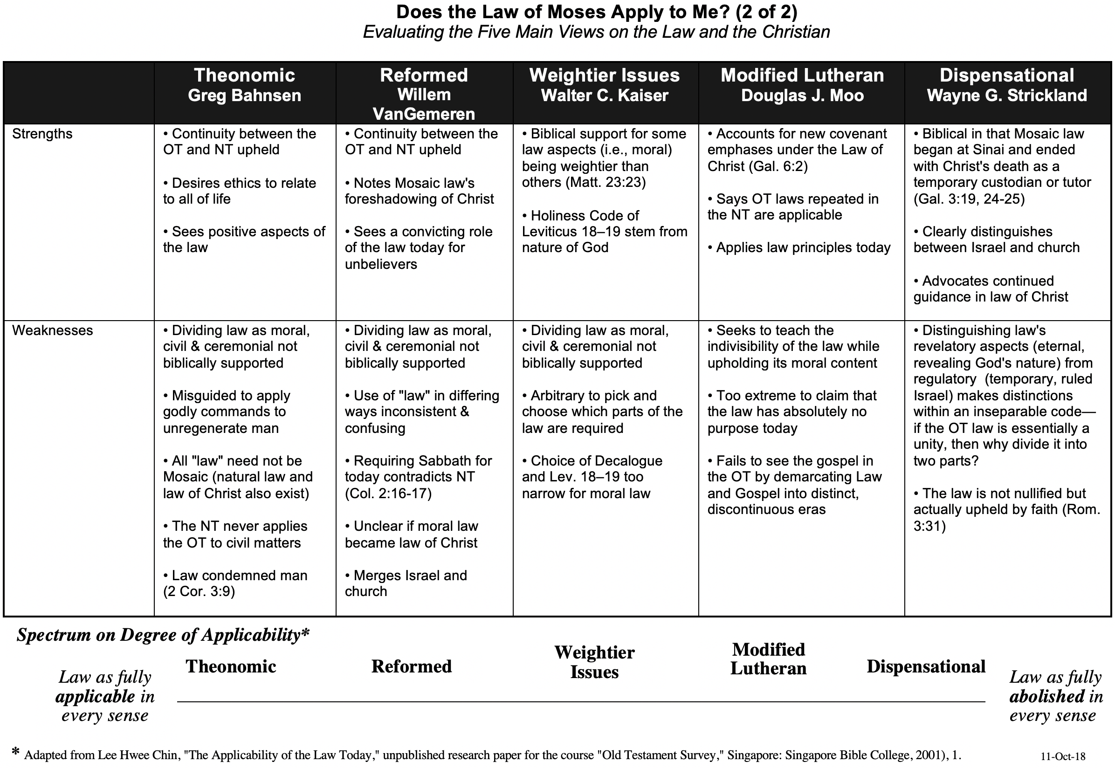

**Should Christians Follow the Ten Commandments?**

Adapted from my 1990 dissertation, “The Eschatological Significance of the Sabbath,” Dallas Seminary, 148-53

Despite the popularity of the belief that the Law is presently valid for believers, the New Testament treats the entire law as abrogated.[1] This is a major tenant of the Book of Galatians, written in response to the error of supposing that some of the law was still in effect. Paul's readers were falsely led into believing that *most* of the law was abrogated (e.g., the sacrificial system, dietary laws, etc.) but *certain* laws remained, circumcision in particular. Paul forcefully took issue with such teaching:

Mark my words! I, Paul, tell you that if you let yourselves be circumcised, Christ will be of no value to you at all. Again I declare to every man who lets himself be circumcised that he is obligated to obey the whole law (Gal. 5:2-3).

The issue to be emphasized here is Paul's view of the law as a whole. His point is that if one is required to keep *any* part of it, he is obligated to keep *all* of it. Conversely stated, if the believer is free from the law, he is free from *all* of it. This applies whether the part referred to is circumcision, the Sabbath, or any other part.[2]

The Pauline epistles uphold the abolishment of the *entire* law, not only part of it. Paul affirmed emphatically that believers are dead to the law (Rom. 7:1-6) and not under its rule (Rom. 6:14; Gal. 3:19, 23-29; 4:25, 31; 5:18). This is because Christ is the fulfillment (cf. Matt. 5:17-18) and termination or end of the law (Rom. 10:4) since His death abolished the law (Eph. 2:15). Further, Paul taught that the Mosaic Covenant has passed away (2 Cor. 3:6-11) and that the Abrahamic Covenant both preceded and followed the period of the law since the law served only temporarily (Gal. 3:14-25). The result is that "now that faith has come, we are no longer under the supervision of the law" (Gal. 3:25). Also, "the fact that God has (manifestly) accepted Gentiles as sons demonstrates that the period of the law is at an end; the custodian has finished his task and the son has become an heir (4:1-6)."[3] Finally, in 1 Corinthians 9:20 Paul very clearly declares himself free from the law:

To the Jews I became like a Jew, to win the Jews. To those under the law I became like one under the law (though I myself am not under the law), so as to win those under the law.

Paul could not have stated more clearly that he was not under the law. He makes the same claim for his Roman readers as well: "you are not under law, but under grace" (Rom. 6:14). The preceding verses represent only a select group of passages that indicate that the law has been abolished and thus has no jurisdiction over the believer. Indeed, when comparing the Mosaic dispensation with "the dispensation in Christ, Paul found the former, glorious as it had been, to be worthless."[4]

Paul and the Decalogue

While many passages have been cited above to show the end of the law, those most pertinent to the present study are two texts specifically pointing to the end of the Ten Commandments in the present age. The first text is Romans 7. Here Paul emphatically states that the believer has died to the law by being joined to Christ (v. 4) with the result that he is released from the law (v. 6). His following illustration specifies this "law" as the Decalogue by referring to the tenth commandment which prohibits coveting (vv. 7f.). The purpose of this prohibition was to reveal Israel's inability to obey the law of God. Specifically, Paul claims freedom from the law because it has already fulfilled its purpose in revealing sin. Further, since the Decalogue is an essential unity, the abolition of one of its commandments (coveting) shows the abolition of them all.[5] In other words, since his illustration denotes that believers are free from *one* of the Ten Commandments, and the Decalogue is a unity, it follows that believers are also free from *all* of the commandments, which includes the Sabbath.

Second Corinthians 3 is a second passage which even more clearly shows the believer's freedom from the Ten Commandments. In this chapter Paul contrasts his apostolic authority as a minister of the New Covenant with that of his opponents at Corinth who, by implication, were ministers of the Old Covenant (cf. 2:17; 3:14). One reason the New Covenant is more glorious than the Old is because this New Covenant is internal, written on men's hearts through the Person or activity of the Spirit (3:3b).[6] Conversely, the Old Covenant was engraved upon tablets of stone (3:3, 7). The crucial issue here is *what* was written on stone in the Old Testament. Was it the entire law? No, only the Ten Commandments were engraved upon the tablets at Sinai (Deut. 4:13; 5:22).[7] In other words, Paul equates the Old Covenant with the Decalogue.[8] This law had a fading glory (i.e., lacked permanent validity)[9] "because only in Christ is it taken away" (v. 14b). Therefore, since Paul contrasts his continuing ministry of blessing with the ministry of cursing in the Ten Commandments, he in effect teaches the abolishment of the Decalogue as a system by which one should live, including the Sabbath.[10] That the Sabbath is included within this abolished Decalogue also finds support in that the death penalty for disobeying the Ten Commandments is never enforced in the New Testament.[11] It is inconsistent to argue for the continuance of the Sabbath requirement in the present age without a continued penalty for neglecting it.

**Fulfilling the Law (Matt. 5:17-18)**

The preceding four pages in these notes explain the end of the Law at the death of Jesus. However, some problem texts seem to indicate the continuity of the law and the Ten Commandments. The most quoted verses in this respect are Christ's words in Matthew 5:17-18:

Do not think that I have come to abolish the Law and the Prophets; I have not come to abolish them but to fulfill them. I tell you the truth, until heaven and earth disappear, not the smallest letter, not the least stroke of a pen, will by any means disappear from the Law until everything is accomplished.

At first glance, it appears that Jesus said the law would be in effect until the new heavens and the new earth. Equally difficult is Paul's statement in Romans 3:31 that faith does not nullify the law, but rather, one should "uphold the law." This law is deemed later in Romans as "holy, righteous, and good" (7:12). Similarly, Paul expresses a positive attitude towards law keeping in Galatians 1:14 and Philippians 3:4-6.

A closer look indicates that the above passages can be reconciled with the many texts that indicate the abolishment of the law in the present age. First, the proper interpretation of what Jesus meant in Matthew 5:17-18 must be addressed.[12] In light of the fact that Jesus seems to have abrogated the entire law by His abrogation of the laws of clean and unclean (Mark 7:19), one could rightly wonder how He came not to abolish the law. Some suppose that He abolished only the ceremonial and civil law while confirming the moral law,[13] but this fails to account for the continuance of the all-inclusive "not the smallest letter, not the least stroke of a pen" (v. 18; NASB).

The proper interpretation of Jesus' statement lies in considering exactly what Jesus said would not be abolished. Actually, He did not refer to the Law (Mosaic Code); He said He came not to abolish the "Law or the Prophets." The formula "the Law and/or the Prophets" refers not to a moral, ceremonial, or civil code but was a common designation by the Jews of Jesus' day to refer to the Old Testament canon as a whole.[14] Therefore, in this saying, Christ claimed that He did not come to abolish the Old Testament as canon. Paul agreed that in the new dispensation the Old Testament would continue to be relevant for teaching, rebuking, correcting and training in righteousness (2 Tim. 3:16); therefore, the time in which Israel was related to God by the Torah would cease with John (Matt. 11:13). Rather than setting aside the Scripture as His opponents accused, Christ came to carry it out in full obedience; the Old Testament pointed to Him as the One who would completely fulfill God's commands.[15] Therefore, the issue here is not how long the law would remain in effect as the guiding covenant for Israel. Rather, the issue is whether the Old Testament would remain authoritative as canon. With this interpretation in mind, Jesus' claim here is entirely consistent with the abrogation of the law taught in the rest of the New Testament.

1. Douglas J. Moo, "Jesus and the Authority of the Mosaic Law," *JSNT* 20 (February 1984): 3-49; Roy L. Aldrich, "Causes for Confusion of Law and Grace," *BS* 116 (July-September 1959): 221-29; id., "Has the Mosaic Law Been Abolished?" 322-35; id., "The Mosaic Ten Commandments Compared to Their Restatements in the New Testament," *BS* 118 (July-September 1961): 251-58.
2. One may object to this reasoning based upon that fact that Paul used circumcision (in the so-called ceremonial law) rather than the Sabbath (in the so-called moral law), but Paul's teaching on the present applicability of the Ten Commandments is noted later in this discussion.
3. Douglas R. de Lacey, "The Sabbath/Sunday Question and the Law in the Pauline Corpus," in *From Sabbath to Lord's Day: A Biblical, Historical, and Theological Investigation.*, ed. D. A. Carson, 159-95 (Grand Rapids: Zondervan, 1982), 166.
4. E. P. Sanders, *Paul, the Law, and the Jewish People* (Philadelphia: Fortress Press, 1983), 144.
5. This is certainly not to say that believers are now free to covet, for this is prohibited elsewhere in the New Testament (e.g., James 4:2). What Paul means is that the prohibition of coveting in the Decalogue revealed man's inability to follow God's commands.
6. Bernardin Schneider, "The Meaning of St. Paul's Antithesis 'The Letter and the Spirit,'" *CBQ* 15 (1953): 193-207.
7. Charles Hodge, *A Commentary on 1 & 2 Corinthians*, GCS, 428. See also Exodus 24:12; 31:18; 32:15-16 for other verses mentioning the tablets. Many argue that Paul's reference to "tablets of stone" serves as a figurative designation for the entire law or Old Covenant (e.g., Victor Paul Furnish, *II Corinthians*, AB, 200; Bultmann, 73-75; Frederick W. Danker, *II Corinthians*, ACNT, 54; Colin Kruse, *The Second Epistle of the Paul to the Corinthians*, TNTC, 91-93; Knofel Staton, *Second Corinthians*, SBS, 56-57). However, the passage compares in graphic terms the actual writing (content) on the cold, external tablets with that "written" on the warm, internal heart; thus, the comparison drawn is between the Decalogue and that which replaces it—the work of the Spirit in the inner man. However, even if the tablets represent the *entire* law (the Old Covenant is the implied contrast in verse 6 and specifically mentioned in verse 14), this still argues for the abolition of the Sabbath as part of that law.
8. De Lacey, "The Sabbath/Sunday Question and the Law in the Pauline Corpus," 167.
9. Ernest Best, *Second Corinthians,* Interp., 31.
10. Even Paul's statement that circumcision is nothing but rather what matters is "keeping the commandments of God" (1 Cor. 7:19) is inadequate proof that believers are to keep the Ten Commandments. There is no evidence that “commandments of God" refers exclusively or even primarily to the Decalogue (C. K. Barrett, *1 Corinthians*, 169; de Lacey, "The Sabbath/Sunday Question and the Law in the Pauline Corpus," 176). Objection to the preceding presentation of Paul's view of the Decalogue may also be based upon his appeal to the fifth commandment in Ephesians 6:1-3. However, here, the primary motive for children obeying their parents is not the Decalogue, but because this is part of one's calling in Christ (4:1) and is right (v. 1b). The appeal to the Ten Commandments is at best a third motivation (ibid., 176).
11. For an evaluation of the penalties for each of the Ten Commandments, see Aldrich, "The Mosaic Ten Commandments Compared to Their Restatements in the New Testament," 251-58. He shows how the believer is not under the Decalogue, but instead "he is under the eternal moral law of God which demands far more than the Ten Commandments. It calls for nothing less than conformity to the character of God" (p. 257).
12. For a discussion of critical viewpoints on this verse see D. A. Carson, "Matthew," EBC, 8:142-44; W. D. Davies, "Matthew 5:17, 18," in *Christian Origins and Judaism*, 31-66.
13. For example, see David Wenham, "Jesus and the Law: an Exegesis of Matthew 5:17-20," *Themelios* 4 (1979): 92-96.
14. Matt. 7:12; 11:13; 22:40; Luke 16:16; John 1:45; Acts 13:15; 24:14; 28:23; Rom. 3:21. Other designations include "the Law of Moses and the Prophets and the Psalms" (Luke 24:44) or simply "Law" (Matt. 5:18; John 10:34; 12:34; 15:25; 1 Cor. 14:21; cf. Carson, *EBC*, 8:142; D. Martyn Lloyd-Jones, *Studies in the Sermon on the Mount*, 1:184, 187; Richard E. Clark, "An Exegesis of the Ten Commandments," Th.M. thesis, Dallas Theological Seminary, 1972, 68-69).
15. This interpretation is consistent with Matthew's use of plhro,w (“fulfill”; e.g., Matt. 2:15; 11:13), which refers to the prophetic nature of the Old Testament. When Christ came as the eschatological fulfillment of the Law, "the Law lost its main function of pointing ahead; it ceased to hold the center of the stage. Jesus, not the Law, is now the center of the Christian's (and Mt's) attention, devotion, and obedience—and that includes moral observance" (John P. Meier, *Law and History in Matthew's Gospel*, 87). For elaboration of this view see Carson, EBC, 8:143-44; Lloyd-Jones, 1:185-86; Robert Banks, "Matthew's Understanding of the Law: Authenticity and Interpretation in Matthew 5:17-20," *JBL* 93 (1974): 226-42, esp. 242; Moo, "Jesus and the Authority of the Mosaic Law," 3-49.